You’re Welcome Ewen Lochiel

There are settings of this tune in the following manuscript sources:
--MacArthur/MacGregor MS, 97-99;
--Angus MacKay’s MS, i, 34-5 (and also in the so-called “Kintarbert MS”, f.56);
--Colin Cameron’s MS, ff.149-50;
--Duncan Campbell of Foss’s MS, ff.104-5;
--Uilleam Ross’s MS, ff.117-8;
--D. S. MacDonald’s MS, i, 139-40;
--John MacDougall Gillies’s MS, f.45;
--David Glen’s MS, ff.66-7;

and in the following published sources:
--Frans Buisman and Andrew Wright, eds., The MacArthur MacGregor Manuscript of
Piobaireachd (1820), p.158;
--C. S. Thomason, Ceol Mor, p.290.

The MS record suggests that this was a widely diffused tune; it is interesting, though, that it remained unpublished before C. S. Thomason.

The compilers of the Highland Society of London’s MS, John MacGregor and Angus MacArthur set the tune like this:

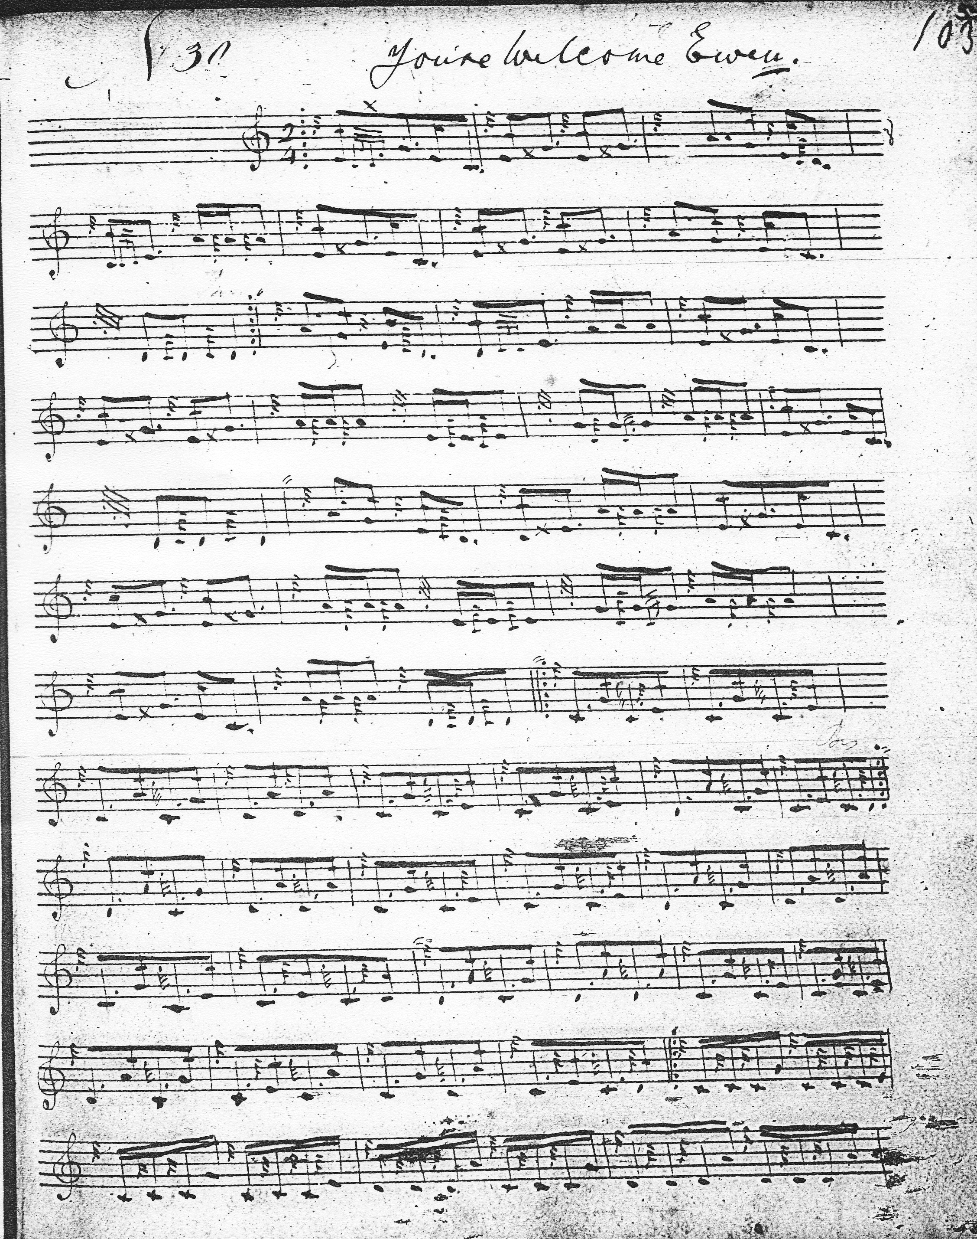

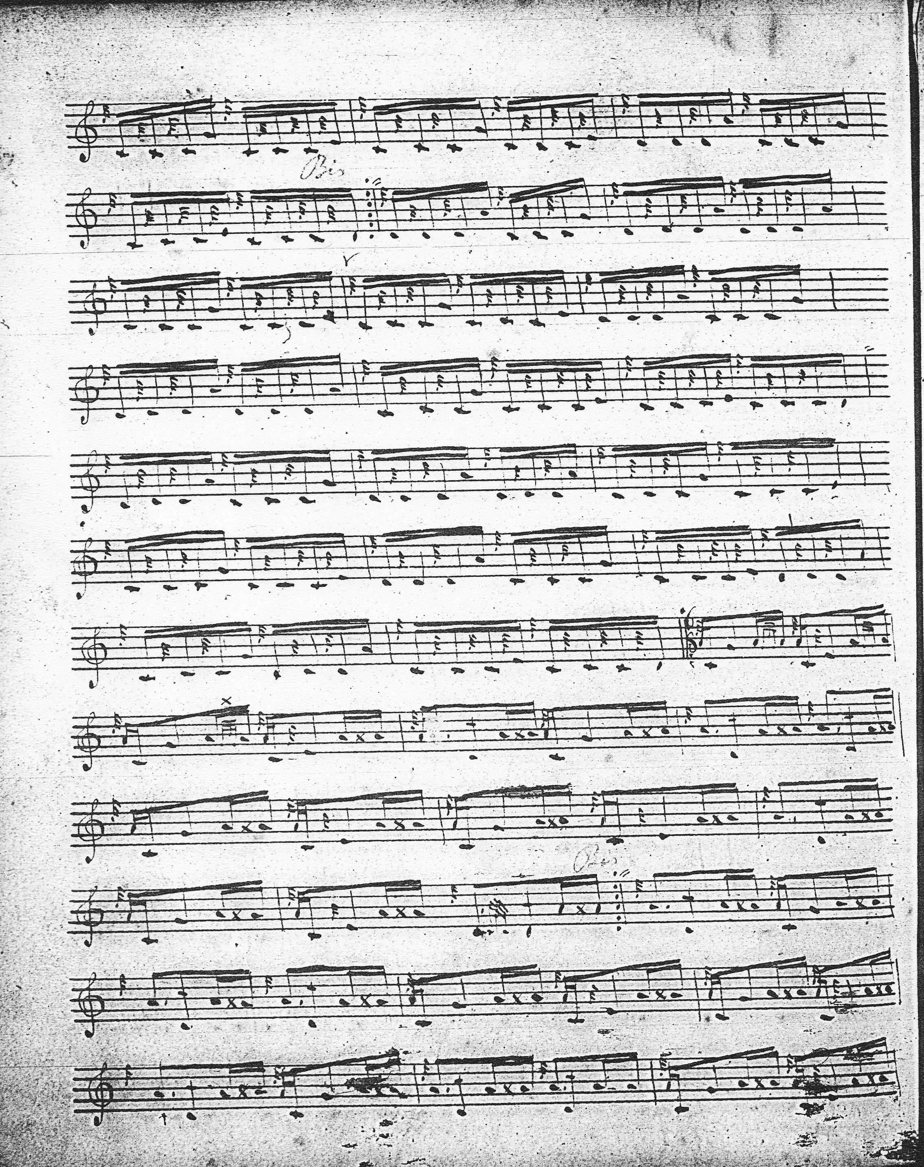

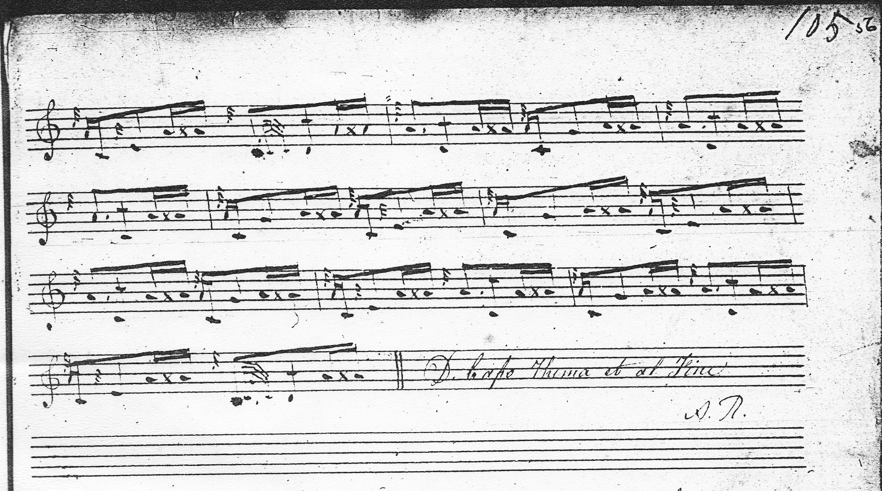

A number of things happen in this interesting setting, timings that would not be heard today if the notation means what it seems to mean. The timing of the echo-beats on E D and B, for example, would suggest a move into 4/4 time rather than the 2/4 specified. They could, of course, be played as timed, but this does things to the rhythmical flow of the tune that would nowadays be considered unidiomatic. The timing of the crunluath fosgailte is also unusual, with the introductory Es clearly added subsequently to the movements whose initial melody notes lie on the bottom hand. The 6/8 time signatures seem also a later addition, squashed in between the opening melody note of the crunluath singling and the end of the previous variation. We know that leading into a crunluath fosgailte movement off an expressed E may have been a distinctive feature of the MacArthur style (see The Highland Pipe and Scottish Society 1750-1950, pp.128-9). Some of these points are discussed further in the accompanying MP3 file. The initials “A. R.” at the foot of the score are probably those of Andrew Robertson the person delegated by the Highland Society to authorise payment for MacGregor and MacArthur’s finished work. Originally from Aberdeen, Robertson became a well-connected Society portraitist. Interested readers may consult his entry in the Oxford Dictionary of National Biography.
In his main MS Angus Mackay sets the tune like this:
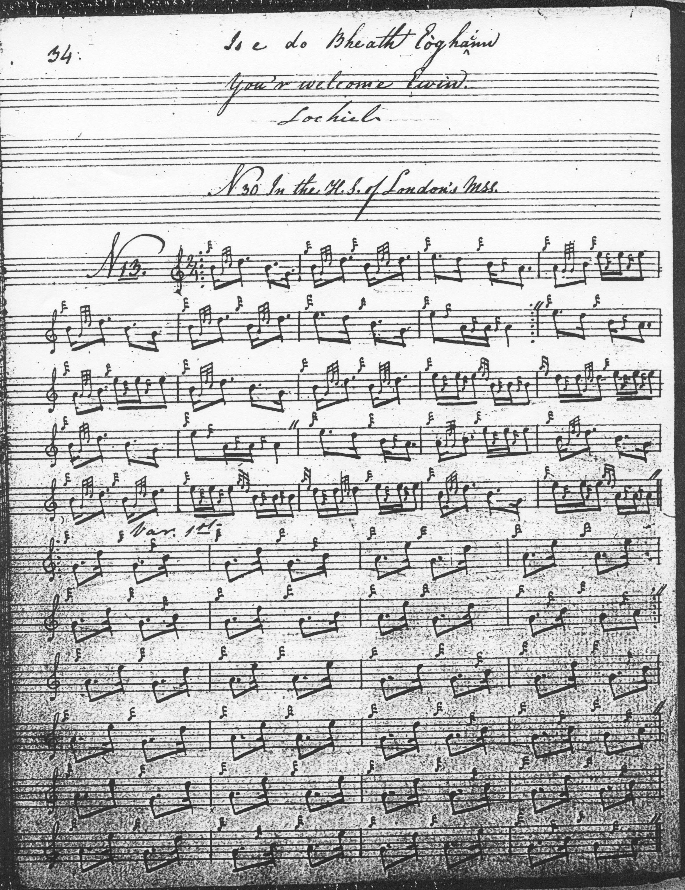
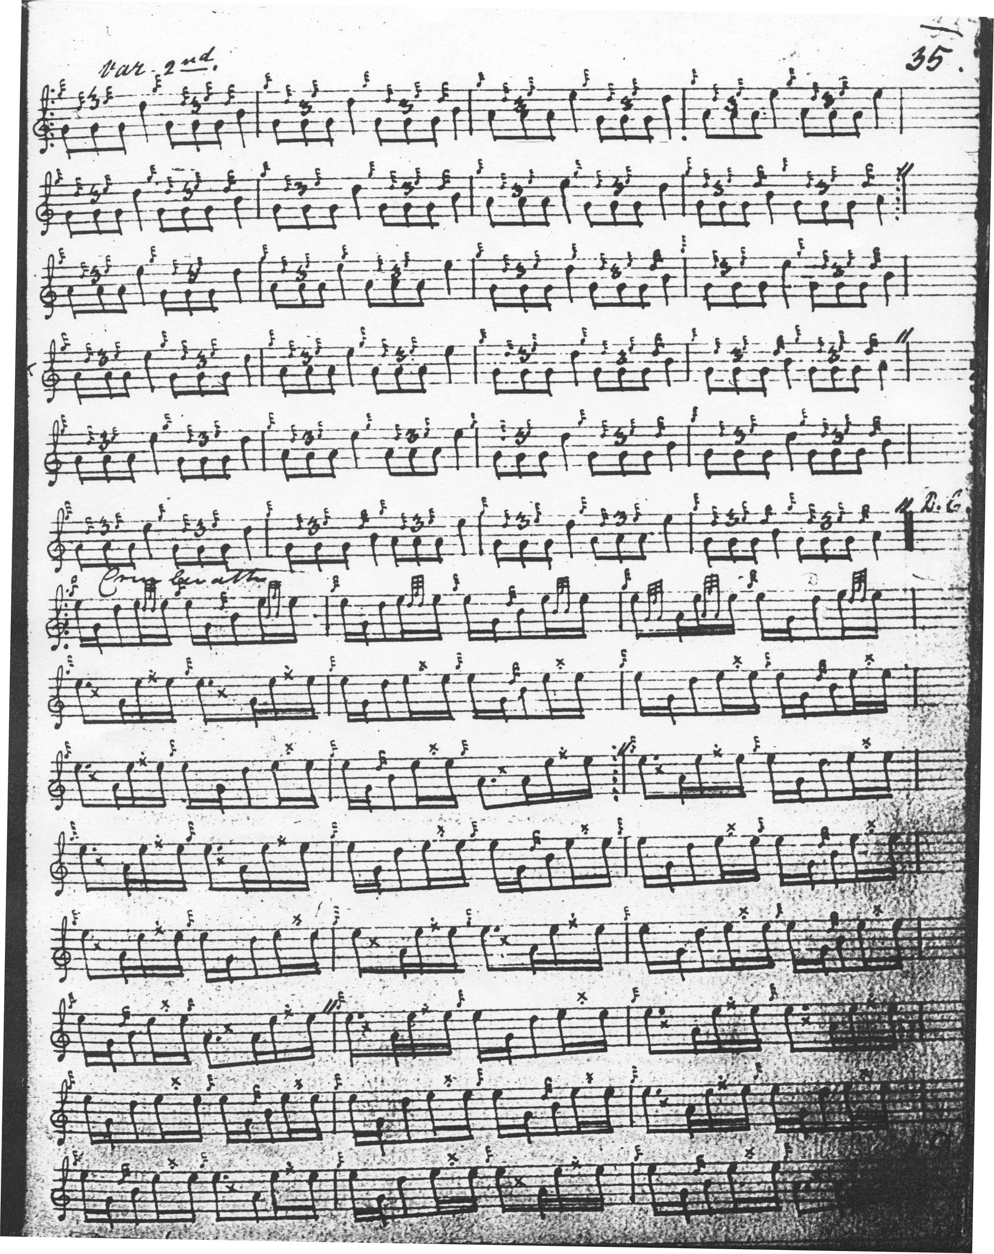

The reader will note that here MacKay retains the MacArthur timing of the crunluath variation. In the so-called “Kintarbert MS”, however, he sets the variation in his more usual style, like so, although citing the same source:
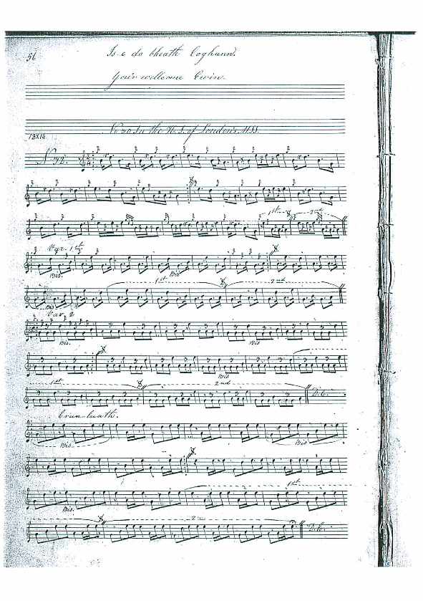

The scores of Colin Cameron, Duncan Campbell, and Uilleam Ross follow those of Angus MacKay, ending with a conventional crunluath fosgailte movement in the style of the “Kintarbert” MS above, which may have been their common source. This latter was the volume containing 88 tunes compiled by Angus MacKay (and probably intended as the second volume of his published collection) which came into the possession of Sir Charles Forbes (1803-1877) of Castle Newe, Strathdon, whose piper was Duncan Campbell of Foss. D. S. MacDonald’s score is transcribed from MacKay’s main manuscript and therefore retains the MacArthur-style crunluath fosgailte variation unlike those of Cameron, Campbell and Ross. John MacDougall Gillies’s score reflects the way the tune was transmitted in the Cameron family, ultimately descending--like the above--from the style shown in the so-called “Kintarbert” MS. C. S. Thomason’s score is reproduced from MacKay’s main manuscript. These settings add nothing to the expressive possibilities of the tune and are not reproduced here.
David Glen (who identifies the “Kintarbert” document, correctly, as “Sir. C. Forbes’s MS”), has a number of little individual touches, showing his typical, pleasing style. Glen sets the tune as follows:
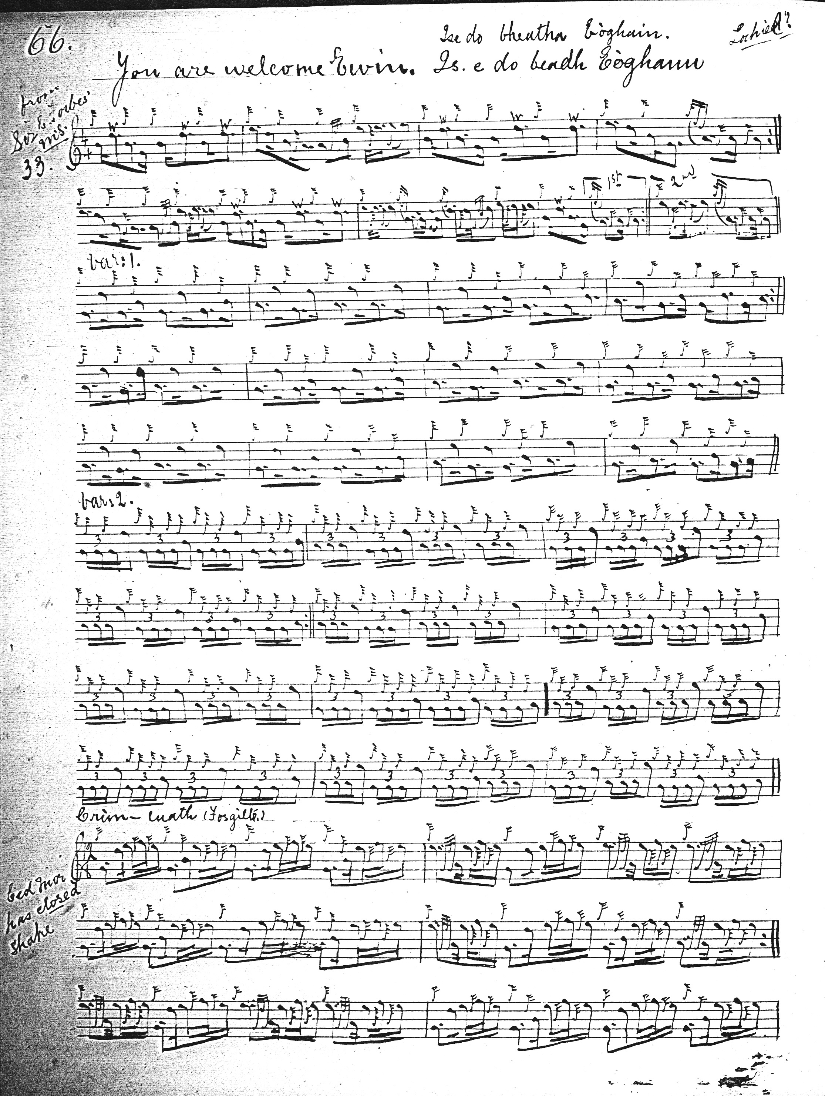
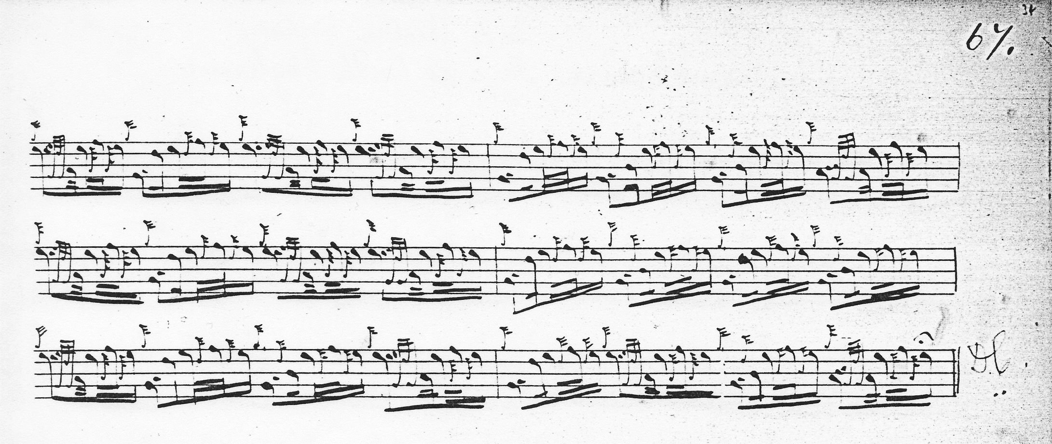
Glen sets the ground in 4/4 and uses the “opened” style in the crunluath fosgailte, and although MacKay repeats the ground after the taorluath variation, Glen does not.
Commentary:
This tune, originally nameless in the Highland Society of London’s MS, seems to have been entered in Angus MacKay’s manuscript at first simply as “You’r welcome Ewin”, the “Lochiel” seemingly added as an afterthought, possibly under the influence of the antiquarian James Logan who is thought to have been responsible for the bulk of the letterpress portions of MacKay’s Ancient Piobaireachd. Hence, it may be a further example of the historicising urge frequently visible during the 19th century to connect the music—sometimes rather arbitrarily--to great figures and events of the past. In his so-called “Kintarbert” manuscript, MacKay’s title is simply “Is e do bheath Eoghann. You’r welcome Ewin.”
Sir Ewen Cameron of Lochiel (1629-1719) was a prominent Highland chieftain who took a leading part in the broils of the 17th century. Hailed by later, romantic, centuries as a royalist hero, the slippery Lochiel was seldom on any side for very long, though the pivotal location of his lands in the south west highlands made him courted, and justifiably mistrusted, by both sides. Although a tangle of competing and overlapping jurisdictions could make life difficult for people like Lochiel, he led the kind of career that makes “cynical opportunism” seem like a euphemism.
* * *
Electronic text © Dr William Donaldson, Cambridge, Massachusetts, 1st May 2012

