The Young Laird of Dungallon’s Salute

This tune is found in the following manuscript sources:
--Colin Campbell’s “Nether Lorn Canntaireachd”, with the title “Dungalans Lament”, ii, 117-20, and 186-7;
--the MacArthur/MacGregor MS, ff.80-83;
--David Glen’s MS, ff.365-367;

and in the following published sources:
--Niel MacLeod of Gesto, Pibereach or Pipe Tunes, pp. 10-13, with the title “Mac, Vic Horomoid, alias McLeod Gesto’s Lamentation”;
--Angus MacKay, Ancient Piobaireachd, pp.113-5;
--Donald MacPhee, Collection of Piobaireachd, i, 34-6;
--C. S. Thomason, Ceol Mor, p.200’
--F. Buisman and A. Wright, eds., The MacArthur-MacGregor Manuscript of Piobaireachd (1820), with the title “Dungallon’s Lament”, p.154.

The earliest setting is in Colin Campbell’s Nether Lorn Canntaireachd, which treats the tune as follows:

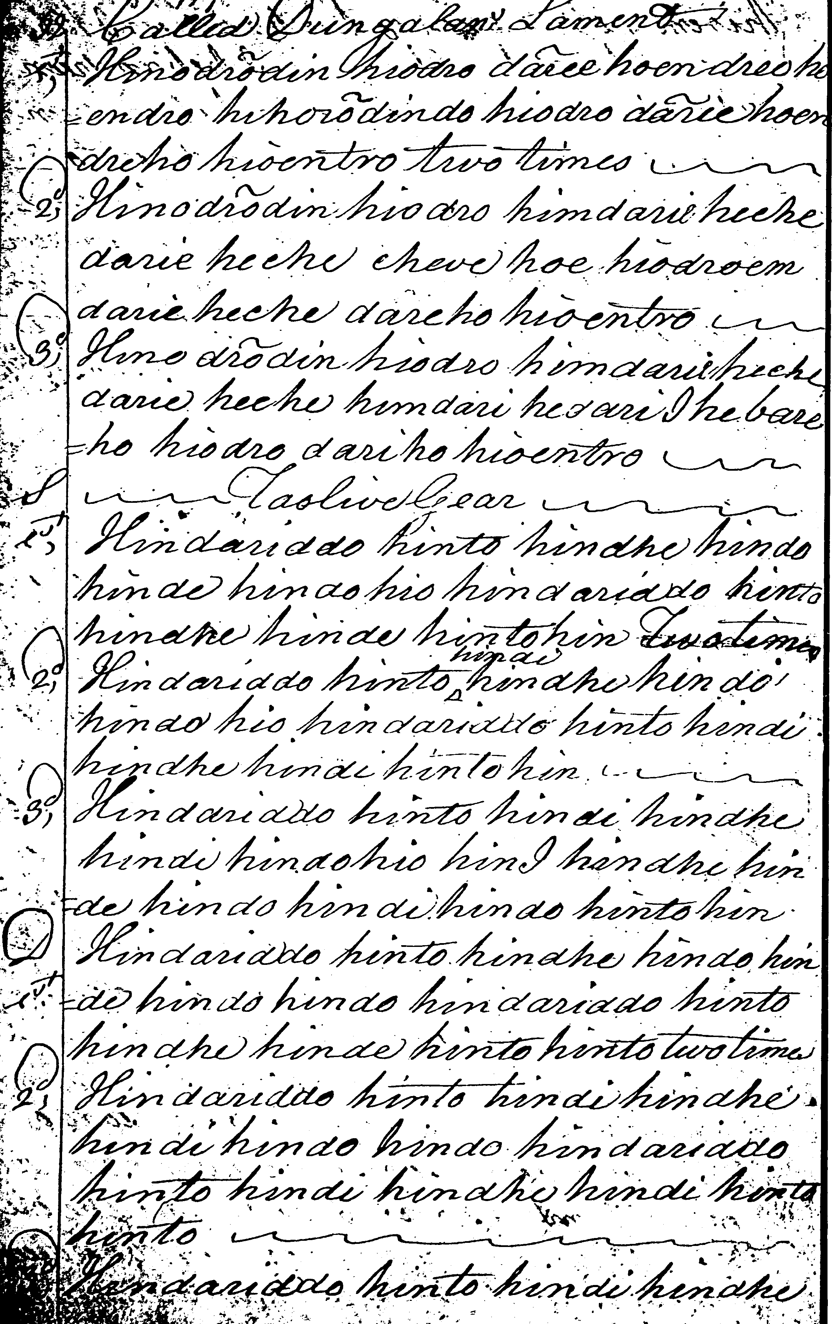

And so on. Colin Campbell turns the ground more nicely than Angus MacKay, perhaps somewhat thus:

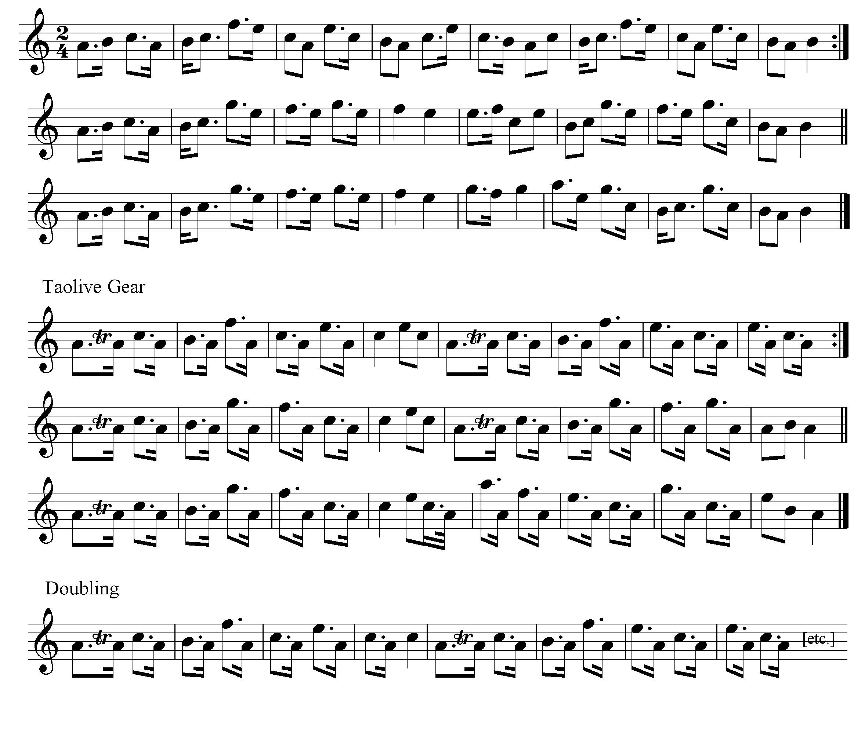
And so on.

Although ostensibly laid out in three lines, it seems clear that the direction “two times” at the end of line one applies to the whole line. Colin Campbell does not direct that a crunluath a-mach be played. If the title is accurate, then this is probably an 18th century tune. As we will see below, there were only three lairds of Dungallan, the last two dying in 1739 and 1759 respectively.

The MacArthur/MacGregor treats the tune as follows:

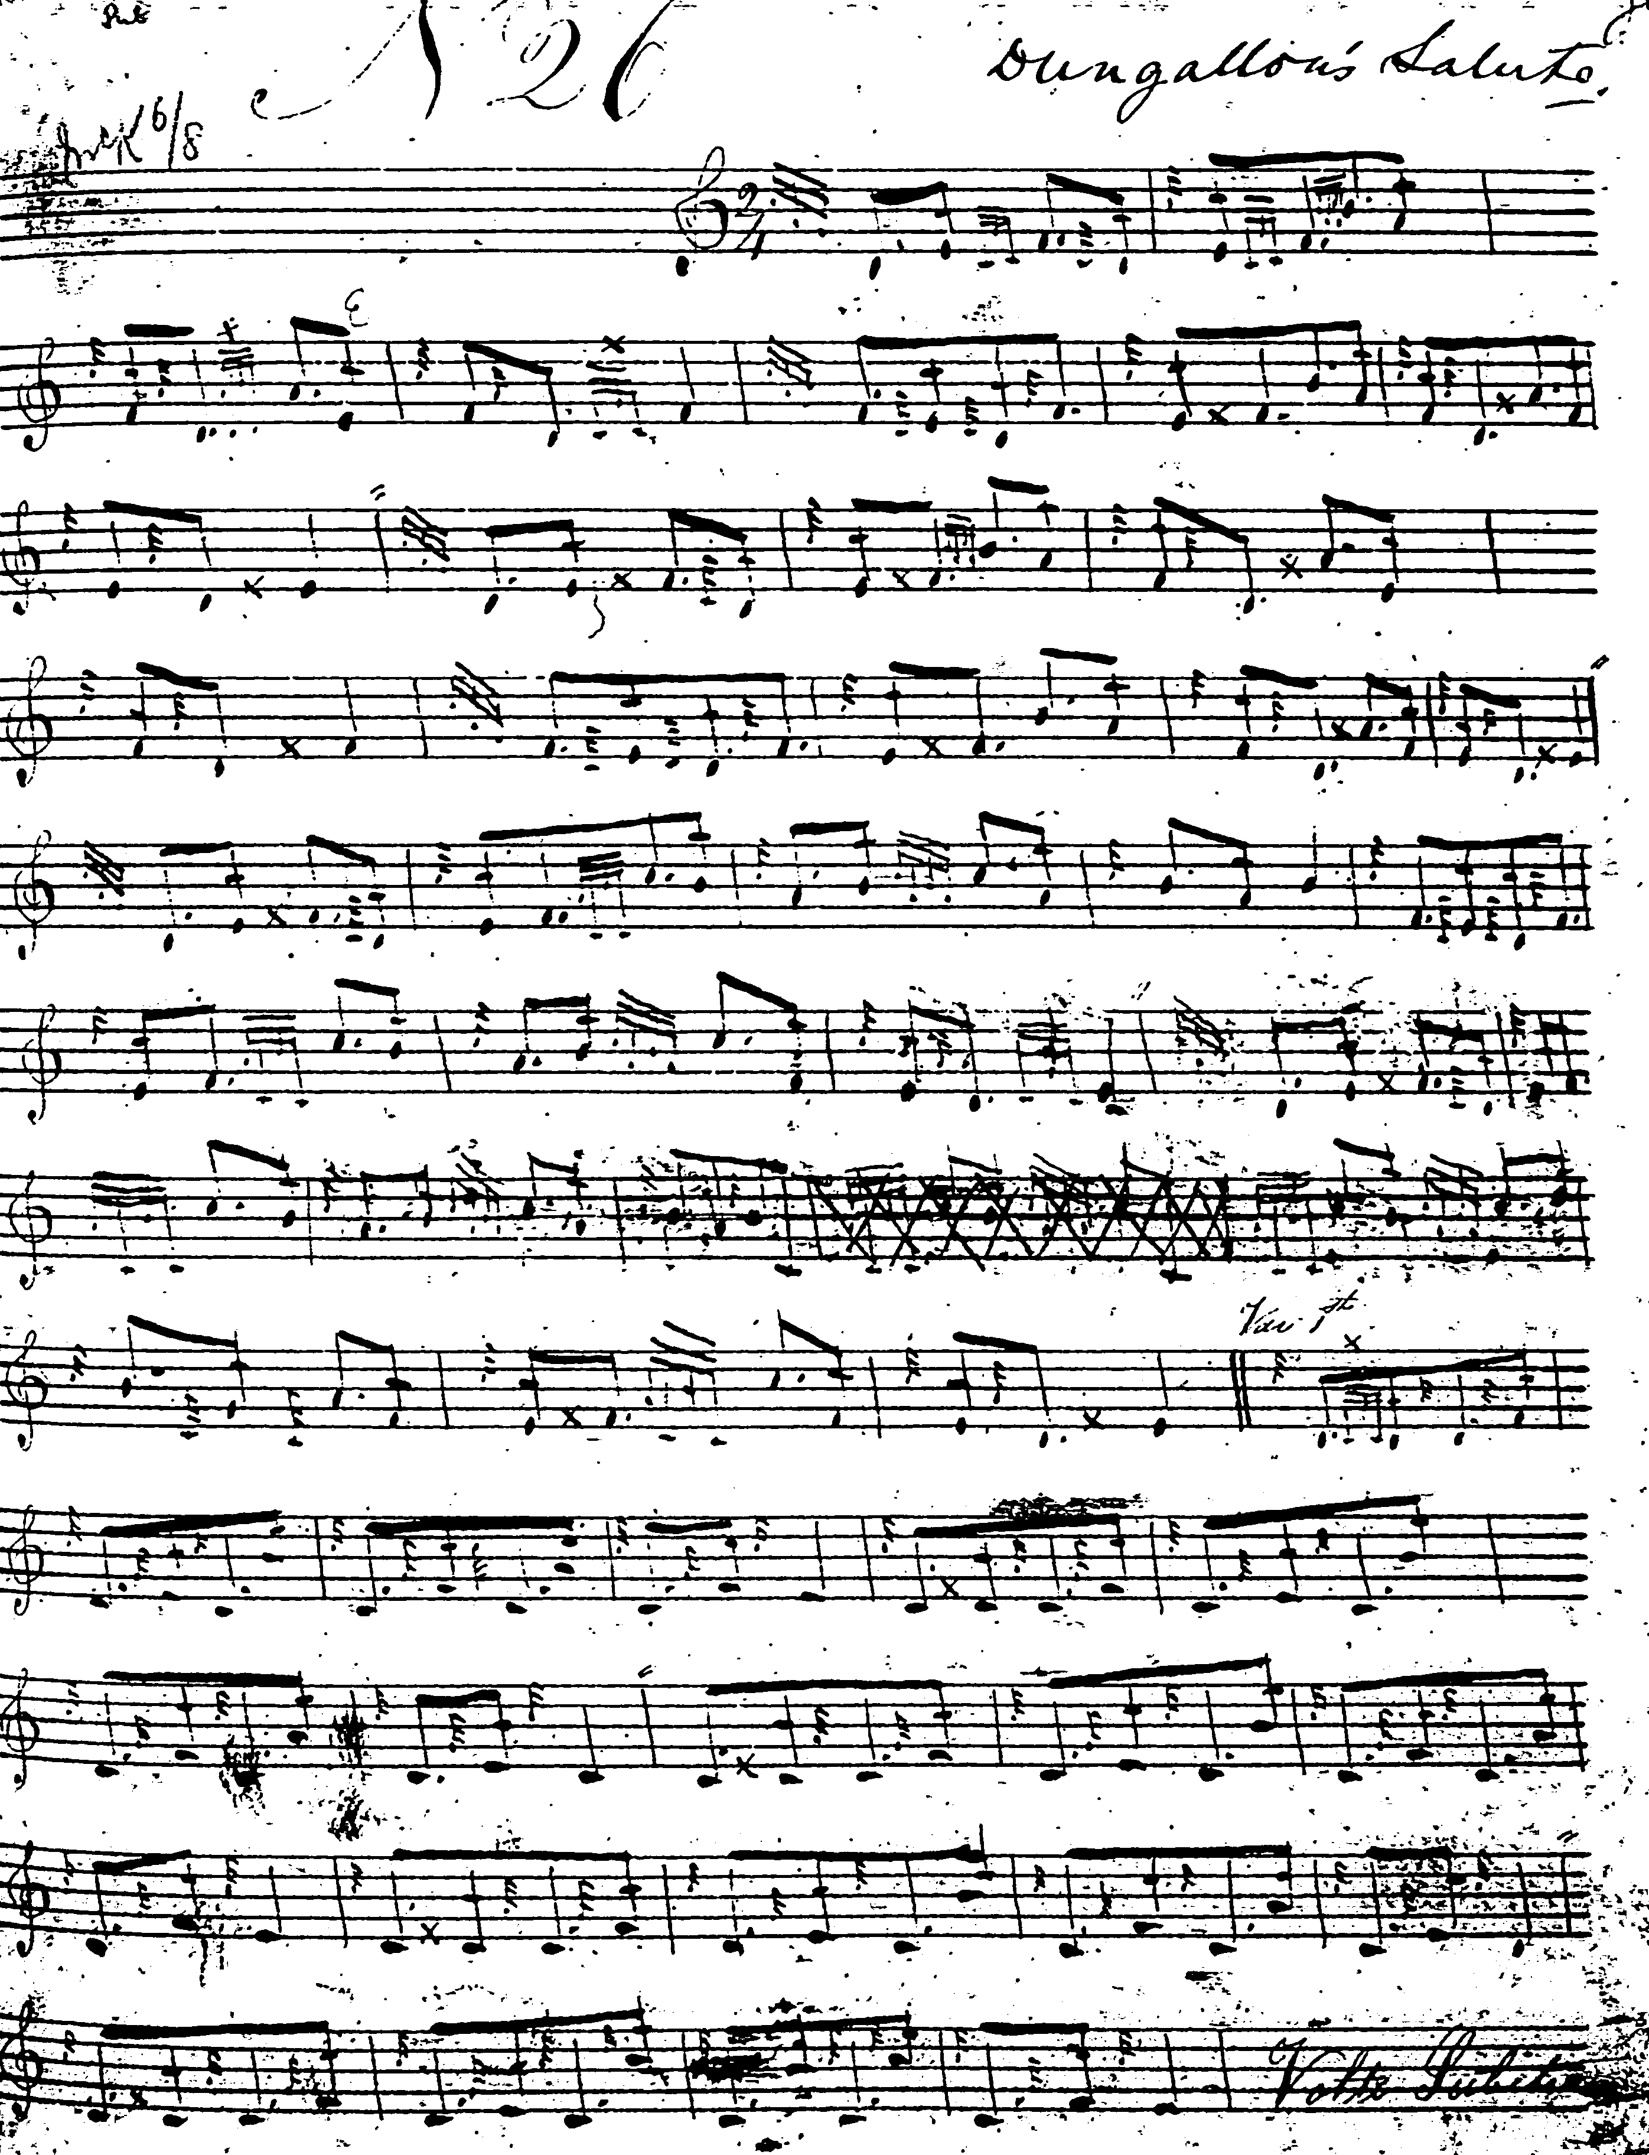
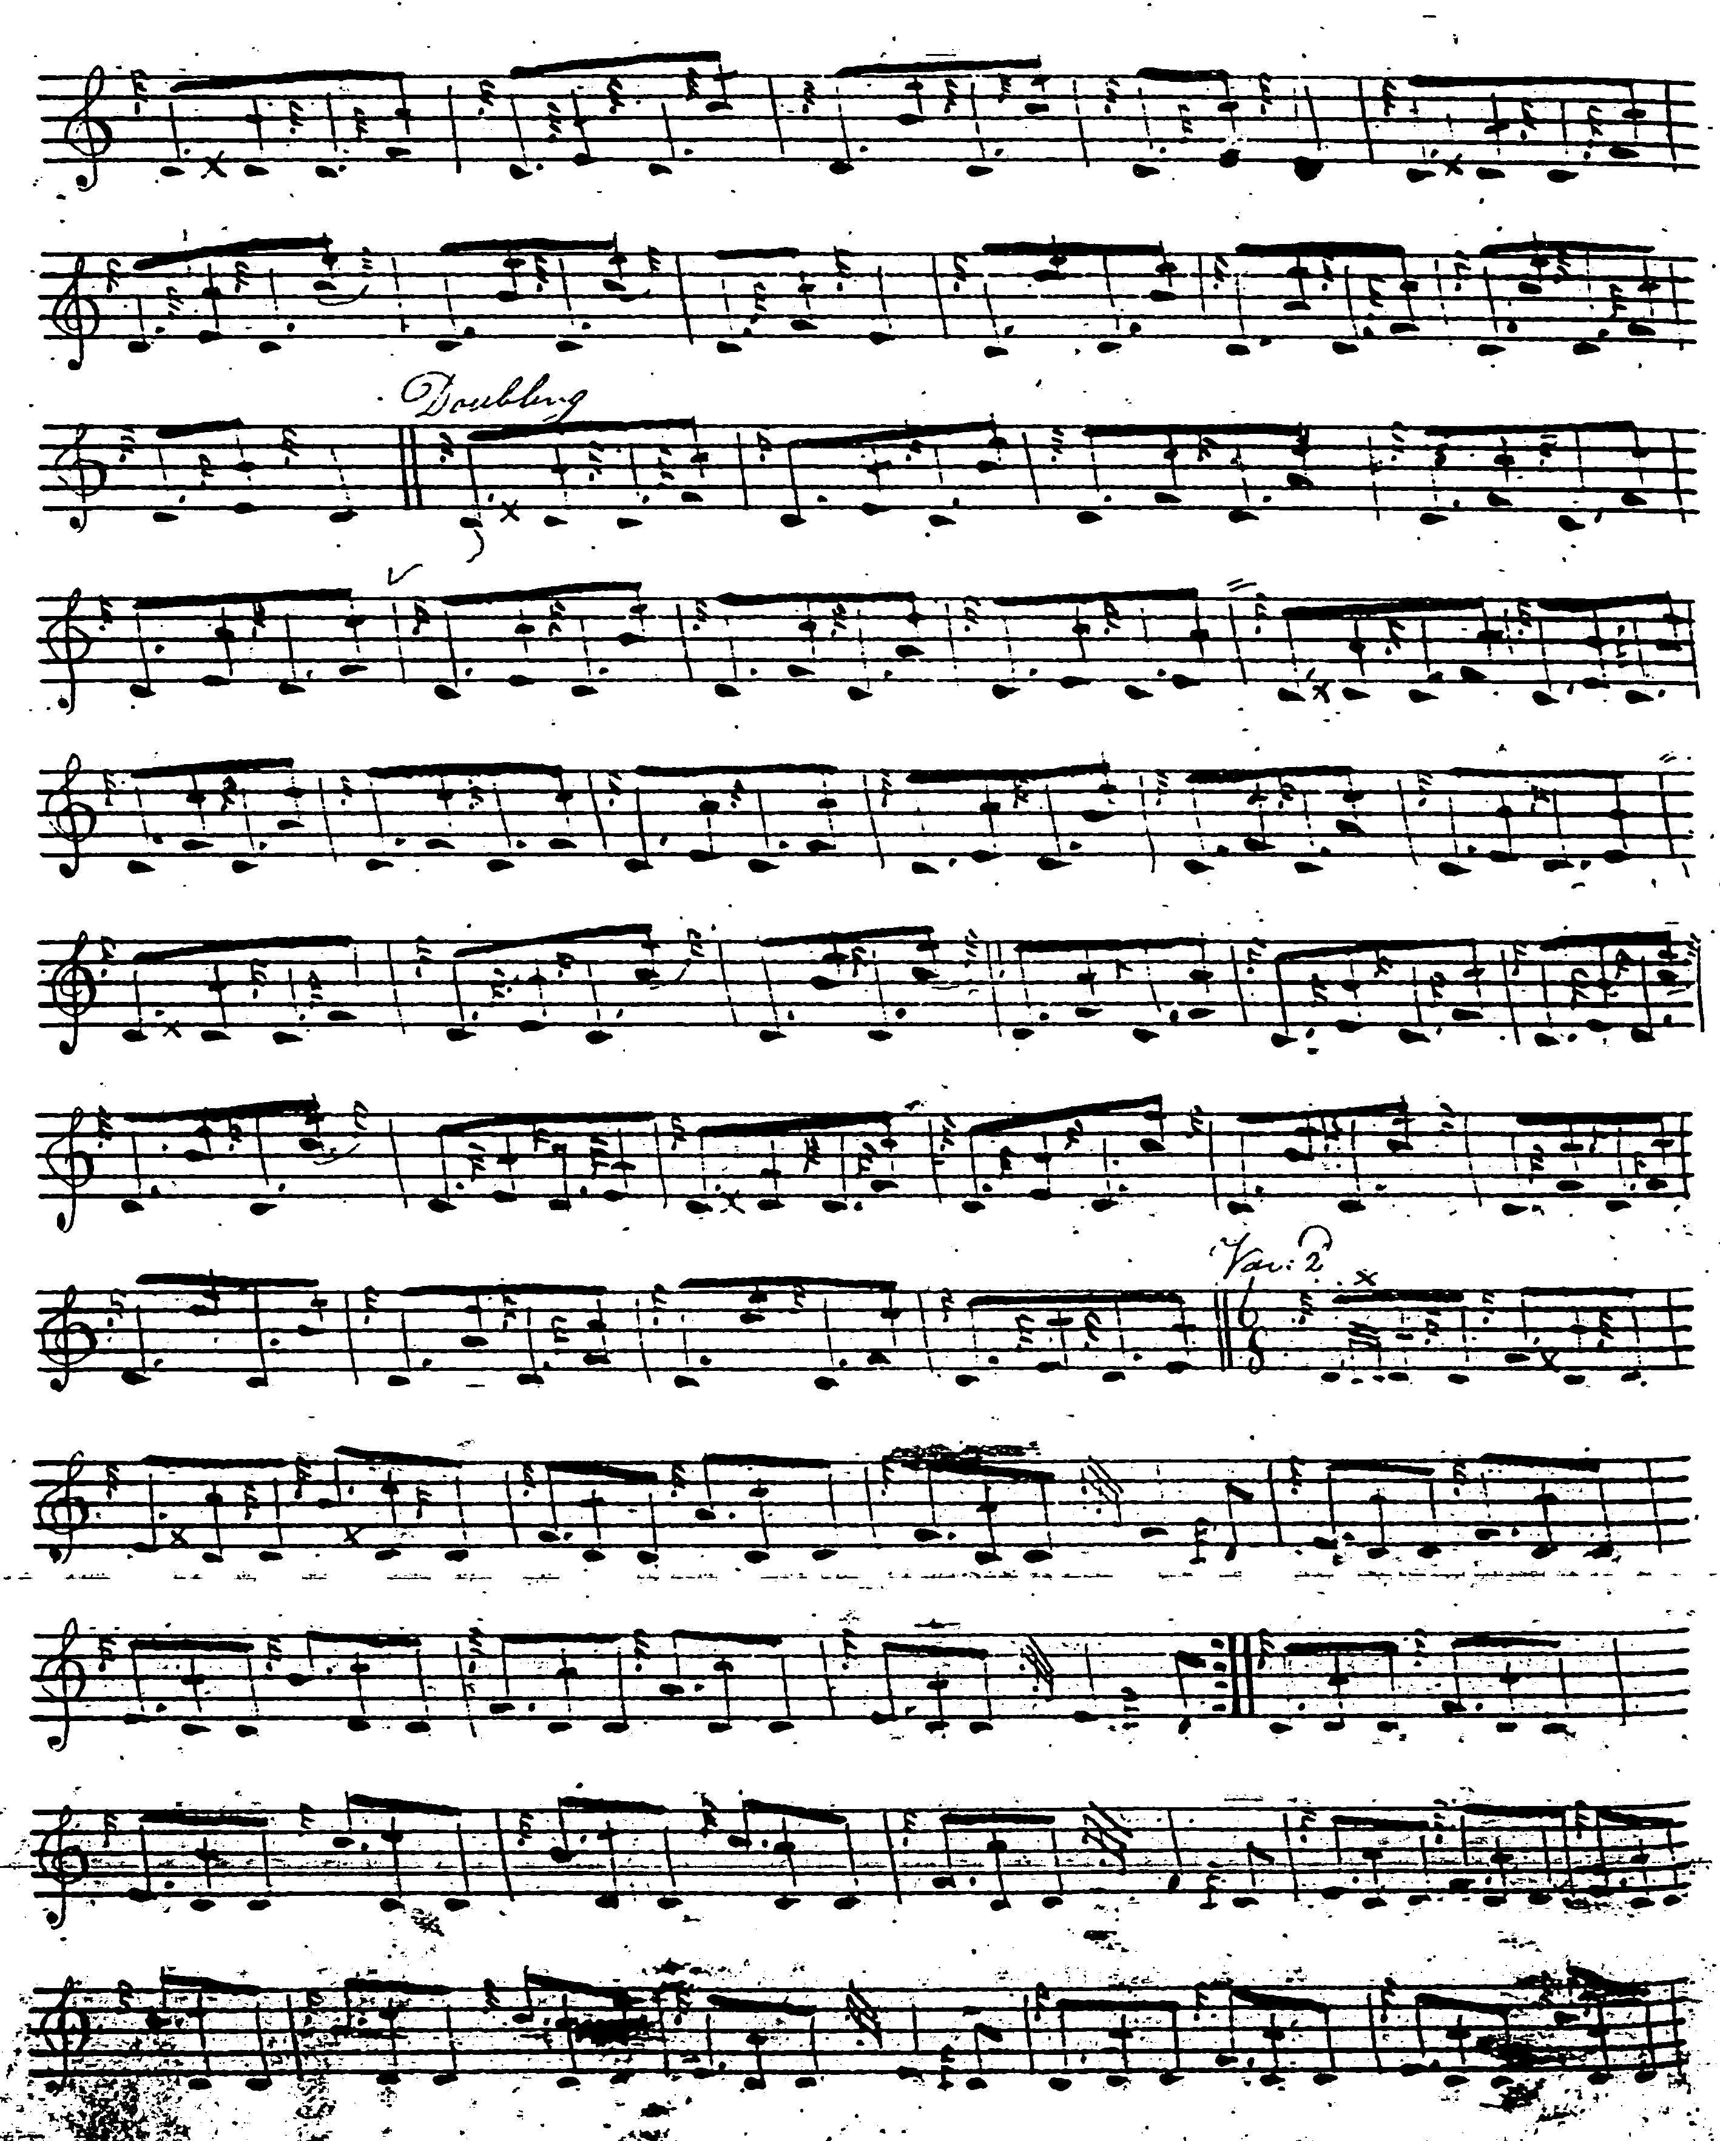
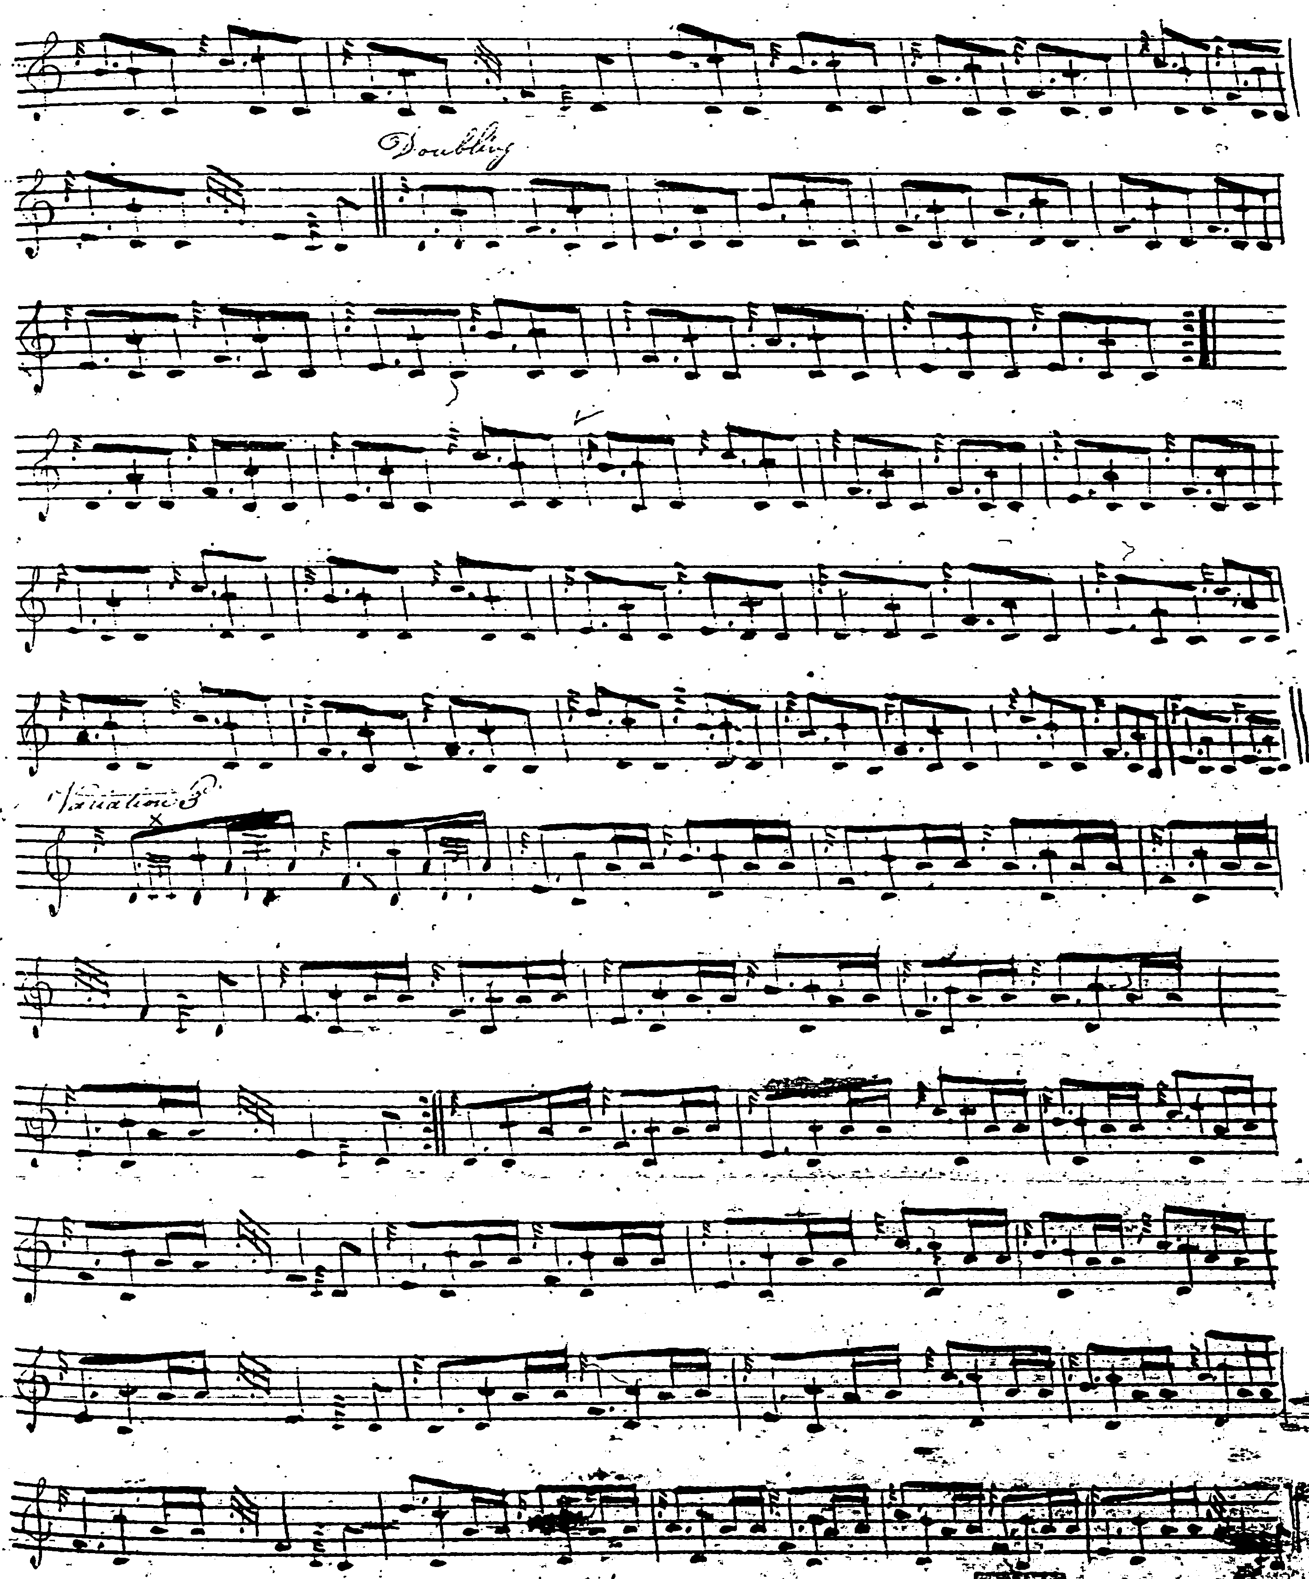
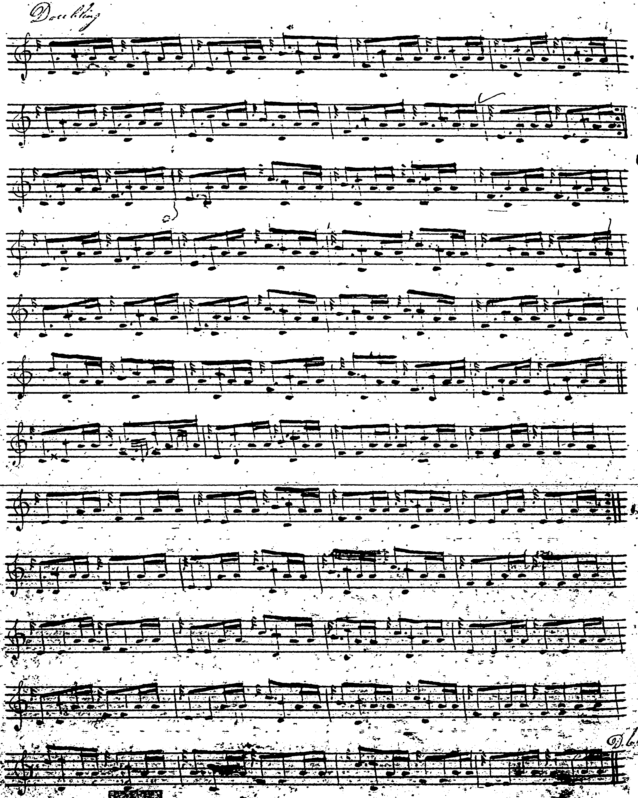

This tune is nameless in the original score, the title “Dungallon’s Salute” being added later in Dr. Charles Bannatyne’s hand. One notes the interesting endings of the A phrase in the first variation, which comes to a point of intermediate rest on B rather than C which is preferred in most of the other scores. The preference for 2/4 rather than MacKay’s compound duple time seems sensibly to reflect the melodic pattern of the tune. The first variation is played “down” here and would require to be played pretty “round” to get it to flow, given the considerable leaps between the intervals. The score plays straight into the crunluath singling from the end of the taorluath doubling no indication of repeating the ground here. This is a perfectly well constructed and mannerly tune; but perhaps one could not acquit it of being just a little dull; which is why it is interesting that MacArthur and MacGregor should have opted to include a crunluath a-mach. Some might think the tune was well and done with by the end of the crunluath doubling.

The score in David Glen’s manuscript is set in 4/4, and is beamed in a way that may perhaps give a better guide to expression in variation one:

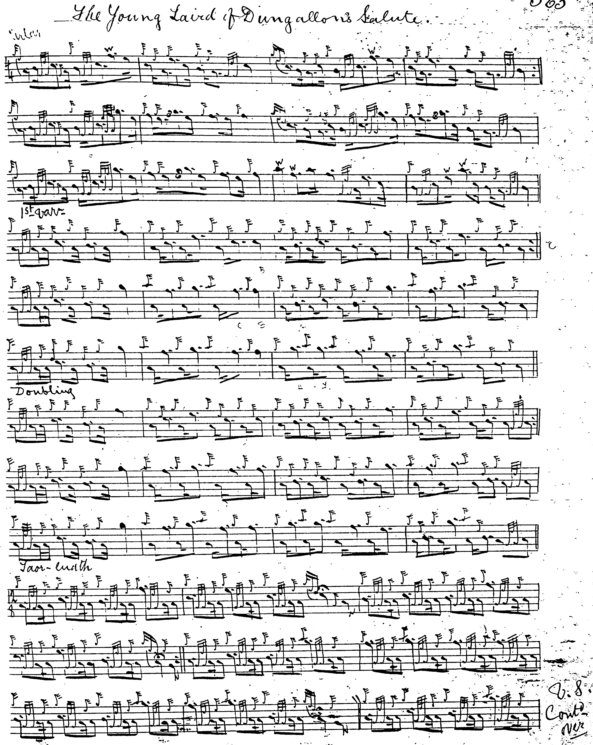

And so on.

Glen gives no direction that the ground be repeated at the end of the taorluath or crunluath doublings, and has no crunluath a-mach.

Published Scores:

Niel MacLeod of Gesto treats the tune as a family one, as the title suggests: “Mac, Vic Horomoid, alias M‘Leod Gesto’s Lamentation”. It is paired with “Mac, Vic Horomoid, alias M‘Leod Gesto’s Gathering”, and in a MS note (later published in The Celtic Magazine, vol.8, 1883, pp.434-5), Gesto says “Mac Vic Horomoid.—Gathering and battle-tune played when he gathered his people to attack invaders of that part of the Isle of Skye which then and still goes under the name of Sheil Toromade, alias the descendants of Toromade, being the western part of Skye, consisting of the parishes of Bracadale and Minginish, Duirinish and Waternish, and half of Snizort. Mac Vic Horomoid.—Lamentation played at the funerals of each of them; a very old tune, and an old practise.” The introduction of writing and print brought a degree of stability to tune titles (although not to the tunes themselves); earlier there had been a considerable degree of fluidity, as here. Gesto treats the tune as follows:

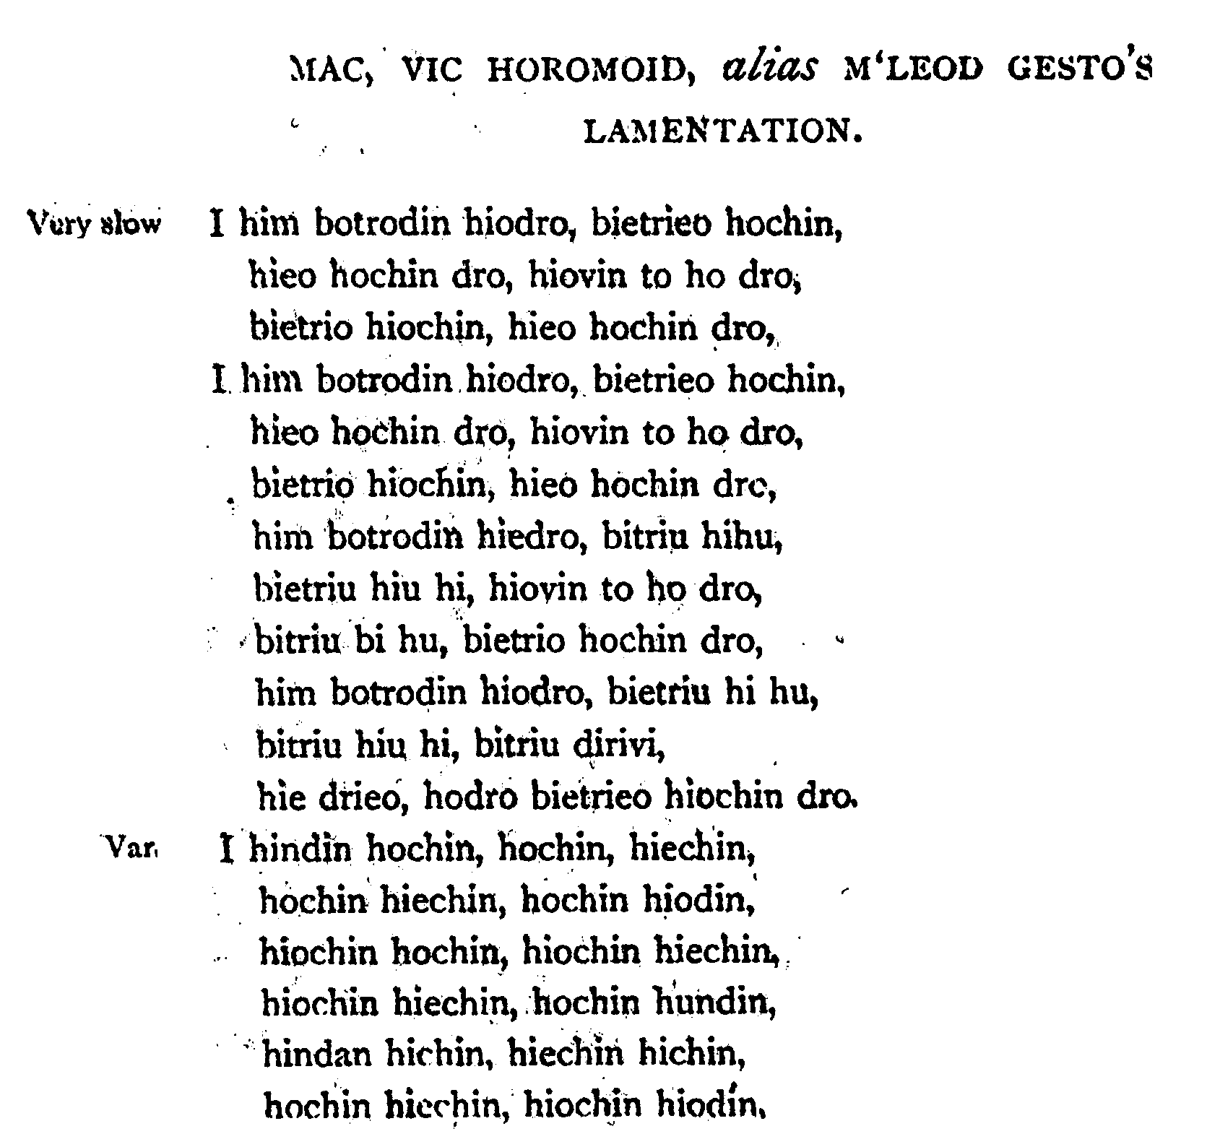

And so on.
Angus MacKay: treats the tune as follows, directing that the ground be repeated at the end of the taorluath and crunluath doublings. He has no crunluath a-mach.

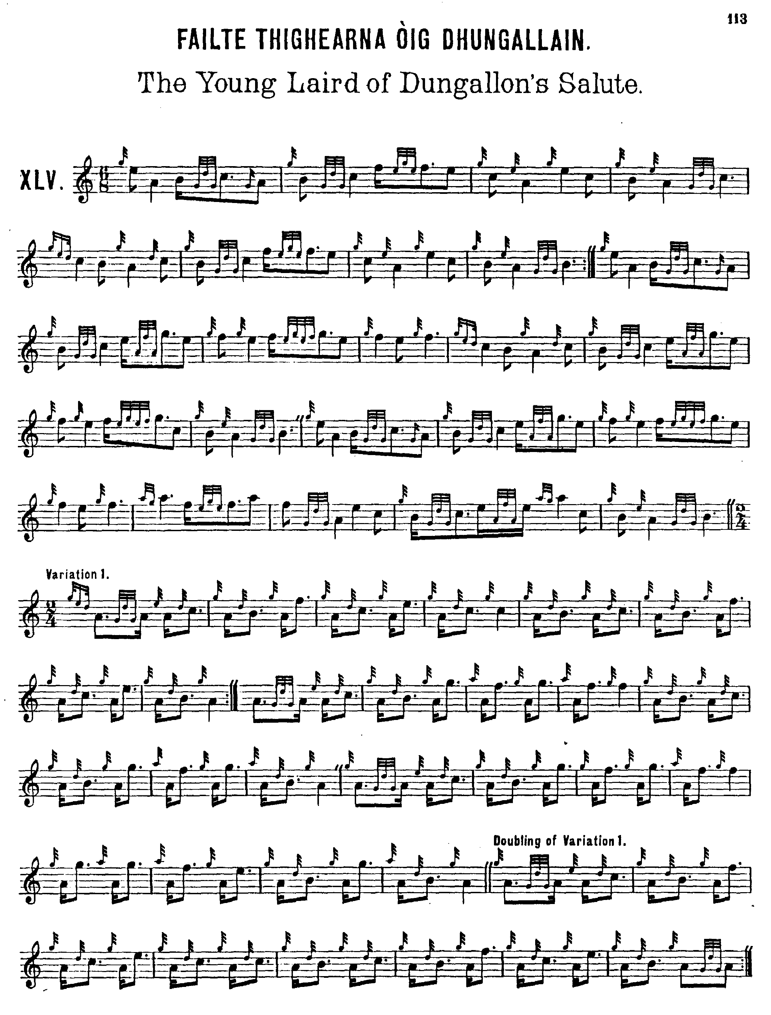

And so on.

Donald MacPhee: has a number of little touches that make him stylistically independent of MacKay, although his tendency to return phrase endings to the tonic may not please everybody. MacPhee directs that the ground be repeated after the taorluath and crunluath doublings. He has no crunluath a-mach.

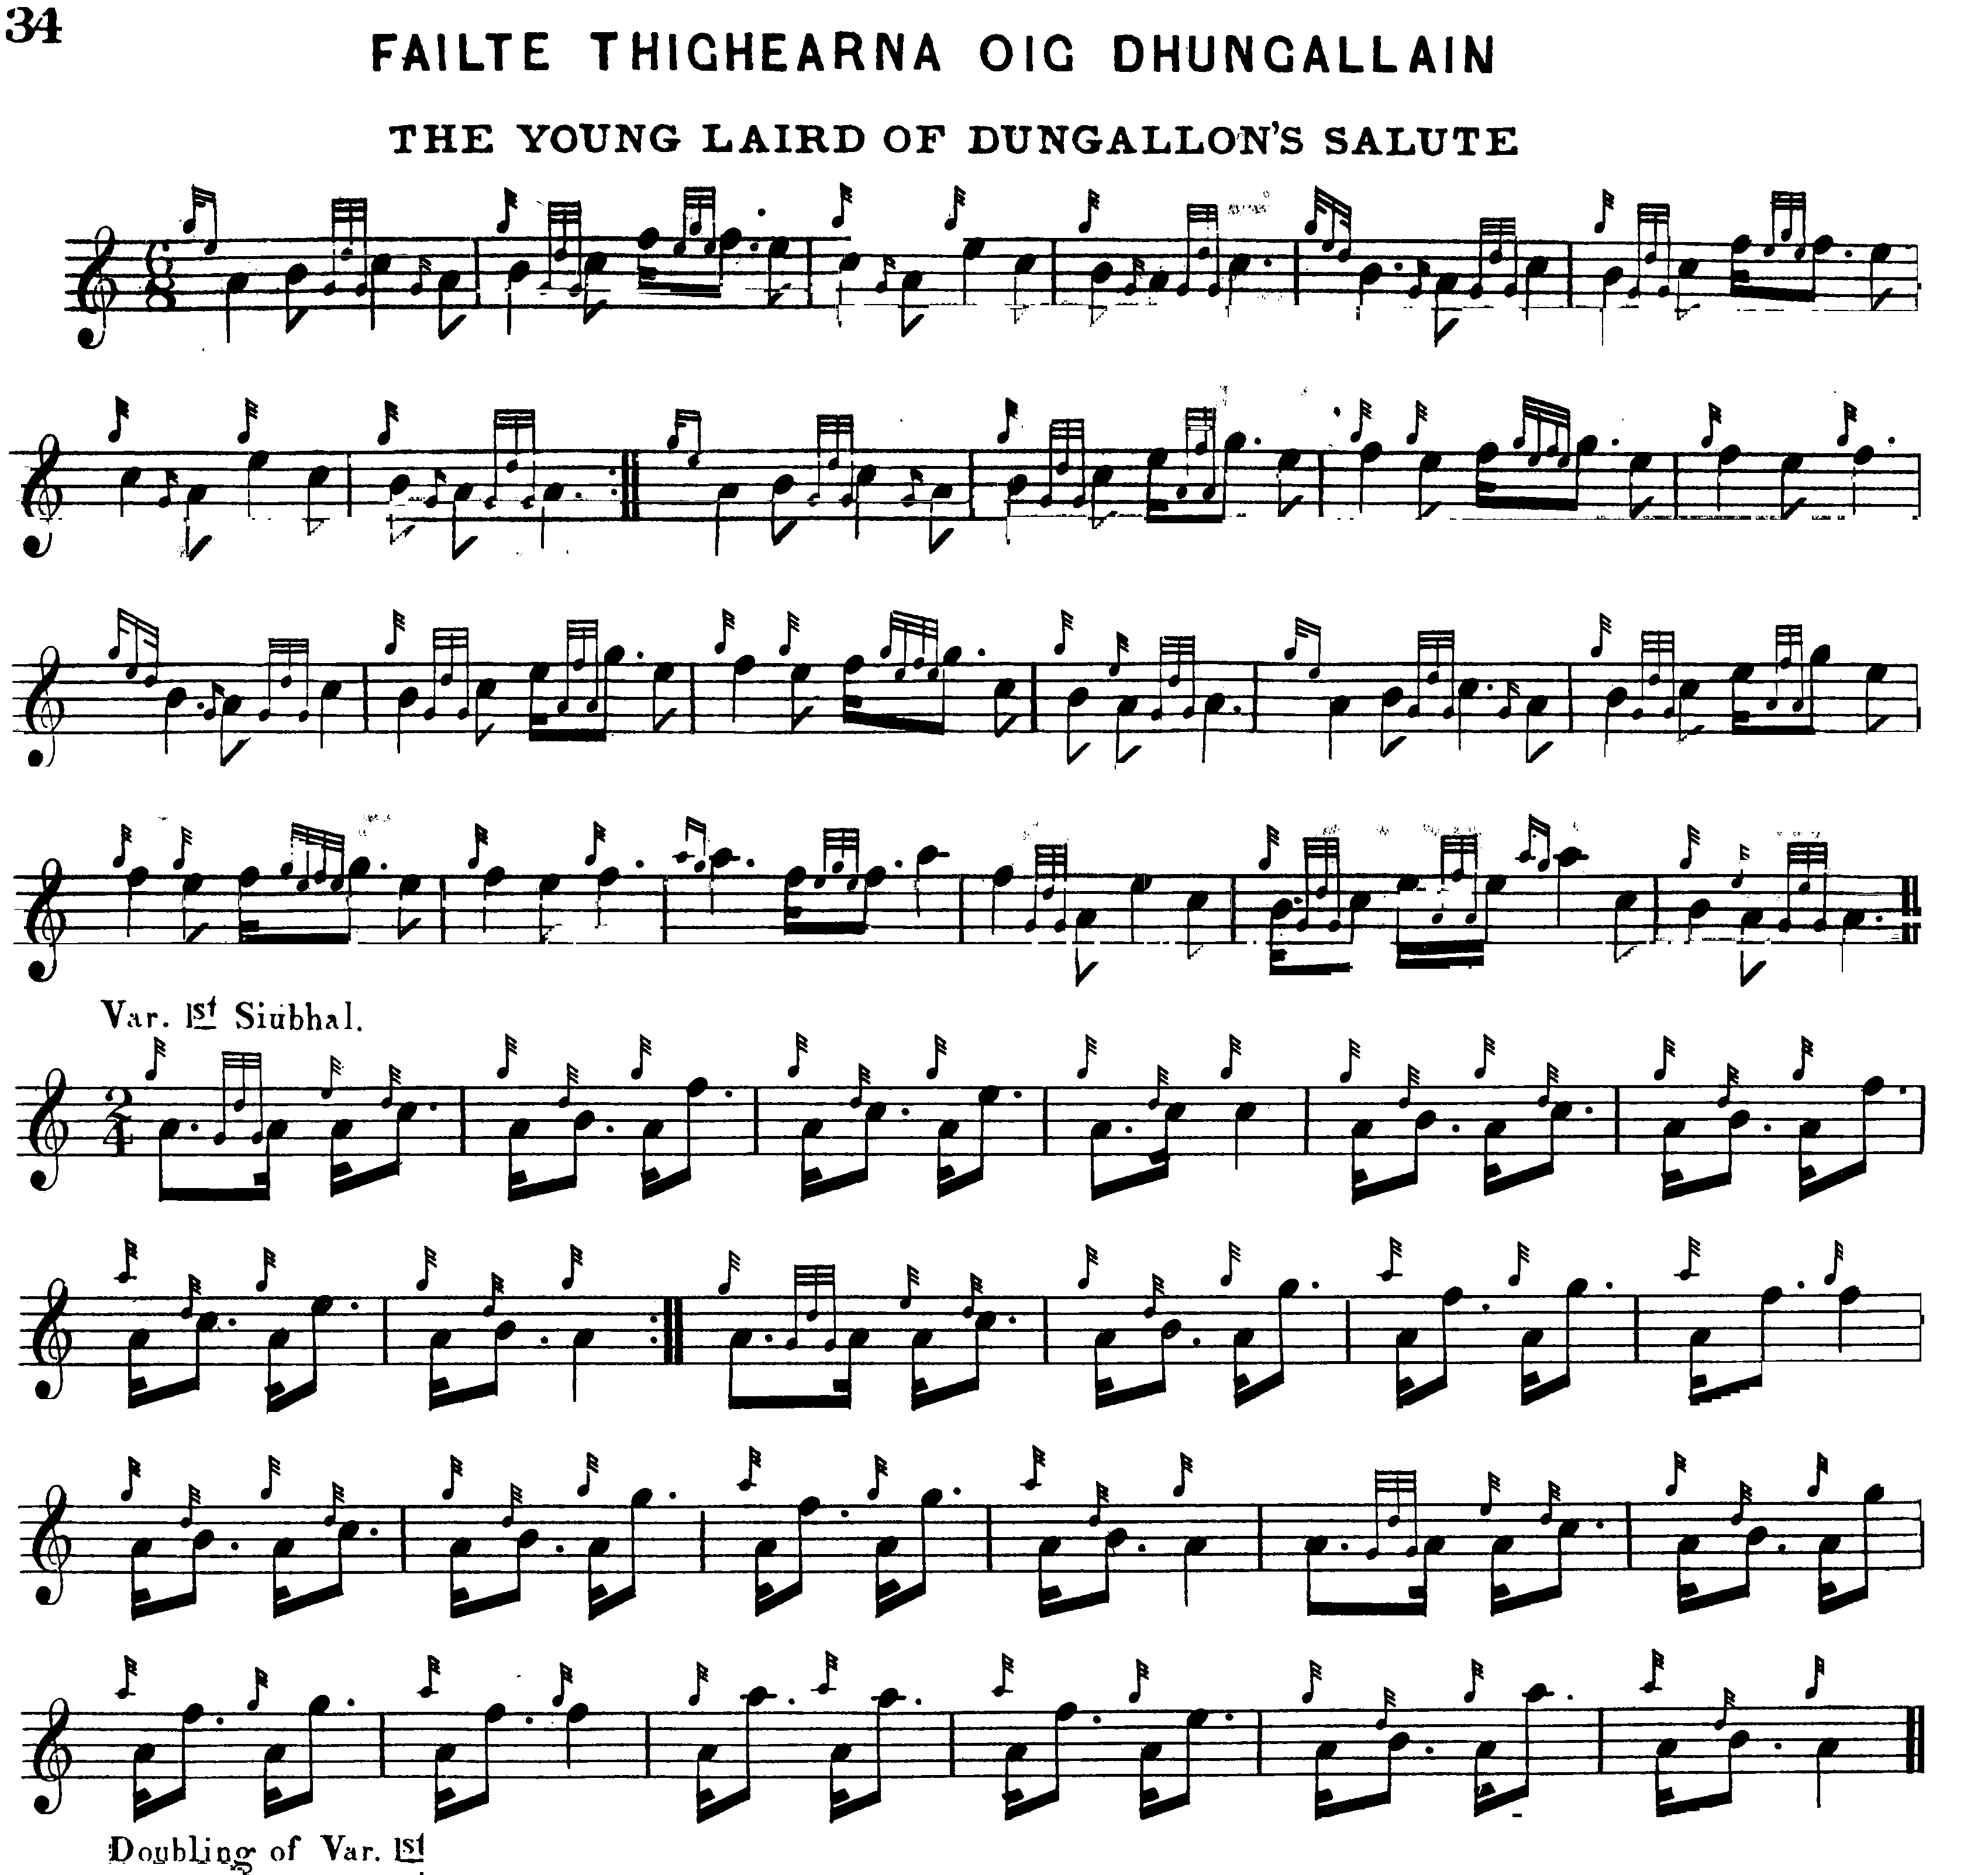
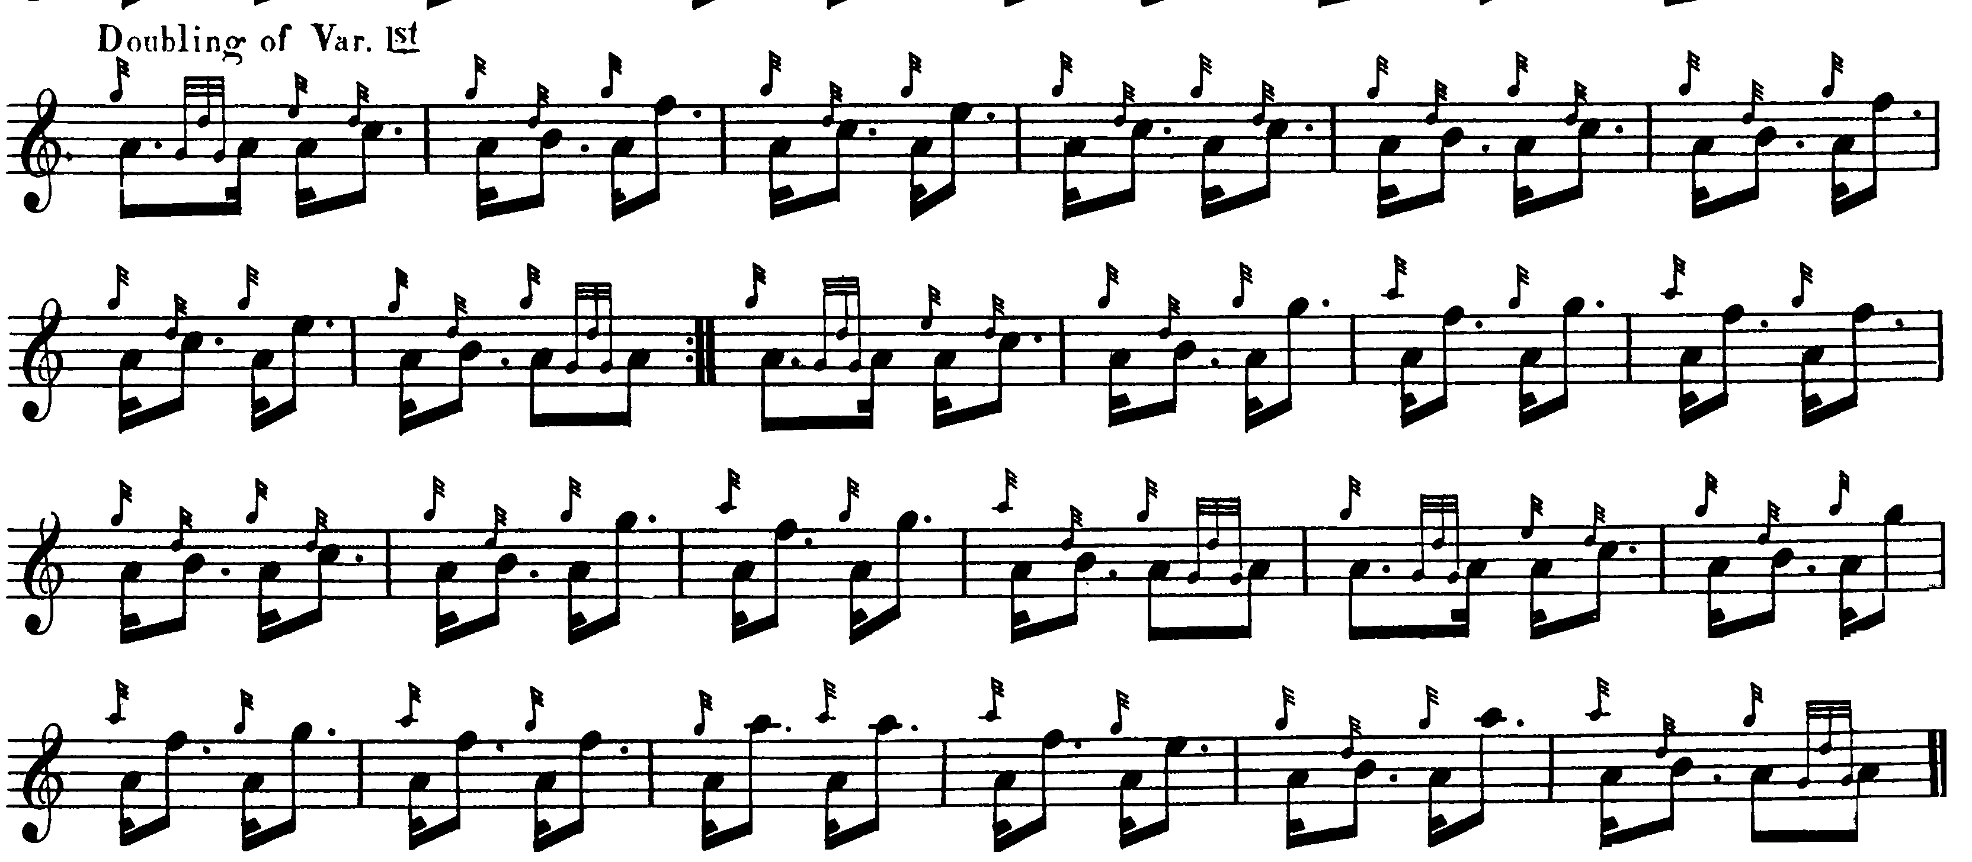

And so on.

C. S. Thomason: cites MacKay and MacPhee’s books and indicates that this was one of the tunes his chief assistant in Ceol Mor, Donald MacKay, was taught by Donald Cameron. Thomason’s score follows Angus MacKay, and like MacKay he directs that the ground be repeated after the taorluath and crunluath doublings. Thomason has no crunluath a-mach. This score is not reproduced here.

Commentary:

In his “Historical and Traditional Notes” in Angus MacKay’s Ancient Piobaireachd, James Logan states:

This tune is apparently very old, but the date of its composition has not transpired. The following are a few of the words adapted to the Urlar or ground work:--

Tha oighre òg air fear Dhungallain.
Is’ fhaicinn fallain togail màil
Tha oighre òg air fear Dhungallain
S’ fhaicinn fallain s’ fhaicinn slàn.

Translation

There’s a young heir to the Laird of Dungallan
May we see him sound collecting rent.
There’s a young heir to the Laird of Dungallan,
May we see him sound, may we see him hale.
(p.11)

This is typical of the fake-antique gloss that colours so much of Logan’s work. If the title is correct, than the tune cannot have been much more than a century old when he wrote. More recent, and reliable, sources--including Alexander MacKenzie, History of the Camerons; with Genealogies of the Principle Families of the Name (1884); John Stewart of Ardvorlich, The Camerons: a History of Clan Cameron (1974); and Alastair Livingstone, et al, Muster Rolls of Prince Charles Edward Stuart’s Army (1984)--make it clear that the Camerons of Dungallan were a short-lived 18th century house, an offshoot of the Camerons of Glendessary, founded by Archibald Cameron, (eldest son of John Cameron of Glendessary by his second wife) who married Isobel, daughter of the famous Sir Ewen Cameron of Lochiel. Archibald Cameron had jurisdiction over the Cameron portions of Sunart and Morven, and lived at Glenahurich in Sunart where the river Hurich meets Loch Shiel. He had three sons, of whom John, the eldest, succeeded his father as laird of Dungallan and died in 1739, and Archibald (the younger) who succeeded to the estate in turn and was a prominent Jacobite, being a Major in Lochiel’s regiment commanding the Morven and Sunart Camerons, and standard-bearer to Prince Charles Edward Stuart. He surrendered to government forces on 6th March 1746, and was imprisoned and his lands forfeited. Later he came to terms with the government and became a captain in the Fraser Highlanders; he died in 1759.

In his notes to this tune in the recent MacArthur/MacGregor collection, published by the Piobaireachd Society and others as The Music of Scotland Ceòl na h-Albainn [sic] (p.114), Frans Buisman stated that the setting was “corrupt”. While the dense obscurity of Buisman’s style is likely to have been a barrier to many readers, the point is of sufficient interest, perhaps, to be dealt with here. This kind of approach has been frequently reflected by commentators who liked to believe: that piobaireachd was (1) ancient--the assumption being that anything which had tottered down to the present from the 15th century (or earlier) was bound to be in a terminal condition; (2) that piping had in any case been banned after the Rising of 1745, and had experienced a period of rapid decline; as a result of which (3) none of the early editors of written or printed collections had been properly trained, and were frequently “confused”, therefore, about idiom and structure; and (4) that there had once existed a single, unitary, authoritative, original version of every tune, and that anything subsequently departing from this imaginary entity was, therefore, “corrupt” and “wrong”. The latter reminds us how sadly isolated many of those who have written about piping during the past few generations have been from the mainstream of studies in traditional cultures, where the creative fluidity of texts has long been a commonplace.

* * *

Electronic text © Dr. William Donaldson, Aberdeen, Scotland, October 2004

