Lament for Viscount Dundee

There are settings of this tune in the following manuscript sources:
--Colin Mór Campbell’s “Nether Lorn Canntaireachd”, ii, 74-6 (with the title “Thanig Gorrie”);
--David Glen’s MS, ff.351-2 and again at 435 (Glen notes that it is “In Jos. McDonald's page 251.” And points out that he gives the final note of line one of the ground as A);
--Robert Meldrum, ff.70-72;

and in the following published sources:
--Angus MacKay, Ancient Piobaireachd, pp.74-5;
--C. S. Thomason, Ceol Mor, pp.195-6 (with the title “Lament for Claverhouse”).

Colin Mór Campbell treats the tune as follows:

1st Himotra hahohioem hodin hiotra chelalhodin hiharara chehodroe hiharara hahohioen [sic: m?]
2^{d} Himotra hahohioem hodin hiotra chelalhodin hiharara chehodroe hiharara haho hioem
3^{d} Cheenotra chelalhodin himotra haho hioem barihe chedarihia chedaria chelalhodin
4 Hiharara heIeho traodre hotra hohioem chelalhodin traho hioem hodin hiotra chelalhodin

S ffirst motion
1st Hinde hae hoohoe have cheve hao hae Two times
2^{d} Hoohoe hao have cheve hae hoohoe
3^{d} Hindhe cheve hae have cheve hae hoehoe

D Hinde hae hoe hoe have cheve hae hae Two times
2^{d} Hoe hoe have have cheve hae hoe hoe
3^{d} Hindhe cheve hae have cheve hae hoe hoe

S Taolive Gear
1st Himbabemba himbabemba hindaendo hodin himbabemba hindaendo himbabemba haem Two times
2^{d} Hindaendo hodin himbabemba haen hindaendo himbabemba hindaendo hodin
3^{d} Himbabemba hindaendo himbabemba haem hindaendo himbabemba hindaendo hodin

D Himbabemba himbabemba hindaendo hindaendo himbabemba hindaendo himbaemba himbaemba Two times
2^{d} Hindaendo hindaendo himbabemba himbabemba hindaendo himbabemba hindaendo hindaendo
3^{d} Himbabemba hindaendo himbabemba himbabemba hindaendo himbabemba hindaendo hindaendo

S Crulive Fosgail
1st Himbadre himbadre hindodre hodin himbadre hindodre himbadre haem Two times
2^{d} Hindodre hodin himbadre haem hindodre himbadre hindodre hodin
3^{d} Himbadre hindodre himbadre haem hindodre himbadre hindodre hodin

D Himbadre himbadre hindodre hindodre himbadre hindodre himbadre himbadre two times
2^{d} Hindodre hindodre himbadre himbadre hindodre himbadre hindodre hindodre
3^{d} Himbadre hindodre himbadre himbadre hindodre himbadre hindodre hindodre

Colin Campbell gives a brisk no-nonsense account of the tune. He omits the “second variation” played today, proceeding from the ground to a siubhal singling/doubling, from thence to a taorluath fosgailte singling/doubling/ and finally to a crunluath singling/doubling. The overall effect is neat, economical and stylish. The original score is as follows:

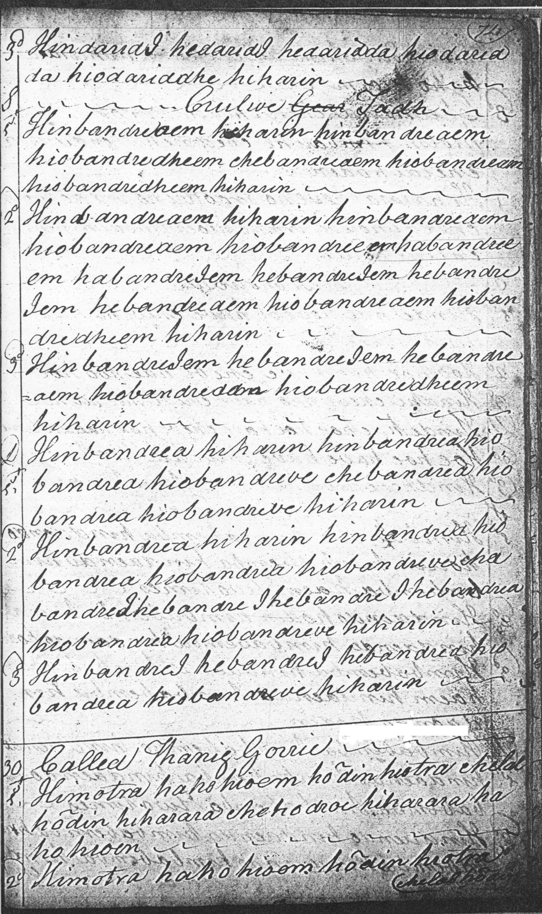
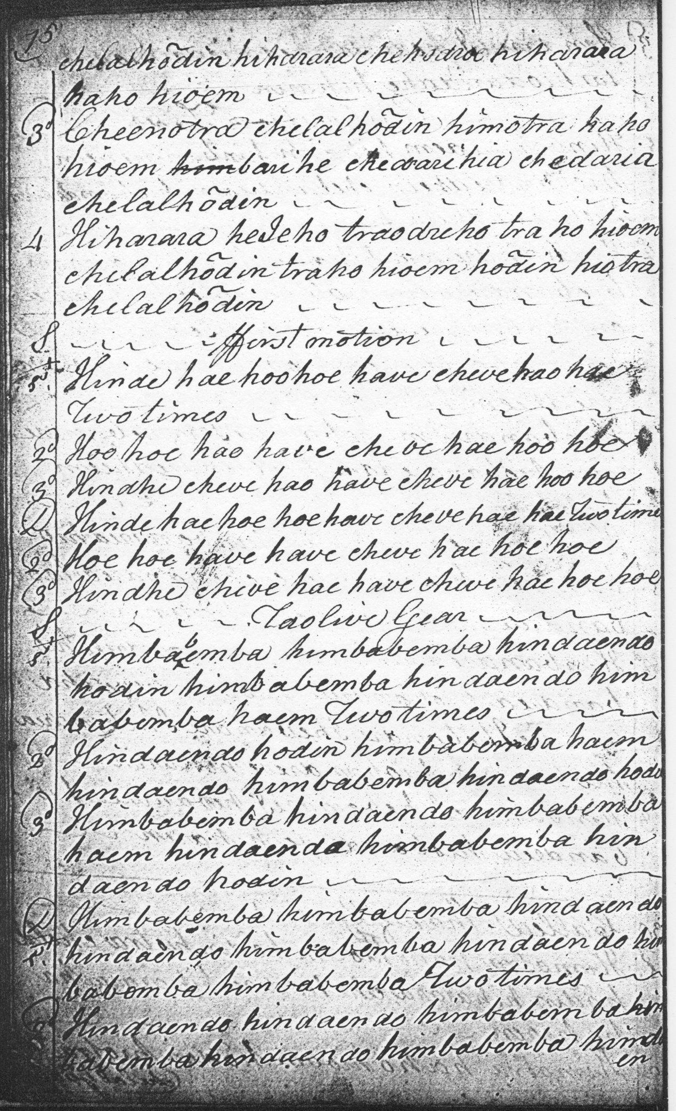

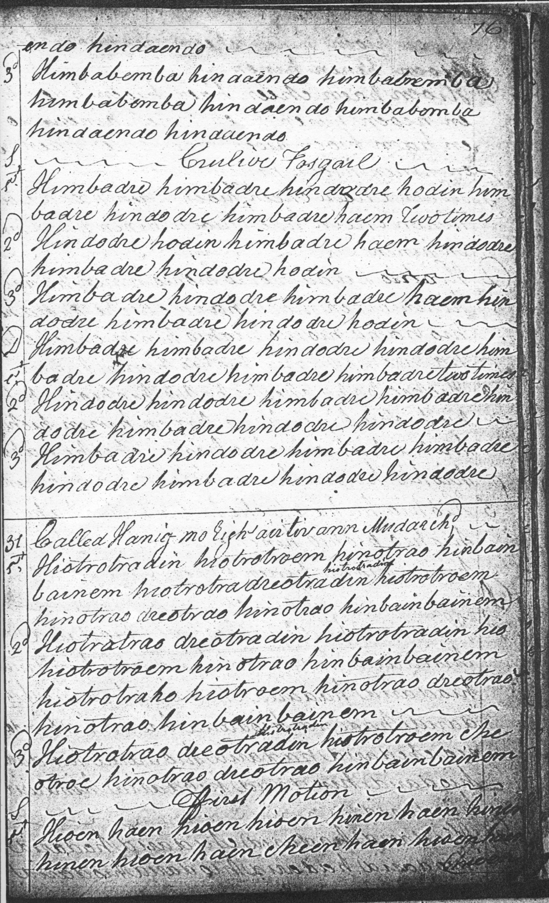

Angus MacKay treats the tune like this:

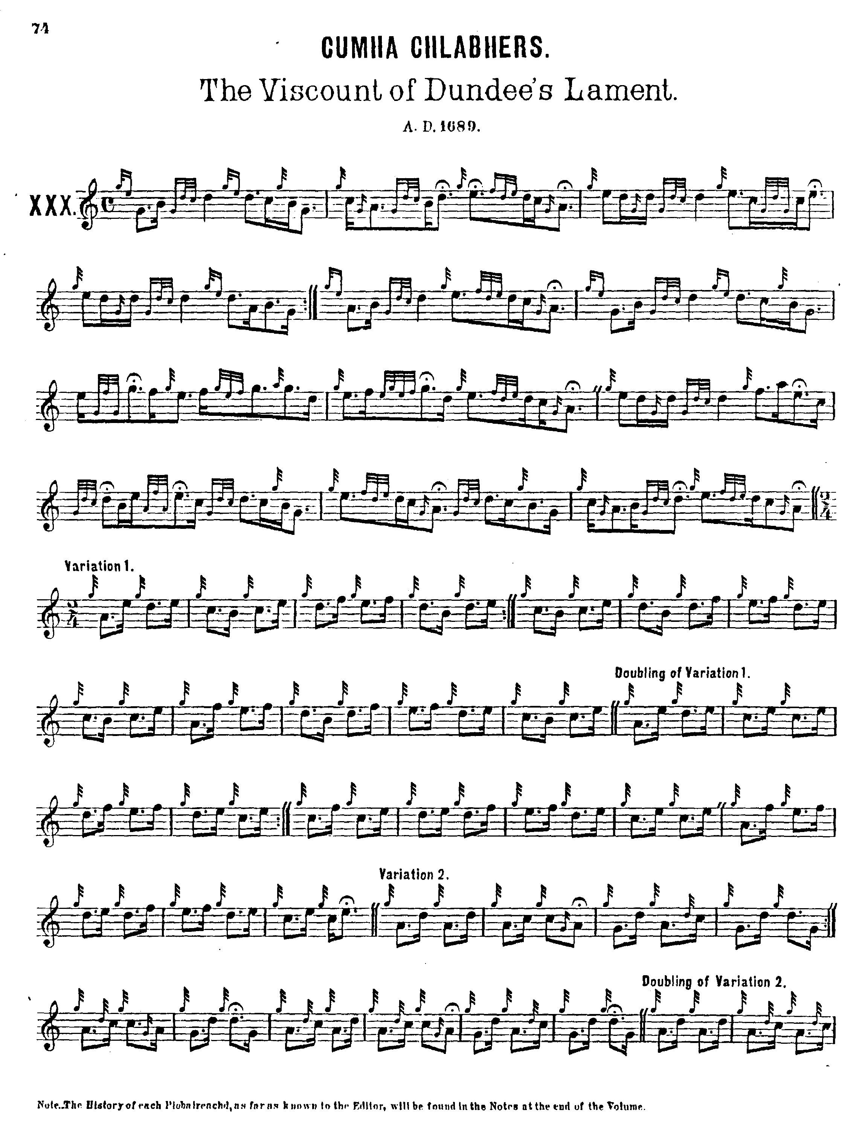

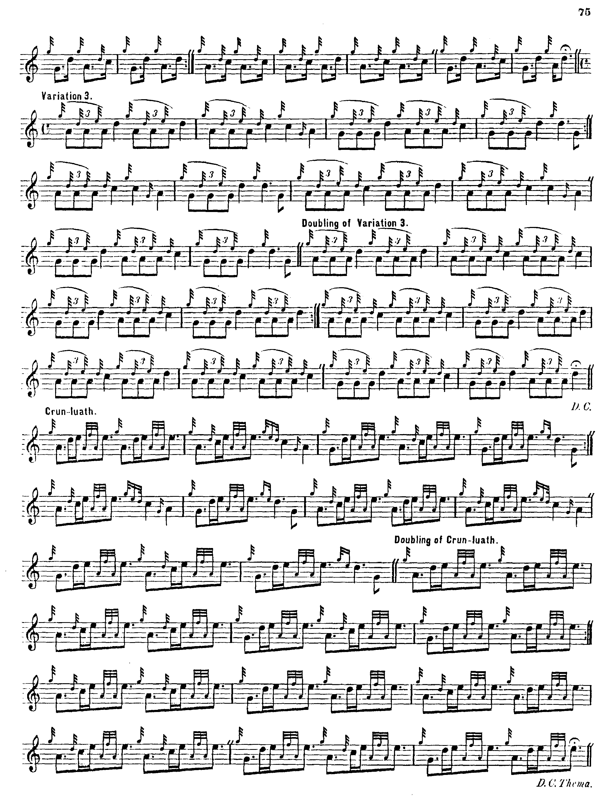

Angus MacKay’s is the earliest score to include the second variation which is normally played nowadays. At the same time, his text is seriously corrupt. The reader will note the misplaced throw on the D in line one of the Ground, and that the end of each part has the last two bars missing from variation two singling onwards.

C. S. Thomason produced an emended text in Ceol Mor citing Donald MacKay, who had learned this tune directly from Donald Cameron, but even this was not free from error as we see in the figure at the end of bar two in the ground which on analogy with the other scores and the treatment of the same movement towards the end of line three of Thomason’s score ought to be a B semi quaver followed by a quaver D with a throw on it. Thomason times the tune like this:

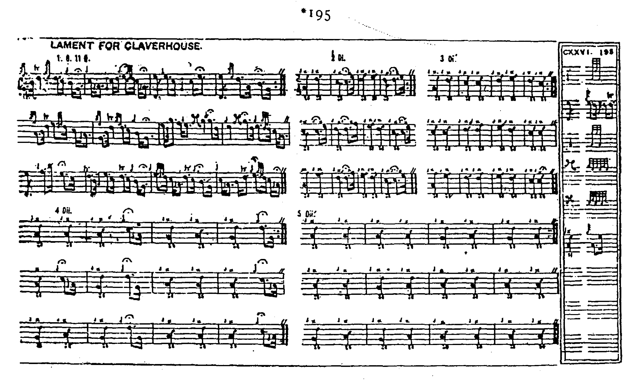

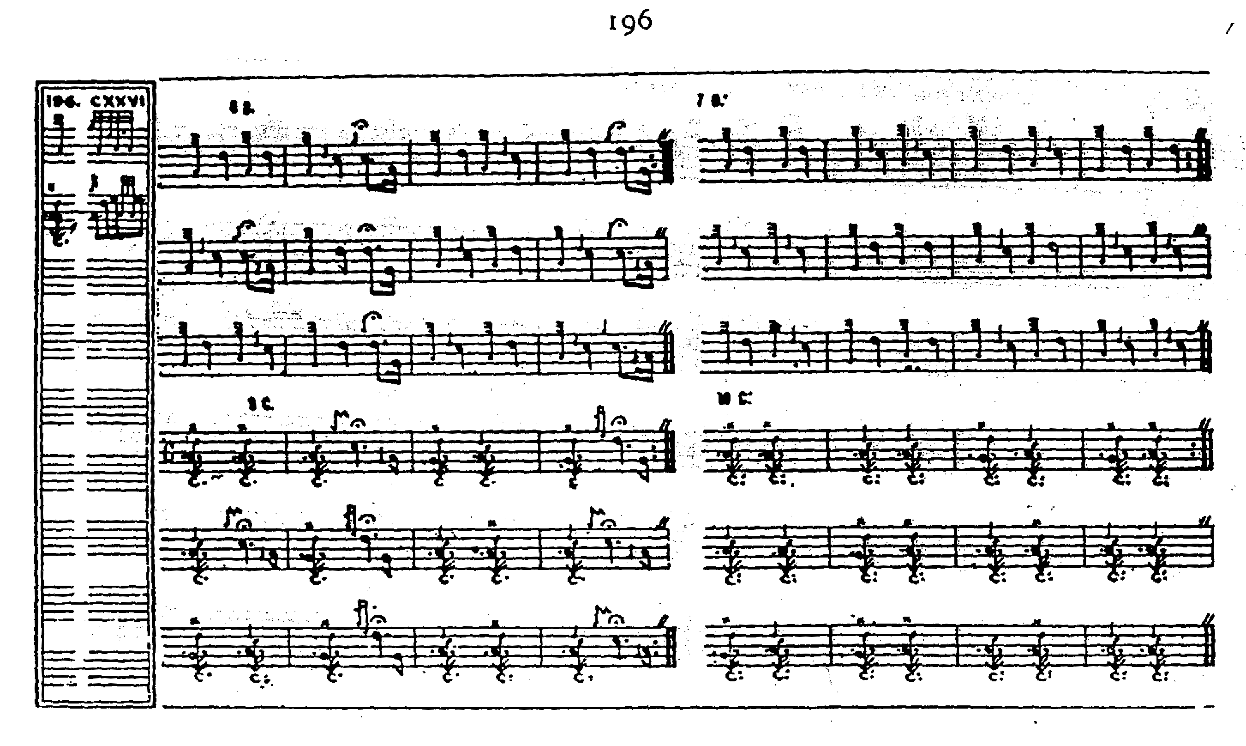

David Glen has two settings one full and closely resembling the one currently played, and another fragmentary one of the ground only in a variant form clearly supplied by Simon Fraser in Australia whose standing as an authority has been seriously questioned. Neither score is reproduced here.

Robert Meldrum’s setting adds nothing to the stylistic possibilities of the tune and is not reproduced here.

Commentary:
A partial setting of “The Lament for Viscount Dundee” appears in the earliest written record, namely Joseph MacDonald’s “Compleat Theory of the Scots Highland Bagpipe” (c. 1760) showing an ornately decorated style with strong MacArthur affinities. This is reproduced with a commentary in my book The Highland Pipe and Scottish Society 1750-1950 (pp.39-40).

There is a note on the dedicatee of this tune, John Graham of Claverhouse, the victor of the Battle of Killiecrankie attached to “The Daughter’s Lament” in the present series. He was long a touchstone of political affiliation in Scottish politics, regarded by the right as the very apogee of the beau chevalier, dashing, charismatic and hugely competent--as one contemporary source put it “fit for any employment civil or military”; and by the religious left on the other hand as “Bloody Clavers”, the demonically-inspired persecutor who peremptorily shot the Covenanting martyr John Brown dead on his own doorstep with the grim aside “You have been given leave to pray; but now you have begun to preach.”

* * *

Electronic text © Dr. William Donaldson, Aberdeen, Scotland, September 2006; revised Cambridge, Massachusetts, March 2025.

