The Vaunting

There are settings of this tune in the following manuscript sources:
--Donald MacDonald’s MS, ff.223-228 (with the title “An Intended Lament”);
--David Glen’s MS, ff.186-187;

and in the following published sources:
--Angus MacKay, Ancient Piobaireachd, pp. 66-7 (with the title “A Bhoilich. The Vaunting. Composed by R. MacDonald Esqr. of Morar.”);
--C. S. Thomason, Ceol Mor, p.125;
--William Stewart, et.al., eds., Piobaireachd Society Collection (first series) iv, 6-7.

The tune is developed as follows:

MacDonald | MacKay | Thomason | Glen | PS 1st Series
Ground  singling  doubling  trebling | Ground  singling  doubling  trebling  quadrupling | Ground  singling  doubling  trebling  quadrupling | Ground  singling  doubling  trebling  quadrupling | Ground  singling  doubling  trebling  quadrupling
Siubhal  singling  doubling  trebling |  |  | Siubhal  singling  doubling  trebling
Taorluath  singling  doubling  a-mach | Taorluath  singling  doubling  a-mach | Taorluath  singling  doubling  a-mach | Taorluath  singling  doubling  a-mach | Taorluath  singling  doubling  a-mach
 |  | Ground
Crunluath  singling  doubling  a-mach | Crunluath  singling  doubling  a-mach | Crunluath  singling  doubling  a-mach | Crunluath  singling  doubling  a-mach | Crunluath  singling  doubling  a-mach
 | Ground | Ground

It will be noted in addition to MacDonald’s neatly symmetrical arrangement (three grounds, three siubhals, three taorluaths, three crunluaths) that there is no indication that the ground be restated within the tune. Although such instructions are frequently given in MacDonald’s published book, they are omitted in the MS throughout, and it is probably in view of this that Thomason elected to include a repeat of the ground at the end of the taorluath variations above.

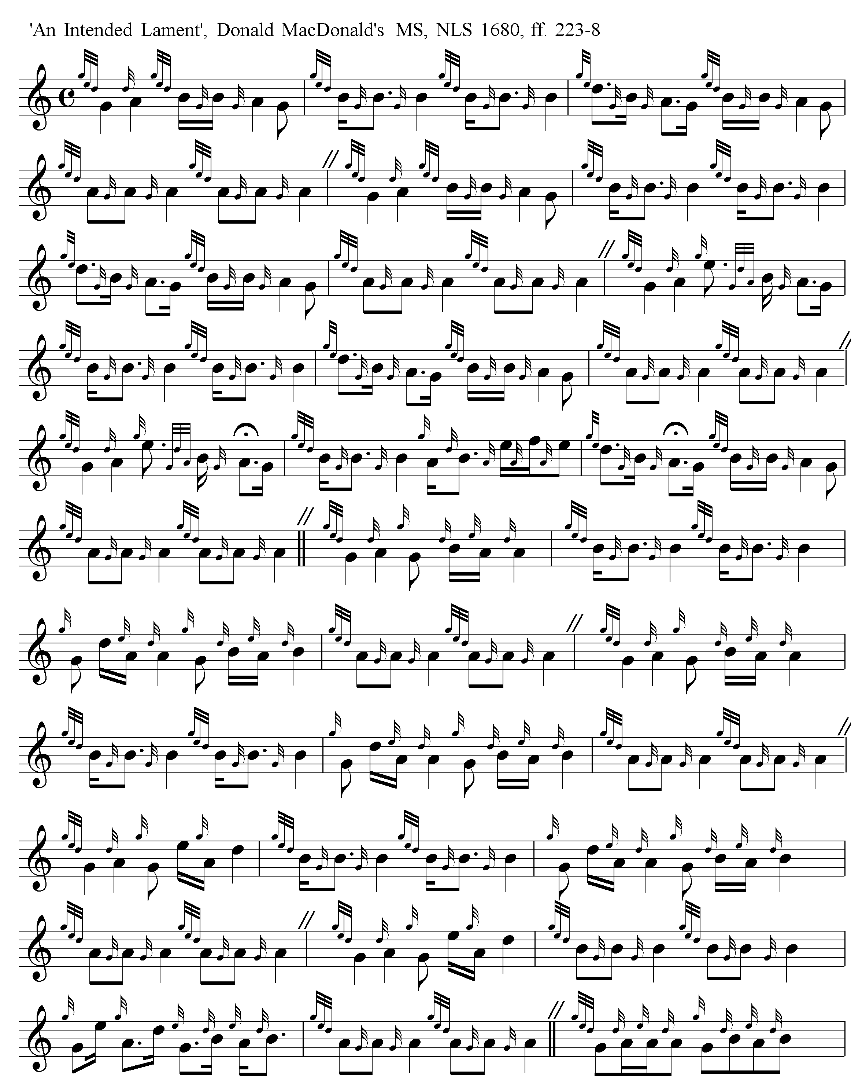
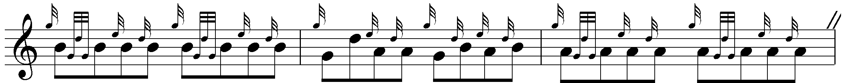

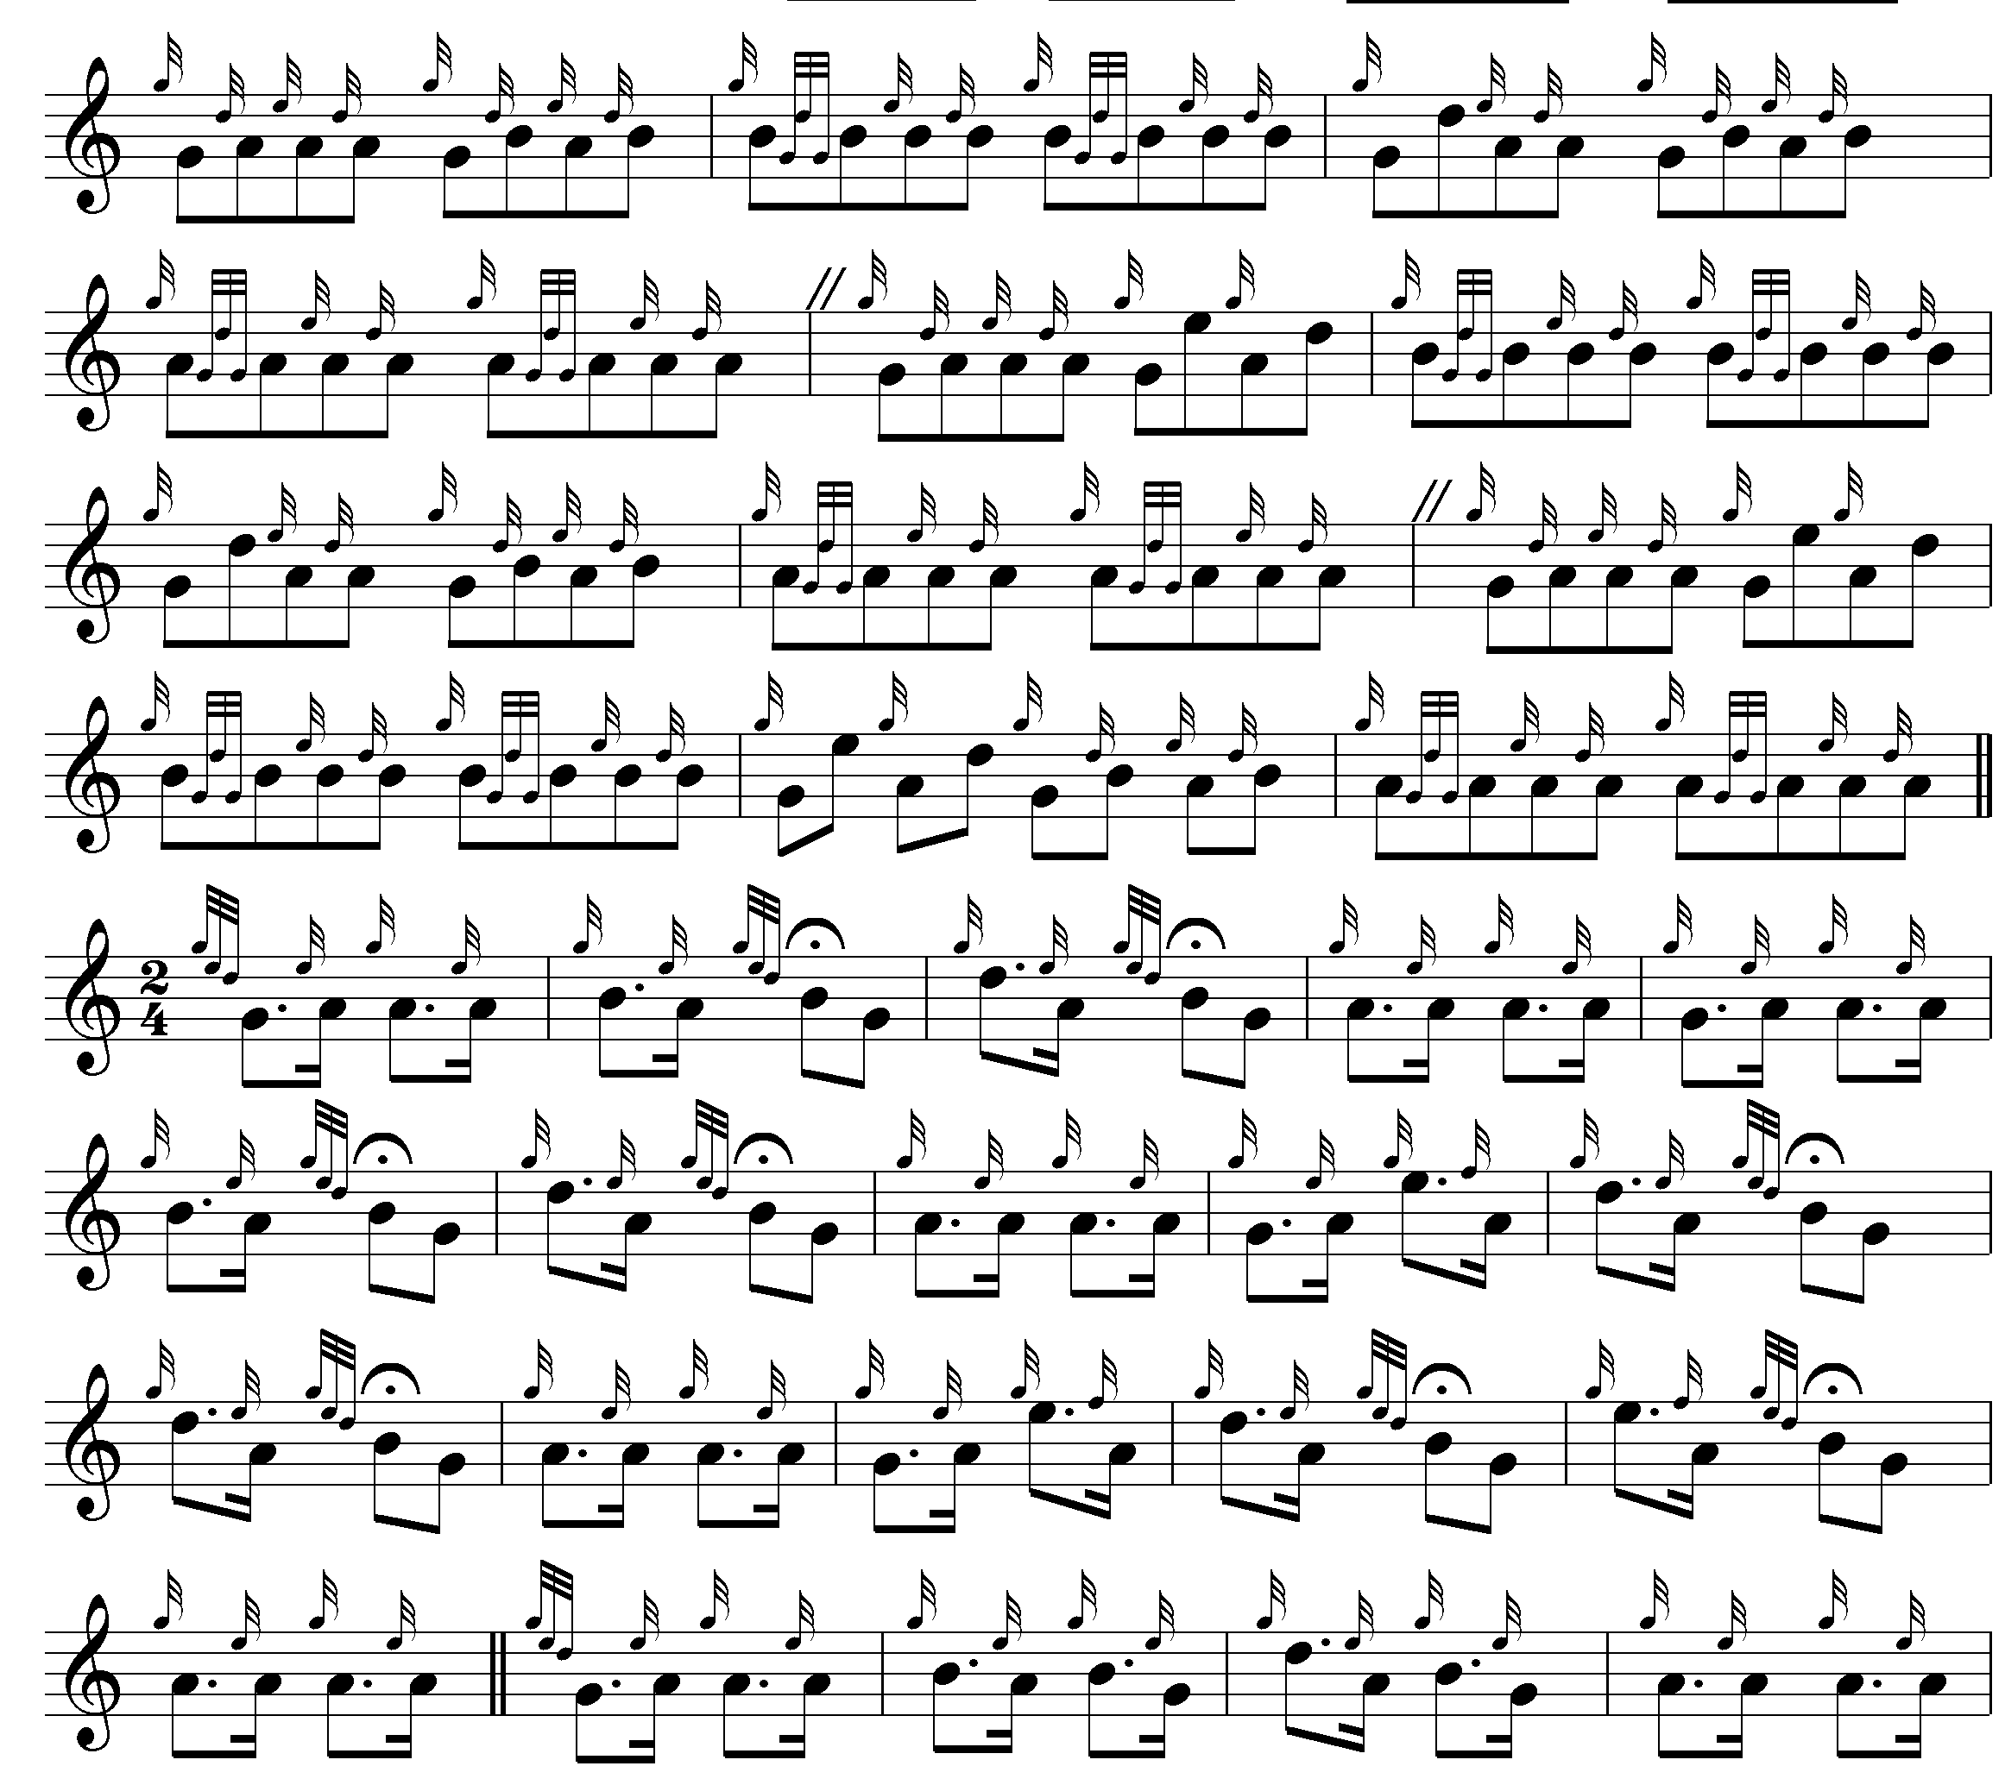
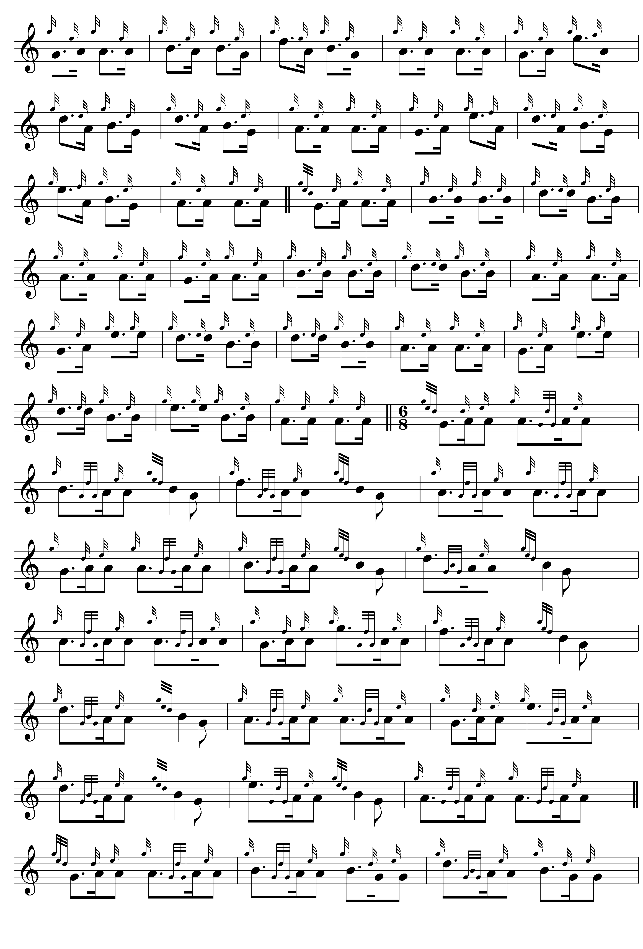

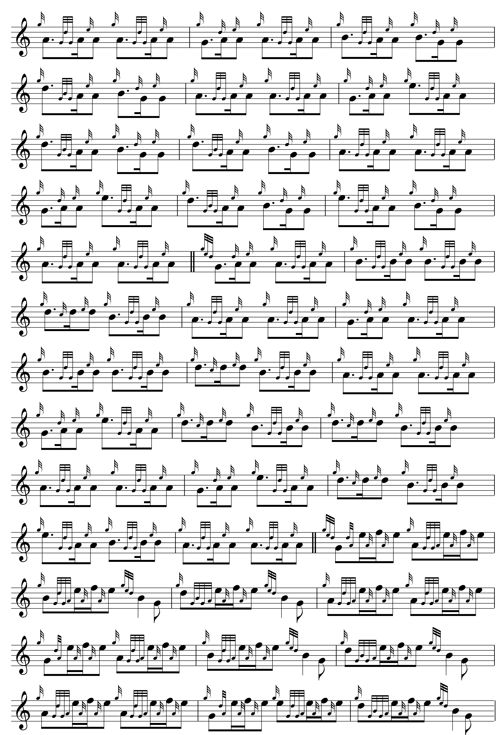

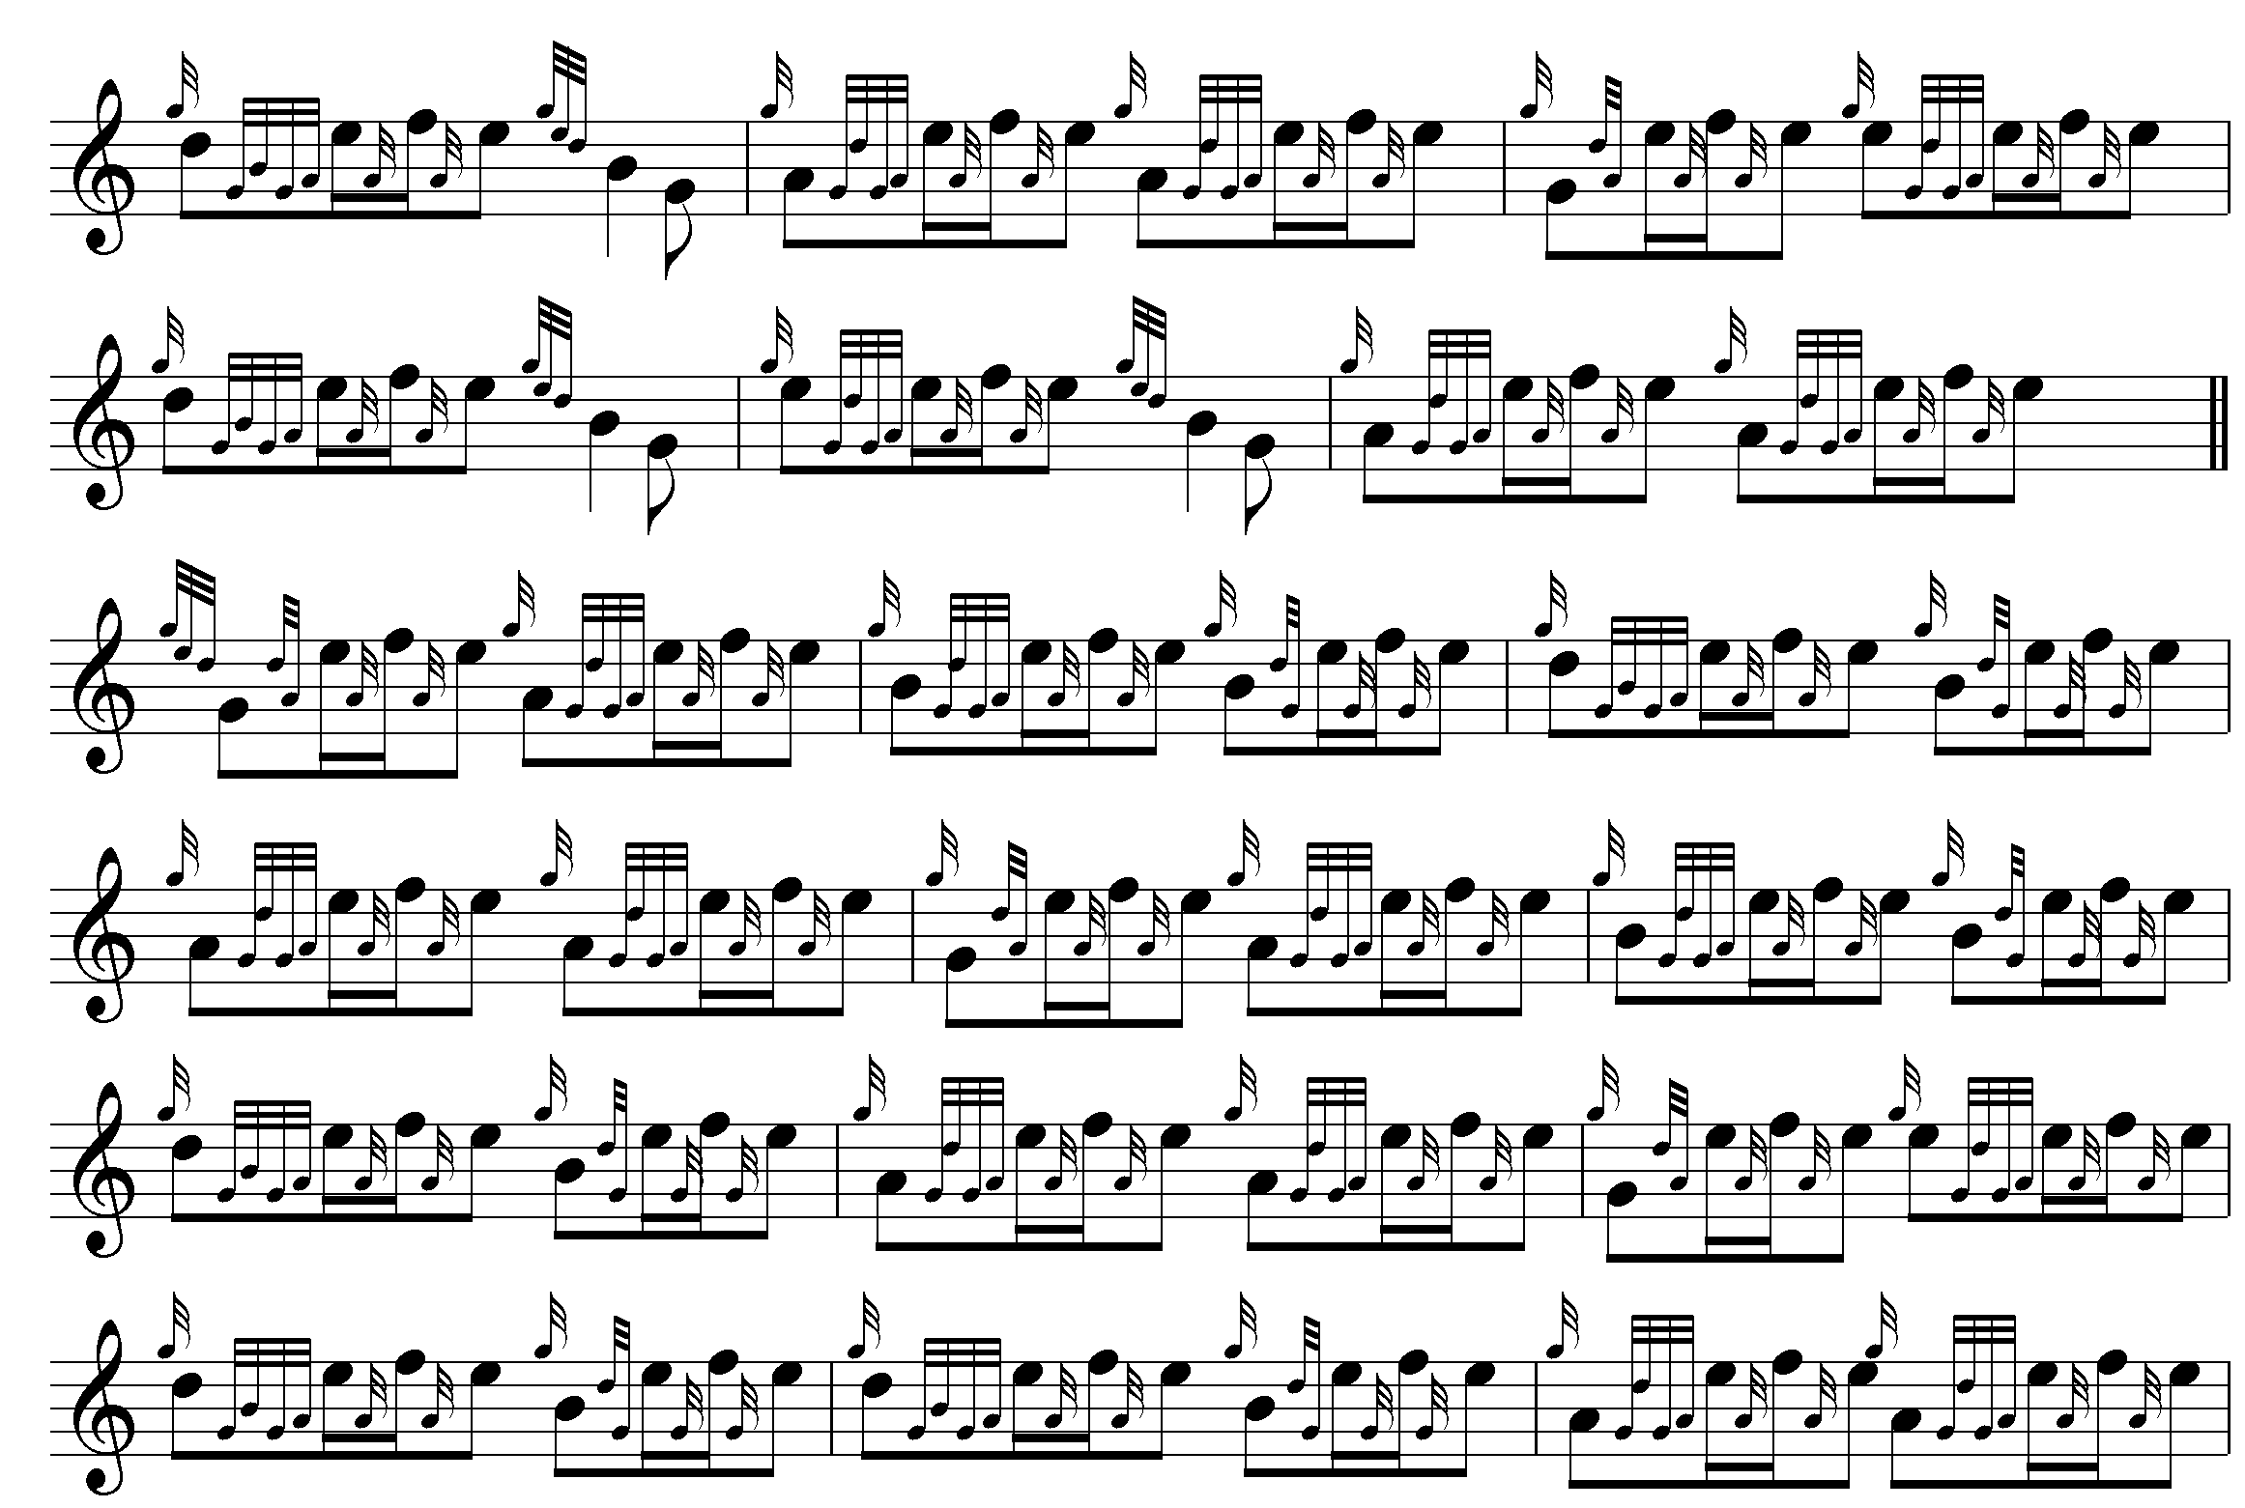
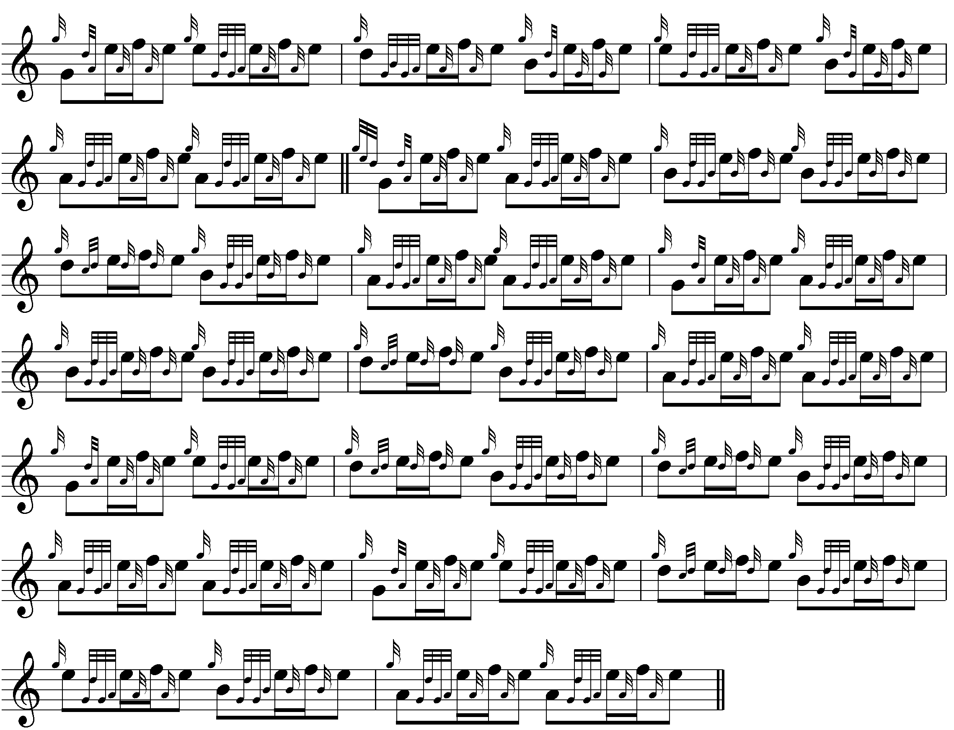

MacDonald interestingly varies the timing of the slurred Bs in the ground, and there is a striking contraction of metre when he reaches the siubhal, a device fairly frequently used by the older players to increase pace and heighten energy, and on this latter structure the remainder of the tune is built:

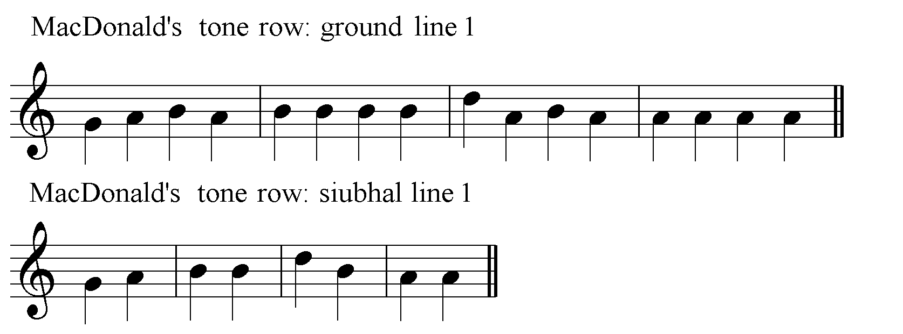

A similar foreshortening appears also in MacKay, although the latter prefers to develop the ground at greater length than MacDonald, and omits the siubhal movements. The following examples show MacKay’s characteristic timings:

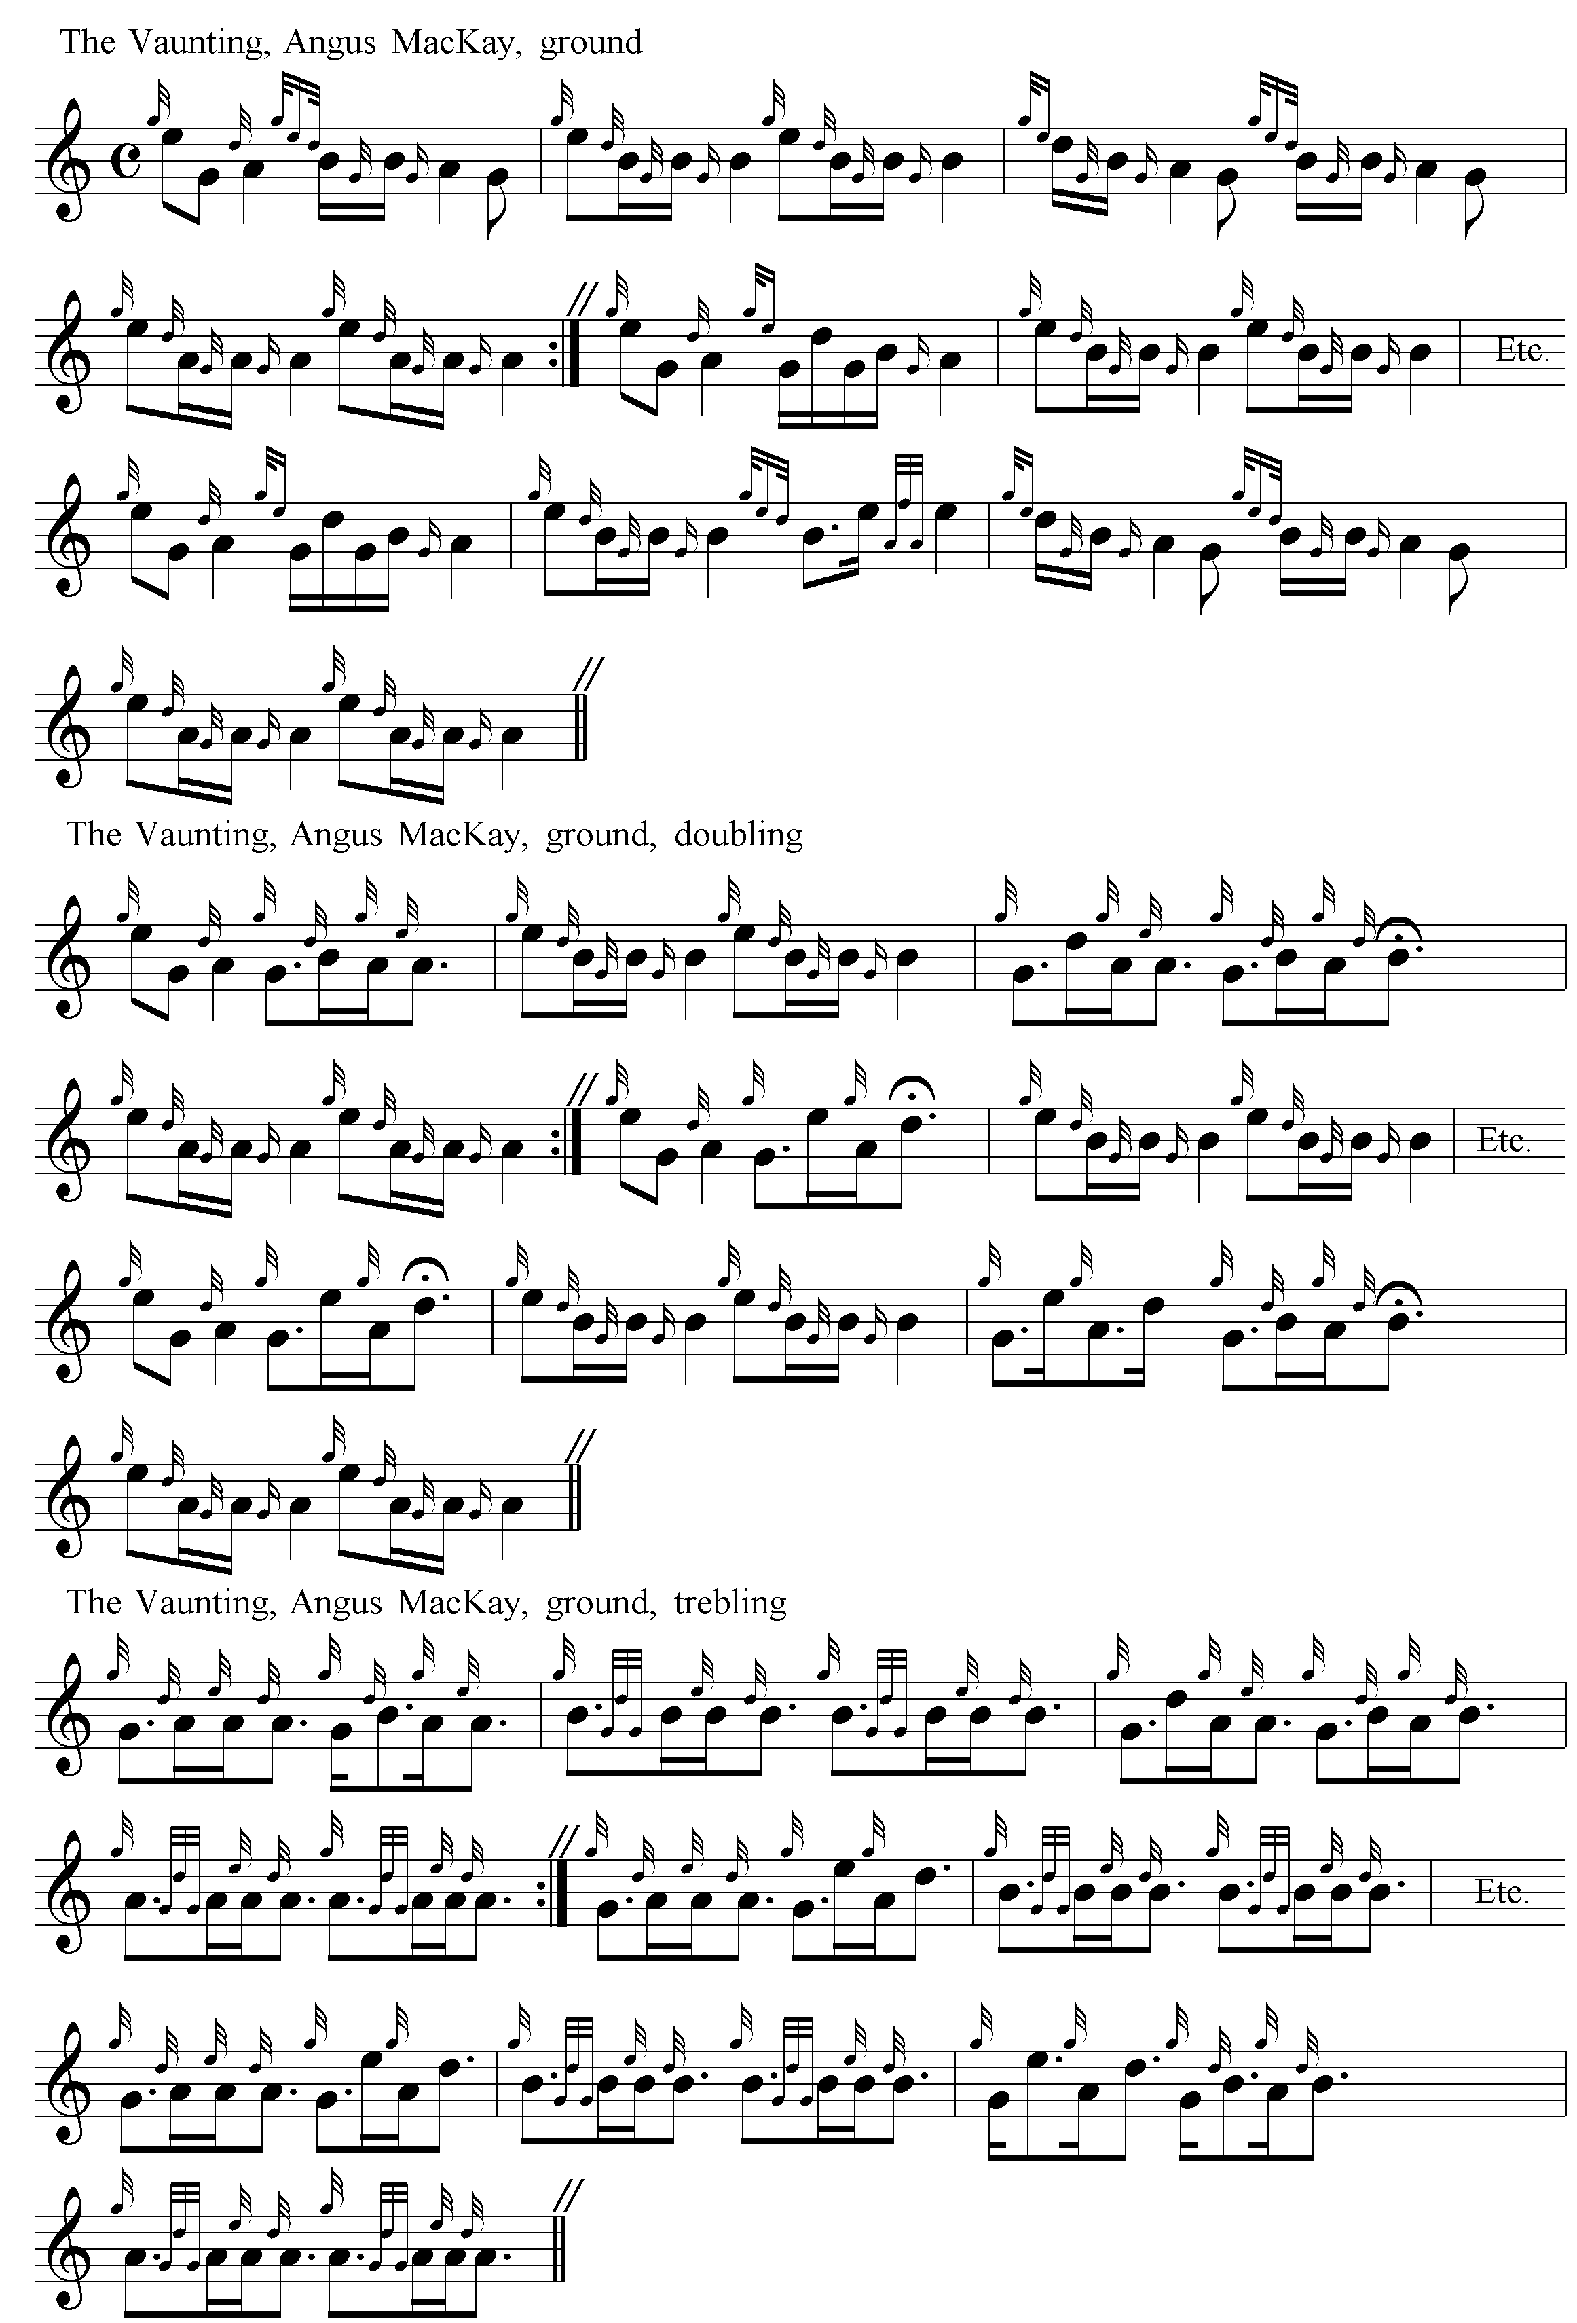

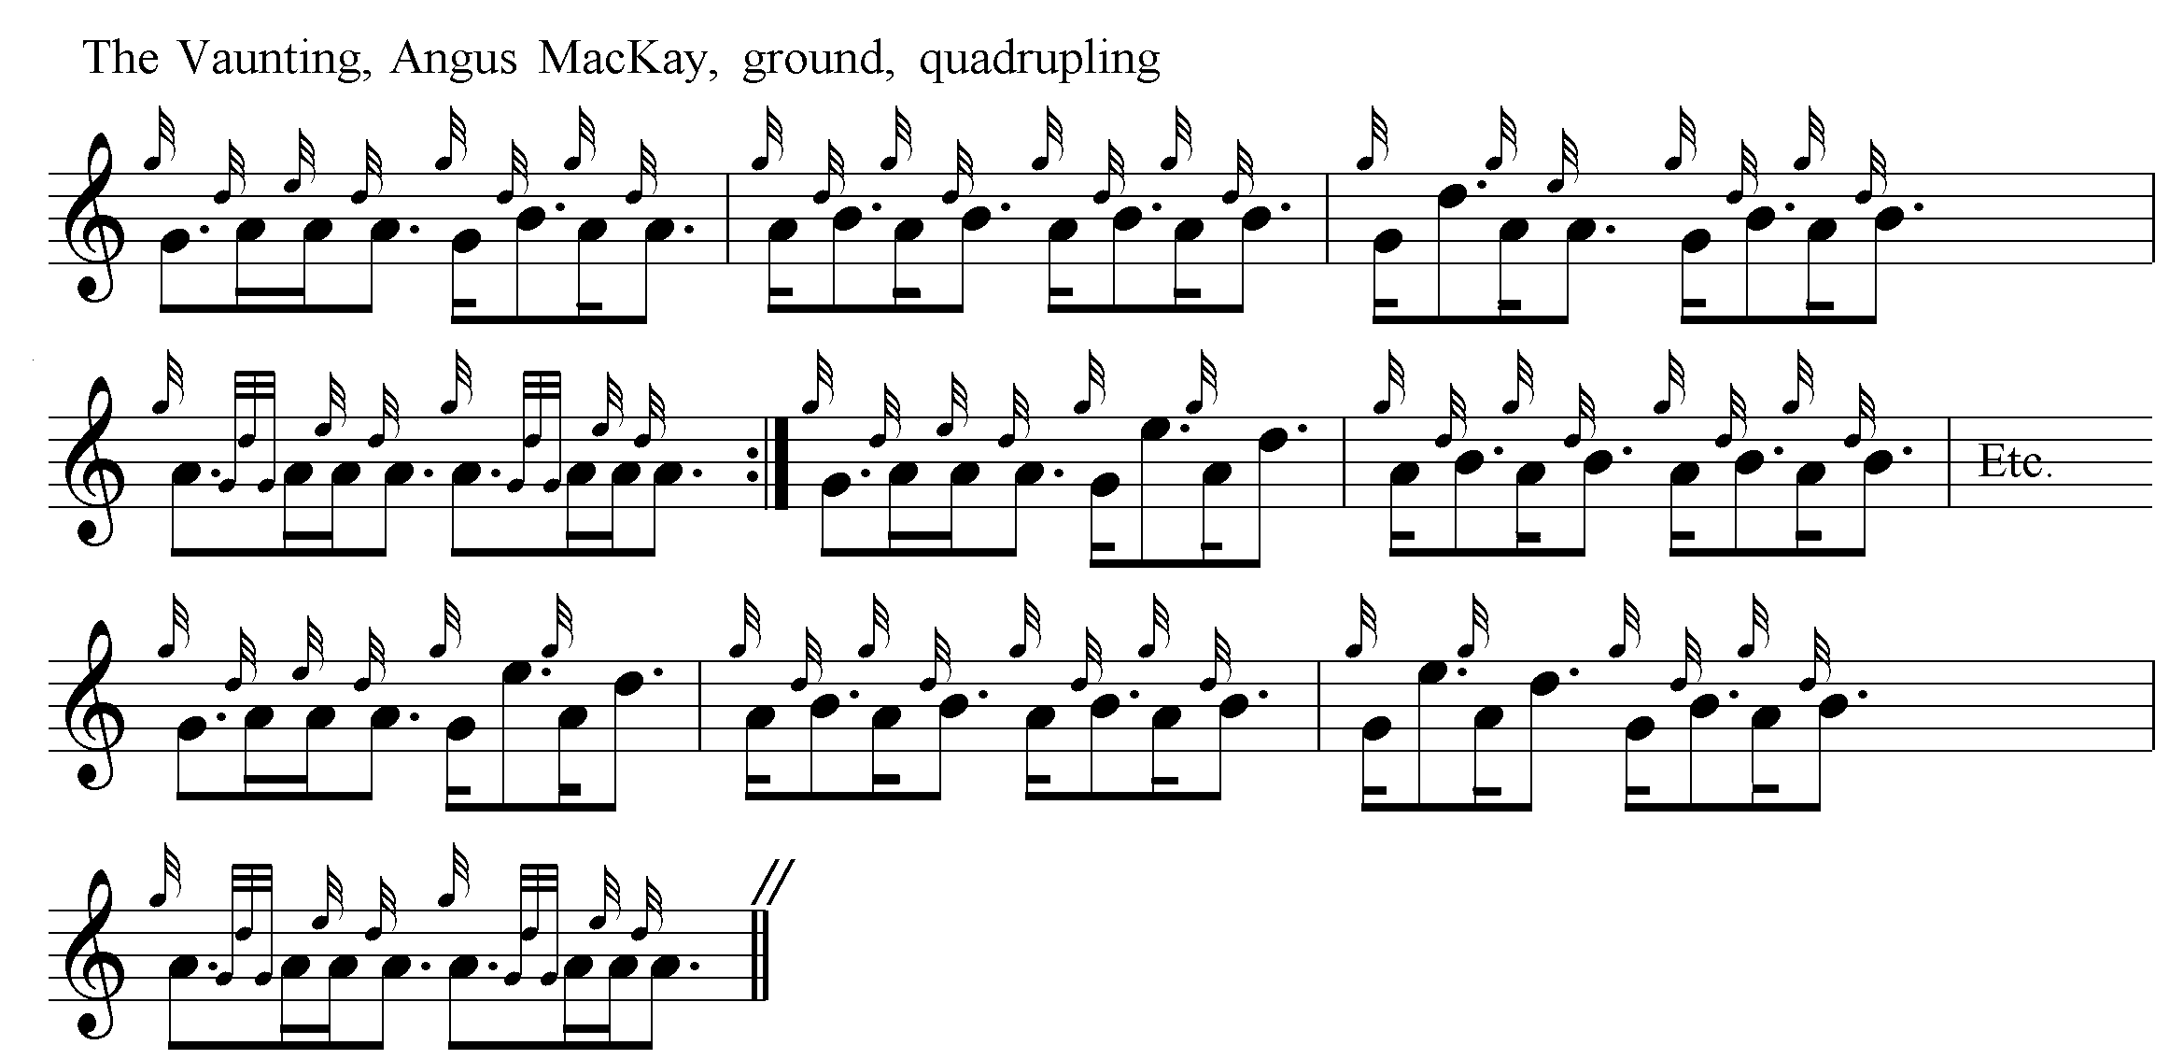

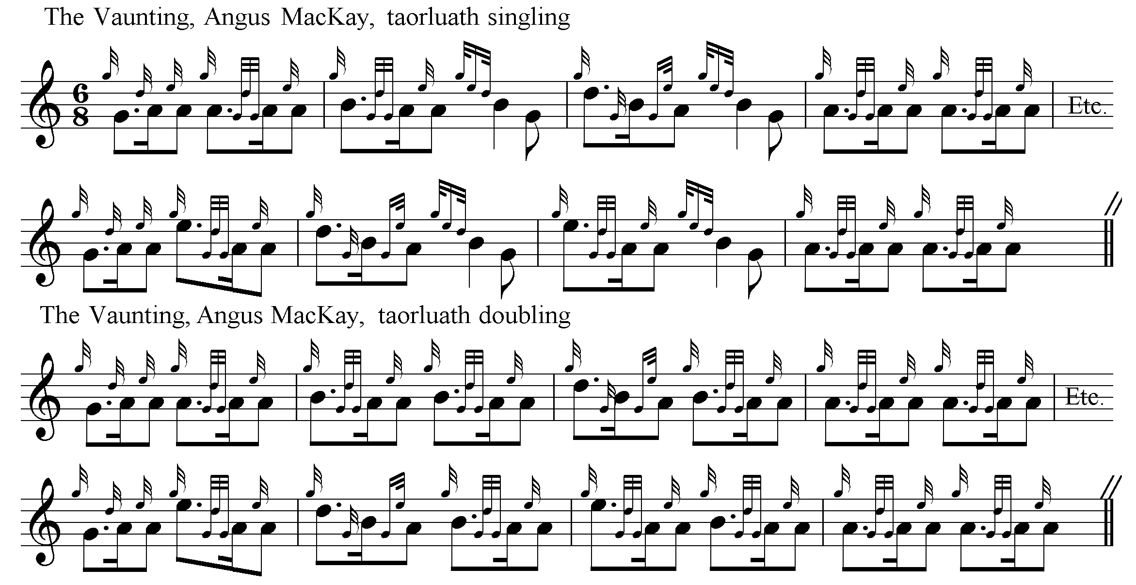

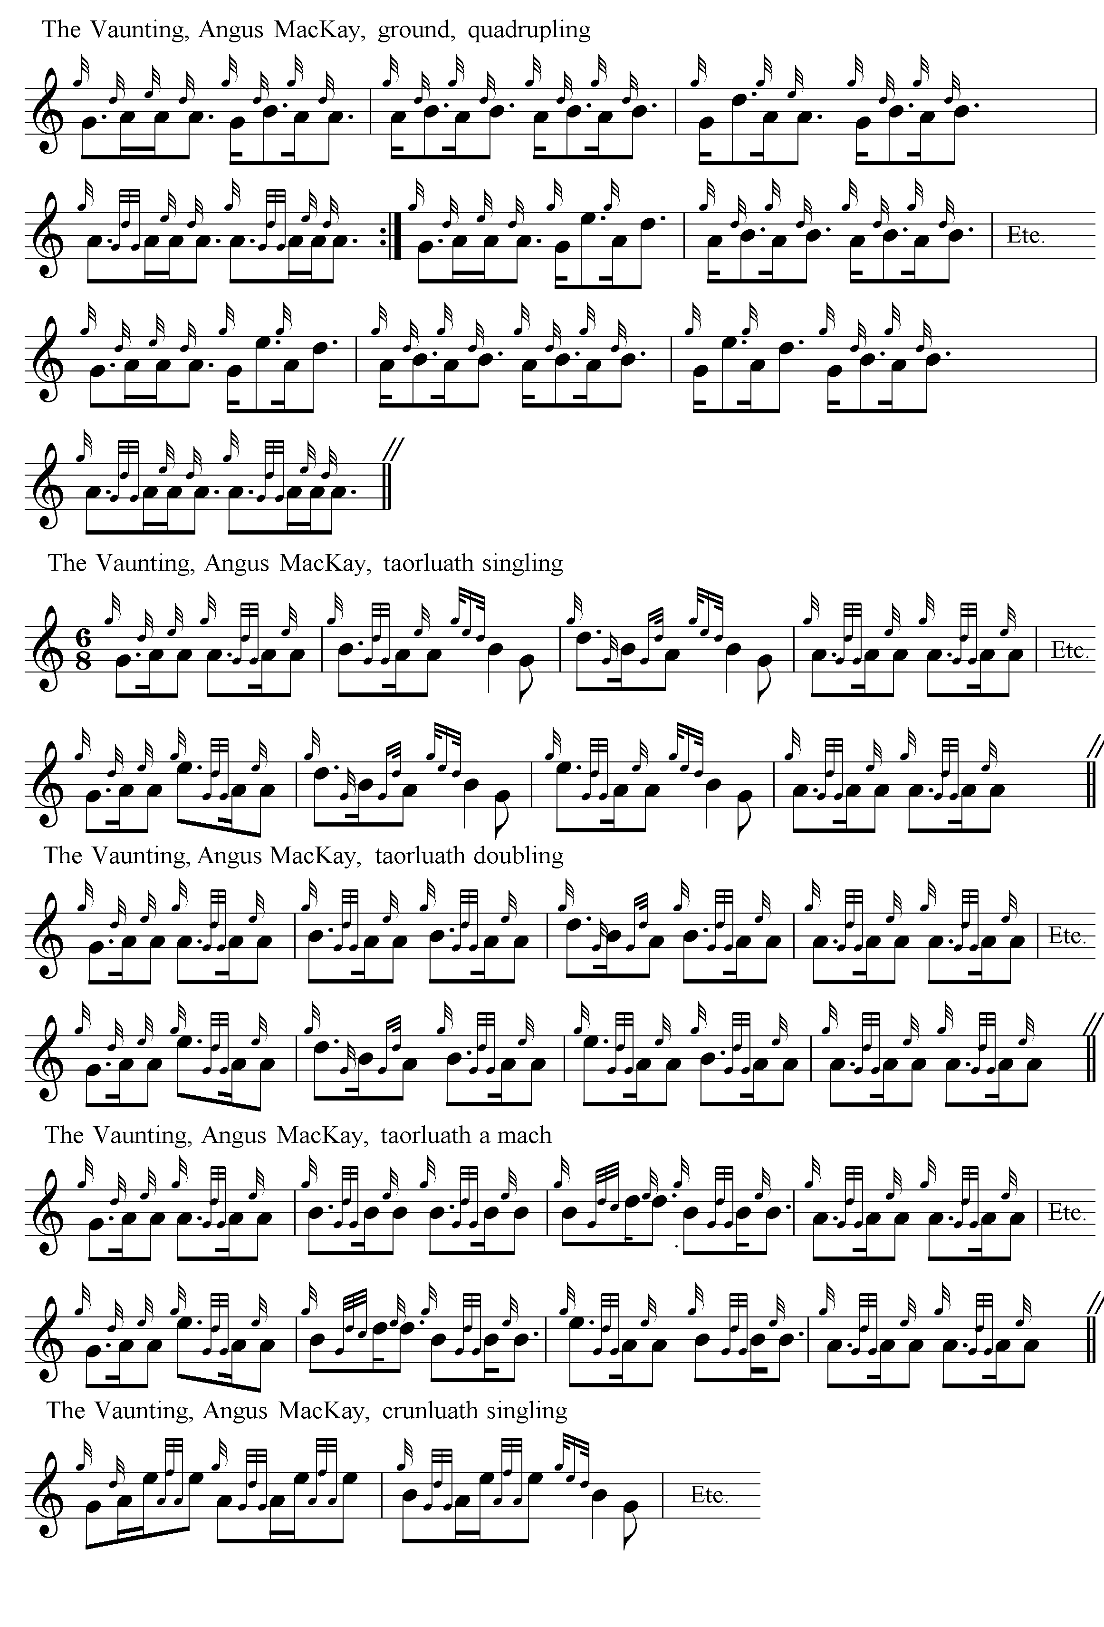
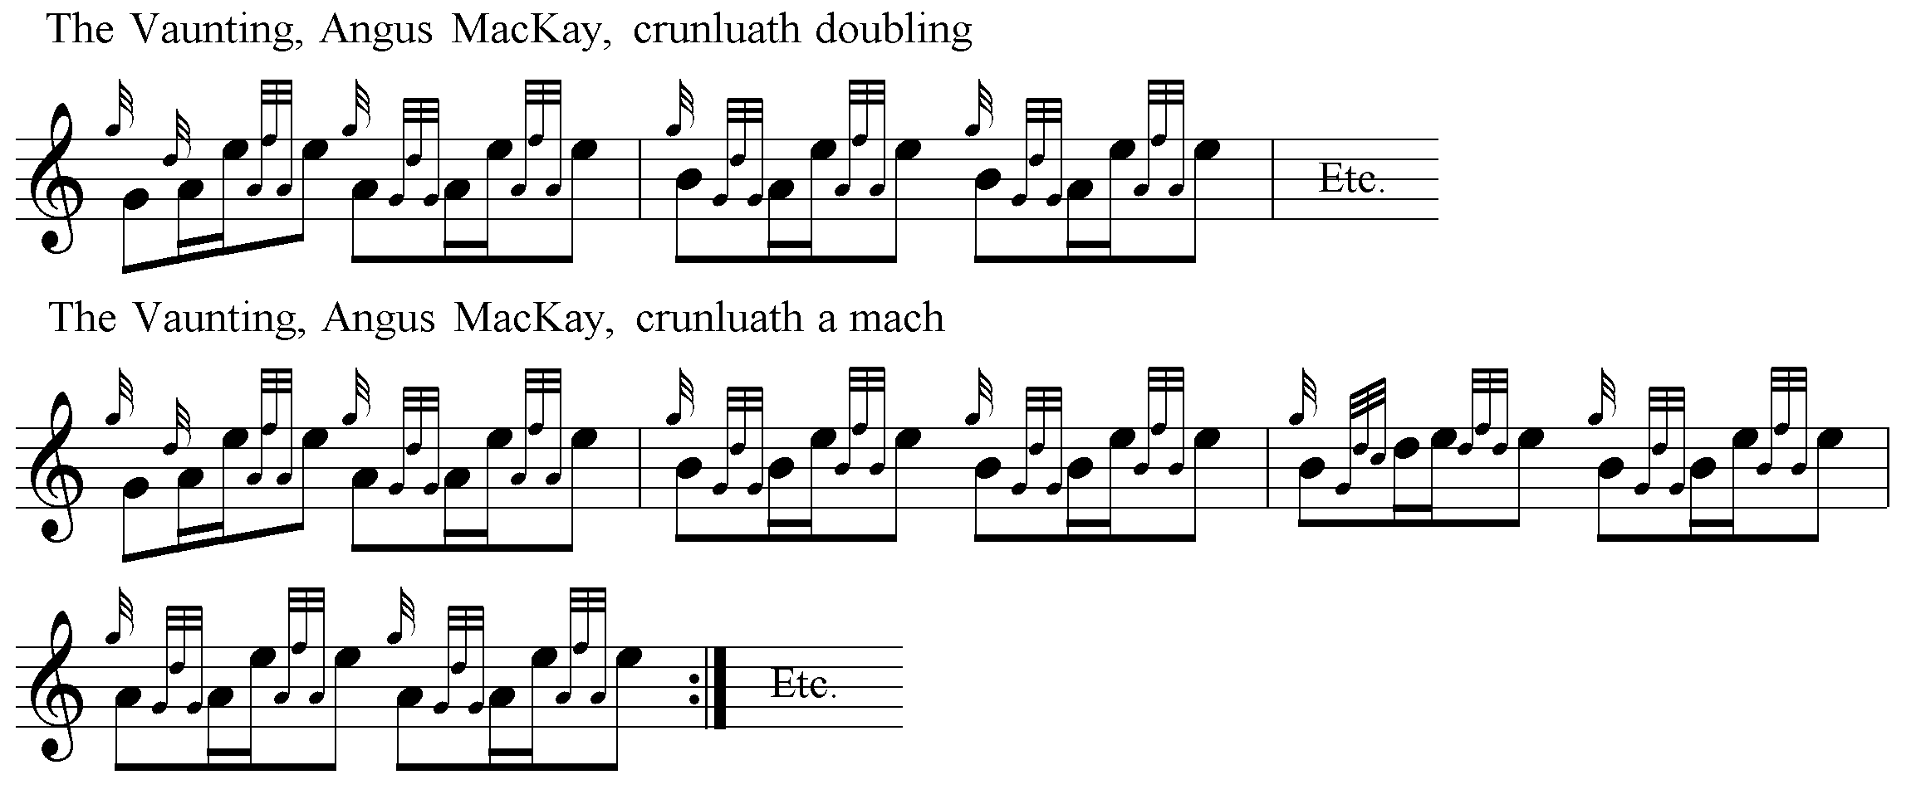

Points to note include the difference of timing the opening gesture between MacDonald and MacKay in the ground, MacKay giving less air to the low G (unless the GED figure at the start of the MacDonald score is an appoggiatura: for which, see the chapter on MacDonald in The Highland Pipe and Scottish Society 1750-1950). There are a number of examples of the way the pointing of phrases can be pushed around between variations, and the timing of the a-mach movements is also interesting. These seem intended to be played off accented opening quavers in a manner more frequently associated with Donald MacDonald (although MacKay’s usage is not consistent, as can be seen in the first line of the taorluath a-mach).

C. S. Thomason’s setting in Ceol Mor broadly follows MacKay in the development of the tune, but has one or two attractive individual touches, possibly from Keith and Colin Cameron, whom Thomason cites amongst his sources for the score. The opening line of the ground shows his characteristic approach, with the grips on B giving a slightly crisper feel than the slurs of MacDonald and MacKay:

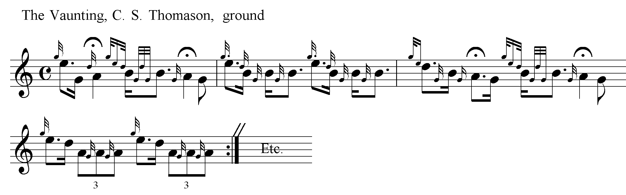

The tune appears in volume IV of the Piobaireachd Society’s First Series, dated 1909, (but actually published in February 1910), and was edited like the rest of the volume by a committee comprising Major Stuart MacDougall of Lunga, Captain Colin MacRae, and John Bartholomew of Glenorchard (who had recently acquired the Nether Lorn Canntaireachd volumes from a descendant of the Campbell pipers) following the death of Major William Stewart of Ensay, the Society’s first editor. The “Preface” states that “the Sub-Committee were empowered to have the tunes in the first instance gone over by the well-known professional players, Pipe-Majors John Macdonald, Inverness; J. MacDougall Gillies, Glasgow; and Wm. Ross, 2nd Scots Guards, and thereafter by Mr. Alexander Cameron, Achnacarry, on the distinct understanding, however, that the Sub-Committee reserved to themselves full discretionary power as to the settings to be accepted and printed.” There is little sign of obvious intervention by the pipers in the resulting scores. Two of them, MacDonald and Gillies were the Society’s paid instructors (as also at this time were John MacColl and Gavin MacDougall of Aberfeldy). The name of G. S. McLennan is conspicuous by its absence. Indeed, the Society refused to appoint him as instructor in Aberdeen, because he declined to change his style to teach the Society scores. An advertisement listing the set tunes placed in the Oban Times (19/2/1910) reminded pipers that the Society’s settings were mandatory, and indicate that the Society's instructors would be teaching them in Glasgow, Inverness and Aberfeldy. Admission to these classes was free, on application to the Hon. Secretary. This could disadvantage people in a number of ways: geographically (if they lived in Aberdeen, for example) or in terms of the way they were taught: the Society’s relentless promotion of the published score were a death-knell for those taught by traditional oral/aural means if they meant to have a competitive career.

The Society’s score was a conflation of MacDonald and MacKay, with a number of interesting timings at various points unsupported by previous scores, as we see in the following examples from the first line of the ground, the trebling of the ground, and the taorluath and crunluath a-mach:

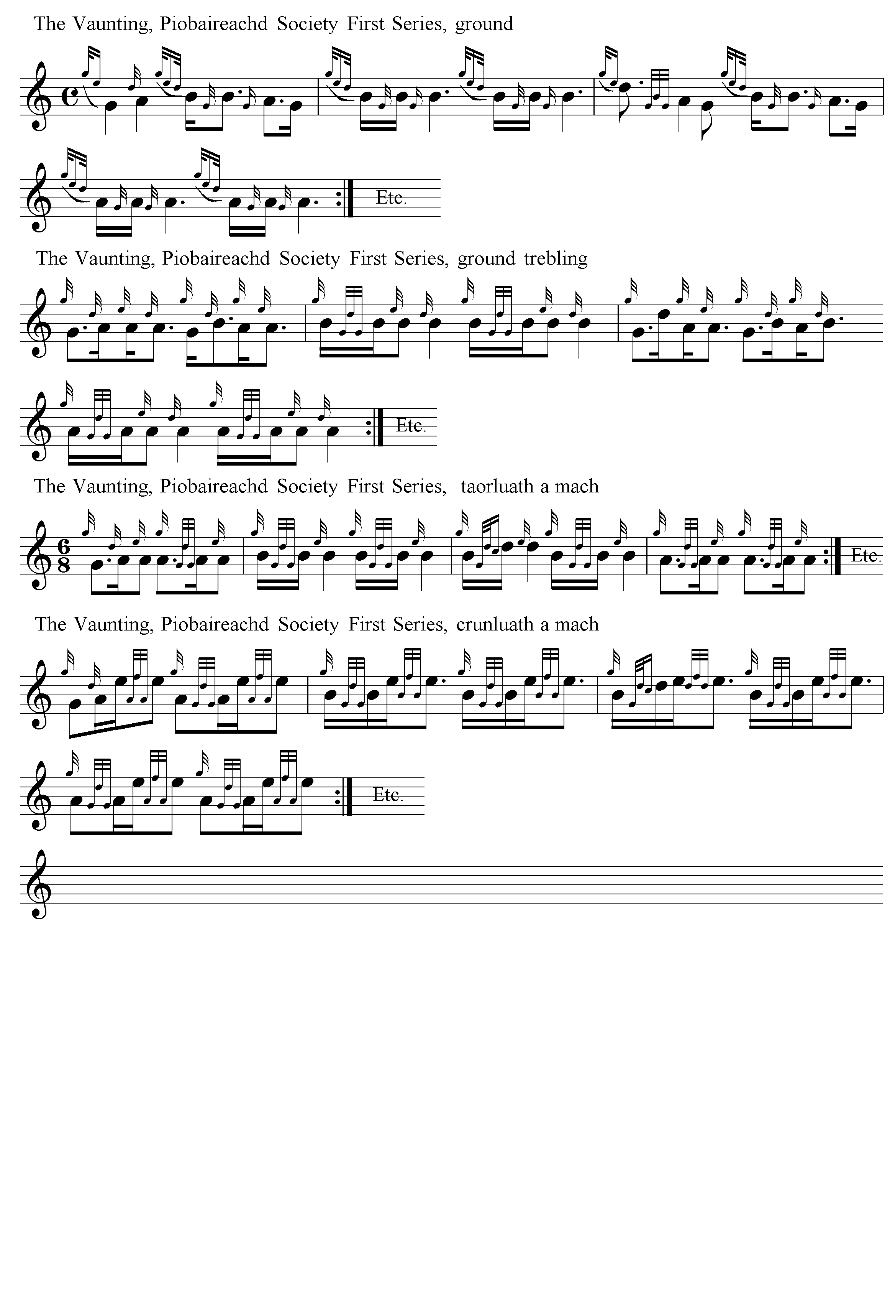

Samples of David Glen’s setting, showing his characteristic stylings appear below. He includes MacDonald’s siubhal, but also gives MacKay’s quadrupling of the ground. His ground is obviously based on MacKay’s Ancient Piobaireachd which he resets \to accommodate his standard eallach and bottom hand echo beats where the accent falls on the opening dotted quaver. This timing of the double echo beats on B and A occurs throughout the score. Glen’s use of double dotting and the acciaccatura will be noted; he explains his timing of the latter in a footnote to the text:

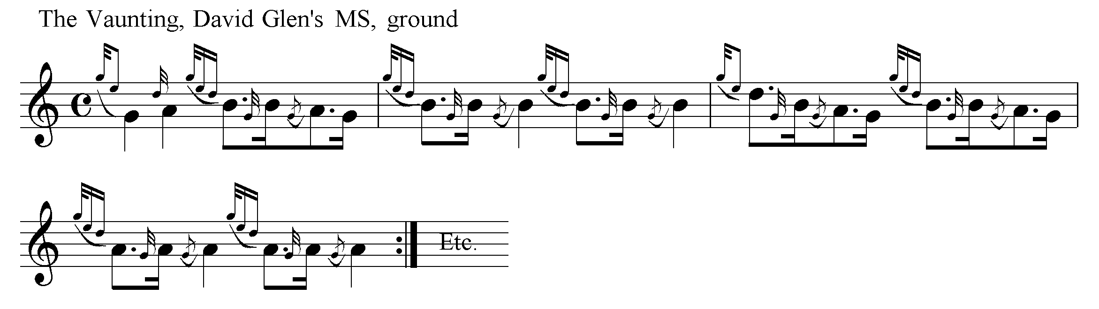
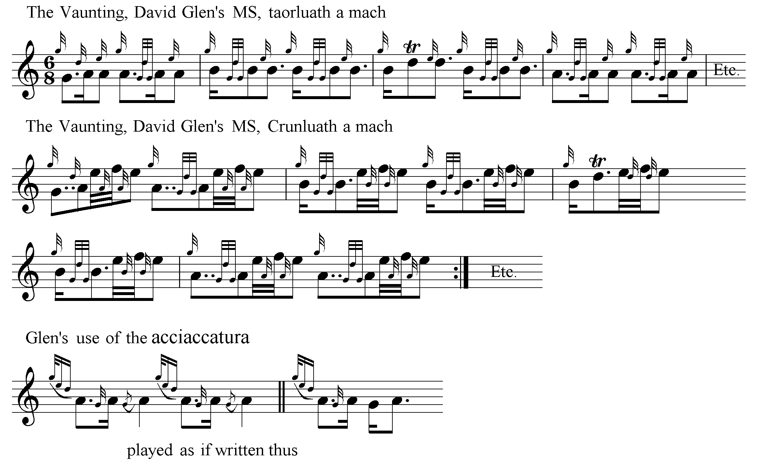

Archibald Campbell edited “The Vaunting” for the Piobaireachd Society’s Second Series (vii, 193-4) in 1938, stating “The setting printed is practically identical with Angus MacKay’s”, but there were frequent silent departures from MacKay’s text, including nearly two dozen changes to note values in the first line of the ground alone.

The oldest version of the story connected with ‘The Vaunting’ is recorded in Donald MacDonald’s MS, dated 1826, as follows:

Ronald Macdonald, Esq. of Morair, was a first-rate player on the bagpipe, and a number of fine pieces were composed by him, besides this one. He had a gentleman’s son residing with him, to pass the winter at his house. This youth took a notion of learning to play upon the pipe, and, in a short time, acquired a thorough knowledge of the method of playing, which made him very happy. Some little time after this, the young man fell sick, and very little hopes were entertained of his recovery. When he thought himself near death, he sent for Mr Macdonald, to whom, when he arrived, he said “O, my very dear friend and master, it would greatly gratify me (since I must die,) if you would compose a Lament for me after I am dead;” to which request the gentleman gave his consent. In the course of a week after this, the young gentleman again sent for Mr Macdonald; and he accordingly came. The young gentleman addressed him as follows: “O sir, if you would have the goodness to let me hear the Lament, before I die, it would make me quite happy.” Ronald MacAilleanoig told him, he was afraid his head could not bear the sound; to which the youth replied, “O, but I think it will do me good.” MacAilleanoig brought his pipes, and blew them up at the sick man’s bedside; the air delighted him so much that the fever took a turn, and in a few days he was quite well. Being now recovered, MacAilleanoig asked the young man what should now be the name of the Lament, “O, (said the young gentleman,) we’ll make a Boalich of it,” which word signifies Drollery. It is a fine air, and very ill to play.

Ronald MacDonald of Morar is also thought to be the composer of “The Red Speckled Bull” and “The Finger Lock”, and a number of traditional tales concerning him appear in the folklorist Calum I. MacLean’s book The Highlands, (Lond., 1959), celebrating his strength and daring, and frequent encounters with the supernatural, including the following:

There is one very lovely pibroch called “MacCrimmon’s sweetheart”. One tradition has it that this pibroch was composed by one of the MacCrimmons to a favourite brown polled cow that fell into a bog. The English name is quite fictitious, for there is nothing in the tradition to suggest a sweetheart, especially a fairy sweetheart: the Gaelic name is Maol Donn, meaning “the bare or hornless brown one”. Tradition in the Arisaig district has it that the pibroch was composed not by a MacCrimmon but by Raghnall Mac Ailein Oig to a sea-shell that he picked up one day as he strode along the shore….

It was during Ronald’s time that the district of Morar and Arisaig was haunted by a dead spectre called the “Colanngun Cheann” (Headless Body). The Headless Body was the spirit of a decapitated woman who returned from the dead to wreck vengeance on the living. …The irascible chief of Siol Dughaill (the Seed of Dugald) as the Macdonalds of Morar were called, caught a woman with a sucking baby stealing ears of corn in his field and promptly cut off her head with a sickle. The spirit of the beheaded woman appeared in the district and waylaid and killed as many of the seed of Dugald as it met. The whole district was terrorised and no one could be found brave enough to challenge the Headless Body. At last Ronald the son of Young Allan decided to rid the land of the scourge and he met the Headless Body on the strand between Morar and Arisaig. A desperate struggle took place until Ronald overcame the monster and had it firmly pinioned and helpless in his strong arms. The Headless Body begged him to let it go. Ronald refused to loosen his grip until he received a solemn promise that the Headless Body would never again interfere with anyone who had one single drop of the blood of the Seed of Dugald in his or her veins. Ronald then let go, and away went the Headless Body singing:

Far from me is the foot of Beinn Eadara,
Far from me is Bealach a’ Maorghain.

The tune sung by the Headless Body was noted by Ronald the son of Young Allan and it is still played by pipers in many parts of the Highlands…

Ronald did compose one very noted pibroch called An Tarbh Breac Dearg (The Dappled Red Bull). He was invited down to the Cameron country where an inveterate enemy let loose a wild bull in a field which Ronald had to cross. The bull attacked Ronald and almost succeeded in goring him to death. The bull, however, was killed by Ronald, but he never recovered from his injuries and his exertions in the struggle with it. It was on that occasion that he composed the pibroch.’ pp.63-7

The tune was a favourite with R. B. Nicol who said it was was a bold cheerful piece to be played very fast, the cadences to be incorporated well into the flow of the tune. He said he played the doubling and trebling of the ground slightly differently from R. U. Brown, playing the semi-quaver/dotted quaver figure in bar 1 of the Piobaireachd Society’s Second Series as written, while R. U. Brown reversed the accent, more after the style of MacKay.

“The Vaunting” was cited by John MacDonald of Inverness at the end of a long and anxious correspondence with piper and naturalist Seton Gordon, running from March 1938 to September 1949, about the editorial methods of Archibald Campbell, and the damage MacDonald considered these as doing to correct piobaireachd idiom. The Seton Gordon Papers are now in the National Library of Scotland. MacDonald says:

I am pleased to note you are doing so much playing lately. It is nice to know that the grand old music is not being neglected as I am afraid it is in great danger of going out and I am quite justified in saying the Piob. Society is helping it on its way to a certain extent…I don't see why the P.S. Music Committee do so much altering of the tunes they publish…in my opinion they dont add to the beauty of the melodies, and unfortunately these go down to posterity as the correct settings…Piobaireachd playing will soon become like the “Gaelic”, it will go so far from the original that it wont recover…To me, it seems quite evident, from results of the last 15 years that the preservation of our ancient and traditional music, with all its beautiful and melodious airs, and sentiment, has passed into the wrong hands, and it will take a long time, if ever, it can be restored to its original standard”… “Piobaireachd”… is passing through a rather “serious period” at the moment by the incompetent way it is handled by the P. Society's Music Committee… Yes I had a copy of “Kilberry's Book” [i.e., The Kilberry Book of Ceol Mor], and my opinion of it is that it is the beginning of the end, of our traditional Piobaireachd playing as handed down to us, I certainly don’t agree with any of his comments on the Camerons or Gillies, and I have had so much to do with him before he went to India and since his return that I am almost justified in saying he is untruthful….I am not continuing teaching the tunes for this years’ competitions as written by the P.S. I am too old now to adopt the modern ideas of Piob.--and am quite happy to keep to what I got from the old Pipers. Kilberry has completely shorn the “Vaunting” of its traditional beauty…’ (NLS, Acc.5640/2)

***

Electronic text © Dr. William Donaldson, Aberdeen, Scotland, 2001

