The Unjust Incarceration

There are settings of this tune in the following manuscript sources:

--Colin Mór Campbell’s “Nether Lorn Canntaireachd”, i, 1-3 (with the title “Kepper Eggarich”);

--Angus MacKay’s MS, i, 55-57;

--Colin Cameron’s MS, ff. 32-3;

--John MacDougall Gillies’s MS, ff.6-7,

--David Glen’s MS, ff.159-60;

and in the following published sources:
--C. S. Thomason, Ceol Mor, p.291;
--David Glen, Ancient Piobaireachd, pp.231-3;
--William Stewart, et. al. eds., Piobaireachd Society Collection (first series), iii, 6-7.

Colin Campbell sets the tune as follows:

1st. Hiharin hioen, hodrooen, himen hoen, hiotroenem, hihodrooen, hiotroenem hihodroen hioem hiharinen
2d. Hiharin hioen hodrooen, himotrao hoen, hiotraenem, hihodrooen hiotroenem, hihodroen hioem, hiharinen
3d. Hihodrotra, cheredea hoen, hadrea hoen, hihorodoenem, hihodrotra, cheredaea, hihodroen hioem, hiharinen
4th. Hihararache, hivedareveche ho, haem, bariveche ho, hihararahohio, hihodrotraem, barivedarevechea, hihodroen, hioem, hiharinen
5^{th.} ChedariIe hiririeha, diliedrehia, cheredeaho himbarihia cheho, hadre himbaria, chedaria, hioem hiharinen
the ffirst Motion
1st. Hinen hinen hioen, hoen, hoen, hinen, himem, hinen, hoen, hioen, hioen, himen hoen hoen hinen hioen, hioen, himen hoen hoen hioem, hinen hinen hinen
2d. Hinen hinen hioen hihoen hoen hinen himen haen hoen, hioen hioen himen hoen hoen hinen hioen hioen himen hoen hoen hioem, hinen three times,
3d. Hoen hoen haem, chehin chehin, hoen haem, chehin hoen hioen hioen himen hoen hoen haem, chehin chehin chehin hoen hoen hioem, hinen three times
4th. Haen haem, chehin hien hien chehin haem hien chehin haen haen hioem, hoen hoen haem hienhien chehin hoen hoen hioem, hinen three times
5th. Chehin hien, dilien hien hien, haen dilien, chehin hien chehin chehin hoen hien hien chehin haem chehin hien chehin hien hioem hinen three times
the 2d motin Called Toliv
1st. Hindarid hindarid hiodarid hodarid hodarid, hindarid, himdarid hindarid hodarid hiodarid hiodarid himdarid hodarid hodarid hindarid hiodarid, hiodarid, himdarid hodarid hodarid hiodarem, hindarid three times [etc. etc.]

and the tune proceeds through the single taorluath variation to a single “Crolive” or crunluath variation following the tone row established in the siubhal. There is no a-mach.

Colin Campbell’s original score is as follows:
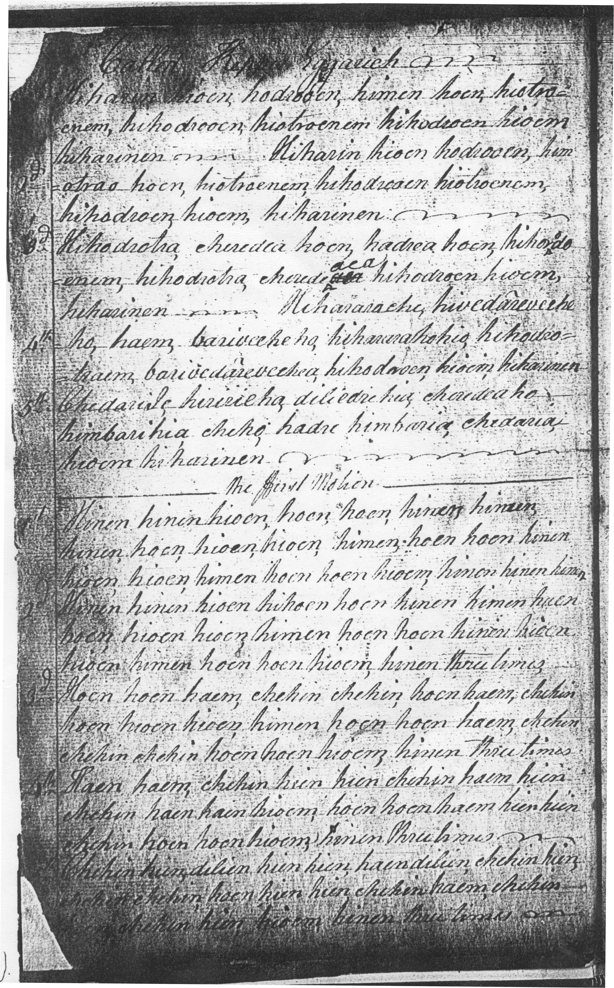
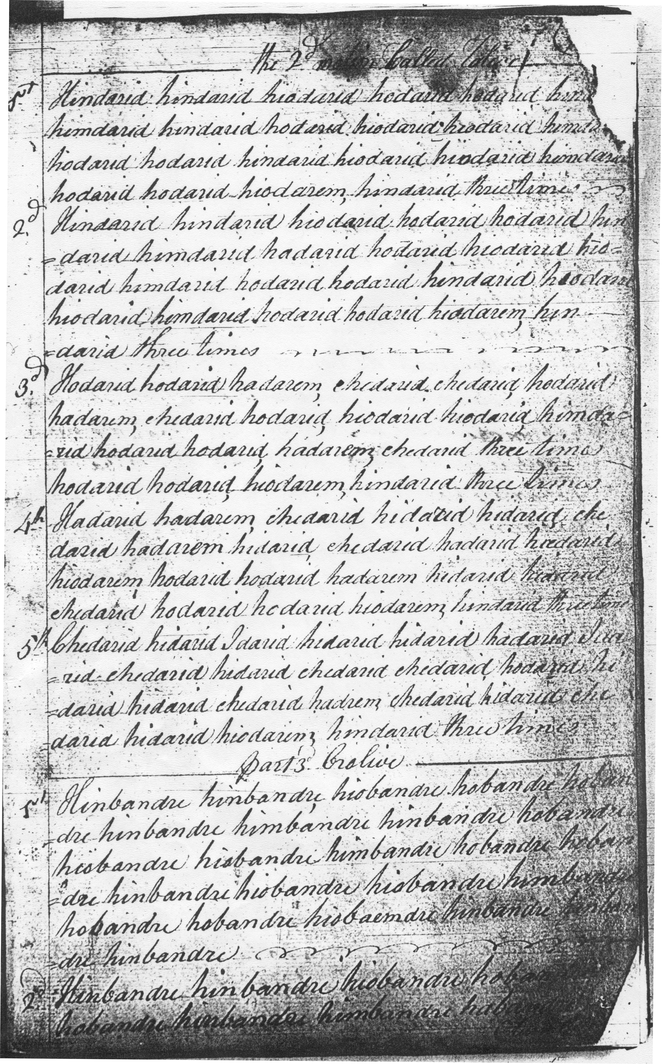
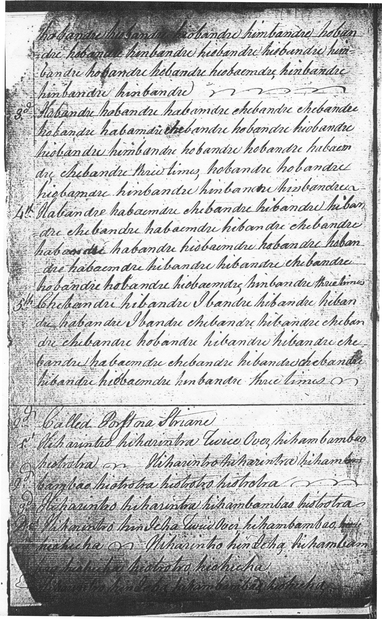

The tune appears in Angus MacKay’s MS without the Nether Lorn’s interesting fourth line. The siubhal is doubled, followed by a single taorluath and a single crunluath variation. The decorative repeat in bar eleven of the ground is not reflected in the variations. The score indicates that the ground should be repeated at the end of the taorluath and again at the end of the crunluath. There is no a-mach:

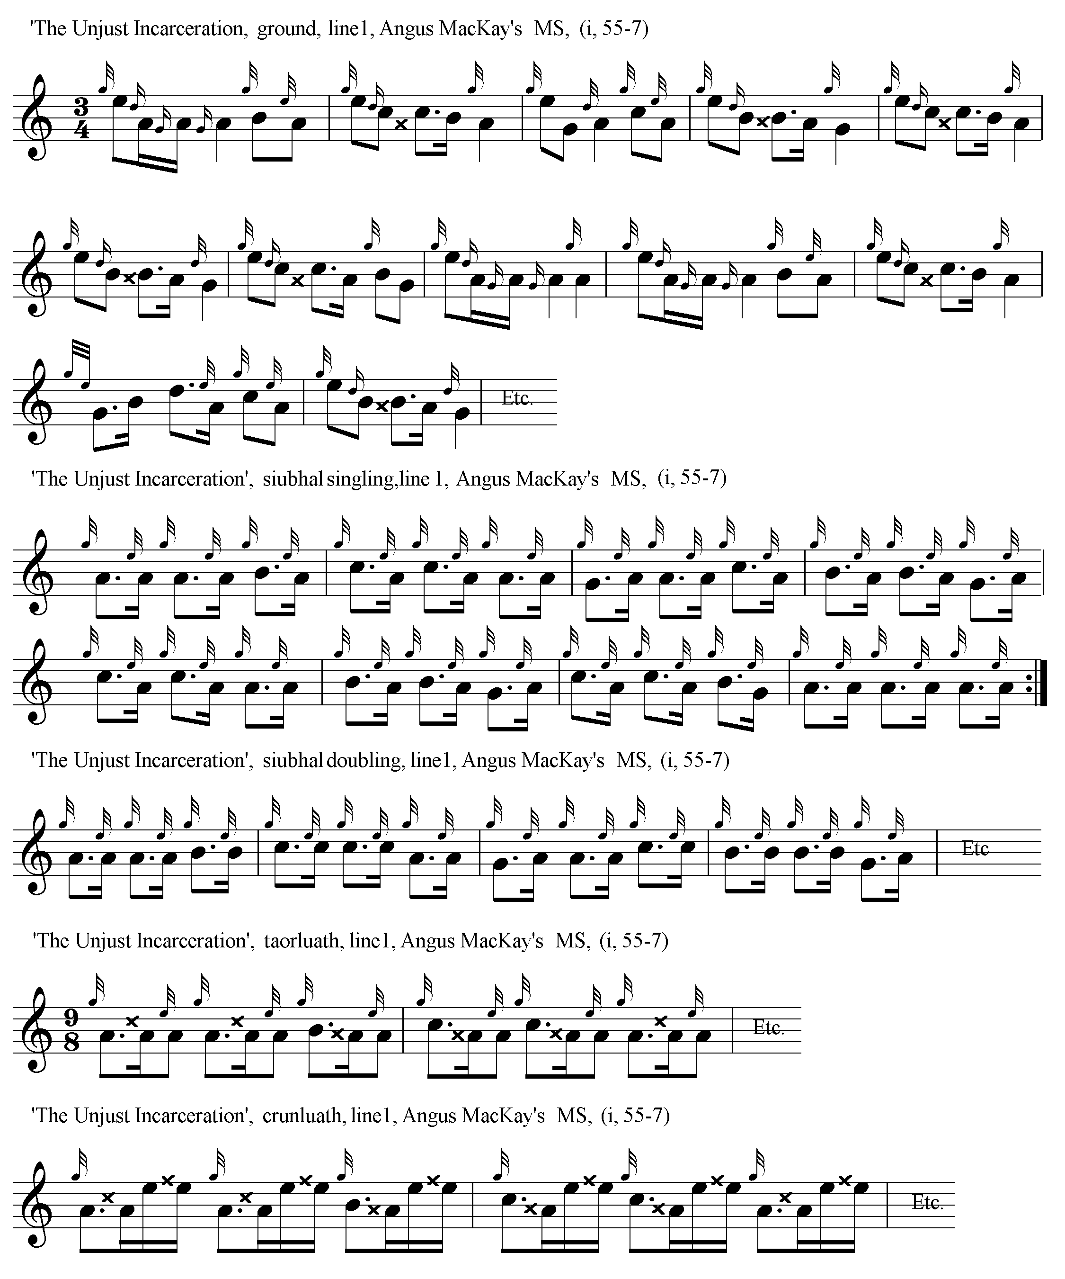

Angus MacKay’s original score is as follows:
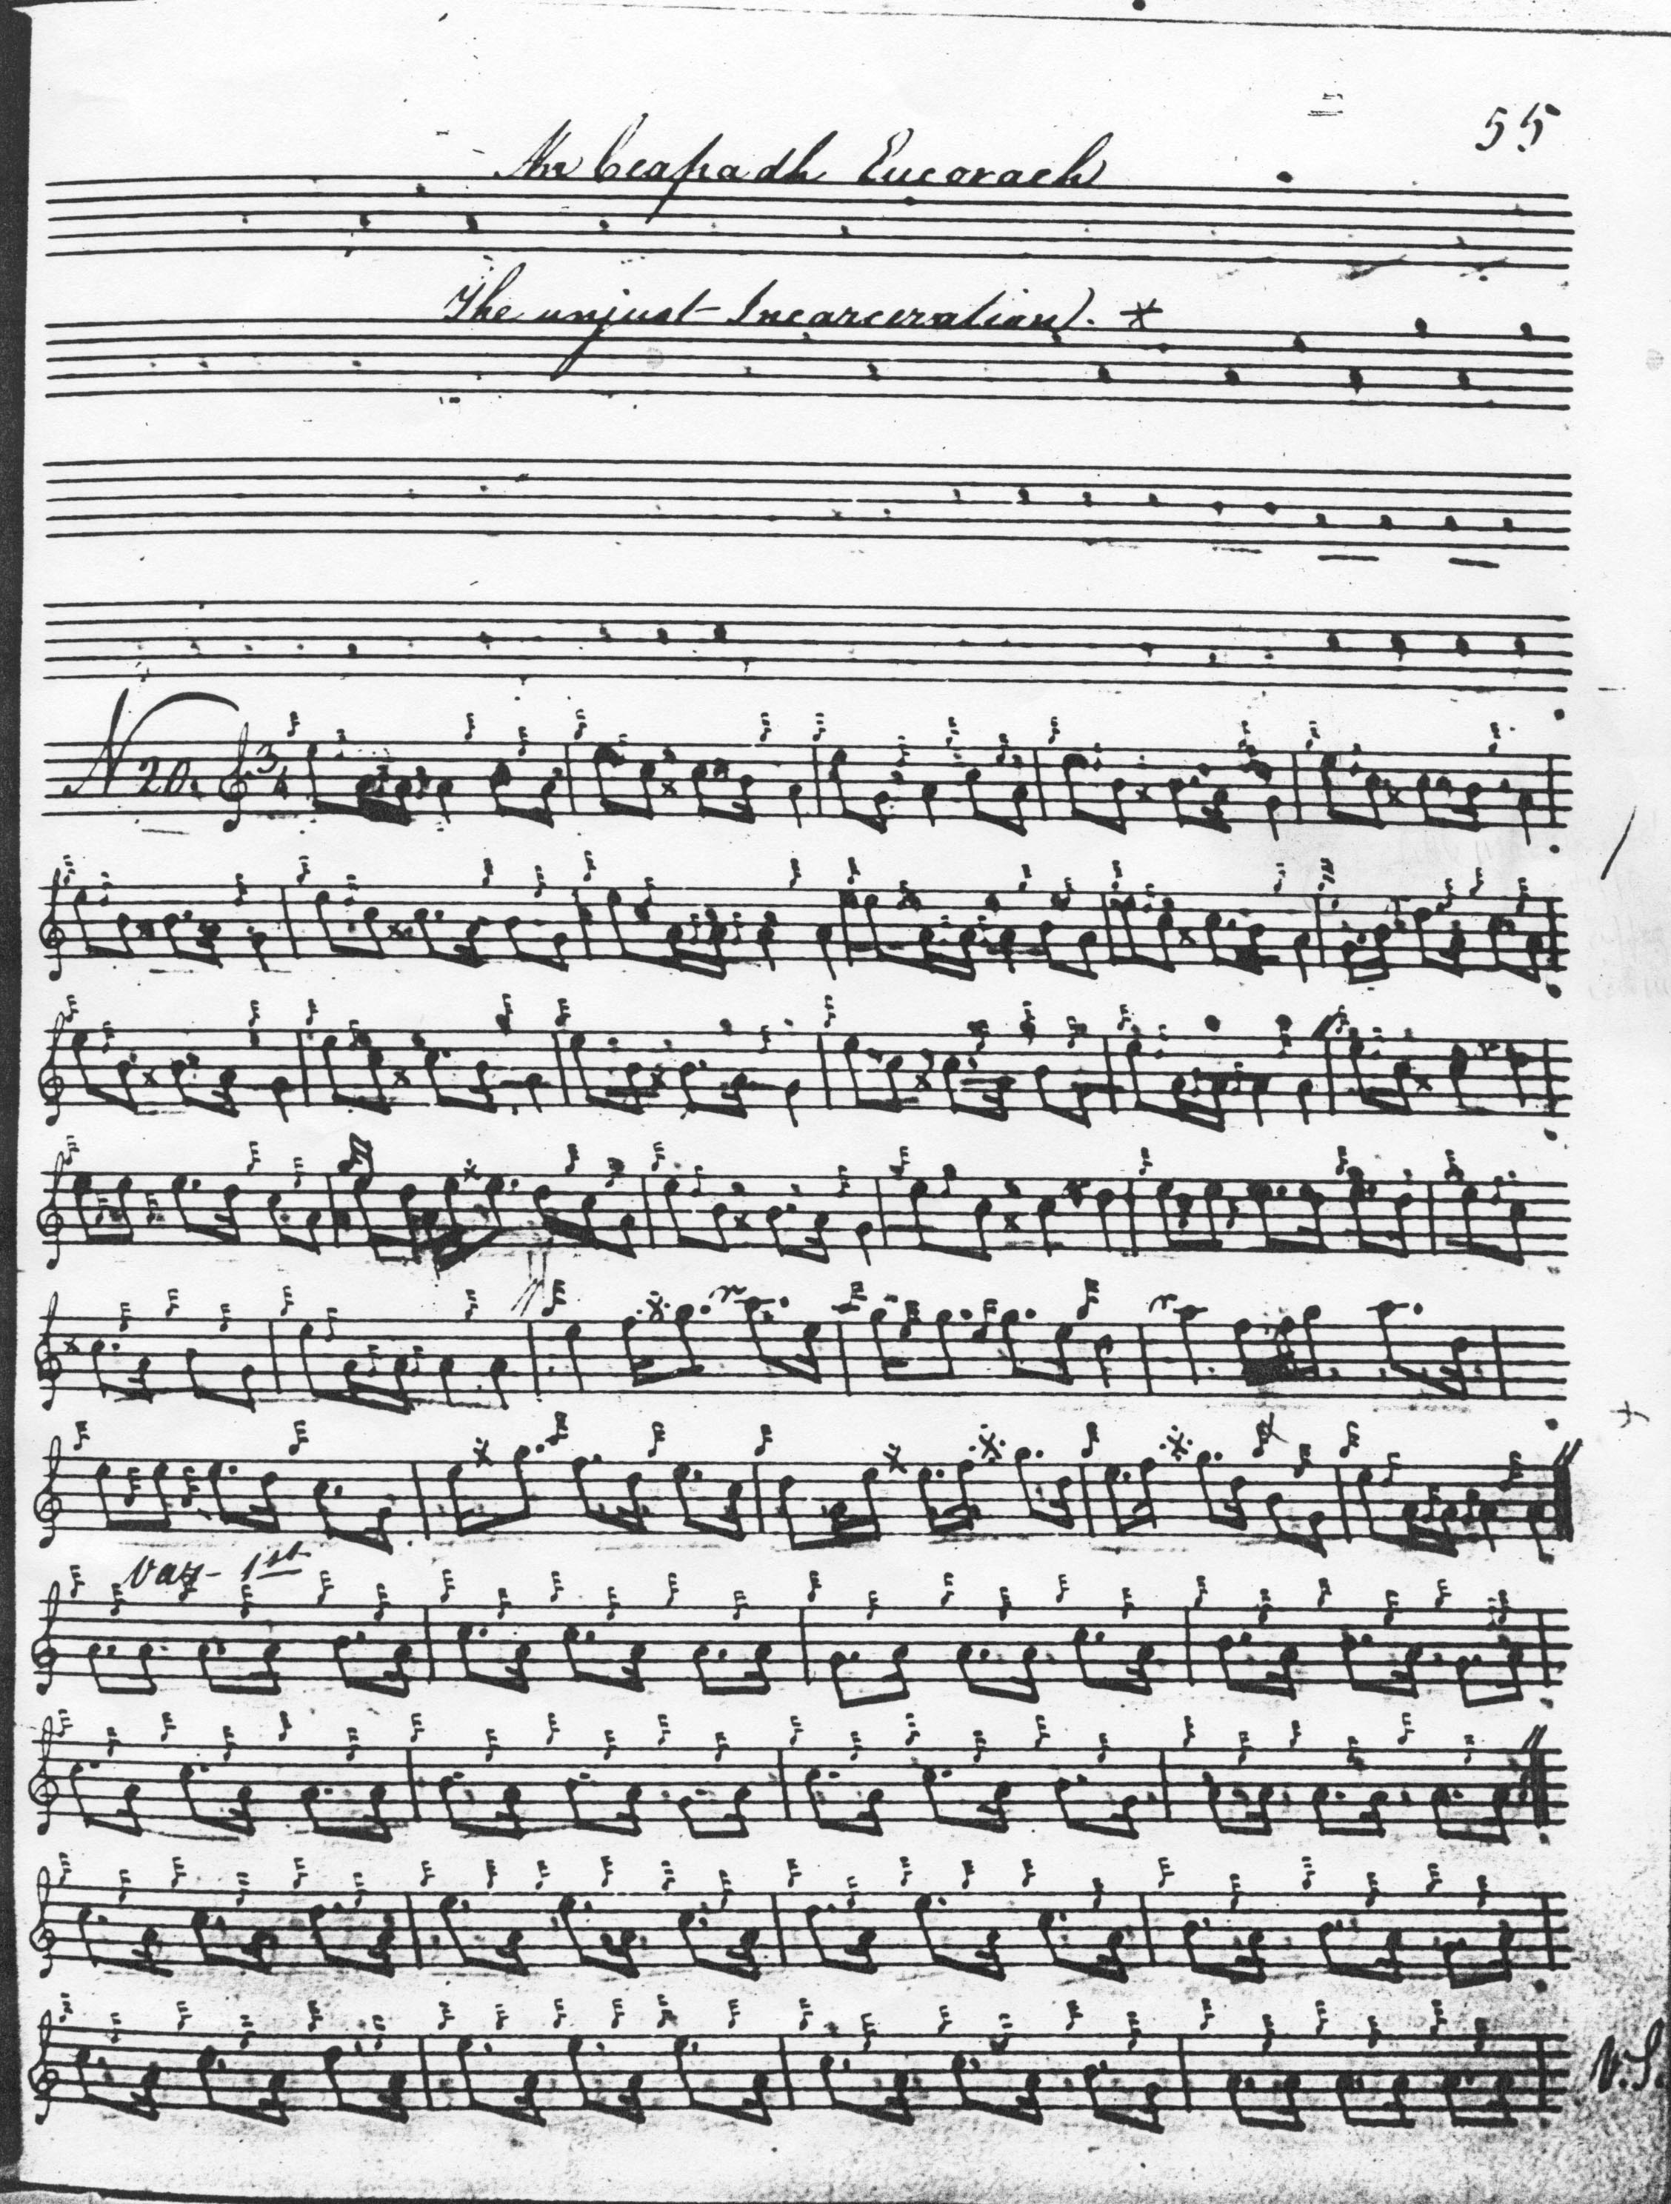

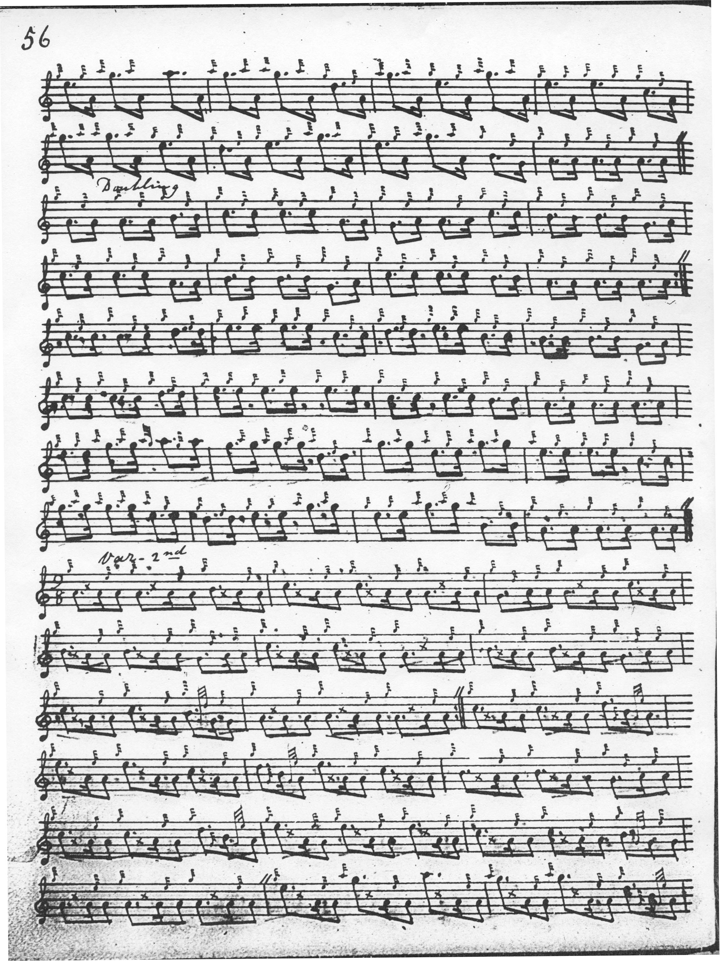

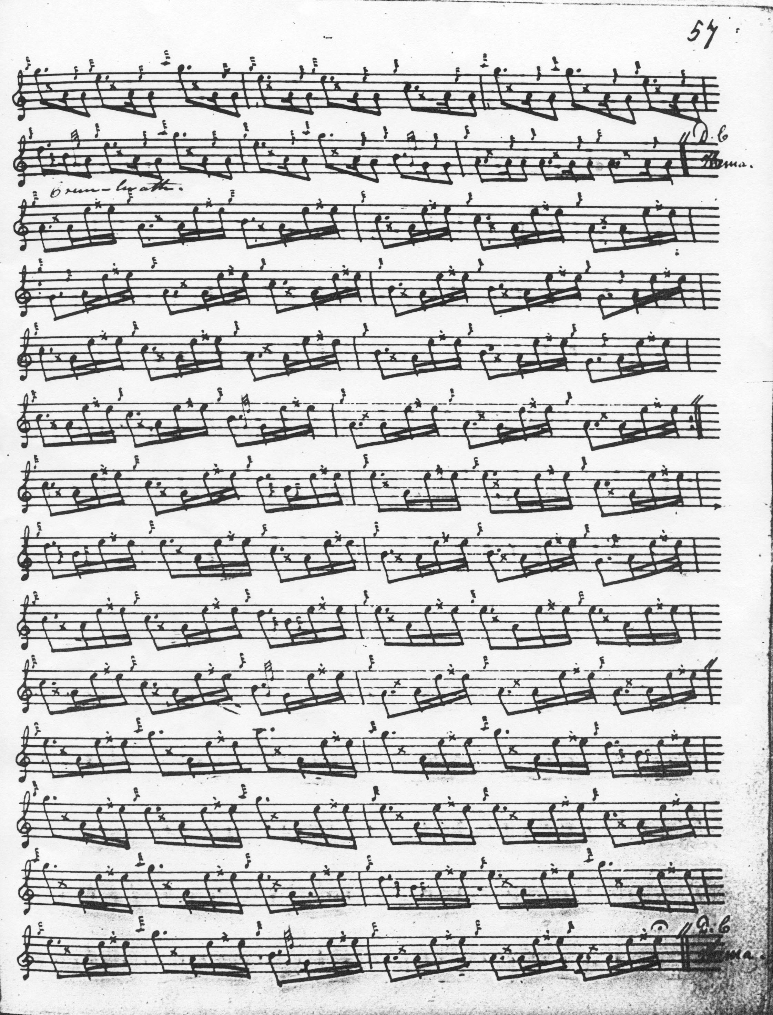

This basic pattern is reflected in the other scores. Colin Cameron develops the tune similarly to MacKay continuing to the end of the taorluath and adding “then comes the Crunluath”. There are one or two features of his style worth noting, however, such as the little cut down at the end of bar 31, and the way E is approached from high A via a reflexive turn through high G in bar 25 of the ground:

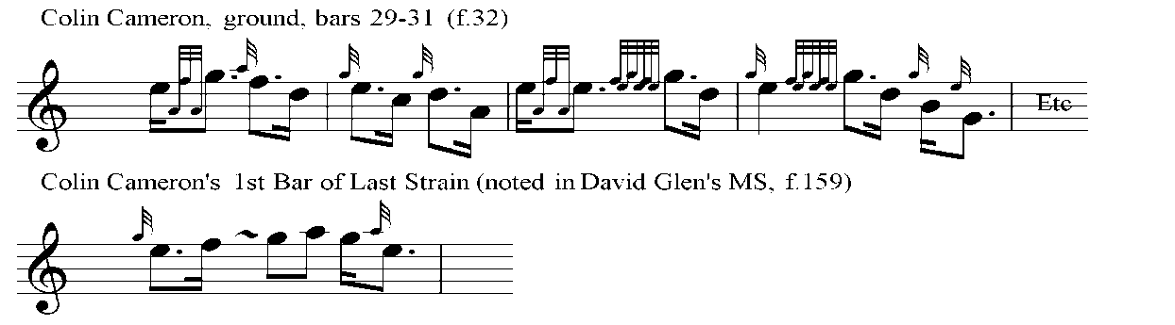

Colin Cameron’s original score is as follows:
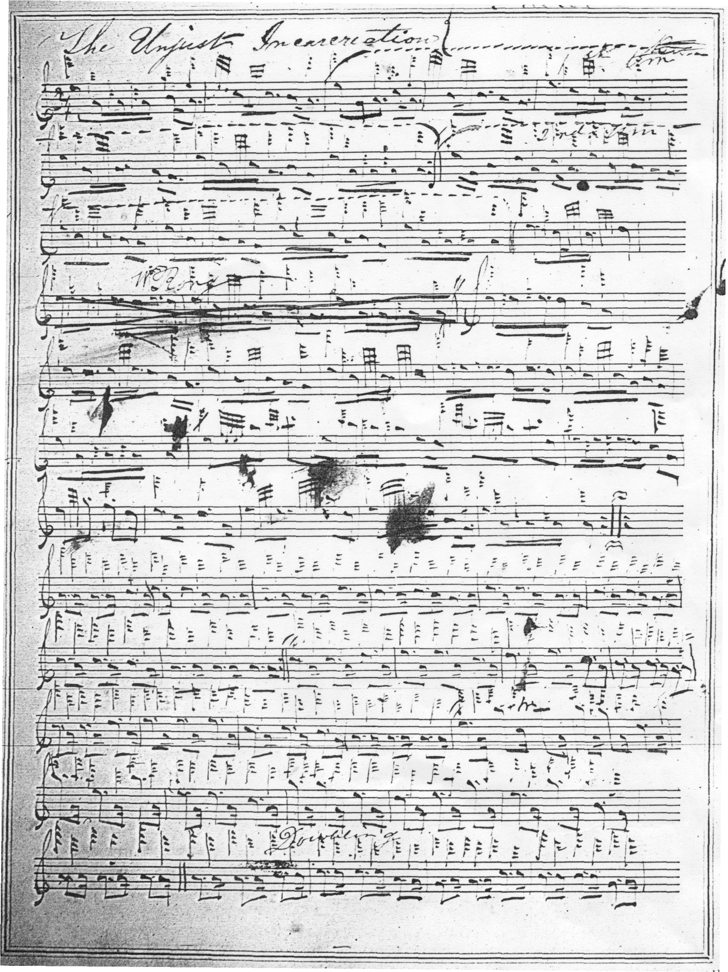
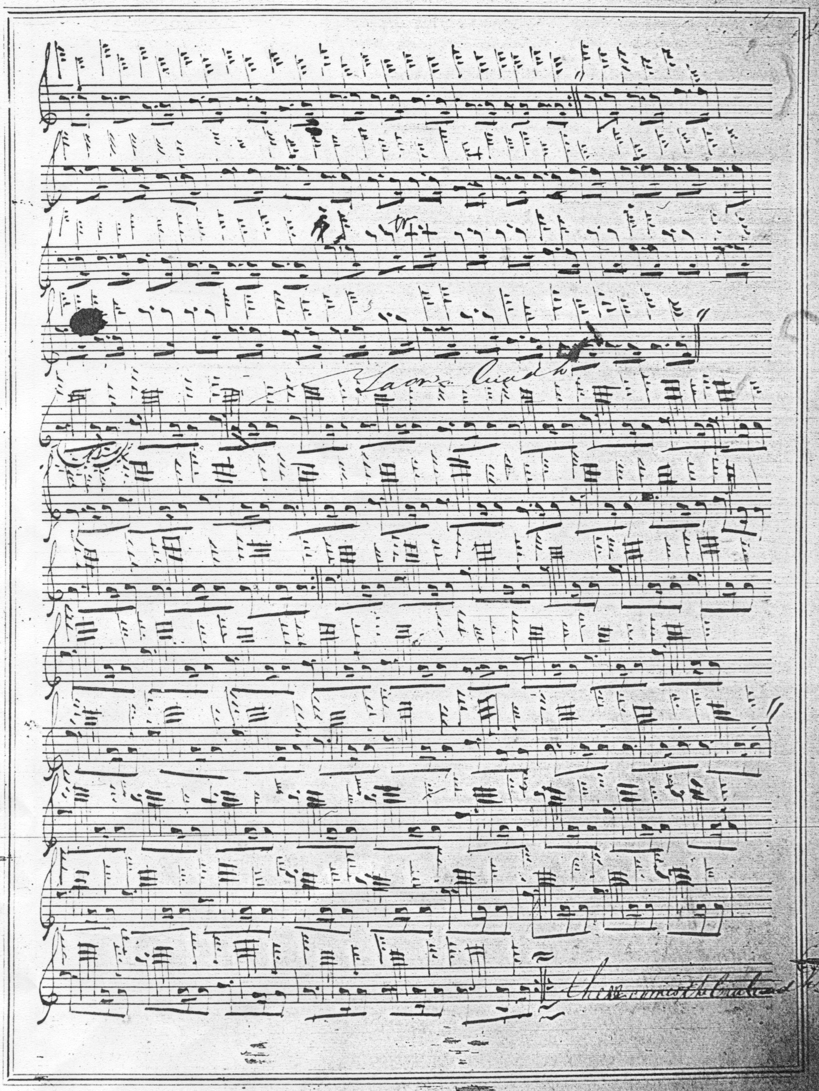

None of the other sources considered here treat the tune as a four-line air in Colin Campbell’s manner. John MacDougall Gillies’s score is very similar to that of Colin Cameron. General Thomason’s setting is on comparable lines: this came from Donald MacKay (Angus MacKay’s nephew), who was taught the tune by Donald Cameron. David Glen provides a Crunluath a mach, and offers as an alternative title “The Piper’s Lamentation in the Stocks”.

Glen set the tune as follows:

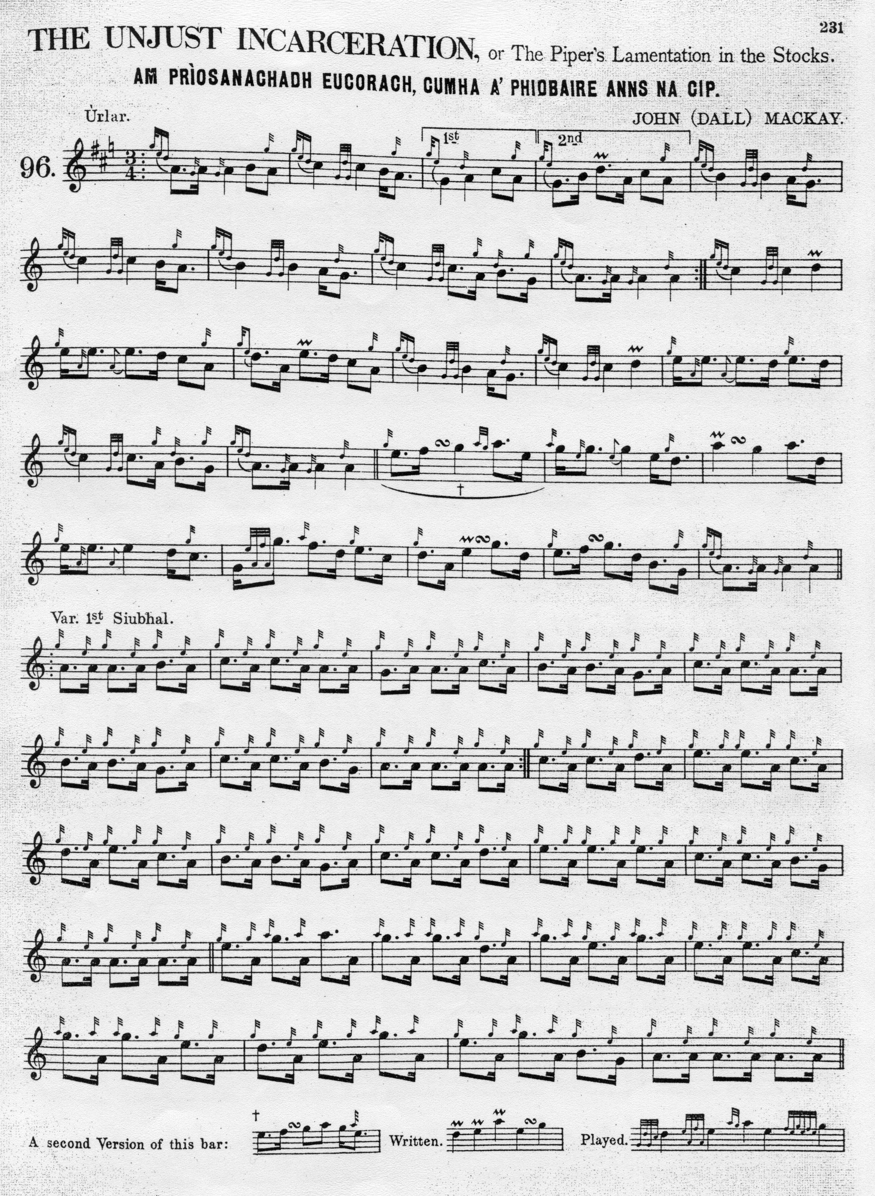
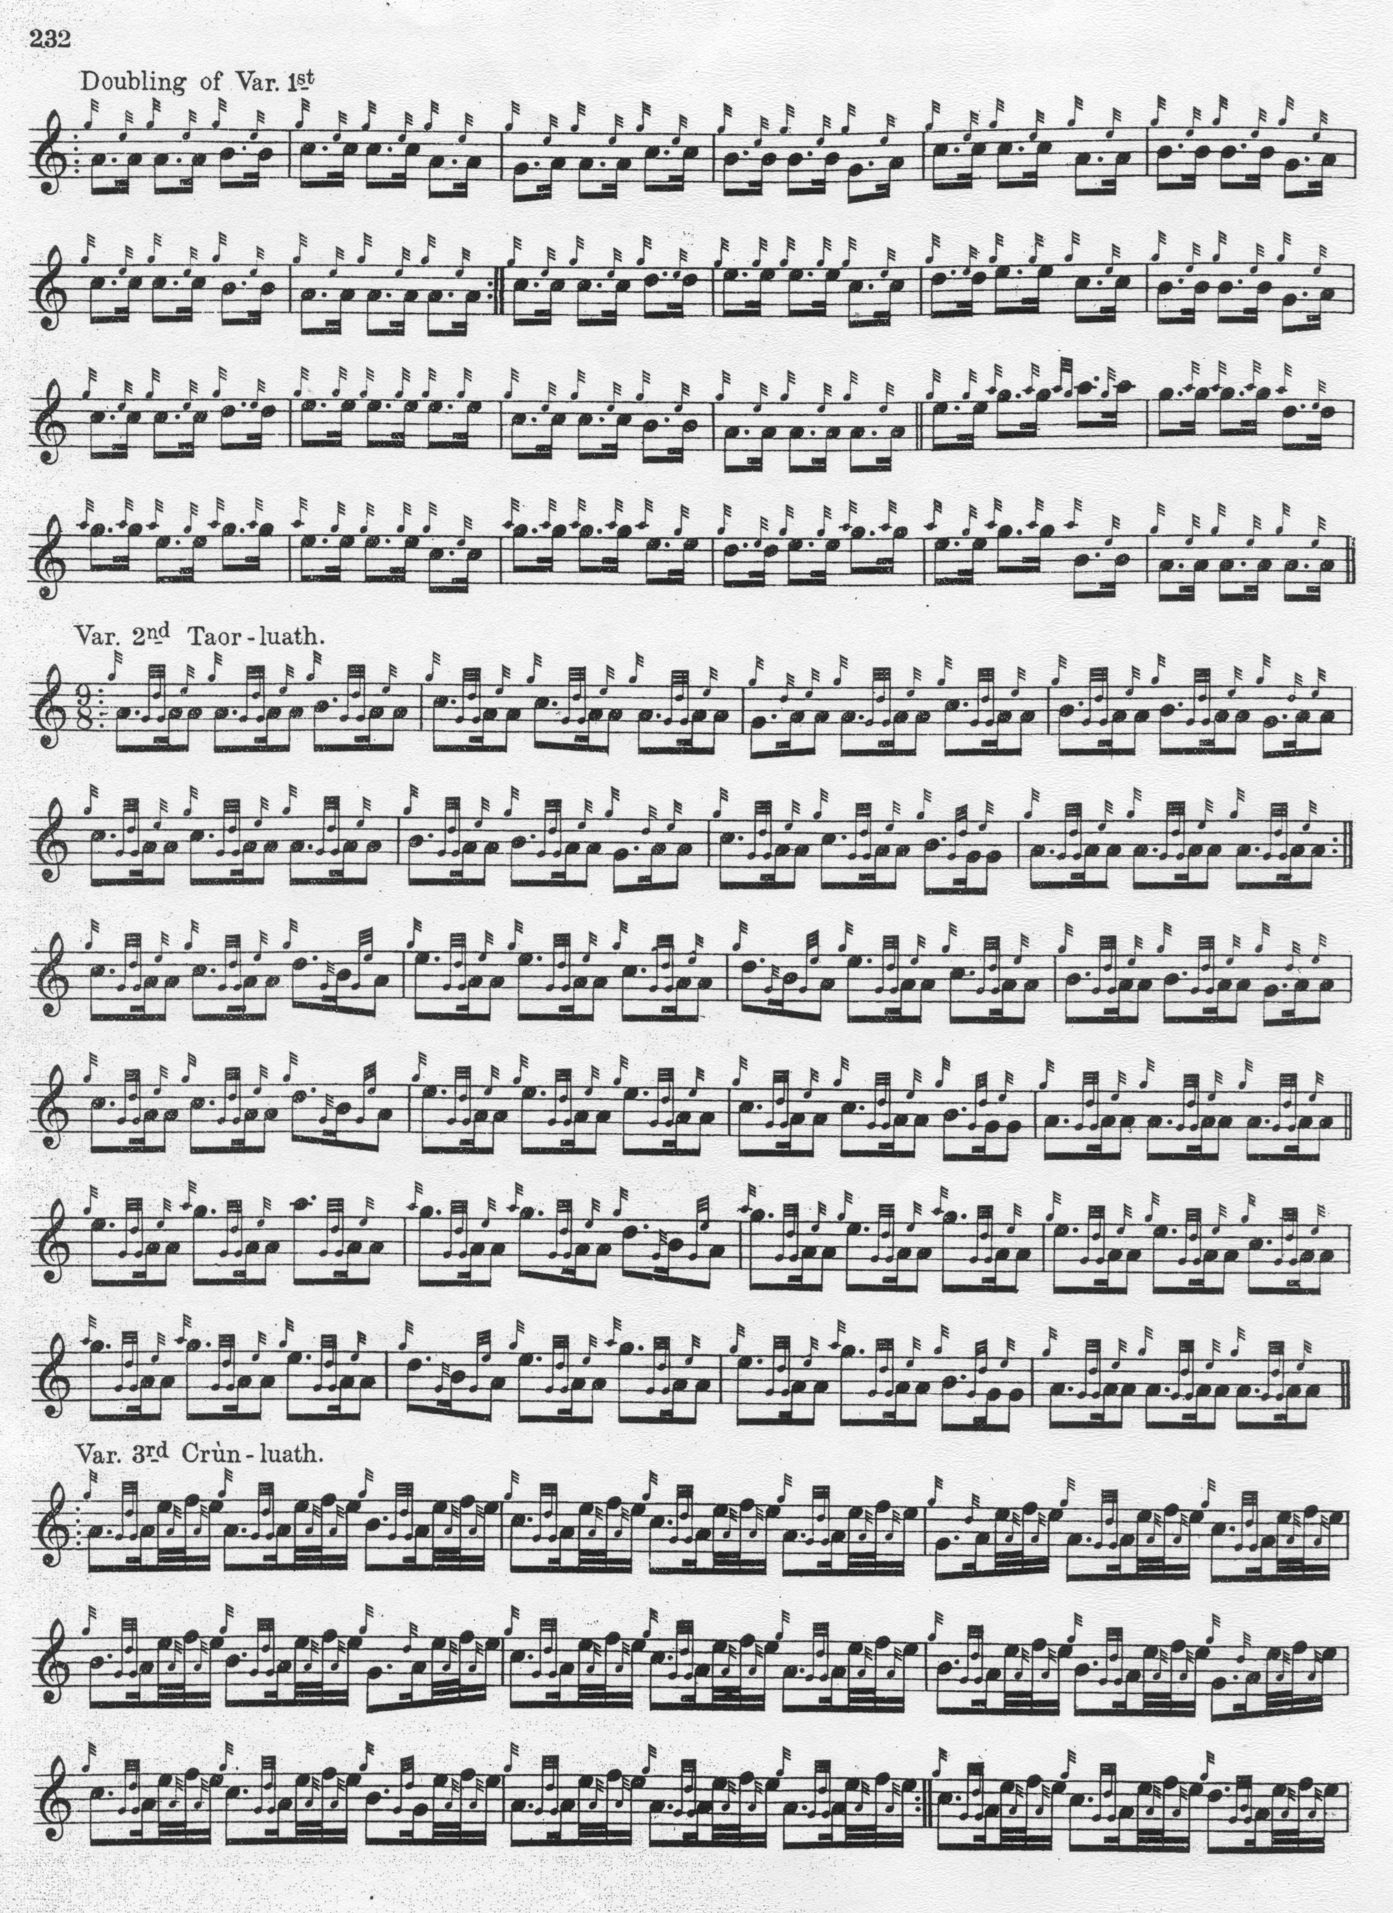
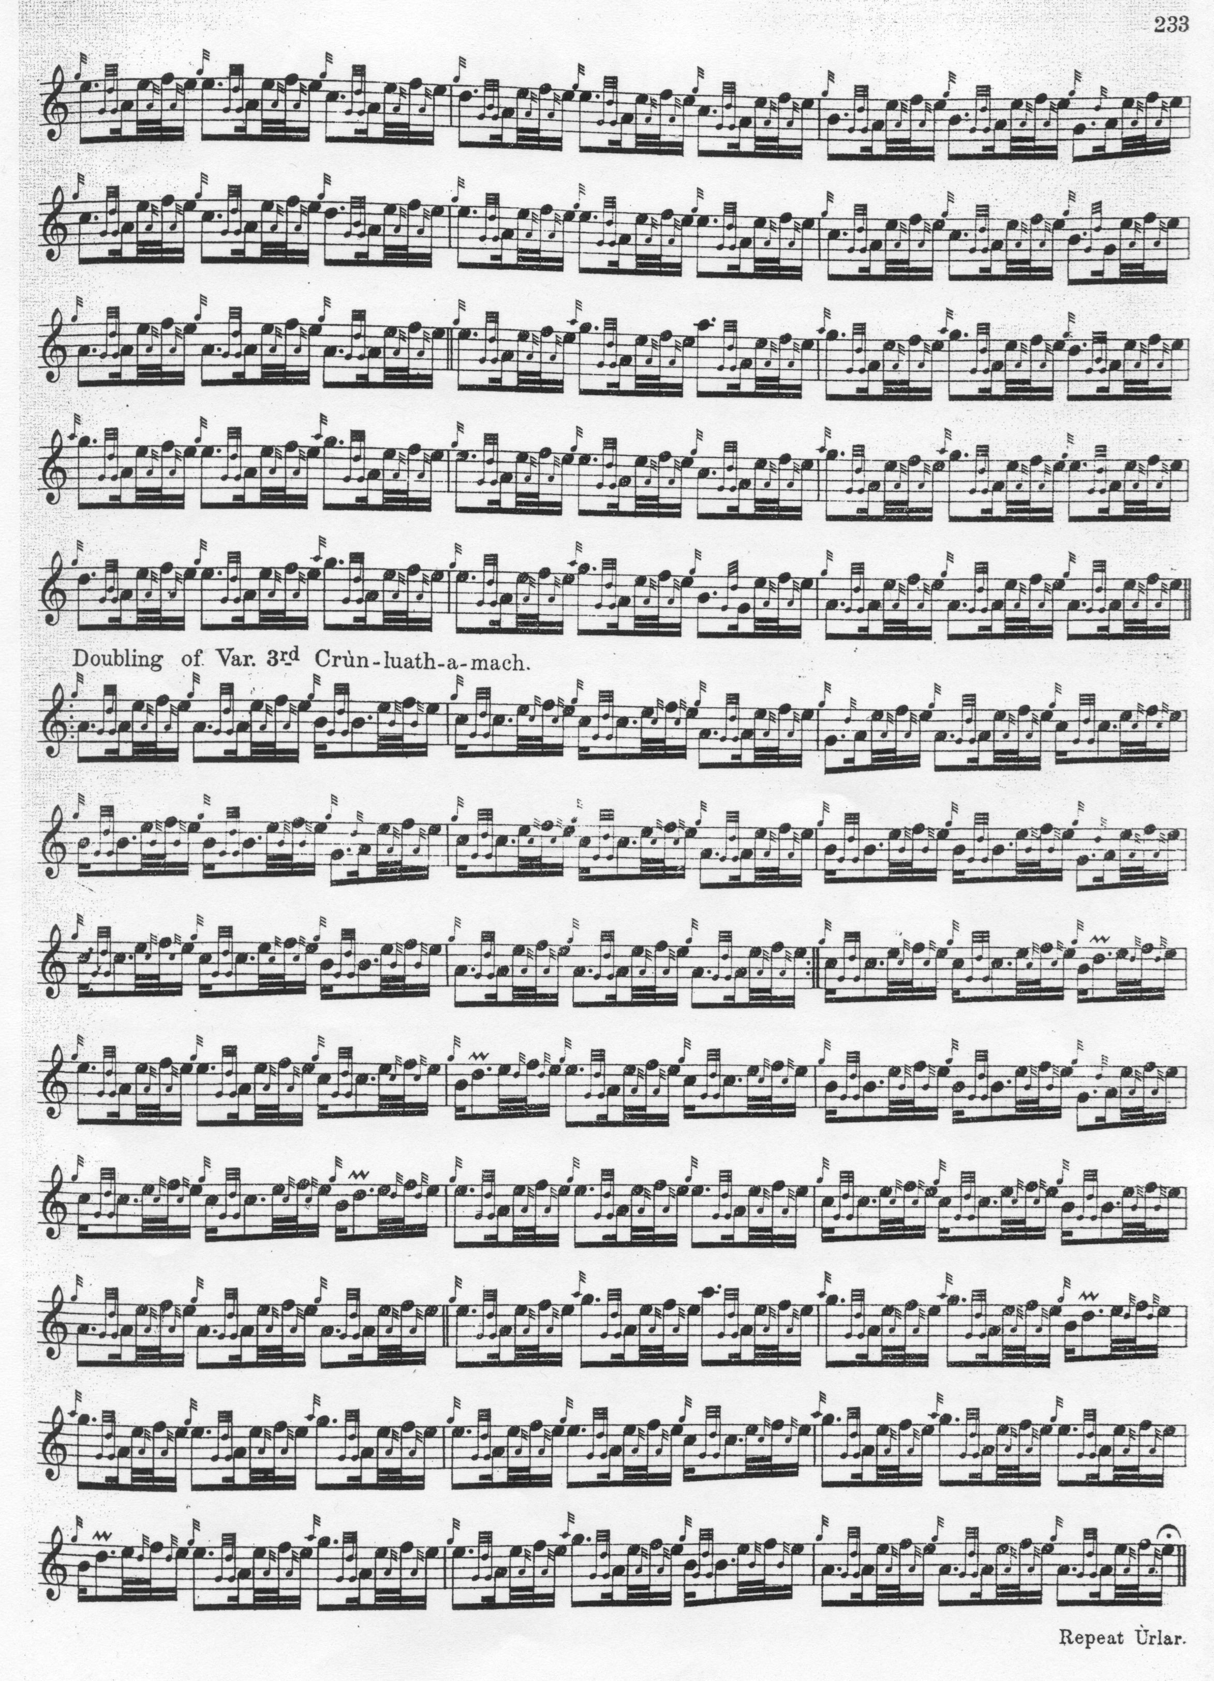

William Stewart of Ensay gives the tune in the first series of the Piobaireachd Society’s Collection with an attribution—as in Glen-- to John Dall MacKay and a suggested translation of the title as “capture by treachery”. Stewart gives his source as Captain Colin MacRae’s MS, but his style is very similar to David Glen’s It makes an interesting comparison with the setting published by Archibald Campbell in the Piobaireachd Society’s second series.

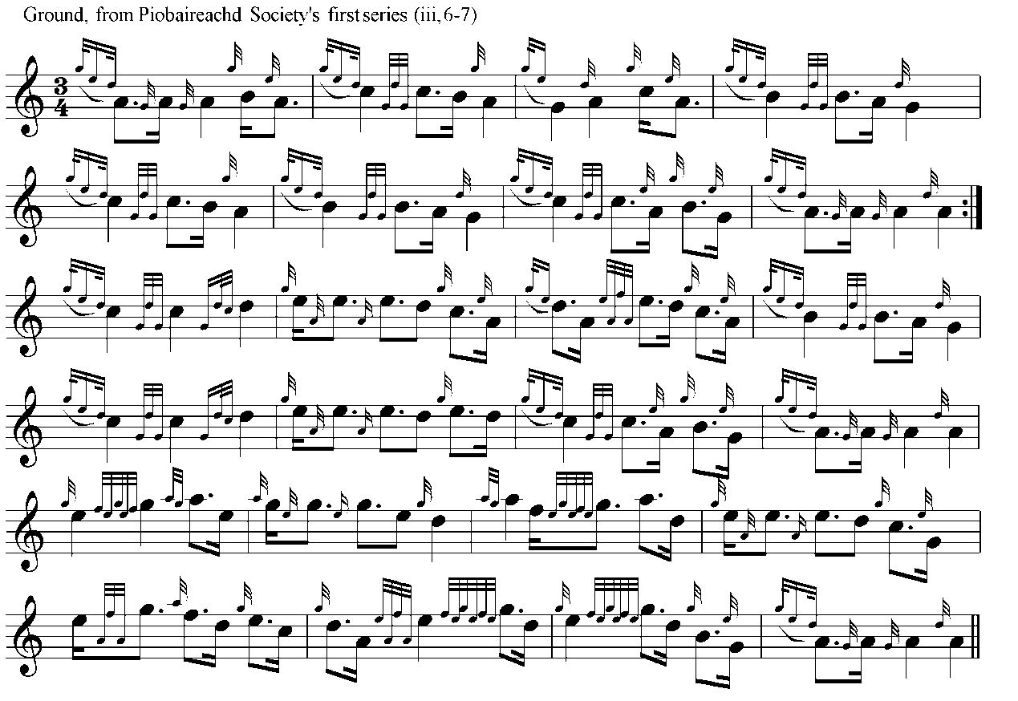

Thereafter the tune is developed as in Angus MacKay, with a siubhal singling and doubling, one taorluath and one crunluath variation. The ground is not directed to be repeated at the end of the taorluath. There is no a-mach.

Commentary:

“The Unjust Incarceration” featured on one memorable occasion in 1923 when there was a play-off for the Clasp at Inverness between Willie Ross and a rising young star named Robert Reid. The Oban Times reported the event as follows:

Another season of Highland Gatherings has come and gone, and it is now possible to write something of the playing of the foremost exponents of the art of pipe music.
In Piobaireachd playing John MacDonald, of Inverness, has shown us that, on his day, he is still superior to any. Unfortunately, he has not been able to compete much this season, for his duties in another sphere leave him very little spare time. At Lochaber, where he was first, he gave us a glimpse of his old brilliancy.
Among the younger generation, Pipe-Major Robert Reid, of the 7th Highland Light Infantry, has enhanced his already great reputation, and his playing of Piobaireachd both at Oban and Inverness was delightful to listen to. Reid is a pupil of McDougall Gillies, of Glasgow, and this distinguished teacher must be gratified at the success of his pupil. At Oban, although the weather was all against good playing, Reid played his tune, “Lament for Donald Ban MacCrimmon”, faultlessly, and brought out all the melody of that testing Piobaireachd. The attractiveness of Reid's playing is that he gives full value to each note, so that one is held by the rhythm of the tune. In addition to this, his fingering is very fine, this being specially noticeable in his Crunluadh and Crunluadhamach.
At Oban, Reid carried off the first prize, and at Inverness he and Pipe-Major W. Ross, late of the Scots Guards and now Pipe-Major of the Lovat Scouts, tied. For a tune they were both asked by the judges to play “Cille Chriosd,” and in the afternoon, on the playing off of the tie, they both played the “Unjust Incarceration”. Ross played the tune through without mistake.
Reid made a couple of slips in the first variation, which allowed Ross to win the clasp to the gold medal. But, apart from the mistakes, and perhaps a slightly hesitating start, Reid's playing was very fine indeed, his Crunluadh-Amach being brilliantly executed. (“Piping in 1923”, Oban Times, 3/11/23, p.3)

* * *

Electronic text © William Donaldson, Aberdeen, Scotland, 2001; revised Cambridge, Massachusetts, March 2025.

