The Lament for the Union

This is a widely diffused tune. There are settings in the following manuscript sources:

--Donald MacDonald’s MS, ff.190-198 (with the title “The Union”);
--Angus MacKay’s MS, ii, 86-88;
--Colin Cameron’s MS, ff.5-6;
--Donald MacKay’s Ballindalloch MS, marked “Donald Cameron’s set”;
--C. S. Thomason’s MS, f.31;
--D. S. MacDonald’s MS, ii, 75-6;
--David Glen’s MS, ff.3-7;

and in the following published sources:
--Niel MacLeod of Gesto, pp.13-16
--C. S. Thomason’s Ceol Mor, pp.227-8

Donald MacDonald: one notes the nice reflexive gracenotes in his ground, but that ground is irregular; the underlying structure is two lines of 8 bars each with an “additional” eallach at the end of each line. Whoever has subsequently inserted bar lines and marked the tune off into sections (and these do appear to be later additions) has done it very clumsily. The first variation though seems “out” , or not in keeping with later notions of regularity. MacDonald is a bar short in the first line through not reflecting his double echo in the ground fully enough. And the same seems true of all the later variations in this position. MacDonald’s taorluath a mach has, as usual, the first note accented, except on the D which is cut, although interestingly not in the crunluath:

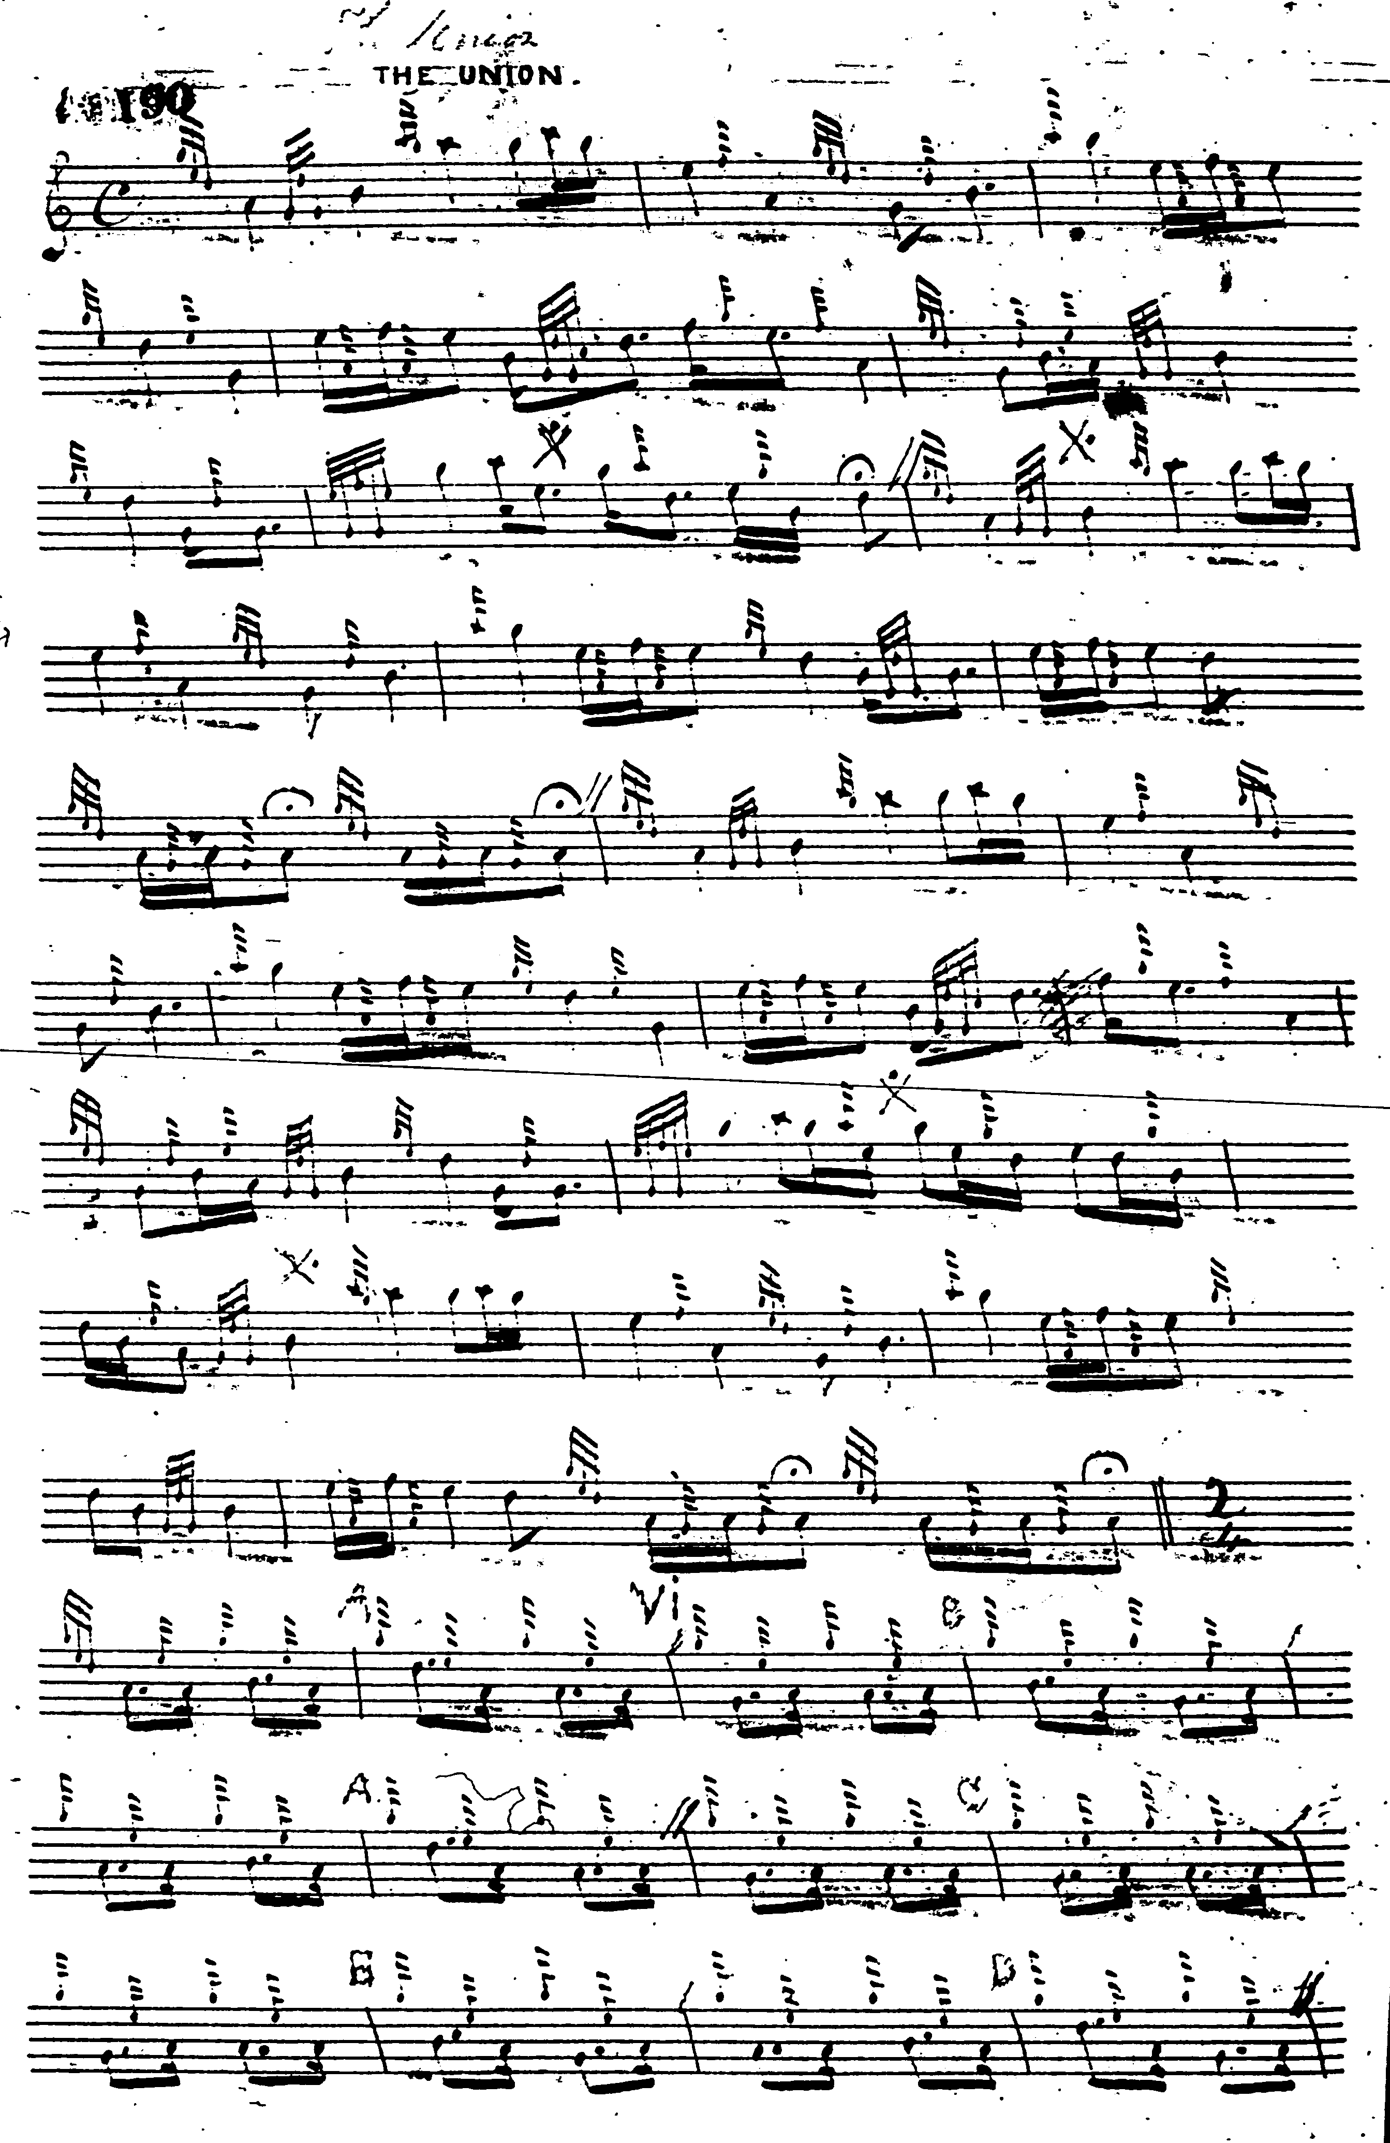
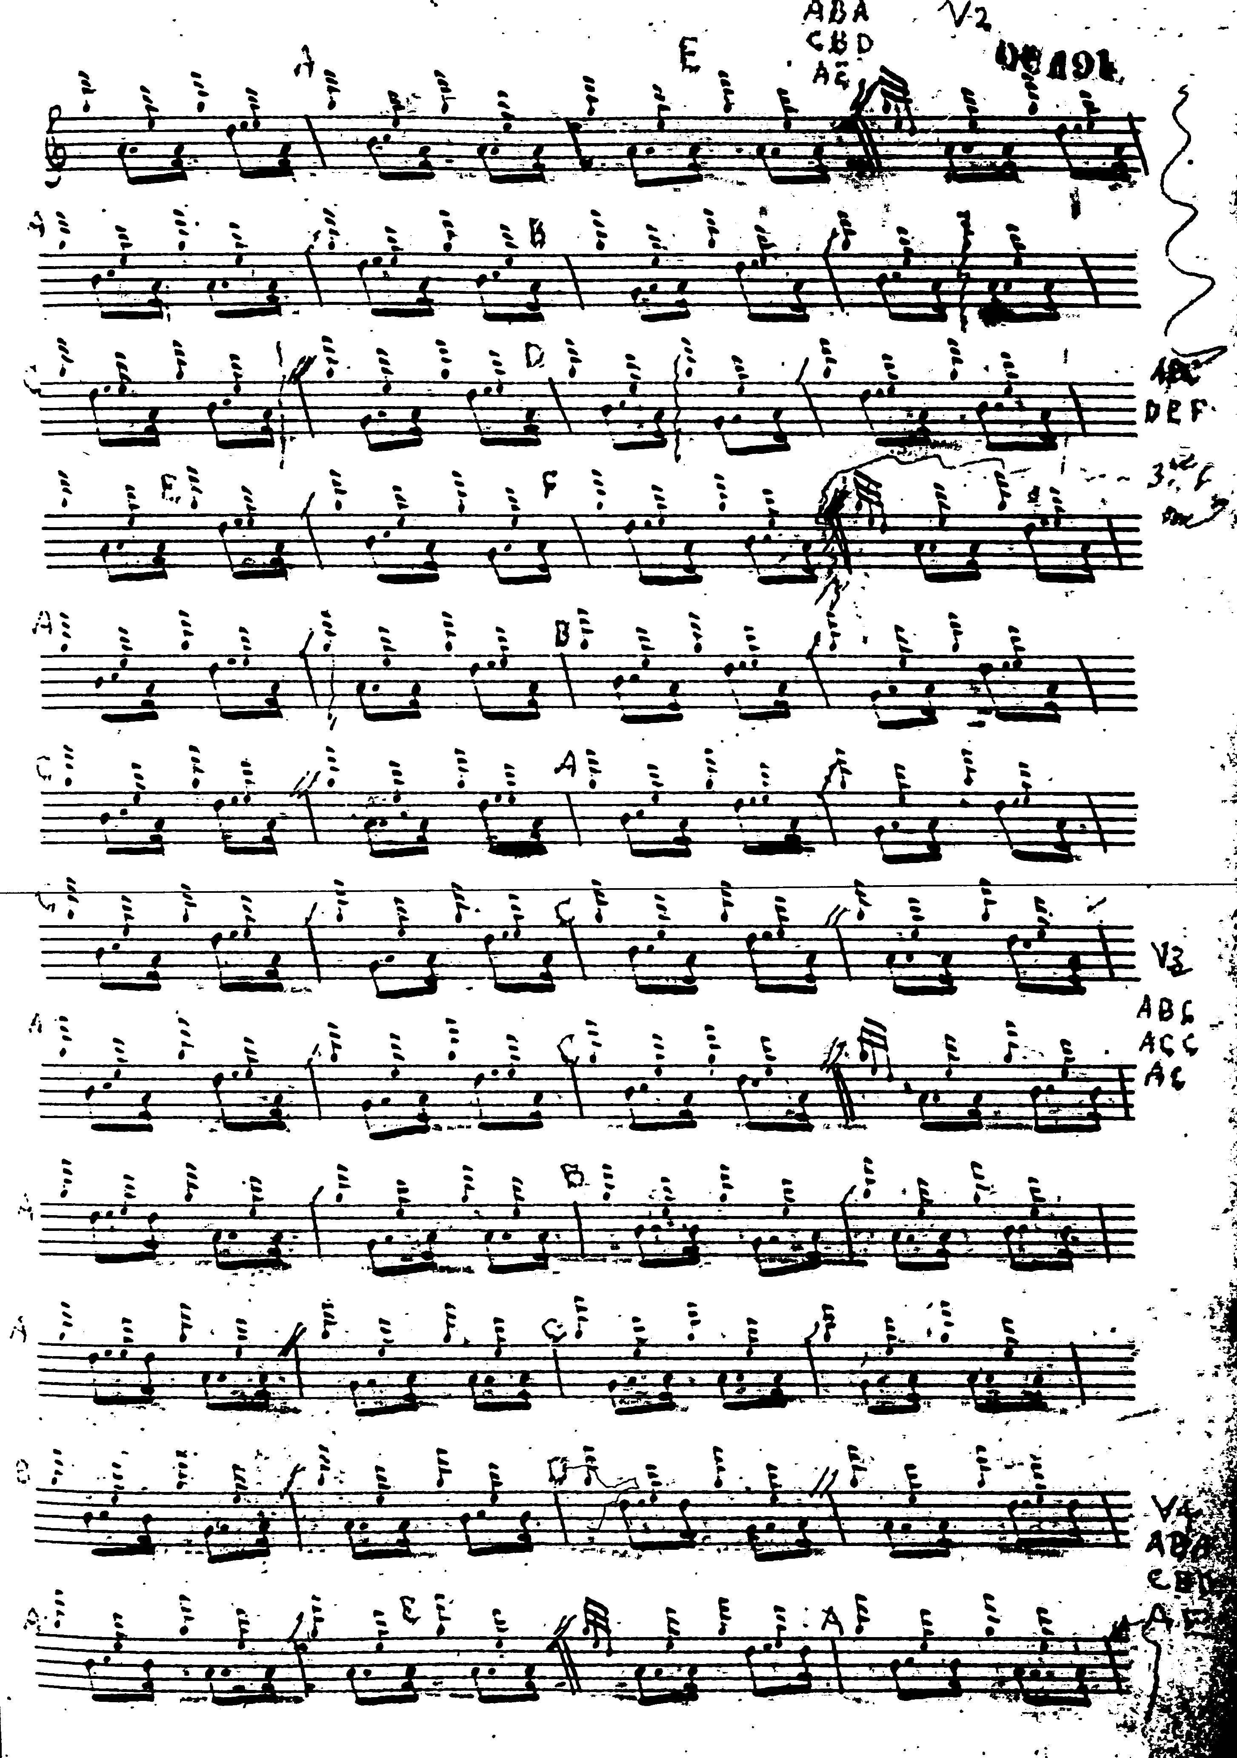
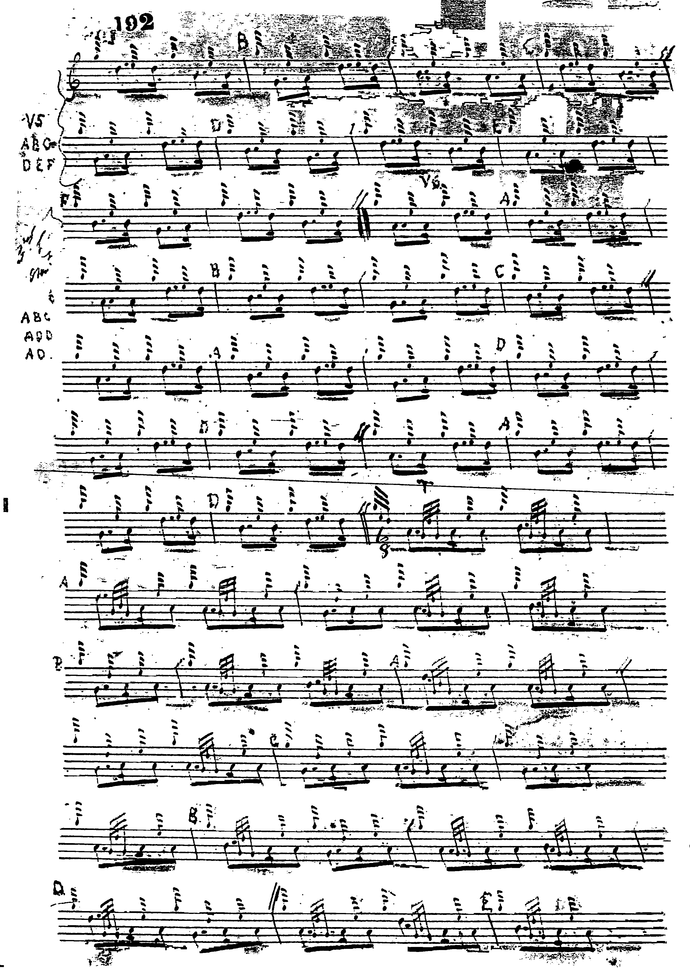
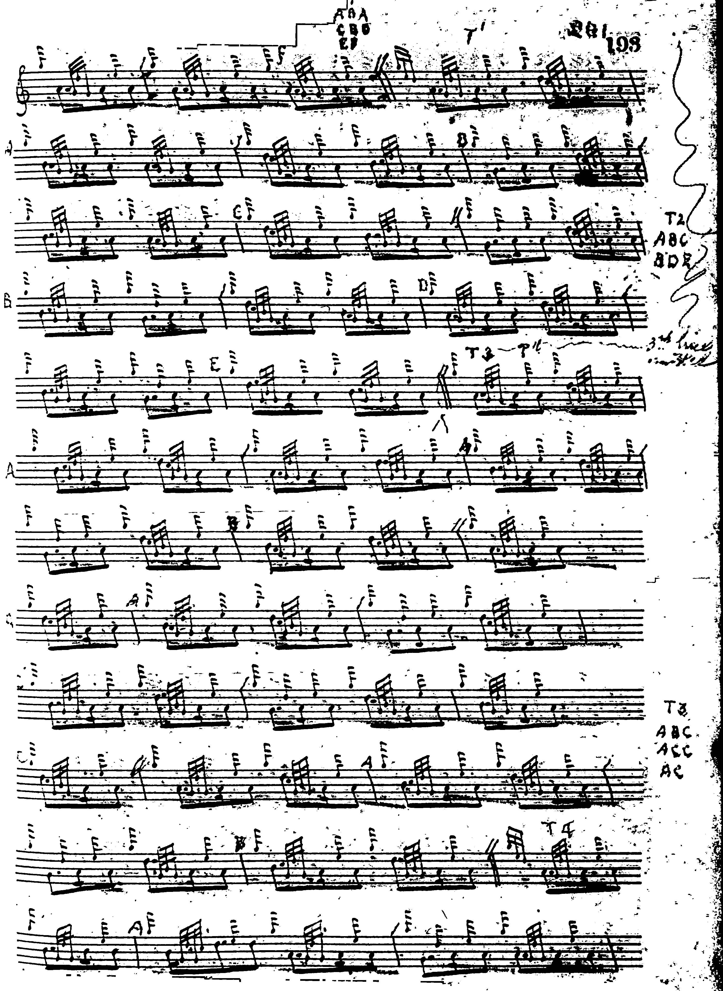

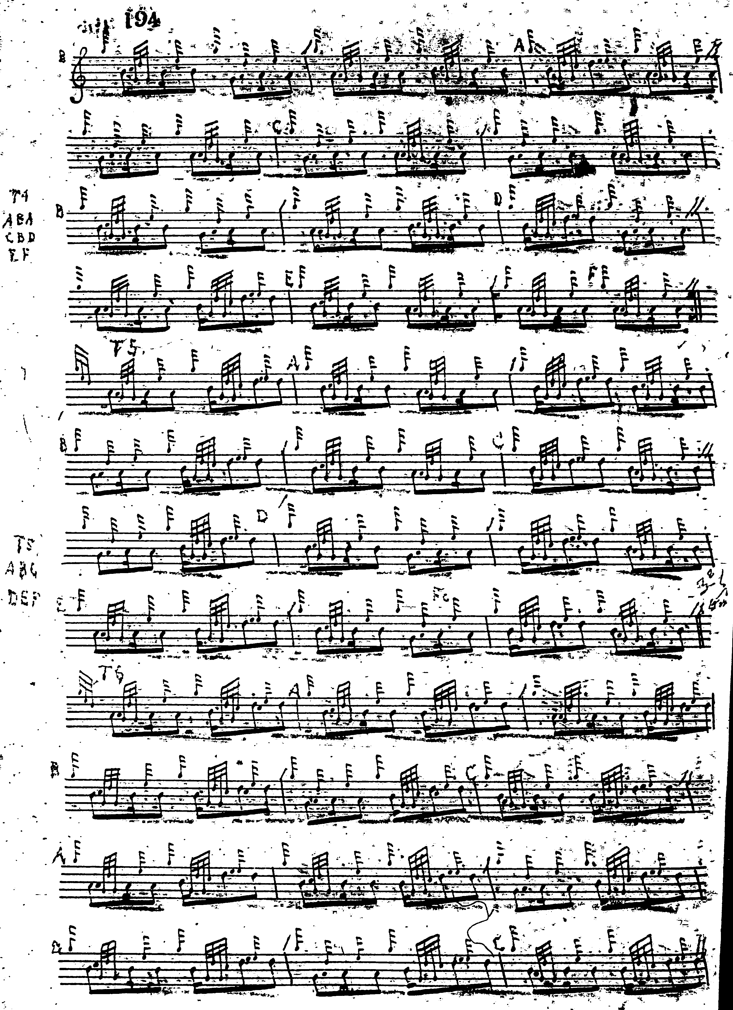
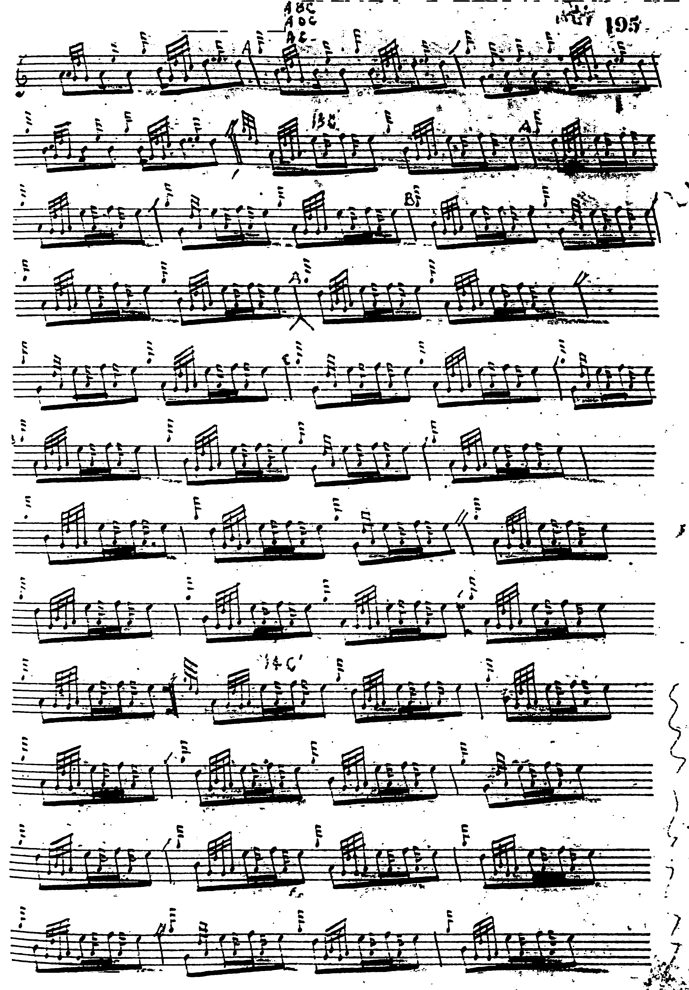
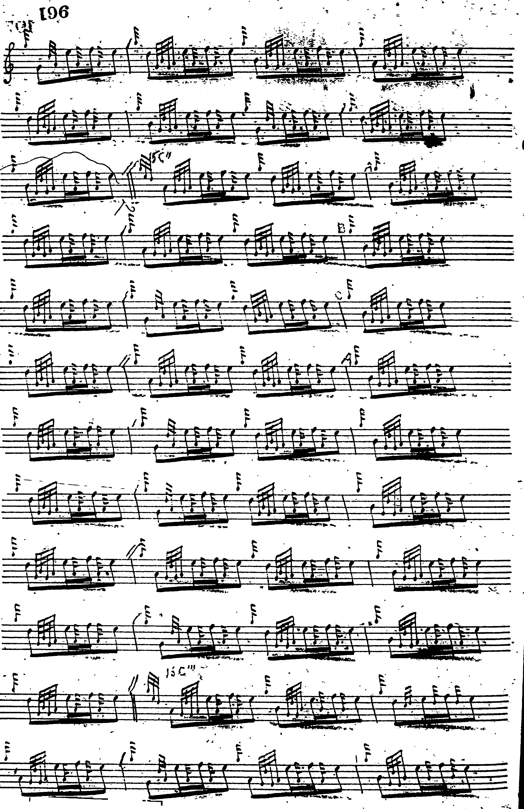
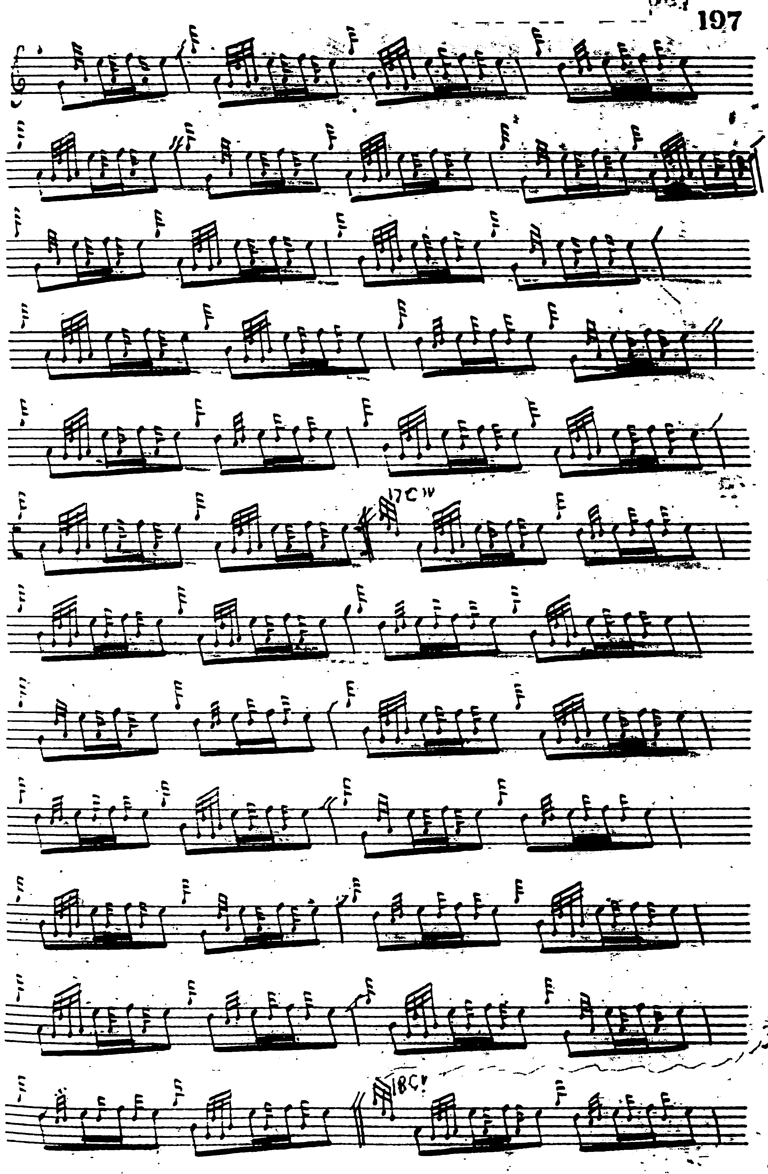

Angus MacKay: also has his ground in two lines of eight bars, but he seems to have had trouble barring this long and seamlessly flowing melody. Indeed, he had two goes at it, as we see below. His first variation is “out” like MacDonald’s: he has 6 bars in line one and 8 in line two, and this same pattern is reproduced in the first variation of each of the subsequent groups. MacKay times his taorluath a mach with the accent on the initial note in each case, including the movement on D. It is interesting, too, that MacKay repeats the ground at the end of the taorluath variations. Here is his first version:

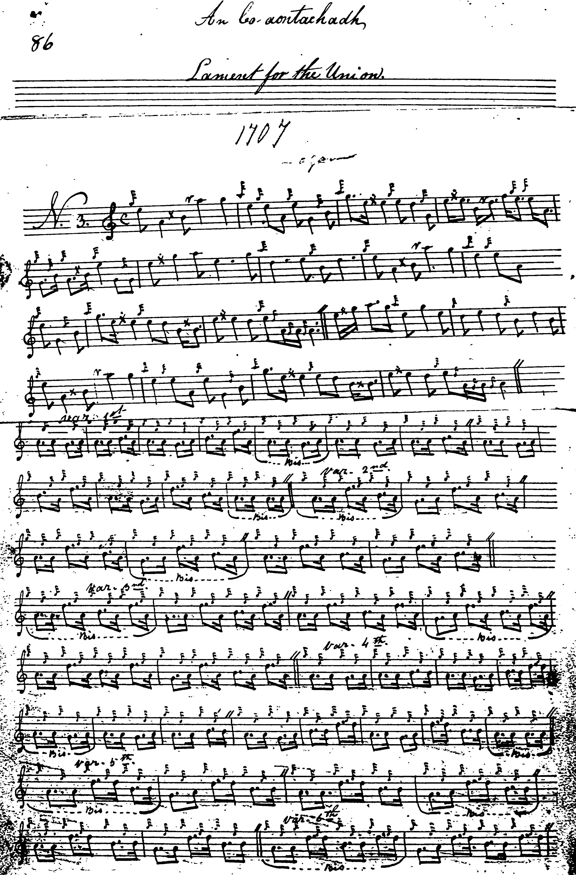
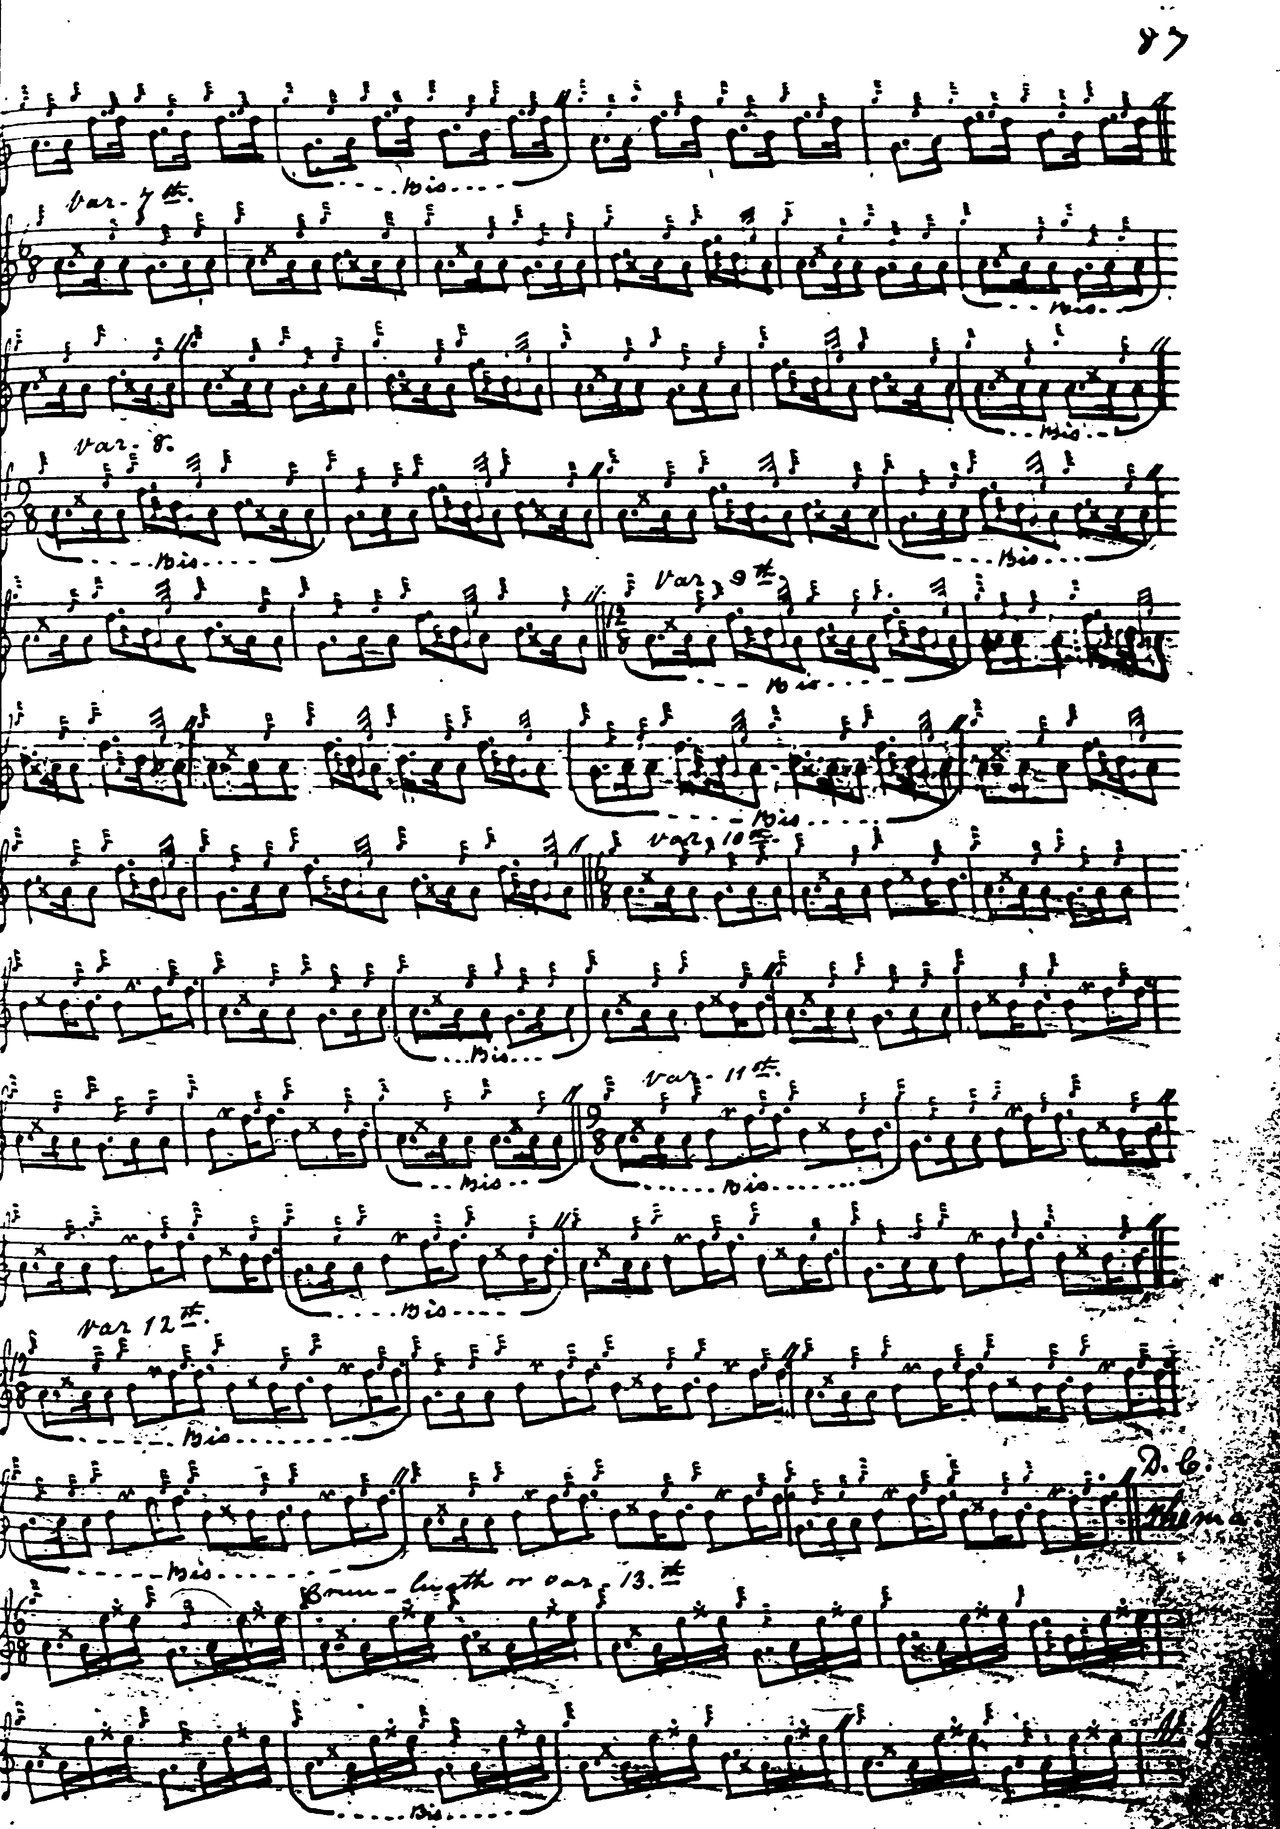

And now Angus MacKay’s second version:

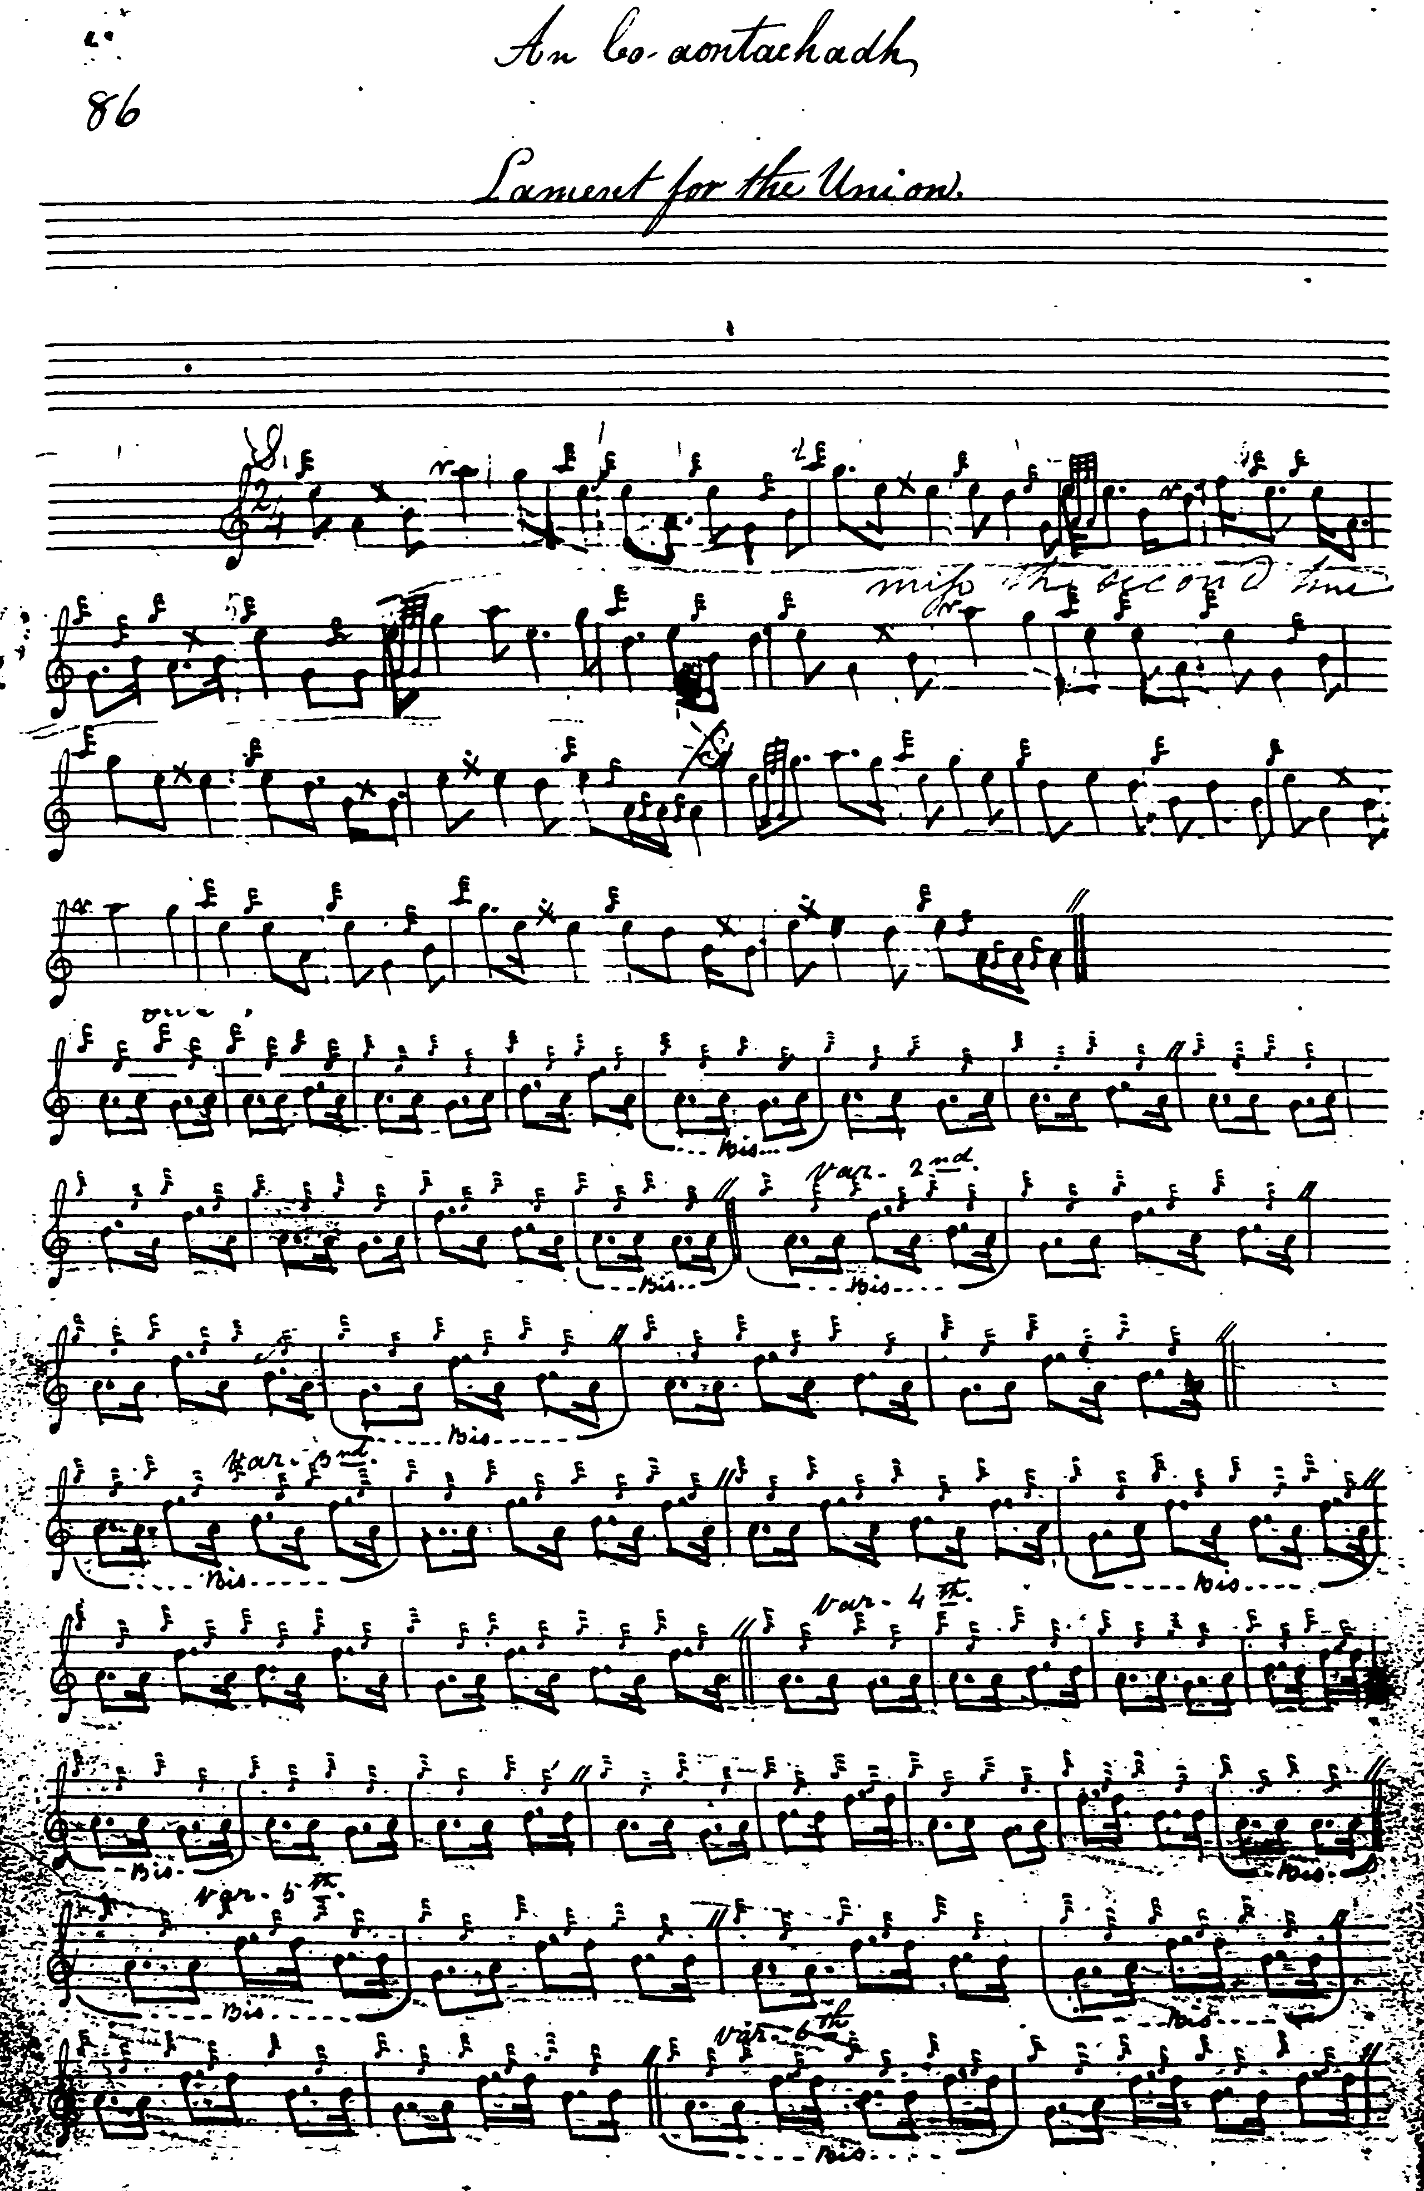
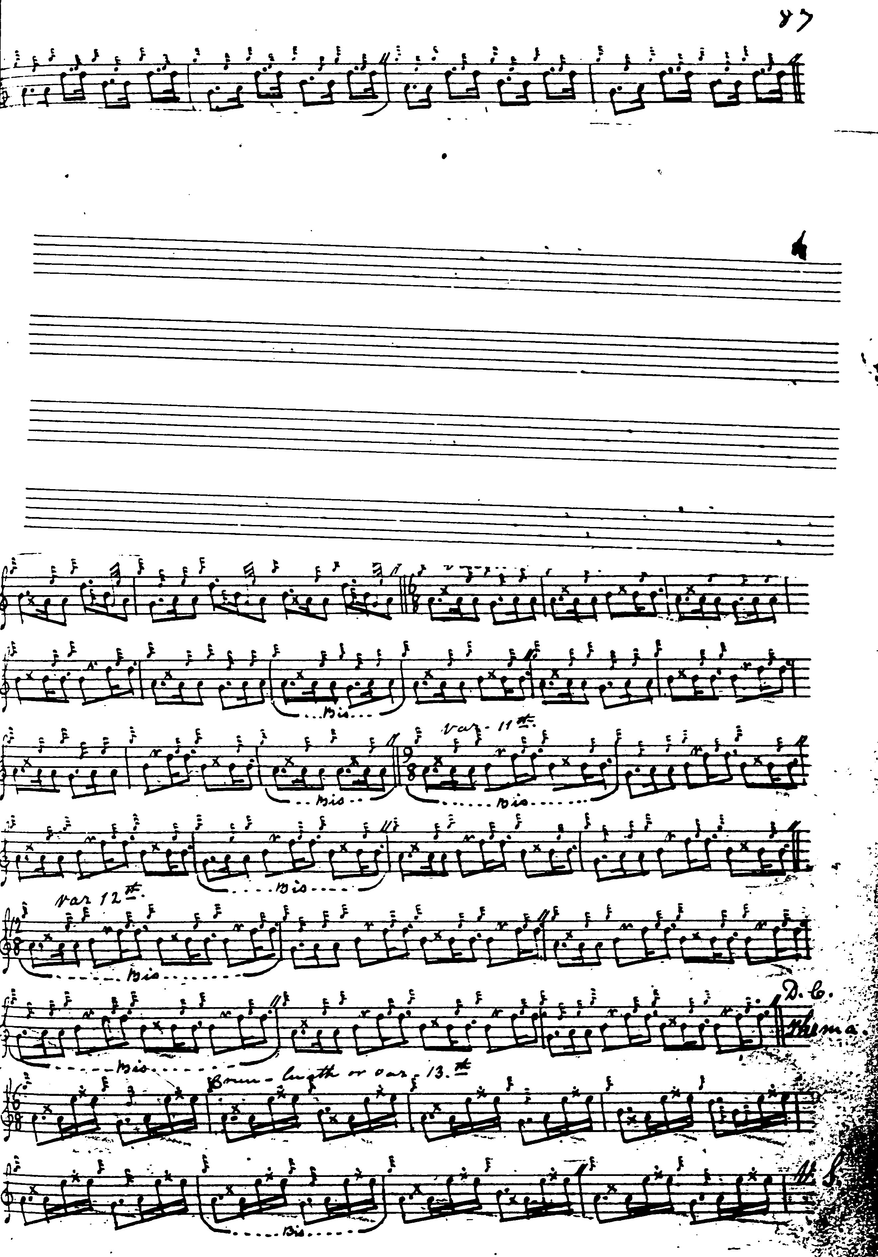
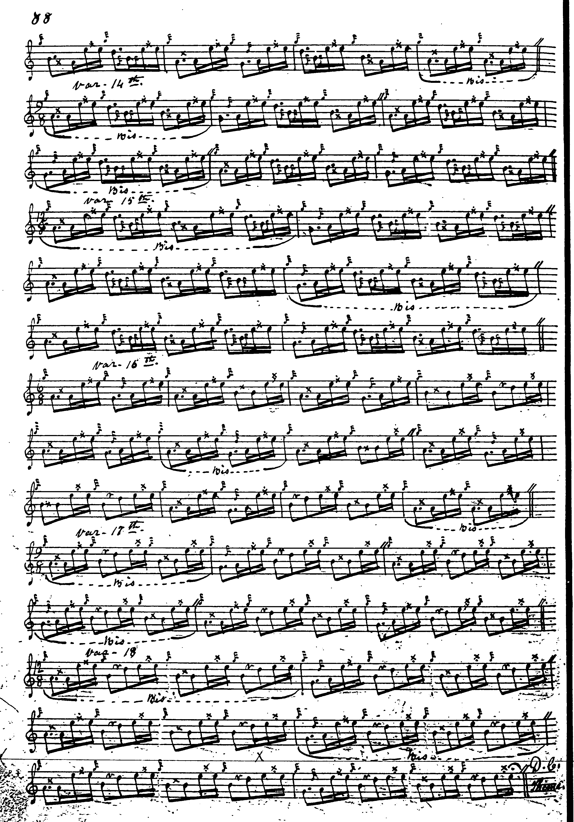

Colin Cameron: the score bears a note at the foot “Donald Cameron’s Book” and it is in two different hands, the ground probably Donald Cameron’s, the remainder in his son Colin’s. It is barred eccentrically, at least in the ground. The ground is in two lines of eight bars each, the final eallach being played “down”. The present score goes up only as far as the taorluath doubling, which is marked “DC”. The approach is broadly similar to MacKay’s:

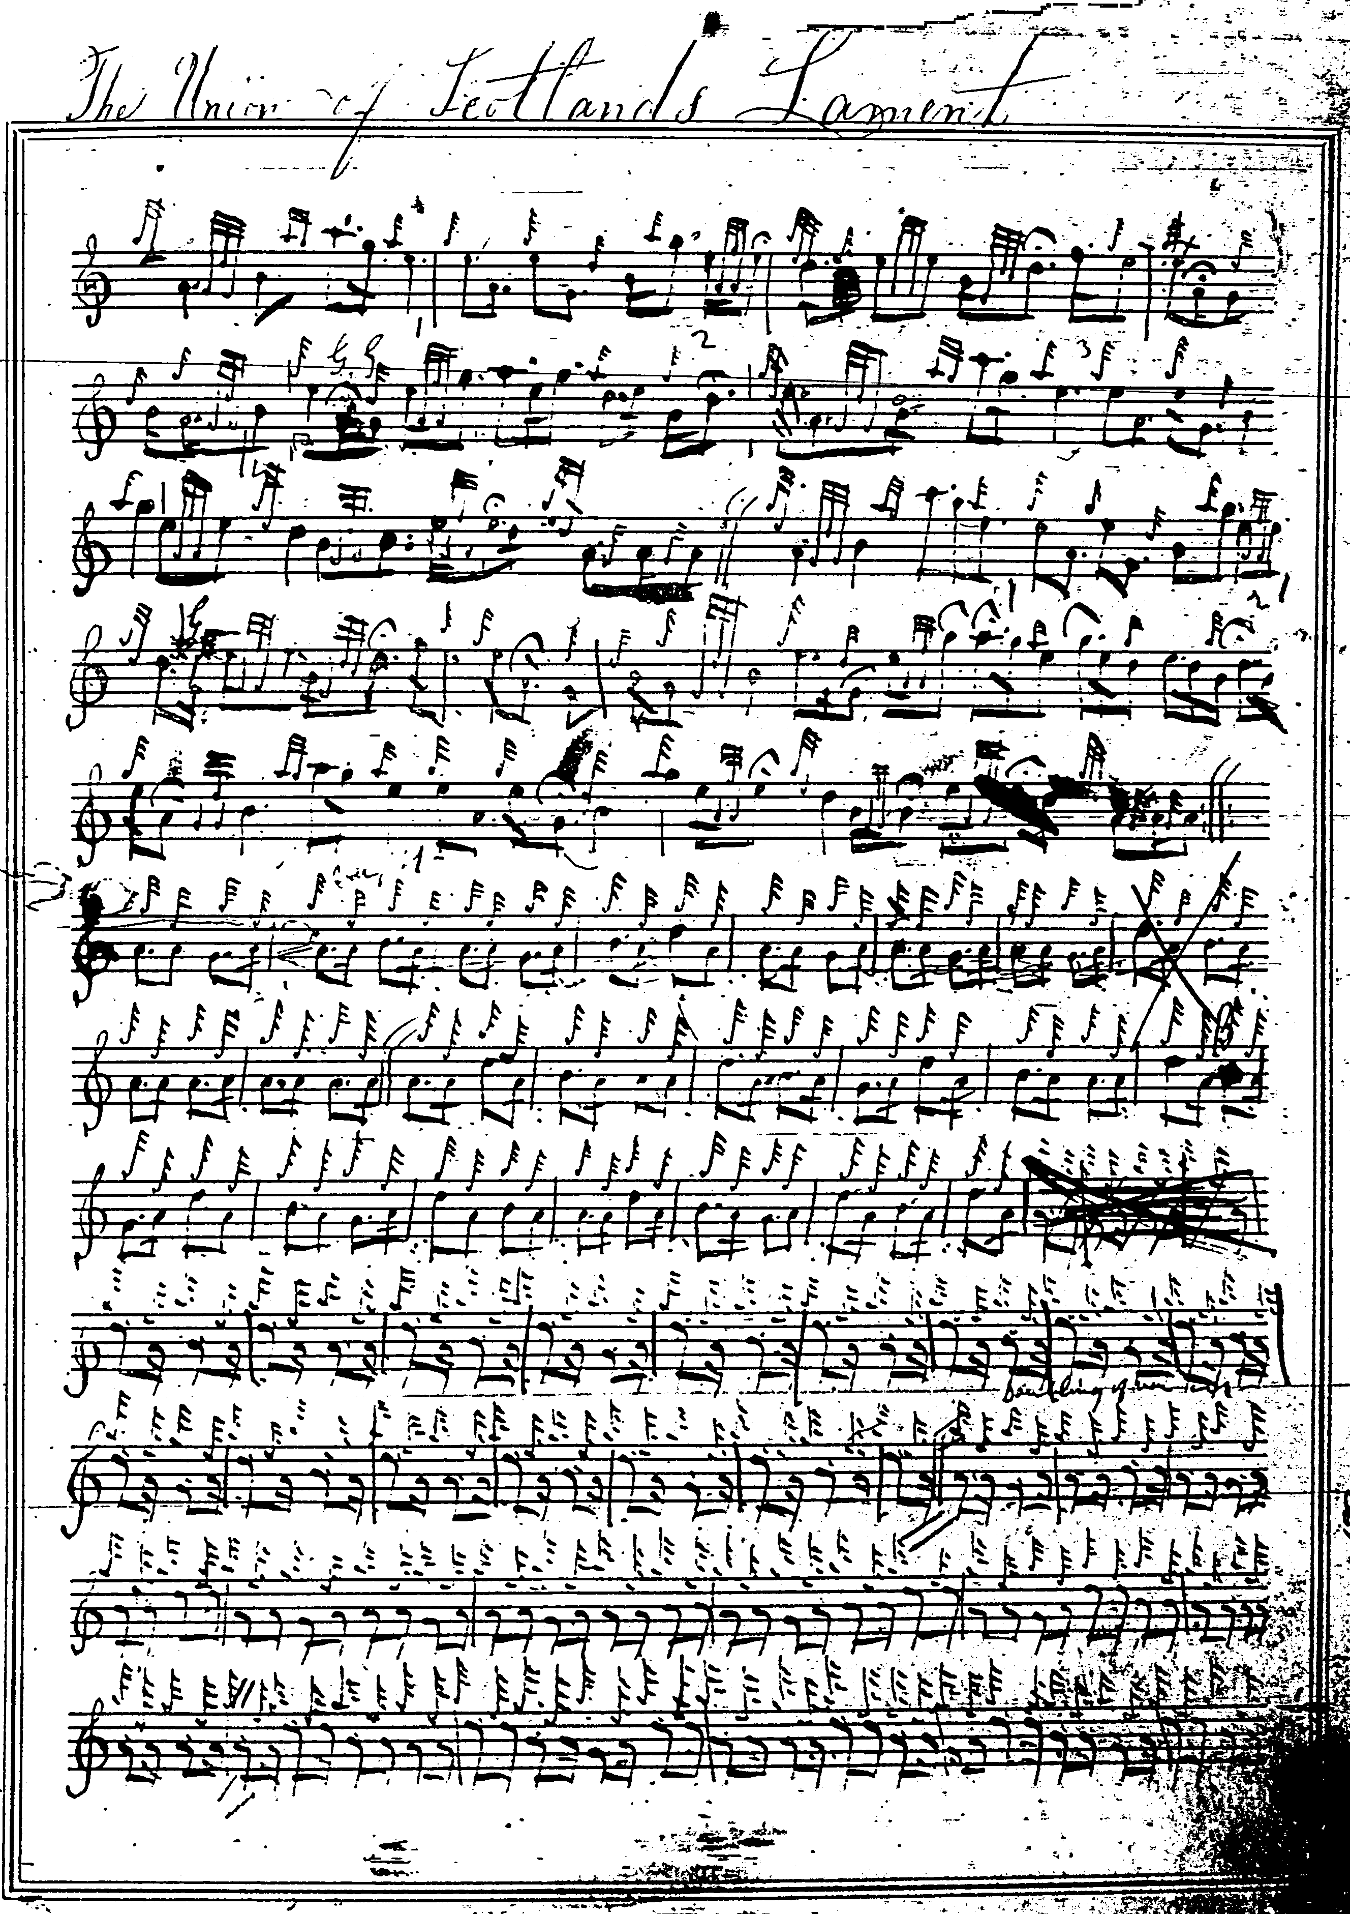

And so on.

D. S. MacDonald’s setting includes an interesting “edre” movement, a Finger Lock type pseudo-crunluath which immediately follows the taorluath a-mach and is applied to all three of the variations and it is after this, by which time the tune must be going at the most tremendous lick, that D. S. brings back in the ground, finishing off with a “duinte” crunluath singling, doubling and a-mach. David Glen has this variation as well, (Glen’s score is reproduced below), but does not repeat the ground within the tune, although it really does seem necessary to provide a breathing-space between the two different sets of crunluath variations if one elects to play them.

David Glen: had two attempts at setting the ground, the first in his MS and later in his published Edinburgh Collection. Both are reproduced below, and discerning players may well find them attractive. He also has the “edre” variations featured in D. S. MacDonald’s score, and his manuscript ground has an appealing little turn on D in bar 1:

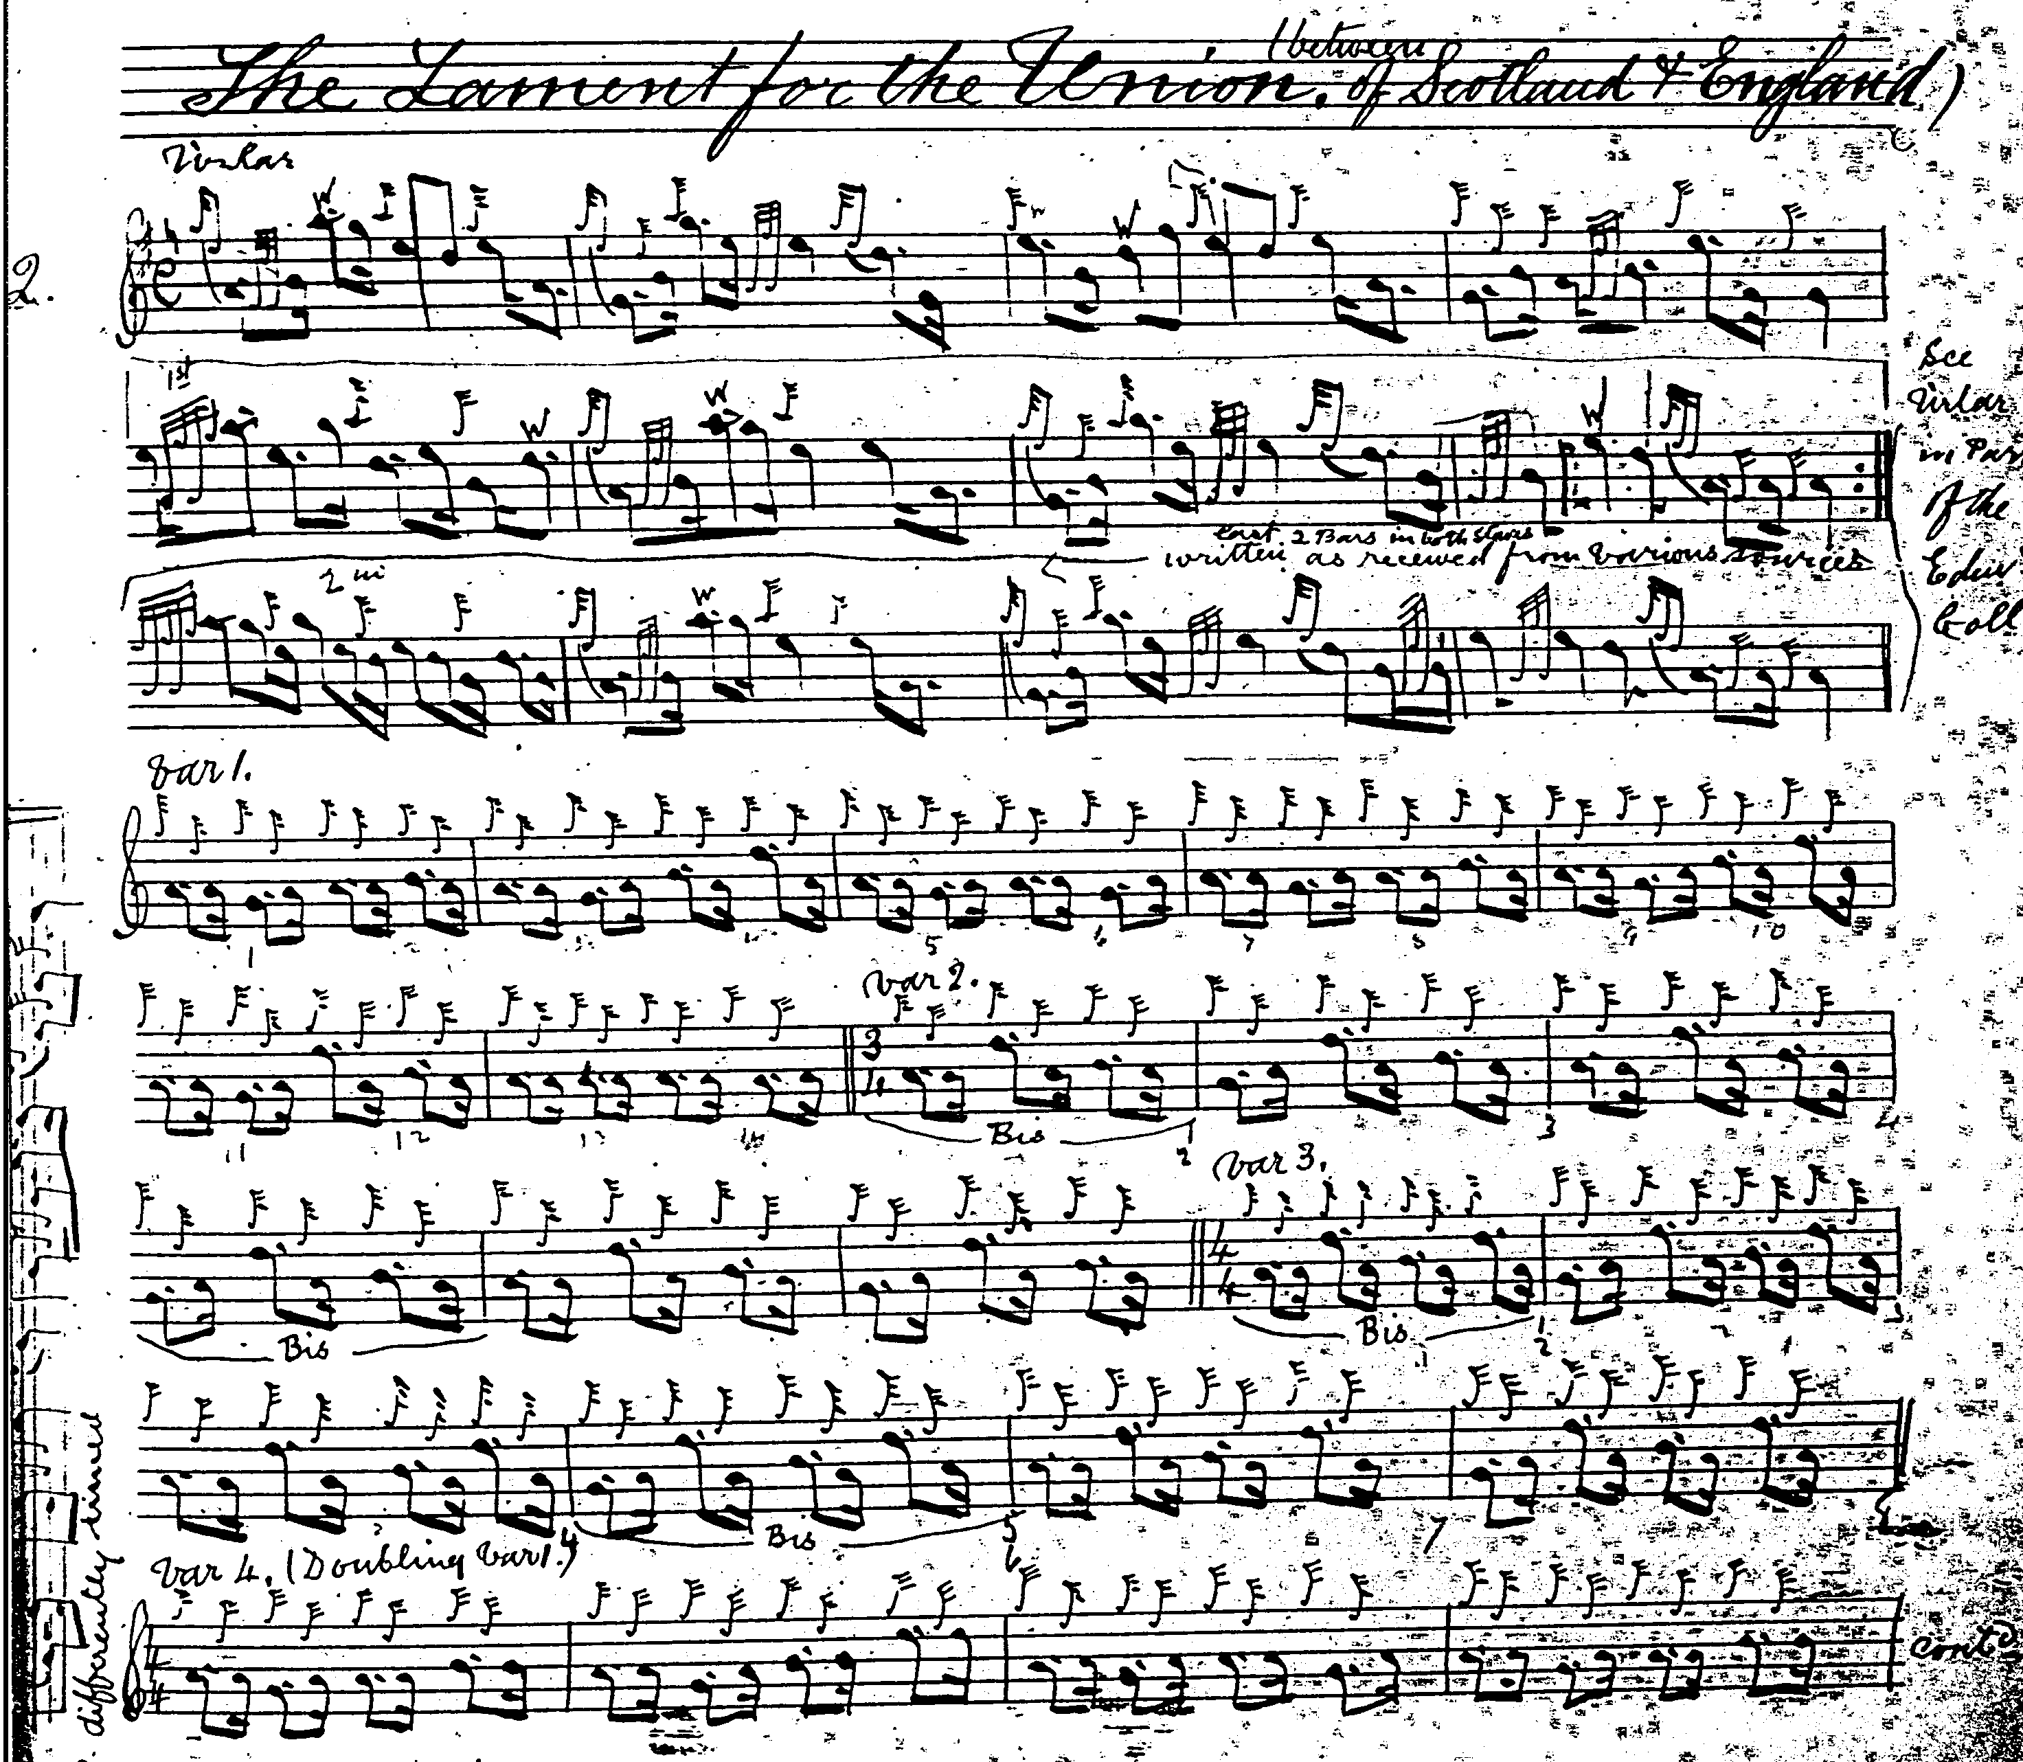
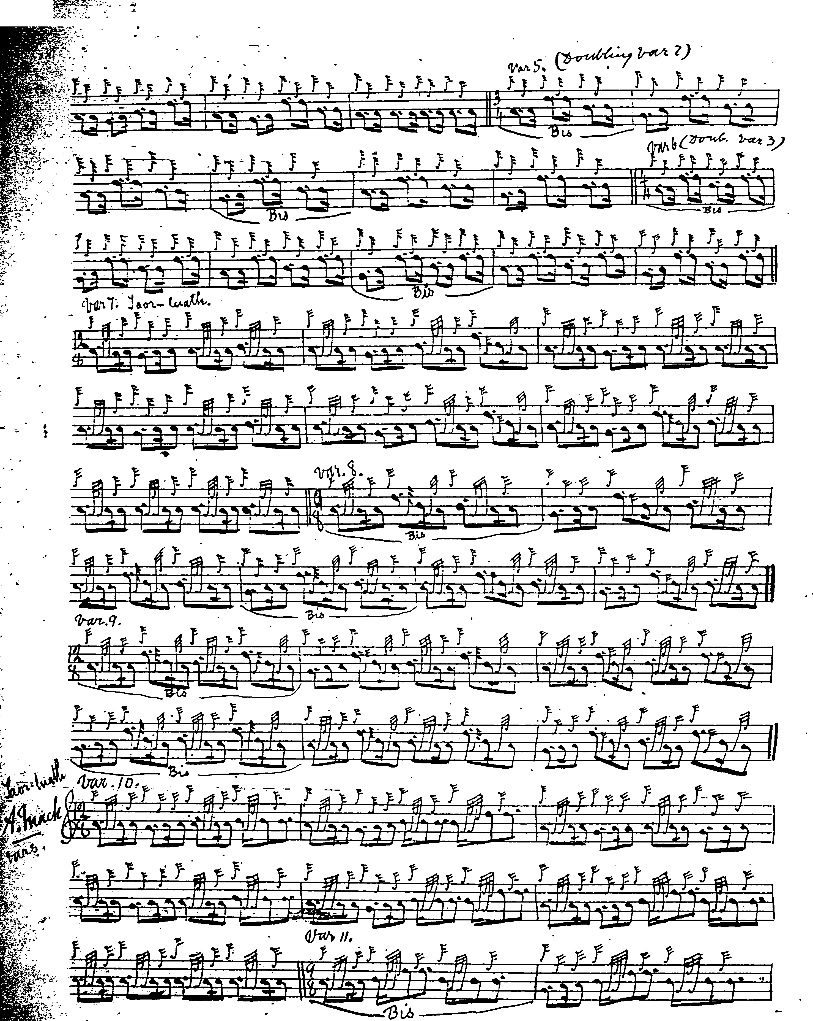
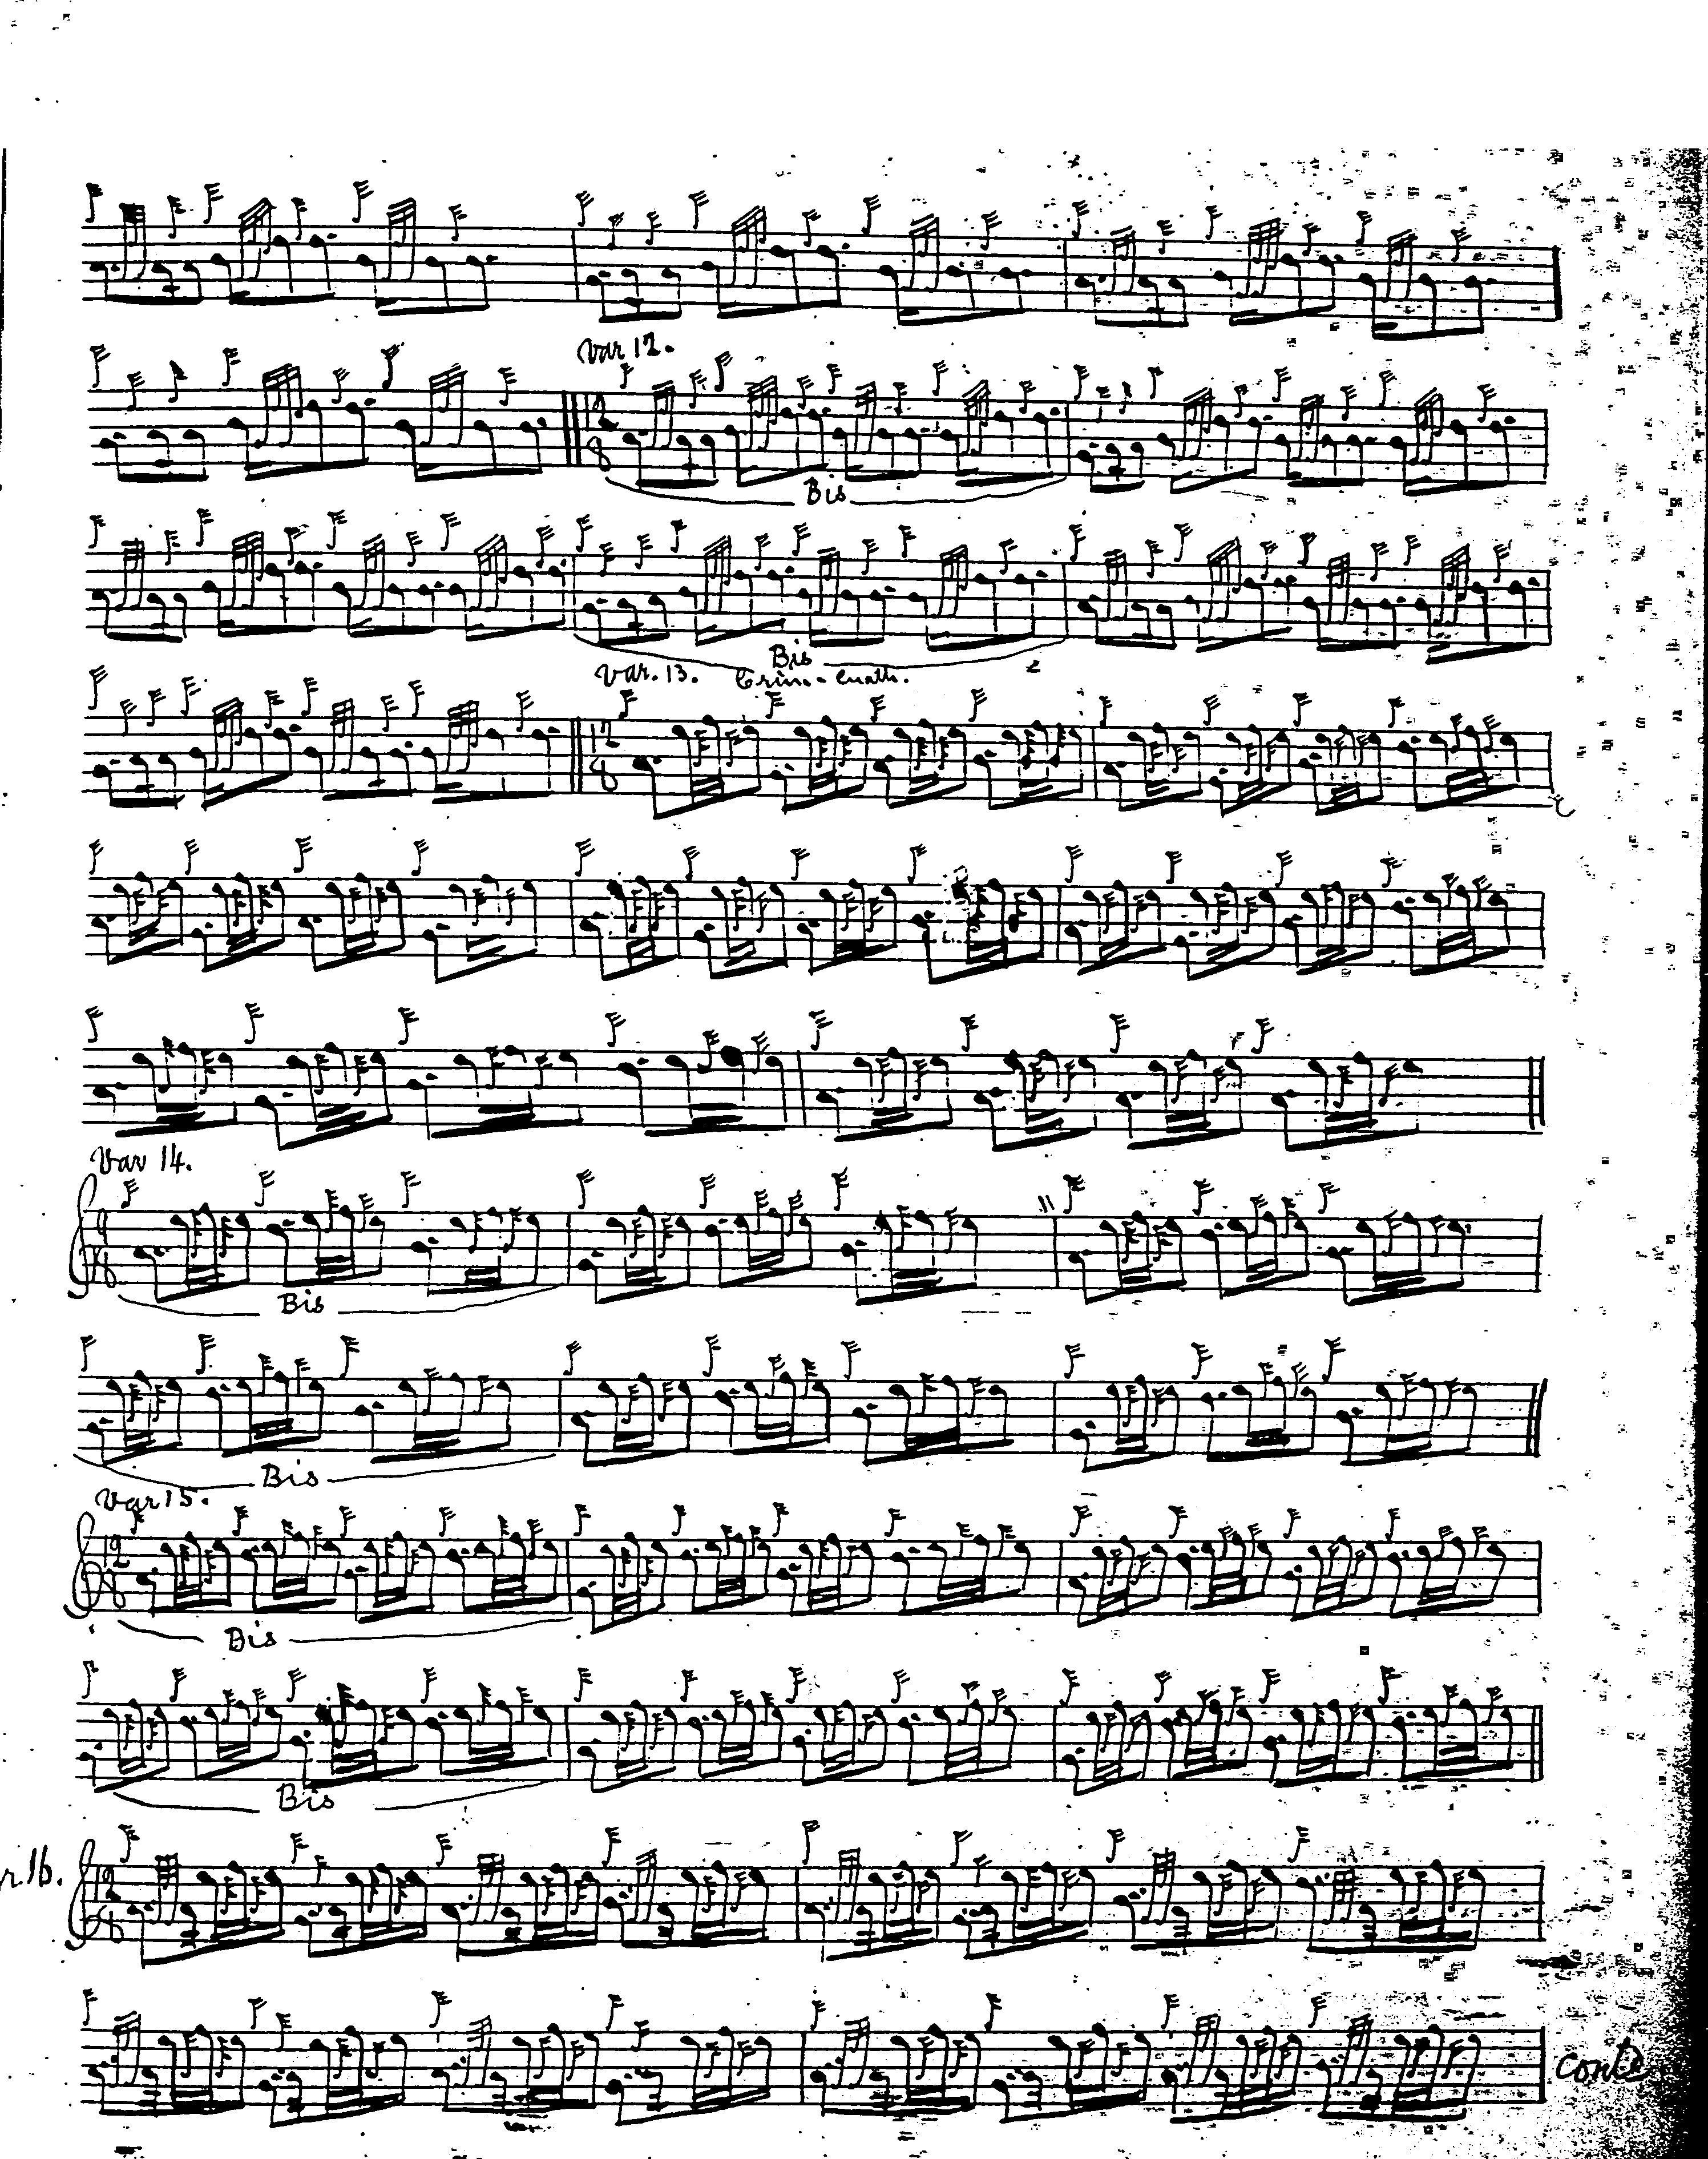

And so on.

The main feature of the Edinburgh Collection ground is Glen’s integrating the grip on B normally included in bar 15 into the first figure in the following bar, with some might think pleasing effect:

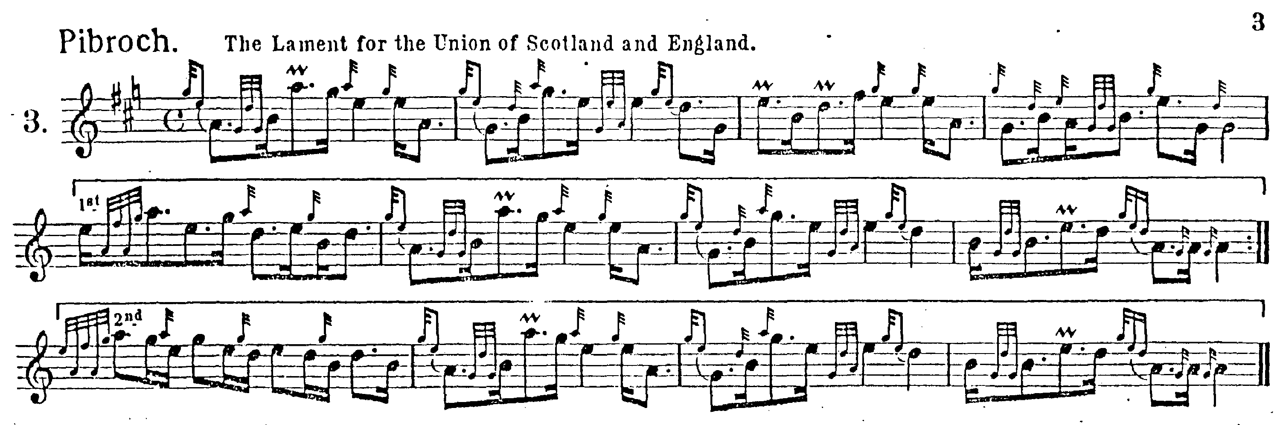

C. S. Thomason’s score is rather eccentrically barred and not perhaps one of his happier efforts:

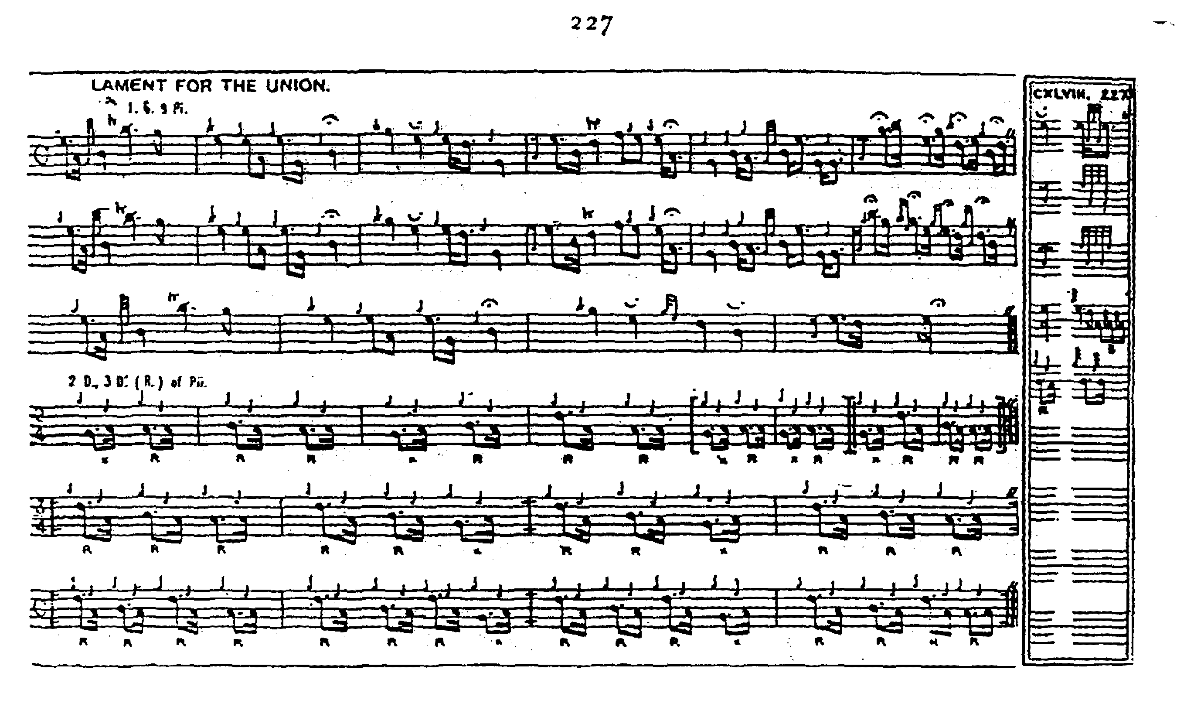

And so on.

This appears to be a rationalisation of Donald MacDonald, perhaps with influence also from the Cameron family since Keith Cameron and Donald MacKay are both cited amongst Thomason’s sources. Donald MacKay was apparently taught the tune by Donald Cameron, and it is given as “Donald Cameron’s Set” in MacKay’s Ballindalloch MS. Notating the ground seems to have given MacKay the same kind of problems as everybody else: there are smudgy traces of adjusted time values which would suggest something along the following lines:

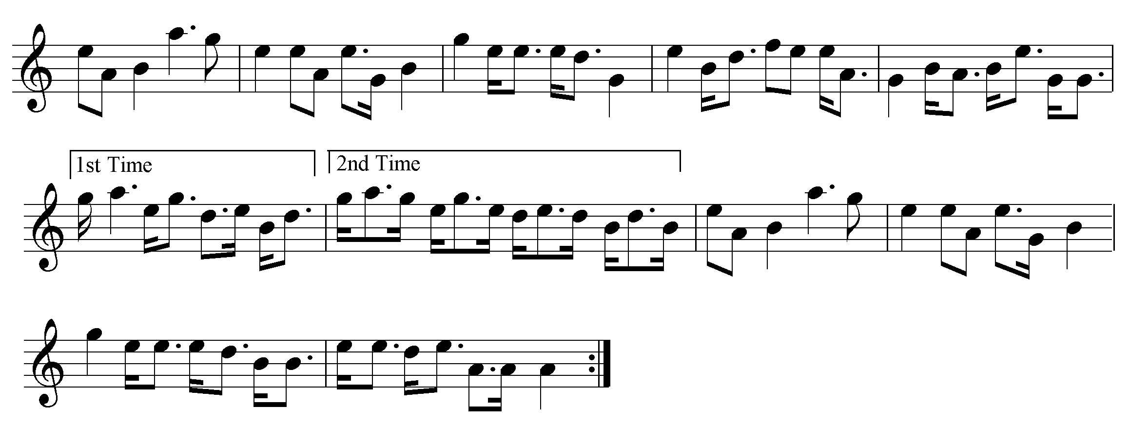

Donald MacKay’s score does not have the “edre” variation recorded by D. S. MacDonald and David Glen. In an interesting article in Piping and Dancing, Willie Gray (writing under the pen-name “Shamateur”) pointed out that although Archibald Campbell had criticised General Thomason for treating the tune as 6 6 4 in structure, Gesto and Simon Fraser had done the same (“Piobaireachd—Ceol Mor By Shamateur”, Vol.5. no.1, September, 1939, pp.1-2, 9).

Niel MacLeod of Gesto’s score is, however, extremely irregular. It is not reproduced here.

The Piobaireachd Society drew intending competitors’ attention to an edited score of this tune, published by Roderick Cannon in Piping Times, May 1998. The idea of this was to address the problem of the first variation by re-writing it to follow more closely the tone row of the ground, and the end result sounds not unlike Donald MacDonald’s. However, some may wonder whether the emendation addresses the problem. The six bar first line of the variation is made up to eight bars on analogy with the ground, but the contraction of the tone row to six bars could perhaps be seen as preparing for a further reduction in the second and third variations whose phrases assume the typical 3, 3, 2 pattern of a primary piobaireachd, so that there is a pattern of 8 held against 6 followed by 3 held against 2. The idea is basically symmetrical.

The argument appears to be that piobaireachd grounds are structured around alternating scales (an idea already familiar to pipers from the light music tradition where the so-called “double tonic sequence”: i.e., a phrase in the key of A followed by a phrase in G, followed by a phrase in A again, and so on, occurs very frequently—although it might have assisted understanding if this had been pointed out). One wonders, too, about the underlying assumption that “regularity” in ceòl mór is expressed in multiples of four. As we see in collections such as Patrick MacDonald’s Highland Vocal Airs, Highland singers could contemplate as satisfying musical structures in which there was frequent asymmetry between first and second strains, where one might be of eight bars and the second of ten. As it stands the first variation is deemed a couple of bars short on its first appearance; but this can be quite simply fixed, if desired, by dropping line one and playing the repeat, which possesses the requisite 8 bars, twice:

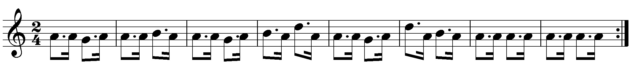

This might produce a stronger tune than the rather meandering version proposed by the Cannon re-edit.

The original scores are wonderfully bold and fine—dropping immediately from the first to the second tonic then climbing by a series of artfully arched and tensioned figures before falling back again, a surging, powerful sequence: the tune carries a brimming musical charge and doesn’t spill a drop.

One of the characteristics of this intriguing tune is the way in which tone row and metre are compressed as the piece progresses. The ground is based on a hexatonic scale, GAB DEF gapped at C. This contracts to GAB D in the first variation, and remains stable in this pattern through the rest of the tune. So, it is not simply a case of the variations being framed in a passive, draughtsman-like fashion to follow a pattern immutably fixed by the ground. The ground is a starting point only: the tune continues to develop rhythmically and tonally, after it has been left behind. The ground contains 64 pulses; the first variation reduces this to 28, the second still further to 24, and the third settles at 32.

Quite possibly the tune is a composite, made out of two bits of pointedly different pre-existing pieces. There are a number of such tunes in the tradition including “MacCrimmon’s Sweetheart” and “The Desperate Battle”. One should always be careful with pìobaireachd titles, of course, but there could be an obvious ironical intention here.

Commentary:

The Union with England of 1707 was bitterly opposed by most Scots as “the black and never-too-much-to-be-execrated Union”. Generations of Jacobites and others, struggled to undo it. But though romantics sigh for lost days of—latterly rather nominal--independence, probably the only real choice lay between being a client state either of France or of England; between Catholicism and belle cuisine, or Protestantism and puddings. It is the kind of thing that happens to smaller countries living in the purlieus of contending superpowers. Generations of whiggish Scottish historians laboured to present the Union as a wise and statesmanlike act. More recent work on the subject suggests that the Union was a standard 18th century political “job”. Certainly, it was bad news for anybody wanting to wage private war in Scotland as it enabled the authorities to draw on the resources of the English state rather than their own smaller and heavily-committed standing forces. Some people did very well out of the Union. Although it severely damaged Scotland’s east coast ports, it legalised the Atlantic trade and made at least technically honest men of the Glasgow tobacco lords. As some recent books, notably Arthur Herman’s The Scottish Enlightenment, 2001, have assured us, it also helped the Scots achieve their true destiny--which was to invent the U.S.A.

* * *

Electronic text © Dr. William Donaldson, Aberdeen, Scotland, September 2004; revised Cambridge, Massachusetts, March 2025

