Tune of Strife

There are settings of this tune in the following manuscript sources:
--Colin Mór Campbell, “Nether Lorn Canntaireachd”, f.i, 3-6 (with the title “Porst na Striane”; and in ii, 56-60 with the title “Ribban Goarm”);
--Donald MacDonald’s MS, ff.161-167 (with the title “The Blue Ribbon” for the tune generally known elsewhere as “The Tune of Strife”);
--Angus MacKay’s MS, i, 43-5 (with the title “The Tune of Strife”);
--John McDougall Gillies’s MS, ff.68-9 (with the title “The Tune of Strife”);
--McLennan Papers, National Library of Scotland Acc. 11516/8, ff.19-20 (with the title “The Tune of Strife”);

and in the following published sources:
--C. S. Thomason, Ceol Mor, pp.139-40; 275-6 (with the alternative title “The Isle of Mull Blue Ribbon”); and
--David Glen, Music of the Clan MacLean, pp.36-8 (with the title “The MacLeans’ Blue Ribbon”).

One difficulty created by the Nether Lorn settings is that the tune Colin Campbell calls “Porst na Straine” is actually what later tradition knows as “The Blue Ribbon”; while the tune he calls “Ribban Goarm” (or Blue Ribbon), is actually what is nowadays known as “The Tune of Strife”.

Colin Campbell sets the “Porst na Straine” tune like this:

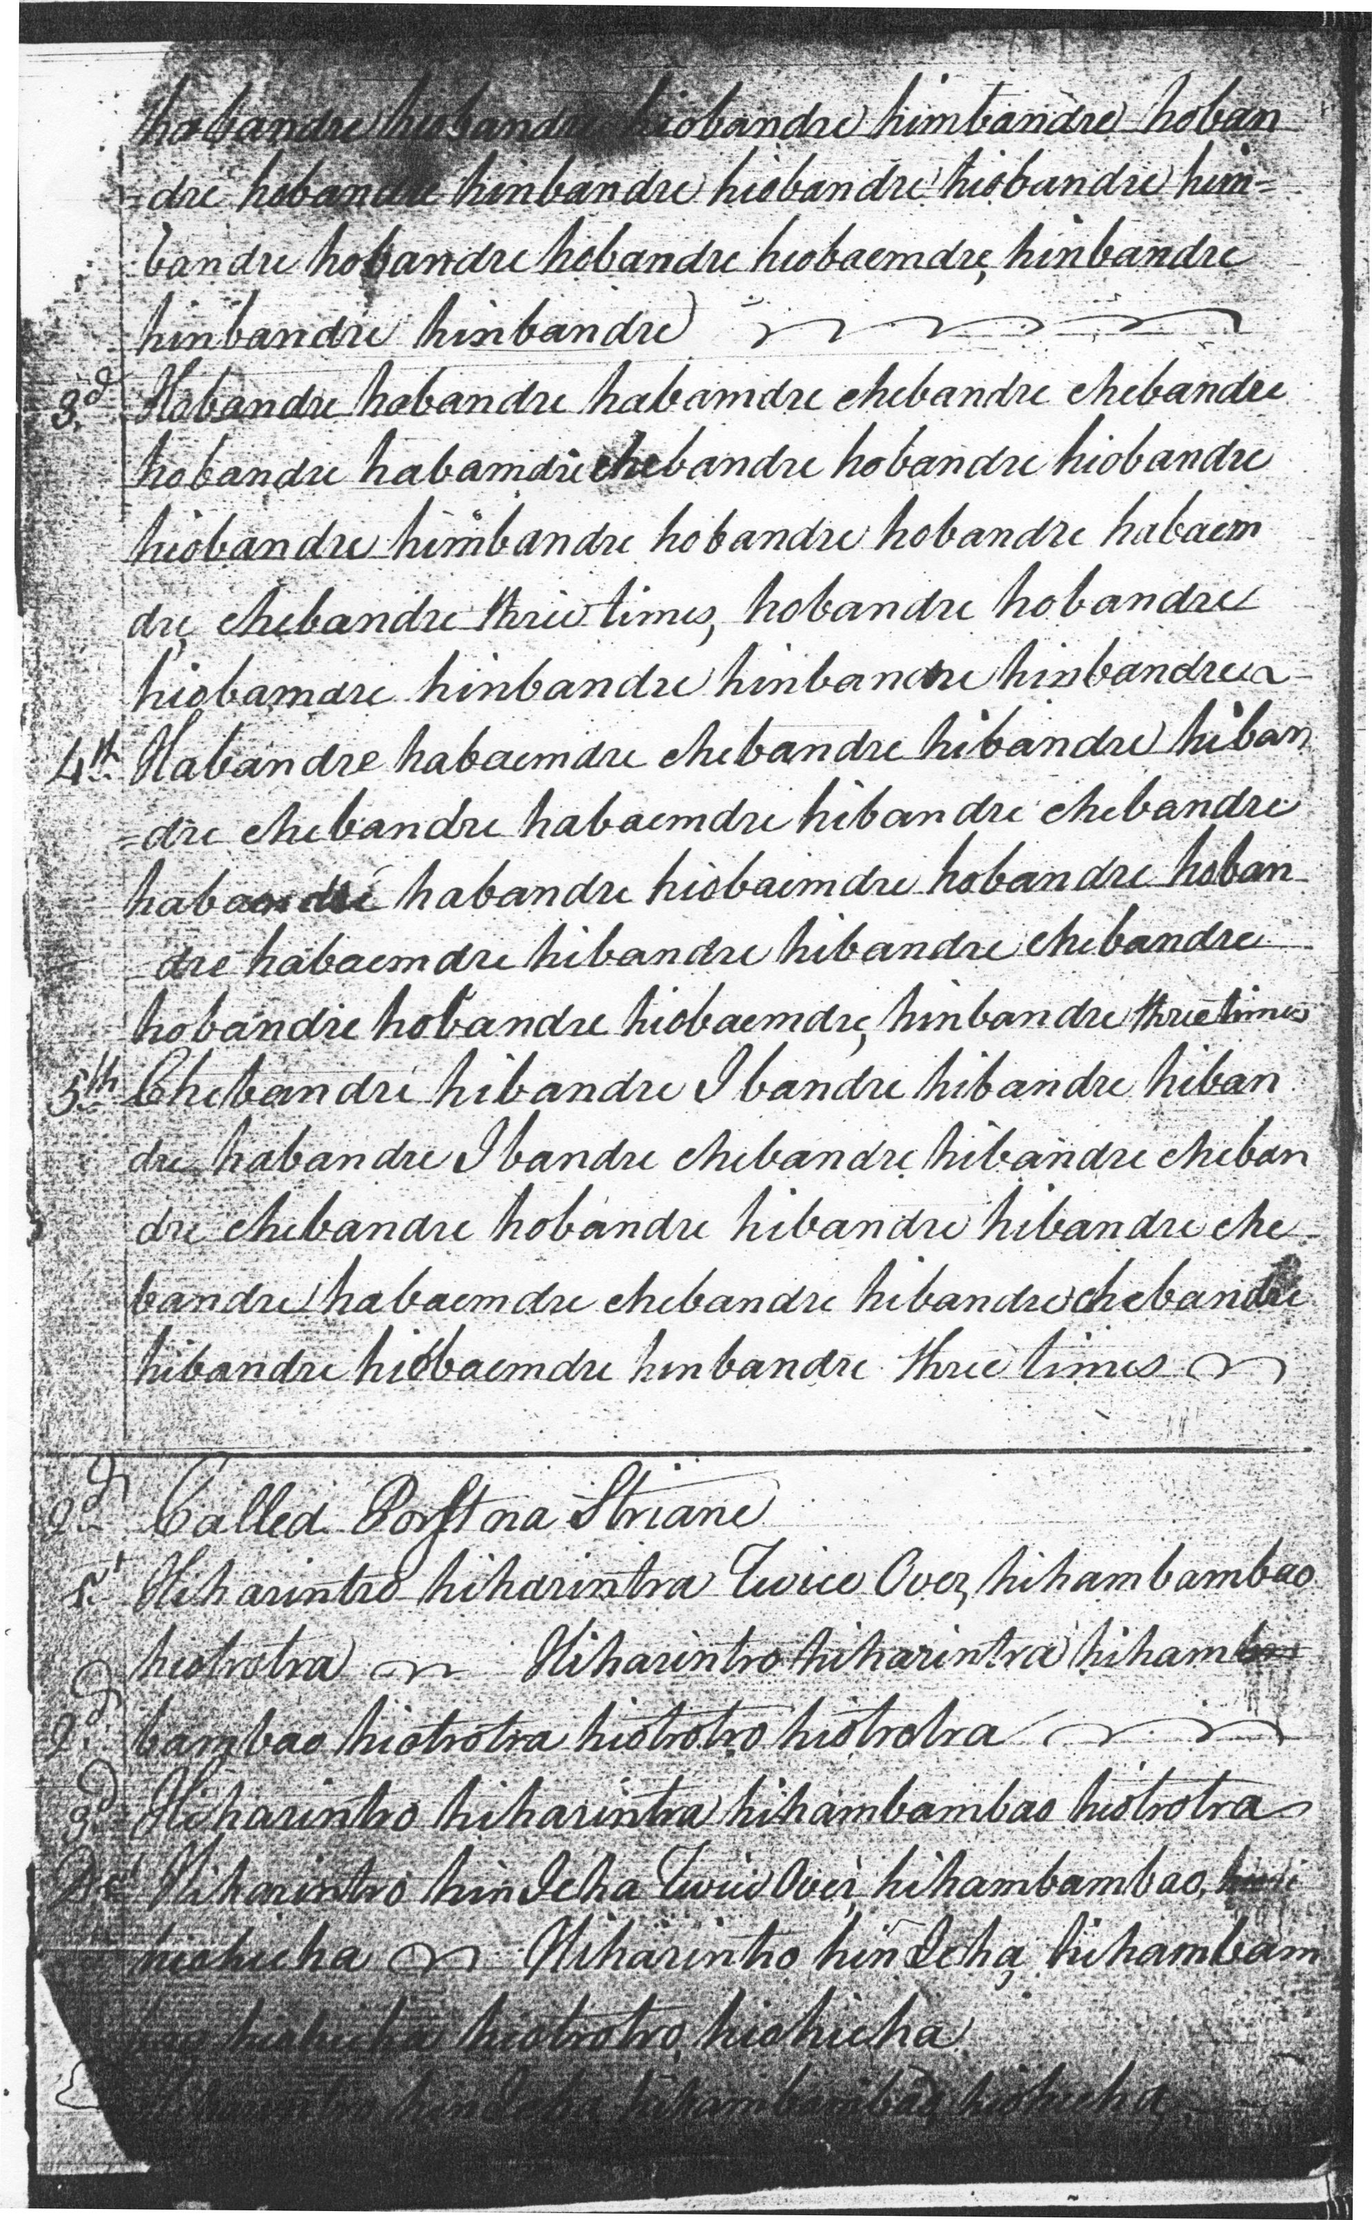

And so on.
This setting is discussed in detail in the entry for “The Blue Ribbon” elsewhere in this series.

Donald MacDonald’s manuscript contains a setting of the tune he calls “The Blue Ribbon” but which is the same as the one Colin Mór Campbell calls “Porst na Straine”. The reader is directed to the entry for “The Blue Ribbon” as above.

Angus MacKay’s score is perfectly regular, developing the tune in orthodox fashion to a crunluath duinte doubling (he does not offer an a-mach). It has an interesting footnote on his father, John MacKay’s, playing of this tune, and although the wording is a little ambiguous it looks as if John MacKay had doubts, about the long second line. The comment is the more valuable given that such information from a master player is extremely rare in this kind of document.

Angus MacKay sets the tune like this:
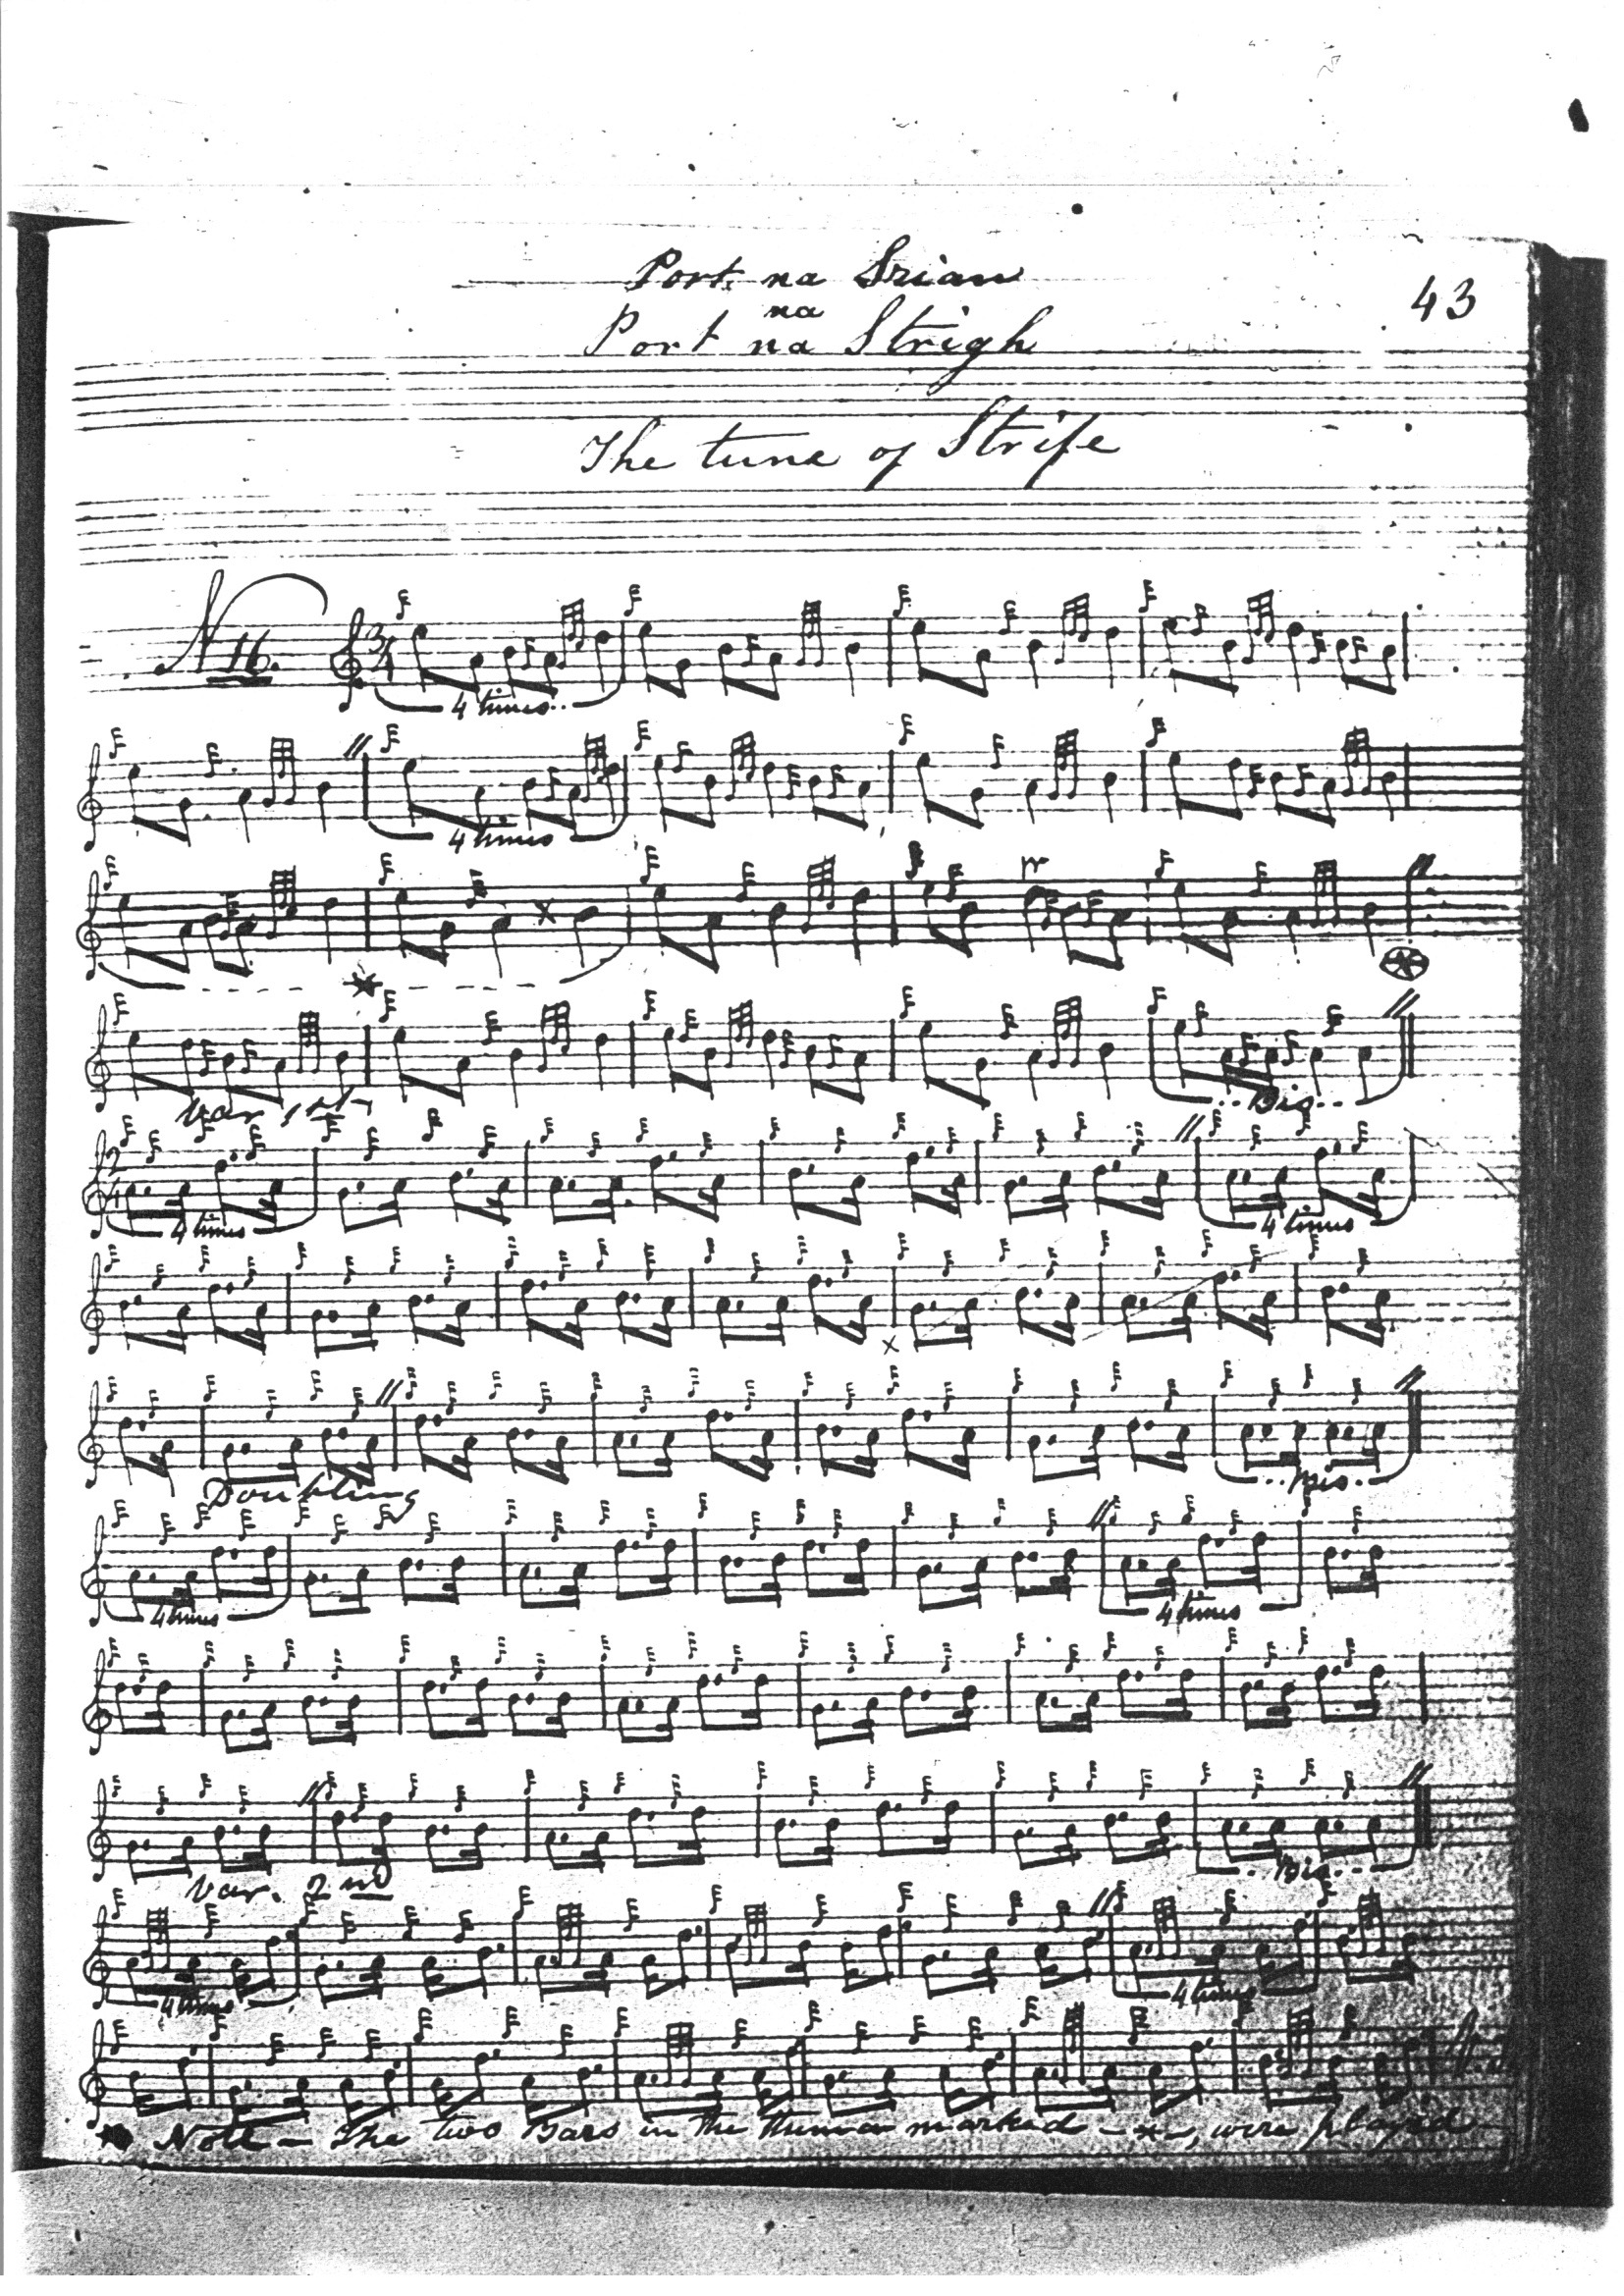
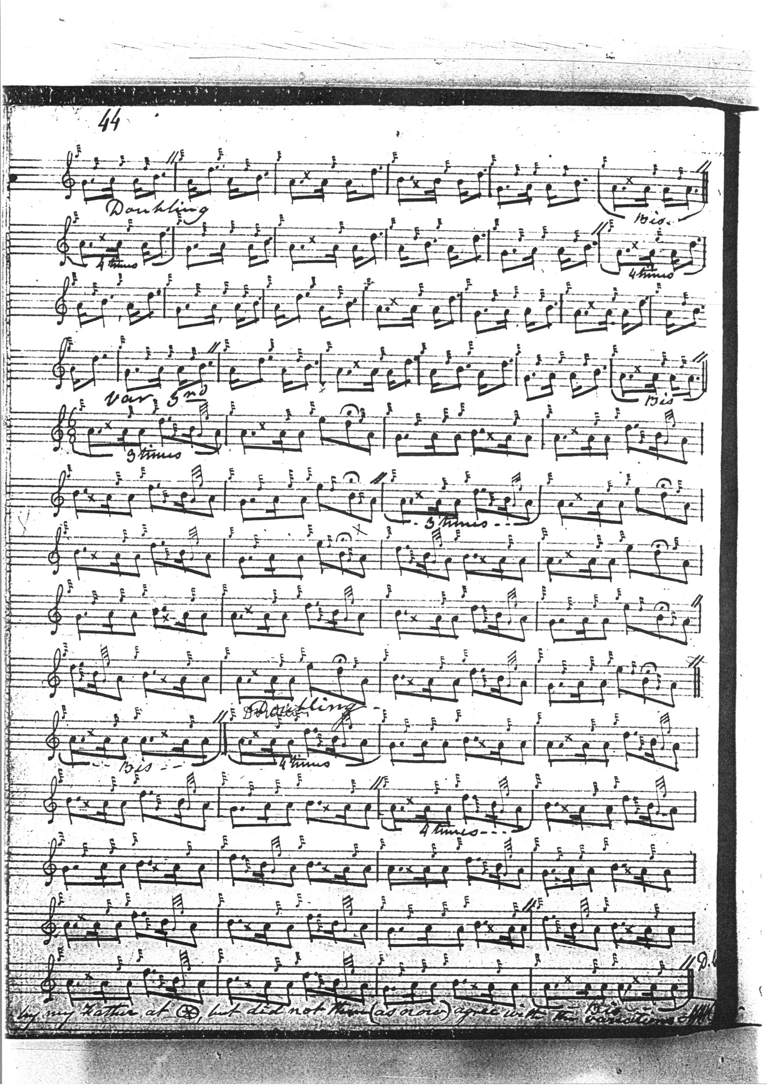

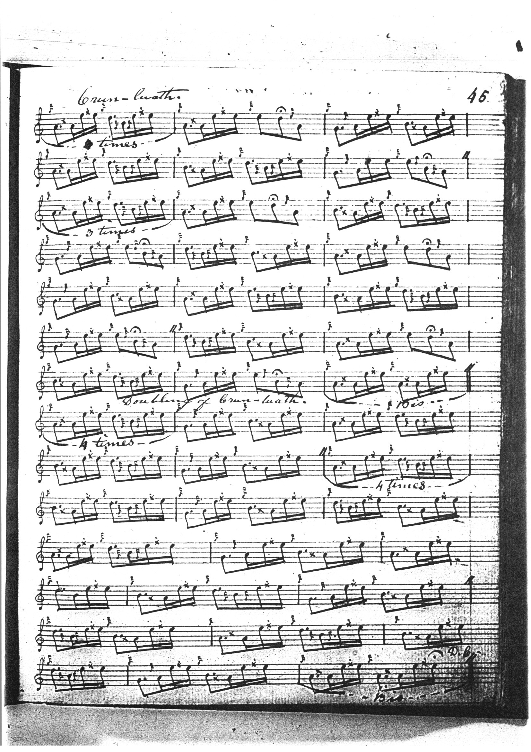

John McDougall Gillies’s score interestingly bears a note to the effect that the version given comes from Angus MacKay’s “Seaforth MS” a compilation of tunes originally presented to Col. Keith Stewart Mackenzie of Seaforth at Brahan, reflecting a habit occasionally seen among Victorian master pipers of compiling manuscript anthologies of piobaireachd as a tribute to wealthy private aficionados or real or prospective employers. The manuscript came into the possession of Donald Cameron and his sons, and Gillies will have gained access to its contents by virtue of being a pupil of Sandy Cameron (the younger). Gillies’s score closely reflects that of Angus MacKay given above, and is not reproduced here.

A citation of the “Seaforth MS” occurs also in the McLennan Papers. This may give us pause until we remember that the Cameron and McLennan families enjoyed a number of links; for example, Donald Mór McLennan of Moy was an early teacher of Donald Cameron:

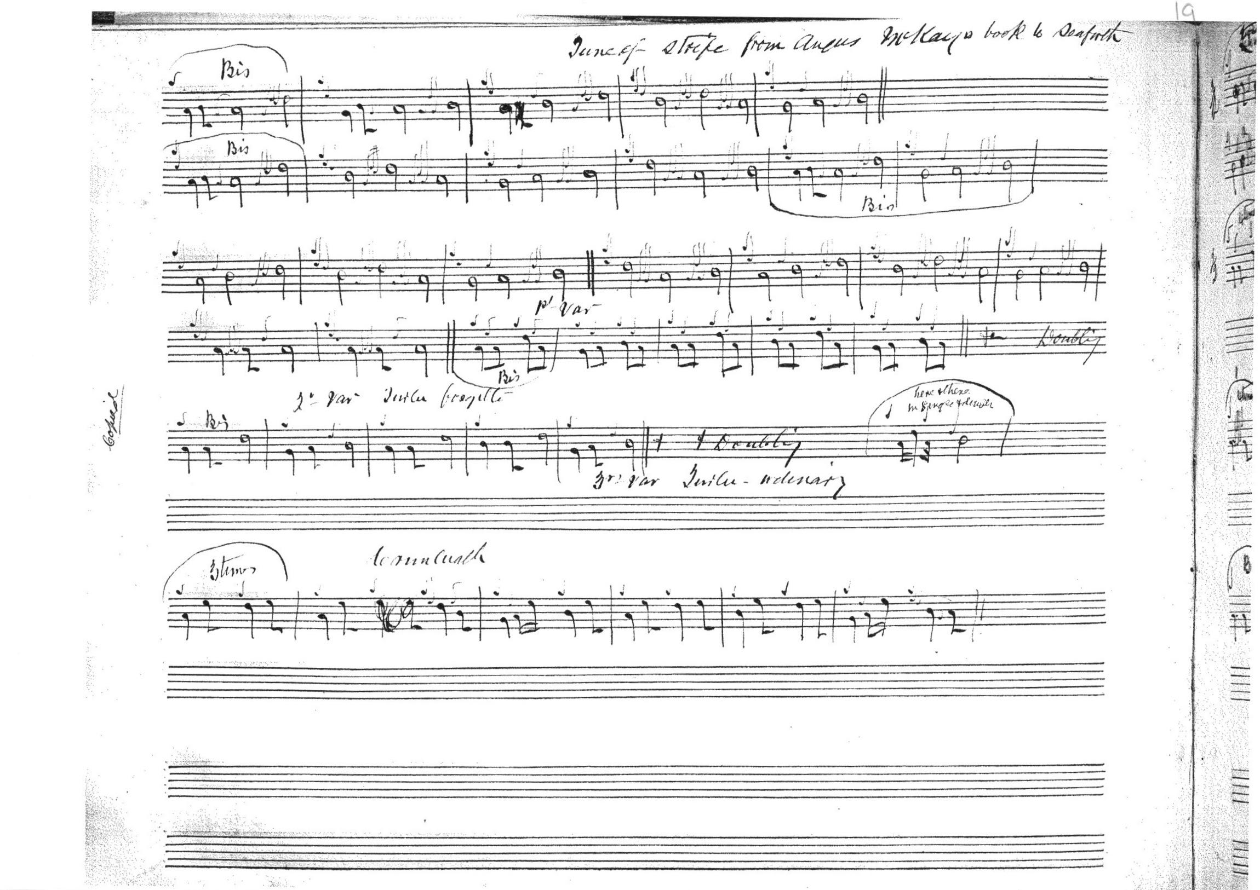

This may look sketchy, but its informality is deceptive: the notation is very economical, containing just about all one would need to reconstruct the tune; although the setting seems dislocated, calling for a single repetition of the opening bar in contrast to MacKay’s more regular-sounding four iterations. This asymmetry seems also to affect the David Glen setting below from John Johnston of Coll.

General C. S. Thomason gives both MacDonald’s and MacKay’s versions of the “Tune of Strife”. He calls the MacDonald version “The Blue Ribbon (Isle of Mull)”, while the MacKay version retains the “Tune of Strife” title. The latter tune was directly taught to Donald MacKay by Donald Cameron. Thomason adds little to MacKay from a stylistic point of view and his score is not reproduced here.

David Glen’s version, entitled “The MacLeans’ Blue Ribbon” begins as follows:

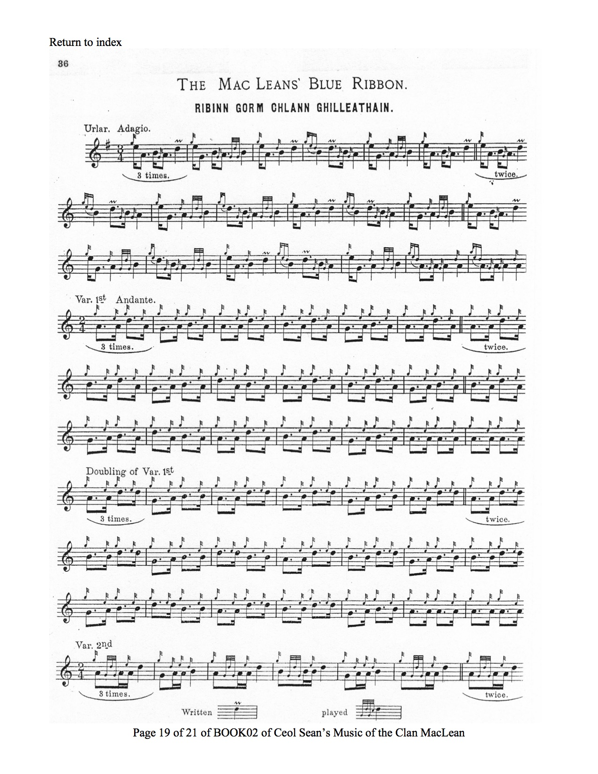
And so on.
This seems little more than a transliteration of the Donald MacDonald’s setting from his published book Ancient Martial Music of Caledonia. Glen published The Music of the Clan MacLean following an approach by the Clan MacLean association “as to the possibility of my collecting and publishing the Music of the MacLeans”, noting that he had “to tender my special thanks to Mr. John Johnston, Isle of Coll, who journeyed specially to Glasgow, in order that I might write down from his playing, several tunes belonging to this Clan which were, so far as I could learn, only known to himself, and which his ancestors had learned from the Rankins, who were the hereditary Pipers of the MacLeans of Coll and Duart.” John Johnston was a frequent correspondent of the Oban Times and while he possessed a good deal of information seemingly from oral tradition, his musical ideas were also strongly influenced by printed sources, and he seems to have taken many of his timings straight from the printed page, in this case of Donald MacDonald.

Commentary:

It is curious that the same or similar titles should be given in this way to two tunes like “The Blue Ribbon” and “The Tune of Strife”. To be sure, the grounds have a certain similarity of motifs but the tunes are structurally quite distinct and are developed to different conclusions. The various titles which have been attached to the tunes may contain a hint as to why they should be joined together in this way. Dwelly records “stri” as strife, and “strial/striam/strain” as a strip of cloth. So that a possible translation might be “The Ribbon Tune”. Thus phonetic similarities may underlie this curious linkage.
In his notes on the tune which he entitled “The Blue Ribbon”, Donald MacDonald says “There are four of these Ribbons, one of them an Island of Mull Ribbon; another of them an Isle of Skye Ribbon, another of them belongs to the Macgregors; and this one belongs to the clan Grant.”
What may lie behind the reference was the habit of wearing political colours and favours; blue being the Whiggish and Presbyterian colour, white for the Jacobites. The Hanoverian cockade was black. It still survives in the cap ribbons of the modern British Army.

*

Electronic text © Dr. William Donaldson, Cambridge, Massachusetts, 11 August 2020

