Too Long in this Condition

This tune appears in the following manuscript sources:
--Colin Mór Campbell, “Nether Lorn Canntaireachd”, ii, 169-70 (with the title “MacFarlans Gathering”);
--Hannay-MacAuslan MS, ff.38-40;
--Angus MacKay’s MS, i,161-2;
--John McDougall Gillies’s MS, ff.64-5;
--David Glen’s MS, ff.272-3;
--Robert Meldrum’s MS, ff.19-21;

and in the following published sources:
--Donald MacDonald, Ancient Martial Music of Caledonia, pp.34-7; now in a new edition, Donald MacDonald’s Collection of Piobaireachd Vol I (1820), Keith Sanger and Roderick D. Cannon, eds., (The Piobaireachd Society, no place of publication, 2006), pp.78-9;
--Donald MacPhee, Collection of Piobaireachd, i, 20-21;
--C. S. Thomason, Ceol Mor, 17-18; 237;
--David Glen, Collection of Ancient Piobaireachd, pp.107-8;
--G. F. Ross, Collection of MacCrimmon and Other Piobaireachd, pp.24-5.

The tune we now know as “Too Long in this Condition” bears the title “McFarlan's Gathering” in the Nether Lorn Cannntaireachd, the earliest recorded source. John MacDougall Gillies picked up a version of it a century later in Glendaruel, and it was subsequently recognized as a separate melody by General Thomason and published as such in his great collection Ceol Mor.

Colin Mór Campbell treats the tune like this:
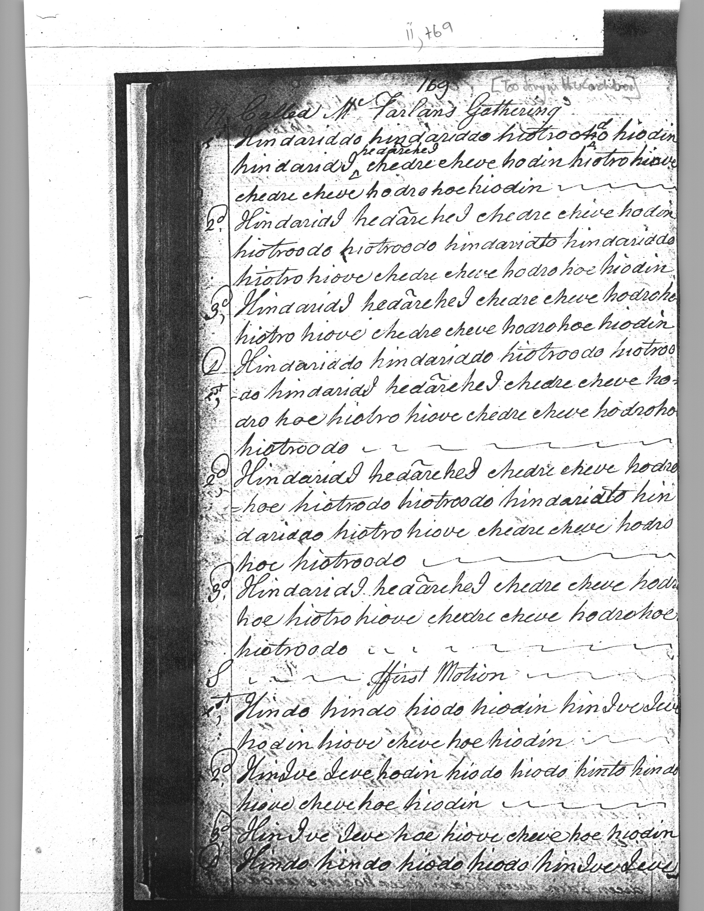

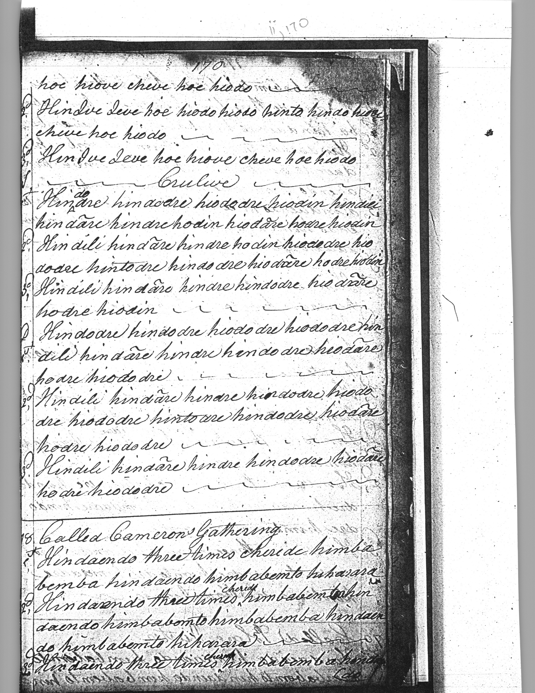

Colin Campbell’s setting is brisk and to the point: ground with doubling, siubhal singling and doubling, then straight to a crunluath fosgailte singling and doubling. We note the interesting passage in the crunluath variations with its throws up from low A to E and F which distinguishes this from the other settings. There is clearly a missing vocable “chedare” in the final phrase of each line of the Crulive singling and doubling and this has been made good in the typeset example below:

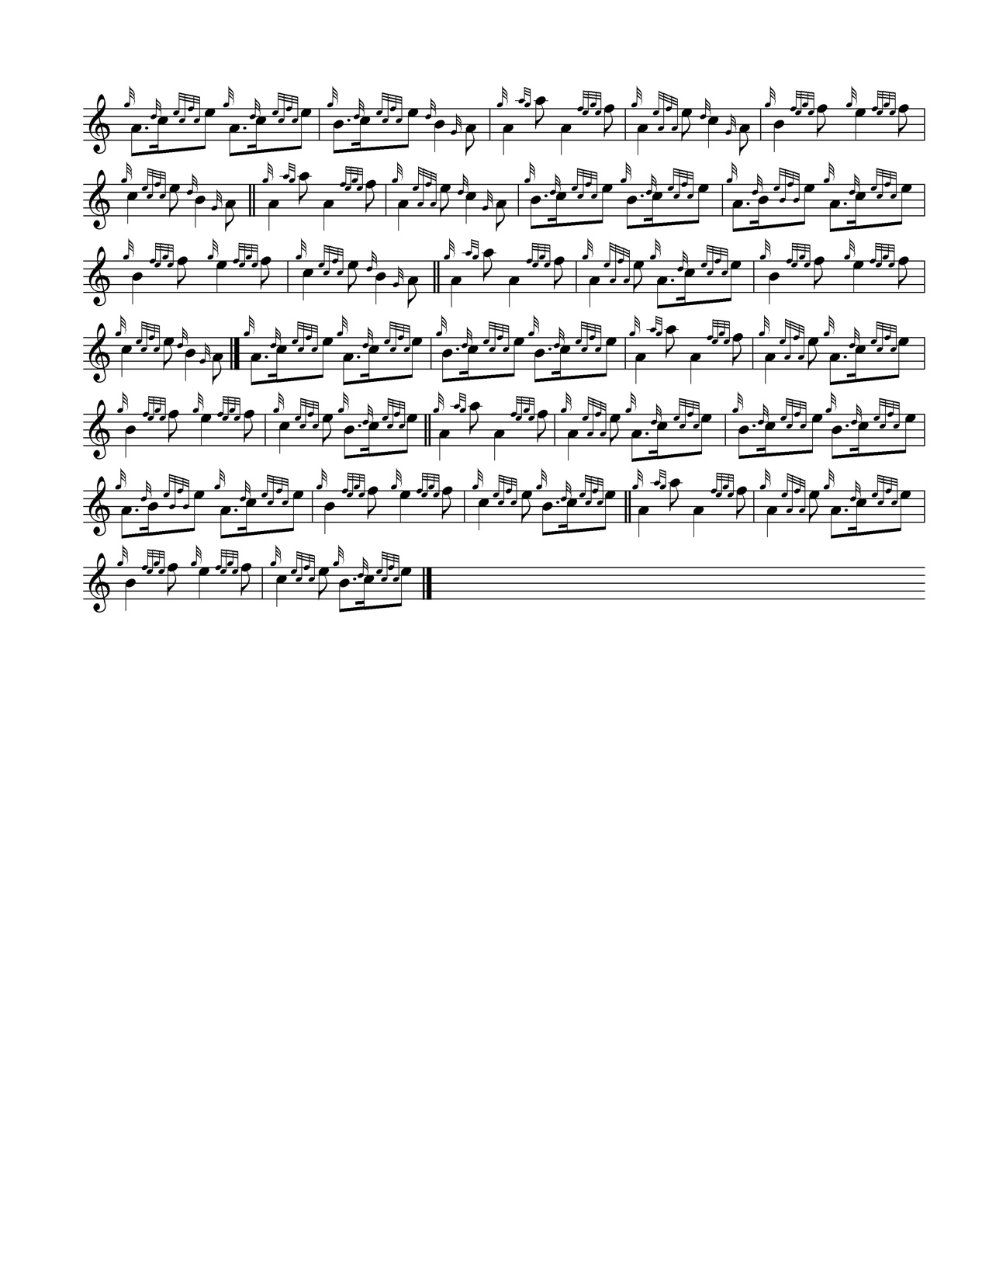

The setting in the Hannay-MacAuslan MS is as follows:

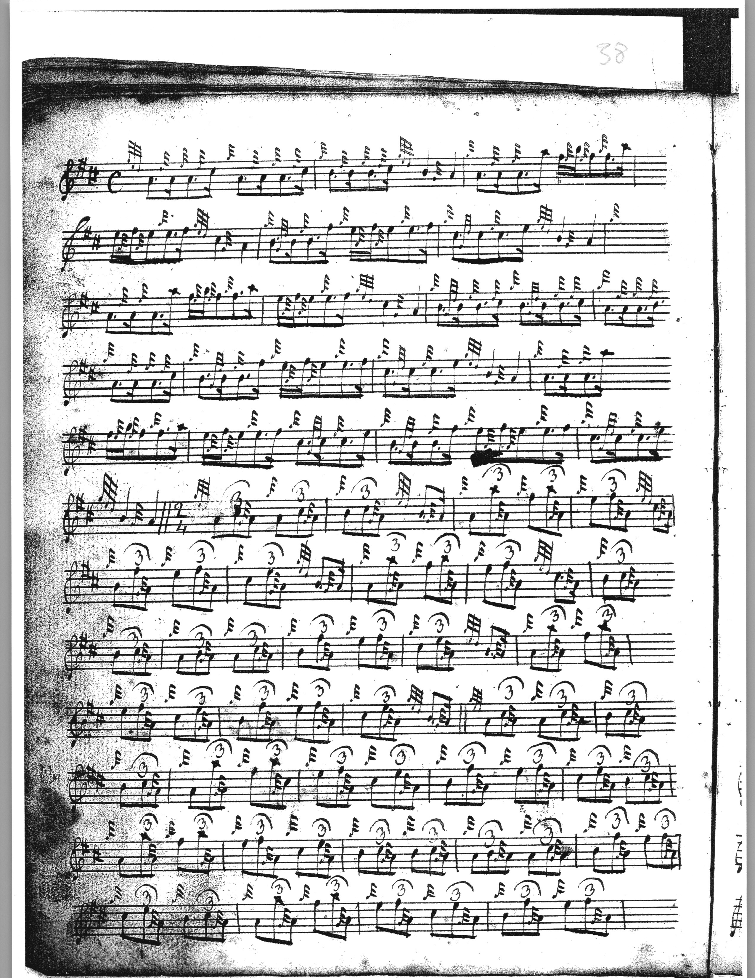

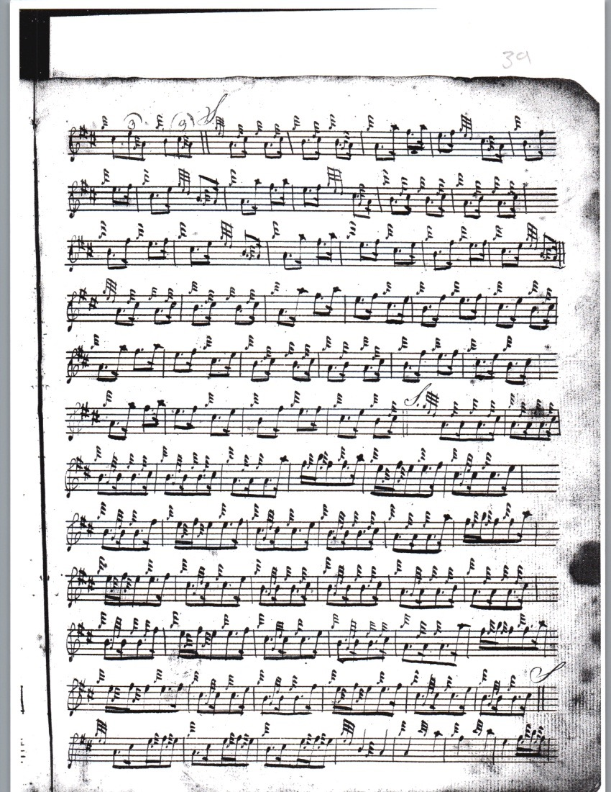

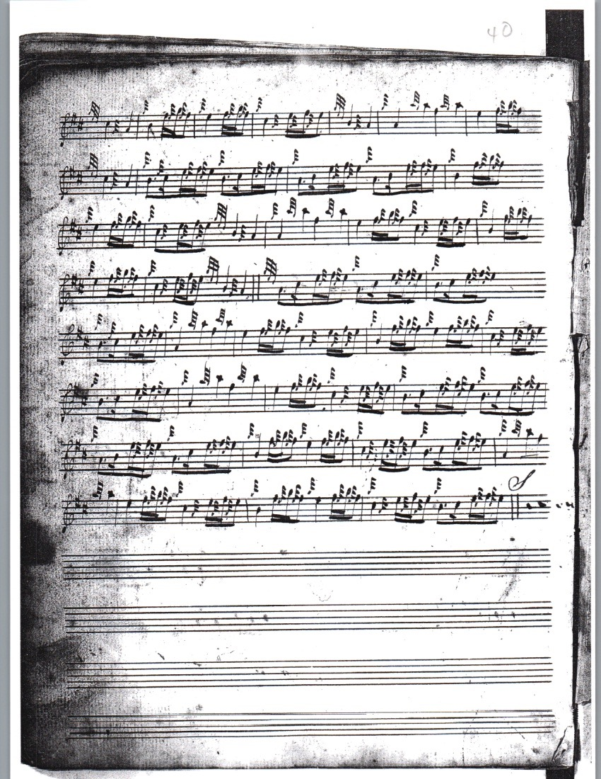

The Hannay-MacAuslan implies a timing in the ground similar to the spaced-out triplings in 4/4 time of “Camerons’ Gathering” and other typical gathering tunes. We might note the return of the ground (in doubling form) following the siubhal, and the section ending markers above the score at appropriate points. These might be useful if the MS was barred subsequently to its initial compilation. Note: the tune has no title in this source, it is the only one of the ten pieces which does not have one. It has a ground singling, followed by a MacDonald style rocking triplet siubhal singling and doubling; an ordinary siubhal singling and doubling follows; then the doubling of the ground, interesting since Donald MacDonald in his published score distributes returns of the ground more freely throughout the tune.

Donald MacDonald’s score has obviously close links with the Hannay-MacAuslan., although there are a number of differences, too. For a start, MacDonald gives the piece the “Too Long in this Condition” title, along with a note about the occasion of the composition, Great Peter McCruimen’s being stripped of his clothes at the Battle of Sheriffmuir which appears to be unique to this source. We notice that the decorations on the bottom-hand movements in the ground are “heavier”, and MacDonald repeats the ground between the two siubhals, once again between the siubhal and crunluath variations, and finally after the last crunluath movement to complete the tune. Altogether it is heard four times, as opposed to twice in the Hannay-MacAuslan, but the overall similarities between the two settings are too obvious to be missed. MacDonald sets the tune like this:

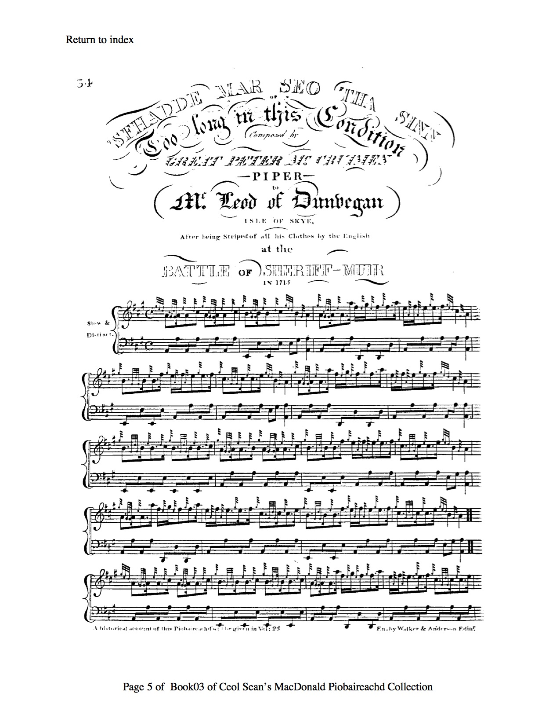

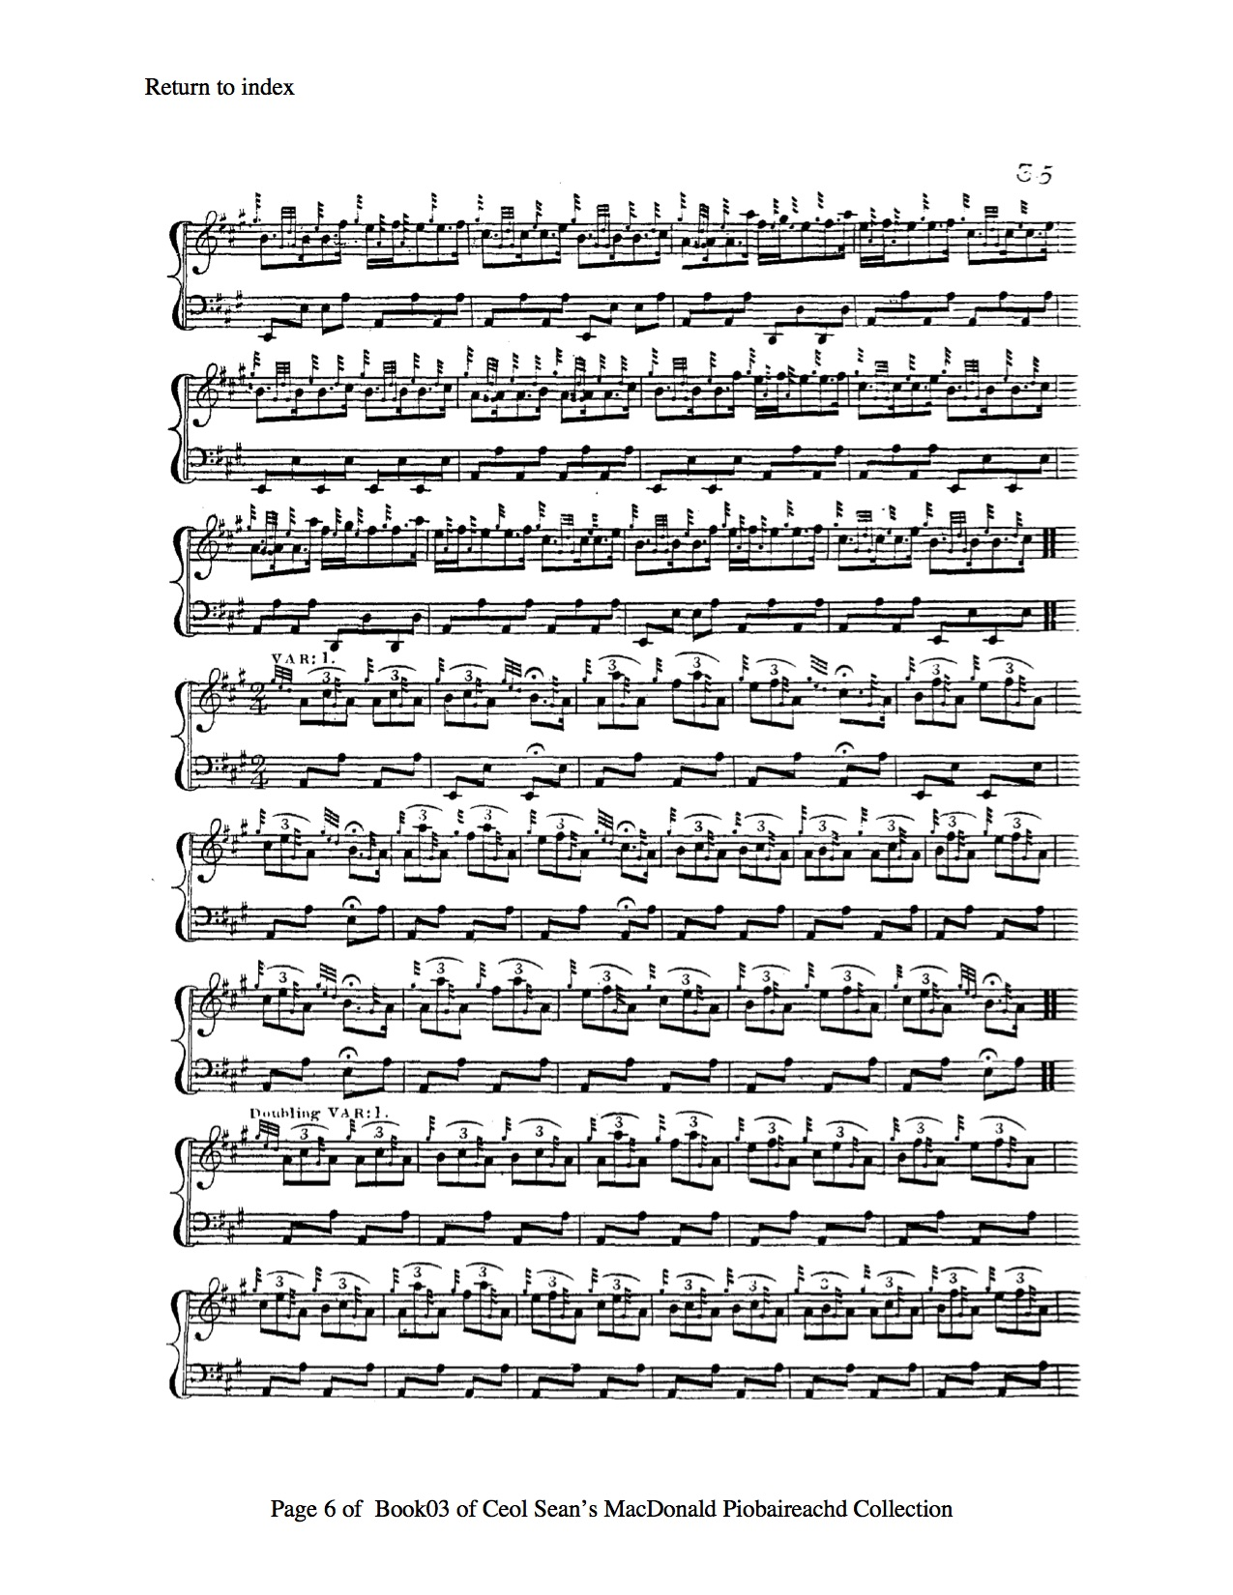
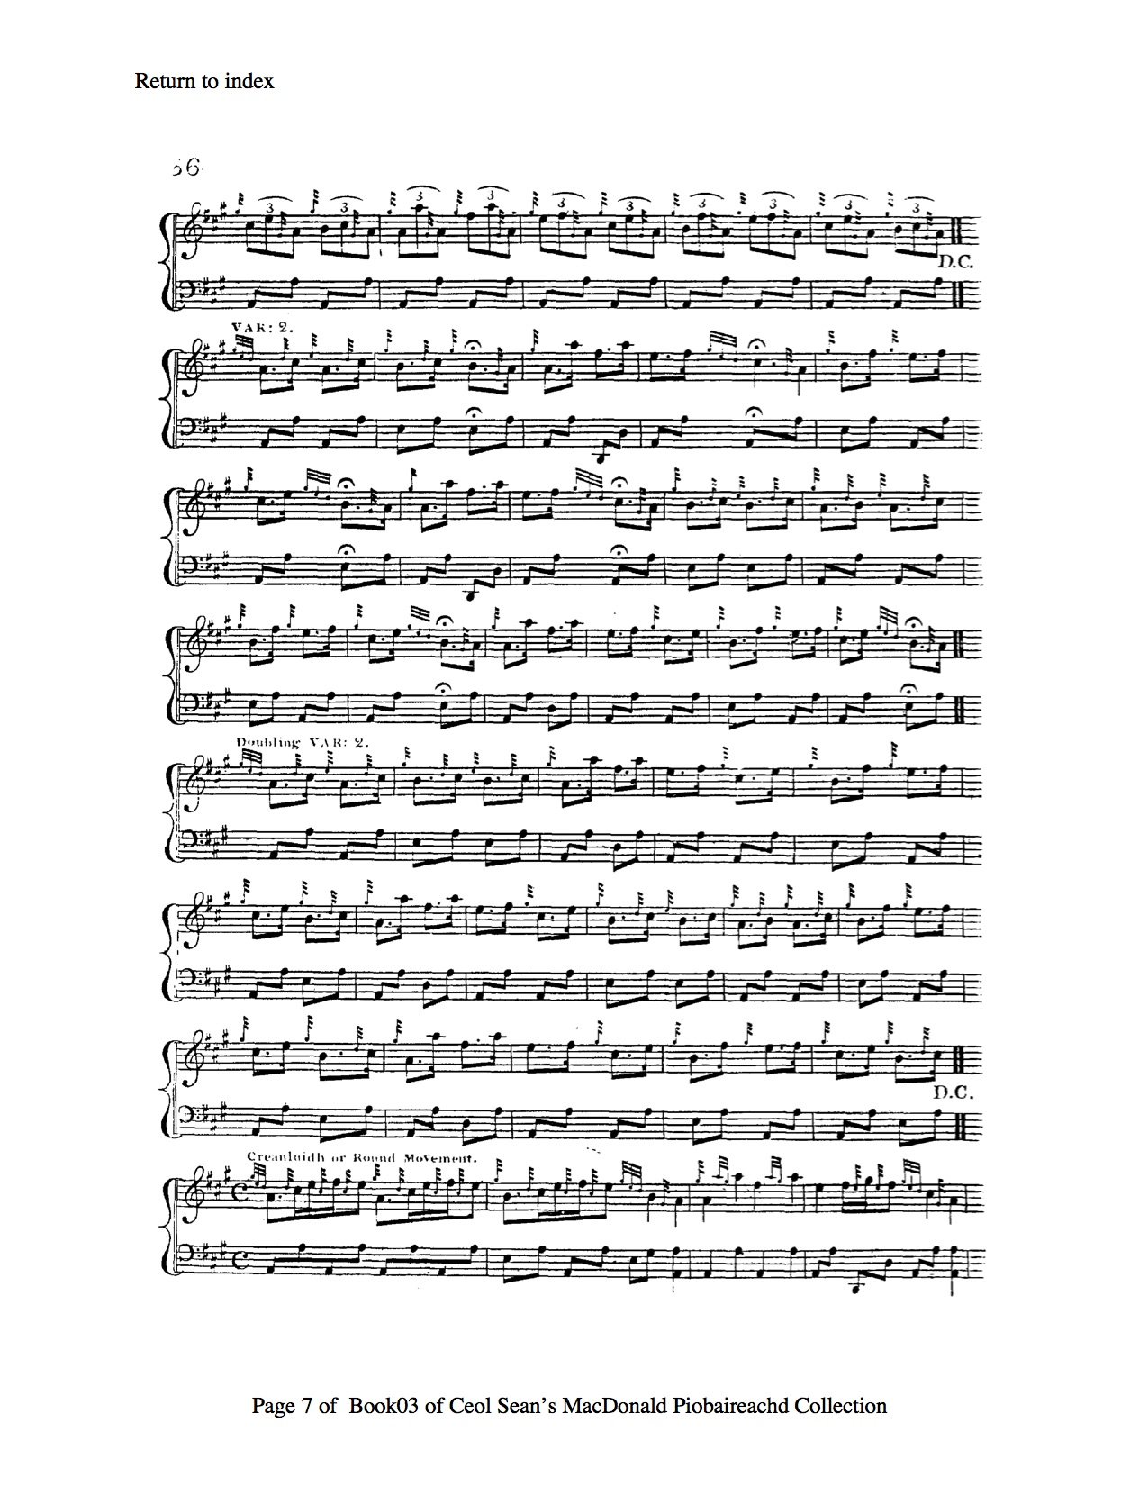

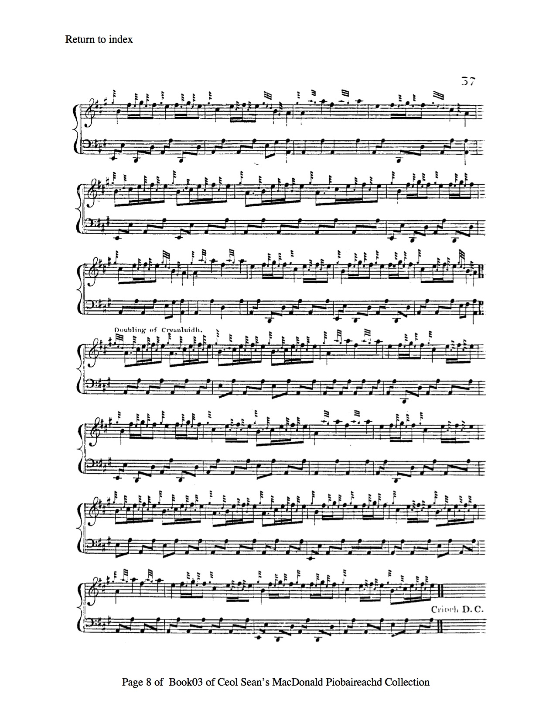

In his manuscript, Angus MacKay sets the tune as follows:
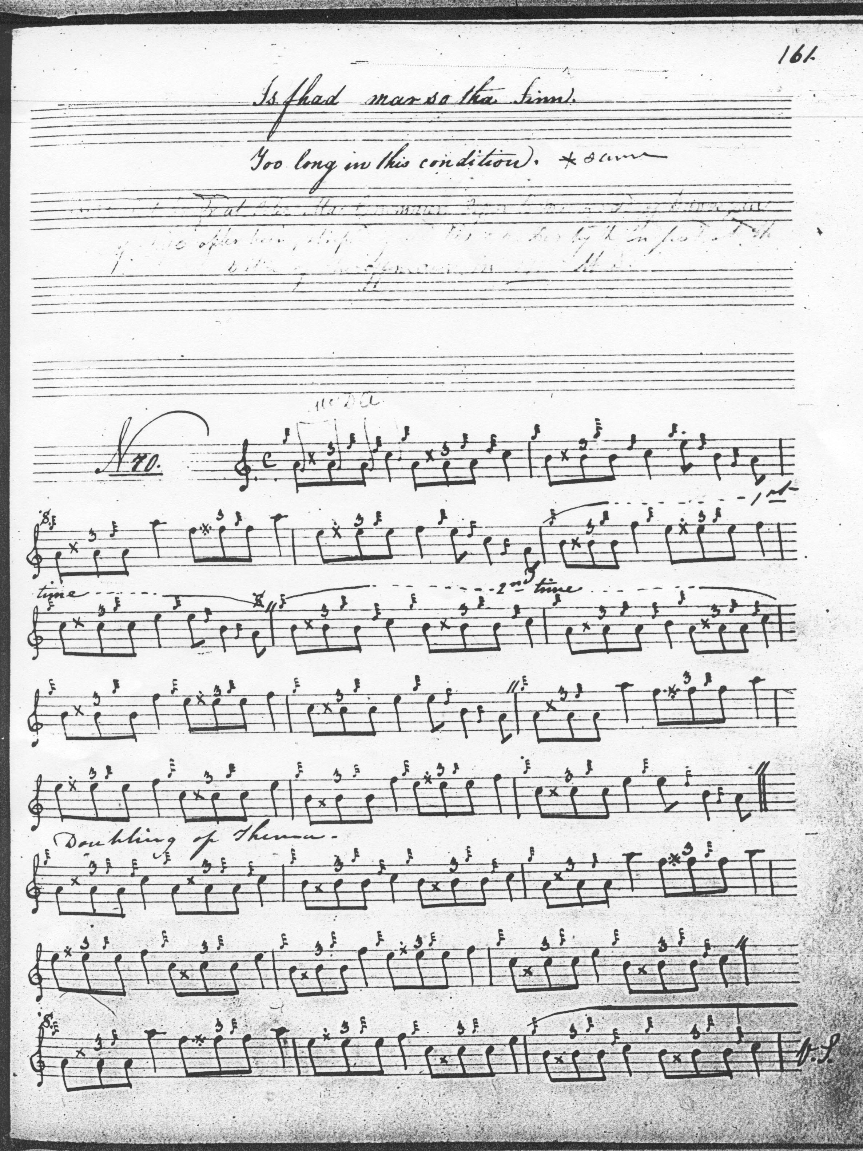

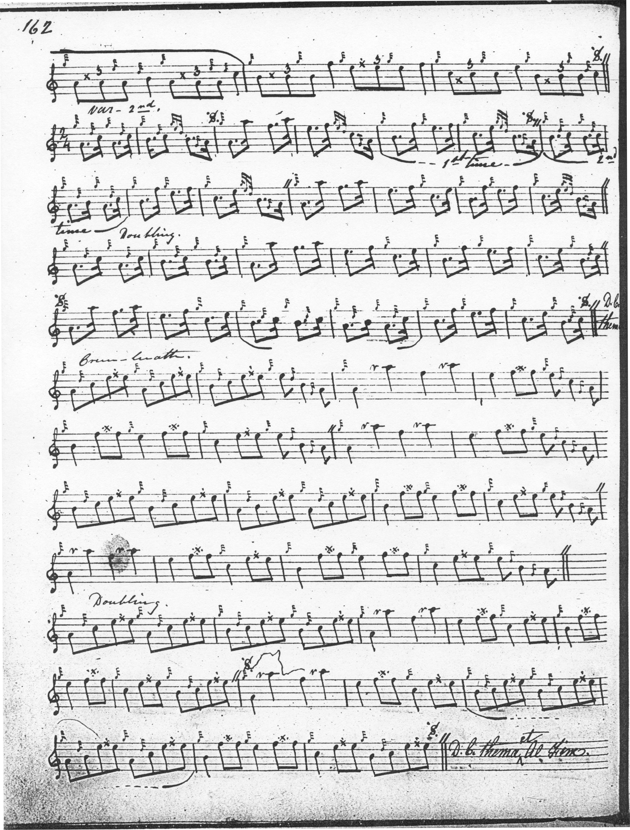

Angus MacKay’s approach is a good deal plainer than MacDonald’s and the Hannay-MacAuslan, resembling the relatively laconic way the tune is developed in the Nether Lorn, with ground and doubling; then on to the second of MacDonald and Hannay-MacAuslan’s siubhals (singling and doubling); then a repeat of the ground, then on to a crunluath fosgailte singling and doubling, repeating the ground again at the end.

John MacDougall Gillies follows MacKay’s style, except that he does not indicate that the ground be repeated between the siubhal and the crunluath variations. This score adds nothing of significance to the musical possibilities of the tune and is not reproduced here.

C. S. Thomason gives two setting in Ceol Mor, one based on Donald MacDonald’s published score, the second deriving from Angus MacKay’s MS and Donald MacKay (Angus’s nephew), the General’s coadjutor, who was directly taught the tune by Donald Cameron, as follows:
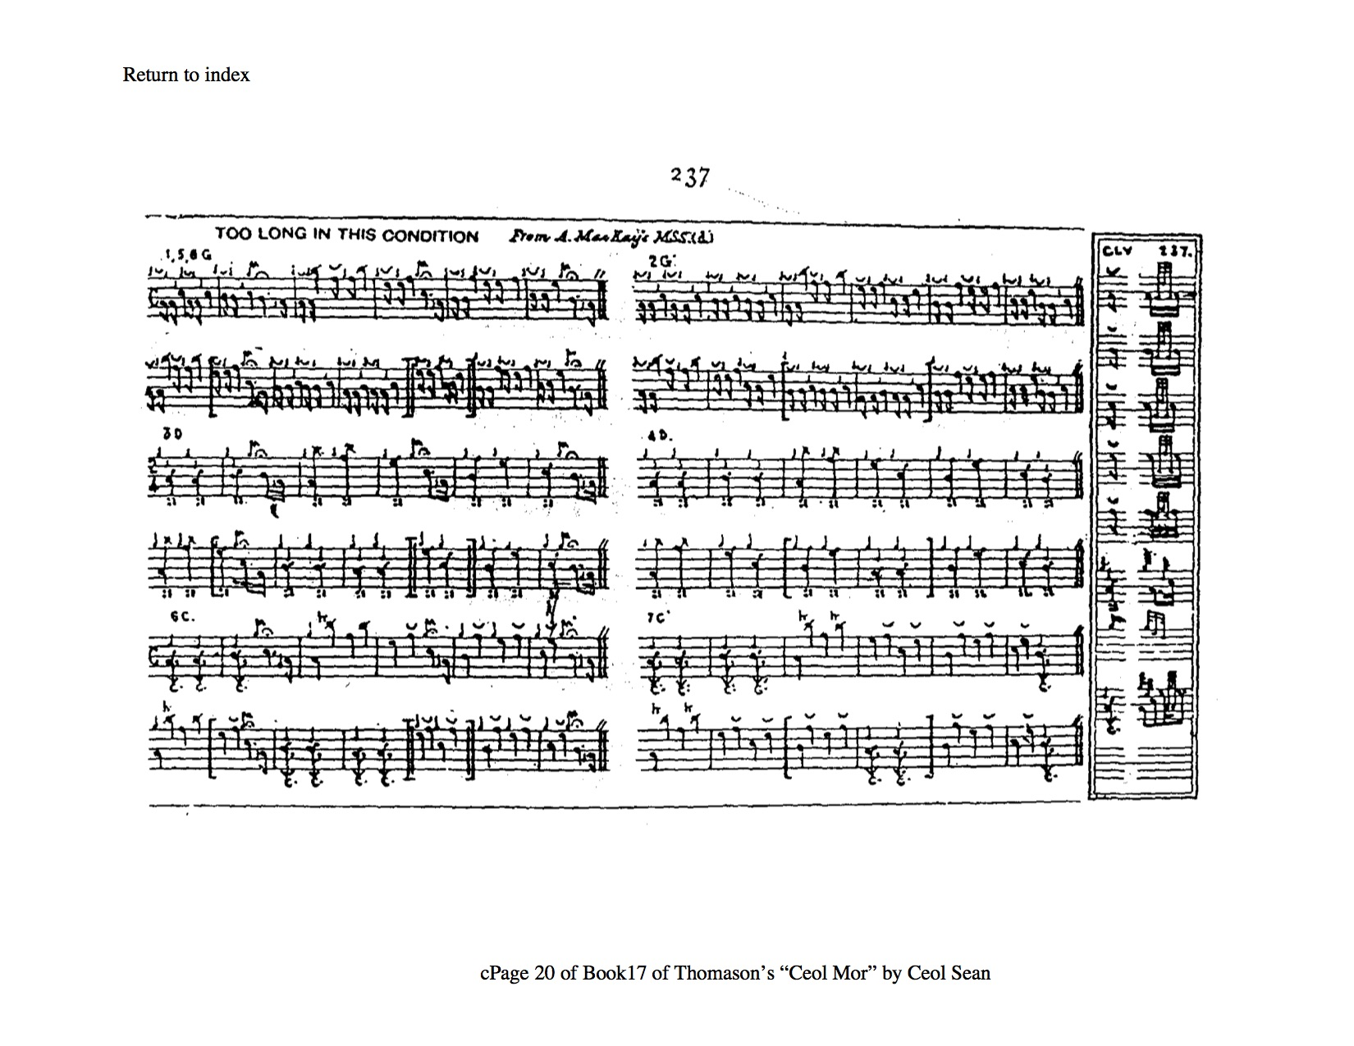

As we see, it offers an interesting timing of the ground and its doubling in which the opening quavers of each figure are cut throughout, giving a strutting staccato effect.

In his manuscript transcript, David Glen interpreted this as follows:

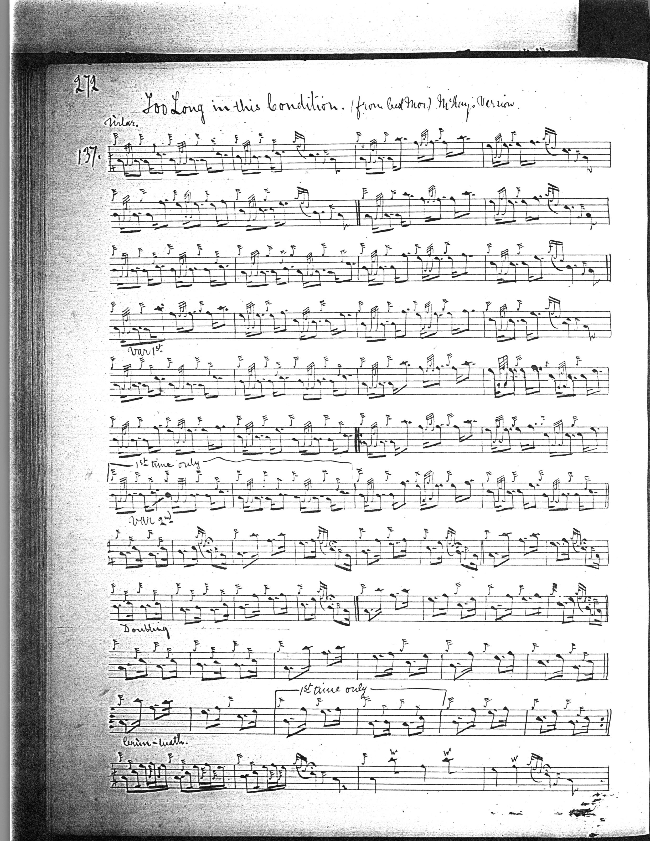

And so on.

Of the remaining settings, that of Robert Meldrum adds little of stylistic interest to the tune and is not reproduced here.

Donald MacPhee follows Donald MacDonald here including repeating the ground between the two siubhal variations and again between the second siubhal and the crunluath. MacPhee adds little of stylistic significance to the tune otherwise and his score is not reproduced here.

The published settings of David Glen and G. F. Ross add little of stylistic interest and are not reproduced here.

Commentary:

The chief question which used to be asked about this tune is whether it should be considered as a mere variant of “MacFarlane’s Gathering”, or as an independent piece. This is discussed in the entry on “MacFarlane’s Gathering” in the present series. It is now clear that “Too Long in this Condition” is by far the more fully-documented of the two pieces. Similar motifs appear in the grounds of both tunes but thereafter each is developed to different conclusions. “Macfarlanes’ Gathering” comprises a ground plus taorluath and crunluath breabach variations, singling and doubling, whereas “Too Long in this Condition” moves through a siubhal singling and doubling on to a crunluath fosgailte singling and doubling.

Highland historian, Henry Whyte, “Fionn” gives the following details in his “Historic, Biographic and Legendary Notes to the Tunes” in David Glen’s Ancient Piobaireachd, p.26:

Too long in this condition. Is fada mar so tha sinn. This is understood to be a MacCrimmon extempore composition. According to certain authorities, it was composed by Patrick Mòr MacCrimmon after being stripped of his clothes at the battle of Sheriffmuir in 1715. According to others, it is the composition of Donald Mór MacCrimmon on the occasion of his flight to Sutherlandshire on account of some depredation. Having entered the house of a relative named Mackay, who was getting married that day, he sat in a corner unnoticed and unattended. When the piper who had come to the marriage festivities began to play, Donald was fingering his stick, and the piper observing this knew that he could play. He asked him to play, but Donald declined. The whole company pled with him to give them a tune, and he ultimately struck up the tune "Too long in this condition," with which the following Gaelic words are associated: - 'S fada mar so, 's fada mar so, 'S fada mar so tha mi ; 'S fada mar so, gun bhiadh gun deoch, Air banais Mhic Aoidh tha mi. He played so well that all the company knew that this was the famous Donald Mór MacCrimmon, and as he made the pipe speak Gaelic they understood his complaint, and he was duly entertained.”

This is a fine example of variants founded on a common musical stock being subsequently recognized as two different and separate tunes. It is not unique in the piobaireachd repertoire, but as we note, for example, in the two versions of “Menzies’ Salute”, given in Donald MacDonald’s MS and Angus MacKay’s published book, which are discussed in the Set Tunes entry for that piece, each version is developed from a common ground through strikingly different variations, indicating the wide degree of performer choice once available to the player. In that instance, however, the tune is still recognized as a single piece under a single title.

*

Electronic text © Dr. William Donaldson, Cambridge, Massachusetts, 27 July 2020

