Struan Robertson’s Salute

There are settings of this tune in the following published sources:
--Angus MacKay, Ancient Piobaireachd, 79-80;
--Donald MacPhee, Collection of Piobaireachd, ii, 19;
--C.S. Thomason, Ceol Mor, 169;
--David Glen, Ancient Piobaireachd, 14.

Angus MacKay sets the tune like this:

There are one or two points of note here, including the short sixteen-bar line and the breabach taorluath and crunluath variations which are obviously played “up” in each case. MacKay has missed the repeat marks at the end of line one of the taorluath singling and doubling which consistency suggests should be supplied, and it is interesting that in a tune so short he should repeat the ground between the taorluath and crunluath variations so that altogether it is heard three times. The B crotchets in bars two and ten of the ground seem to call for an appoggiatura of some sort, but none of the published scores shows this feature.

Donald MacPhee sets the tune like this:

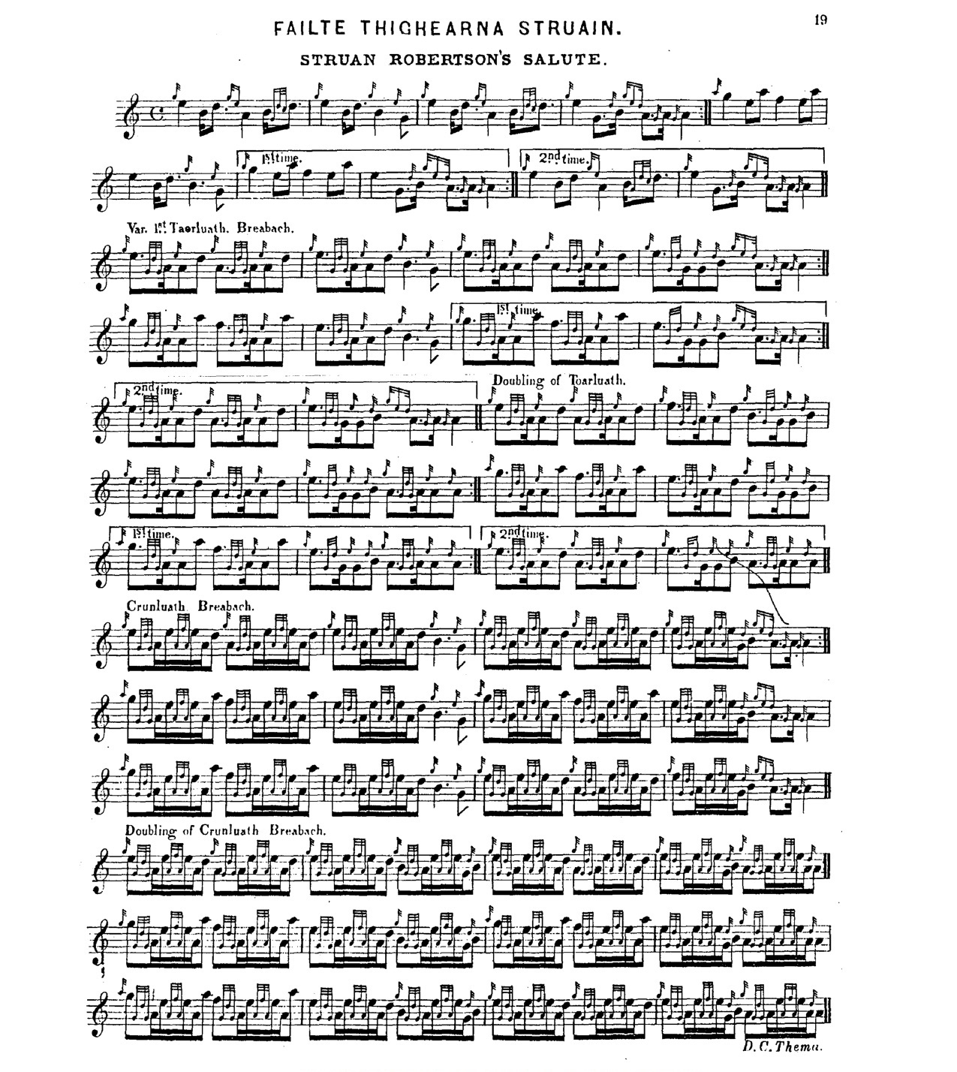

MacPhee’s ground is rather more dotted and cut and his eallach at the line endings emphasizes the initial low A in place of MacKay’s more staccato version. He supplies MacKay’s missing repeat mark at the end of the first line of the taorluath singling, and sensibly drops the repeat of the ground between the taorluath and crunluath variations, but otherwise his setting is very similar.

C. S. Thomason gives Angus MacKay, Angus’s nephew Donald MacKay, and Keith Cameron, son of Donald Cameron, as his sources for this tune. His ground is perhaps the most rhythmically explicit of the settings, perhaps reflecting the preferred timings of leading Cameron players (Donald MacKay was a pupil of Donald Cameron). Interestingly Thomason times his taorluath singling “up” and the doubling “down”, presumably to give rhythmical variety, although both his crunluath variations are cut “up”. He repeats the ground within the tune as does Angus MacKay. We note too that his eallach movement is similar to the timing Sandy Cameron the younger seems to have given to his pupil Archibald Campbell, the Piobaireachd Society’s editor, who went on to apply it wherever such movements occur, regardless of the surrounding rhythmical context. Thomason gave several different timings for these devices depending on the metrical circumstances. Thomason times the tune like this:

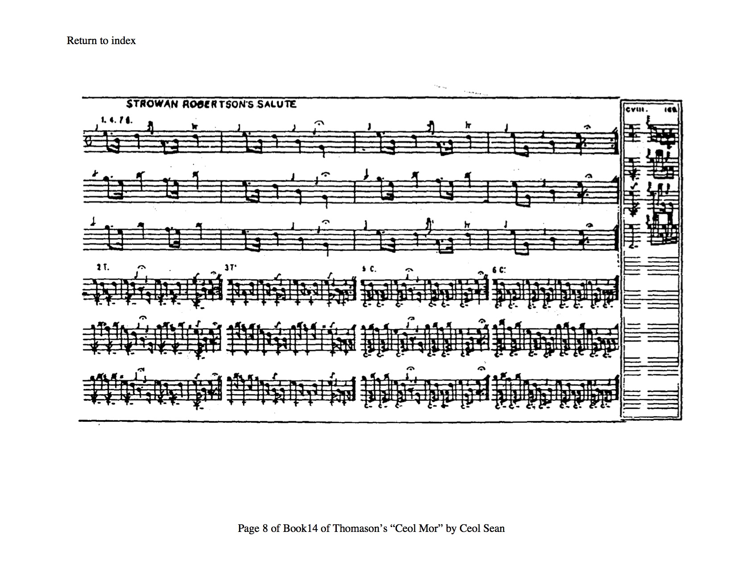

David Glen sets the tune thus:

David Glen reflects a number of features from the earlier scores, but in the main he follows Angus MacKay. Glen interestingly offers alternate “up” and “down” cut timings for his taorluath variations. If played “down” this could give a nice contrast with his smartly “up-cut” crunluath variations. Like MacPhee, David Glen does not repeat the ground between the later variations.

Commentary:

In “Historic, Biographic and Legendary Notes to the Tunes” in David Glen’s Ancient Piobaireachd (p.2), the Gaelic scholar and piping aficionado Henry Whyte, “Fionn”, wrote:

There’s a tradition in the Clann Donnachaidh that this tune was composed to commemorate the
appearance of the Clan at Bannockburn. It is known in the Athole district as "Teachd Chlann
Donnachaidh"- The Coming of Clan Donnachie - and the story goes that it was the timely
arrival of this Clan which turned the tide of battle. It is said that Bruce at a certain stage,
despairing of the arrival of Struan and his Clan, had exclaimed, "I'd give my right hand for
Donnachadh Reamhar this day!" when the welcome appearance of Duncan, and the sudden
onset of himself and his Clan, turned wavering into victory. To this "Donnachadh Reamhar"
the Clan owes the name of Clan Donnachie, or children of Duncan; while to Donnachadh's
loyalty and Robert Bruce's gratitude the name of Robertson bears witness to this day. Bruce
desired the Clan Donnachie Chief to name his eldest son Robert after him, a name thereafter
handed down in the family of the Chief, until, in commemoration of the capture of King James
I's murderers by Robert Reoch, Donnachadh's great-grandson, it was perpetuated in the surname
of Robertson.

Lairds of the Robertson name in its various branches are preserved in the record for several centuries, of whom perhaps the most interesting was Alexander Robertson of Strowan, 1670-1749, an inveterate Jacobite, “out” at the Revolution, again in the Fifteen, and, well into his seventies, out again in the Forty-Five. A poet of some contemporary repute, his Poems on Various Subjects and Occasions published probably in 1751 still make vigorous reading. He was very much a clan chief of the old style. The story went that he had not paid a creditor since 1690, and when taxed with discouraging the building of roads into his territory, declared that it had never prevented his friends from visiting him, and he had no intention of encouraging his enemies.

Of the tune itself, there are quite a few new and recent pieces in Angus MacKay’s Ancient Piobaireachd of 1838 (which in some respects rather belies its Ancient title) commemorating various contemporaries prominent in the affairs of the Highland Societies of London and Scotland, and this could be one of those—although there was a “Strowan Robertson’s March” offered by John Forbes from Killiechassie who gained 3rd & 4th Prizes in the Edinburgh competition of 1824 (“List of Pipers with their Tunes – July 1824”).

All the existing versions spring from a single published setting, that in MacKay, and from it the others clearly derive. The manuscript tradition is a complete blank here. This is highly unusual, and implies something peculiar about the transmission of this tune. A closer inspection of the score suggests that the version that has come down to us by this route may be a mere variant—an abbreviation, perhaps a mis-remembered version--of that lovely piece “Sir James MacDonald of the Isles’s Salute”.

The scores featured here raise interesting interpretational issues about the timing of breabach movements, whether they should be played “up” or “down”, whether one should give expression to the “kicking” or “prancing” movement the name implies, or whether they should be played as even quavers as is mostly heard nowadays since the promotion of the style by Archibald Campbell and the Piobaireachd Society in the 1920s and ‘30s.

“Struan Robertson’s Salute” has long been a favourite beginners’ tune. We note an entry in the Oban Times, 15/12/1923: “Instructing Boys in Bagpipe Playing” from H. S. Strafford, secretary of the committee of the Cowal Highland Gathering: “the Cowal Committee are now holding classes for young piobaireachd players in Glasgow…The teacher is Robert Reid, and there is a merely nominal charge. The three tunes they learn are MacLeod of Raasay's Salute, Too Long in this Condition, and Struan Robertson's Salute, all from MacPhee's book”.

*

Electronic text © Dr. William Donaldson, Cambridge, Massachusetts, 23 June 2020

