Sound of the Waves against the Castle of Duntroon
There are settings of this tune in the following manuscript sources:
--Peter Reid’s MS, f.24;
--Angus MacKay’s MS, i, 97-100;
--Colin Cameron’s MS, ff.19-21;
--D. S. MacDonald’s MS, ii, 4-6;
--David Glen’s MS, ff.193-196;

and in the following published sources:
--Donald MacPhee, Collection of Piobaireachd, i, 4-7;
--C. S. Thomason, Ceol Mor, pp.26-7 (with the title “Duntroon's Warning”);
--David Glen, Ancient Piobaireachd, pp. 220-2 (with the title “Duntroon’s Pibroch”).

The Duntroon tunes—“The Sound of the Waves”, “Duntroon’s March”, “MacDonald’s or Duntroon’s Salute”, and “Duntroon’s Warning” are a bit of a tangle with various overlapping titles and musical motifs. For example, the earliest of the staff-notated scores is that of Peter Reid, who sets the tune like this:

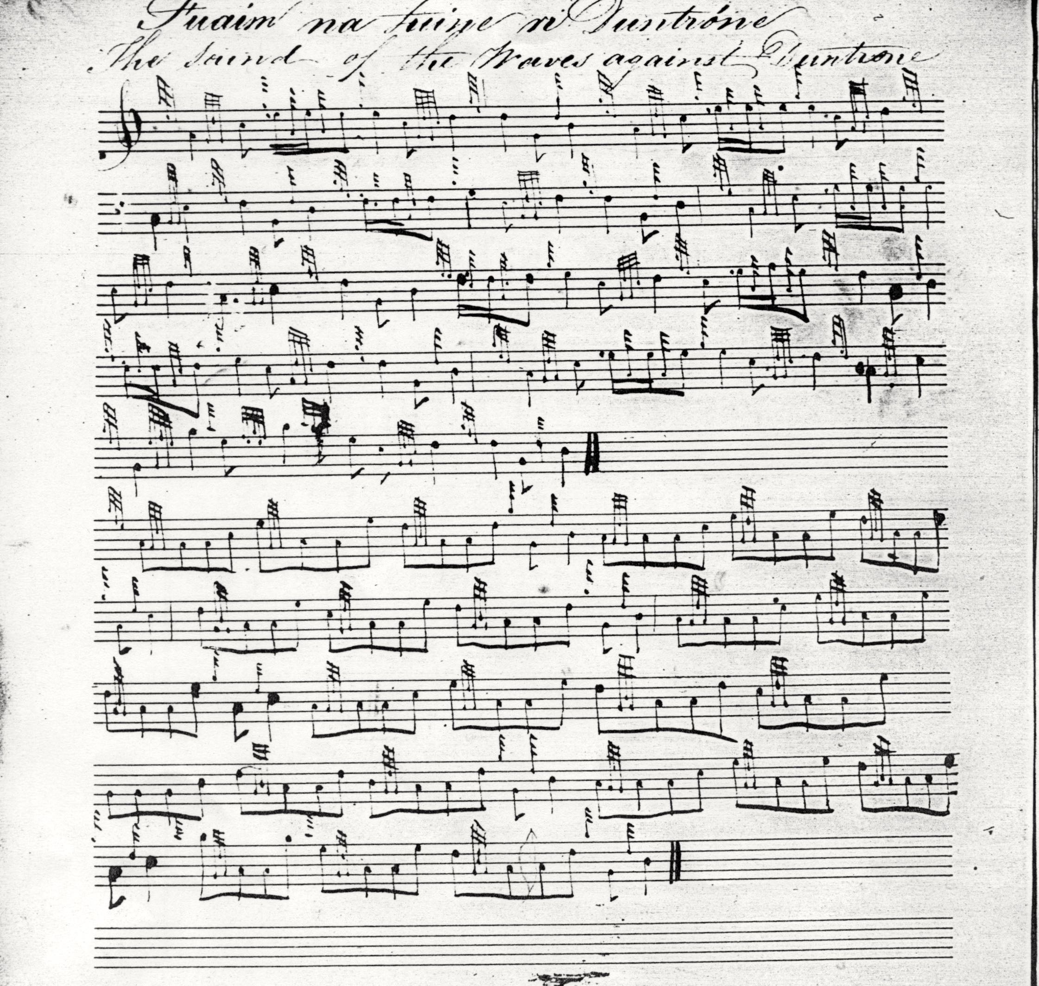

Reid’s setting bears little obvious resemblance to the main group of “Sound of the Waves” tunes, or to the other “Duntroon" tunes (included in the present series with the titles “MacDonald’s or Duntroon’s Salute”, and “Duntroon’s March”), and is not discussed further here.

Angus MacKay sets “The Sound of the Waves” tune like this:

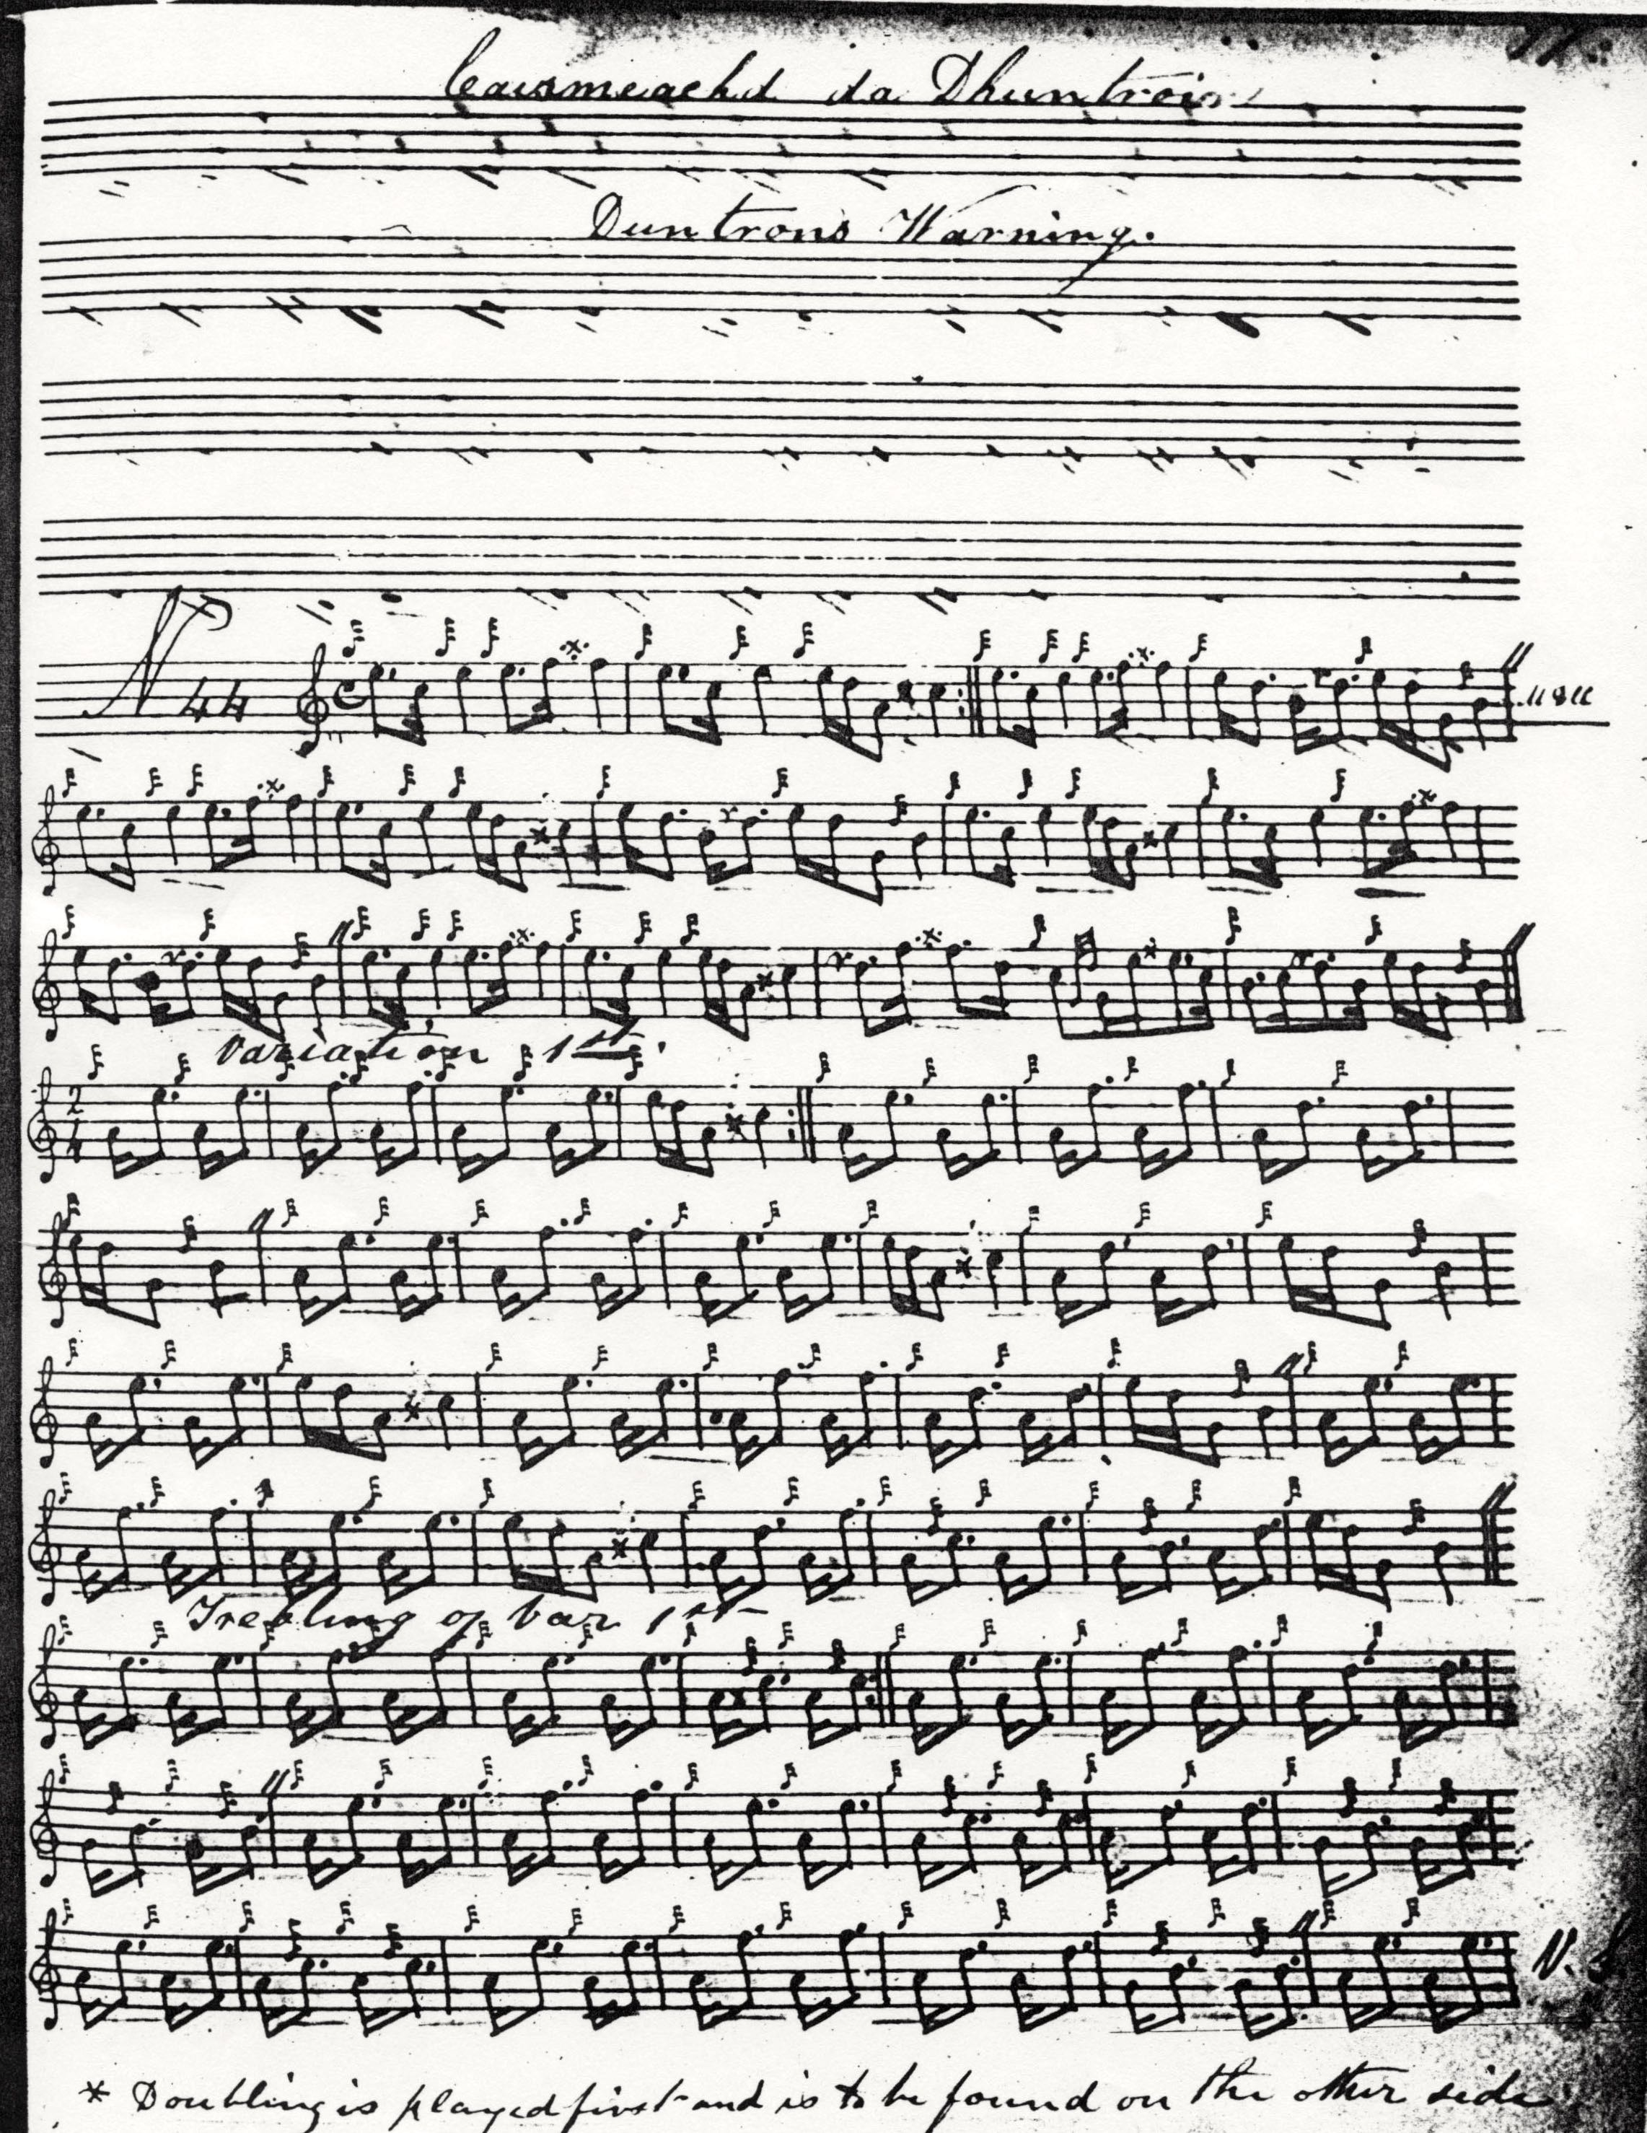

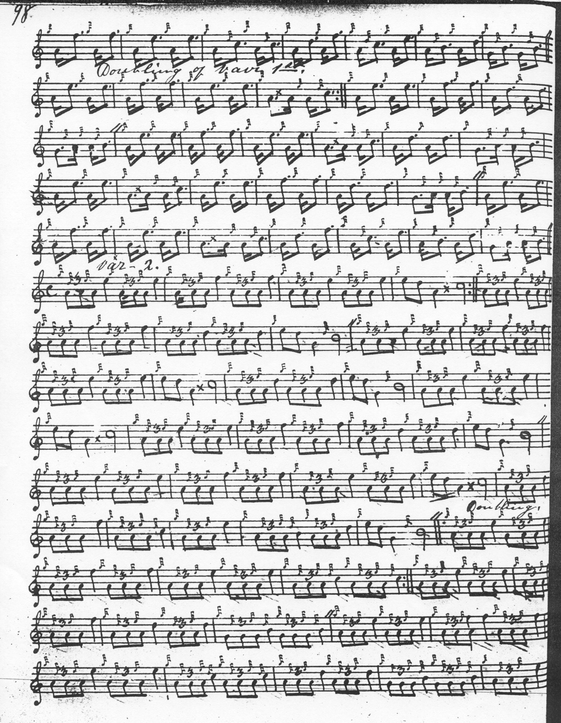

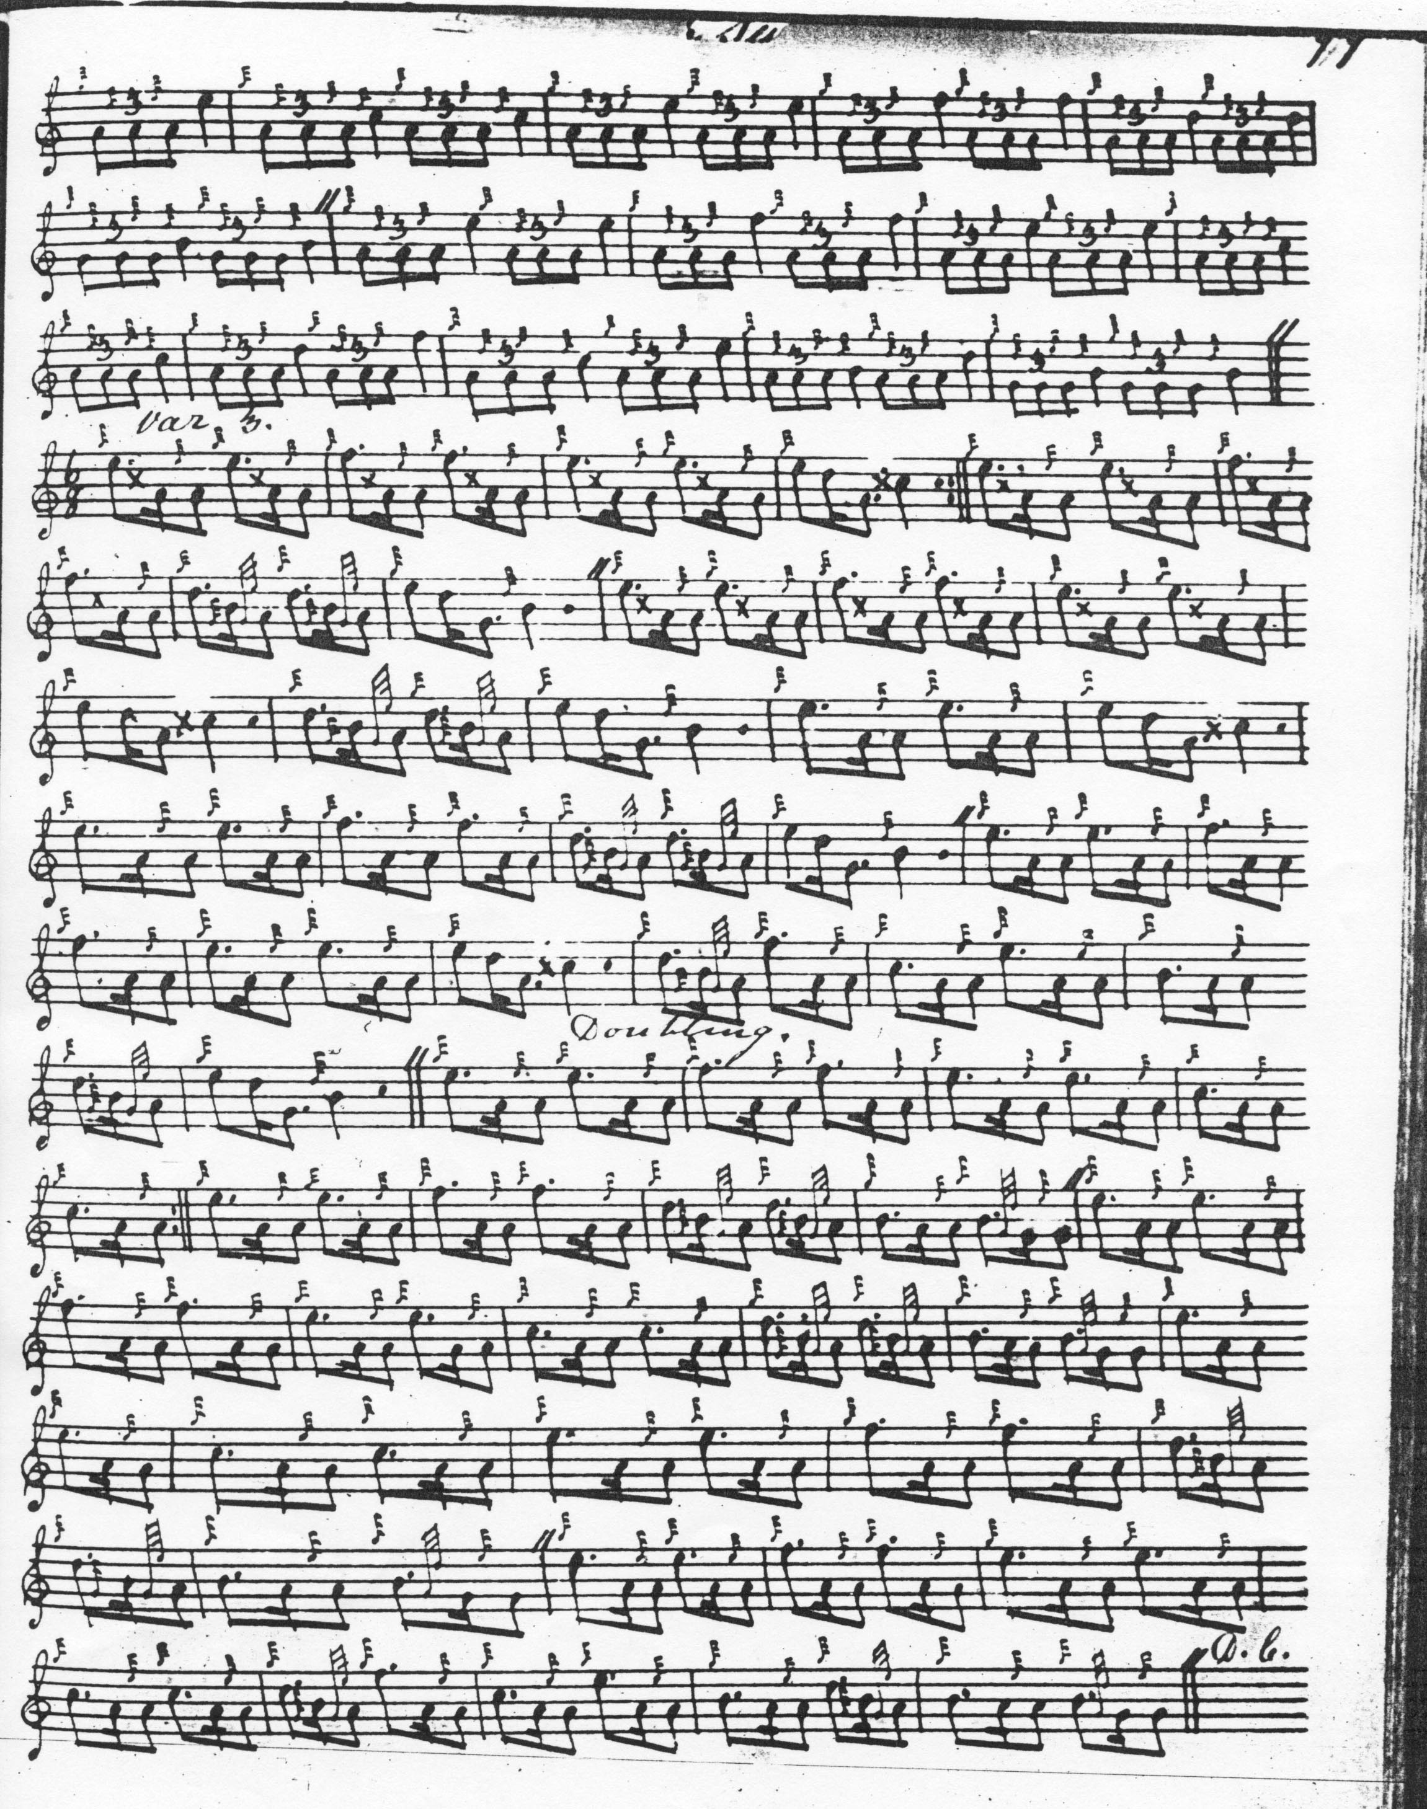

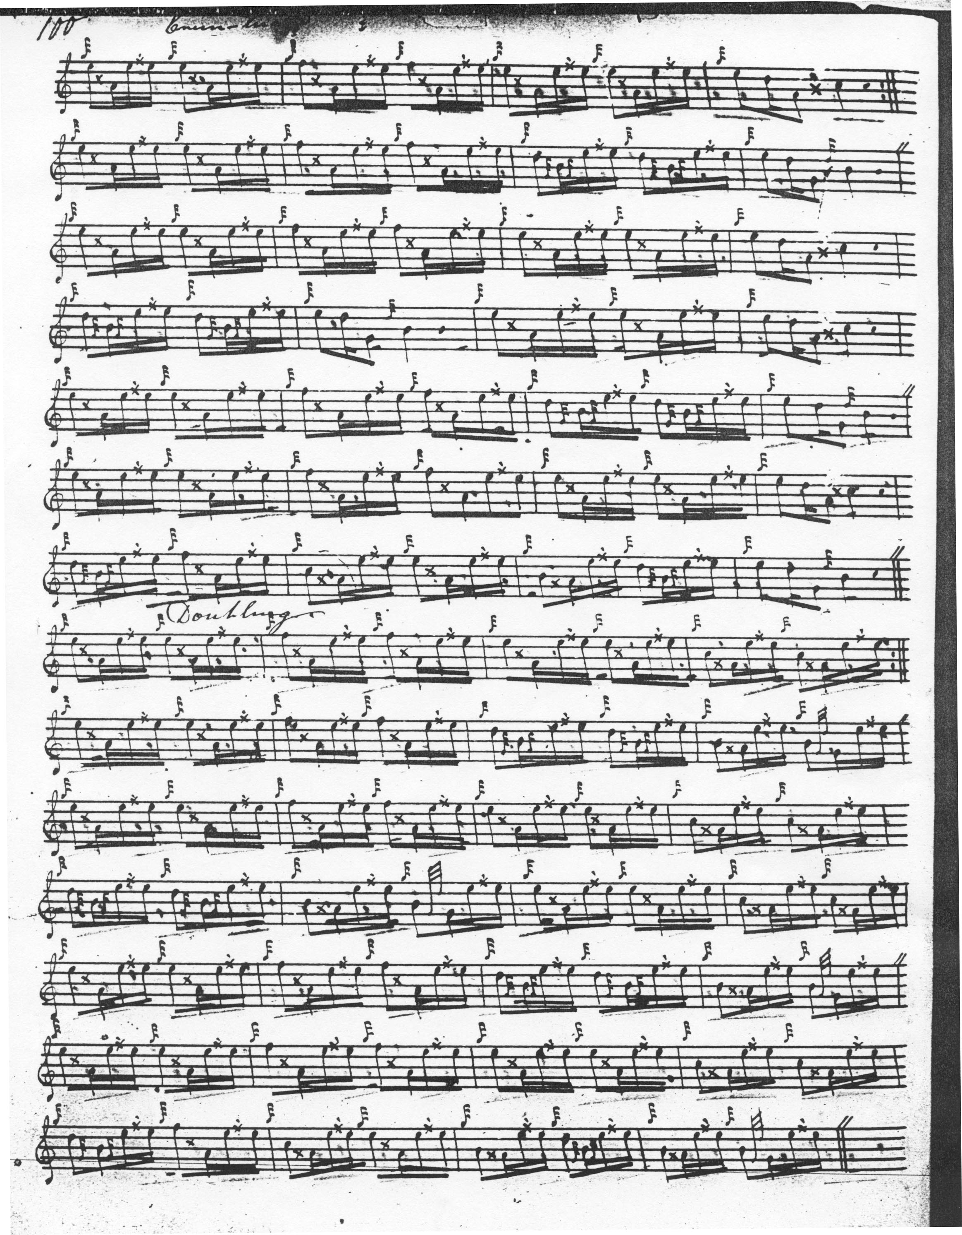

It will be obvious at once that there is a huge amount of repetition here. Bars 1, 3, 5, 7, 9, 11,13, and 15 are identical, amounting to about half of the musical material in the ground, and the remainder is closely related tonally. There are many shared motifs between the A and B phrases, the B phrase differing from its counterpart merely in having its second element drop by one tonal step, so that the main building blocks of the tune seem very narrowly differentiated. This may possibly be deliberate, in order to produce an onomatopoeic ostinato effect, a tonal reflection of the lulling sound of the waves. But many may feel that there is not enough tonal tension generated between the tune’s two scales: the first, A, C, E, F, (although the scale is gapped at D, D is nonetheless asserted as an appoggiatura with varying degrees of emphasis in MacKay’s score); the second G, B, D. E, F, gapped at C. To be sure, the pattern mutates in line two, where D is more strongly asserted, as a themal note and in line three where the two scales are ingeniously combined. The reader will note the asymmetrical development in MacKay’s score; the siubhal has a doubling and trebling; all other movements have a doubling only. MacKay indicates that the ground should be repeated at the end of the taorluath doubling, but not at the end of the crunluath doubling.

Colin Cameron sets the tune like this:

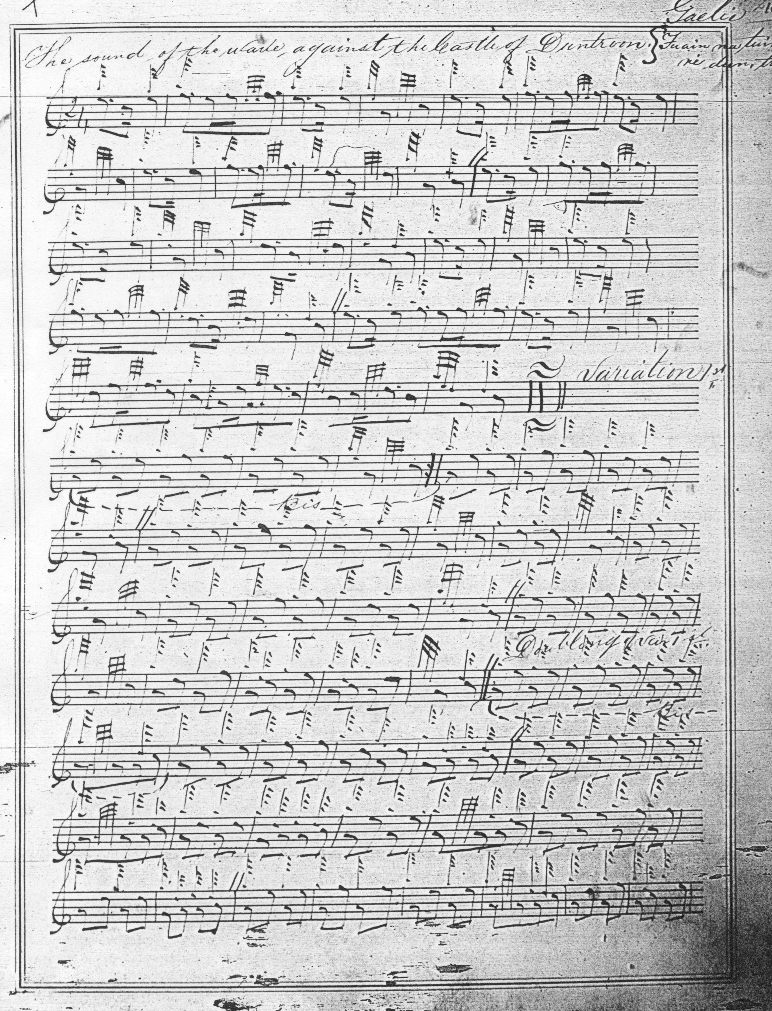

And so on.

Colin Cameron plays “down” on the cadences emphasizing the low As and Gs, giving, some might think, a rather heavy feel, and features a cadence E at the beginning of the ultimate bar of the ground. We note too his slightly different treatment of the movement on F in bar one of the ground and in corresponding positions elsewhere, and the “round” pointing of the siubhal (perhaps a scribal convenience, but possibly indicating that the movement could be played either “up” or “down”). Cameron ends his score with the taorluath doubling, indicating in a marginal note that the crunluath variations can easily be taken from it. He drops MacKay’s siubhal trebling, opting for balancing singling and doubling development for each of the variations.

Donald MacPhee takes an interesting route through the tune with a number of touches to vary the beaten track, including differentiated timings for his E/A and D/G cadences in the ground, playing the first round and the second sharply “down”, and playing the siubhal singling “down” and the doubling “up”. McPhee sets the tune like this:

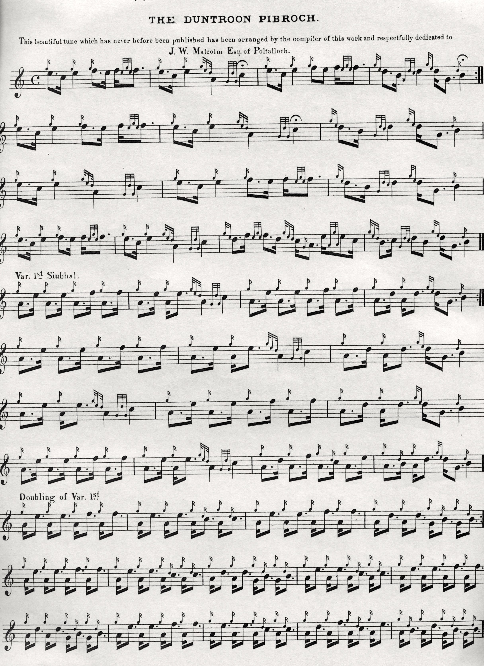
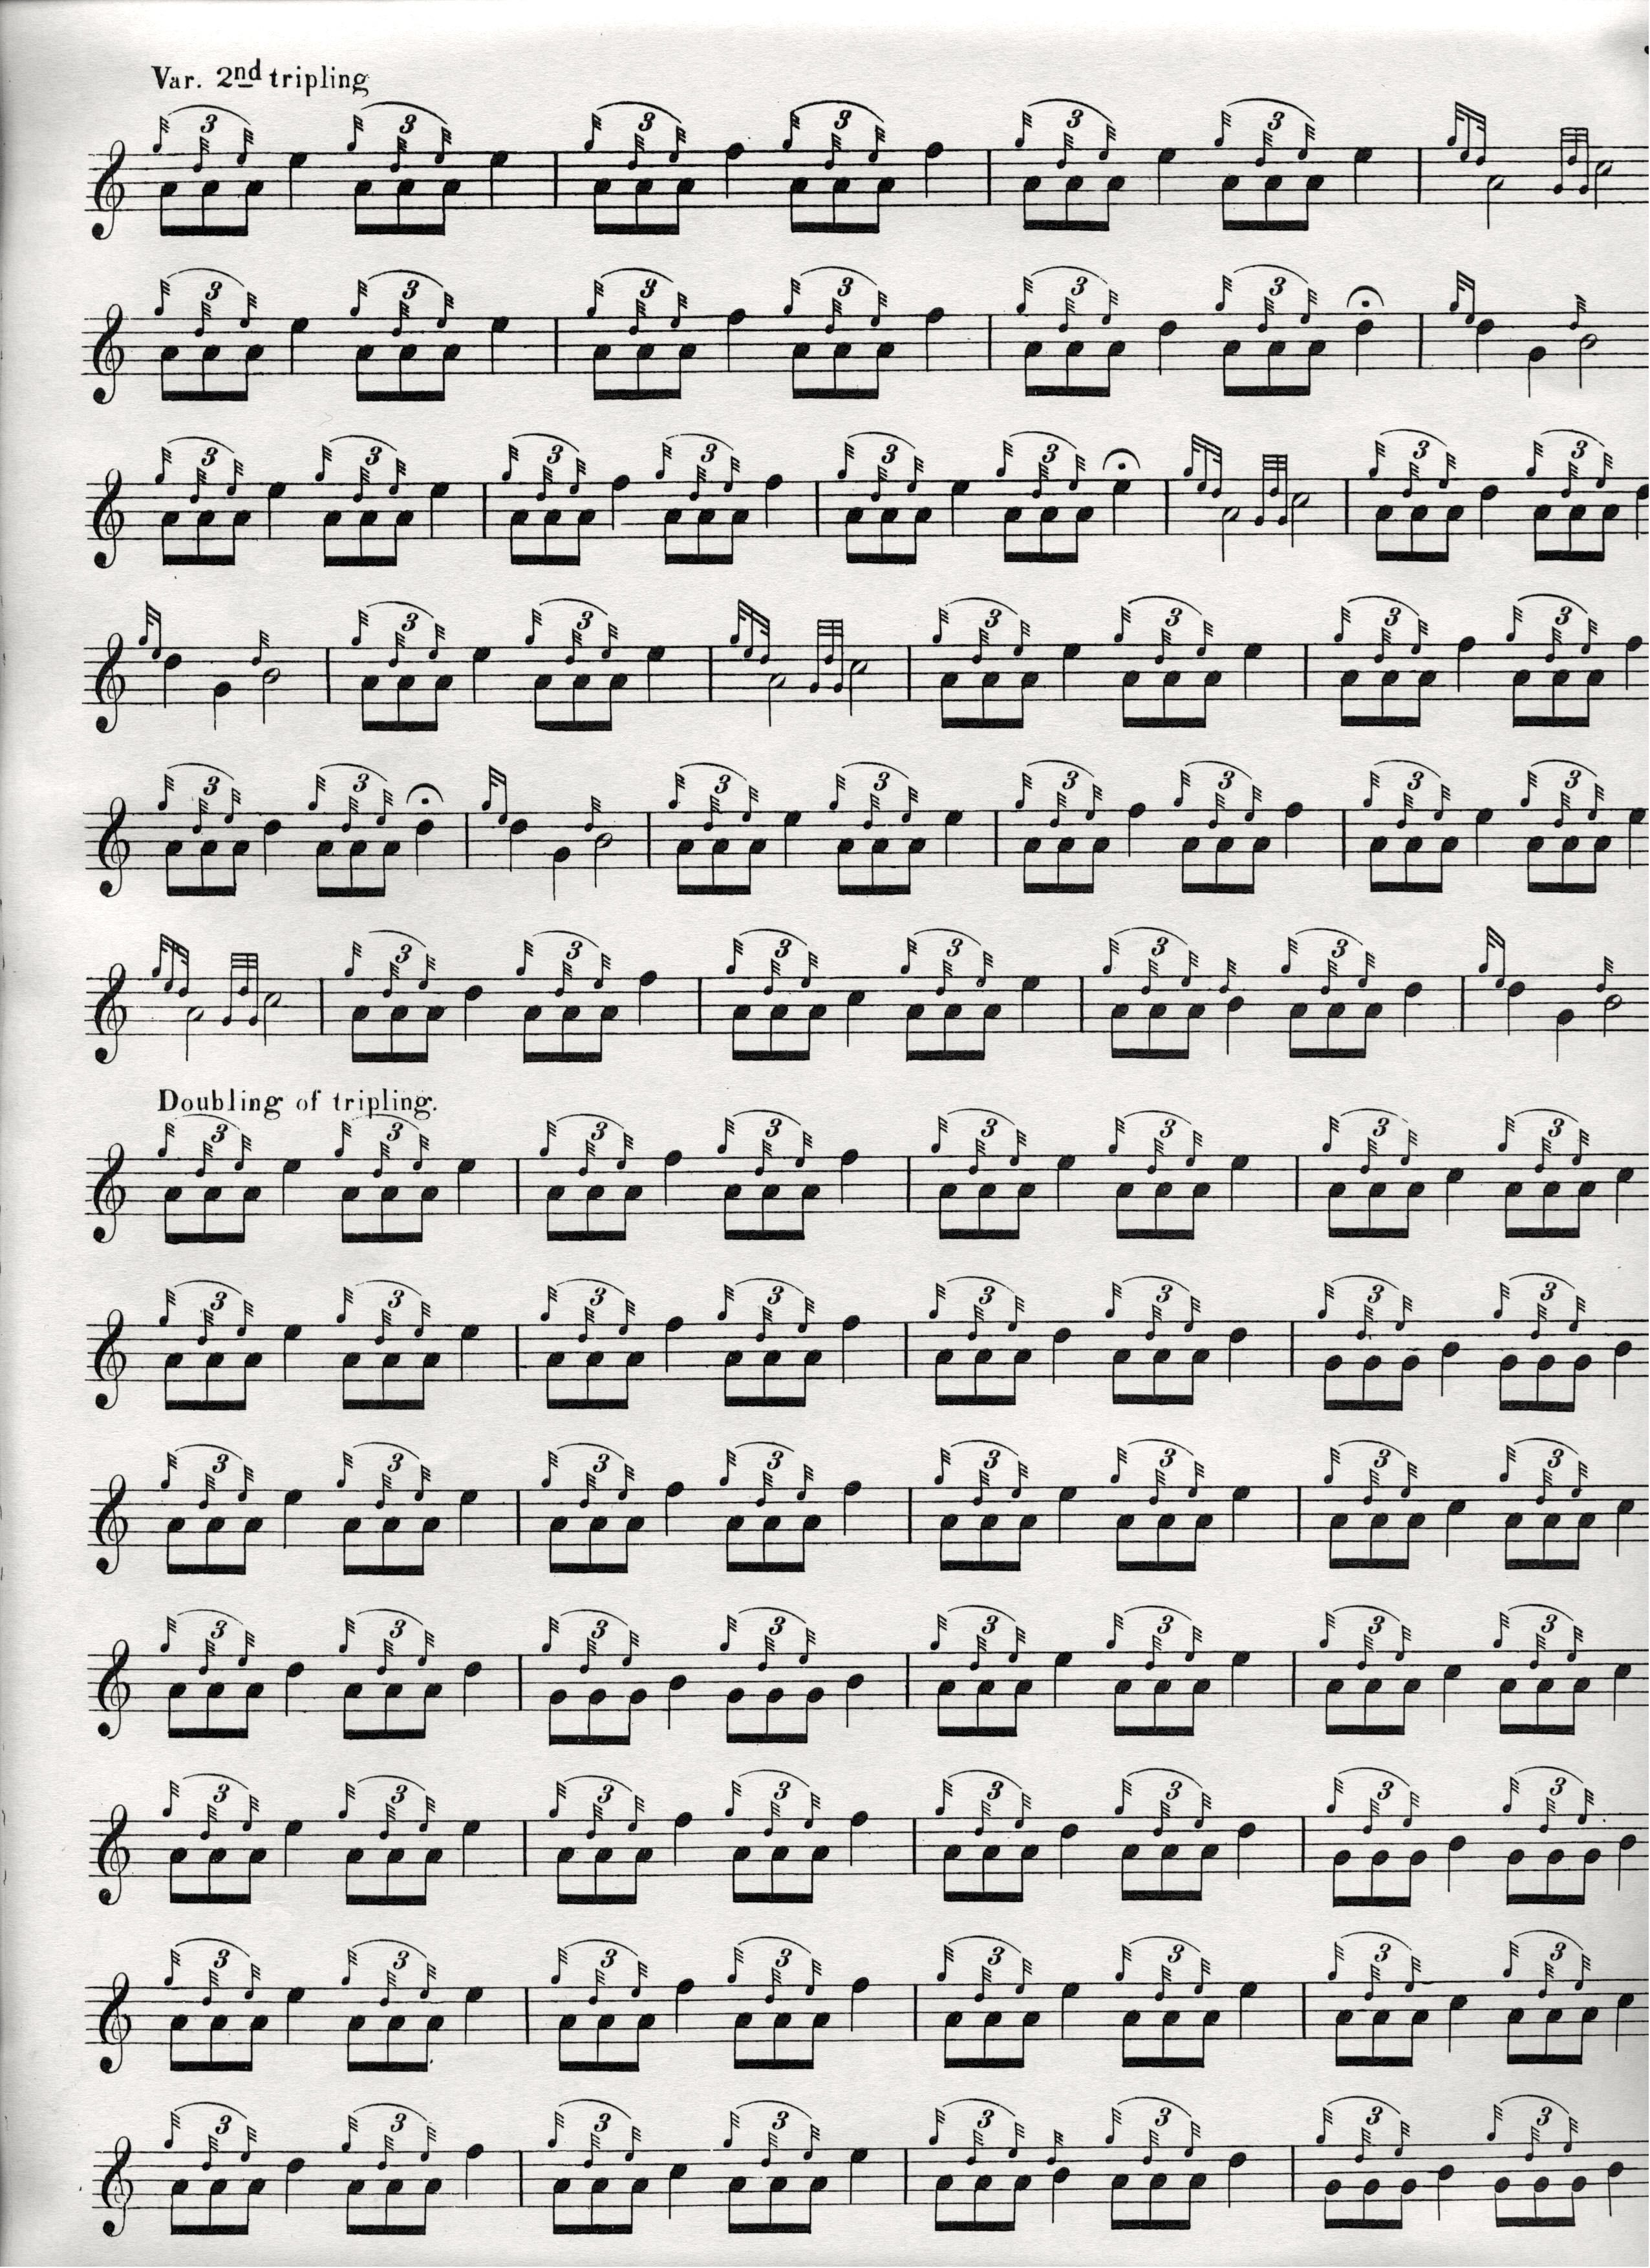

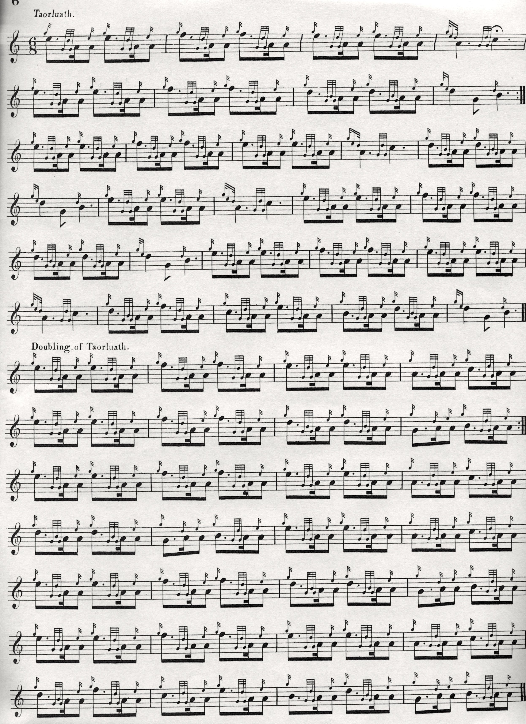
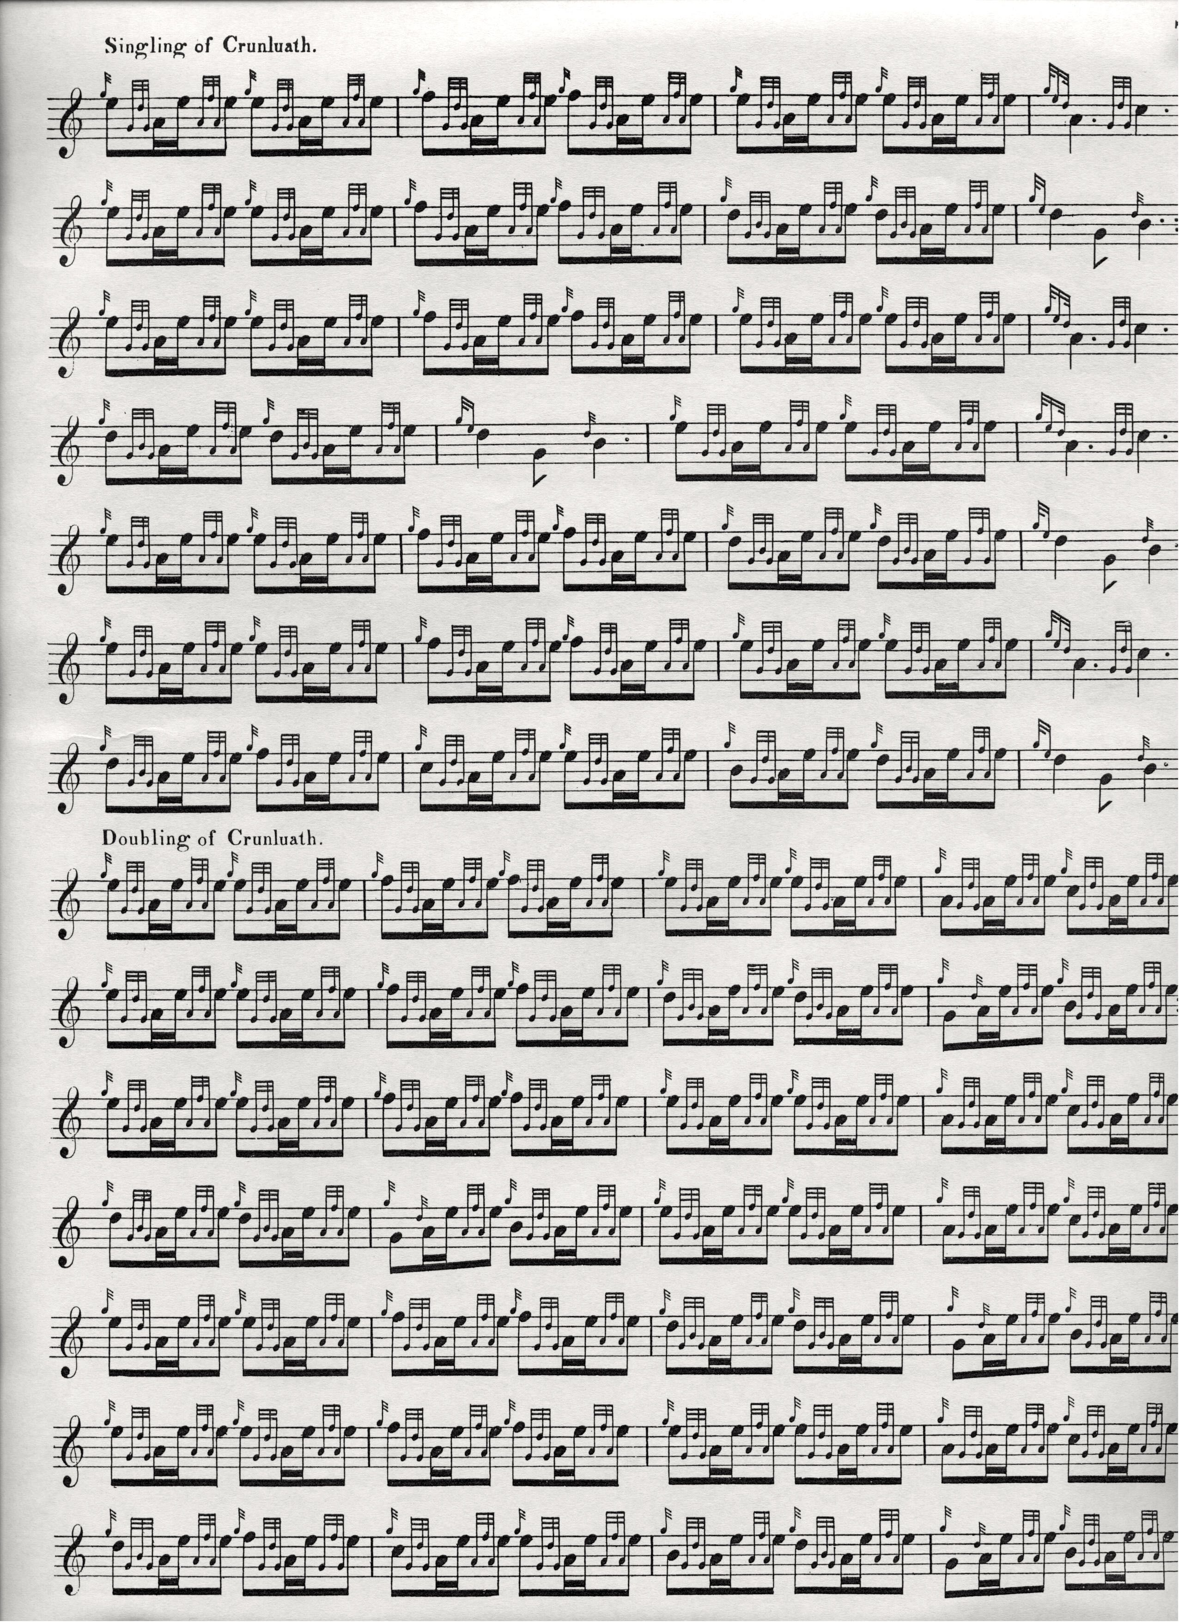

Donald MacPhee’s might well be the preferred setting, except for his curious decision to re-format the piece as a four line tune by re-arranging the first line in two phrases, A and B, and then repeating it, throughout the tune

David Glen follows MacPhee in a number of expressive details both in his manuscript and in the published setting in Ancient Piobaireachd, the only significant difference between the two Glen settings being that in the published version (but not the manuscript) it is indicated that the ground be repeated after the taorluath and crunluath doublings, as below:

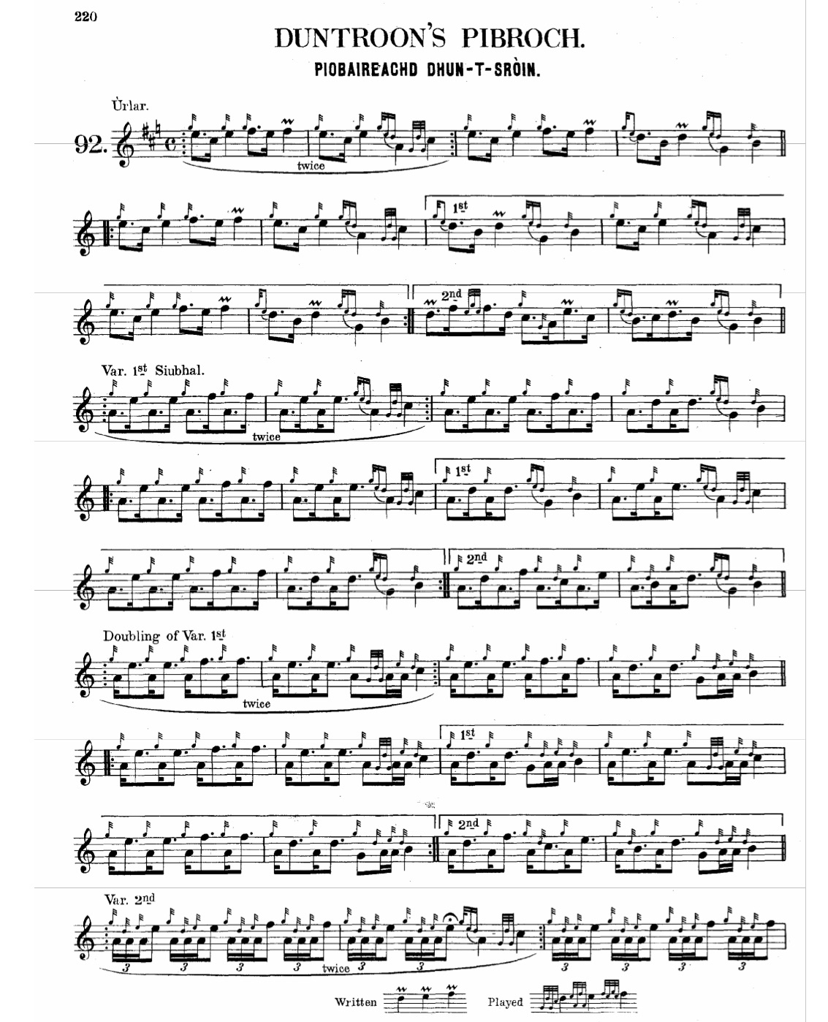

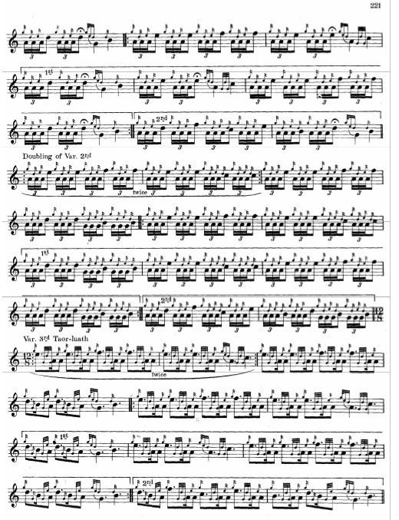
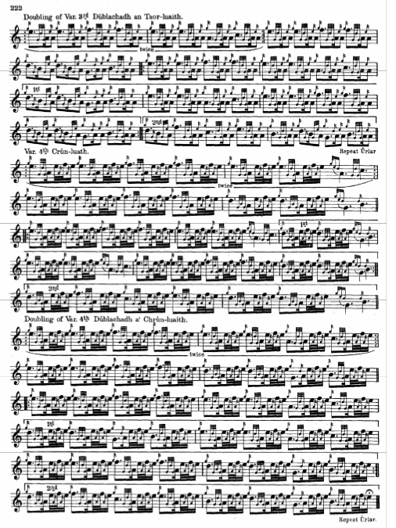

C. S. Thomason calls this tune “Duntroon’s Warning” and his full title (given in the index) is “Caismeachd Dhuntruin no Fuaim na tuinne ri Duntrone. He marks its source as “z” interestingly, a category he describes as “Sources of information other than those supplied above, the authentic origin being unknown to the Editor”, although in actuality he follows MacKay here, including reproducing MacKay’s siubhal trebling. His score adds little to the interpretational possibilities of the tune, and is not reproduced here.

D. S. MacDonald follows his source—Angus MacKay’s manuscript--rather closely, and is not reproduced here.

Commentary

There are intriguing thematic links between this tune and the piece called “Duntroon’s March”, a single copy of which is preserved in the Nether Lorn Canntaireachd.
“Duntroon’s March” has its own separate entry in the present series, and the historical notes to the Duntroon tunes reprinted below, first appeared there:

‘The Duntroon tales emerge from a skein of stories surrounding “The Piper’s Warning to his Master”, the central theme being how a piper sacrificed himself to alert his chief to an intended ambush, more usually associated with the castle of Dunyveg in Islay (for further details see the “Set Tunes” PDF file on “The Piper’s Warning”).

For many a century Time has been working away at those grey old walls of Duntroon, and sunshine and shade melt softly into each other as we look up at them this morning, resting, after a long row, upon our oars in the bay.
They were rough enough doubtless two hundred years ago, when Coll MacDonald, the fierce left-handed warrior, came over from Ireland to claim his inheritance in Kintyre, taken from his father on account of rebellion, and gifted to the Campbells by James I. Determined to be revenged, he passed on through Argyllshire sparing nothing belonging to the hated name. After burning the Earl of Argyll’s Castle of Sween in Knapdale, Coll sailed down Loch Sween, round the point of Keils, and up into Loch Crinan, intending to do the same at Duntroon; but being uncertain as to the strength of its garrison, he first dispatched his piper across the mountains to Crinan with orders to gain admission into Duntroon Castle and bring him information regarding it. When the piper arrived, he was hospitably received and lodged as a stranger within the castle; yet, treachery being for some reason suspected, he was not allowed to leave again in the morning, but detained as a prisoner in one of the turrets. Thence, after long waiting, he saw his master’s ships entering the loch. What chance for him now? The poor piper! The suspicions of Duntroon are confirmed beyond a doubt, and his fate it is not difficult to foresee; but he does not think of himself. The Campbells are on the alert. He must save his master. And over the waters of the bay sound out the notes of a warning, composed on the spur of the moment, yet not to be mistaken in its meaning. Tradition has joined to the air these words, and with the spirit of it they accord well:—

Coll, my love, keep from the tower, keep from the tower! Coll, my darling-, keep from the sound, keep from the sound! I am in ward; I am in ward!

MacDonald heard; and, veering northwards, landed his troops at the head of the loch, and led them through the valley of Kilmartin, burning, pillaging, and cattle-lifting up to the shores of Loch Awe. […]
Coll’s son Alexander, Allister MacCholla, as they call him in Gaelic, is better known to history as the Major-General of the gallant Marquis of Montrose, whose career we will now trace through a troublous year, in order to reach our second Duntroon piper. […]
Montrose […] divided his troops into three bodies, one commanded by MacDonald of Clan Ronald, another by Sir Alexander MacDonald, and the third by himself, and with them swept the whole county like a fearful, animated pestilence; driving away the cattle, burning the villages and crops, slaying in cold blood every young man capable of bearing arms. Is it wonderful that the “Raid of the Athollmen” is still remembered with horror throughout the county they desolated, and that the name of Alexander MacDonald, and even that of James Graham, is execrated in many a Gaelic curse? The inhabitants of almost every western parish have some story to tell regarding this invasion. In Craignish they will show you the hill from which they fired on the castle and were beaten back with heavy loss; in Melfort, the site of the barn where men, women, and children fleeing for refuge were burned to death; but nowhere has the devotion been forgotten of the brave boy, our second piper of Duntroon.
With the surrounding country full of retainers ready to give the alarm, it would have been folly to approach Duntroon from the land side, so Alexander MacDonald, following his father's example, determined to approach it by sea; though at this time an assault from either side might probably have been successful, for it happened that only Duntroon himself and a few friends were living in the castle—garrison there was none—and so unsuspecting of any kind of evil were they, that while the enemy’s ships were entering the bay a dance was going on in the hall overlooking
it. Darkness fell, ship after ship sailed up stealthily and anchored below the rock, and in the room above it still the dance went on. Were ever dancing and death nearer one another than they were that night? […]
The order is given to land quietly and secure the gate; the men are beginning to obey, when suddenly the stillness is broken by the sound of a pibroch, played wild and shrill from on board one of the ships, and as the first notes of it died away in the darkness, the lights in the castle windows are extinguished. The secret of the Athollmen is betrayed, but by whom? Allister, mad with passion, shouts for the traitor to be seized and brought before him. That is not difficult, since the pipes are still playing; but his amazement almost overpowers his anger when he recognises the player, a lad picked up by chance in the north of Ireland, and pressed into service because of his music.
“Why have you chosen to betray your leader?” he asks.
“I have chosen to rescue my leader,” replies the boy.
“Did I not hire you to encourage my followers in battle, not to give warning to the enemy?”
“Have I not encouraged your followers? But I dare not betray my chief.”
“Am I not your chief by wage and contract?”
“Duntroon is my chief by a higher allegiance. I am his clansman, born beyond the hill yonder at Slochivullin.”
Time permits of no further parley. The garrison may be about to fire on them. “Cut off his traitorous fingers, and hang him to the masthead !” is the savage order.
Ah, pity, Allister! have you forgotten your father’s piper?
And the touching tradition closes by telling us how, when nothing but the bleeding stumps of his fingers were left him, the faithful clansman still played on, the music growing fainter and ever fainter as the chanter filled with blood, ending only when his pipes were taken from him, and with them his life.
The Athollmen pressed on to find the castle gates unbarred, and no one waiting to oppose their passage. In the dark hall, where half an hour before the dancing went on merrily, an old woman, too old to care for life, sits by herself, who tells them that she, thanks to the boy’s pibroch, is now the garrison of Duntroon. These are the notes of his pibroch, worthy of being played in blood :—
These the handed-down words of his last greeting to his chief:—

All hail to thee! all health to thee! all hail to thee, Duntroon!
All hail to thee all health to thee! all hail to thee, young Neil!
They are on thee, they are at thee: be heedful, O Duntroon!”

His or not, they are alive with the unselfish, reverent devotion of the Celtic heart, which the thing we call civilisation has elected to crush out and destroy. (pp.201-5)’

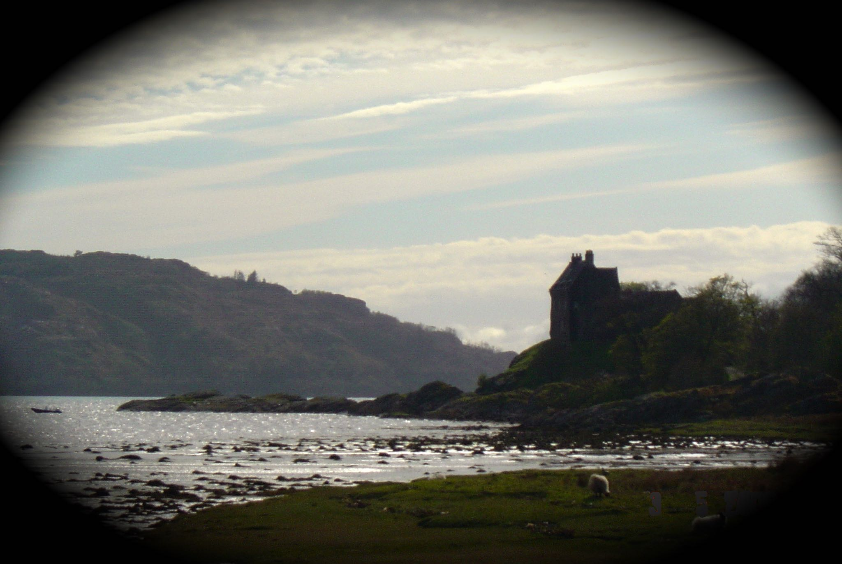

Duntroon Castle from the east.

* * *

Electronic text © Dr William Donaldson, Dunmore Town, Bahamas, 21st January 2017

