Sir James MacDonald of the Isles’ Salute

There are settings of this tune in the following manuscript sources:

--**Peter Reid**’s MS, f.34;

--**David Glen**’s MS, f.179 and again at ff.360-362;

and in the following published sources:

--**Angus MacKay**, *Ancient Piobaireachd,* pp.99-101 (with a note “Composed by William Macdonald Esqr. of Vallay”);

--**Donald MacPhee,** *Collection of Piobaireachd****,*** ii, 26-28;

--**C. S. Thomason**, *Ceol Mor,* pp. 71-2.

**Angus MacKay** sets the tune as follows:







**MacKay** had a ground, a pair of siubhals singling and doubling, taorluath fosgailte singling and doubling, taorluath breabach singling and doubling (pointed “down”), and a crunluath breabach singling and doubling, pointed “up” by way of contrast.

**Donald MacPhee**’s setting follows **MacKay** fairly closely except that he emphasises the initial low A his eallachs in preference to MacKay’s cut version. We also note his curious timing of this movement in his “tripling of second variation” as follows:

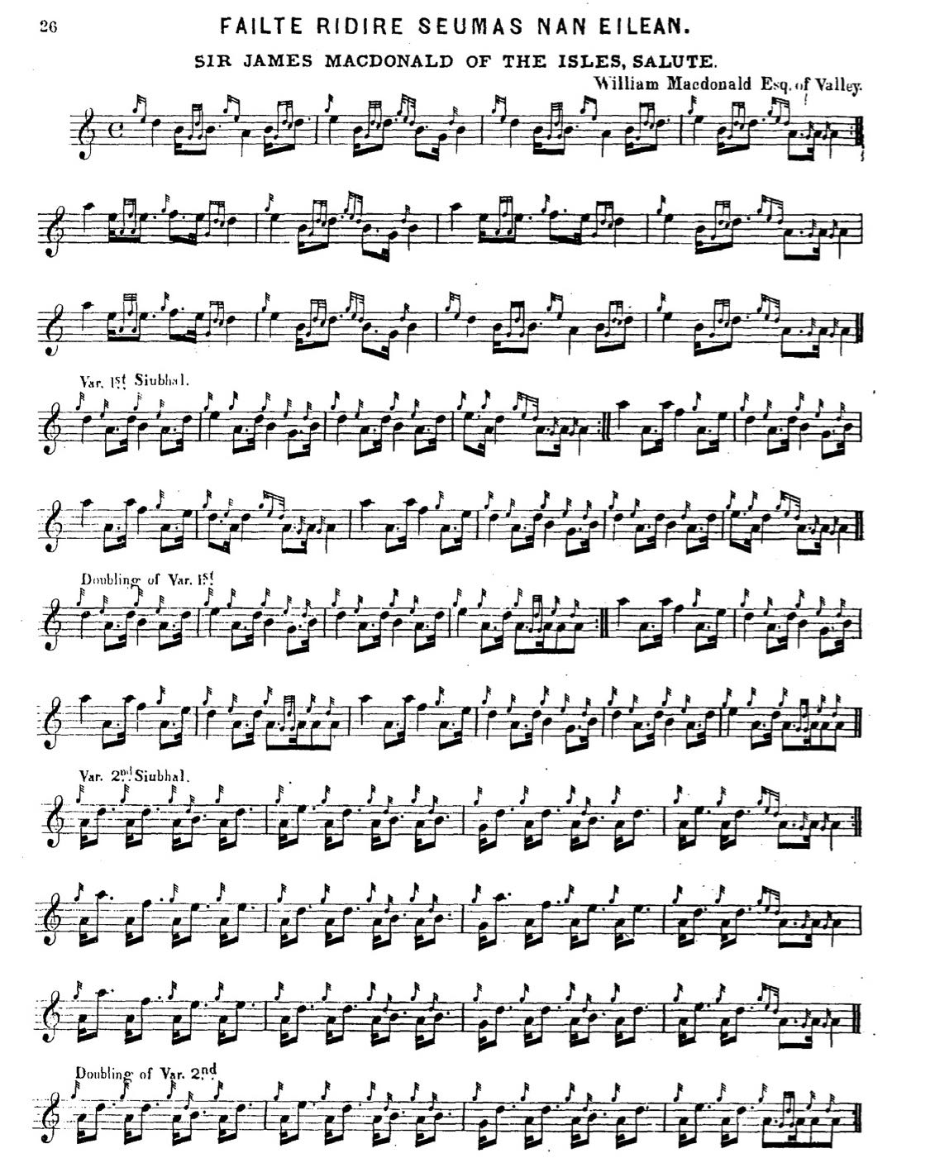

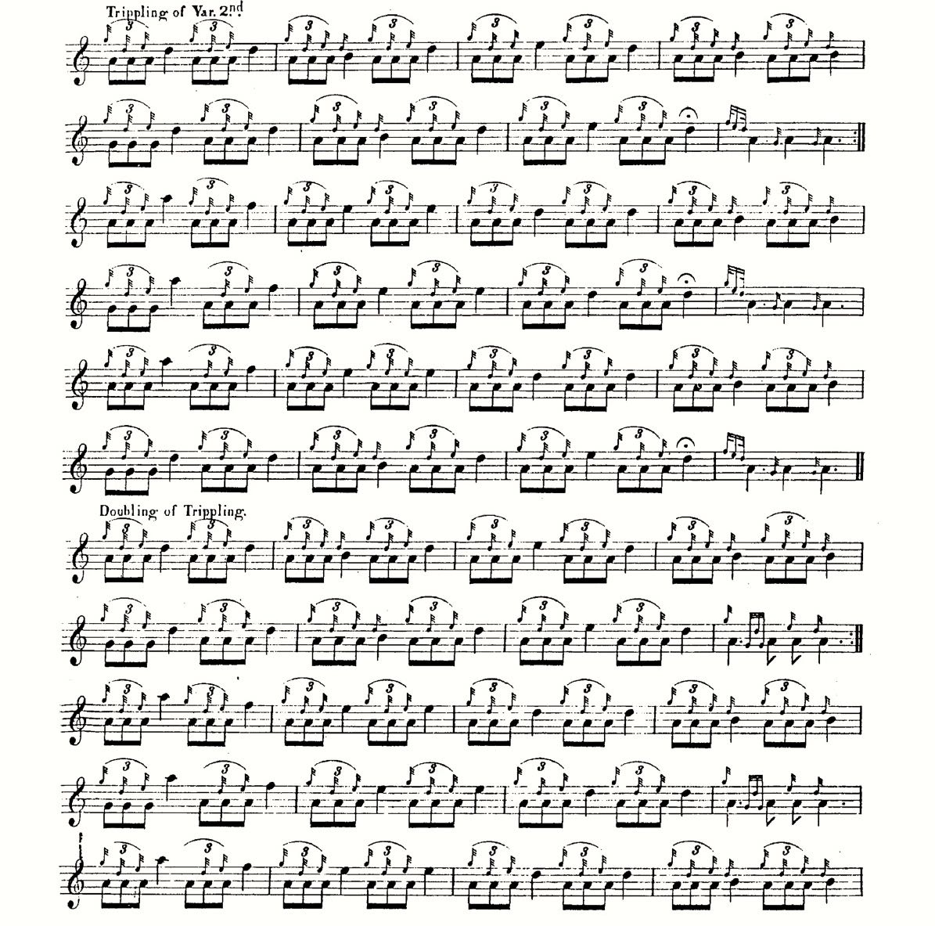

and so on.

Like MacKay, MacPhee points his taorluath breabach “down” and his crunluath breabach “up”. He also removes MacKay’s instruction to repeat the ground between the taorluath and crunluath variations.

**C. S. Thomason** also follows **MacKay**, although he steps over into 2/4 in the taorluath fosgailte, presumably on the authority of Angus’s nephew, **Donald MacKay,** who was taught by **Donald Cameron**, this being one of the tunes which “D. Cameron corrected, or passed as correct in his uncle’s Angus MacKay’s Book.” (*Ceol Mor,* 1905, Index), as follows:

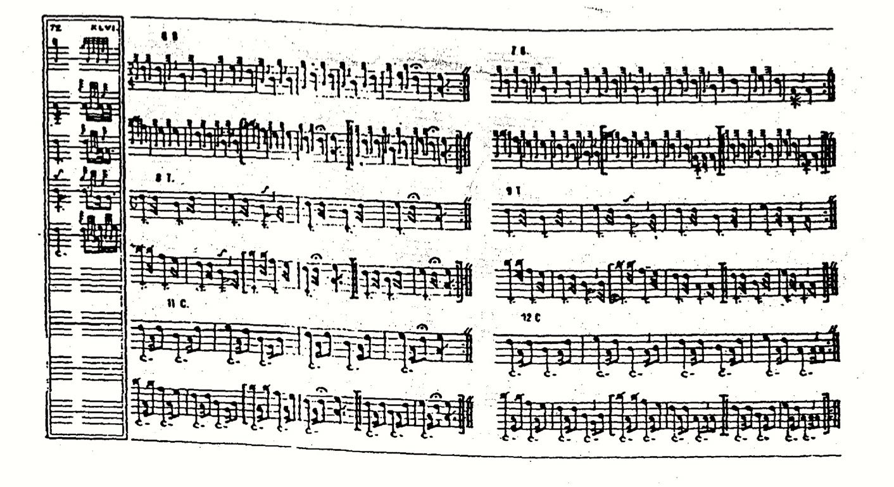

The oldest of the manuscript settings, **Peter Reid**’s seems to be incomplete, finishing two thirds of the way through the second siubhal with no indication that there might be more to follow. Reid treats the tune like this:

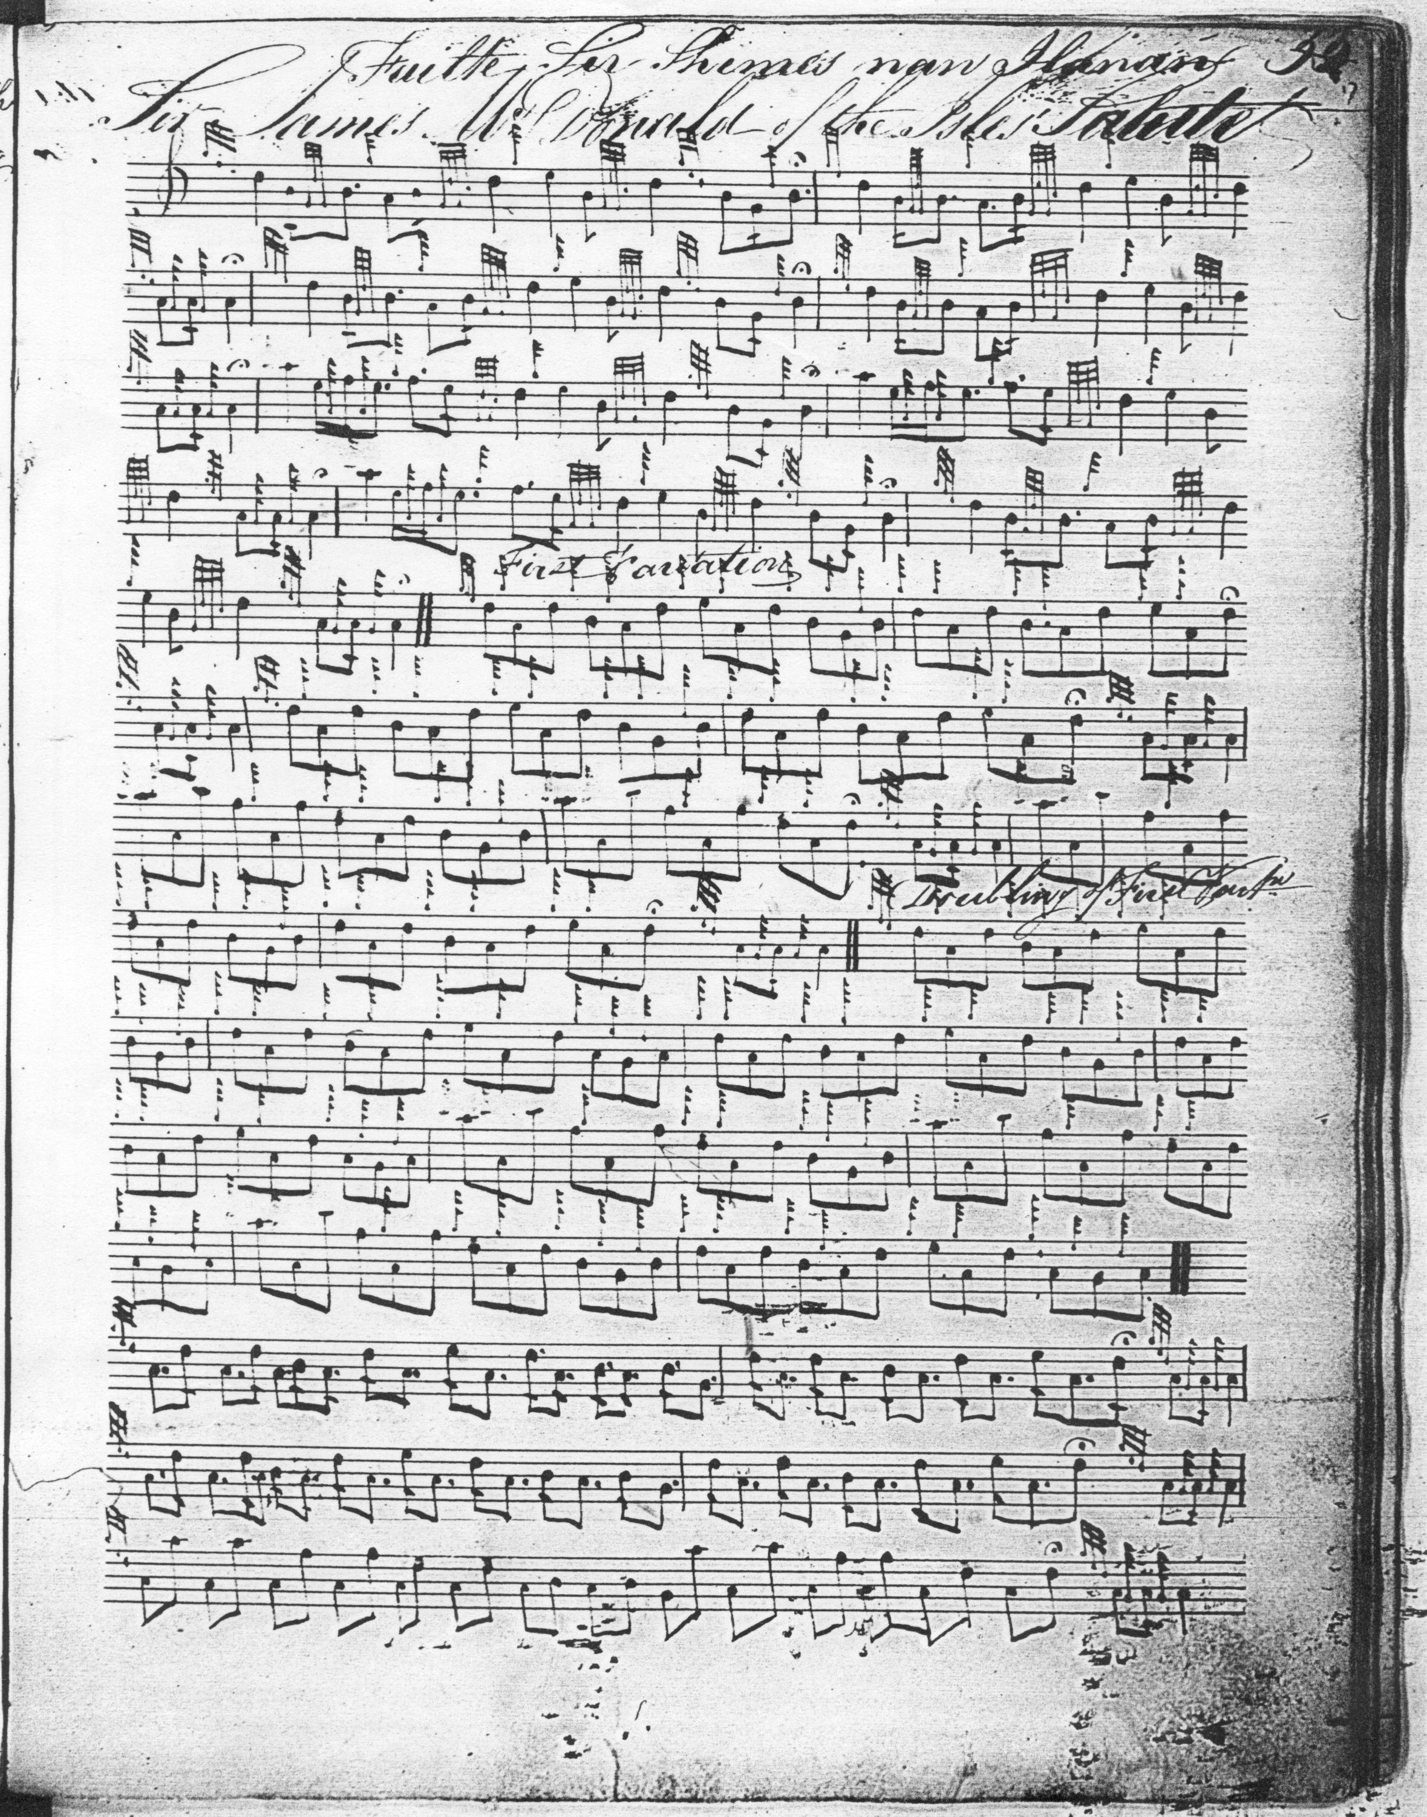

We note that **Reid** drops the cadence E on the first low A and wherever the corresponding phrase occurs throughout the tune. He emphasises, as many of the other settings do, the first low A of the eallach group; and his first variation is interestingly written in even-quaver triplets—a possible indication that the movement could be pointed in a number of different ways according to the taste of the performer. It is a pity that Reid seems to have taken the score no further.

**David Glen** also follows **MacKay**,simply substituting his own eallach, dotting the initial low A in his familiar style, and timing his taorluath fosgailte in the “modern” manner. The tune appears twice in Glen’s manuscript; the first occurrence at f.179 merely gives the ground; the complete setting is at ff.360-62 from which the example below is taken:

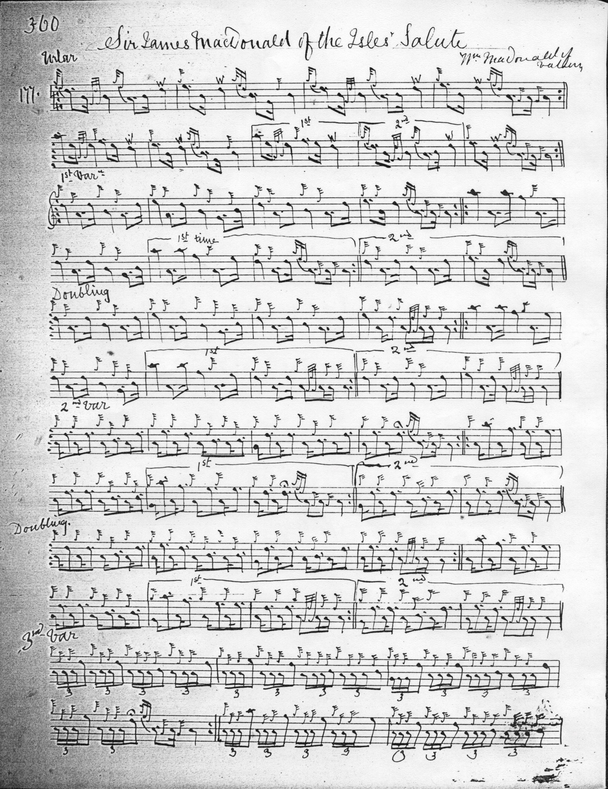

and so on.

*Commentary:*

The dedicatee of this lovely tune has been identified as one of a number of possible MacDonald lairds. In *Piping Traditions of the Outer Isles* (Edinburgh, 2013) Bridget MacKenzie suggests that William MacDonald (the “MacDonald’s Tutor” of the famous lament) and founder of the Vallay branch of the family, was himself a notable player and composed this tune for Sir James MacDonald the 10th chief of the MacDonalds of Sleat who died in 1678. It has also been suggested that tune was made for Sir James MacDonald, son of Angus, 7th of Dunyveg, who died in 1621, or alternatively the young Sir James MacDonald, 16th of Sleat, the intended dedicatee of Joseph MacDonald’s *Compleat Theory of the Scots Highland Bagpipe,* who died in Rome in 1766. Musically, the tune does have a strongly “eighteenth-century” feel, with motifs linking it to “The Prince’s Salute” and “The Battle of Glenshiel”.

Although the manuscript and early printed tradition speaks with a relatively single voice, “Sir James MacDonald’s Salute” was obviously something of a favourite with the older pipers, a tune of this title being offered in the 1824 Edinburgh competition by Glengarry’s piper, Archibald Munro (pupil of Angus MacKay’s father, John MacKay, and later teacher of Malcolm MacPherson—“Calum Piobaire”); and at the 1838 event by the pipemaker William Gunn. The tune is also recorded in Eliza Ross’s keyboard transcriptions of pipe and fiddle music heard by her at Raasay House in the early years of the nineteenth century. It would appear to be from the playing of John MacKay, but it differs from his son Angus’s account of the tune with regard to a rather remarkable crunluath variation, which appears to parallel a number of other tunes incorporating tripling movements at this stage such as “The Men Went to Drink”. The relevant passages are as follows:

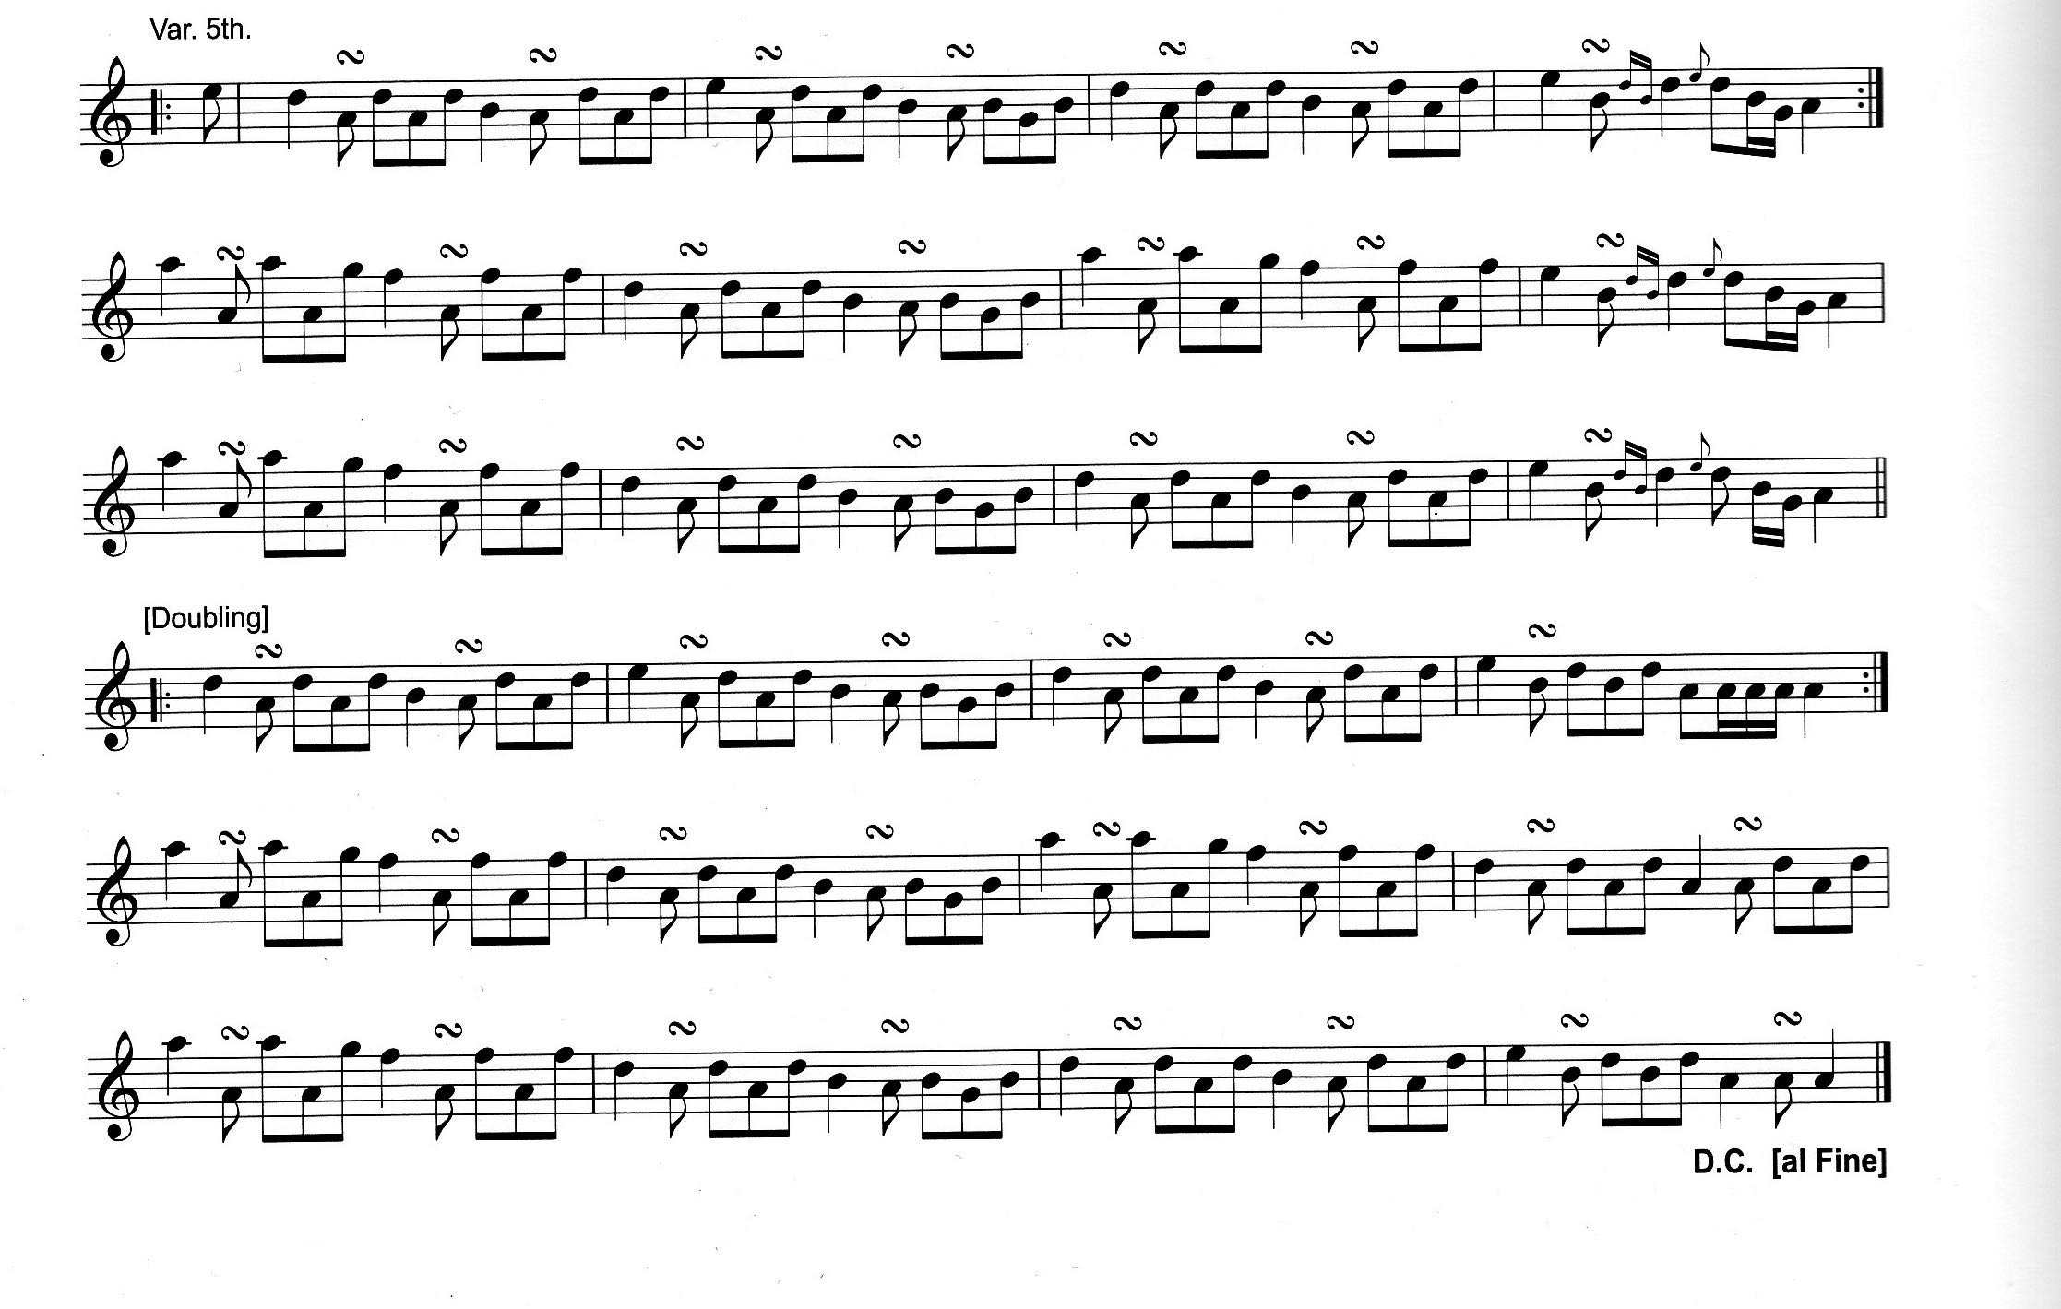

(Peter Cooke, Morag MacLeod and Colm Ó Baoill, eds., *Original Highland Airs Collected at Raasay in 1812 by Elizabeth Jane Ross,* Musica Scotica Trust, Glasgow, 2016, pp.178-80). Her “turn” marks above the low A quavers indicate a keyboard approximation of the crunluath movements she would have heard actually played; likewise her representation of the concluding *eallach* gesture by a figure which descends from E to D, through B and low G before concluding on low A. A realisation in pipe notation might go roughly along the following lines:

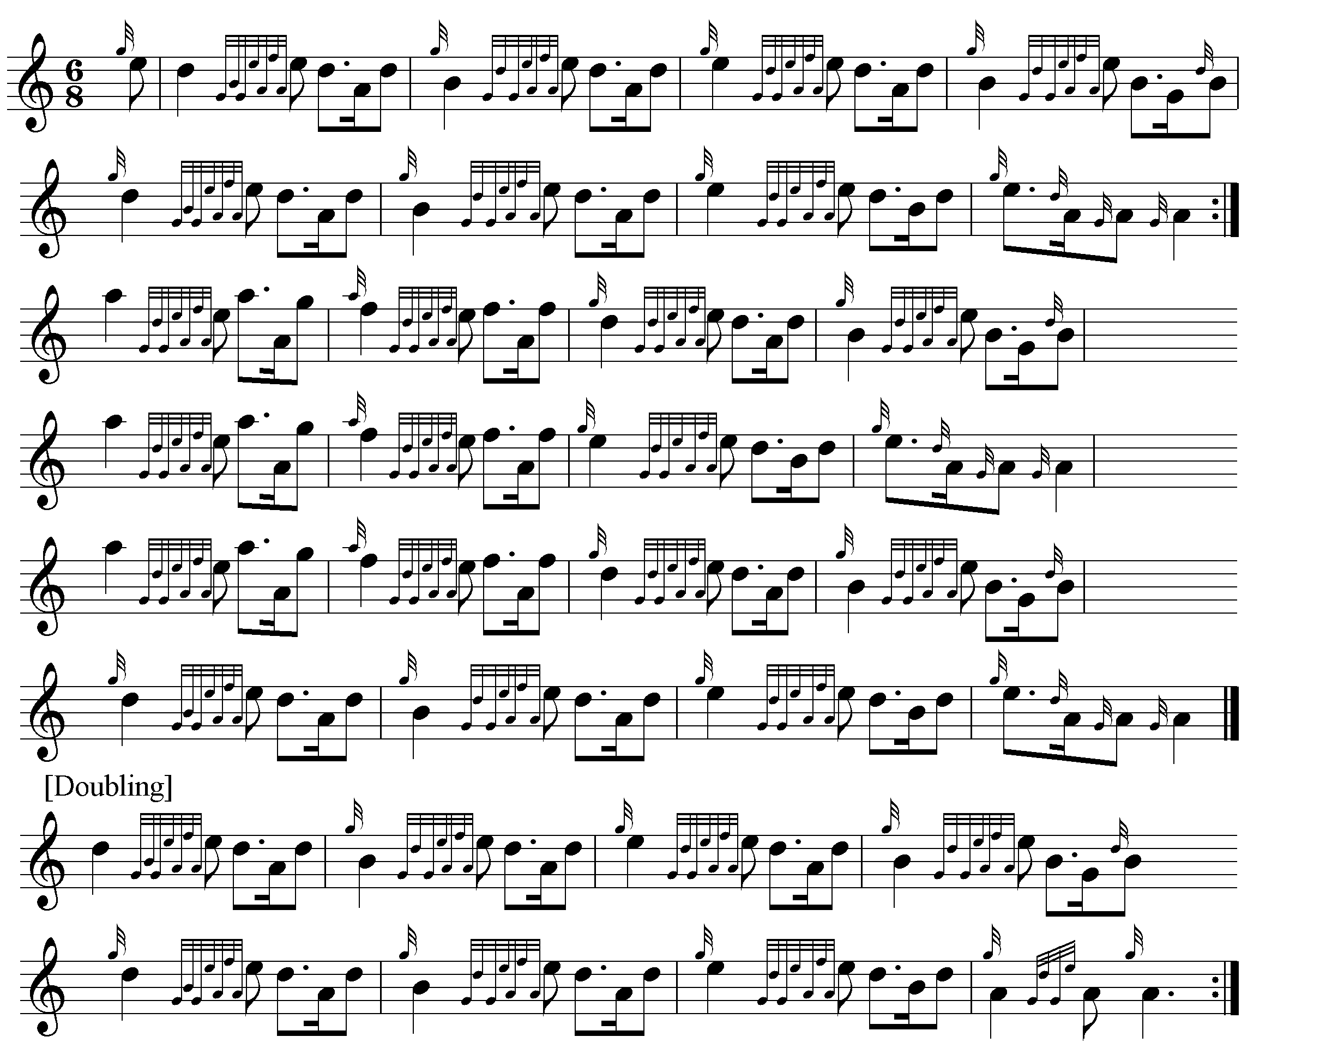

Later Eliza got a very handsome and exotic set of pipes made for John MacKay by local craftsmen when out in India with her husband Sir Charles D’Oyly, and in return he composed for her “Lady Doyle’s Salute”.

*

Electronic text © Dr. William Donaldson, Cambridge, Massachusetts, 12th July 2016