Scarce of Fishing

There are settings of this tune in the following manuscript sources:

--**Angus MacKay**’s MS, i, 36-8 (with the title “Spiocaireachd Iasgaich. Scarse of Fishing. Tha Spiocaireachd Iasgaich, am bliadhna am Geogheoben &c.”);

--**Peter Reid**’s MS, f.62 (with the title “Cumh Fir Ceanloch nan Eala Lochnells Lament”);

--**Uilleam Ross**’s MS, ff.201-5 (with the title “Black Donald of the Shores March”);

--**Colin Cameron**’s MS, ff.45-7 (with the title “Scarce of Fishing Spiochdaireachd Iasgaich”);

and in the following published sources:

--**William Ross**, *Ross’s Collection,* pp. 22-27;

--**C. S. Thomason**, *Ceol Mor,* pp.209-210;

--**David Glen**, *Ancient Piobaireachd,* pp.132-5;

--**William Stewart**, *et al.,* eds., *Piobaireachd Society Collection (first series),* ii, 12-15;

--**G. F. Ross**, *Collection of MacCrimmon and Other Piobaireachd,* pp*.*52-3.

|  |  |
| --- | --- |
| Reid | MacKay |
| Ground | Ground (6/8) |
| Doubling of Ground |  |
| Trebling of Ground | Trebling of Ground |
|  | Siubhal singling (2/4)  doubling |
|  | Pendulum movement (cut ‘up’) singling  doubling |
|  | Taorluath (6/8) singling  doubling |
|  | Ground |
|  | Crunluath singling  doubling |
|  | Ground |

Reid, MacKay and Cameron's settings are very similar to one another, with the exception that Colin Cameron has an interesting way of timing phrase endings in the ground and elsewhere, which is noted below.

**Peter Reid**’s score comprises a ground and doubling and trebling of the ground only, with no indication that further parts are contemplated. However, Reid's verbal instructions regarding the doubling are ambiguous: he says immediately following the ground that the next variation should be “Doubling of Ground work with each note cross’d to be play’d Cruinluidh”, but this is what appears to be set out immediately below and rather misleadingly labelled “Threbling”:

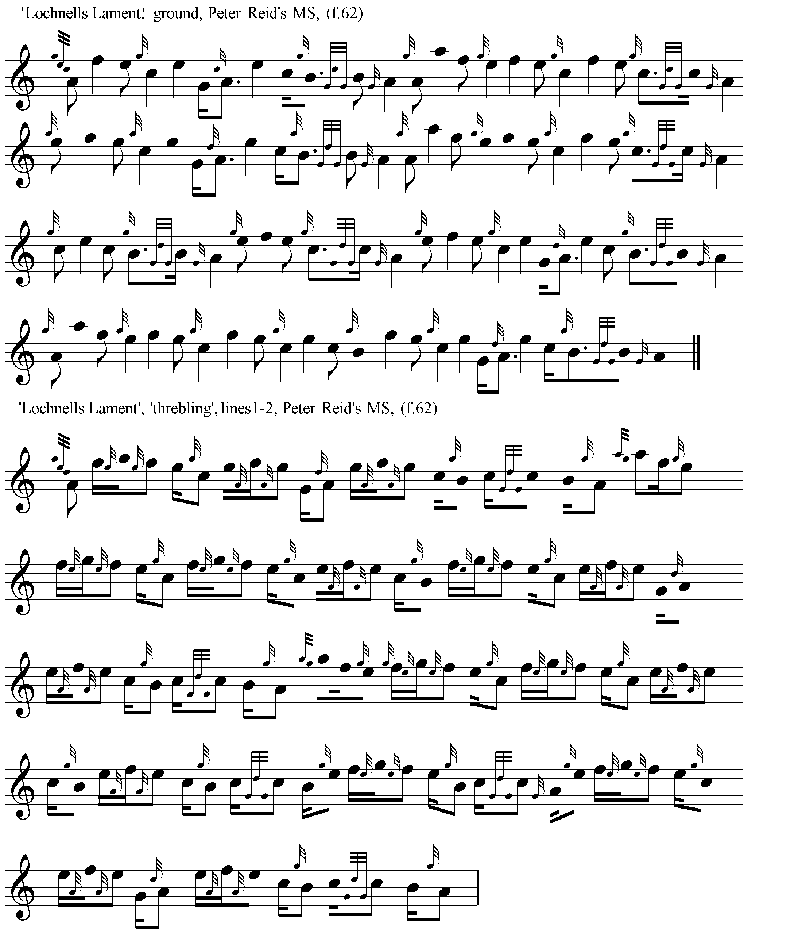

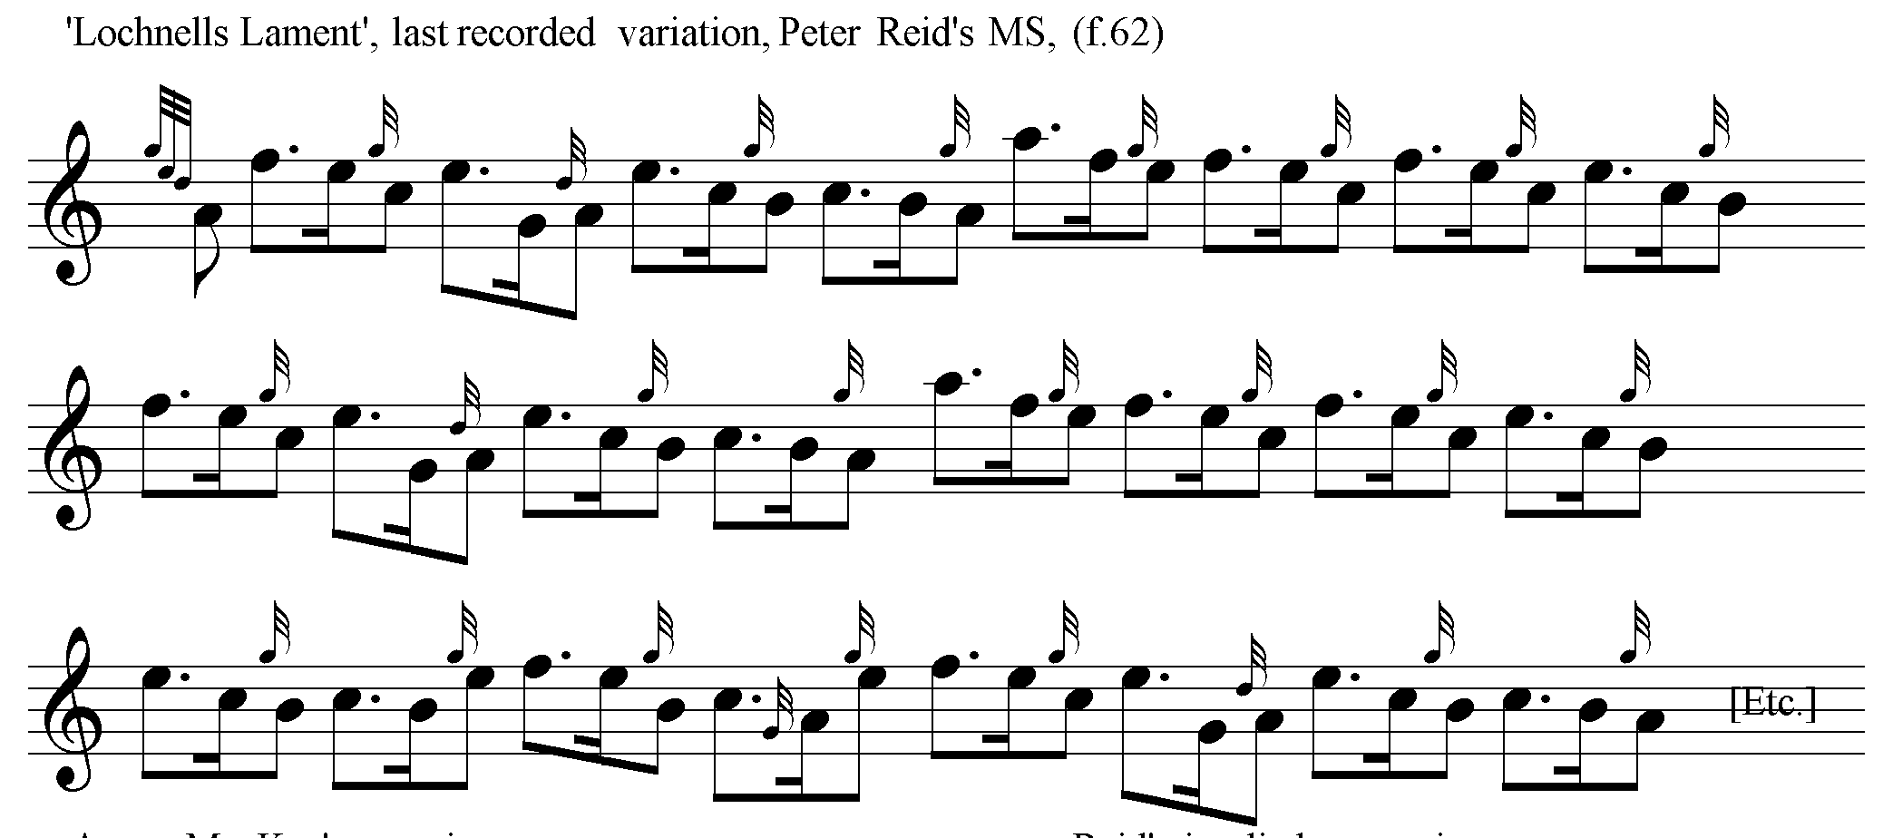

**Peter Reid**’s original score is as follows:

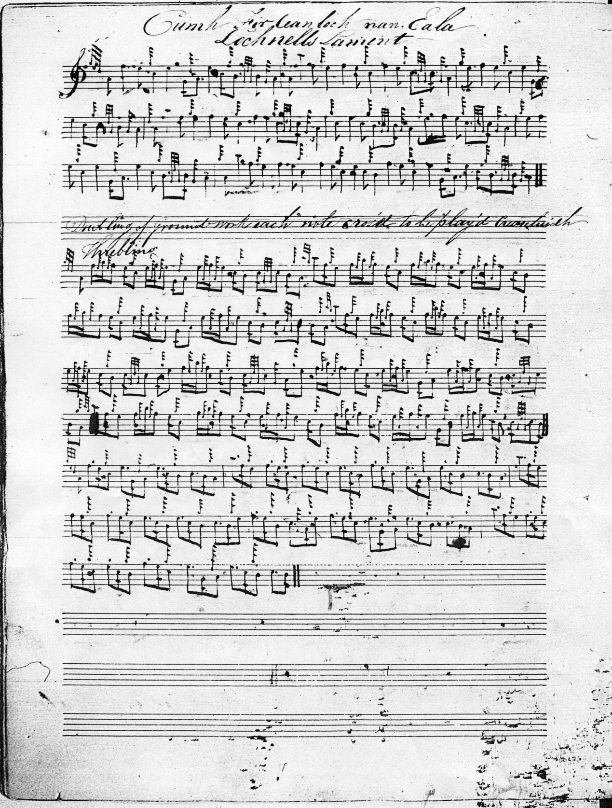

One notable feature of Reid’s score is the opening acciaccatura represented by the conventional three demi-semi-quaver formula, later represented by a crotchet/quaver figure when it figures again, a little later, played off C.

**Angus MacKay** develops the tune much more fully than Reid, as follows:

The following examples show MacKay’s characteristic timing of the tune:

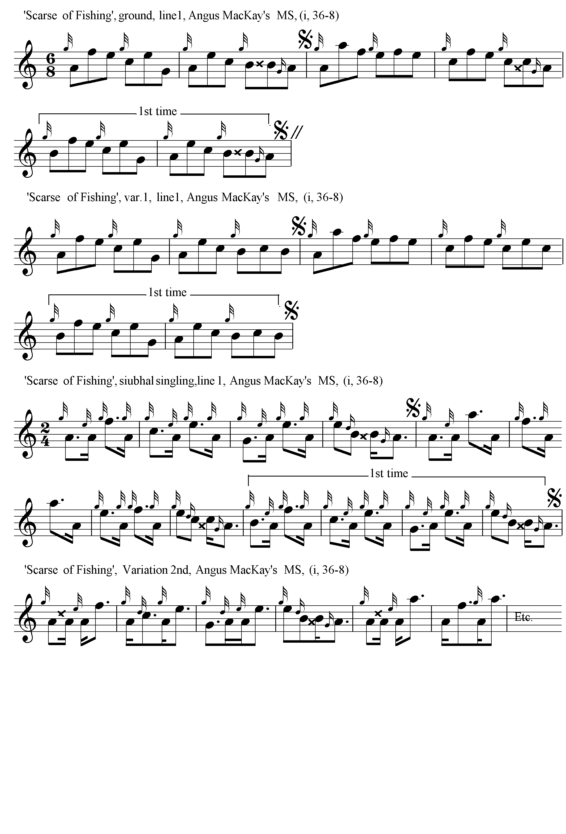

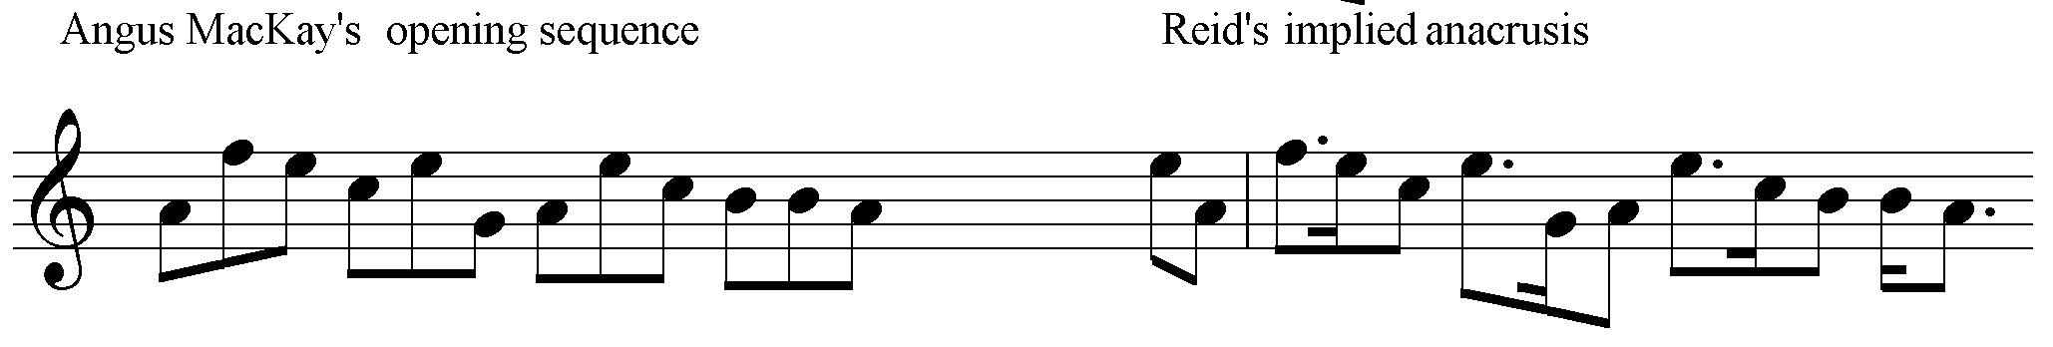

**Angus MacKay**’s original score is as follows:

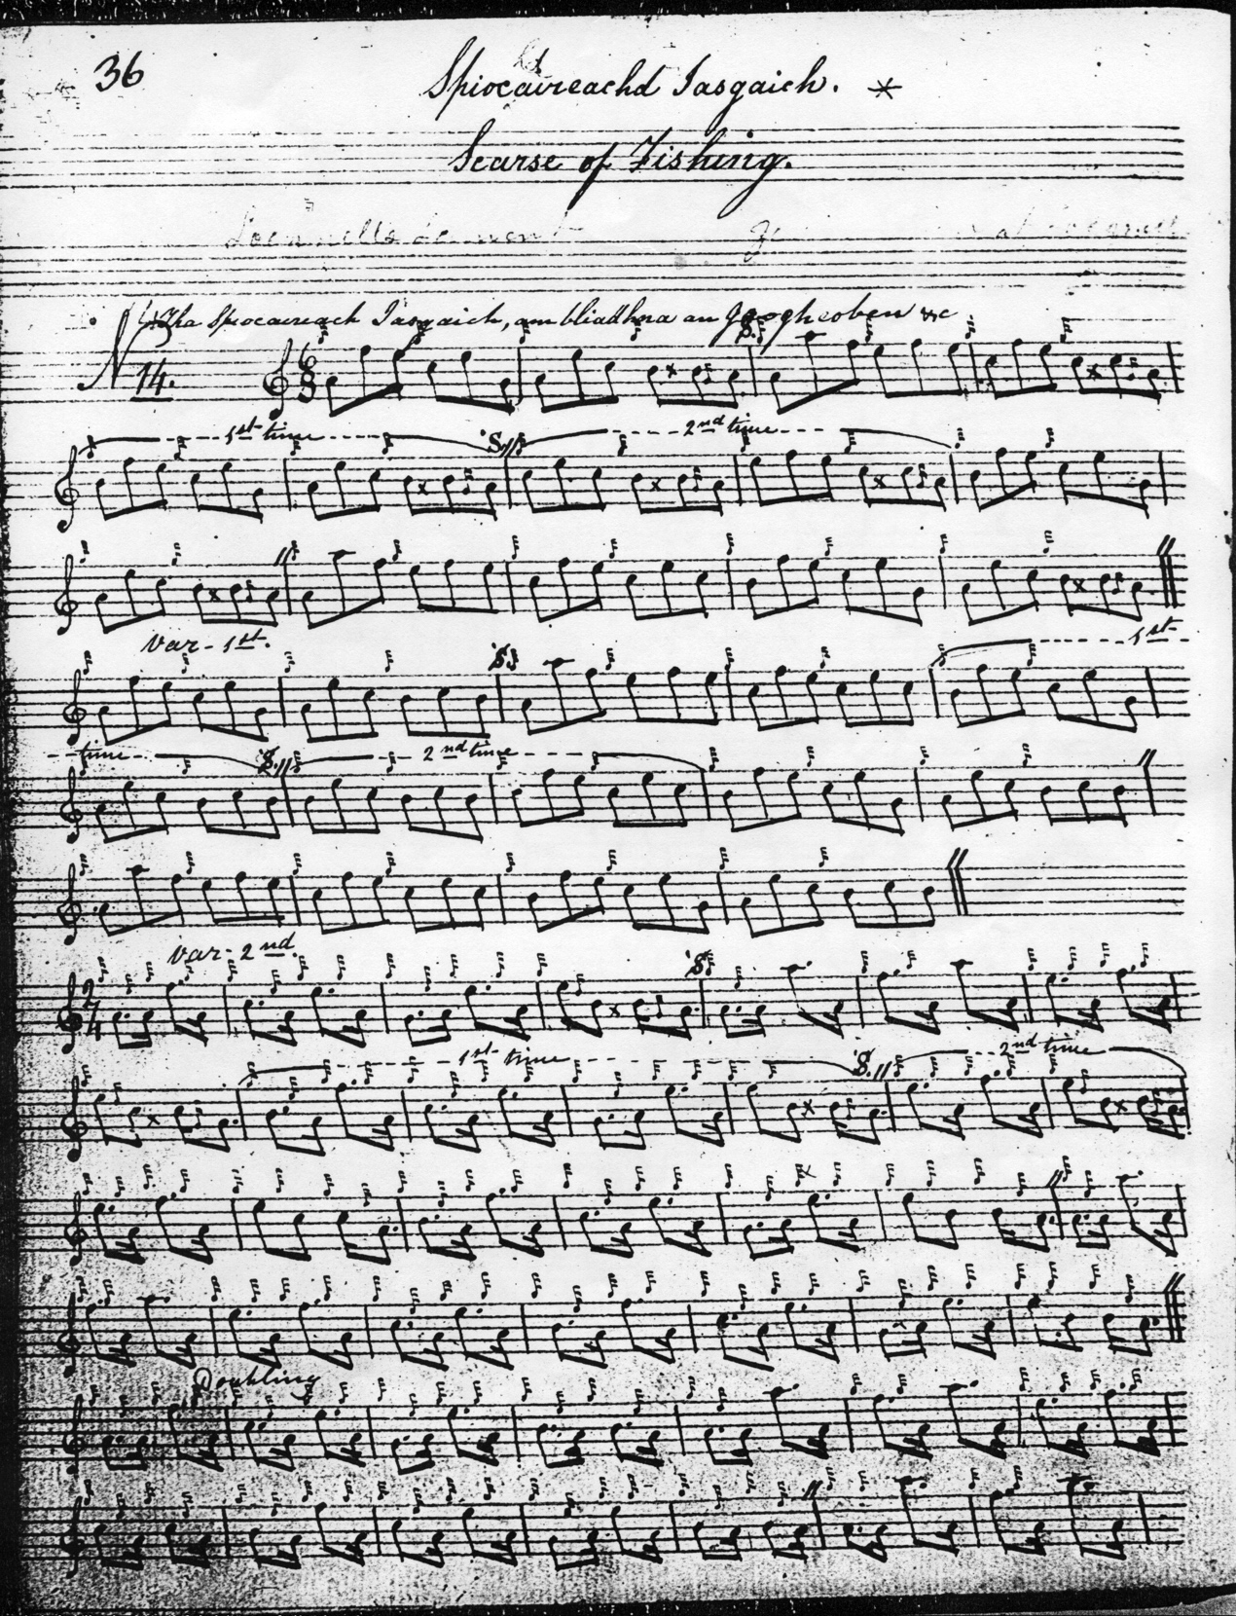

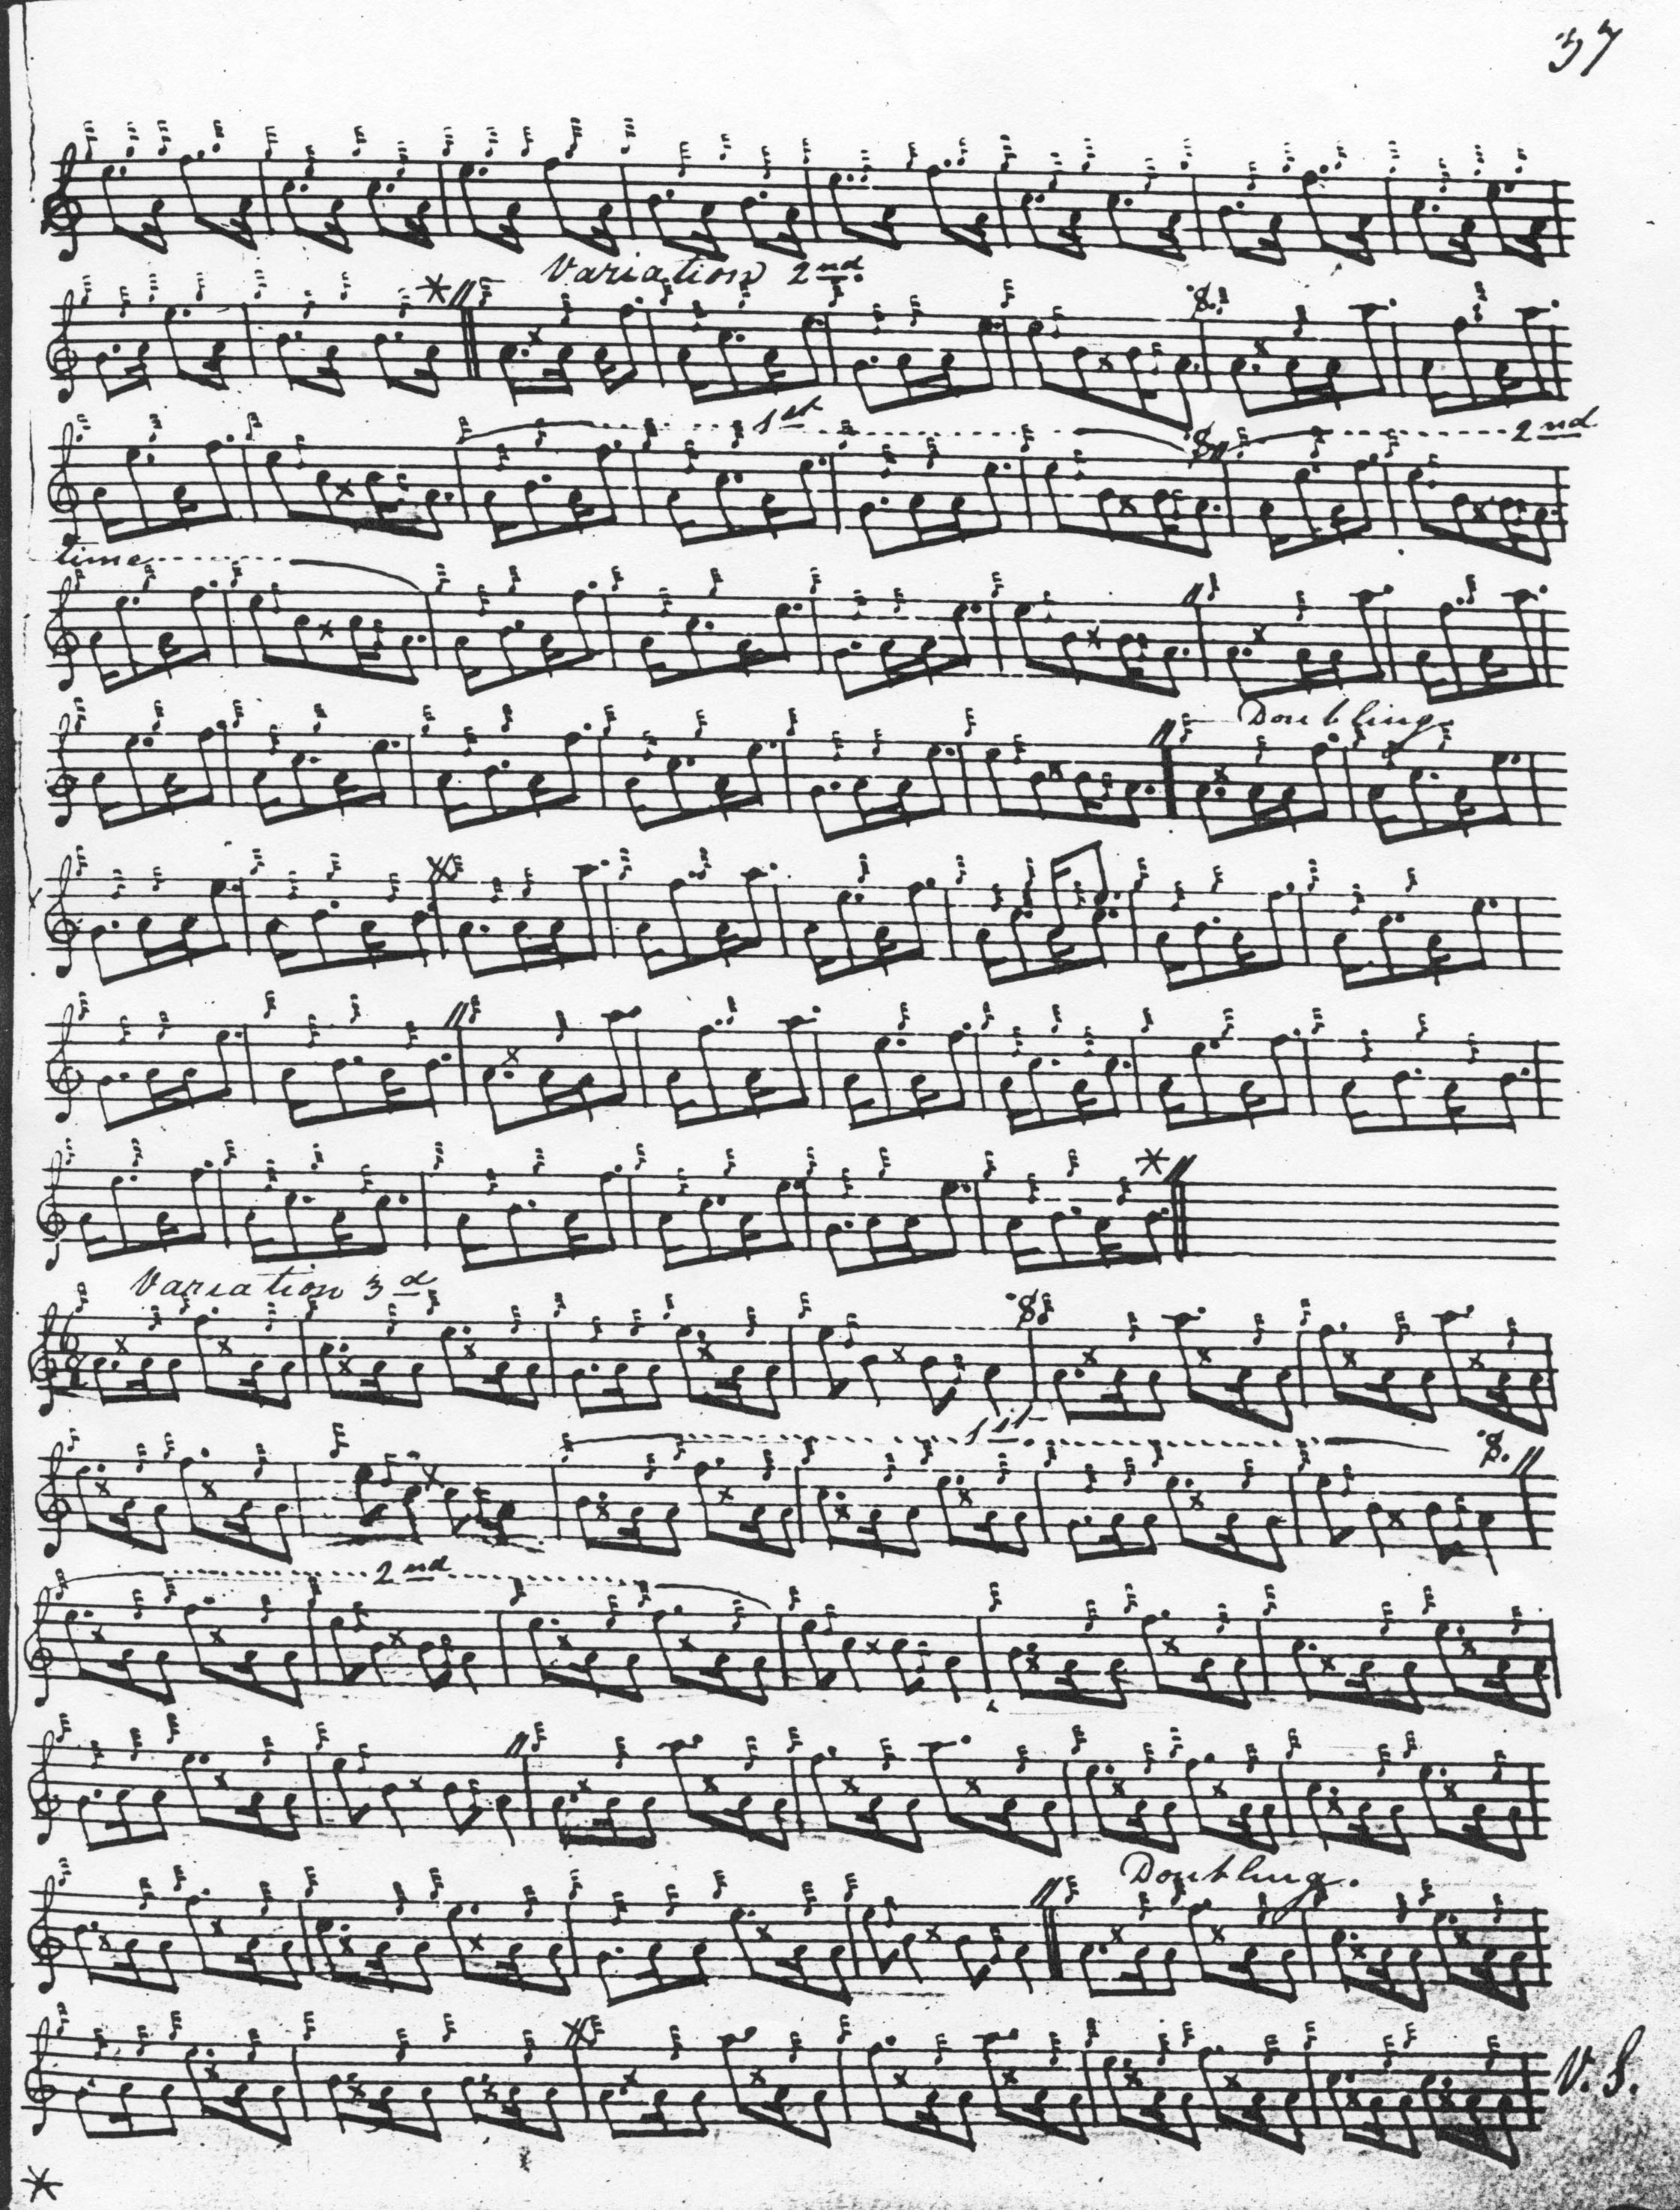

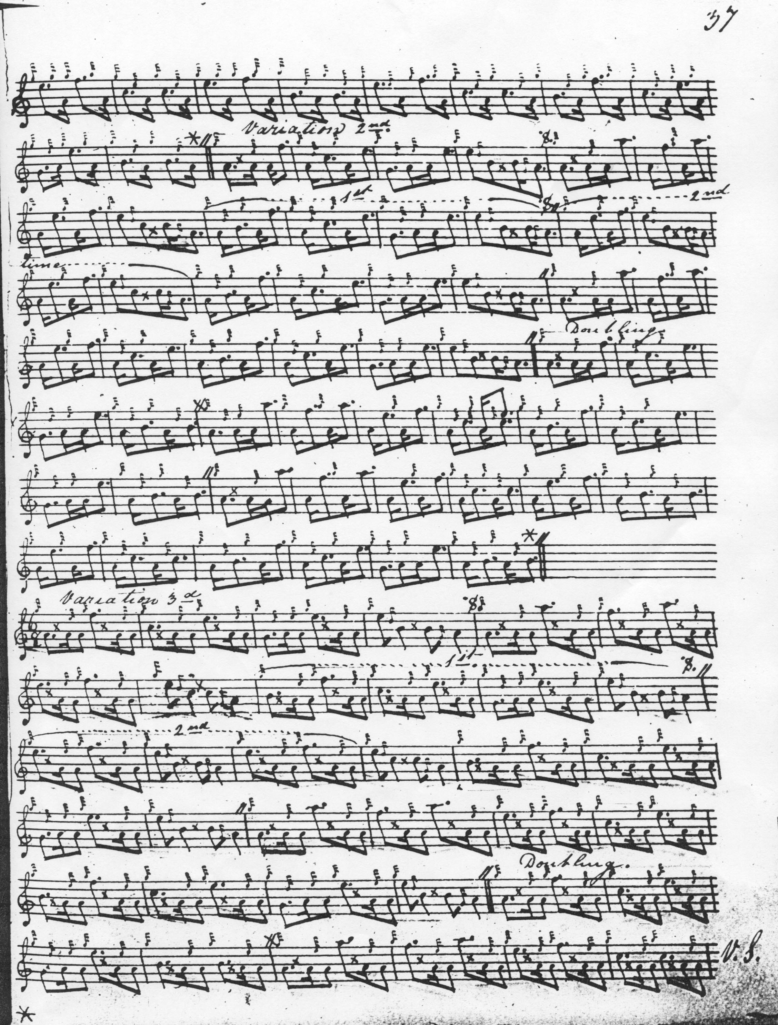

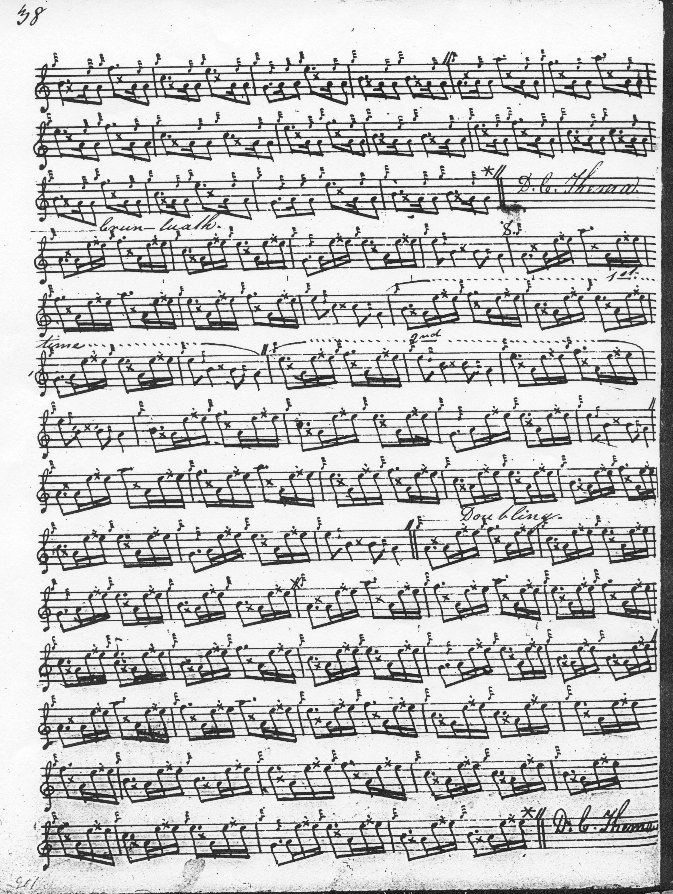

**Colin Cameron** differs from Reid and MacKay in the heavy cadencing of phrase endings, a style also reflected in the setting published in Uilleam Ross’s *Collection* a little later, although with a slightly different timing. Otherwise Cameron develops the tune in a similar way to MacKay:

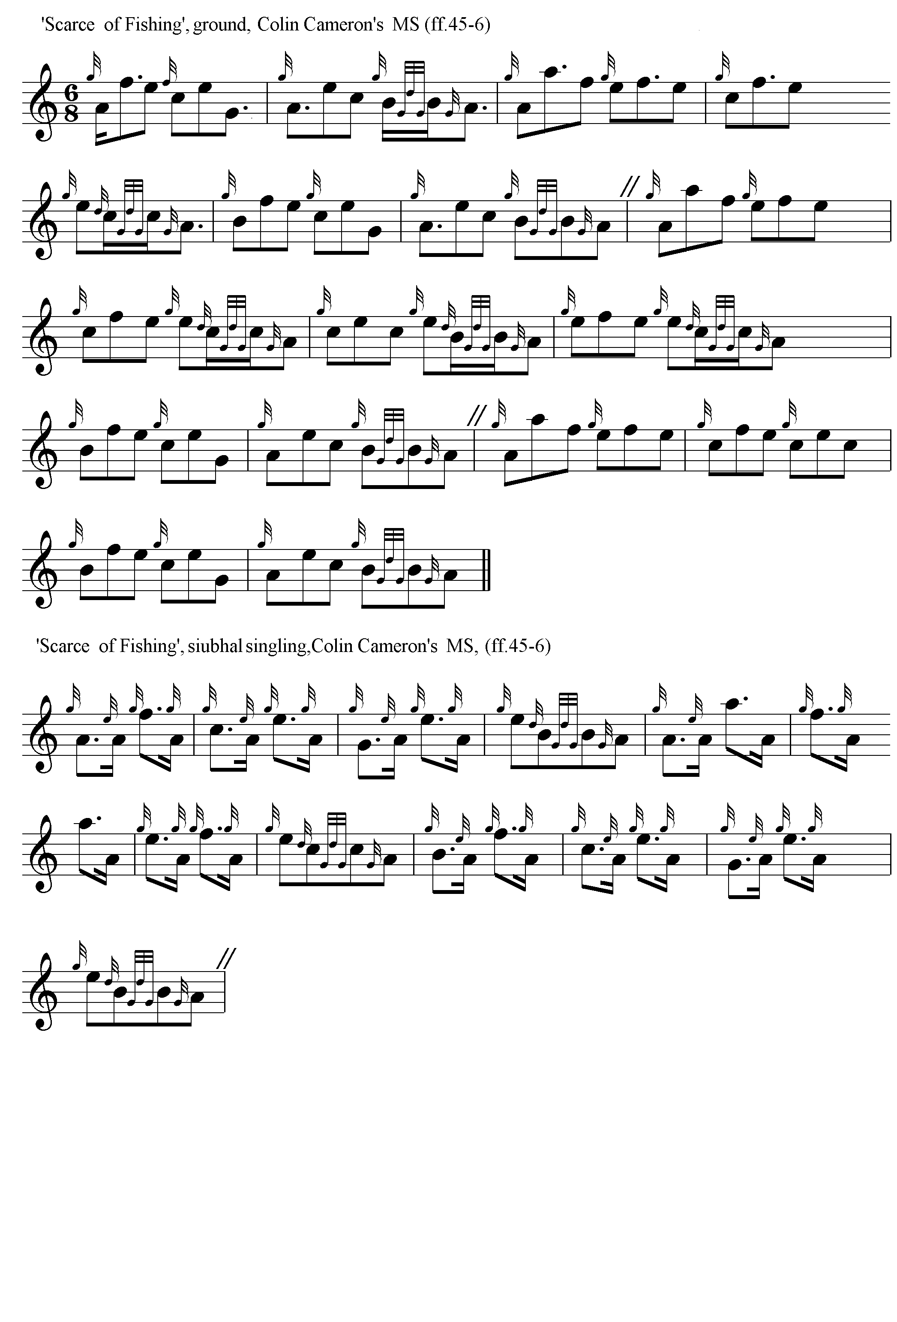

“Scarce of Fishing” was first published in Uilleam Ross’s *Collection*. The following extract shows Ross’s timing of the ground, which he marks “Very Slow”:

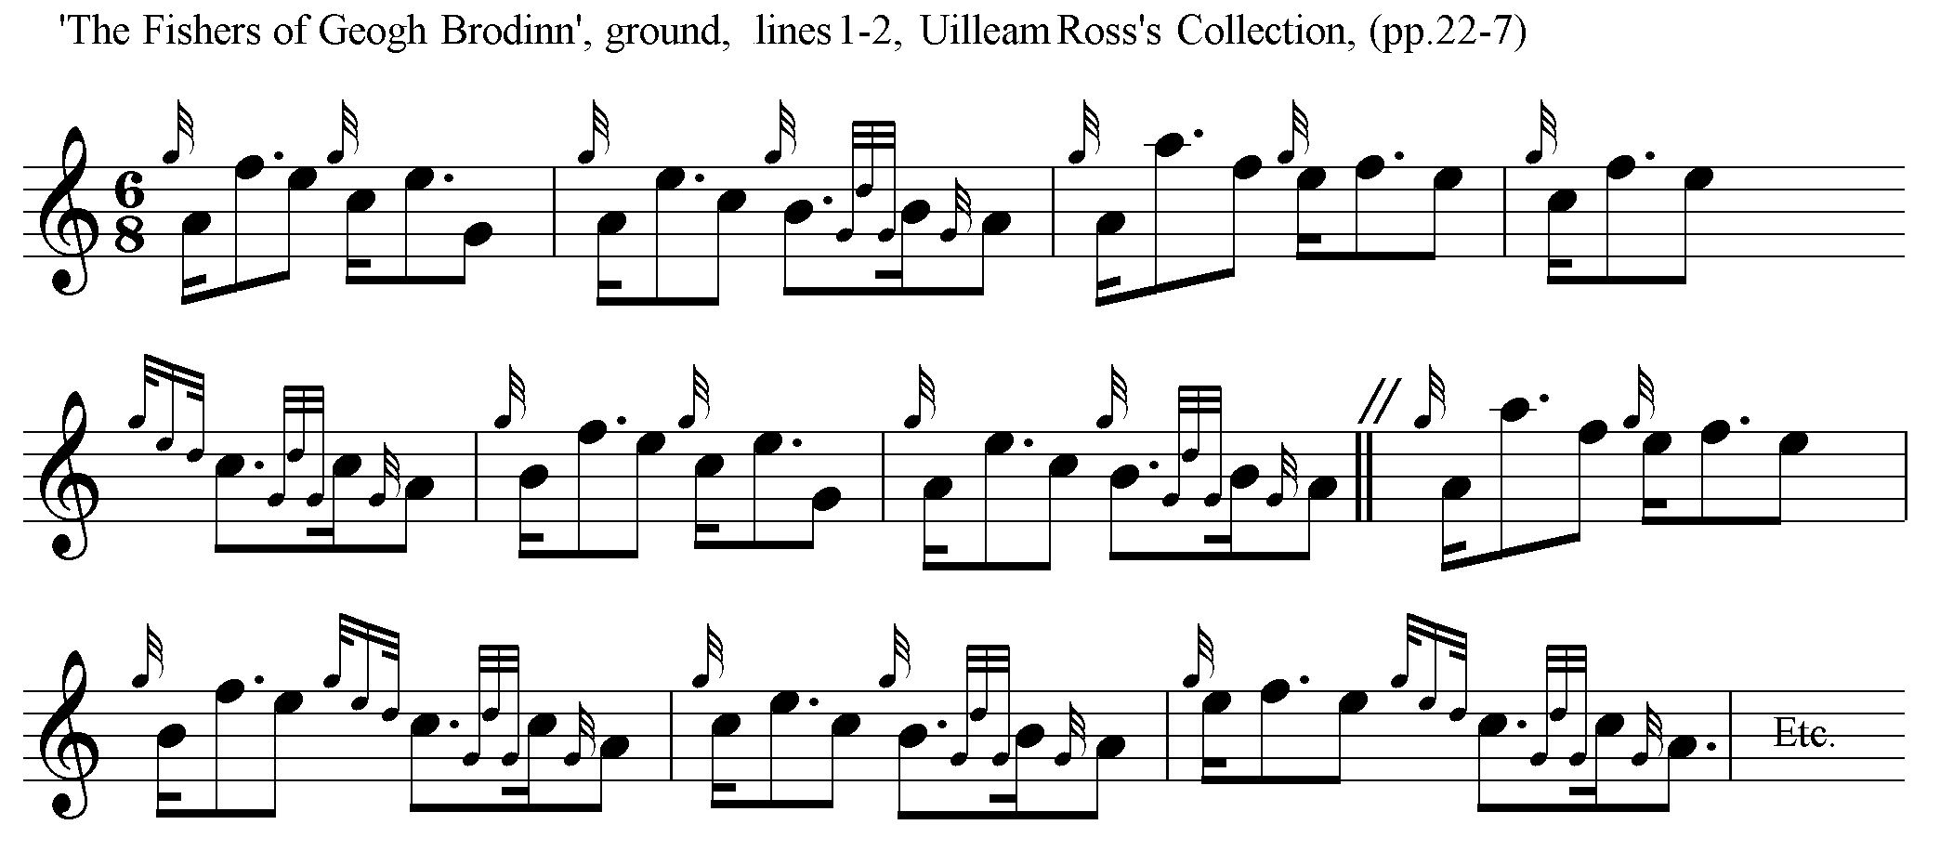

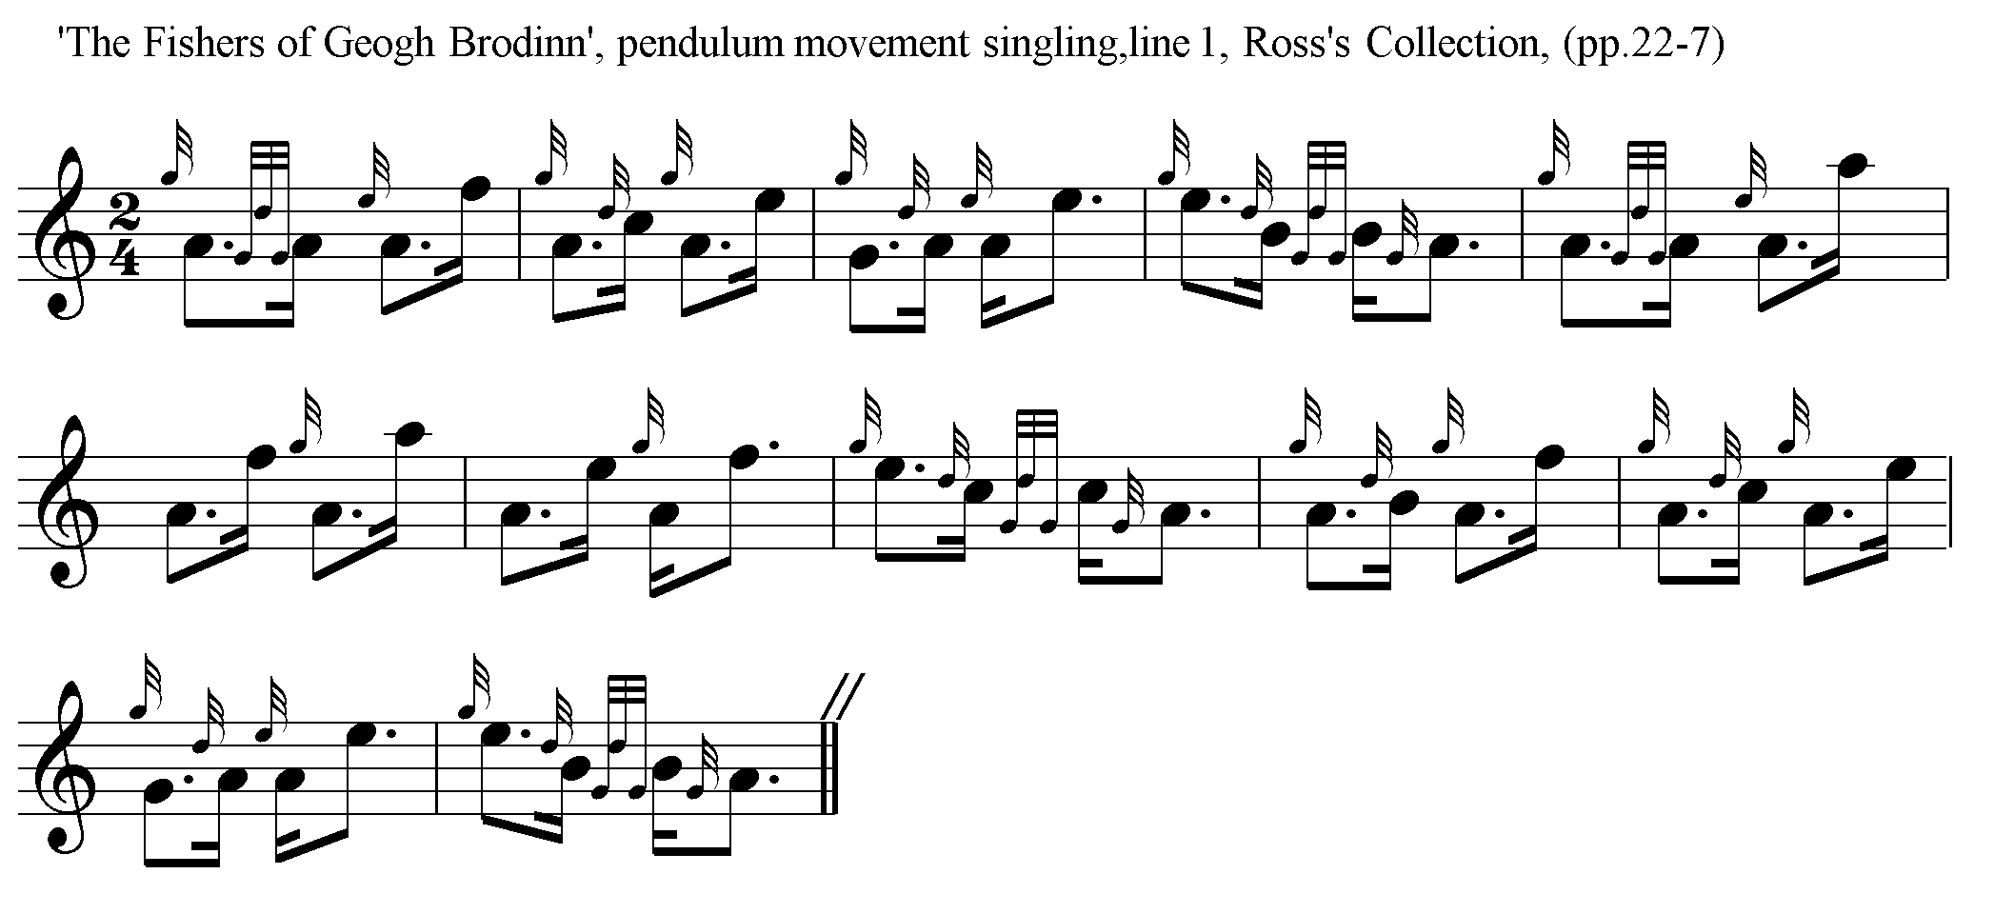Ross points the pendulum movement “down” as opposed to the “up” cut of MacKay, and Cameron's even quavers:

Ross indicates that the ground should be repeated at the end of the taorluath doubling and again at the end of the tune, which in terms of number and type of variations he develops similarly to MacKay and Cameron. He has no crunluath a-mach.

Of the other earlier published settings **C. S. Thomason** has the cadences present in Colin Cameron and Uilleam Ross, and it would seem that Donald Cameron played the lighter McKay style of Var.1 without the throws on F and E depicted in Reid's ‘Threbling’ (Ceol Mor, pp.209-10).

The setting published by **William Stewart** in the *Piobaireachd Society Collection*, first series, (ii, 12-15 as “Lochnell’s Lament”) follows Ross rather closely. In his notes Stewart defends this style as the true old way, dismissing the “up” cut style in the pendulum movement as “*cas-mu-seach*” (heads-and-thraws) and ascribes its popularity (wrongly) to Donald MacPhee.

*Commentary*

# Writing in the *Oban Times* in 1950, Malcolm MacInnes, editor of *120 Bagpipe Tunes, Gleanings and Styles* (Glasgow, 1939), made an interesting suggestion regarding the timing of “Scarce of Fishing”:

The tune “Scarce of Fishing” seems, as played, to have any rhythm fancied by the player, although the rhythm of the original Gaelic song is unmistakably 6/8.

It can be shown in English thus:--

'Tis/ long since the/ day when we/ played

A/ F E C/ E G A/ E

in the/ heather

C B/ B, A .

This shows four beats, each with one long and two short syllables, the first note, low A, being introductory, before the bar, and the beat being on the F.

He added “The title of this tune is a minor point but it ought to be corrected. ‘Scarce of Fishing ‘sounds like the English of an illiterate. The Gaelic ‘*Spiochaireachd Iasgaich’* means ‘Very Poor Fishing’ and is very good Gaelic”. (“Survey of Piobaireachd”, 11/11/50, p.3.)

R. B. Nicol frequently referred to the tune using Uilleam Ross’s title, “The Fisher of Geogh Brodinn”

*

Electronic text © William Donaldson, Aberdeen, Scotland, 2001; revised, Cambridge, Massachusetts, March 2025

## 