Rout of the Lowland Captain

There are settings of this tune in the following manuscript sources:

**–Colin Mór Campbell**’s “Nether Lorn Canntaireachd,” ii, 70-2 (with the title “Fhailt MhicLeain”);

**–Angus MacKay**’s MS, ii, 23-24;  
**–D. S. MacDonald**’s MS, i, 47-9;  
–**David Glen**’s MS, ff.212-214;

and in the following published source:  
**– C. S. Thomason**, *Ceol Mor*, pp.282-3.

**Colin Mór Campbell** treats the tune as follows:

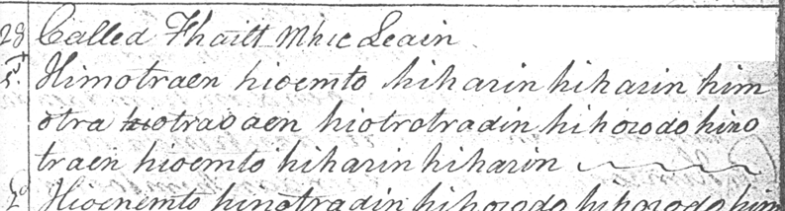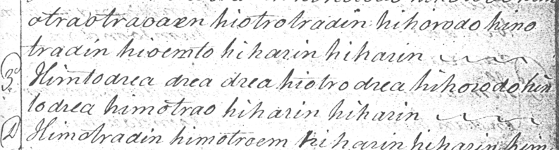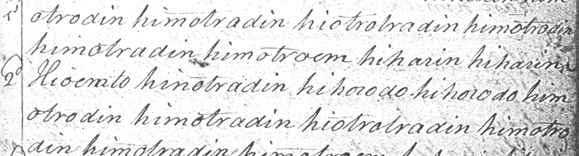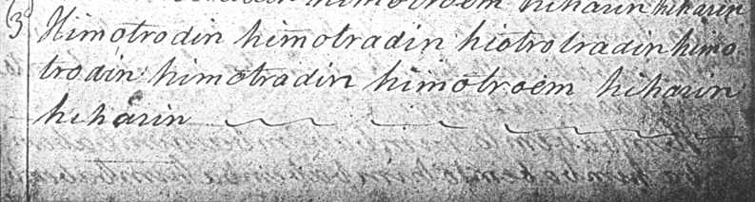

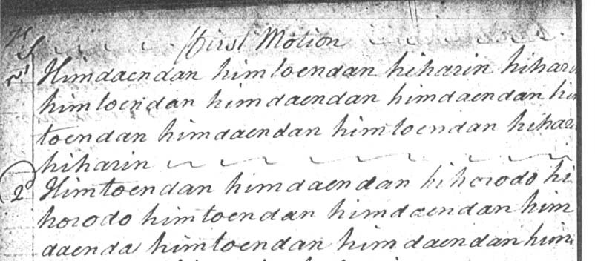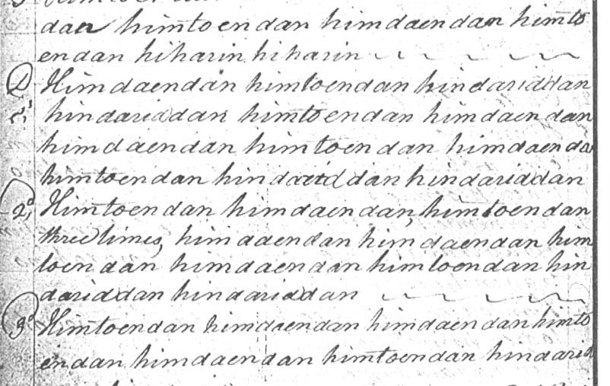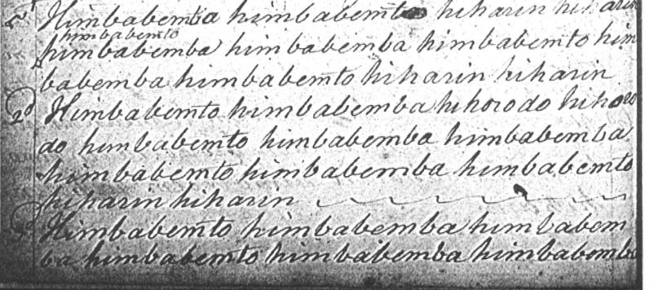

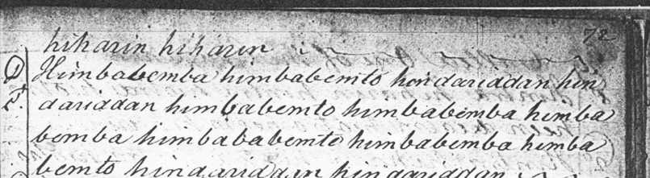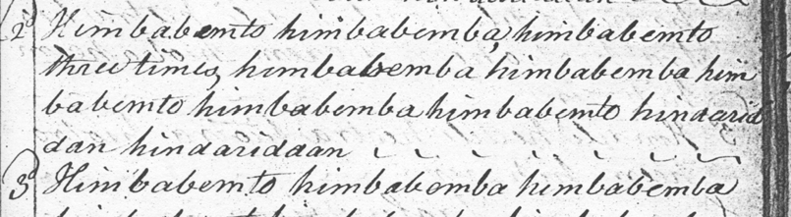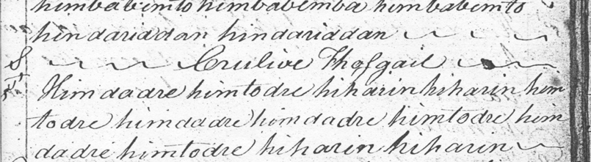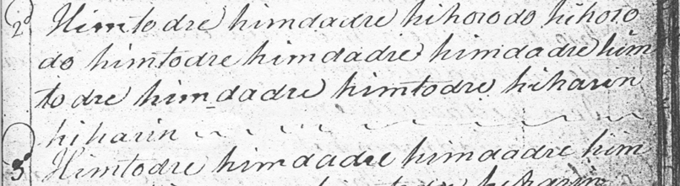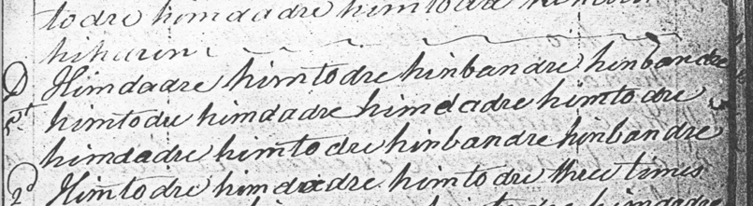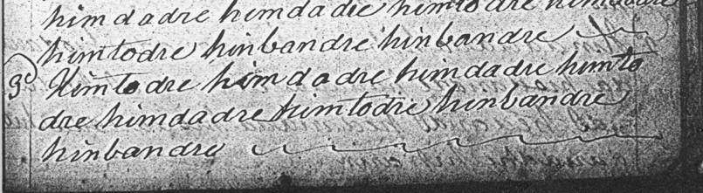

The sources all treat “The Rout of the Lowland Captain” in a similar way from a structural point of view, with a ground and doubling of ground, a first variation singling and doubling, a taorluath fosgailte singling and doubling, and a crunluath fosgailte singling and doubling.

**Angus MacKay** sets the tune as follows:

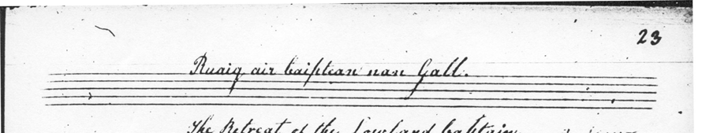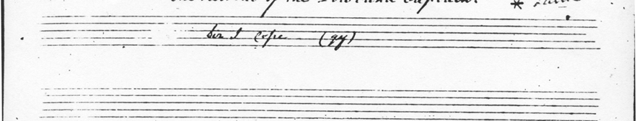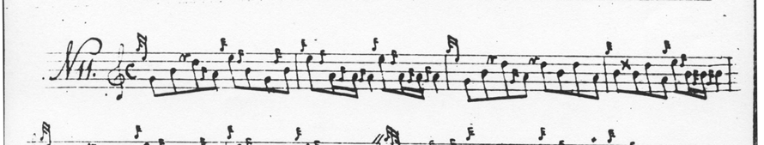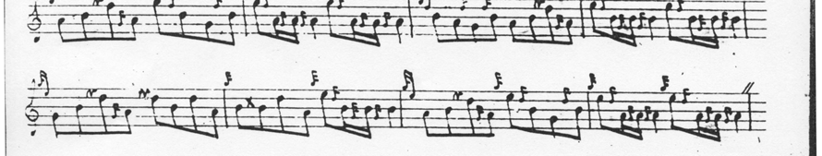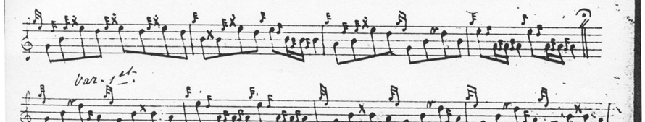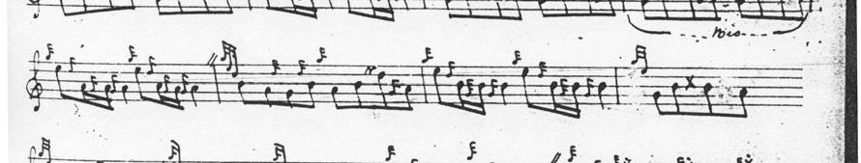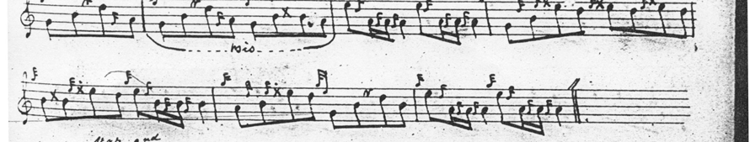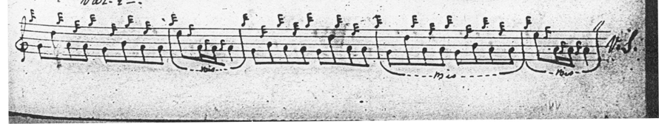

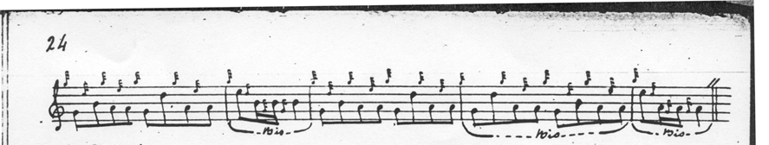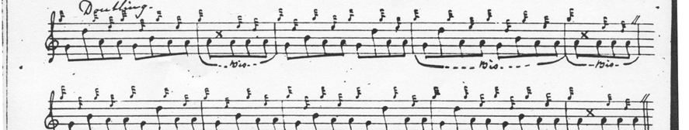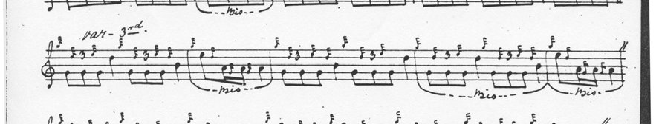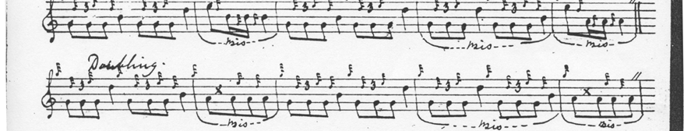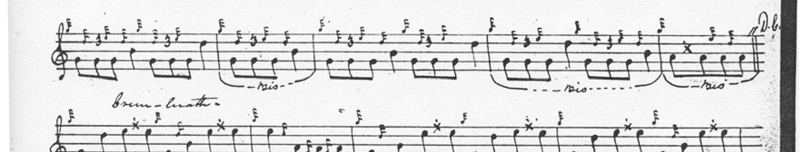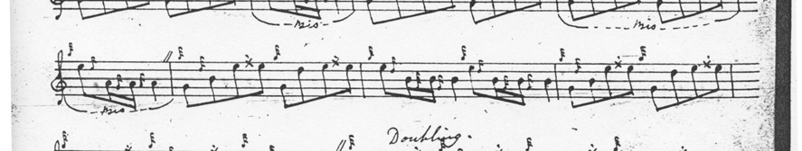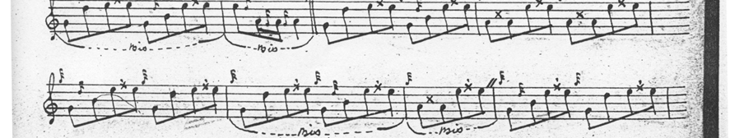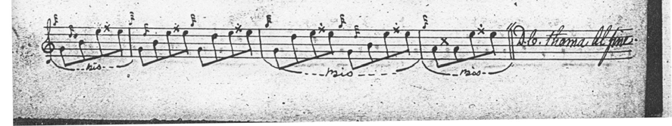

The tune is given in complete form in the ground and doubling of the ground, but thereafter MacKay gives only two of the three lines in the variations. MacKay’s title is different from that of Colin Campbell, who calls the tune “MacLean’s Welcome” and this is the first occasion on which mention of “The Lowland Captain” and his retreat or rout enters tradition. On this occasion the setting by **D. S. MacDonald** seems preferable. MacDonald prepared Angus MacKay’s papers for publication and was consequently well-versed in his editorial style. We may accept his version, therefore, as probably representing the latter's final intentions with regard to the tune, although it is interesting that MacDonald gives the crunluath fosgailte movements in the “opened” style rather than the closed style favoured elsewhere by Angus MacKay:

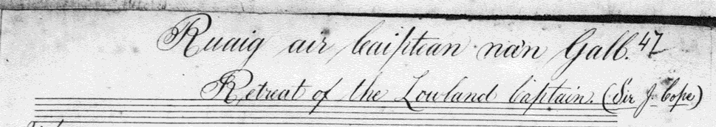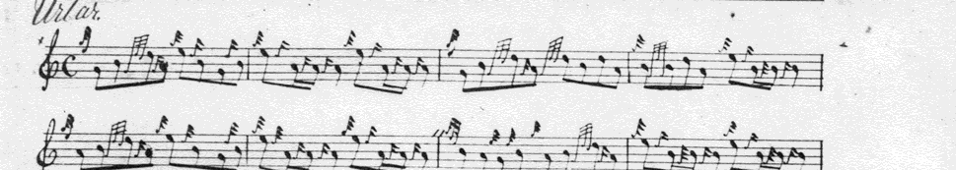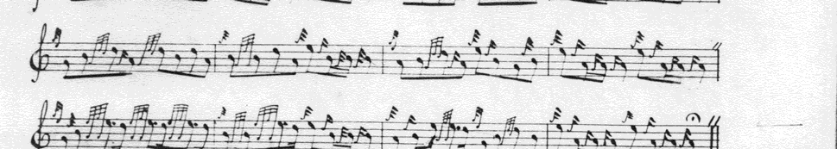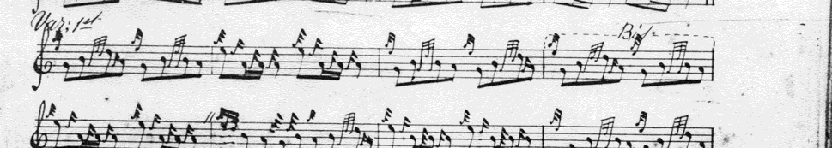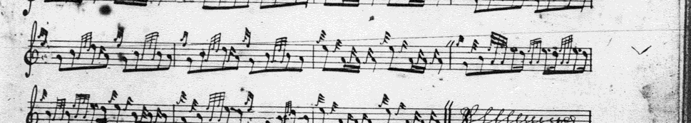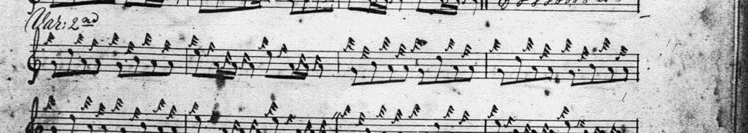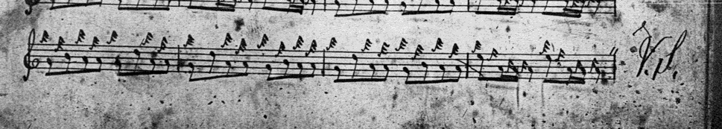

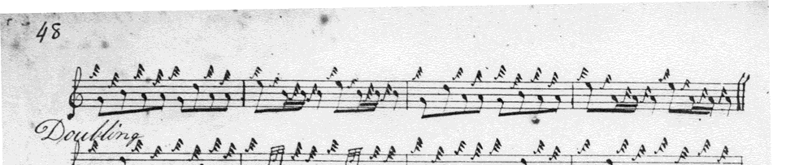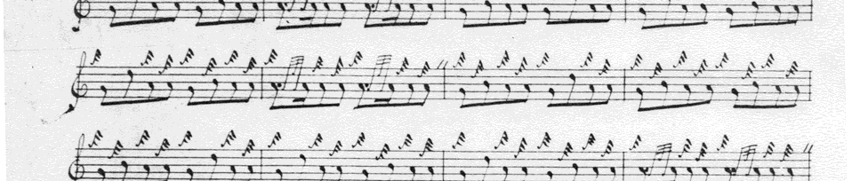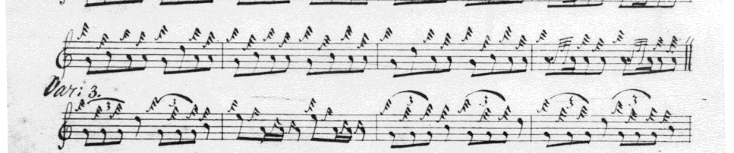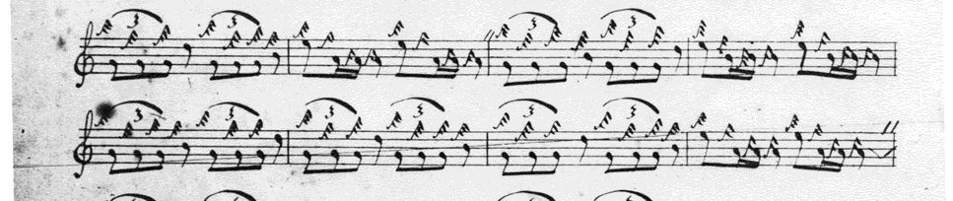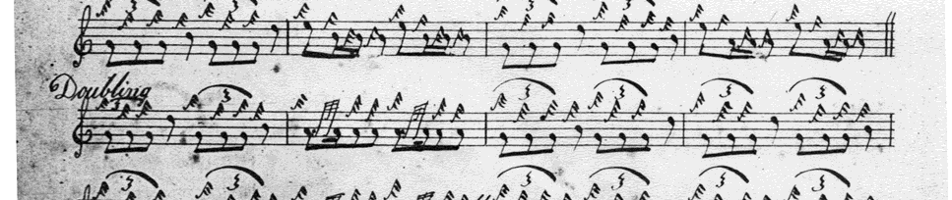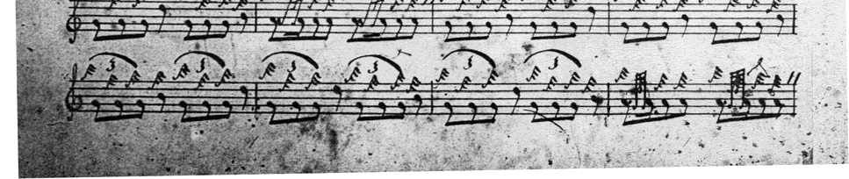

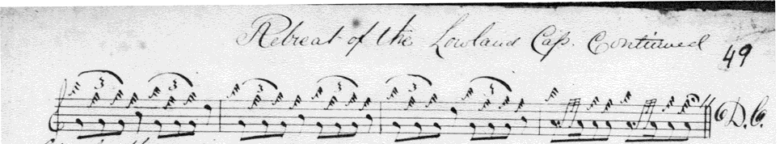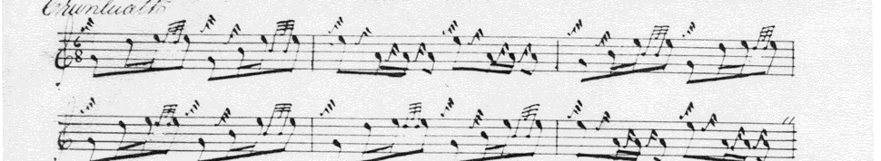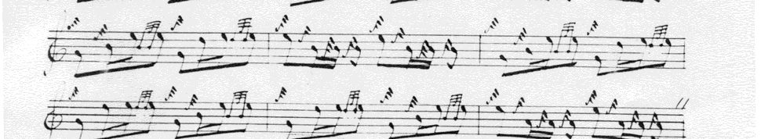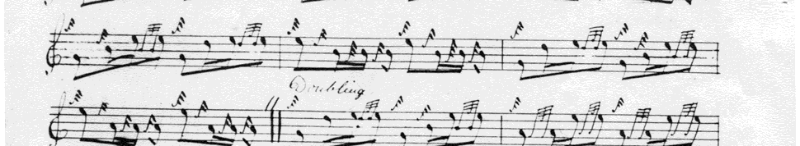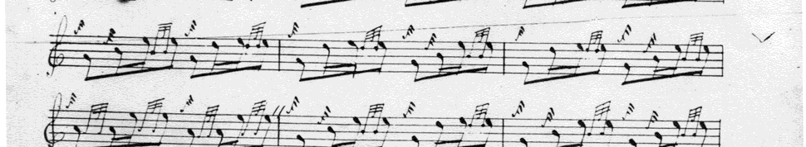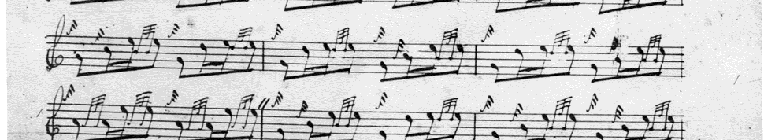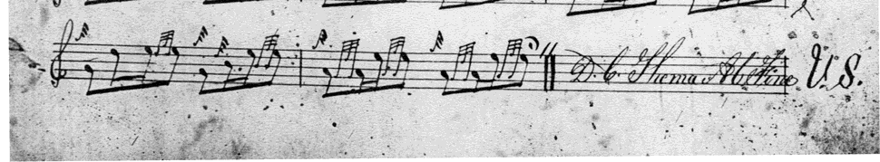

**C. S. Thomason** and **David Glen** time the double echo beats differently but otherwise take a similar route through the tune, including extending the tone row to include the note E in the third line of the variations, presumably to reflect its presence in similar positions in the ground.

**Thomason** sets the tune like this:

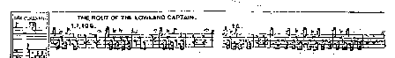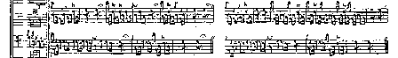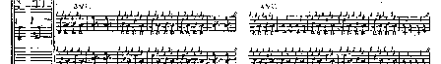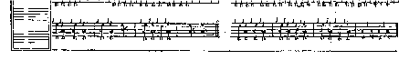

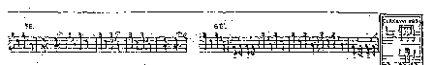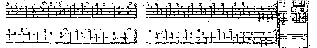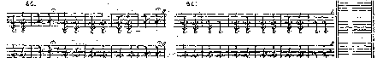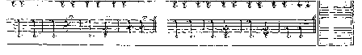

**Glen** sets it like this:

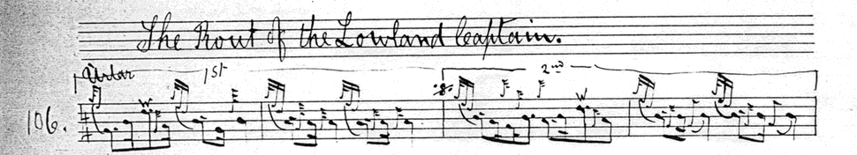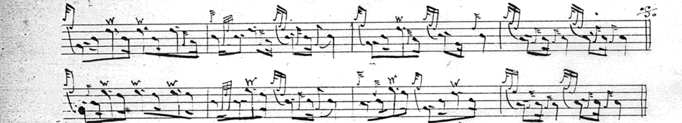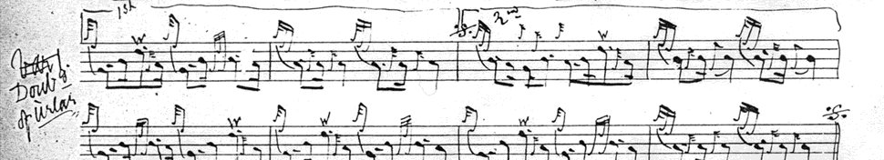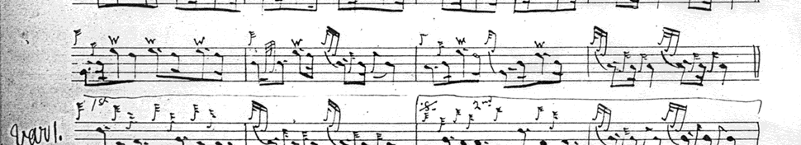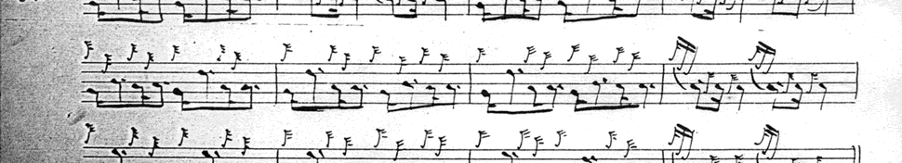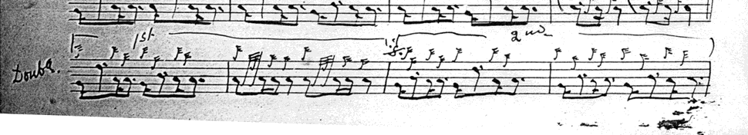

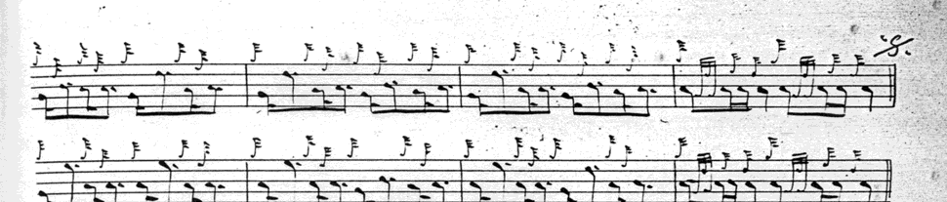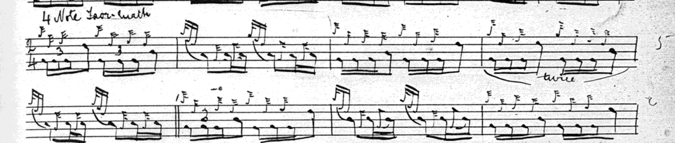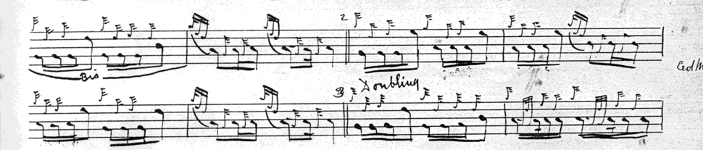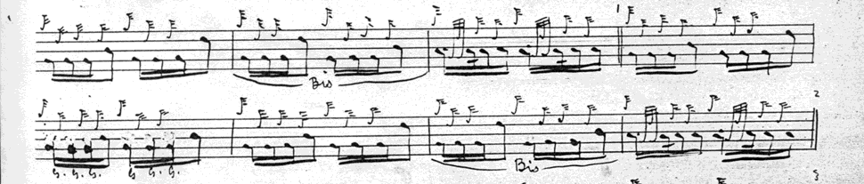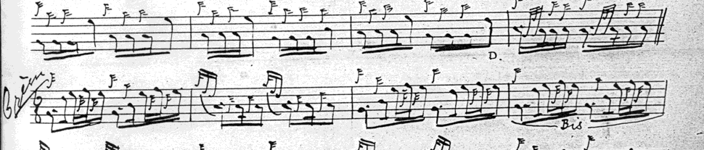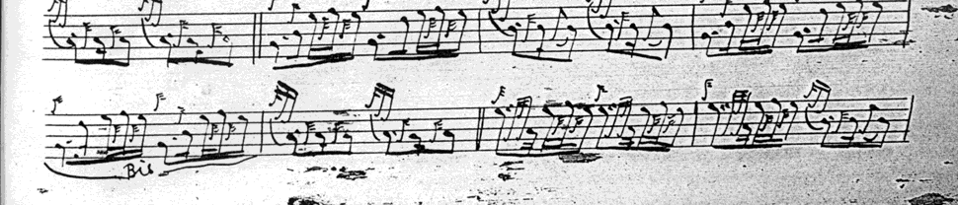

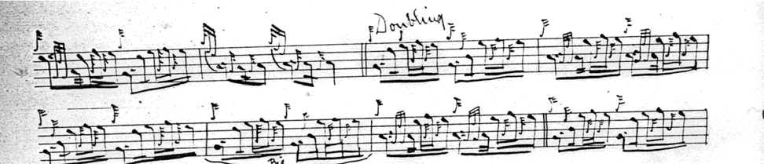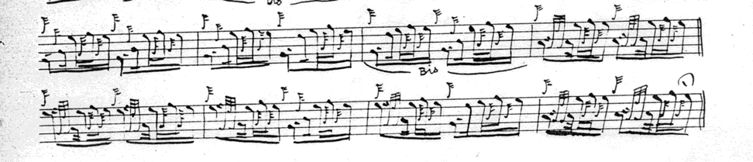

So the choice seems to lie between playing D. S. MacDonald’s recension of MacKay or the scores of Thomason or Glen: all have something to recommend them.

*Commentary:*

Little is recorded of the historical background of this tune, although Angus MacKay’s manuscript identifies the Lowland Captain as Sir John Cope whose government army was defeated by Jacobite forces under Prince Charles Edward Stuart at the Battle of Prestonpans on 21st September 1745. “The Rout of the Lowland Captain” has strong affinities with “My King has Landed in Moidart” and it is possible they both came from the same musical intelligence or at least the same musical context, both being tunes of the ’45. The reader will also note echoes of “The Vaunting.”

***

Electronic text © Dr William Donaldson, Cambridge, Massachusetts, 9th May 2012