Ronald MacDonald of Morar’s Lament

This tune appears in the following published sources:
--Donald MacDonald’s Ancient Martial Music of Caledonia (pp. 94-7);
--Donald MacPhee’s Collection of Piobaireachd (ii, 46-7);
--C. S. Thomason’s Ceol Mor (pp. 40-1);
--David Glen’s Collection of Ancient Piobaireachd (pp. 218-9);
--The Piobaireachd Society Collection (first series, iii, 8-9).

Amongst the manuscript sources, it appears in
--Angus MacKay, (i, 110-111);
--John MacDougall Gillies, (f.114);
--and David Glen, (f.178).

Donald MacDonald’s richly decorated and very attractive setting is the earliest on record. The timing of the double echo beats presents the modern performer with an interesting technical challenge. Its substance is as follows:

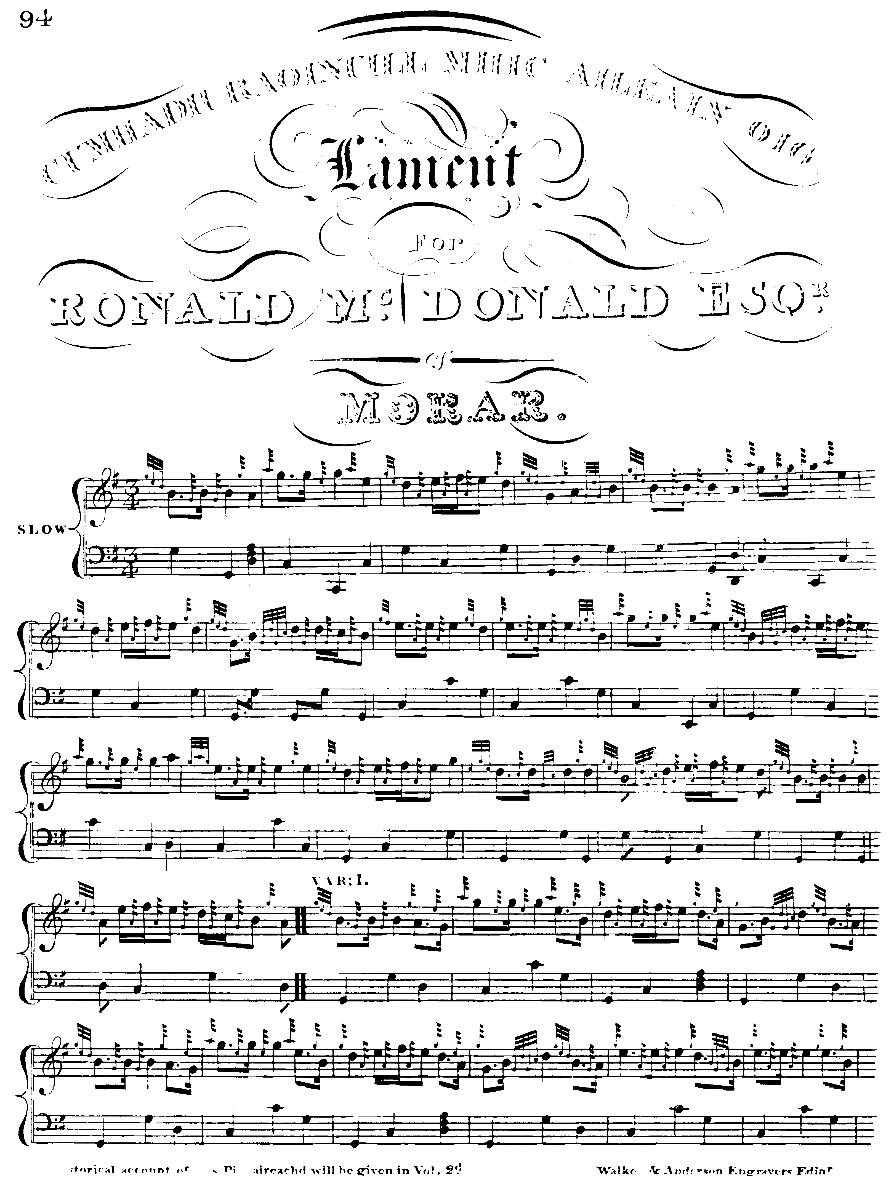

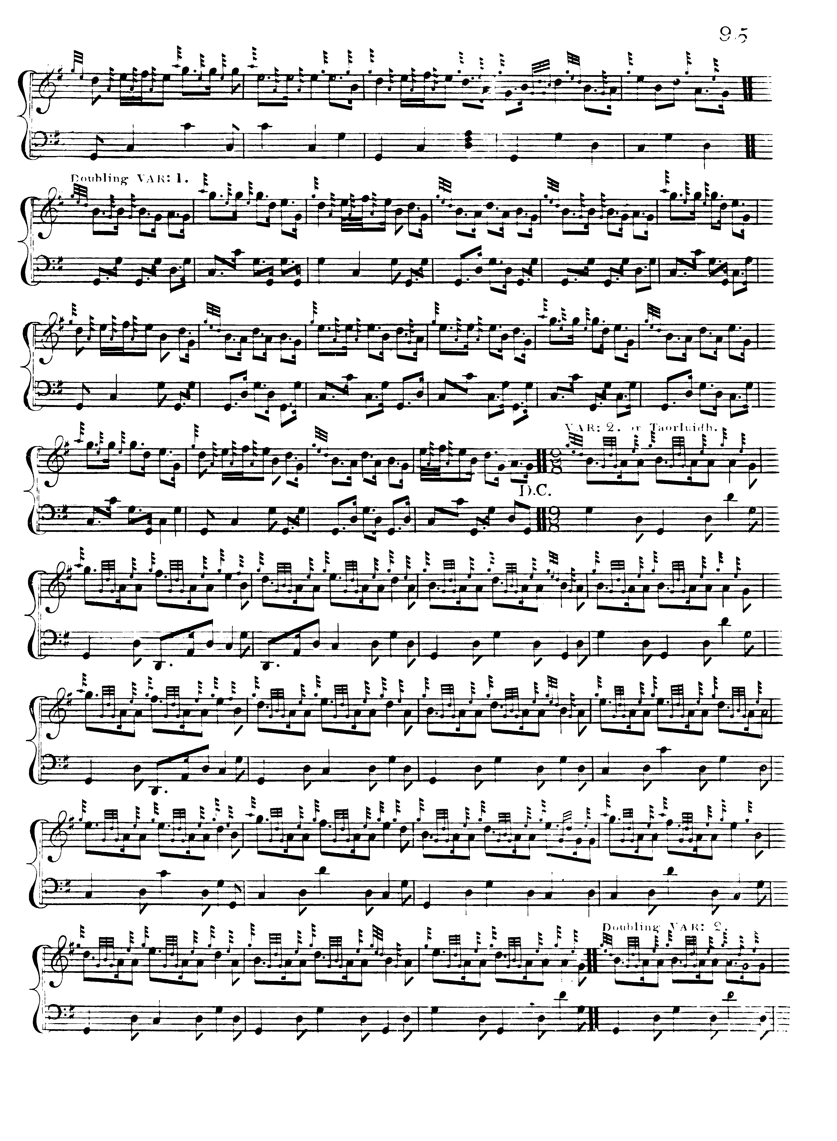
MacDonald directs that the ground be repeated after the end of the doubling of the first variation as above, and again at the end of the crunluath doubling, but not after the taorluath doubling as one might expect. He has no crunluath a mach.

Angus MacKay sets the tune as follows:

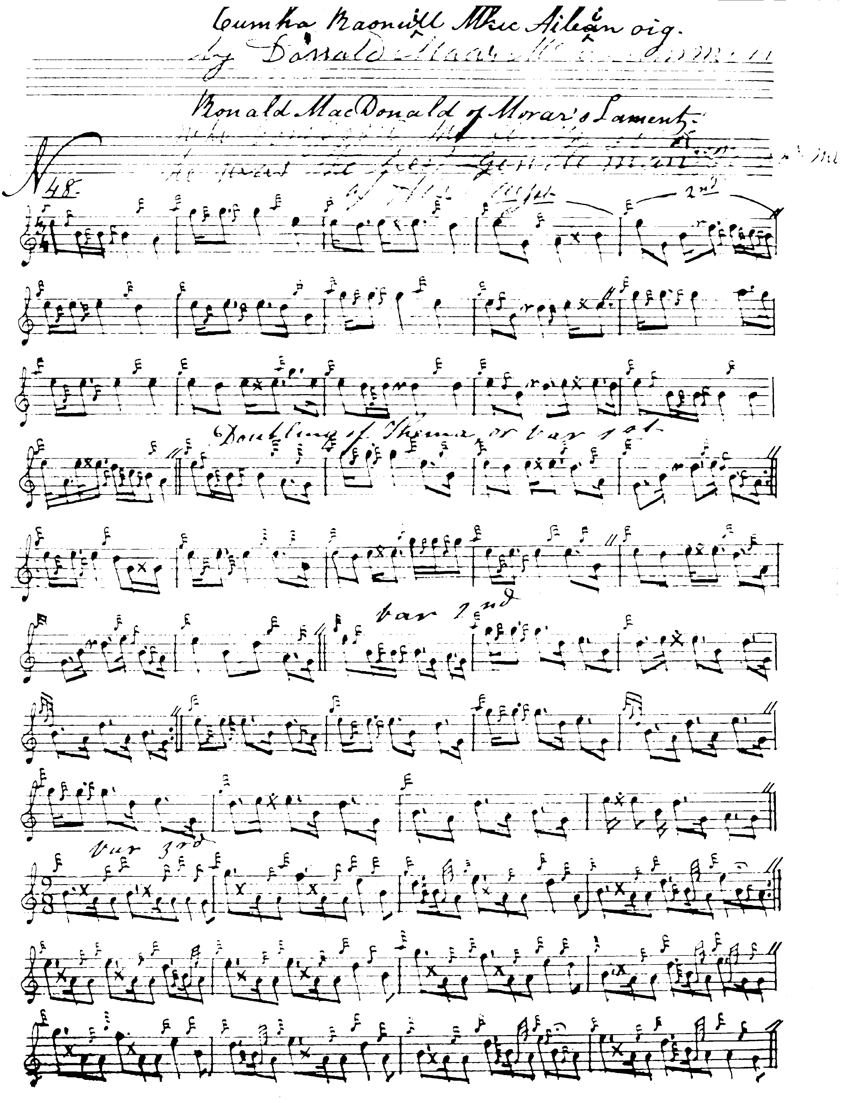

And so on. MacKay directs that the ground be repeated at the end of the taorluath doubling, and has no crunluath a mach.

Commentary

The tune has long been considered ‘irregular’. For example MacDonald and MacKay have a nineteen bar pattern in the ground, moving to sixteen in the taorluath.
and a number of later editors have attempted to rationalise the structure. Donald MacPhee’s timings are as follows:

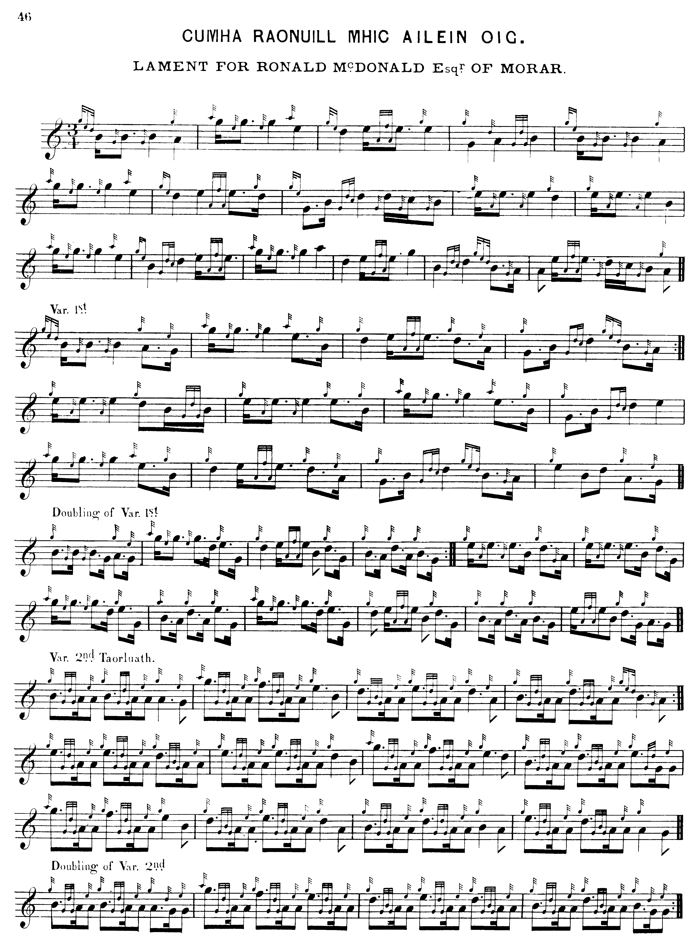

and so on.

Thomason also emends the tune, and the results in playing are quite attractive:

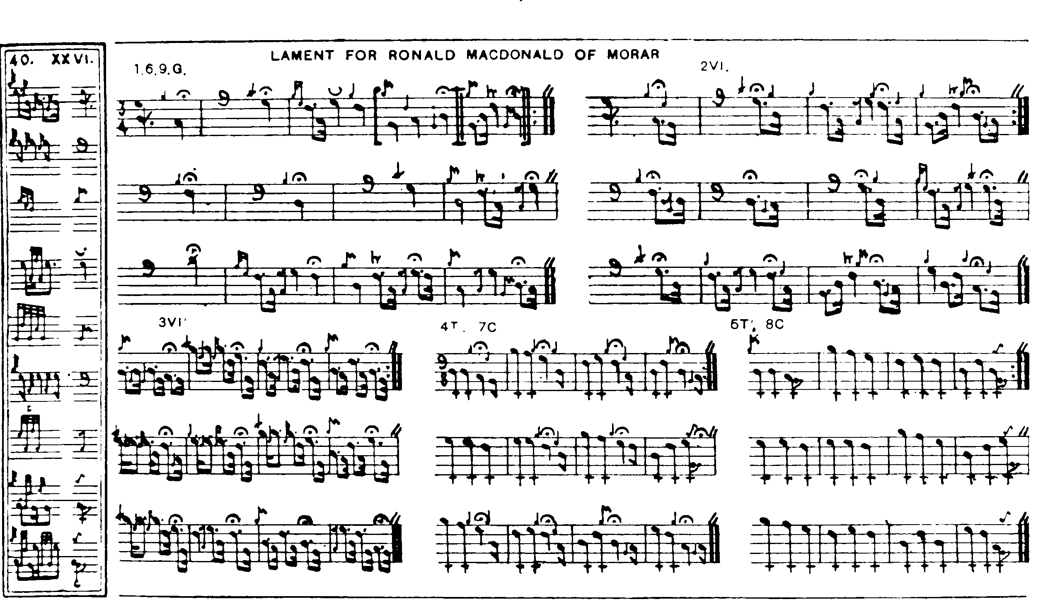

Glen follows MacDonald’s timing in the echo beats, and Thomason’s recension of line three.

William Stewart, editor of the Piobaireachd Society’s first series, volume three, interestingly combines MacDonald and MacKay type timings in the echo beats:

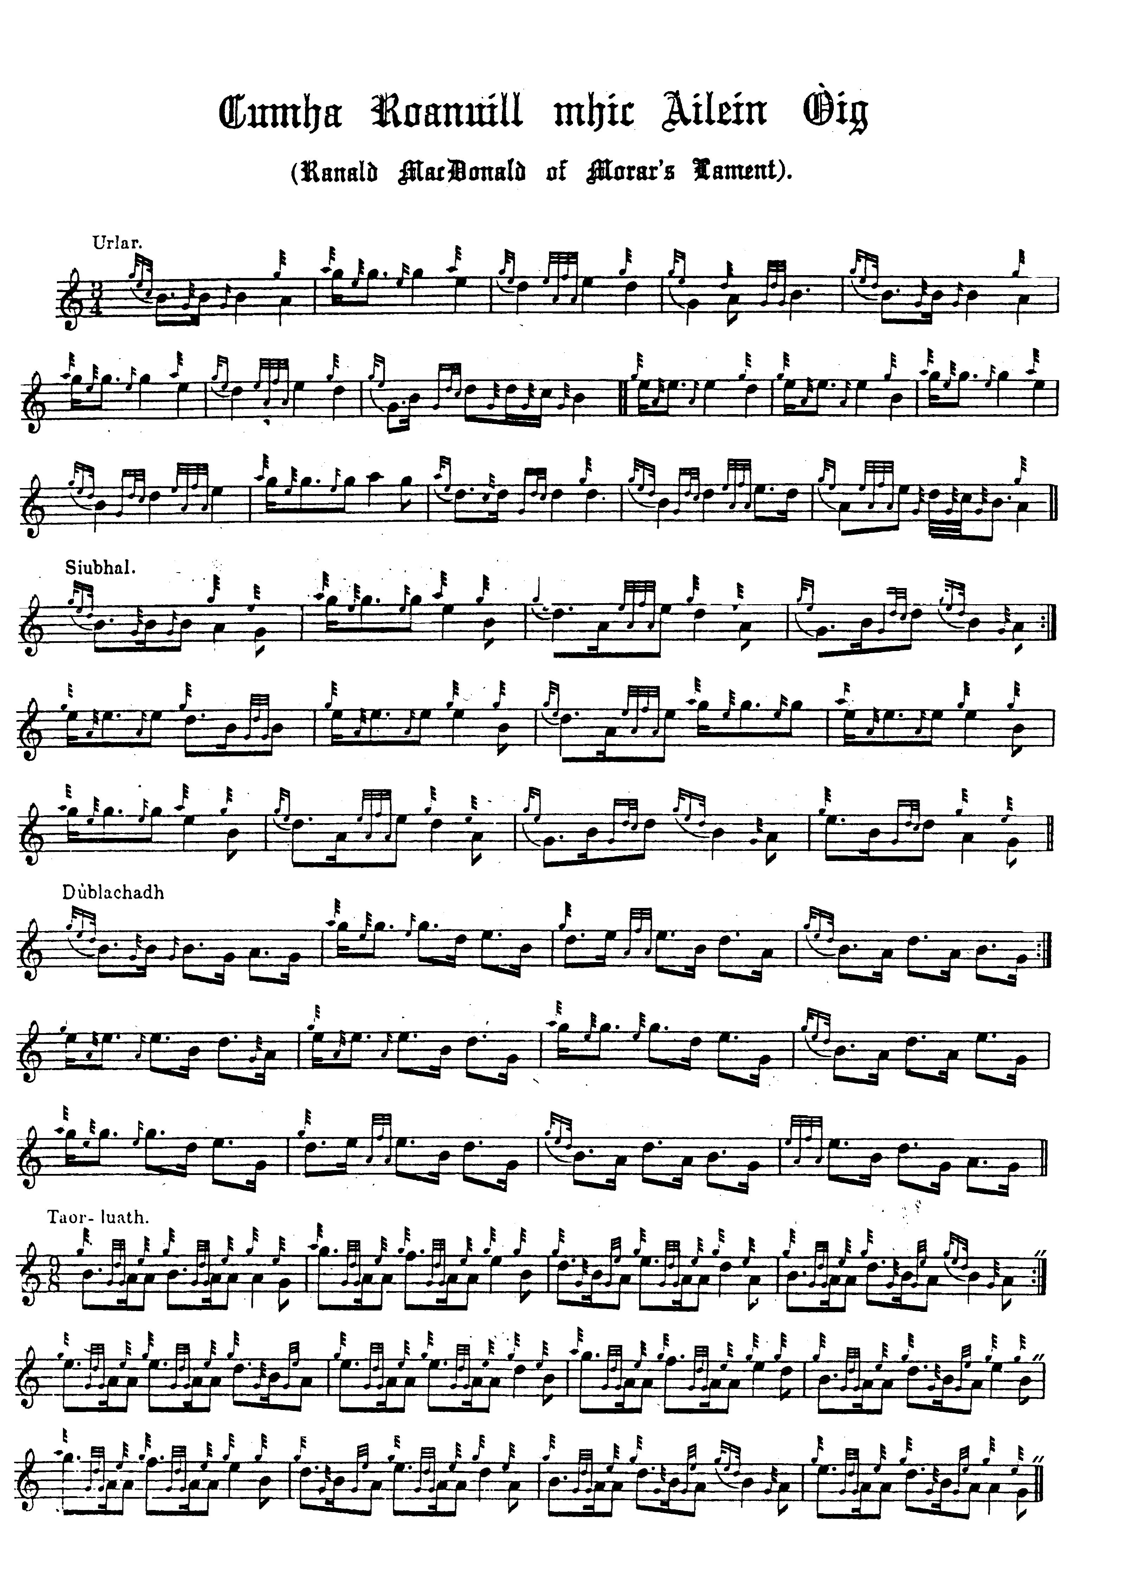

‘The Lament for Ronald MacDonald of Morar’ is a good example of a piece which has been edited in different ways and offers the player a number of mostly attractive routes through the tune. Of course, for most the choice of what to play will be limited by the requirements of competition, but it will be obvious to anybody who has followed the Set Tunes series thus far that in any objective hierarchy of ‘authority’ Archibald Campbell’s scores would not rank very highly.

Ronald MacDonald of Morar, who was known as Raghnall Mac Ailein Oig, was a famous character in Highland lore, celebrated as a hero and composer of pipe music. ‘Fionn’ records in his ‘Historic, Biographic and Legendary Notes’ attached to David Glen’s Collection of Ancient Piobaireachd (p.20) that ‘Ronald MacDonell of Morar was famous as the composer of many pipe tunes that have stood the test of time…[he was] composer of “The Finger Lock”…and it is well known that he was the composer of the tune called “A’ Bhòilich”—The Vaunting. In addition to being a first-class piper, he was also a player of the harp and violin. He was known as Ronald of the Cross, and was the third son of Allan Og of Morar, fourth in descent from Allan, eldest son of Dougal, Chief of Clan Ranald, who was killed in 1520. In a MS. history of the Clan Ranalds, dated 1700, he is referred to as “The best player upone the pype now living.”’

The folklorist Calum MacLean, records a number of lively stories about Raghnall Mac Ailein Oig in his book The Highlands (Lond., 1959): ‘There is one very lovely pibroch called “MacCrimmon’s sweetheart”. One tradition has it that this pibroch was composed by one of the MacCrimmons to a favourite brown polled cow that fell into a bog…Tradition in the Arisaig district has it that the pibroch was composed not by a MacCrimmon but by Raghnall Mac Ailein Oig to a sea-shell that he picked up one day as he strode along the shore.

Despite the lapse of over three hundred years Raghnall Mac Ailein Oig (Ronald the son of Young Allan) remains the outstanding local hero. Ronald had at one time driven cattle to the southern markets and on his way home was overtaken by nightfall. He wandered on in the darkness until finally he saw a distant light. He made for the light and it came from a small bothy. The night was cold and stormy and he knocked at the door and asked for shelter. An old woman answered his knock and told him that she could not admit him. Ronald begged her to let him in to the shelter and warmth of the fire. Still she refused, but Ronald put his foot to the door and forced his way in. “There will soon come one”, said the old woman, “and she will not take very long in putting you out.” They both sat down by the fire. It was not long until the daughter, a huge red-haired woman, arrived. Immediately she seized Ronald and began to put him outside. She was so strong that she put him down on his knees. The shame of being beaten by a mere woman incensed him and he sprang up and wrestled with her until she was finally thrown. The struggle then ceased and Ronald was made heartily welcome. He spent the night in the bothy and the result was that he fathered a natural son. Long years afterwards the son came to Morar to see his father. He was not recognised until he came into the kitchen of his father’s house and took up a set of pipes that lay on a table and began to play. Ronald heard the playing and came in to see who the piper was. It was then he realised that the piper was none other than his son. Some time later Ronald put his son to a further test. A filly had died in his stable and he and the son went to remove the carcase. Inside the stable it was quite dark, but the son caught hold of the hind legs and proceeded to drag the dead animal out through the door. The father took the fore legs and pulled against the son. Not knowing what his father was doing, the son pulled and pulled until the carcase was torn in two and the son fell outwards with the hind quarters in his grasp. After that Ronald had no doubts but that he really was his son.

It was during Ronald’s time that the district of Morar and Arisaig was haunted by a dead spectre called the “Colann gun Cheann” (Headless Body). The Headless Body was the spirit of a decapitated woman who returned from the dead to wreck vengeance on the living. …The irascible chief of Siol Dughaill (the Seed of Dugald) as the Macdonalds of Morar were called, caught a woman with a sucking baby stealing ears of corn in his field and promptly cut off her head with a sickle. The spirit of the beheaded woman appeared in the district and waylaid and killed as many of the seed of Dugald as it met. The whole district was terrorised and no one could be found brave enough to challenge the Headless Body. At last Ronald the son of Young Allan decided to rid the land of the scourge and he met the Headless Body on the strand between Morar and Arisaig. A desperate struggle took place until Ronald overcame the monster and had it firmly pinioned and helpless in his strong arms. The Headless Body begged him to let it go. Ronald refused to loosen his grip until he received a solemn promise that the Headless Body would never again interfere with anyone who had one single drop of the blood of the Seed of Dugald in his or her veins. Ronald then let go, and away went the Headless Body singing:

Far from me is the foot of Beinn Eadara,
Far from me is Bealach a’ Maorghain.

The tune sung by the Headless Body was noted by Ronald the son of Young Allan and it is still played by pipers in many parts of the Highlands.

Ronald the son of Young Allan was called upon to deal with an even more formidable adversary than the Headless Body. The most notorious chieftain of Clanranald was Evil Donald (Domhnall Dona Mac ’ic Ailein) who lived in the seventeenth century. Donald sold himself to the Devil in return for power and glory all through his life. Donald continued merrily on his evil course, but the Devil saw to it that he was never allowed to forget the contract between them for very long. Donald was continually followed by a frog-like creature as large as a bullock. All attempts to dispose of it were unavailing, and wherever Evil Donald went the gigantic frog was bound to make its appearance. Often he left Moidart and sailed across to South Uist fondly imagining that the frog was secure in the dungeon of Caisteal Tioram only to discover that it would appear out of nowhere and clamour to be taken aboard. On his return to the mainland the frog would be locked in the dungeon of the castle of Ormicleit and again it would appear swimming in the wake of his boat. The years rolled on and Evil Donald drew close to the end of his allotted span. He had been out in South Uist and was overtaken by the frog on the journey homewards. Evil Donald landed at Canna, and the frog gave him a lingering look as it got out of the boat and disappeared not to be seen again. Evil Donald observed this and knew that the end was not far off. Word was sent to Ronald the son of Young Allan asking him to go to Canna to be beside Evil Donald as the end approached. Ronald arrived in Canna and spent the nights at the bedside of the dying chief. On this particular night Evil Donald was very low, and in hushed tones he told Ronald of his contract with the Devil.

“I sold myself to the Destructive One for success and vainglory in this life and tonight he comes to claim me. All through life I delighted in doing evil. At the battle of Inverlochy I could not get my fill of Campbell blood. There is no evil thing that I have not done, and tonight I must meet the master I served so faithfully.”

Midnight approached and a shrill whistling was heard outside. Someone looked out, and there on a high rock by the shore stood a dark figure. As soon as the whistling was heard, the dying man made to get up but Ronald the son of Young Allan held him down. A second time the whistle was heard and again the old man struggled to get up but Ronald held him down. The third time the summons came the old man almost reached the door and only the great strength of Ronald succeeding in bringing him back to bed. As the hour of midnight struck a fearful noise was heard outside. Again they looked out and the dark figure had gone and the rock on which he stood was cleft in twain. As the noise died away Evil Donald of Clanranald sank back on the bed and gave up the ghost.

Ronald did compose one very noted pibroch called An Tarbh Breac Dearg (The Dappled Red Bull). He was invited down to the Cameron country where an inveterate enemy let loose a wild bull in a field which Ronald had to cross. The bull attacked Ronald and almost succeeded in goring him to death. The bull, however, was killed by Ronald, but he never recovered from his injuries and his exertions in the struggle with it. It was on that occasion that he composed the pibroch.” pp.63-7

* * *

