The Red Speckled Bull

There are settings of this tune in the following manuscript sources:
--Donald MacDonald, ff.258-261 (with the title “Se’n t’Arm Mharbh me”);
--Angus MacKay, i,104-106 (with the title “An t’arm Breachd Dearg The British Army”);
--Colin Cameron, ff.25-26;
--John MacDougall Gillies, ff. 93-4 (with the title “An t’arm Breachd Dearg”);
--David Glen, ff.197-198;

and in the following published source:
--C. S. Thomason, Ceol Mor, pp.134-6, with the title “The Army Red Tartaned (Maolroy)”.

Donald MacDonald omits the third line in his doublings throughout. The pattern of the ground and the singlings of the various movements is 6 6 4, but in the doublings this becomes 6 6. He develops the tune thus:
Ground
doubling of ground
siubhal singling
siubhal doubling
taorluath fosgailte singling and doubling
crunluath fosgailte singling and doubling.
There is no indication that the ground be repeated at any point of the tune:

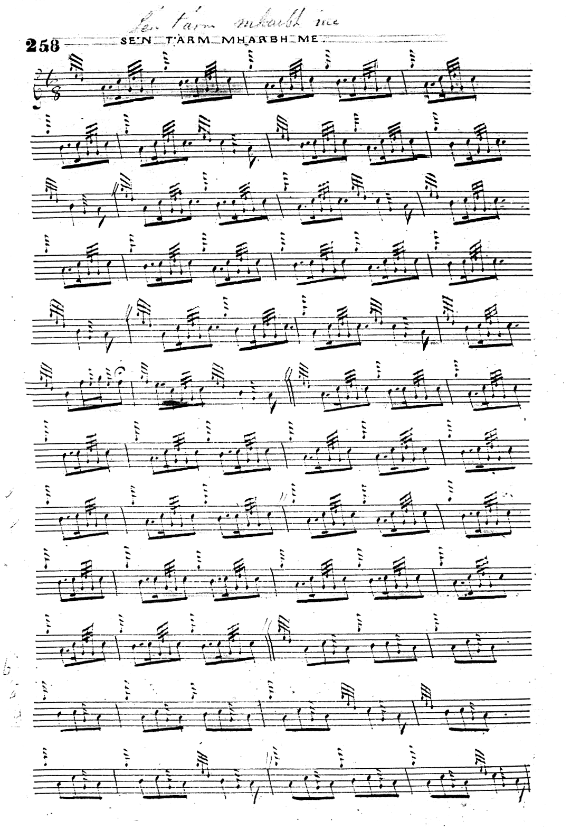
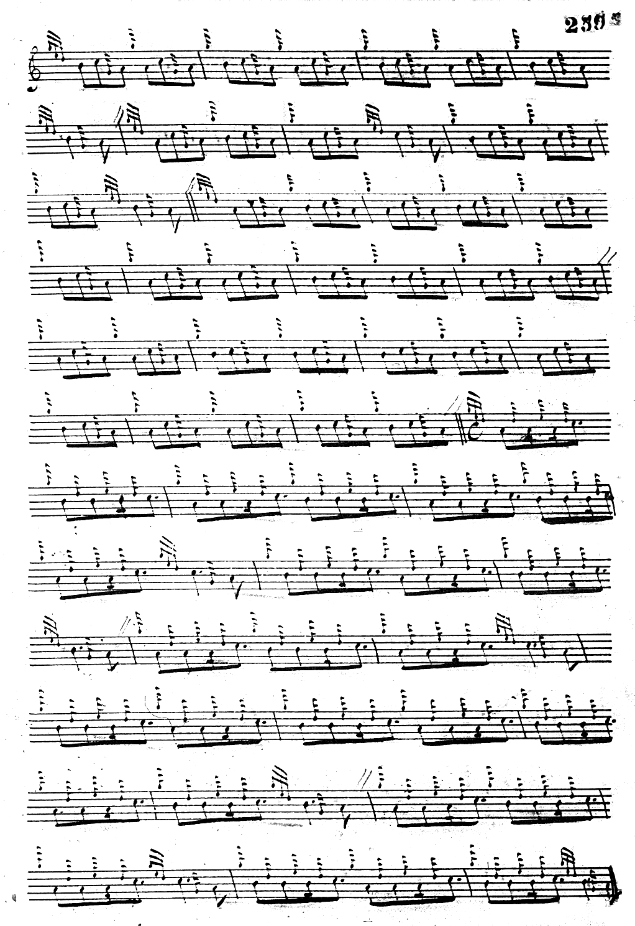
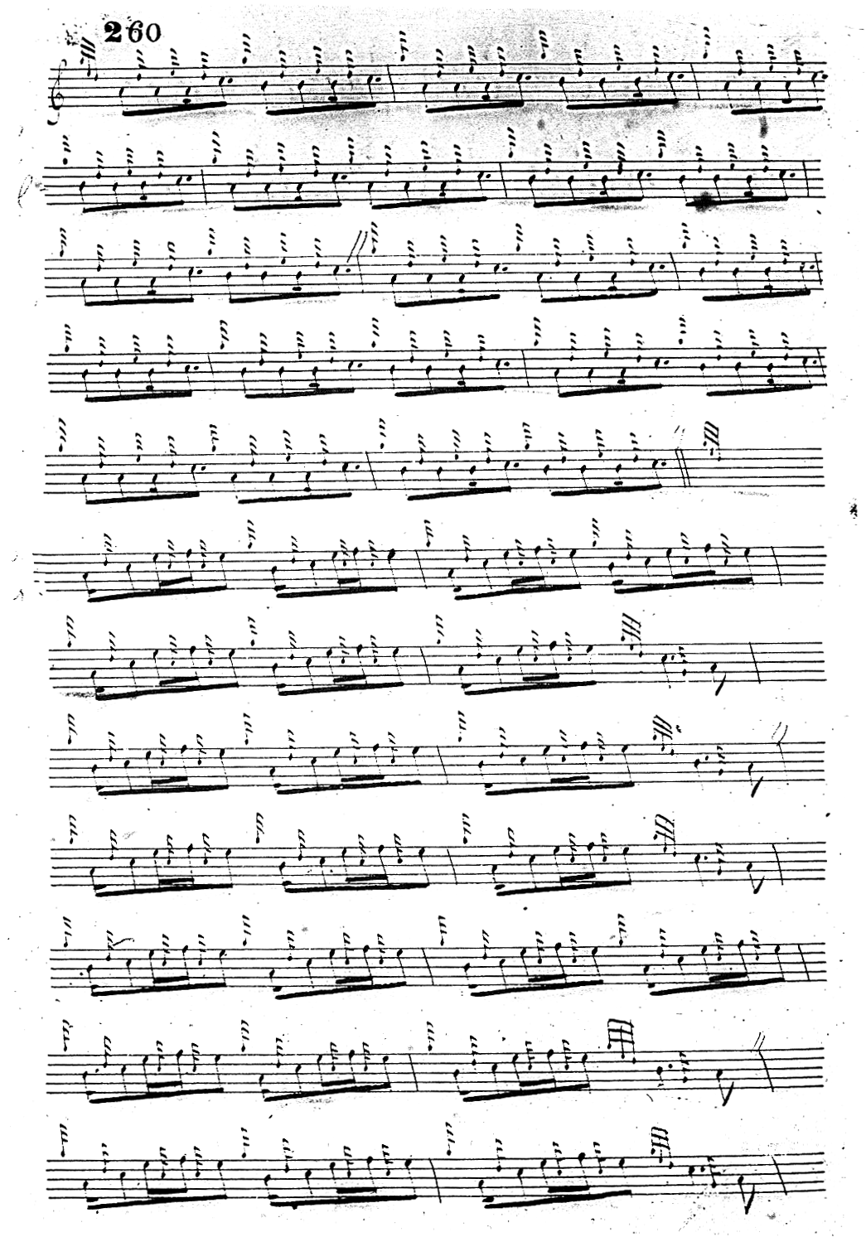
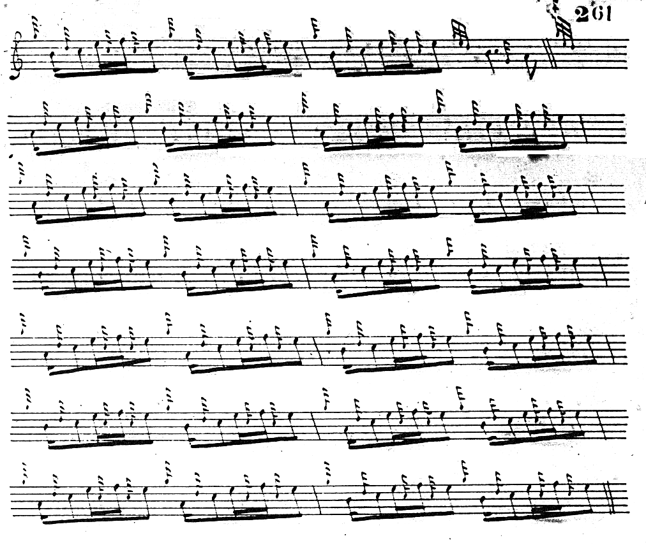

One notices his interesting pointings in the taorluath and crunluath fosgailte movements, including a striking cut “up” at the beginning of each movement of the latter variations in typical MacArthur style. MacDonald times a number of his fosgailte tunes in this manner.

Angus MacKay treats the tune in a broadly similar manner to Donald MacDonald with the important difference that his doublings are the same length as his singlings and his score therefore has a more “regular” appearance, but he still has one or two distinctive touches. His ground is set in 4/4 (as opposed to MacDonald’s more idiomatic 6/8) and seems very square and deliberate in comparison, with the metrical flow being frequently broken up with obtrusive cadence movements.
He then develops the tune through a doubling of the ground, a first siubhal singling and doubling in a style similar to MacDonald’s; a second siubhal singling and doubling, not in MacDonald, in typically expansive MacKay style; and a taorluath fosgailte singling and doubling . At this point MacKay directs that the ground be repeated; he follows this with a crunluath variation, singling and doubling and ends with a final repeat of the ground:

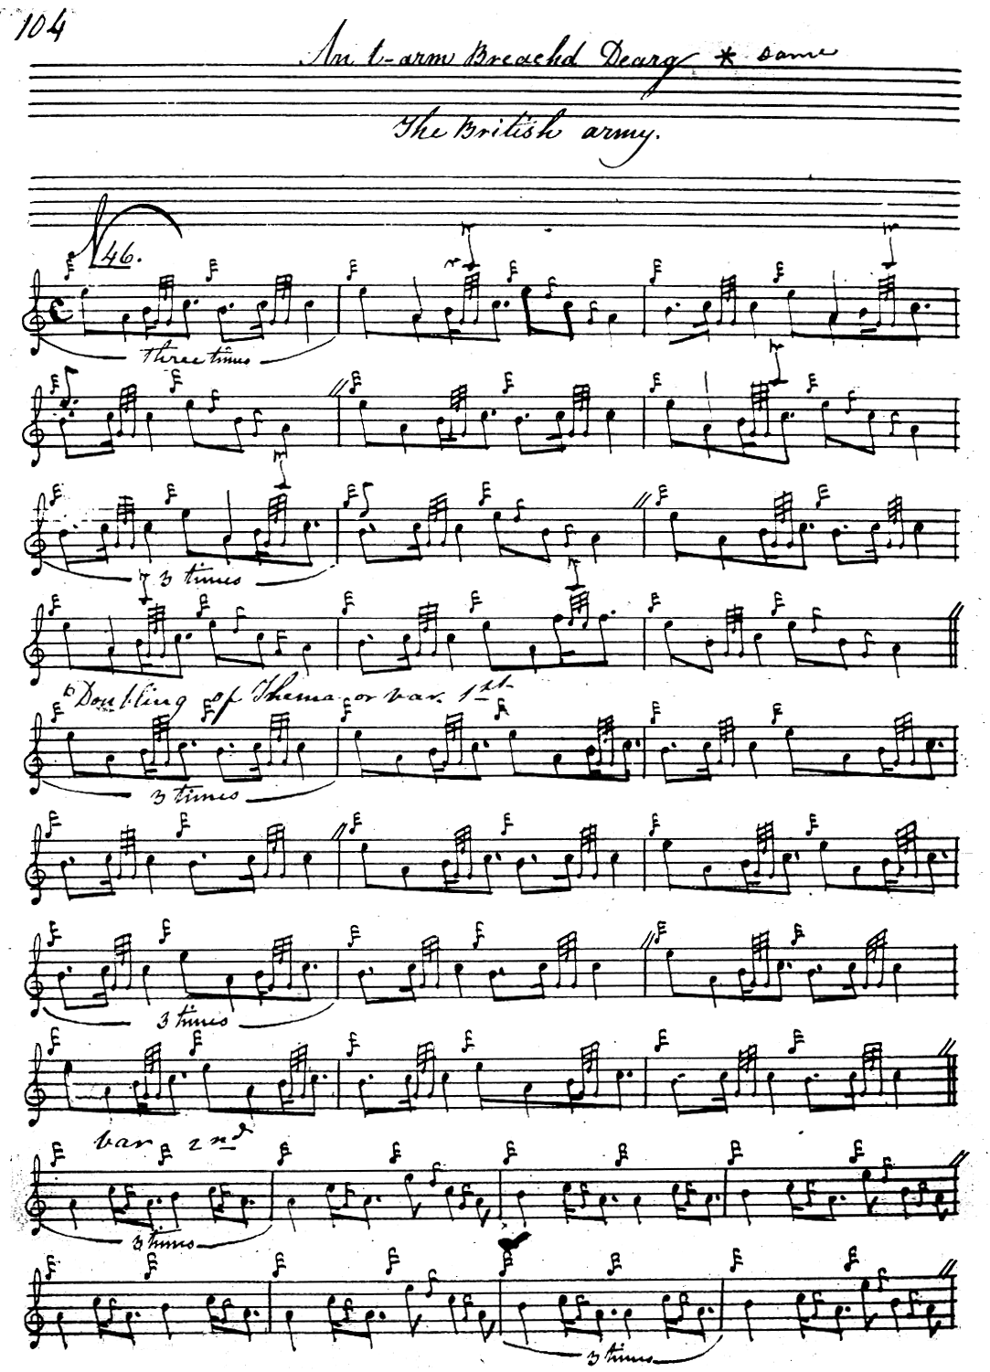
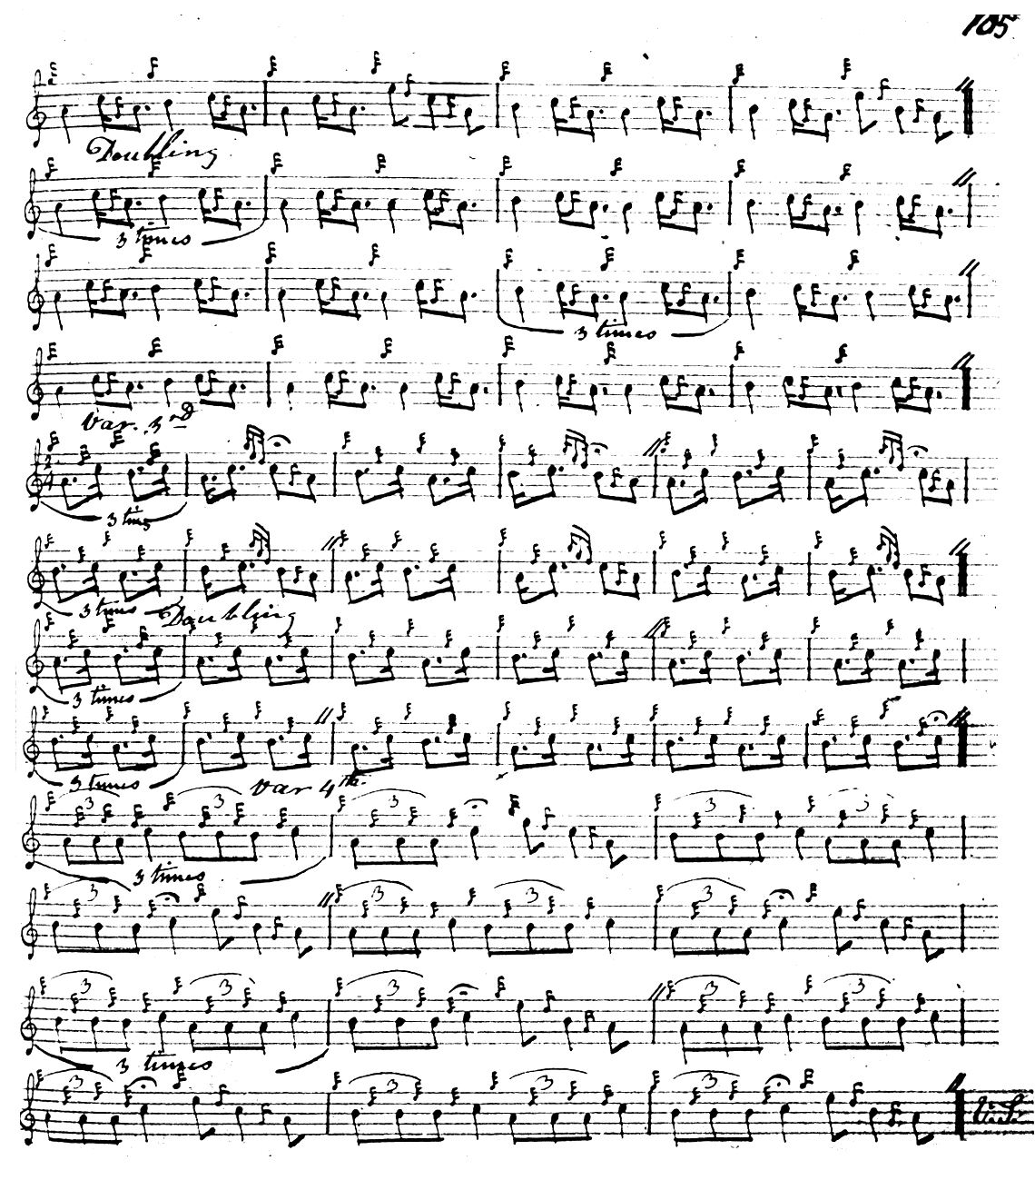
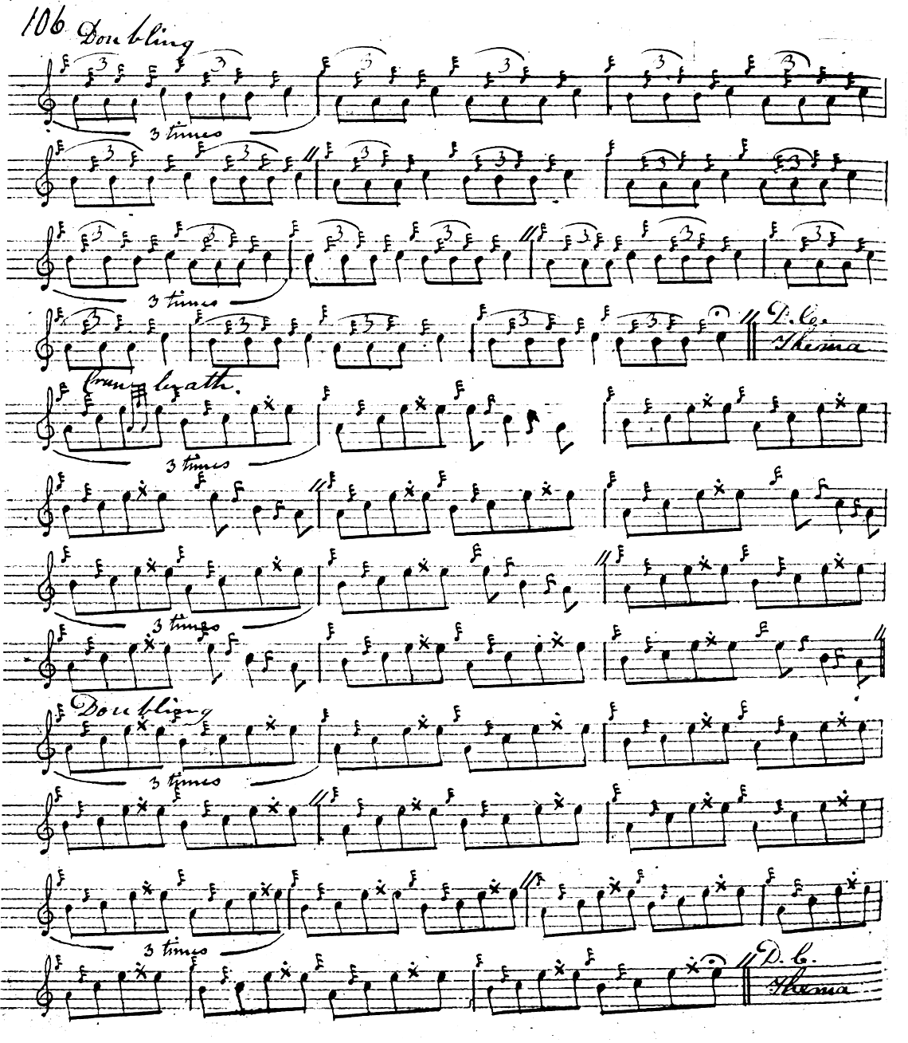

In his crunluath variations MacKay shows the opening two notes in each movement as even quavers. This may be intended to be taken literally, and the effect therefore similar to that in MacDonald’s score, although perhaps just a bit squarer.

Colin Cameron’s score is very close to that of Angus MacKay and is not reproduced here.

John MacDougall Gillies’s score follows Colin Cameron’s closely and it is not reproduced here.

C. S. Thomason has as an alternative title “The MacQuarrie’s Gathering”, although this is not stated in any of the other sources. An t-arm breac dearg is the motto of the MacQuarries of Ulva. He gives his source for the music as Donald MacDonald. His score departs from MacDonald’s in a number of ways, including a movement on the C in doubling of the ground bars 4, 8, and 14 and incorporates a flourish at the end of the ground doubling and siubhal singling which is not present in MacDonald. There are subtle differences in the siubhal doubling also from his stated source. Thomason repeats the ground at the end of the taorluath fosgailte doubling and again at the end of the tune. Thomason also plays the “up-cut” style in his crunluath, the movement beginning semi-quaver/dotted quaver, rather than the other way around:

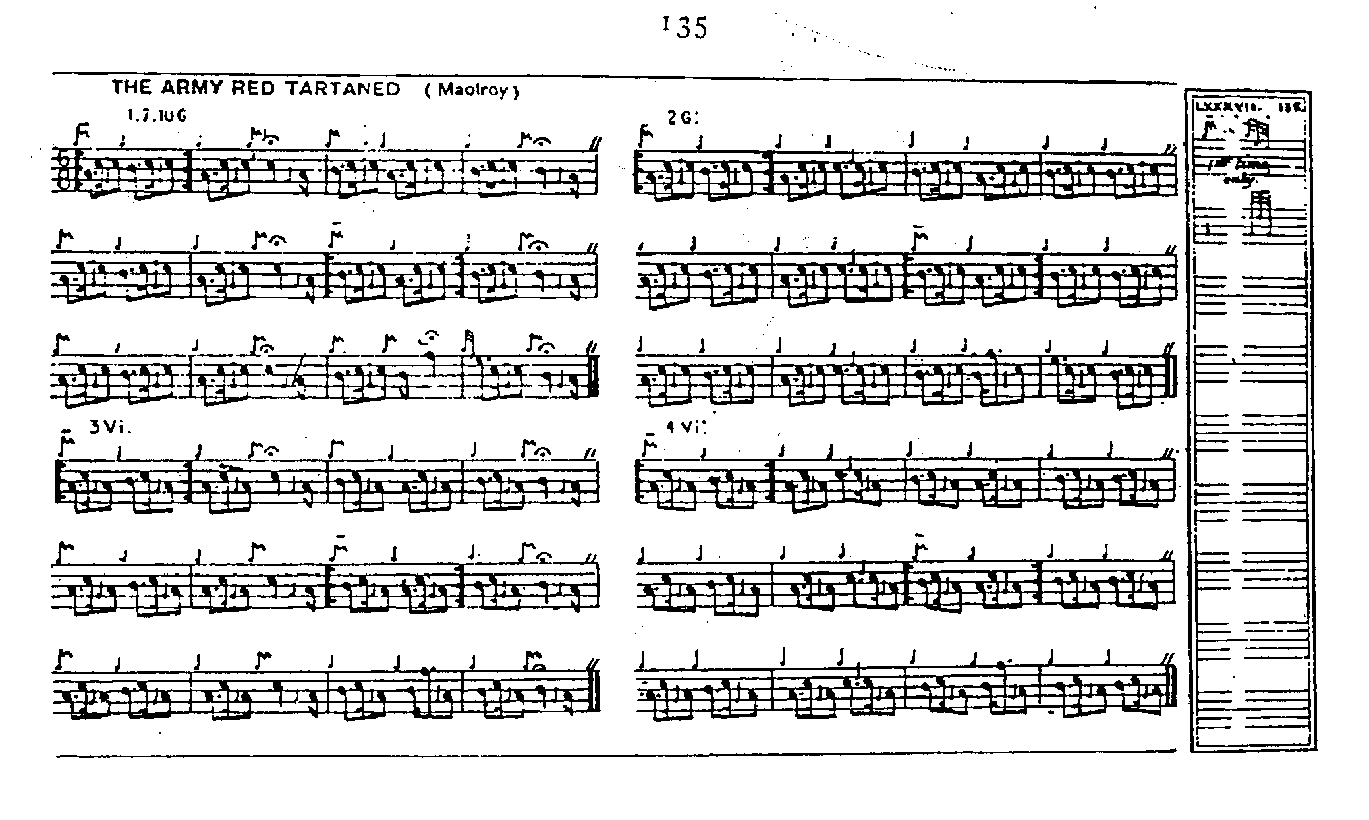
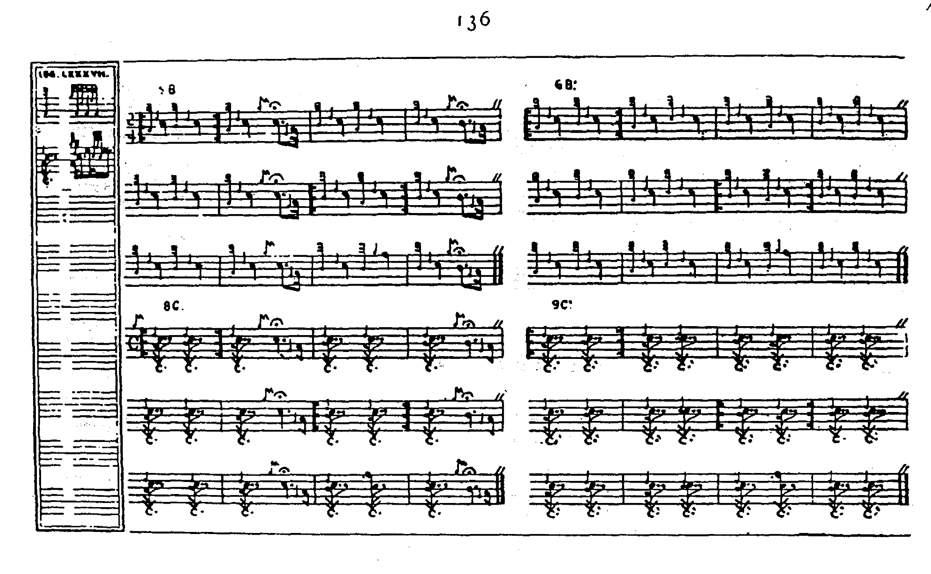

Players drawn to Thomason’s style, but encountering obstacles in his notational system, may find the following transcript by David Glen useful:

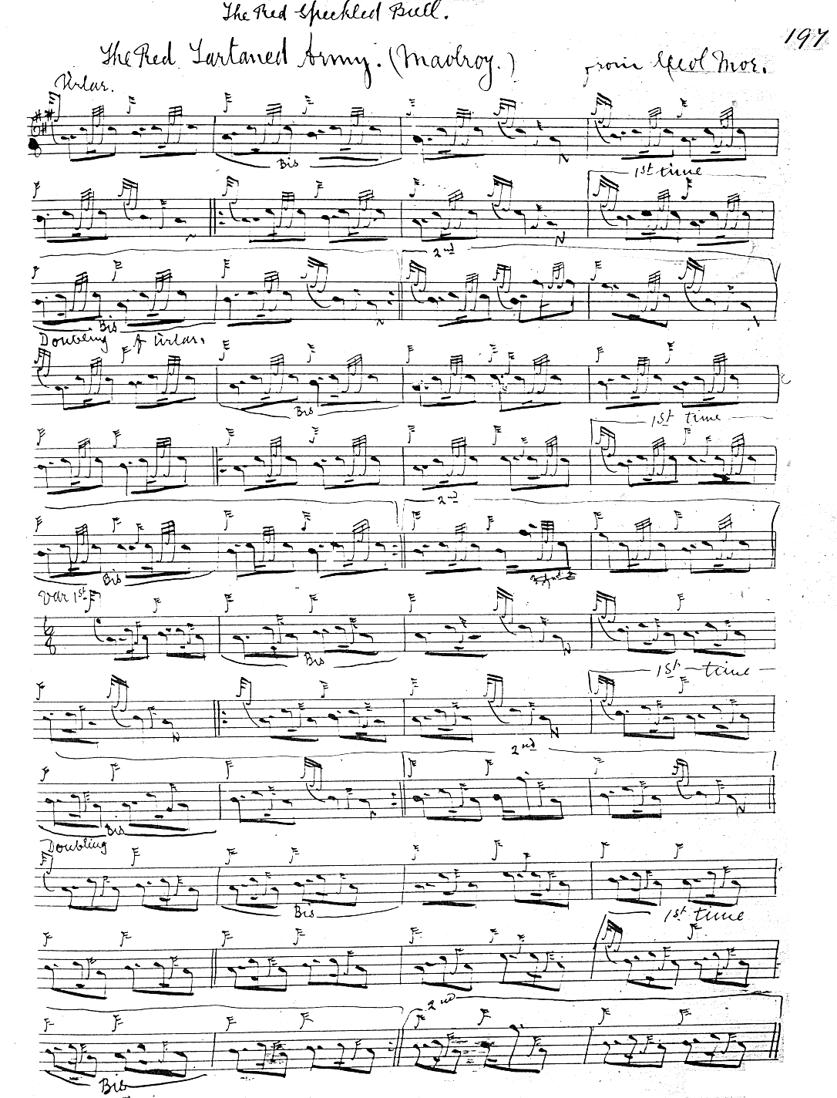
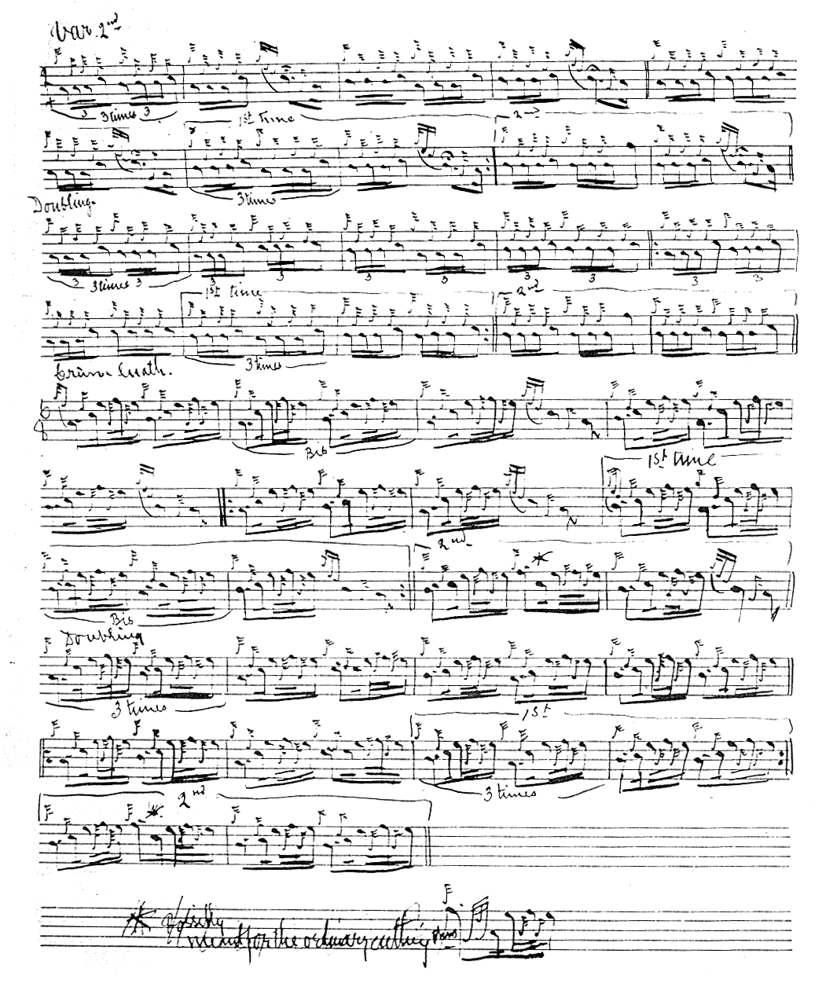

Glen times his crunluath movements in the way which has later become standard, with the starting note a dotted quaver.

Commentary:

In his manuscript notes to this tune, Donald MacDonald says:

“An t arm breachd derg, Se ’n t’arm mharbh me
These words describe the appearance of an army at a distance. The composer of this rattling march, was one of the pipers who was at the battle of Maol-roy, and he says, it was the army that killed him; which is the literal meaning of the Gaelic above” (f.8)

* * *

Electronic text © Dr. William Donaldson, Aberdeen, Scotland, July 2006

