The Prince’s Salute

This tune appears in the following manuscript sources:
--Angus MacKay’s MS, i, 141-144;
--David Glen’s MS, f.414;
--Robert Meldrum’s MS, ff.152-154;

and the following published sources:
--Donald MacDonald, Ancient Martial Music of Caledonia, pp.1-6;
--Donald MacPhee, Collection of Piobaireachd, i, 17-19;
--C. S. Thomason, Ceol Mor, p.5;
--David Glen, Ancient Piobaireachd, pp.25-7;
--William Stewart of Ensay, Piobaireachd Society Collection, 1st Series, i, 1-3.

Donald MacDonald treats the tune as follows:

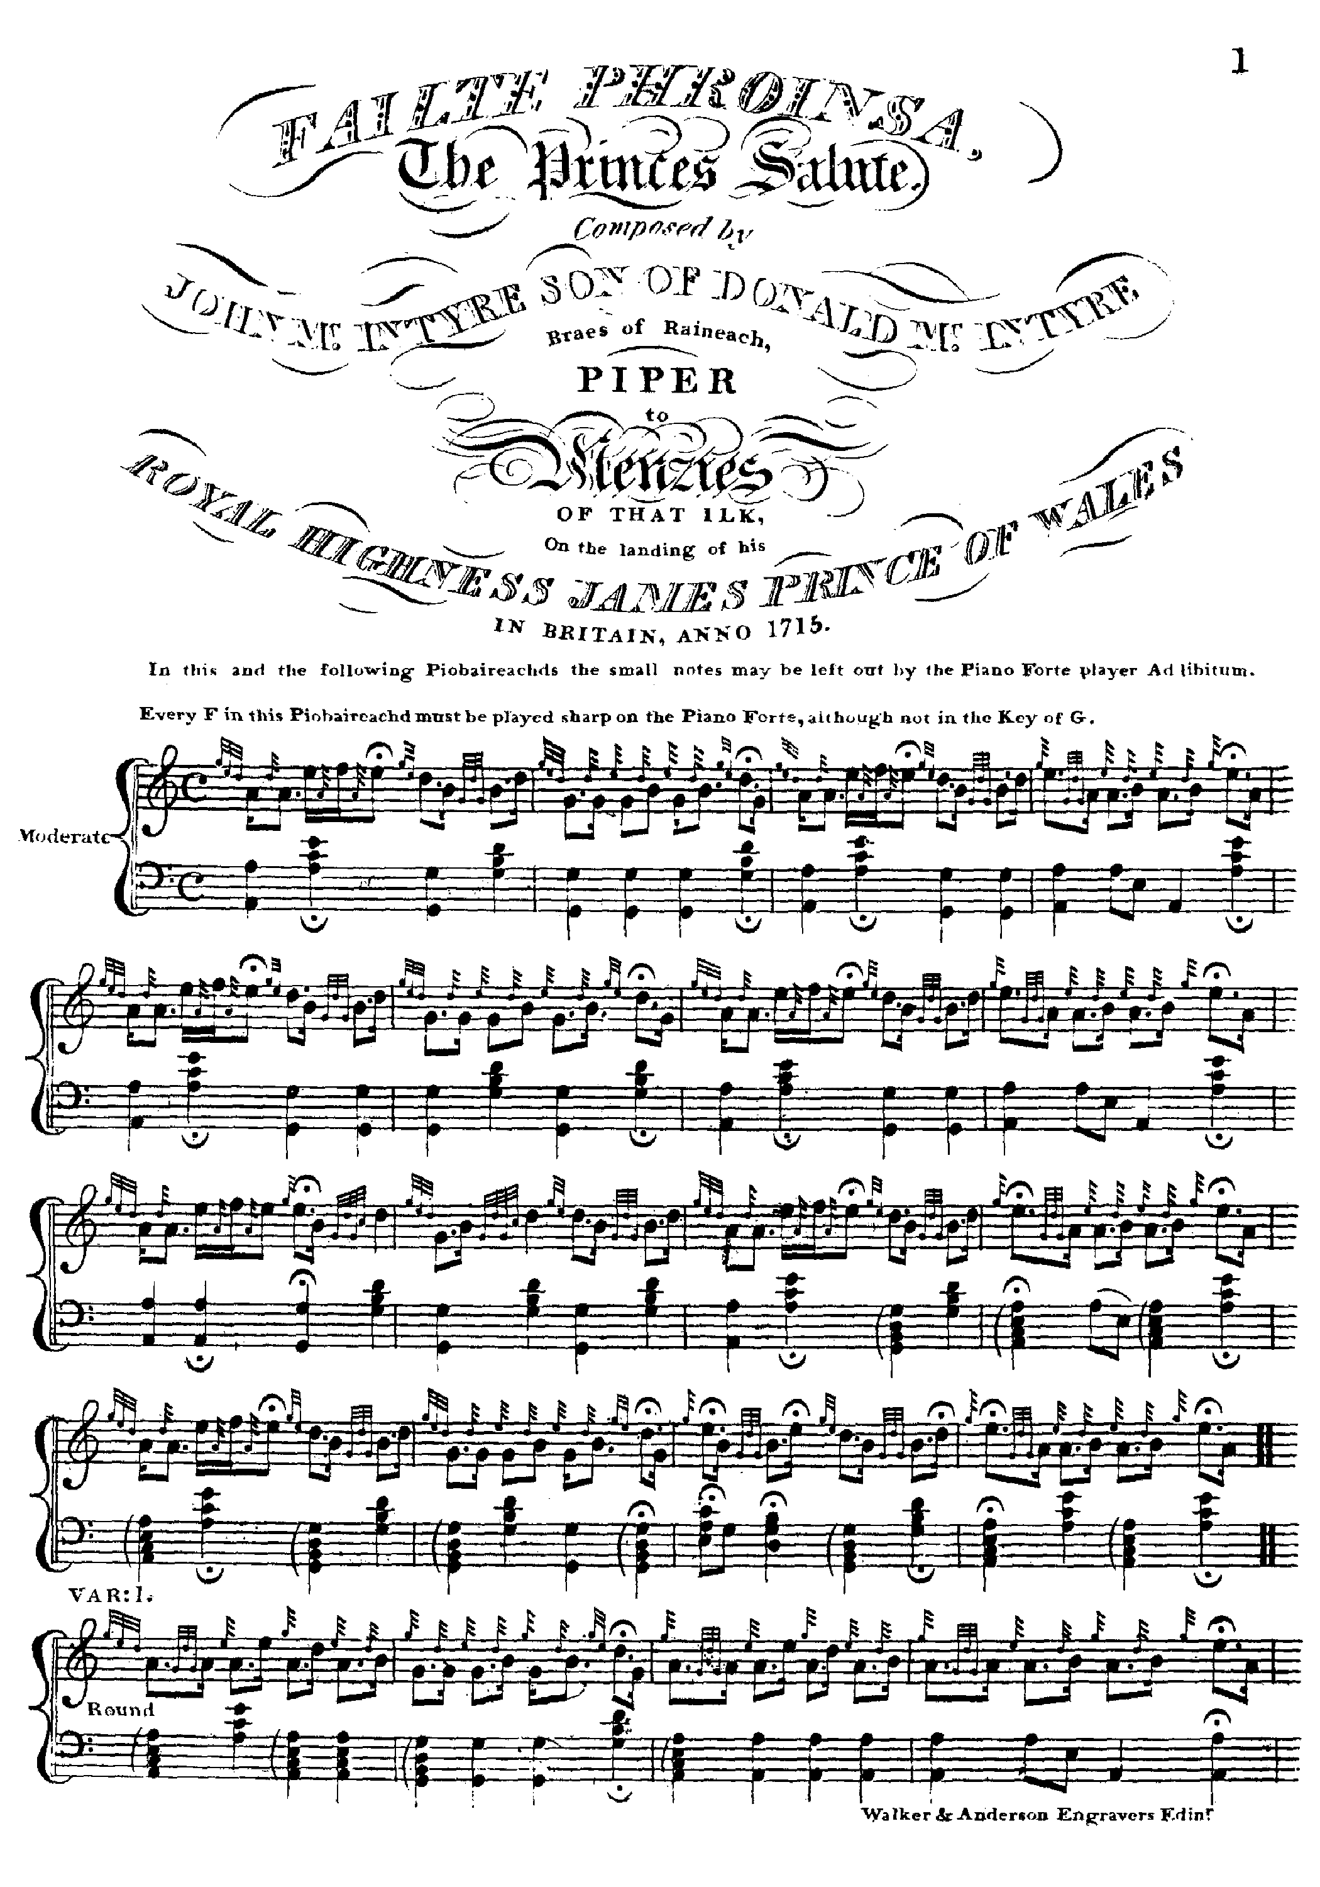
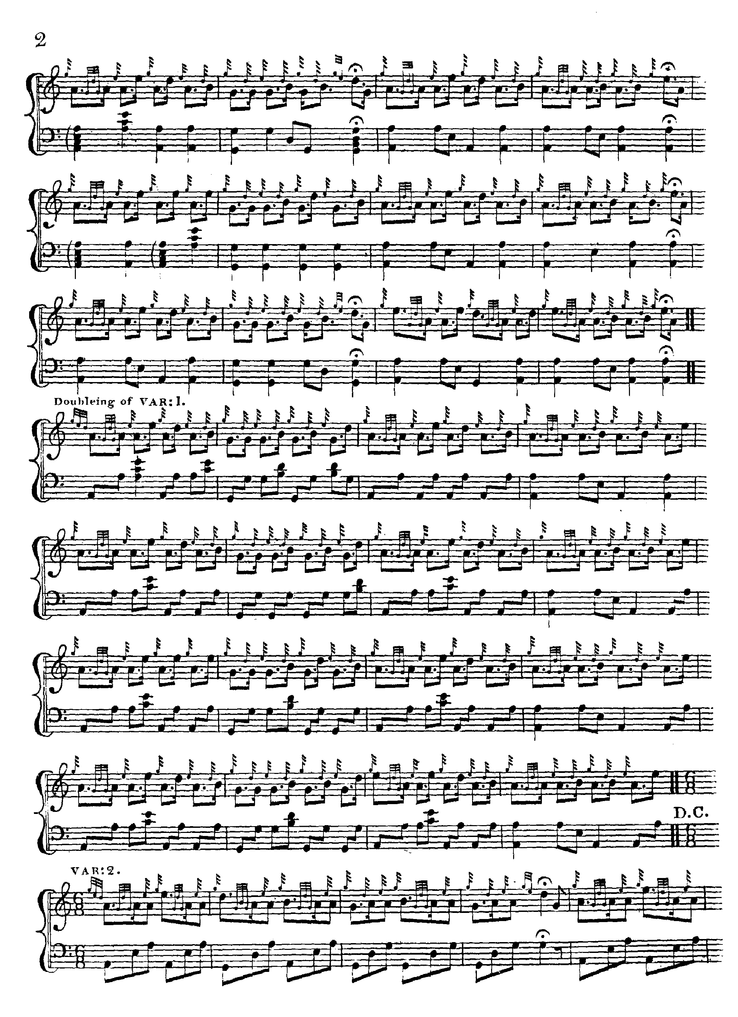
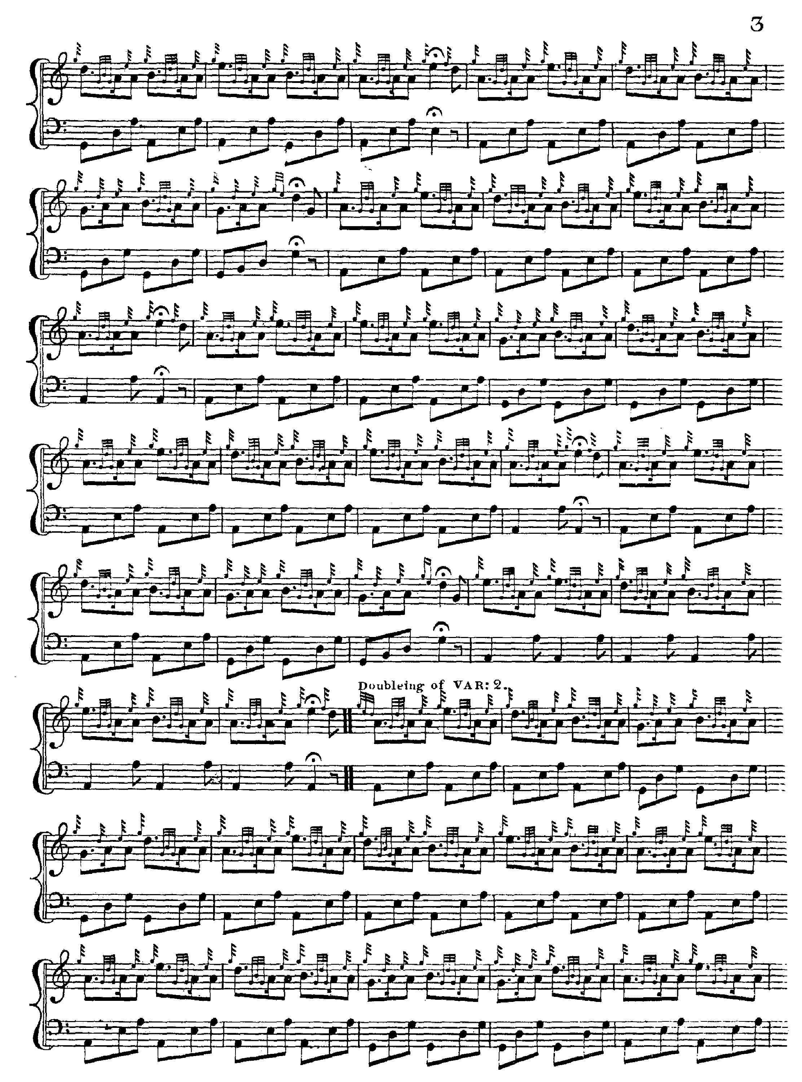
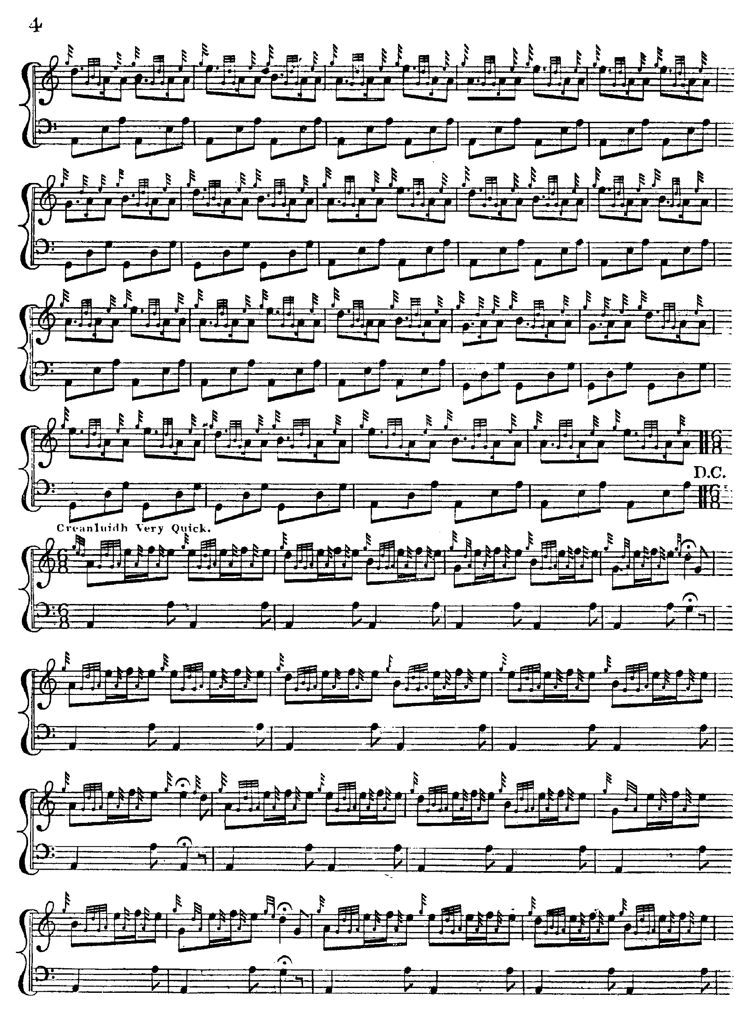
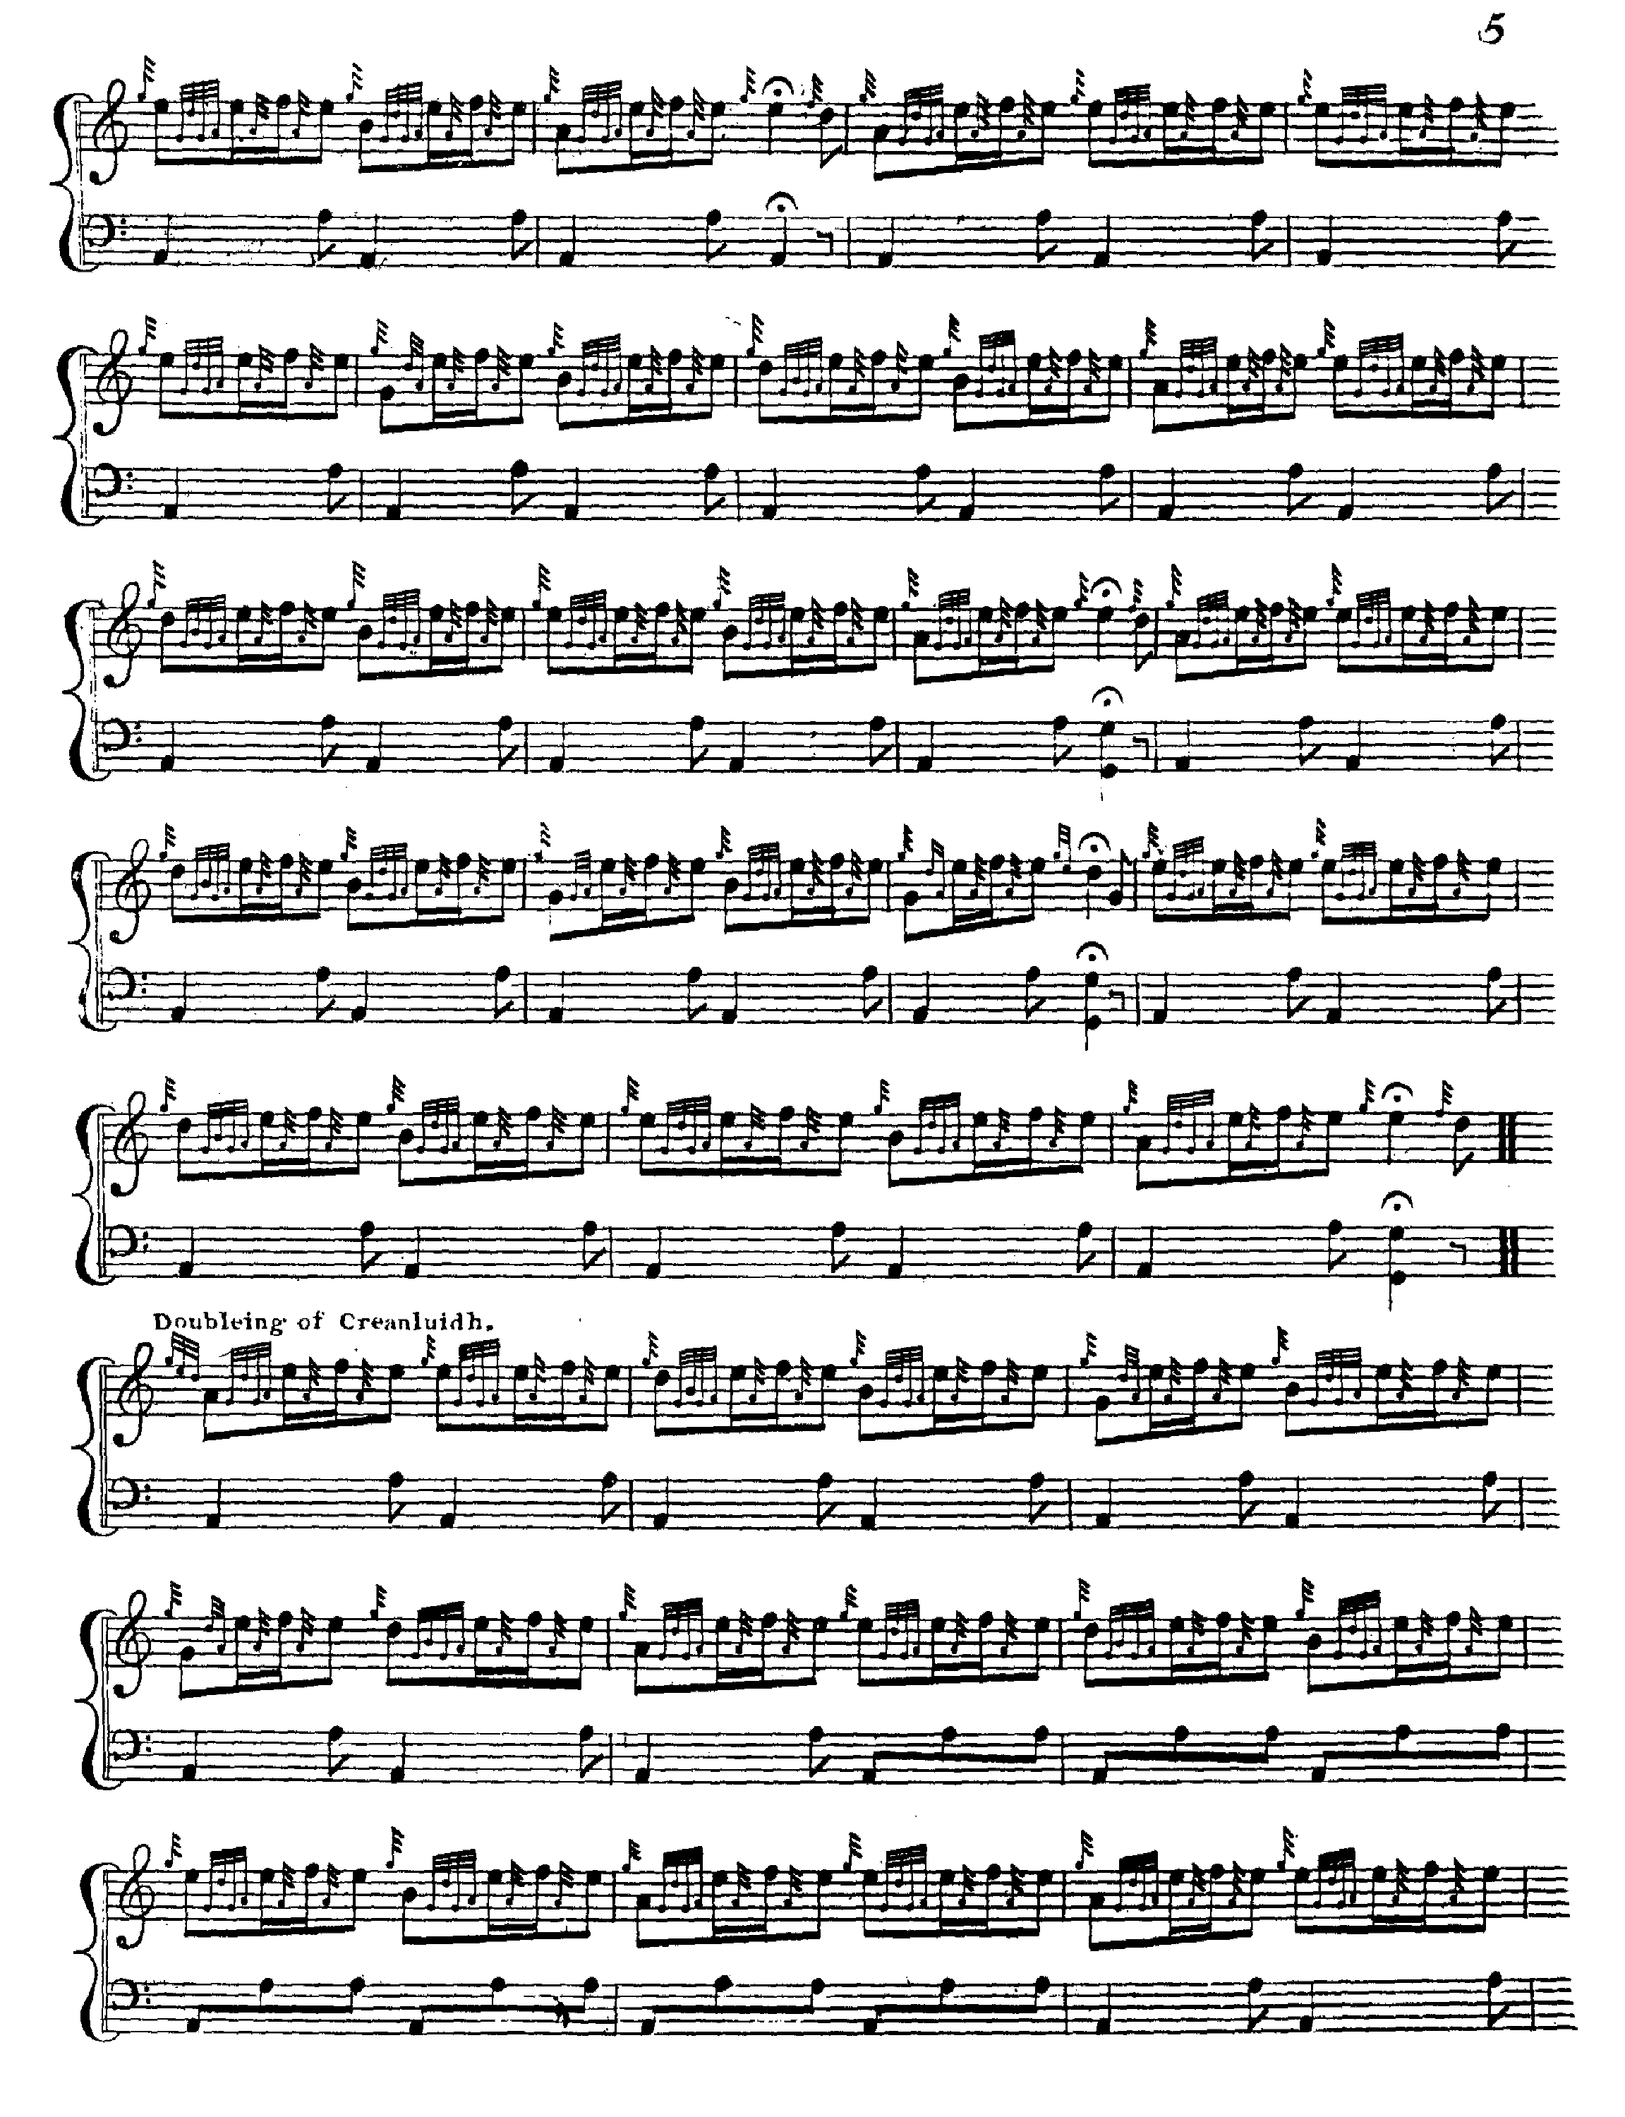
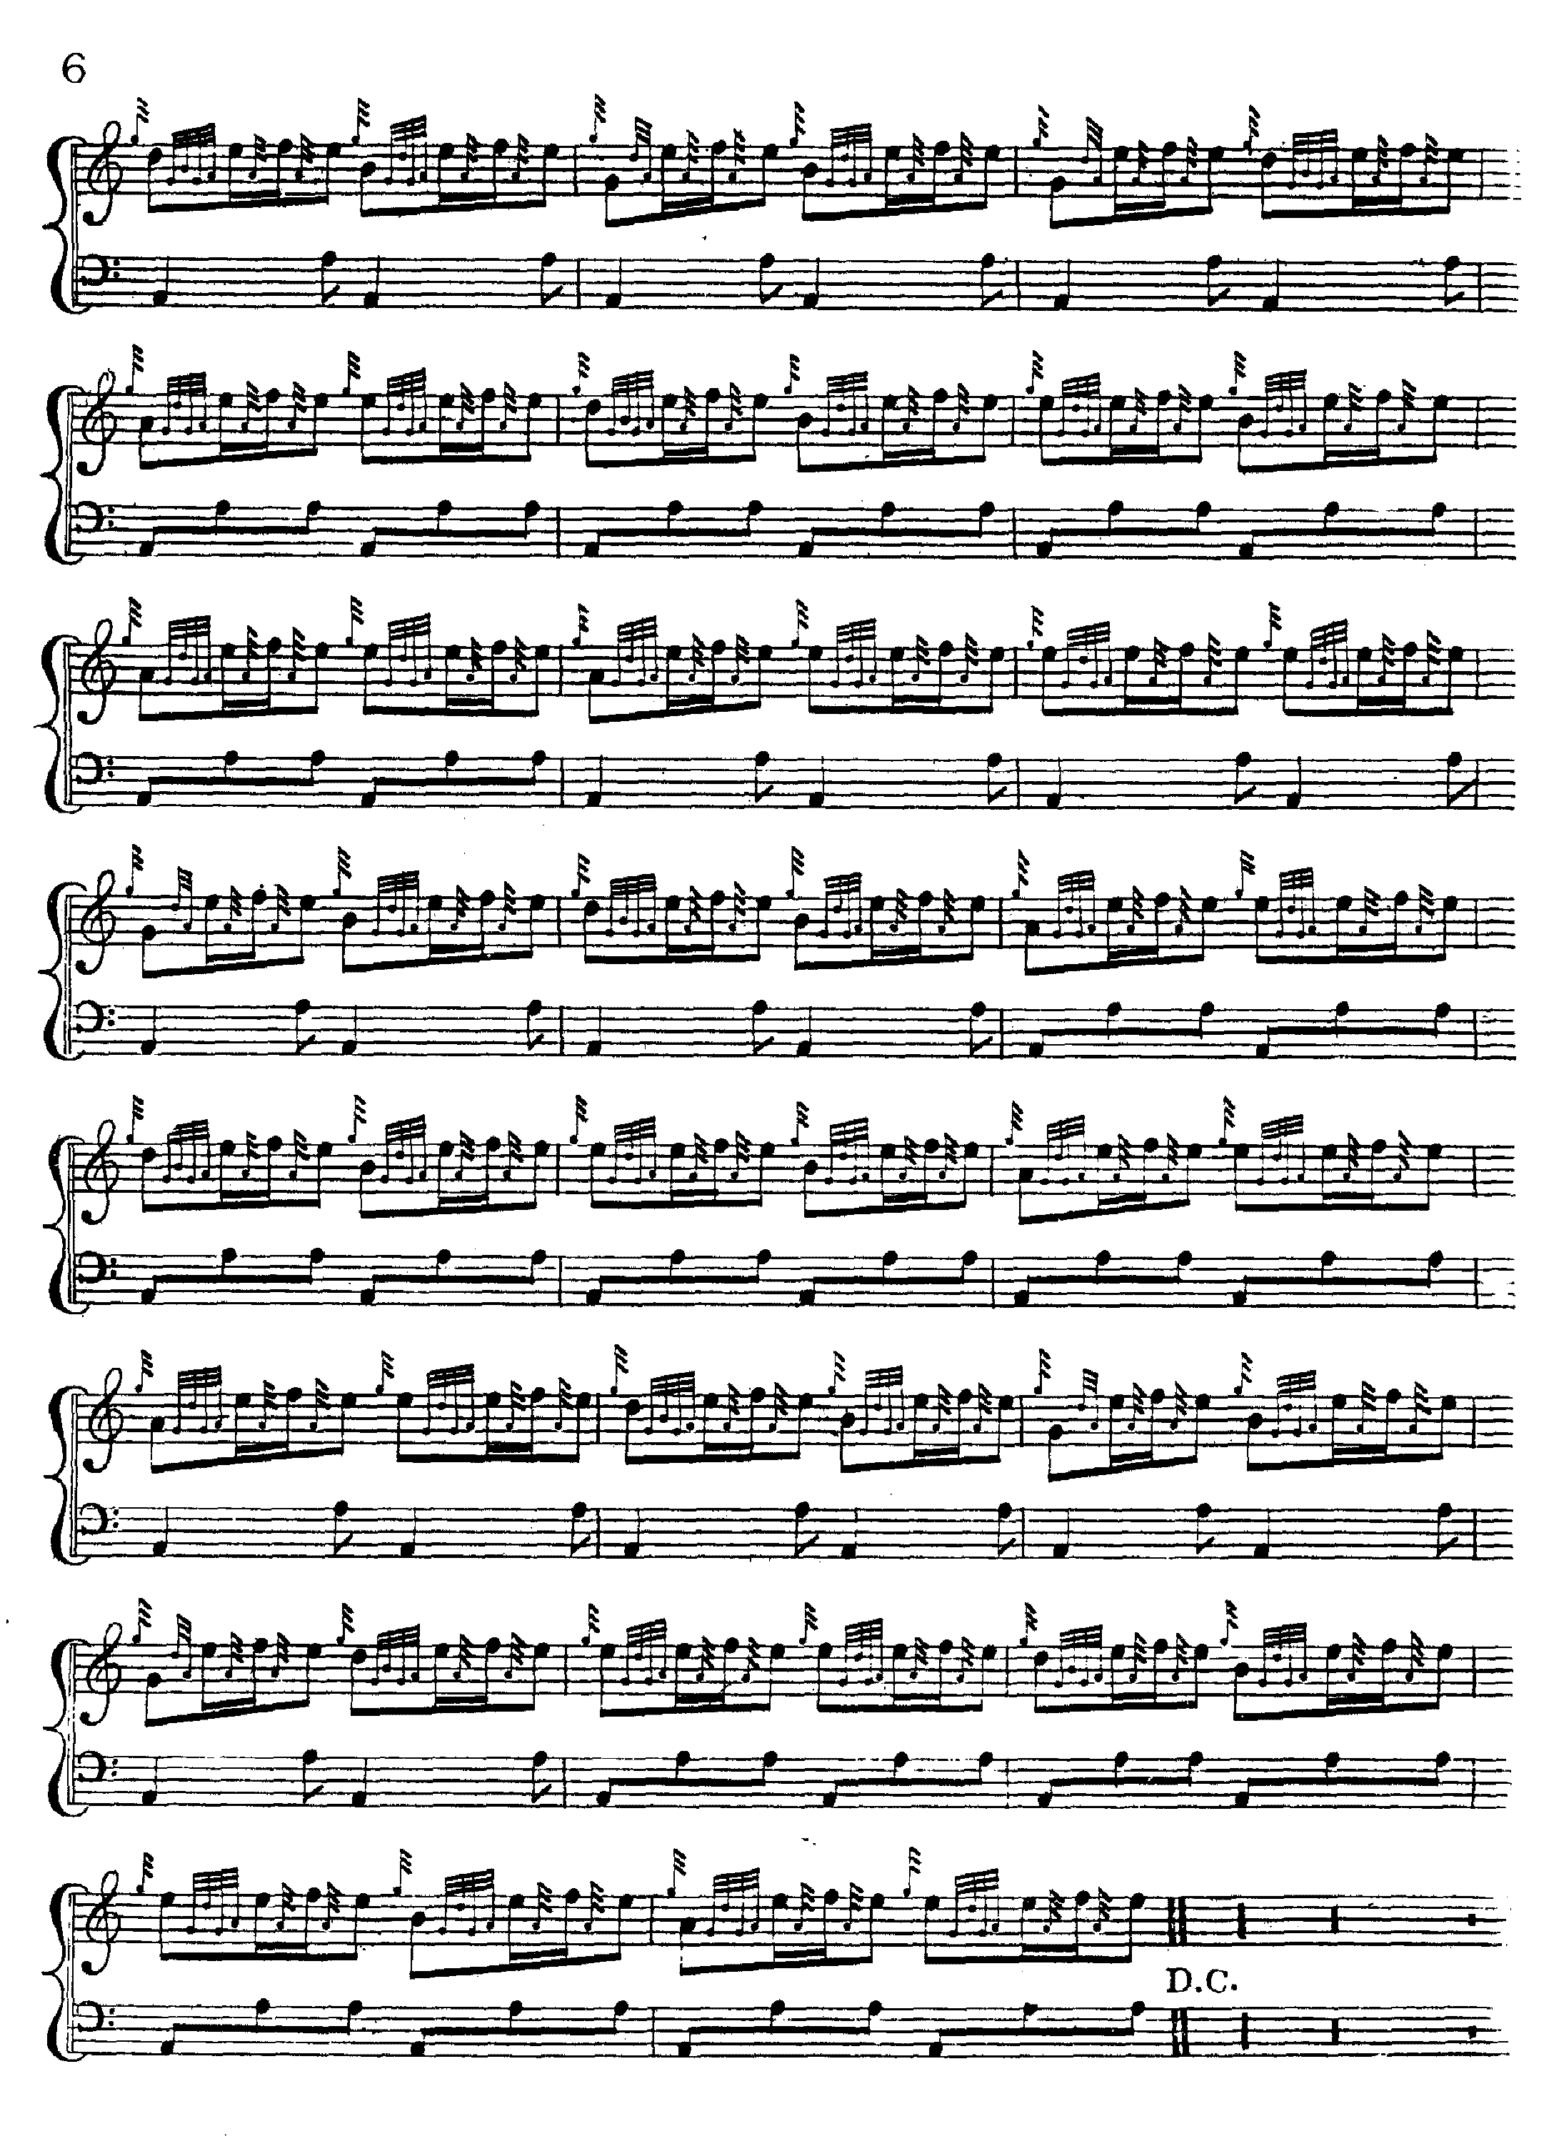
MacDonald develops the tune thus:
Ground
Pendulum movement singling/doubling
Ground
Taorluath singling/doubling
Ground
Crunluath singling/doubling
Ground.

There are a number of features here which attract comment, amongst them the “down” pointing of the pendulum movement, the absence of a crunluath a-mach, and the restatement of the ground on no fewer than four occasions, calling for some subtle variation of the timing to prevent tedium. The reader will note the F gracenote on the cadence at the end of line one in taorluath and crunluath.

Angus MacKay times the tune as follows:

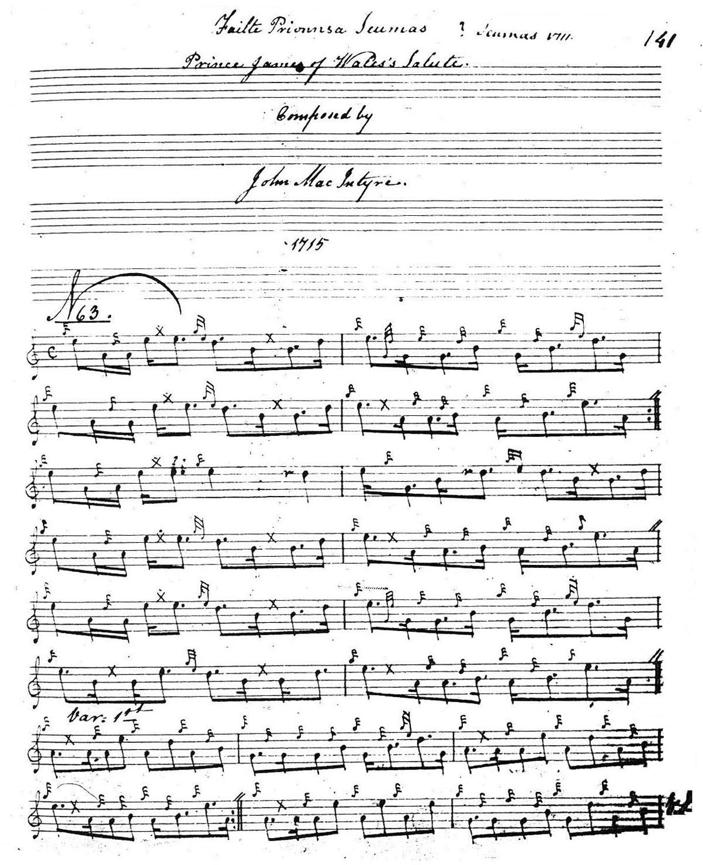
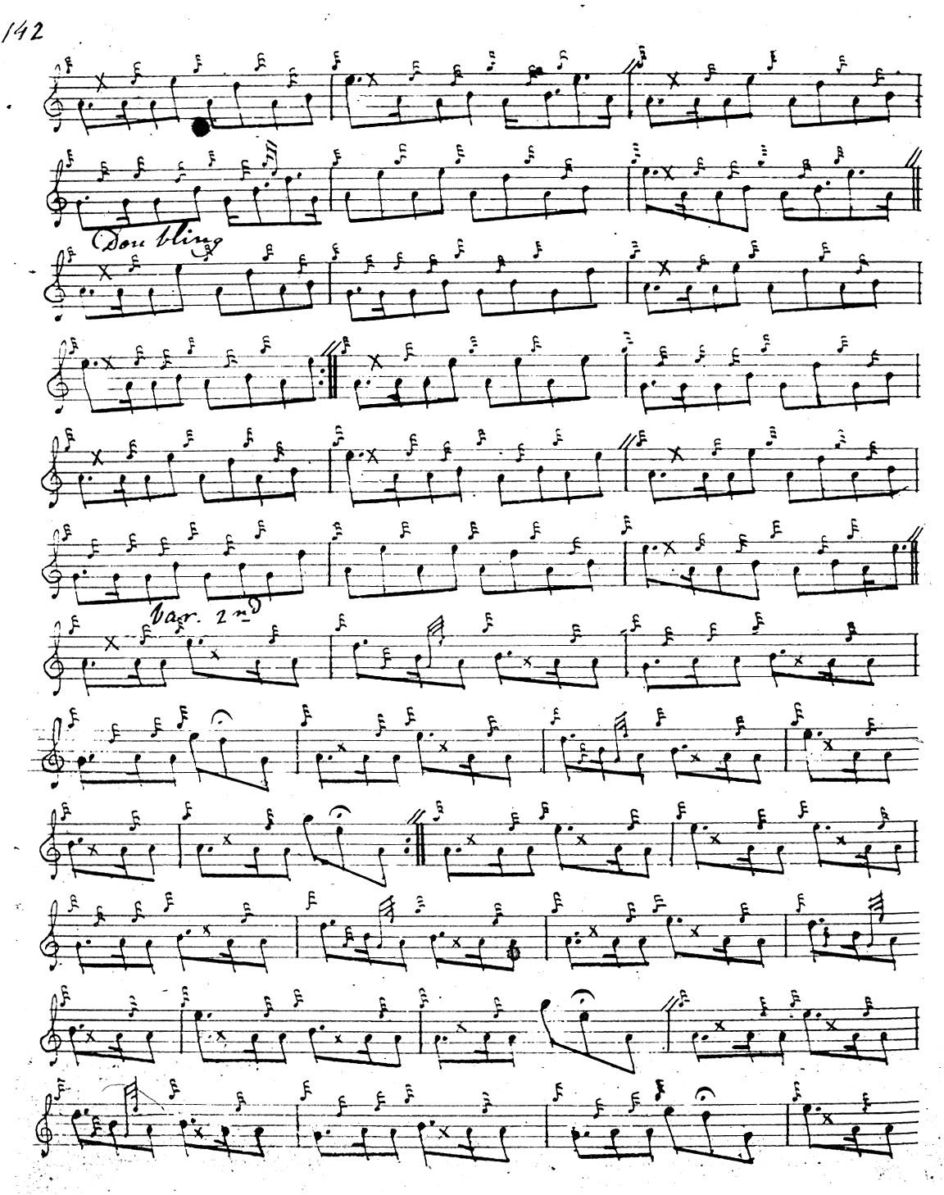
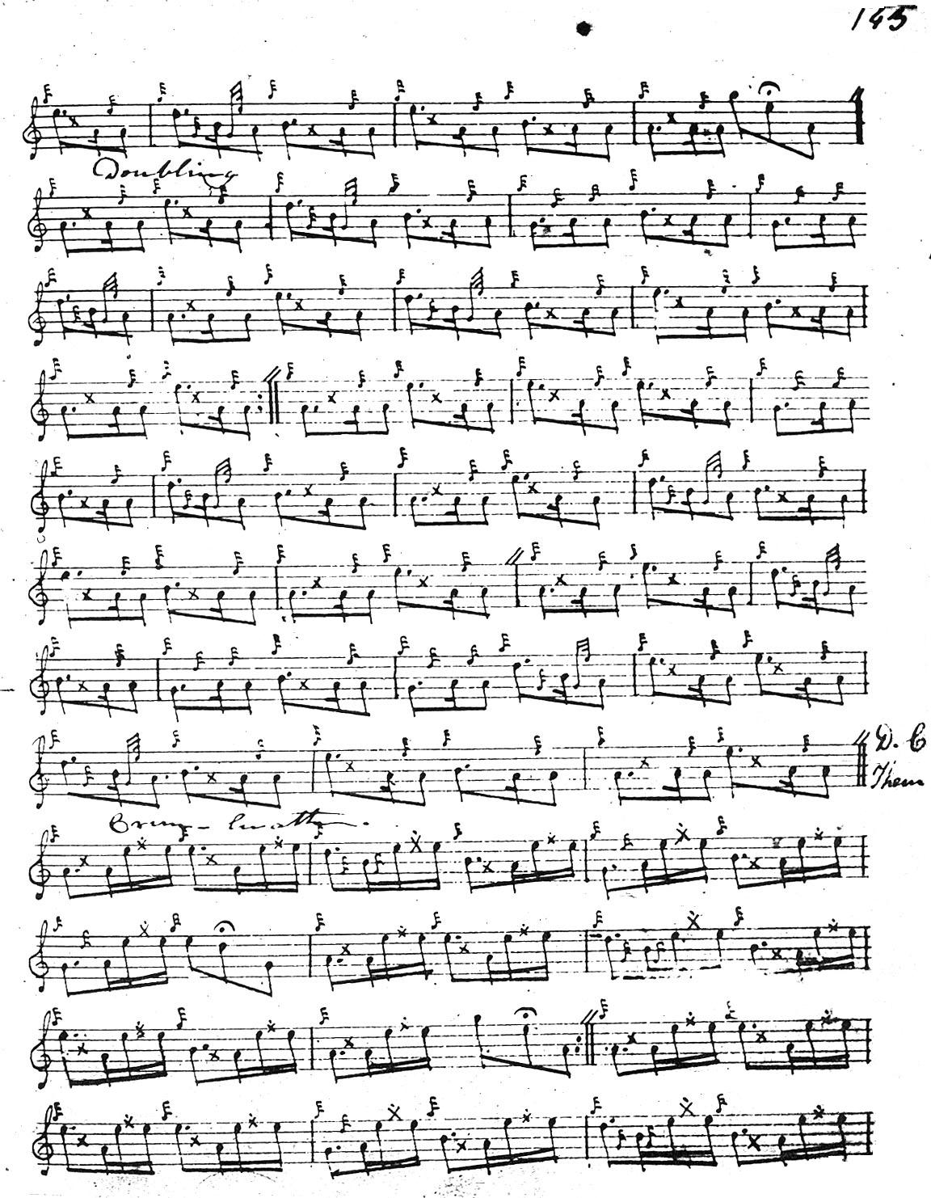
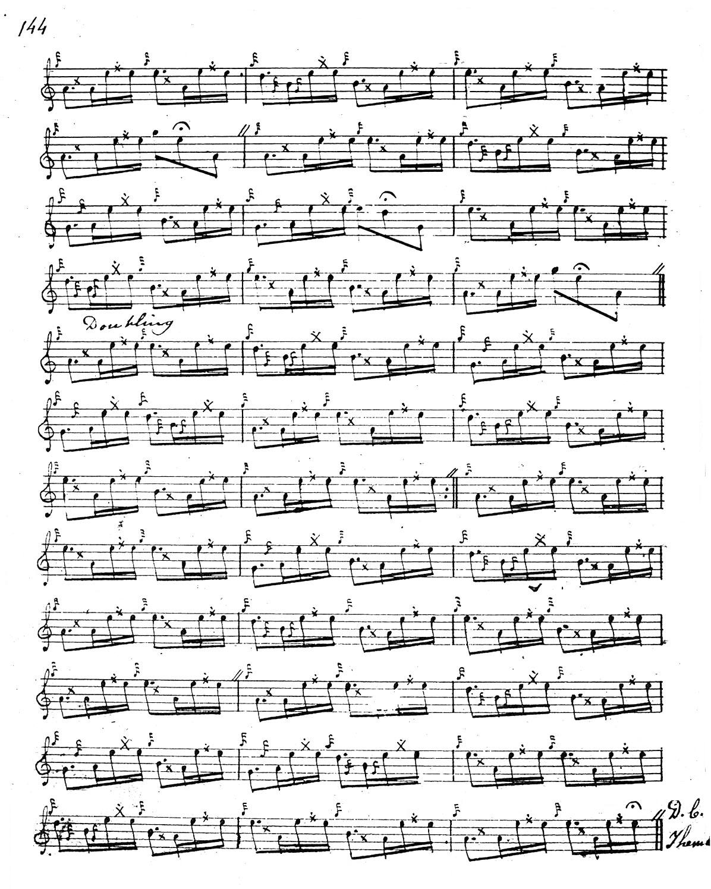

MacKay develops the tune exactly the same way as Donald MacDonald. There are minor differences in timing, but MacDonald’s published score seems obviously one of MacKay’s main sources for this tune.

Donald MacPhee treats the tune in a similar way to MacDonald and MacKay, but has a number of individual touches in timing, and it is in his score that the F cadence on E at the line endings of the singlings (except, interestingly, for the crunluath singling which has a simple G grace note) makes its first appearance:
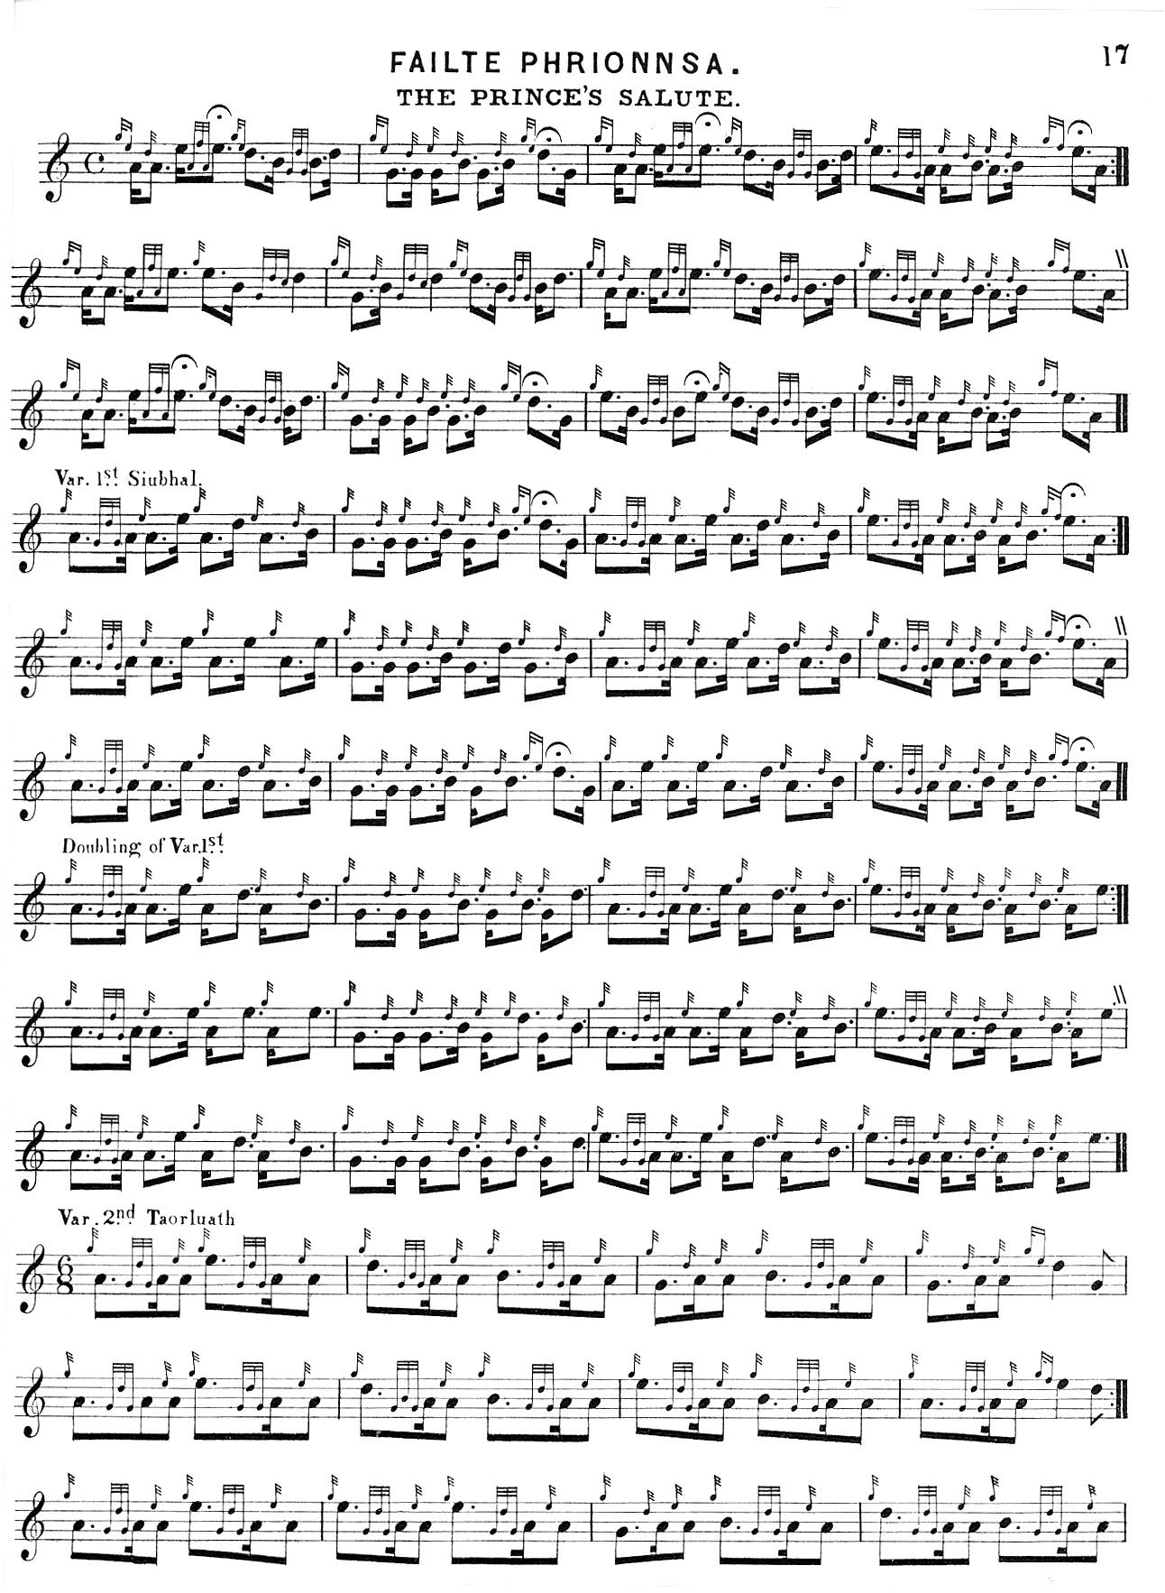
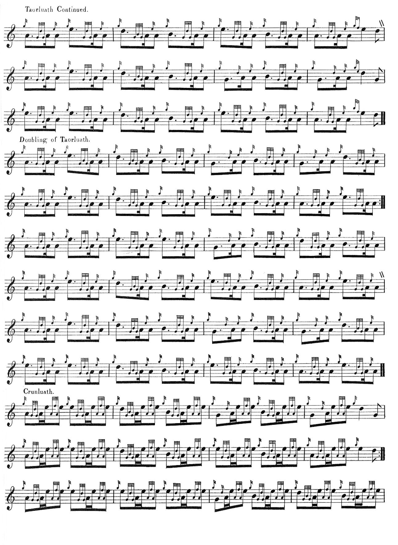
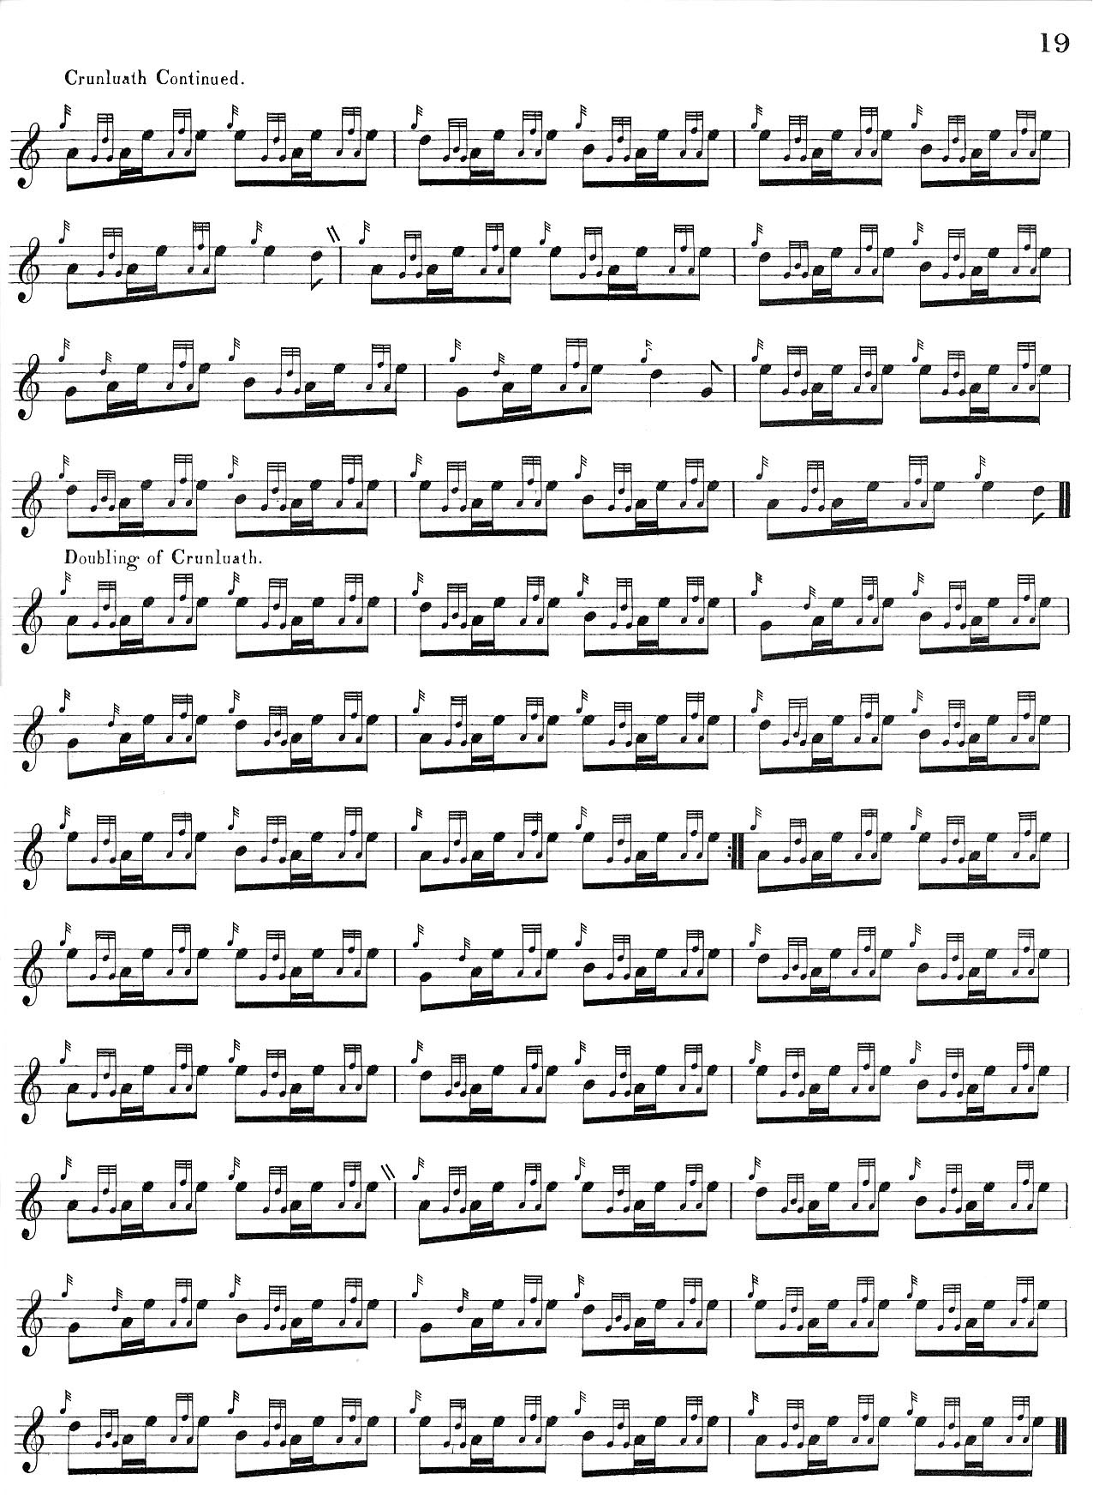

We note that MacPhee times his pendulum movement “up” and does not indicate that the ground should be repeated within or at the end of the tune.

C. S. Thomason’s setting is based on the scores of Donald MacDonald and Angus MacKay; he also acknowledges as sources both Donald MacKay (Angus MacKay’s nephew and pupil of Donald Cameron), and Donald Cameron’s son Keith Cameron. Thomason points the pendulum movement “up” as Donald Cameron did (see below). He does not include Donald MacPhee’s F cadences. Thomason’s setting is as follows:

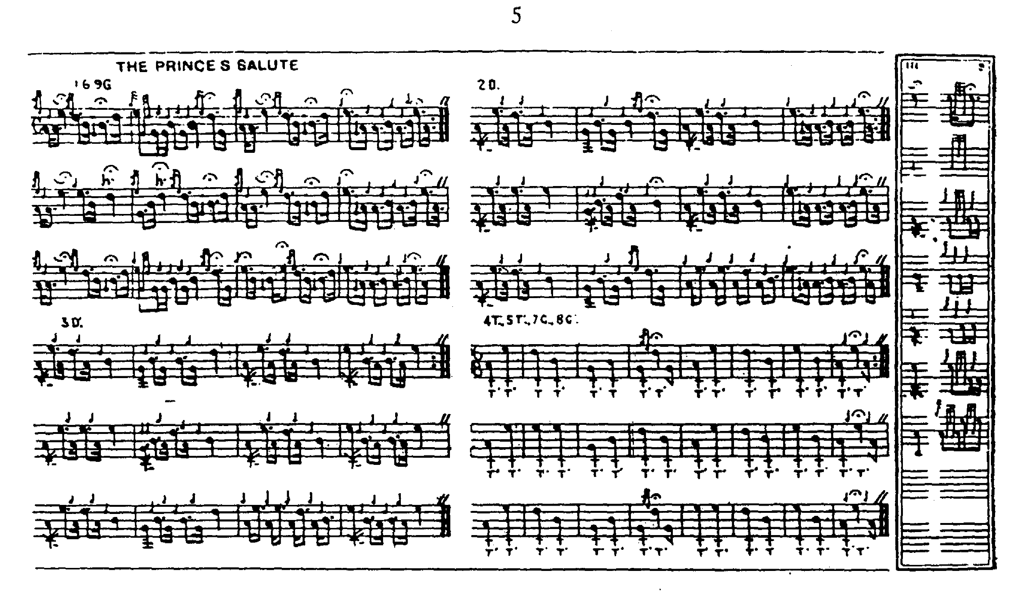

The setting in David Glen’s manuscript is a mere sketch and is not reproduced here. In his published book, Ancient Piobaireachd, Glen follows MacKay with the exception that he times his pendulum movements “up” and includes MacPhee’s F cadences on the Es at the phrase endings. Glen repeats his ground at the end of both taorluath and crunluath doublings. Since this score adds little to the stylistic possibilities of the tune, it is not reproduced here.

William Stewart’s setting in the Piobaireachd Society Collection (first series) is basically a combination of Donald MacPhee and David Glen with occasional slight alterations to the pointing. The following gives an idea of its general style:

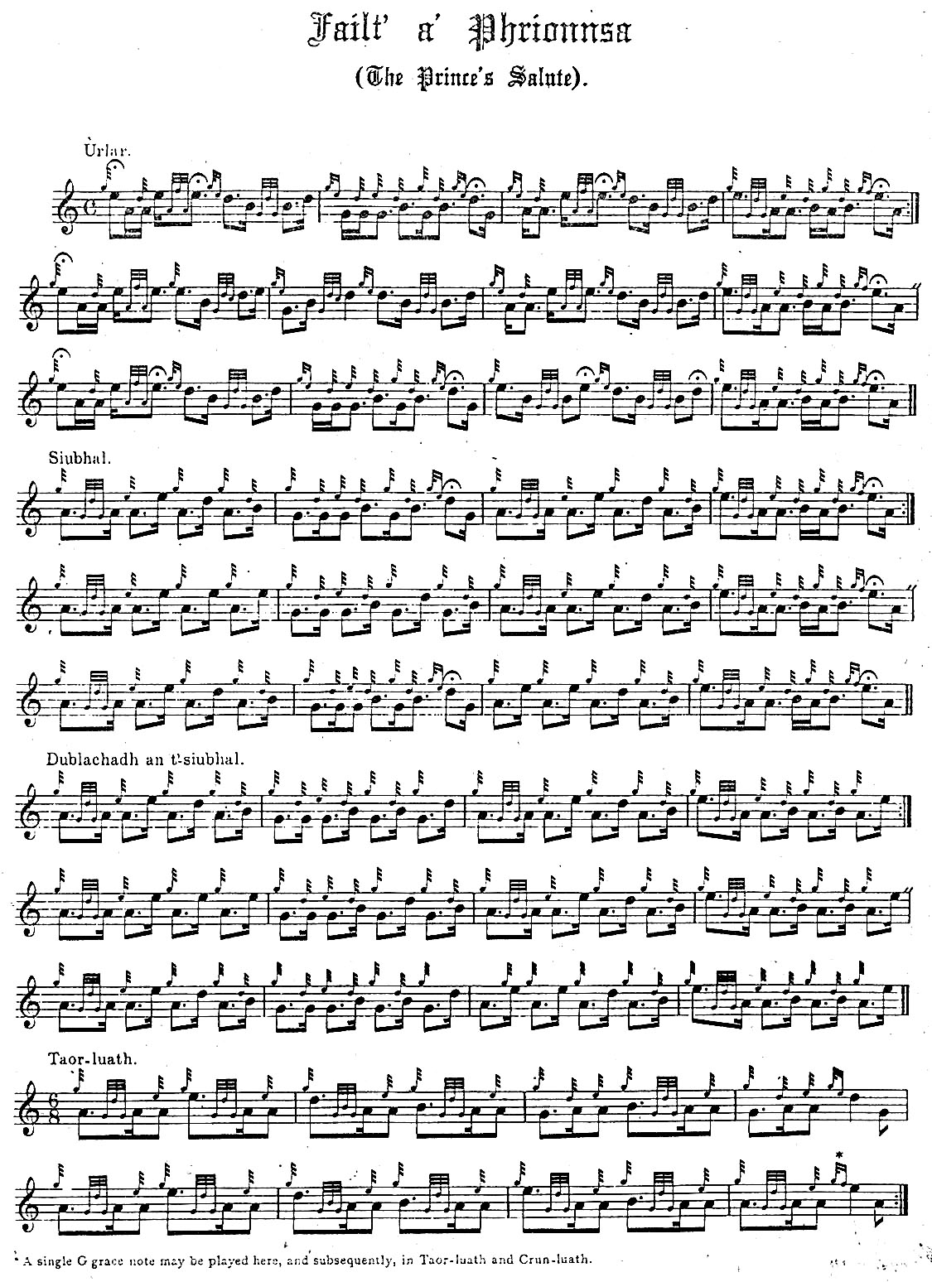

and so on.

Commentary:

This is the tune that Donald Roy MacCrimmon played for the song-collector and editor Alexander Campbell in Glenelg in the autumn of 1815, “in tones that spoke to the ear, and affected the heart;” (Highland Pipe and Scottish Society, p.183). An old competition favourite, it was offered by Angus Ross in the first of the Edinburgh competitions in 1784 and submitted very frequently thereafter in players’ lists during the years of the Edinburgh competitions.

From the point of view of organisation, all the settings of this tune both MS and published, are similar, with a ground, pendulum movement (singling and doubling), taorluath (singling and doubling), crunluath (singling and doubling). Neither MacDonald nor MacKay has a crunluath a-mach, nor does the setting in the Piobaireachd Society Collection (first series, i, 1-3), or the published collections of MacPhee (i, 17-19), or Thomason (Ceol Mor, p.5). Thomason was taught this tune both by Donald MacKay and Keith Cameron and had his final setting confirmed by Colin Cameron (Highland Pipe and Scottish Society 1750-1950, p.298).

MacDonald indicates that the tempo should be “moderate” in the ground and the pointing “round” in the pendulum movement and we see in the accompanying MP3 file what this might mean. The crunluath is marked “very quick”. He directs that the ground be repeated between the pendulum movement and the taorluath singling, and again between the taorluath doubling and crunluath singling and as well, of course, at the very end of the tune, so that it is heard in all four times. This seems consistent with Alexander Campbell’s report on Donald Roy MacCrimmon playing this tune where “the regular return to the subject or theme of the piece, is in fine contrast with the more intricate passages” (Highland Pipe and Scottish Society, p.183).

Angus MacKay’s approach to the tune is very similar in outline. He sets his pendulum movement as even quavers, perhaps indicating that the performer could choose between playing “up” or “down” depending on the context, or perhaps indicating that even quavers was his preferred timing. Bearing in mind that the corresponding movement in MacDonald is marked “round”, the difference may amount to little in practice. The reader will recollect, too, that exaggerated pointing of such movements and the jerky style which resulted was identified as a vice by Lt. John McLennan, who called it “Raoichden an Asail, The Braying of the Ass” (Highland Pipe and Scottish Society, p.303).

MacKay uses an unusual expressed high G quaver to introduce cadences at the end of each line of the taorluath and crunluath singlings, suggesting that he intended it to have distinct time value:
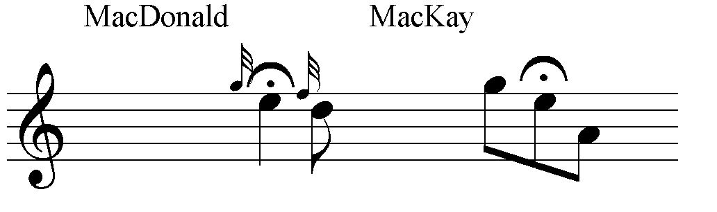

“The Prince’s Salute” prompted discussion when it was published in the first volume of the Piobaireachd Society Collection, first series, (i, 1-3) in 1905. William Stewart pointed the pendulum movement “down”, stating “The ‘Sett’ here given is that played by most of the best pipers of former and present times.” When he wrote in the introductory matter of the second volume in the series that he specifically had the Cameron and MacPherson pipers in mind when he made these remarks, C. S. Thomason wrote to the Oban Times on behalf of Sandy Cameron the younger to protest that this was wrong, that the latter’s father, Donald Cameron, had played this movement “up”, as he, Thomason, himself could testify (Highland Pipe, p.298; Ceol Mor, p.5).

* * *

Electronic text © Dr. William Donaldson, Aberdeen, Scotland, August 2006

