Porst Ullare

There is a single manuscript source for this tune:

**--Colin Campbell**’s “Nether Lorn Canntaireachd”, i, 41-3.

Colin Campbell sets the tune like this:

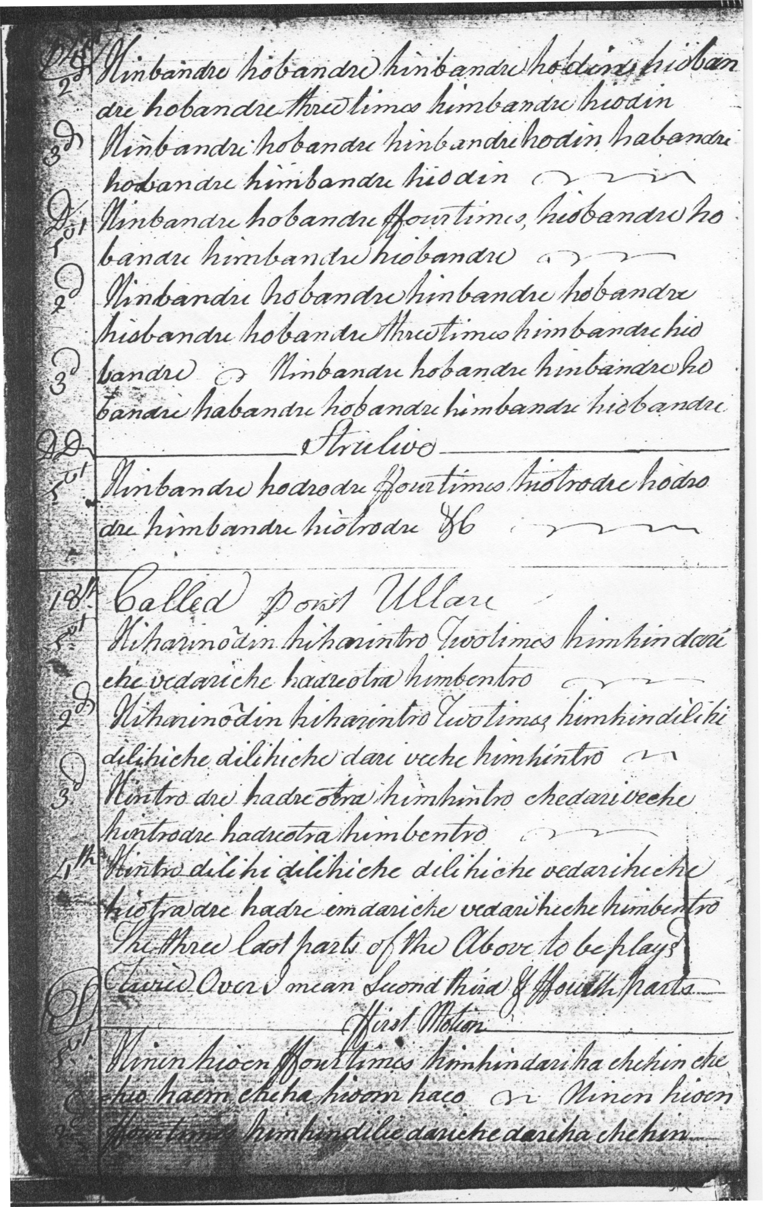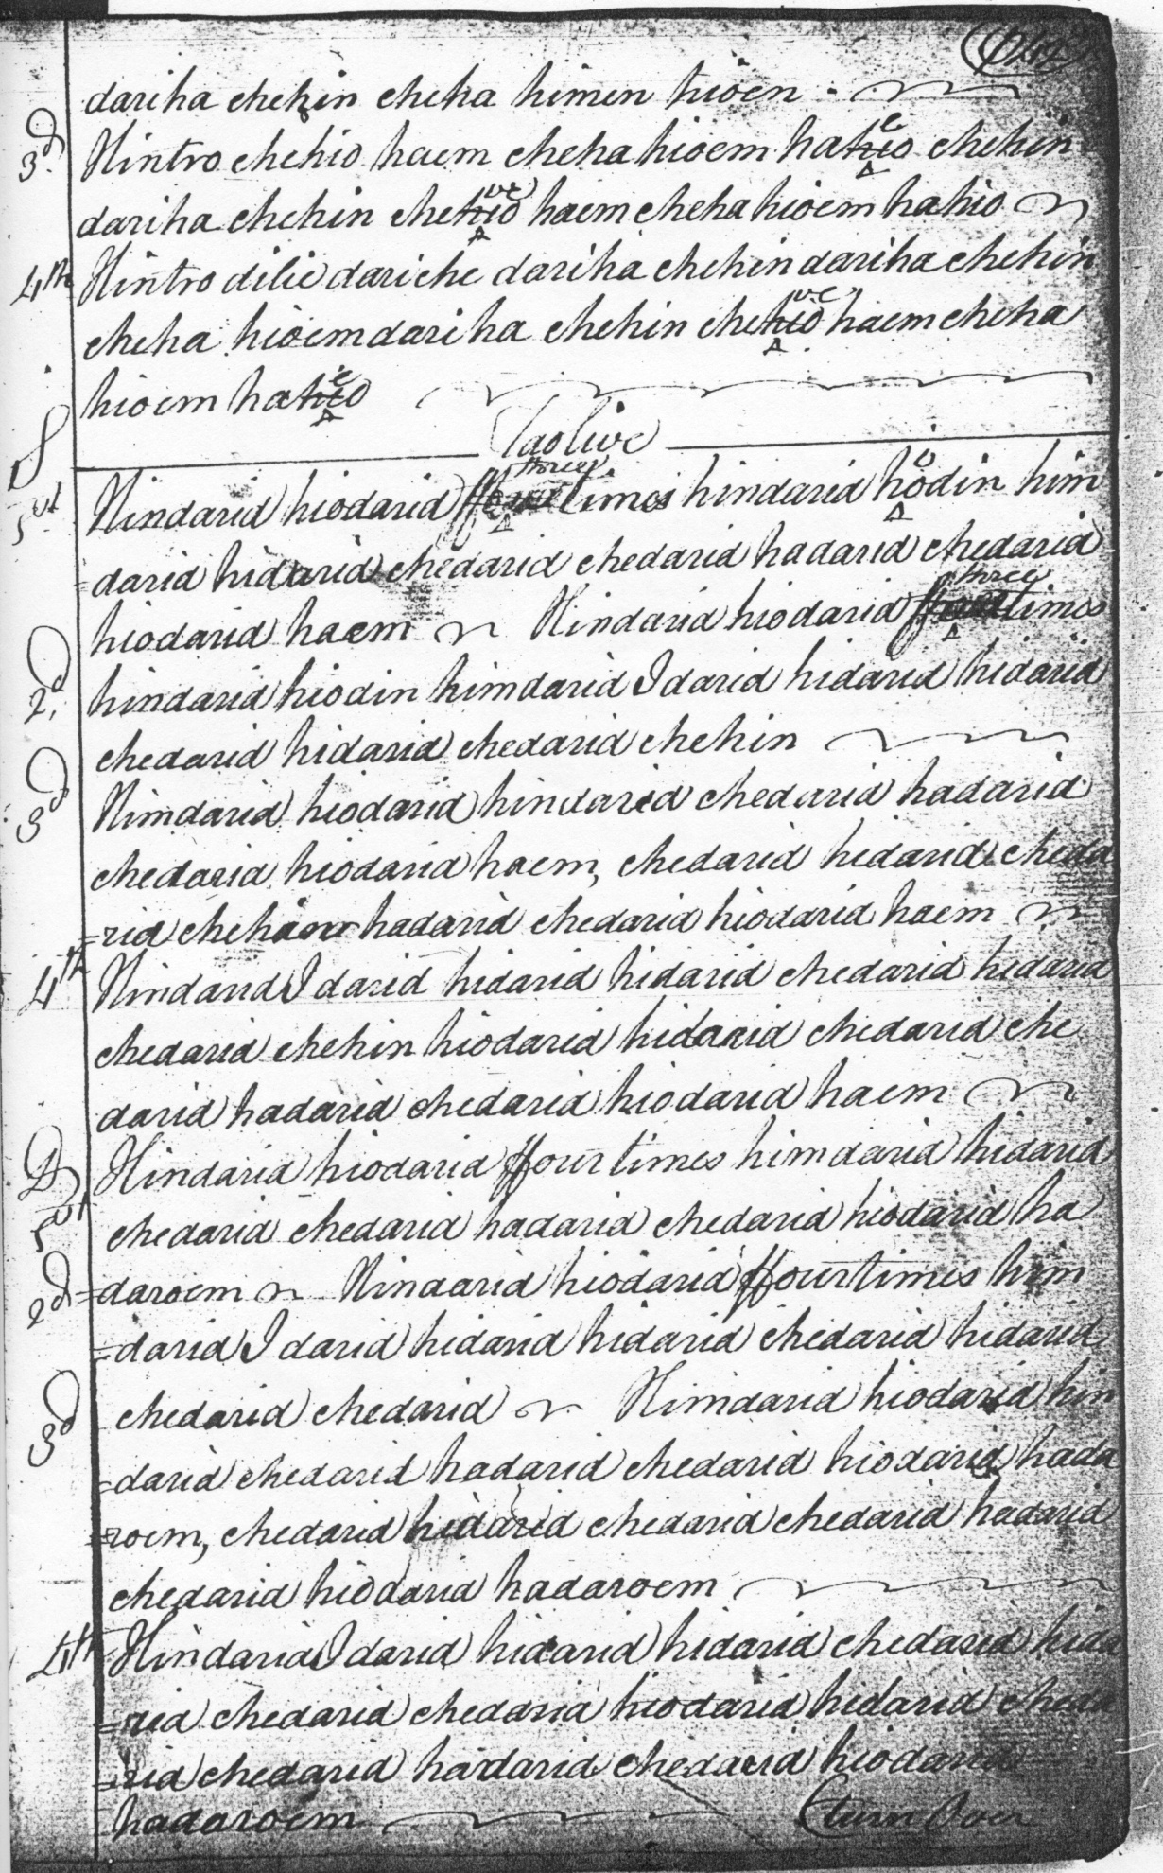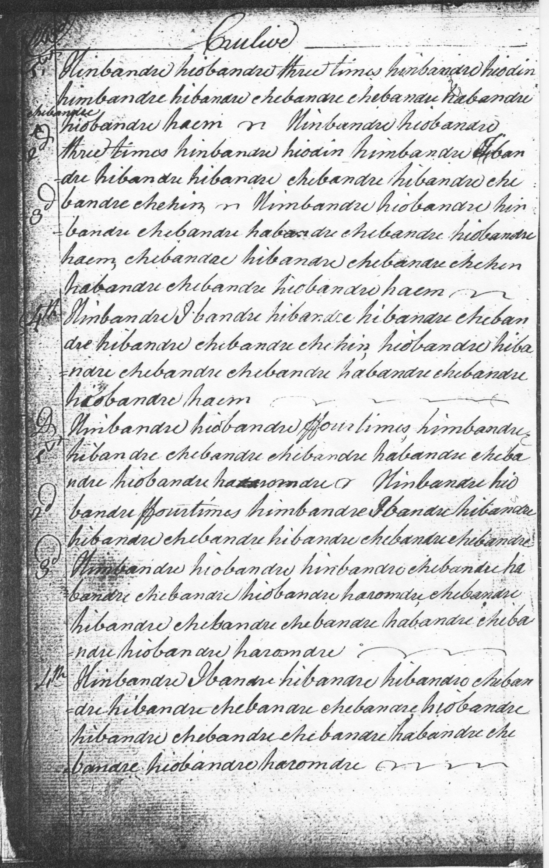

*Commentary*

The Piobaireachd Society published two versions of this tune, one in the first issue of *Piobaireachd Society’s Collection* (Second Series), xii, 387-9, where the tune was set in 4/4 time, and a second version published online in 1986, where the time signature was altered to 3/4 (<http://www.piobaireachd.co.uk/images/stories/PublishedArticles/porturlar2011.pdf--page> since taken down).

The original score might suggest 6/8 as a better option, perhaps along the following lines:

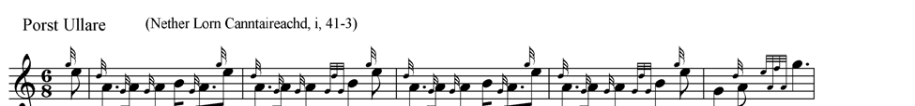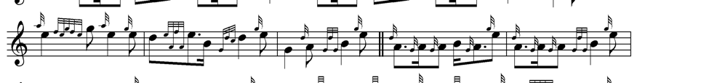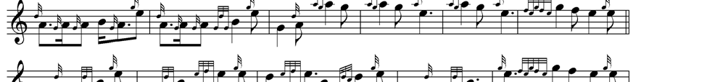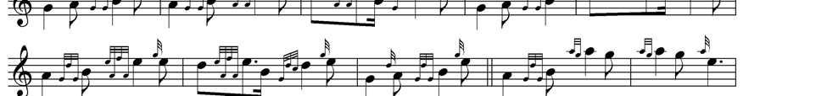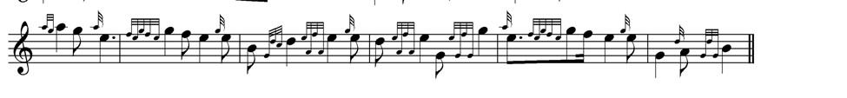

* * *

Electronic text © Dr William Donaldson, Cambridge, Massachusetts, 27 February 2011; revised Cambridge Massachusetts, February 2025