The Battle of the Pass of Crieff
There are published settings of this tune in the following manuscript sources:
--Colin Mór Campbell, “Nether Lorn Canntaireachd”, i, 22-4 (with the title “Bhratich Bhan”);
--Peter Reid’s MS, f.20 (with the title “MacLean of Coll’s”);
--Angus MacKay’s MS, i, 81-82 (with the title “Bior-linn Tighearna Cholla. The Laird of Coll’s Barge”);
--Colin Cameron’s MS, ff.84-5 (with the title “Baiteal Bealloch na’n Cràdh The Battle of Bealloch na’n Cràdh (Pass of Grief)”);
--David Glen’s MS, ff.322-324 (with the titles “The Battle of the Pass of Crieff” and “MacLean of Coll’s War Galley”);
--Robert Meldrum’s MS, ff.61-64 (who also gives two titles, the same as David Glen’s);

and in the following published sources:
--William Ross, Collection, pp.75-7;
--C. S. Thomason, Ceol Mor, p. 255.

Angus MacKay sets the tune as follows:
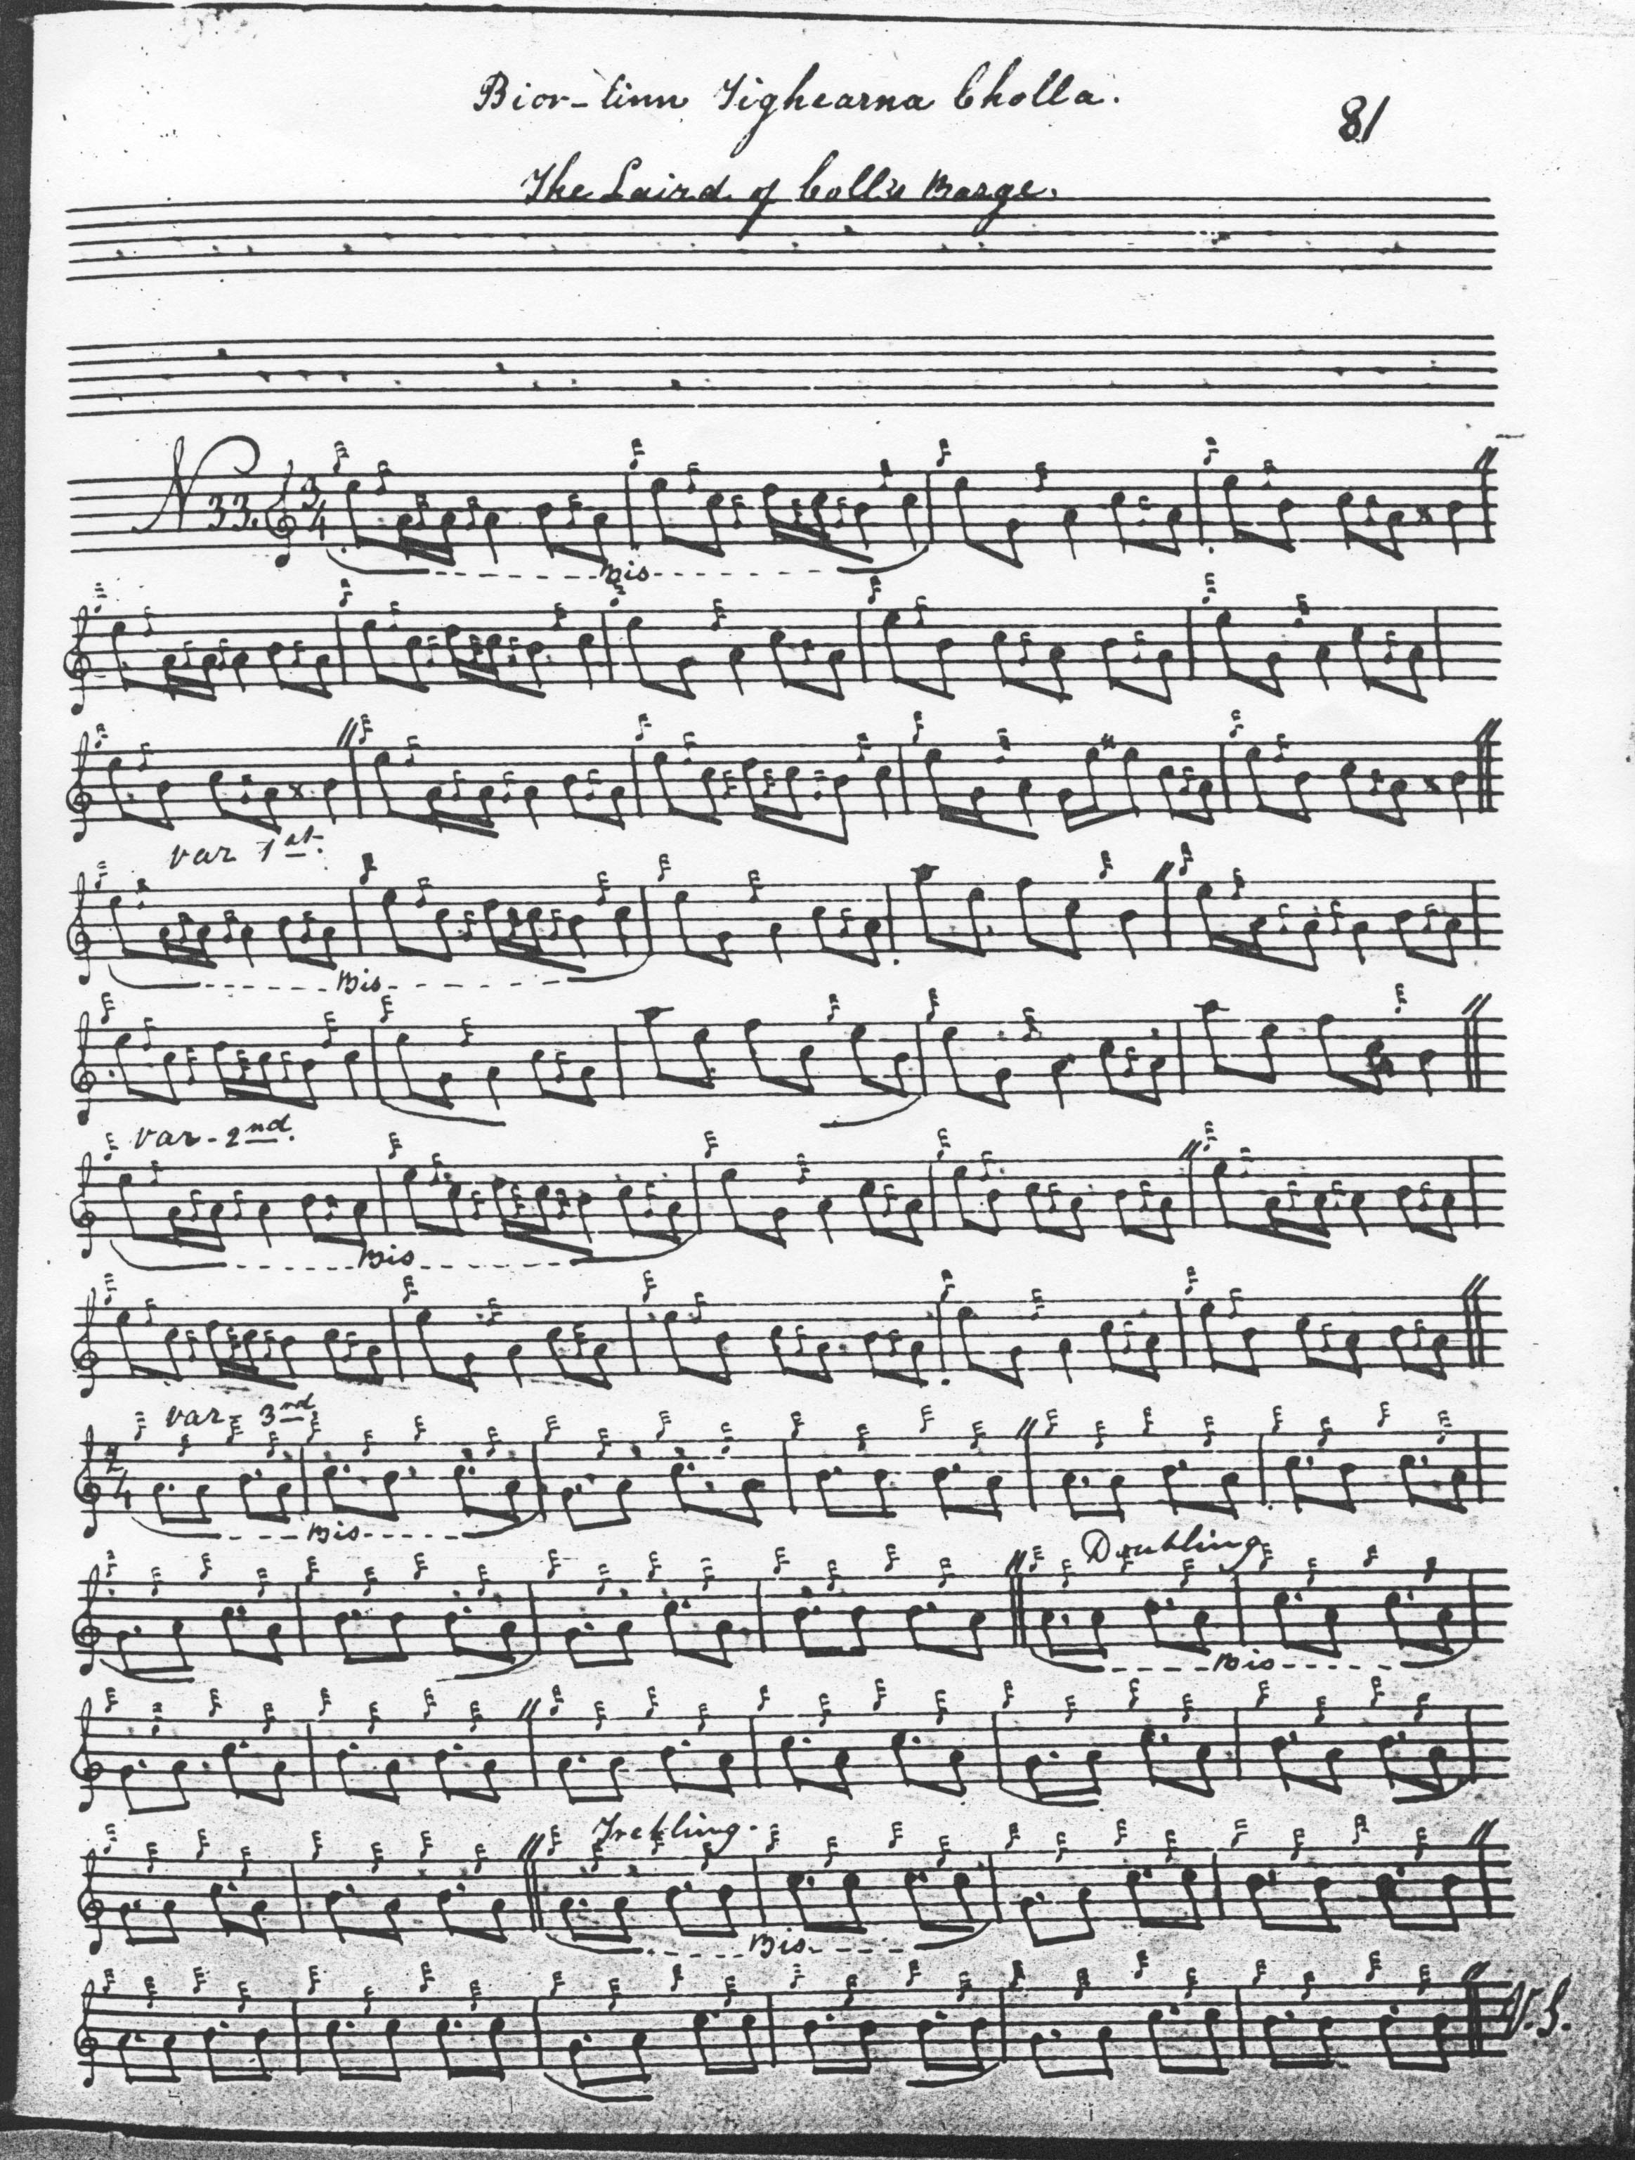

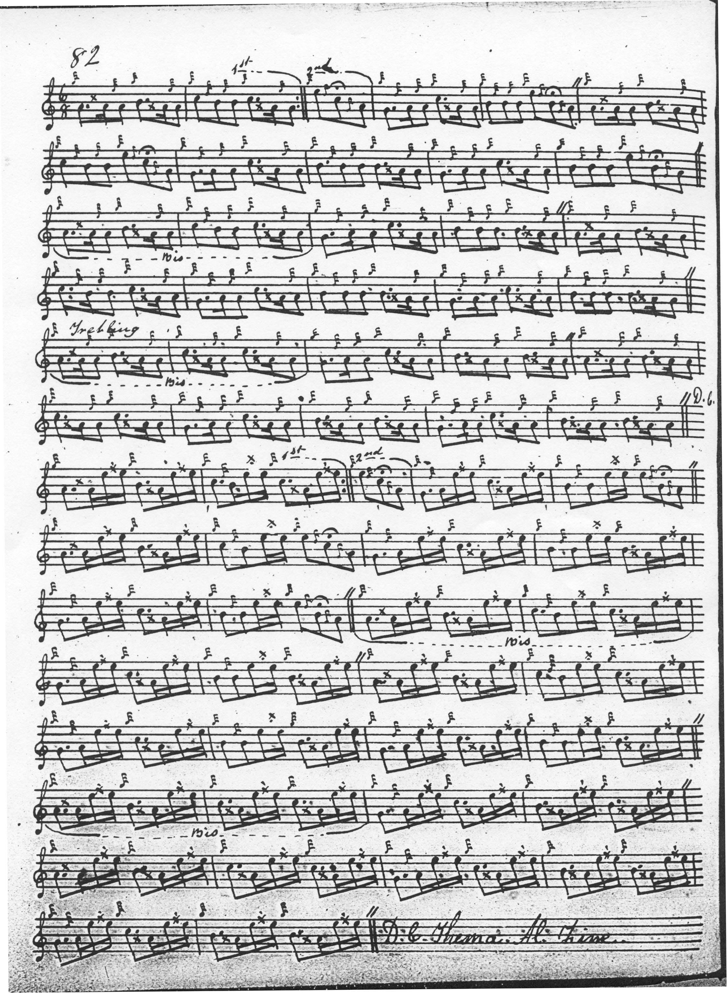

Peter Reid sets the tune as follows:

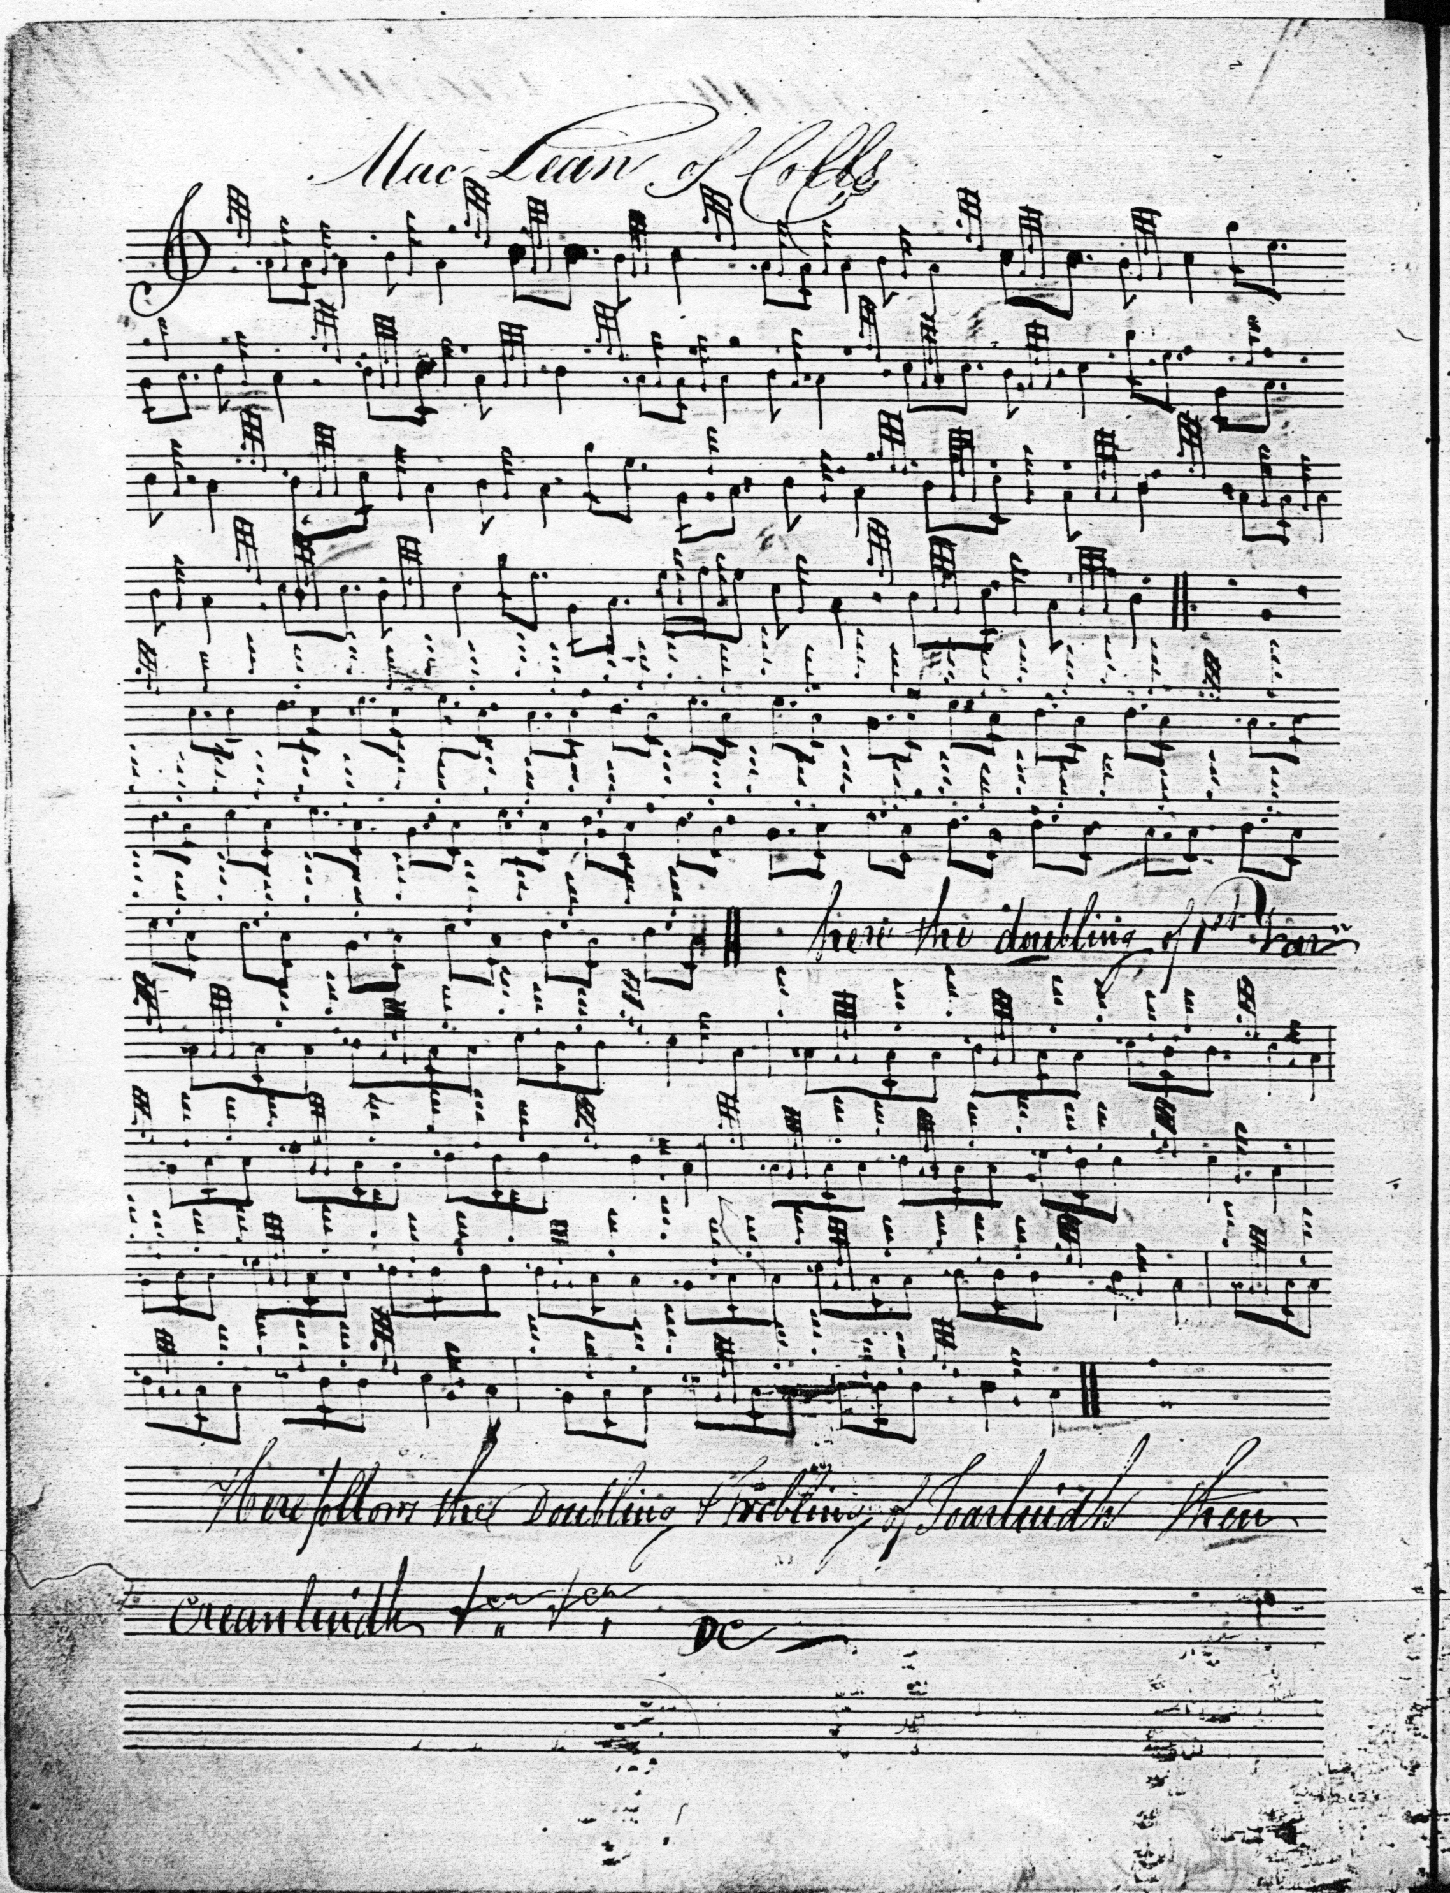
Many may feel that the most attractive setting of the tune is that given in Uilleam Ross’s Collection as follows:

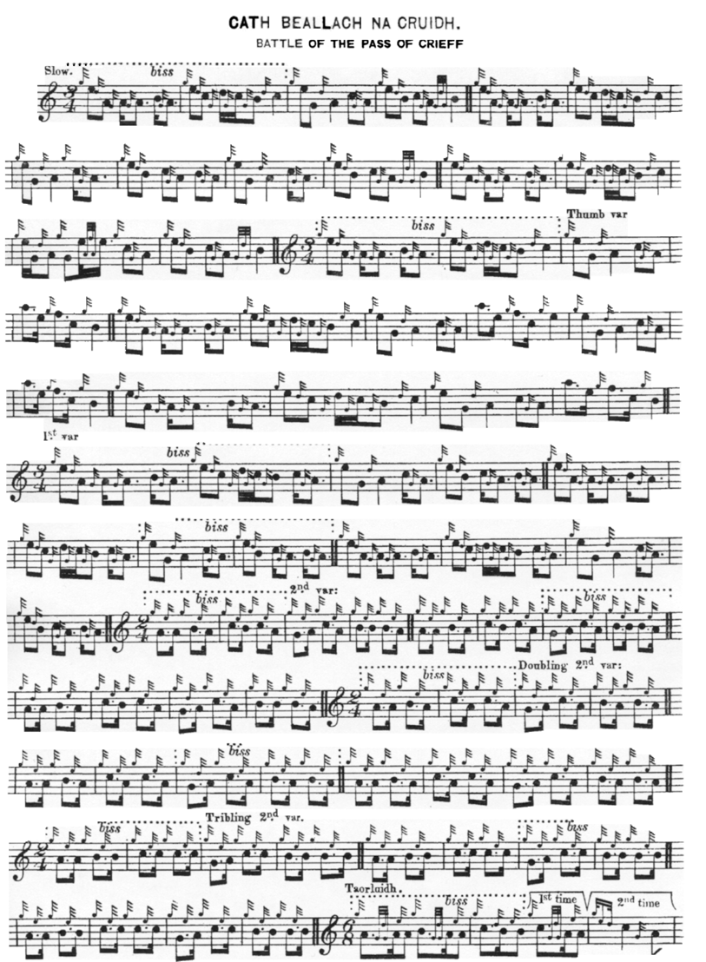
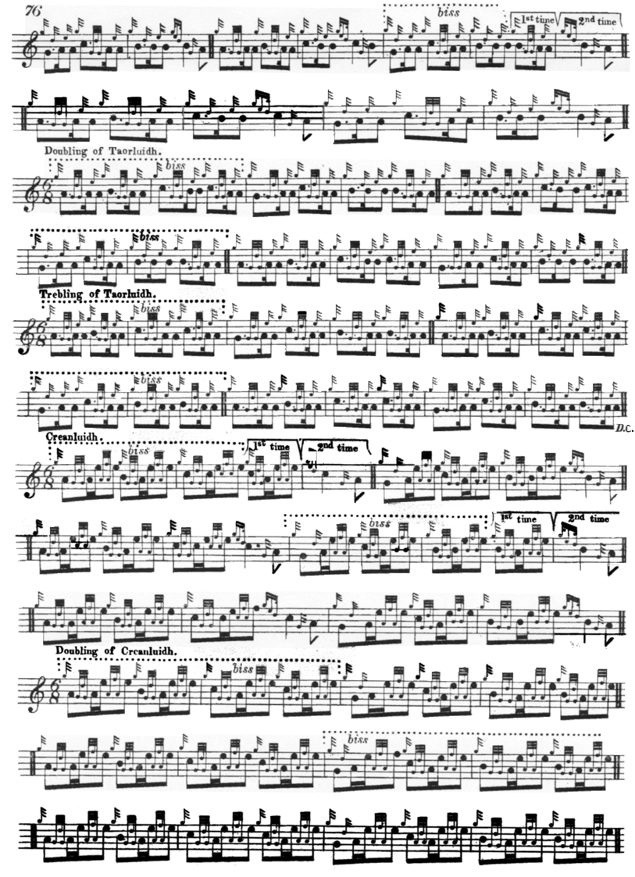
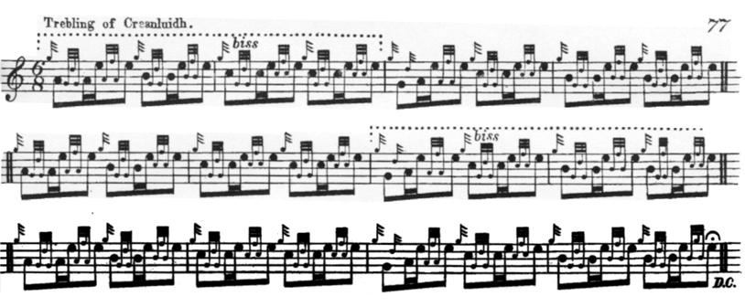
Commentary
In many ways this tune typifies the irresponsible and inaccurate editing which make the Piobaireachd Society scores such a barrier to a proper understanding of the music. The editorial notes say “Angus MacKay’s setting has been adopted for the text” (PS, i, 17), but MacKay’s title is discarded without explanation and his note values suffer frequent silent alteration. Archibald Campbell jettisoned the 3/4 time selected for volume one of the Society’s second series in favour of quadruple time for the ground in his arrangement in the Kilberry Book; most of the other editors opt for 3/4 and 6/8.
The “Pass of Crieff” title has also created problems. As we see above, Colin Cameron calls it “The Pass of Grief”, reading “Cràdh” literally as “pain/anguish/torment”. When the Piobaireachd Society first adopted the title in its first series, later abandoned, Lt. John McLennan, G. McLennan’s father and teacher, wrote to the Oban Times: “We have this year ‘Battle of the Pass of Crieff/ for competition, and after a searching enquiry, I find there is not a ‘Pass’ within twenty miles of Crieff. I have read seven books on Perth and Perthshire, including two large volumes by the Marchioness of Tullibardine on the ‘War of Perthshire’ and failed to find any trace of it”. (“The Piobaireachd Society's Music”, 02/04/1921, p.3. McLennan is referring to A Military History of Perthshire 1660-1902, 2 vols. Perth 1908, which was edited by the Marchioness Kitty, who composed the classic 6/8 march “The Scottish Horse” and later became famous as the “Red Duchess” of Atholl. It was she who gifted Duncan Campbell of Foss’s “Skinner Manuscript” to the National Library of Scotland, indexed by her sister-in-law, Lady Dorothea Stewart-Murray). Interestingly, Robert Meldrum also notes in his manuscript,”There is no such a place as the Pass of Crief”’ (National Library of Scotland, Acc.11151, f.61).
There is, however, a Pass of Creach, Bealach nan Creach, which lies in Kildonan, in Sutherland. The minister of the parish, the Rev. Alexander Sage gives an account of it in the Old Statistical Account of Scotland (1791-99):
Towards the north-west, in the height of the parish...there is a place called Bealach-nan-Creach...The hill road, called Bealach-nan-Creach, on the west side of Bein Mhadugh, signifies the Pass or Streight of Spoils, depredation, or booty. During the establishment of the feudal system, when the McKays were proprietors of Strathnaver, in the parish of Farr, great numbers of cattle were carried away from the Highlands of Sutherland, on this side of the county, through this pass, from which it derived its name. Such depredations were not considered as acts of spuilzie or theft, but the effects of bravery and reprizals. Near the foot of Bein Ghrim-mor, and not far from the Bealach, there is an extensive green field, (now used as a shieling), called Inis Chomhraig, or the Field of Contests; where there are many small hillocks, covered with moss and heath; and also a larger cairn, called Carn-an-Teichigh, the Cairn of Retreat. In this place, it is supposed, the people of Sutherland engaged with the McKays, to get their cattle brought out of their hands, before they had time to cross the Bealach, and could get them landed on the Strathnaver side, where, to risk an engagement, would have been attended with greater danger. (pp.407-8).
This piece is a member of a wider “tune family”. It has different names and a clear cognate link with “MacKay’s White Banner” (for which see “The MacKay’s Banner” elsewhere on this site).
***
Electronic text © Dr. William Donaldson, Aberdeen, Scotland, November 2002; revised Cambridge, Massachusetts February 2025

