The Park Piobaireachd (no. 2)

There are settings of this tune in the following manuscript sources:
--Donald MacDonald’s MS, ff.268-270;
--Angus MacKay’s MS, ii, 56-8;

and in the following published source:
--C. S. Thomason, Ceol Mor, p. 386.

Only two manuscripts appear to have this particular variant of the Park Piobaireachd, namely those of Donald MacDonald, where the tune has no title, and Angus MacKay. Since the same bar (no.19) is missing in the ground in both MacDonald and MacKay, it seems likely that the former was the source for the latter text. Both versions assume regular 32 bar form at some point in the variations. The development of the tune is the same in each case up to the end of the taorluath doubling: at this point the score stops in MacDonald, while MacKay proceeds to a crunluath singling and doubling.

Donald MacDonald treats the tune as follows:

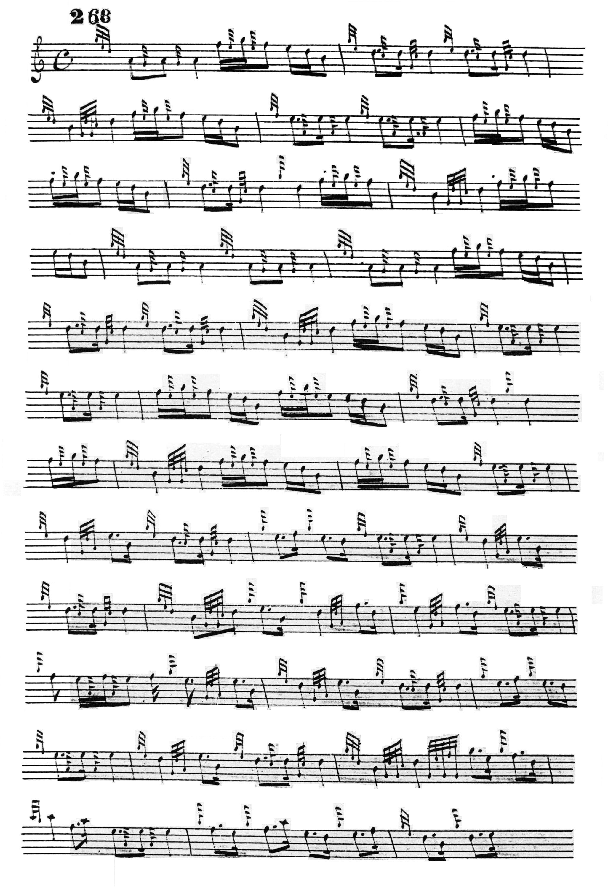
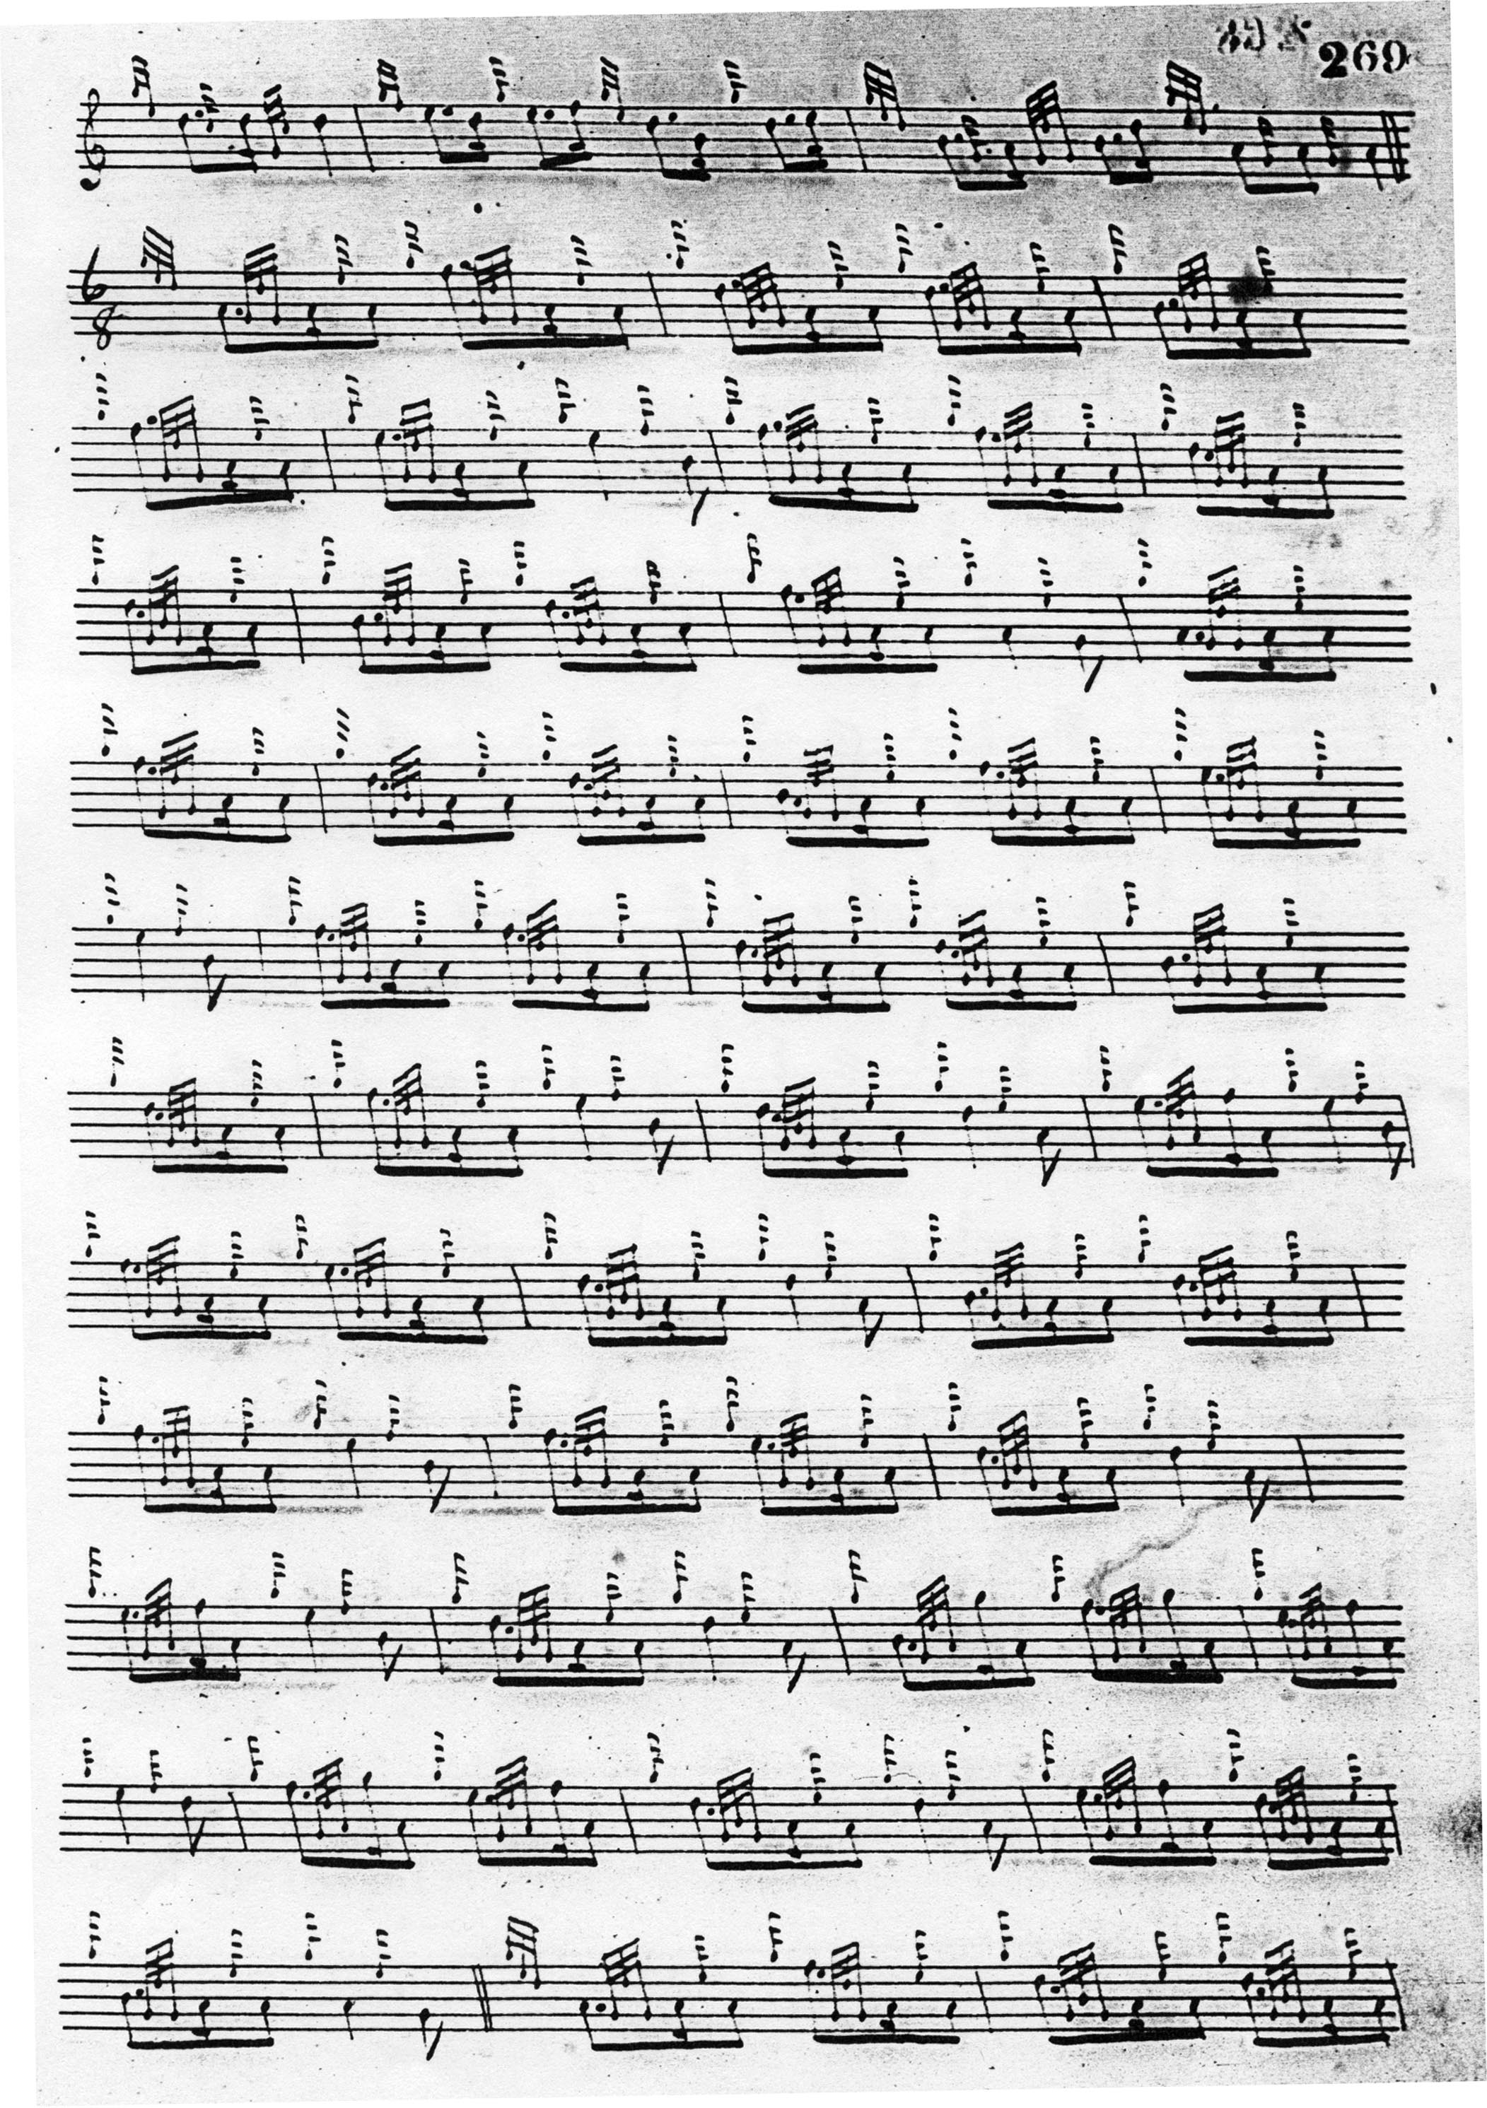
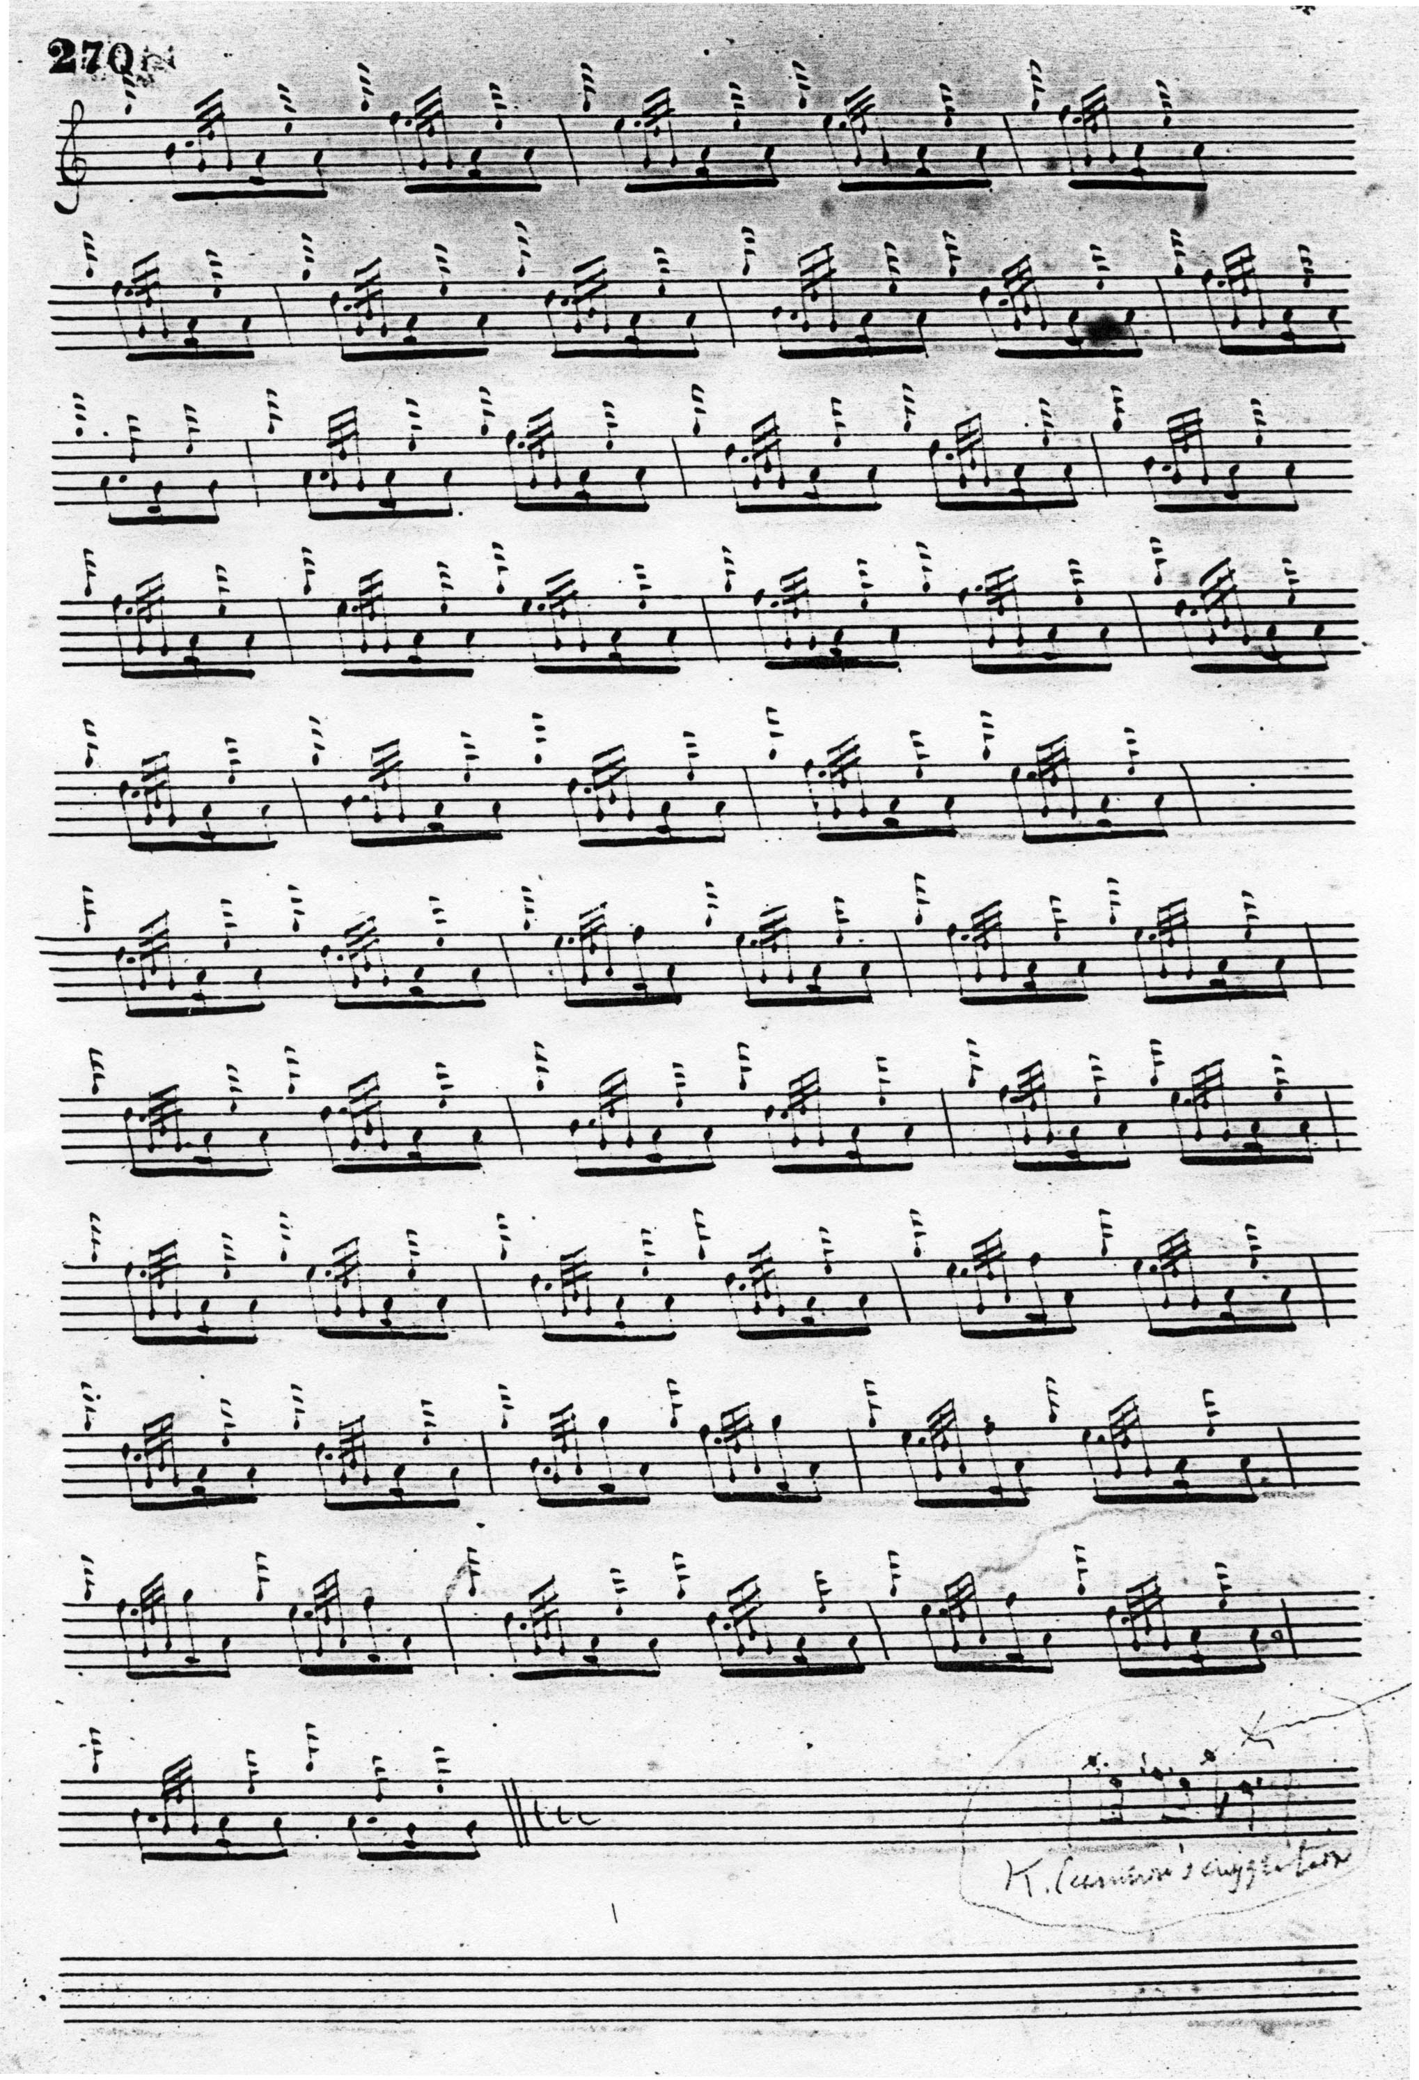

MacDonald’s setting contains numerous interesting expressive details including timing of the eallach and other echo beats, throws of varied weight on D, and the little G/F cadences down on to E, very characteristic of his style. The note “K. Cameron’s suggestion” was probably inserted by General Thomason. The setting would not be considered “regular” from a modern point of view. MacDonald does not settle into a thirty-two bar pattern until the taorluath doubling which is the last movement he records.

Angus MacKay set the tune as follows:

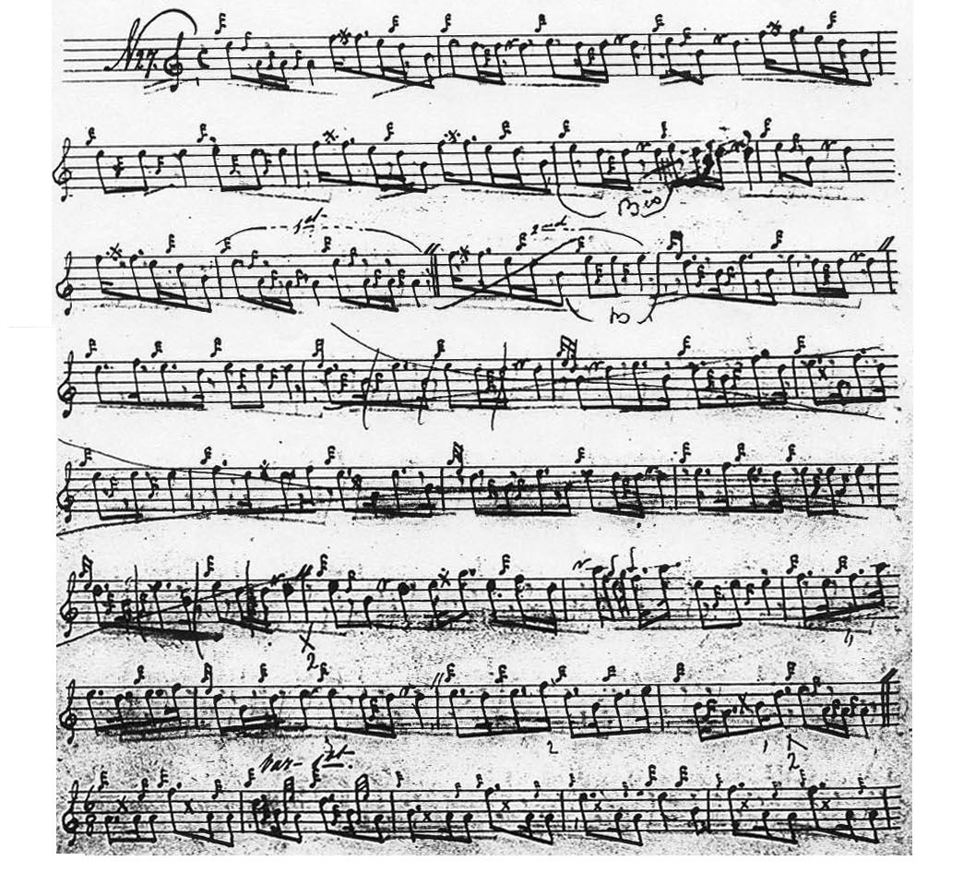

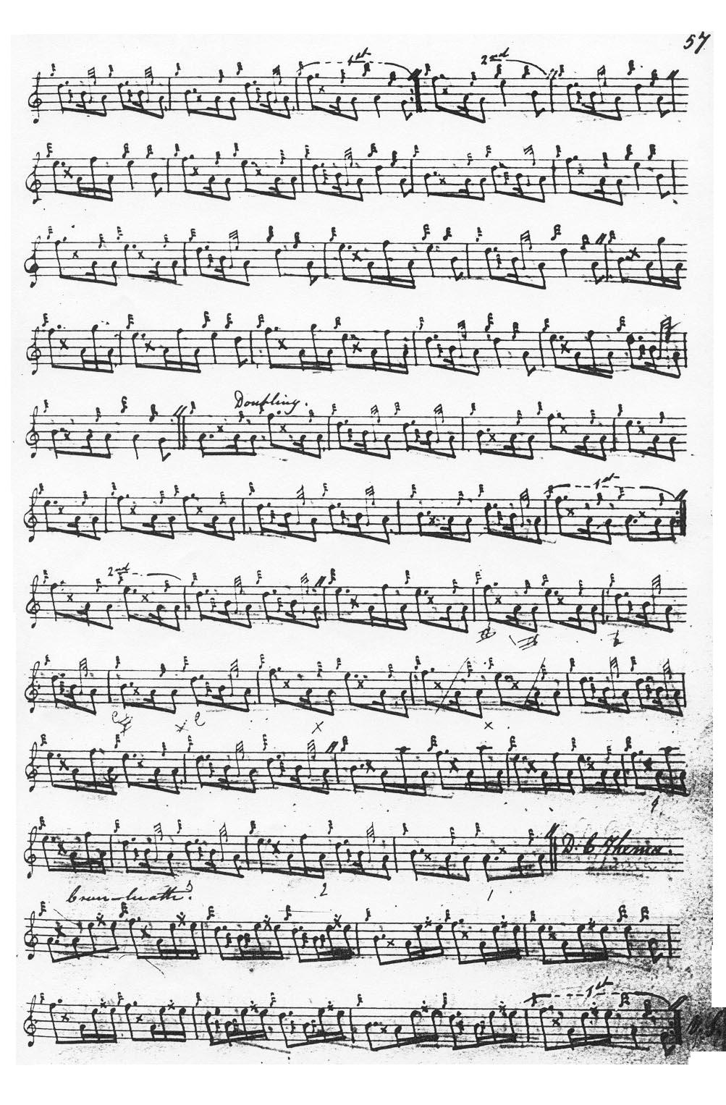
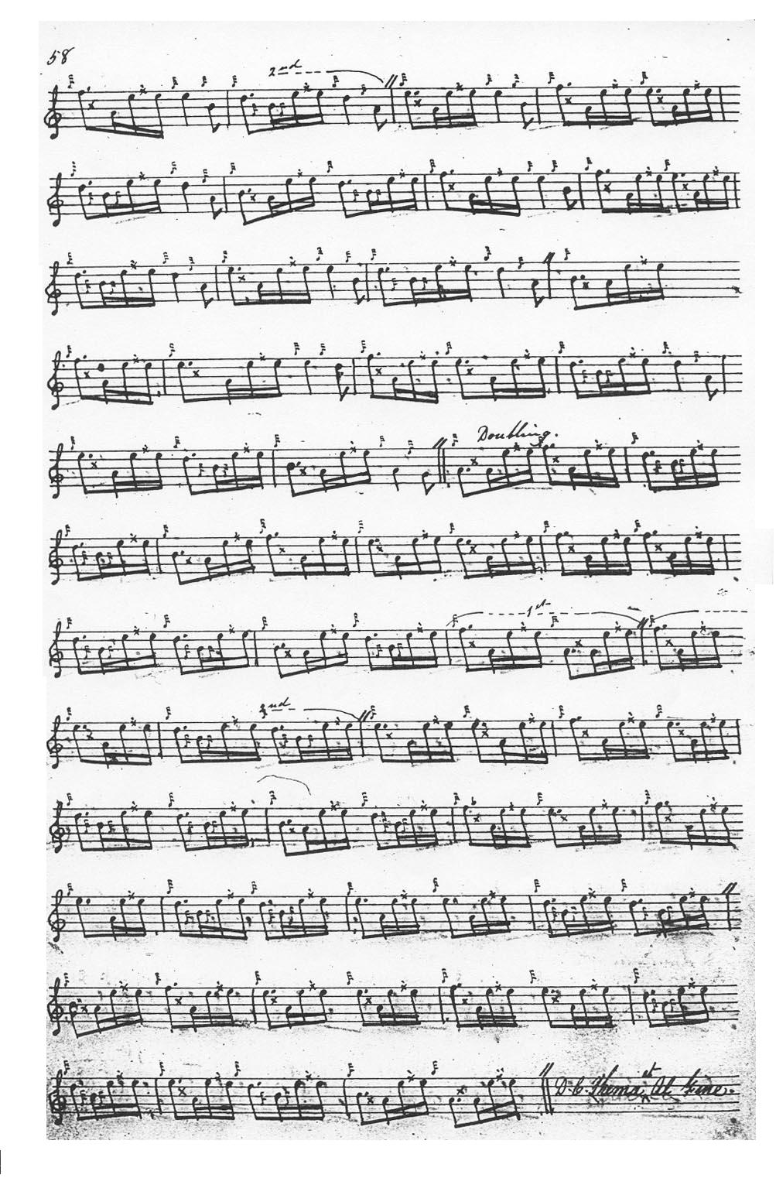

As we can see in MacKay’s setting of the ground, the score was subject to substantial editorial revision. The most obvious inference here is that he had his doubts about the coherence of MacDonald’s ground. MacKay’s marking of section endings is also a little eccentric and some of his variations would also be considered nowadays irregular.

C. S. Thomason gives Angus MacKay’s manuscript as his sole source here (rather interestingly) and he does not resolve the structural difficulties here. His score is therefore not reproduced.

Commentary:

The score published in the Piobaireachd Society Collection (second series, iv, 115-17 which appeared in 1932), is said by Archibald Campbell to be largely based on Angus MacKay. The MacKay MS presents some difficulties at this point, however, because much of the central section of the ground has been heavily scored out, although it can still be construed, and this Campbell appears to have followed. Yet there are numerous changes to MacKay’s time values silently made, including changing MacKay’s 6/8 time signature in the taorluath variations into 2/4.

From a historical point of view, this seems to be another of those tunes whose title, at least, appears to link it with the loss of the great Earldom of Ross as various MacDonald chieftains struggled with one another and their neighbours in the foundering Lordship of the Isles in the closing years of the fifteenth century. The battle was fought in the neighbourhood of Strathpeffer.

* * *

Electronic text © Dr William Donaldson, Aberdeen, Scotland, January 2008

