The Parading of the MacDonalds
There are settings of this tune in the following manuscript sources:
--Donald MacDonald’s MS, ff.36-40 (with the title “MacDonald of the Isles Salute”);
--Angus MacKay’s MS, ii, 77-8;
--John MacKay’s MS, ff.30-31;
--D. S. MacDonald’s MS, ii,132-161 [the MS bears the signs of more than one pagination system];
--David Glen’s MS, ff.141-2 and again at ff.239-41;

and in the following published source:
--C. S. Thomason, Ceol Mor, pp.69 and again at 326.

Donald MacDonald sets the tune like this:

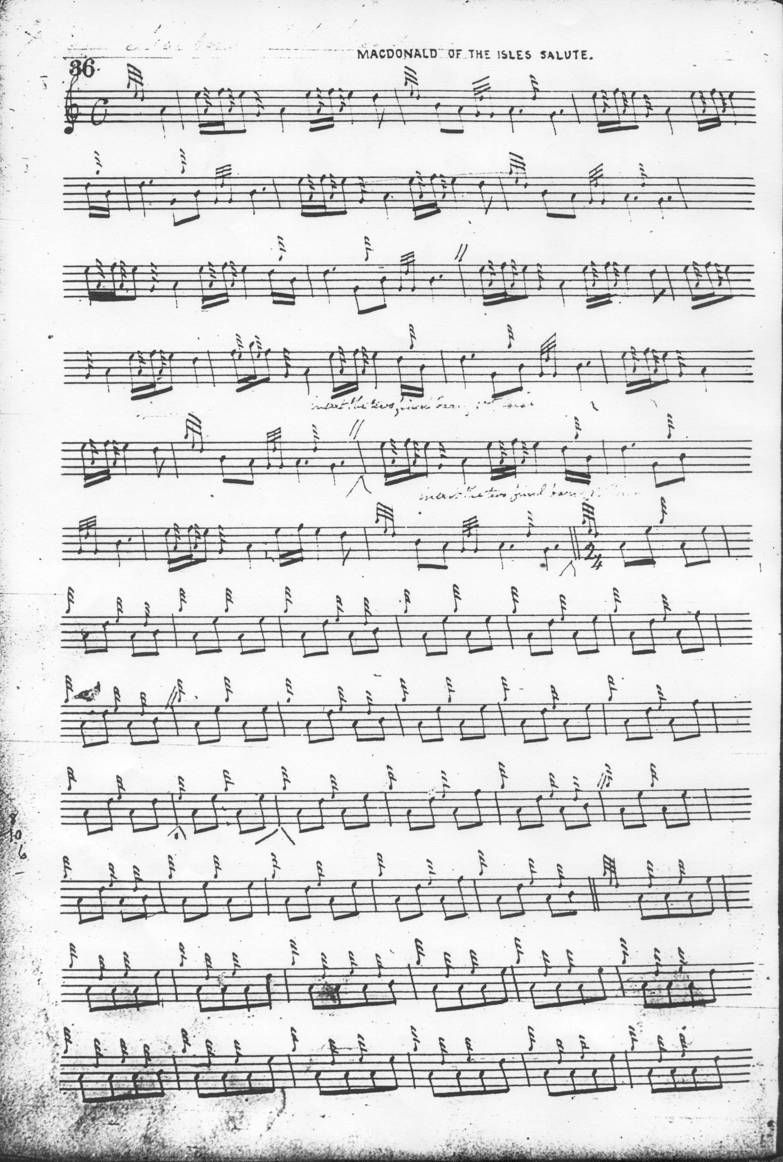
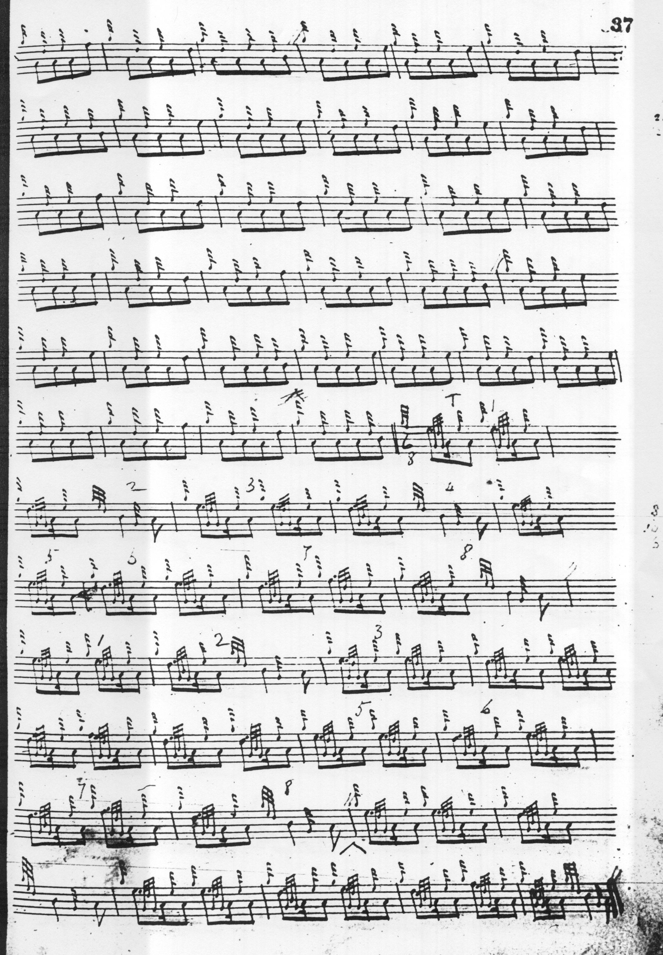

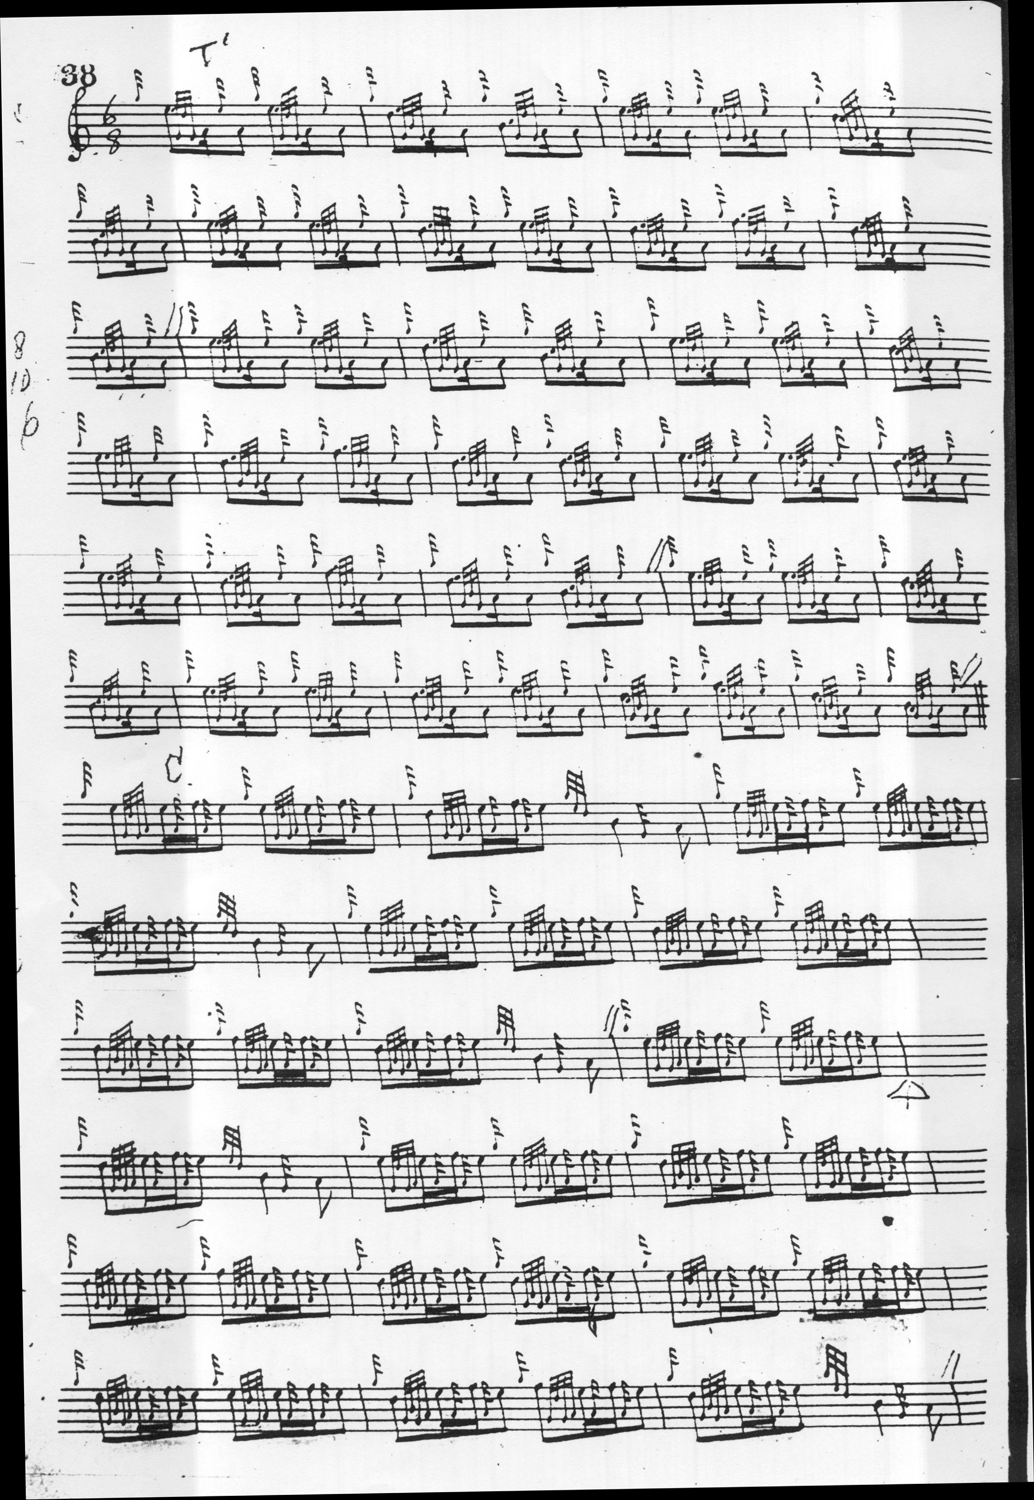

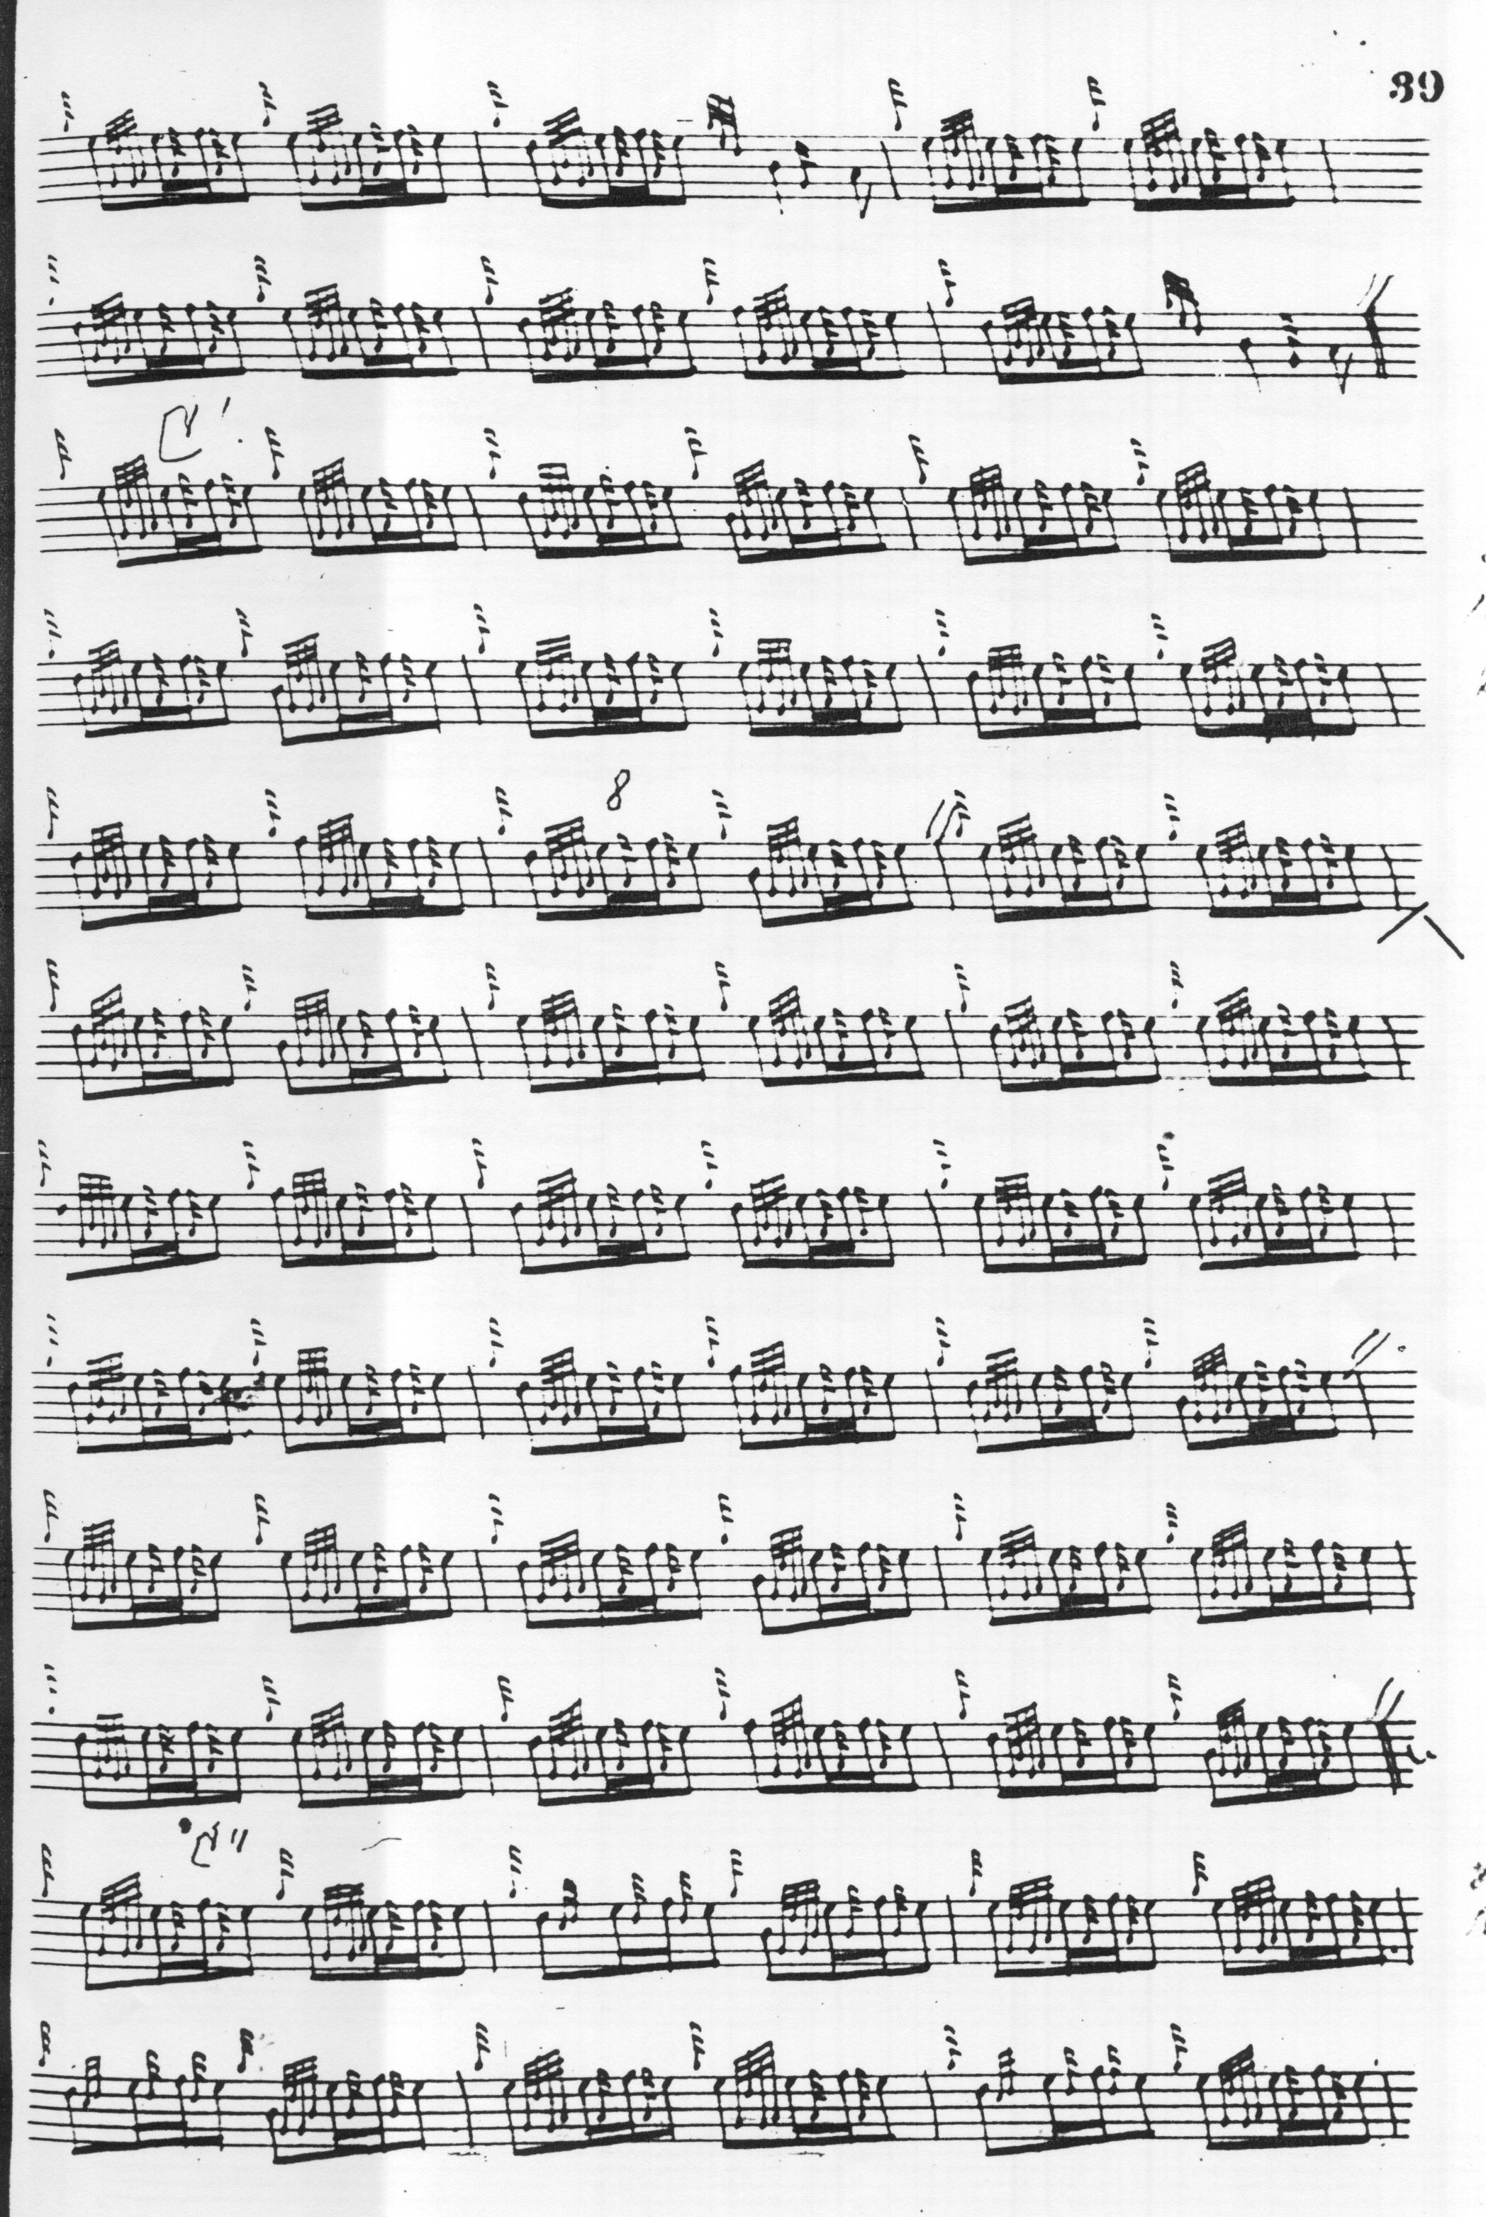
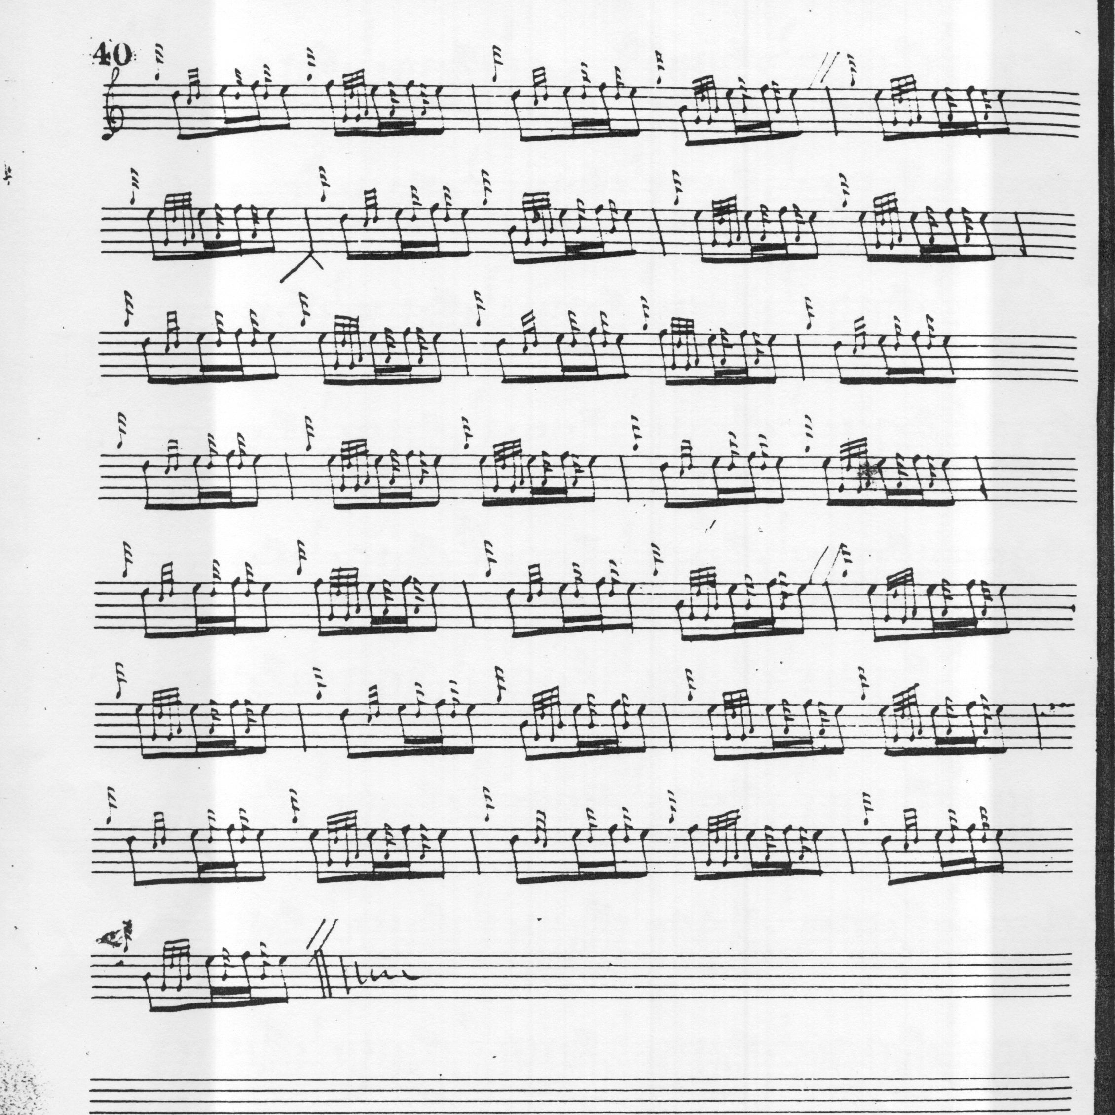

Donald MacDonald opens with an anacrusis (dropped by MacKay) and his ground could permit of a number of different interpretations with regard to structure: it could be in three lines, line one having four bars (repeated); line two perhaps a unit of six, leaving a four bar coda in line three, giving eighteen bars in all. A little caution may be necessary here, however—whoever has barred this tune (probably General Thomason) may have misconstrued the structure: it could be read as basically four lines of even four bar phrases, or of two lines of eight, with a little two bar ritornello at the end. The interlined comments seem to envisage adding four bars made up of material from elsewhere in the ground to correct a perceived deficiency in lines two and three, as we see reflected in Thomason’s score below. In the siubhal, MacDonald has four bars in line one (if one considers that 4/4 is the actual metre) not repeated as in the urlar, but only five (rather than the expected six) in line two, and three in line three, bringing the tune down to a twelve bar pattern from the siubhal onwards through the taorluath and crunluath variations. MacDonald’s opening line, repeated in the ground, is not repeated in the variations; if it were, that would bring the variation sections up to sixteen bars. In addition one may note that his plodding 4/4 timing in the ground contrasts with MacKay’s more sprightly 6/8.

The pattern 4, 5, 3 repeats right through the tune in both MacDonald and MacKay’s settings . If we are to decide that this is “wrong” then they are consistently “wrong” together. It is possible that MacKay may have had access to MacDonald’s manuscripts and his approach is similar, although MacDonald has a crunluath a-mach (in his usual style in which the opening note is held) while MacKay ends the tune at the crunluath doubling bringing in a repeat of the ground immediately thereafter. A reasonable conclusion would seem to be that MacDonald’s score has a number of seeming inconsistencies and that MacKay’s version does not resolve them.

Angus MacKay sets the tune like this:

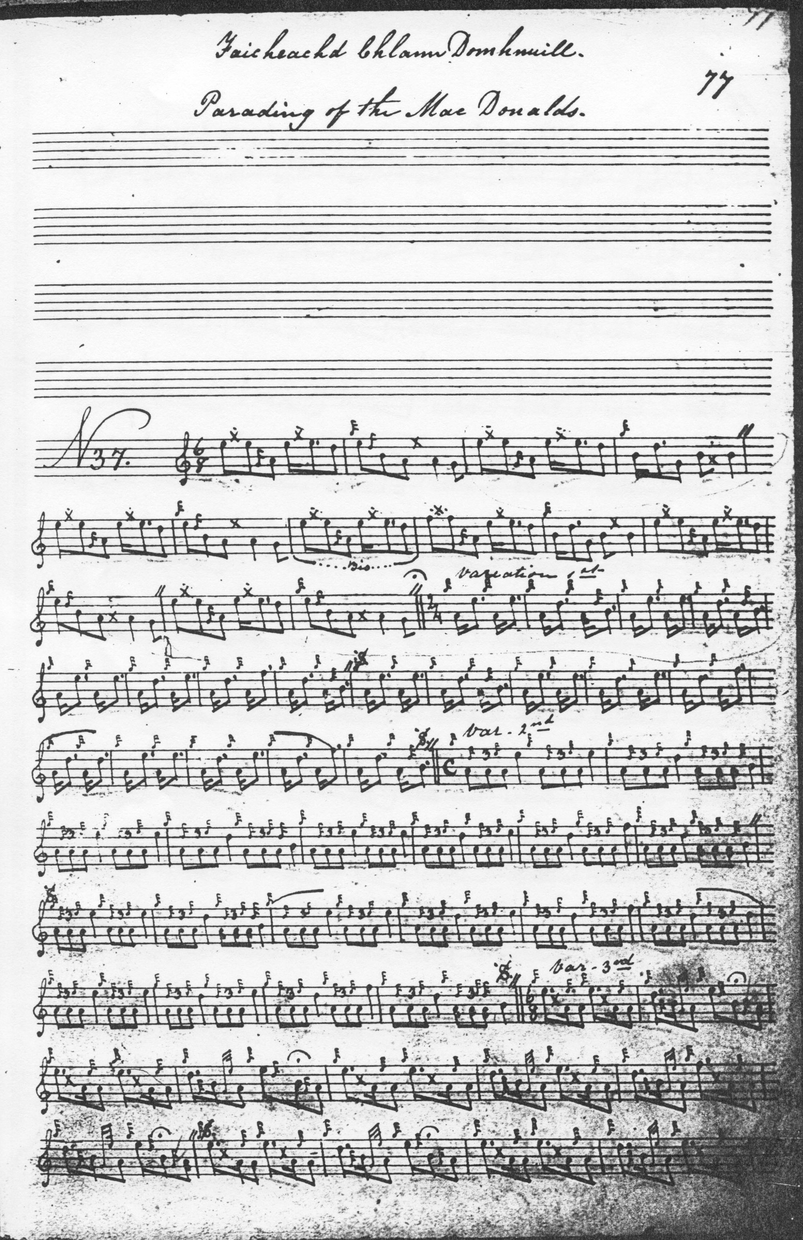
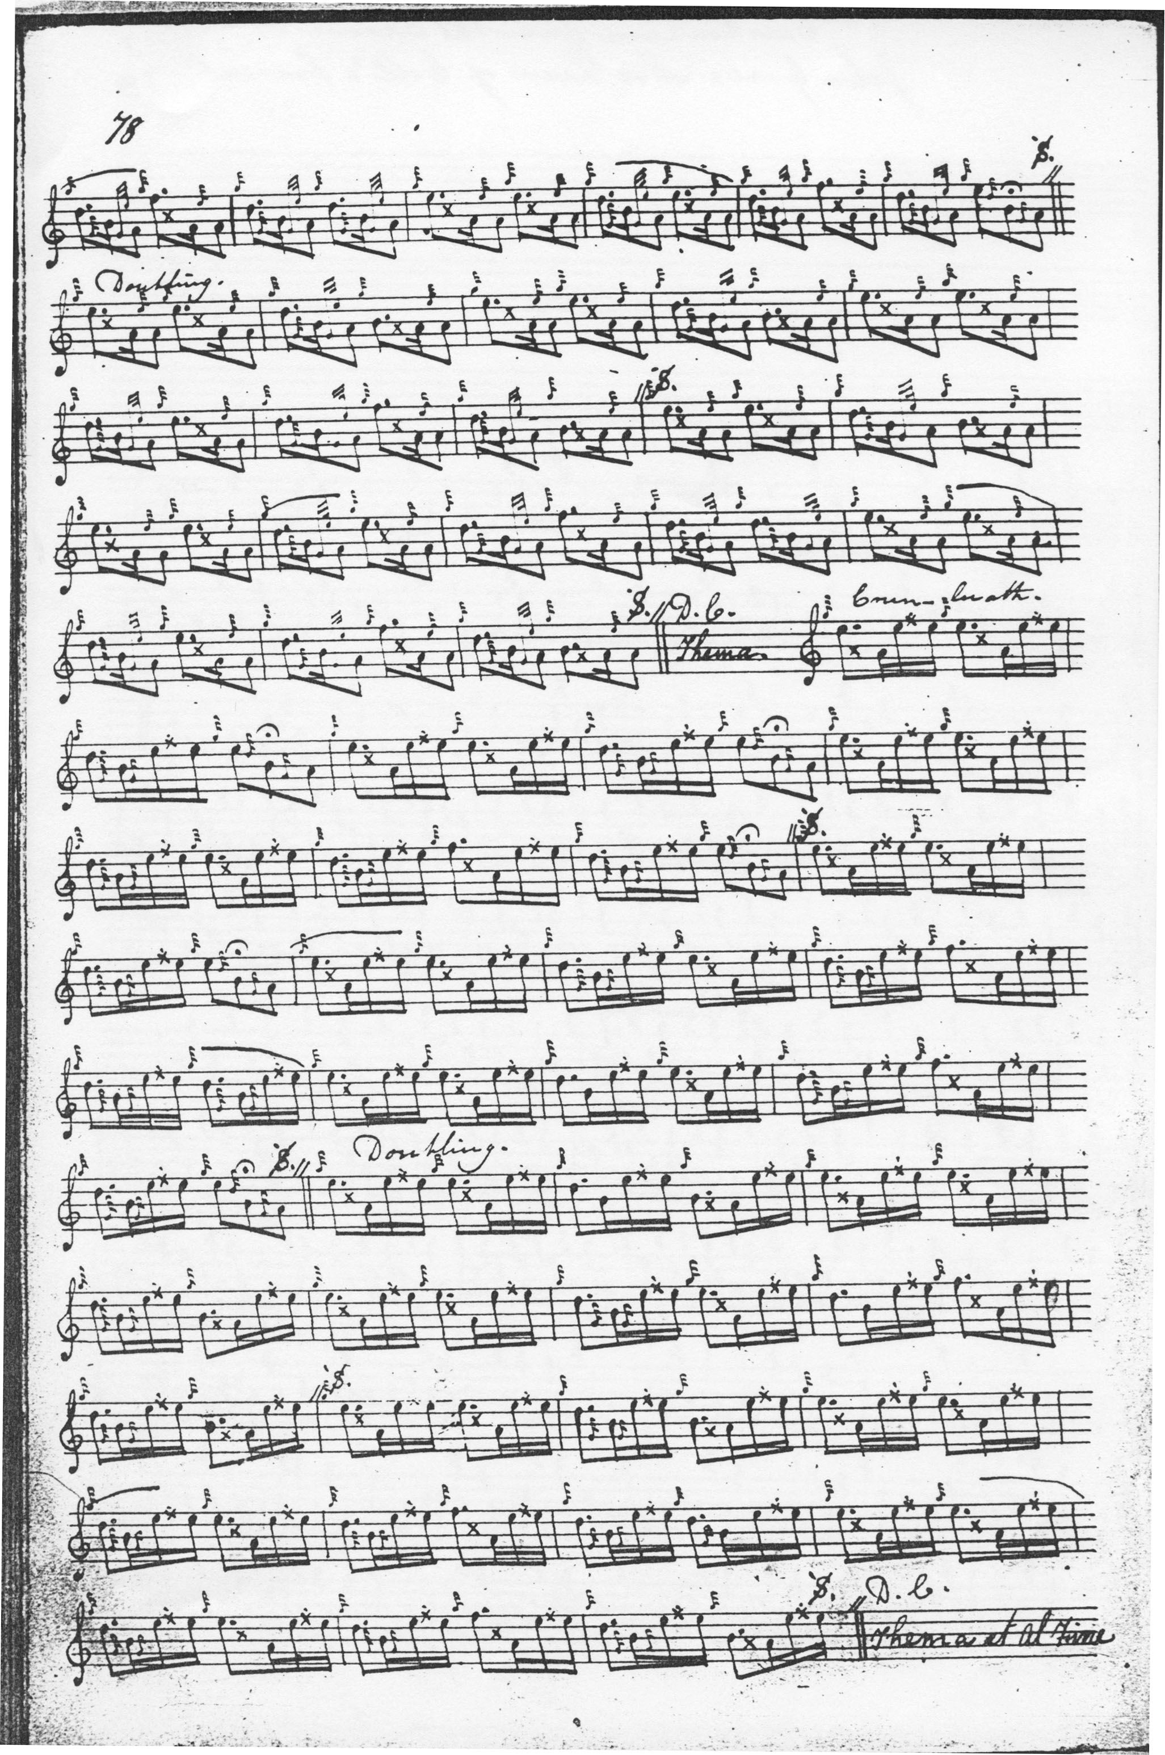
Although MacKay follows MacDonald’s structure in the variations, his intentions with regard to the ground are not so clear. MacKay sets the urlar in 6/8 time and arranges its three lines in groups of 4 8 and 2 bars (although 4 6 4 might seem a more shapely arrangement), making fourteen bars in all. MacDonald does not repeat the ground within or at the end of the tune, but MacKay directs that this should be done following the taorluath and crunluath doublings, in accordance with normal practice for each of these sources.

John MacKay takes Donald MacDonald’s route through the tune and his score is not reproduced here.

D. S. MacDonald’s score is a rough transcript lacking ornamentation, making a rather perfunctory attempt to amend its source, Angus MacKay. It is not reproduced here.

C. S. Thomason sets the tune twice, once under the title “MacDonald of the Isles Salute” which follows Donald MacDonald’s score, and one edited text which he prints under the title “The Parading of the MacDonalds”, as follows:

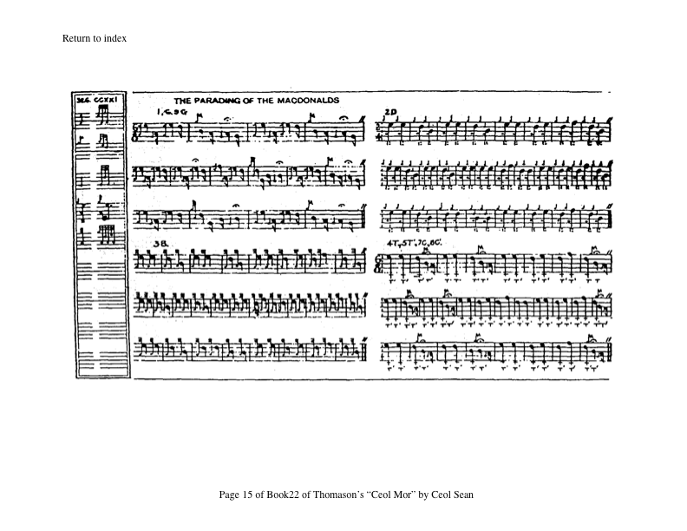

Thomason’s setting also has problems. His main source is obviously Donald MacDonald, although he subjects MacDonald to drastic emendation in the ground, dropping bars three and four and seven and eight of MacDonald’s opening sequence, producing a ground fourteen bars long and changes the time signature to 6/8 from MacDonald’s 4/4 time. In the second line of his siubhal the General has given an E where there should be a D in the first figure of bar fourteen. The second line Thomason makes up to twelve rather than the expected ten bars, by adding fresh material at bars eleven and twelve. He makes the third line of the siubhal up from MacDonald’s six, to eight bars with additional material at bars twenty-three and twenty-four so the final arrangement is into three lines of eight, twelve, and eight bars. This establishes the pattern for all the later variations. One may note that although taorluath and crunluath singlings and doublings are specified, only the singling form is actually given.

David Glen also had two goes at this tune, the first of them an emended version of Donald MacDonald, thus:

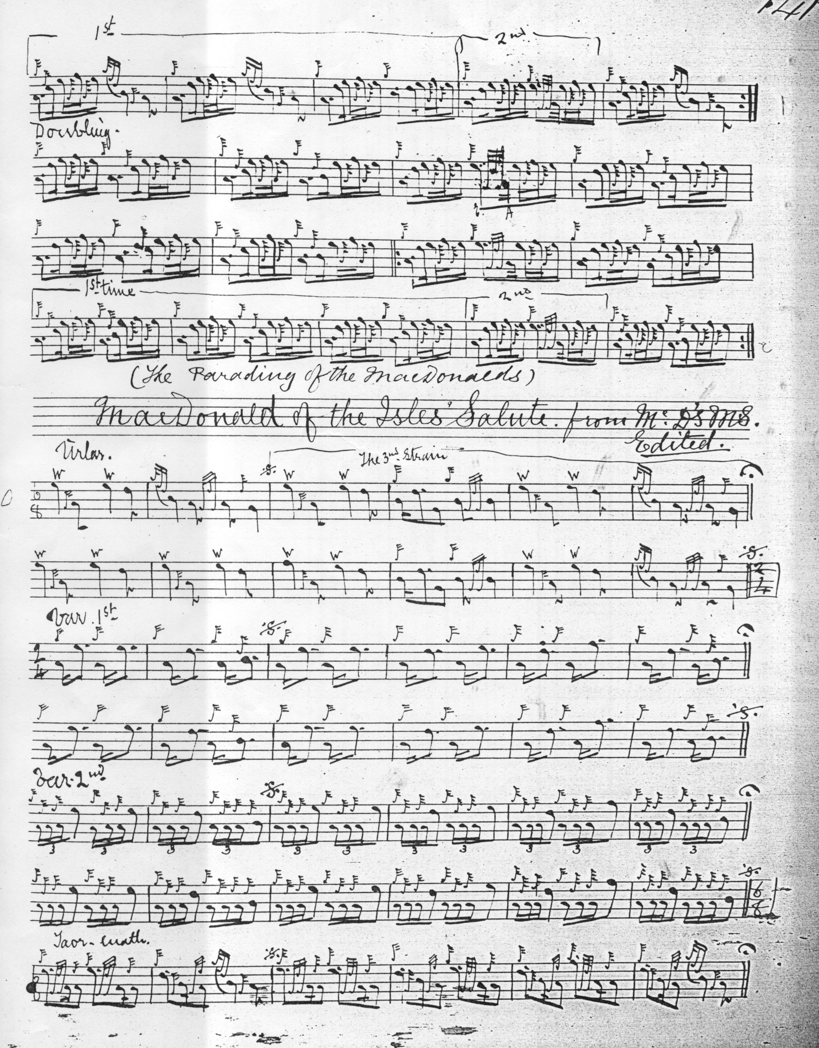

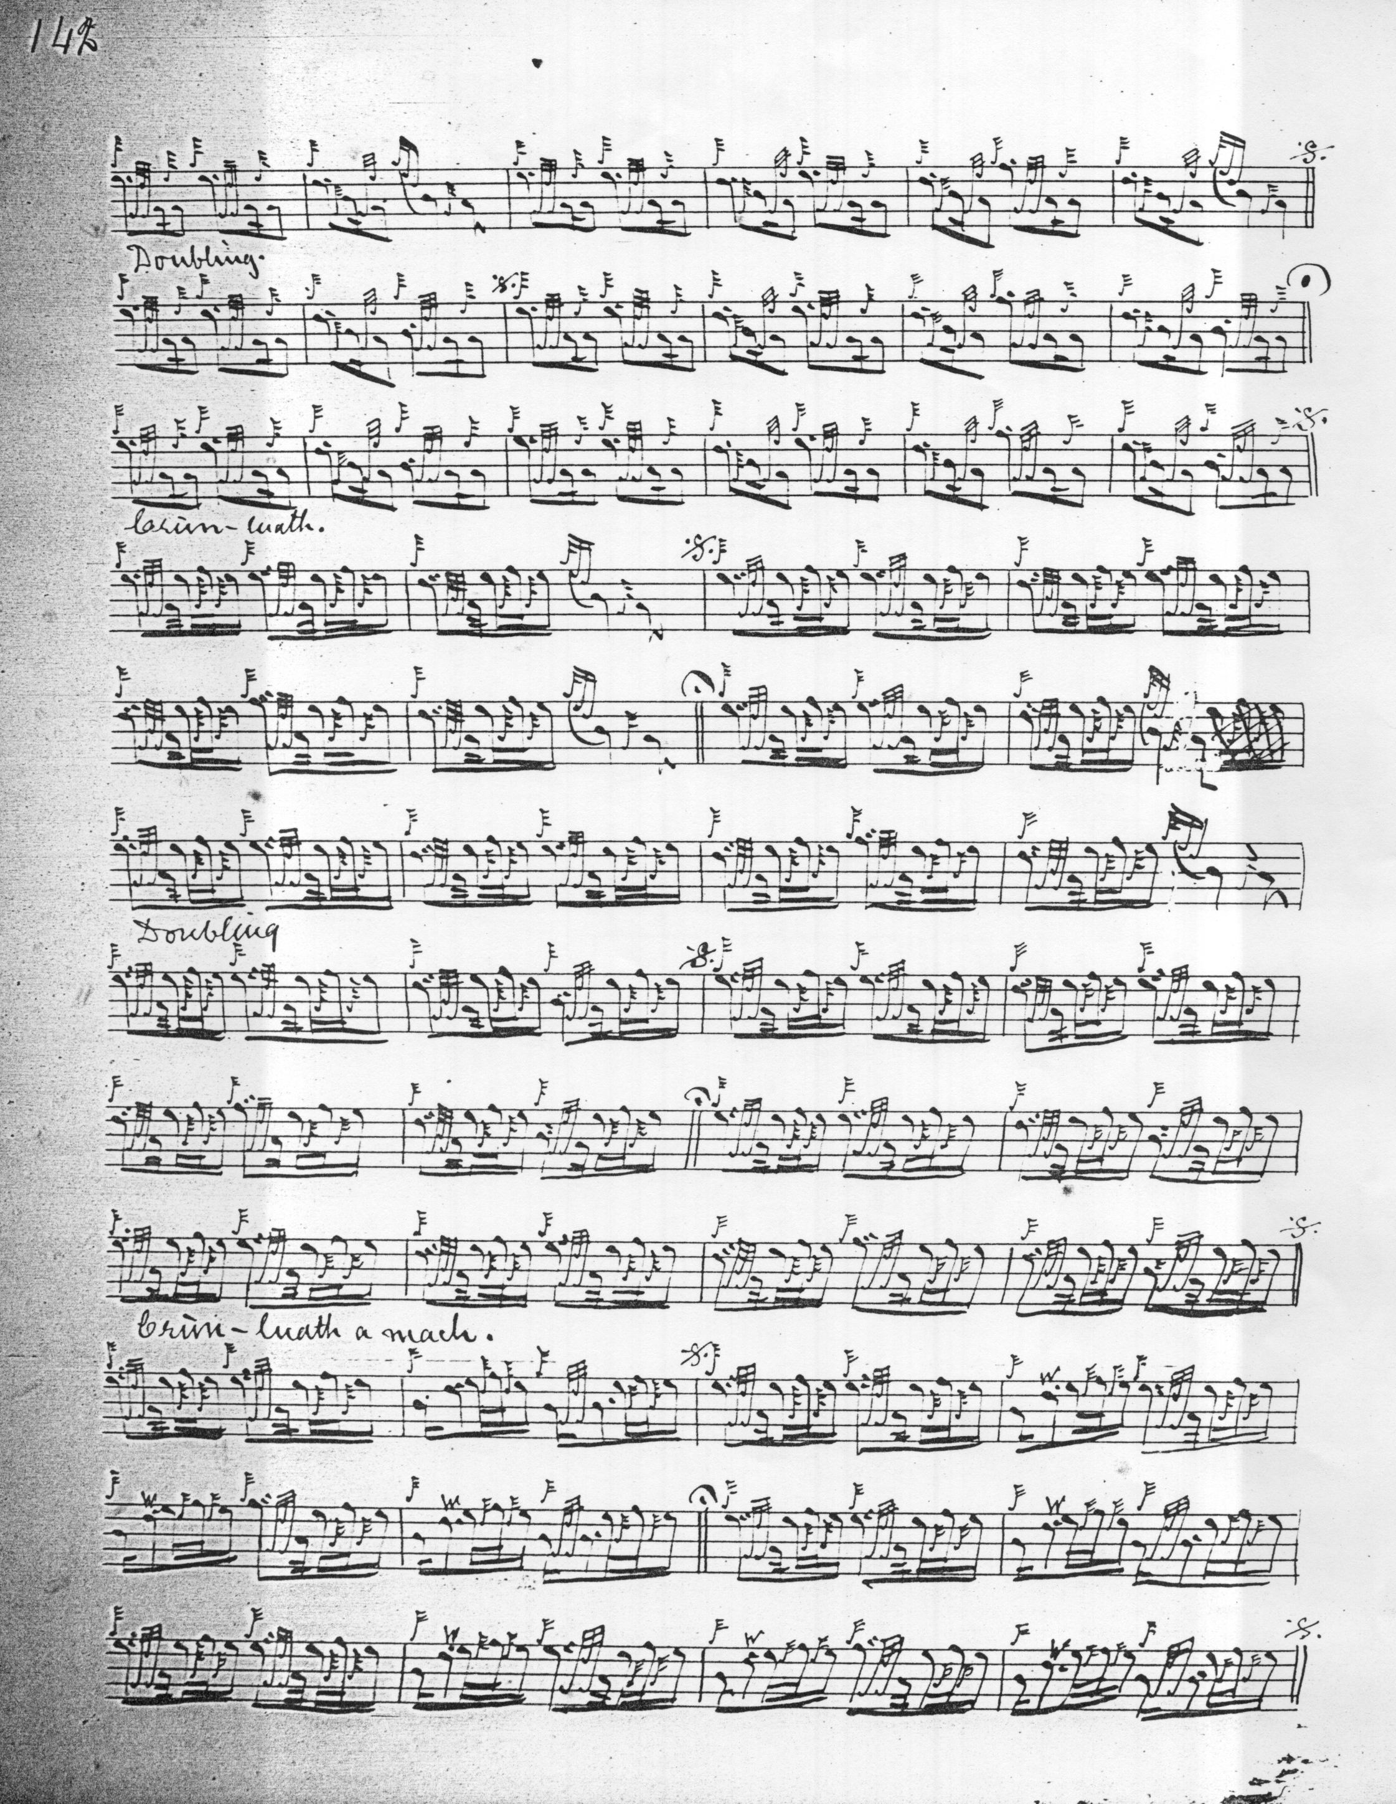

Glen drops MacDonald’s initial anacrusis, then presents the ground in three lines of six, six, and four bars, by considering MacDonald’s first six bars as in fact constituting line one, he drops bars seven and eight from MacDonald’s score, reducing MacDonald’s eighteen bars to sixteen. The remainder of the tune follows the pattern thus established. Glen gives no indication that the ground should be repeated at the end of the taorluath and crunluath doublings, but he does retain MacDonald’s crunluath a-mach albeit in the more “modern” MacKay style, with the initial Bs being cut.

Glen’s second score is an amended version of Thomason, as follows:

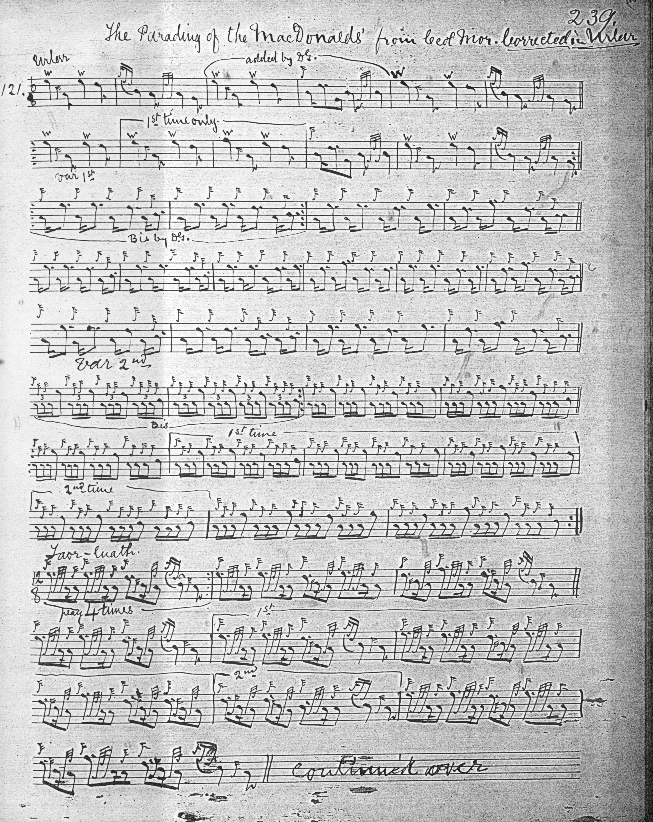
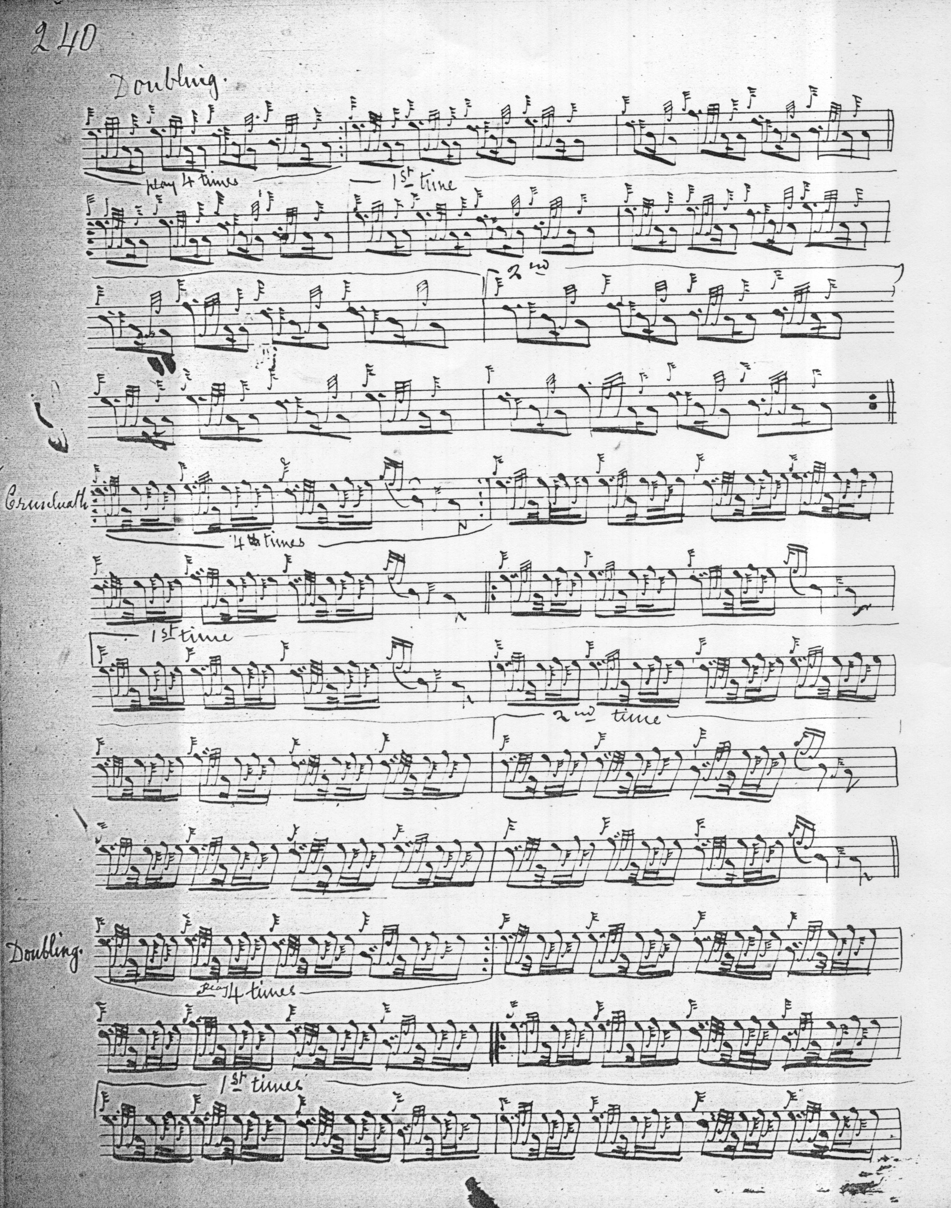
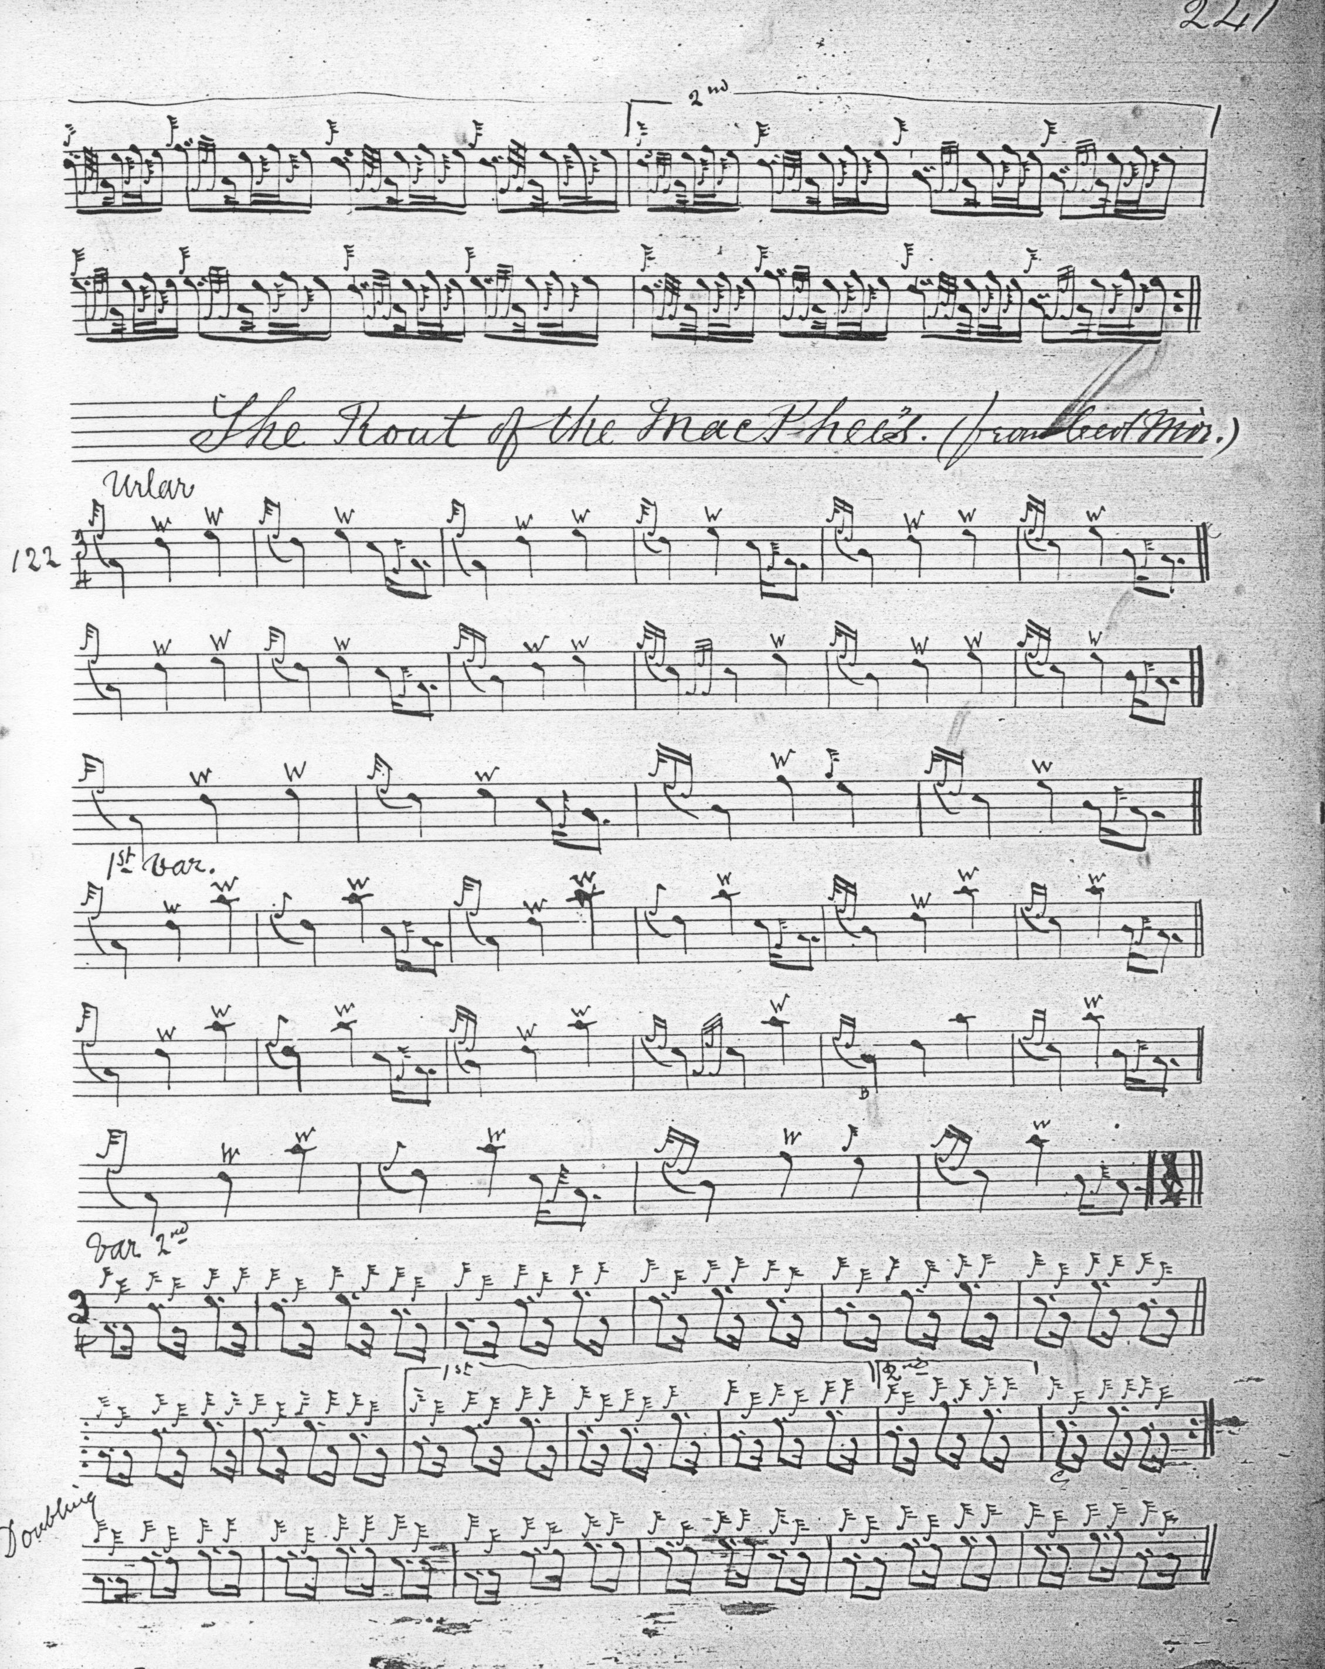

We see the same resolution of the first line of the ground into six bars as in the earlier Glen setting, but here he directs that the initial two bar phrase in the siubhal and later variations be repeated (for which there is no support in Thomason) and with, some may think, less than happy effect.

Commentary:

In his notes to his MS, Donald MacDonald says “Failte MhicDhomhnuill na’n Elean, MacDonald of the Isles’ Salute. This beautiful Piobaireachd is, perhaps, one of the oldest airs, I know. When composed, or to which of the chiefs, is utterly unknown.” (“History of the airs in this volume”, p.1).

The mustering of a Highland clan in warlike array is a thing long departed, but the romantic pull of the idea remained, and a distant echo was to be seen in the nineteenth century’s invention the modern highland games. One of the moving forces behind this was Alexander Ranaldson MacDonell of Glengarry (1773-1828) who attempted to revive the barbarian side of the Highland inheritance, with legs being torn off cows and similar rude feats of strength. As the century advanced, however, gentrification and sanitisation proceeded apace, and little that Glengarry understood by “Highland Games” was allowed to remain. The Games took their place in the constellation of commercial entertainment industries that sprang up with the Victorian cities and the spread of the railway network. Yet a hankering for a genuinely barbaric past continued to tug and we see a note of unmistakable nostalgia by the nineteenth century’s end:

Scotland has become cosmopolitan, and the fastnesses of the Highlands are no longer the retreats of wild cateran clans, whose peculiar habits and primitive ideas of social life helped to bind them together with ties of family strength, and at the same time to keep them unspotted from the Lowland and outside world that knew not the Gaelic and the tartan and the pipes. The Piob Mhor is not now an agency to be reckoned with by any one who wishes to explore the hills and glens, neither are there any little wars in Lorn or elsewhere, in which it can have an opportunity of leading Mac against Mac, or clan against clan. True, the Highland regiments who fight Britain's battles abroad still wear the tartan and march to the same old strains, but they are not now Highland clans. They are British battalions, whose empire, instead of being bounded by the horizons of a Scottish glen, is world-wide, and they march and wheel, and charge the enemy and storm the heights in strict accordance with the orders of a general who has his orders from Westminster. The only gathering of the clans we have nowadays are the gatherings in the halls of our big cities, where a thousand or two of people bearing a common name meet under the presidency of the next-of-kin of the chief of olden times, and drink, not mountain dew, but tea, and have Highland or Jacobite songs sung to them by people whose profession is singing, and applaud dancers and pipers who dance and pipe because it pays them to do so. This is very far removed from the time when the Piob Mhor was in the zenith of its power, though when one gets enthused with the atmosphere of such a meeting, and forgets the slushy streets outside, and the telegraph and the railway, and other nineteenth century things that have made the Highlands impossible, the song of the hundred pipers is quite sufficient to make the blood course quicker, and to translate one for a moment to other scenes and other times. But it is only for a moment. The prosaic present comes back with a reality that will not be denied, and one remembers with a sigh that the song is but a sentiment, and that never more will the gathering cries of the clans re-echo through the glens, the fiery cross pass from hand to hand, or the peal of the pibroch ring from clachan to clachan in a wild cry to arms. (W. L. Manson, The Highland Bagpipe Its History, Literature, and Music, Paisley, 1901, pp.10-11).

* * *

Electronic Text © Dr. William Donaldson, Cambridge, Massachusetts, 21 May 2013

