Nameless (cherede darievea)

Amongst the older written scores, this tune appears in Colin Mór Campbell’s Nether Lorn canntaireachd only (ii, 14-16): there is no other recorded source. Colin Mór begins the tune as follows:

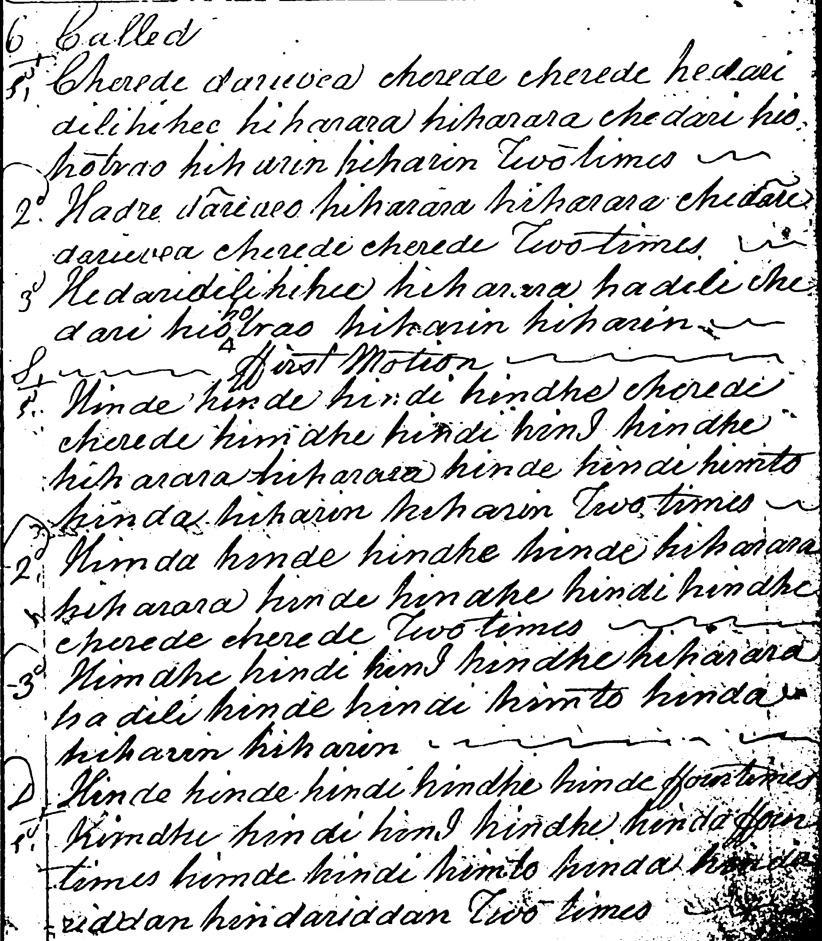

The complete score follows:

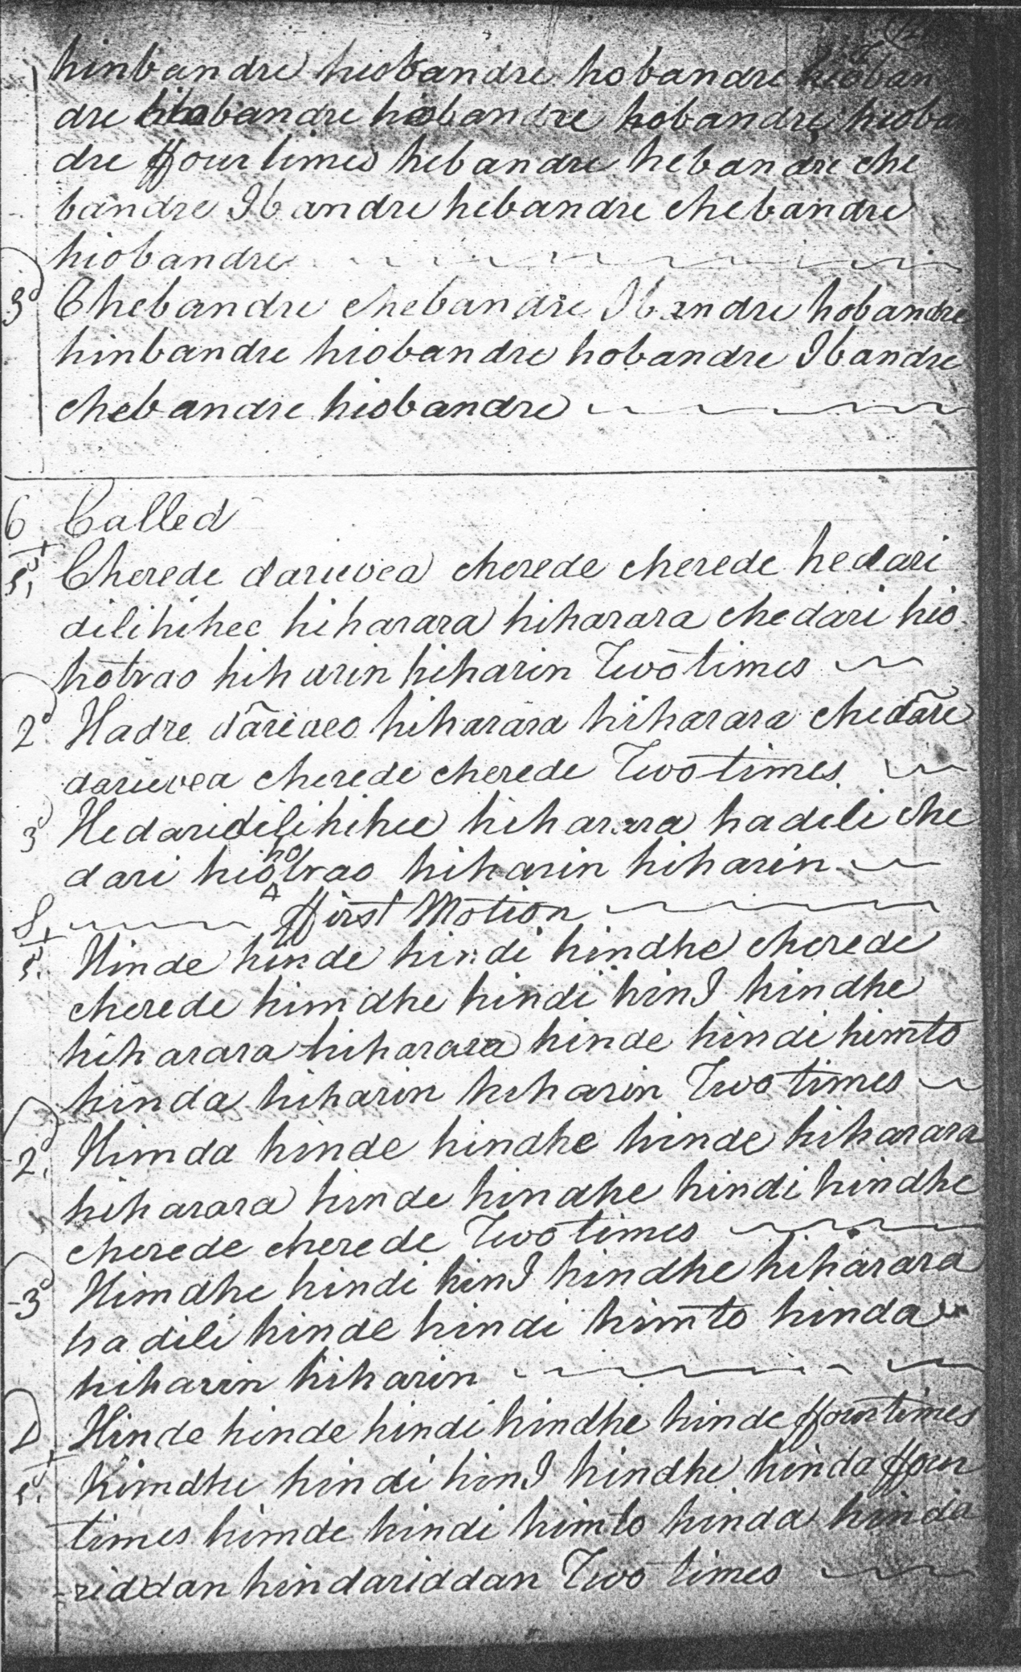

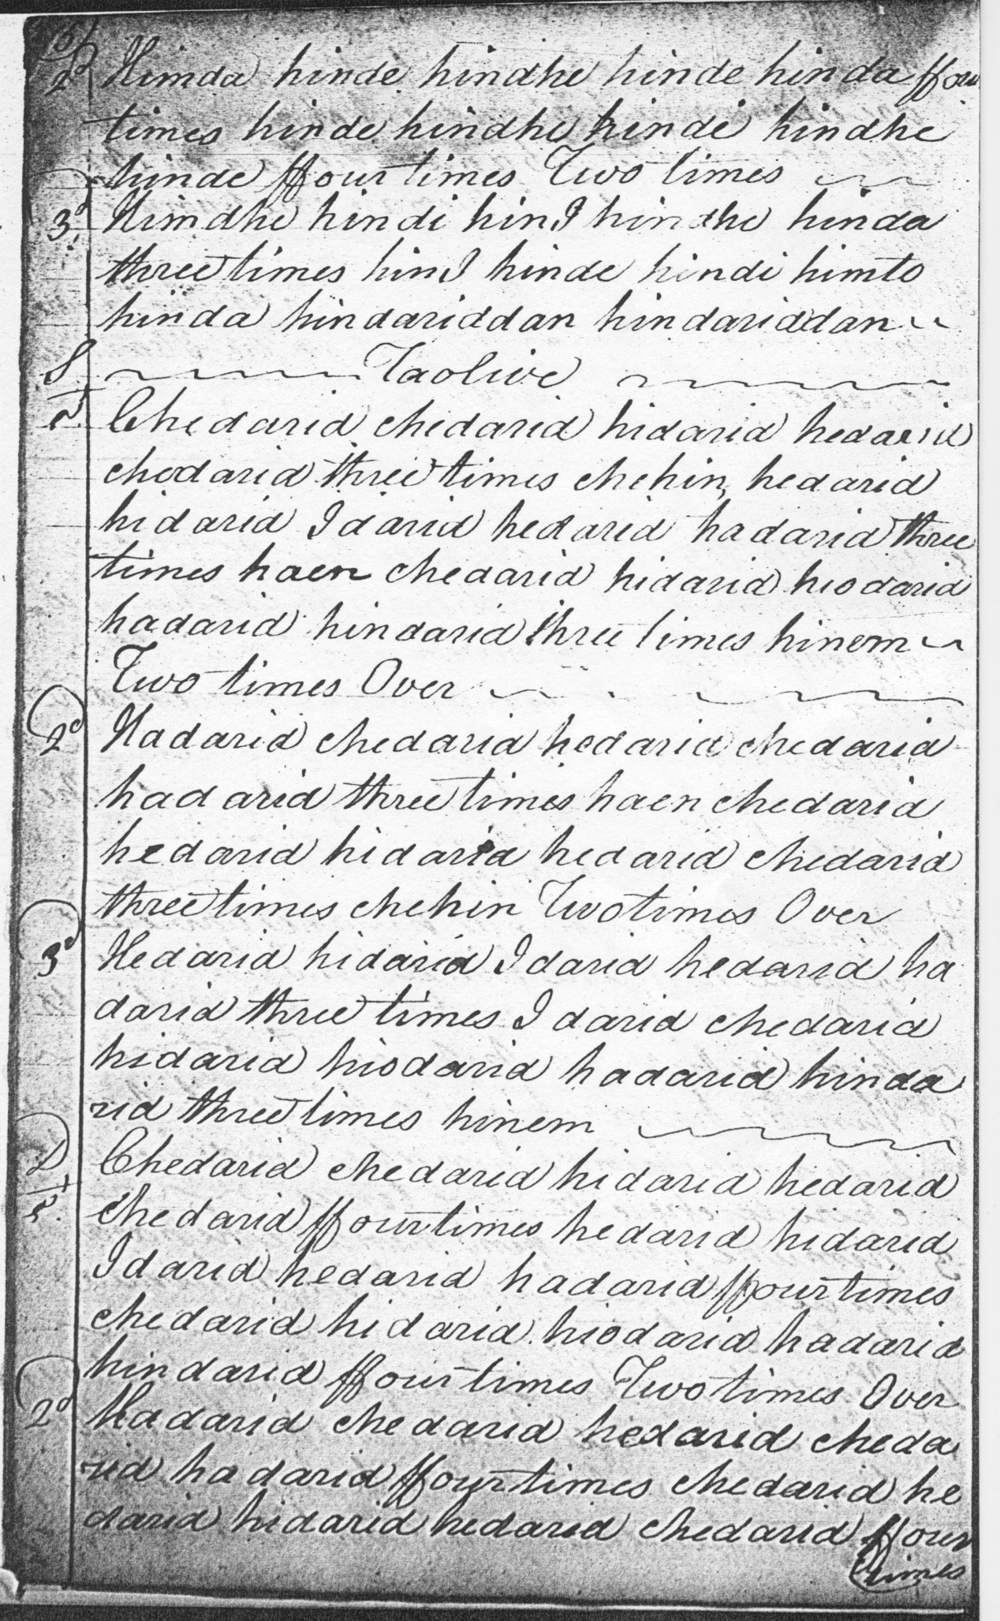
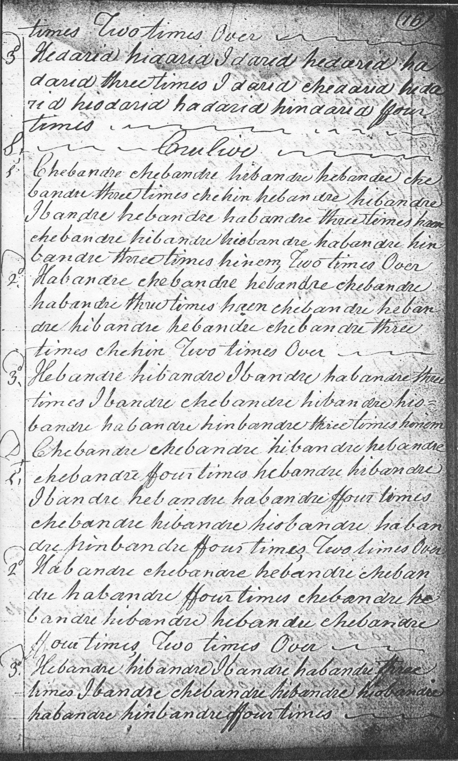
The timing of variation one is the most obvious stylistic point here. Archibald Campbell points it “down”, in the Piobaireachd Society Collection (second series), viii, 227-8 and in the Kilberry Book of Ceol Mor, p.69 but the effect is rather heavy and there is nothing to stop the movement being played “up”, if the performer prefers, as follows:

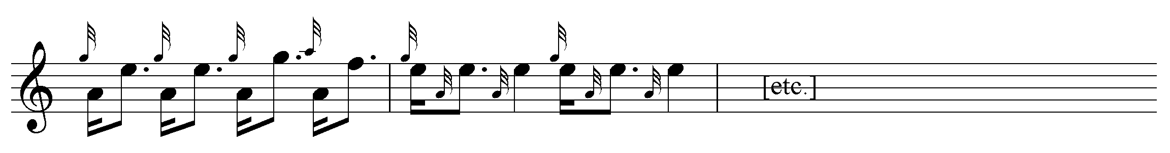

This would have the additional advantage of offering a rhythmical contrast with the following taorluath variation.

Some might query whether the tone row is strong enough to support Colin Campbell’s repeating the second line throughout but that is clearly what the score says.

Archibald Campbell suggests that a crunluath a-mach “could be played, if desired, in the usual form”, while pointing out, correctly, that there is no indication that one should be played in the original score. Some people might think its inclusion excessive in a tune of this sort. The Piobaireachd Society’s attaching of such movements to the end of very nearly every tune has long been a dubious practice, with heightening of technical demand rather than artistic finish appearing often to have been the criterion. In terms of melody and tonality there are interesting similarities with the “Laird of Anapool” and the imposing nameless tune that Thomason christened “Ben Cruachan”. There are settings of this latter in the MacArthur/MacGregor MS, Angus MacKay’s MS, Duncan Campbell of Foss’s MS and David Glen’s MS (it’s in the MacArthur MacGregor check published volume ; check back in Cambridge.) The similarity of tonal contour suggests that “Ben Cruachan” and this one sprang from a single mind; whoever wrote “Ben Cruachan” wrote the “Big Nameless” tune as well.

* * *

Electronic text © Dr. William Donaldson, Aberdeen, Scotland, September 2004; revised Cambridge, Massachusetts, February 2025

