My Dearest on Earth Give Me Your Kiss

There are settings of this tune in the following manuscript source:

--**David Glen**’s MS, ff.89-93;

and in the following published sources:

--**C. S. Thomason**, *Ceol Mor,* pp.152-3;

--**David Glen**, *Ancient Piobaireachd,* pp.240-243.

This tune came down from a single informant, namely Colin Cameron, and what his sources for it were is not known.

**C. S. Thomason** sets the piece like this:

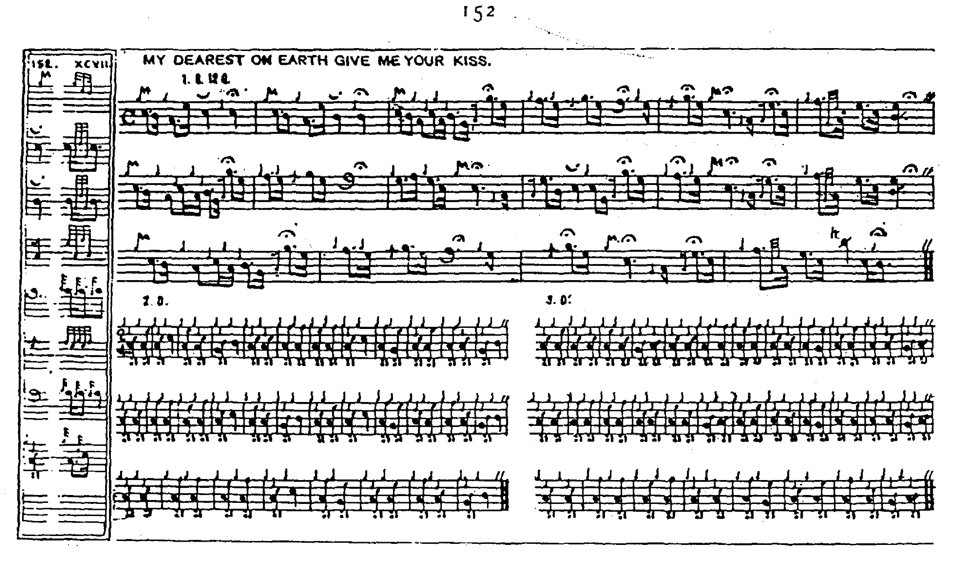

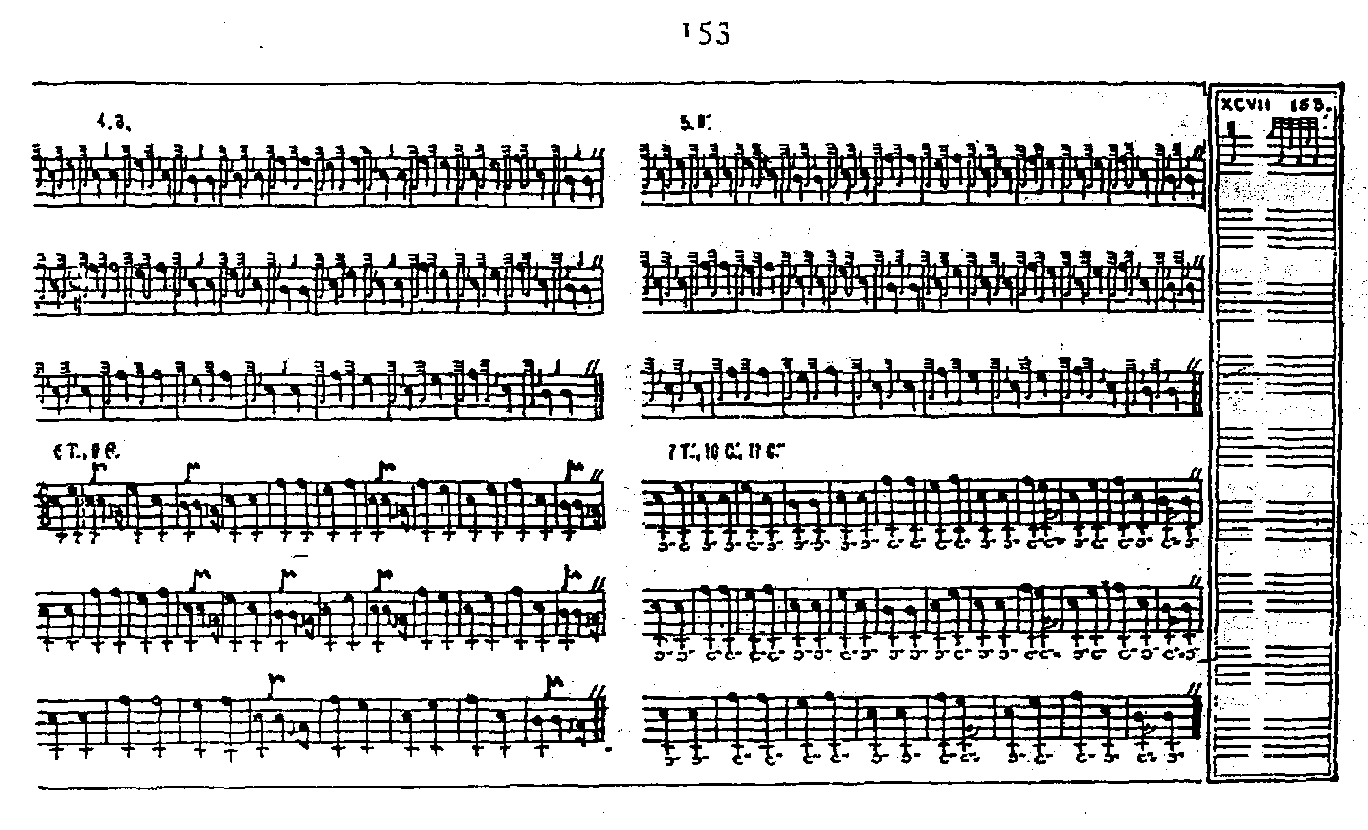

Thomason version is rather awkwardly barred throughout. For example, the initial note of the motif in bar 5 should the E quaver at the end of the preceding bar and the note values in bar four of line two plainly require adjustment to preserve the metre.

**David Glen**’s version goes like this:

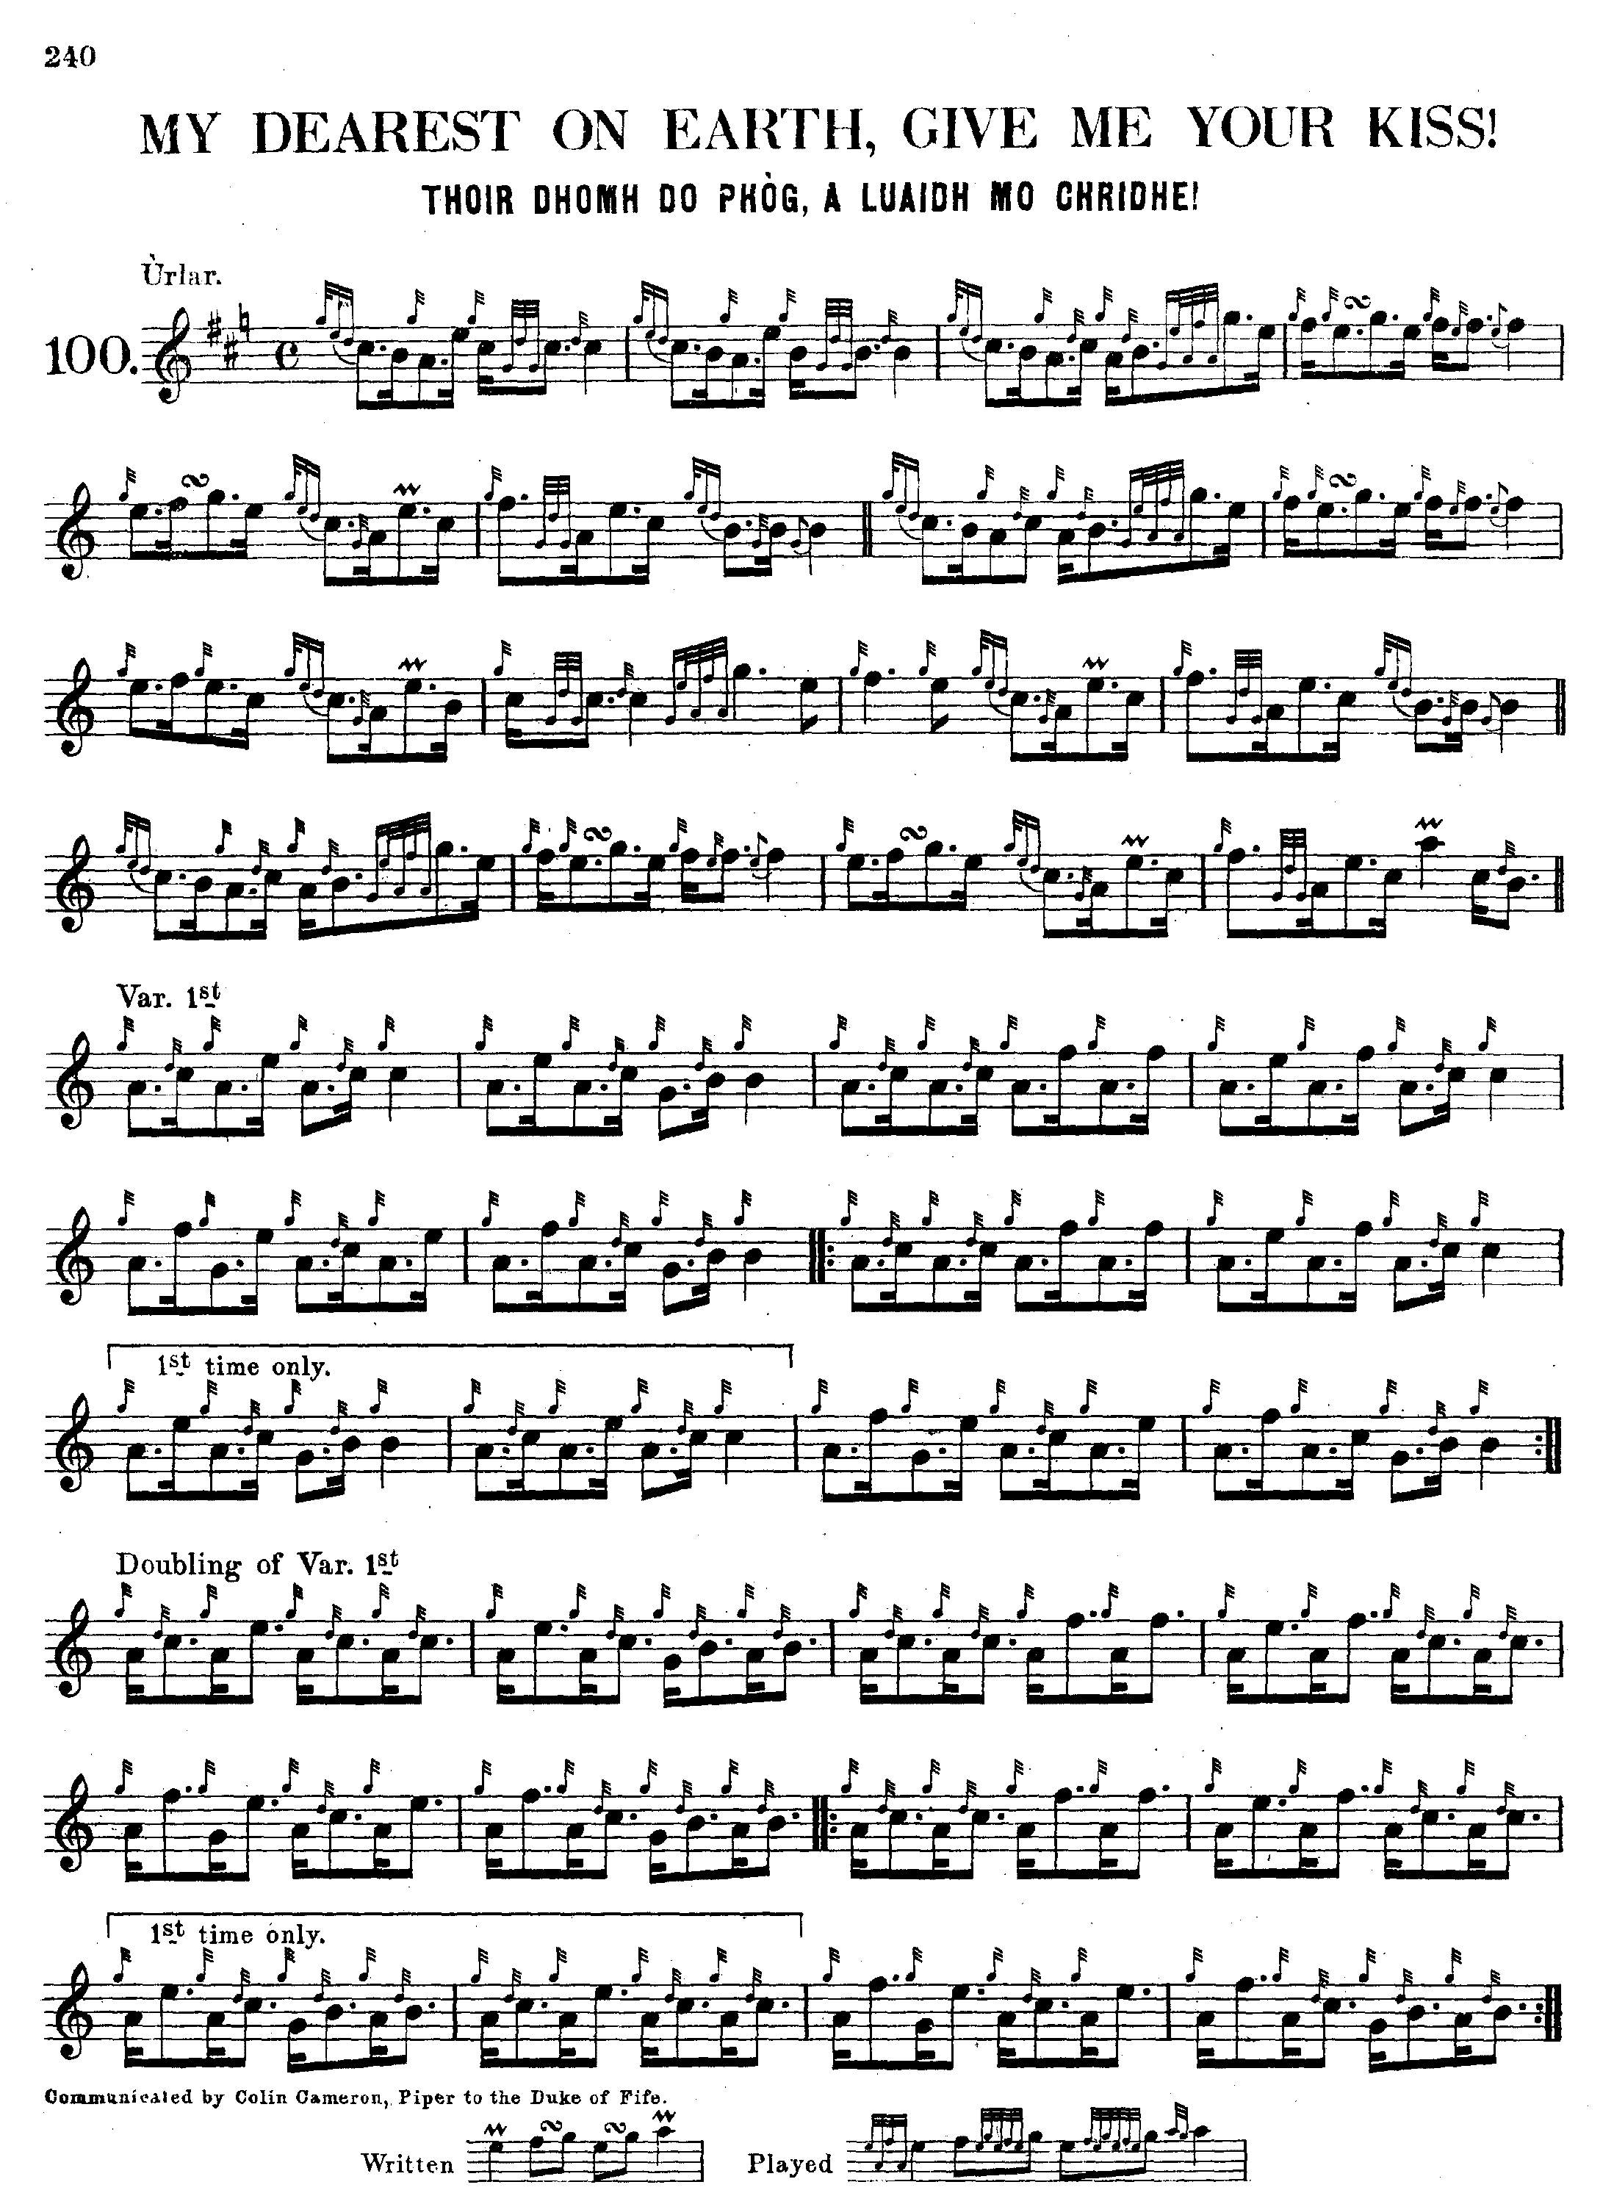

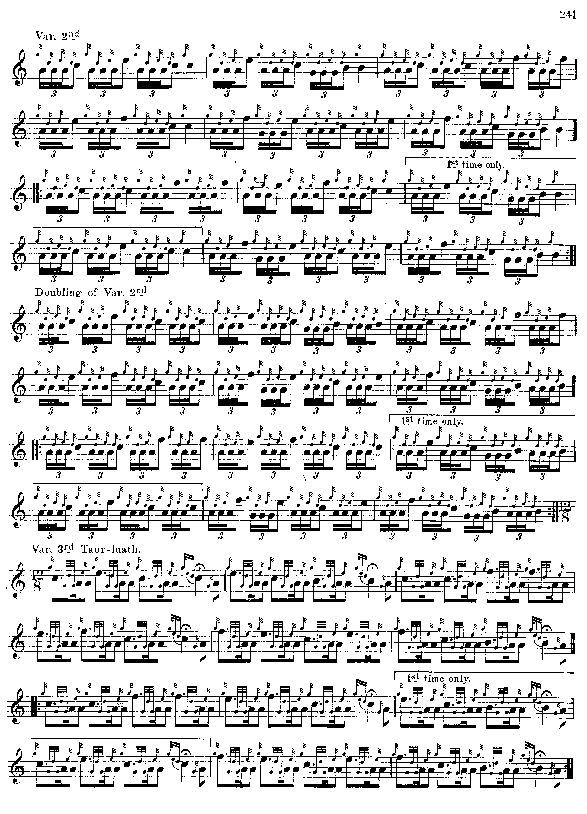

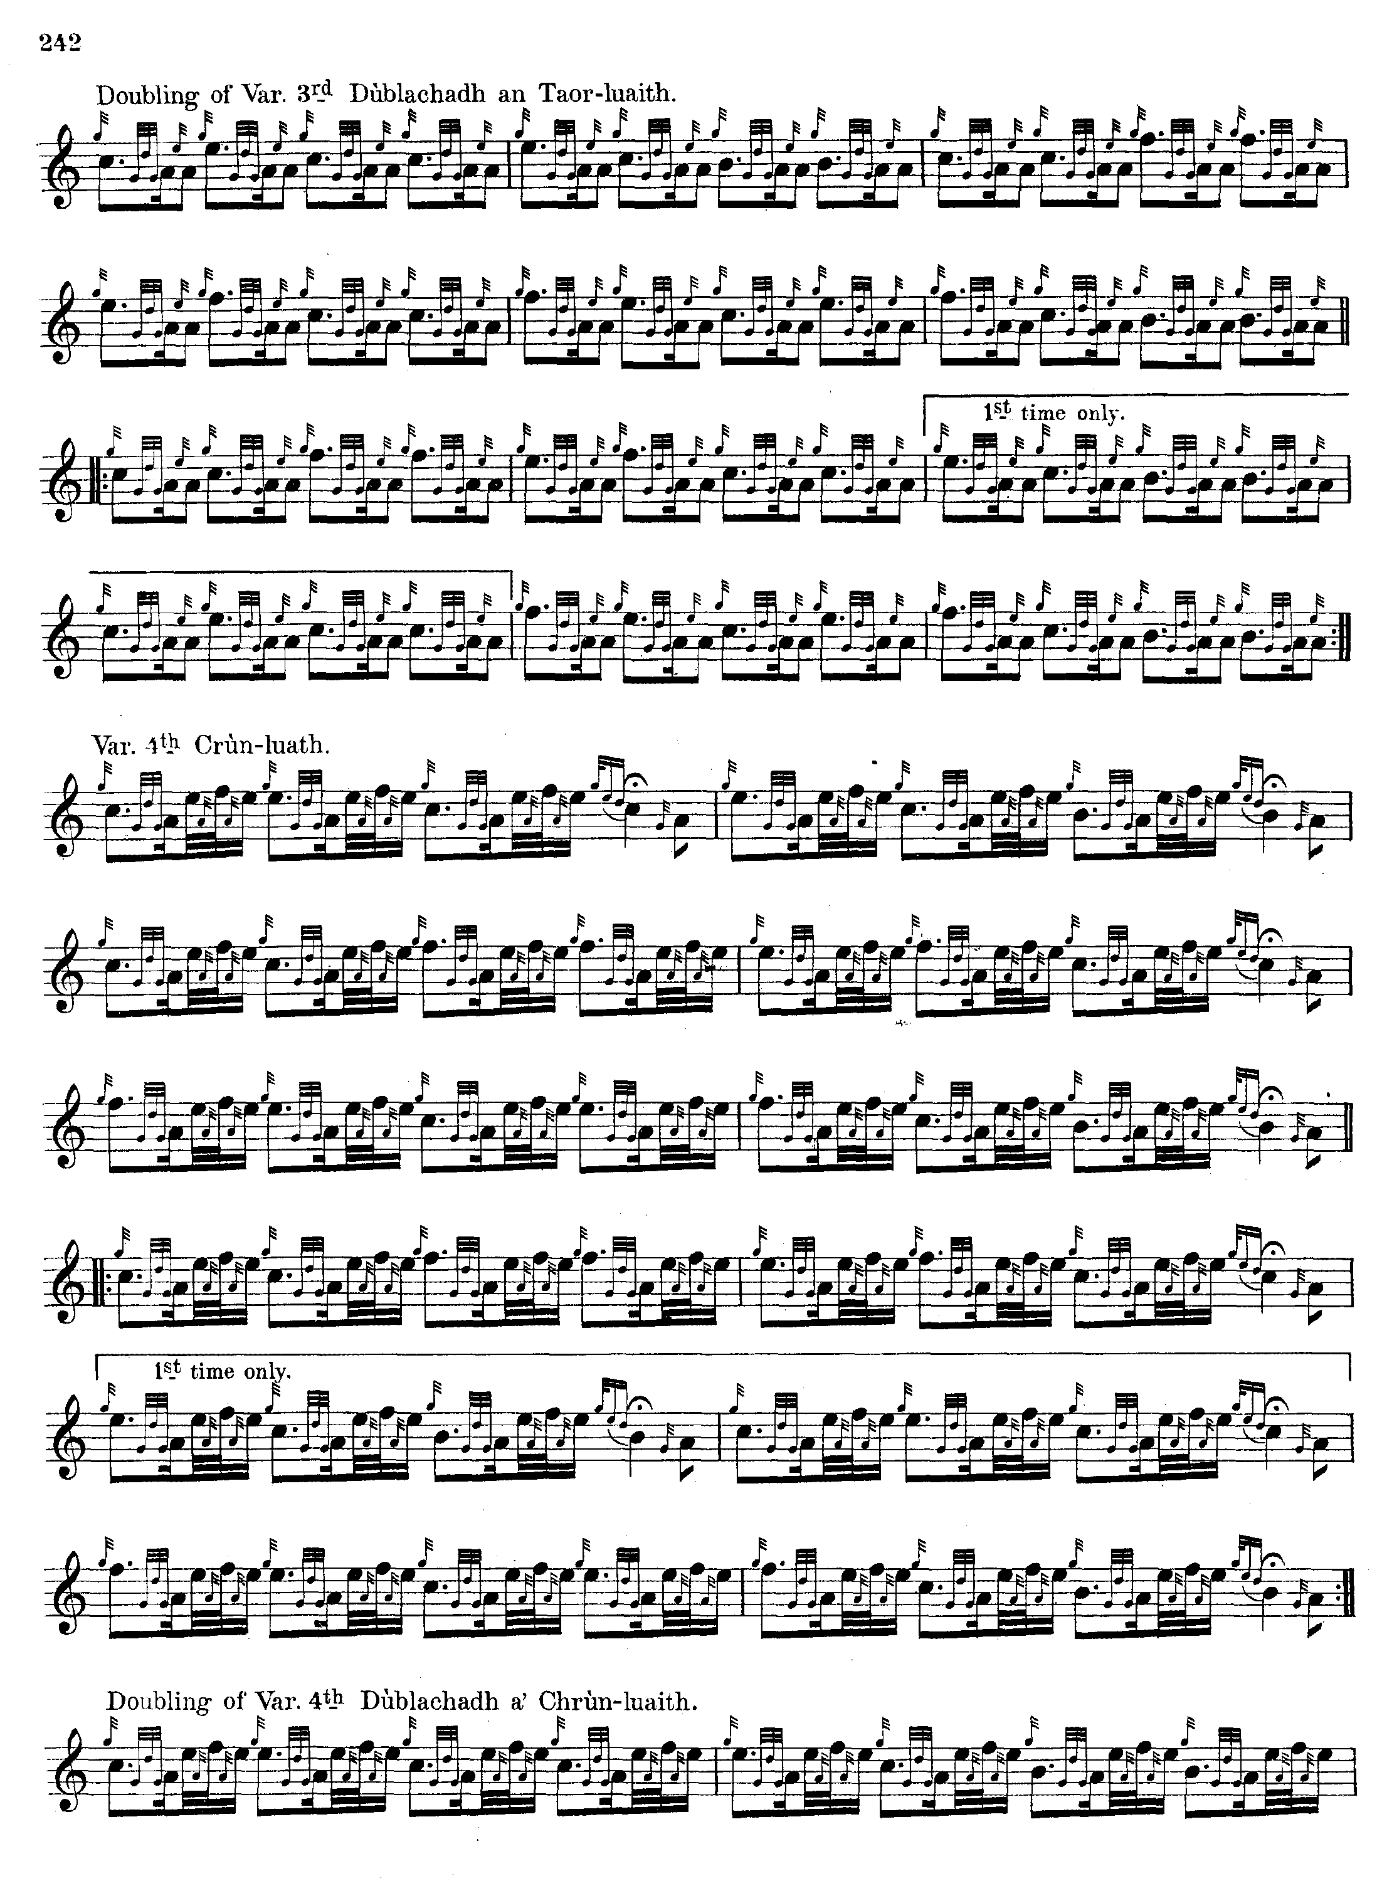

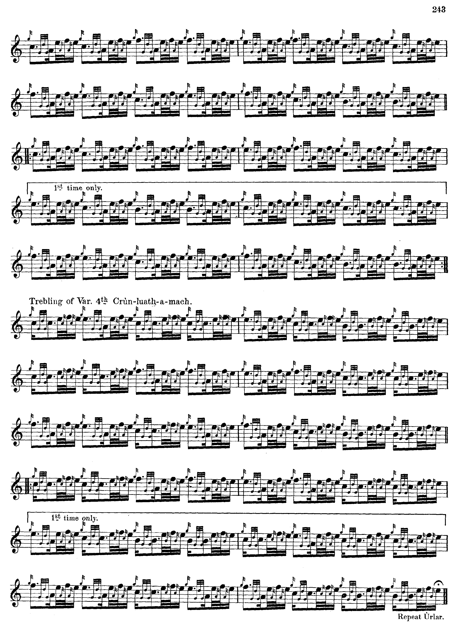

Glen’s solution to the problem of the second line in the ground is slightly different from Thomason’s but still fails to produce a metrically convincing reading, although there are various features of his score which do commend themselves, such as his varied timing of the siubhal, pointing the singling “down” and the doubling “up”. In his manuscript setting both movements are pointed “down”. Glen and Thomason were, of course, fairly close musical colleagues and both give Colin Cameron as their source for this late addition to the 19th century canon. Colin’s hand was rather untidy, as readers of this site will be aware, and the problem may lie in a misreading of note values in the affected line. They could perhaps be read as follows:

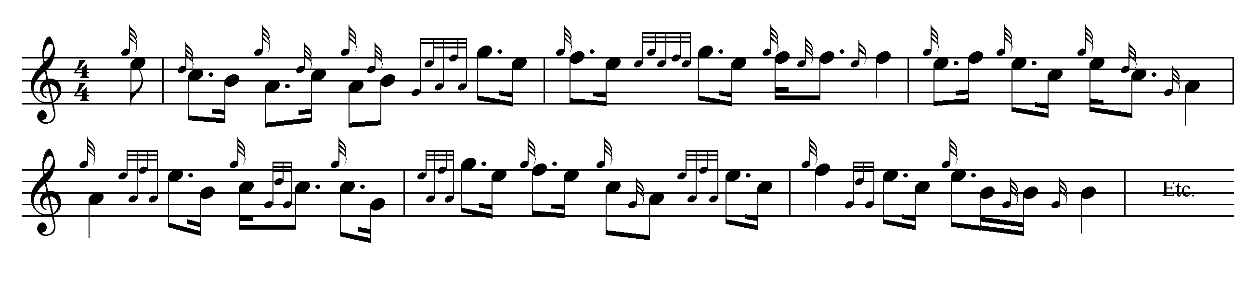

*Commentary:*

In view of the deficiencies in Glen and Thomason’s grounds--both seem “out” in the second line of the ground, we find ourselves in the somewhat unusual situation of preferring the emended setting attributed to John MacDougall Gillies in the *Piobaireachd Society Collection* (second series) as the best available version.

In the winter of 1948 Bob Brown wrote to Archibald Campbell requesting guidance on the “approved” interpretations of certain tunes (presumably “set” for that year) of which this was one. Campbell replied:

14 Letham Road

Cambridge

7.2.48.

My Dear Brown,

Many thanks for your letter. […] I am afraid that I cannot be much help, as, once more, these are tunes which I was not taught. […]

My dearest on Earth. I sometimes wonder whether this is the same tune as one in John Bruce’s list for the 1832 competition. “The Lovely Lady’s Request”, “Iarrtas na bain tighearn Bridhraich”. It is not in any of the manuscripts and seems to have been supplied by Colin Cameron to General Thomason, and to Glen who published it as the last tune in his book. Both versions are much the same, though I think that Glen’s is written the more intelligently. Glen also has the G grace note on E in line 2 bar 5 of the ground. I can’t lay my hand on the original score that General Thomason had, and I am not sure that I have ever seen it.

Little is known of the background of the tune. “Fionn”’s note in David Glen’s published collection seems entirely speculative:

This pleasant tune is evidently the composition of some amorous piper who seeks to impress on his sweetheart the sincerity of his affection by means of his *pìob-mhór.* ("Historic, Legendary and Biographic Notes," p.21)

“Luaidh mo Chridhe” has powerful echoes of other pieces. It is almost as if somebody had violently collided “The Young Laird of Dungallon” with “The Lament for MacLeod of Colbecks”. Indeed it sounds very much like an uncollected composition of John MacKay (Angus’s father), who seems to been perfectly content to re-work similar motifs in successive compositions and whose tunes seem frequently to display the sprawling over-development we see above. It seems, at least to the present writer, an immensely dull tune, and it is not obvious what could be done to remedy this, since the tone row is insufficiently tensioned to support so large a structure.

* * *

Electronic text © Dr. William Donaldson, Aberdeen, Scotland 11th June 2012.