Mrs. Smith’s Salute

There are settings of this tune in the following manuscript sources:

--**Angus MacKay**’s MS, i,.205-7 (and also in his so-called “Kintarbert MS”);

--**Colin Cameron**’s MS, ff.39-40;

--**Duncan Campbell of Foss**’s MS, ff.65-68;

--**Uilleam Ross**’s MS, ff.6-9;

--**Ronald MacKenzie**’s MSS (NLS MS 22125, 73-82, with title “Failte Bantighearna Mhic a Gobhainn. Mrs Smith’s Salute Composed by John MacKenzie Taymouth Castle Anno. 18.”

--**D. S. MacDonald**’s MS, i, 53-55;

--**John MacDougall Gillies**’s MS, ff.80-81;

and in the following published sources:

--**C. S. Thomason**, *Ceol Mor,* p.35(Thomason gives Colin Cameron as his source for this tune along with Angus MacKay's MS);

--**David Glen**, *Ancient Piobaireachd,* pp.118-9 (Glen says: “Composed by John McKenzie.”)

**Angus MacKay** sets the tune as follows:

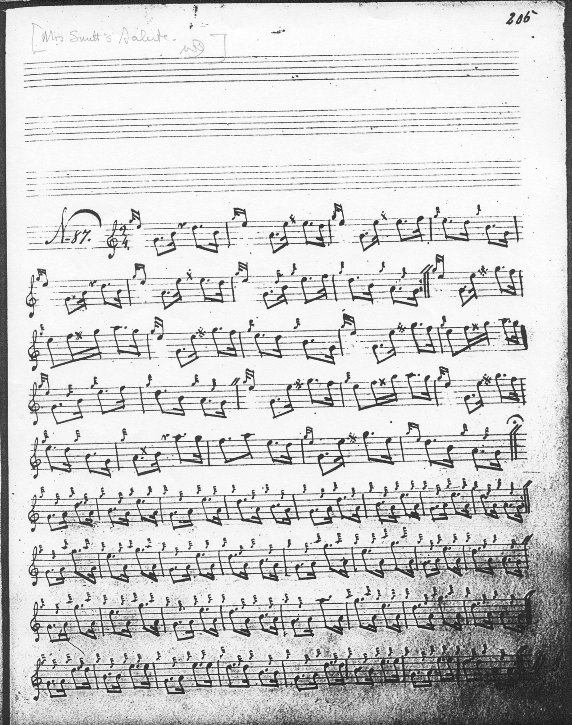

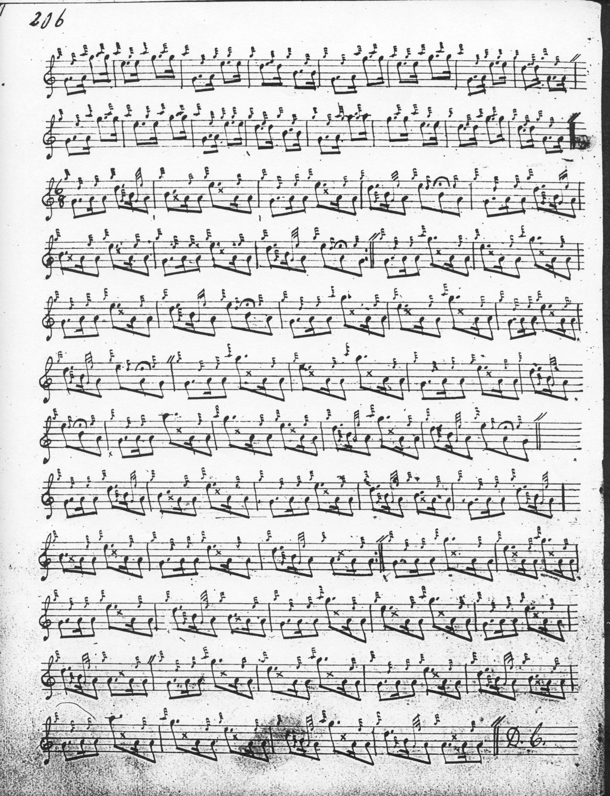

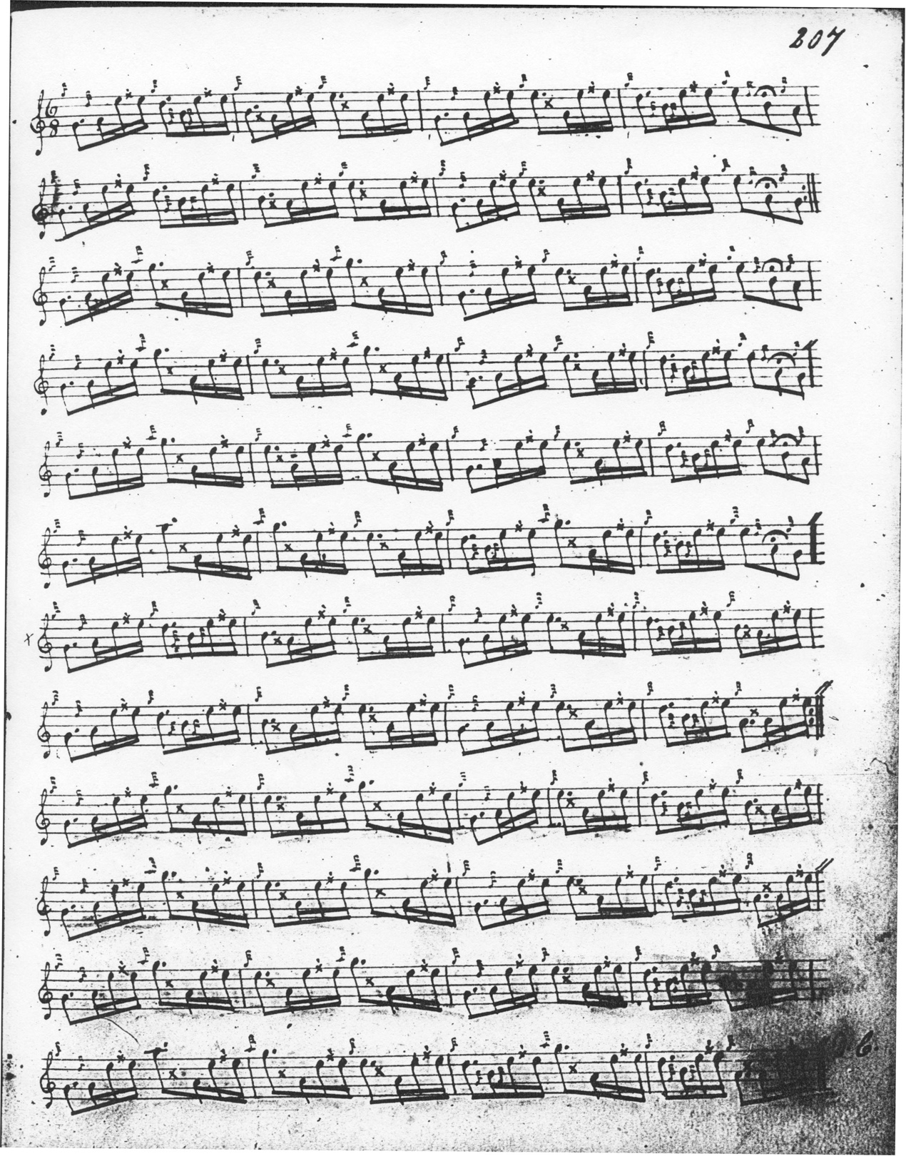

**Colin Cameron** sets the tune like this:

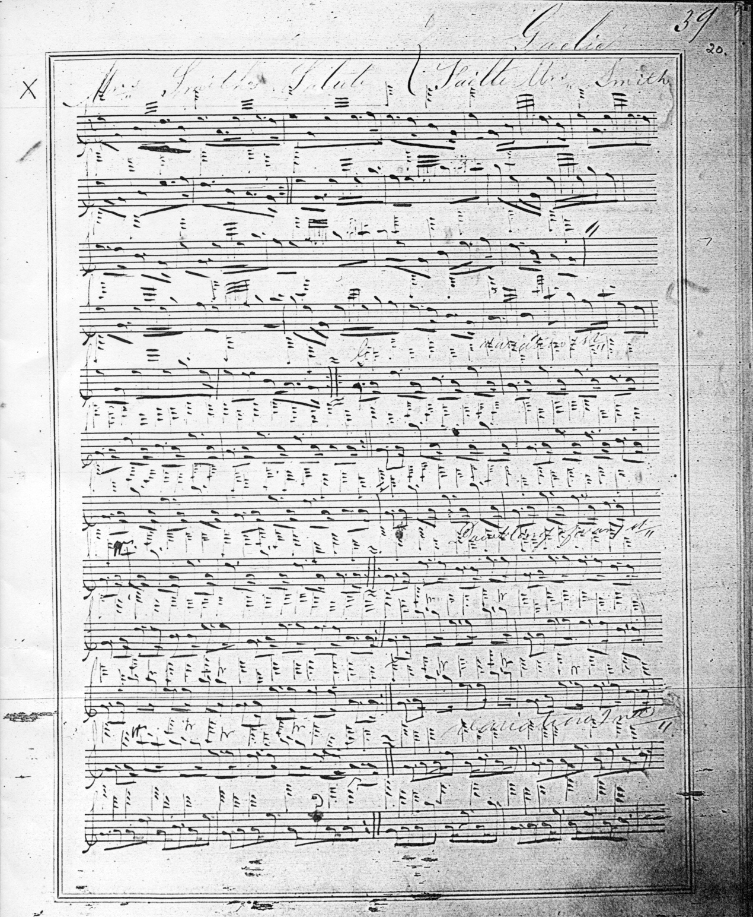

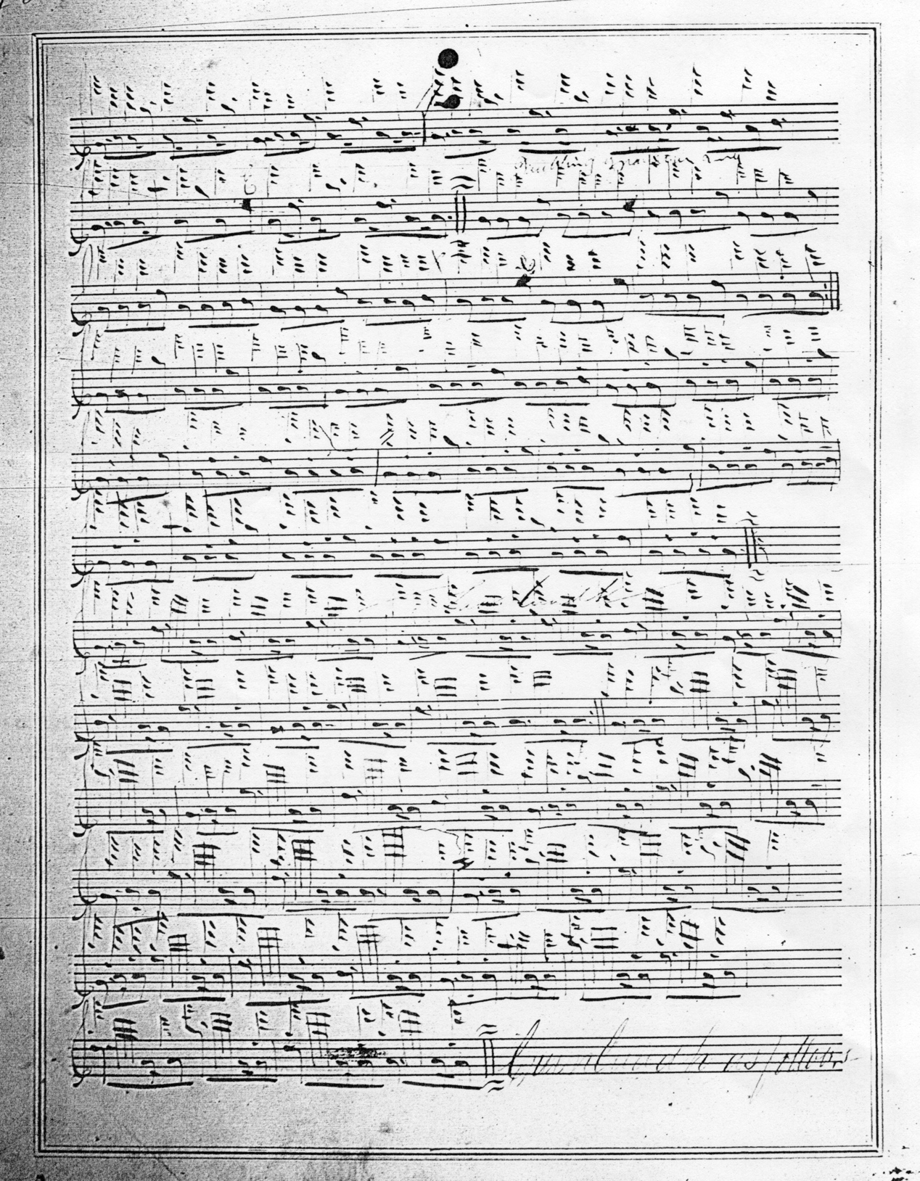

Colin Cameron has a variation, a pendulum movement, followed by a taorluath fosgailte which MacKay does not have. Colin takes his score down to the end of the duinte taorluath that follows the fosgailte variation and closes with the words “Crunluadh vs. follows”.

The scores of **Duncan Campbell of Foss**, **Uilleam Ross** and **D. S. MacDonald** add nothing significant to Angus MacKay’s setting of the tune, and are not reproduced here. **John MacDougall Gillies**’s score is incomplete, proceeding only as far as the taorluath singling, although Gillies does record in a later note a sketch of the pendulum movement and taorluath fosgailte recorded by Colin Cameron. Gillies’s score is not reproduced here.

Of the published settings, **C. S. Thomason**’s score combines Angus MacKay’s ground and taorluath/crunluath, with the attractive pendulum movement and taorluath fosgailte which came down through Colin Cameron. Since Thomason’s score adds little of expressive significance to the tune it is not reproduced here.

**David Glen**’s seems the best of the published versions and offers a good playing score for the tune. Glen does not contribute anything particularly new, but his score is beautifully presented, and it includes Colin Cameron’s variations which so much enhance the tune.

**David Glen** sets the tune like this:

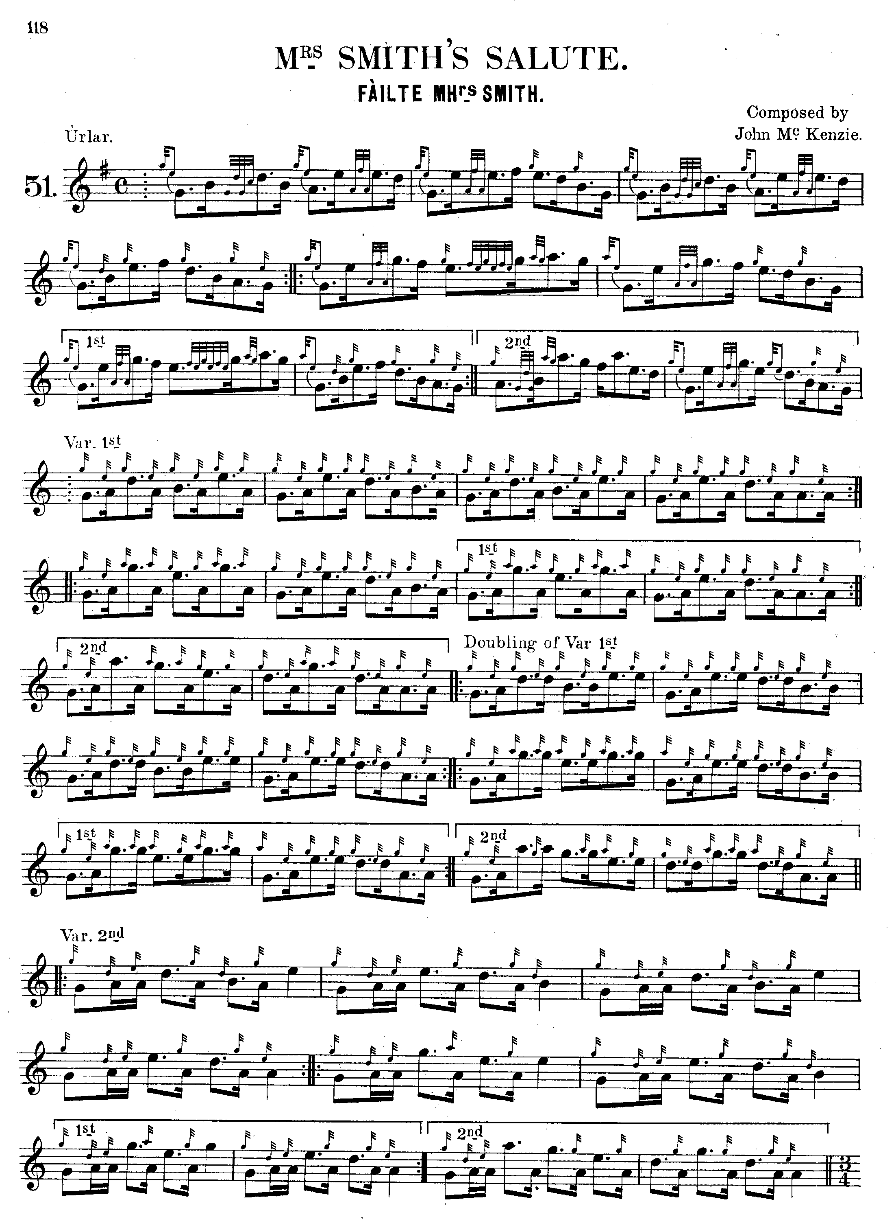

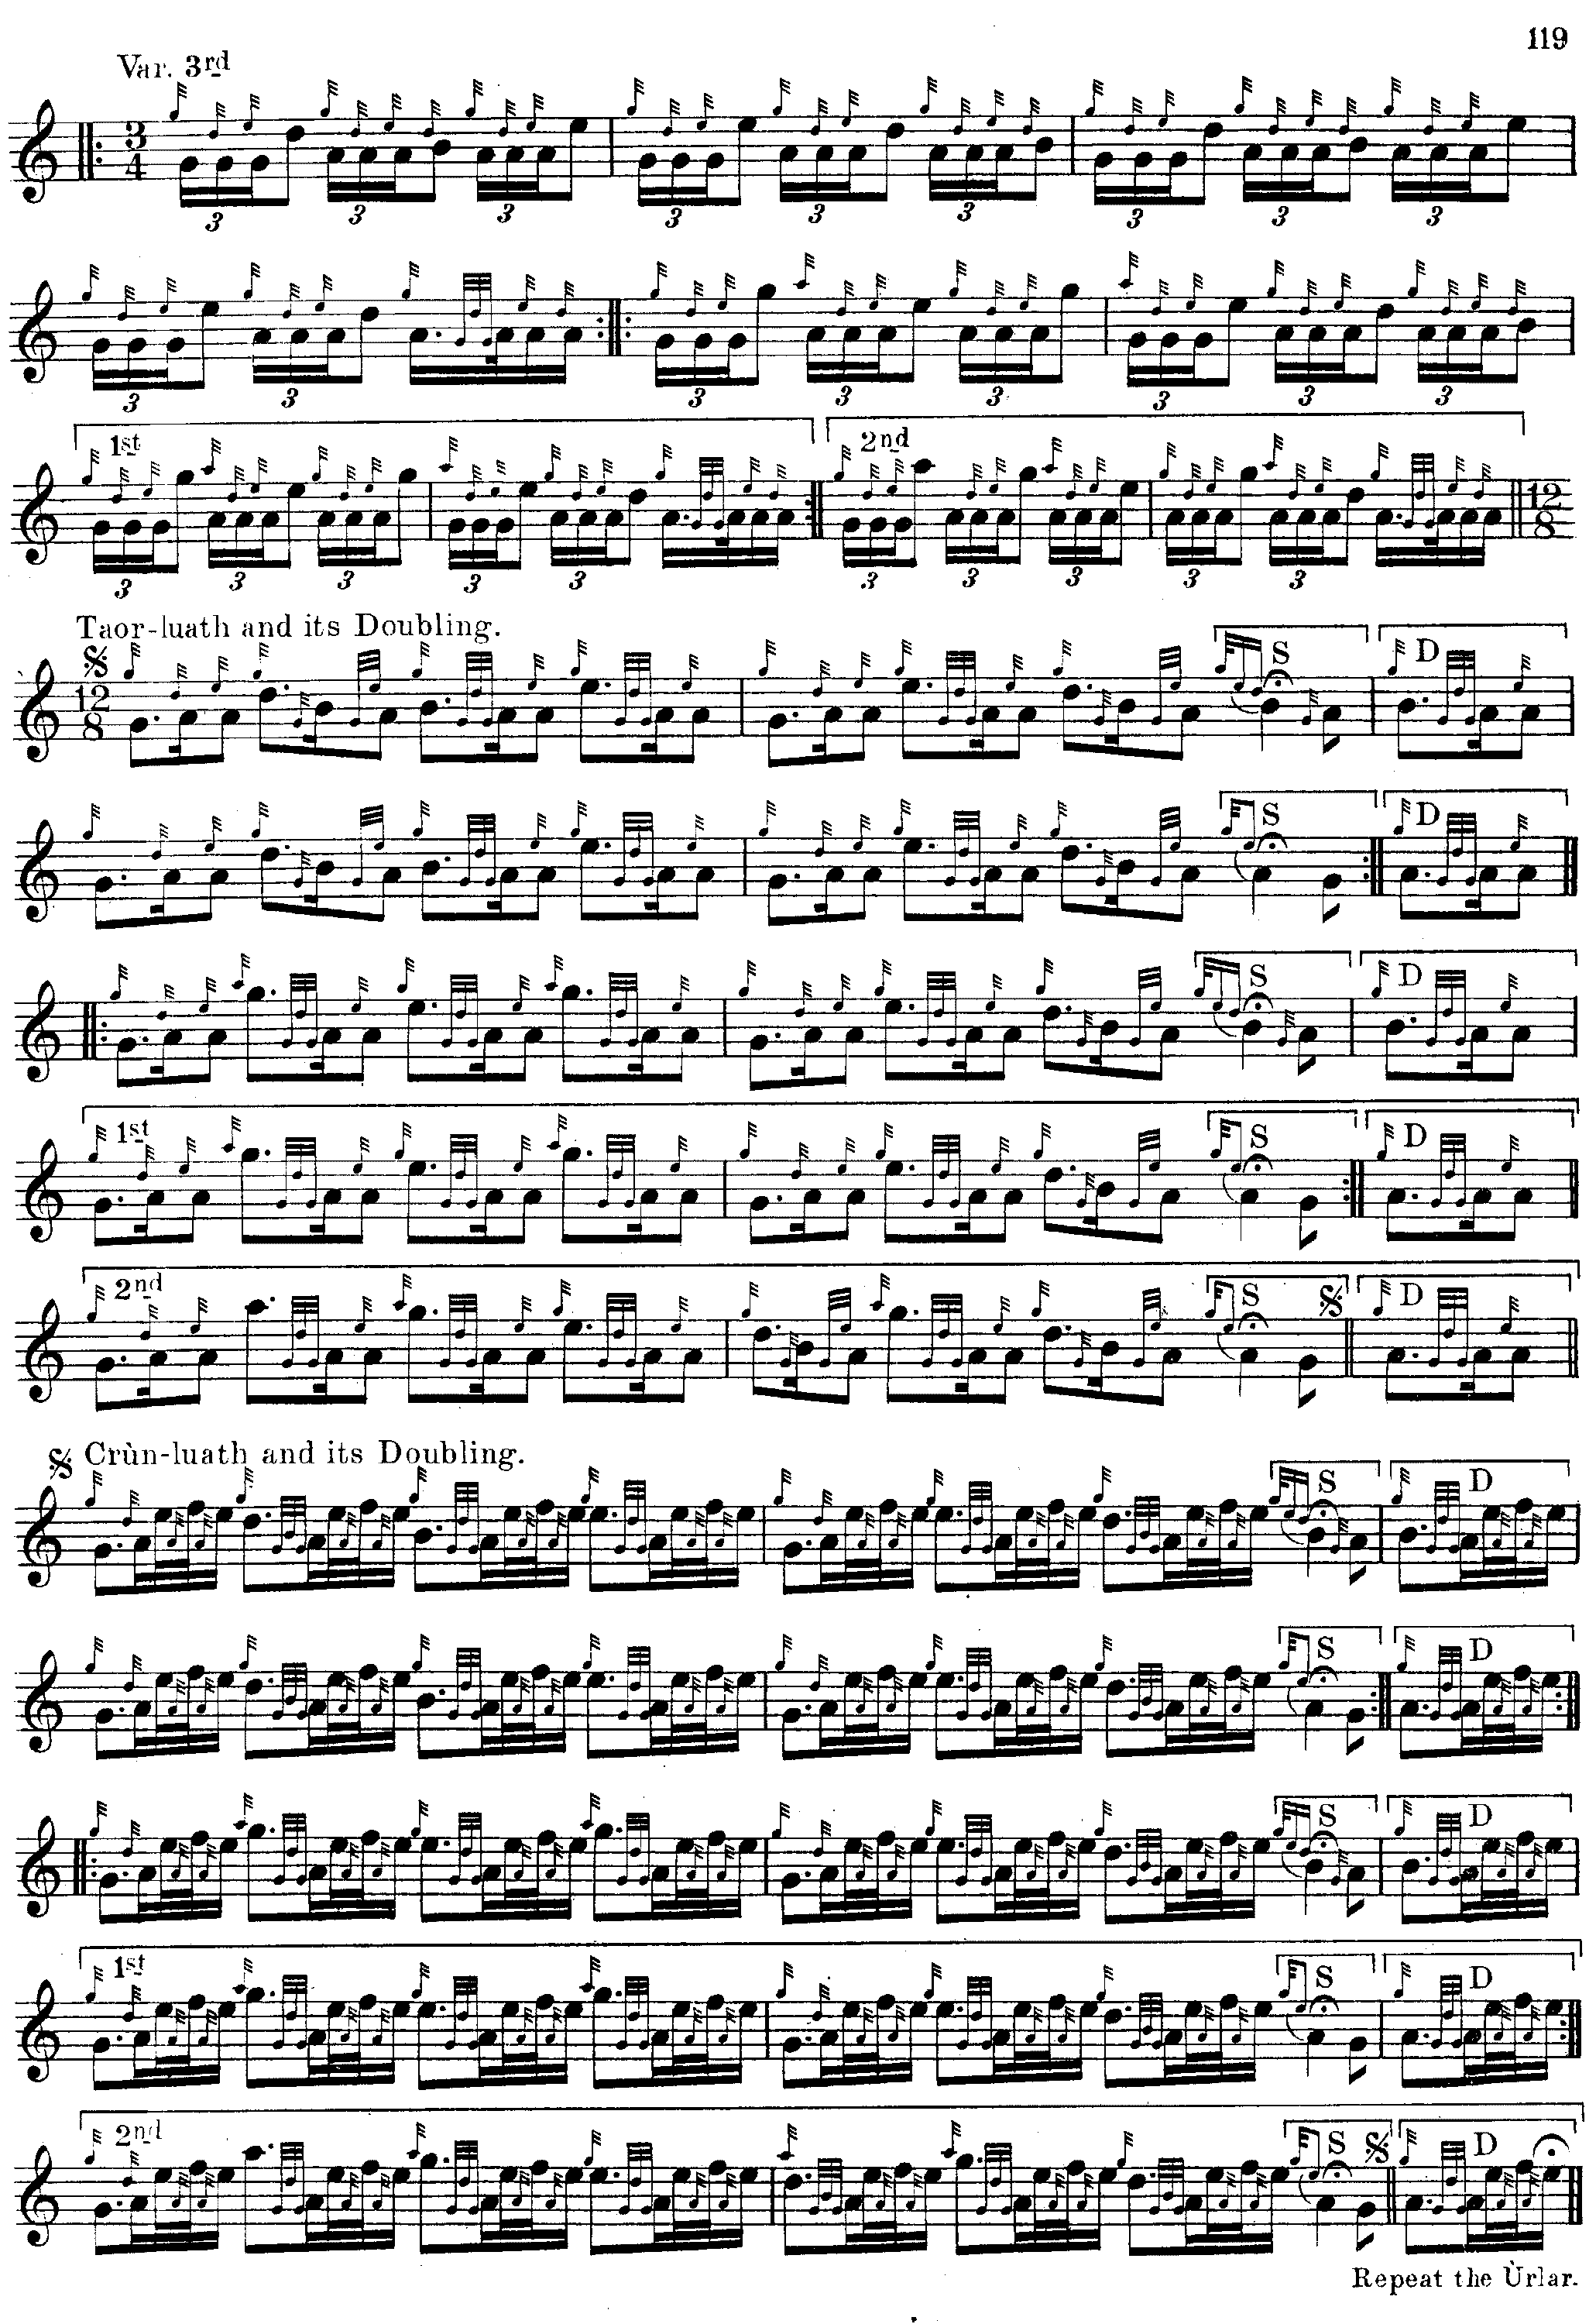

*Commentary:*

The widely diffused record suggests that this 19th century composition was once more popular, perhaps, than it has been in more recent years. Also, and most interestingly in view of what it implies about the variety of tradition especially since this was a recently composed tune.

In his “Historic, Biographic and Legendary Notes to the Tunes” attached to David Glen's *Ancient Piobaireachd,* piping historian Henry Whyte ("Fionn") says:

**Mrs Smith's Salute**

**Fàilte Mhrs. Smith.**

This is the only specimen of a Piobaireachd we have from John Bàn Mackenzie. It is understood Mrs Smith was a lady belonging to a Highland family, and was resident for a time at Taymouth Castle when John Ban Mackenzie was piper to the Marquis of Breadalbane. It was doubtless to her he also composed “Mrs Smith's Reel.” “*Am pìobaire Bàn,*” as this piper was familiarly called, was born near Dingwall in 1796, and died at Munlochy, Ross‑shire, in 1864. He was for twenty‑eight years piper at Taymouth. He was a fine specimen of a Highlander, and a capable exponent of the *piòb‑mhòr.*  He composed a number of tunes, one of the best known being “Mackenzie's Farewell to Sutherland.” He was one of the few who held the title of “King of Pipers.”

The tune is preserved in Angus MacKay’s so-called “Kintarbert Manuscript” where composers are sometimes indicated. Mrs. Smith’s Salute is marked “By John MacKenzie. 1837.” Angus seems a little out in his dates: “Mrs. Smith’s Salute” was one of the tunes offered in the Edinburgh piping competition in 1829.

Here is a striking representation of John Bàn, from a recently rediscovered portrait, probably done at Taymouth Castle:

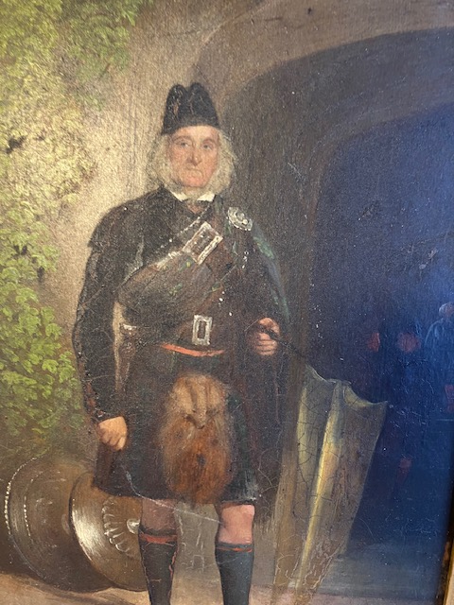

* * *

Electronic text © Dr William Donaldson, Aberdeen, Scotland, 23 July 2010; revised Cambridge Massachusetts, February 2025