Mrs. MacLeod of Talisker’s Salute

There are two Talisker salutes, one for the laird and one for the lady. Talisker was the chief cadet family of the MacLeods of MacLeod.
There are settings of this tune in the following manuscript sources:
--Angus MacKay’s MS, ii, 13-15;
--Colin Cameron’s MS, ff.94-95;
--Duncan Campbell of Foss’s MS, ff.69-72;
--Uilleam Ross’s MS, ff.98-101;
--David Glen’s MS, ff.316-319’

and in the following published sources:
--Uilleam Ross’s Collection, pp.66-69
--C. S. Thomason’s, Ceol Mor, pp.284-5

Angus MacKay sets the tune as follows:

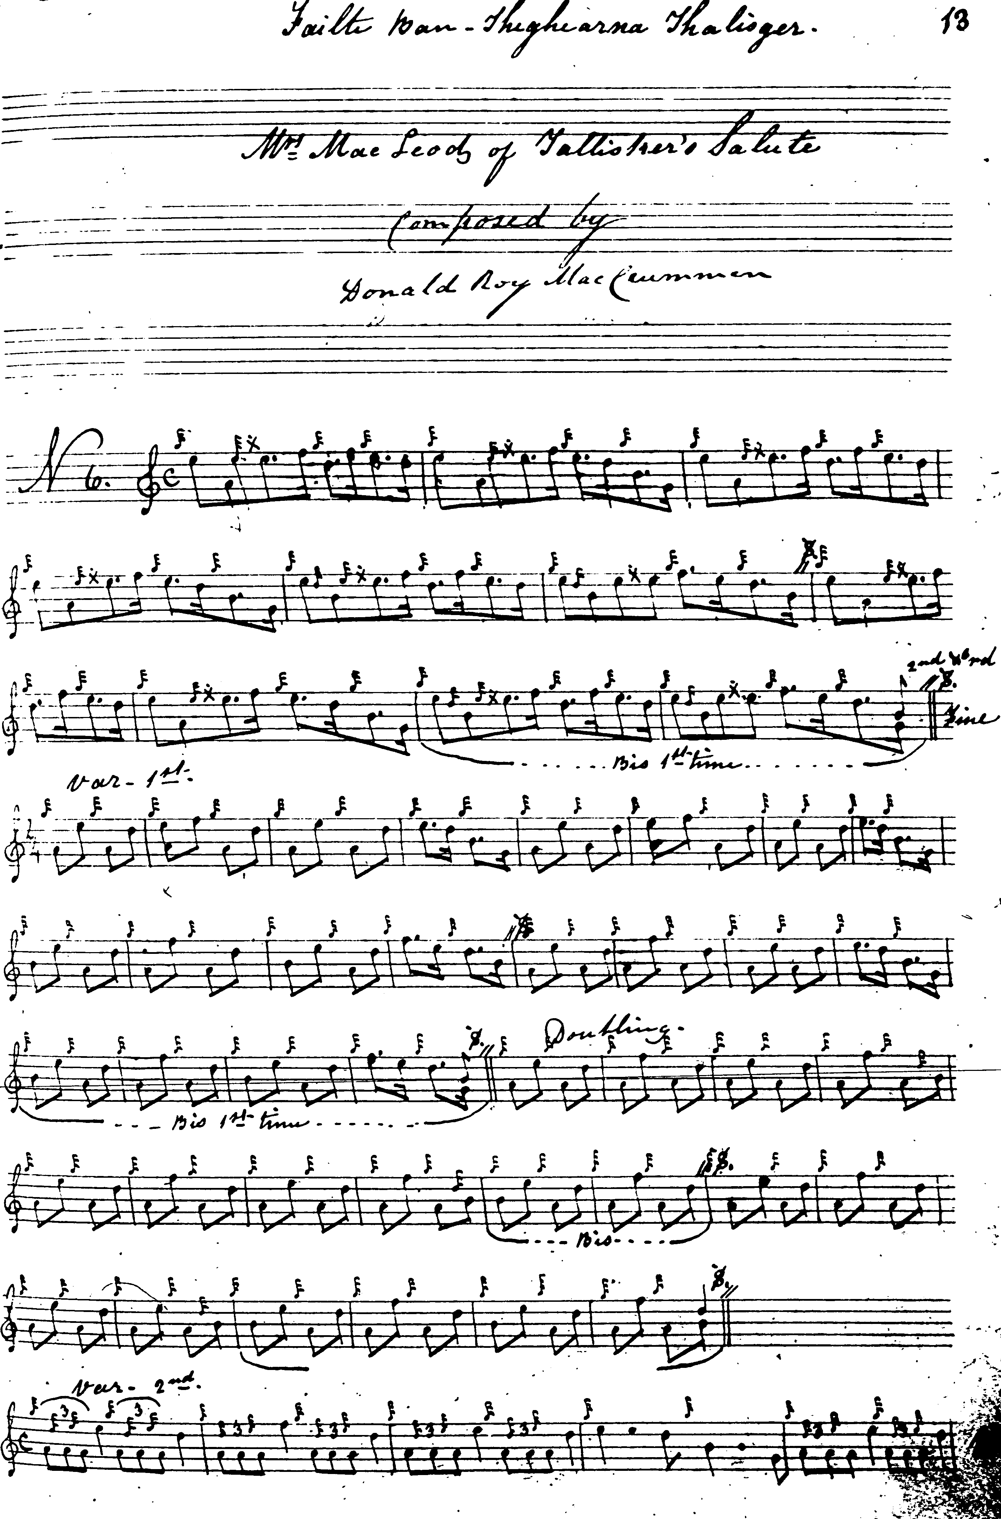
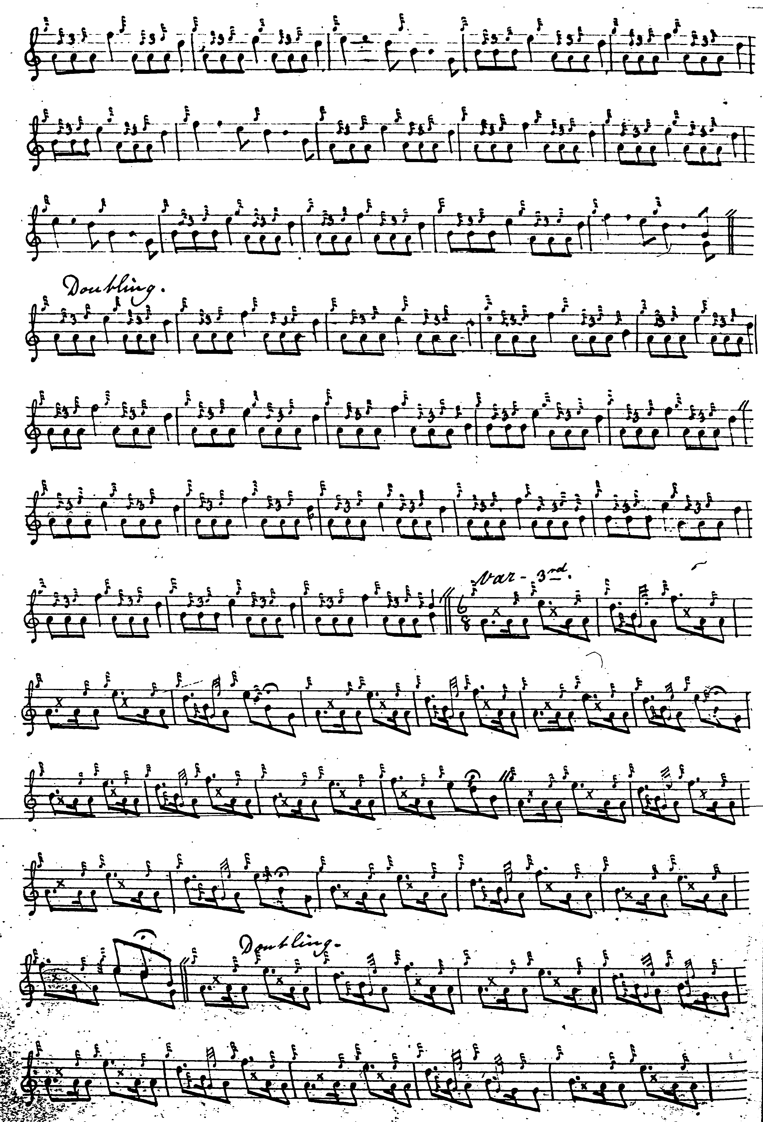
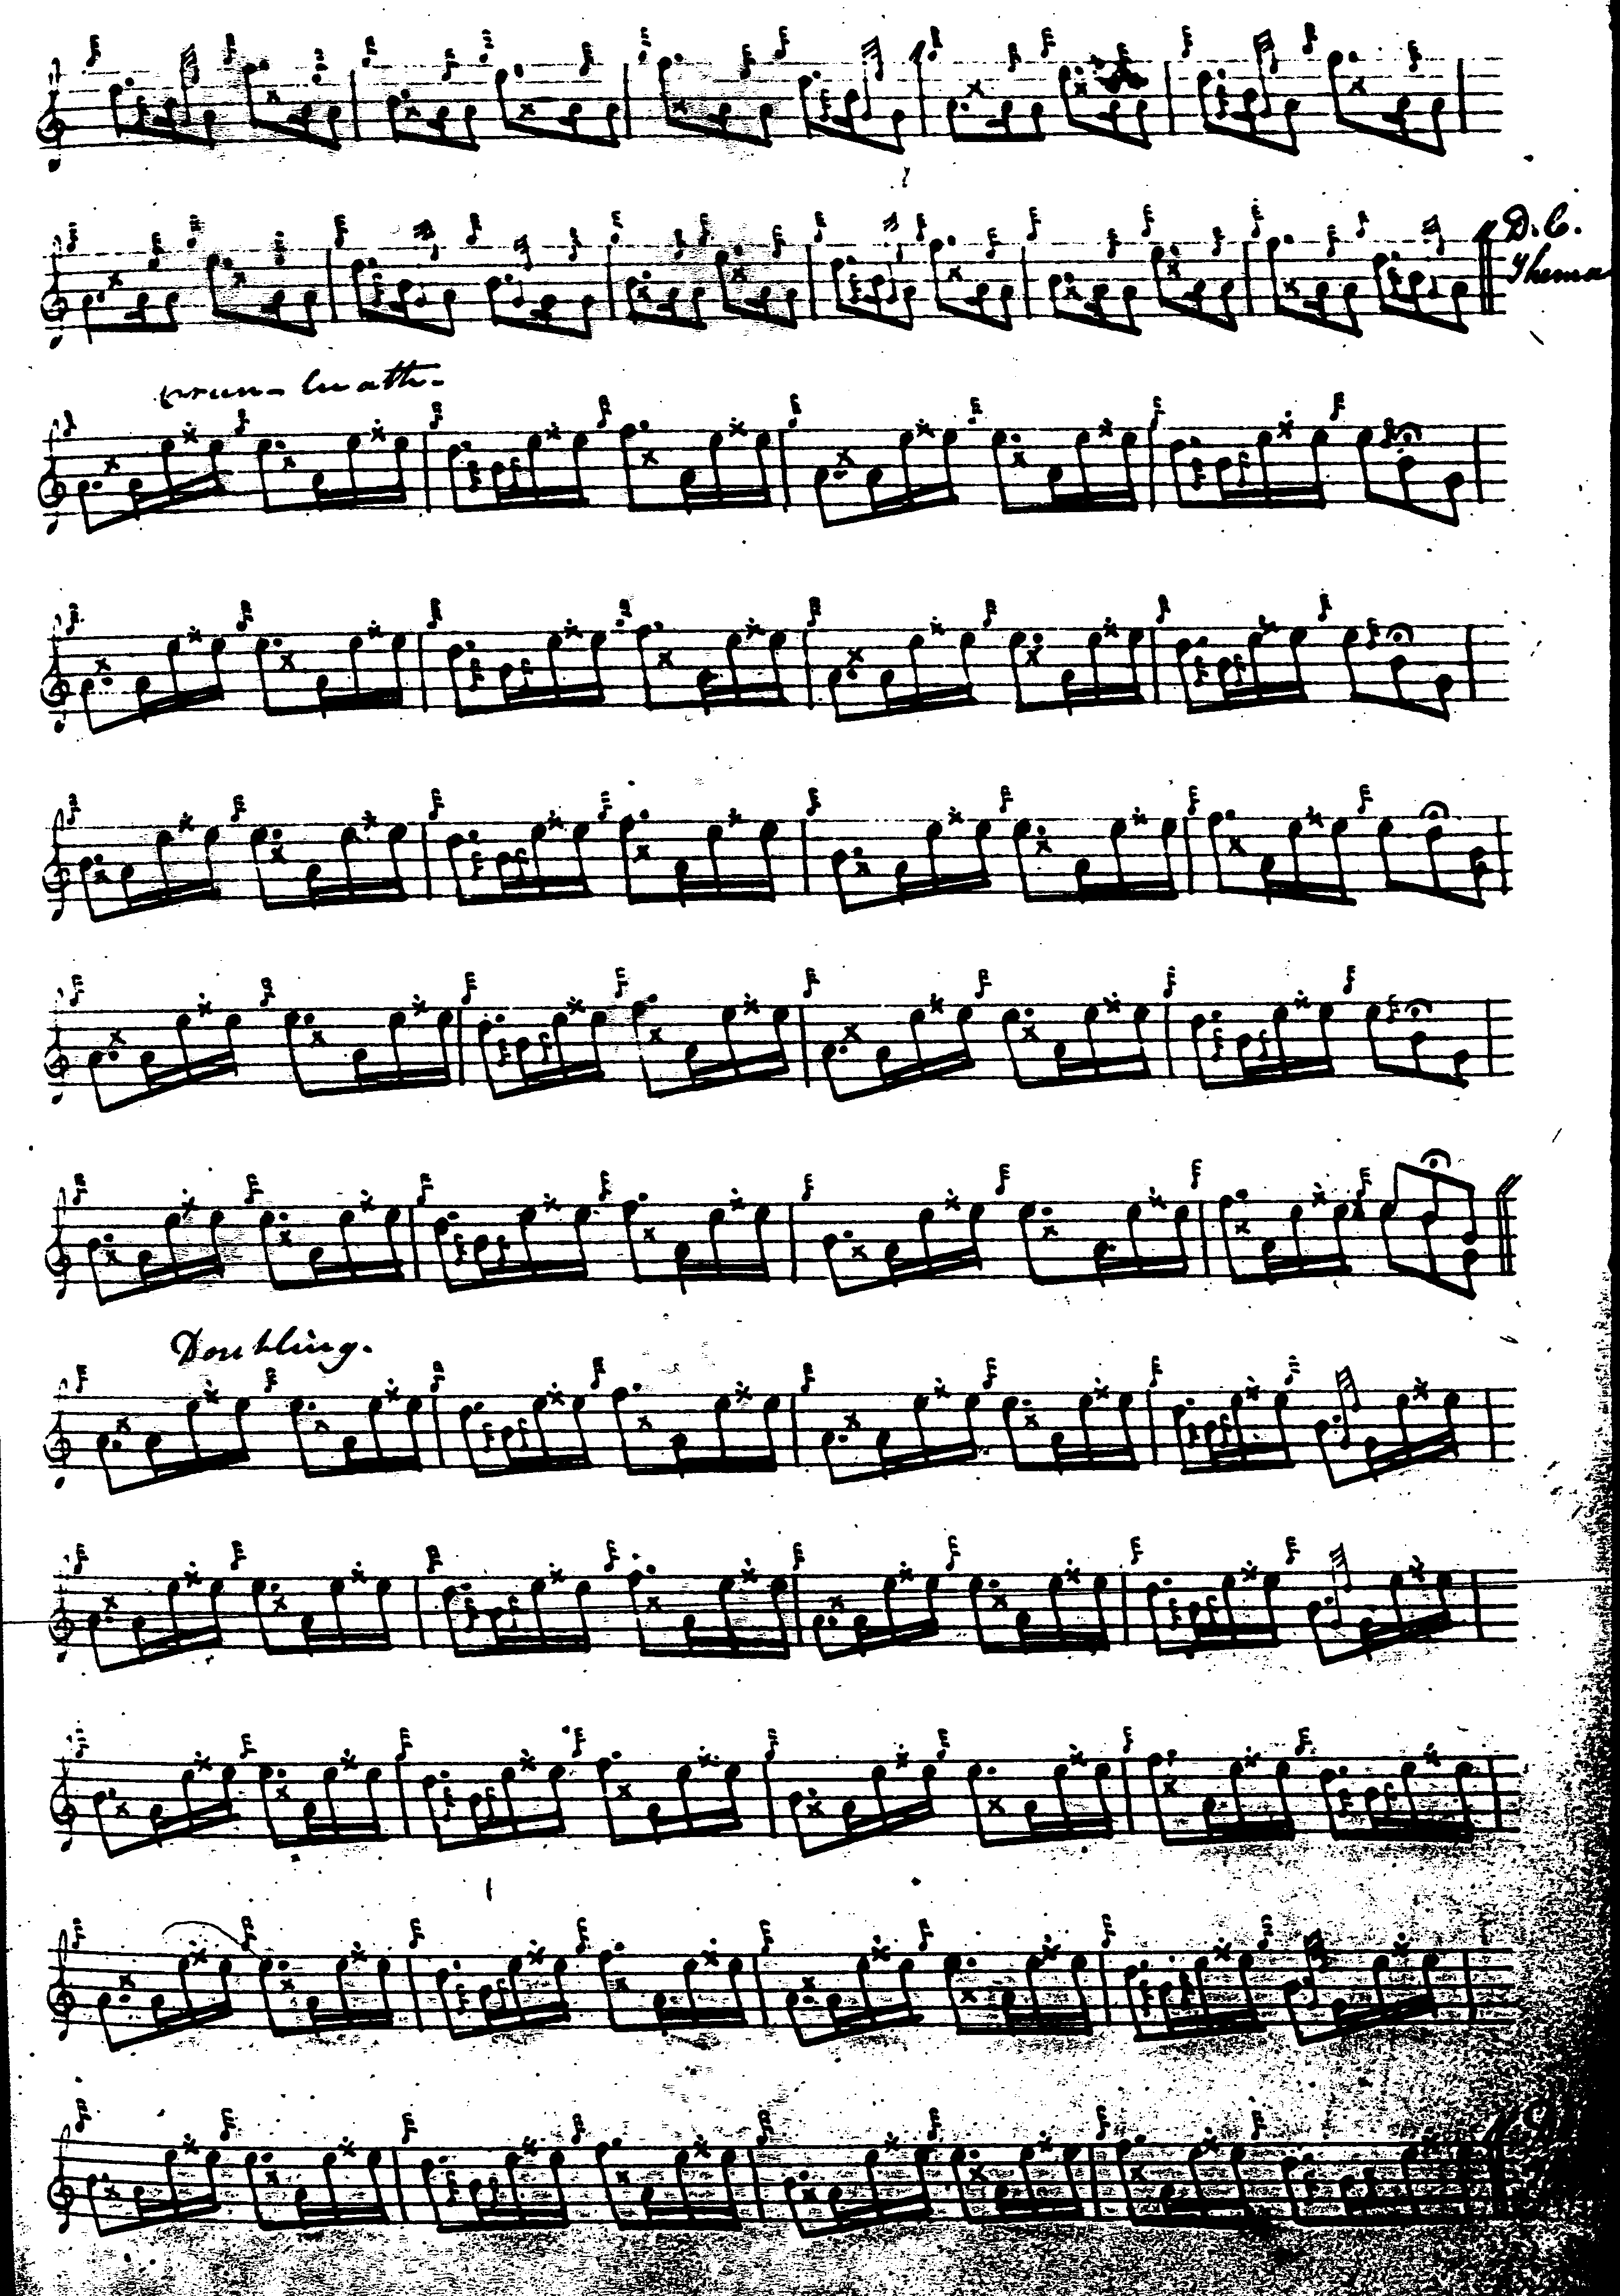

Angus MacKay times the 1st Variation and doubling as even quavers but with interesting and stylish little cut up from E to F in line one. The inclusion of taorluath variations in both fosgailte and duinte forms might be thought excessive in such a relatively slight piece, as might the instruction to repeat the ground at the end of the duinte taorluath doubling.
MacKay omits the dal segno marks which should be present in lines 3 and 4 from the taorluath fosgailte variation onwards. In his otherwise neat and orderly score, once the pattern has been unmistakably established he simply gives the first two lines of the succeeding variations leaving the player to construct line 3 for him/herself following the normal conventions. MacKay directs that the ground be repeated after the taorluath and crunluath doublings. He has no crunluath a mach.

Colin Cameron times the tune as follows:

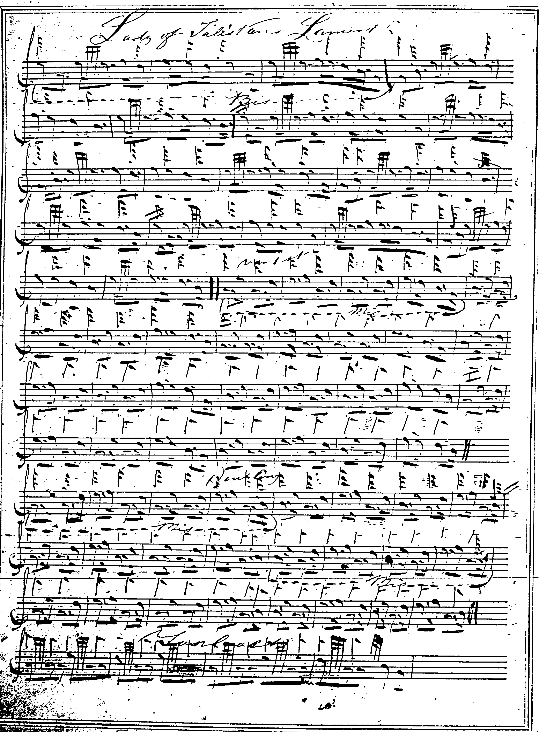
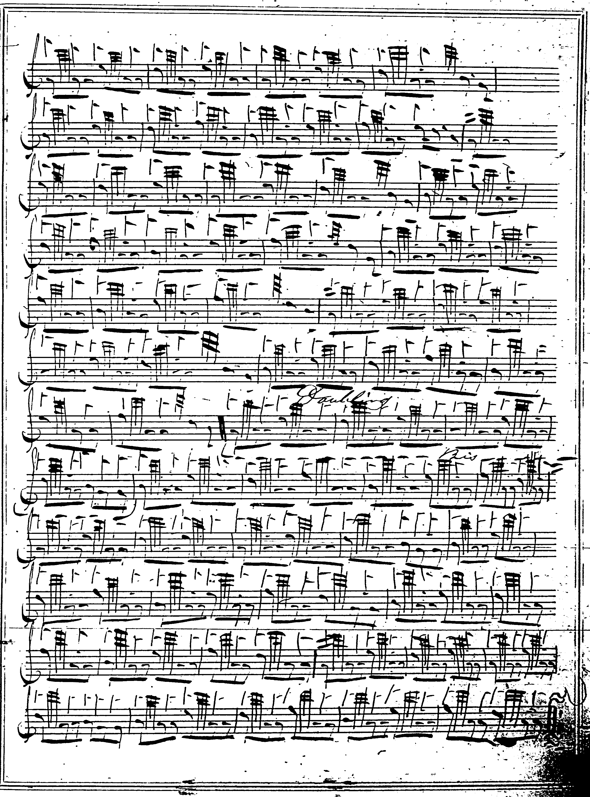

Colin Cameron’s title is “Lady of Talisker’s Lament”. He indicates all the dots and cuts; some might well prefer his first variation, which he points “down” to that of Angus MacKay, since in his doubling he does not alternate every melody note with low A or B, coming sometimes to E, which varies the pattern and gives a less “heavy” feel. Interestingly he drops the taorluath fosgailte and proceeds straight to a duinte taorluath singling from the end of his first variation doubling. His tone row is different from MacKay’s in the A phrase, preferring the more varied AEDE to MacKay’s AEDF which some may feel a more shapely disposition of the tune, in that the entry of the all-important F is delayed until the end of the line, creating a pleasing sense of climax. Colin Cameron’s score ends at the taorluath doubling: there’s no indication of a crunluath movement, although presumably one was intended.

Duncan Campbell of Foss adds nothing of significance to the other scores and is not reproduced here.

In his manuscript, Uilleam Ross times the ground and first variation as follows:

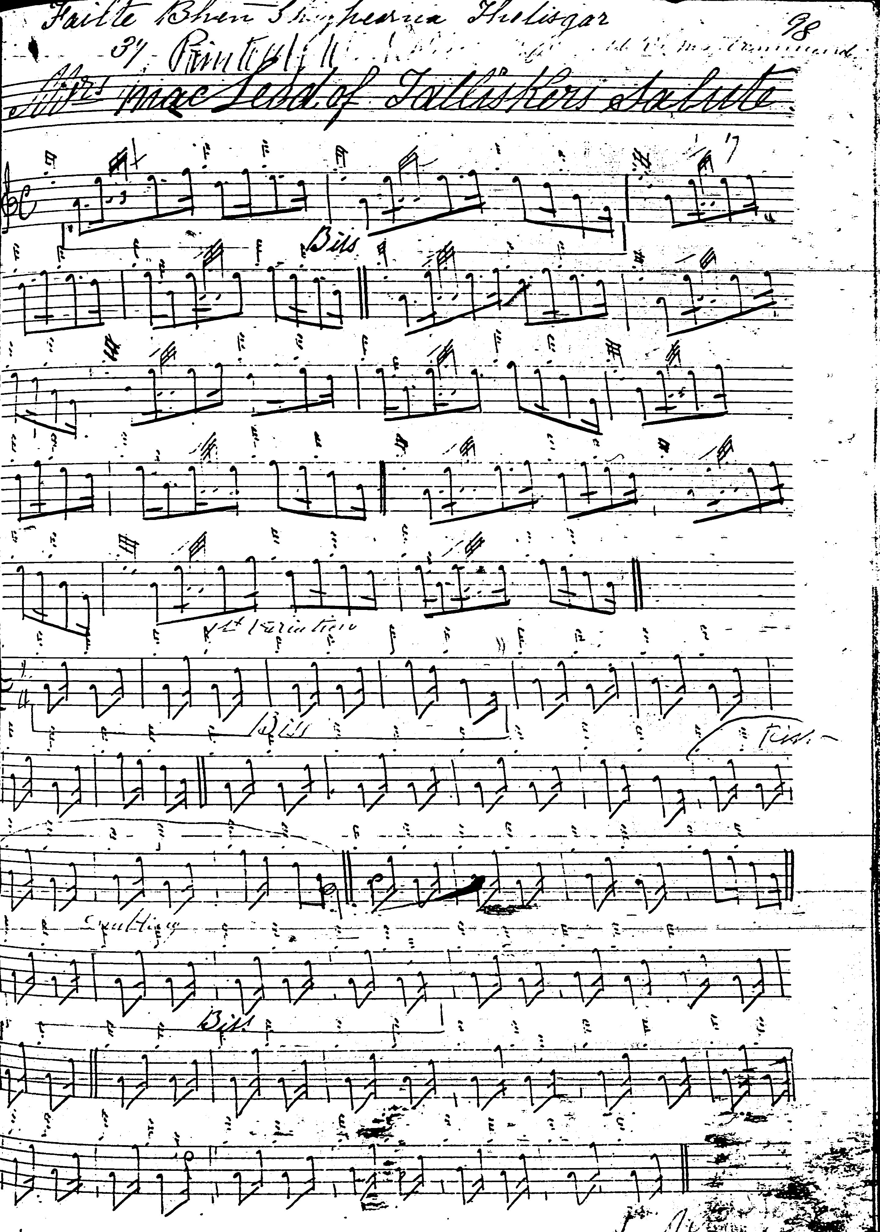
and so on.

The reader will note Ross’s interesting styling of variation one here.

David Glen’s score is very similar to Uilleam Ross’s, and adds little of significance to the earlier settings. It is not reproduced here.

Amongst the published scores, the setting in Uilleam Ross’s Collection—the earliest published version of the tune--shows a number of individual touches:

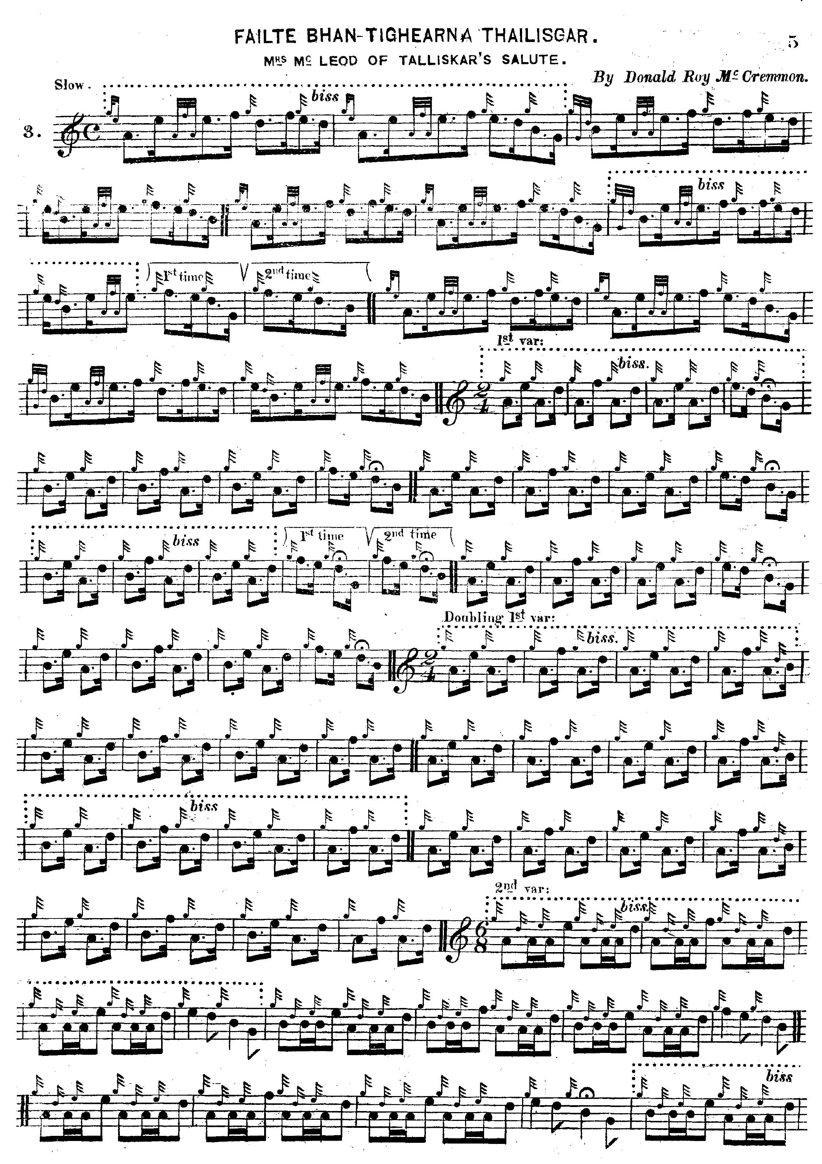

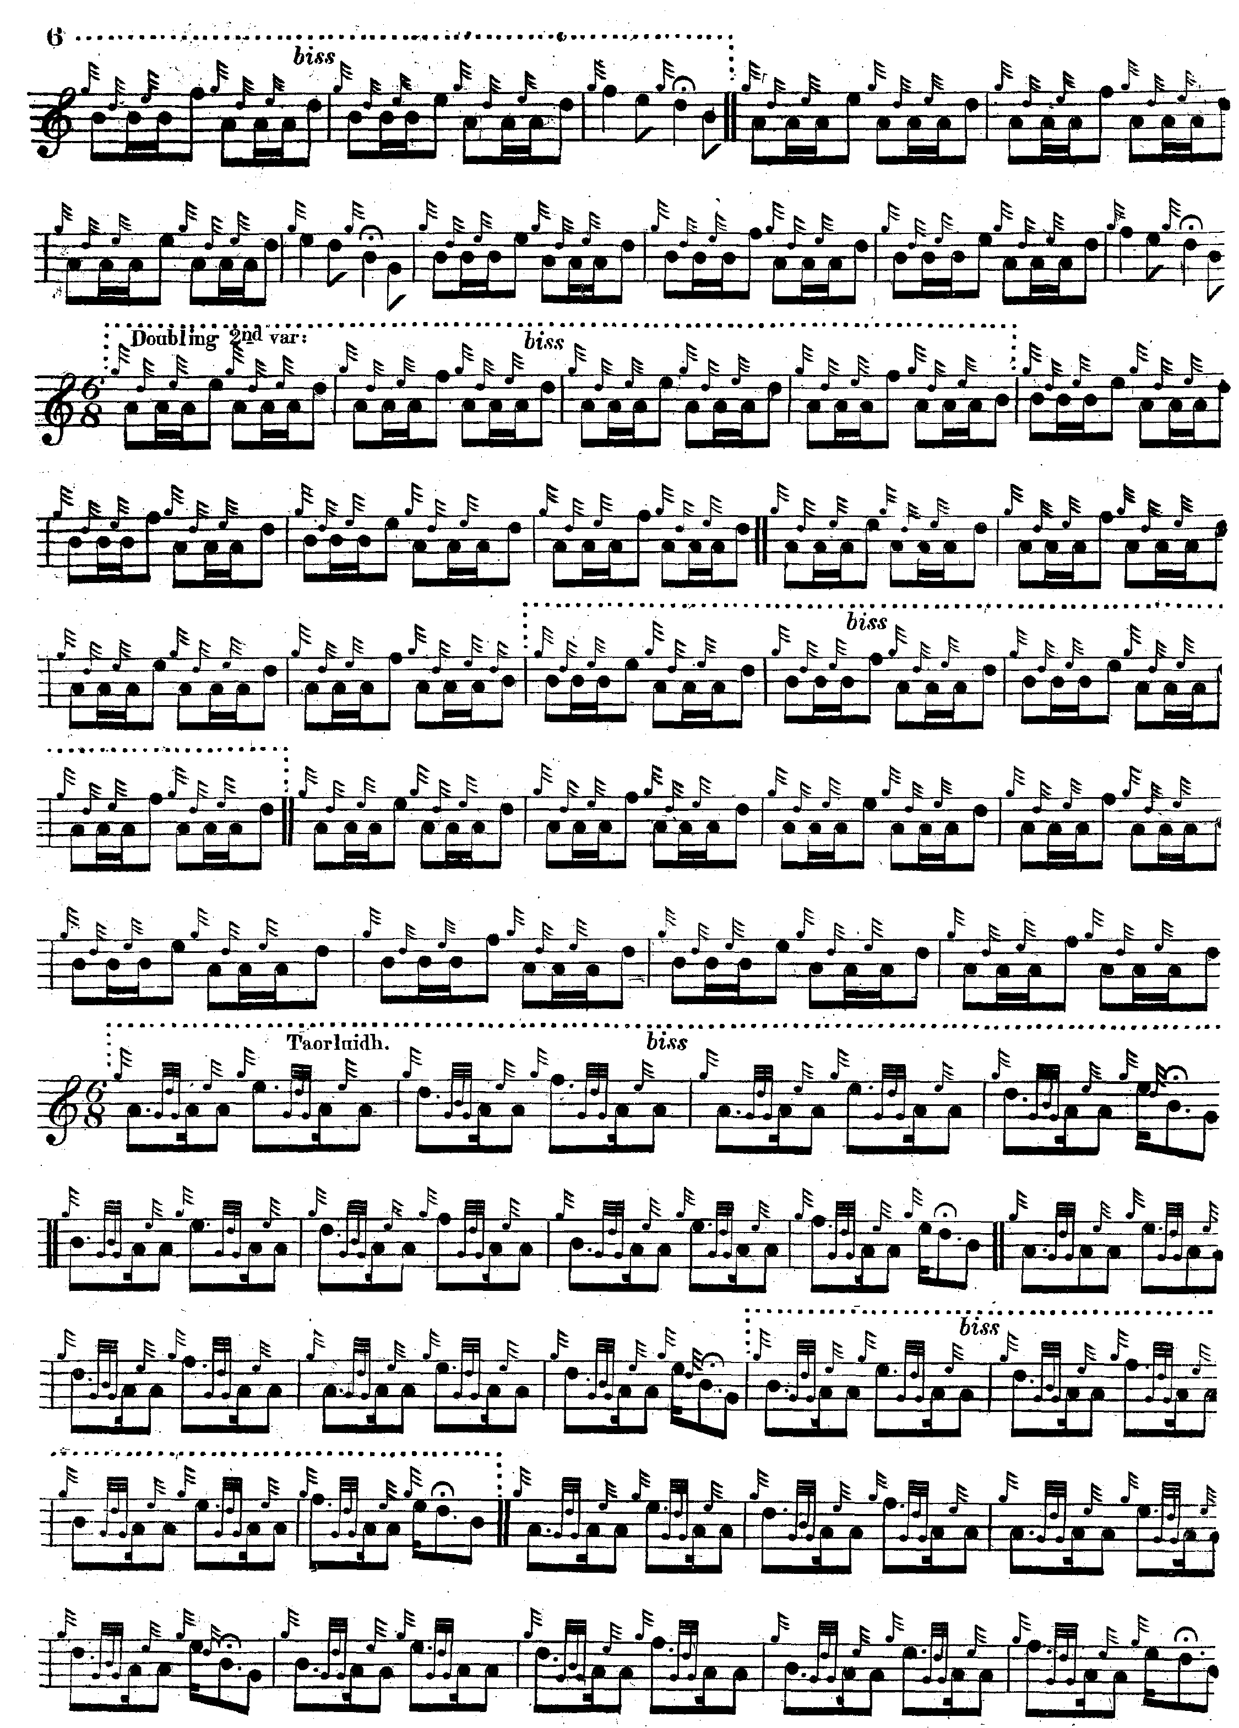
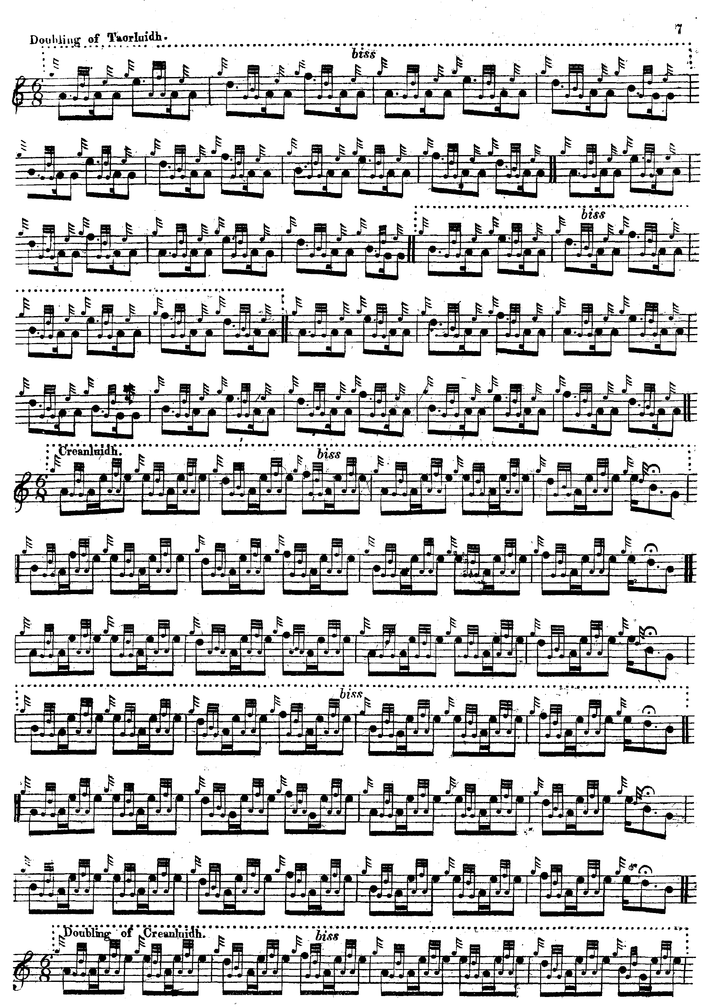
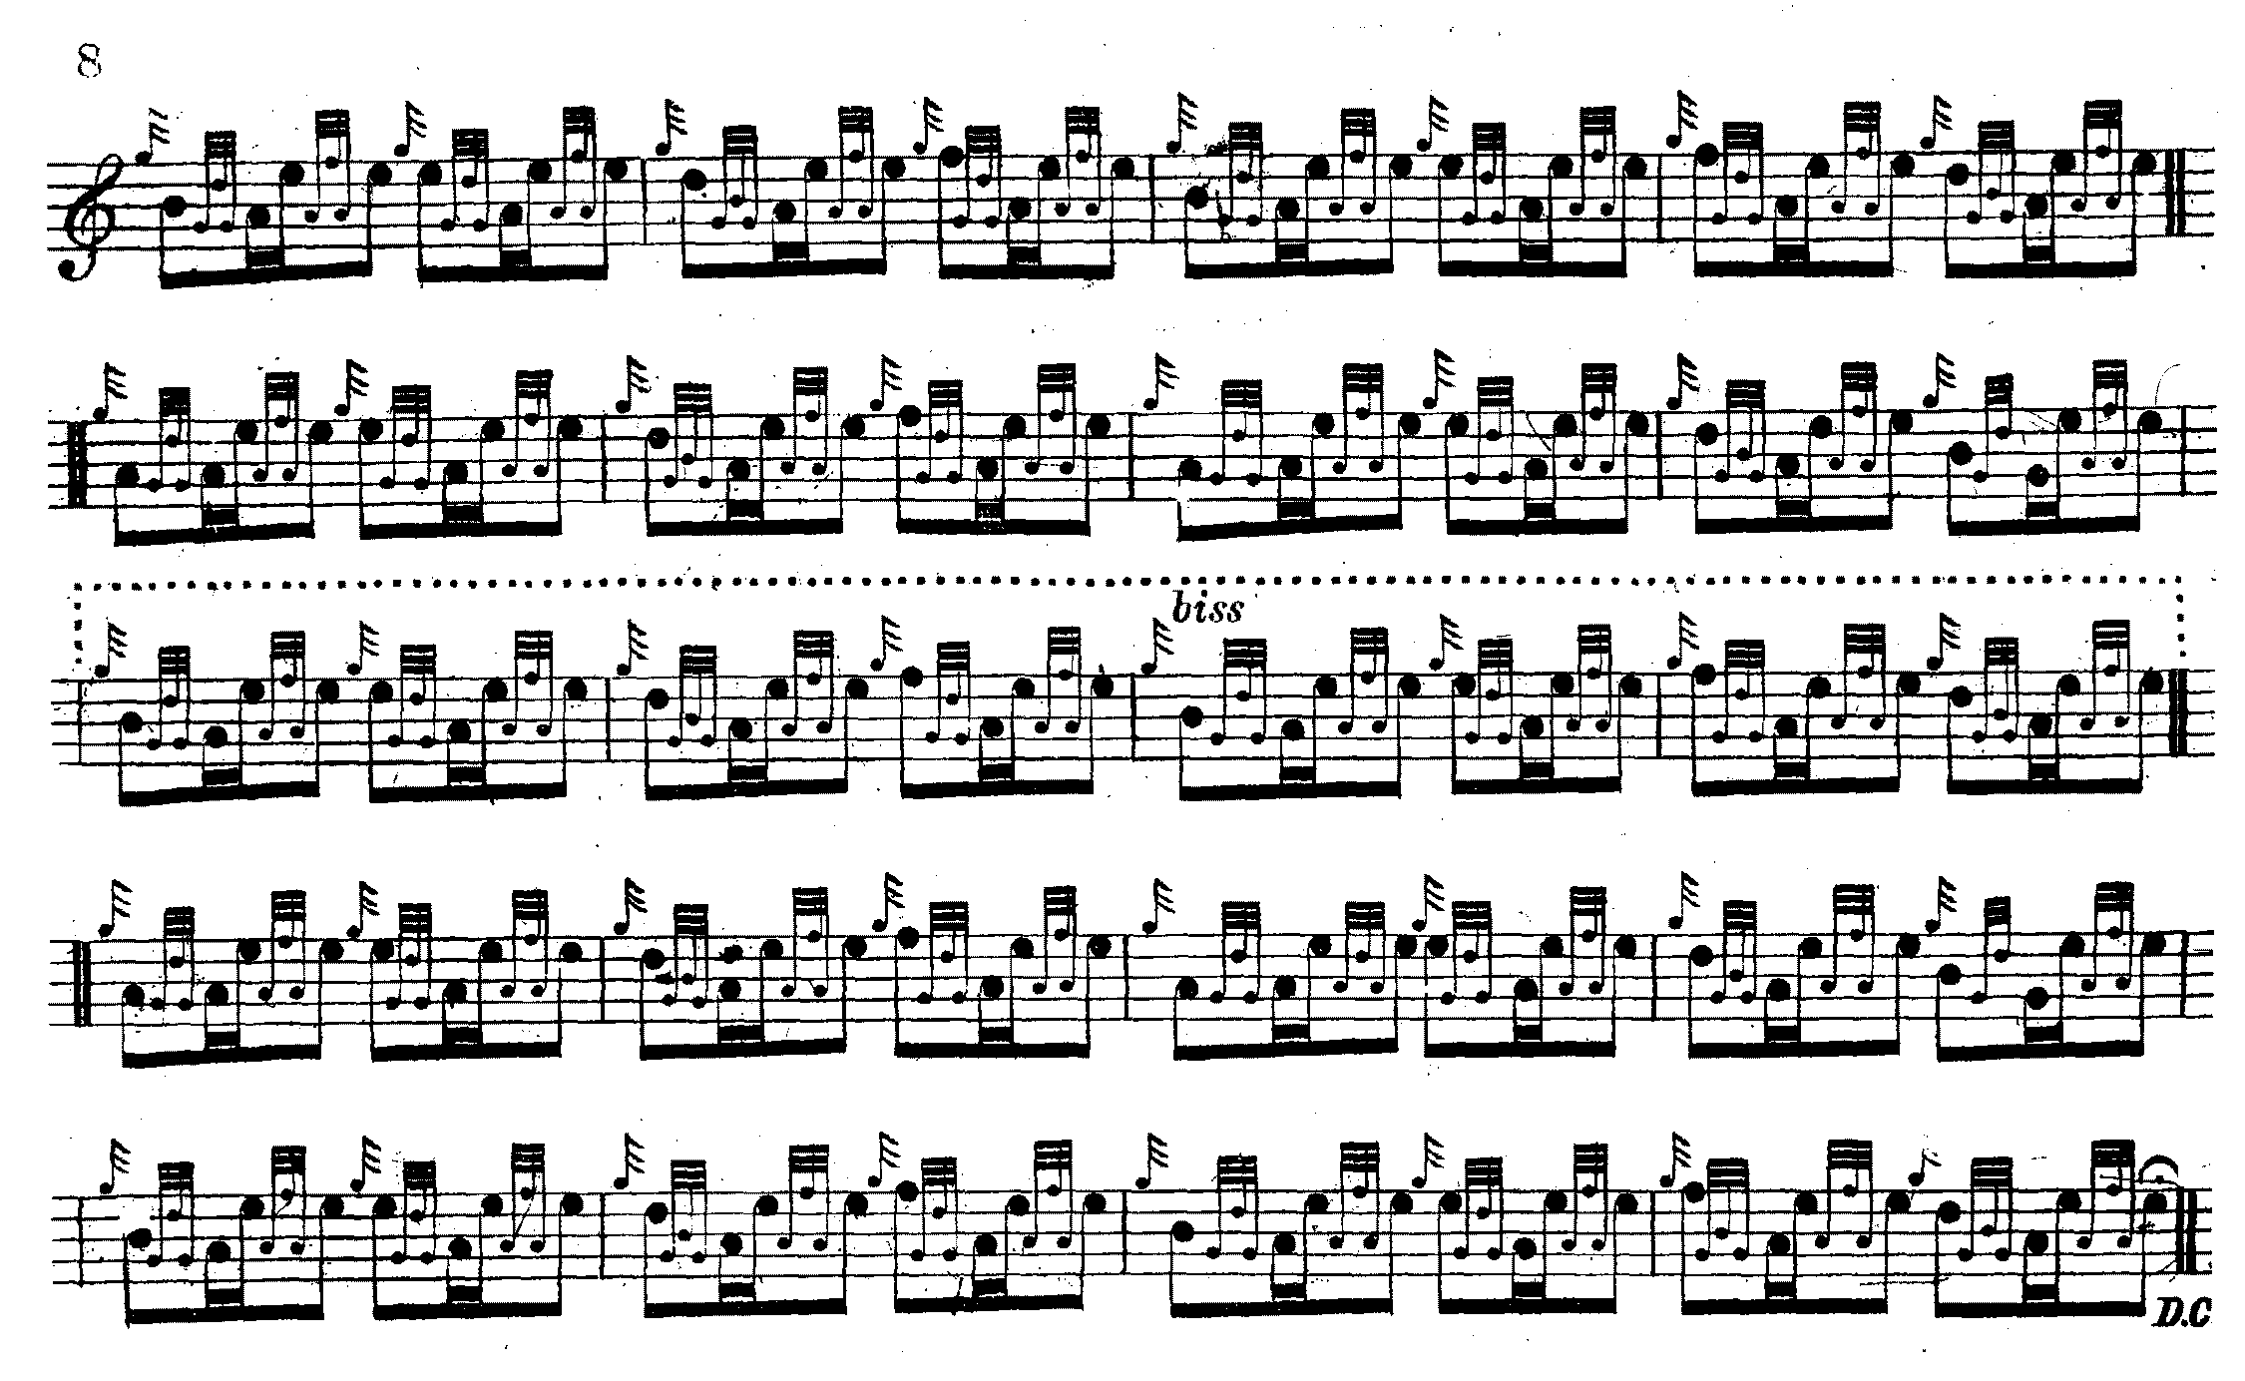

Ross sets the ground rather differently here from the way in he does it in his MS, and he has an interestingly accented fosgailte tripling, different once again from the MS (where he uses even quavers) in which the first note of each group receives the accent.

C. S. Thomason’s setting differs from Uilleam Ross’s only in trivial details such as timing the taorluath fosgailte movements as evenly accented demi-semi-quaver runs and is not reproduced here.

Commentary:

This tune seems to be closely linked to the dedicatee’s family. The Mrs. MacLeod in question was probably Margaret Isabella MacDonald, wife of Magnus MacLeod, 5th of Talisker. Her family were the MacDonalds of Castleton, which would have meant she was a member of the great house of Clanranald. It looks as if Donald Roy MacCrimmon has cleverly quoted motifs from famous Clanranald tunes and woven them into his musical tribute:

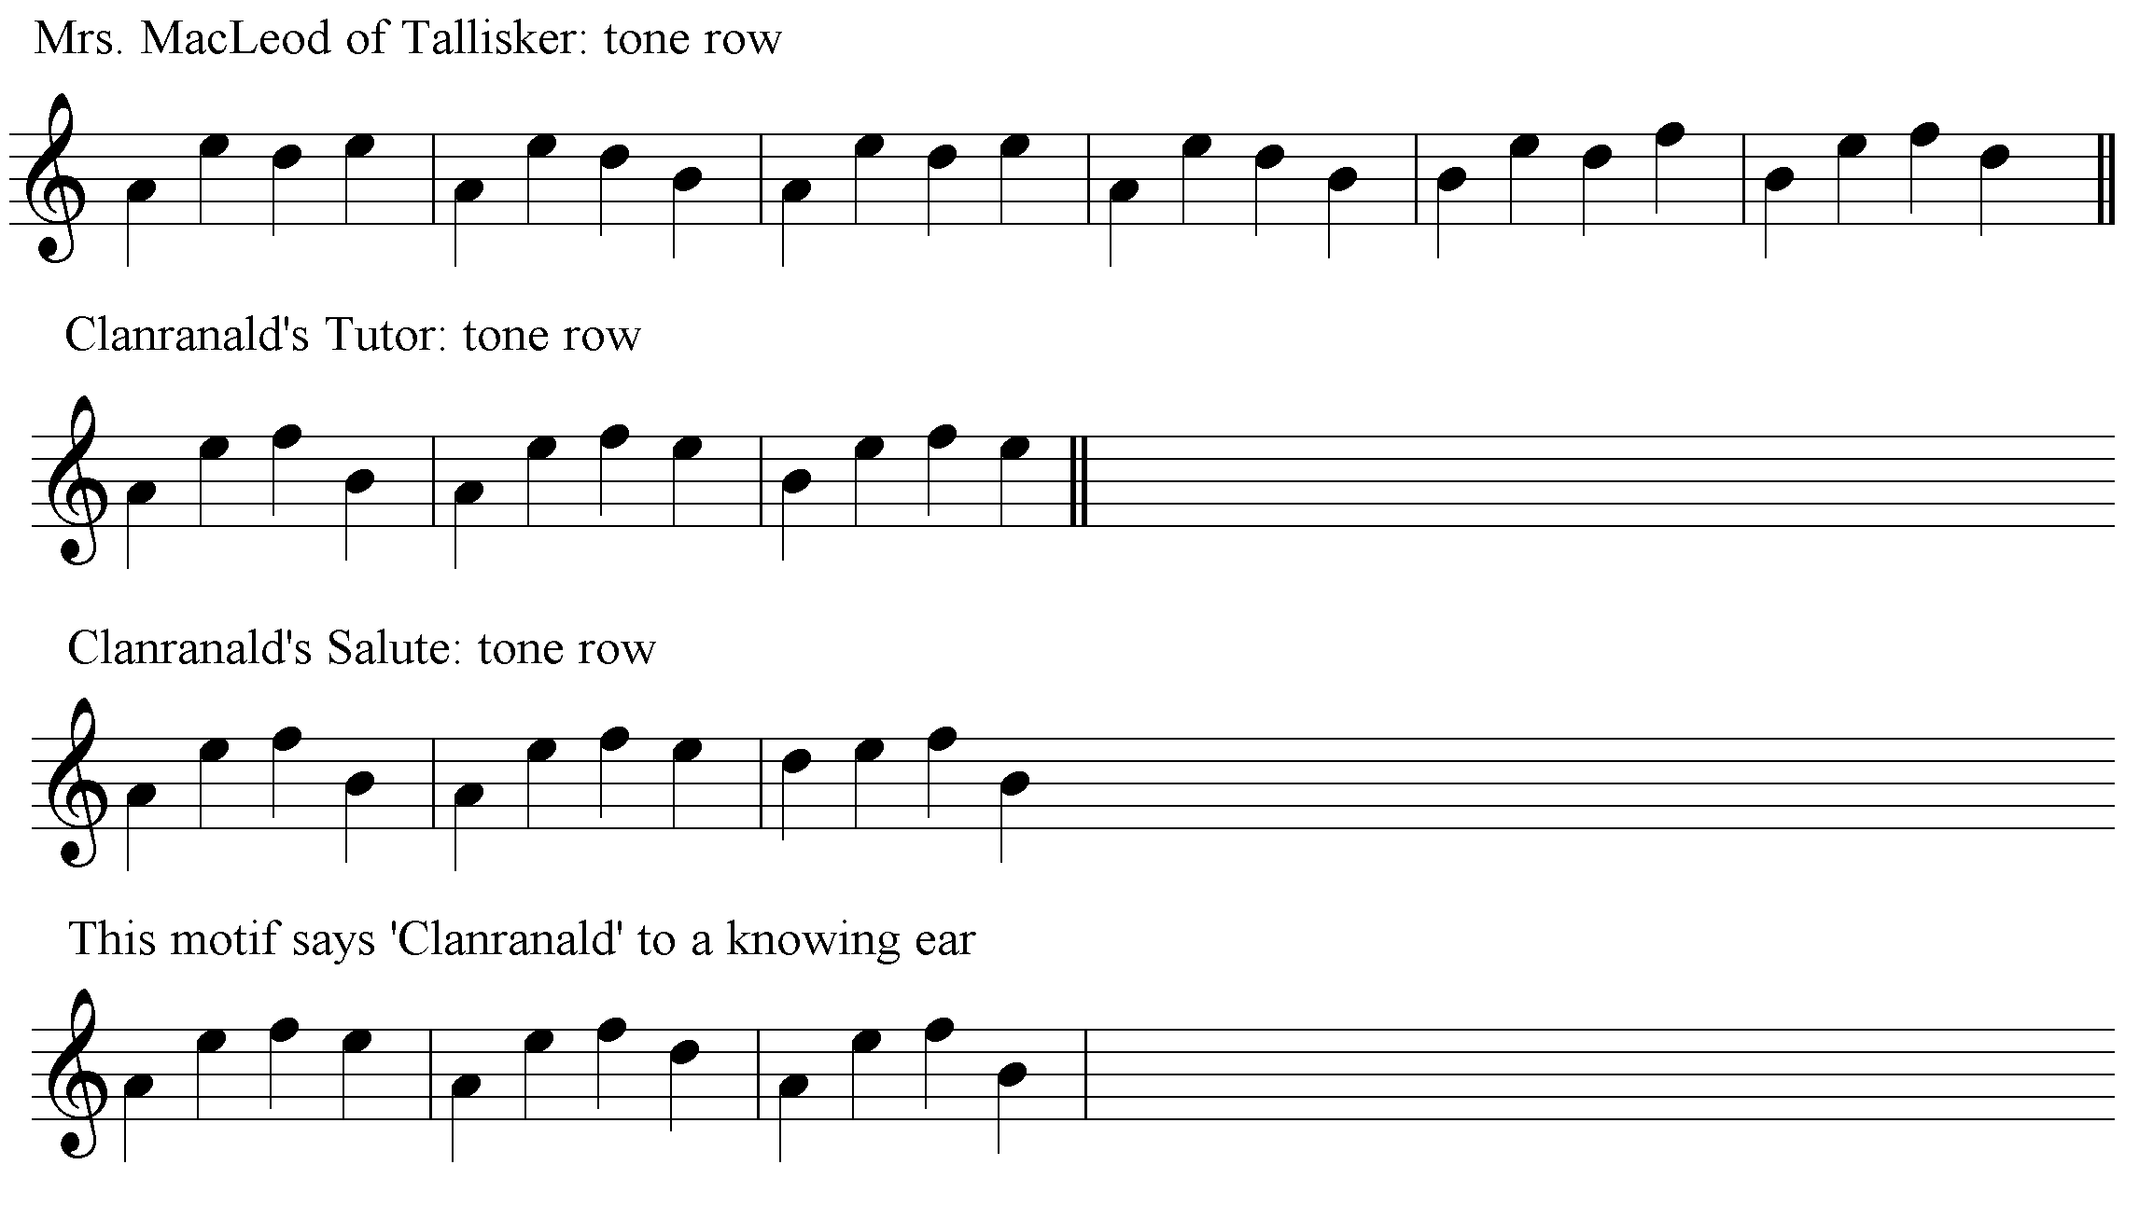

What Donald Roy MacCrimmon seems to have done is to focus attention on the middle strand of the ‘Clanranald motif’, and to interlace its rising curve with a stepwise figure, so that he can sustain a longer line without losing musical tension.

In their notes to this tune in the Piobaireachd Society’s Collection (second series, xi, 337) James Campbell and Archibald Kenneth show their characteristically dismissive attitude towards C. S. Thomason’s work: “The tune has been published in ‘Ceol Mor’”, they say, “in a somewhat mutilated form which does not correspond with any of the MS authorities”. In fact, Thomason actually followed his stated sources quite faithfully, as the reader can check from the scores now online.
Archibald Kenneth (1915-1989) was musical, as his light music compositions indicate. His position as a Piobaireachd Society editor from 1963 gave him access to at least some of the Society’s private holdings of the printed and manuscript collections which they had acquired from the early 20th century onwards. But he appears to have given little weight to the rich pìobaireachd tradition which was still current when he was born. This is probably--as David Murray, an ex-president of the Society, was to point out--because James Campbell (Archibald Campbell’s son) was a dominant figure throughout this period in the Society’s affairs, and ensured that his father’s scores and the time-values they enshrined were treated as a standard template to be closely followed. Therefore, the culture of disparagement towards General Thomason earlier promoted by Archibald Campbell (see, for example, his “Introduction” to the Kilberry Book of Ceol Mor, pp.12-13 where a few words of conventional praise are offset by lengthy and destructive criticism) was to continue for years after Campbell’s death in 1963. This is apparent in the continuing habit of negative reference to Thomason in the notes to the later Society volumes, a theme strongly present in the following piece by Archibald Kenneth, written in the later 1970s. Concerning Ceol Mor he wrote:

I must make it clear that I consider it so full of error that I'd hesitate to advise anyone to use it as a basis for actually learning anything, except perhaps as being a good index for the various MSS.--the Index, in other words, is the best part of a remarkable compilation, which could have been and should have been far more authoritative than the author's limitations allowed it to be. It is a sobering thought that one dare not accept the Ceol Mor setting of any tune as corresponding with any source, without carefully checking it in the MS. from which it is alleged to have been taken. Certainly Gen. Thomason usually gives his authorities for treatment of any tune, but it isn't enough to say, in effect, that you as Editor have altered a tune--the point is, HOW have you altered it? And when several fingers are in the pie, it is sheer conjecture who did what. The risk of learning from it is that you may be spending your time and talent on a thoroughly bad setting of a tune which might at once be turned down by anyone that knew it. Worse still, if not turned down, such a setting might gain an acceptance to which it wasn't entitled. It is to me a matter of amazement that anyone so very ill-qualified could ever have had the brass neck to take on this enormous task. I suppose Ceol Mor gave some sort of stimulus to piping and in particular to the cause of piobaireachd, but it is easy to understand the resentment that may have been felt. Yet we have all heard about fools rushing in--would there have been any revival of piobaireachd without this one? It is also a matter of astonishment that the desire to learn, coupled with the excellent teachers he studied under, should have combined to leave him so ignorant of the art. What, I wonder, did Sandy Cameron think of him?
Did he write him off as hopeless: a mere crank who would never make a piper and whom he humoured more than taught? Or was he polite to the General as a matter of policy? Politeness, it has been said is one of the curses of Scotland [...] It is possible that some or all of his expert contemporaries looked on him as in more modern times Donald Main or G. F Ross were regarded, in other words, as a great authority in his own estimation only.
It could be said that the current Piob. Soc. series supplants--or will eventually supplant--Ceol Mor, but the claim is risky and it is not likely that it ever will supplant it in totality, for several reasons.
One thing is that there is a large amount of rubbish in Ceol Mor which doesn't deserve republication. Another is that the current series is best regarded as a study in depth of the known settings of the various tunes and the space required for a comparable treatment of the entire contents of Ceol Mor would involve a prodigious expenditure for mediocre results [...]
(NLS. Acc 9103/28, “Memoranda concerning Piobaireachd Society publications”, typescript essay “Ceol Mor Notation”).

It may eventually have dawned on Kenneth that all was not well with the Piobaireachd Society’s own scores, but at this point he clearly did not appreciate the scale of the liberties that Archibald Campbell had taken with the sources. He was in a position to have checked Thomason against the latter’s stated sources, but evidently did not do so, assuming that if Thomason differed from what Archibald Campbell said, he must, by that very fact, be “wrong”.

Kenneth also seems unaware of the continuing esteem in which Thomason was held by leading members of the performer community, though Thomason’s work was virtually unobtainable for long periods. Bob Nicol’s own copy of Ceol Mor was stolen from the pipers’ room at Balmoral, and he was grieved by its loss. He was aware that Thomason—the first President of the Piobaireachd Society--had actually been deposed from office as supporters of the “traditional” Angus-MacKay style of notation gained control in 1904. “They put him off the Piobaireachd Society”, said Nicol, “–for knowing too much.”

* * *

Electronic text © Dr. William Donaldson, Aberdeen, Scotland, September 2004; revised Cambridge, Massachusetts, February 2025.

