The Men Went to Drink

There are settings of this tune in the following manuscript sources:

**Angus MacKay**’s MS, i, 88 (and in the so-called “Kintarbert” MS, f.72);

**Colin Cameron**’s MS, f.71;

**Duncan Campbell of Foss**, MS, ff.163-164;

**Uilleam Ross**’s MS, ff.78-79;

and in the following published sources:

**Uilleam Ross**, *Ross’s Collection of Pipe Music,* pp.11-12;

**C. S. Thomason**, *Ceol Mor,* pp.11-12;

**David Glen**, *Collection of Ancient Piobaireachd,* pp.158-9;

**John McLennan**, *The Piobaireachd as MacCrimmon Played It,* p.3. (with the title “The Banquet”).

**Angus MacKay set**s the tune as follows:

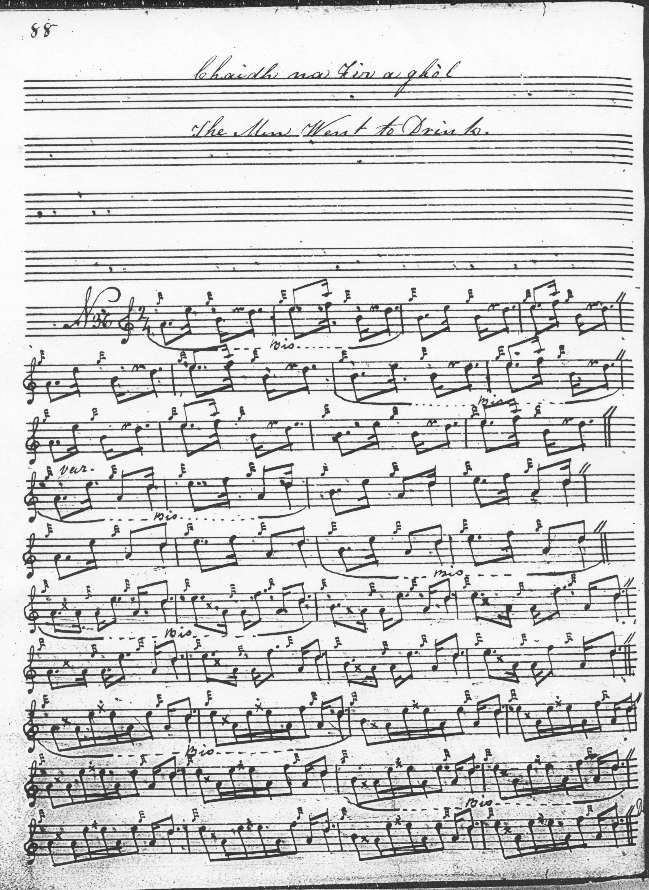

There are a number of issues with Mackay’s setting: line three is missing from the first variation singling and doubling; in the taorluath singling and doubling, the repeat mark for the B phrase is missing in line two along with the whole of line three; the crunluath is given entire. The “Kintarbert” setting is still more sketchy with no gracenoting after the start of the taorluath singling and none of the phrase repeats in the ground marked. But the MS is so unfinished that it might be unsafe to draw firm conclusions from it. MacKay repeats the ground between the taorluath and crunluath variations; the *da capo thema* mark after the taorluath doubling is only just visible in the main MSS but clearly present in the “Kintarbert”.

**Colin Cameron**’s approach to the tune follows that of Angus MacKay’s. The setting adds little to the musical interpretation and is not reproduced here.

**Duncan Campbell of Foss**’s score also follows MacKay. The setting adds little to the musical interpretation and is not reproduced here.

**Uilleam Ross**’s two settings differ in significant details. The manuscript score follows MacKay and adds nothing from an expressive point of view. It is not reproduced here. The published setting, however, takes a different route through the tune. It is a slimmer setting than MacKay’s with singlings only in most of the variations, and in many respects more idiomatic timing. It may well represent the stylings of the MacDonalds of Glentruim who contributed a significant body of material to *Ross’s Collection.* John MacDonald of Inverness’s father, Sandy MacDonald, was piper to the Earl of Fife at Mar Lodge, a little further up Royal Deeside from Balmoral Castle, while his uncle William MacDonald, was Piper to the Prince of Wales. Ross himself, of course as piper to the Queen would have been based frequently at Balmoral during the summer months. This was the period when Deeside was very much the centre of the piping world before that role was assumed by Glasgow city towards the end of the nineteenth century. Ross sets the tune as follows:

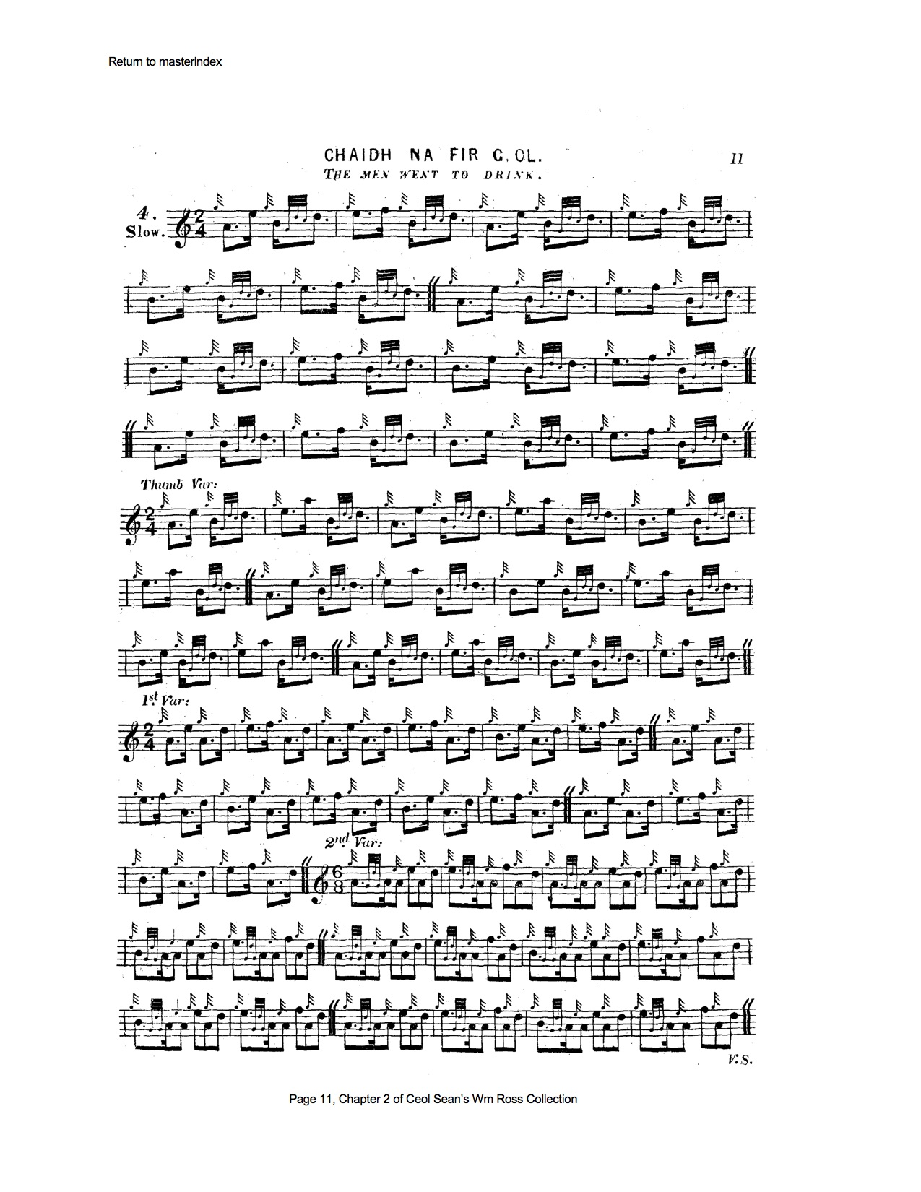

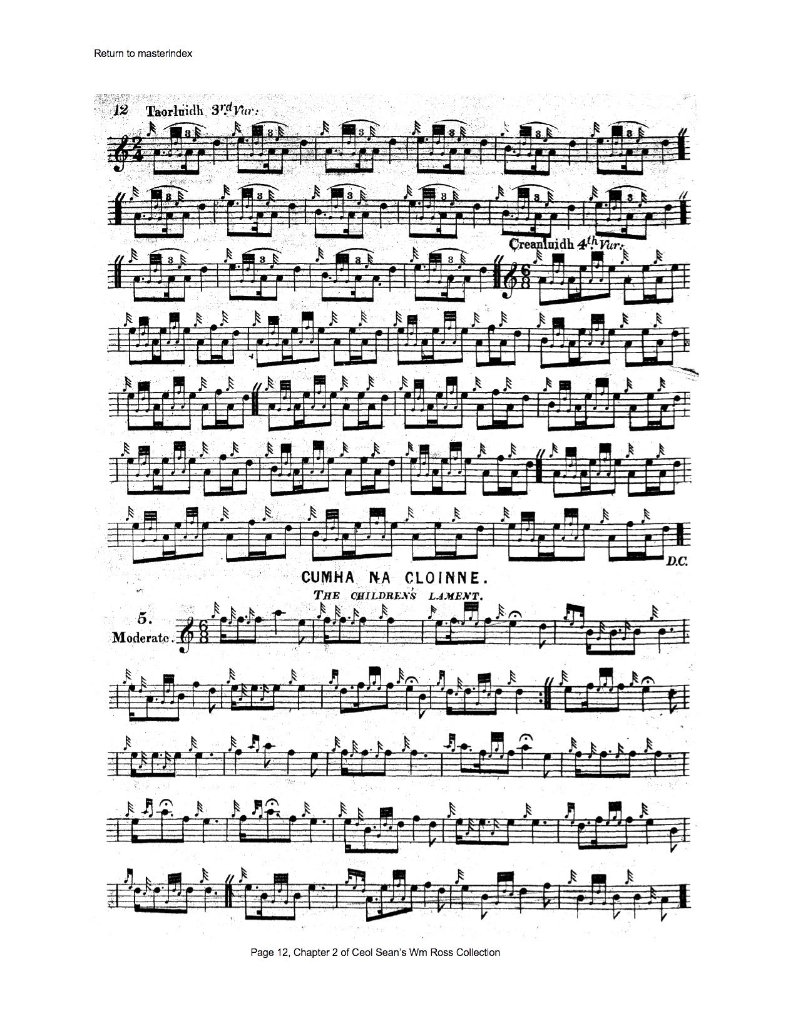

In the overall context of Ross’s setting the taorluath doubling seems a little obtrusive and might be omitted without significant loss.

**C. S. Thomason** cites amongst his sources Angus MacKay’s MS, Uilleam Ross’s published collection, and Donald MacKay--Angus MacKay’s nephew--who was directly taught the tune by Donald Cameron. Thomason published two versions, the first, given below, with a single siubhal, the second with a singling and doubling, the singling being taken from Angus MacKay’s MS version above. So perhaps the first setting he gave was as Donald MacKay reported his teacher Donald Cameron playing the tune, the second, in accordance with Thomason’s developing editorial principles, being to include all the recorded variations for any given tune. Thomason’s first setting is as follows:

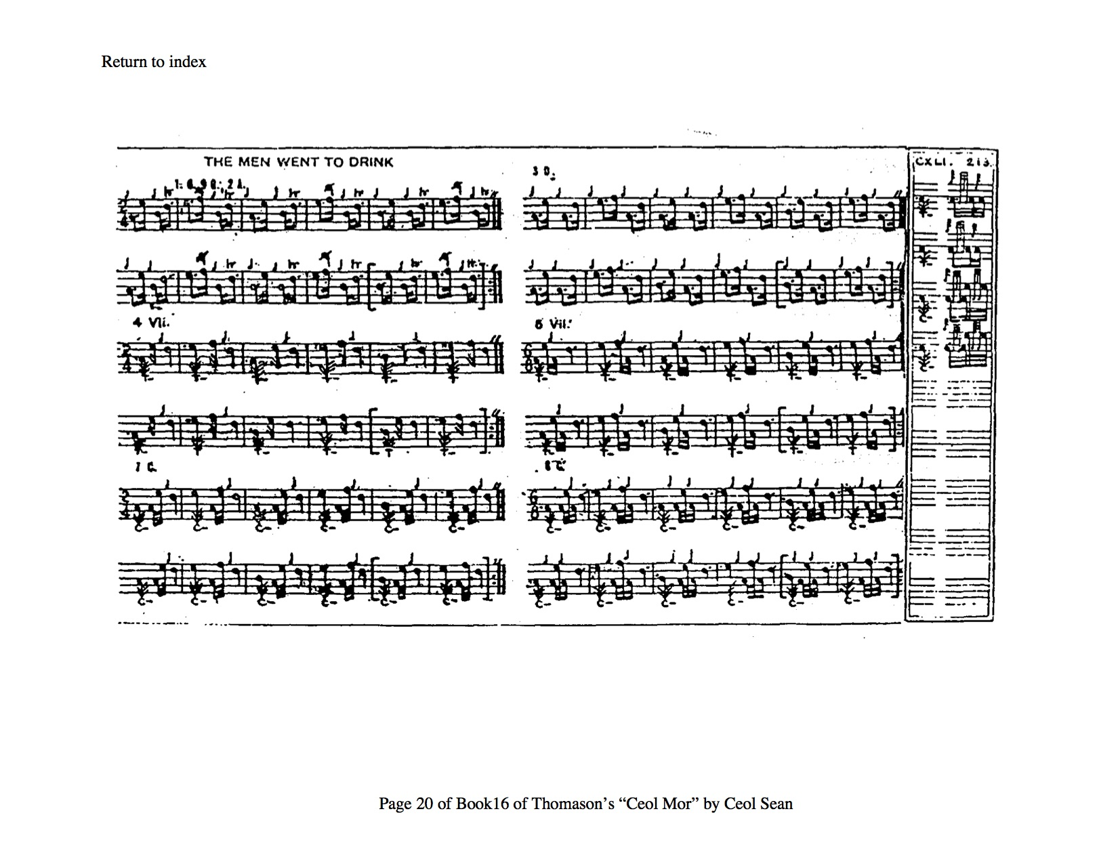

**David Glen** gives the tune three taorluath variations, as follows:

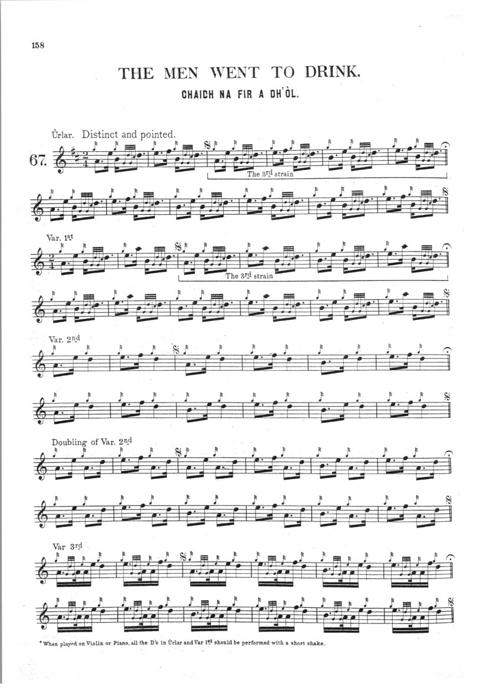

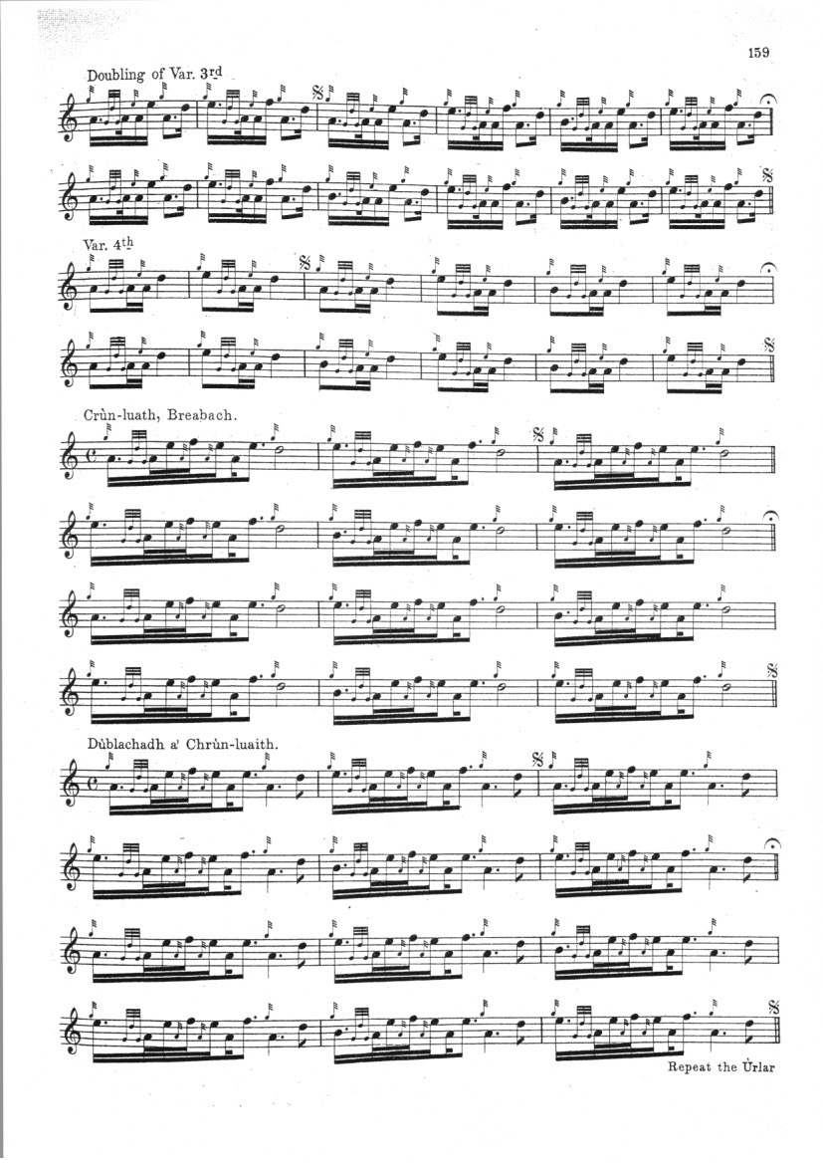

Glen’s score seems to be based on combination of MacKay and Uilleam Ross, although his timing of the crunluath variations which divide the tune--which seems to depend for a good deal of its effect on its onward drive and impetuosity--into a succession of distinct metrical chunks might be open to question.

**Lt. Iain McLennan**’s setting is of considerable interest, representing as it does a family tradition descending from at least the eighteenth century and which has been somewhat neglected by piping historians. Considered in the light of the evidence, the McLennans seem at least as important to piping tradition as the Camerons and Macphersons. McLennan sets the tune as follows:

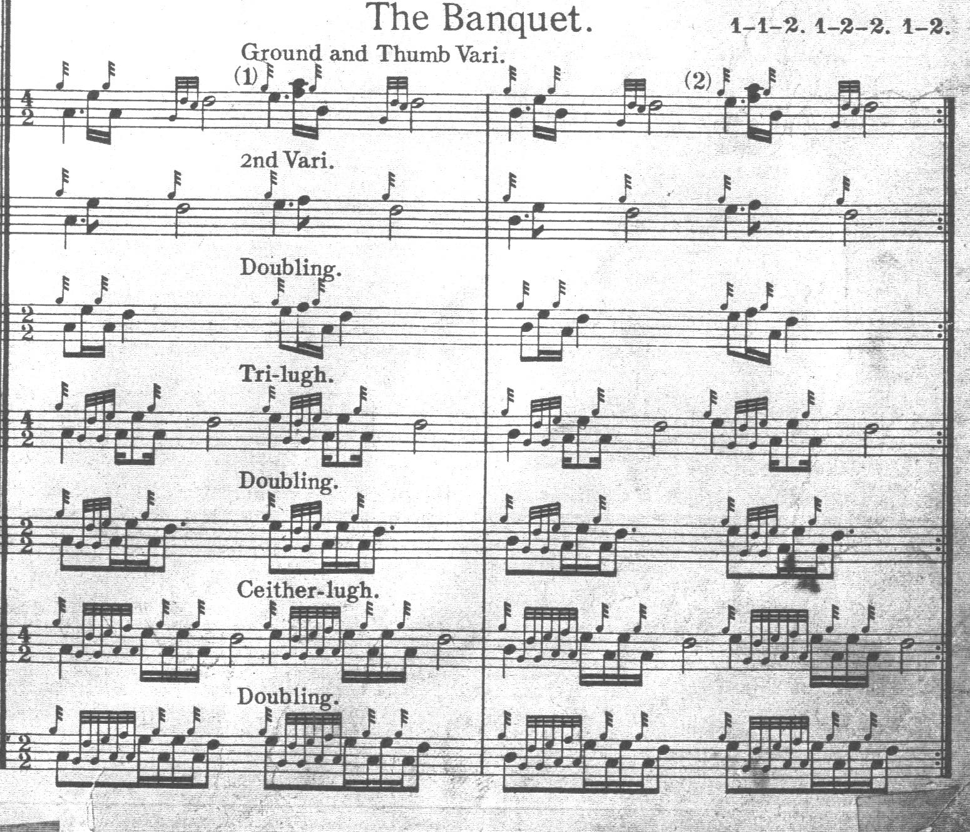

One of the most striking things here is the compression and economy gained by the clever McLennan notational system, which is nearly as compact as Thomason while being typographically a good deal clearer. That and the interesting use of changing time signatures which seem intended to convey differences in tempo between the various parts. It is noticeable, too, that the tonal range narrows in the later stages of the tune, with F disappearing from the tone row from “Tri-lugh” onwards.

*Commentary:*

The Highland historian Henry Whyte, “Fionn”, has a note on this tune on p.35 of the Historical section of Glen’s Collection:

The Men went to Drink

Chaidh na fir a dh'òl

This tune is evidently reminiscent of a spree in

a wayside inn called "Tigh-an-lòin." Some of the

words associated with the tune may interest pipers : -

Tha na fir ag òl

Tha na coin a tathunn,

Ann an Tigh-an-lòin,

Tha na fir a tighinn,

Uisge-beatha ’s beòir

Tha na coin a tathunn,

Tha na fir ag òl.

Tha na fir a tighinn.

Chaidh na fir a dh'òl

'Chuid nach òl sinne dheth

Ann an Tigh-an-lòin,

Oladh na gillean e,

Uisge-beatha ’s beòir

Dh'òladh na gillean e

Chaidh na fir a dh'òl.

Phàigheadh na gillean e.

Chaidh na fir a dh'òl, &c.”

This is a series of nonsense-rhymes roughly along the following lines “The men are drinking, the dogs are barking, in Tayinloan, whisky and beer….”

Tayinloan is about half way down the long peninsula of Kintyre, on the Gigha shore. According to the *New Statistical Account of Scotland* published earlyin the Victorian period, the area was notorious for whisky smuggling at a time when many Scots regarded it as a point of principle to evade rather than pay the whisky duty.

This tune, under the title “The Men went to Drinking” was entered for the Edinburgh competition in 1825.

*

Electronic text © Dr. William Donaldson, Cambridge, Massachusetts, 21 July 2020; revised February 2025.