Mary’s Praise (3)

There are settings of this tune in the following manuscript sources:
--Colin Campbell’s “Nether Lorn Canntaireachd” MS, i, 139-42 (with the title “MacLachlan's March”);
--Hannay/MacAuslan MS, ff.26-30 (with a note saying “This Pibrach was Composed by McLachlan's Lady praising a Natural Production. Very S: Moladh madre Thuibh &.C.”)
--Angus MacKay’s MS, i, 67-8;
--Donald MacKay the younger’s “Ballindalloch” MS, f.30;
--C. S. Thomason’s MS, f.37;
--John MacDougall Gillies’s MS, ff. 52-3;
--Robert Meldrum’s MS, ff.34-37;

and in the following published sources:
--Donald MacDonald, Ancient Martial Music, pp.73-79 (with the title “Moladgh Mari Marys praise for her gift. McLauchlans March Composed by the family piper.”);
--Donald MacPhee, Collection of Piobaireachd, i, 10-13;
--C. S. Thomason, Ceol Mor, pp.30-1;
--David Glen, Ancient Piobaireachd, pp.182-4;
--Iain McLennan, The Piobaireachd as MacCrimmon Played it, p.3;
--G. F. Ross, Some Piobaireachd Studies, p.39.

Colin Campbell and Donald MacDonald develop the tune in a similar way. Colin Campbell treats it as follows:

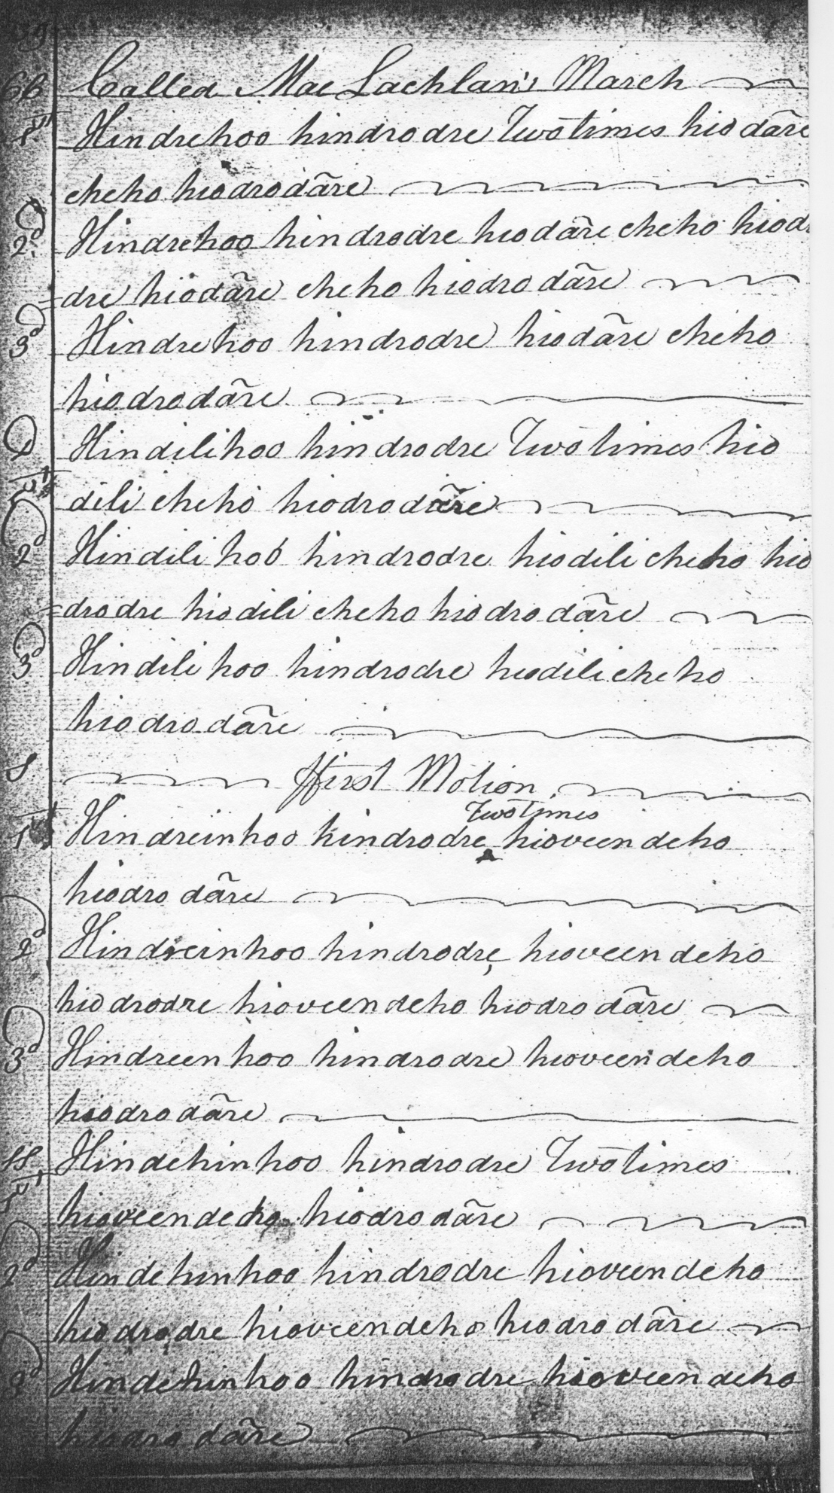
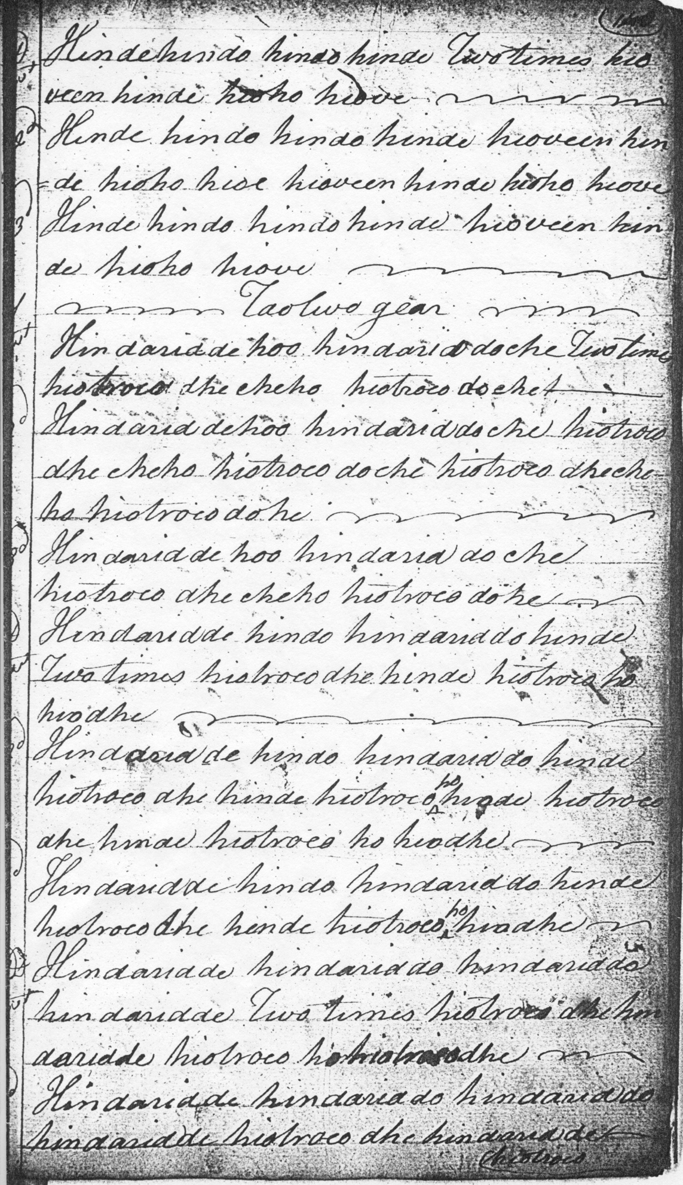
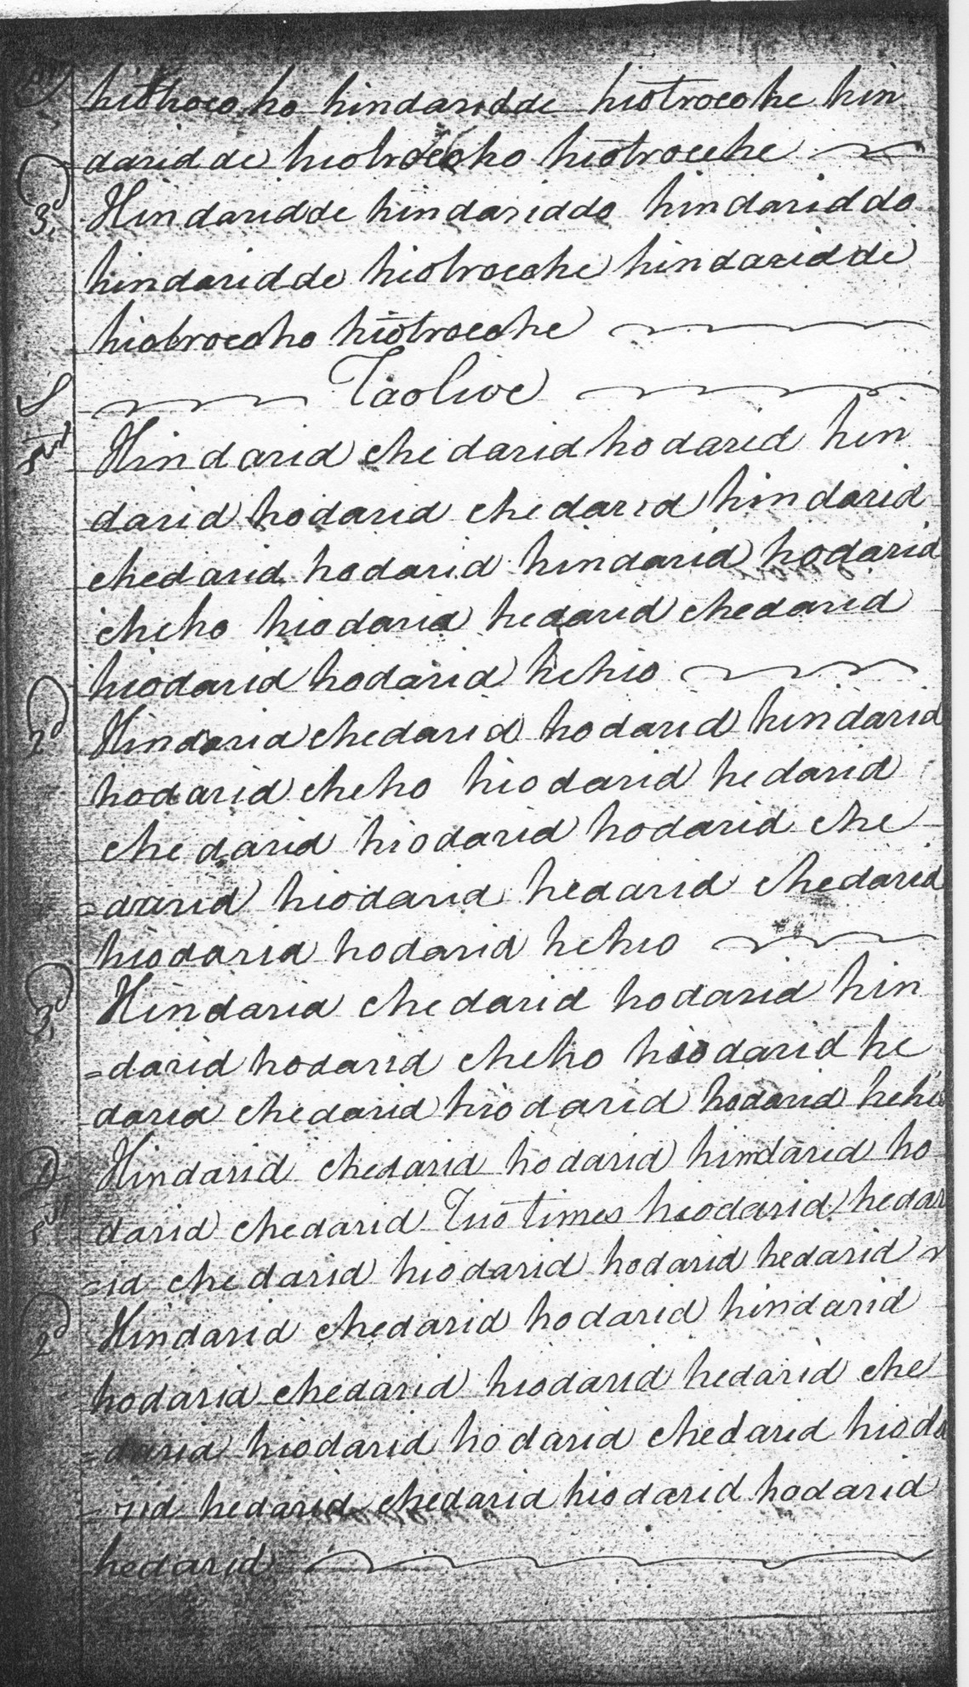
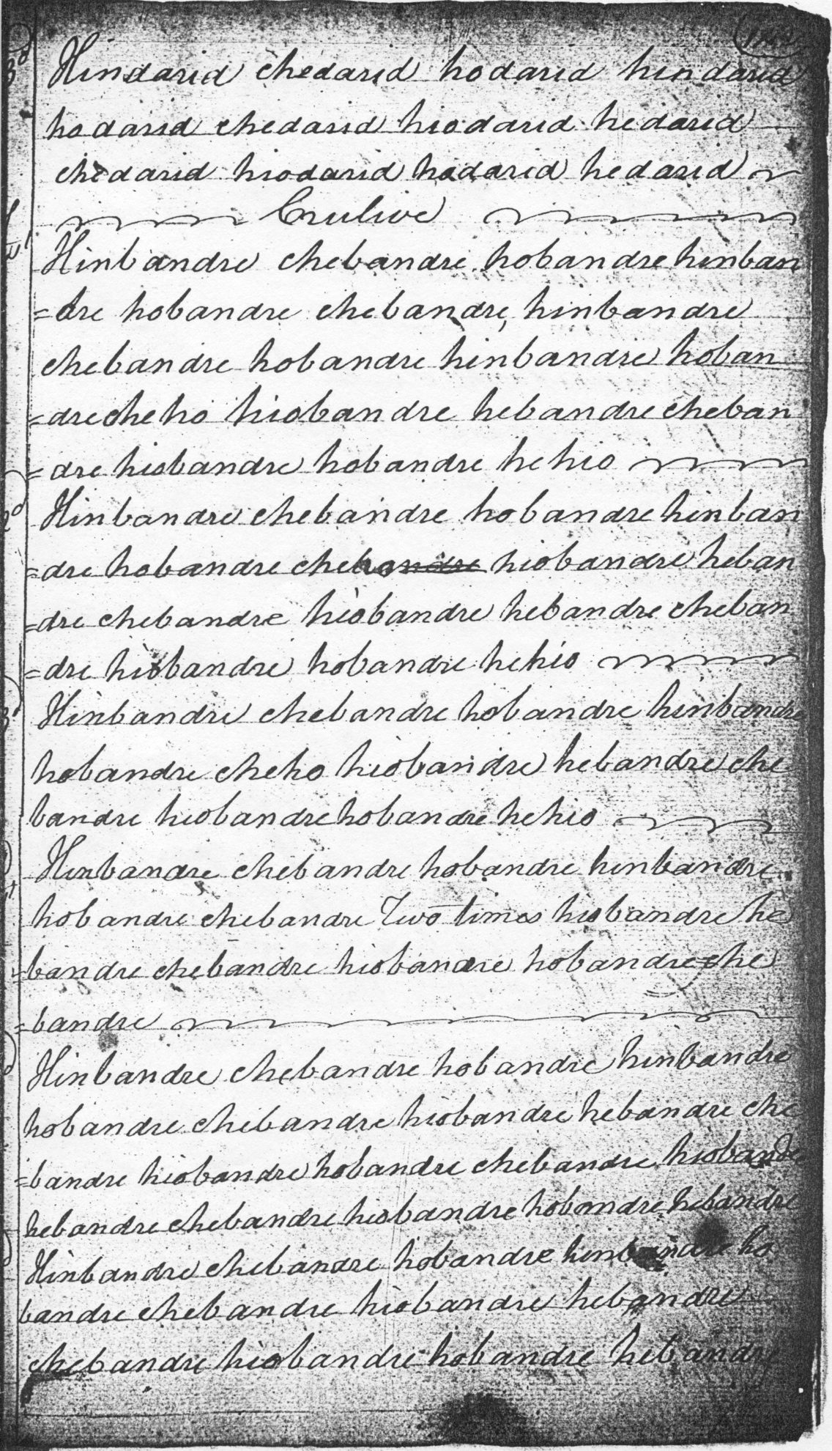

1st. Hindrehoo hindrodre Two times hiodare cheho hiodrodare
2d. Hindrehoo hindrodre hiodare cheho hiodrodre hiodare
cheho hiodrodare
3d. Hindrehoo hindrodre hiodare cheho hiodrodare
D.1st Hindilihoo hindrodre Two times hiodili cheho hiodrodare
2d. Hindili hoo hindrodre hiodili cheho hiodrodre hiodili cheho
hiodrodare
3d Hindilihoo hindrodre hiodili cheho hiodrodare

S ffirst Motion
1st. Hindreinhoo hindrodre Two times hioveendeho hiodrodare
2d Hindreinhoo hindrodre, hioveendeho hiodrodre hioveendeho
hiodrodare
3d. Hindreenhoo hindrodre hioveendeho hiodrodare
SS, 1st. Hindehinhoo hindrodre Two times hioveendeho hiodrodare
2d. Hindehinhoo hindrodre hioveendeho hiodrodre hioveendeho
hiodrodare
3d. Hindehinhoo hindrodre hioveendeho hiodrodare
D.1st. Hindehindo hindohinde Two times hioveen hinde hioho hiove
2d Hinde hindo hindo hinde hioveen hinde hioho hioe hioveen hinde
hioho hiove
3d. Hinde hindo hindo hinde hioveen hinde hioho hiove

Taolive gear
1st. Hindaridee hoo hindariddoche Two times hiotroeodhe cheho hiotroeo
doche
2d. Hindariddehoo hindariddoche hiotroeo dhe cheho hiotroeo do che
hiotroeo dhecheho hiotroeo dohe [etc]
D 1st. Hindaridde hindo hindariddo hinde Two times hiotroeodhehinde
hiotroeoho hiodhe [etc]
DD 1st. Hindaridde hindariddo hindariddo hindaridde Two times
hiotroeodhe hindaridde hiotroeoho hiotroeodhe [etc]

Taolive
S 1st. Hindarid chedarid hodarid hindarid hodarid chedarid hindarid
chedarid hodarid hindarid hodarid cheho hiodarid hedarid chedarid
hiodarid hodarid hehio [etc]
D 1st. Hindarid chedarid hodarid hindrid hodarid chedarid Two times
hiodarid hedarid chedarid hiodarid hodarid hedarid [etc]

Crulive
S 1st. Hinbandre chebandre hobandre hinbandre hobandre chebandre,
hinbandre chebandre hobandre hinbandre hobandre cheho hiobandre
hebandre chebandre hiobandre hobandre hehio [etc]
D 1st. Hinbandre chebandre hobandre hinbandre hobandre chebandre Two
times hiobandre hebandre chebandre hiobandre hobandre hebandre [etc]

Colin Campbell has no crunluath a mach.

The earliest of the staff notated scores would appear to be the Hannay-MacAuslan Manuscript, compiled in the early years of the 19th century. There the tune is set as follows:

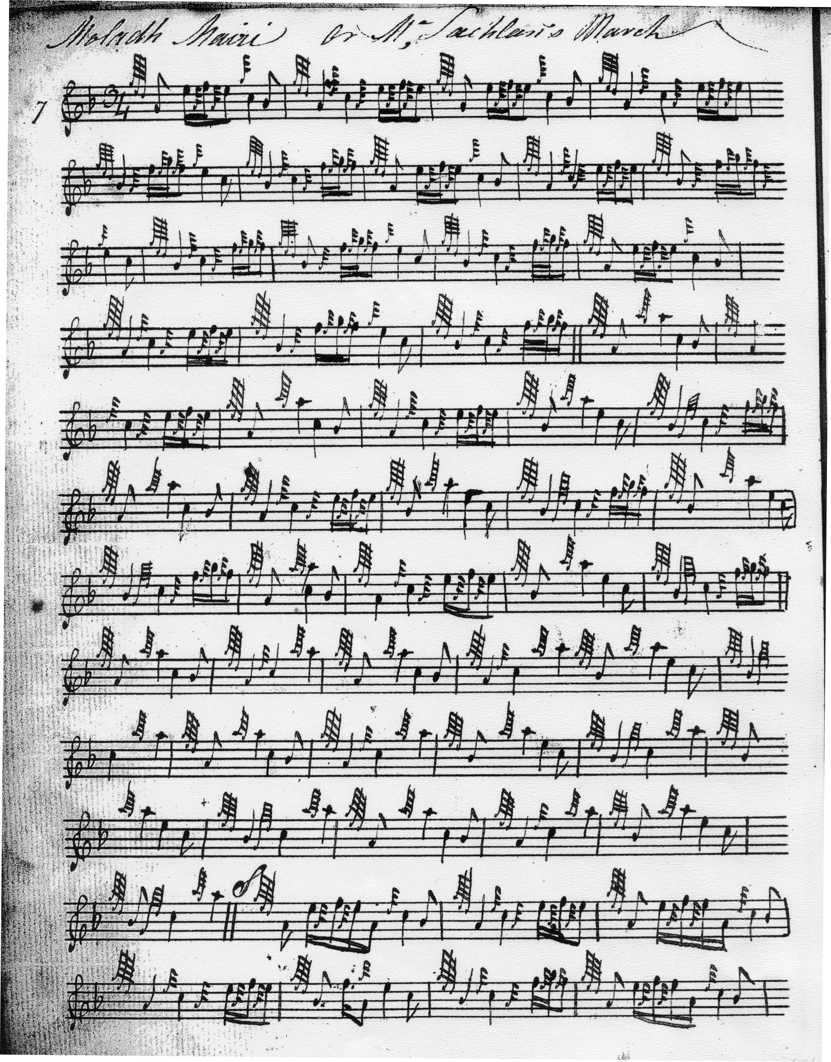

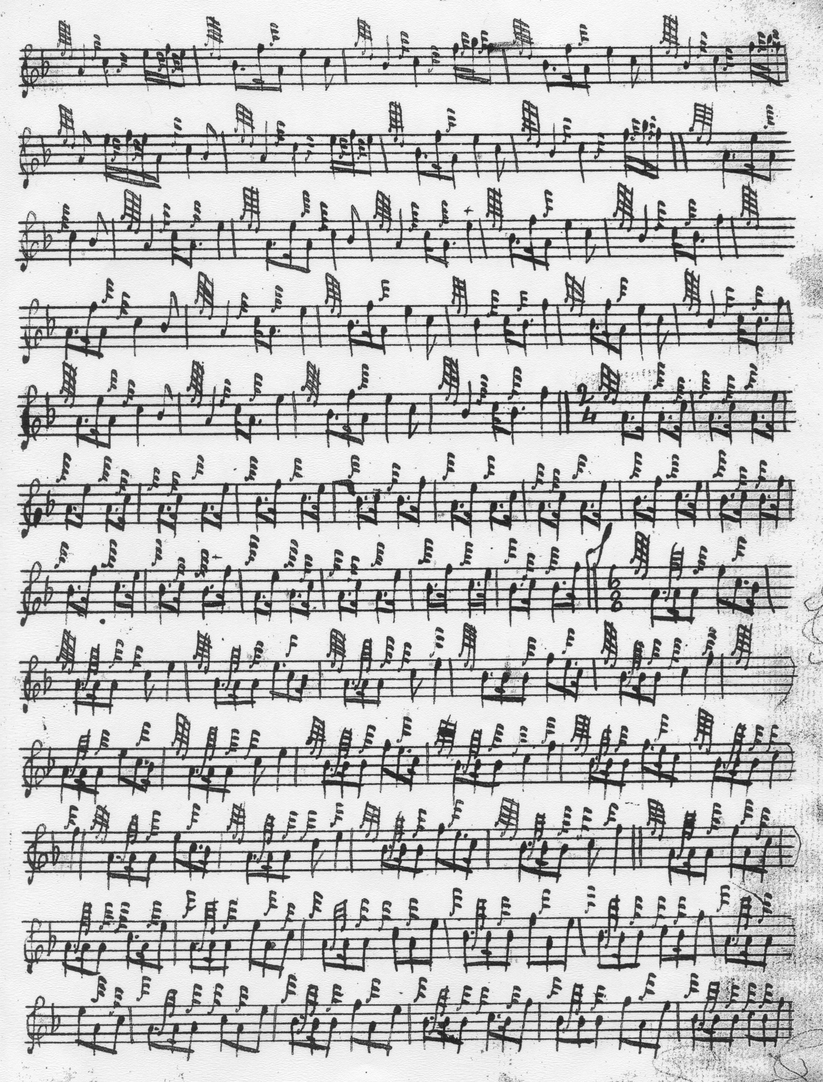

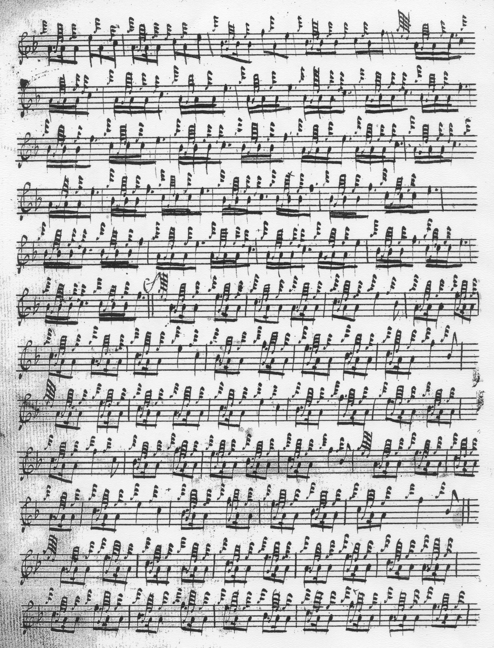

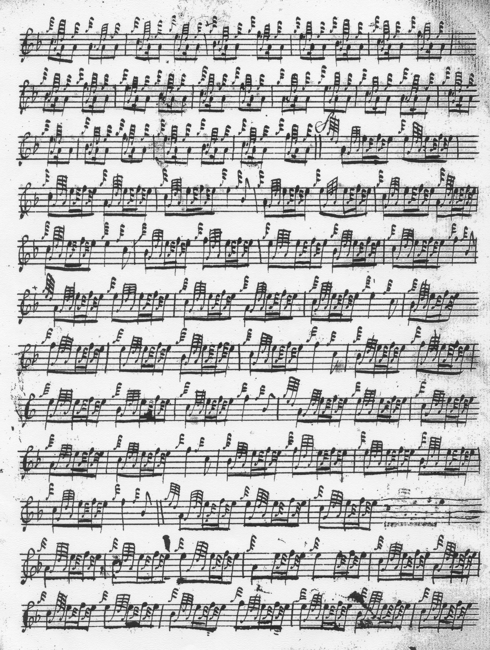

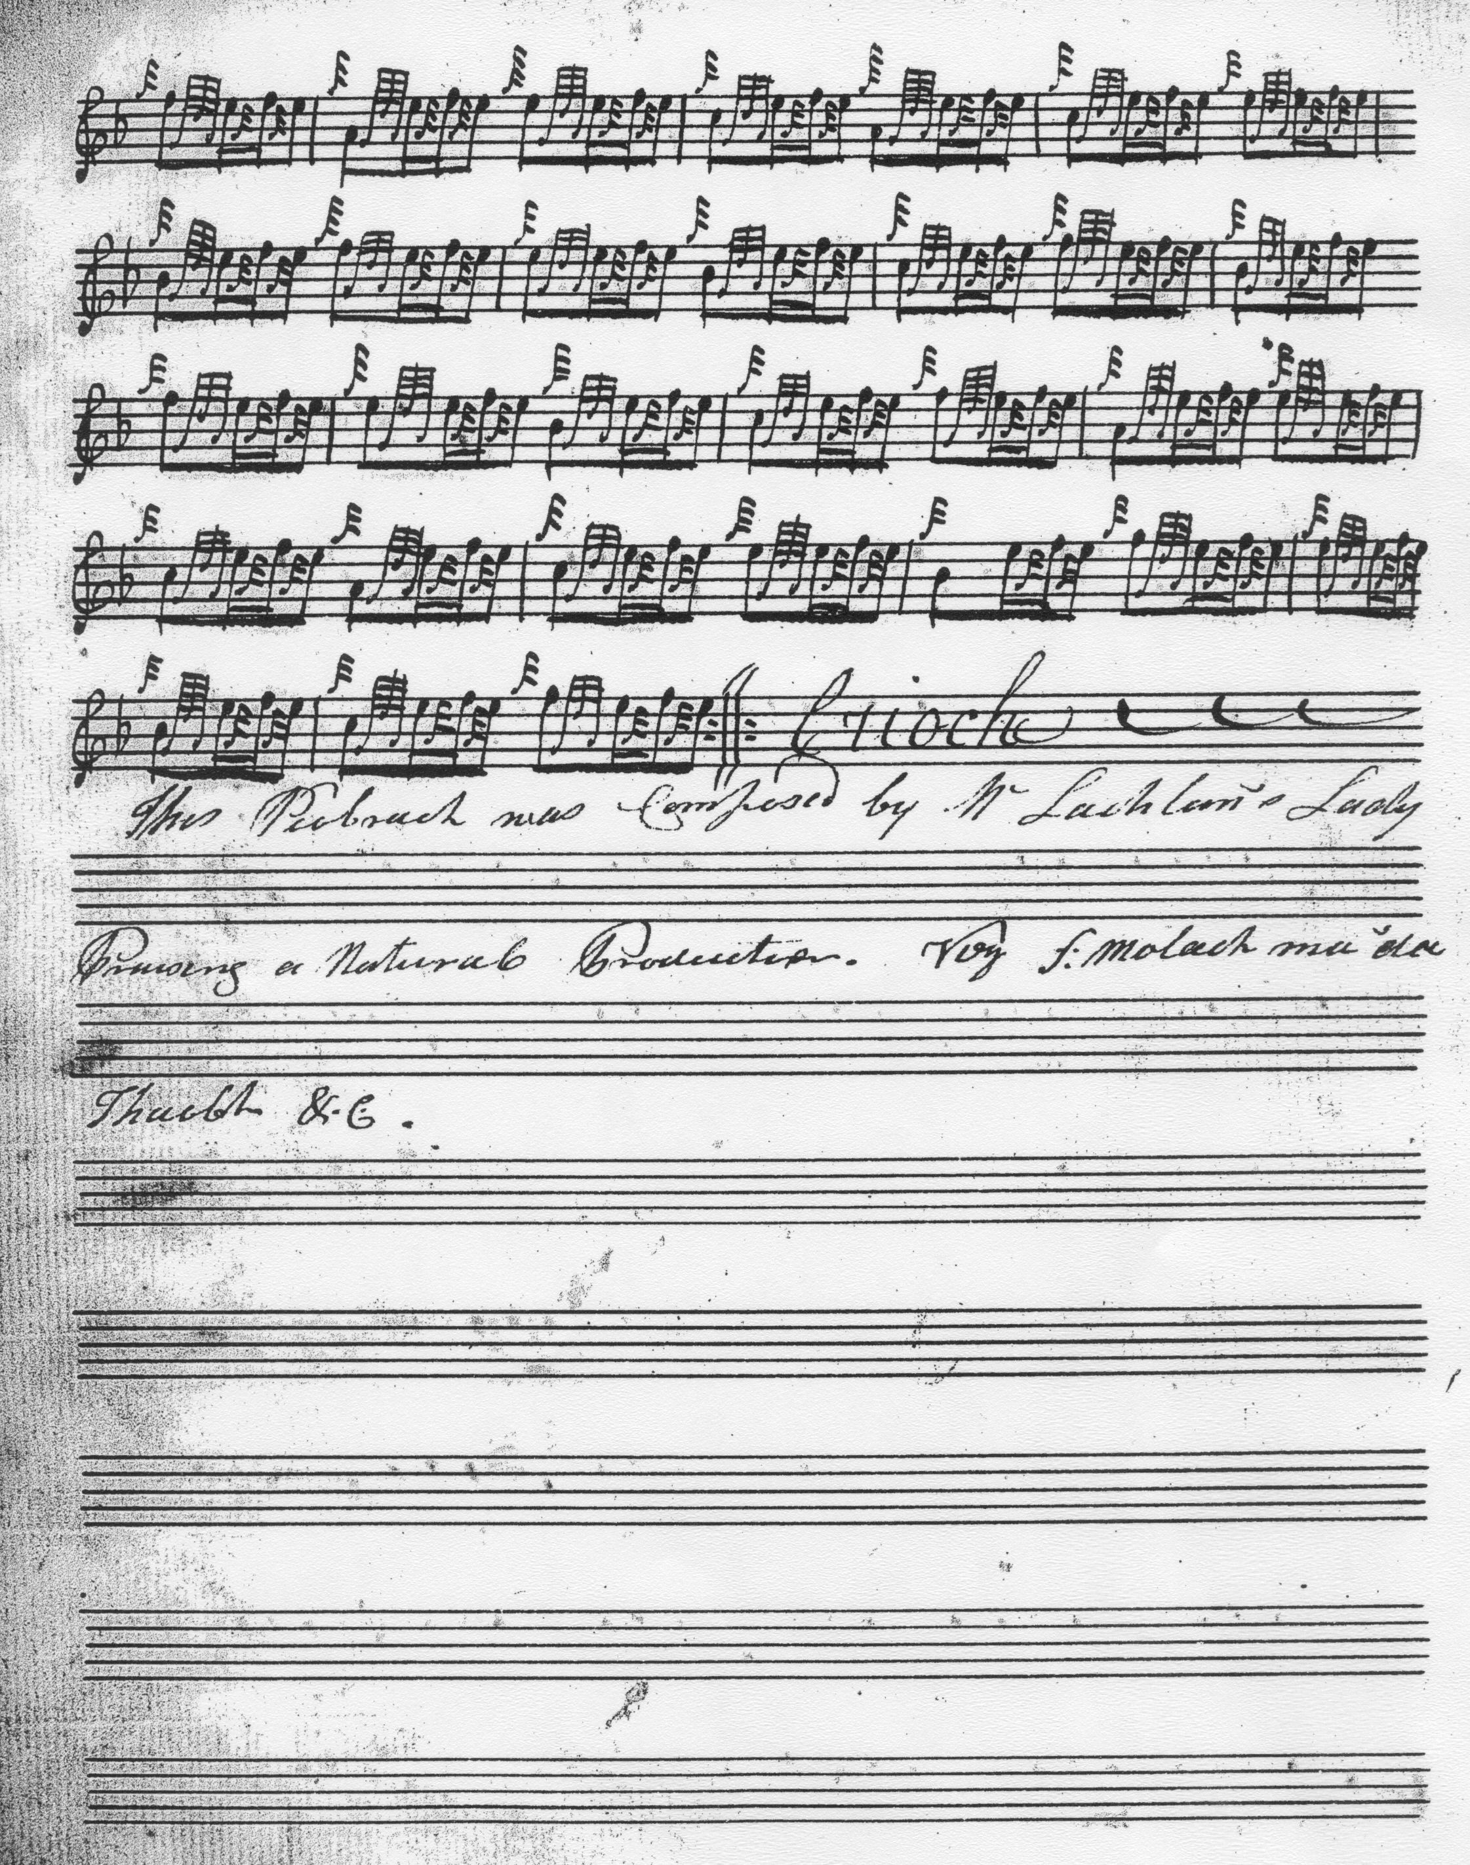

There are interesting differences of ornament between the Hannay MS and that of Donald MacDonald. In Hannay throws on A and E are prefixed by an initial A gracenote, extended to a half grip in Donald MacDonald’s score. The Hannay is sometimes thought to have been a source for MacDonald’s collection and there is little in the timing of this piece to cast doubt on this supposition. The tunes are timed very similarly in each setting and repeats of the ground are indicated in the same places.

Donald MacDonald's is the most fully developed of the major settings, doubling the thumb variation which Colin Campbell does not, and indicating a return of the ground three times within the tune: once following the thumb variation doubling, once again after the siubhal, and finally at the end of the trebling of his fourth variation. In several ways this seems the richest and most interesting of the scores. MacDonald sets the tune as follows:

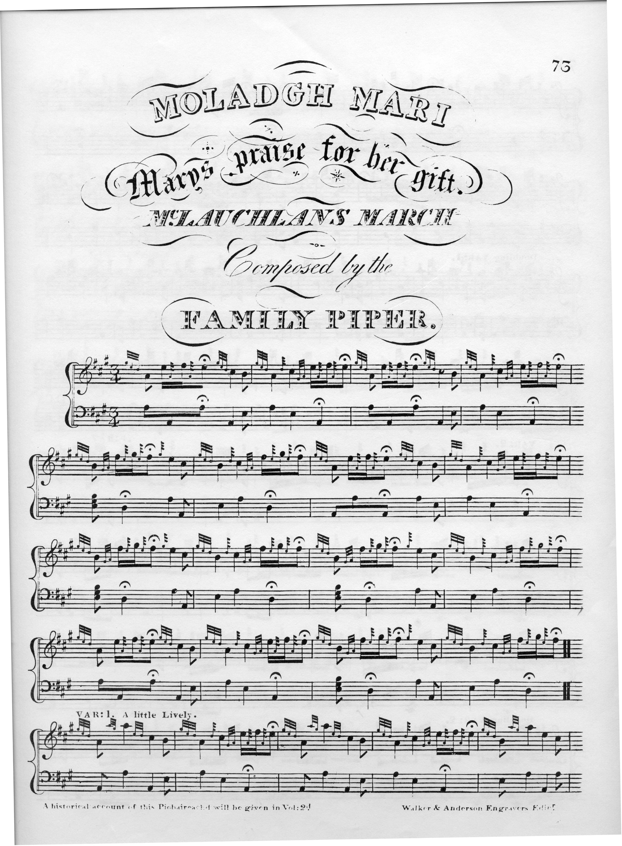
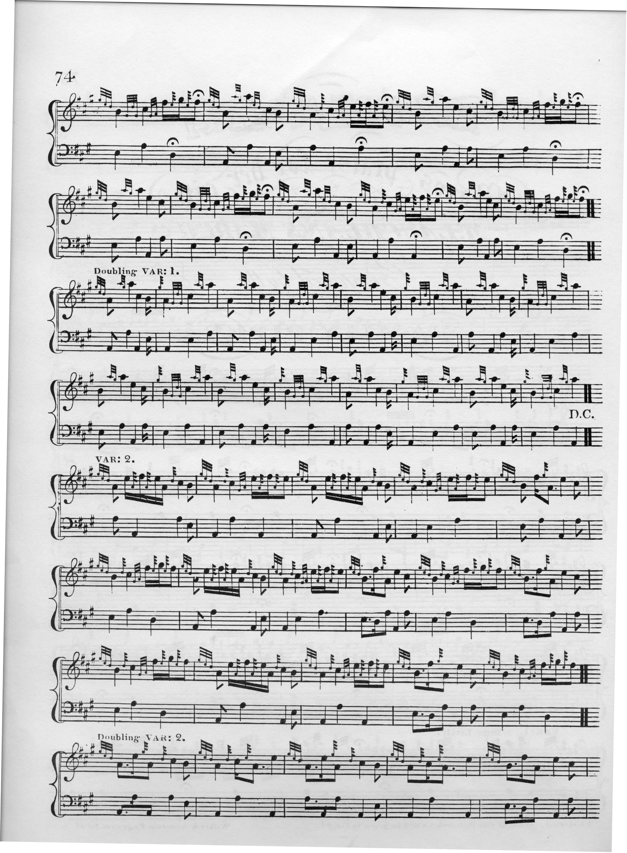
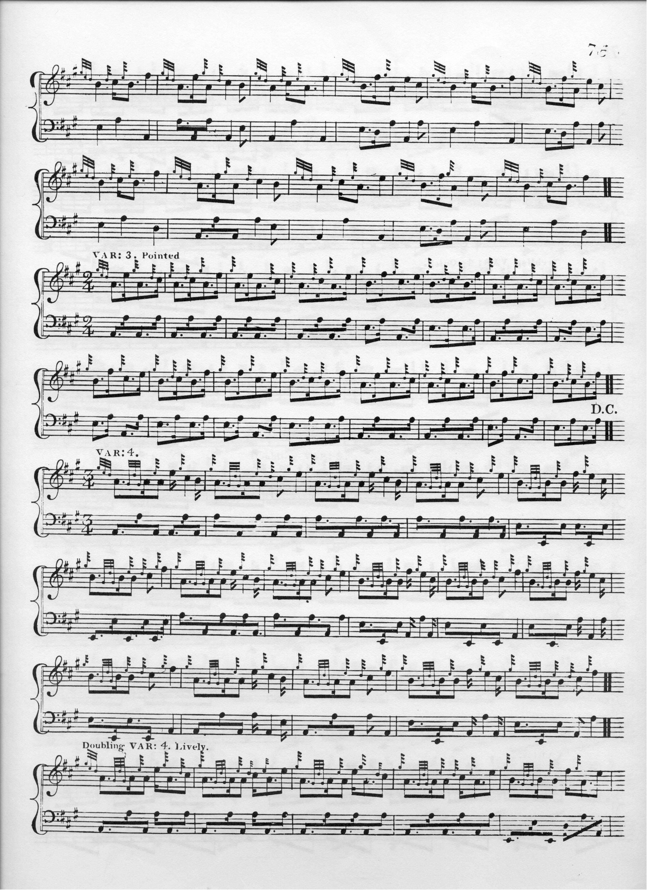
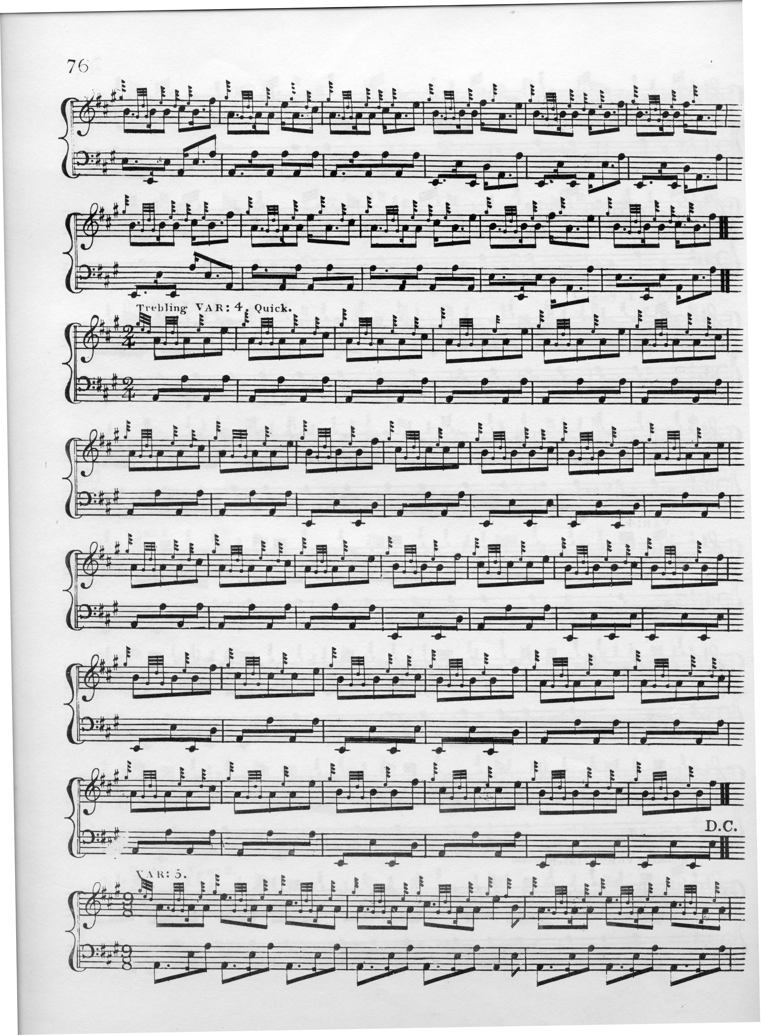
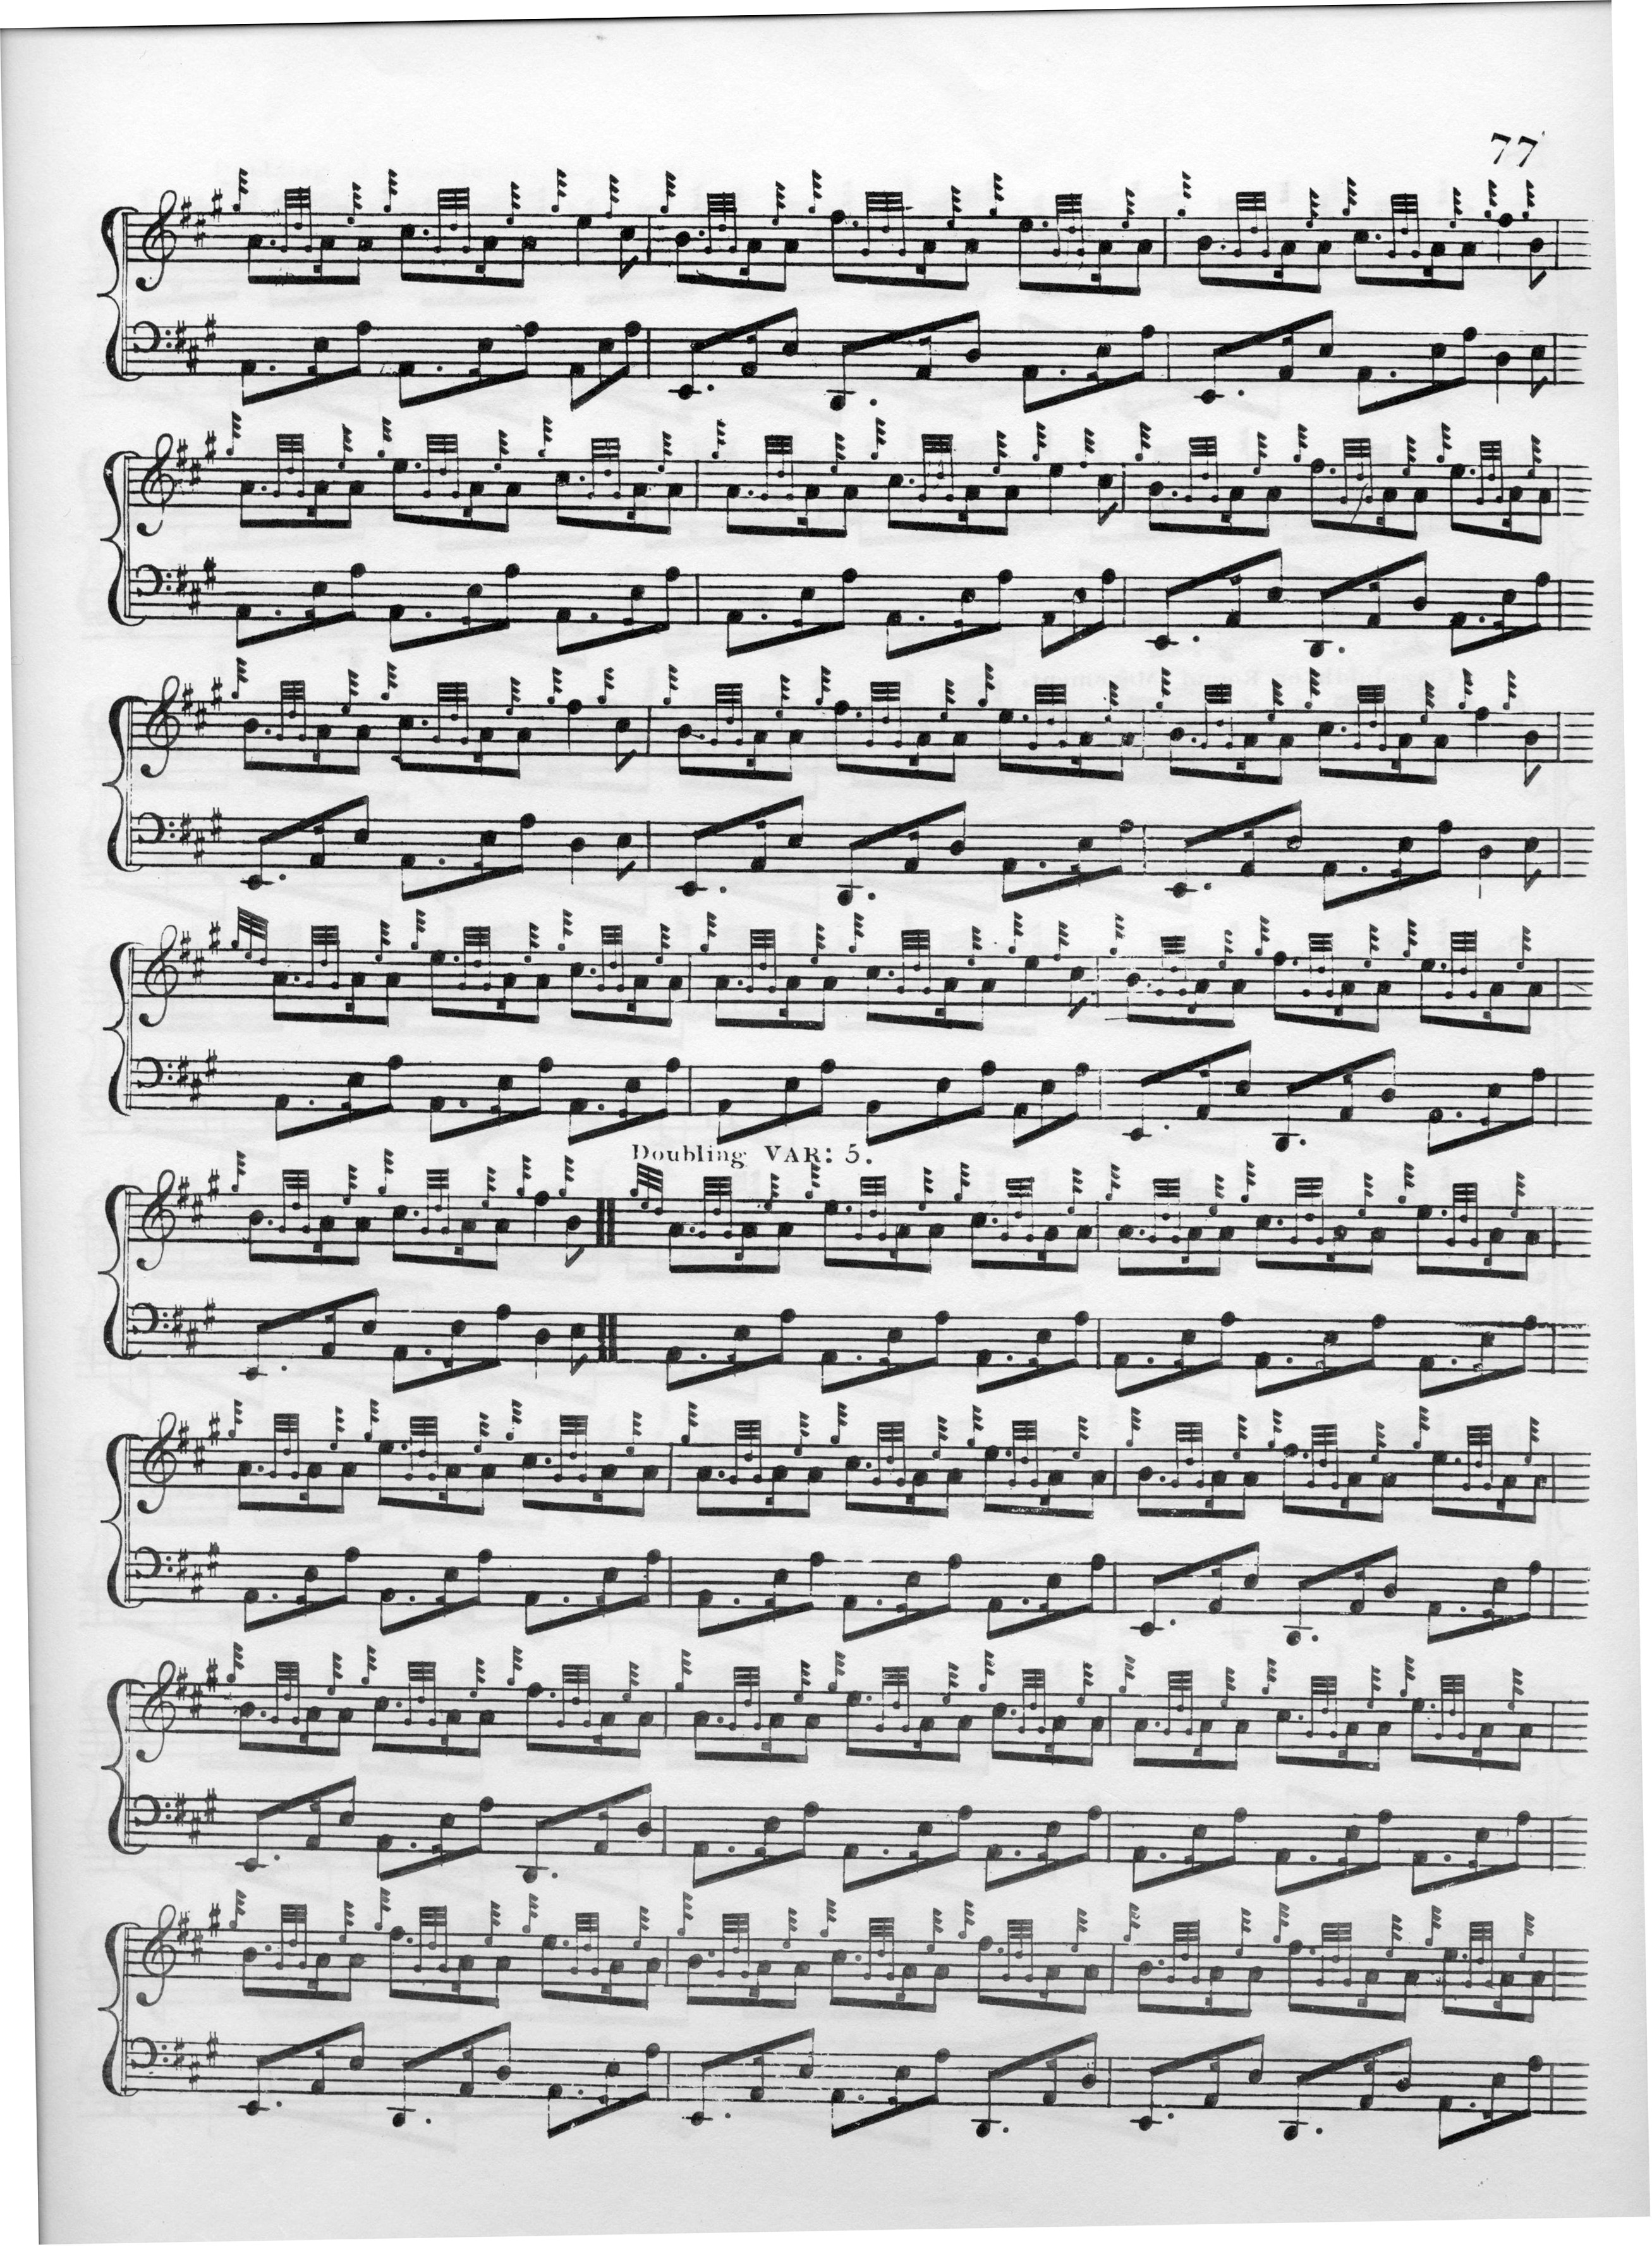
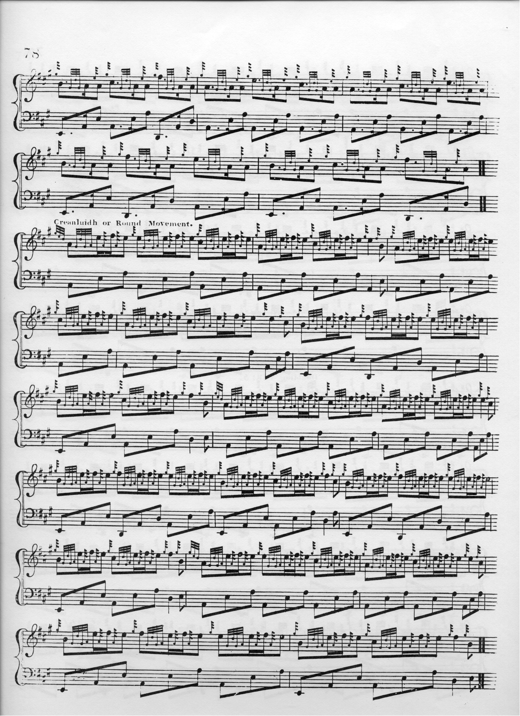
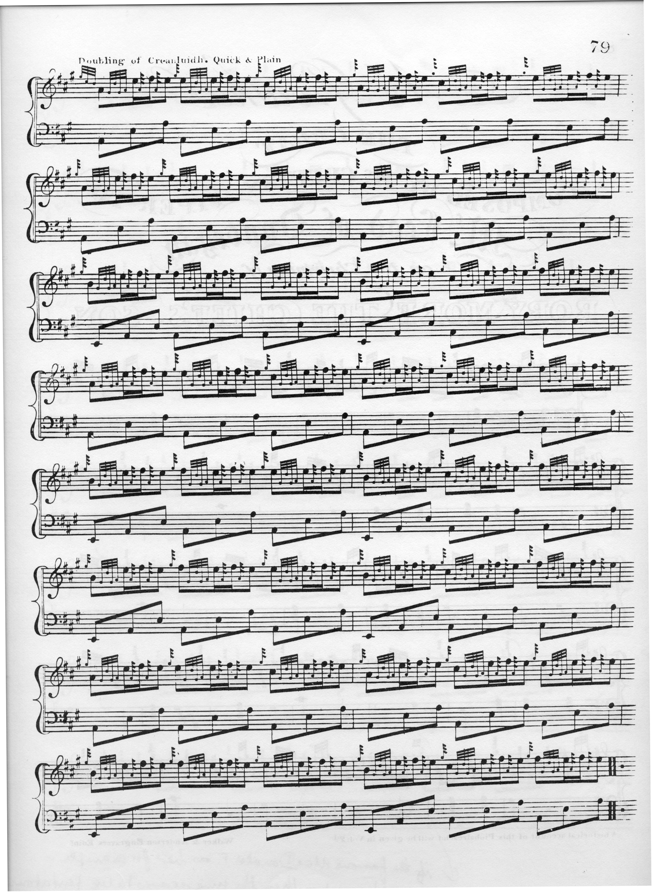

MacDonald's score is accompanied by various directions regarding tempo and expression. The thumb variation singling is marked ”A little Lively”; variation 3 is “pointed”; the doubling of variation 4 is “Lively”; the trebling of variation 4 “Quick”; and the doubling of the crunluath is “Quick & Plain”.

Angus MacKay's setting seems clearly to have been influenced by Donald MacDonald's, but omits variation 2, and also (rather unusually for MacKay) repeats of the ground within the tune. It does contain a variation, however, not present in Colin Campbell or Donald MacDonald, his “var.3rd” described below. In addition, his var.4 is cut “up” while MacDonald's is cut “down”. Angus MacKay sets the tune like this:

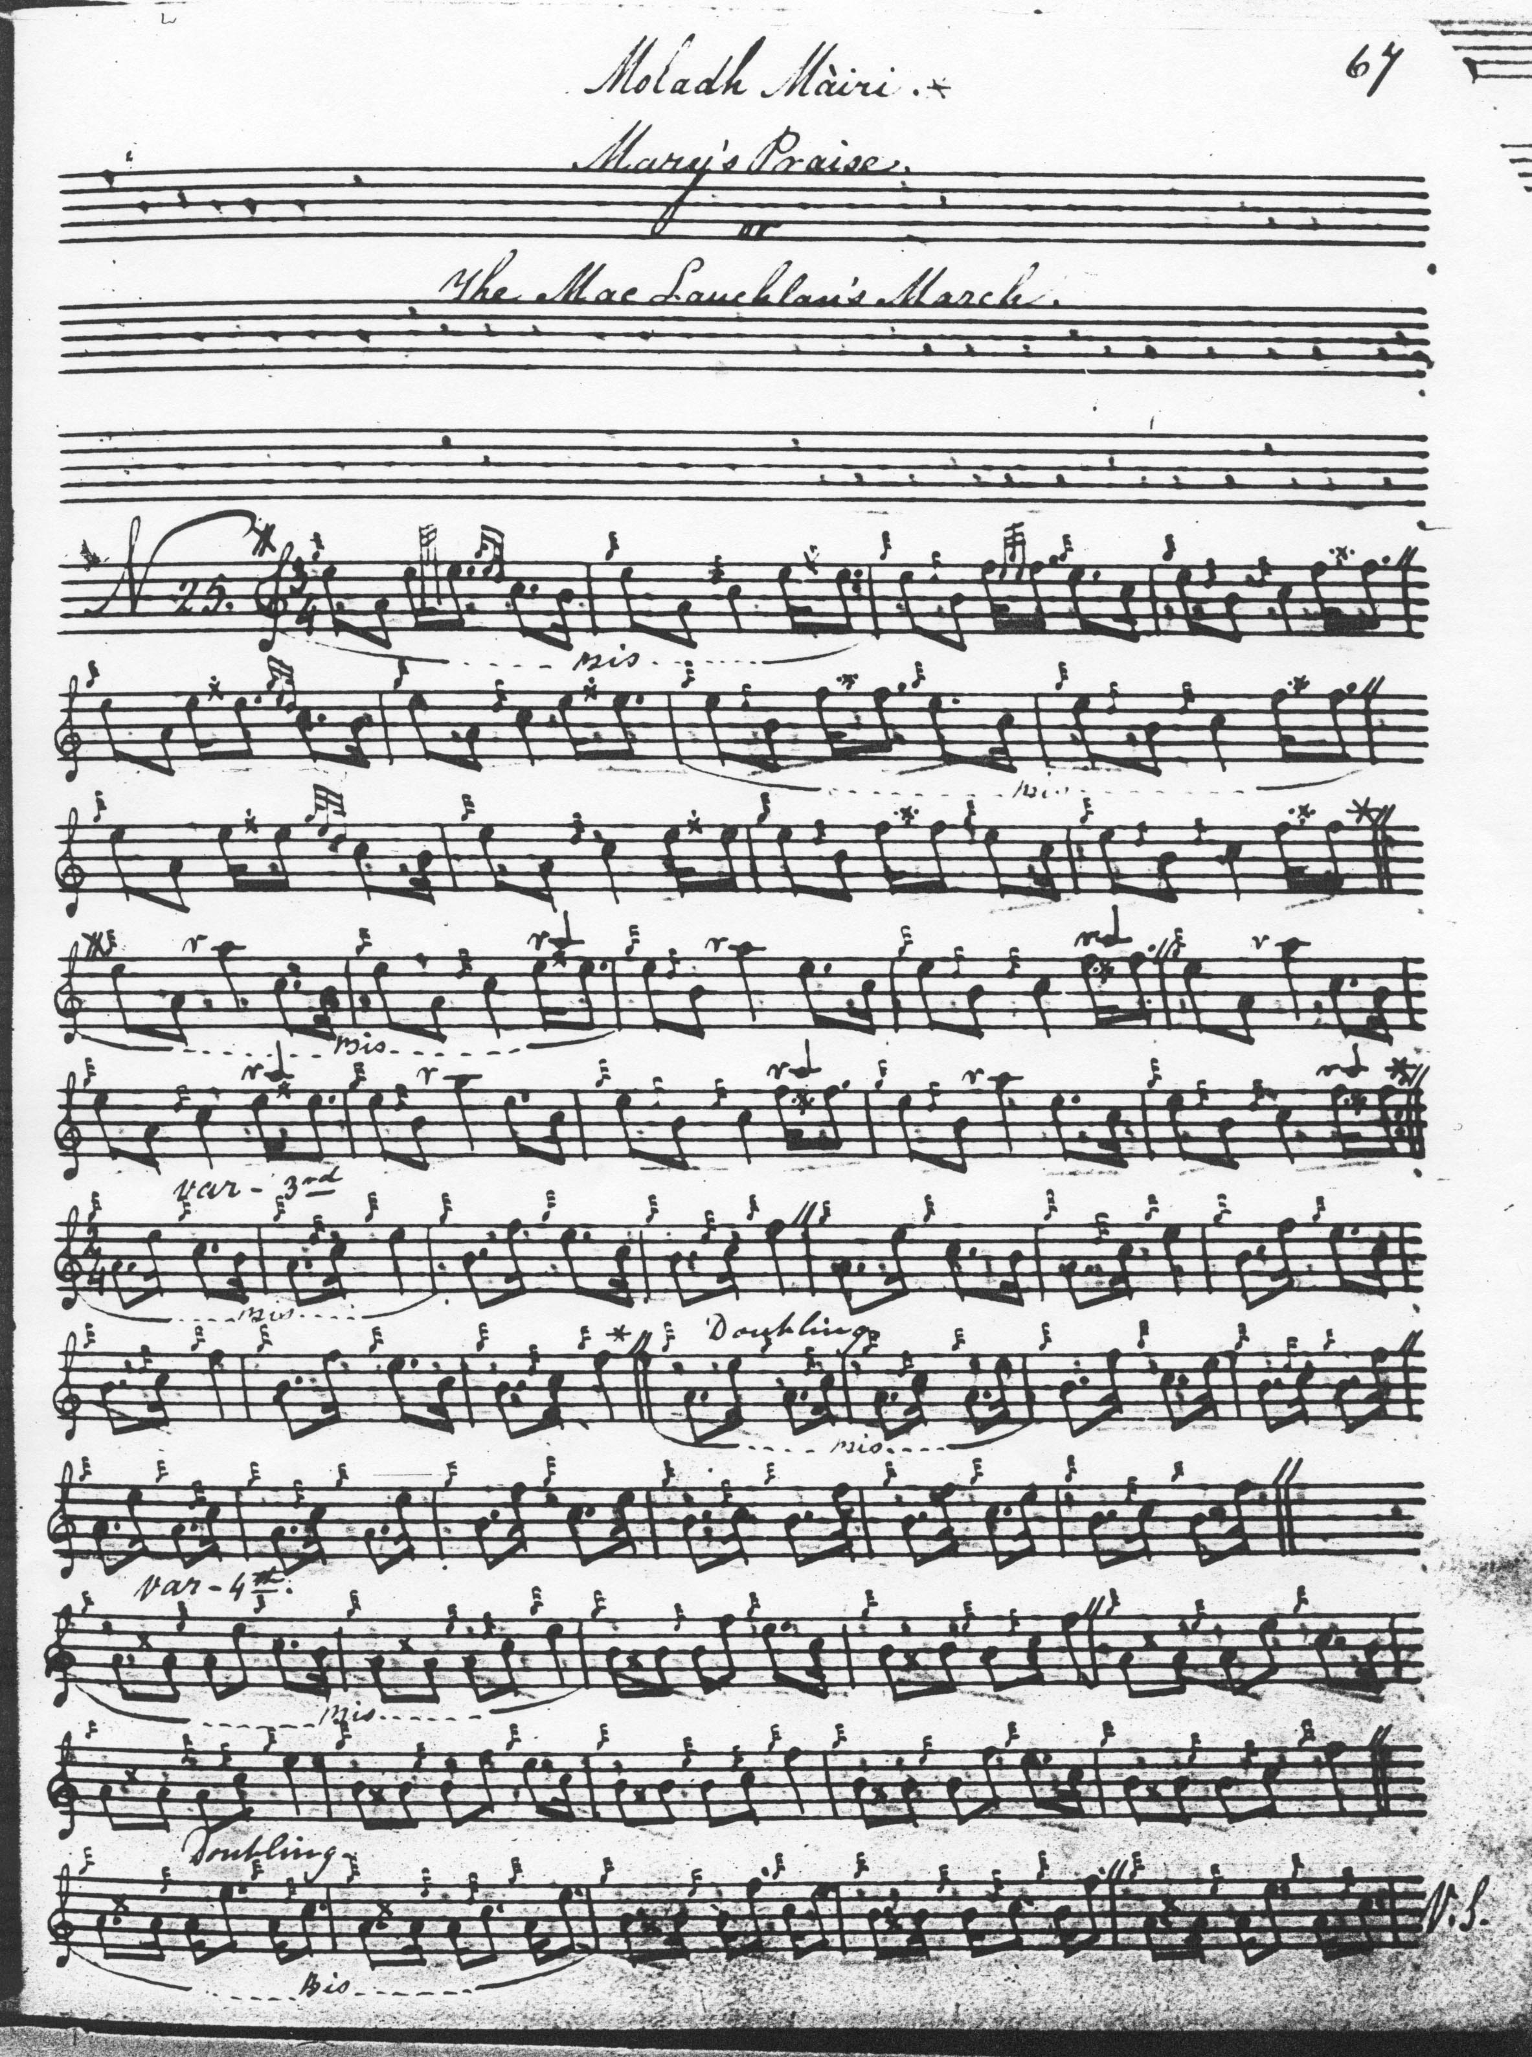

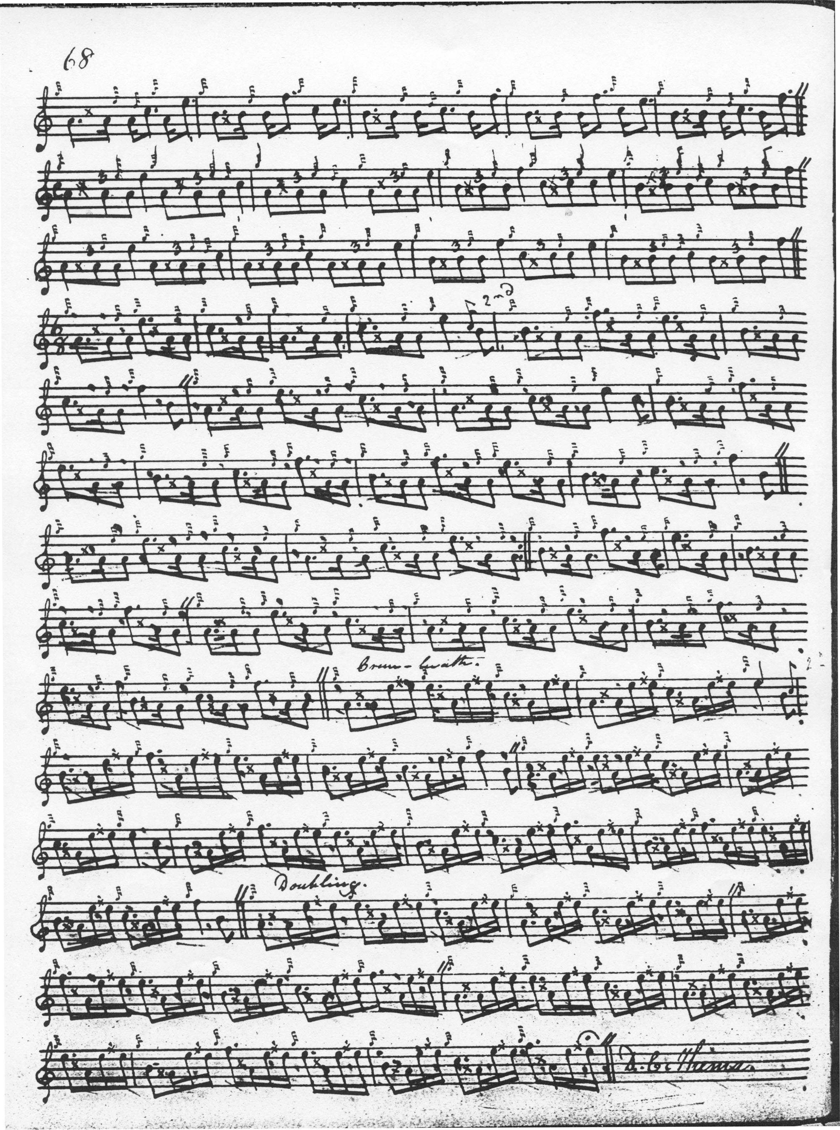

John MacDougall Gillies’s MS book contains one of the more subtle timings
of the tune. Gillies set it as follows:

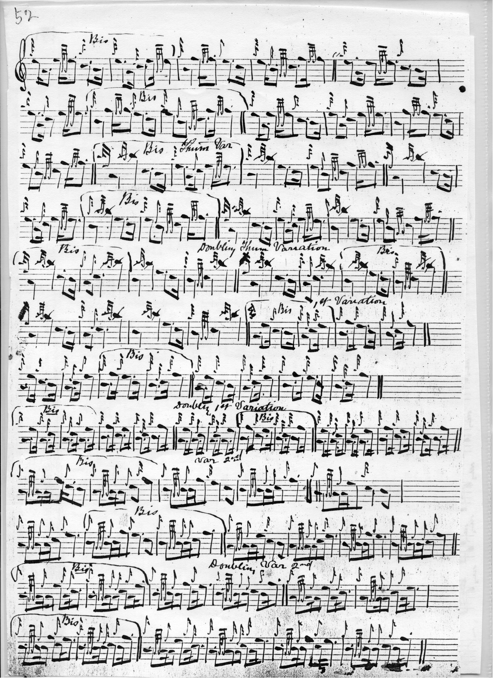
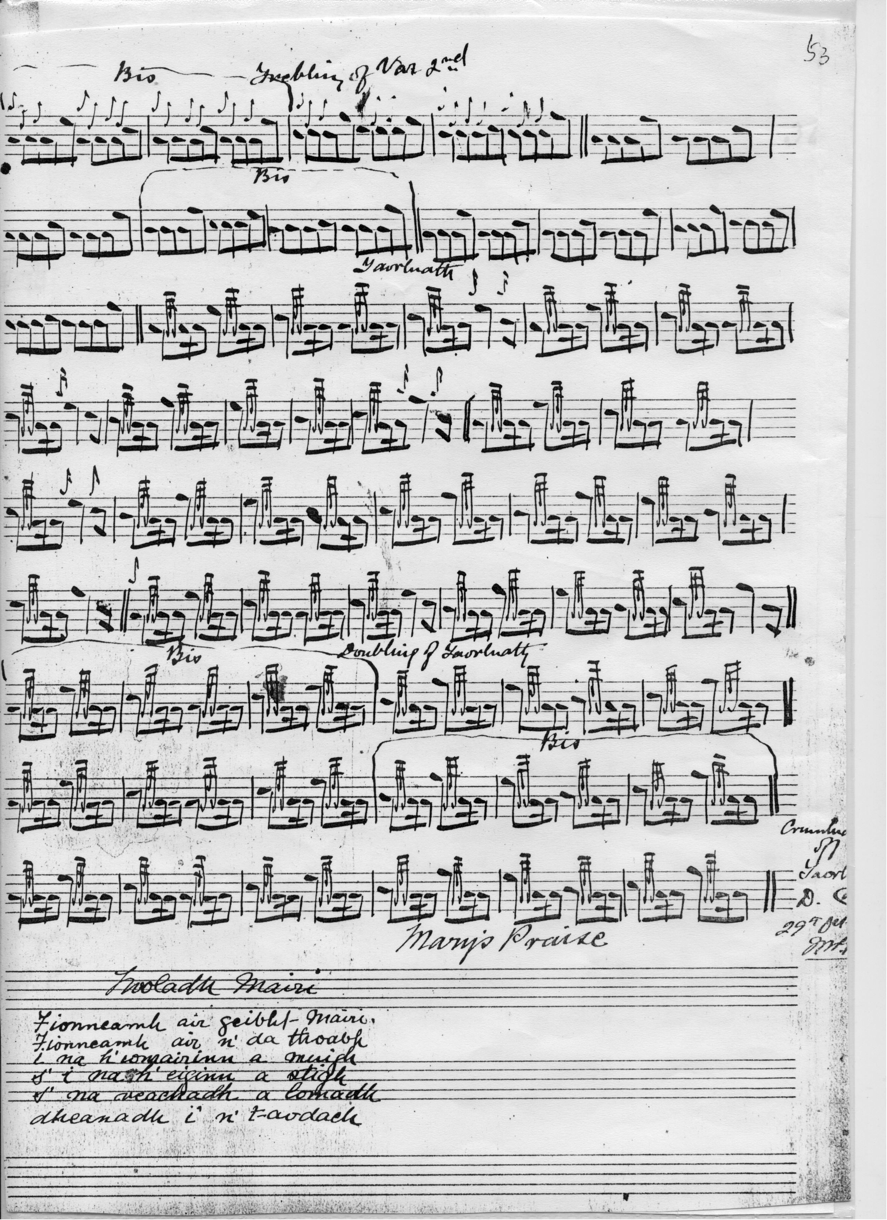

We note particularly the cut down from E to B in the last bar of line one of his ground, and the cut up at the beginning of bar two line one in his thumb variation providing rhythmical tension between the A and B phrases. Gillies’s style was regarded by contemporaries as distinctive and these two touches would probably have been considered characteristic;

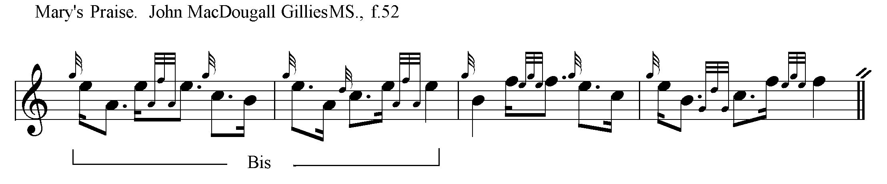

Several of the settings listed above do not contribute significantly to the expressive possibilities of the tune and are therefore not included here. Amongst these are the manuscript settings of Donald MacKay and Robert Meldrum and the published settings of Donald MacPhee, (i, 10-13), whose score combines elements from MacDonald and MacKay, as does C. S. Thomason’s in Ceol Mor. David Glen’s setting closely follows that of Angus MacKay, while Iain McLennan’s is guided by Donald MacDonald’s published score, (although this seems to be the only one of the settings to stipulate a crunluath a-mach).

G. F. Ross’s setting reflects his beliefs about “regularity” and his unease about changes of time signature within a tune. While he cannot be acquitted of dogmatism in this instance, some of his suggested timings might interest the thoughtful performer:

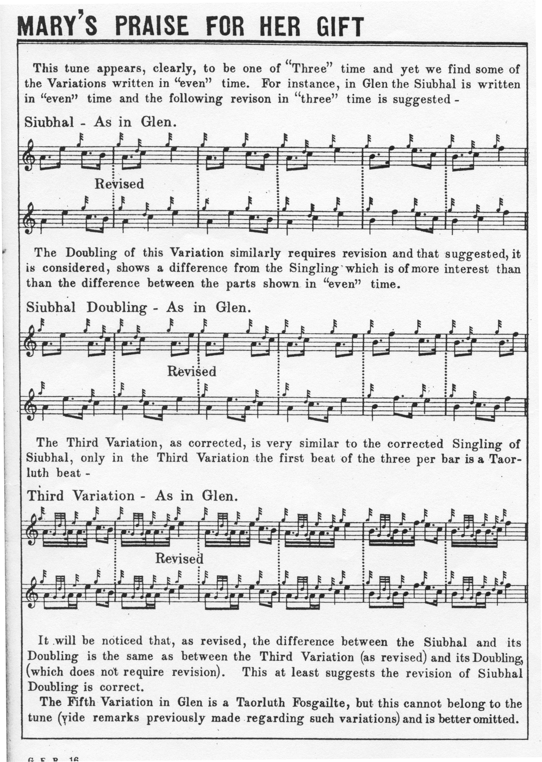

Commentary:
Dr. Charles Bannatyne claimed that this was a Lamont tune. The following extract from the Oban Times (07/10/1905, p.3) gives a good example of his characteristically assertive style:

The fine Lamont piobaireachd, called “Stiallag”, we might say has been “skinned” by another clan, and called “Moladh Mairi”, with a story tacked on concerning a certain Mary, a forlorn piper, and an old wether’s skin which Mary kindly gave him. So overcome was he at the gift, worth then about a groat, that the muse attacked him, and he composed the beautiful “Moladh Mairi”. Was ever there such a prostitution of art for the sake of an old skin? Bosh! Lamont of Lamont gave his kinsman and piper the farm of Stiallag in life-rent for some service rendered. The piper, by way of thanks composed the tune of “Stiallag”, the first verse of which goes:-

’S leam fhéin, ’s leam fhéin,
’S leam fhéin Stiallag
’S leam fhéin, ’s leam fhéin,
’S leam fhéin Stiallag
’Se le m’shloichd am dhéigh,
’S leam fhéin Stiallag

The Lamonts of Stiallag were cadets of the Lamonts of Lamont. In an old Argyllshire rent-roll made up for taxation and registration purposes in the sixteenth century, reference is made to one Duncan Campbell of Stiallag, and probably he may have been the piper who received Stiallag, and wakened his kinsman and chief the morning after his marriage with the sweet notes of the celebrated piobaireachd now commonly known as “Moladh Mairi”, or “Mary’s Praise”.

John MacDougall Gillies’s score ends with the following verse:

“Moladh Mairi
Fionneamh air geibht Mairi,
Fionneamh air n' da thoabh
i na h'iongairinn a muigh
s' i na h'eiginn a stigh
s' na reachadh a lomadh
dheanadh i' n' t-ardach”
(Gillies MS f.53).
Dr Seumas Grannd of the University of Aberdeen advises that this is capable of a highly indelicate interpretation.

* * *

Electronic text © William Donaldson, Aberdeen, Scotland, 15th June 2012

