Lament for Mary MacLeod

There are settings of this tune in the following manuscript sources:
--Angus MacKay’s MS, (i, ff.203-204);
--D. S. MacDonald’s MS, (i, 124-50;
--David Glen’s MS, (ff.156-158);
--Robert Meldrum’s MS,, (ff.1-3);

and in the following published sources:
--William Ross, Ross’s Collection, pp. 104-5—with the title “Mary MacLeod's Lament, (The Isle of Skye Poetess). Copied from Alex. MacDonald Piper to the Late Earl of Fife”;
--David Glen’s Collection of Ancient Piobaireachd (pp.192-3) and also in his Edinburgh Collection (iv, 16), where the score is marked “as played by Colin Cameron”;
--C. S. Thomason’s Ceol Mor, (pp. 269-70);
--G. F. Ross’s Collection of MacCrimmon and other piobaireachd (pp.46-7).

The oldest of the scores, Angus MacKay’s MS, times the tune as follows:

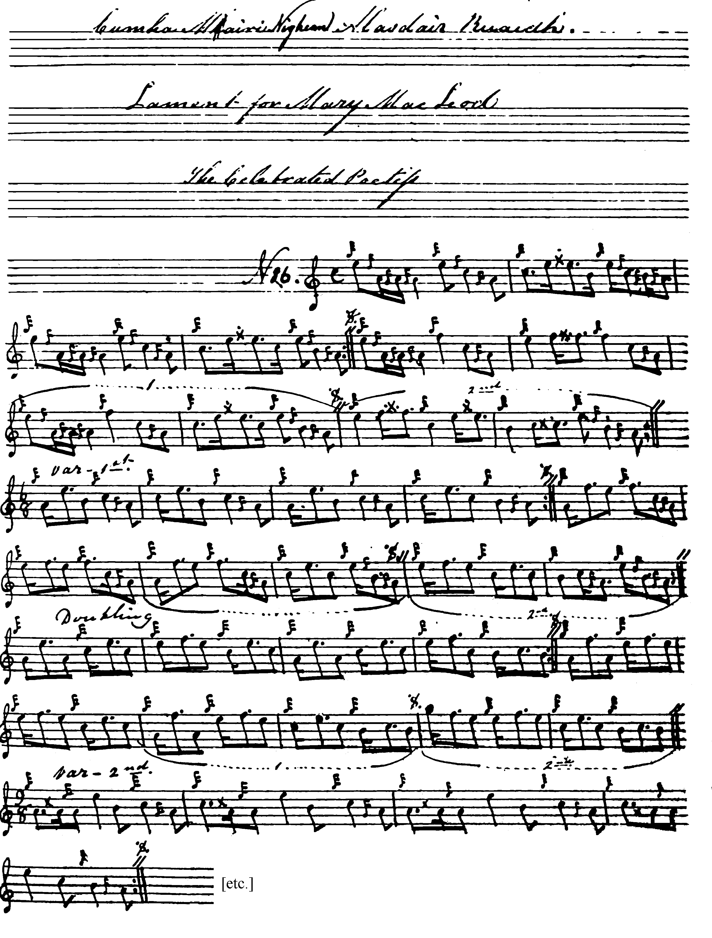

And so on.

The earliest published version is in Uilleam Ross’s Collection, with a note, “Copied from Alex. Macdonald [father of John MacDonald of Inverness] piper to the Late Earl of Fife”, as follows:
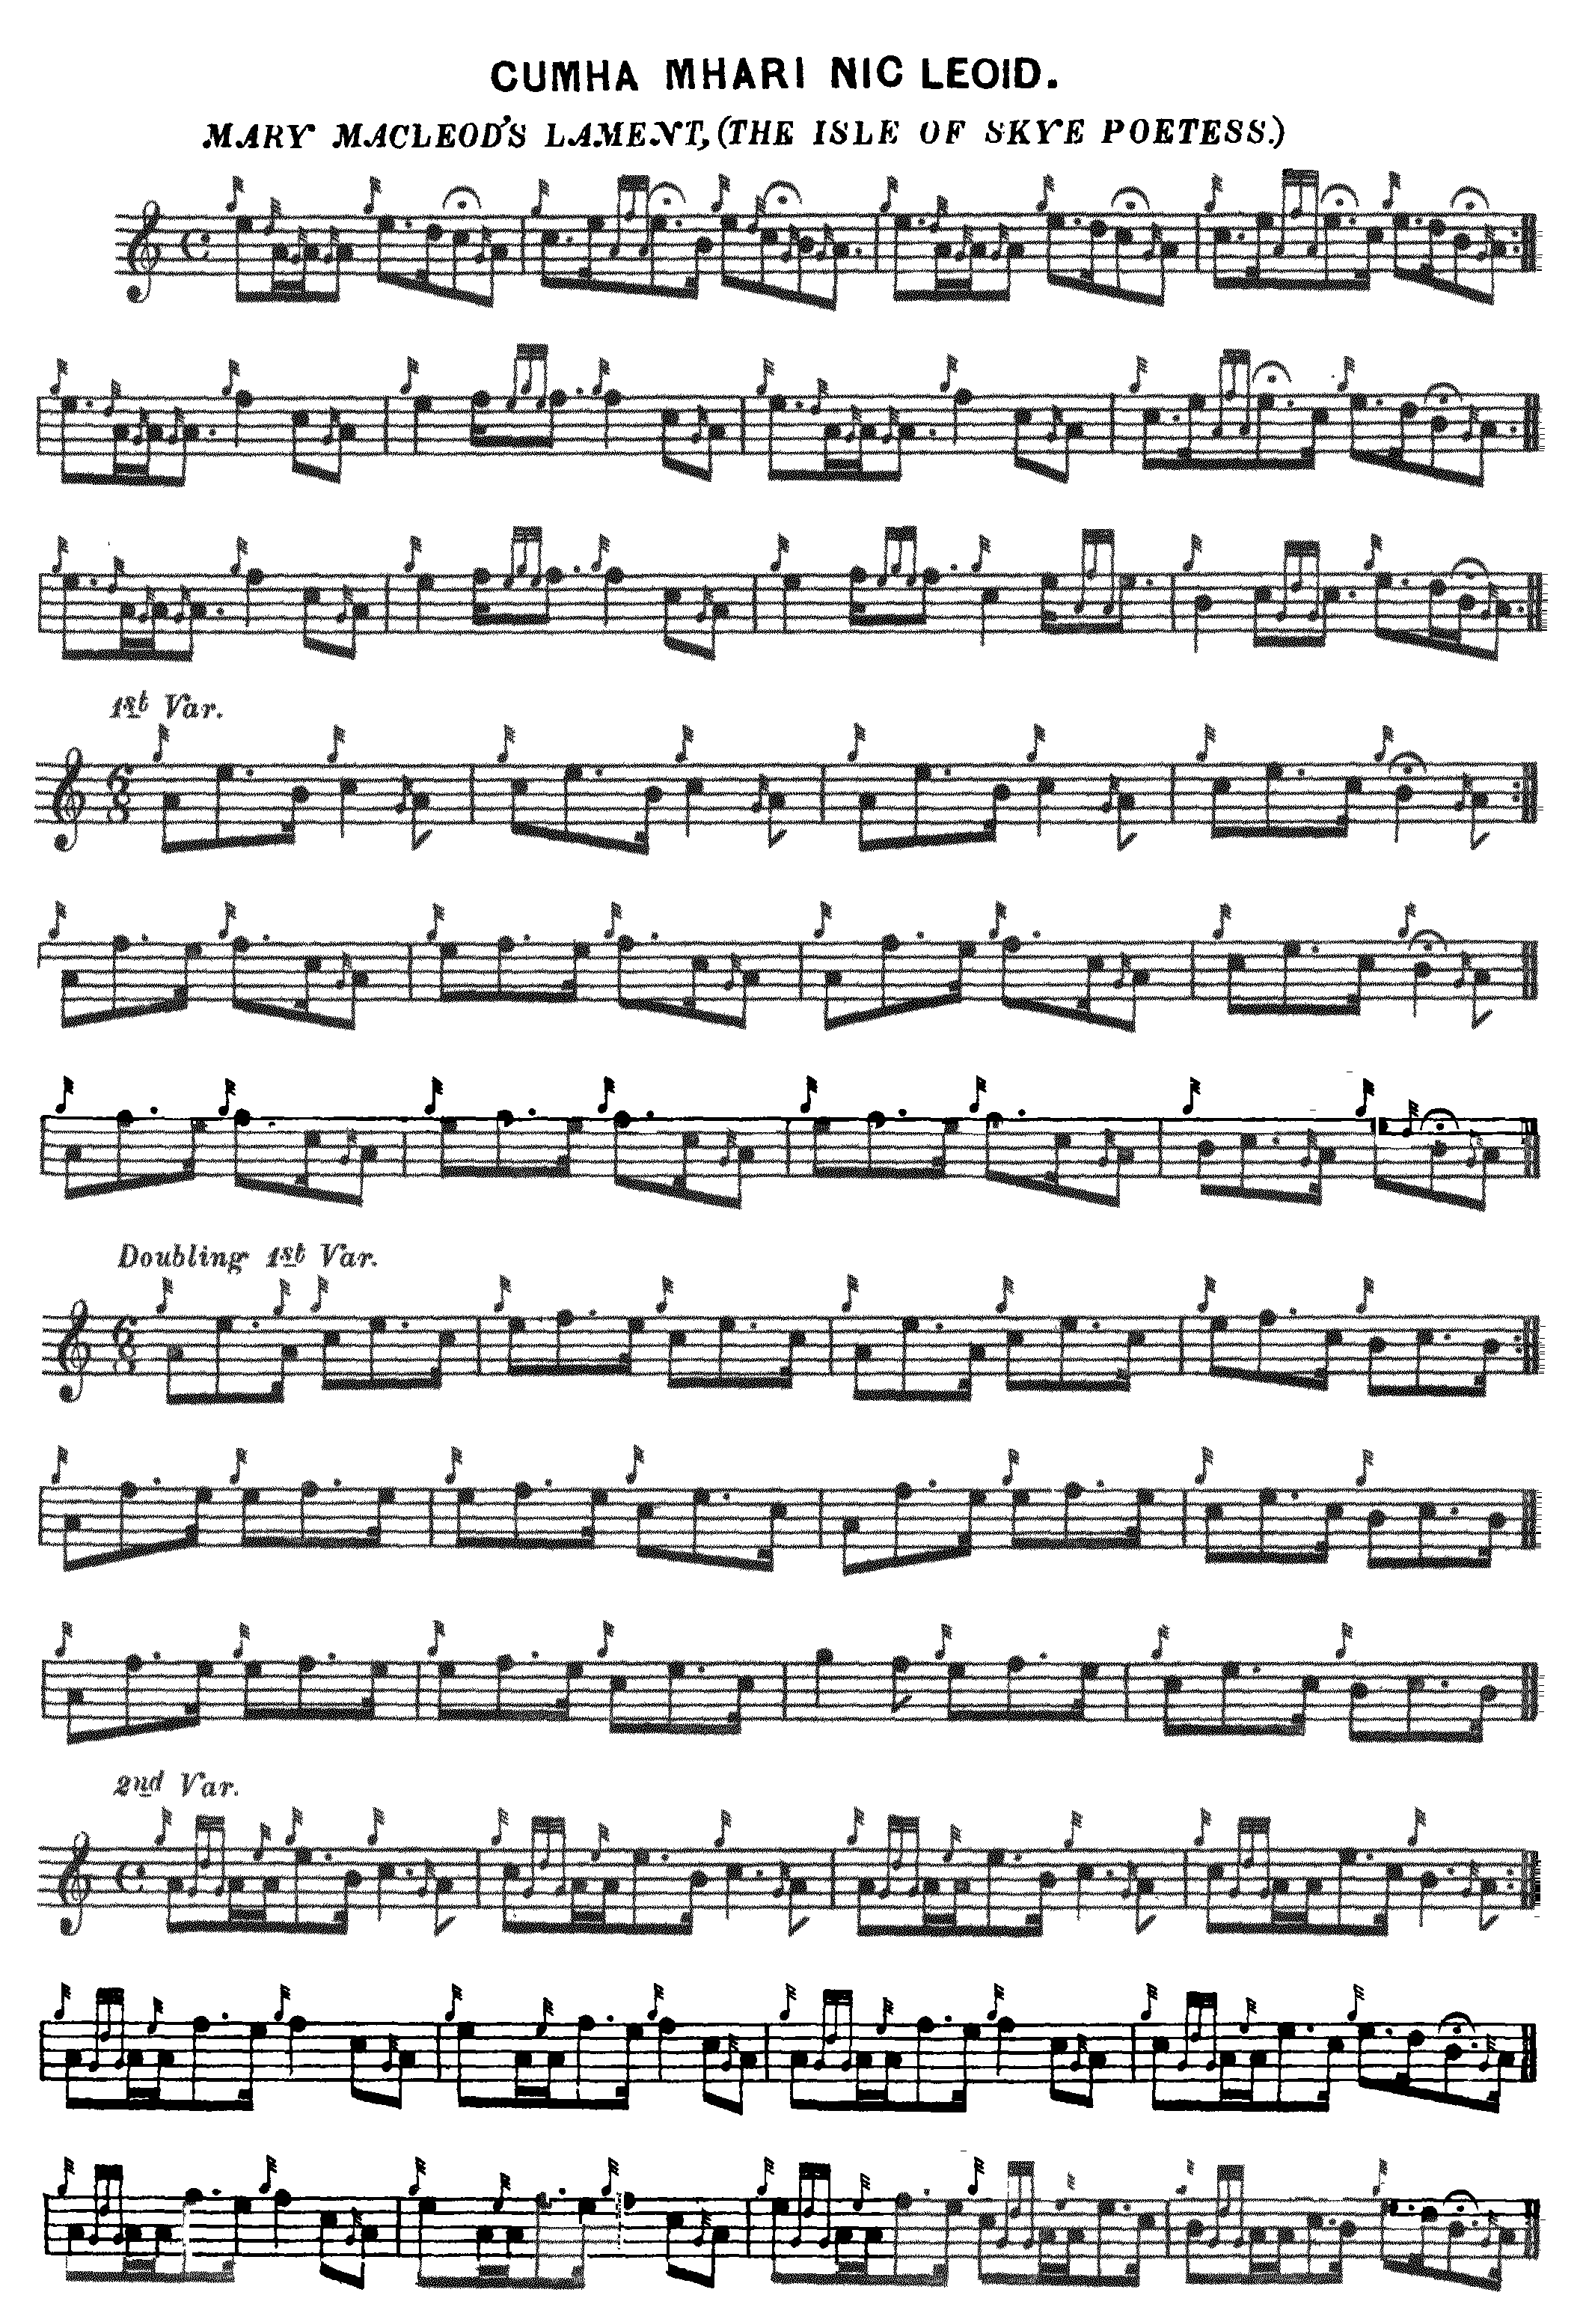

And so on. It is intriguing to see attributed to Sandy MacDonald the high G at the beginning of bar 15 of the doubling of the first variation. Sandy MacDonald’s son, Johnny, played high A here (see below), an interesting example of stylistic variation within a single family.

Commentary

Comparison of the differences between the settings of Uilleam Ross and that of Archibald Campbell in the Piobaireachd Society Collection is instructive. Campbell wrote that his setting “corresponds- with Ross except in four specified details (PS v, 156) but in fact he made more than twenty silent changes to the note values in the first line of Ross’s ground alone. Campbell provided a further nine numbered textual notes in which he describes differences between cadences and gracenote in the various sources in a manner which implied scrupulous scholarship.

The real situation was rather different, however, and can be illustrated by exploring one example, namely the high G quaver which occurs in bar 15 of the first variation doubling and in corresponding places in the later variations. This was endorsed by most of the written tradition; but some leading 20th century performers played high A in this position. Archibald Campbell wrote round to seek advice on this point and the replies are in his editorial files now in the National Library of Scotland. Campbell himself was a strong partisan of the high G here, writing to piping judge and naturalist Seton Gordon in April 1929 he said: “Many thanks for your letter telling me what John MacDonald says. I will place it in the file of Mary Macleod as a piece of evidence to assist in confuting the anti-high G heretics...” (Seton Gordon Papers, National Library of Scotland, “General Correspondence, 1927-29”, 11/4/1929). In Campbell’s notes to the tune (PS v, 156) he stated simply that “some pipers play high A plain” in this position. He did not reveal that the pipers concerned included John MacDonald of Inverness and also Willie Ross who had written to Campbell about this from Edinburgh Castle as follows:

Sir,
Thank you for your letter and tune which I am returning to you and all I can say about the A is that when I was staying at Blair Athole in 1892 my grand uncle [Aeneas Rose] taught me to play the tune with High A. He also said I could play F in the Taorluath and Crunluath (doublings). I learnt the Tune from a MS Book which my uncle had on loan from a David Dow. I tried to get hold of the book after Dow died but nobody seemed to know where it went to. I heard [John MacDougall] Gillies play the A in 1897 at Aberfeldy and Helensburgh. Whether he played the A because of a bad G I dont know.
Roderick Campbell a pupil of S Camerons plays the A and teaches it. I taught all my pupils to play the A but if they prefer the G they were at liberty to play it, but they all seemed to prefer the A. Candidly I dont like the G. (NLS, MS22112, 18/03/1934)

Nor do Campbell’s notes draw attention to his routine translation of Uilleam Ross’s quavers into crotchets at bar and phrase endings which seriously disrupts the flow of the tune.

The dedicatee of the tune, Mary MacLeod, or Màiri Nighean Alasdair Ruadh, (c.1615-c.1707) was one of the foremost women songwriters and poets in vernacular Scottish Gaelic of the seventeenth and early eighteenth centuries. Most of her output concerns the praise of the house of Dunvegan. Her approach was innovative from a technical point of view and it has been said that it was echoed by pipers in their own medium (see “The Passing of the Piobaireachd”, by Lt. John McLennan, Oban Times, 26/09/1903, p.3). In terms of form, the later variations of the tune are sometimes claimed to be unique, but at least one other piece, “The Men Went to Drink” (Uilleam Ross’s Collection, pp.11-12; C. S. Thomason’s Ceol Mor, p. 219; and David Glen’s Collection of Ancient Piobaireachd, pp.158-9) uses similar devices.

A final stylistic point may be appropriate here. As written by MacKay, and followed by the later editors, the ground is awkward to play in a rhythmically satisfying manner, and one wonders if the duple time used in the variations might not be a better choice than the quadruple time selected by MacKay for the ground of the tune. These issues are explored in additional detail in the PDF file for “The Rout of Glenfruin” which has interesting melodic links with our present piece. The accompanying MP3 file suggests a possible timing of the ground in 6/8.

* * *

Electronic text © Dr. William Donaldson, Aberdeen, Scotland, November 2002; revised Cambridge, Massachusetts, February 2025.

