The Marquis of Argyll’s Salute

There are settings of this tune in the following manuscript sources:
Colin Mór Campbell, “Nether Lorn Canntaireachd”, ii,159-162 (with the title “Donaich dall Mhac Donail Nuras”);
Donald MacDonald’s MS, ff.245-248;
Peter Reid’s MS, ff.25-26;
David Glen’s MS, ff.382-384 (with the title “The Marquis of Tullibardine’s Salute at Dunvegan Castle”);

and in the following published sources:
Niel MacLeod of Gesto, Collection of Pibaireachd or Pipe Tunes, pp.26-7 (with the title “Marquis of Talibeardin’s Salute at Dunvegan Castle, played by Patrig Oig Maccrimmon”);
Angus MacKay, Collection of Ancient Piobaireachd, pp.61-2;
C. S. Thomason, Ceol Mor, p.197;
David Glen, Collection of Ancient Piobaireachd, pp.226-7.

Colin Mór Campbell treats the tune as follows:

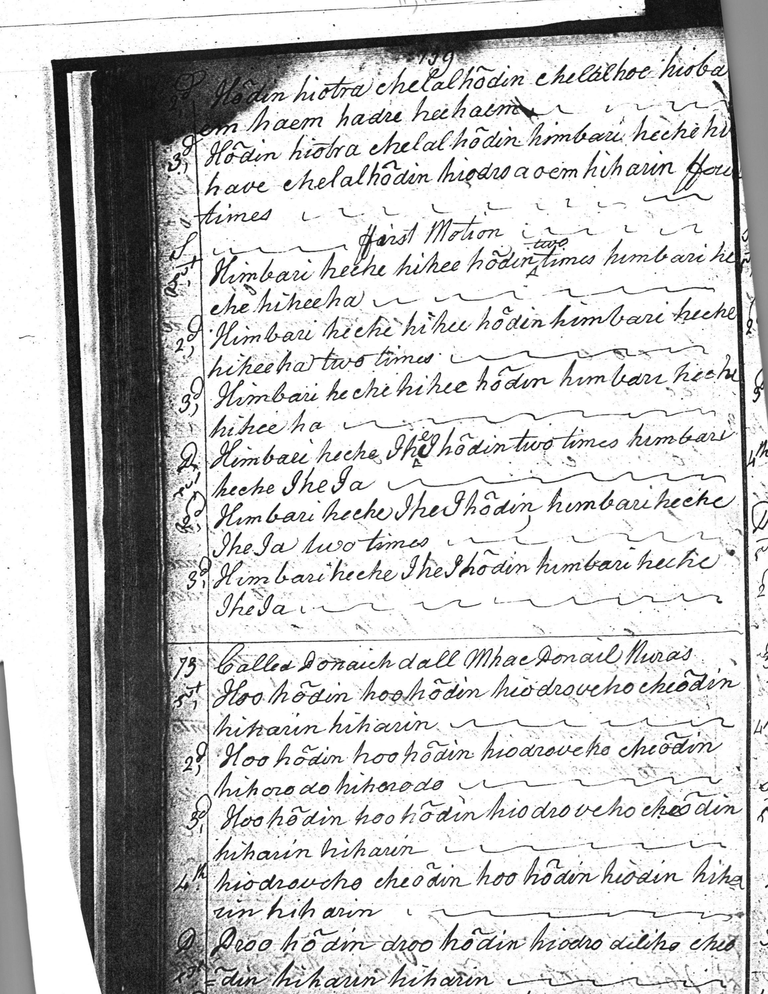
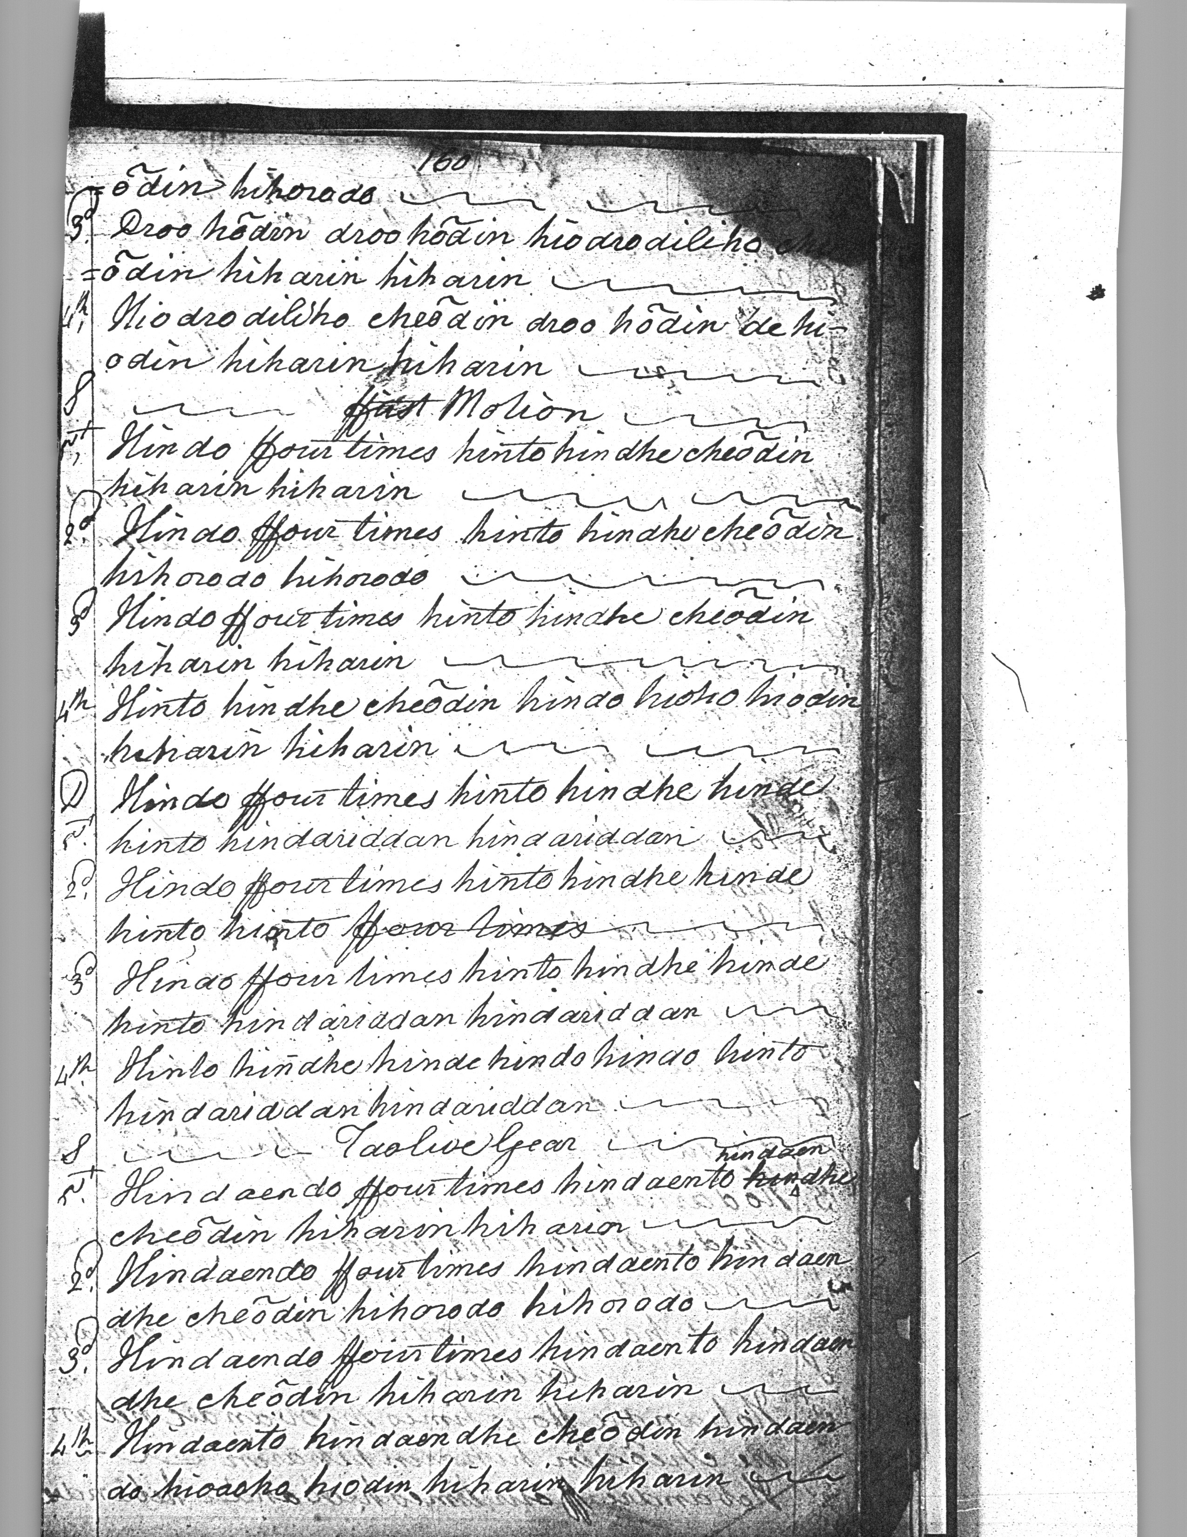

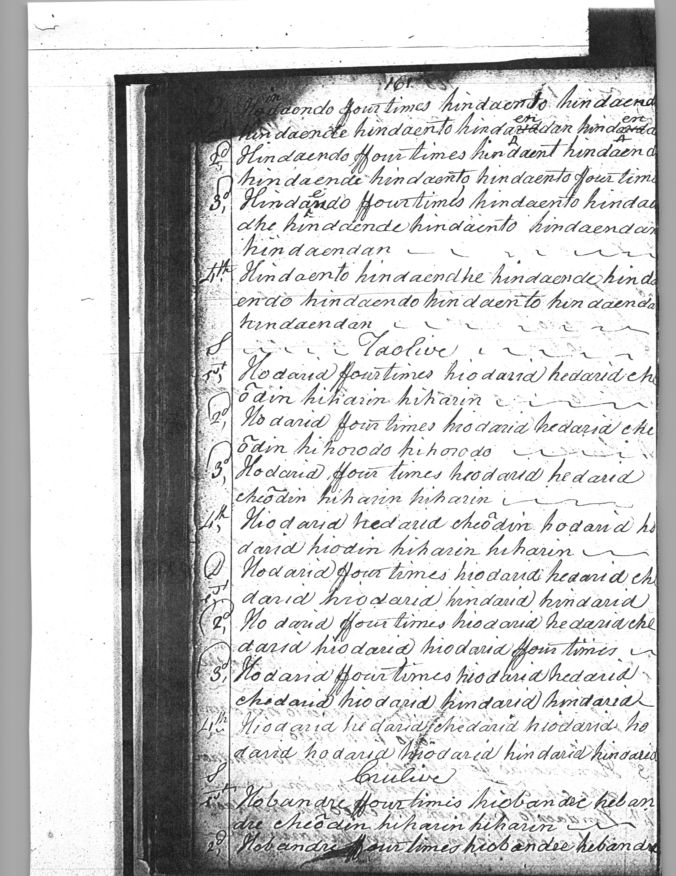

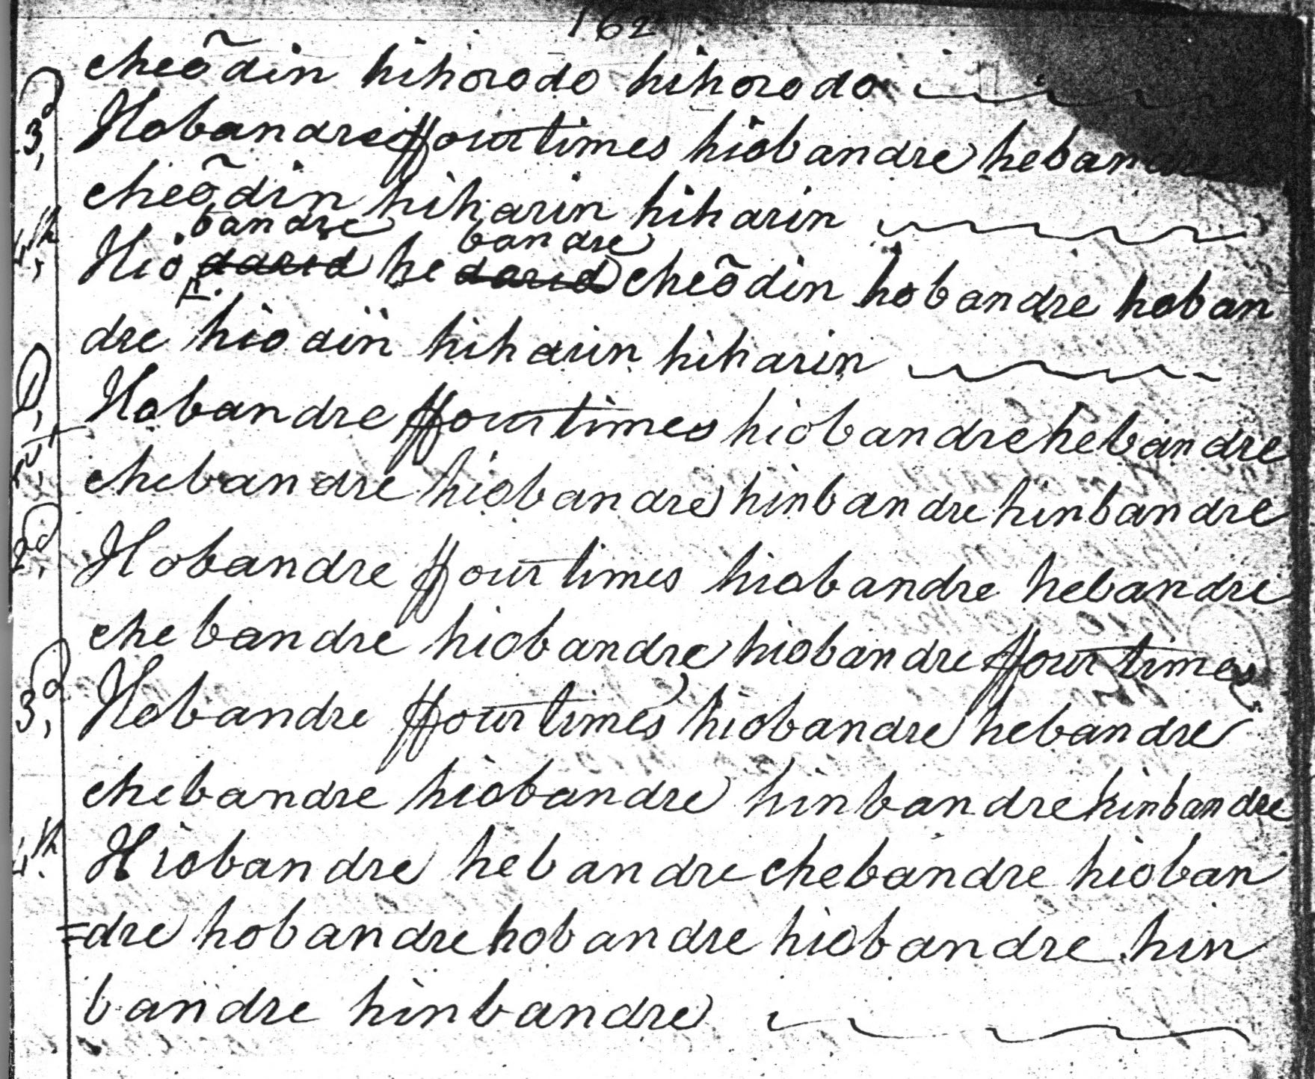

In structural terms, Colin Campbell’s ground is in four lines: a six-bar line one, ending in hirarin hiharin is repeated to form line two, with the open ending hihorodo hihororo substituted for hiharin hiharin. Then at the point when one might expect fresh motif to enter, back comes line one again, repeated exactly, so that with the exception of the change in the point of rest at the end of line two where the phrase comes to rest on B rather than A, the opening line is essentially reiterated three times. In the thumb variation that follows there is a missing double echo movement on B at the end of line two in Colin Campbell’s score; but the structure is exactly as in the ground, and the pattern continues in the ffirst Motion. There is a moment of obvious editorial uncertainty at the end of line two in the doubling of the ffirst Motion, which Colin Mór concludes with a curious syllable hiorto, visibly emended from something else which had been there first, and the words “ffour times” struck through with Colin Campbell’s normal wavy “end of line” symbol. In a further sign of carelessness there is the missing “o” at the end of the “hindaento” vocable in the taolive gear doubling second line. Next, we get a taorluath duinte singling and doubling (again perhaps rather unusual in this source, where you usually get one style of the taorluath and crunluath movements or the other, although this latter is a common feature in the tunes of Angus MacKay’s father, John). There follows a crunluath duinte singling and doubling. The metre of the fourth lines in the variations following the ground seems to fluctuate between five and six pulses throughout.

Donald MacDonald sets the tune like this:

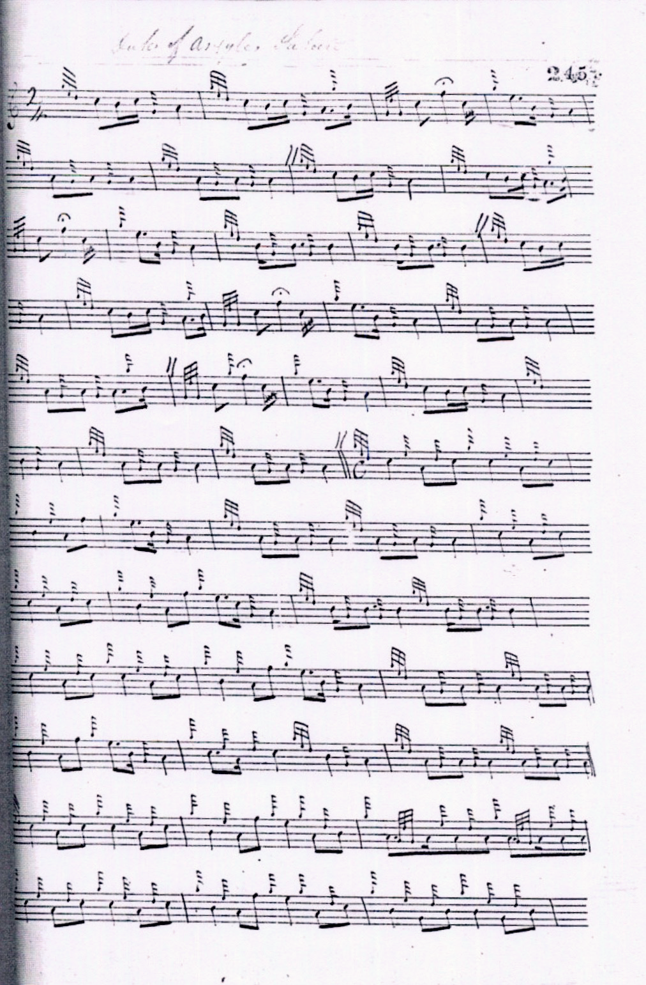
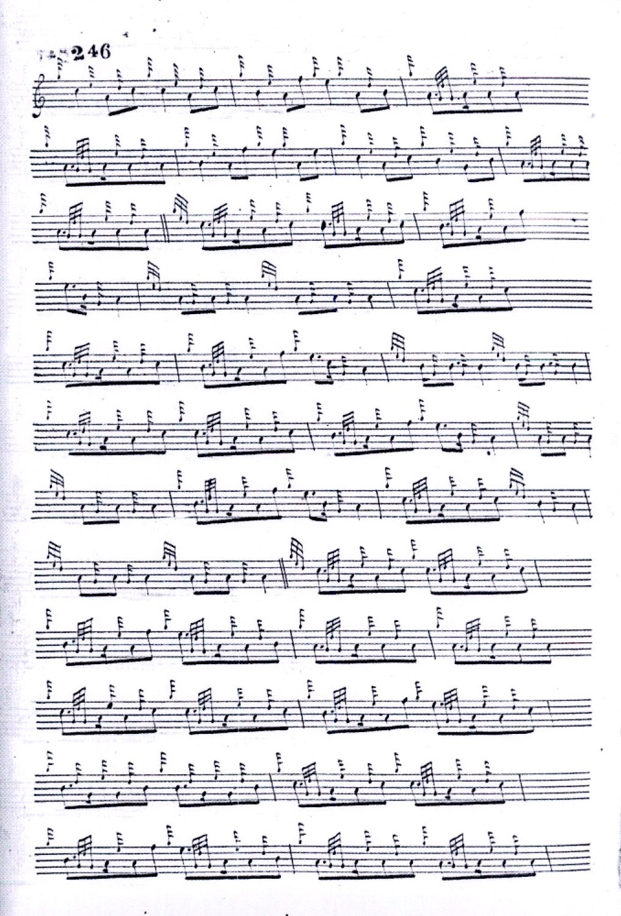

and so on. MacDonald stabilizes the metre as above before proceeding to a crunluath singling and doubling similar to Angus MacKay’s score which is reproduced more fully below. MacDonald’s version drops the thumb variation and has a differently-timed siubhal movement singling and doubling from Colin Mór Campbell and on it the remainder of the variations, a taorluath and crunluath breabach singling and doubling are founded. The Nether Lorn siubhal if played “down” would seem to provide more musical variety than MacDonald’s siubhal and taorluath movements which from a melodic and rhythmical point of view may seem rather too close together.

Niel MacLeod of Gesto’s is the earliest of the printed settings and similar to Donald MacDonald’s in the general style and development of the tune. Since Gesto and MacDonald were in close personal contact at the time this may reflect a general interchange of ideas:

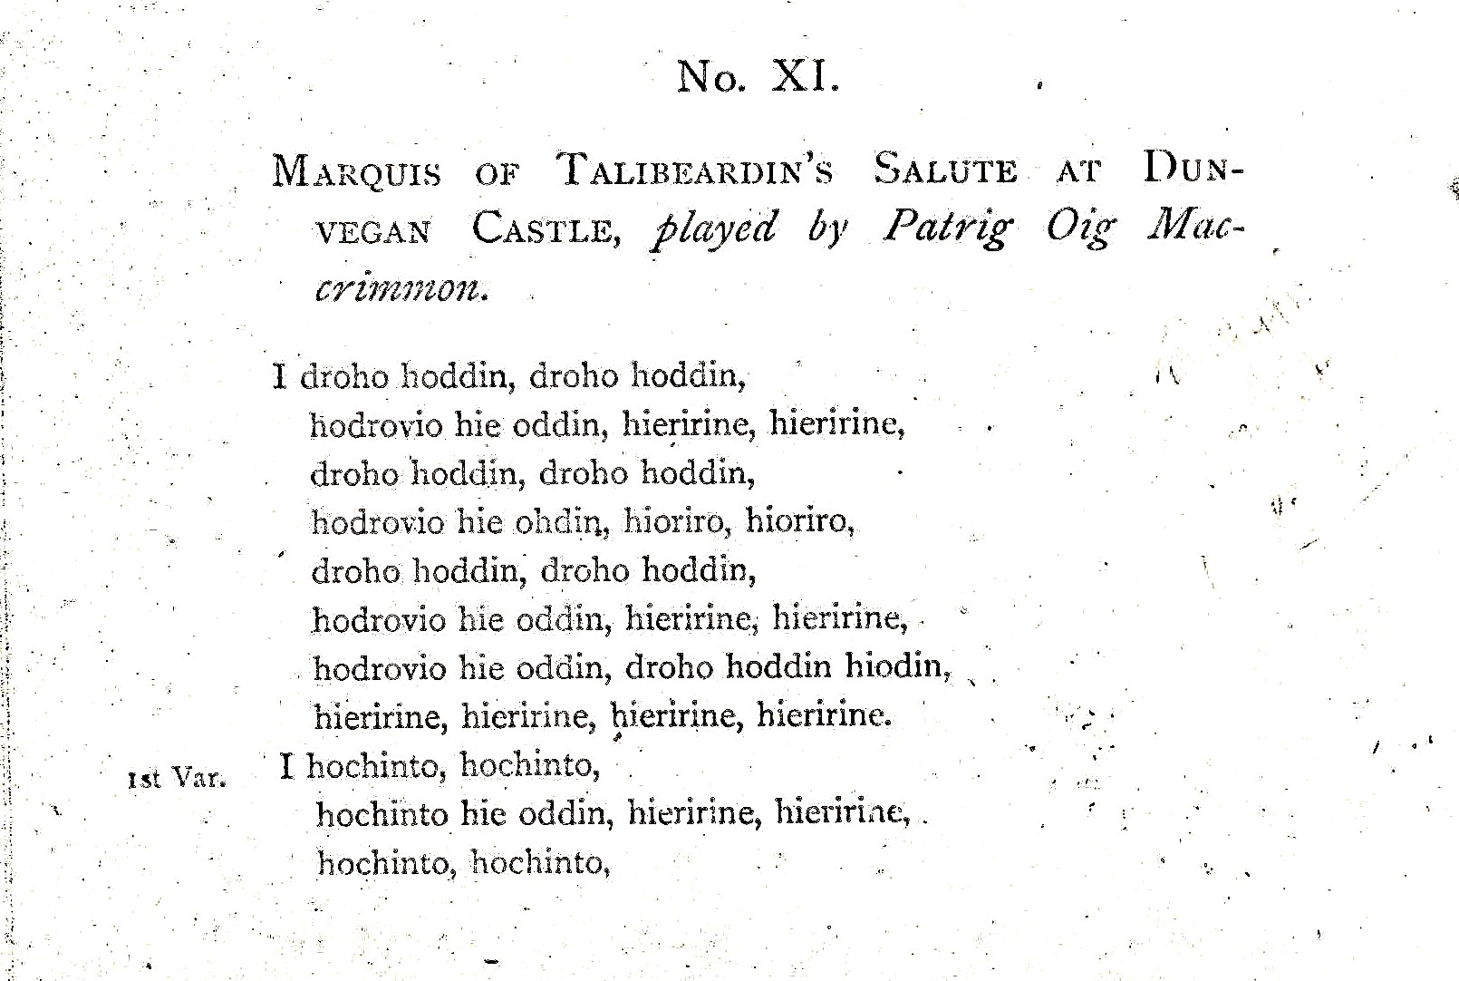
and so on.

David Glen and Charles Bannatyne offer a speculative reading of the Gesto setting in Glen’s manuscript as follows:

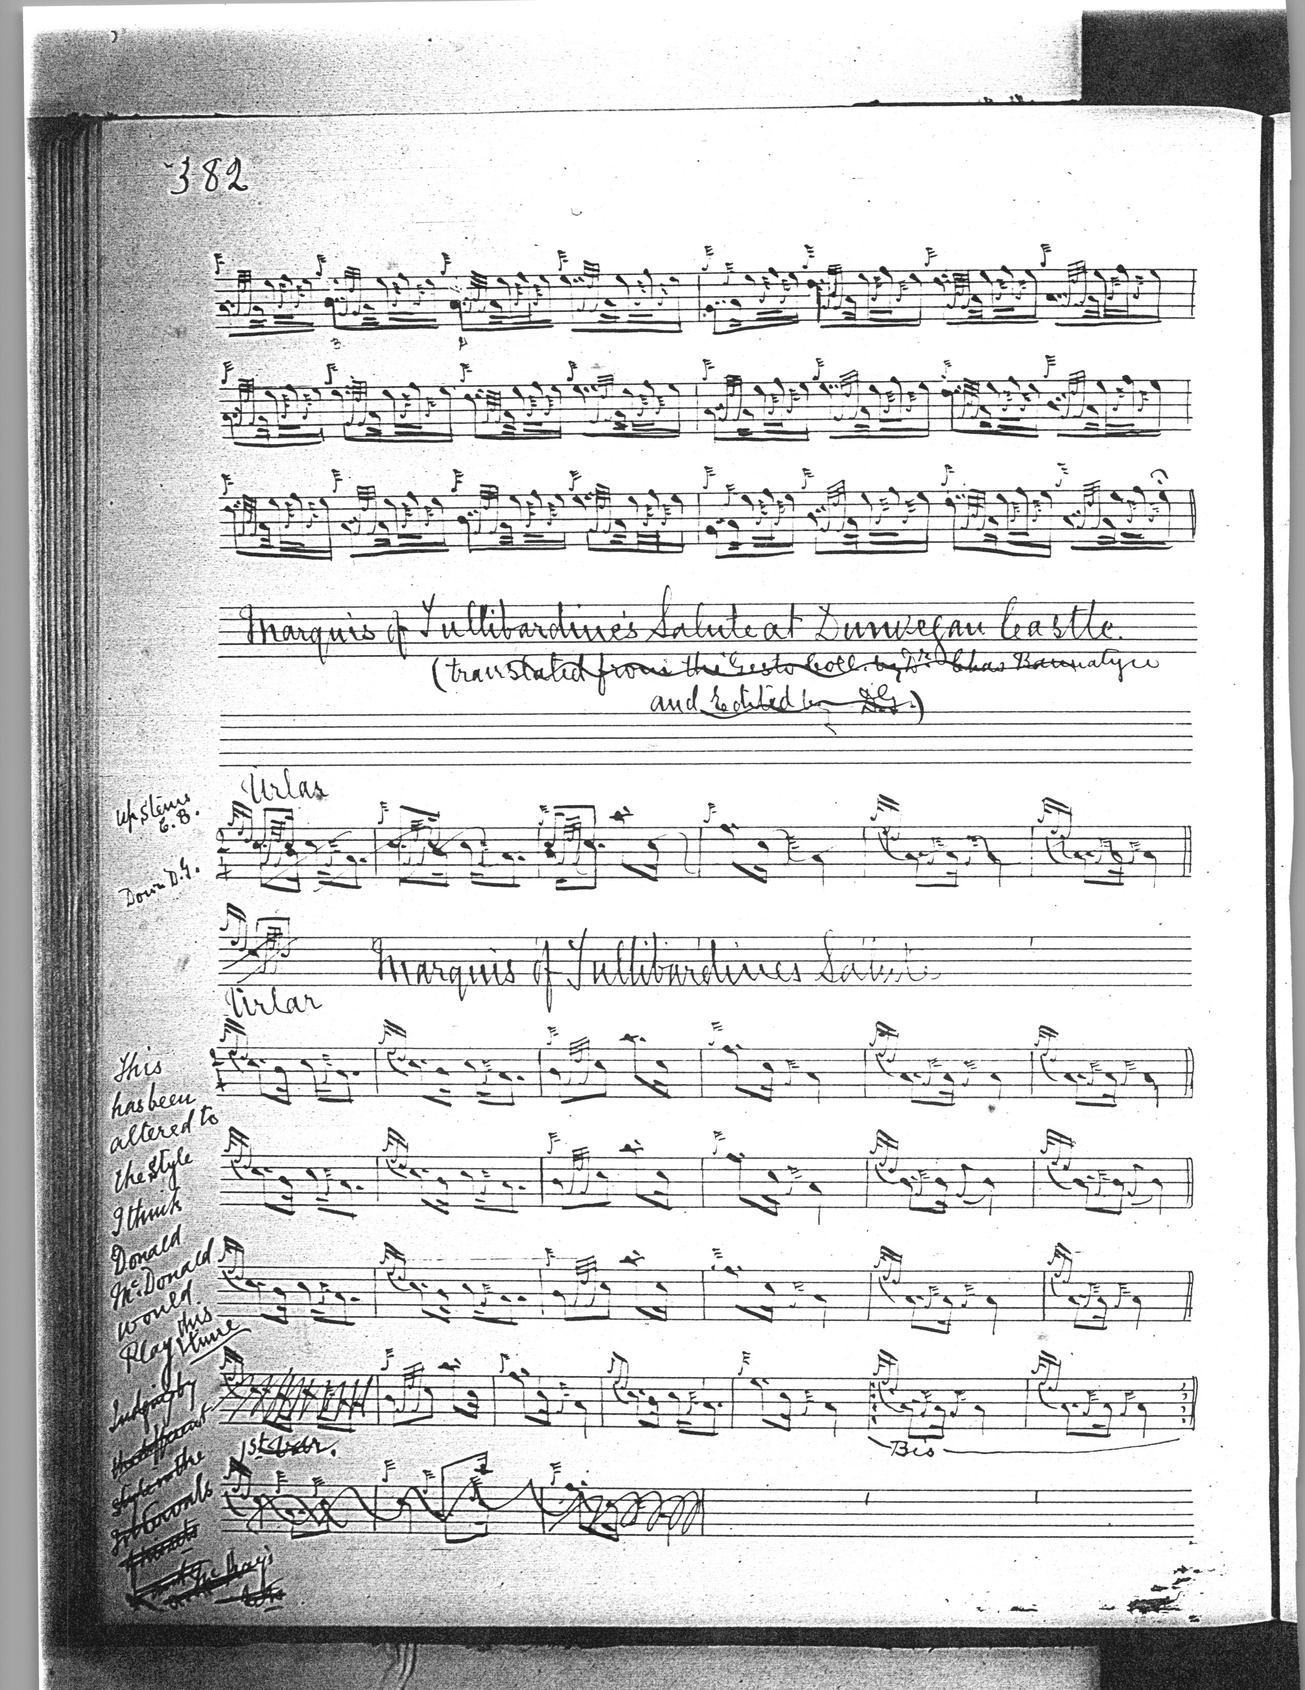

and so on.

They do not seem to have found it a simple task, as the above sample may indicate. Oral tradition is often imagined as a fluid and changeful medium; but so too is the manuscript and printed tradition, and often we play versions based on editorial decisions taken many years after the pieces in question were first committed to paper.

Peter Reid’s setting is rather subtler than MacDonald’s, with a good onward musical flow, but there are multiple problems with his version, including a missing movement near the start of the repeat of line one of the ground, and again in corresponding places later on. Reid has a thumb variation, and his siubhal is more similar to Campbell’s than to MacDonald’s; he also takes an interestingly different route through line four in the ground and variations:

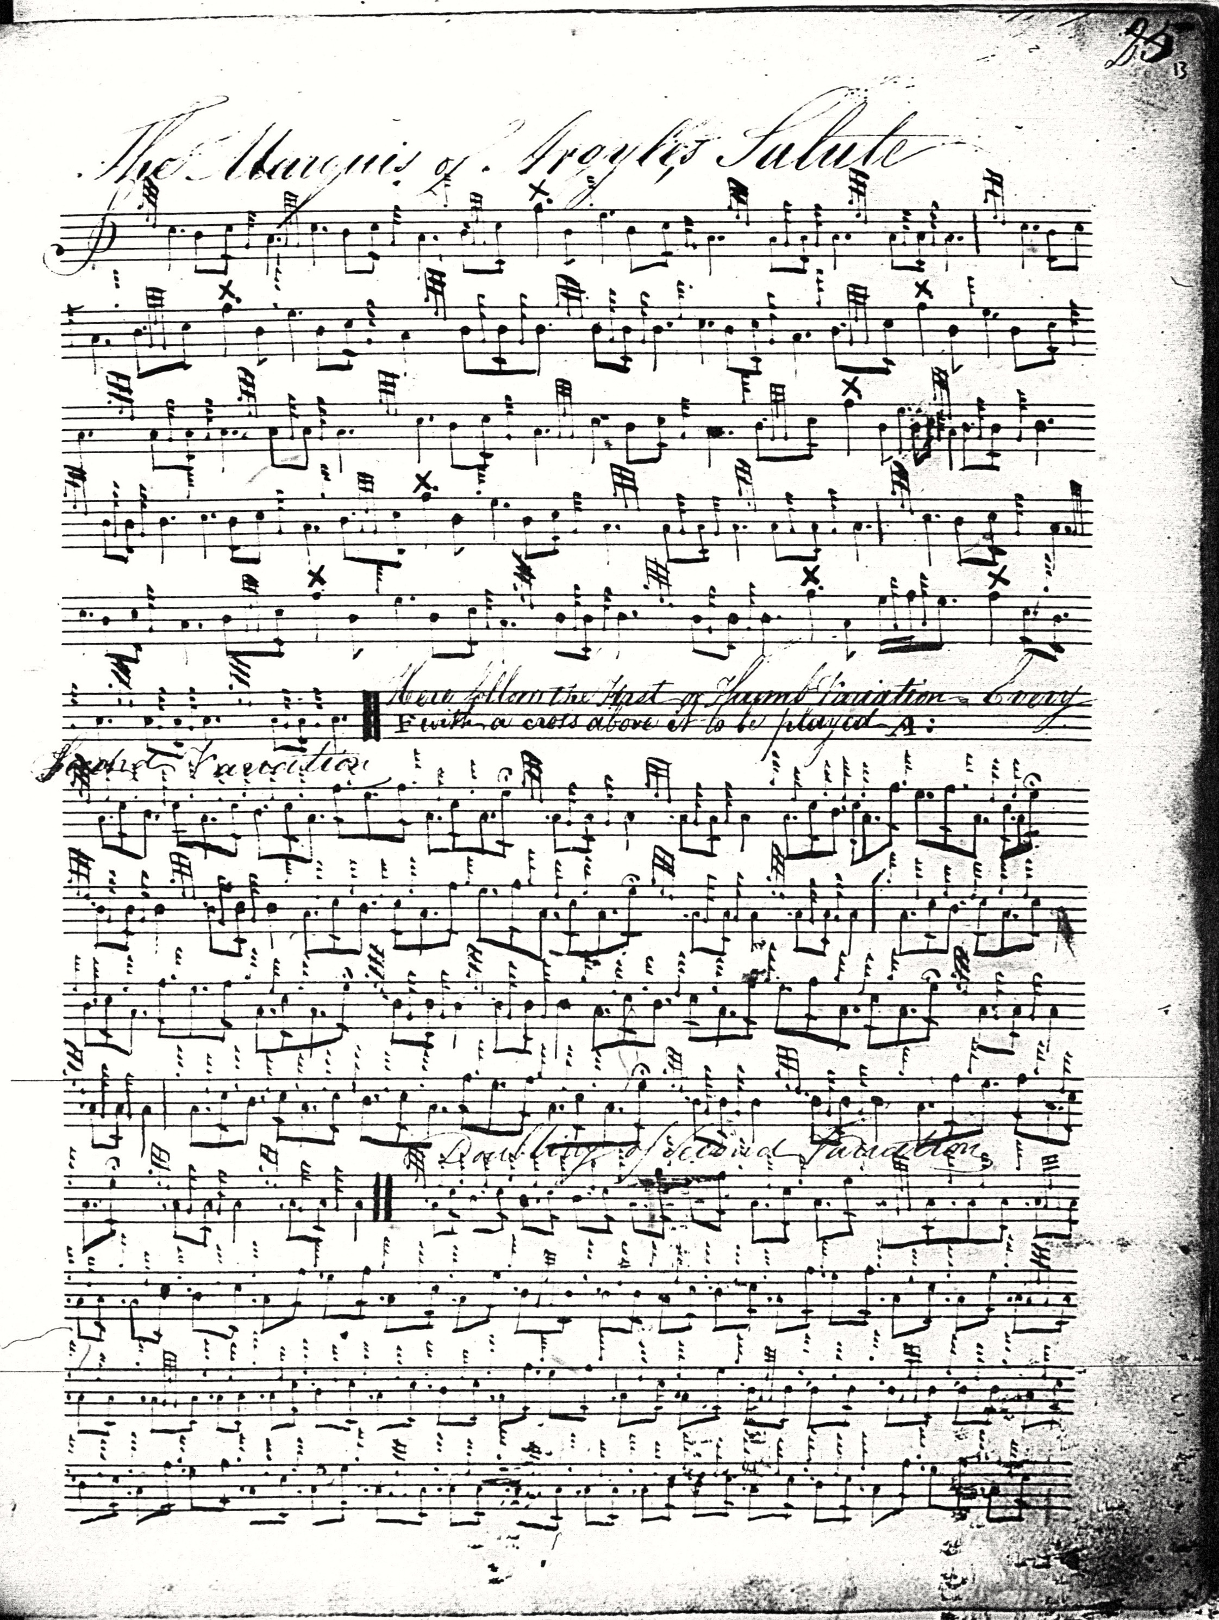

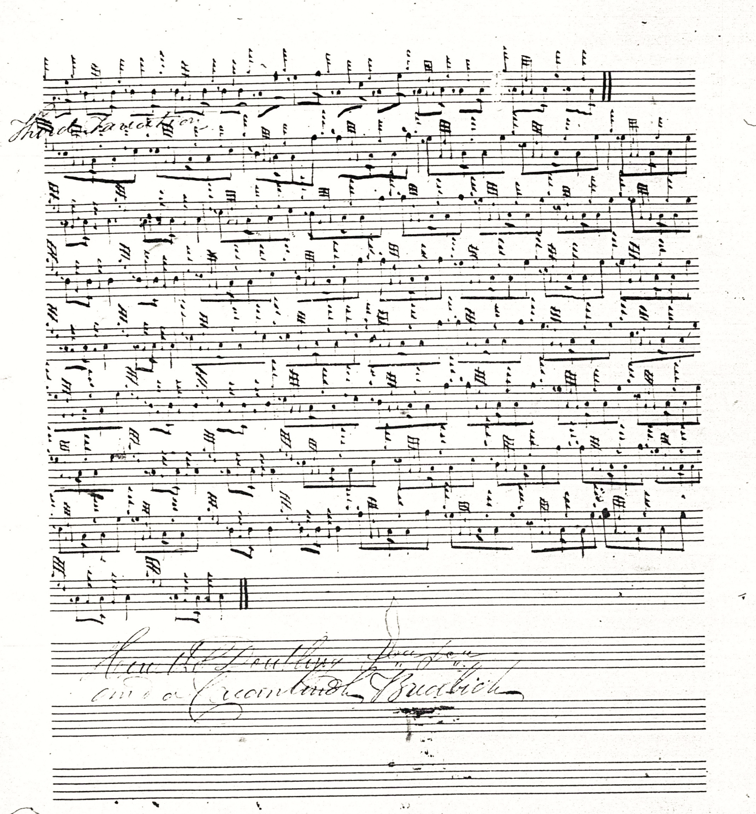

Reid’s score goes only as far as the taorluath breabach singling and ends with an indication that the taorluath should be doubled and then followed by a crunluath breabach. Reid’s ground presents a number of difficulties: we have line one as in MacDonald, six bars in length ending with a double echo on A; in line two Reid drops the second figure--which if added would make it very like MacDonald’s second line--ending on a couple of double echo beats on B; then in line three, if we supply the missing second figure, dropped again here, we get something very close to MacDonald’s third line; Reid now give us a fourth line similar to MacDonald’s second line again, ending with a double echo beat on B, so that the sequence of lines is 1 2 1 2 1 plus a final line made up largely from materials from line 2 again, giving Reid six lines to MacDonald’s four. His first variation singling shows similar dimensions. Somebody has made a half-hearted attempt at barring the taorluath breabach, but it seems even more eccentric than the siubhal; indeed, Reid’s score adheres to no pattern recognized as regular in modern times.

Angus MacKay sets the tune as follows:

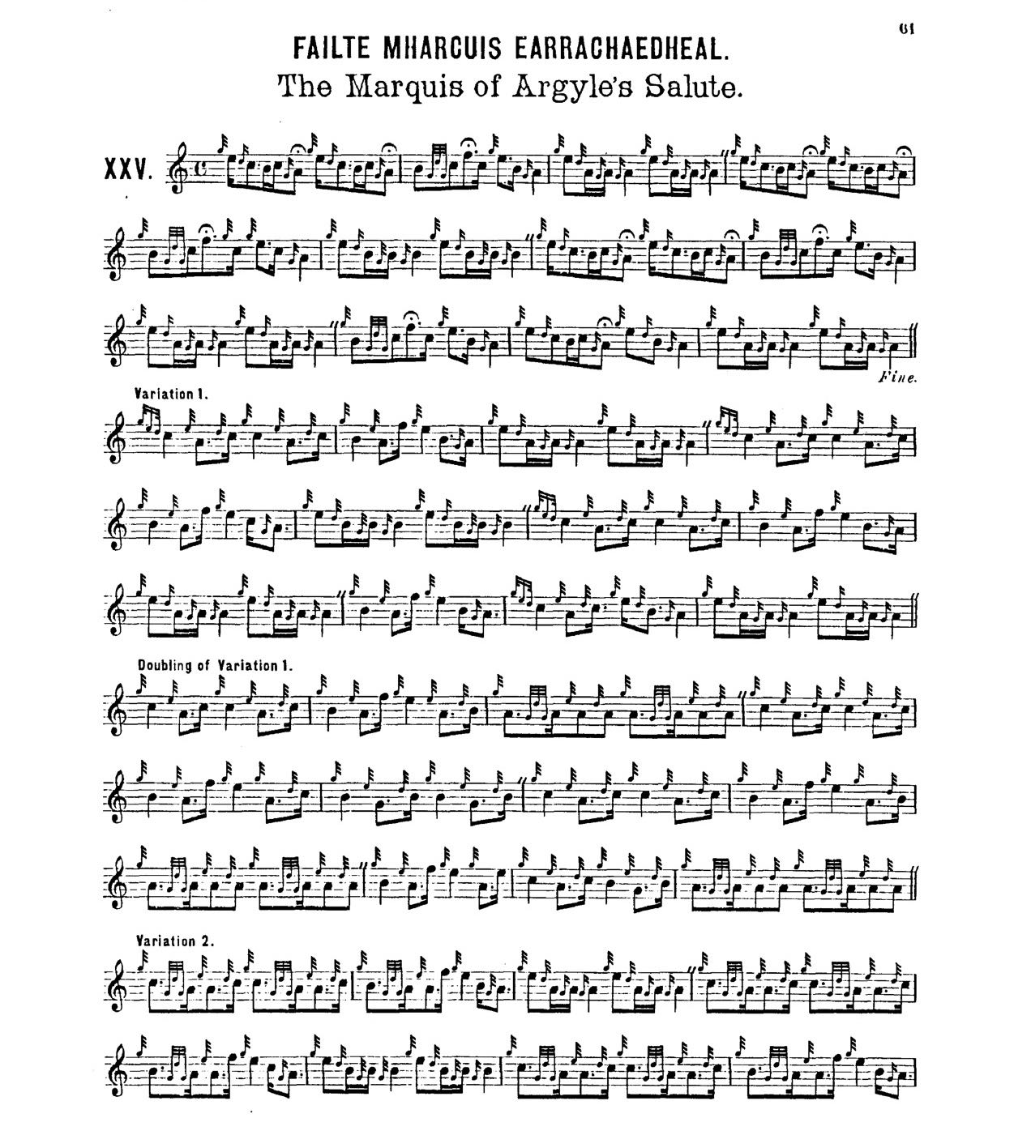

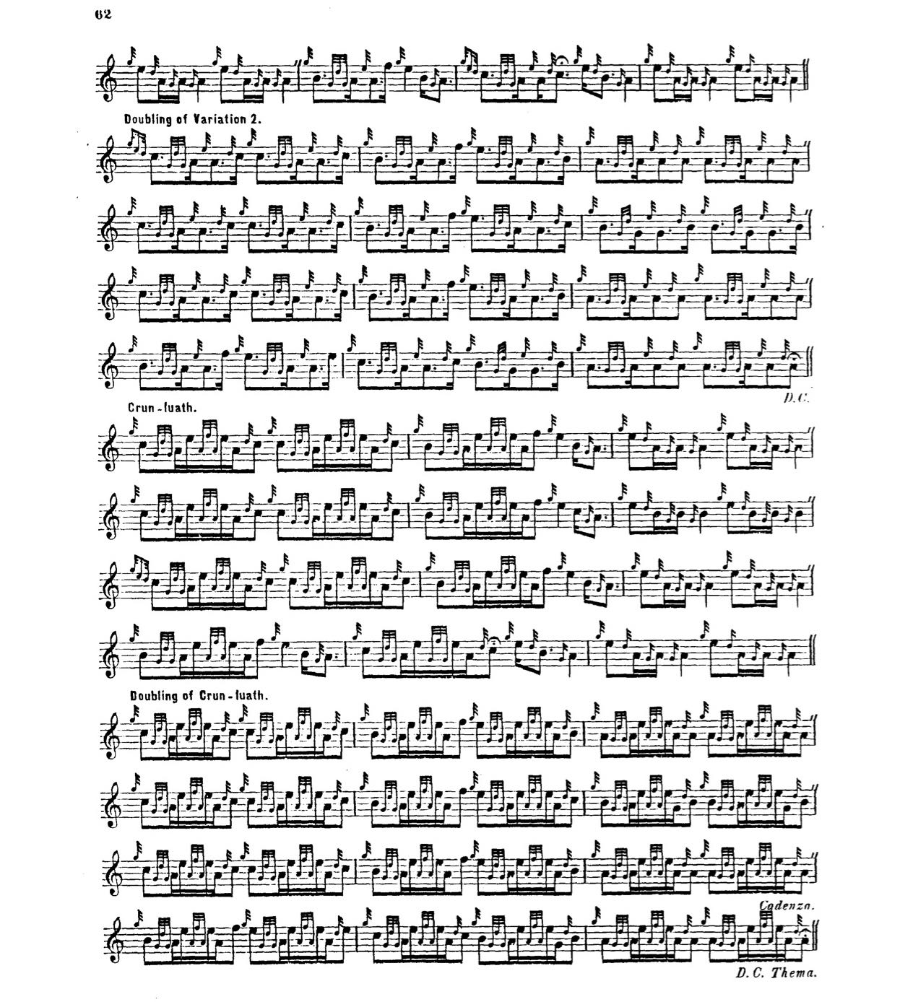
MacKay, or whoever was responsible for final editing of Ancient Piobaireachd (1838), indicates that a cadenza be played at the end of the crunluath doubling, which instruction also occurs in his setting of “The MacLeans’ March” (Ancient Piobaireachd, p. 55). So far as I am aware, these are the only references of their kind in the literature of the pipe, either manuscript or printed. A note in the “List of Italian, Gaelic and Other Musical Terms” prefixed to the music text of Ancient Piobaireachd contains a not-very-helpful gloss, probably written by MacKay’s textual editor, James Logan, stating: “Cadenza, imports a pause which gives the opportunity for the introduction of an extempore flourish, according to the taste and fancy of the performer. It has a peculiarly happy effect at the close of a variation, in serving to introduce the thema, or groundwork, Urlar, before Da Capo.” It is possible that Logan, a journalist whose knowledge of piping was rather superficial, may have misunderstood the flourishes executed by the player when occasionally pausing to re-tune during the performance, which was a normal practice in competitive play during the earlier part of the 19th century before it was banned by event organisers anxious to keep proceedings within narrower time-bounds.

C. S. Thomason’s Ceol Mor gives MacDonald and MacKay as sources, but adds nothing of stylistic significance to them. The score is not reproduced here.

David Glen’s version in his published Collection of Ancient Piobaireachd is balanced and sensible and follows MacKay closely. It is beautifully typeset and its clear presentation makes it probably the best of the playing scores. Glen sets the tune like this:

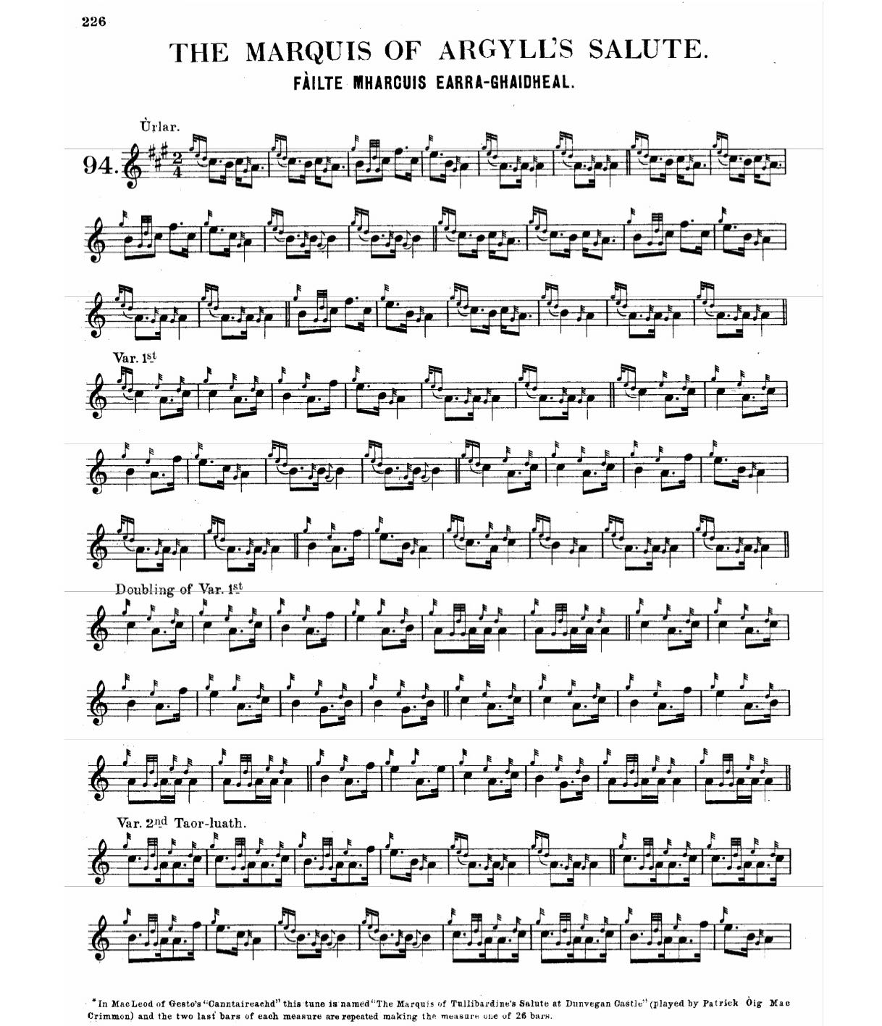

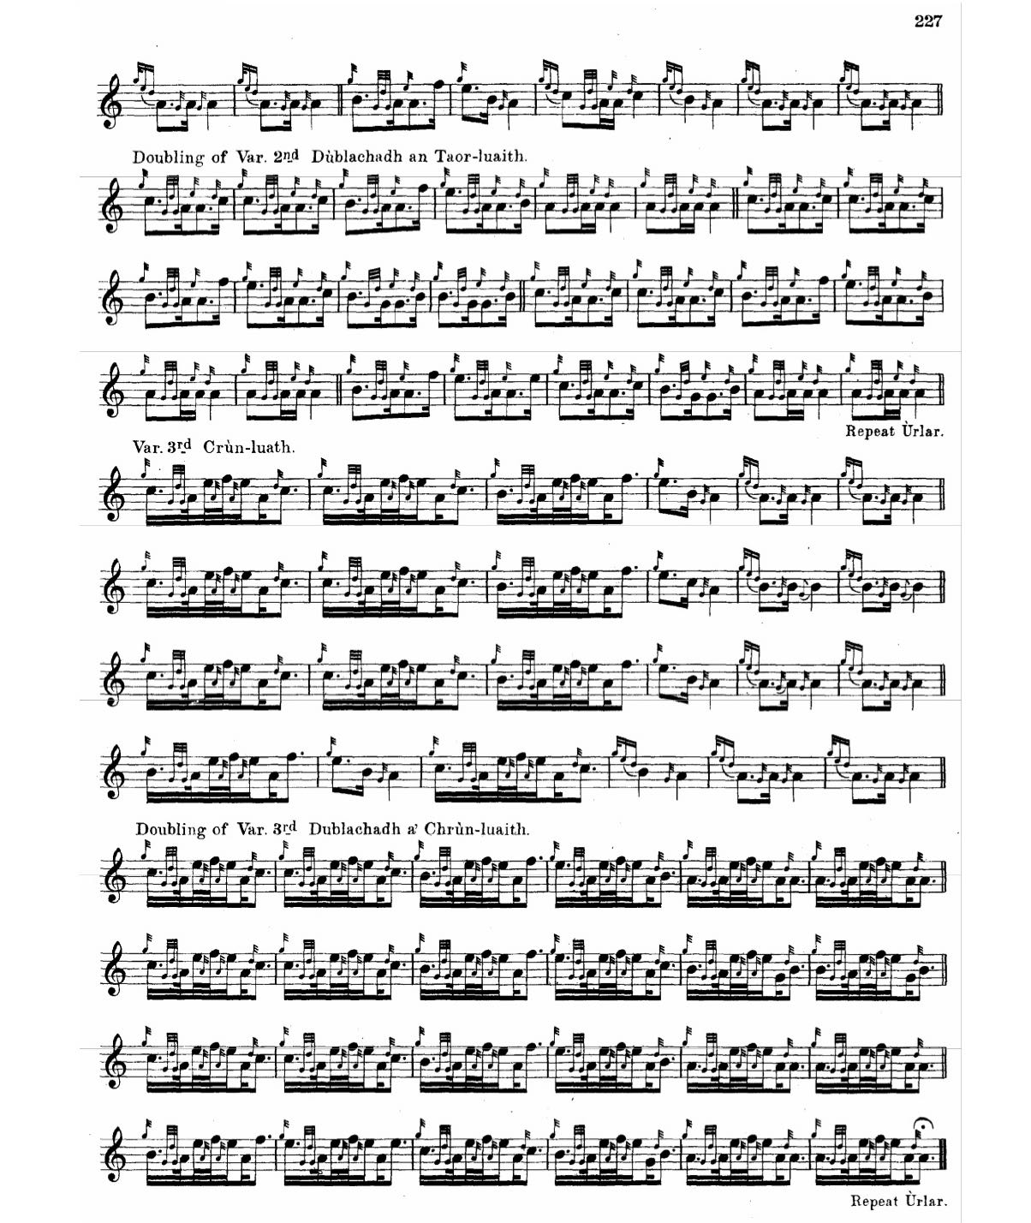

Commentary:
The various titles link this tune with the houses of Argyll, Atholl, and also perhaps Clan Donald, typically of the arbitrary nature of tune titles, and the hazards of placing too much reliance upon them. More interestingly, the different outcomes we see starting from basically the same ground, reminds us of the possibility of melodies with appropriate tone rows being developed in different ways, and in constructing variations the performer could, once upon a time, exercise a degree of choice.

The structure as it stands is certainly unusual, indeed Haddow considered it unique (M.R.S. Haddow, The history and structure of Ceol Mor: a guide to Piobaireachd, the classical music of the great Highland bagpipe: a collection of critical and historical essays. Privately printed 1982). Haddow’s index identified the tune’s structure as 3,3,3,3 It is the only one adhering to this pattern, apparently. Even if counting the double echoes on B at the end of the repeat of line 1 as a decorative repeat, giving us 3:3,3, he suggests there is still nothing else like it in the tradition.

In expressive terms, there are obvious themal links with “All the Old Men Paid Rent but Rory”.

The apparent dedicatee, Archibald Campbell, MacCailean Mór, Gilleasbaig Fiar-shùileach, or “Squinting Archibald”, 1st Marquess of Argyll, 1607-1661 was one of the most notable characters in 17th century Scotland. He was head of Clan Campbell during the Civil Wars, a leader of the Scottish Covenanters and one of the greatest power-brokers in the country. His reputation is not a savoury one: he was one of the instigators of the massacre of Dunaverty (see the notes to “The Laird of Contulich’s Lament” in the present series), and suffered heavy defeat in turn at the hands of Montrose at the second battle of Inverlochy (which Argyll prudently viewed from a galley moored offshore) in 1645. He picked his way with Machiavellian and ultimately self-destructive guile through the treacherous shoals of war and peace in one of the most violent periods of post-Reformation British history. In one twist too many he was arrested and beheaded as he tried to make his peace with the royalists at the Restoration.



Electronic text © Dr. William Donaldson, Dunmore Town, Bahamas, 23 January 2020

