March for a Beginner

There are settings of this tune in the following manuscripts:
--Joseph MacDonald’s “Complete Theory of the Scots Highland Bagpipe”, ff.47-8
--Angus MacKay’s MS, ii, 128-9 (untitled, with a note: “From a MSS. written in Bengal by Mr. John MacDonald About the year 1730”);
--Duncan Campbell of Foss’s MS, ff.186-188;

and in the following printed sources:
--William Ross’s Collection (with the title “The Black Watch’s Salute”), pp. 47-9;
--C. S. Thomason’s Ceol Mor, pp. 256, 347 (with the title “The Black Watch’s Salute; or Reminiscences of Bengal”).

Joseph MacDonald treats the tune as follows:

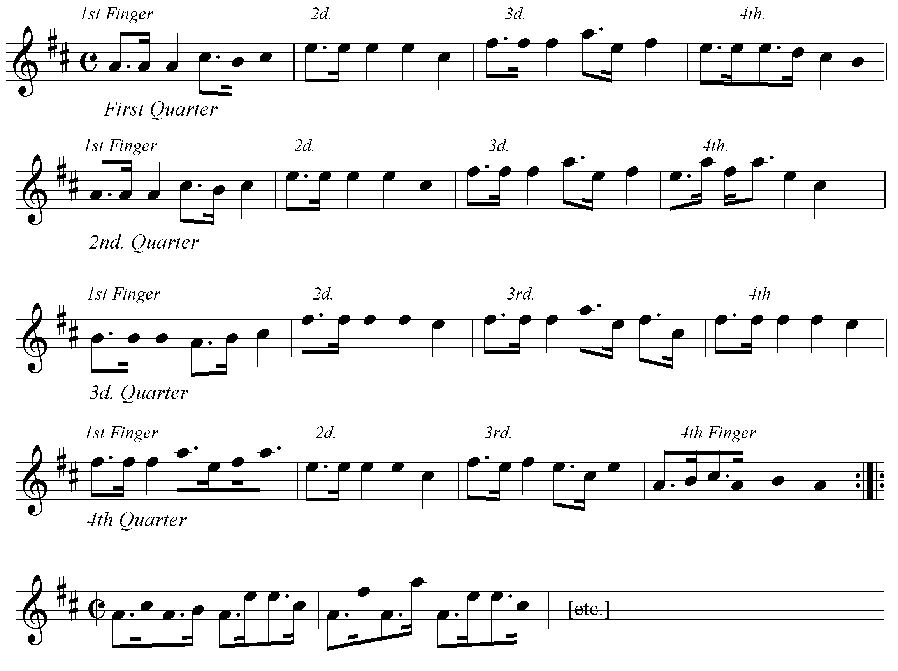

And so on.

Joseph accents the initial note of his double echo beats, including the one on A which gives a more satisfying rhythmical effect than the standard un-metrical eallach used in the Kilberry Book: he points his siubhal “down”.

Angus MacKay’s setting is also rather attractive:

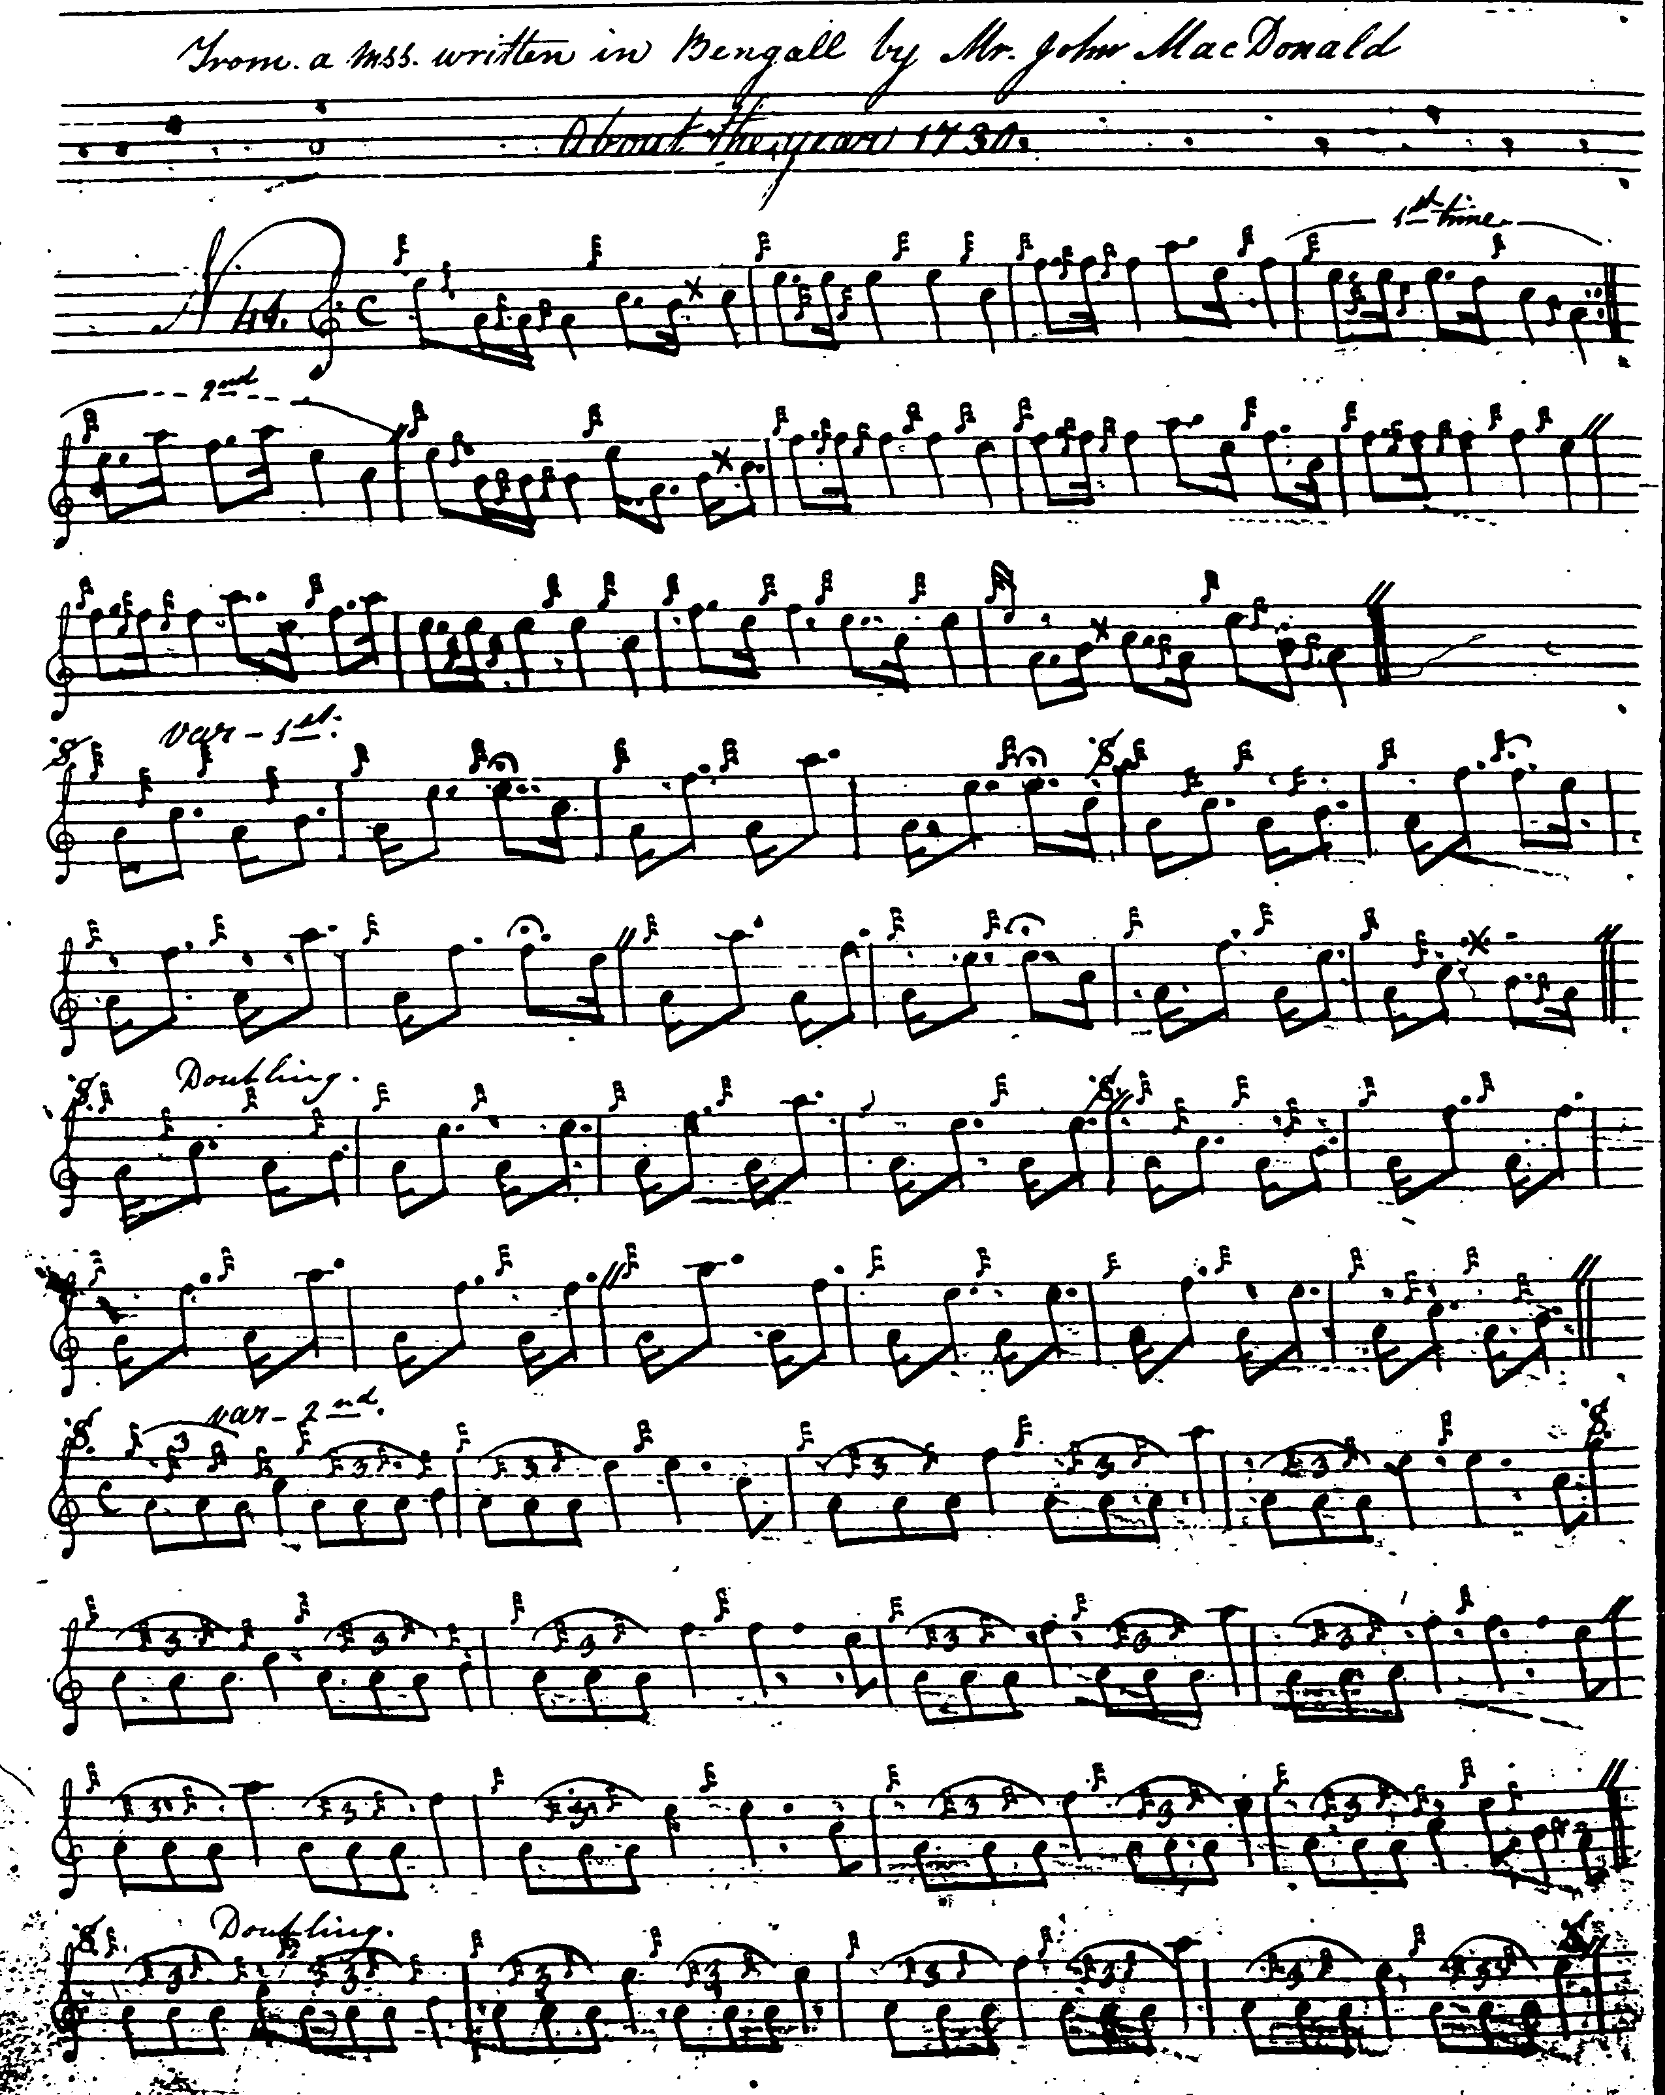
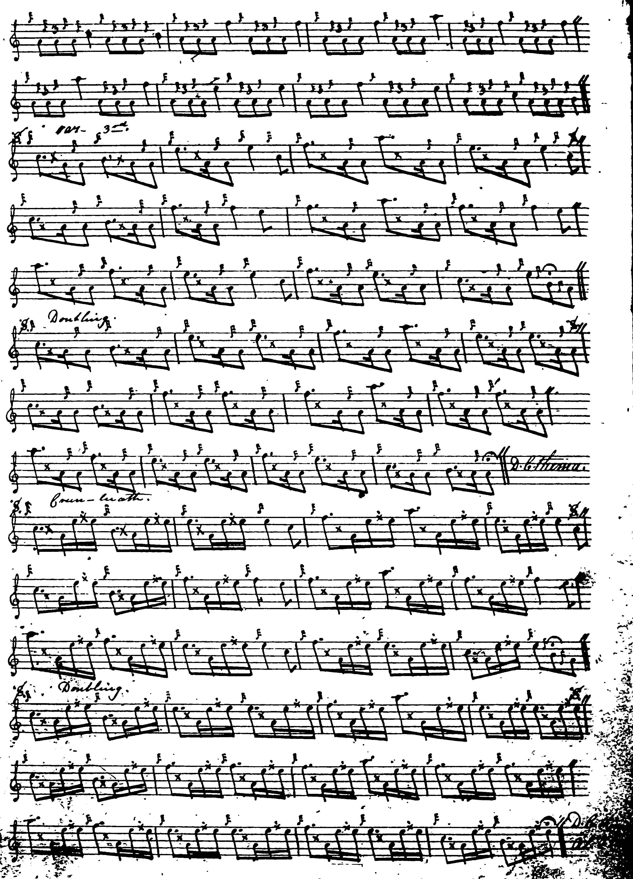

Angus MacKay emphasises the initial note of most of his echo beats very pleasingly and plays his siubhal “up”, as opposed to the “down” timing of some other scores. The tune is the last one in the second volume of MacKay’s manuscript, and the ground looks slightly unfinished. I think one could justify timing the crotchets at the end of the bars in his ground as quavers because this is what MacKay does later in the tune, helping to avoid a boxy “even crotchet” feel; and we see this happening in some of the scores below. MacKay directs that the ground be repeated after the taorluath and crunluath doublings.

Duncan Campbell of Foss treats the tune as follows:

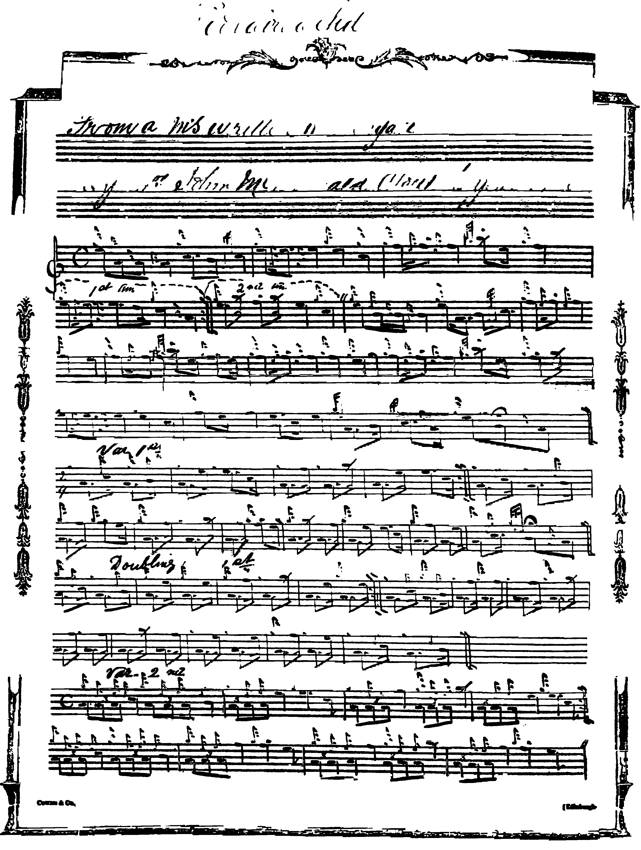

And so on.

Duncan Campbell times his double echoes differently from MacKay and points the siubhal “down”.

Uilleam Ross treats the tune as follows:

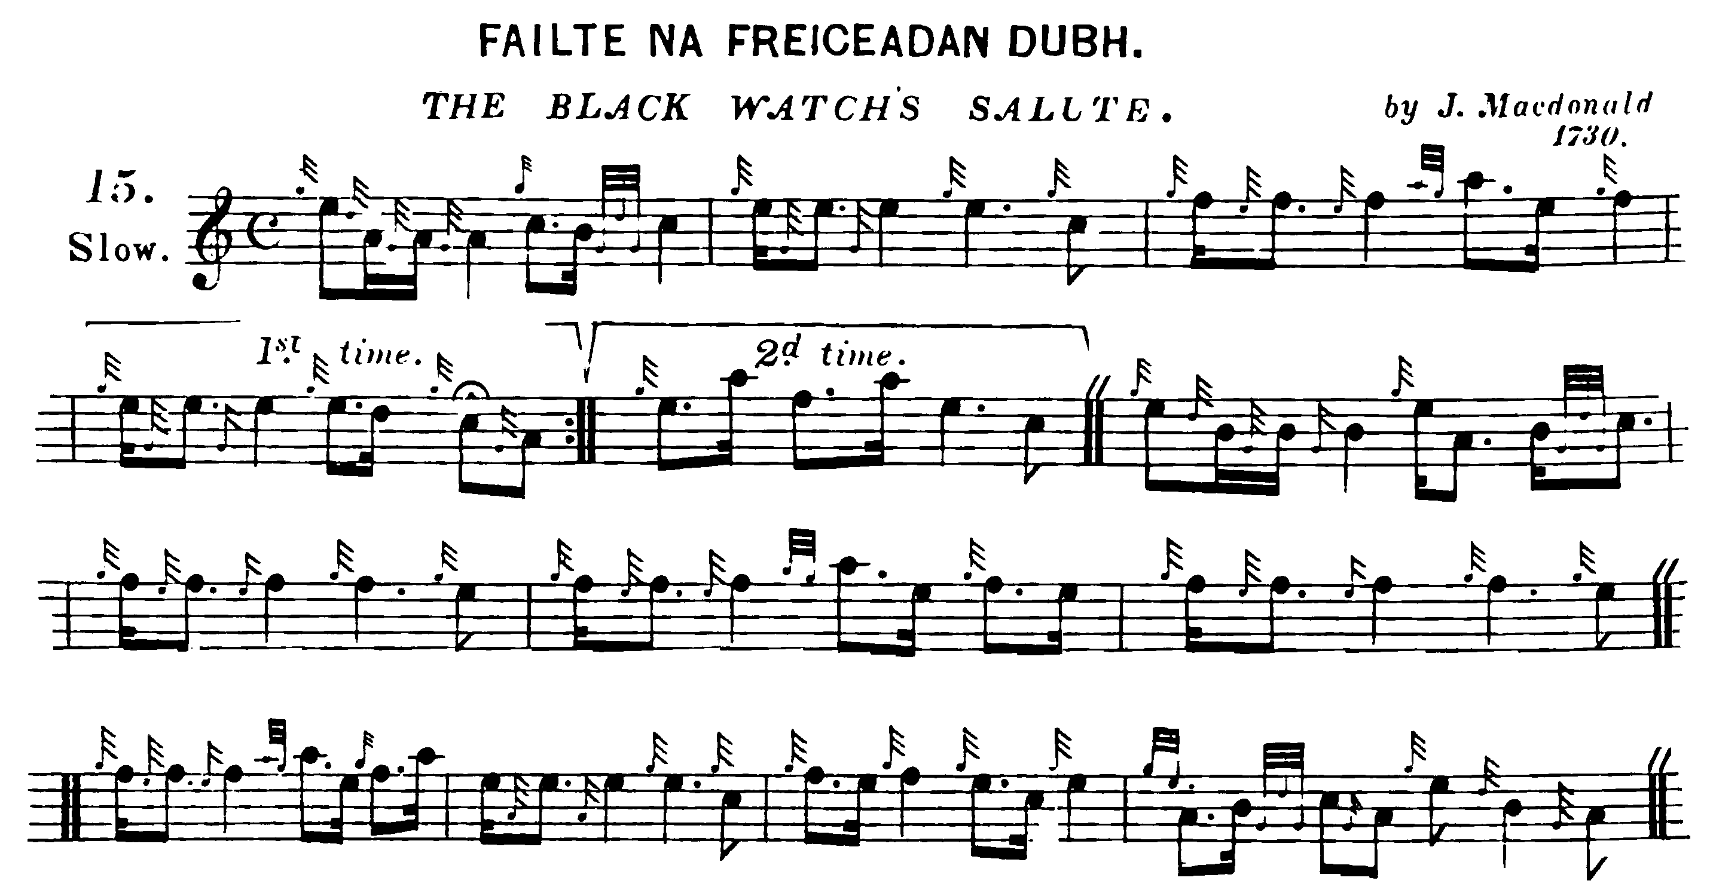
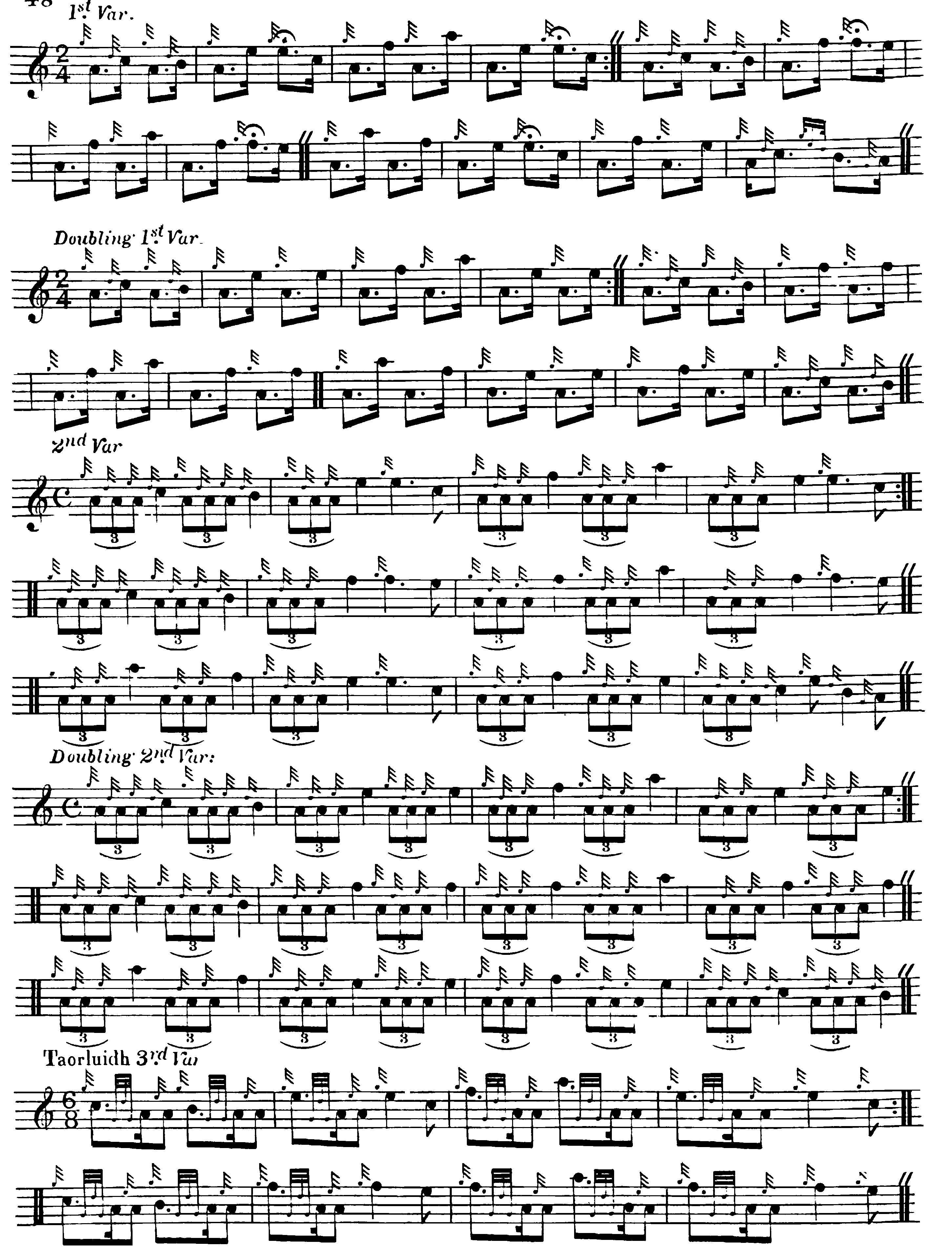

And so on.

Many may feel that Uilleam Ross’s score represents a distinctly more idiomatic treatment of the ground--as does that of C. S. Thomason:

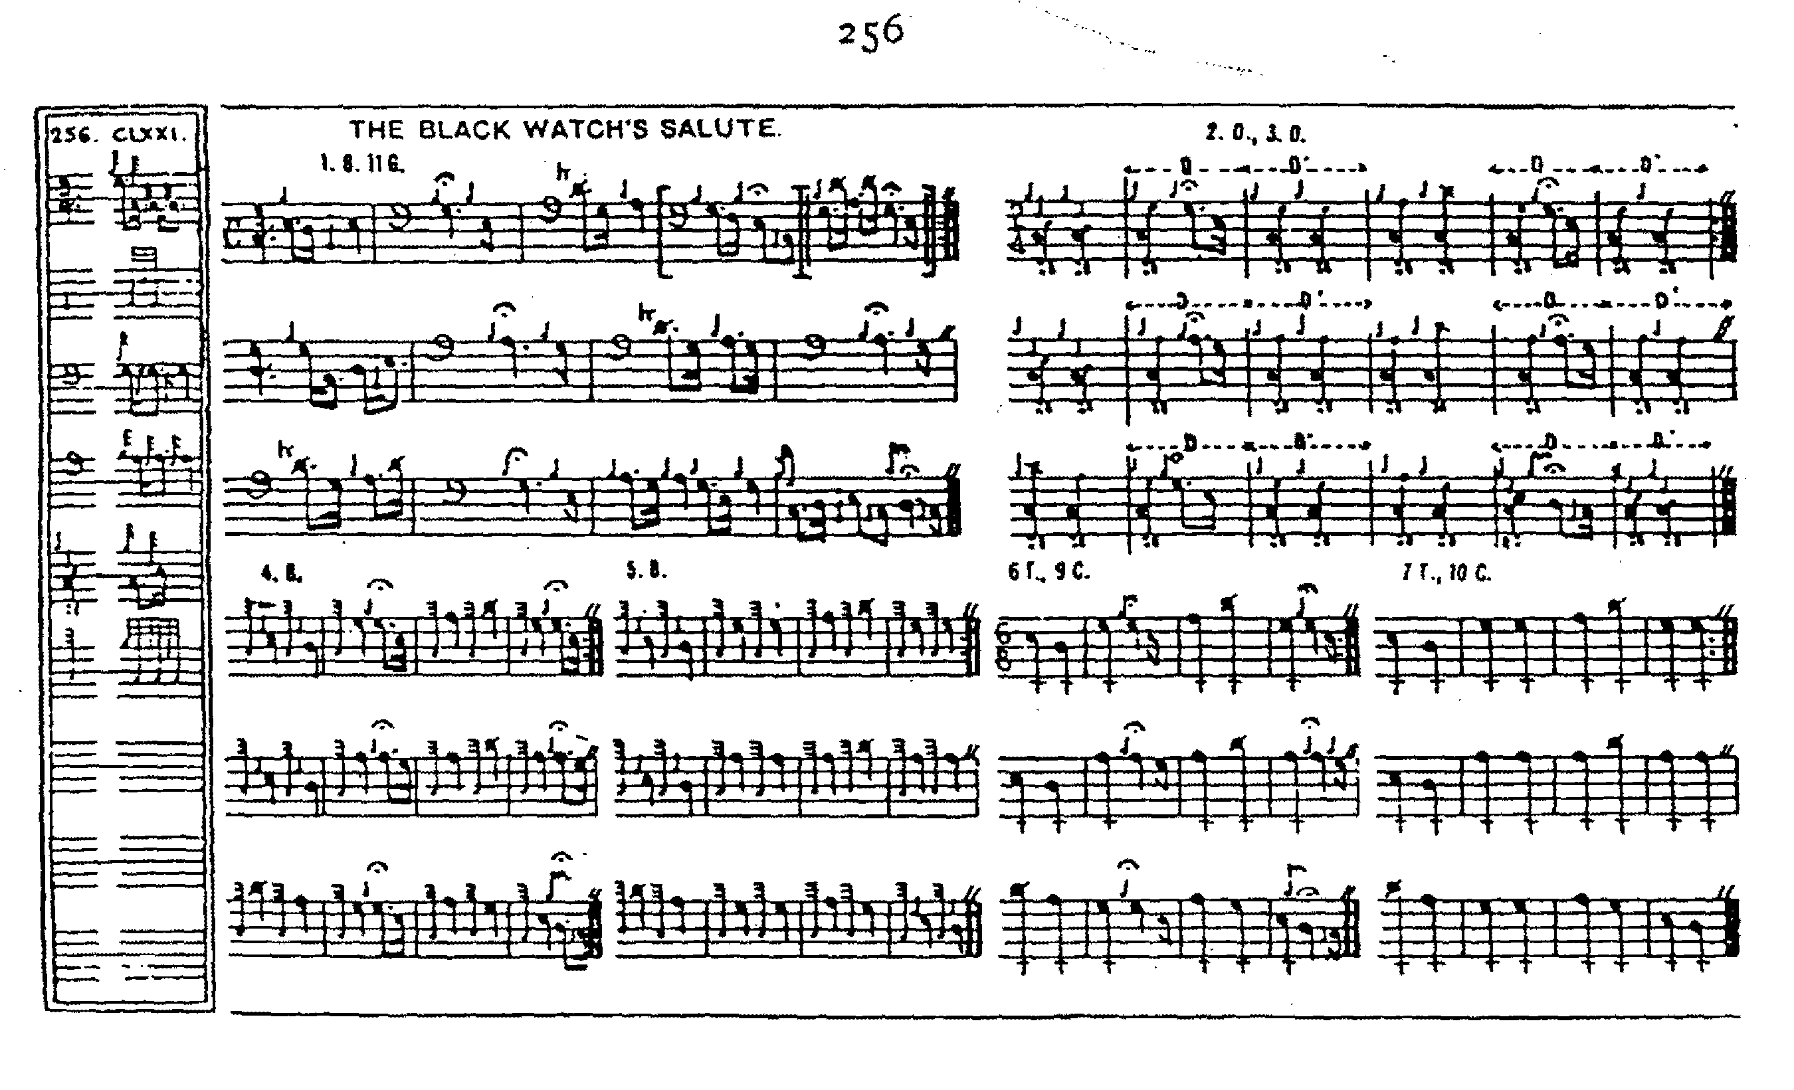

Commentary:

Thomason included the tune twice in Ceol Mor and his response to a query about this from a reader of the Oban Times, writing under the pseudonym “Feadan”, sheds interesting light on his editorial methods:

“[…] I will avail myself of this opportunity to make known to others, contemplating such appeals, that my powers in this line are now extremely limited by a failure of hand power, which drives me to a typewriting machine, with, at the best, very poor results. Nothing pleases me more than to impart any information I can to a brother piper, but when I sit down to this machine I candidly confess that my brains go wool-gathering.
I am much obliged to ‘Feadan’ for pointing out to me the identity of the two pibrochs, ‘March of the Laird of Coll’, p.1 and ‘Salute to Inveraray,’ p.237. I had not noticed this before, and I am afraid that there are a few other examples of identity of music under varying titles to be found in the book. They have caused me no little trouble, but I suppose such slips are inseparable from the fact that the book took me many years to compile and my sources of information were very varied.
The tune which I gave originally on p. 154 was ‘The Sinclairs’ March’ which proved to be the same as ‘The Red Ribbon’ given on p.226. I therefore removed it and substituted ‘The Laird of Coll’s March,’ which I got from a collection of Clan Maclean music lately published. [David Glen’s Music of the Clan MacLean, Edinr., 1900] I may be wrong, but I was under the impression that this had been taken down by Mr D. Glen from the playing of a Piper [John] Johnston, [of Coll] who had obtained it in Canada. It now turns out to be identical with the ‘Salute to Inveraray,’ which I got from A. MacKay's MSS. I cannot say which of these two titles can claim priority, as I don't know from whence Johnston got it.
Now to the ‘Black Watch's Salute.’ I got this from [Uilleam] Ross, who was a Black Watch man, but I cannot say what was his authority for the title or the date 1730. J. Macdonald was not a Black Watch piper, but Joseph Macdonald of the E.[ast] I.[ndia] C.[ompany]'s service who was […]the first to attempt the notation of pibroch music. If ‘Feadan’ will turn up p.347 of ‘Ceol Mor’ he will find the same tune named ‘Isle of Skye’ by myself. It was my original intention to have given a title to all the nameless tunes in my possession--of course, clearly stating the origin of these titles--simply for the purpose of reference, but I was, by piper friends, dissuaded from doing so. It was Colin Cameron who drew my attention to the repetition, and said that he had always known the tune as the ‘Bengal Pibroch.’ Since then I have come across the tune in some MSS. of Duncan Campbell, and there I find the following in the place of a title--’Thoughts of Home. Piobaireachd. From a MS. written in Bengal by John (?Joseph) Macdonald about 1730’. Joseph Macdonald wrote about forty years before his brother Patrick published his work in 1803. I find the tune there but without grace notes--rather an important item in piobaireachd music--and should not have recognised it but for ‘Feadan’s’ letter[…]”, “Ceol Mor”, Oban Times, 02/01/1904, p.3.

* * *

Electronic Text © Dr. William Donaldson, Aberdeen, Scotland, October 2004

