MacLeod’s Controversy

This tune occurs in the following manuscript sources:
--Colin Mór Campbell’s “Nether Lorn Canntaireachd”, i,70-1 (with the title “Contalich’s Lament”); --David Glen’s MS, ff.354-355;

and in the following published sources:
--Angus MacKay, Collection of Ancient Piobaireachd, p.84; --C. S. Thomason, Ceol Mor, p.161; -----G. F. Ross, Collection of MacCrimmon and other Piobaireachd, pp.16-17 (which points the eallach and “runs down” as Glen does).

Colin Mór Campbell sets the tune as follows:

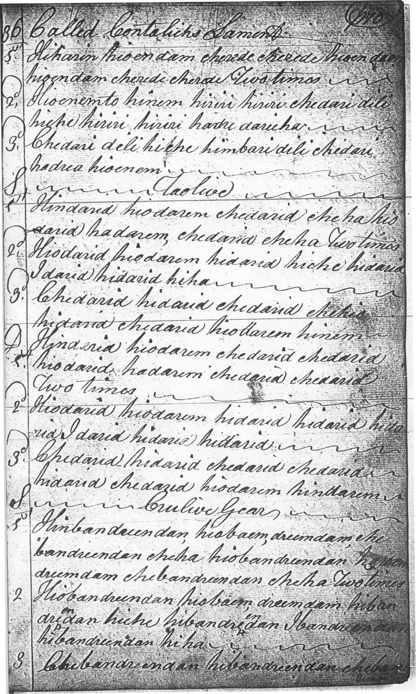
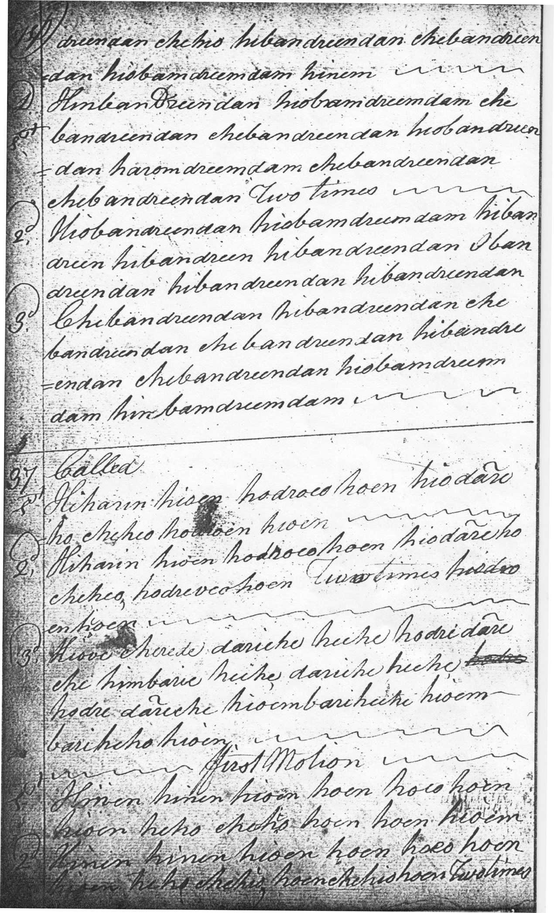

Colin Mór ends the tune with an interesting crunluath breabach (singling and doubling). It presents one or two difficulties of interpretation. The figure representing the second movement of the crunluath appears in the singling as “hiobaem, dreemdam” and in the doubling as “hiobamdreemdam”. The Nether Lorn system evolved, and Colin Campbell ended up with a number of equivalent ways of representing the same thing, so that “baem” and “bam” would have the same value, indicating the standard crunluath movement from B through low G probably as below. The interesting interpretational aspect is that the syllable “ha” could mean that the cadence D should have a high G cutting or an F, which latter, if played fairly open, would give an effect similar to the E F D triplings visible in other scores at this point, as follows:

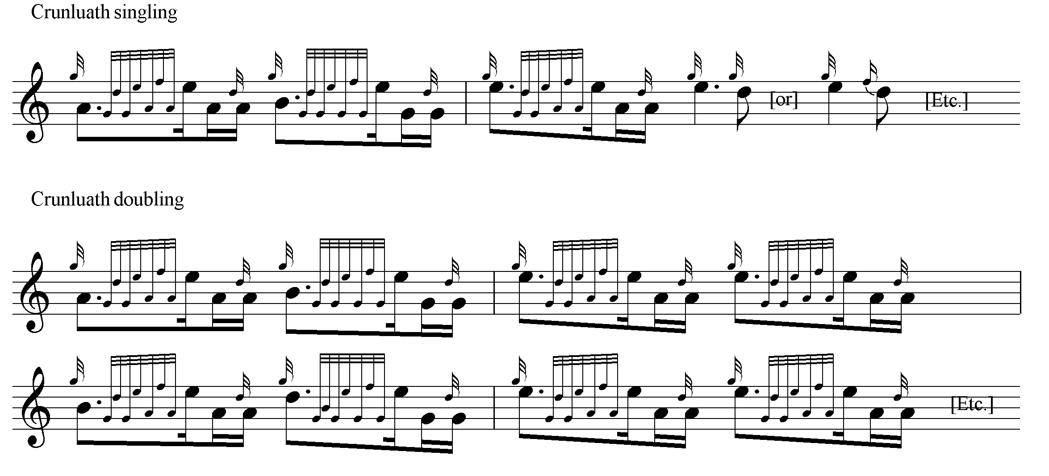

The tune was published in Volume 10 of the Piobaireachd Society Collection, the bulk of which was edited by Archibald Campbell. The aim was to present settings from Angus MacKay’s by then very scarce—indeed virtually unobtainable--published book. As usual there were a number of silent changes to note values in the ground which did little to enhance the expressive possibilities of the tune. MacKay actually set the piece as follows:

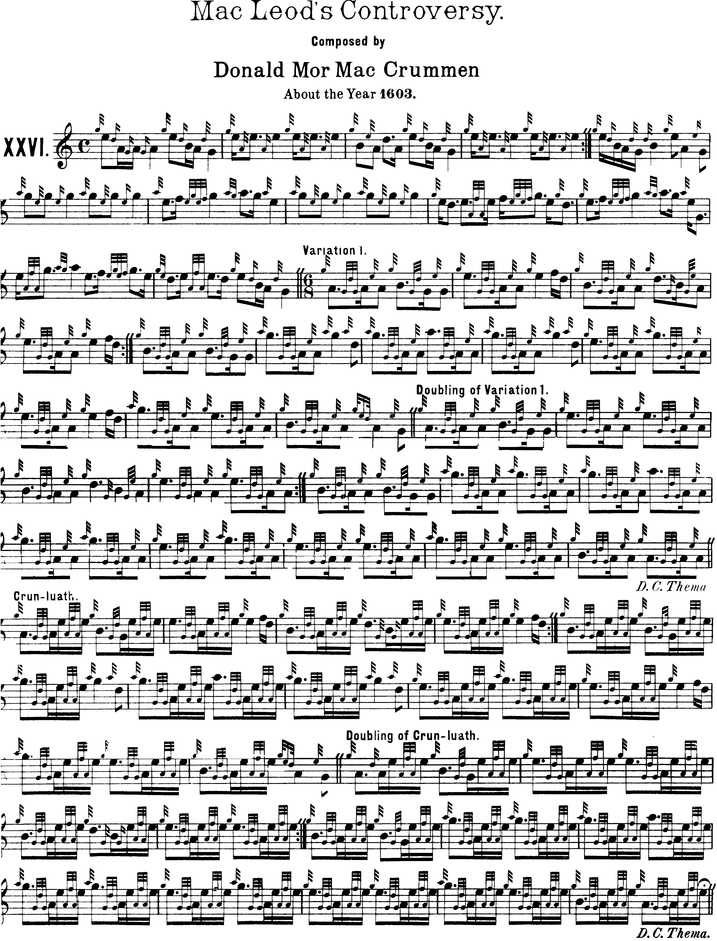

David Glen points the eallachs “down” and holds the Bs on the “runs down”, like this:

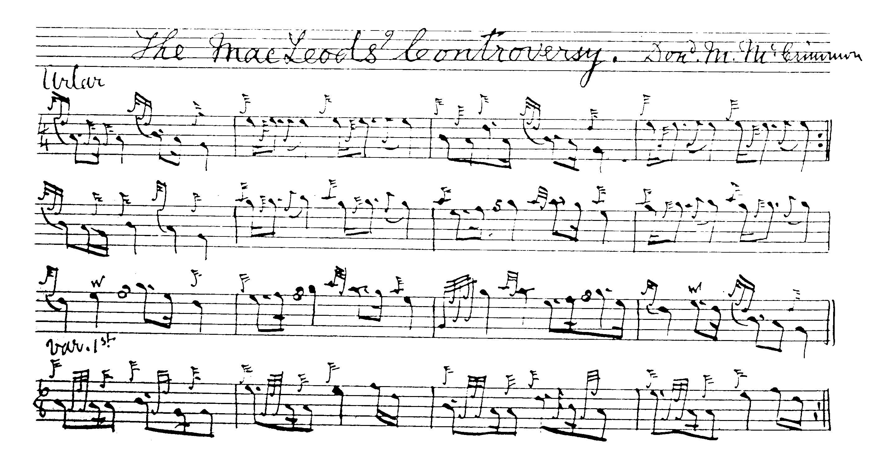
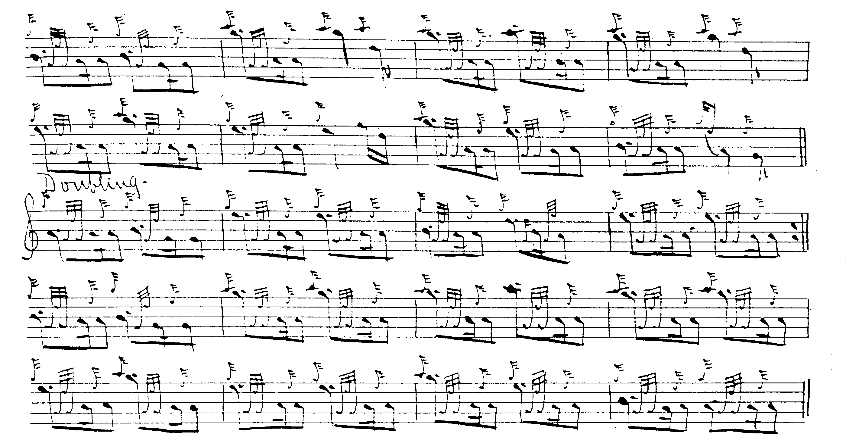
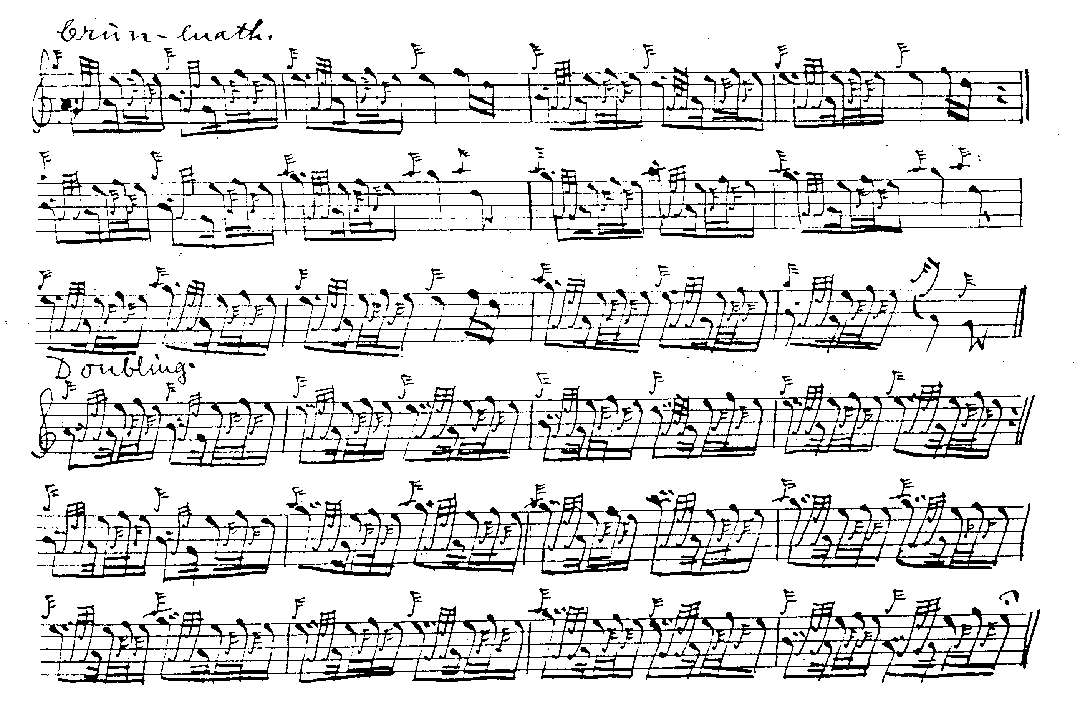

C. S. Thomason’s and G. F. Ross’s setting do not add appreciatively to the expressive possibilities of the tune and are not reproduced here.

Commentary:

In Angus MacKay’s Ancient Piobaireachd, the writer of the letterpress portions, James Logan, illustrates the background to the tune by quoting from a near-contemporary account as follows:

The events which this controversy gave rise to, were characteristic of the times; and the following is the quaint relation of the circumstances given by Sir Robert Gordon. “Donald Gorme MacDonald… had married Sir Rory MacLeod of the Herris, his sister, and for some displeasure or jealousy conceived against her, he did repudiate her; whereupon Sir Rory sent message to Donald Gorme, desiring him to take home his sister. Donald Gorme not only refused to obey his request, but also intended divorcement against her; which, when he had obtained, he married Kenneth MacKenzie, Lord of Kintail, his sister. Sir Rory MacLeod took this disgrace so highly, that assembling his countrymen and followers without delay, he invaded with fire and sword, a part of Donald Gorme, his lands in the isle of Skye, which lands Sir Rory did claim to appertain to himself. Donald Gorme impatient of this injury, convened his forces, and went into the Herris, which he wasted and spoiled, carried away their store and bestial, and killed some of the inhabitants. This again did so stir up Sir Rory MacLeod and his kin, the Seil Tormot, that they took journey into the isle of Ouyst [Uist], which appertaineth to Donald Gorme, and landing there, Sir Rory sent his cousin Donald Glase, with some forty men, to spoil the island, and to take a prey of goods out of the precinct of Kille, Trynuid, [sic] where the people had put all their goods to be preserved as in a sanctuary. John MacCean MacJames, a kinsman of Donald Gorme's, being desired by him to stay in the island, with twenty others, re-encountered with Donald Glasse MacLeod and most of his company, and so rescued the goods.
Sir Rory seeing the bad success of his kinsmen, retired home for a time; thus both parties were bent headlong against each other, with a spirit full of revenge and fury, and so continued mutually infesting one another with spoil and cruel slaughters, to the utter ruin and desolation of both their countries, until the inhabitants were forced to eat horses, dogs, cats, and other filthy beasts. In the end, Donald Gorme assembled his whole forces, in the year of God 1601, to try the event of battle, and came to invade Sir Rory his lands, thinking thereby to draw his enemies to fight. Sir Rory MacLeod was then in Argyle craving aid and advice against the clan Donald. Alexander MacLeod, Sir Rory MacLeod his brother, resolves to fight with Donald Gorme; so assembling all the inhabitants of his brother's lands, with the whole race of the Seil Tormot, and some of the Seil Torquill out of the Lewes, he encamped beside a hill, called Benquillin in the isle of Skye, with a resolution to fight against the clan Donald the next morning, which was no sooner come but there ensued a cruel and terrible skirmish, which lasted the most part of the day, both contending for the victory with great obstinacy. The clan Donald in [the] end overthrew their enemies, hurt Alexander MacLeod and took him prisoner, with Niel MacAlister Roy, and thirty others of the chiefest men among the Seil Tormot, killed two near kinsmen of Sir Rory MacLeod’s, John MacTormot and Tormot MacTormot, with many others.
After this skirmish there followed a reconciliation betwixt them, by the mediation of old Angus MacDonald of Kintire, the Laird of Coll, and others. Then Donald Gorme delivered unto Sir Rory MacLeod all the prisoners taken at Benquillin, together with his brother Alexander, since which time they have continued in peace and quietness.” This is the relation given by Sir Robert, of the origin and termination of this unhappy dispute…The piobaireachd was composed by Donald Mòr, Piper at the time to the MacLeods.

It all sounds very neat; but if one were to look at the many “controversies” in which the MacLeods of Dunvegan and Harris were involved during the sixteenth and early seventeenth centuries (during which their enemies were often supported by the MacLeods of Lewis, making such general terms as “the MacLeods” and “the MacDonalds” difficult to use precisely), one might be puzzled as to which, if any, this tune might apply. A long-standing aim of the Scottish government based in Edinburgh was to “civilise” or “daunt” the Highlands—it often seems immaterial which. Certainly, if it was an act of deliberate policy by the Lowland-based government to destabilise the Gaelic-speaking communities in the Rough Bounds and the Isles, one would say—if one did not know much to the contrary about the general efficacy of Scottish government down the centuries—that it succeeded almost to a fault. Land was the key resource, and land rights, amongst people of a traditional cast of mind, were important enough to kill for; anybody, even blood kin. So that the tangled skein of official property rights which often meant that you might be given title to the lands of your deadliest foe while he (or occasionally she) might be given official title to yours, meant that possession was generally determined by main force. And this was enthusiastically applied.

“Iomarbhaidh” (pron: “imurvy”) means “struggle, confusion, strife” and this particular bloody and protracted mess saw the MacLeods of Dunvegan and Harris involved in major trouble not only with neighbouring MacDonalds of Sleat, which was bad enough, but also with the powerful house of Clanranald which was if anything several degrees worse. The accounts are long and sometimes confusing, but the salient points are conveniently set forth in Alexander Nicolson’s History of Skye (Glasg., 1930) on which much of the following is based.

In the earlier Highland history a lot of the information is traditionary, and there are strong folkish tendencies in the tales. In each of the two main disputes, with respectively the MacDonalds of Clanranald, and the MacDonalds of Sleat, the motif is that of the rejected wife (indeed, one source remarks that it is quite extraordinary how often these people thrust rings on to one another’s fingers, and dirks into one another’s hearts). Allan, son of the turbulent John of Moidart, captain of Clanranald, married a daughter of Alastair Crotach MacLeod, she being a widow of John Og MacDonil Gruamach, and they had a son. Allan then took up with a daughter of Hector Mór MacLean of Duart by whom he had several children. The MacLeods took this ill, and the usual civilities followed. A party of them raided the MacDonald Island of Eigg, but were overcome and cast adrift bound hand in foot in an open boat. In revenge, the MacLeods returned in greater strength and murdered the entire inhabitants by suffocating them in a cave, including Angus, brother of Allan of Clanranald. This triggered a Clanranald raid on Trotternish during which a congregation of MacLeods was burned alive in the church at Trumpan and the raiders were slaughtered in turn in the Blar milleadh gàraidh “The Battle of the Spoiled Dyke” (so called because the bodies of the MacDonalds were given a rude mass burial by having a dry-stone dyke pushed on top of them, through which their bones could apparently be glimpsed for long years afterwards). In the meantime, Allan of Moidart’s children by his MacLean wife, murdered his son—Allan Og--by his MacLeod wife, who as eldest was heir of Clanranald, further outraging his first wife’s family. Allan, senior (he of the two wives) died about 1593, and was succeeded by his (MacLean) son Angus who became captain of Clanranald. He in turn fell at the skirmish of Amhainn Ròag intercepting a MacLeod raiding party in South Uist. The trouble dragged on for years and ultimately involved the devastation of considerable portions of the isles of Harris, Eigg, Rum, Coll, Tiree and Mull.

In Skye, the immediate troubles went back to the early years of the sixteenth century, when MacLeod/MacDonald relations had deteriorated seriously during the time of Donald Gruamach, the 5th laird of Sleat. The MacLeod laird, Alastair Crotach of Dunvegan and Harris, had succeeded by a combination of political acumen and inspired duplicity in acquiring paper title to MacDonald lands in North Uist and Sleat. So Donald Gruamach raised an army, supported by his kin, the MacLeods of Lewis, invaded Alastair Crotach’s lands in north Trotternish, impounded the cattle and killed everything human he could lay his hands on. The Dunvegan people returned blow for blow as encounters like “The Field of Blood” and “The Cauldron of the Heads” bear witness. Donald Gruamach’s son, Donald Gorm, repeated the feat some years later resulting in the MacLeods being driven finally from Trotternish, and the MacDonalds occupying the northern stronghold of Duntulm. The affair eventually came to a head in the so-called Cogadh na Cailliche Caime, or “The War of the One-eyed Woman”. It happened like this:

Donald Gorm Mór, 7th of Sleat and grandson of Donald Gruamach, had married Margaret, the sister of Rory Mór MacLeod of Dunvegan. When she became disfigured by losing an eye, Donald Gorm sent her back to her brother, mounted on a one-eyed horse, with a one-eyed servant and a one-eyed mongrel dog trotting behind. Rory Mór furiously demanded the restitution of his sister, but Donald Gorm coolly espoused a sister of MacKenzie of Kintail with whom the Dunvegan MacLeods were at feud. This prompted a MacLeod attack on Trotternish, and a MacDonald reprisal against Harris, leading to a retaliatory MacLeod raid on North Uist. In return the MacDonalds laid waste to Minginish and Bracadale, and were rashly attacked at “Coire na Creiche” as a result of which the MacLeods were routed and many of their chiefs taken prisoner. This was in 1601 and turned out to be the last clan battle on Skye. Clearly things could not go on like this, even in the Highlands. The king intervened and managed to effect a reconciliation between MacDonald and MacLeod. Nicolson takes up the story:

In celebration of the peace, a great festival was held at Dunvegan. Donald Gorm, and the principal. cadets of the clan, with all his train, attended; and a magnificent gathering took place. MacLeod’s renowned piper, Donald Mór MacCrimmon, struck up the famous piobaireachd “Fàilte nan Leòdach,” as the MacDonalds were approaching the castle; and when he was finished, MacArthur, the piper of MacDonald, reciprocated the friendly greetings by playing that favourite tune, “MacDonald’s Salute.”
For six days the festivities were continued. There were athletic contexts, piping competitions, composition exercises by the bards, and trials of wit between the jesters. Food and drink were provided on that generous scale that has always been a feature of the hospitable halls of Dunvegan…
From a reference made to this memorable occasion by one of the bards of MacDonald, namely, Neil MacVurich, we gather that there was no stinting then of “the generous wine which would overcome the hardiest heroes”…[and that]

“Twenty times drunk we were each day,
Nor did we rebel against it…” (pp.114-5).

Since the turbulence of the Rough Bounds and the Isles was effectively beyond the ability of the 15th and 16th century Scottish state to control, the Privy Council, moved by a mixture of short-term opportunism, moral pusillanimity and cynical calculation, left the locals to cut one another’s throats—so long as it was principally their own throats that they cut—while wringing its hands on the sidelines. As we know, the written record is often imperfect and a lot of the above is traditionary. But if even the tenth part of it were true, it suggests a society in the grip of a murderous collective psychopathy so thorough-going that how anybody could have got a hold of the idea that the Highlands were romantic and glamorous in the days of the clans seriously strains belief.

* * *

Electronic text © Dr William Donaldson, Aberdeen, Scotland, November 2002.

