MacLeans’ March

There are settings of this tune in the following manuscript sources:
--Colin Mór Campbell’s “Nether Lorn Canntaireachd”, i, 166-8;
--MacArthur/MacGregor MS, ff.43-5;

and in the following published sources:
--Frans Buisman and Andrew Wright, eds., The MacArthur-MacGregor Manuscript of Piobaireachd (1820), p.142;
--Angus MacKay’s Ancient Piobaireachd, pp.53-5;
--C. S. Thomason’s Ceol Mor, pp.185-6.

Colin Mór Campbell’s setting is as recorded in the Piobaireachd Society Collection (second series, x, 309) except for a typographical error in the “First Motion” line two where the vocable given as “hioedo” should be “hioeo”. This score is not reproduced here.

The MacArthur/MacGregor sets the tune like this:

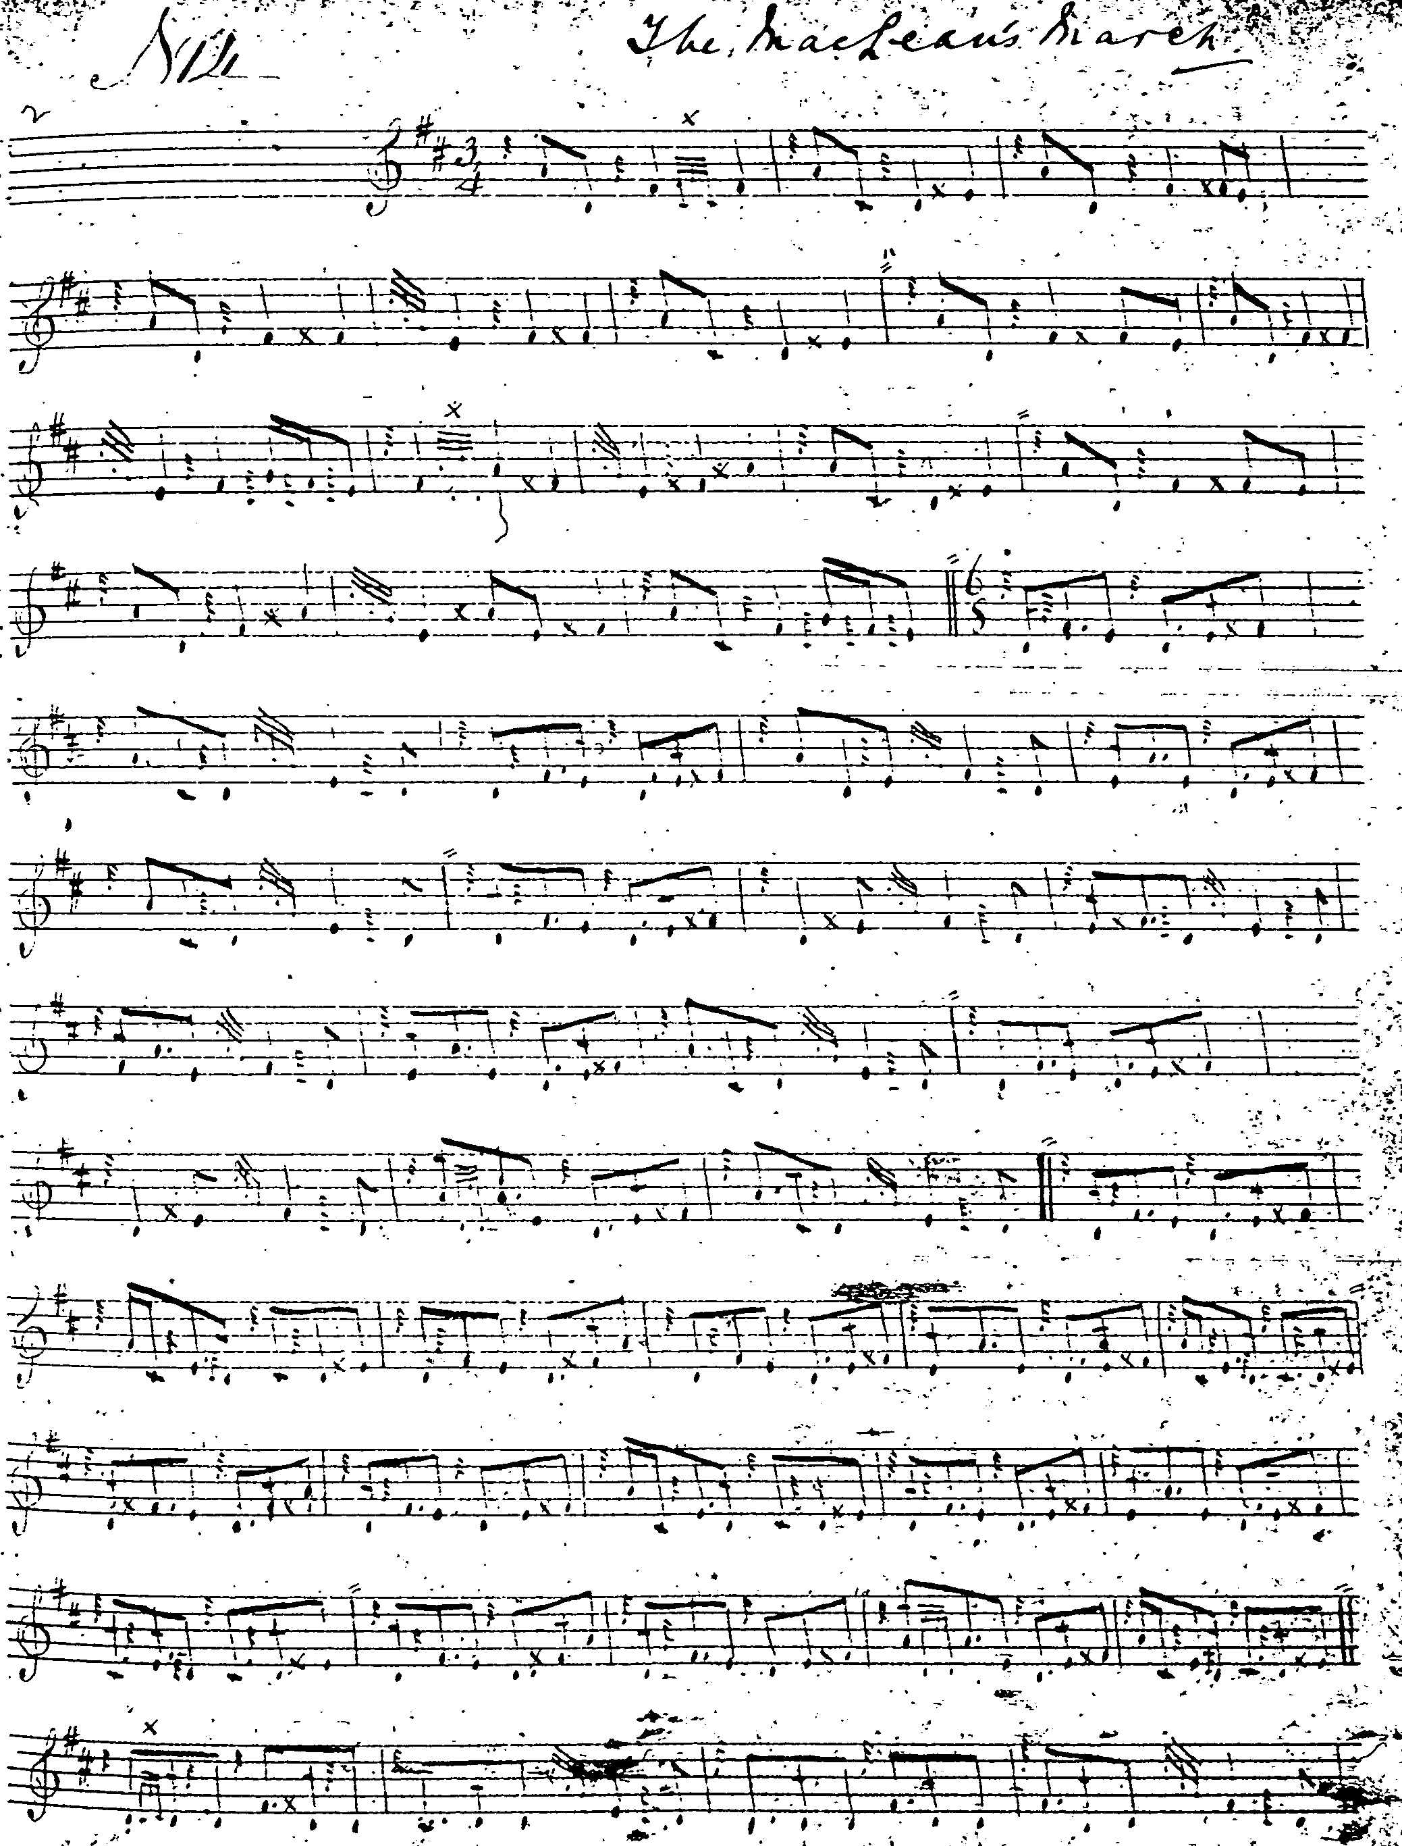
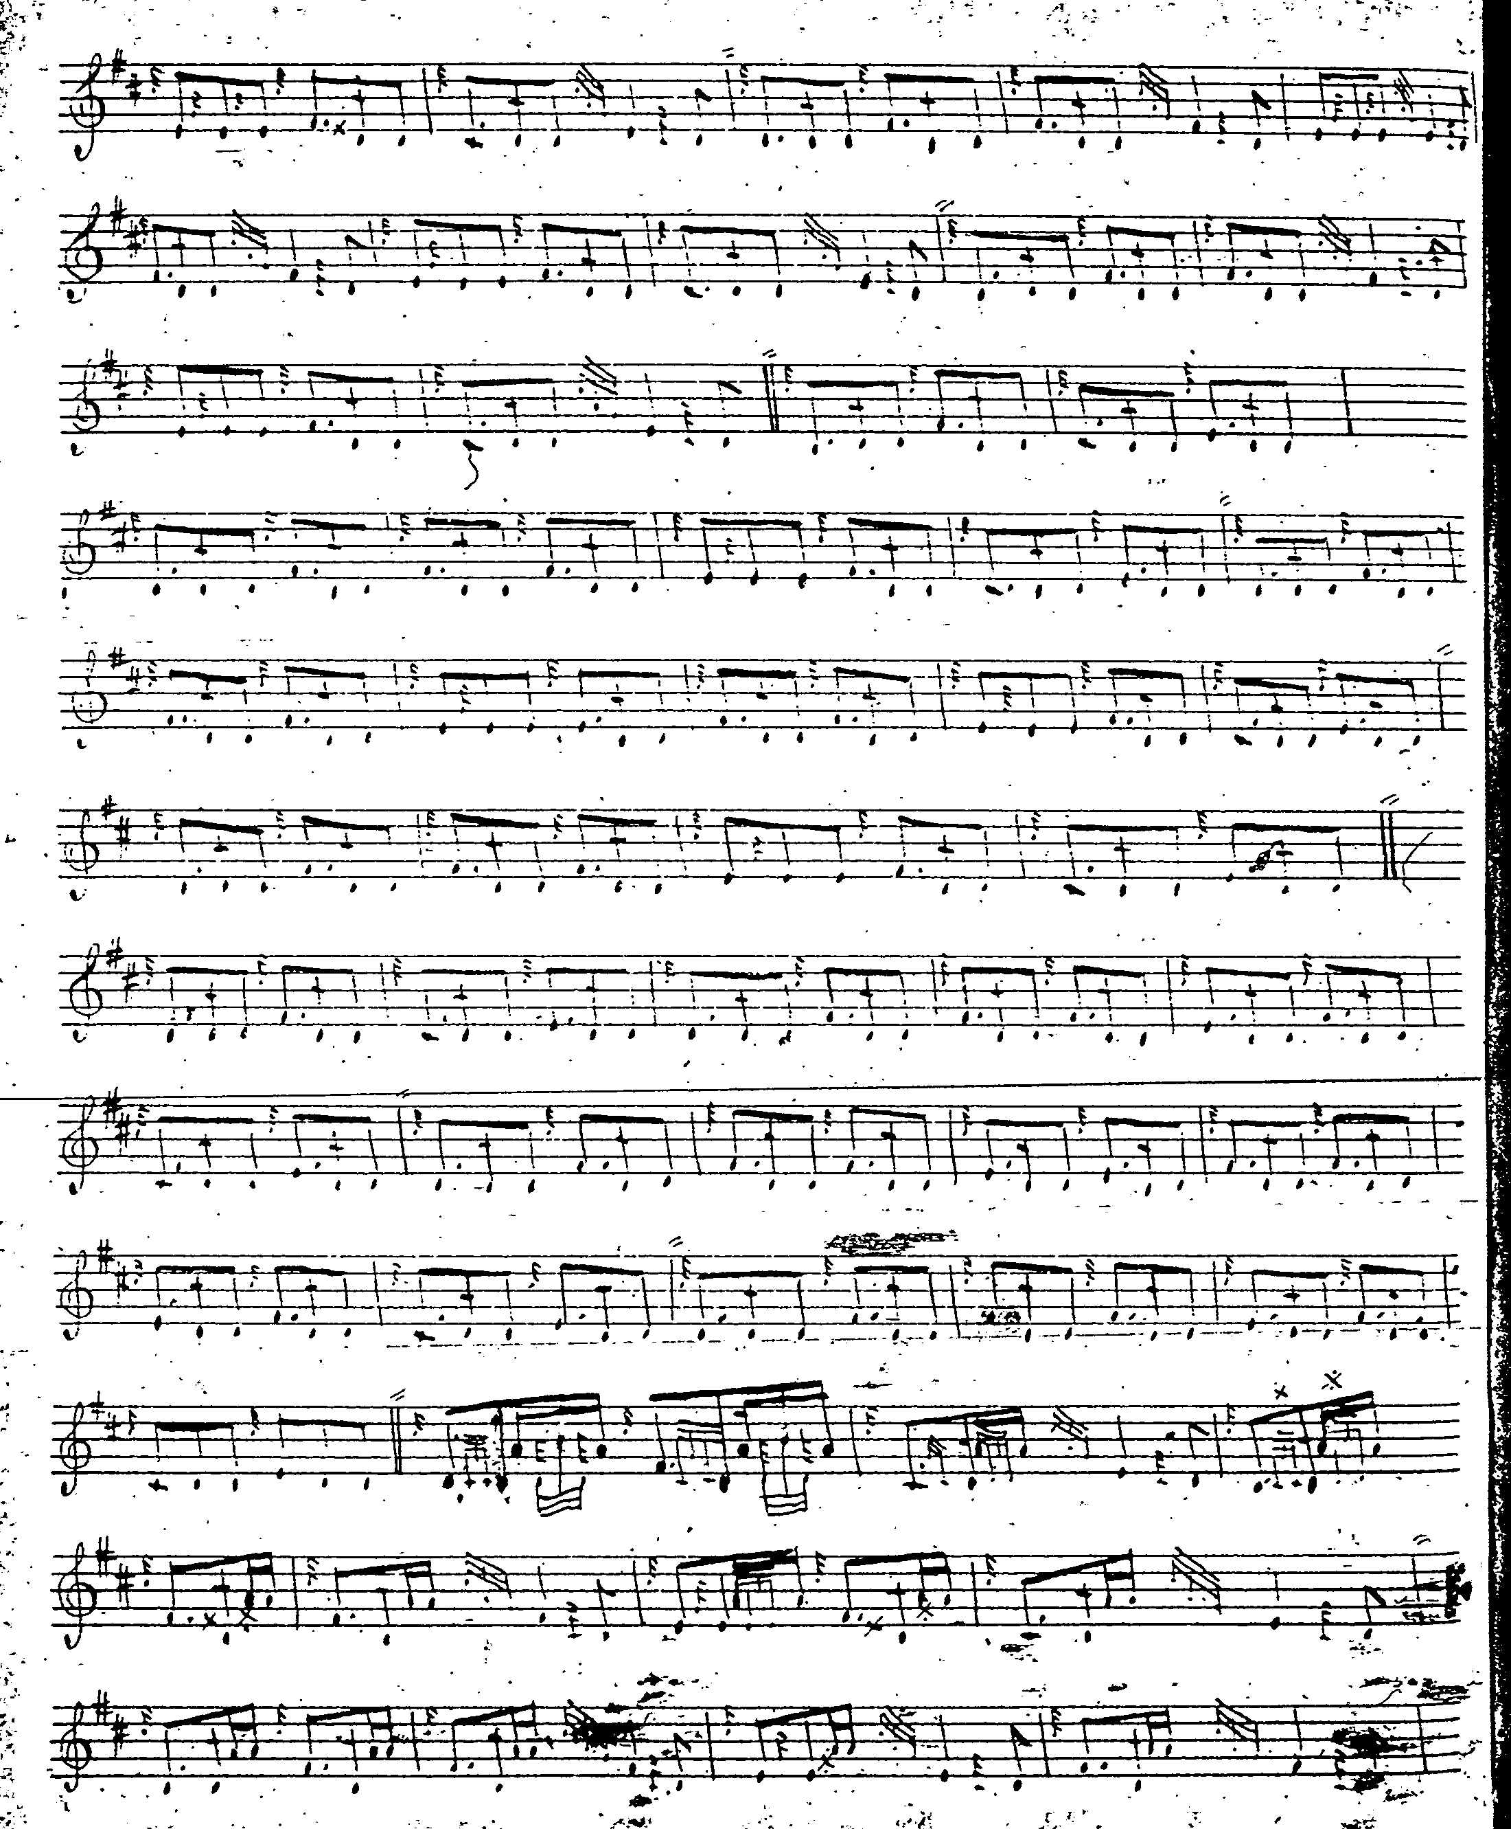

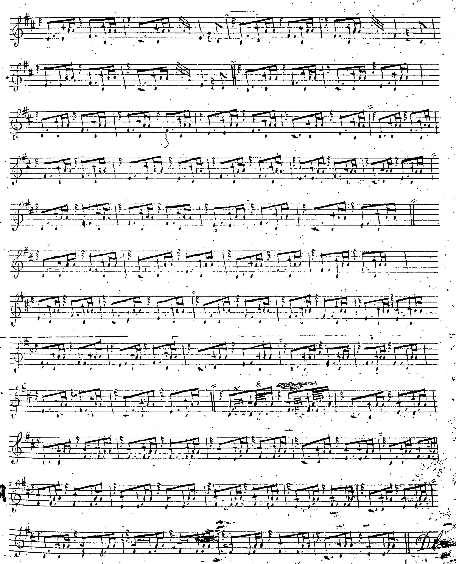

The first variation seems rather curiously timed with the syncopated opening figure in the A phrase, unlike MacKay’s more symmetrical but more heavily cadenced version.

Angus MacKay sets the tune as follows:

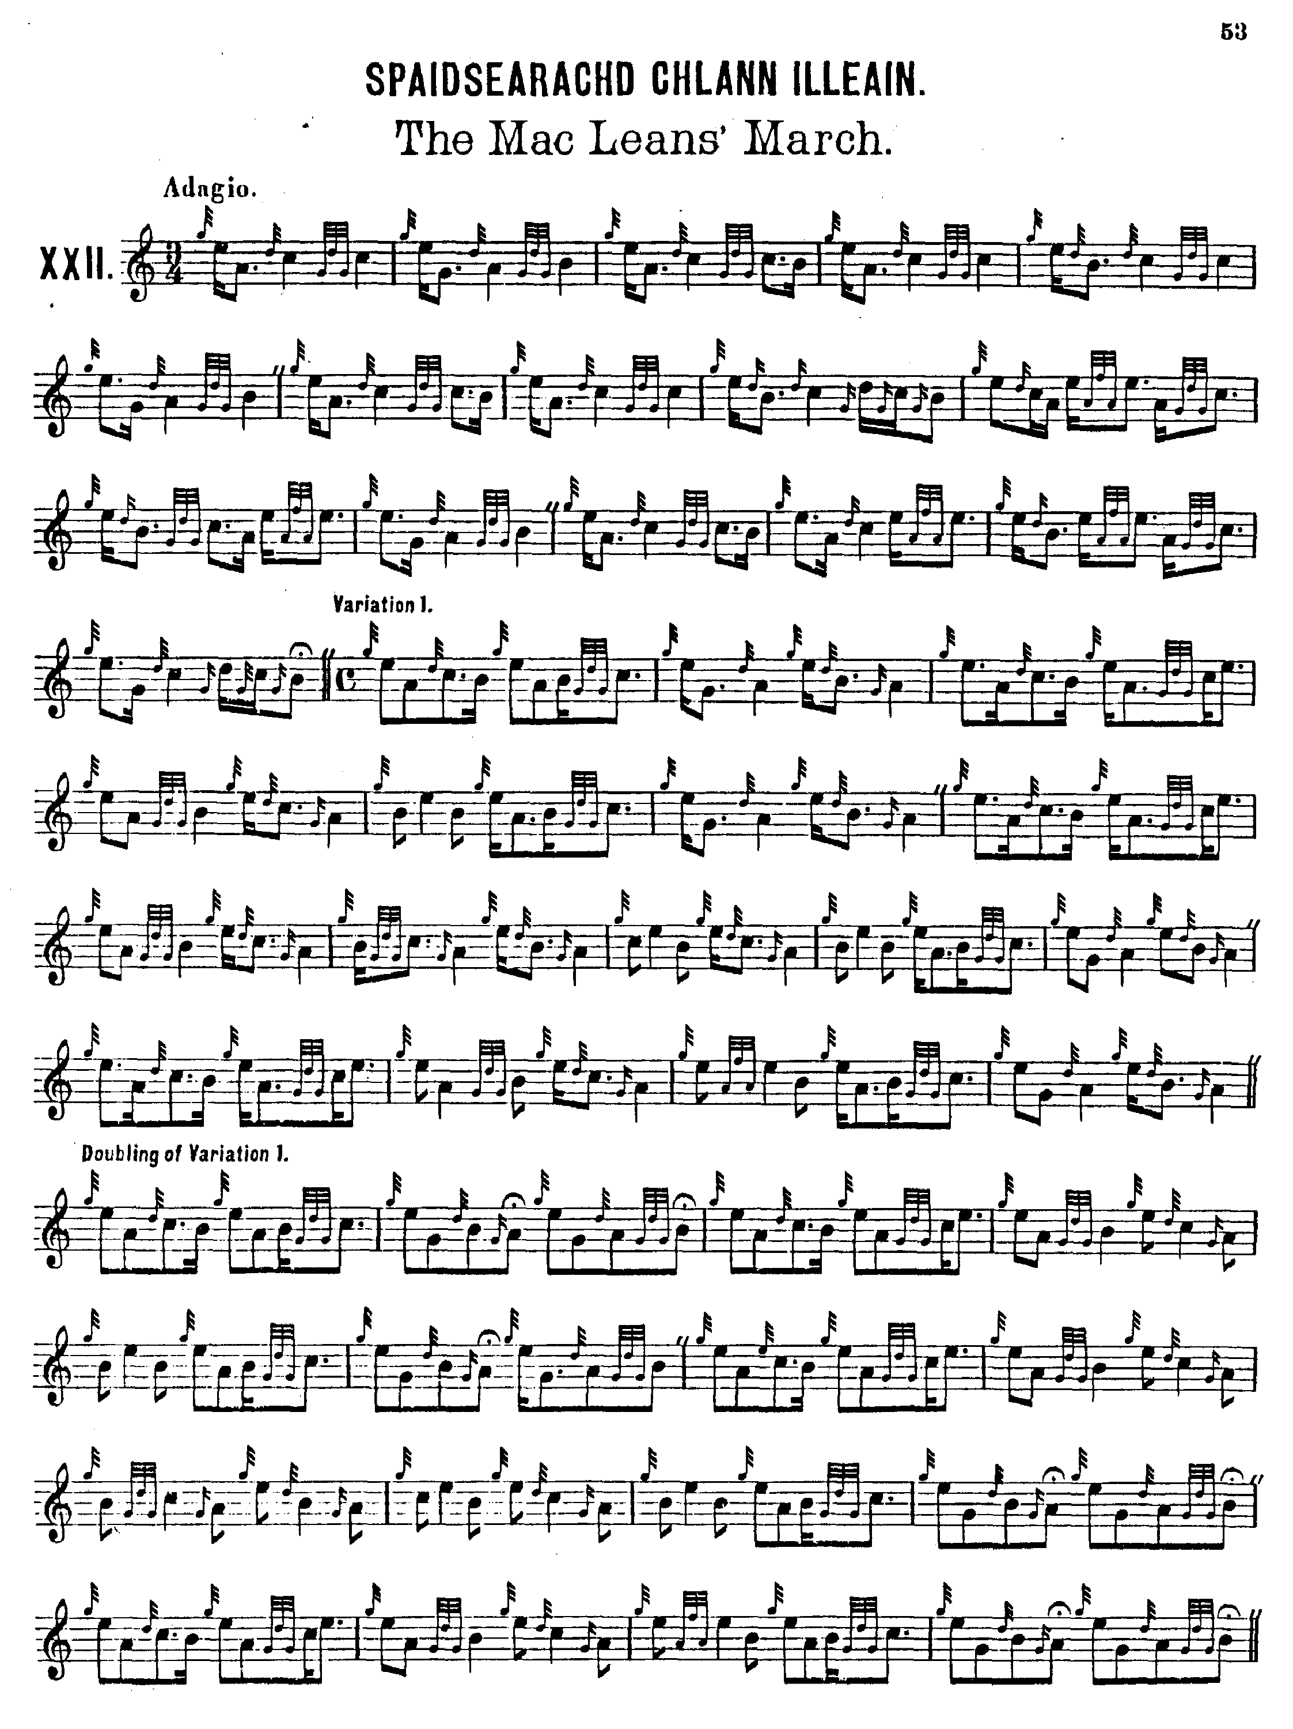
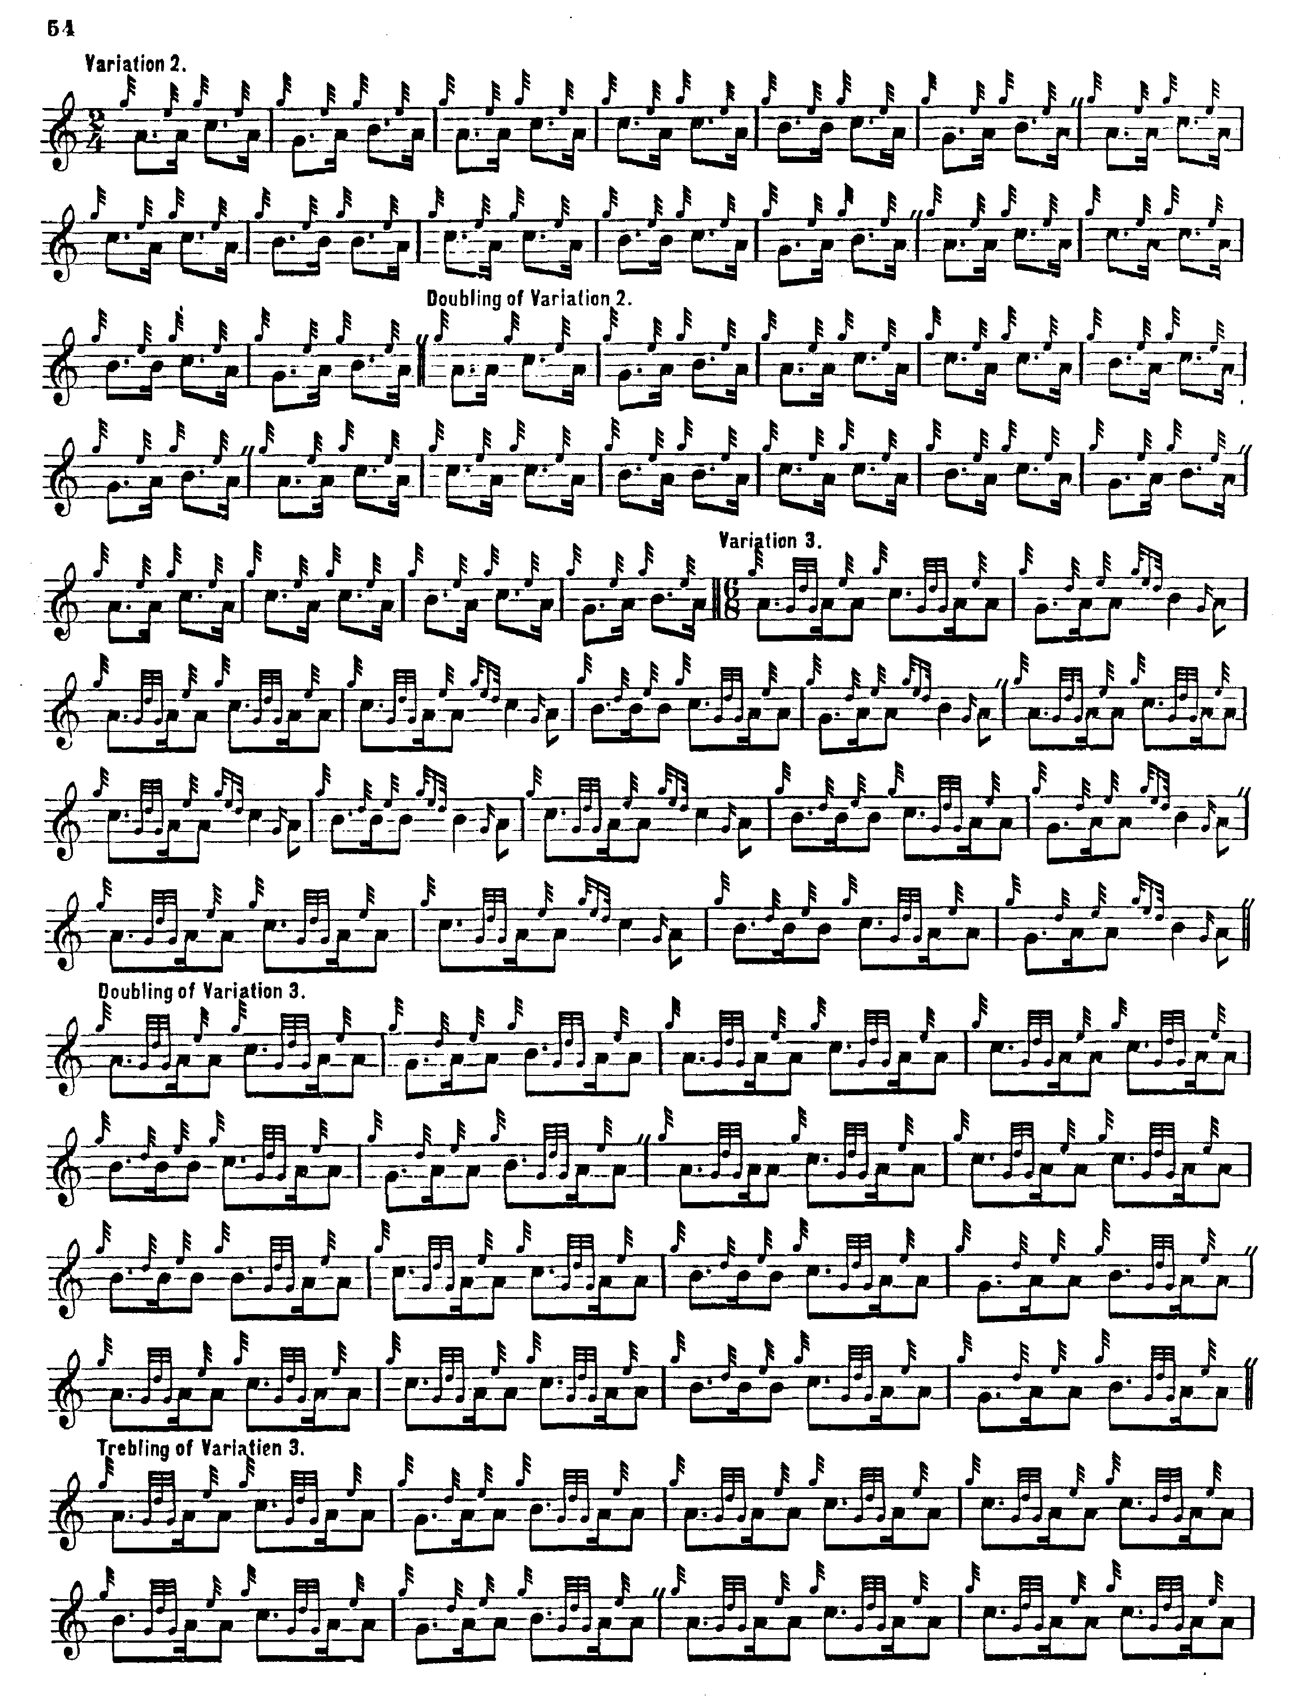

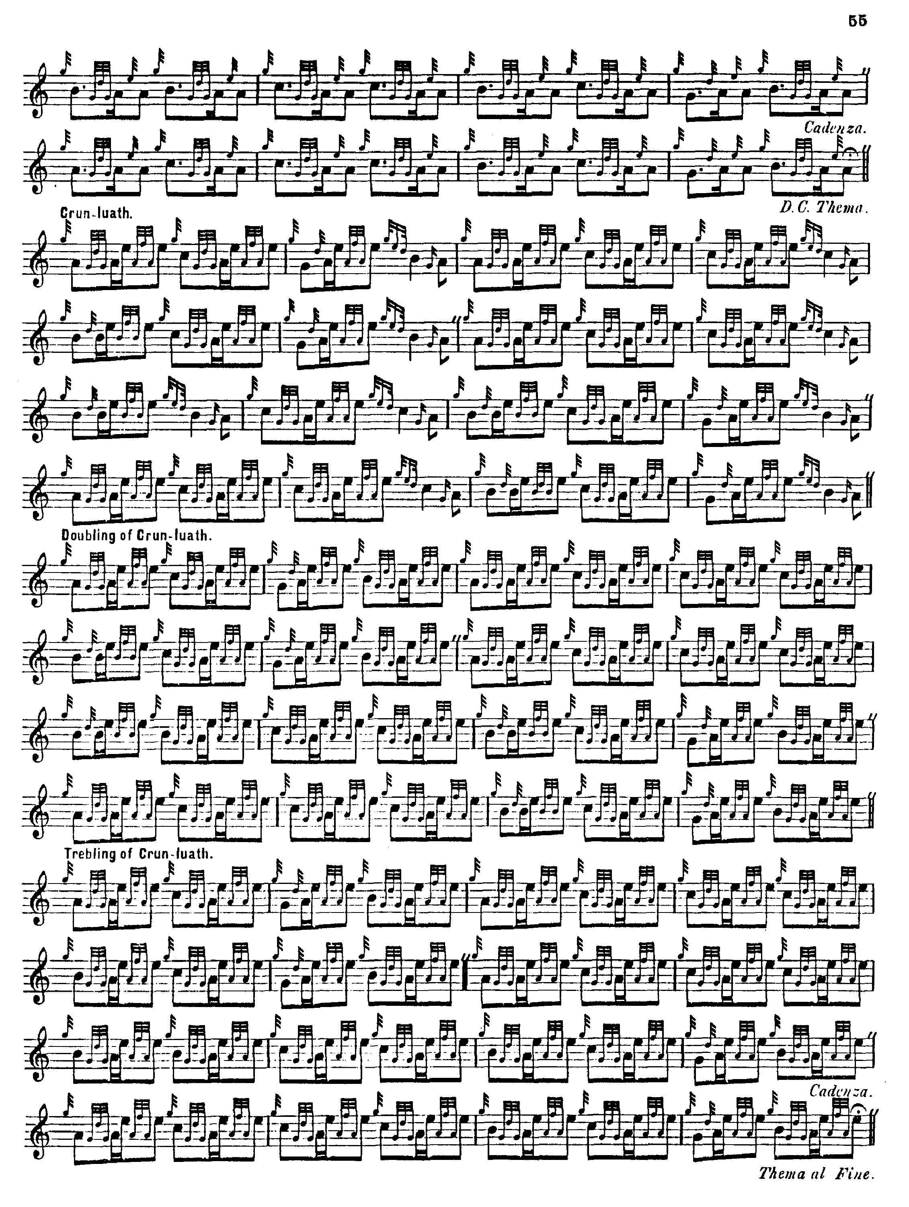

Some of the dotting and cutting is obviously missing in variation one where it seems clear that MacKay timed his E cadences alternatively “up” and “down”, sometimes holding them and sometimes cutting them, in a very pleasing manner, evidently intended to provide some rhythmical variety in a tune that could otherwise be laboriously square. The question of what the “cadenza” marking might mean in a piping context is an interesting one. In the “Menzies Salute” elsewhere in this series, I note that MacKay indicated that a “Cadenza” be played at the end of the Crunluath Doubling of that tune, which also occurs here in his setting of “The MacLean’s’ March”, at the end of both the taorluath and crunluath variations. I do not think that this term is not used anywhere elsewhere in the older idiomatic scores. A note in the “List of Italian, Gaelic and Other Musical Terms” prefixed to the music text of Ancient Piobaireachd states: “Cadenza imports a pause which gives the opportunity for the introduction of an extempore flourish, according to the taste and fancy of the performer. It has a peculiarly happy effect at the close of a variation, in serving to introduce the thema, or groundwork, Urlar, before Da Capo.” It is possible that the likely author of this note, the journalist James Logan, may have misconstrued the flourishes executed by the player when occasionally pausing to re-tune, which was a common practice in competition during the early part of the 19th century. There is nothing else in the written or printed record, so far as I am aware, which would support an alternative view.

We can normally be fairly sure about MacKay’s timing because he developed a clever scheme of notation that showed the time value of everything possessing duration within the bar and not stuck on as a spray of “cadence” notes with a value extraneous to the arithmetic of the bar which made their timing a matter of considerable perplexity. It is a pity that the advances Angus MacKay made in this field were so sedulously undone by later editors, a point considered at greater length in the commentary section below.

C. S. Thomason’s setting shows an alternative way of timing the E cadences, cutting them “down” in most cases. Presumably this represents the style of K. Macrae, formerly piper to Lord Fife, whom Thomason cites as one of his sources. He also has a taorluath a-mach which, again, might serve to attractively break up the potentially rather monotonous rhythmical pattern established by the long taorluath variations singling, doubling, trebling, of the other sources. Thomason set the tune as follows:

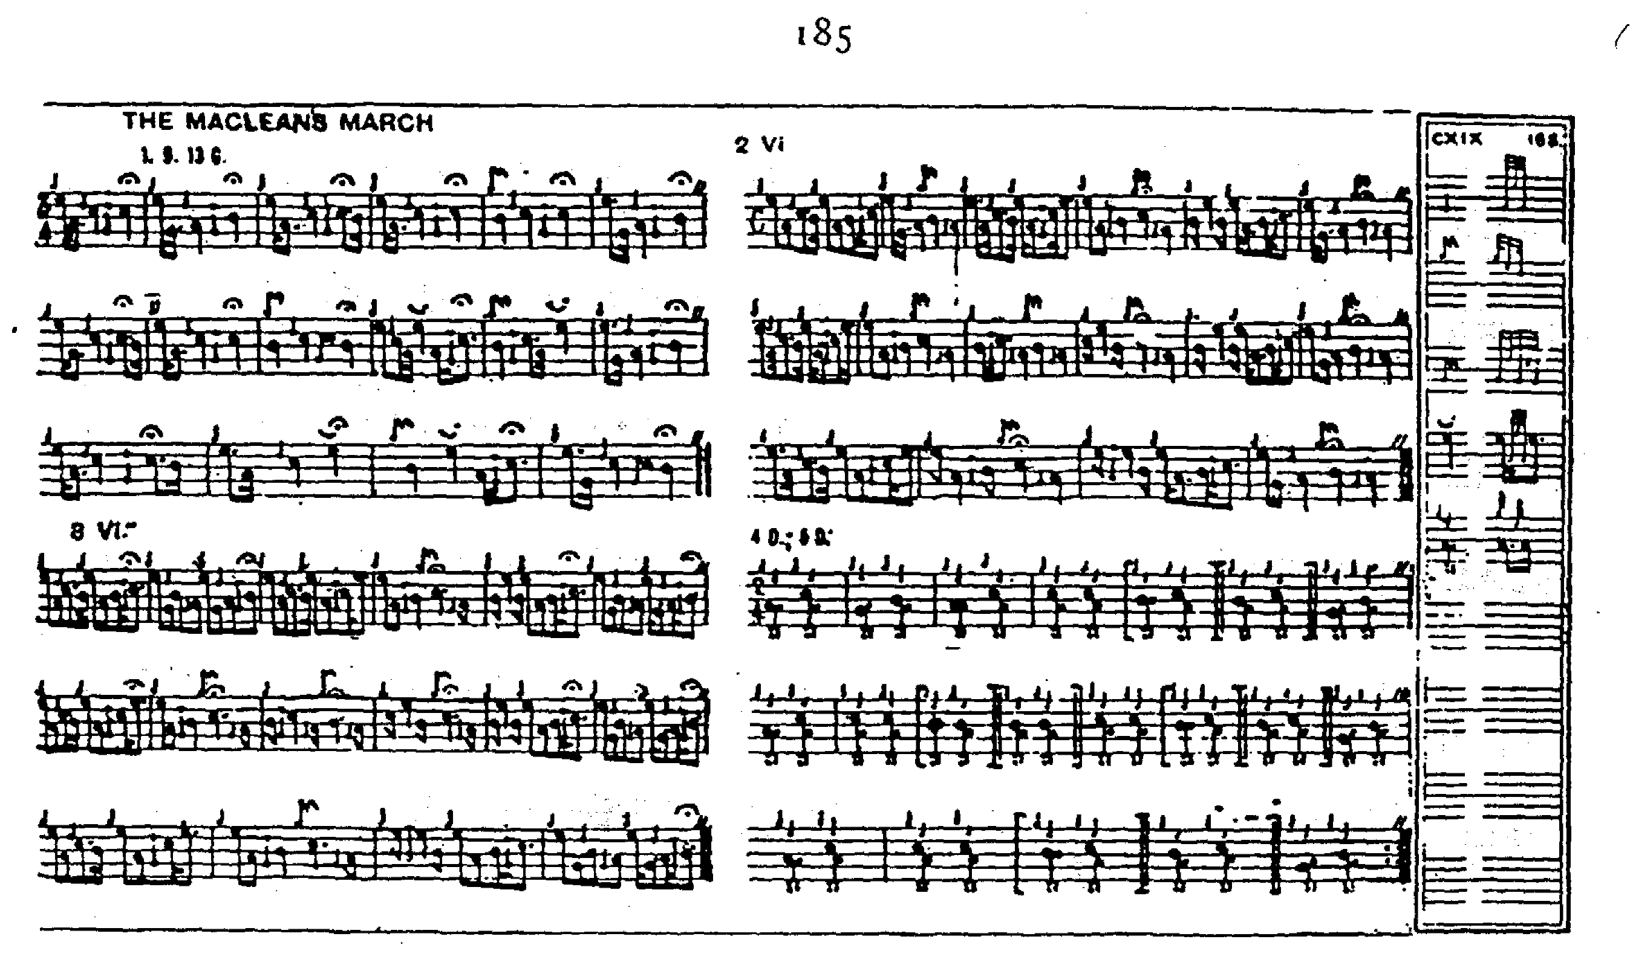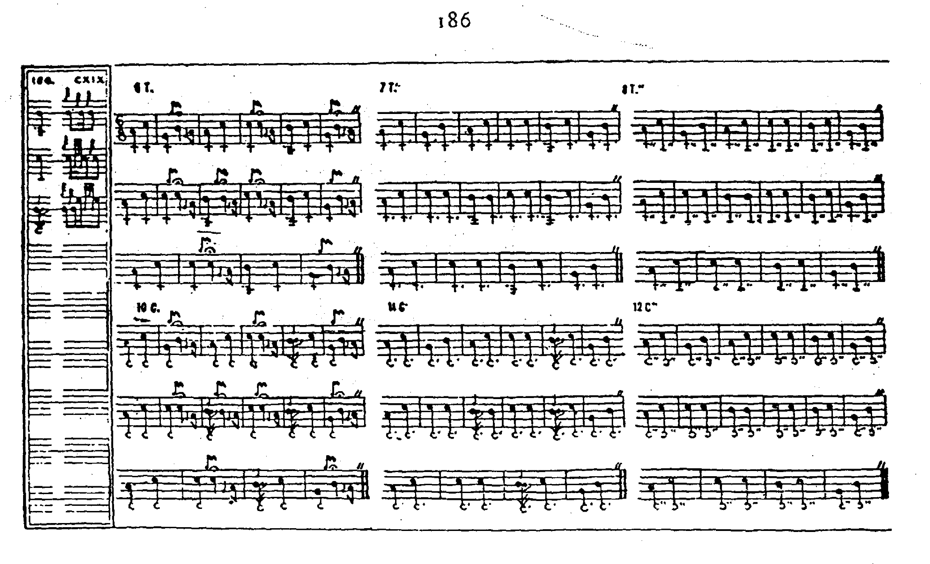

Commentary:

Both MacArthur and MacKay treat the cadence E’s in a way that integrates them into the flow of the melody and makes them rhythmically explicit. Later editors retreated from this practice. A letter from Dr. Charles Bannatyne to the Oban Times on 2nd March 1907 on “Angus MacKay’s Collection of Piobaireachd” shows us why. Bannatyne then had in his possession several of the older manuscripts (which Archibald Campbell and J. P. Grant later bought from his estate following his death in 1924) and had given them considerable study. But he was a bold rather than a careful thinker and his claim that the notational practice of Angus MacKay lay at the root of modern confusion now seems seriously unjust:

Mackay wrote all long grace notes as full ground notes, and herein lies one difference from his sources--a difference which has been greatly to blame for the controversies of many years regarding the correct method of noting piobaireachd […] It appears to me that Angus MacKay did some drastic editing. He never collected at first hand, so far as I can see, but got all his music from the Highland Society of London and from its members.
Herein he differs from Donald MacDonald, who collected at first hand the magnificent book called “The Ancient Martial Music of Caledonia”, a publication which rhythmically considered, is yet one of the finest. Take away the few superfluous grace notes, and look on the cadences as MacDonald intended them to be considered, viz., as appoggiaturas, whose time is subtracted from the notes they embellish, and the result is fine music. These long grace notes may be either quavers, semi-quavers, or dotted semi-quavers in value [although MacDonald consistently writes them all as demi-semi quavers], and their value in performance comes off the note they are tied to. Thus, if a quaver is tied to a dotted quaver, the latter when played has only the value of the dot, namely a semi-quaver.

Take the case of a “D beat group” written with a quaver E tied to a dotted quaver D, the next D being a semi-quaver; in practice this is the same as writing E a full quaver in the ground, attached to two semi-quaver Ds. Some players don't seem to understand this, as last year I was asked more than once the playing value of a G E D cadence tied to a dotted 'A' quaver succeeded by two A’s added by the double beat of the little finger, 'hieririn,' as it is called in canntaireachd. This is exactly the same when played, as if written E quaver, first and second A’s semiquavers, third A in both being, say a crotchet. The first A is added by D grace note, and the fact that this D succeeding an E is more than ‘cut’ makes it advisable to write it as a semi-quaver, though its value is scarcely that, and yet is more than a demi-semi-quaver. When this movement is written as a tied embellishment, I think it would meet the case to make the E a dotted semi-quaver, and the D a demi-semi quaver, but it seems hardly correct to write the E a semi-quaver only, and tie it to a dotted quaver. From several years’ practical experience of piobaireachd judging, I asseverate that the best performers recognise long grace notes of the several values I mention; and with their highly trained sense of rhythm, they invariably subtract these long grace notes from the ground note embellished, and this is one of the charms of their magnificent execution. (p.3)

The term “appoggiatura” is a flexible one and has meant different things at different historical periods (for further details see The Highland Pipe and Scottish Society pp.109-112). Bannatyne’s assumption was that the introductory demi-semi-quaver clusters in Donald MacDonald should be treated as appoggiaturas in the early 20th century sense, taking fixed amounts of time from the following note. Archibald Campbell and J. P. Grant adapted his conclusions, clumsily, to produce their own unidiomatic introductory movement on low A and were attacked by Bannatyne for producing rhythmical nonsense:

With a little care, the music would have been beyond all but the most captious criticism. As it stands it lays the compilers open to charges of

(a) Defective knowledge of: (1) Notation
(2) Piobaireachd
(b) Defective ear as to melody & quantity.

As notes possess quantity so do sounds & the appended examples show
it: type hieruren Each is a correct form. The centre one is D Glen's. The Third is MacArthur’s & D. MacDonalds. Glen’s is the remains of a former groping after truth in which the D grace note, which should only just be heard, is too obtrusive. The following form has nothing to recommend it & I never heard it in Ceol Mor. It is defective in every attribute of good notation & is nearly unplayable in piobaireachd.

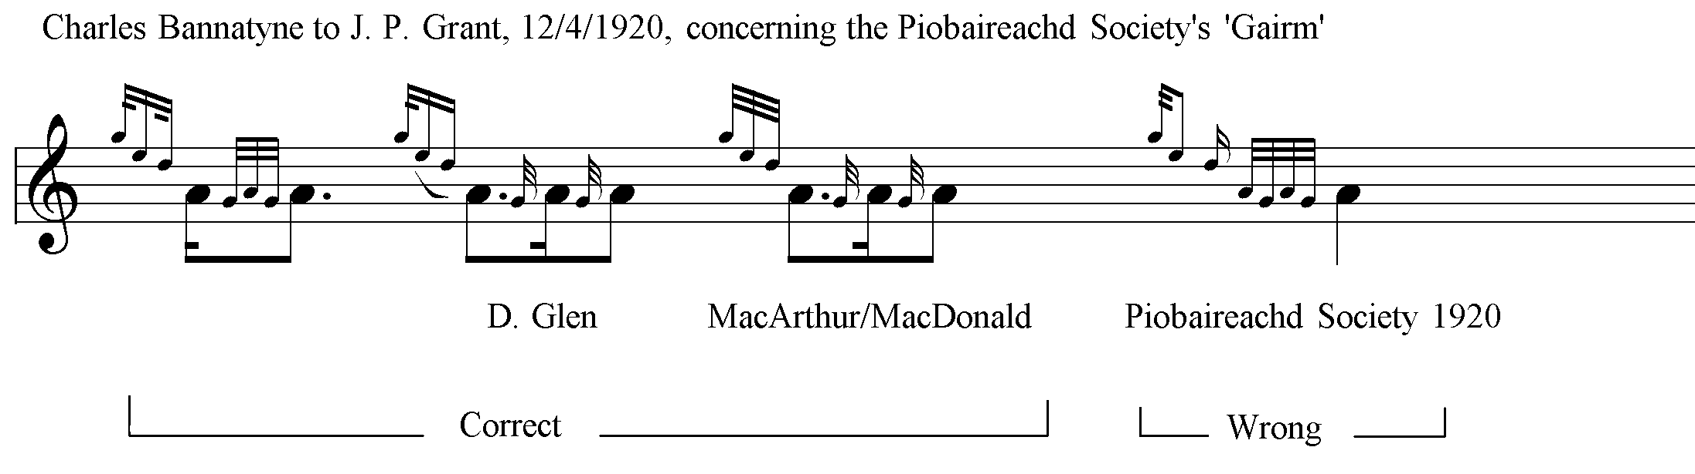

Mr. MacLennan [in The Piobaireachd as MacCrimmon played it] wrote...certain forms as grace notes but his beat was the minim & therefore his small notes had greater Comparative value than the Society’s where the crotchet is the beat. With the latter in use it is wise to look for the ‘pitfall & gin’ of the formula ‘When in doubt as to quantity write certain piob notes as grace notes’. In company with a celebrated piper I went over the music to find if it were playable. It is, but if competitors play it as written it will present the most hilarious exhibition ever heard by this or any other generation. (quoted in Highland Pipe and Scottish Society, pp.327-8).

However, the “hilarious exhibition”, i.e., the Campbell and Grant version, became the uniform introductory movement double echo beat on A used throughout the Piobaireachd Society Collection (second series). The Society’s teaching programme employed major players like Willie Ross and John MacDonald of Inverness to teach these scores, and thus the Society gairm/eallach eventually became the only form of the movement to be heard in competitive playing.

After his death in 1924 Bannatyne and his work were sedulously undermined by Archibald Campbell who dismissed him, in a typical remark, as “a man who had a very slight knowledge of piobaireachd music, and his ideas of how a tune should be timed and played are quite valueless” (letter to J. P Grant, 05/06/1949, quoted in Ian K. Murray, “The Enigma of Dr Charles Bannatyne”, Proceedings of the Piobaireachd Society Conference, vol.26, 1999, p.22). Almost fifty years later, Archibald’s son, James Campbell, could still be found dismissing Bannatyne’s settings of “The Bells of Perth” and “My King has landed in Moidart” as “infamous” (Proceedings of the Piobaireachd Society Conference, vol.22, 1995, p.5).

It tells us much that James Campbell’s often reprinted and frequently acclaimed article, “The Elusive Appoggiatura” (published in Piping Times, Vol. 40 No. 9, June 1988 pp.22-25; reprinted in Vol.56, no.9, June 2004, pp. 23-7; and in The Voice, vol. 31, no.4, Winter 2002, pp.17-19), should be derived so closely from the argument of Charles Bannatyne in his Oban Times letter quoted above.

* * *

Electronic text © Dr. William Donaldson, Aberdeen, Scotland, July 2005.

