The MacKays’ Short Tune

This tune appears in the following manuscript sources:
--Duncan Campbell of Foss, ff.222-223 and
--Uilleam Ross’s MS, f.176

Duncan Campbell times the tune as follows:

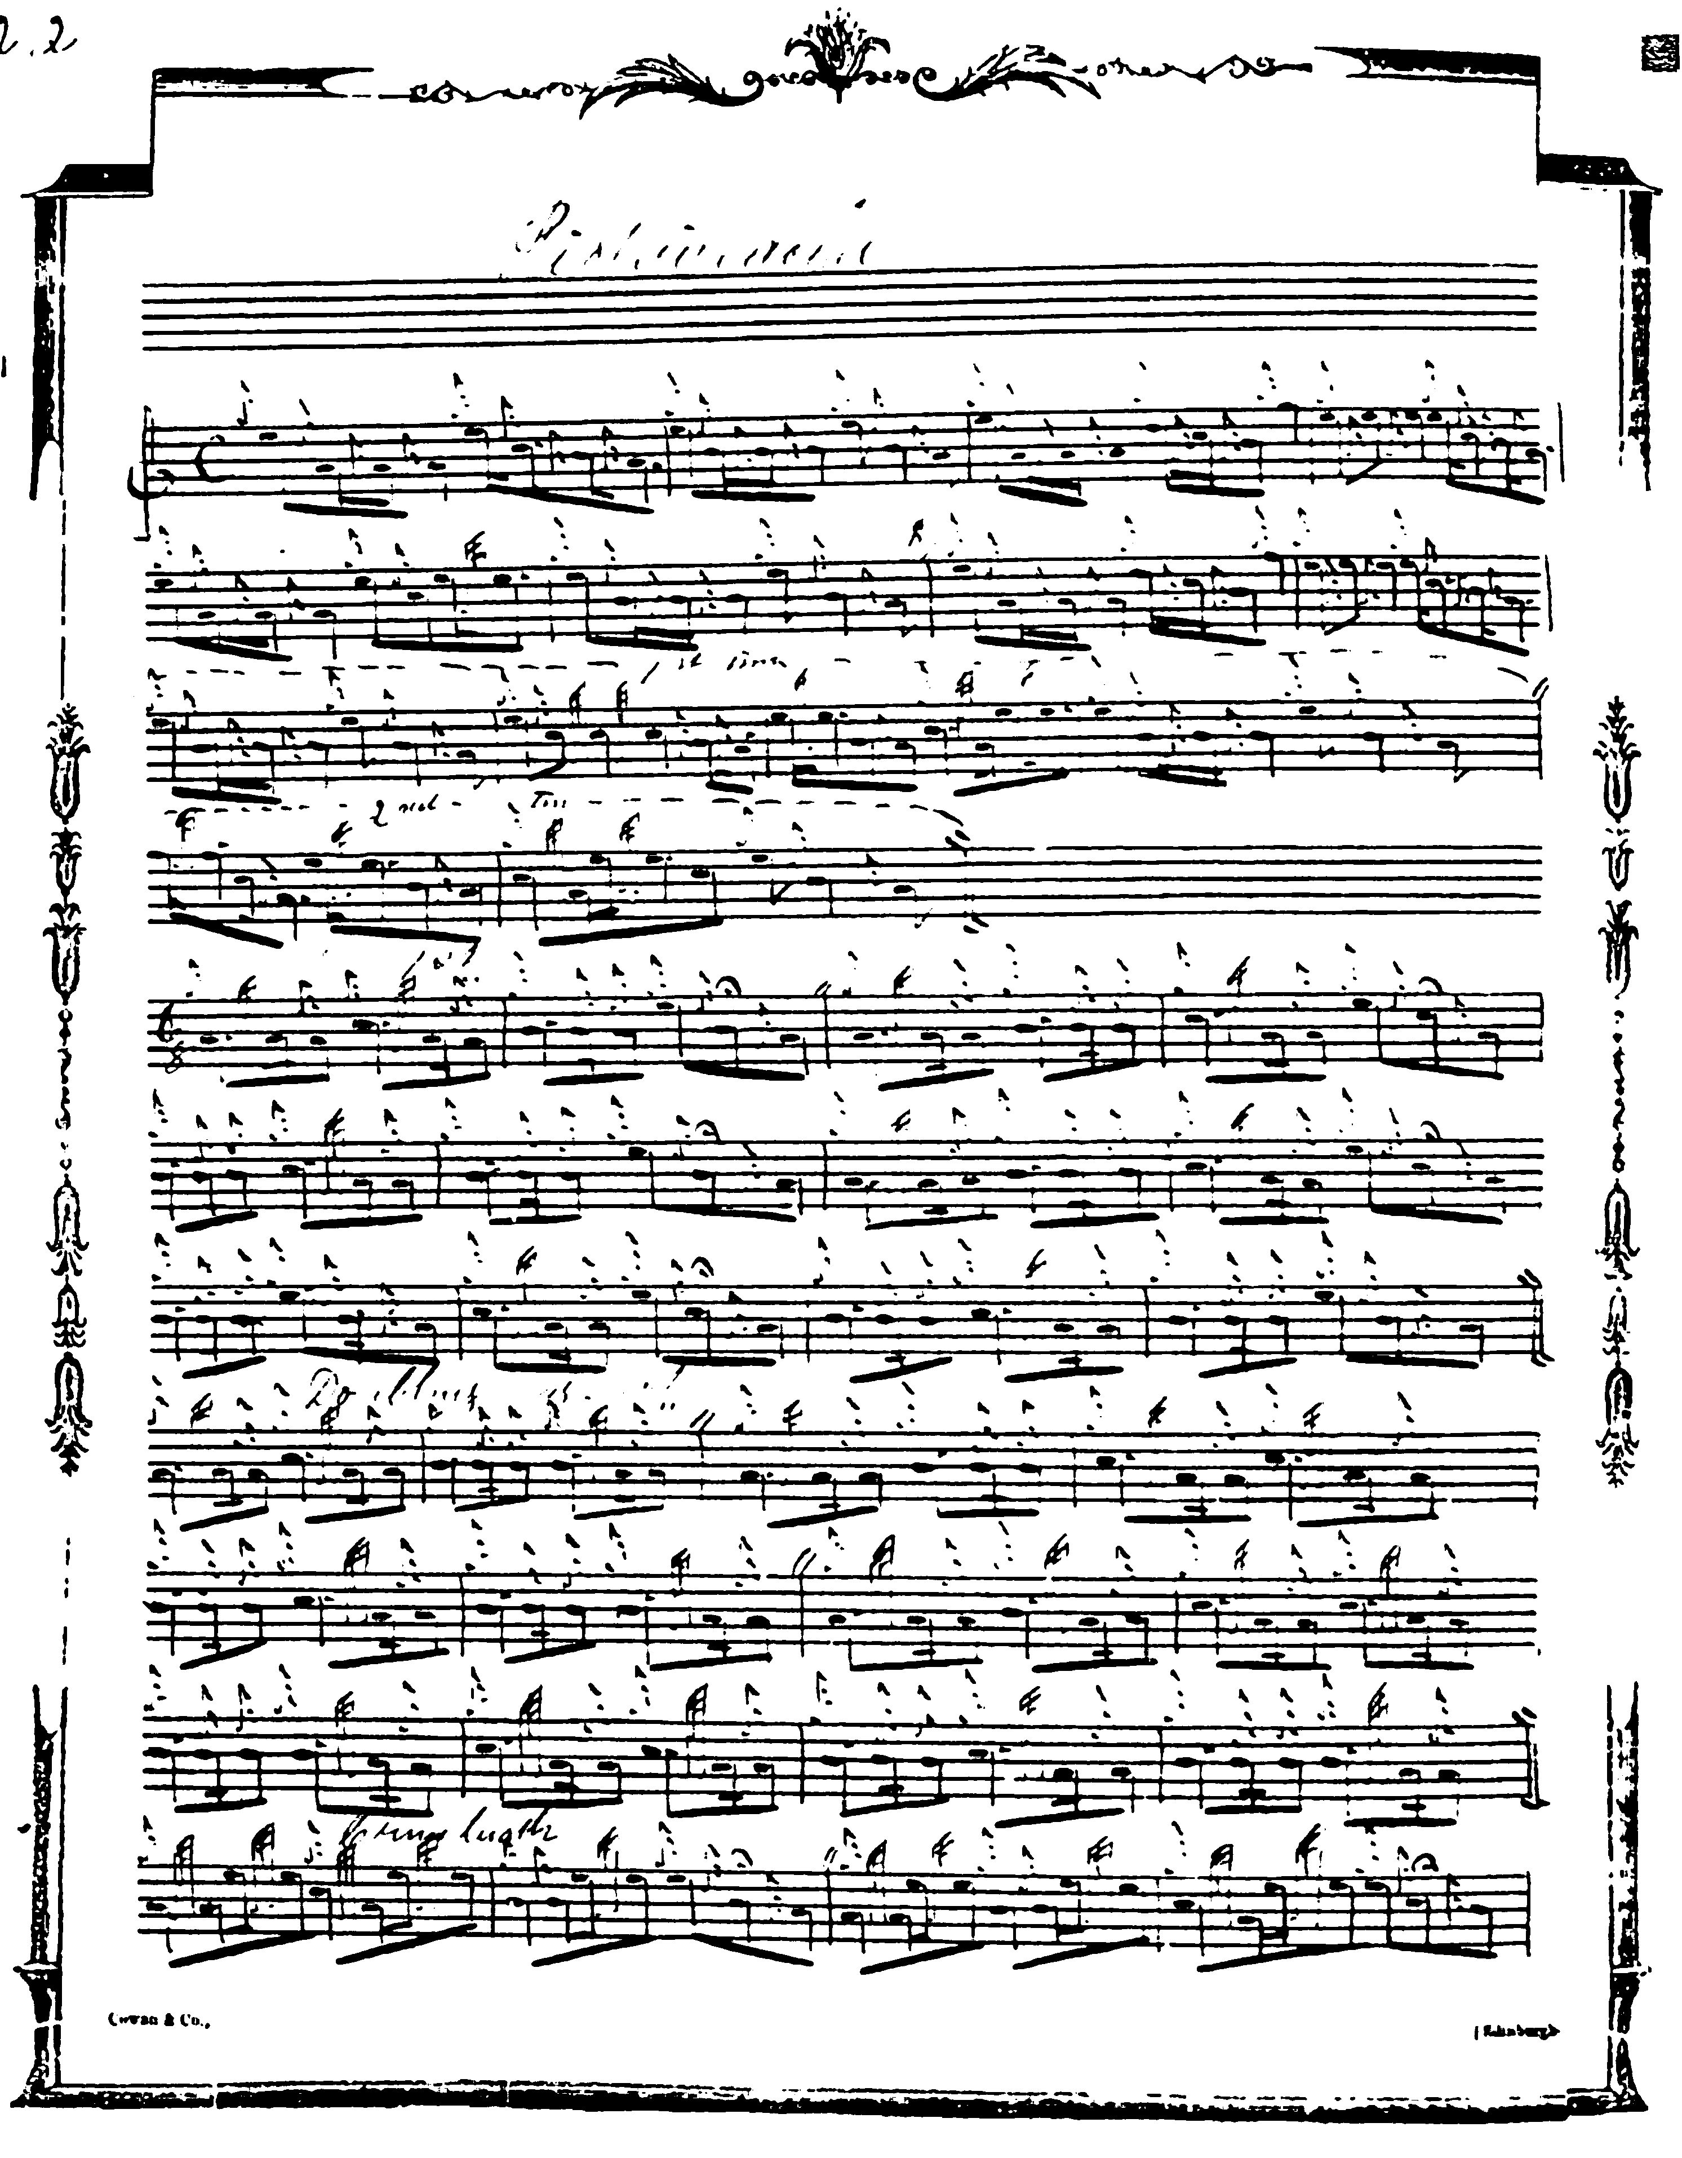
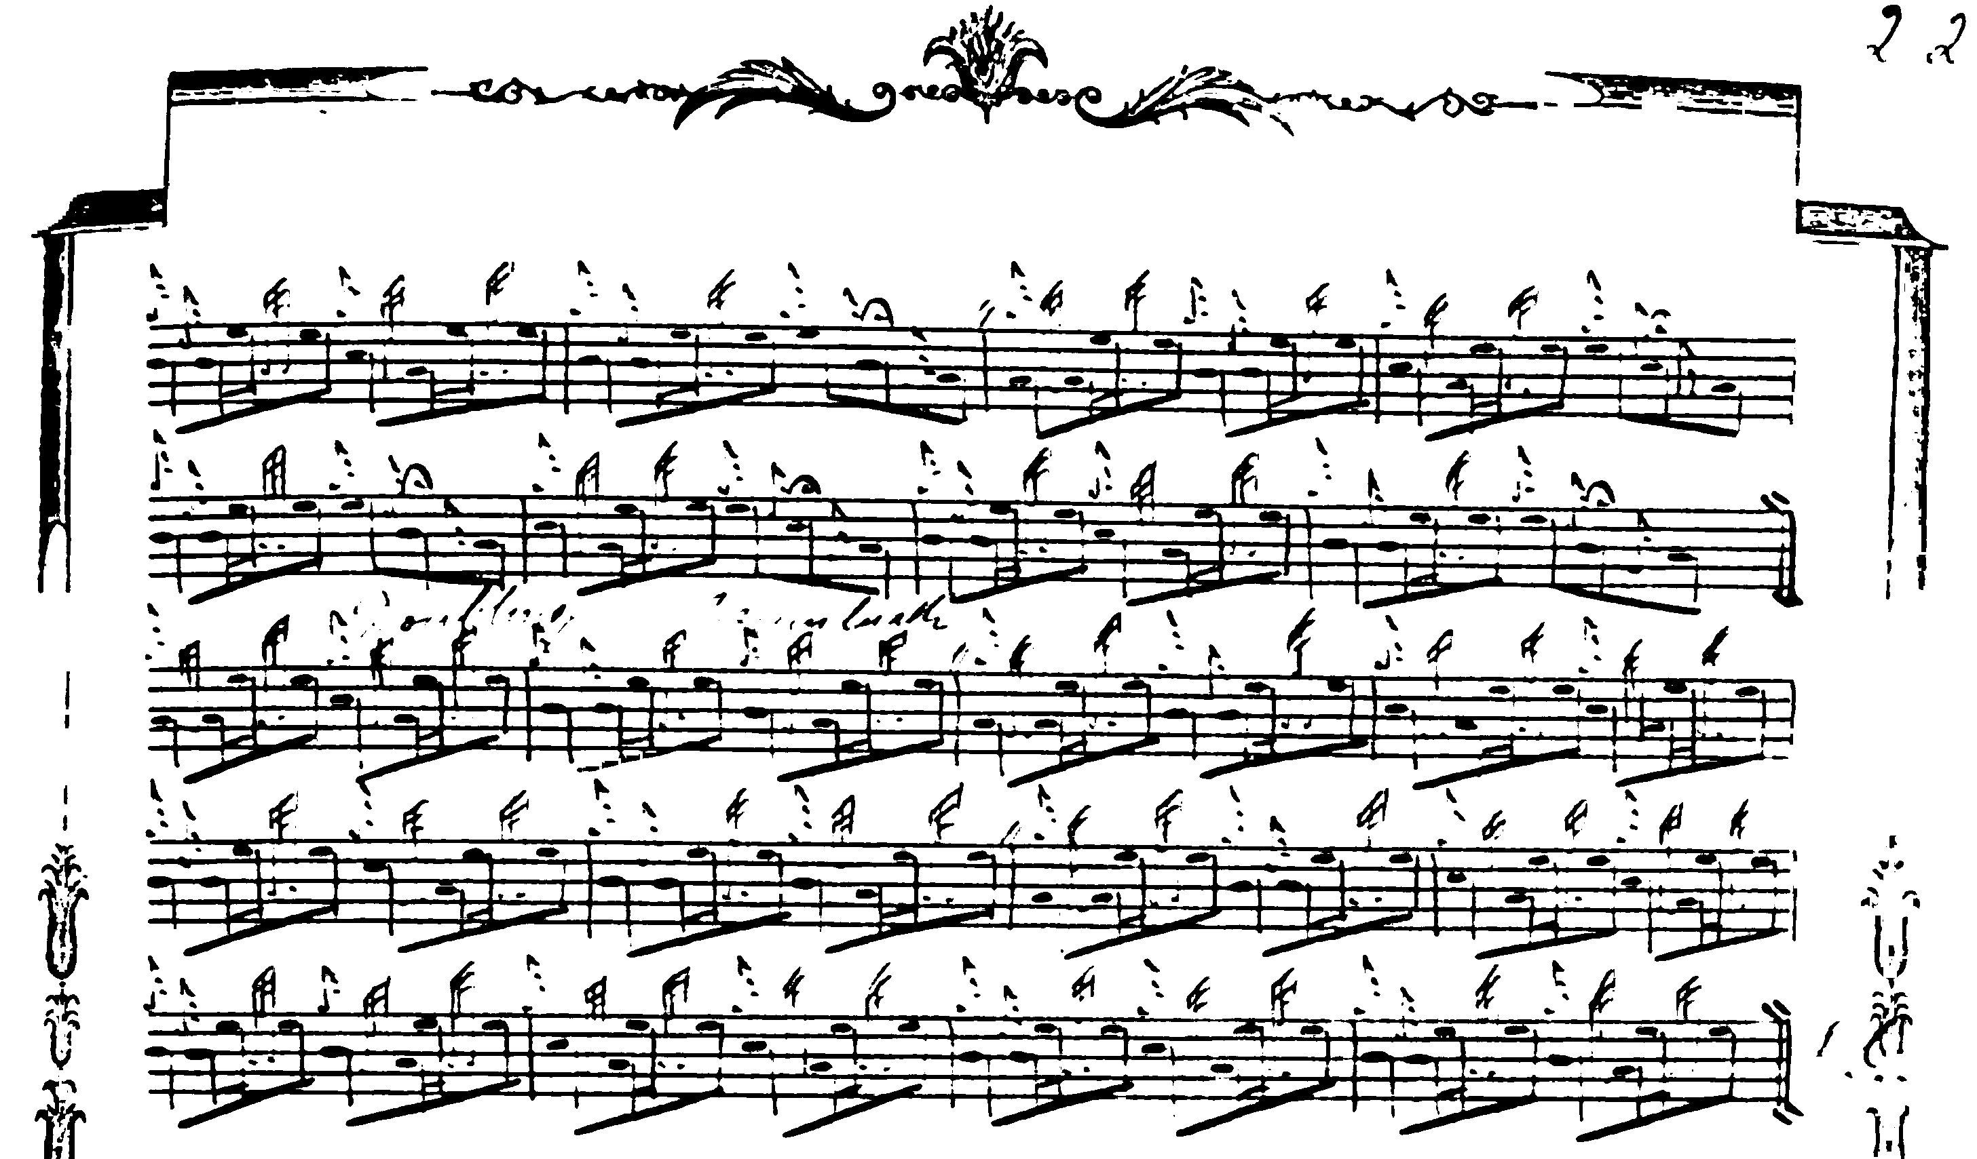

As frequently happens with Duncan Campbell’s scores, where the third line is obvious, he gives the first two only, a means of saving space at a time when paper was still quite expensive. He specifies that the ground be repeated following the crunluath, but not after the taorluath variation.

Commentary:

Archibald Campbell’s notes to this tune in the Piobaireachd Society Collection (second series), viii, 238, state that it is in MacKay's MS and that it was the only one in that source that Thomason had not included in Ceol Mor. Perhaps the reason why Thomason did not include this tune in Ceol Mor is that it does not actually occur in Angus MacKay’s MS. The earliest recorded source would appear to be Duncan Campbell of Foss’s MS, where it appears simply as “Piobaireachd”. It crops up again in the MS of Uilleam Ross, f.176, which appears to be the only source for the “MacKays Short Tune” title.

* * *

Electronic text © Dr. William Donaldson, Aberdeen, Scotland, October 2004.

