MacIntosh of Borlum’s Salute

There are settings of this tune in the following manuscript sources:

**--Peter Reid**’s MS, f.37;

**--Angus MacKay**’s MS, ii, 43-4;

**--Duncan Campbell of Foss**’s MS, ff.73-5;

**--Colin Cameron**’s MS, ff.142-3;

**--Uilleam Ross**’s MS, ff.76-78;

**--D. S. MacDonald**’s MS, i, 109-11;

and in the following published sources:

**--C. S. Thomason**’s *Ceol Mor,* pp.222-3;

**--David Glen**’s *Ancient Piobaireachd,*  pp.122-3.

**Peter Reid** sets the tune as follows:

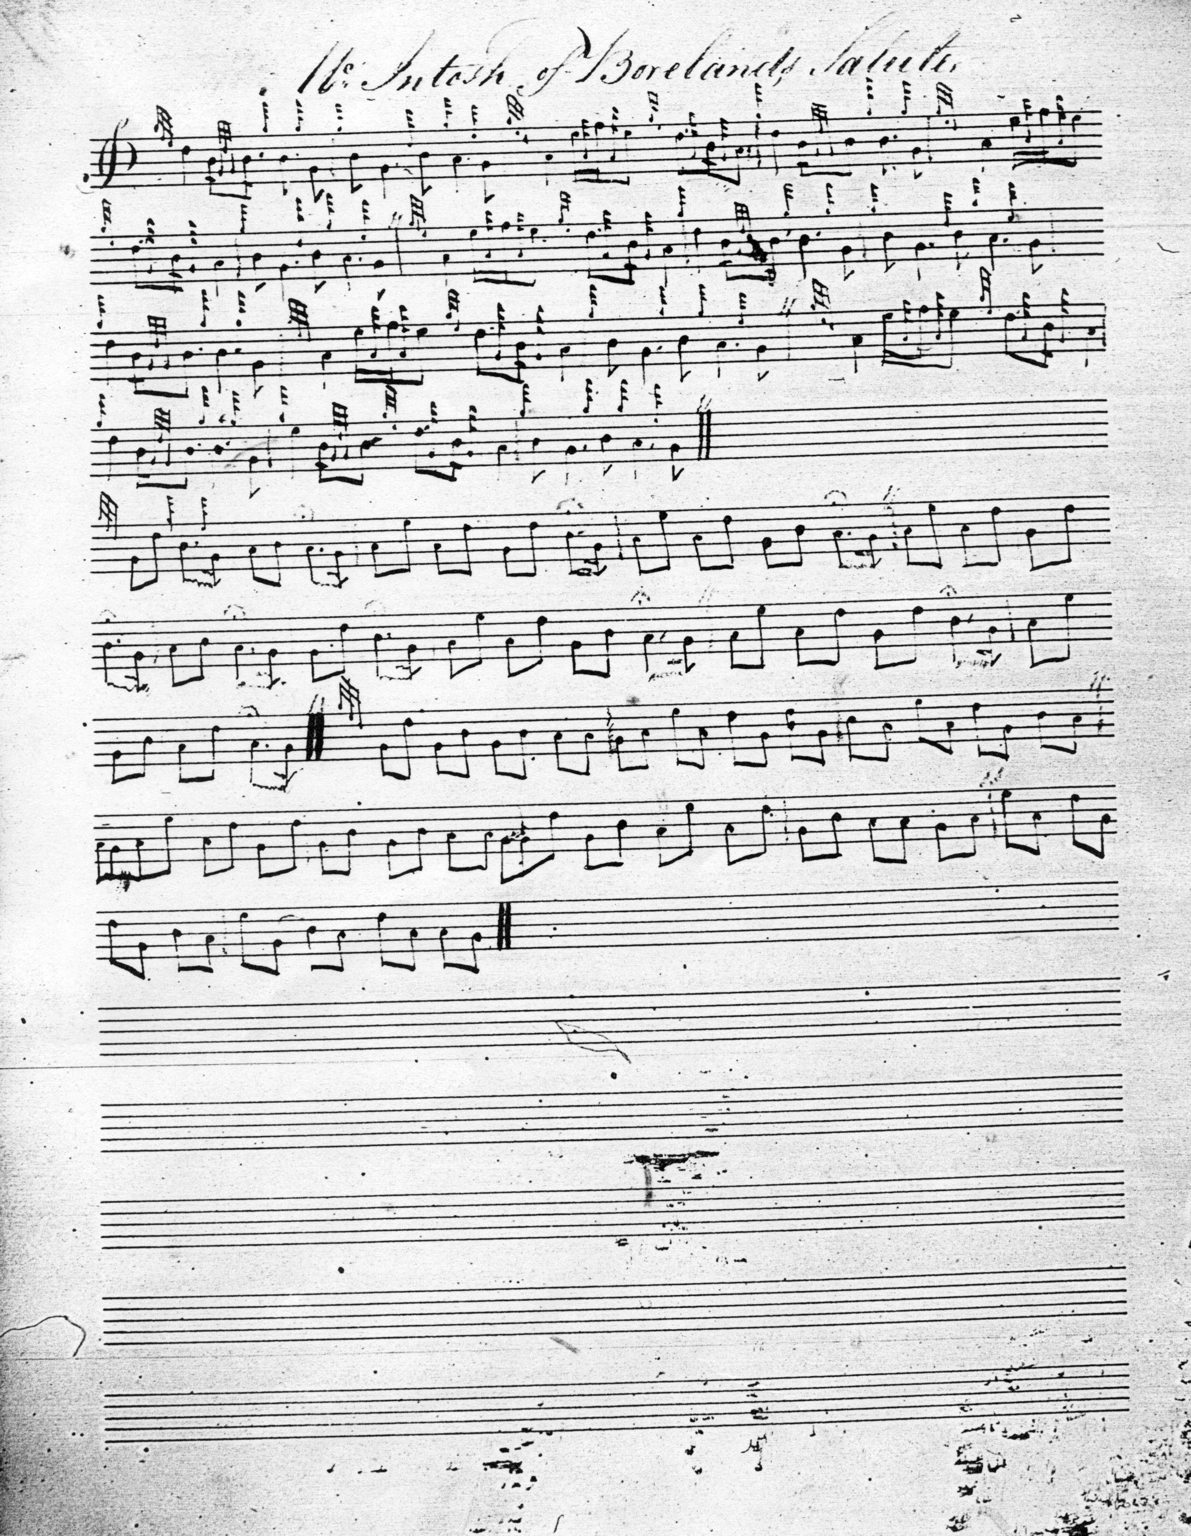

The tune simply stops at the end of the siubhal doubling in Reid’s MS—there is no indication that the score is complete; Reid simply records the essence of the tune and passes on. Reid’s ground is 6 6 4. As is his siubhal singling. And apart from a couple of extraneous pulses in line two, so is the doubling.

**Angus MacKay** sets the tune in fuller--and more heavily cadenced--form, thus:

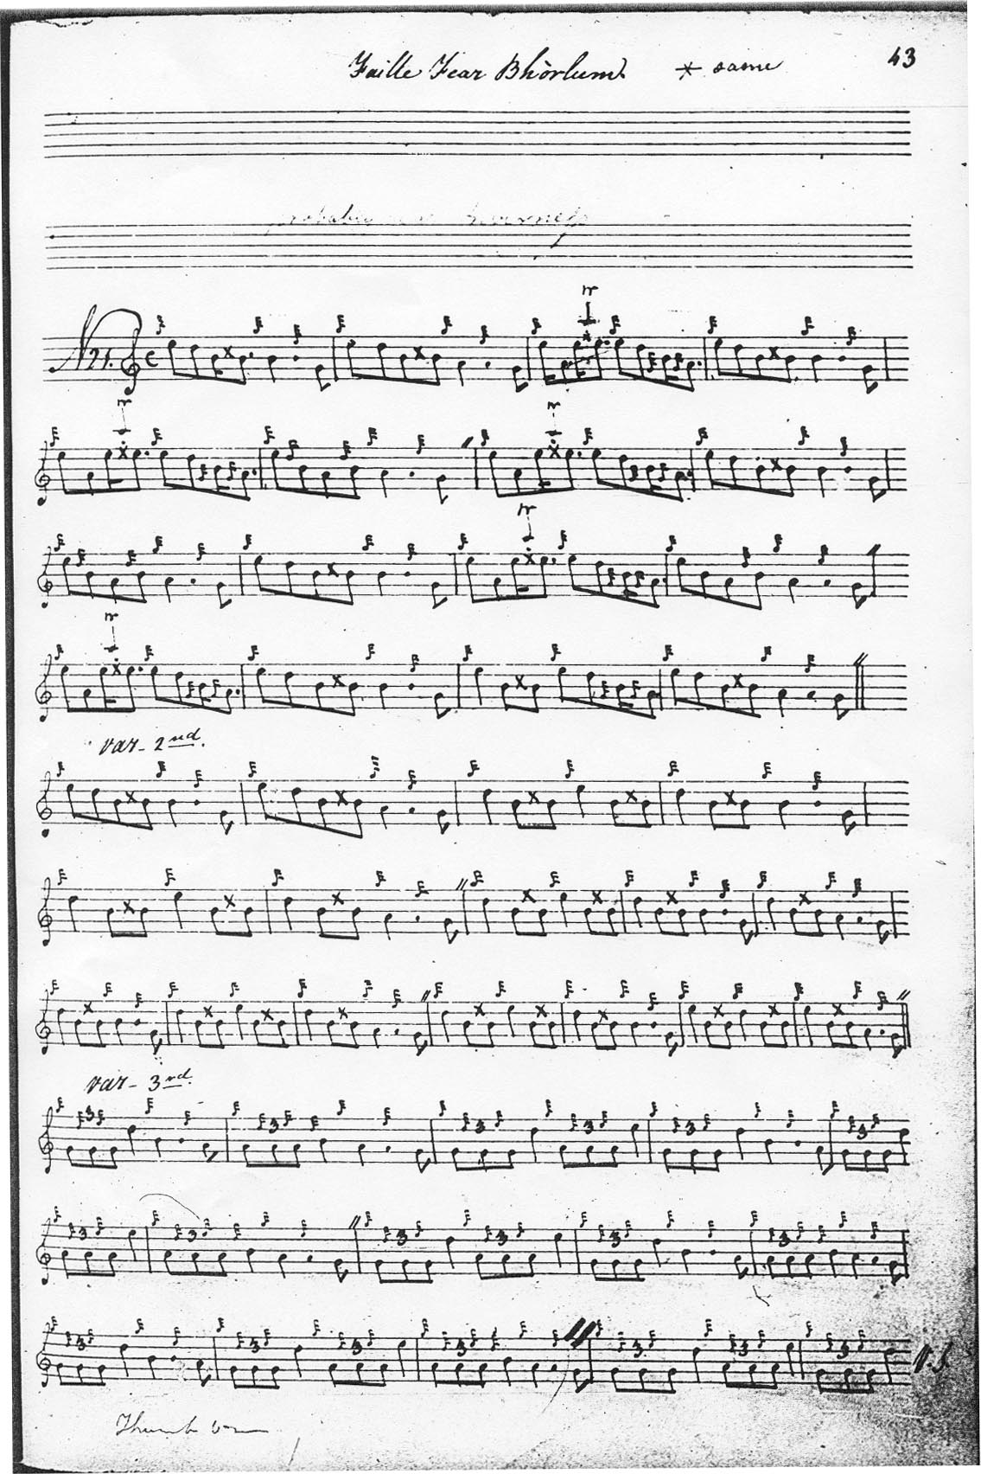

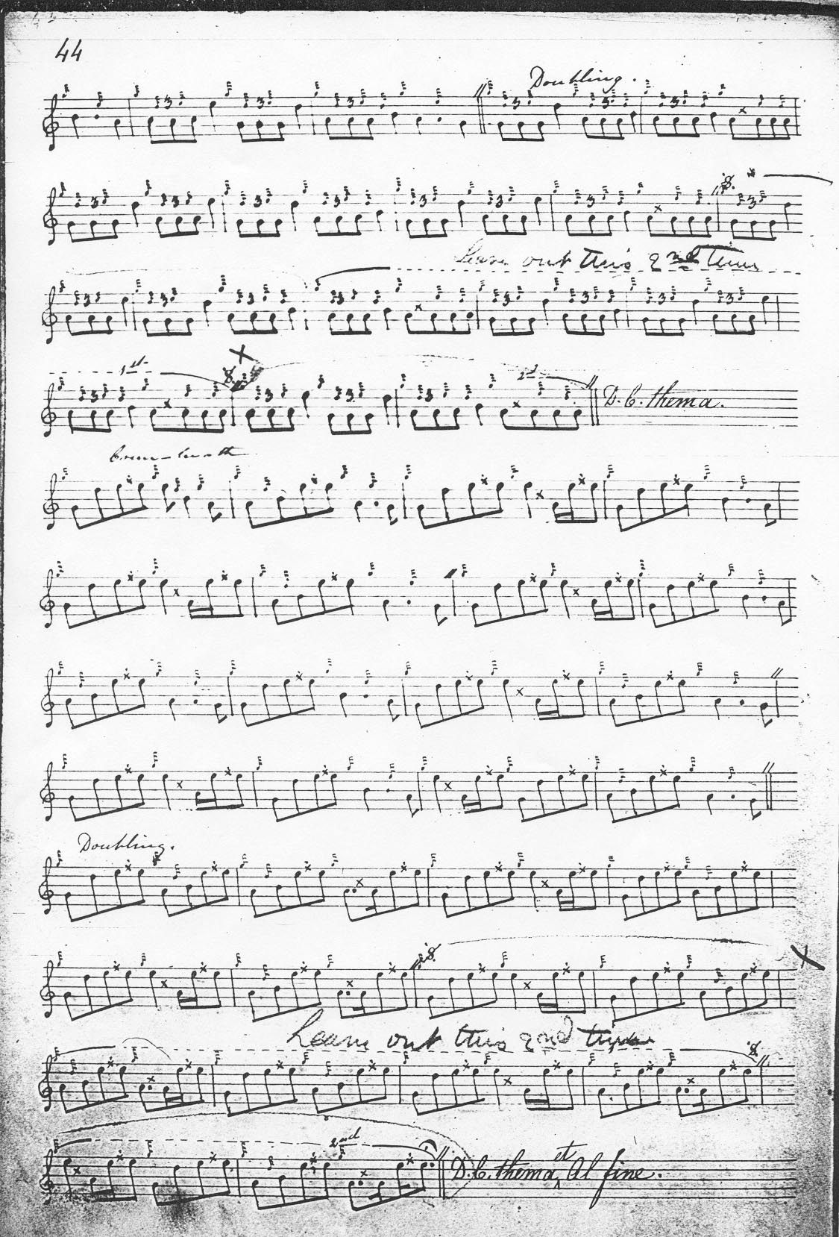

MacKay develops the tune on a much more spacious scale, with ground, thumb variation, second ground and orthodox taorluath and crunluath fosgailte variations singling and doubling. He does not have Reid’s interesting siubhal.

**Duncan Campbell of Foss**’s, **Colin Cameron**’s and **Uilleam Ross**’ssettings do not extend the range of interpretational possibilities of MacKay and are not reproduced here, although they pose interesting questions in terms of textual descent. Each has the same two extraneous bars in the second line of the ground implying a common written source which was not Angus MacKay’s main manuscript. **D. S. MacDonald’**s score, which we know was based directly on this latter source does not show this feature. MacDonald expands MacKay, writing out all his abbreviations as full ornaments, and writing out in full the thumb variation. Since it does not add to the expressive possibilities of MacKay’s score, however, it is not reproduced here. Nor is the setting of **C. S. Thomason** for similar reasons.

**David Glen** produces, as usual, the most precise of the 19th century scores with everything precisely dotted and cut, as follows:

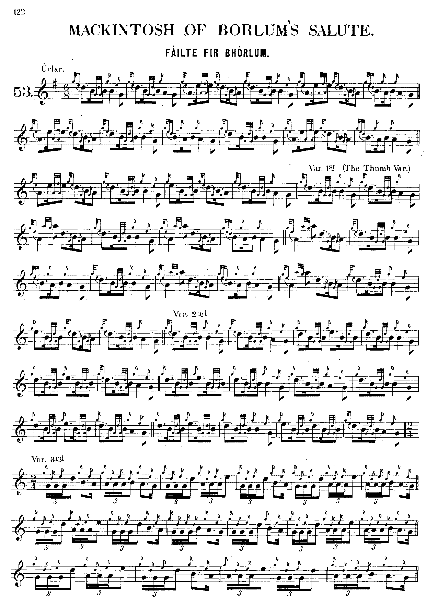

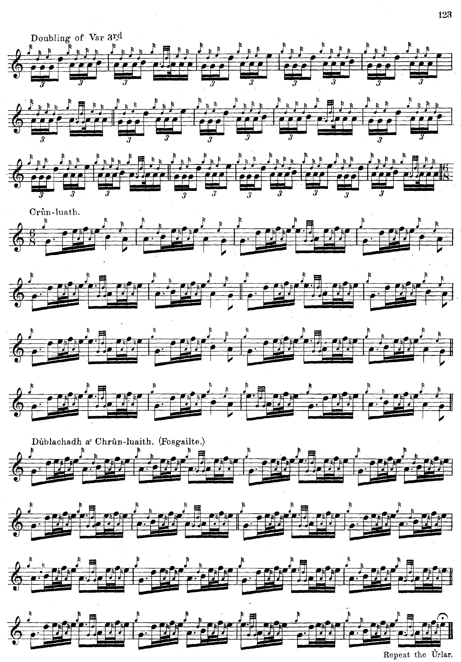

Glen does not stipulate that the ground be repeated at the end of the taorluath doubling, perhaps sensibly in view of the incremental nature of the ground, thumb, and second variation.

*Commentary:*

“McIntosh of Boreland’s Salute” is the earliest title. This sounds like a name heard rather than seen. There are a number of Borelands in Scotland but they are all in the south of the country. Angus MacKay’s title—translated--is simply “The Laird of Borlum’s Welcome”. It may be that the historicising tendencies that tended to gather around piobaireachd during the 19th century resulted in this tune becoming associated with the most famous representative of that title: Brigadier William Mackintosh of Borlum commonly known as *“Uilleam Dearg”* or “Old Borlum” (*c.*1657-1743). He was an interesting figure, a graduate of King’s College, Aberdeen (MA. 1677), professional soldier, agricultural improver, and long-time Jacobite agent. During the Rising of 1715 Borlum proved the most enterprising of the Jacobite commanders, launching a daring raid across the Forth and seizing the town of Leith. One contemporary described him as “a tall, raw-boned man, about sixty, fair-complexioned, beetle-browed, grey-eyed, speaking with a broad Scotch accent”. (Quoted in *ODNB* entry for William Mackintosh by David Horsburgh)

“MacIntosh of Borlum’s Salute” is in some respects simply an extended musical quotation, a version of “Black Donald’s March” transposed down a tone, at once recalling an earlier period of legendary heroism and suggesting that the old heroic days are not yet gone (although the invocation may be tempered by the suggestion that in these later times they may be available only at a lower key).

* * *

Electronic text © Dr. William Donaldson, Aberdeen, Scotland, 8th June 2012