MacGregor's Gathering/Salute

There are settings of this tune in the following manuscript sources:  
– **Peter Reid**'s MS, ff.7-8 (with the title “The Stuarts' Gathering”);

– **Robert Meldrum**'s MS, ff.9-11;

and in the following published sources:  
– **Angus MacKay**'s, *Ancient Piobaireachd,* pp.153-6;  
– **Donald MacPhee**'s, *Collection of Piobaireachd,* i, 30-1;

– **David Glen**'s, *Ancient Piobaireachd,* pp.89-90;  
– **C. S. Thomason**'s *Ceol Mor,* p.179.

**Peter Reid** sets the tune as follows:

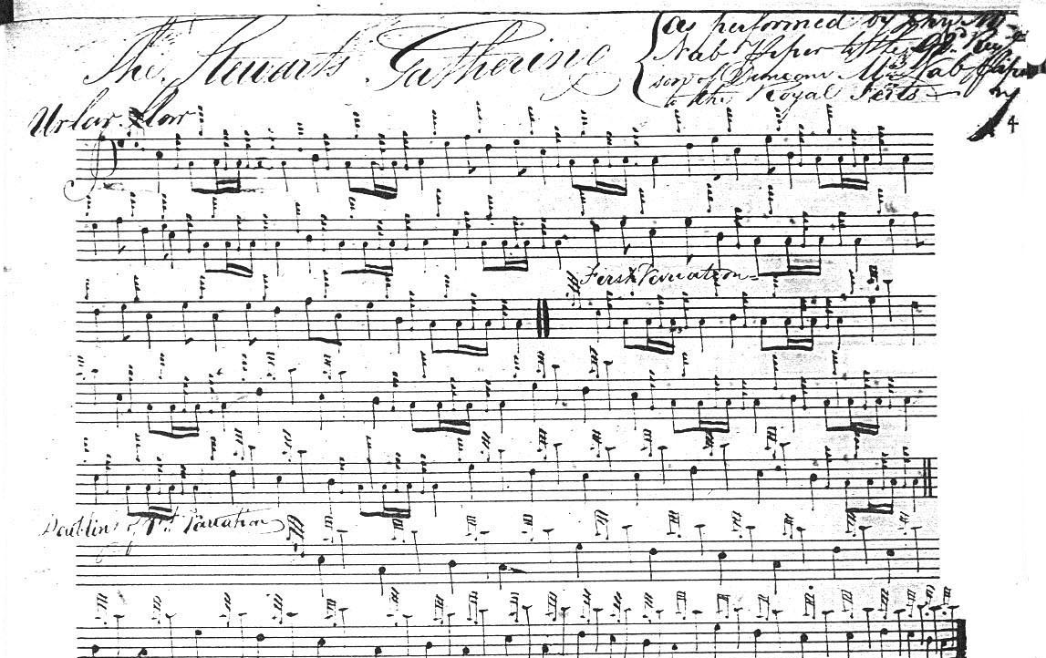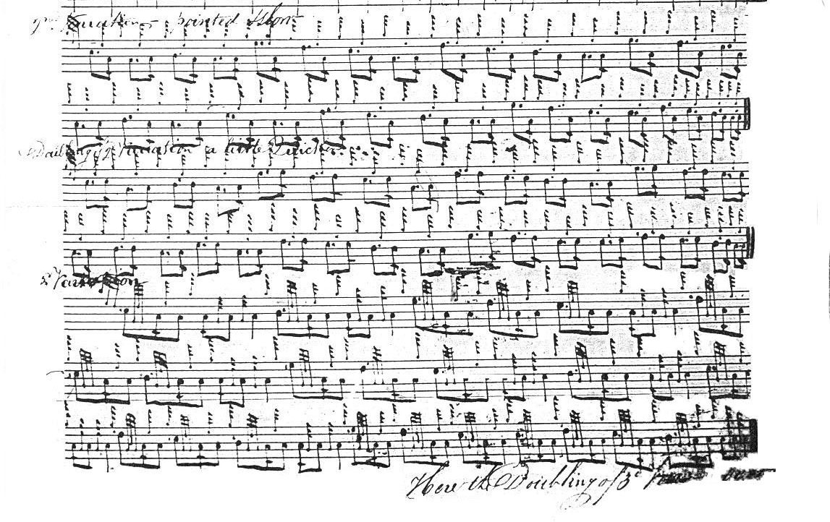

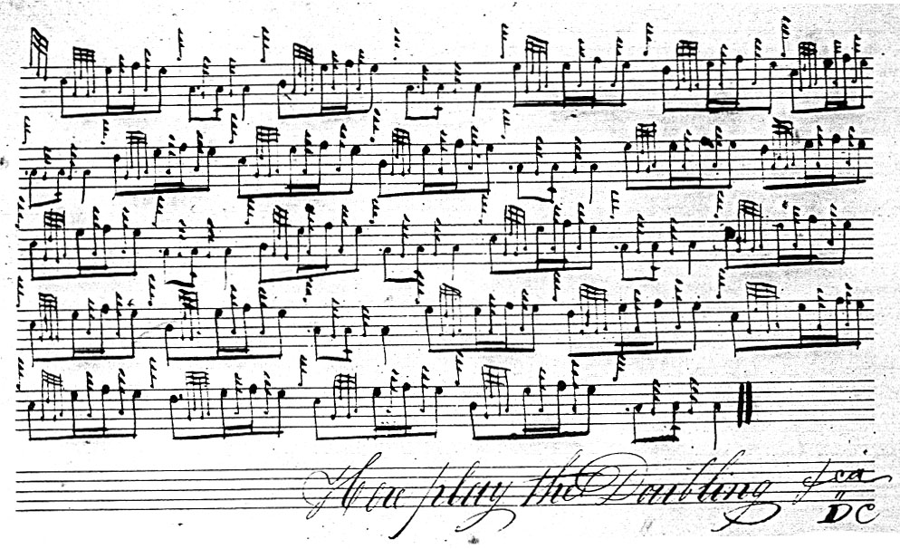

There is interesting reversal of the triplets on A as between the ground, where the initial note is a quaver in duration and the taorluath singling where it is cut, and reduced to a semi-quaver, and then back to the original pattern in the crunluath singling. It shows us the little tricks the old masters had for varying the beaten track and sustaining the musical tension and the interest of both player and audience. In addition the motif is carried right through the tune in the singlings unlike the other settings.

**Angus MacKay**'s setting is less well organised than Reid’s. In place of Reid’s simple and symmetrical development consisting of ground, thumb variation singling and doubling, siubhal variation singling and doubling, taorluath variation singling and doubling, crunluath singling and doubling; MacKay has three thumb variations, the first full of abrupt left-hand throws, and the third developing a tone row which is then discarded as a basis for the following variations. MacKay also has only a single taorluath and crunluath variation. In addition, MacKay's setting of the gairm/eallach triplets on A as even quavers gives no direct indication of how he intended them to be timed. “The MacGregor's Salute” is one of the handful of pieces in *Ancient Piobaireachd* to be set with a left-hand accompaniment for realisation on keyboard instruments. The others were “The Glen is Mine,” “MacIntosh's Lament” and “Prince Charles's Lament” and they were all obviously intended to have drawing-room appeal, particularly so in the case of this tune whose ground was used as the air for Sir Walter Scott's well known song, “The MacGregors' Gathering” (see Commentary below). MacKay sets the tune like this:

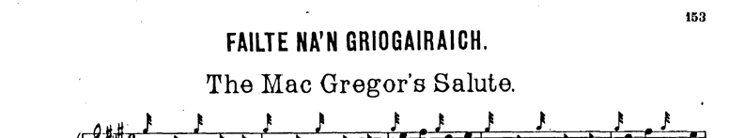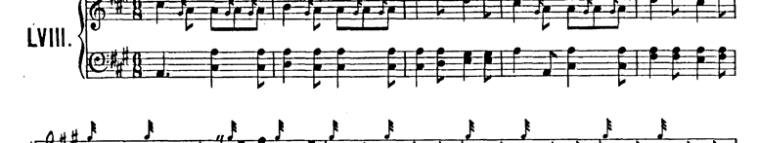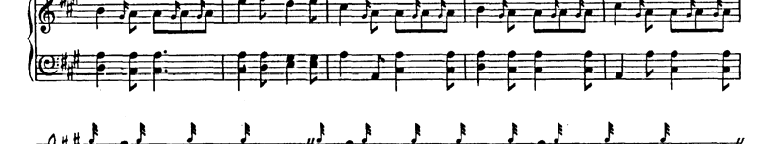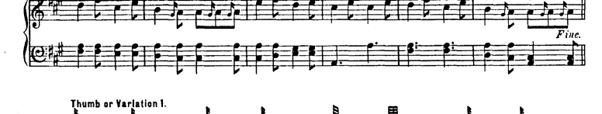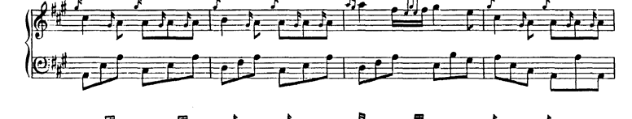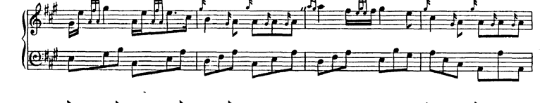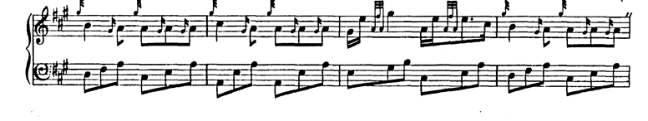

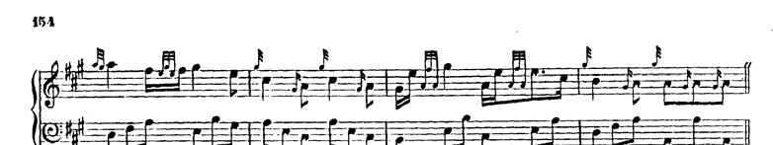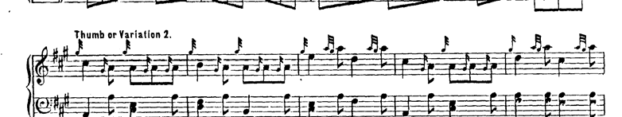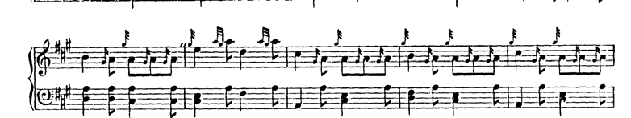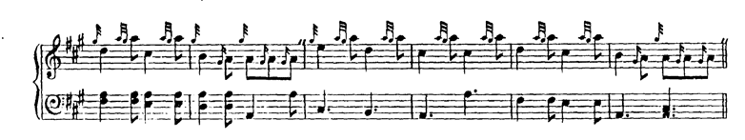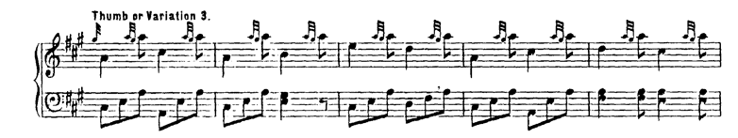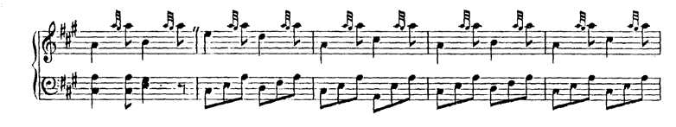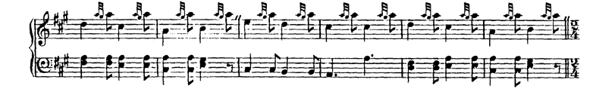

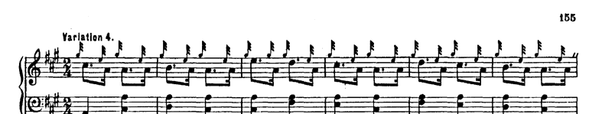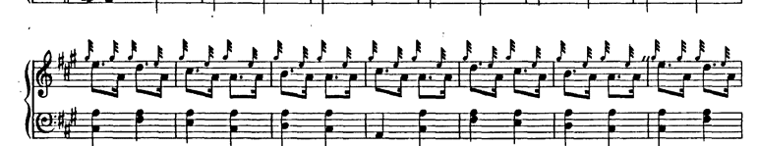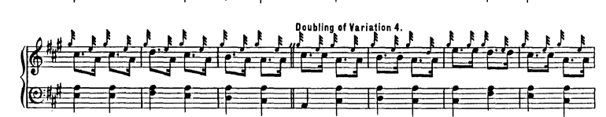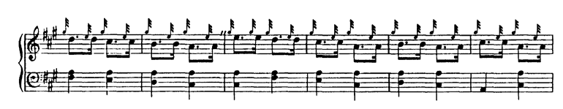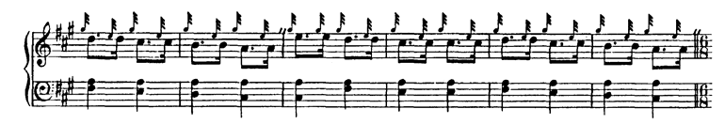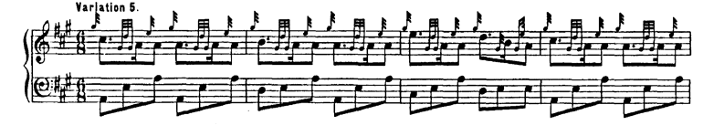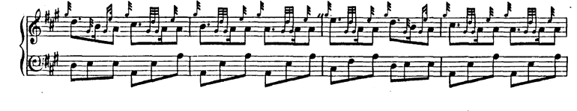

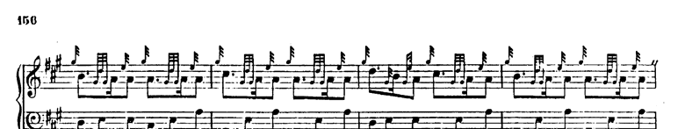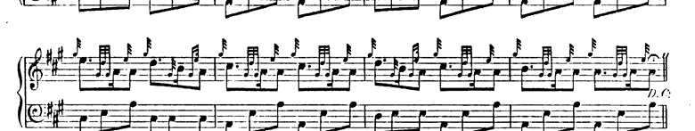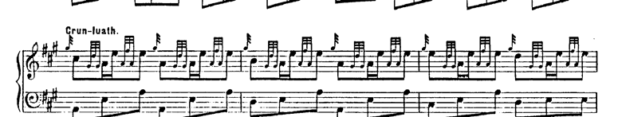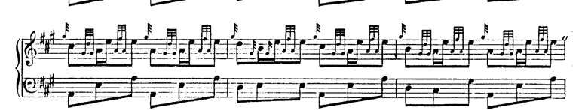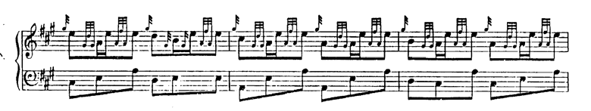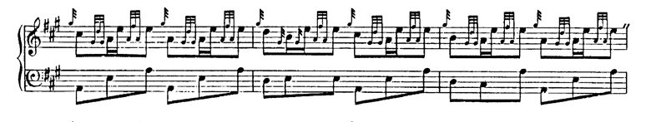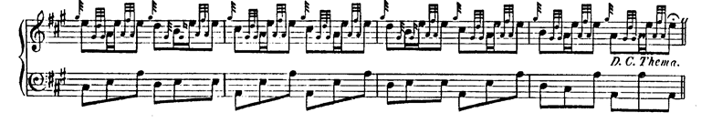

**Donald MacPhee** develops the tune on similar lines to MacKay. He does little other than tidy up MacKay's notation, making the gairm/eallach tripling rhythmically explicit, and sensibly re-jigging the tone row of the third thumb variation so that it leads to the pattern established in the later variations. MacPhee’s pattern is ground; thumb variations one, two and three; siubhal singling and doubling; taorluath; crunluath, repeat of ground. He sets the tune as follows:

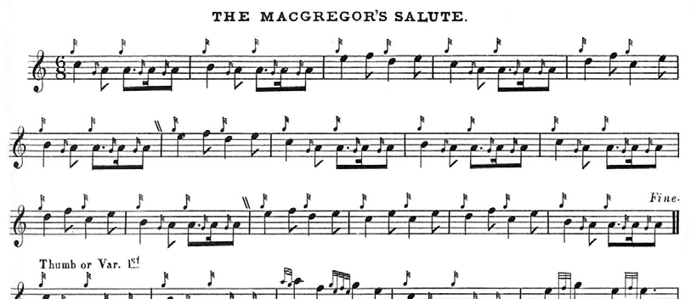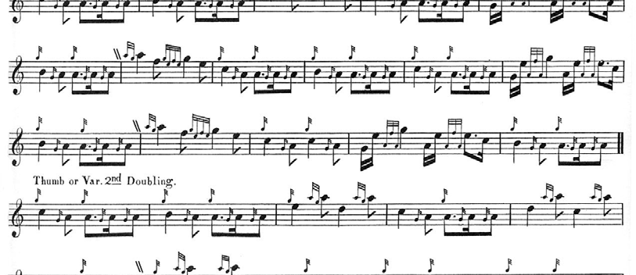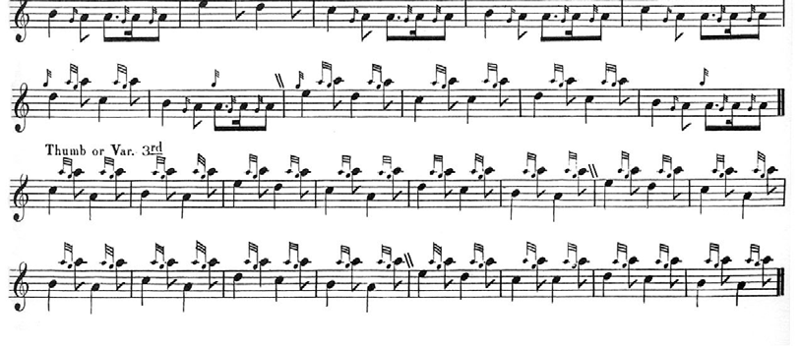

and so on.

**David Glen**'s setting is a notationally more sophisticated version of MacKay's score. It adds little to the stylistic possibilities of the tune and is not reproduced here.

**C. S. Thomason** calls the tune “MacGregor's Gathering” and although, rather unusually, he gives no source it is clear that he is broadly following MacKay. In addition there seems to be

a note error in his second thumb variation. Since it adds nothing to the stylistic possibilities of the tune, Thomason's score is not reproduced here.

**Robert Meldrum** broadly follows MacPhee, but his score is interesting in showing the Piobaireachd Society gairm/eallach beginning to affect older more idiomatic stylings in this tune. Meldrum begins like this:

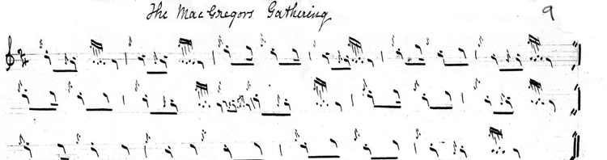

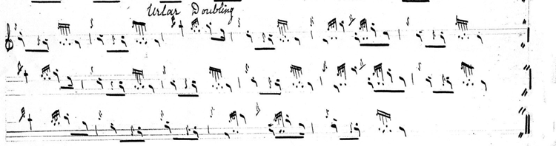

and so on. In a typical reflection of the mounting pressures to adhere to a single prescribed style, Meldrum adds a crunluath a mach.

*Commentary:*

When Alexander Campbell was sent by the Highland Society of Scotland to collect music and song in the Highlands, during the course of which he met Donald Roy MacCrimmon and Niel MacLeod of Gesto, the outcome was the publication in 1816 of his collection *Albyn's Anthology*. To this his patron, Sir Walter Scott, contributed three songs on Highland subjects set to piobaireachd melodies: “The MacGregors' Gathering,” “Pibroch of Donuil Dubh” and “Lament– (Cha till suinn tuille).” “The MacGregor's Gathering” is a typical example of Scott’s romantic susceptibility to the bloodier and more sensational aspects of Highland history, an evocation of the outlaw clan MacGregor, proscribed following their slaughter of the Colquhouns at the Rout of Glenfruin in 1603:

The moon's on the lake, and the mist’s on the brae,

And the Clan has a name that is nameless by day;

Then gather, gather, gather Grigalach!

Gather, gather, gather, etc.

Our signal for fight, that from monarchs we drew,

Must be heard but by night in our vengeful haloo!

Then haloo, Grigalach! haloo, Grigalach!

Haloo, haloo, haloo, Grigalach, etc.

Glen Orchy’s proud mountains,

Coalchuirn and her towers,

Glenstrae and Glenlyon no longer are ours;

We’re landless, landless, landless, Grigalach!

Landless, landless, landless, etc.

But doom’d and devoted by vassal and lord,

MacGregor has still both his heart and his sword!

Then courage, courage, courage, Grigalach!

Courage, courage, courage, etc.

If they rob us of name, and pursue us with beagles,  
Give their roofs to the flame, and their flesh to the eagles!

Then vengeance, vengeance, vengeance, Grigalach!

Vengeance, vengeance, vengeance, etc.

While there’s leaves in the forest, and foam on the river,

MacGregor, despite them, shall flourish for ever!

Come then, Grigalach, come then, Grigalach!

Come then, come then, come then, etc.

Through the depths of Loch Katrine the steed shall career,

O’er the peak of Ben-Lomond the galley shall steer,  
And the rocks of Craig Royston like icicles melt,  
Ere our wrongs be forgot, or our vengeance unfelt.

Then gather, gather, gather Grigalach!

Gather, gather, gather, etc.

***

Electronic text © Dr. William Donaldson, Aberdeen, Scotland, August 2006