MacFarlane’s Gathering

The main published source for this tune is C. S. Thomason’s Ceol Mor (p.131) where it first appeared in print, identified as “Leech of Glendaruel & Gillies’ Version” and “Set by Pipe Major Gillies after Piper Leech of Glendaruel”. The tune was recovered in 1894 by John MacDougall Gillies following an appeal by piping historian and Gaelic scholar Henry Whyte (“Fionn”) in the Oban Times. “Fionn” had encountered sung versions but had not seen the tune in any of the existing published collections of pipe music. Famous master players like Gillies, and Colin Cameron (both of whom contributed material to Thomason and Glen’s editions) tended to act as a magnet for unusual things, and a channel through which traditional material found its way into print. The setting published by Thomason is an interesting one with the parts pointed alternately ‘down’ and up’ (except for the crunluath variation). Since this is the earliest on record for this version of the tune, it seems likely to be the closest to the piece as Gillies got it:

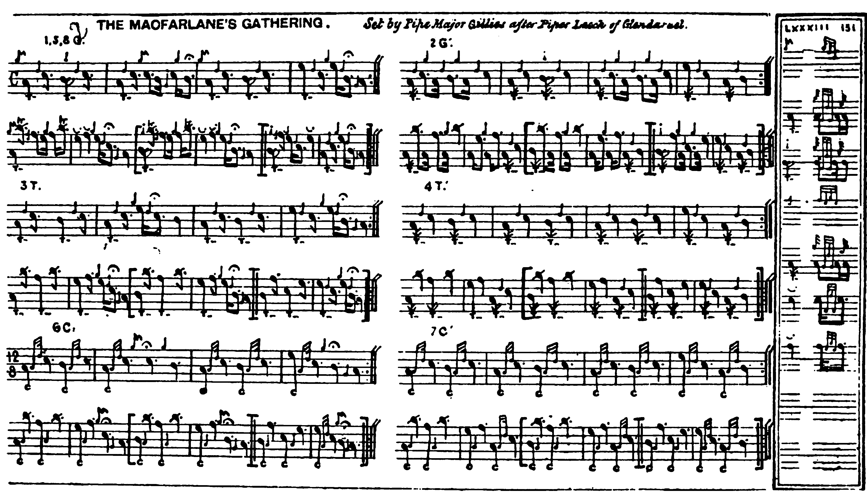

The Victorian recovery of “MacFarlane’s Gathering” from performance tradition obscured the fact of its preservation in scribal form in a source compiled a century before that time: Colin Mór Campbell’s “Nether Lorn Canntaireachd” which was then unknown. Further details of this version will be found in the file for “Too Long in this Condition”. There are two settings of Gillies’s version in manuscript, one in David Glen’s MS (ff.190-191), the other in Robert Meldrum’s (ff.85-6). Both are later than Thomason’s score and both seem clearly derived from printed versions, although as usual there are stylistic subtleties on display. For example, one notes Meldrum’s timing of the figure at the end of bar 2 of the ground as even quavers, and his playing of the crunluath breabach singling and doubling “up” as opposed to the “down” timing adopted by Gillies above. Glen’s score is marked “from Ceol Mor”, but he times the crunluath variations “up” as Meldrum does. As always, of course, this kind of thing is--in Glen’s phrase—"entirely at the pleasure of the performer” and governed by rhythmical context and melodic contour and not by fixed and inflexible rule.

Meldrum’s timings are as follows:

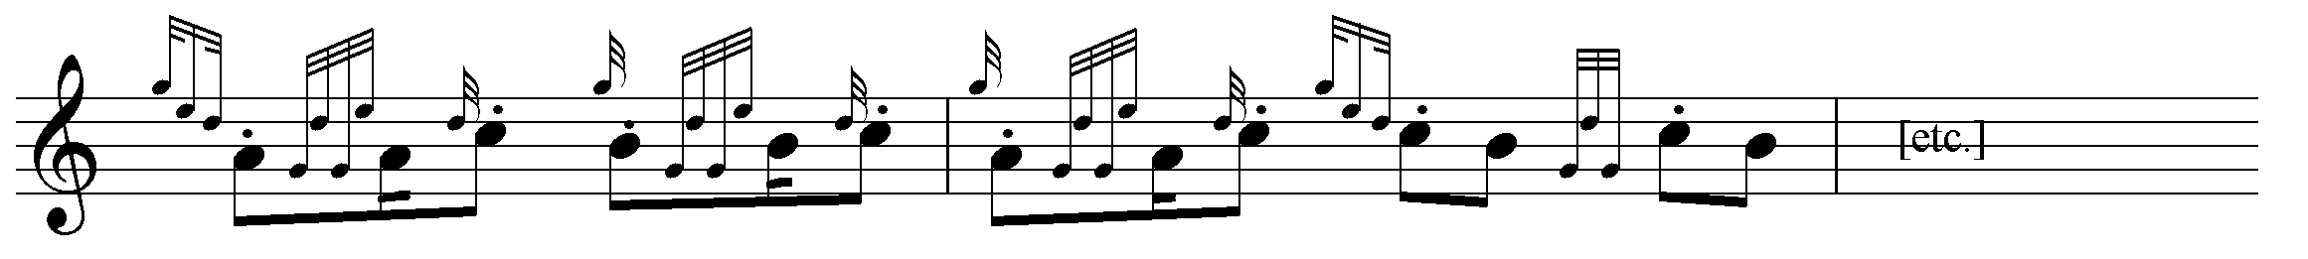



David Glen, noting melodic links with “Too Long in this Condition”, sets the tune as follows:
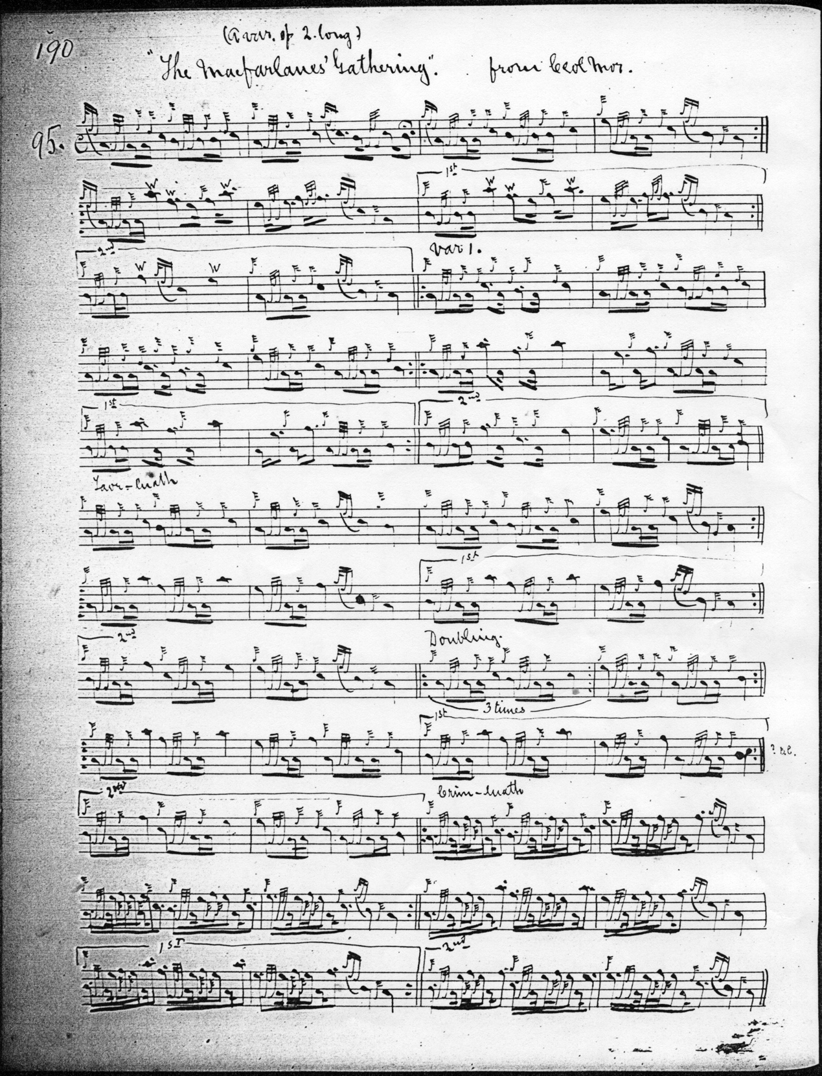

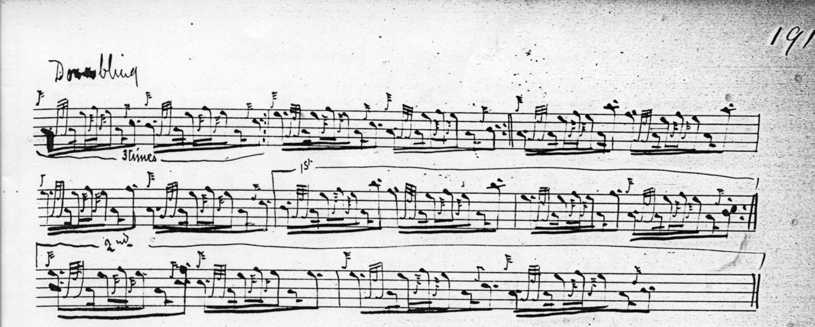

Commentary

“Fionn” noted in his “Celtic Scraps” column in the Oban Times (07/06/1890, p.3) in response to a correspondent requesting information on the Clan Macfarlane: “They are known in Gaelic as ‘Clann Pharlain.’ Their war-cry is ‘Lochslòigh’ (Lochsloy), and their ‘gathering’ or ‘cruinneachadh’ is ‘Togail nam bò.’ Sir Walter Scott in one of the notes to ‘Waverley’ has the following reference to this ‘gathering’:--'The Clan Macfarlane occupying the fastnesses on the western side of Lochlomond were great depredators on the low country, and as their excursions were made by night, the moon was proverbially called their lantern or buat. Their celebrated pibroch of ‘Hoggie nam bo,’ which is the name of their gathering tune, intimates similar practices, the sense being:-
We are bound to drive the bullocks,
All by hollows, hirsts and hillocks,
Through the sleet and through the rain.
When the moon is beaming low,
On frozen lakes and hills of snow,
Bold and heartily we go
And all for little gain.

I have been able [‘Fionn’ continues] to collect some of the Gaelic words of the ‘gathering,’ but I am sorry I cannot say whether the music is to be found in any collection of pipe-music. Perhaps some of our readers can say where the music is to be found.

TOGAIL NAM BO

Thogail nam bò,
Thogail nam bò,
Thogail nam bò théid sin; (repeat)
Thogail nam bò,
Ri uisge ’s ri ceò
Ri monadh Ghlinn-crò théid sinn.

Thogail nan creach,
Bhuala nan speech,
Thogail nan creach théid sinn;
Bhuala nan speach,
Thogail nan creach,
Bhuala nan speach théid sinn;
Thogail nam bò,
Ri uisge ’s ri ceò,
Ri monadh Ghlinn-crò théid sinn.

Thogail nan creach,
Thogail nan creach,
Thogail nan creach théid sinn,
Thogail nan creach,
Bhuala nan speach
Thogail nan creach théid sinn;
Thogail nam bò,
Ri uisge ’s ri ceò,
Ri monadh Ghlinn-crò théid sinn.

The badge of the clan is cloudberry – ‘Lus nam faidhreag.’ Cameron, in his interesting work, ‘Gaelic Names of Plants,’ has the following reference to this plant.
‘Rubus chamaemorus’ – Cloudberry. Gaelic ‘oireag’ variously written – ‘oighreag, foighreag, feireag.’ Irish ‘eirea’” (from ‘eireachd,’ beauty.)

‘Brac le feireagan is cruin dearg ceann’--MacIntyre. (Checkered with cloudberries with round red heads.) ‘The cloudberry is the most grateful fruit gathered by the Scotch Highlanders’(Neill). The badge of Clan MacFarlane.’ I believe there are at least two septs of the clan – one being known as ‘Sliochd an eich bhric,’ but I cannot give the history. Perhaps some one will oblige…”

* * *

Electronic text © Dr. William Donaldson, Aberdeen, Scotland, November 2002; revised Cambridge, Massachusetts, February 2025.

