The MacDonalds are Simple
There are settings of this tune in the following manuscript sources:
--Colin Mór Campbell’s “Nether Lorn Canntaireachd”, ii, 42-5 (with the title “Clandonniel Sochaach”);
--Angus MacKay’s MS, ii, 103-4 (and in the so-called “Kintarbert MS”, ff.45-6);
--Colin Cameron’s MS, ff.136-7;
--Duncan Campbell of Foss’s MS, ff.52-4;
--Uilleam Ross’s MS, ff.128-9;
--D. S. MacDonald’s MS, ii, 68-9;
--John MacDougall Gillies’s MS, ff.13-14;
--David Glen’s MS, ff.47-9;

and in the following published source:
--C. S. Thomason, Ceol Mor, p.338.

This tune is widely diffused in the scribal record, but interestingly less so in the published one, although many Victorian master pipers seem to have thought it worthwhile to record this tune.

Colin Campbell sets the piece like this:

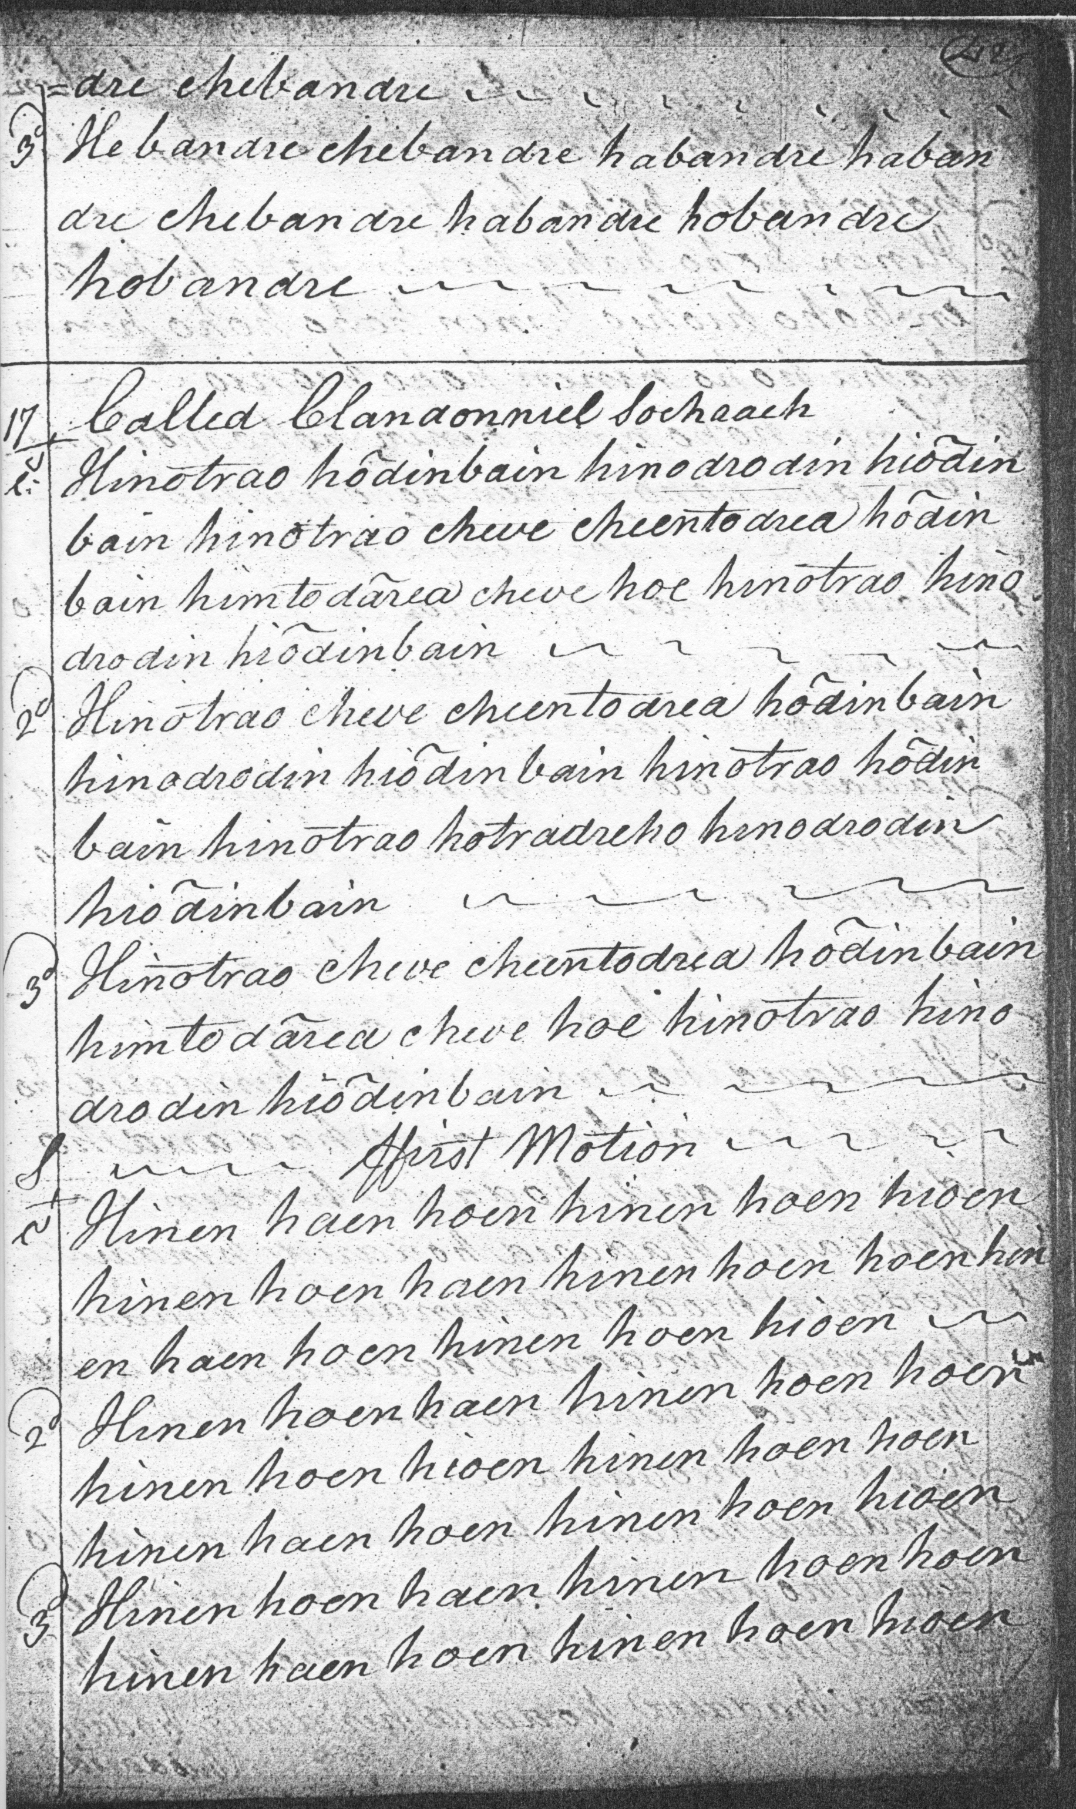
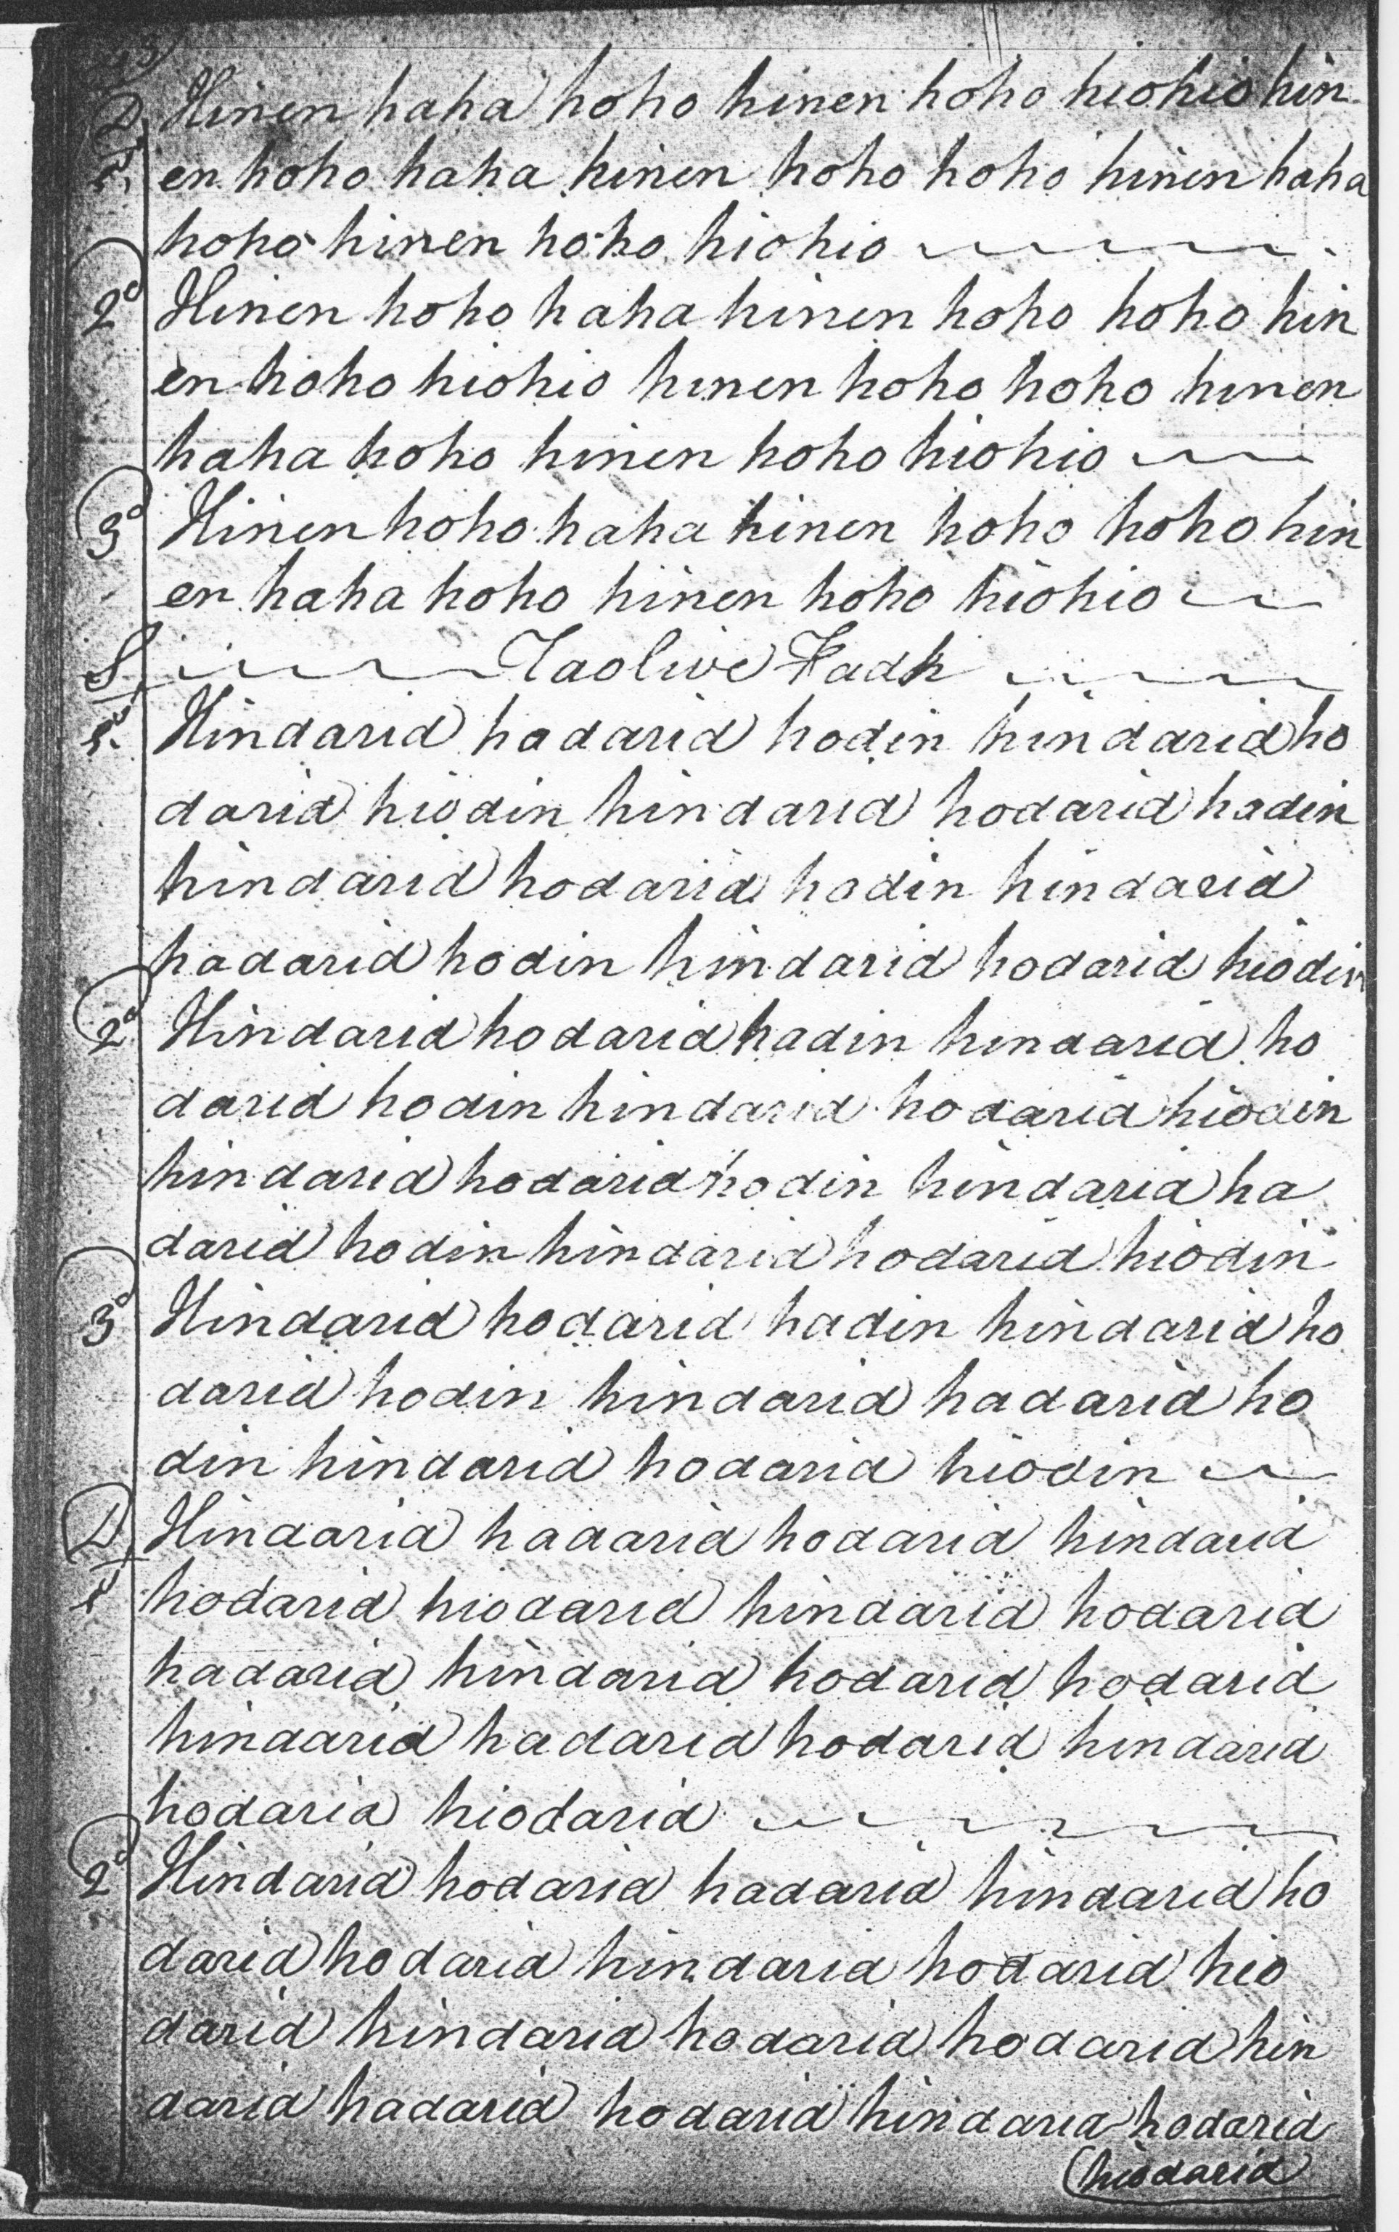
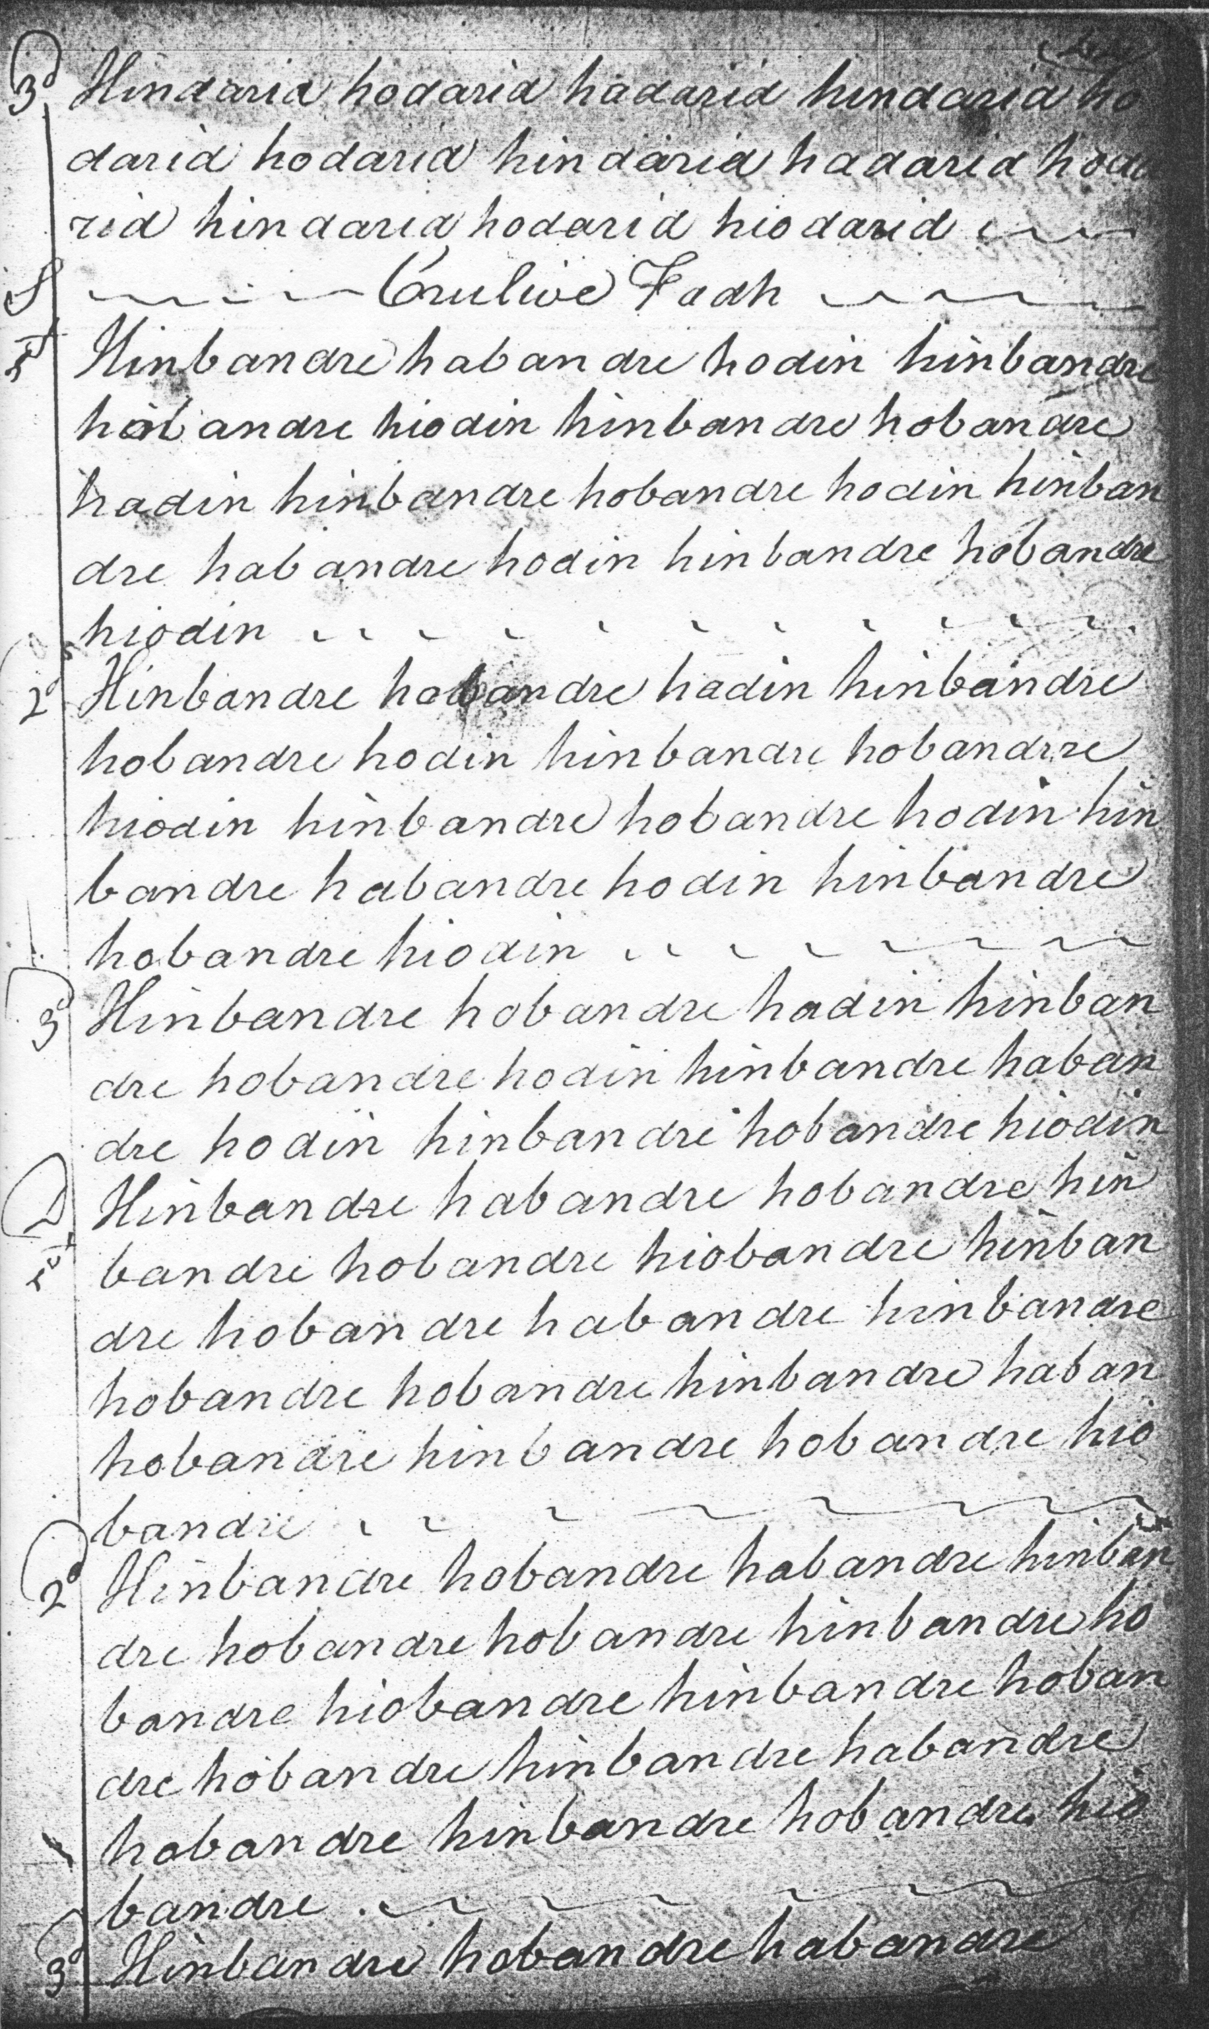
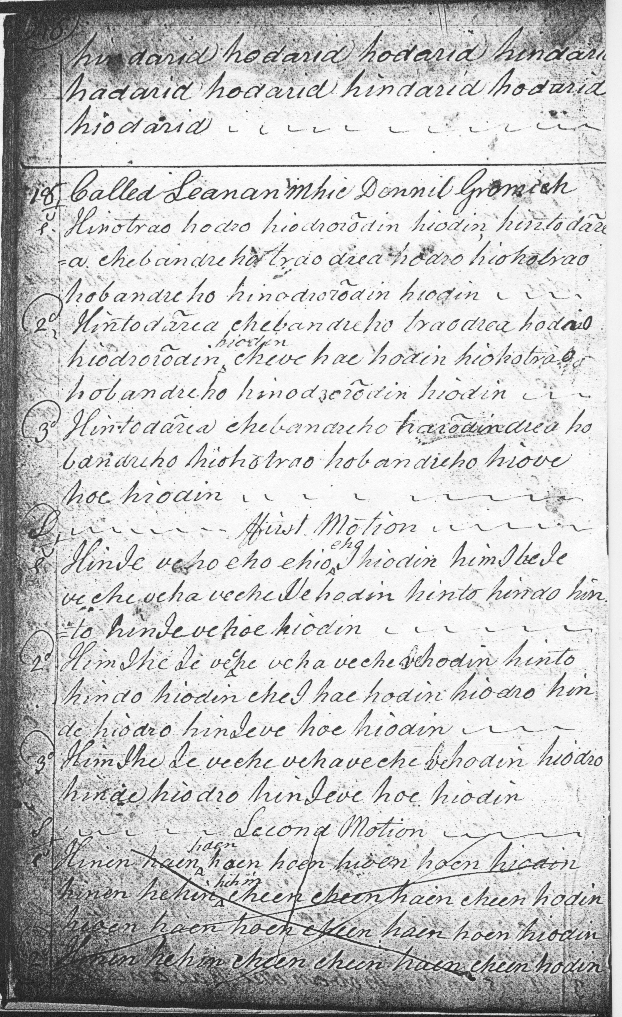

The reader will note the seemingly redundant syllable “hinotrao” towards the end of the first line of the ground, and again in bar four of line three. The variations are extremely regular and do not reflect this expression, so this could be a deliberate exaggeration, a satirical indication of the gullible “socharach” qualities imputed to the MacDonalds. It may be worth noting too that in the third bar of line one the melodic line descends to low A rather than low G, and that the tune does not go down to low G at all in the variations. Notable too is the absence of the pendulum movement we see in some of the later scores. Colin Campbell organises the piece as follows:

ground;
siubhal, singling and doubling;
taorluath duinte, singling and doubling;
crunluath duinte, singling and doubling.

Colin Campbell’s treatment of the cadences in the taorluath and crunluath variations have an appealing simplicity and well sustain the rocking forward momentum of what is evidently intended to be quite a fast tune.
In the final line of the crunluath doubling, the compiler has reverted to the taorluath (rather than crunluath) vocables when he moved to a new page.

Angus MacKay sets the tune like this: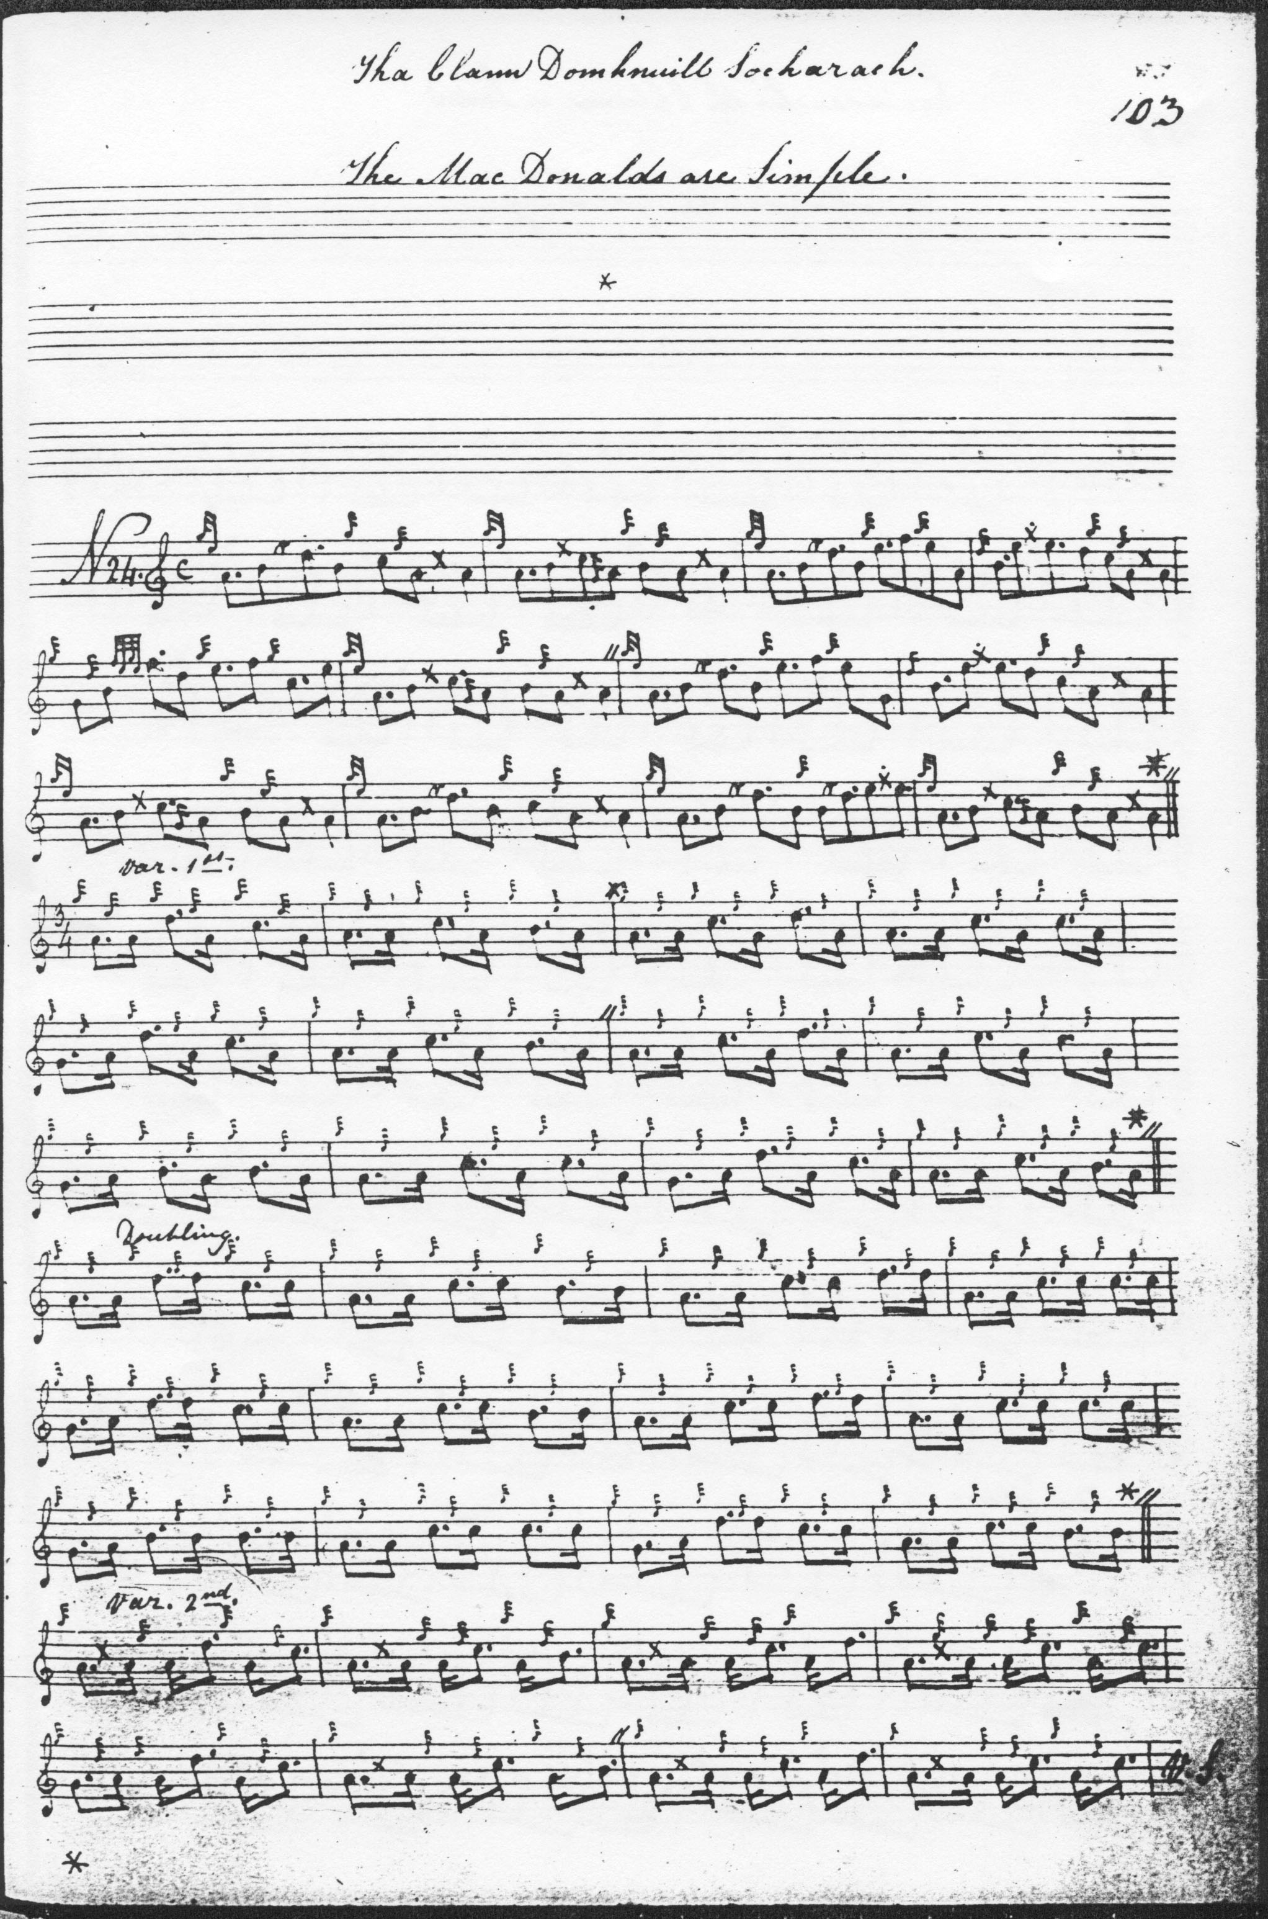
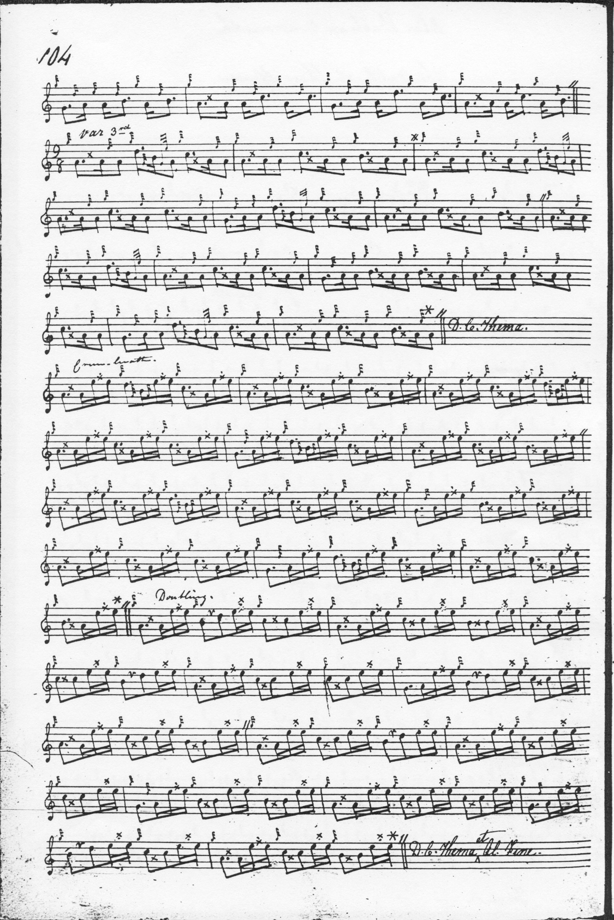
MacKay seems to have missed the repeat mark for the third line of the ground (which should have been inserted at the beginning of bar three of the first line), but the intention is clear from the later parts of this most regular tune. MacKay’s pleasing introduction of low G into his variations arguably gives him a more subtle tension than Colin Campbell’s tonally “squarer” approach. In addition he includes a pendulum movement absent in the Campbell score, answered by the taorluath doubling movement which follows. MacKay concludes the tune with a crunluath and a mach. He stipulates that the ground be repeated at the end of the taorluath and crunluath, and he drops the “redundant” phrase we see in lines one and three of Colin Campbell’s ground. Many may feel that of the two settings, MacKay’s is musically the more interesting.

Colin Cameron’s score is a rough transcript from Angus MacKay’s, only partially graced. It seems to add little to the expressive possibilities of the tune and is not reproduced here; however a complete score is available from a Cameron pupil, John MacDougall Gillies, and it is reproduced below to show how the tune was handled in the tradition that came down through the Cameron family. Uilleam Ross’s score, likewise seems a simple tidying-up of MacKay, and does not take a distinctive route through the tune: it is not reproduced here. D. S. MacDonald’s score is roughed out in outline only and is not reproduced here.

Duncan Campbell of Foss has one or two individual touches in the ground as follows:

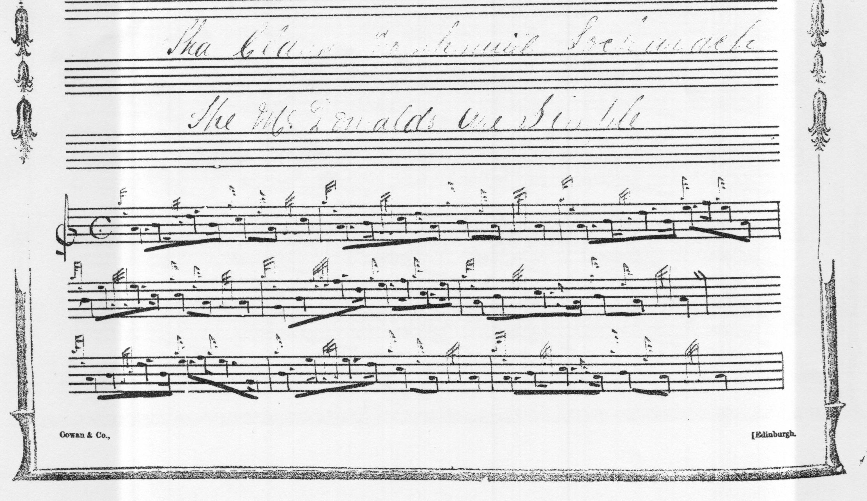
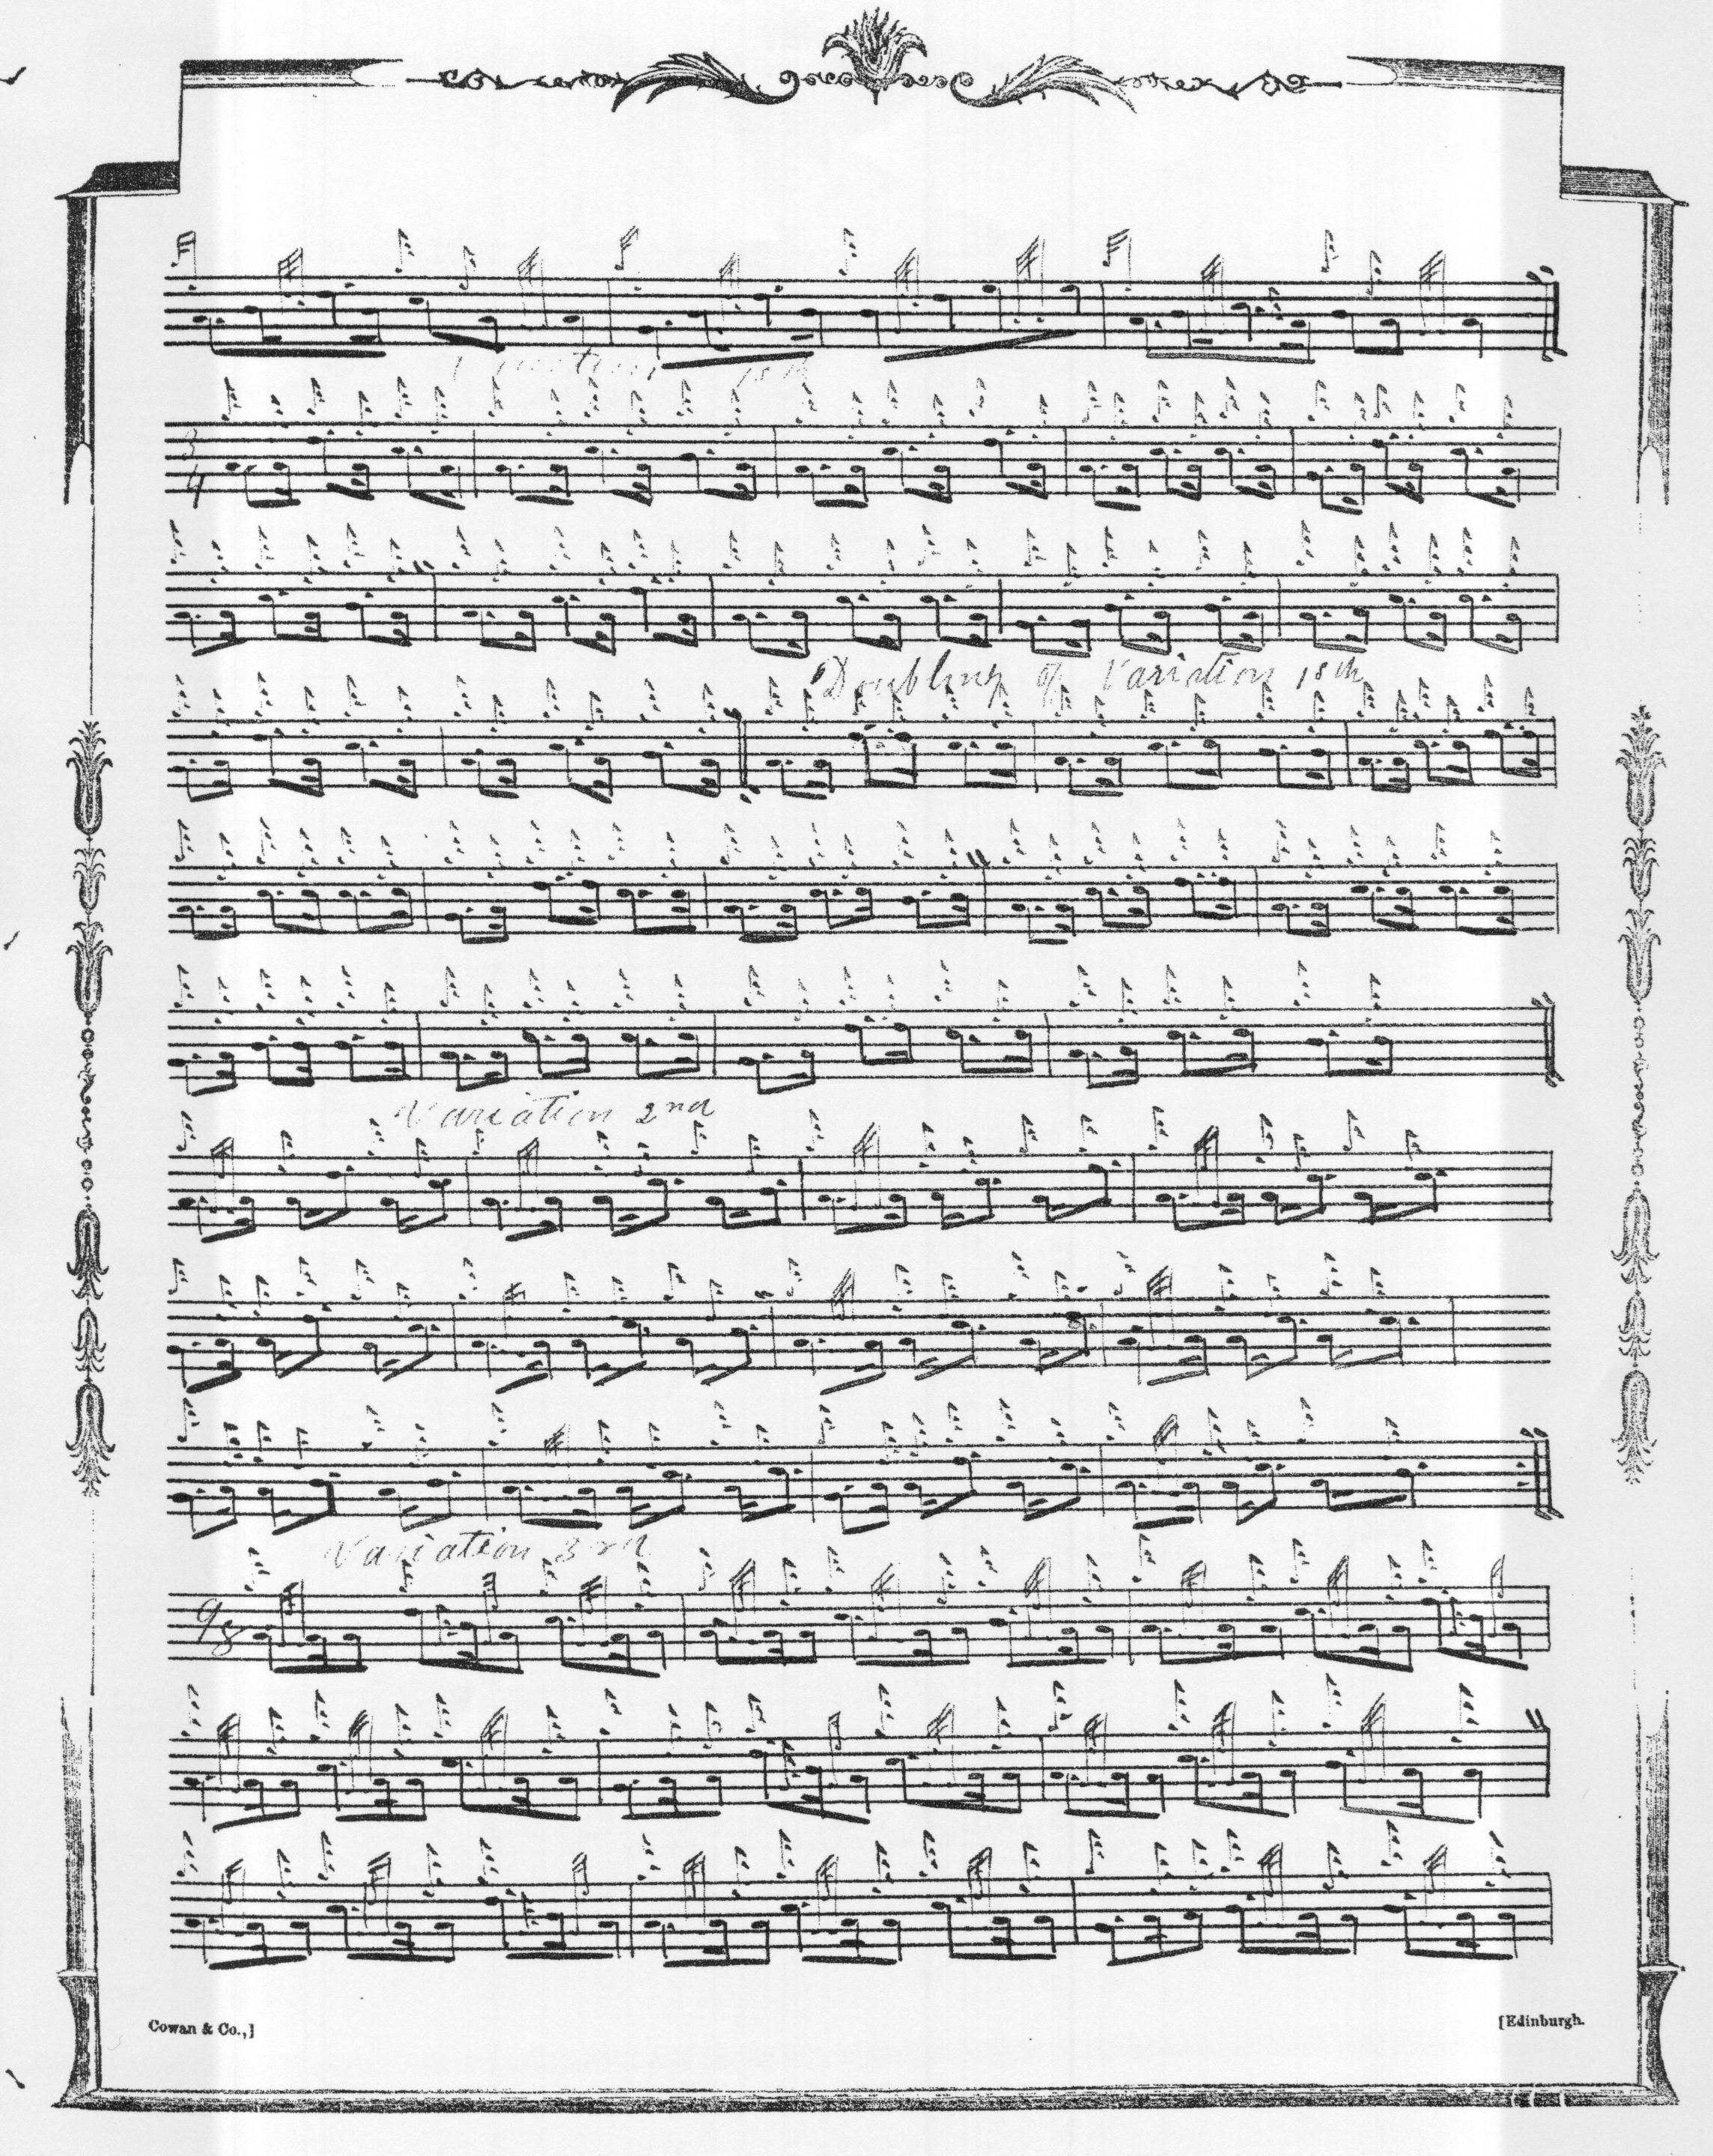

and so on. Duncan Campbell follows MacKay rather closely, but we might note the way the opening motif ends on C (rather than A), attractive additional E cadence at the beginning of bar 4 of his ground, and the drop down to low G at the beginning of bar eleven.

John MacDougall Gillies sets the tune as follows. We might note his interesting even timing of the pendulum movement which is abruptly “up” cut in both MacKay and Colin Cameron:
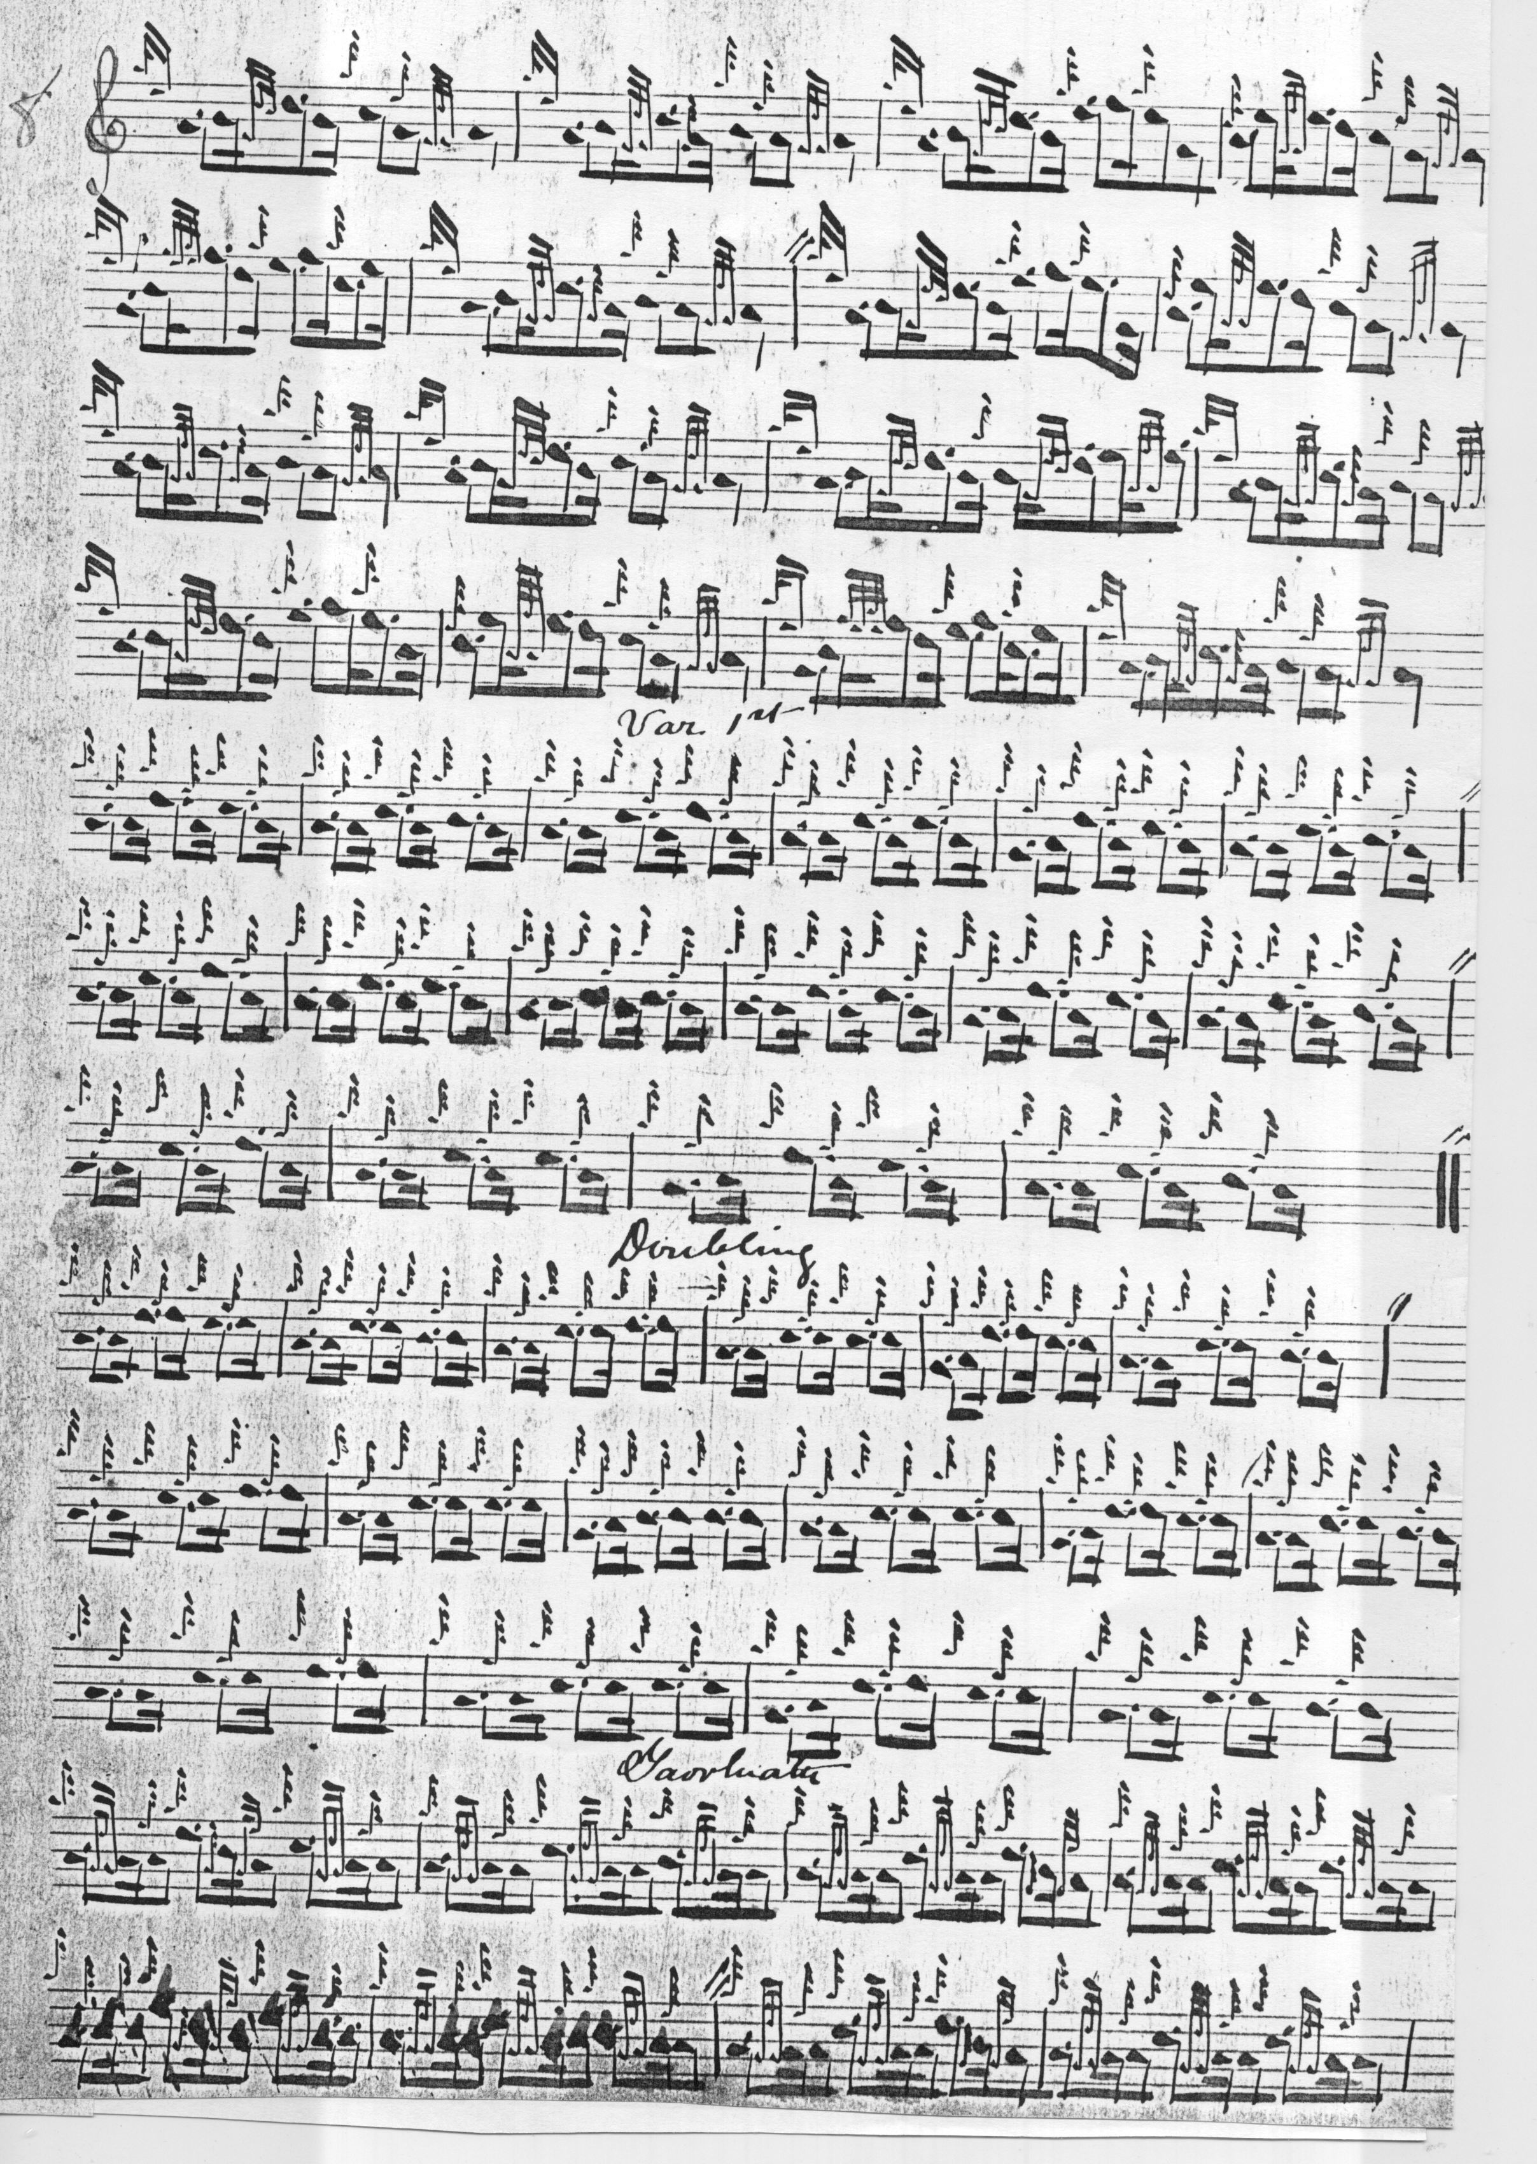

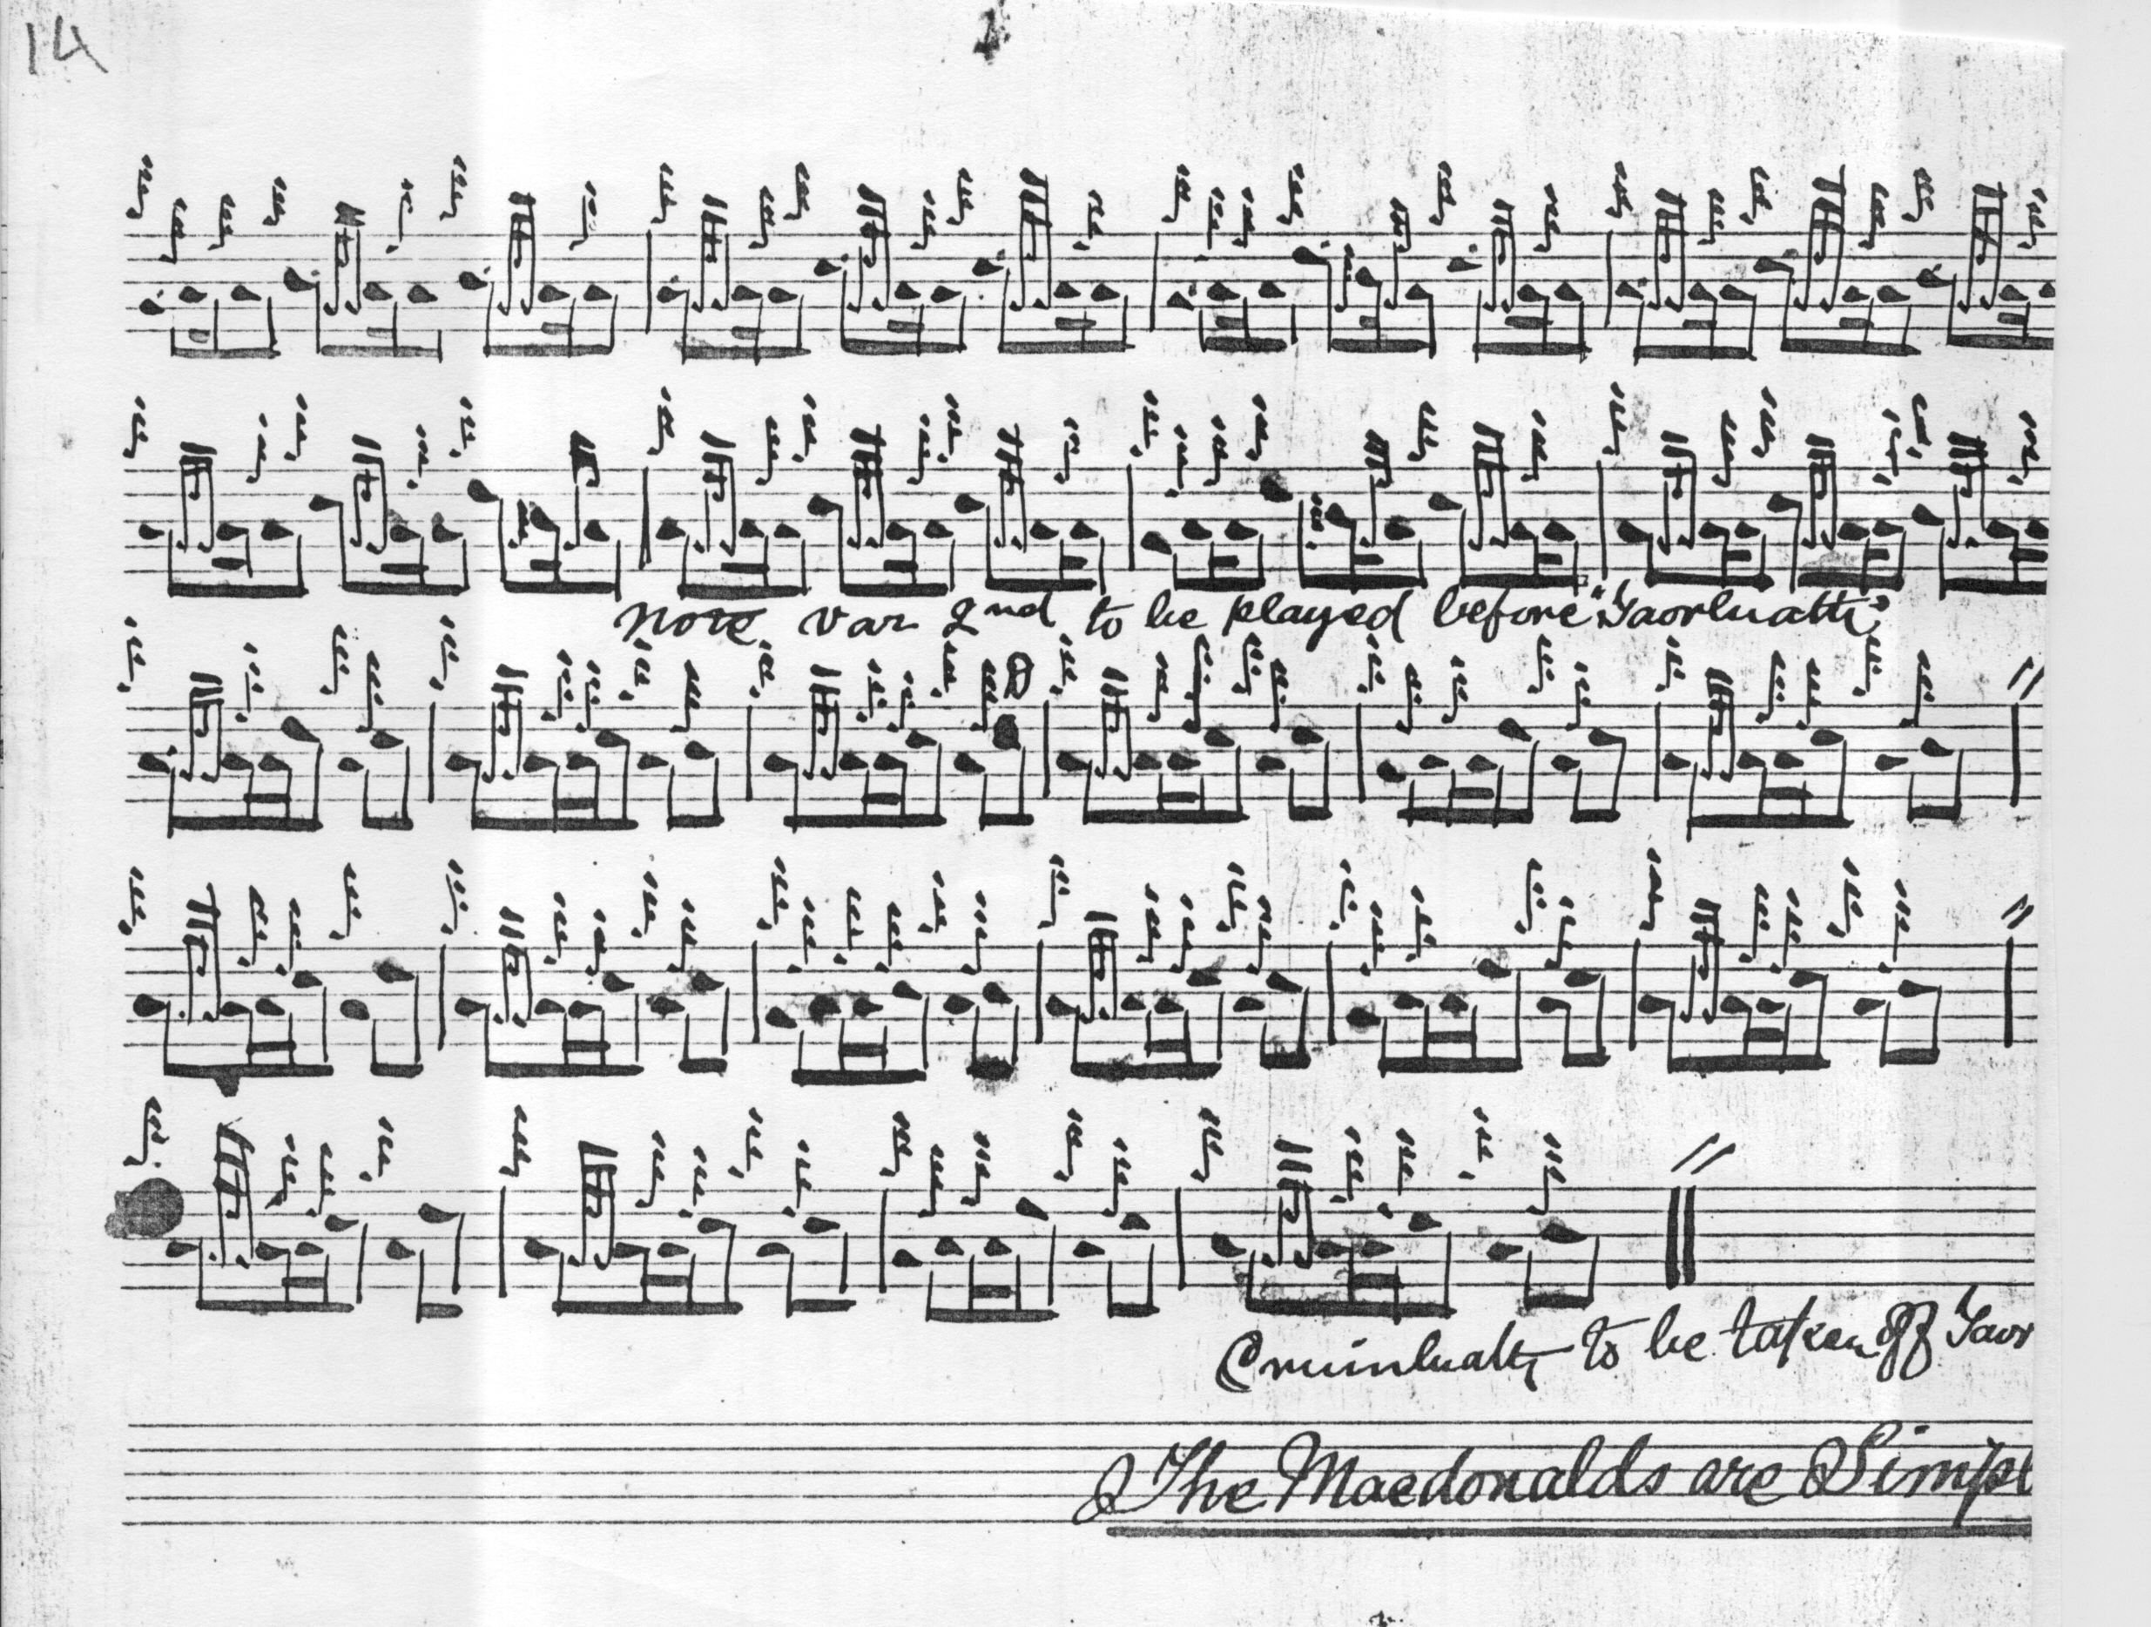

David Glen dots and cuts more meticulously and carefully, also supplying Angus MacKay’s missing repeat marks; we note, too, how he highlights the F’s in the end phrases of the variations, and his addition of a taorluath a mach to better balance the later sections:
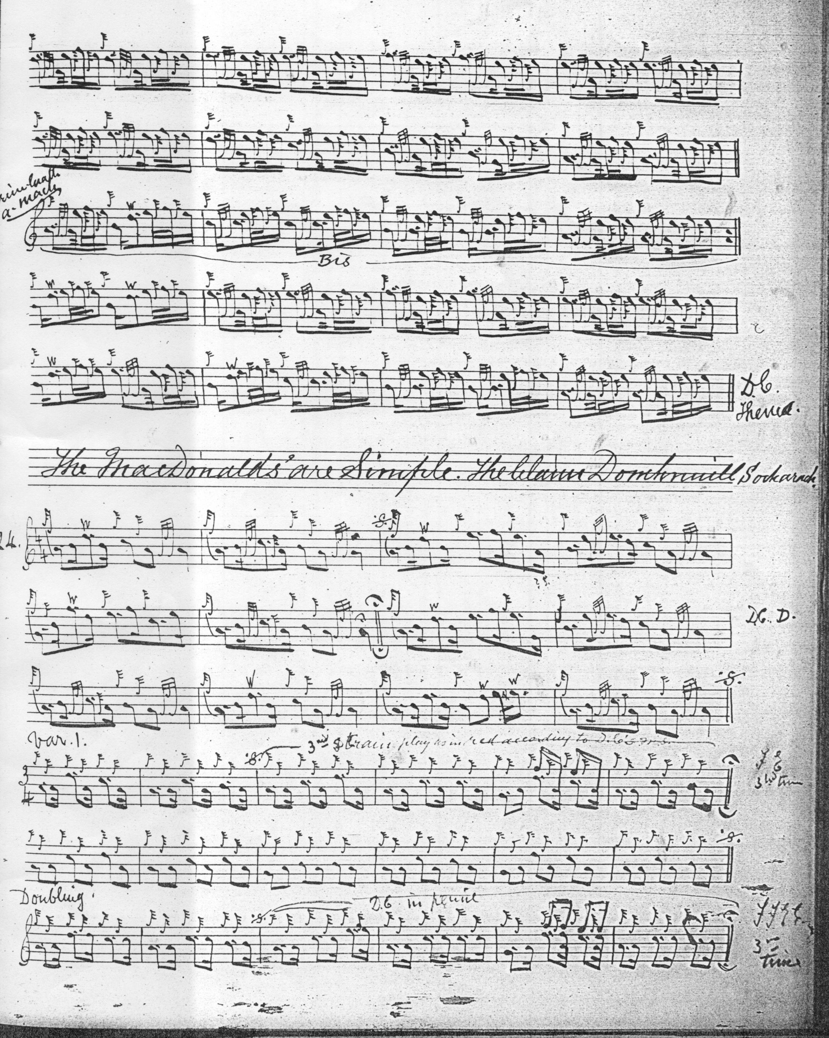

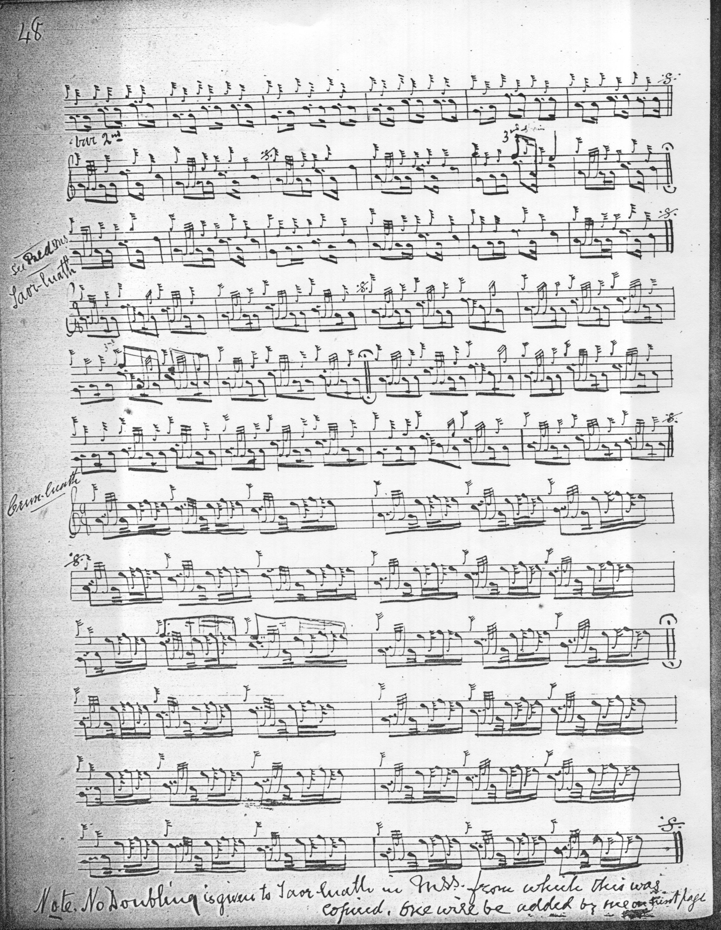

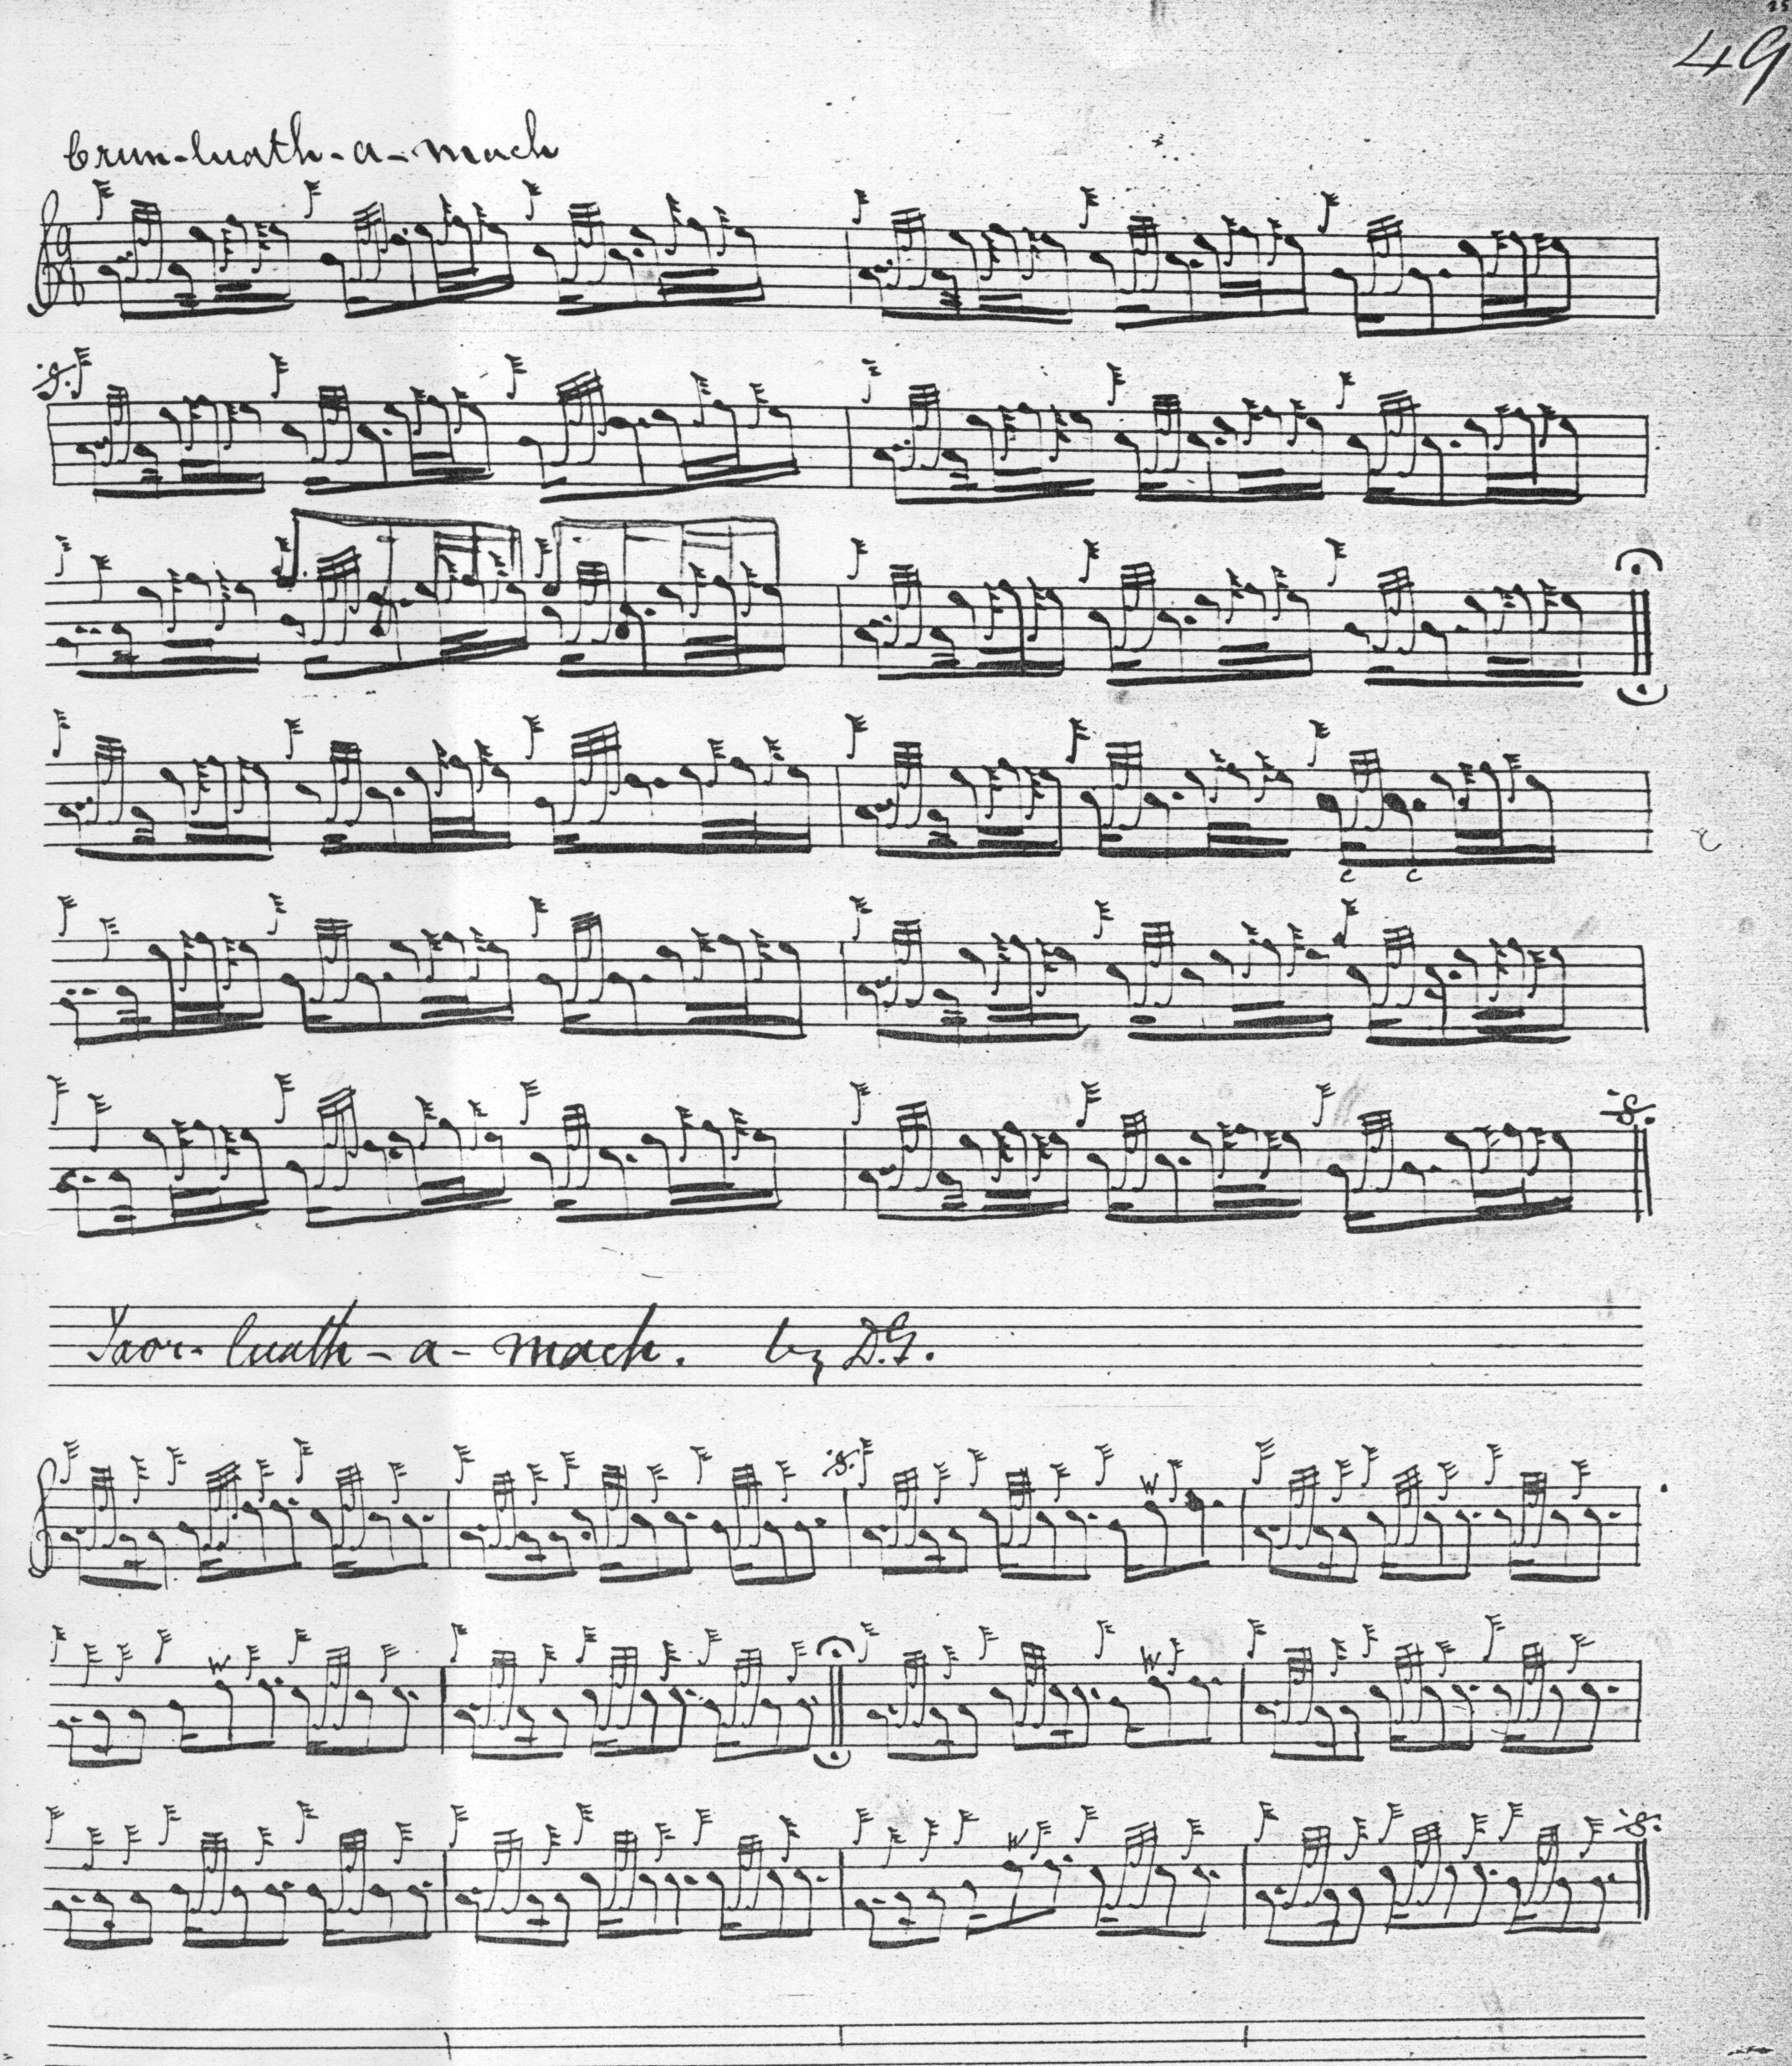

Commentary:

Little is known of the historic background for this tune, but it has clear stylistic links with “The Blind Piper’s Obstinacy”, and recalls also the repeated down-cut figures in “The Hens March o’er the Midden” (Thomason, Ceol Mor, p.252) another tune with satiric, or comic implications.

* * *

Electronic text © Dr William Donaldson, Cambridge, Massachusetts, 21 May 2013; revised February 2025.

