MacCrimmon’s Sweetheart
Manuscripts
This is a widely disseminated tune.
There are MS settings in
--Colin Mór Campbell’s “Nether Lorn Canntaireachd” i, 162-4, (with the title “Vuail Doan” [“Voal Doan” in the index];
--Peter Reid’s MS, f.42 (with the title “Mhaol Donn Morar’s March”);
--Angus MacKay’s MS, i, 134- 6 (with the title “Cumha Mhuil Duin Suposed to be a Lament for Muil Duin Son of Conol King of Cantyre”);
--Colin Cameron’s MS, ff.86-7 (with the title “MacCrimmon’s Sweetheart. Gaelic, A Mhuil Duin”). There are settings also in Donald MacKay (the younger’s) MS (ff.16-17), in C. S. Thomason’s MSS (f.26), and in the MS book of John MacDougall Gillies (ff.50-1), with an additional copy in “A Selection of Piobaireachd Supplied by Pipe -Major John MacDougall Gillies to his pupil George Wilkie of Dundee, 1920-21” in the Wighton Collection at Dundee City Library).
And in the following published settings:
The earliest published setting is in William Ross’s Collection (pp.77-9). Amongst pre-Great War sources there are settings also in C. S. Thomason’s Ceol Mor (p.208), in David Glen, who prints two versions in Ancient Piobaireachd, (pp. 98-9; 164-6), which latter has echoes of Reid’s setting, but is unlike anything else in the written record, and in Lt. John McLennan’s The Piobaireachd as MacCrimmon Played it (p.2).
The MS and published settings are broadly similar in their development of the tune, the chief difference lying in whether the thumb variation is doubled or not.
The tune as it has come down to us may be a composite. The siubhal, taorluath and crunluath variations in all the surviving sources are listed as a separate tune with the title “The Battle of the Red Hill” in the MacArthur/MacGregor (ff.24-5) and in Angus MacKay’s MS (i, 11-12), as “The Black Plaid” in Colin Cameron’s MS (f.53), and as “Men of the Black Tartan” in David Glen’s MS (ff.314-315).
Colin Mór Campbell treats “MacCrimmon’s Sweetheart” as follows:
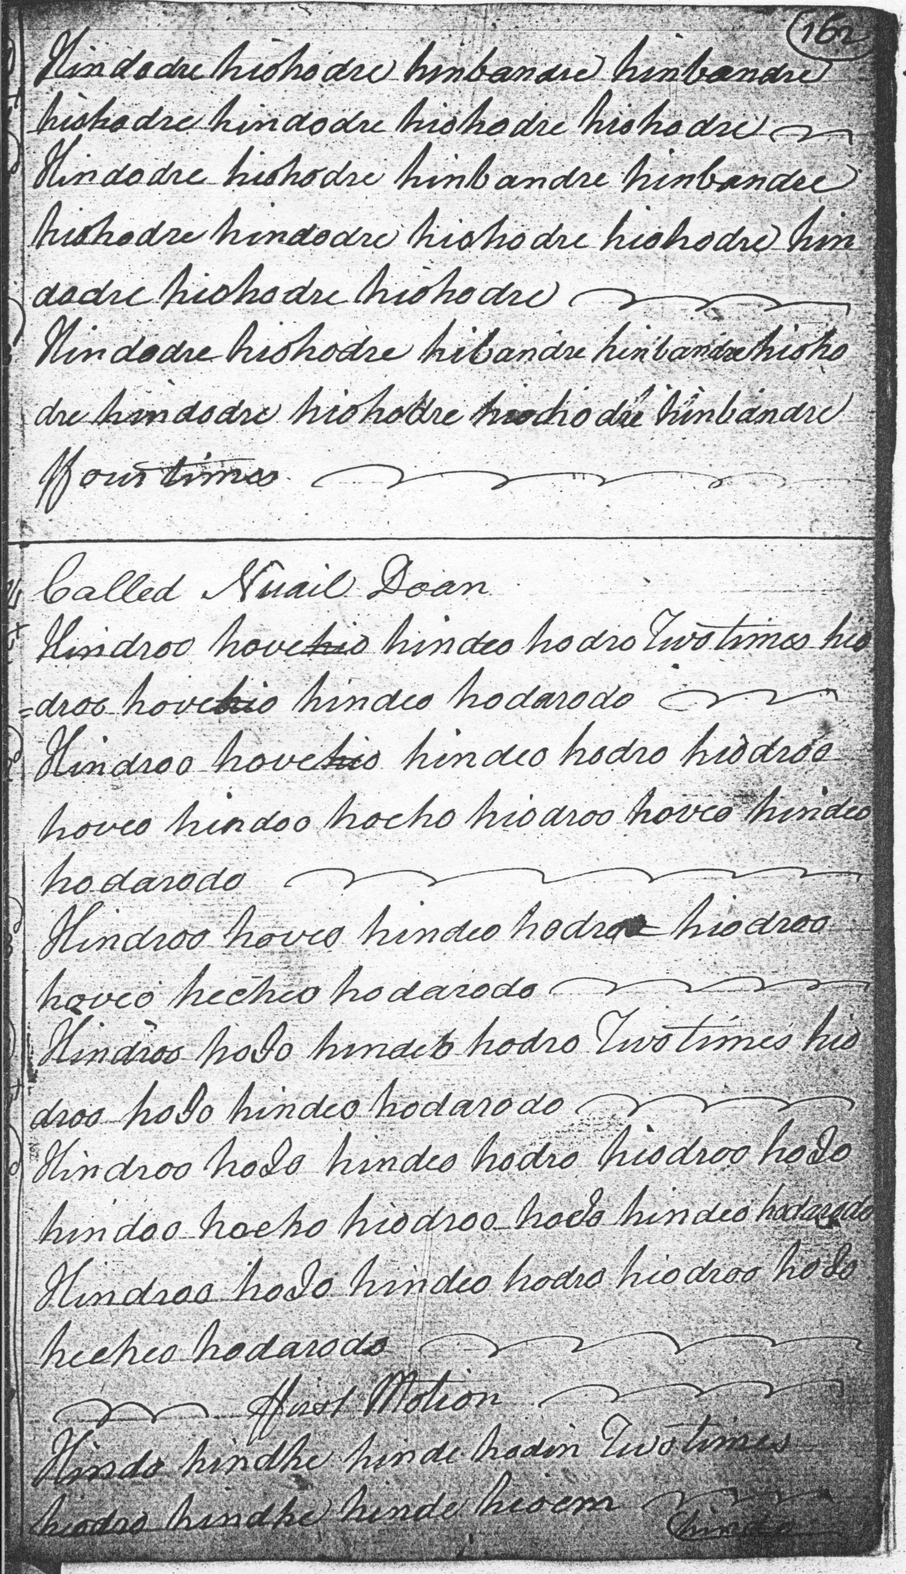
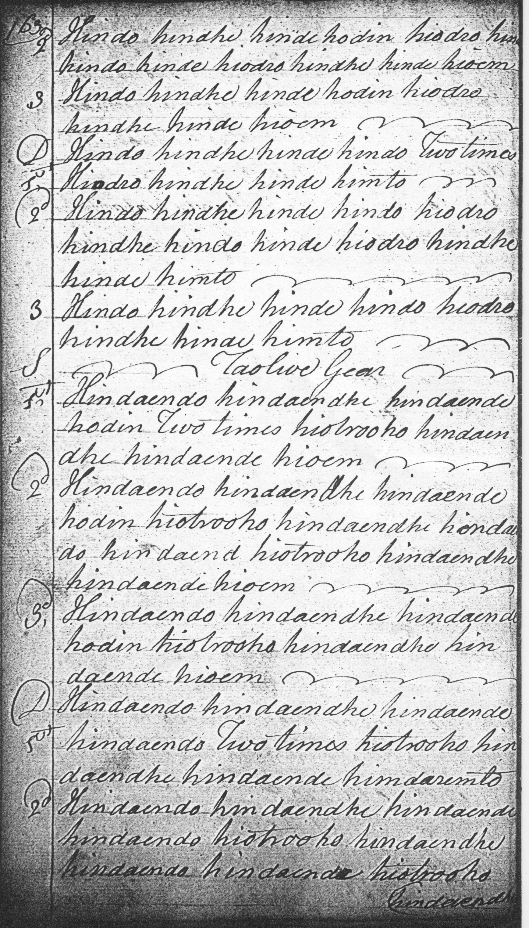
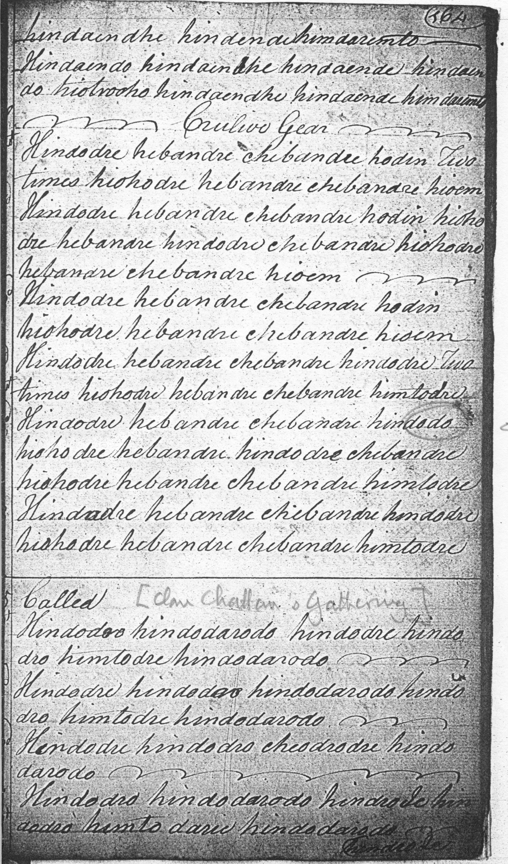

Called Vuail Doan
Hindroo hovehio hindeo hodro Two times hiodroo hovehio hindeo hodarodo
Hindroo hovehio hindeo hodro hiodroo hoveo hindoo hoeho hiodroo hoveo hindeo hodarodo
Hindroo hoveo hindeo hodro hiodroo hoveo hecheo hodarodo
Hindroo hoIo hindeo hodro Two times hiodroo hoIo hindeo hodarodo [etc] f
first Motion
Hindo hindhe hinde hodin Two times hiodro hindhe hinde hioem
Hindo hindhe hinde hodin hiodro hindhe hindo hinde hiodro hindhe hinde hioem
Hindo hindhe hinde hodin hiodro hindhe hinde hioem
Hindo hindhe hinde hindo Two times hiodro hindhe hinde himto [etc]
Taolive Gear
Hindaendo hindaendhe hindaende hodin Two times hiotrooho hindaendhe hindaende hioem [etc]

Hindaendo hindaendhe hindaende hindaendo Two times hiotrooho hindaendhe hindaende himdaremto [etc]

Crulive Gear
Hindodre hebandre chebandre hodin Two times hiohodre hebandre chebandre hioem [etc]

Hindodre hebandre chebandre hindodre Two times hiohodre hebandre chebandre himtodre [etc]

Peter Reid’s setting is only partially graced (although the musical intention seems broadly clear), and the variations continue through to a taorluath fosgailte singling, ending with the words, “Then the Doubling then Creanluidh DC”:
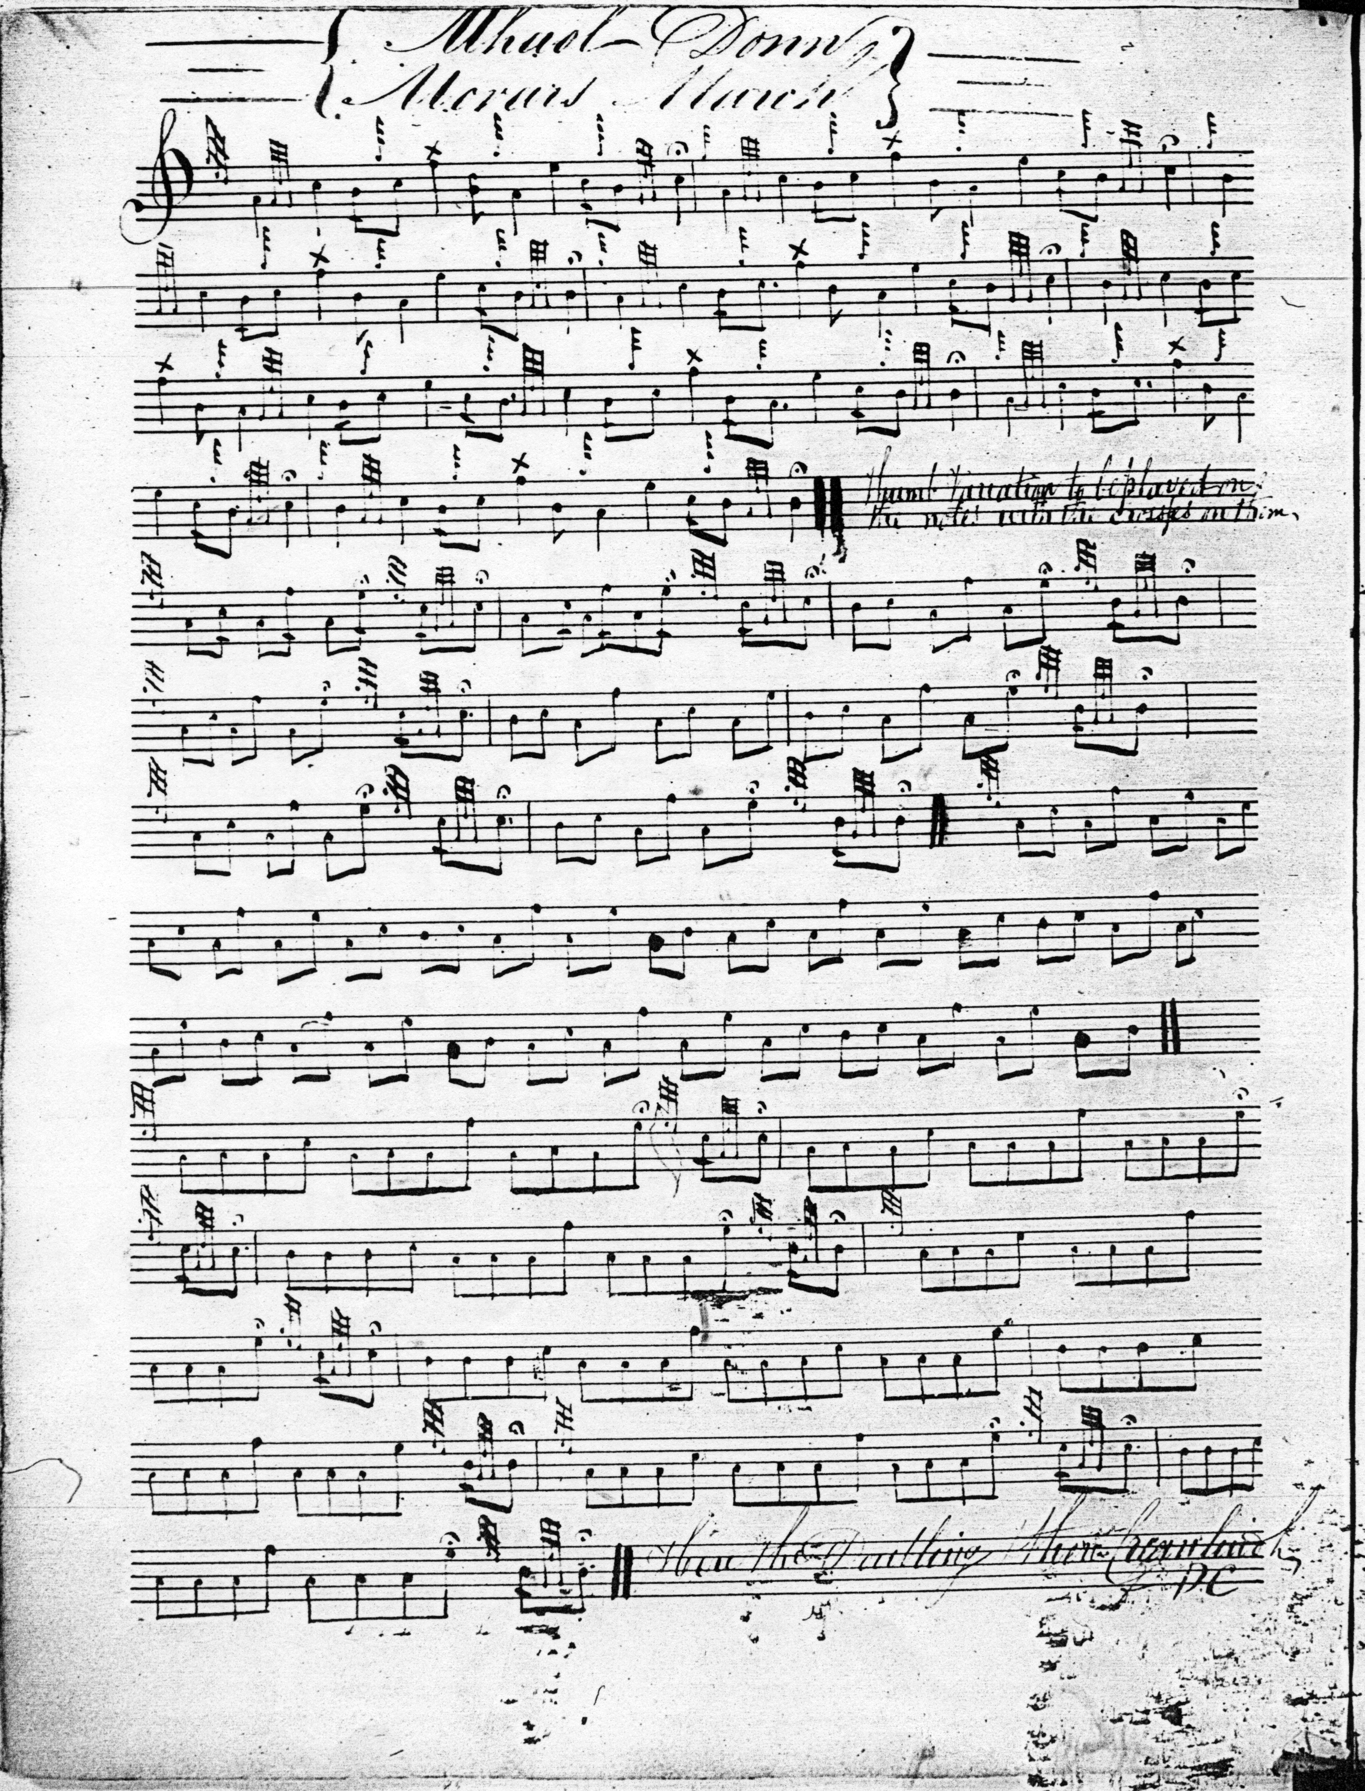
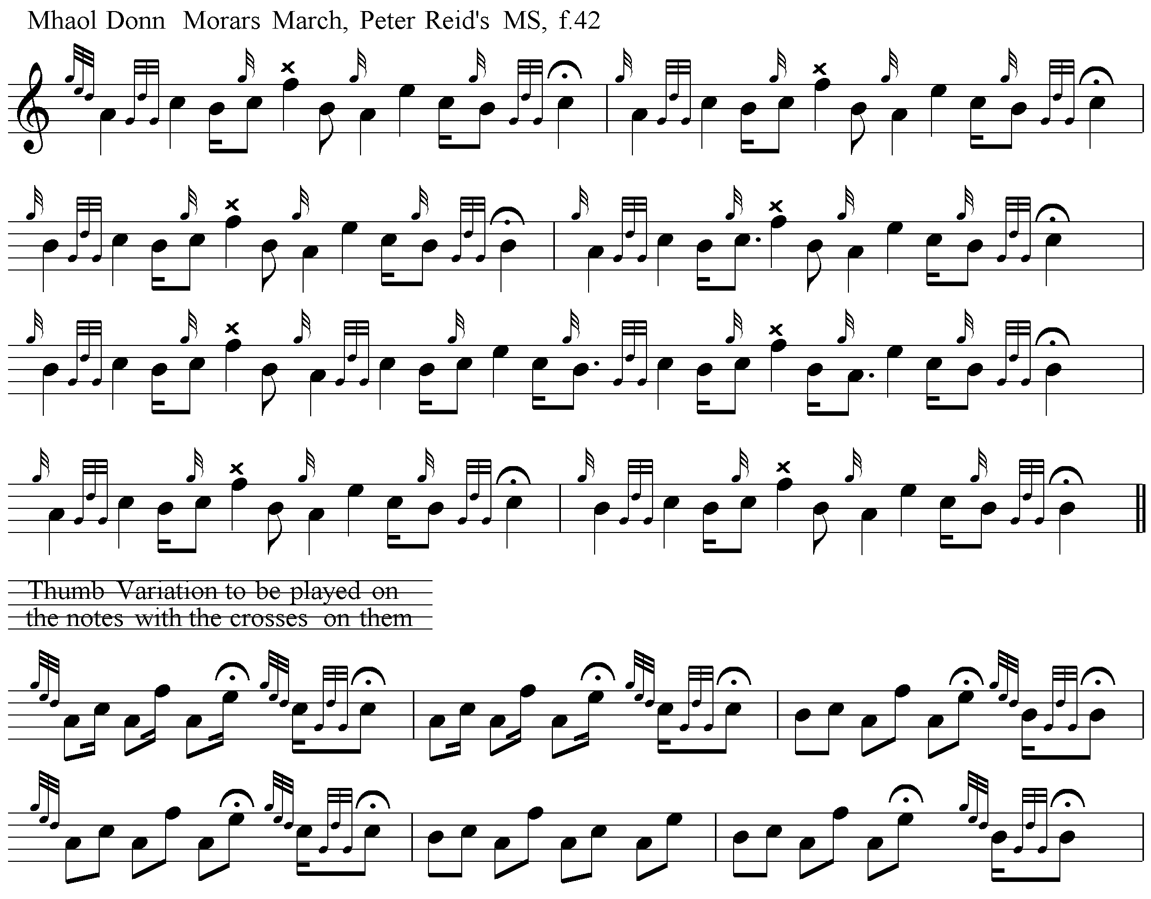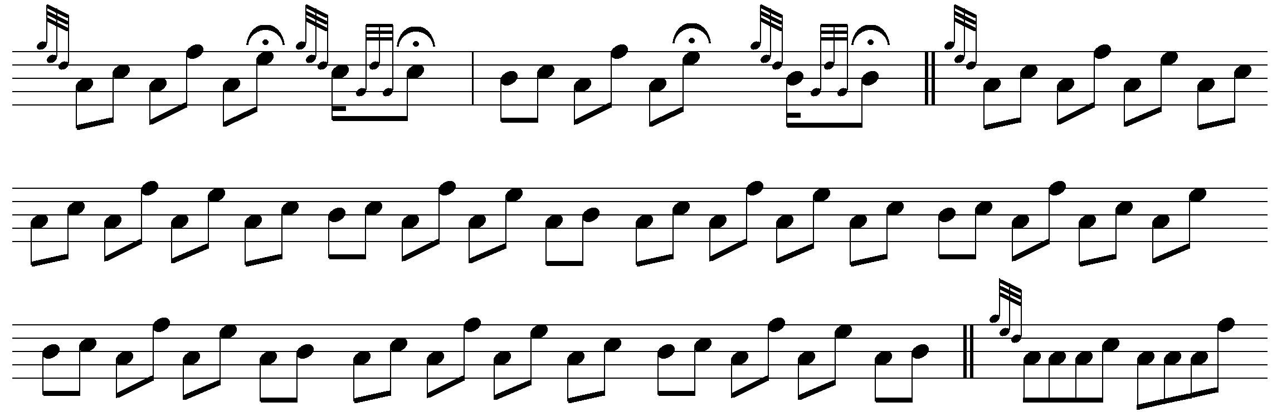
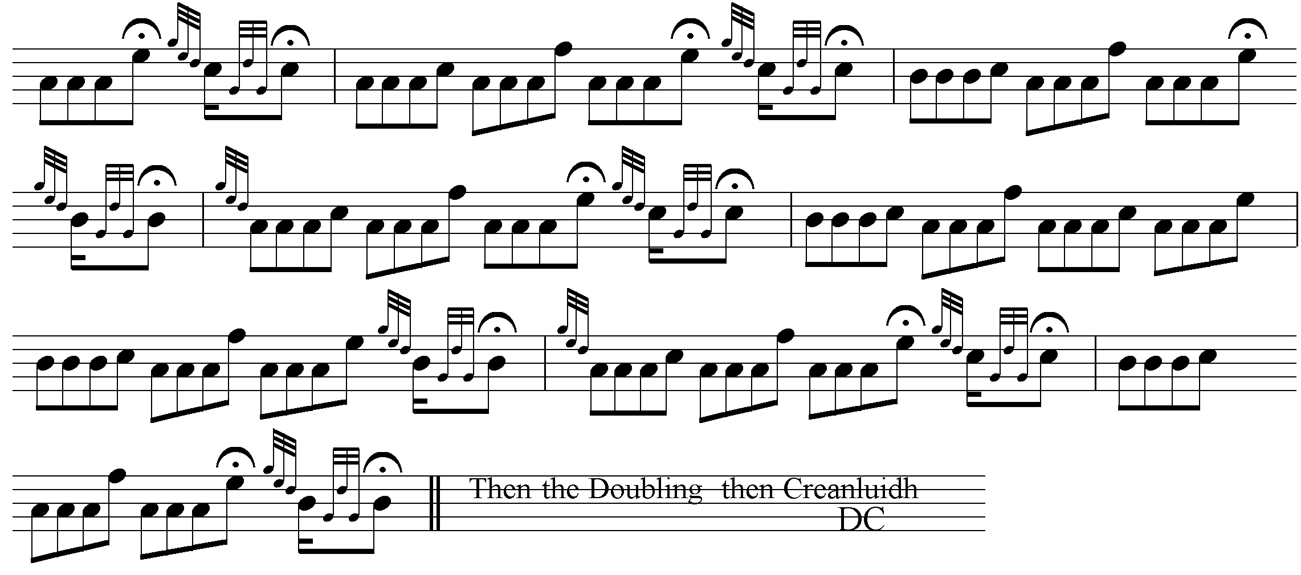

Opening Sequences:
One difficulty for the modern player lies in the timing of the opening sequence in the ground. Angus MacKay treats it as follows:
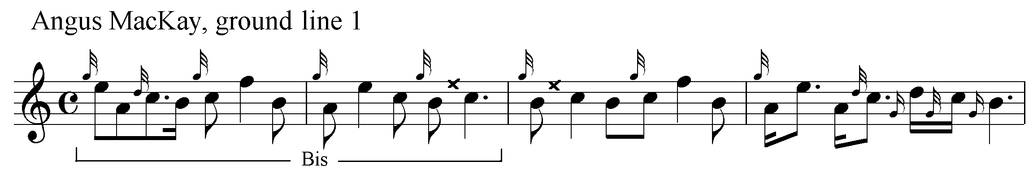
This is Colin Cameron’s timing:
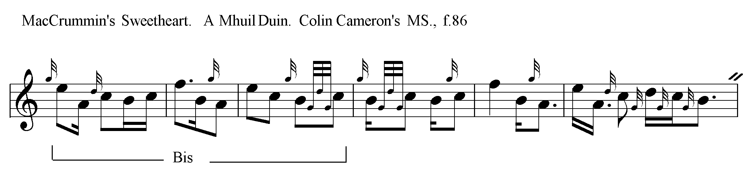
And John MacDougall Gillies times it like this:
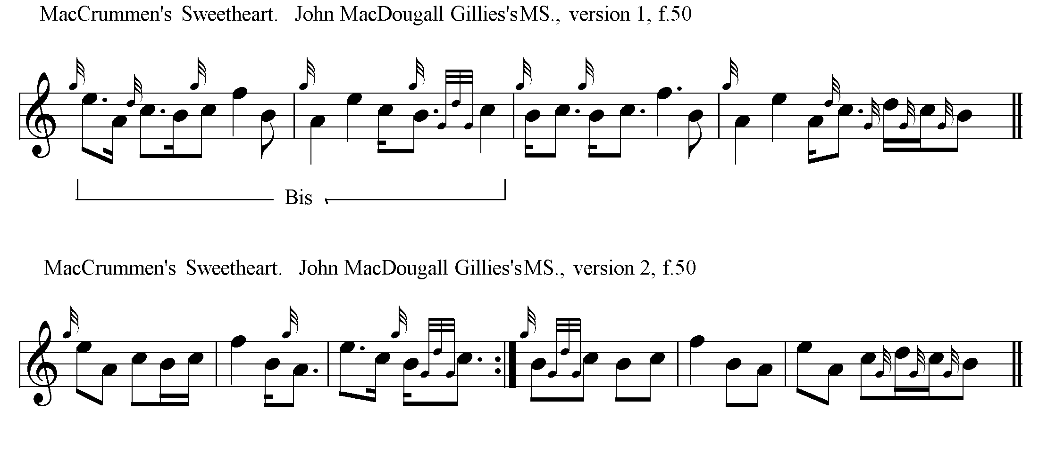
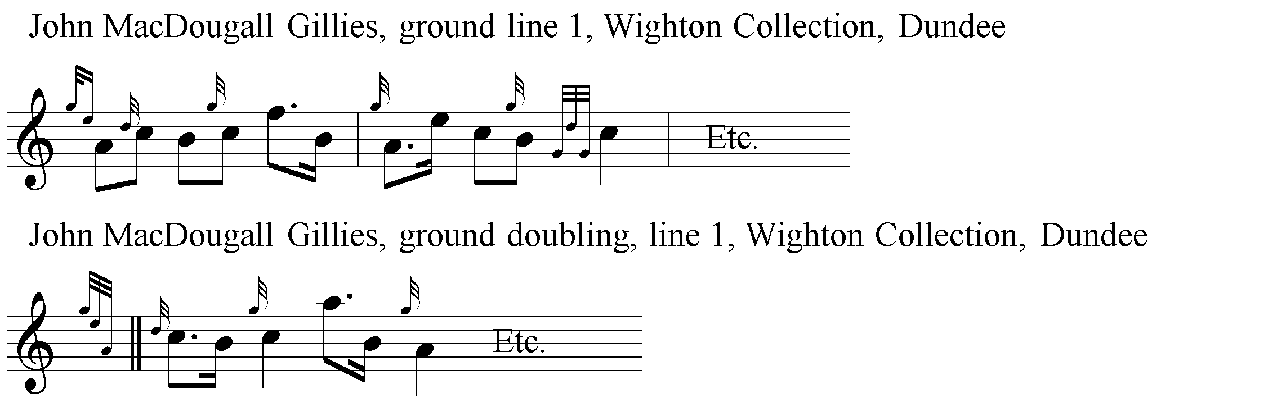
However, Archibald Campbell’s versions in the Piobaireachd Society Collection (vii, 205-6), and Kilberry Book of Ceol Mor (p.28) time the piece with an E cadence played on to an accented low A crotchet. The following example shows the difference between the setting given by Archibald Campbell and those of Gillies and the Cameron family whose stylings he claimed them to be:

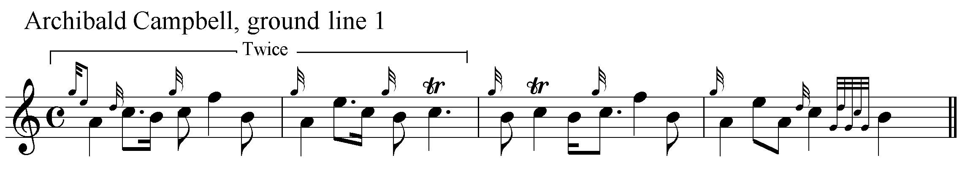

Campbell stated that “The setting printed was taught by Alexander Cameron and J. MacDougall Gillies”, and that “Angus MacKay’s Urlar is the same as the text, except for slight differences in timing some of the notes”. But the older MS settings largely rebut this claim, most particularly the three surviving versions in the hand of John MacDougall Gillies. In none of these settings is Campbell’s initial A crotchet more than a quaver. In the final MacDougall Gillies example, the A is timed as a demisemiquaver, and the movement of which it forms part is placed before the bar line. The implication being that the E/A opening gesture is an anacrusis played on to an accented C.
Uilleam Ross’s Collection of 1869 contains the first published setting of “MacCrimmon’s Sweetheart”, and is amongst the most attractive. It is given below:
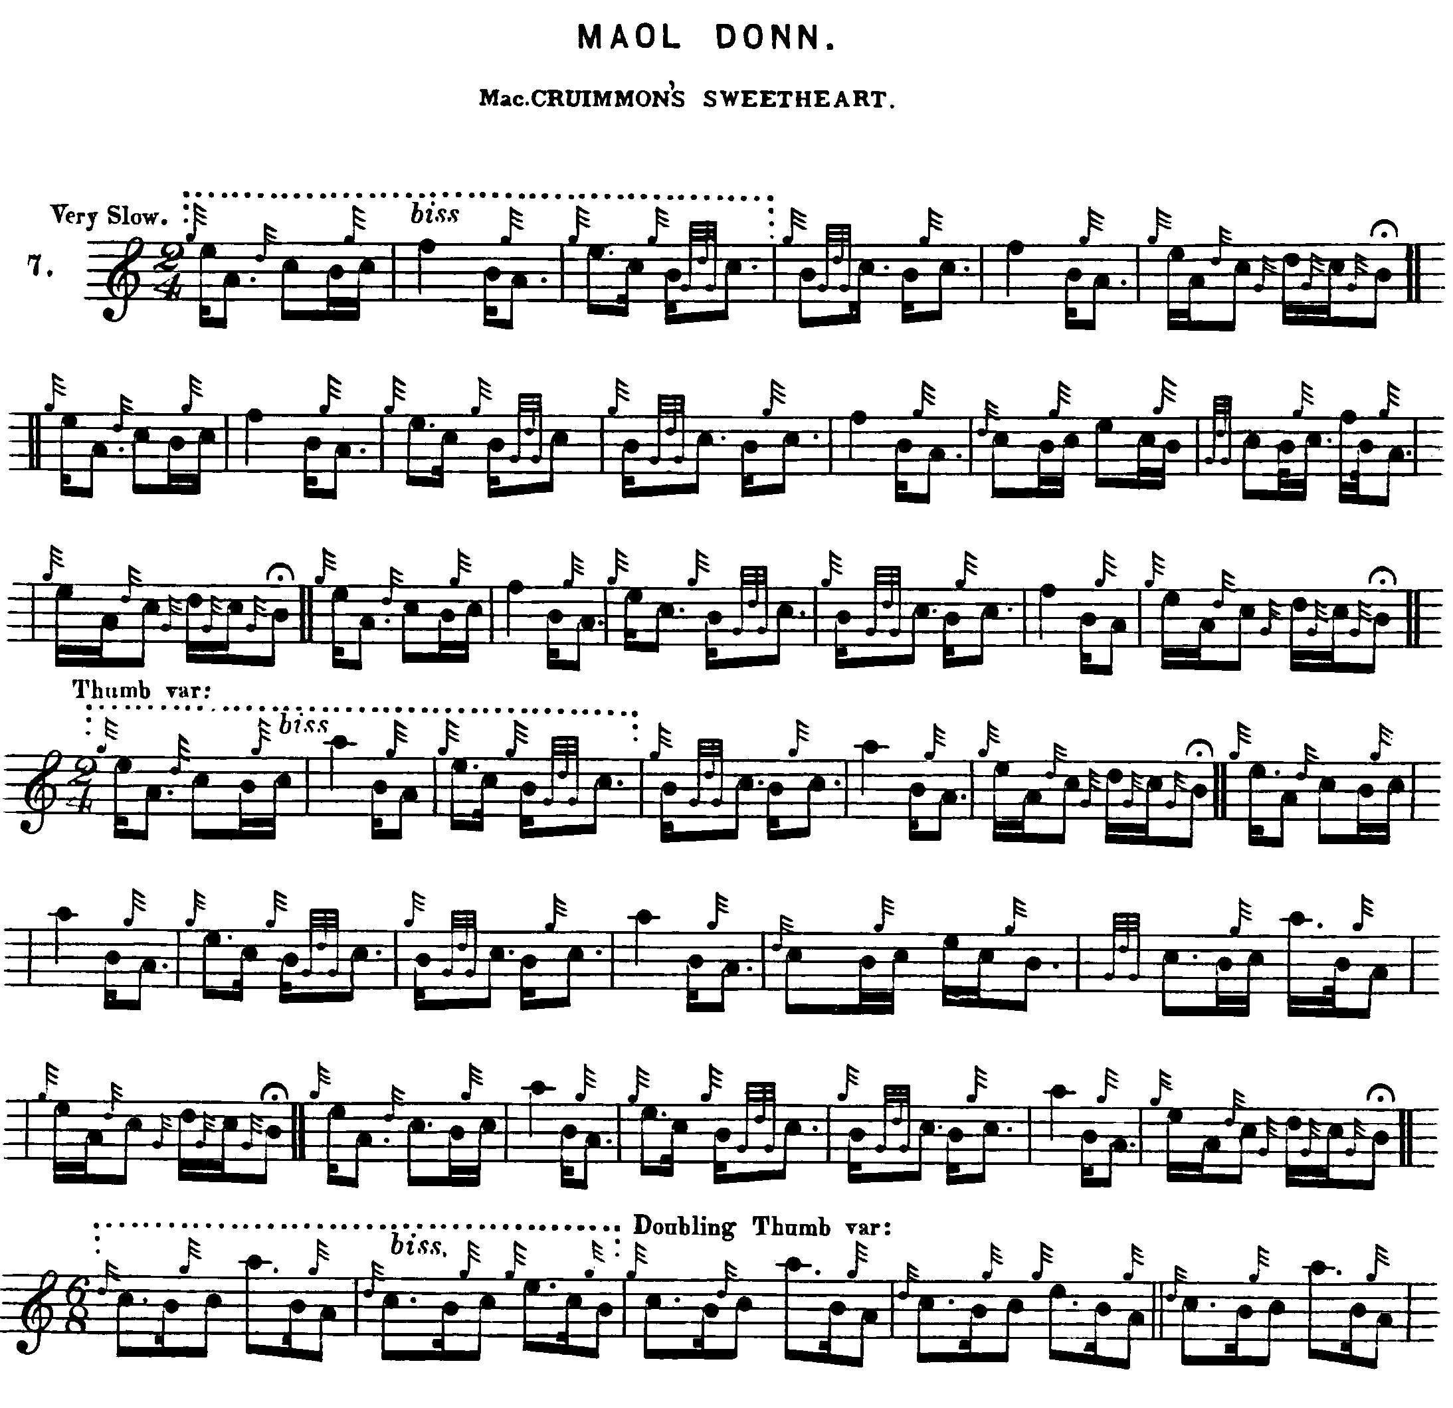
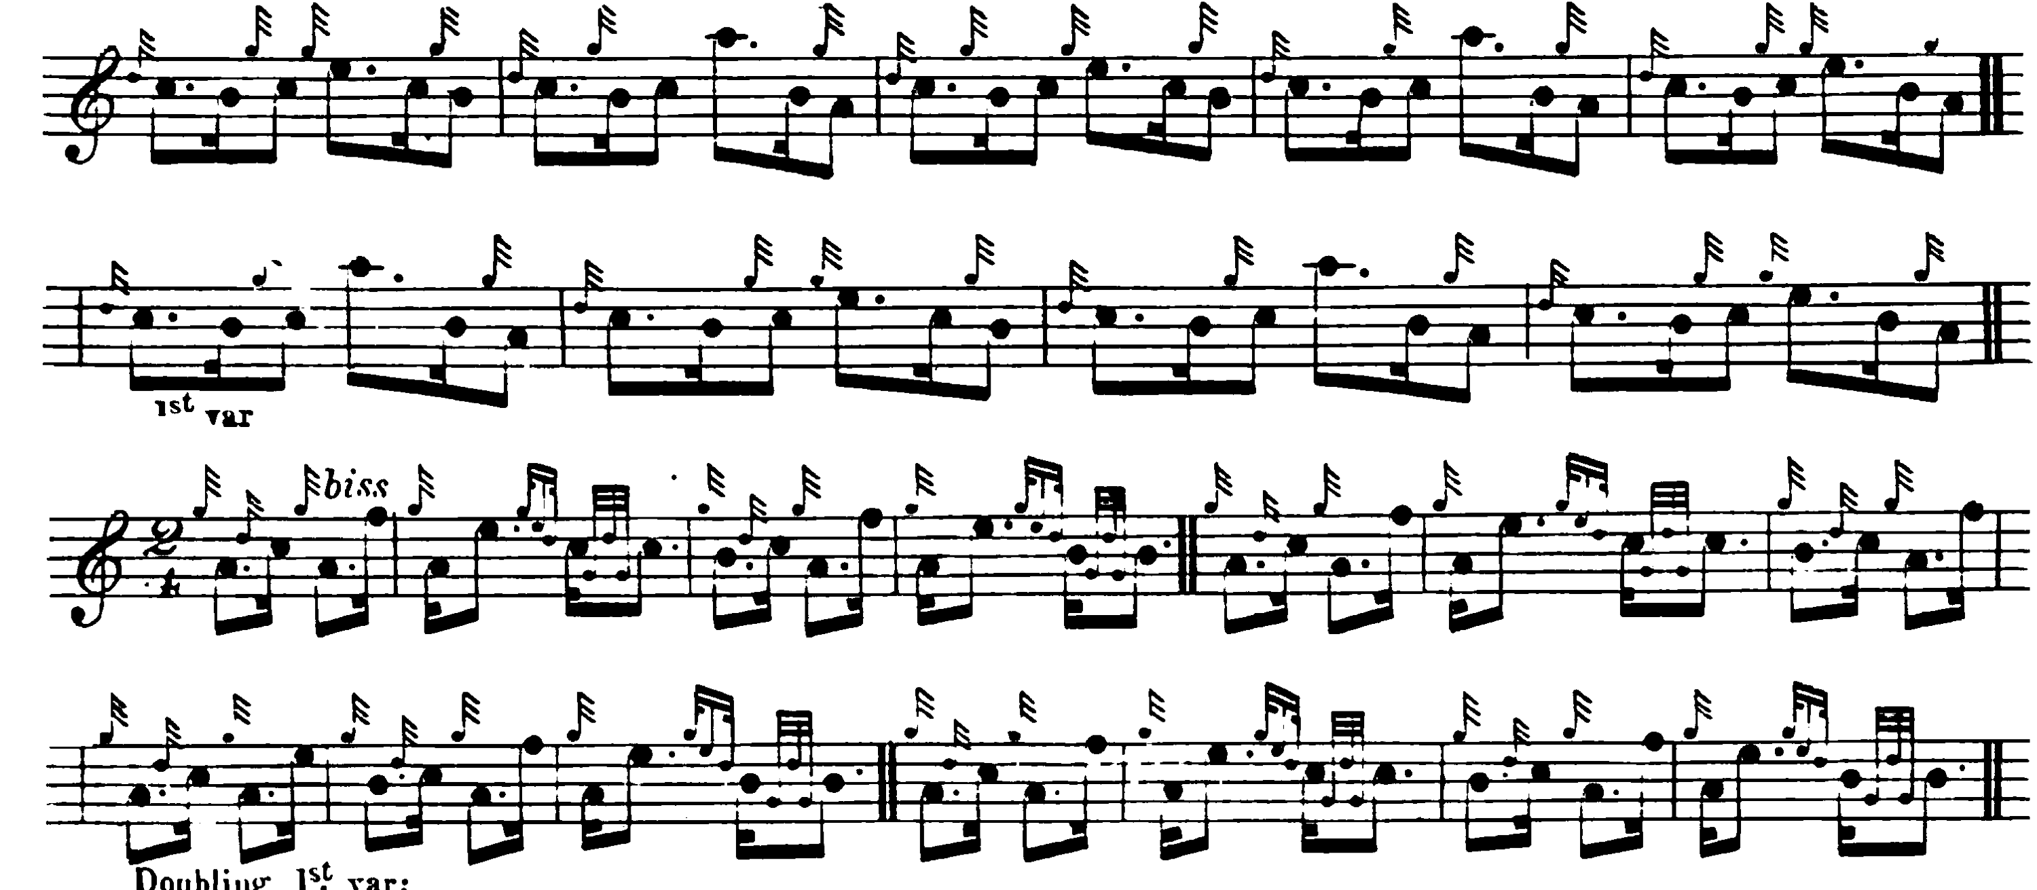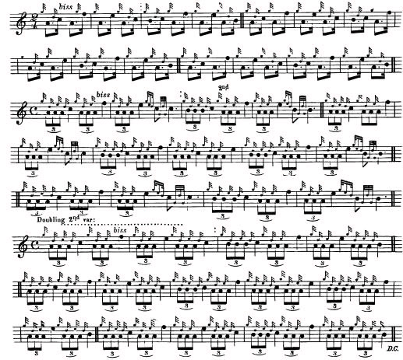
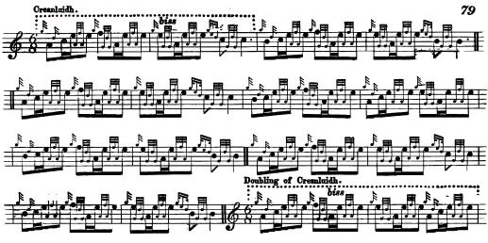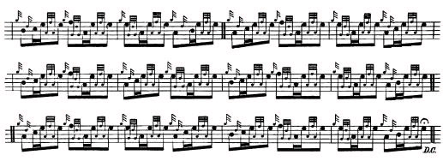
The use of MacKay-type closed fosgailte movement will be noted, and the interesting cut down from E to A at the beginning of bar nine (and in corresponding positions elsewhere) which is a feature also of Colin Cameron’s score. The title ‘MacCrimmon’s Sweetheart’ is first used in Colin Cameron’s MS, which, since it was completed in 1869, probably predates Ross. The latter knew Colin Cameron, as we see from settings included in Ross’s Collection, and the two probably met regularly during the summer months, since one was based at Balmoral, and the other with the Duke of Fife at Mar Lodge near Braemar. Apparently, the numerous master pipers on upper Deeside, including William MacDonald, piper to the Prince of Wales at Abergeldie (brother of Sandy MacDonald, and uncle of John of Inverness) used to meet at Peter Coutts’s place at Tullochmacarrick in Glengairn. Coutts had been a piper to the Queen at Balmoral and later to Farquharson of Invercauld; at the Ballater games, his “venerable figure with its patriarchal mien was ever a conspicuous feature” (“Leaving Glenurquhart”, Piping Times vol.12, no.11, Aug. 1960, pp.12-14).
In Ceol Mor, C. S. Thomason times the opening sequences like this:
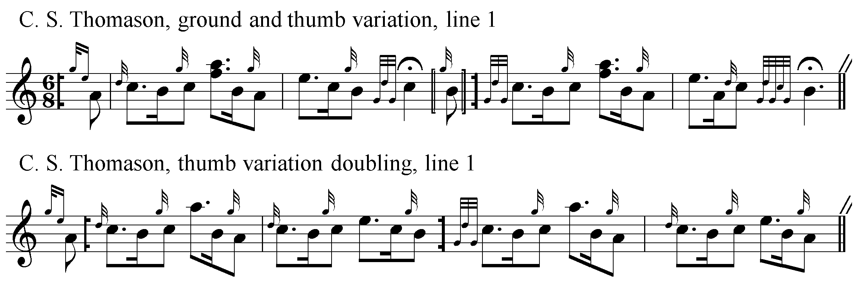
Thomason’s timing is similar to that favoured by Lt. John McLennan in his book The Piobaireachd as MacCrimmon Played it (1907), the letterpress portions of which are in epistolary form and addressed to his son, the famous G. S. McLennan. Lt. John thought that generations of dubious theorising about piobaireachd which stressed its remoteness from other forms of music, its wildness and irregularity, had led many contemporary players to present the music in an exaggeratedly slow and unmusical fashion. He adopted the minim as his basic unit of duration rather than the crotchet, reasoning that it was more in keeping with the spirit of the music, and provided a more varied rhythmical palette. By this means relative time values between the notes could be more precisely expressed. It also enabled him to dispense with the fermata, declaring “It has done a great deal of harm to Pibroch, but pipe music when properly written has no use for this back door.”(p.5). Here is the opening sequence of his setting of “McCrimmon’s Sweetheart”:

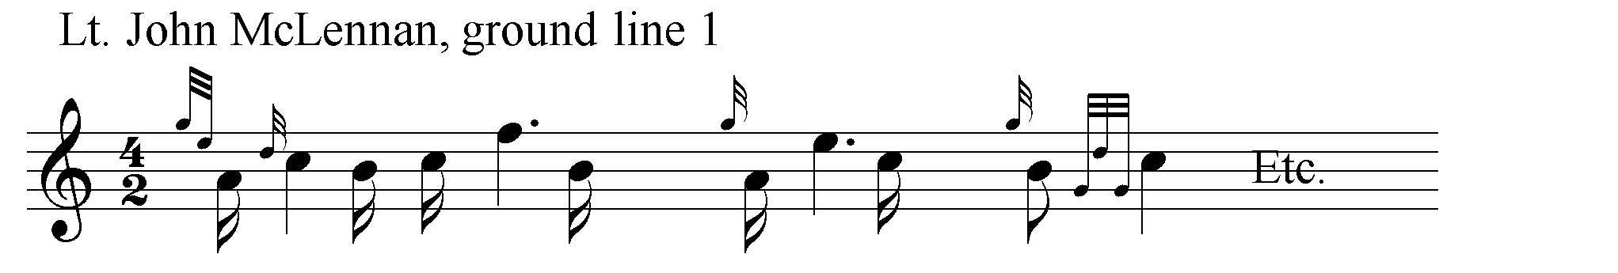
It is notable that McLennan dispenses here with bar lines in order to emphasise the flow of the phrase. It will have been considerations like these that led his son, G. S. McLennan, to decline to be the Piobaireachd Society’s instructor in Aberdeen. G.S. refused to teach their crude and unrhythmical scores as written and abandon his father’s more authentic and musical style, the culmination of centuries of tradition-bearing in this important and long-established teaching family.
David Glen published two settings in Ancient Piobaireachd, and the second of them is given below. (pp.164-6) The ground has similarities with Peter Reid’s version, but the duinte conclusion to which the tune is developed does not seem to be paralleled elsewhere in the written record:
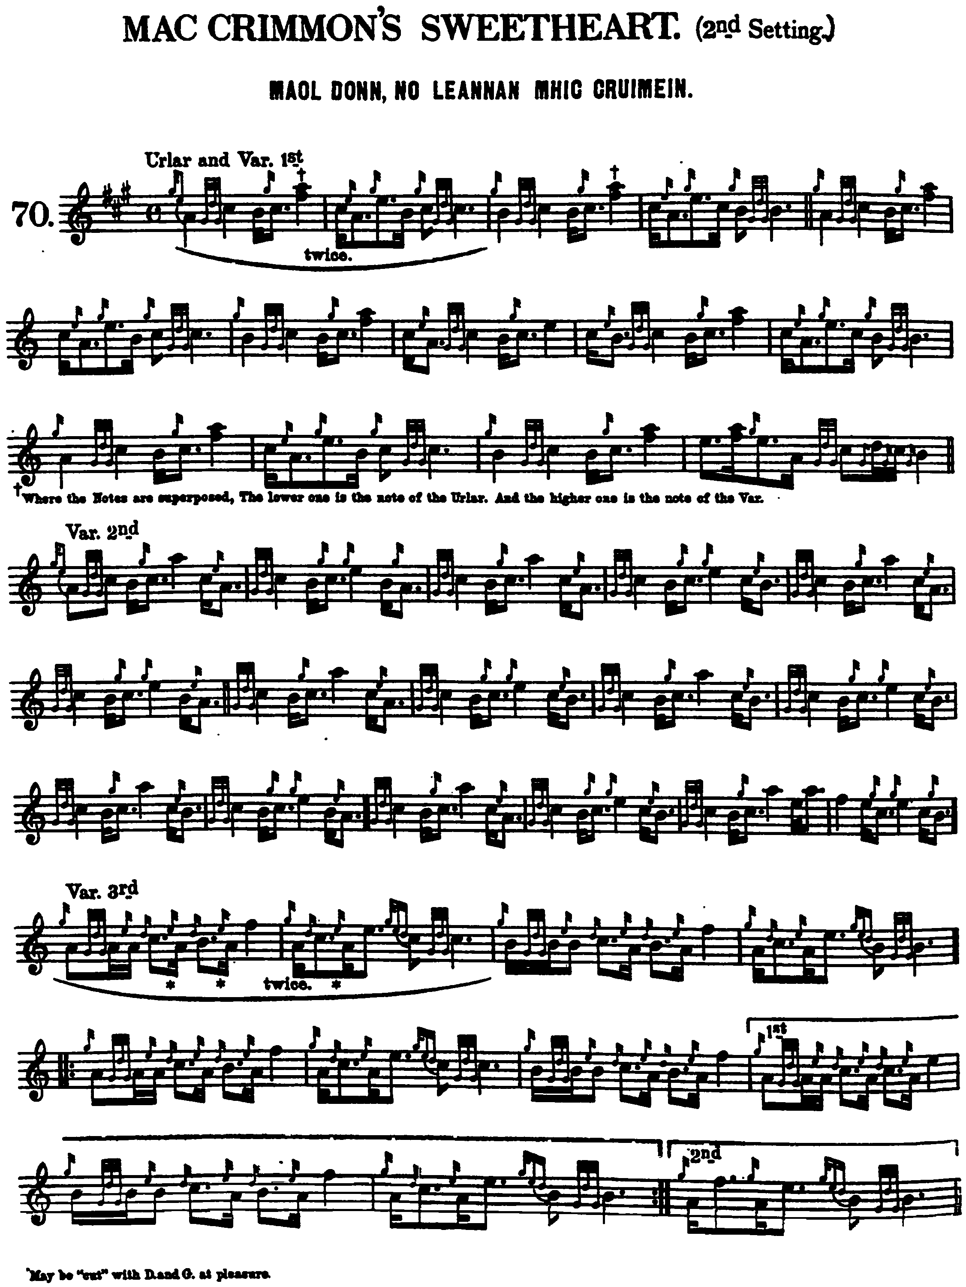
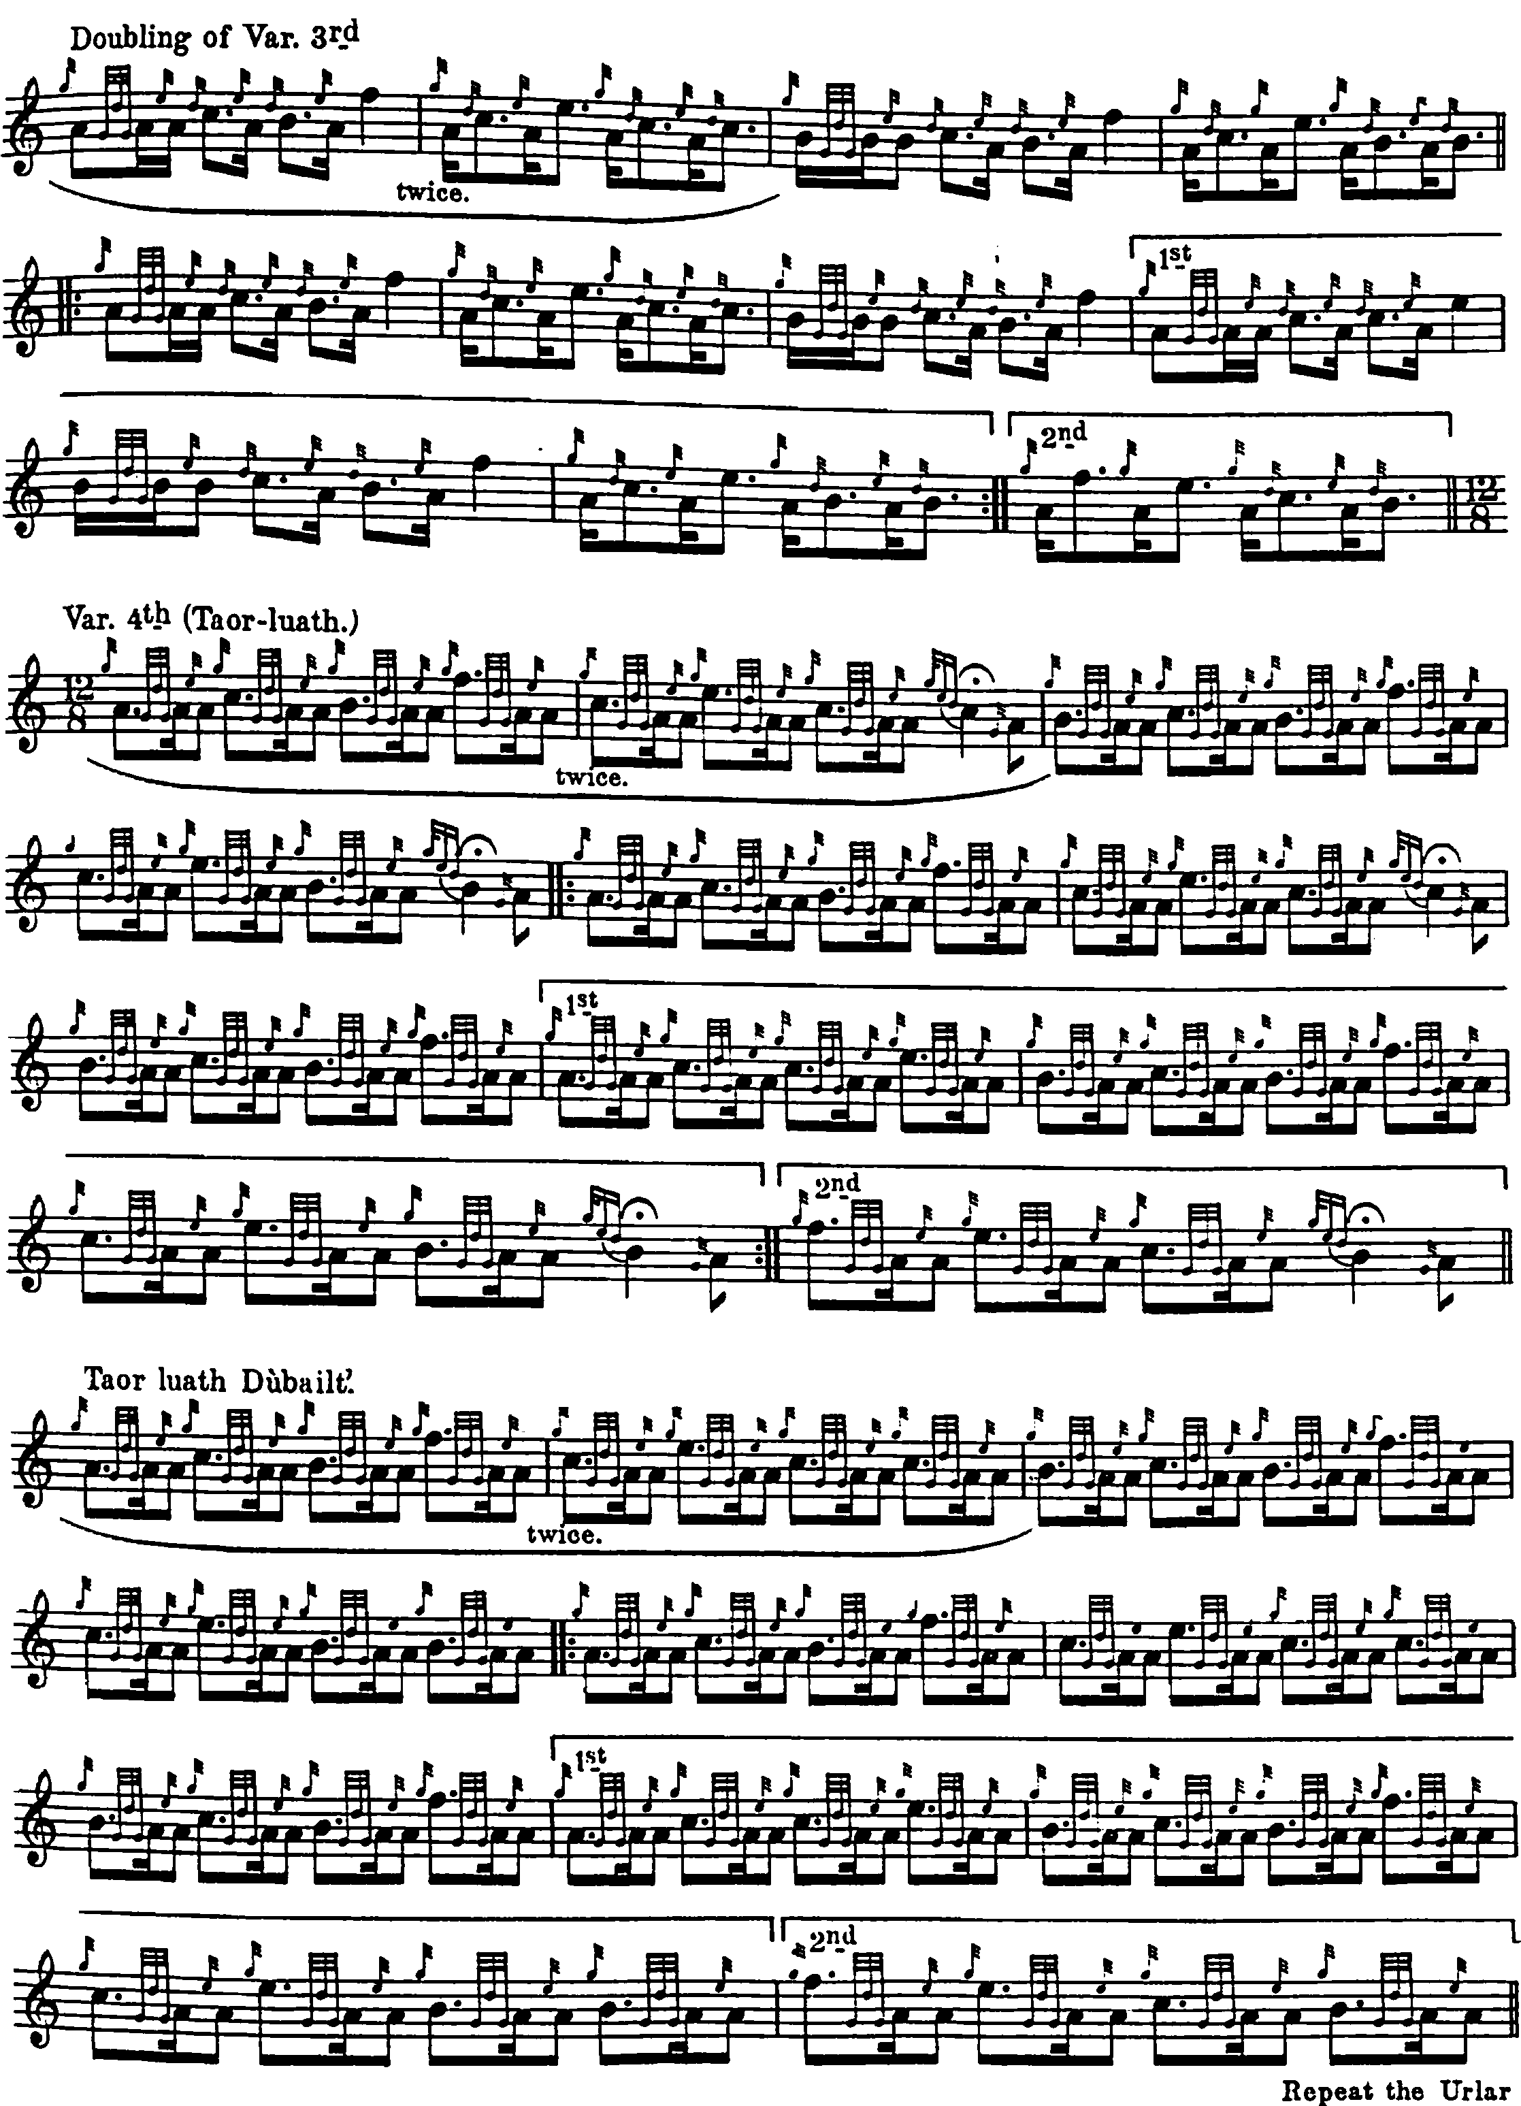

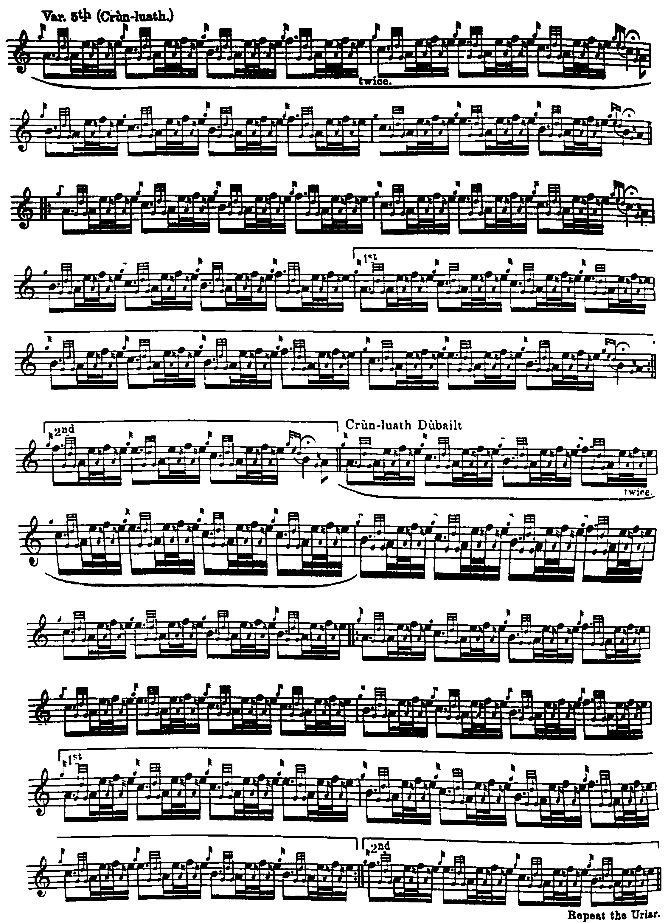
Commentary
This is one of the best-loved piobaireachds, an old favourite frequently offered in competition from the later 18th century onwards, and one of the tunes recorded by John MacDonald of Inverness on the Columbia label in 1927.
There are a number of stories attached to the tune, this one given by John Johnston of Coll in C. S. Thomason’s “Ceol Mor Legends”, ff.364-5:
This is a tune composed by Clanranald's piper--of the day--to a cow lost in a bog by a widow in Benbecula, South Uist.
The cow was a noted one, & was greatly admired by the widow, as her only one apparently. It got lost in the common moss one day, & ultimately the whole neighbourhood turned out to look for it, likely in compassion for the owner, the piper among the rest; but its finding defied them, after their best efforts, nor was the skeleton of it found till over a year afterwards, by a mere accident.
The whole circumstances therefore afforded the piper a good theme to begin, which he did as if the widow herself was the author, thus:--
“Gad iunndrain a tha me, si mo ghradh a mhaol dounn, Gad iarreidh feadh fhraochan, s' gad shlaodadh a poul”
This tune was also a great favourite with the old pipers, though composed for a trifling matter, owing to its own merits & its plaintive air throughout. It is very old...
The Gaelic scholar and journalist Henry White of Easdale who wrote under the pen name “Fionn” stated in his historical notes to Glen’s Ancient Piobaireachd that the tune was a composition of Donald Roy MacCrimmon, and that “Maol Donn” was a common name for a Highland cow, op.cit., pp.13, 17.
***
Electronic text © Dr. William Donaldson, Aberdeen, Scotland, August 2001; revised Cambridge, Massachusetts, February 2025.

