MacCrimmon will never return

There are settings of this tune in the following manuscript sources:
--Colin Mór Campbell, “Nether Lorn Canntaireachd”, i, 117-19;
-- Peter Reid’s MS, ff.48-9;

and in the following published sources:
--Angus MacKay, Ancient Piobaireachd, pp.17-20;
--Donald MacPhee, Collection of Piobaireachd, ii, 1-2;
--C. S. Thomason, Ceol Mor, p.162;
--David Glen, Collection of Ancient Piobaireachd, pp.74-5;
--John McLennan, The Piobaireachd as Performed in the Highlands, p.4.

Since there is little stylistic difference between the published settings of this tune, the main interest focuses on the Nether Lorn score and that of Peter Reid. Both show MacKay’s severely plain style softened by appropriate decoration. The tune is nowadays fairly seldom heard, perhaps because of the rather dull way in which it develops, narrowing down to a monotonously reiterated three note scale on D, E and F. Basically, there seems insufficient musical variety between the A and B phrases to support the later variations, unless very artfully played.

Colin Mór Campbell sets the tune like this:

56 Called Cha till me tuil

1st Drevehiao, echevecheento Two times drevehiao ehaihaemto
2d Drevehiao echevecheento, drevehiao echaihaemto Two times
3d Drevehiao echevecheento drevehiao ehaehaemto

D 1st Drevehiao echeIcheento Two times drevehiao ehaIhamto
2d Drevehiao echeIcheento drevehiao ehaI hamto, Two times
3d Drevehiao echeIcheento drevehiao ehaI hamto

DD 1st DreIhio IeheIcheento, Two times dreIhio IhaIhamto,
2d DreIhio IeheIcheento, dreIhio IhaIhamto Two times
3d DreIhio IechIchento dreIhio IhaIhamto

S First Motion
1st Chebare hebare chebare chehio chebare hebare chebare chehio, chebare hebare harode hahio
2d Chebare hebare chebare chehio, chebare hebare harode Two times [?Chebare hebare chebare cheho, chebare hebare harode harode chebare hebare harode hahio?]
3d Chebare hebare chebare chehio chebare hebare harode hahio

D 1st Chebare hebare chebare chebare Two times chebare hebare harode harode
2d Chebare hebare chebare chebare, chebare hebare harode harode Two times
3d Chebare hebare chebare chebare, chebare hebare harode harode

S Taolive
1st Chedarid hedarid chedarid chehio Two times chedarid hedarid hadarid hahio
2d Chedarid hedarid chedarid chehio chedarid hedarid hadarid hahio Two times
3d Chedarid hedarid chedarid chehio chedarid hedarid hadarid hahio

D 1st Chedarid hedarid chedarid chedarid Two times chedarid hedarid hadarid hadarid
2d Chedarid hedarid chedarid chedarid, chedarid hedarid hadarid hadarid Two times
3d Chedarid hedarid chedarid chedarid chedarid hedarid hadarid hadarid

Crulive
S 1st Chebandre hebandre chebandre chehio Two times, chebandre hebandre habandre hahio
2d Chebandre hebandre chebandre chehio chebandre hebandre habandre hahio Two times
3d Chebandre hebandre chebandre chehio, chebandre hebandre habandre hahio

D 1st Chebandre hebandre chebandre chebandre Two times chebandre hebandre habandre habandre
2d Chebandre hebandre chebandre chebandre, chebandre hebandre habandre habandre Two times
3d Chebandre hebandre chebandre chebandre chebandre hebandre habandre habandre

DD Strulive
1st Chebandre hebandre chebandre chebandre Two times chebandre hebandre chetradre chetradre
2d Chebandre hebandre chebandre chebandre, chebandre hebandre chetradre chetradre Two times
3d Chebandre hebandre chebandre chebandre chebandre hebandre chetradre chetradre

This might suggest something along the following lines:

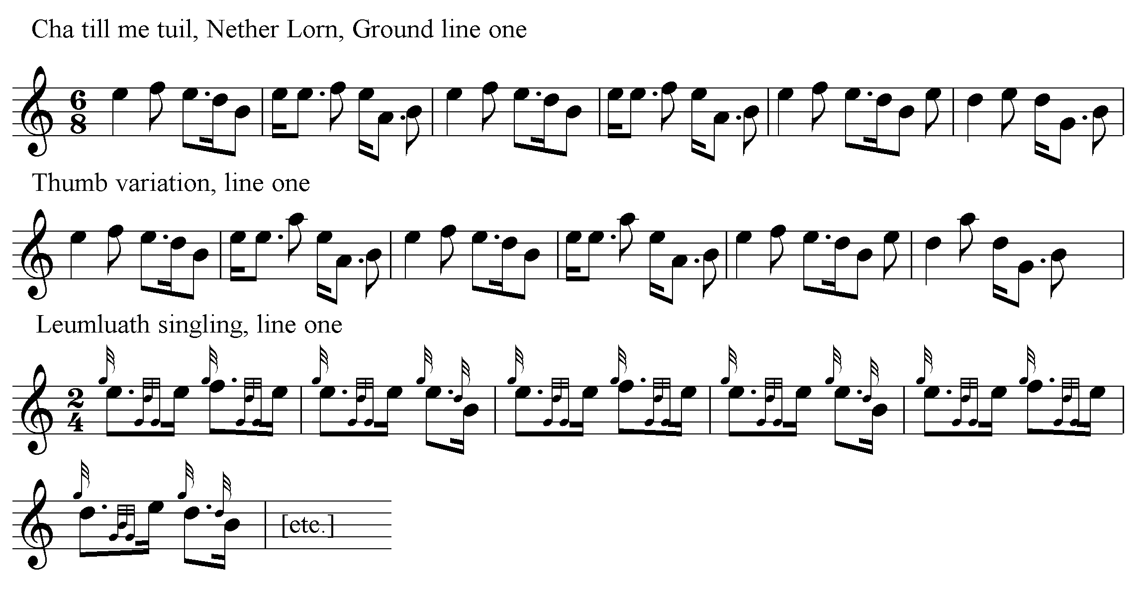

And so on.

Of the scores in staff notation, the most interesting is probably that of Peter Reid, notable for showing the beautifully decorated MacArthur style in which he was taught. His title is “Cha Till mi Tuille I return no more A Lament play’d at Funerals—”. It is set as follows:

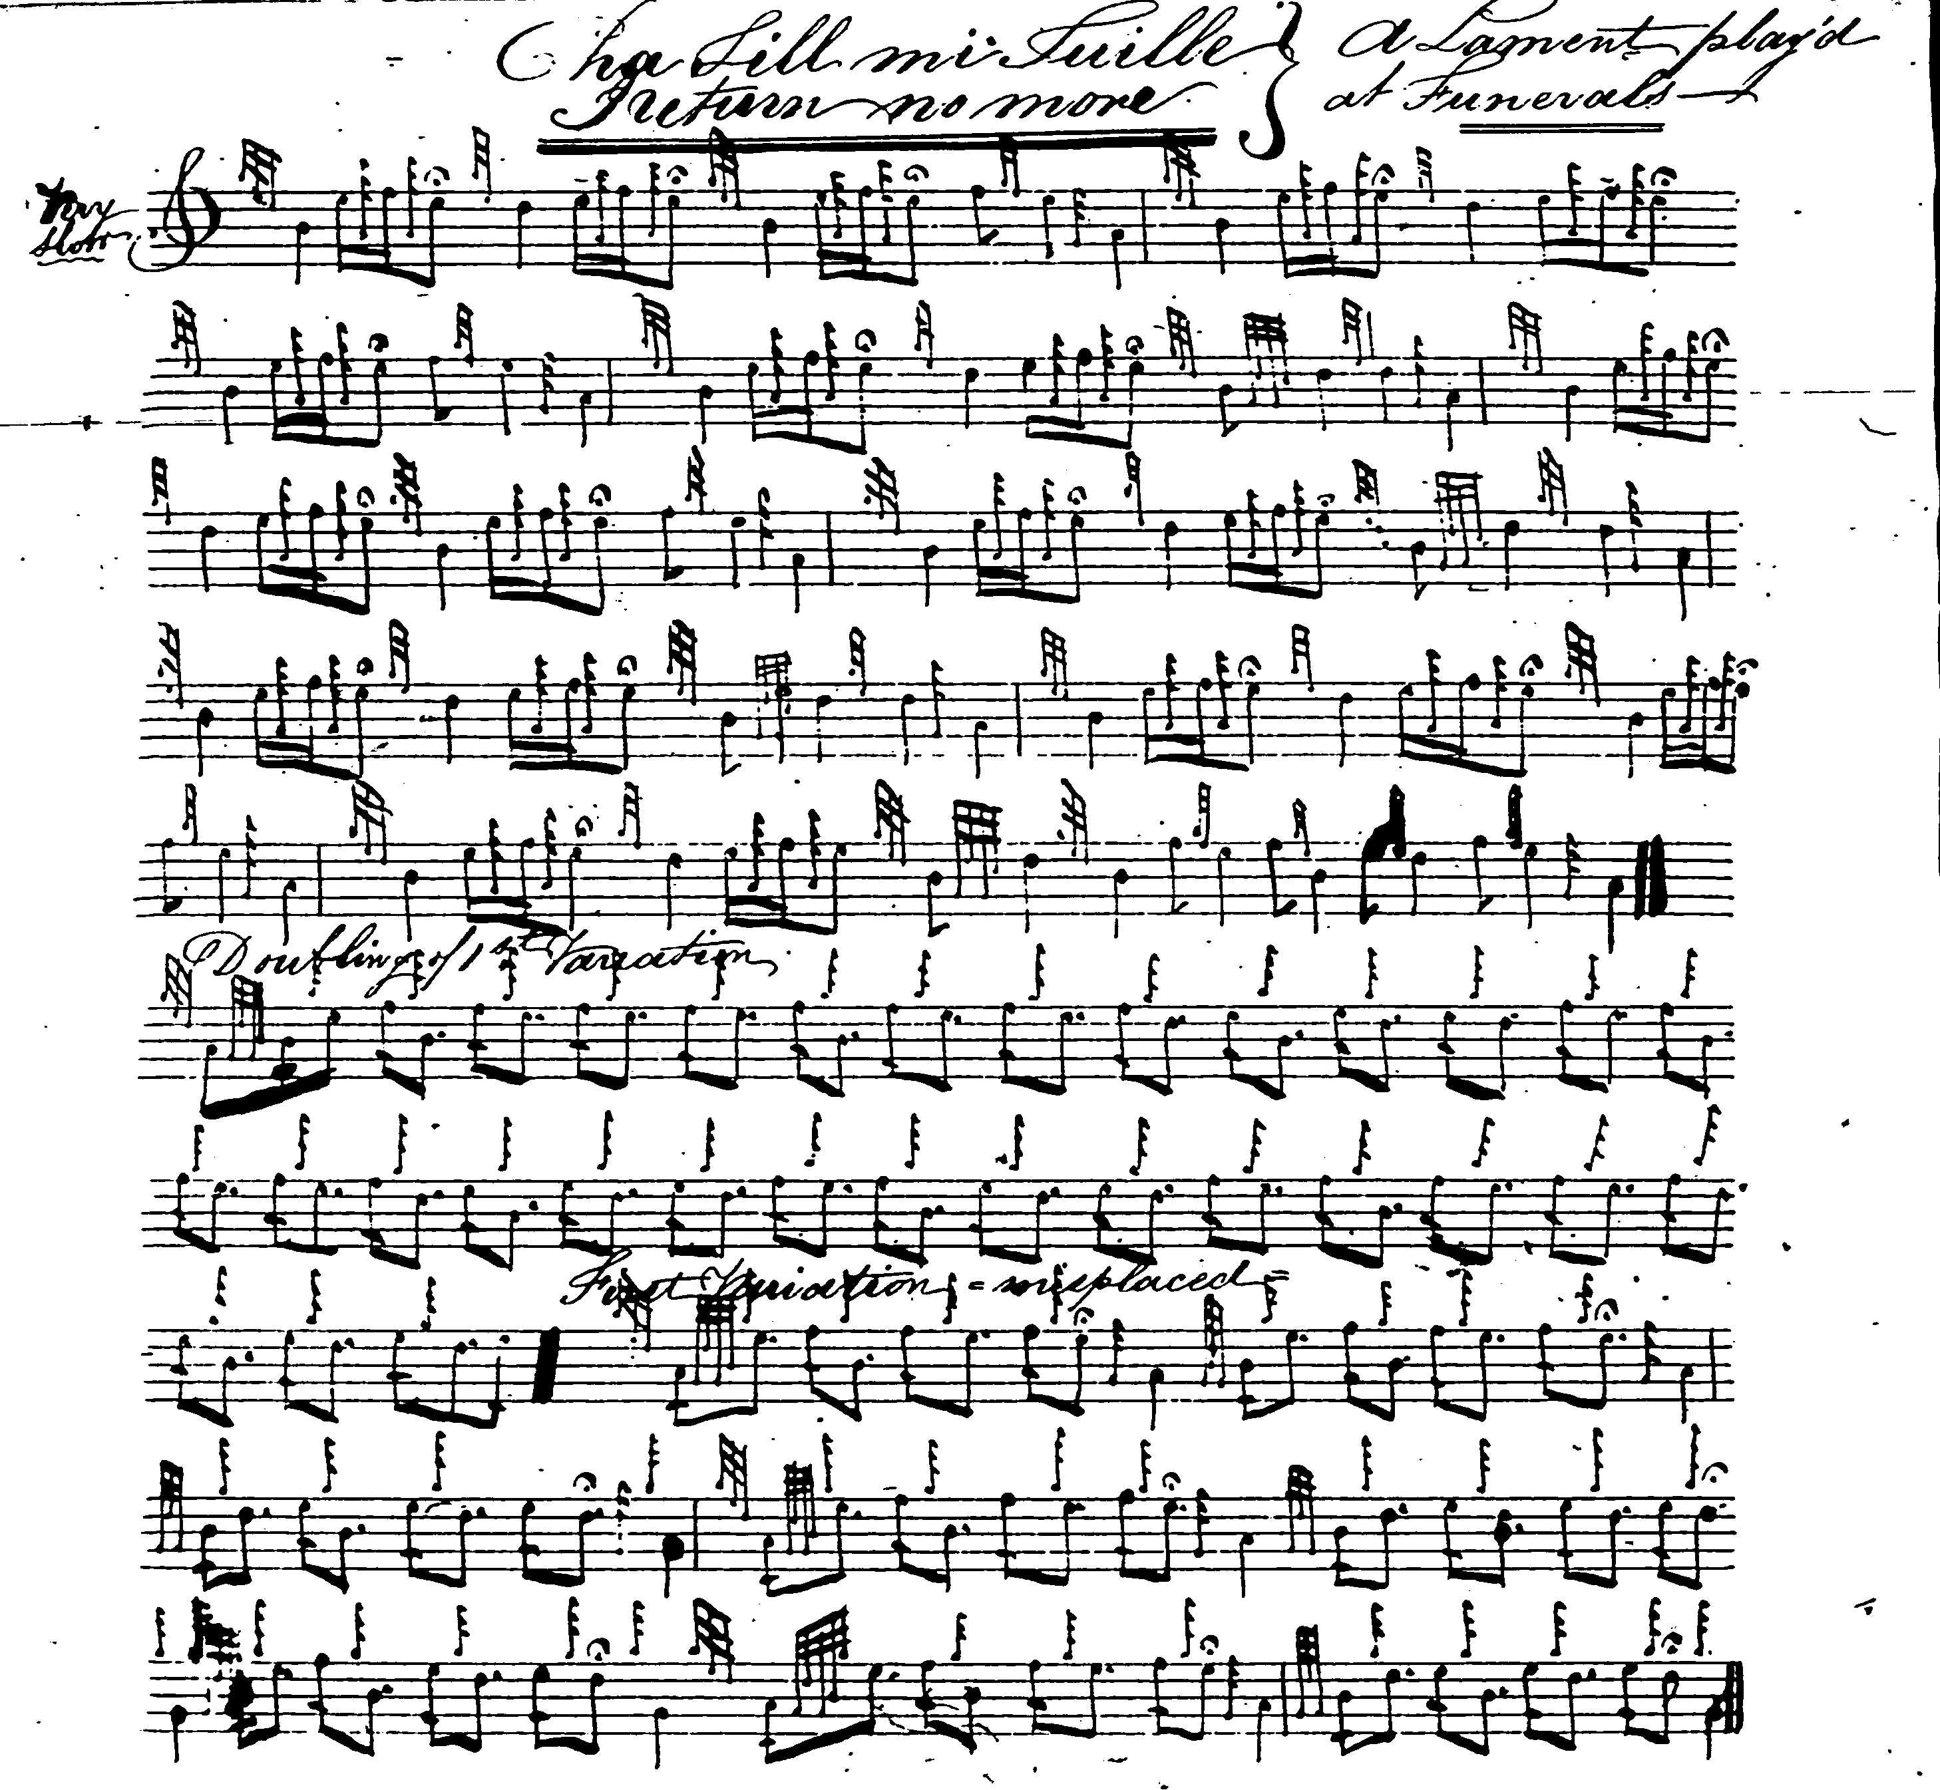

The compiler was obviously dissatisfied with this score; one notes his marking of the singling of the first variation as “misplaced” and the curious prolongation of line three of the ground. It is doubtful, indeed, if it is finished, and it is interesting that the compiler recorded Angus MacKay’s ground of this tune on the reverse of the sheet.

There is a high degree of similarity amongst the published settings. David Glen set the tune like this:

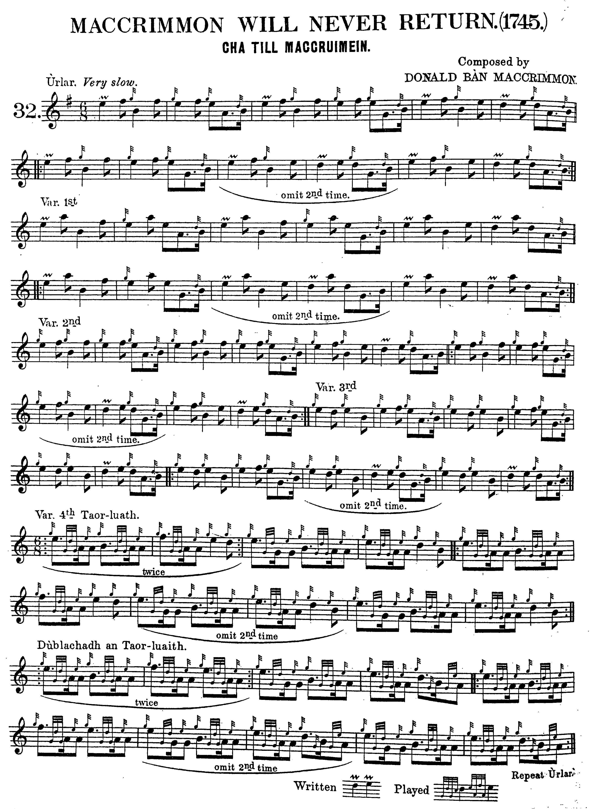
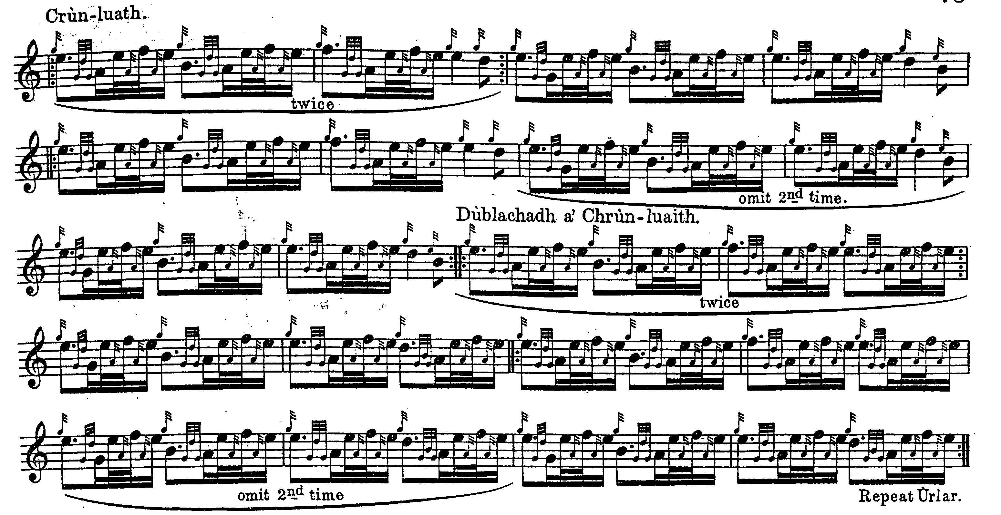

Commentary:

This tune was formerly called simply “Cha till mi tuille”. The link with the MacCrimmons was established by the writer Sir Walter Scott who used a version of the air for his original song “Lament--(Cha till suinn tuille)” which was published in the second volume of Alexander Campbell’s Albyn’s Anthology in 1818. It begins as follows:

MacLeod’s wizzard flag from the grey castle sallies,
The rowers are seated, unmoor’d are the galleys;
Gleam war-axe and broad-sword, clang target & quiver,
As Mackrimmon sings, “Farewell to Dunvegan for ever.”

The title was given as “Cha Till MacCriumein. MacCrummen will never return” with an attribution to Donald Bàn MacCrimmon in Angus MacKay’s Ancient Piobaireachd published in 1838, with historical notes by the antiquarian James Logan. For further information on this see The Highland Pipe and Scottish Society 1750-1950, especially pages 418-420.

As Peter Reid suggested above, this tune was indeed played at funerals, including that of Calum Piobaire. In its account of this event in July 1898, the Oban Times reported

The remains of the deceased were interred with Highland honours in Lagganbridge churchyard – excellent pipe music being discoursed by the pipers of Cluny Macpherson of Cluny and that of the Count de Serra Largo in conjunction with the Badenoch Volunteer Pipe Band, under the able leadership of Colour-Sergeant MacDonald, Kingussie. …On arrival at the grave Mr John MacDonald, [of Inverness] piper to Count de Serra Largo, played “MacCrimmon will never return” and while the coffin was being lowered into the grave he played “The Children’s Lament” – a tune taught to him by the deceased…”. “Death of a well-known Champion Piper”, Oban Times, 23/07/1898, p.2.

The Count de Serra Largo was a Scottish businessman, Alexander Cameron Mackenzie, who received a Portuguese title for services in Brazil and continued to use it on his retirement to Scotland. He lived near Tain.

* * *

Electronic text © Dr. William Donaldson, Aberdeen, Scotland, June 2005; revised Cambridge, Massachusetts, January 2025.

