Lord Lovat’s Lament

There are settings of this tune in only one late manuscript source:
--Robert Meldrum’s MS, ff.140-42;

and in the following published sources:
--Angus MacKay, pp.141-3;
--C. S. Thomason, p.198;
--David Glen, pp.35-6;
--Piobaireachd Society Collection (first series), iv, 8-9;
--G. F. Ross, Some Piobaireachd Studies, p.26;
--B. J. MacLachlan Orme, The Piobaireachd of Simon Fraser with Canntaireachd (privately printed, 1979), pp.250-3.

Angus MacKay develops the tune as follows:

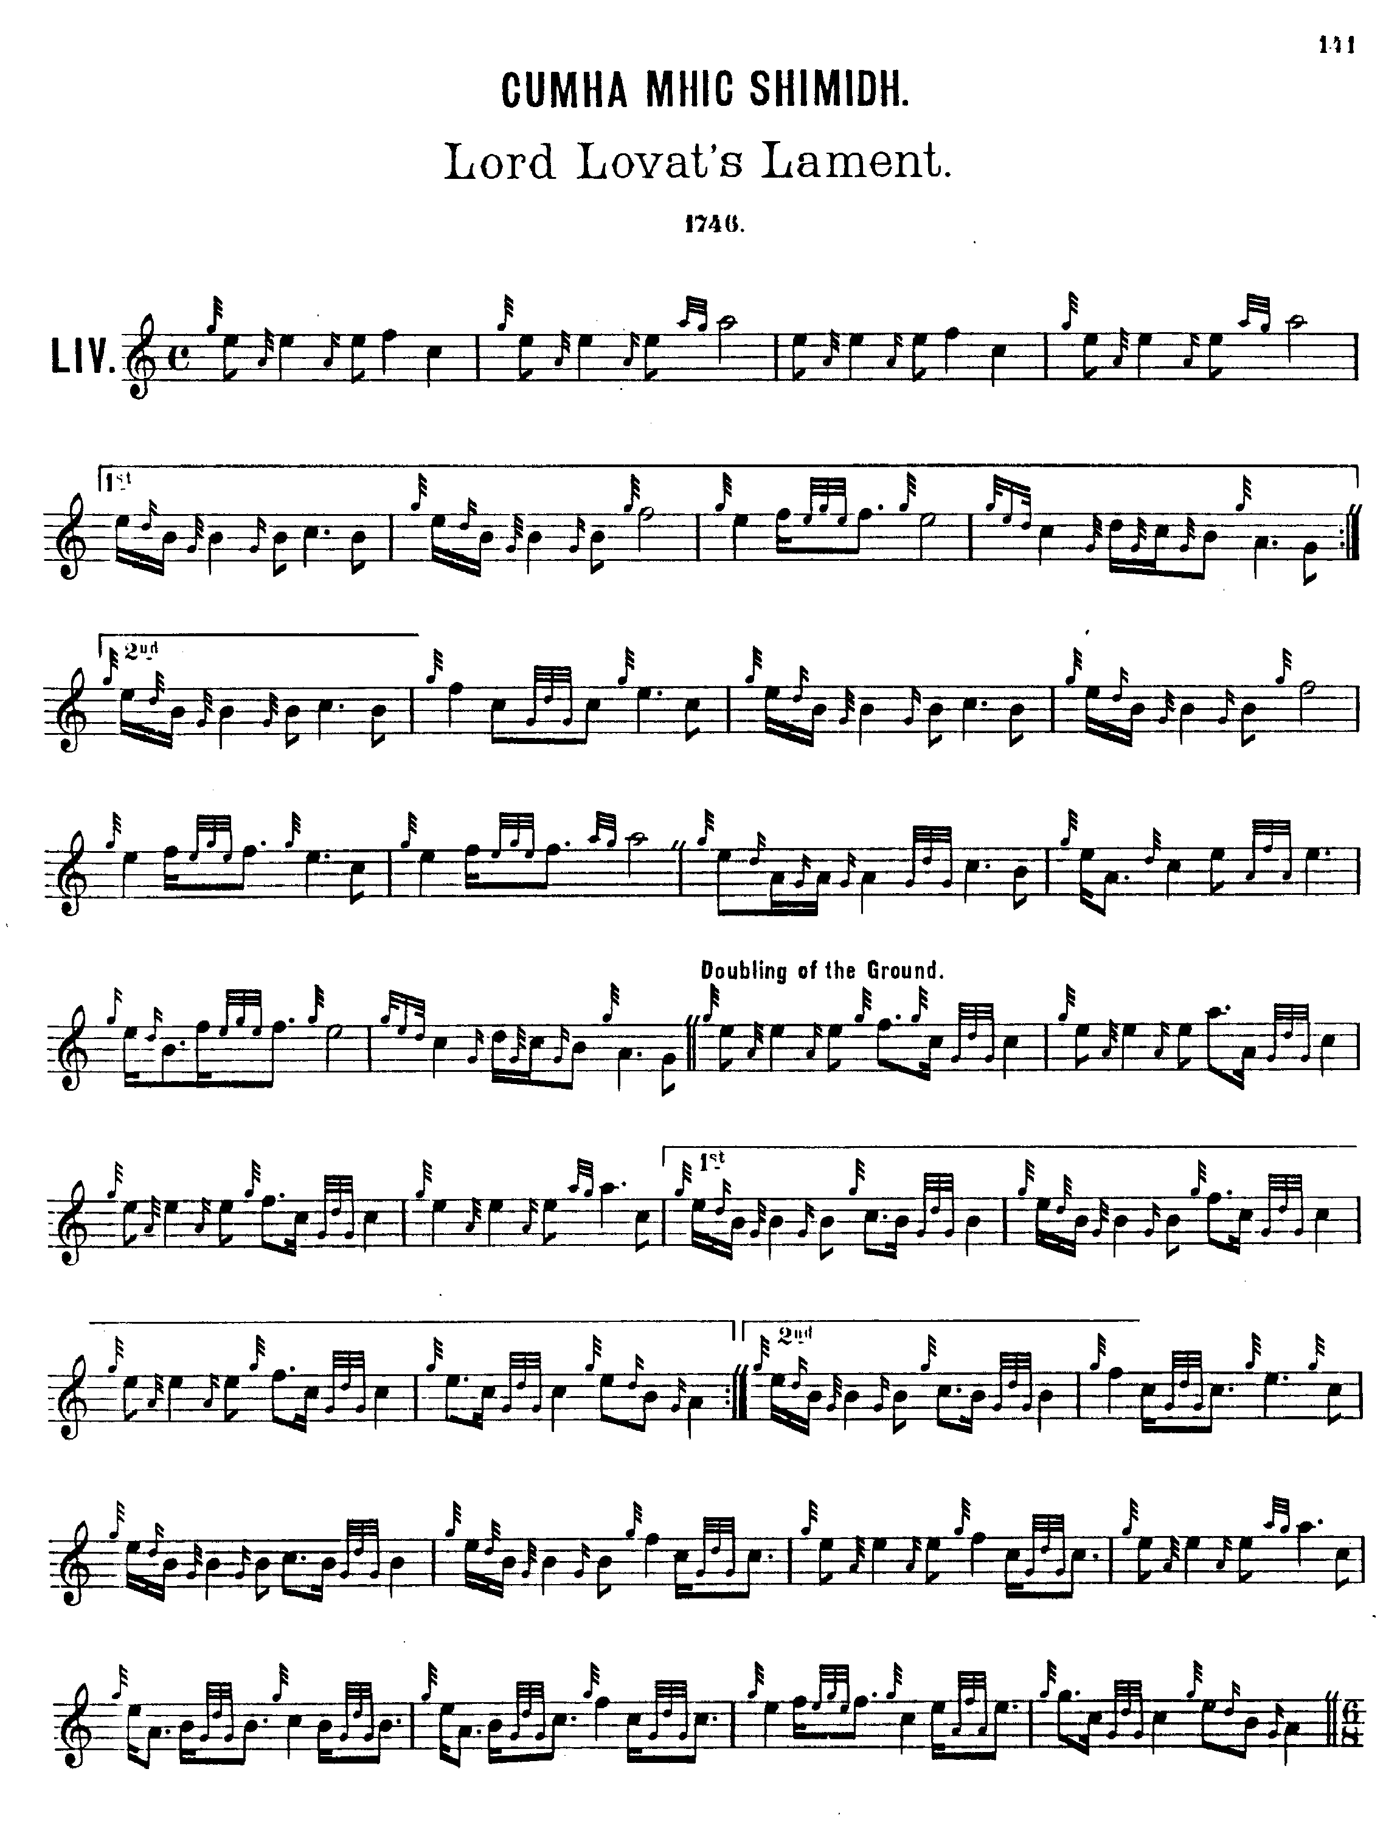
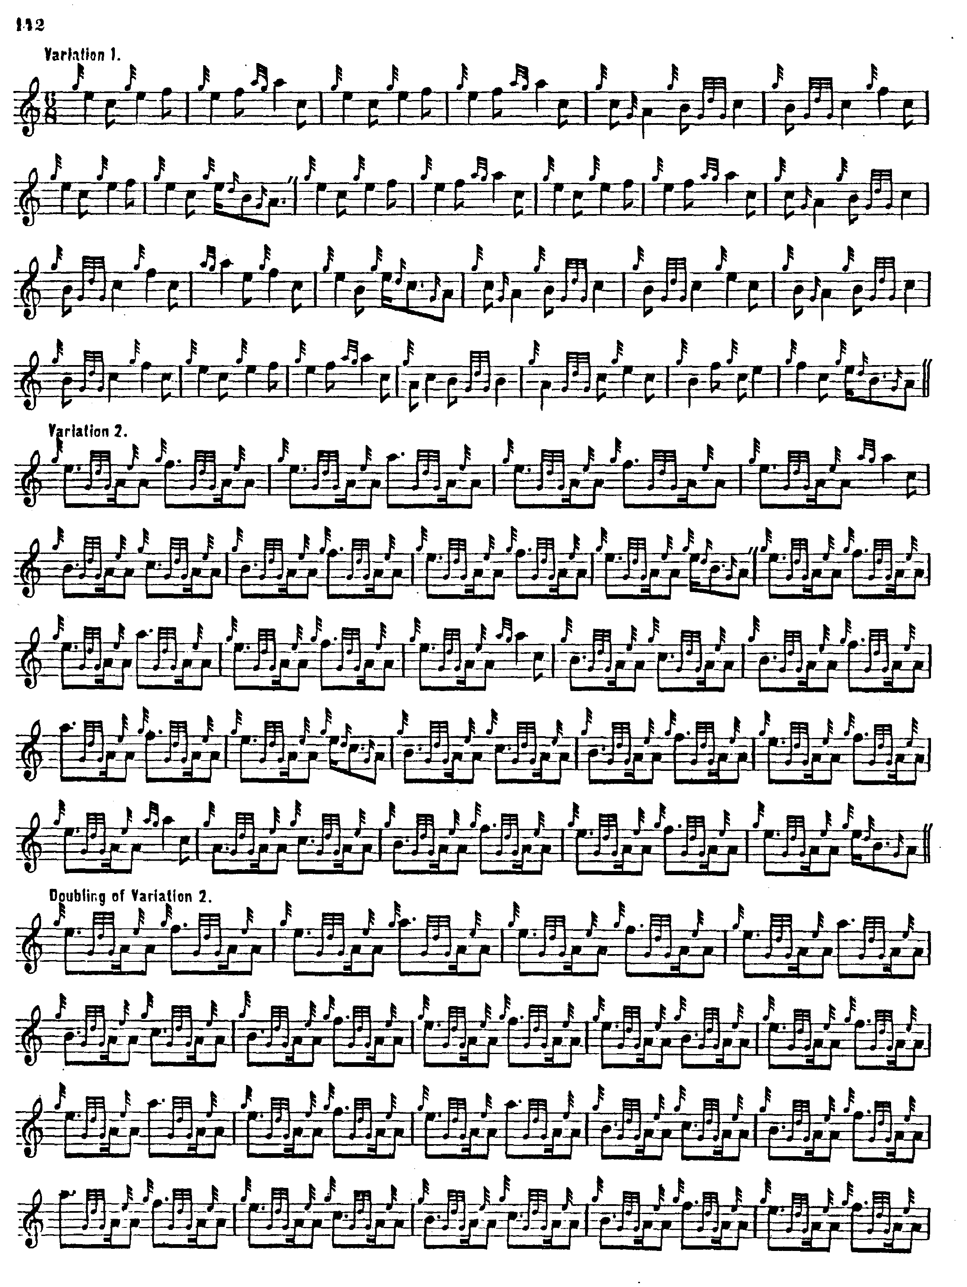
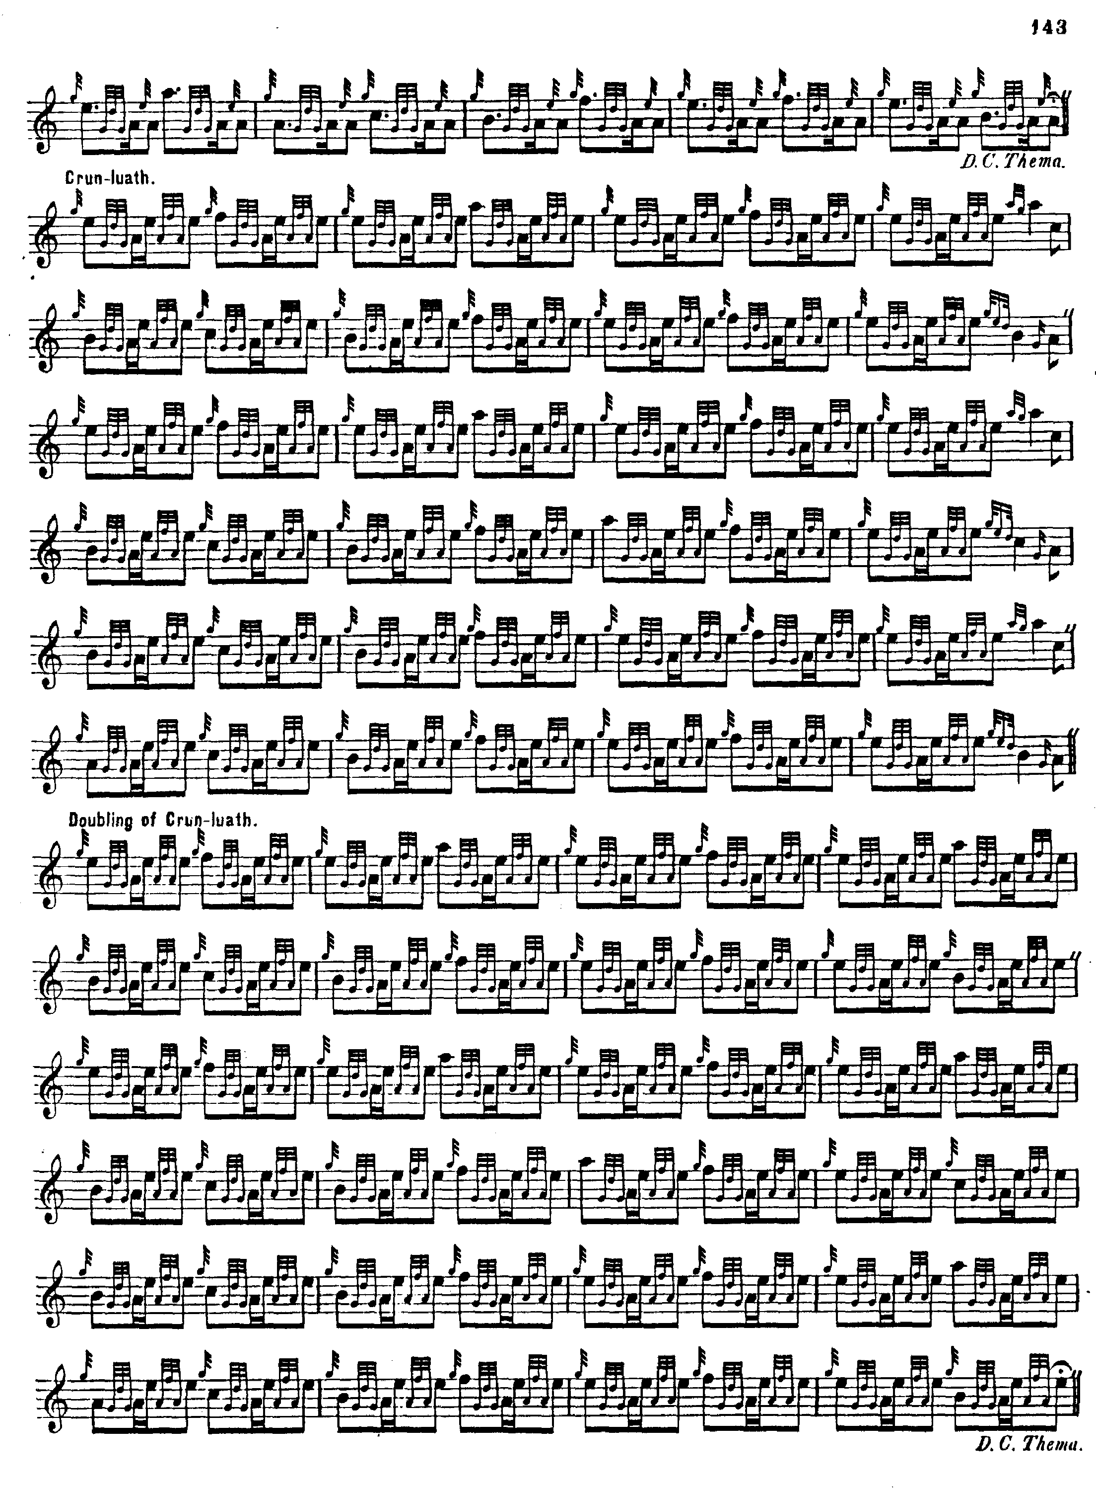

Ground: 8 10 4
doubling of ground: 8 10 4
variation one: 8 8 10
taorluath singling: 8 8 8
taorluath doubling: 8 8 8
ground
crunluath singling: 8 8 8
crunluath doubling: 8 8 8
ground.

MacKay’s variations are regular as clockwork from the taorluath singling onwards, three lines of eight bars each, twenty-four in all, while the ground and variation one range from 22 to 26 bars:

Subsequent editing of this tune shows various attempts to evolve a “regular” score on the basis of MacKay’s. There seems to be no other early source. Three of these scores have their source in Simon Fraser.

The first of these was published in David Glen’s Ancient Piobaireachd, where it was described as “Communicated by Mr Simon Fraser, Melbourne, Australia.” It is structured as follows:
ground 8: 8 8
variation one 8: 8 8
variation two 8: 8 8
taorluath singling 8: 8 8
taorluath doubling 8: 8 8
ground
crunluath singling 8: 8 8
crunluath doubling 8: 8 8
ground

Glen’s score treats the tune like this:

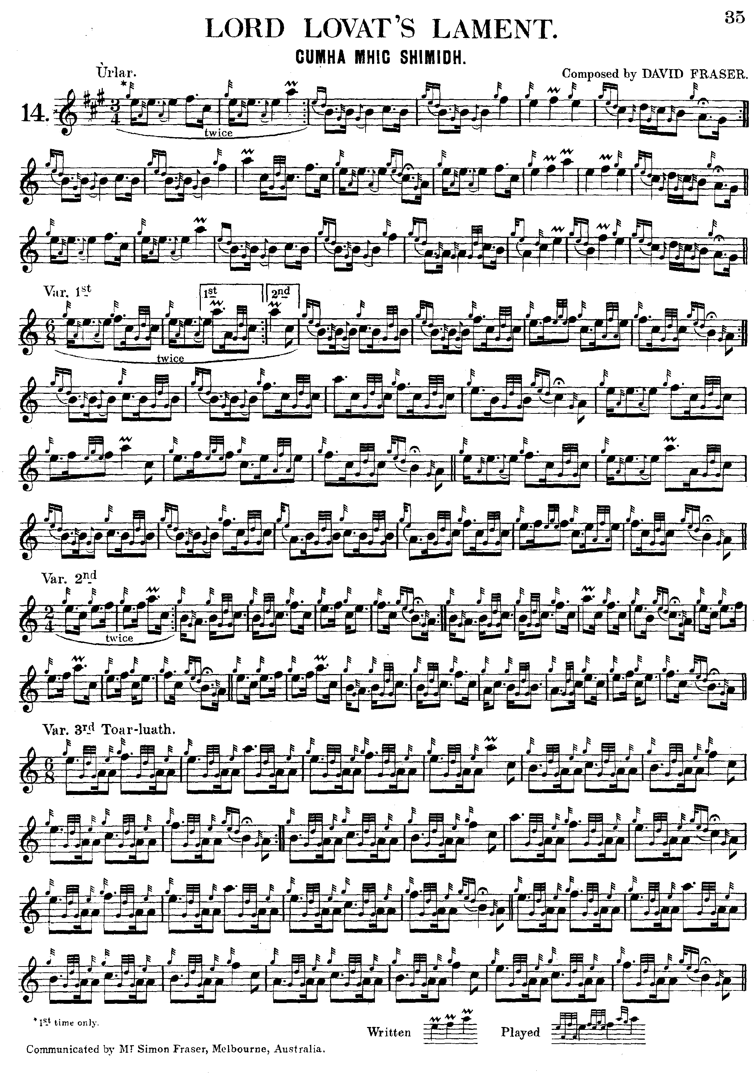

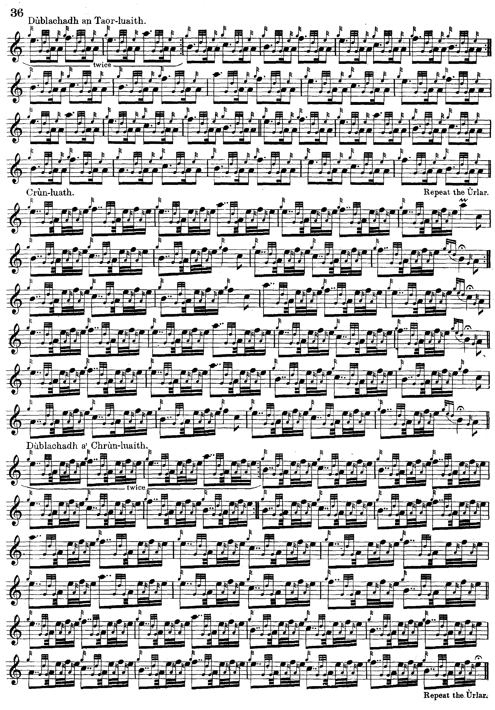

Comparing this with the setting published by Archibald Campbell in the ninth volume of the Piobaireachd Society Collection (second series, pp.248-9)—which also gives Simon Fraser as a source--it is obvious, firstly, that the two versions are significantly different from each other and, secondly, that Glen’s is musically the better of the two.

In B. J. MacLachlan Orme’s edition of Simon Fraser’s tunes, two settings of “Lord Lovat’s Lament” are given; the first is Glen’s but the second is different in a number of respects from that published by the Piobaireachd Society, so that altogether three different settings of this tune appear to have had their origins in Simon Fraser. There are grounds for treating Fraser’s claims about his material with caution, and these are discussed in my book The Highland Pipe and Scottish Society (pp.408-414). But hopefully players would feel able to select material on the basis of its musical appeal rather than supposed “authenticity” or “authority.”

C. S. Thomason had two goes at this, of which the first will probably strike most people as the better setting. It is based on MacKay but made up to an 8 8 8 pattern throughout and makes an attractive playing score:

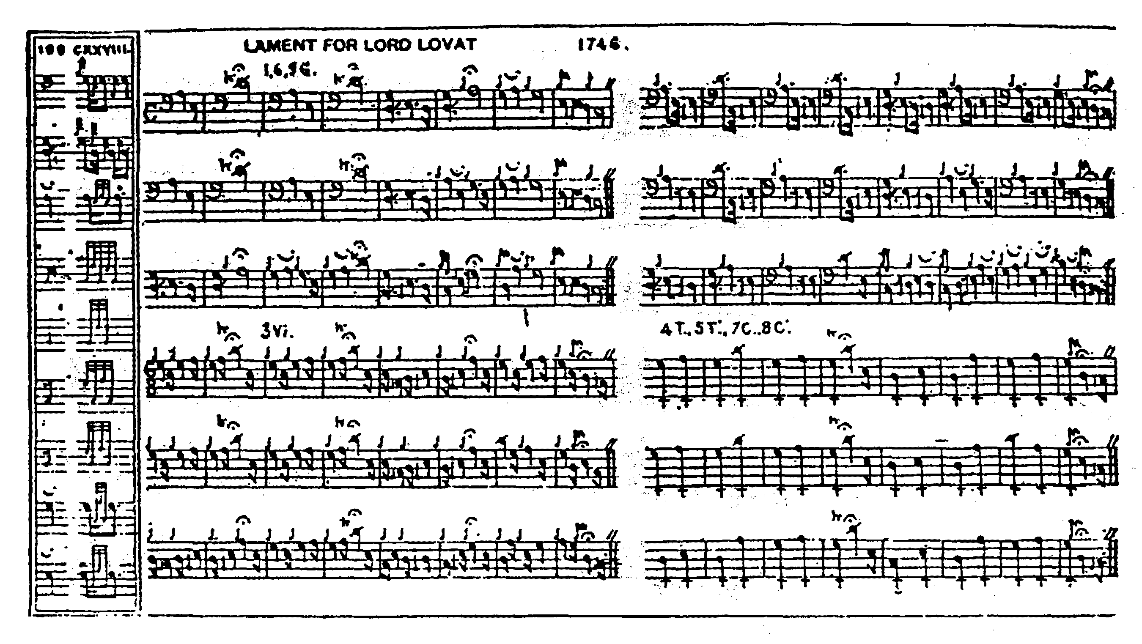

The Piobaireachd Society (first series) follows MacKay, but the Music Committee, (then comprising Capt. Colin MacRae, John Bartholomew of Glenorchard and Stewart MacDougall of Lunga) took the unusual step of indicating “superfluous” bars in the variations which they suggested could be dropped to make them square with the ground:

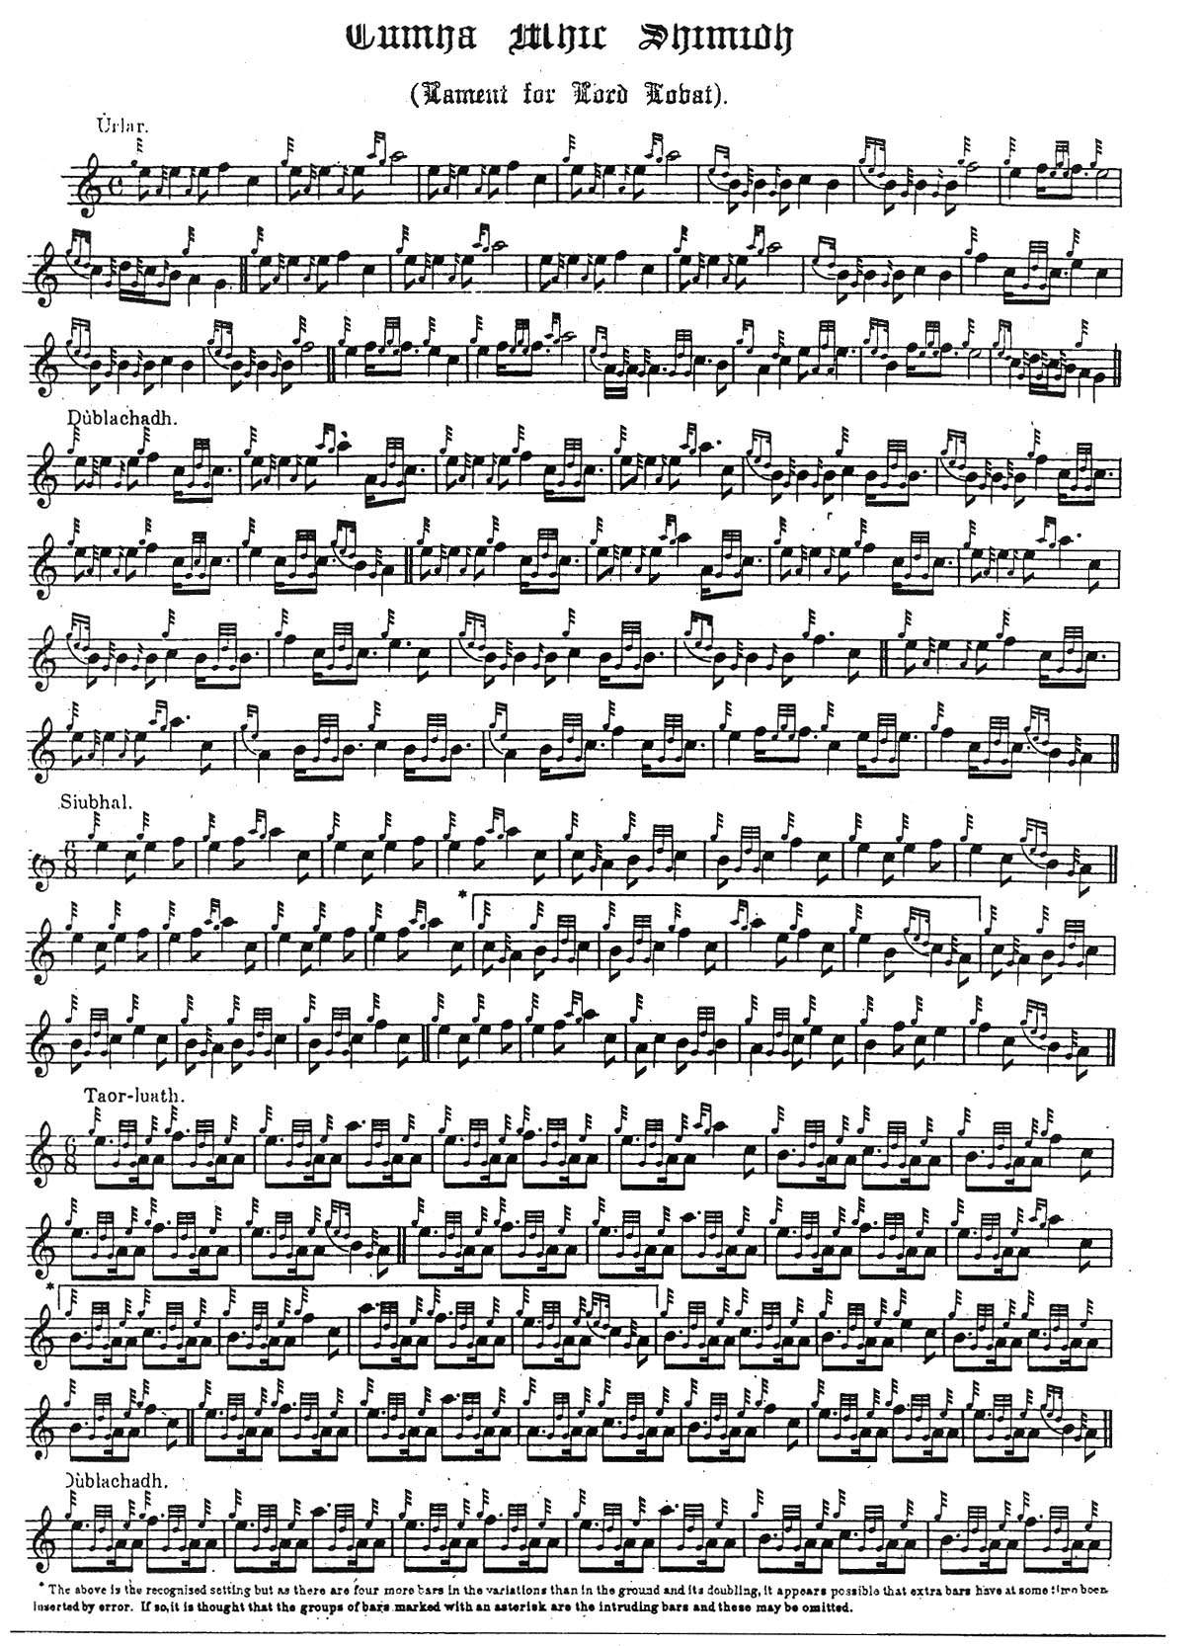
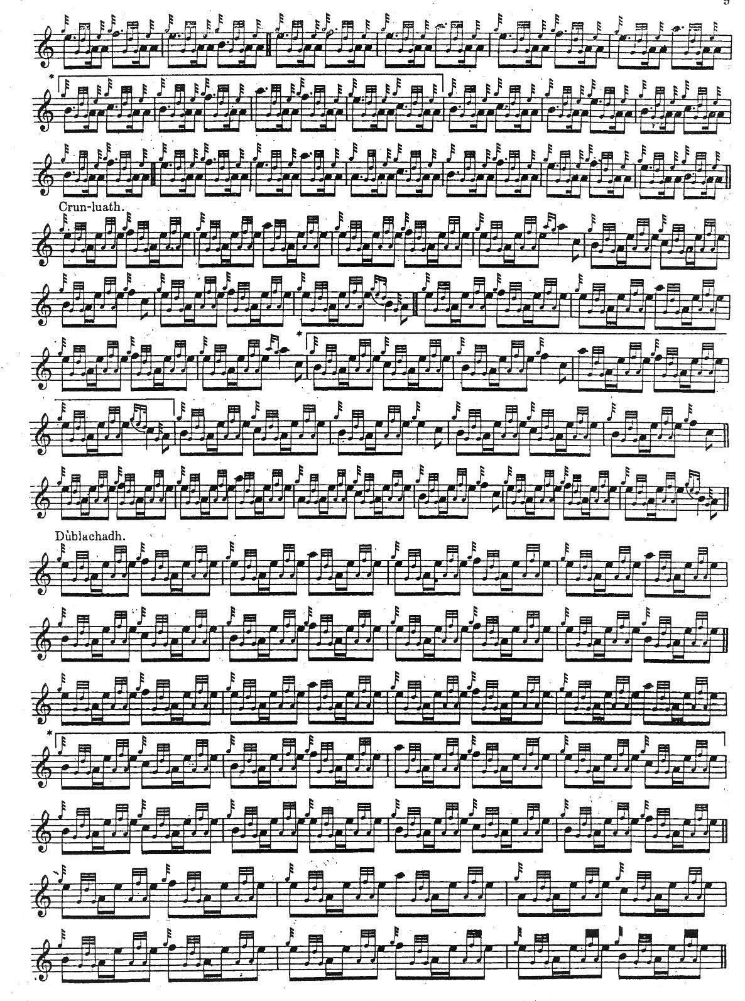

Robert Meldrum follows Angus MacKay’s published version in his ground, but his tone row is different in the taorluath and crunluath variations. He adds little to the stylistic possibilities of the tune, however, and his score is not reproduced here.

G. F. Ross weighs the structural features of the various versions in a judicious note and prints a version of MacKay’s ground bringing it up to an 8: 8 8 pattern amended in the light of David Glen’s setting:

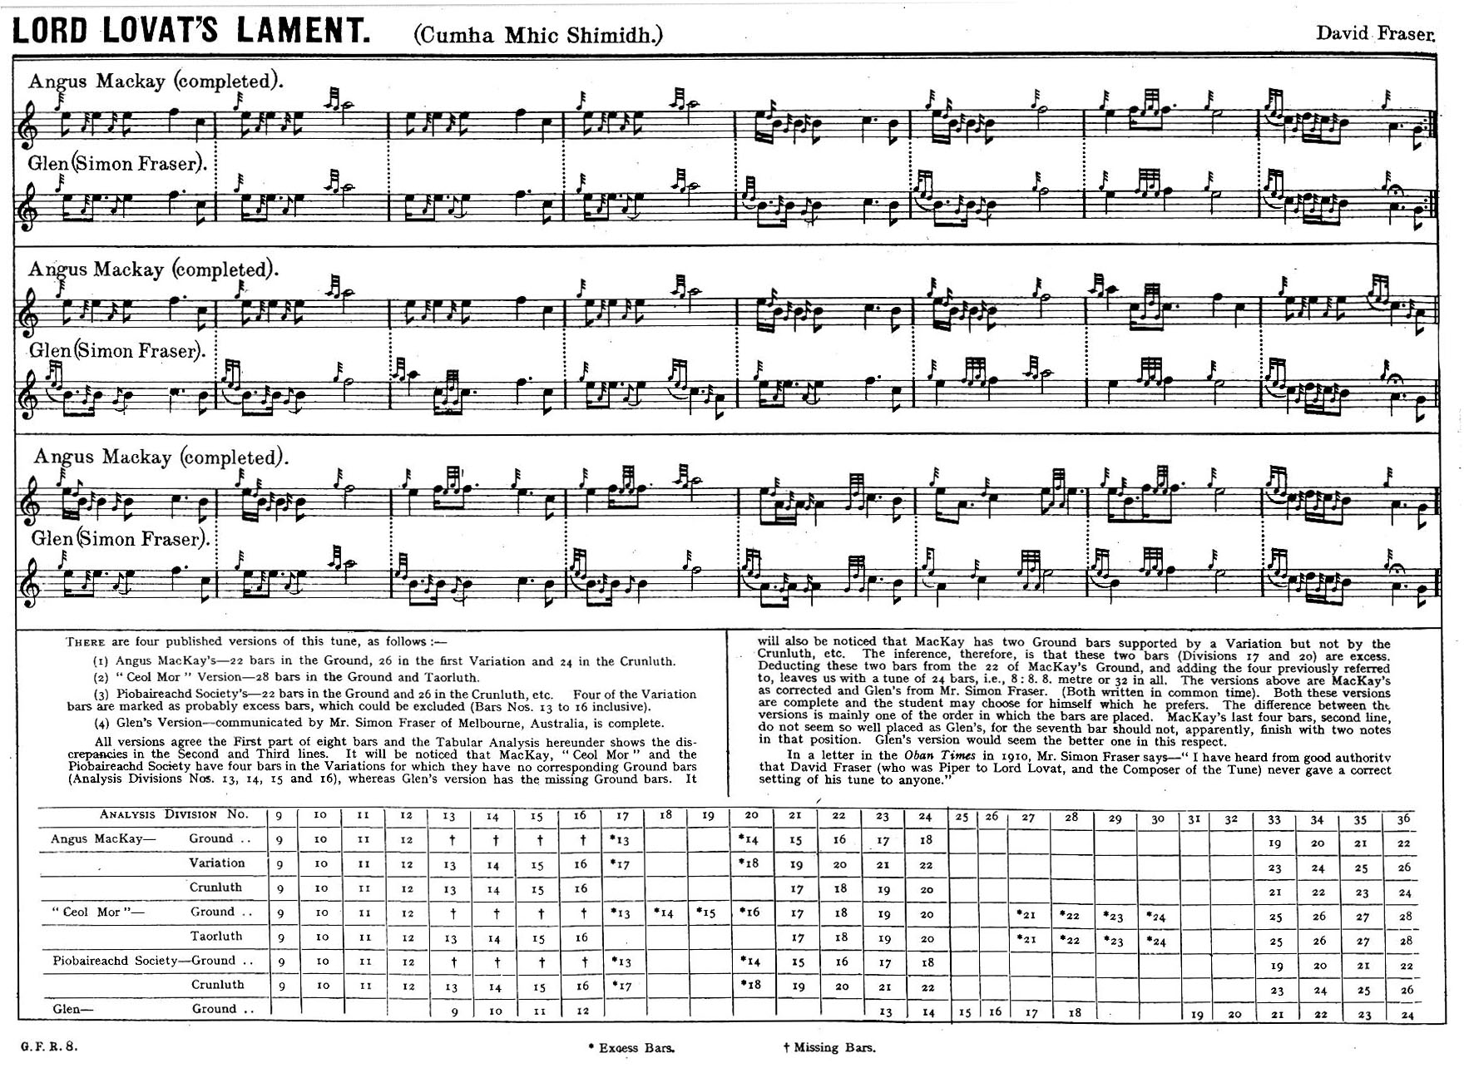

Commentary:

Lovat was a remarkable character, one of the great rogues of 18th century Scottish history and described as follows:

Simon Fraser, twelfth Lord Lovat…a person too remarkable in history to be overlooked [despite] his want of public or private virtue… was the second son of Thomas Fraser of Beaufort, by Sybilla Macleod, daughter of the laird of Macleod, and was born at Beaufort, near Inverness, in the year 1667…careful to watch the tides, and to take advantage of every wind that might ruffle the ocean of politics, his eye was steadily fixed upon the estate of Lovat, which, as his cousin Hugh, Lord Lovat had but one daughter, he had already marked out as his own. (Robert Chambers Biographical Dictionary of Eminent Scotsmen Edinburgh 1855, iv, 385-405).

On the death of his cousin in 1698 Simon Fraser assumed the title of Lord Lovat, though it was many years before, with the help of Duncan Forbes of Culloden, he was able to secure the legal settlement of the estate. Thomas Carlyle described him as “tall and stately (and might have been handsome in his youth), with a very flat nose. His manners were not disagreeable, though his address consisted chiefly in gross flattery and in the due application of money. He did not make on me the impression of a man of a leading mind. His suppleness and profligacy were apparent.”

Following the Battle of Culloden Lord Lovat took refuge in various hiding places on his own estates and eventually with Macdonald of Morar. By now lame he was captured on an island in Loch Morar in June 1746 and taken in stages to London. He was executed on Tower Hill on 9th April 1747. Lovat is said to have looked forward to his internment in the family vault at Kirkhill with all the pipers from John o’ Groats to Edinburgh playing at his funeral. But the government refused to release his body for burial in Scotland.
Lovat was, said Sir John Clerk, “a man of bold, nimbling kind of sense, very vain of his clan, the Fraziers, and ready to sacrifice everything to their interest.”
His son was eventually allowed to buy back the family’s forfeited estates as a reward for raising two regiments and other service for the government. (W. C. Mackenzie, Lovat of the Forty-Five, Edinburgh 1935, pp. 169-75).

The family was to maintain its military commitments. The 16th Lord Lovat played a key role in recruitment to the Scottish regiments for the First World War and was responsible for the strong links between the War Office and the Piobaireachd Society of which he was President from 1907 until his death in 1933.

The absence of the tune in the 18th and 19th century manuscripts suggests that this may not have been a widely diffused piece: it all seems to come down ultimately from Angus MacKay.

Thomason’s approach to this tune sheds interesting light on his general editorial principles:

“Lord Lovat’s Lament”...I have never heard this played, and my appeals to piper friends for correction met with no success; but a record of D.[onald] Cameron’s correction of the first two lines, as given to me by D.[onald] MacKay, saved us. D. MacKay could not remember the correction for the third line and I had given up the air as lost. The corrections, as far as I had them, gave me a metre of 8, 12, 4, which left a deficiency of 4 bars in the last line to bring it into the 2, 3, 2 category. To discover the four missing bars I carefully studied the third lines of all the three line airs in my collection with the following results. Out of 189 pieces thus studied I found in 99 the first section of the third line the same as in the first line, in 38 more this was approximately the case, and in 44 the first and third lines did not conform at all. Under these circumstances I determined to supply my deficiency from the first line, and was not a little surprised when I began dealing with the Taorluath that A. MacKay had supplied half the deficiency, and from the same source. So I have every reason to be satisfied with that correction. (Ceol Mor, “Rhythm in Sections”, p.3)

Despite the numerous attempts to revise the tune, Bob Nicol said that John MacDonald taught him Angus MacKay’s version, and that he had never heard him play anything else.

* * *

Electronic text © Dr. William Donaldson, Aberdeen, Scotland, September 2006

