Lament for the Little Supper

This is a widely diffused tune, and is found in the following manuscript sources:
--Angus MacKay’s MS, ii, 16-17;
--Colin Cameron’s MS, f.52;
--Duncan Campbell of Foss’s MS, ff.34-36;
--Uilleam Ross’s MS, ff.237-238;
--C. S. Thomason’s MS, f.33;
--D. S. MacDonald’s MS, i, 6-7
--John MacDougall Gillies’s MS, f.54;
--David Glen’s MS, ff.38-39;
--The McLennan Papers, NLS. Acc. 11516/8, f.24;
--Robert Meldrum’s MS, f.216;

and in the following published source:
--C. S. Thomason, Ceol Mor, p.229

Angus MacKay sets the tune as follows:

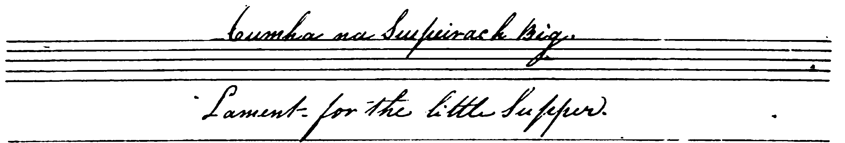
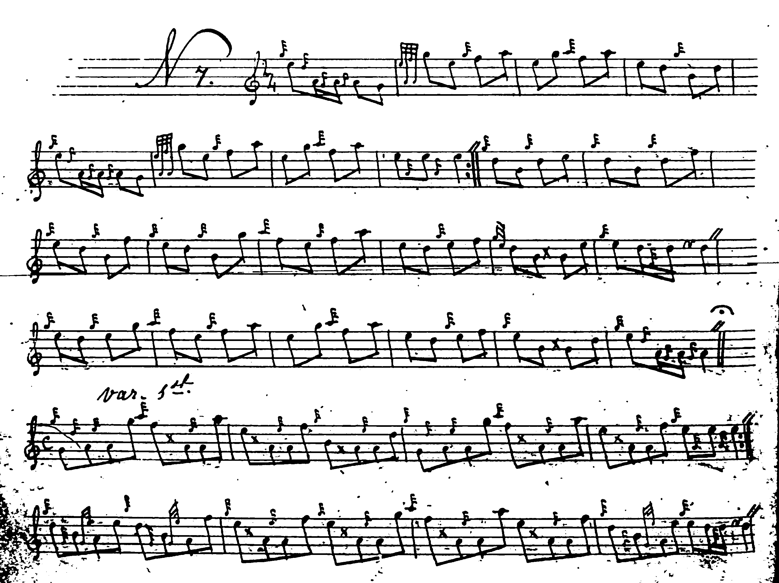
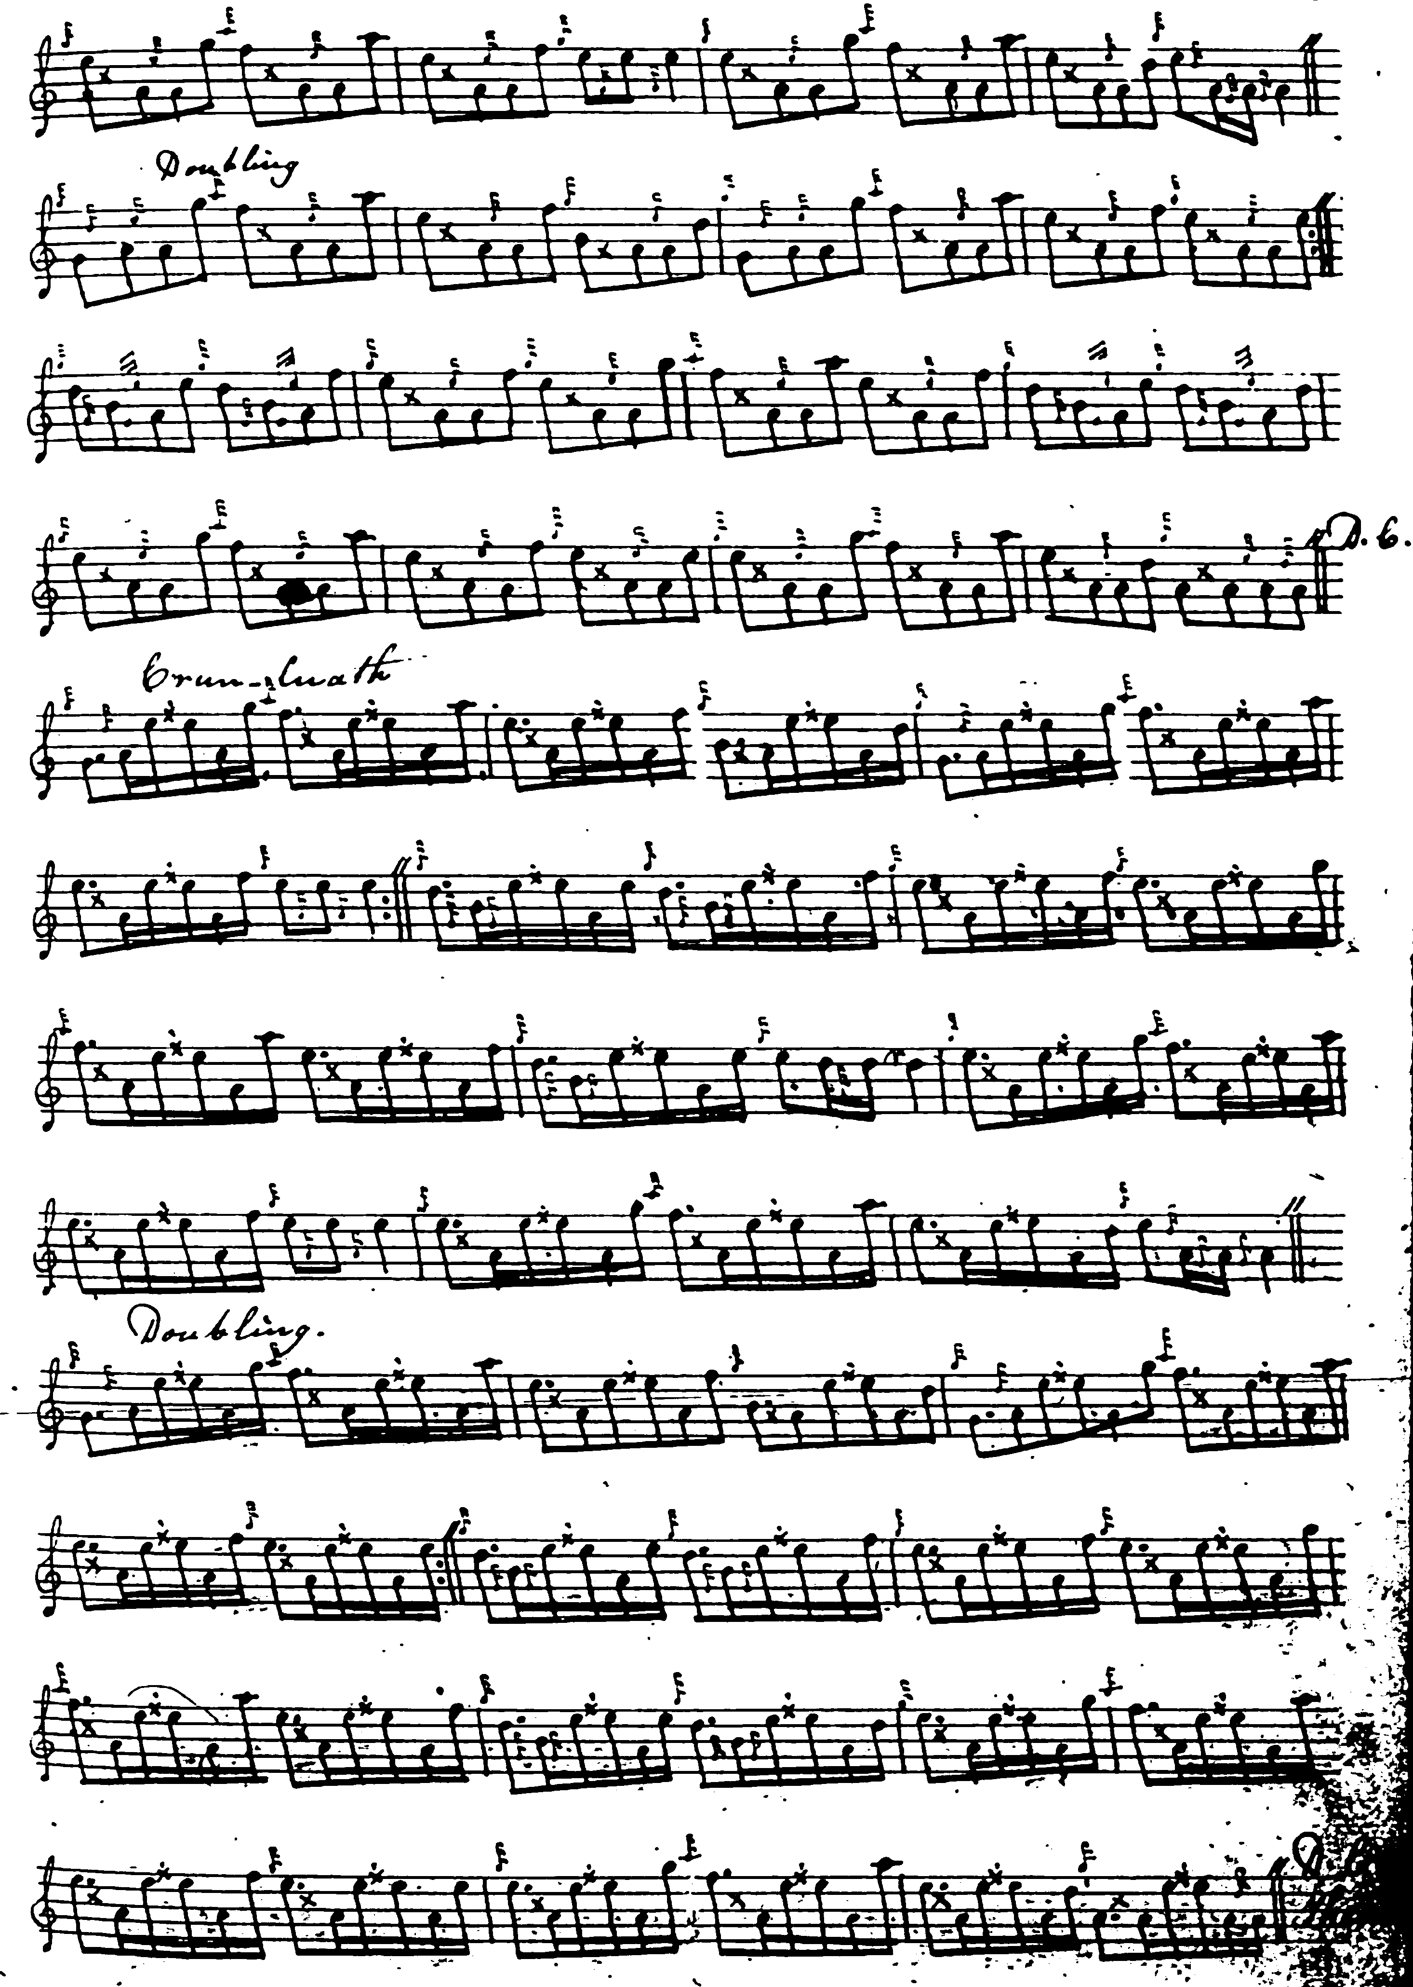

The score is set, as Angus MacKay’s frequently are, as even quavers, giving the interpreter considerable scope for variations of timing. His structure in the ground is irregular. “The Lament for the Little Supper” seems intended to be an even-lined tune of four lines, but MacKay comes out at 8, 8, 8, 6, in the ground, although his variations are regular. He develops the tune in the following manner: ground; taorluath breabach singling and doubling; ground; crunluath breabach singling, doubling; ground. Both breabach variations, taorluath and crunluath, are played “up”.

--Colin Cameron sets the tune as follows:

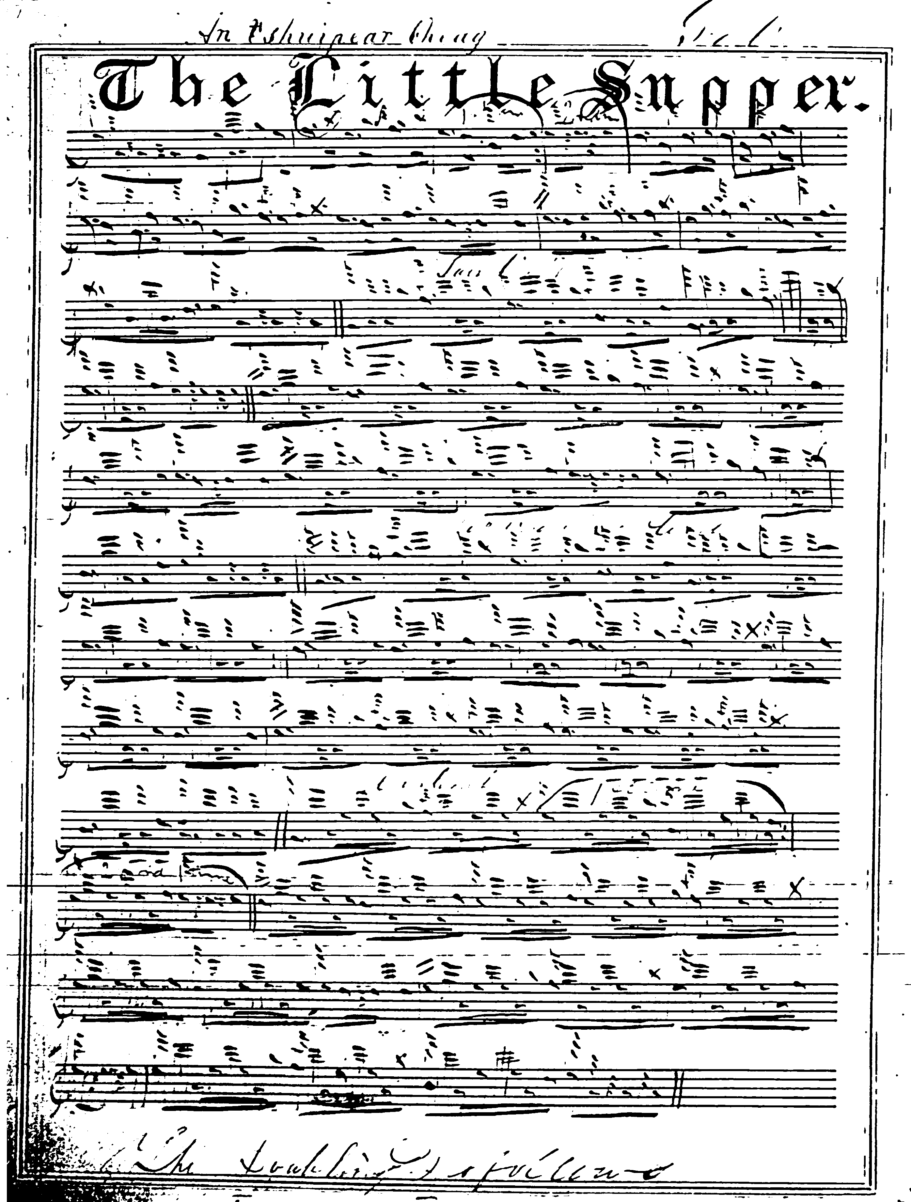

Colin Cameron’s setting is dotted and cut, giving a more precise view of the intended timing, but is “short” both in the third and fourth line of the ground.
Duncan Campbell of Foss, times the tune as follows:

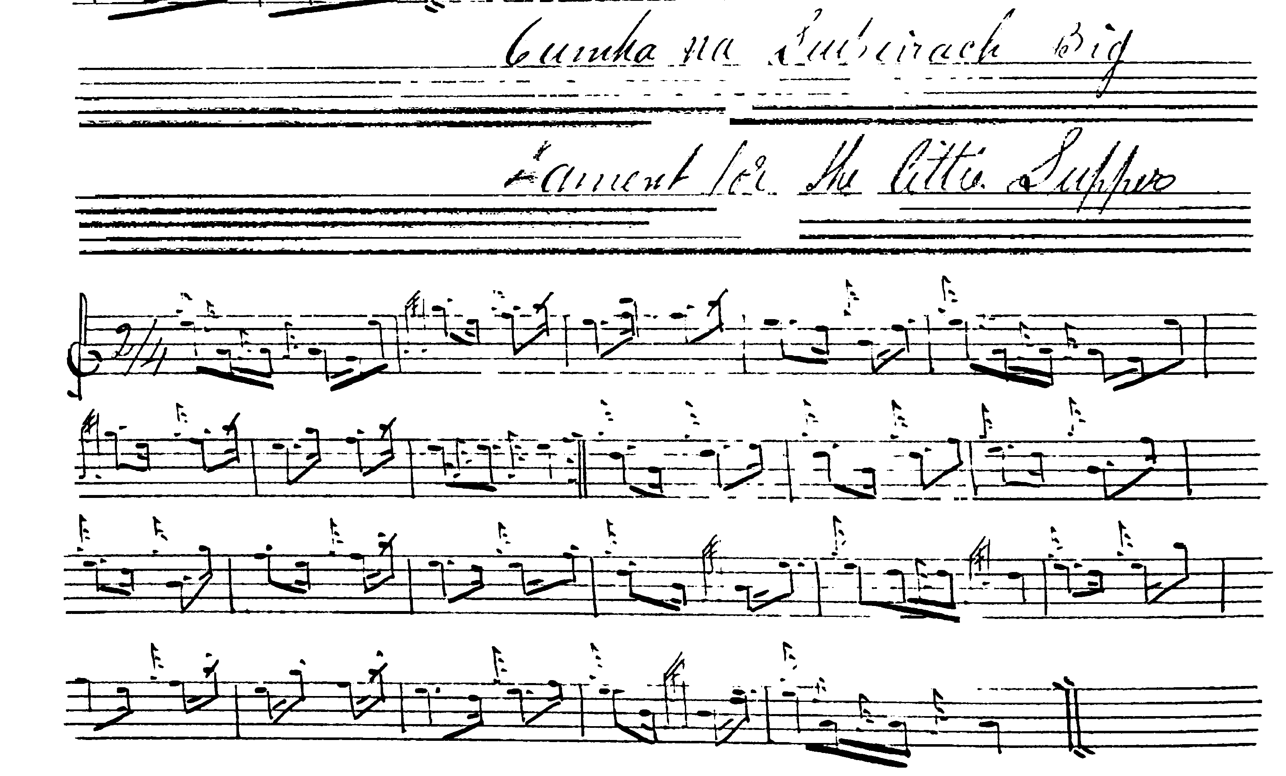
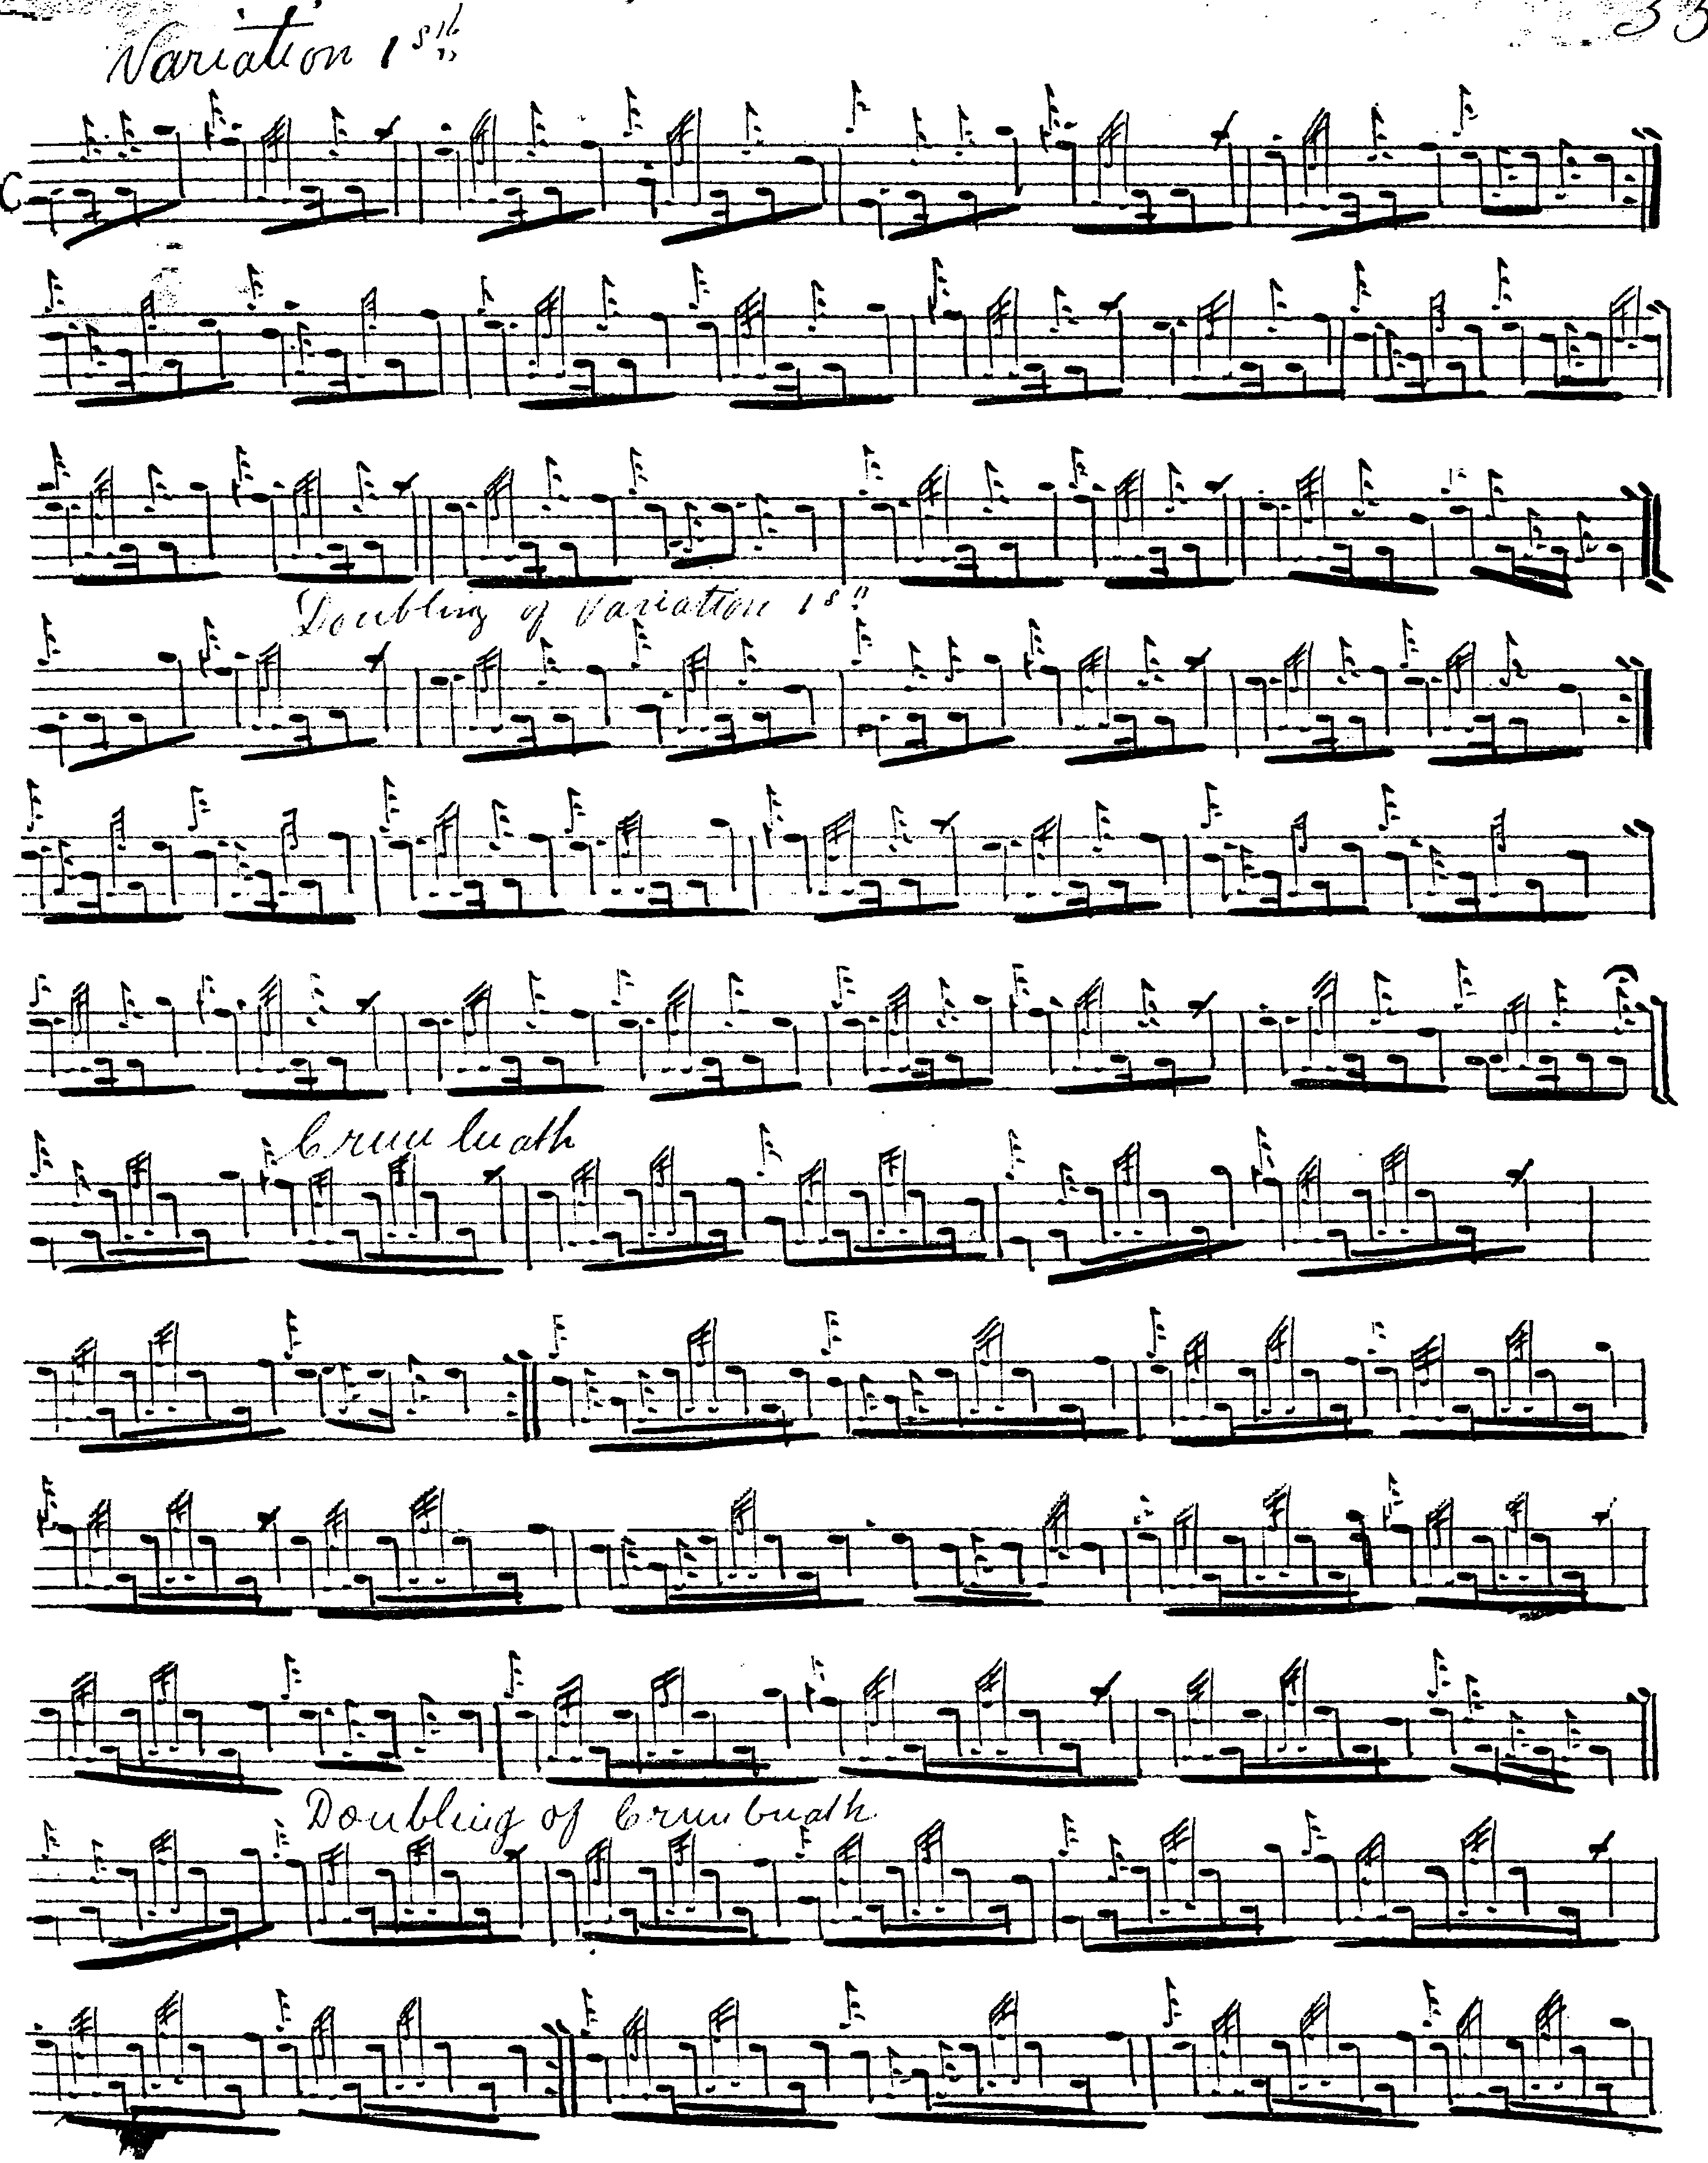
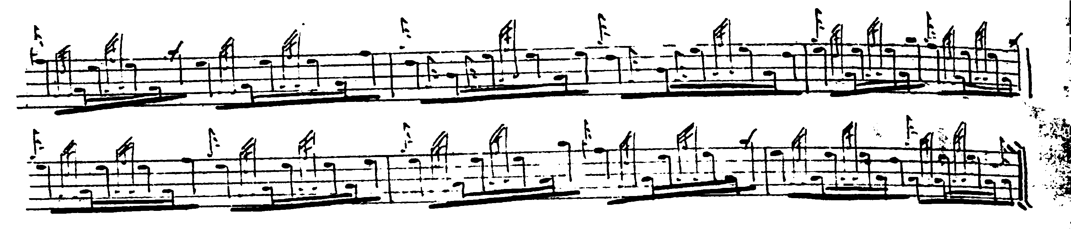

Once again, Duncan Campbell’s score is neatly dotted and cut, and is interesting in showing his intended timings; but it, too, is short in the last line of the ground, while the variations follow an even 4: 4, 4 pattern as in the other scores.
Uilleam Ross’s setting is very similar to Duncan Campbell’s and shows the same structural peculiarity in the ground. It is not reproduced here.

D. S. MacDonald, follows MacKay and is also “short” in the ground. This score is not reproduced here.

John MacDougall Gillies, is “short” in line 3 as well as line 4, and is not reproduced here.

C. S. Thomason presents the tune as follows:

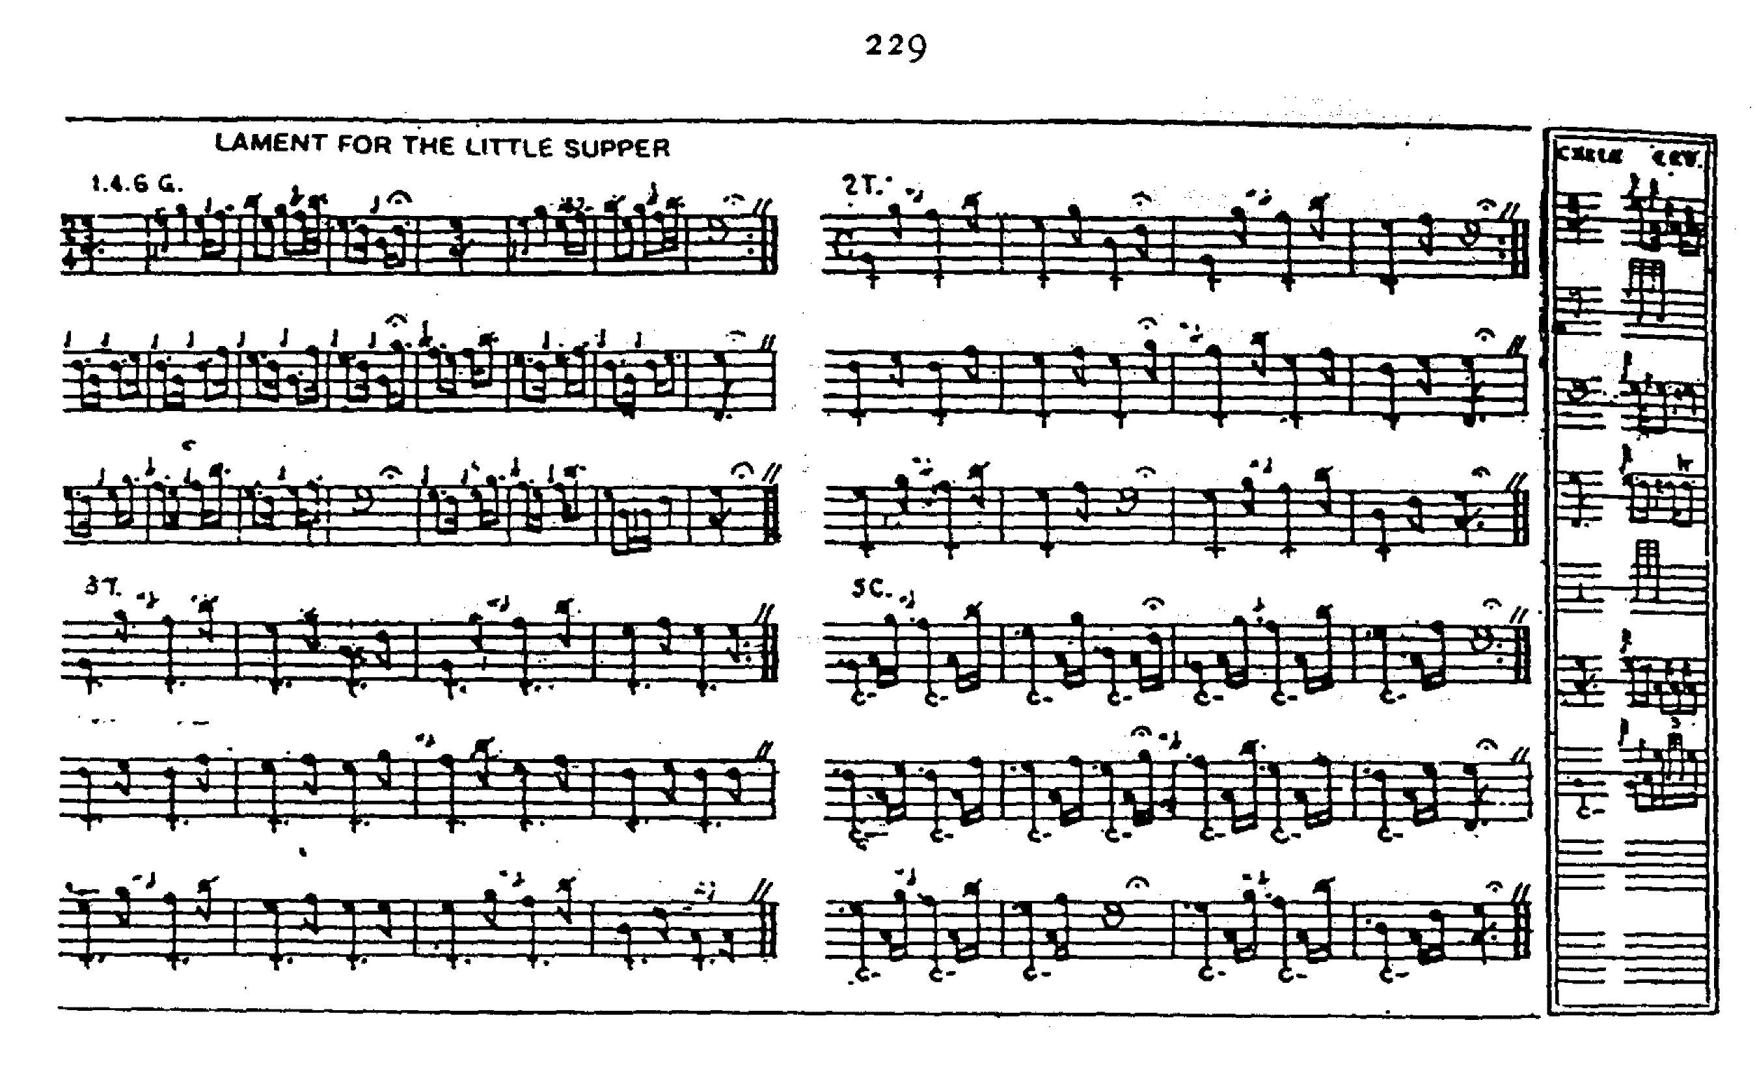

Thomason brings line four in the ground up to the “correct” proportions rather pleasingly, some might think, avoiding the weak repetition of phrase material which marks the proposed emendation in the Piobaireachd Society Collection (Second Series) viii, 237-8.

Another possible timing of line four might go like this:

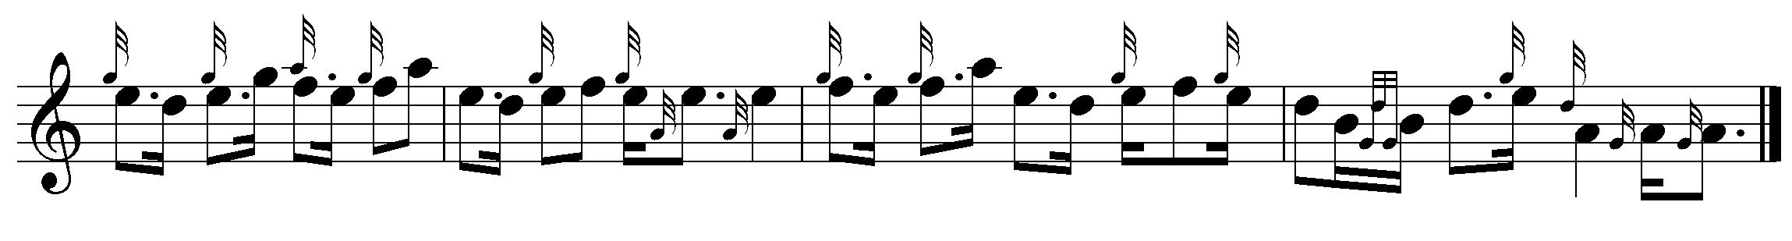

Thomason plays his taorluath breabach “down” and his crunluath breabach “up”.

David Glen, records Thomason’s “fix” for line four of the ground, and offers an alternative route not unlike the Piobaireachd Society score:

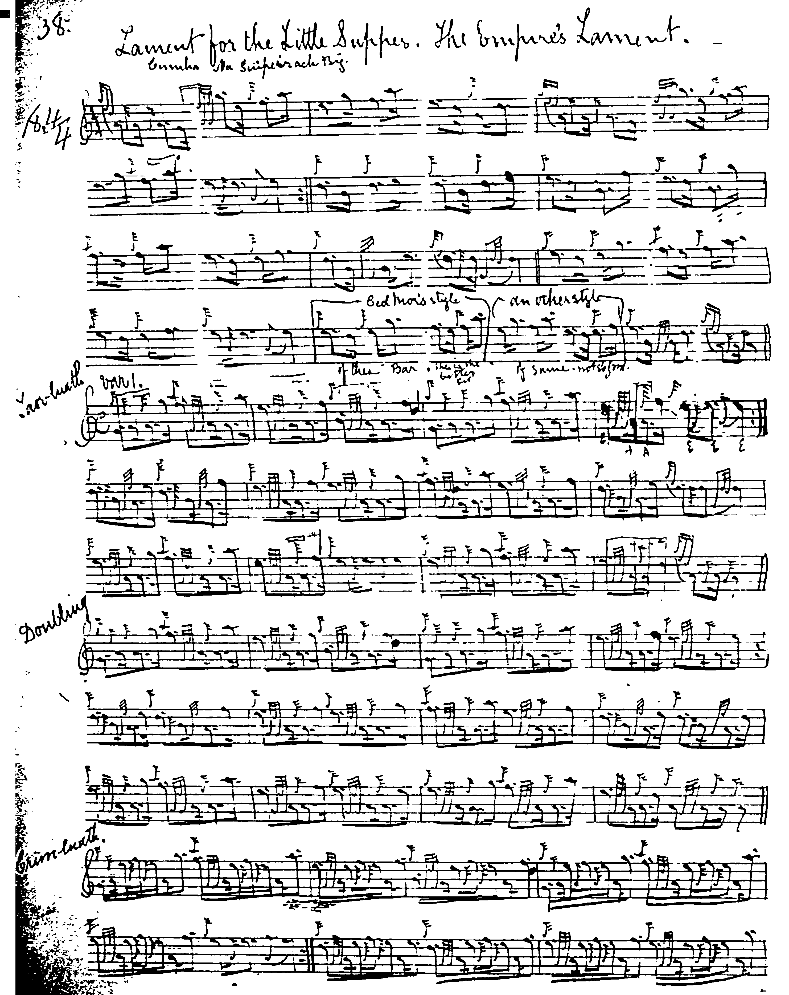

And so on.

Glen times his eallachs “down” in his usual style. Like Thomason he points his taorluath breabach “down” and his crunluath breabach “up”.

McLennan’s setting is roughed out merely. It shows his characteristic 4/2 timing with eallachs played “down”; but this score leaves the structural imbalance of the ground intact and is not reproduced here.

Robert Meldrum, sets the tune as follows:

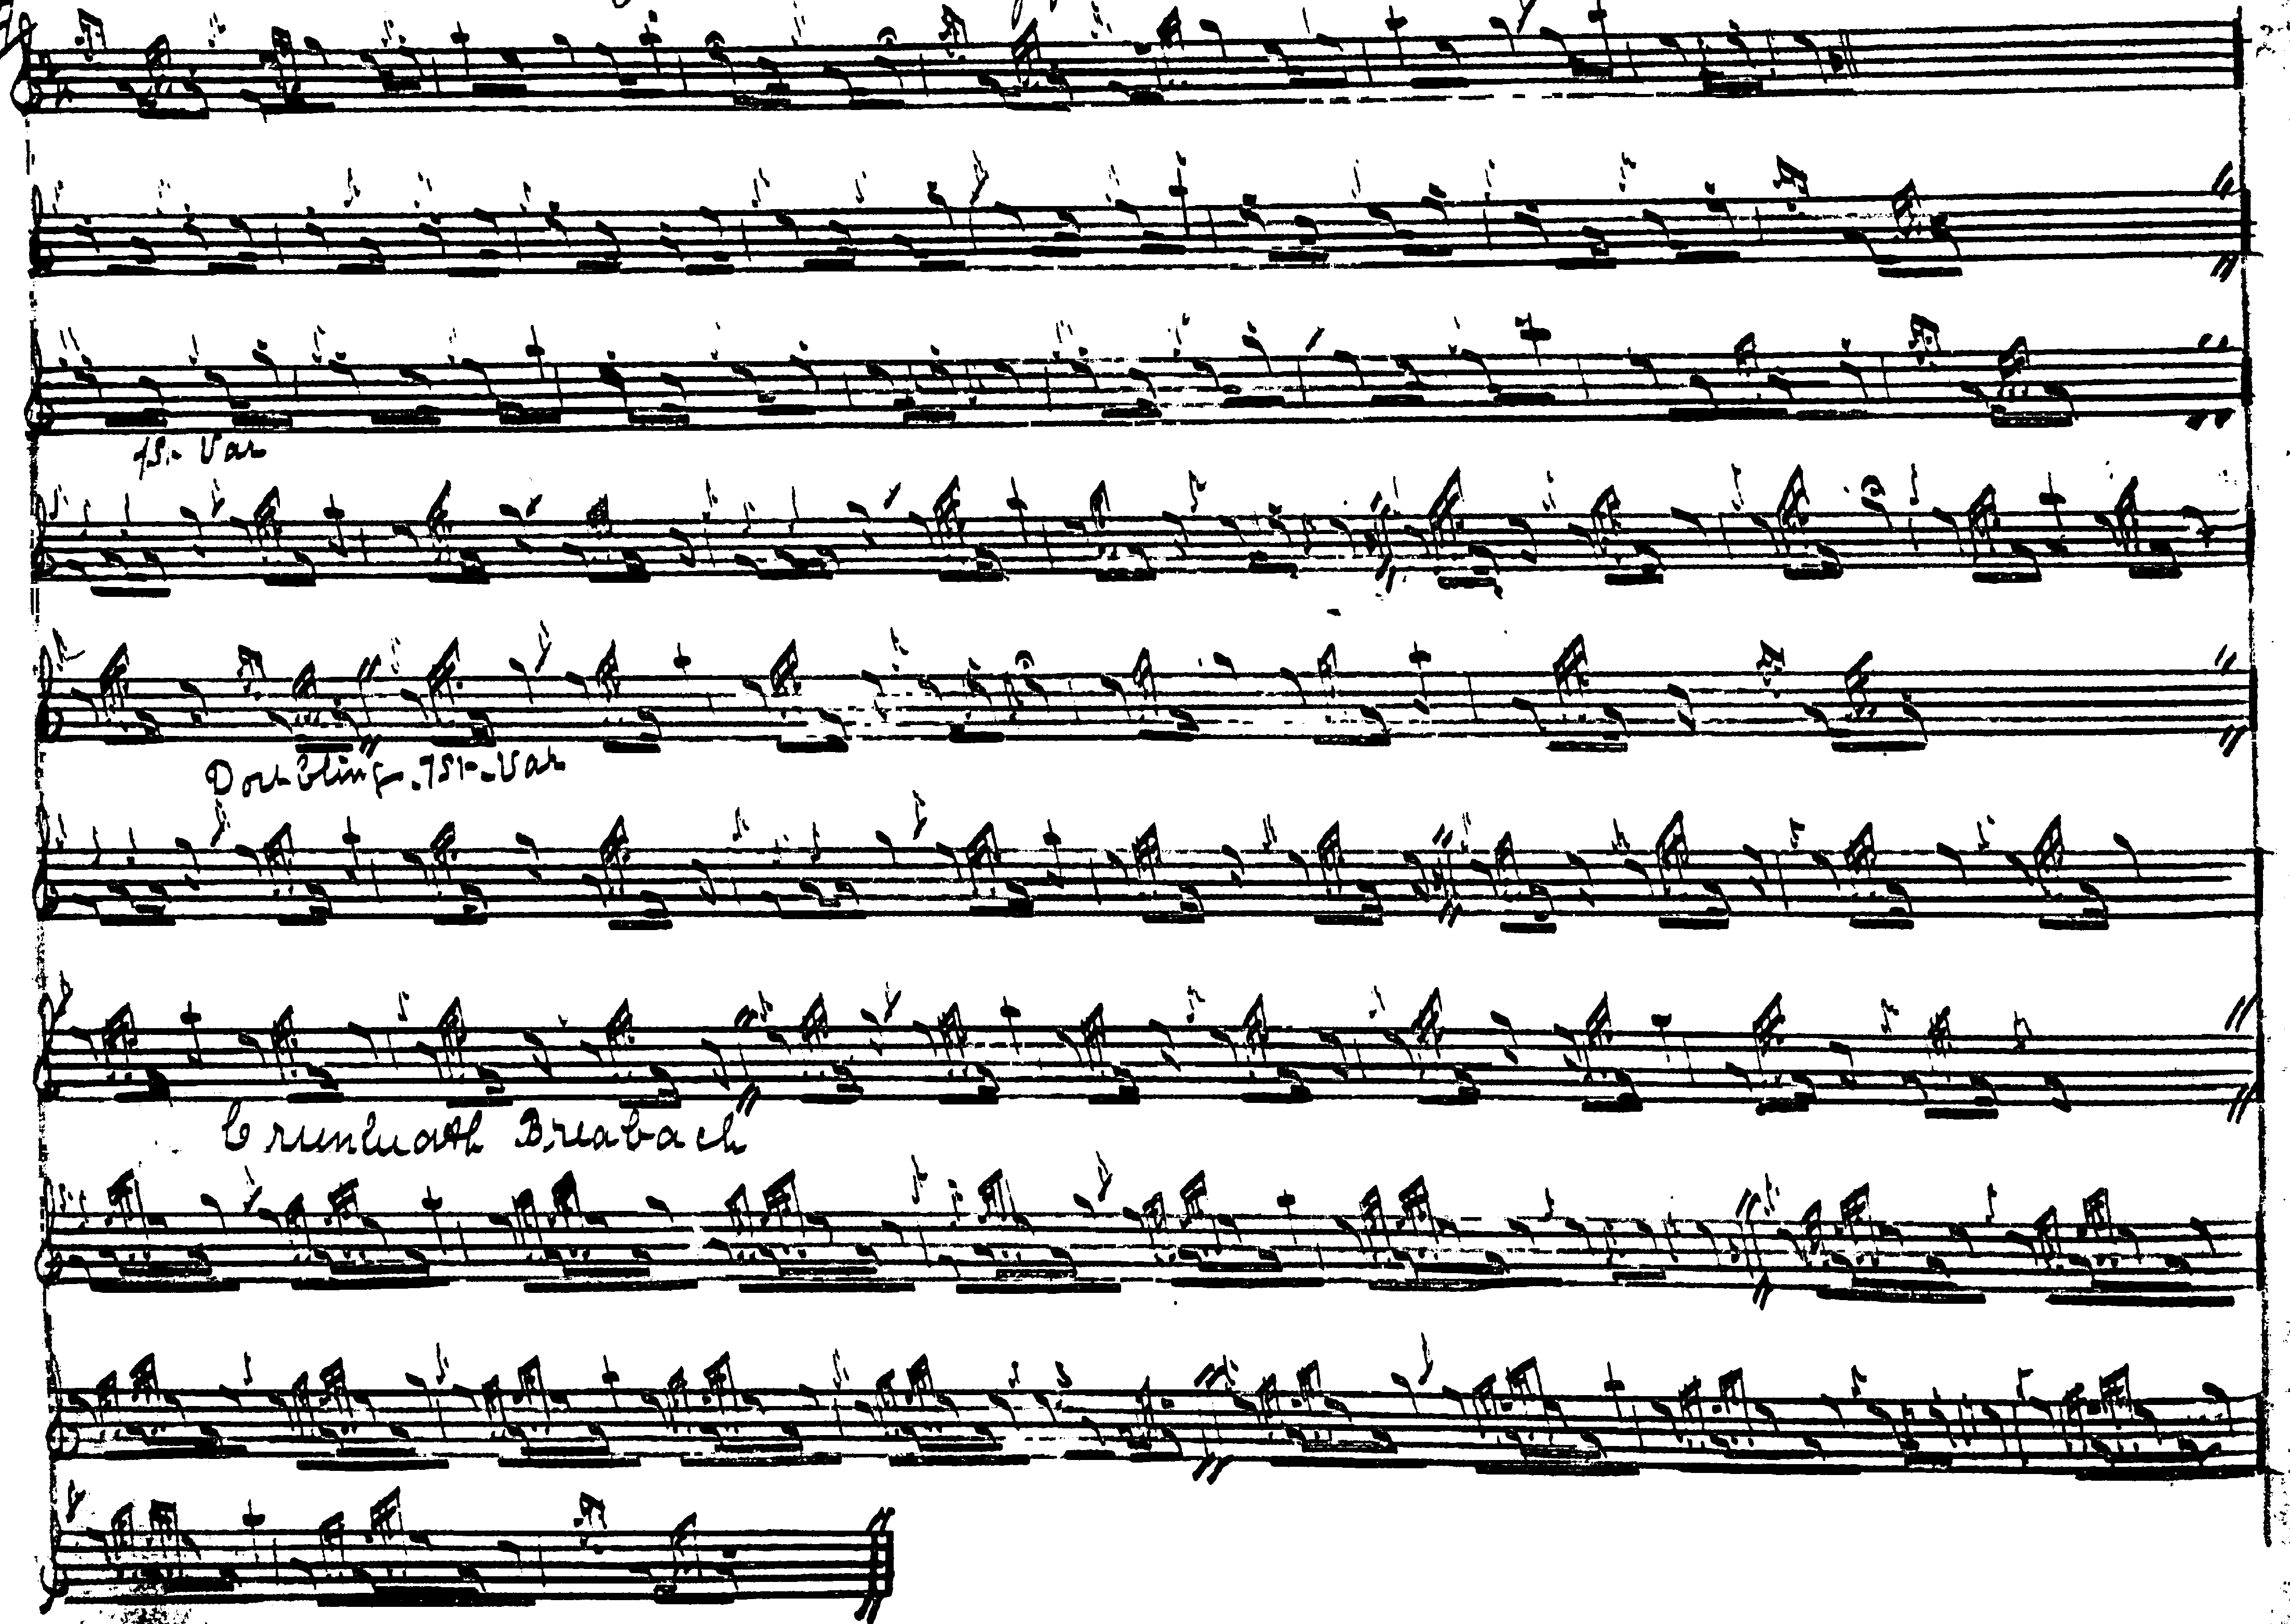

Rather interestingly, Meldrum returns to low A at the end of line three. Like several other of the idiomatic scores, he times his taorluath breabach “down” and his crunluath breabach “up”.

Commentary:
There are interesting echoes of this tune in “The Lament for the Great Supper” the opening of whose ground is very similar; but thereafter the tunes develop in a different manner.

In his “Ceol Mor Legends” General Thomason gives the story of “Lament for the Little Supper” as follows:

In 1872 when Donald MacKay was teaching me this Pibroch, I asked him if he could give me the story of it. He told me apparently the identical story which follows here, but could not tell me the name of the Clans concerned nor of the locality. He thought however that the locality was bordering on the Moray Firth. At one time I thought I had run it to earth in Speyside, but further inquiries in Elgin did not prove satisfactory. I have only lately come across the story in the ‘Seven Gardens and a Palace’ by E. V. B--page 156. published by John Lane 1900. I think the identification of the story is clear[...]
Haunted by its terrible tradition the scene once seen long ago looms gloomily afar. The Castle of Rait, near the town of Nairn, is founded upon a rock, yet it has not stood. Three roofless shattered walls forlornly pierced by empty windows & their broken transoms are all that remain of it; and the sky looks down upon a dismal hollow place of heaps and wildering thorns. Wintry winds mourn through & through with a sound of bitter wailing. Late Autumn suns glow with lurid light upon the walls & Summer's belated flowers bloom sweetly at their foot between the rocks and tumbled boulders. Not alone has stress of time and tempest rent and ruined the ancient stronghold. A curse is there, that ‘says us plain, no whisper in the ear, the place is haunted’. The story of Rait Castle lives but in dim traditions of the countryside. They tell of the Chief of the Cummings’ fatal feast, and how his guests of the Clan Chattan were to be treacherously slaughtered. All is ready as the Mackintoshes troop up the hill. Courteously they are welcomed & the banquet is begun and loud the revelry wore on into the night. Suddenly, the skirl of bagpipes shrills through the din of song and laughter resounding on the stair,--and one enters bearing a ghastly dish--a black bull’s head. Then the silent toast is given “The Memory of the Dead,” and at the signal the clan rise up to draw their swords each man upon his guest at his side. But Cumming’s daughter had secretly forewarned young Mackintosh her lover; and every Mackintosh had his dirk ready, hid under his plaid. Out flashed the blades as with a yell of derision the Mackintoshes flung themselves on the traitors, and plunged their daggers into their hearts. None but the Cummings’ chief escaped alive; and he, mad with rage, sprang up to the turret where his daughter had taken refuge, and as she flew to the window, trying to leap out and escape from her maddened father, with his broadsword he struck off both her hands.
...From that night of horror, ever after Rait has been desolate. Centuries have rolled away, the cruel tragedy is forgot,--only the blood-stained ruin on the hill stands in solitary, silent witness.” ff.370-372.

* * *

Electronic text © Dr. William Donaldson, Aberdeen, Scotland, October 2004; revised Old San Juan, Puerto Rico, January 2025.

