Lament for the Castle of Dunyveg

There are settings of this tune in the following manuscript sources:
--Colin Campbell’s “Nether Lorn Canntaireachd”, ii, 142 (with the title “A Glas”)
--Angus MacKay, i, 232-234;
--Colin Cameron, f.122;
--Duncan Campbell of Foss, ff.18-20;
--Uilleam Ross, ff.165-168;
--D. S. MacDonald, i, 50-52;
--John MacDougall Gillies, ff.36-7;
--David Glen, ff.32-34;

and in the following published source:

--C. S. Thomason’s Ceol Mor, p.225.

Colin Campbell’s setting has two parts only, a ground and first variation, thus:

Called A Glas
1st Hodinbain hodarodo hiharin hiharin cheenbain drehotra hodrodreho hiodin
2^{d} Hodinbain hodarodo hiharin hiharin hiodrodreho hiodrodareho hiodrodreho hihorodo hihorodo cheenbain drehotra hodrodre hiodin
3^{d} Hodinbain hodarodo hiharin hiharin cherede darihee hodro hoe heho cheo hiharin hiharin

D ffirst Motion
1st Dili hedarie hehodreo hiharin hiharin dili hedarie hehodreho hiodrodreho hiodin
2^{d} Dili hedarie hehodreo hiharin hiharin hiodrodreho hiodrodareeho hiodrodreho hihorodo hihorodo dili hedarie hehodreho hiodrodreho hiodin
3^{d} Dili hedarie hehodreo hiharin hiharin cherede dari Ihee hodrotroe heho ehio hiharin hiharin

Angus MacKay sets the tune as follows:

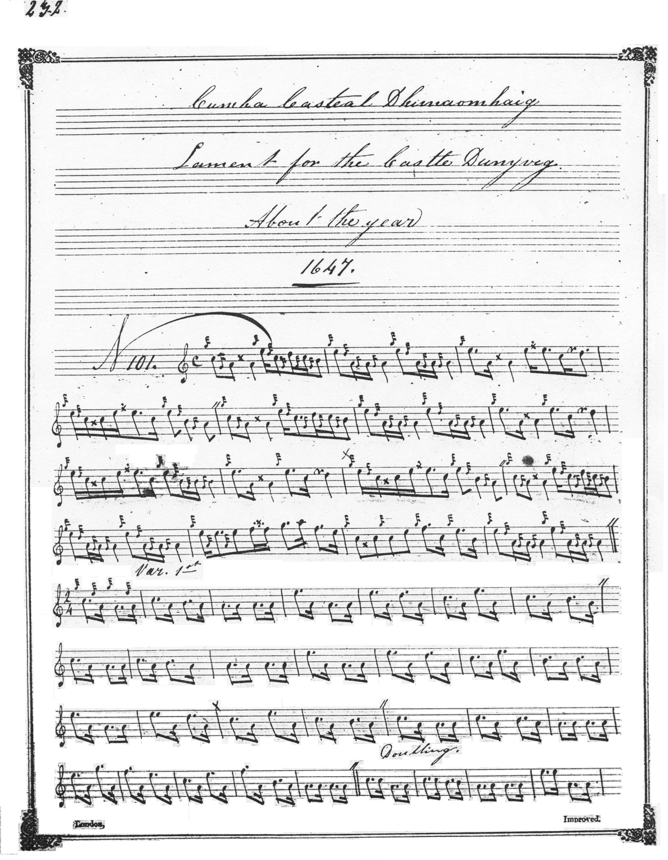
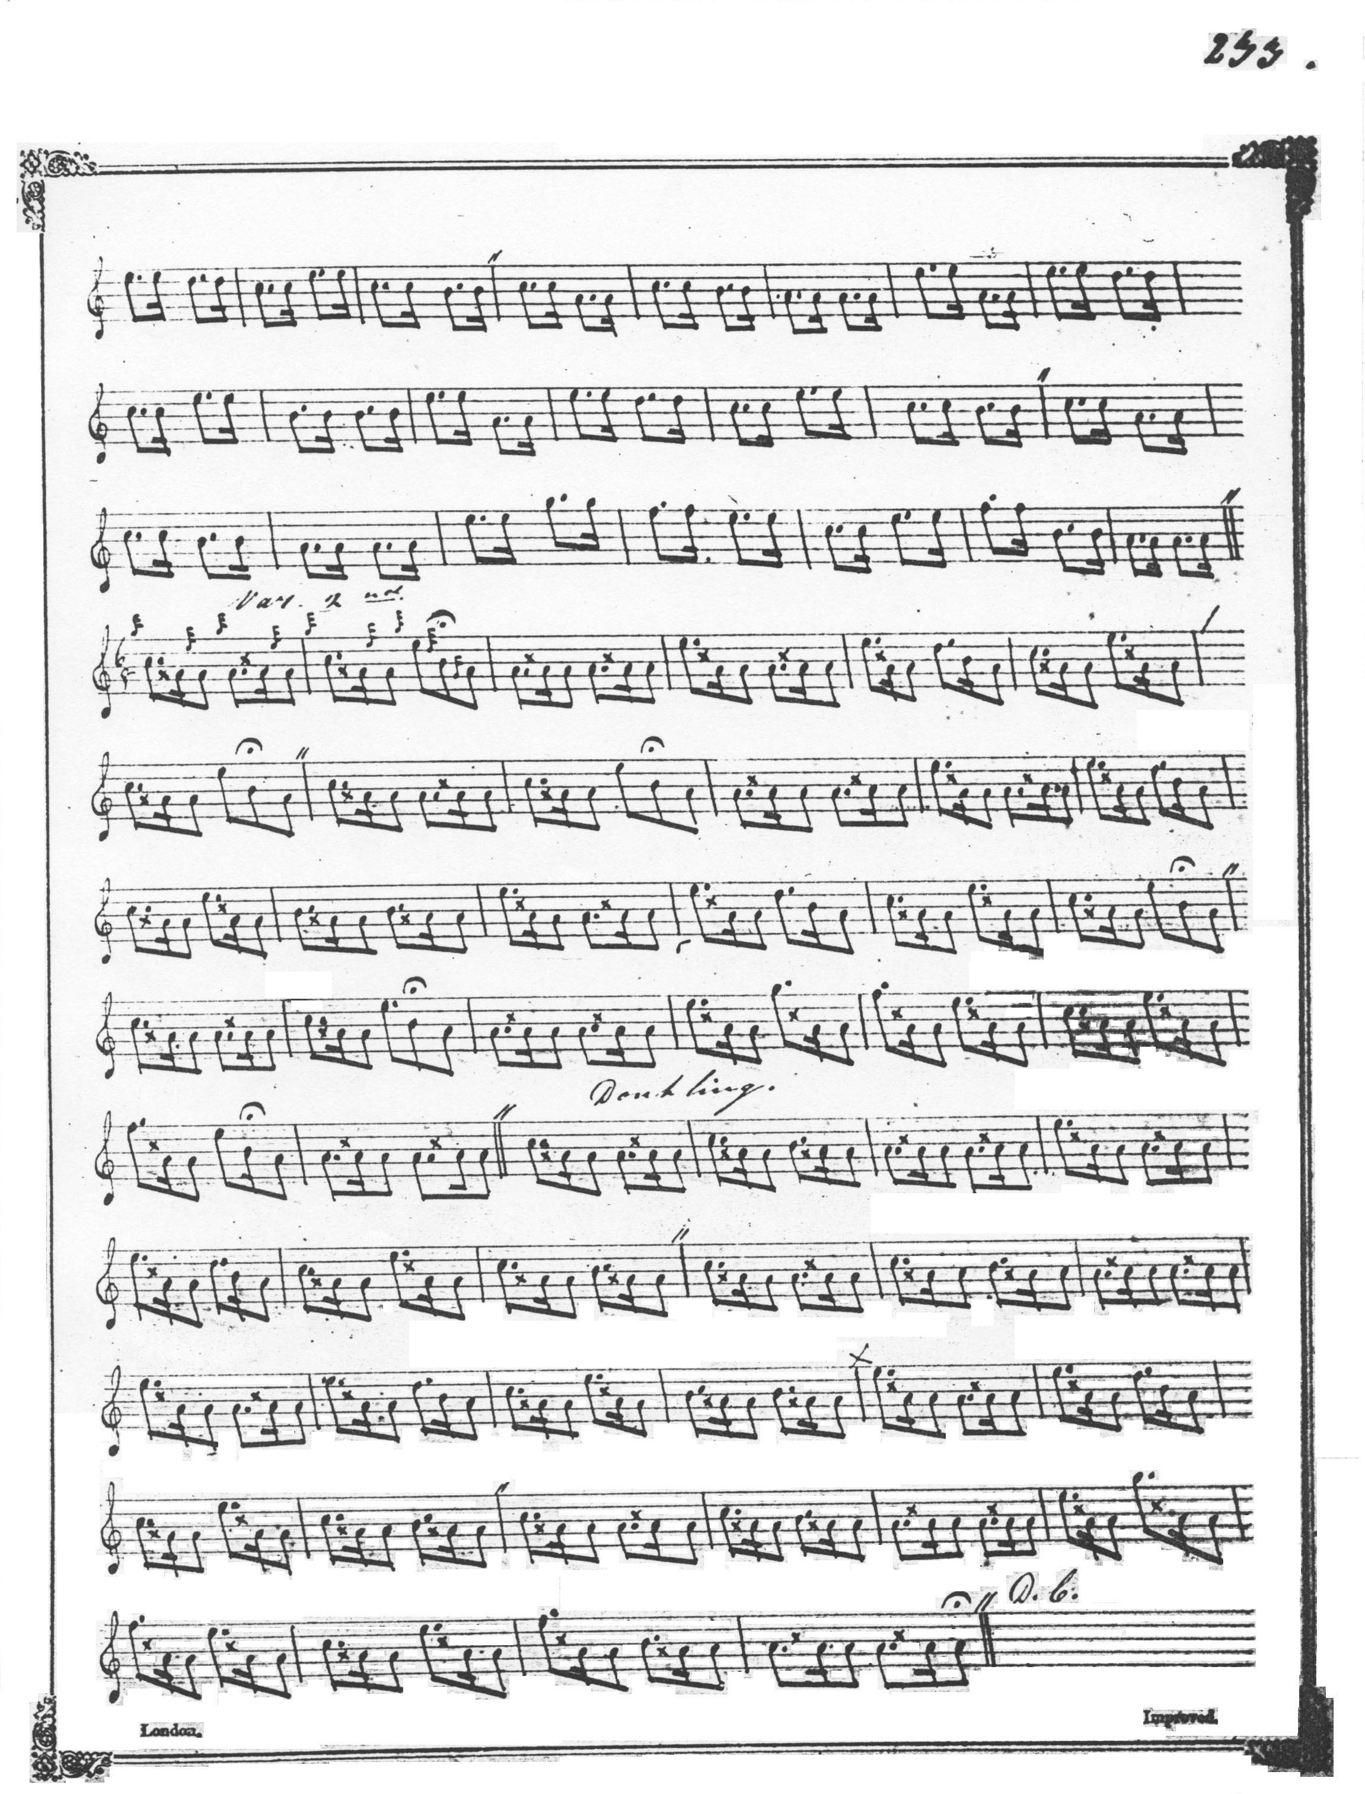
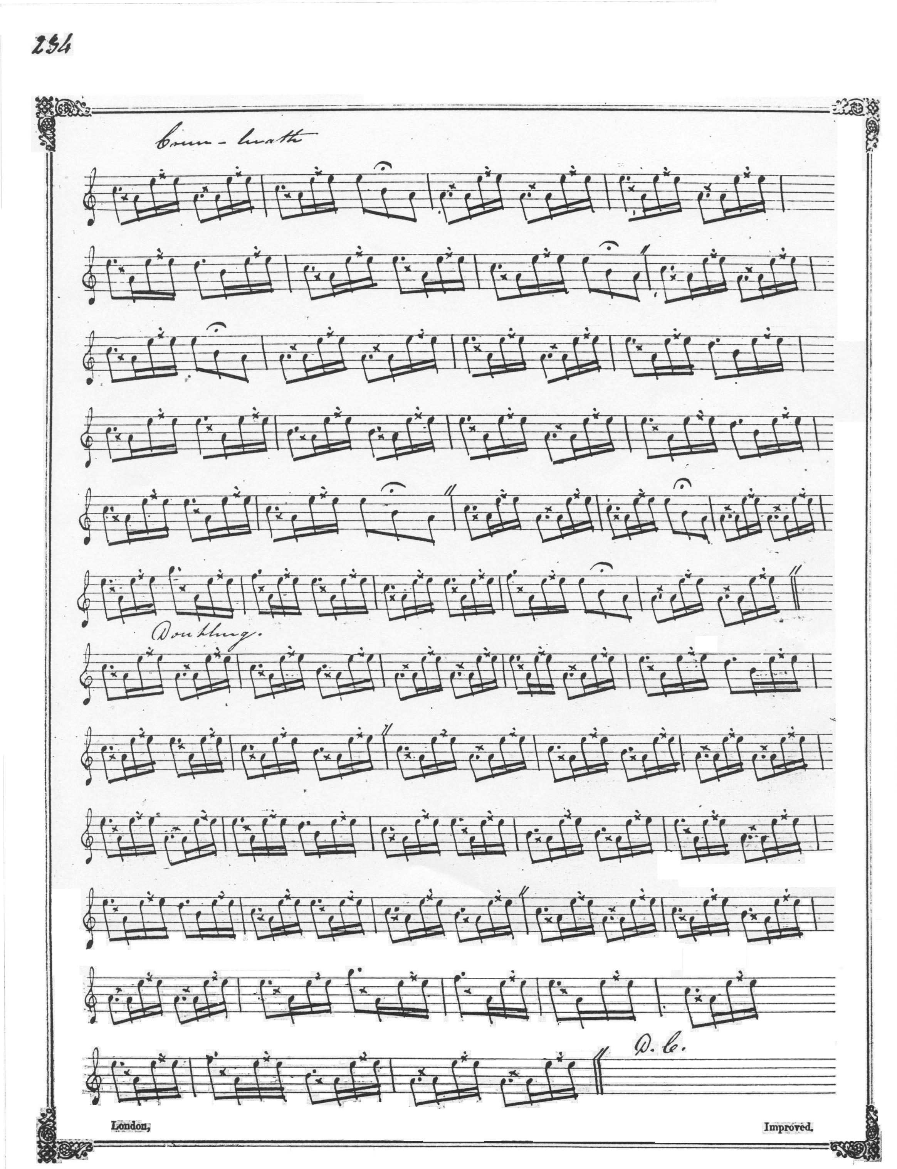

MacKay’s ground, fifteen bars long, would nowadays be considered “irregular’. In addition, he is short of a bar throughout his variations, produced by dropping two pulses from the flourish bars by treating them as if they were in 2/4 time when they occur in the ground. The development of the tune is otherwise straightforward: ground, siubhal singling/doubling, taorluath singling/doubling, crunluath singling/doubling. The ground is directed to be repeated after the taorluath and crunluath doublings.

Colin Cameron adds the missing bars in the variations. His is a partial score only, going no further than the doubling of the taorluath and giving no indication that anything is to follow, and it is only partially graced. As in MacKay, Colin Cameron’s ground is fifteen bars in length. His title suggests that MacKay’s manuscript was his likely source:

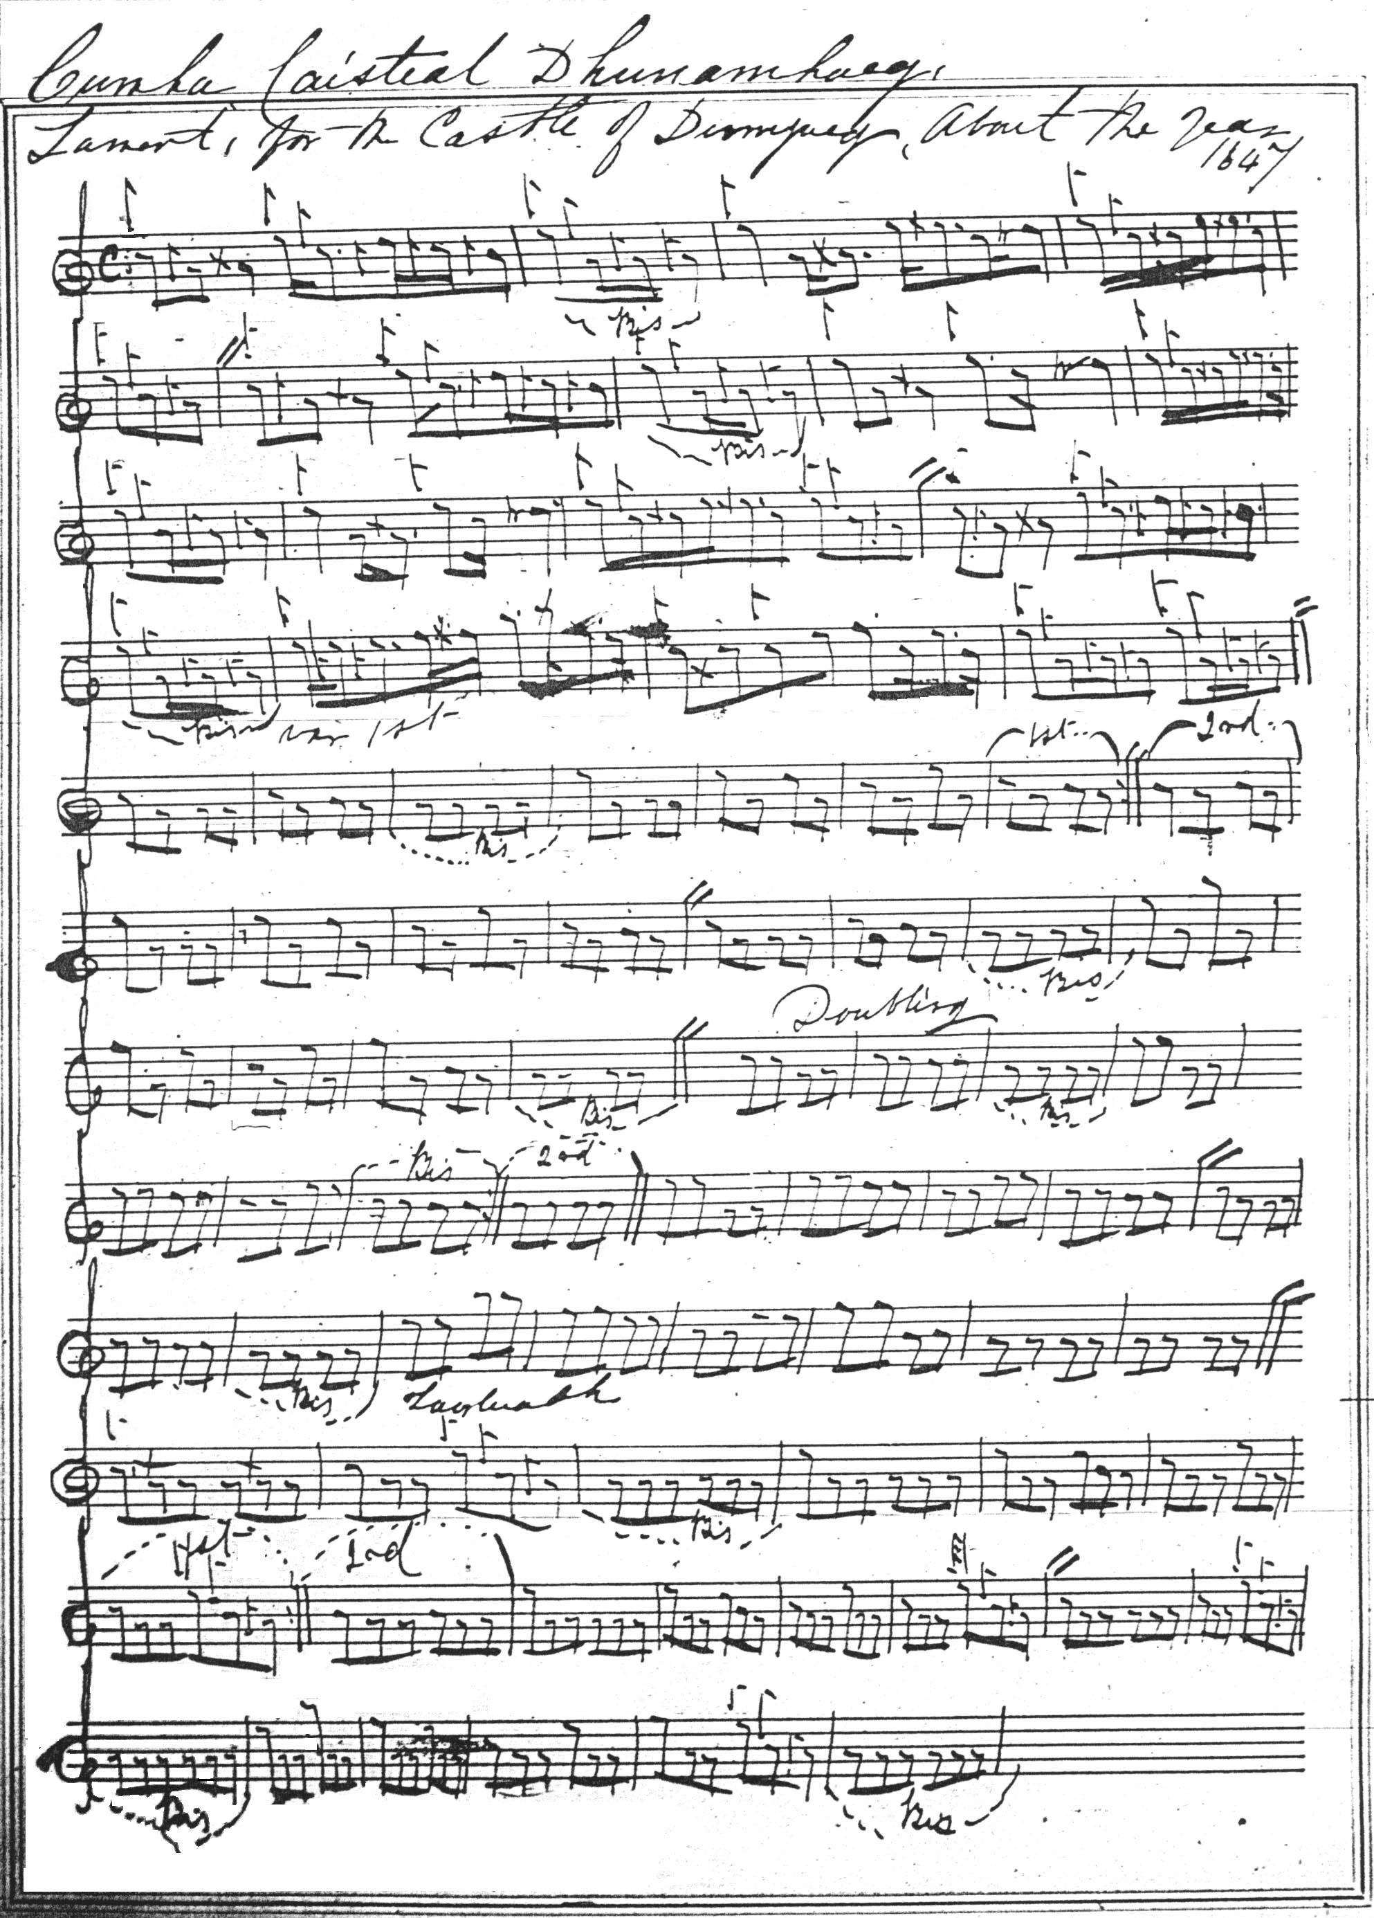

Duncan Campbell of Foss’s setting also has fifteen bars in the ground, and amends Angus MacKay’s variations in a similar manner to Colin Cameron’s score above. Campbell’s title, “Lament for the Castle of Dunyveg—the year 1647” suggests that his score also has its source in MacKay’s manuscript. Since it adds little to the expressive possibilities of the tune, Duncan Campbell’s score is not reproduced here.

Uilleam Ross sets the tune as Duncan Campbell and Colin Cameron do, retaining MacKay’s fifteen bar ground and making up the variations to more “orthodox” dimensions. Angus MacKay’s manuscript seems the obvious source here once again. Since Ross’s score adds nothing to the expressive possibilities of the tune, it is not reproduced here.

D. S. MacDonald follows his source, Angus MacKay’s manuscript, closely here and his score is therefore not reproduced.

John MacDougall Gillies follows Colin Cameron’s setting and adds nothing further to the stylistic possibilities of the tune, although he does indicate explicitly (which Cameron does not) that the crunluath variations singling and doubling should follow the pattern laid down in the taorluath. His score is initialled and dated 25 October 1884.

David Glen notes the structural irregularity of the tune and suggests that the apparent deficiency in the ground could be made good by repeating the flourish bar at the end of the ground, or repeating the opening two bars of line one. He says “The above Pibroch is one Bar short of measure. The last bar might be played twice or, the 1st two bars might be played twice dropping the last Bar of last part of Urlar & Vars this latter being the better way.” Glen sets the tune as follows:

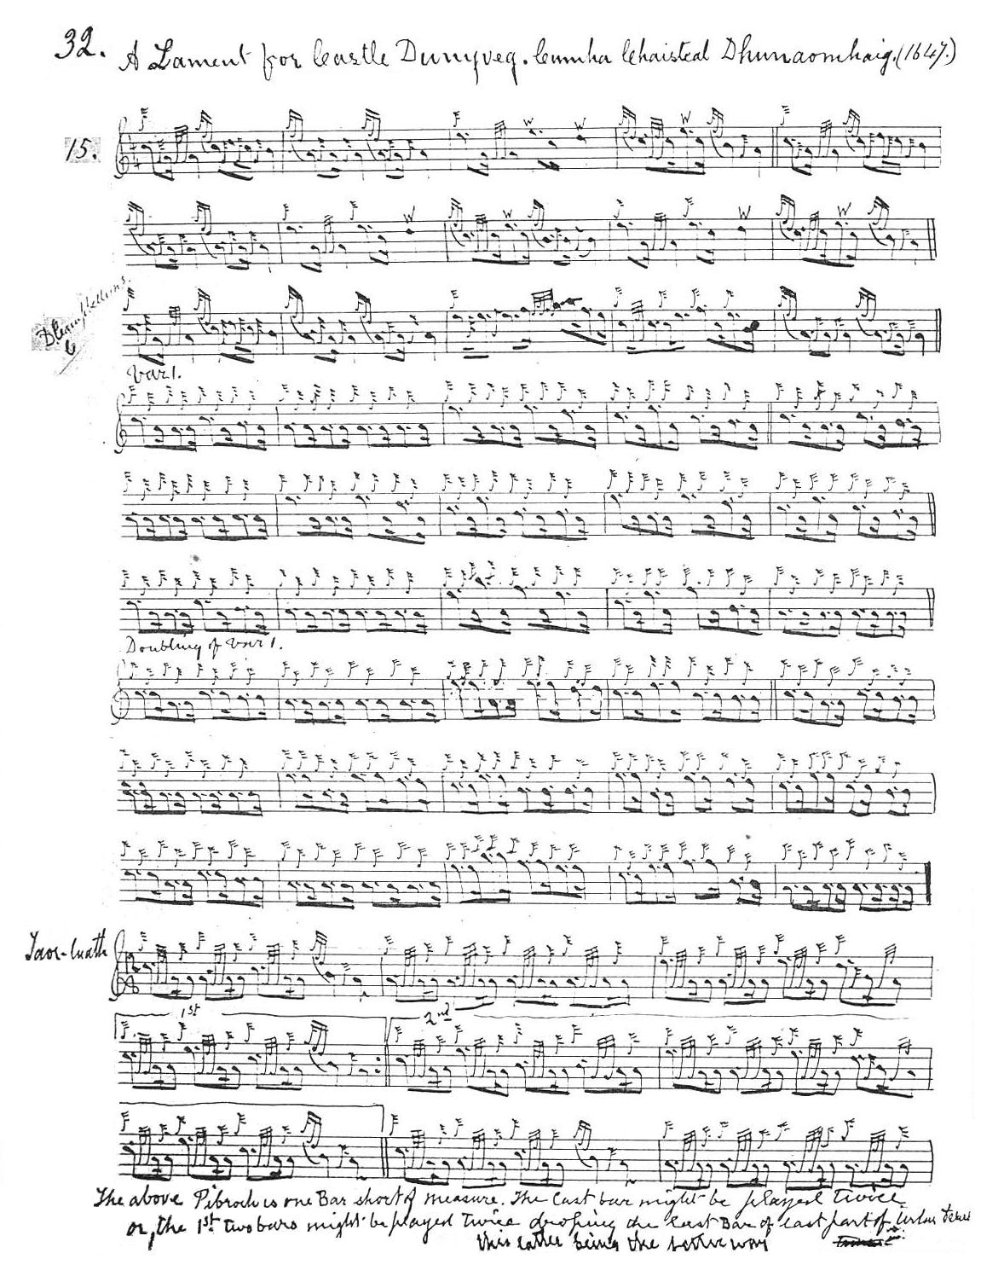
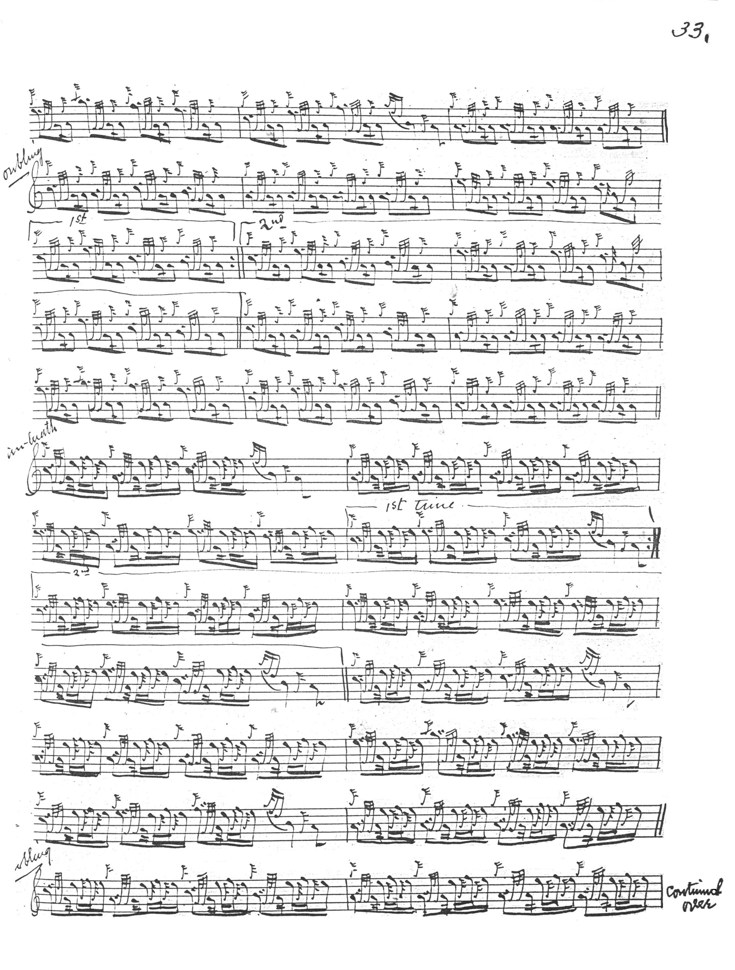
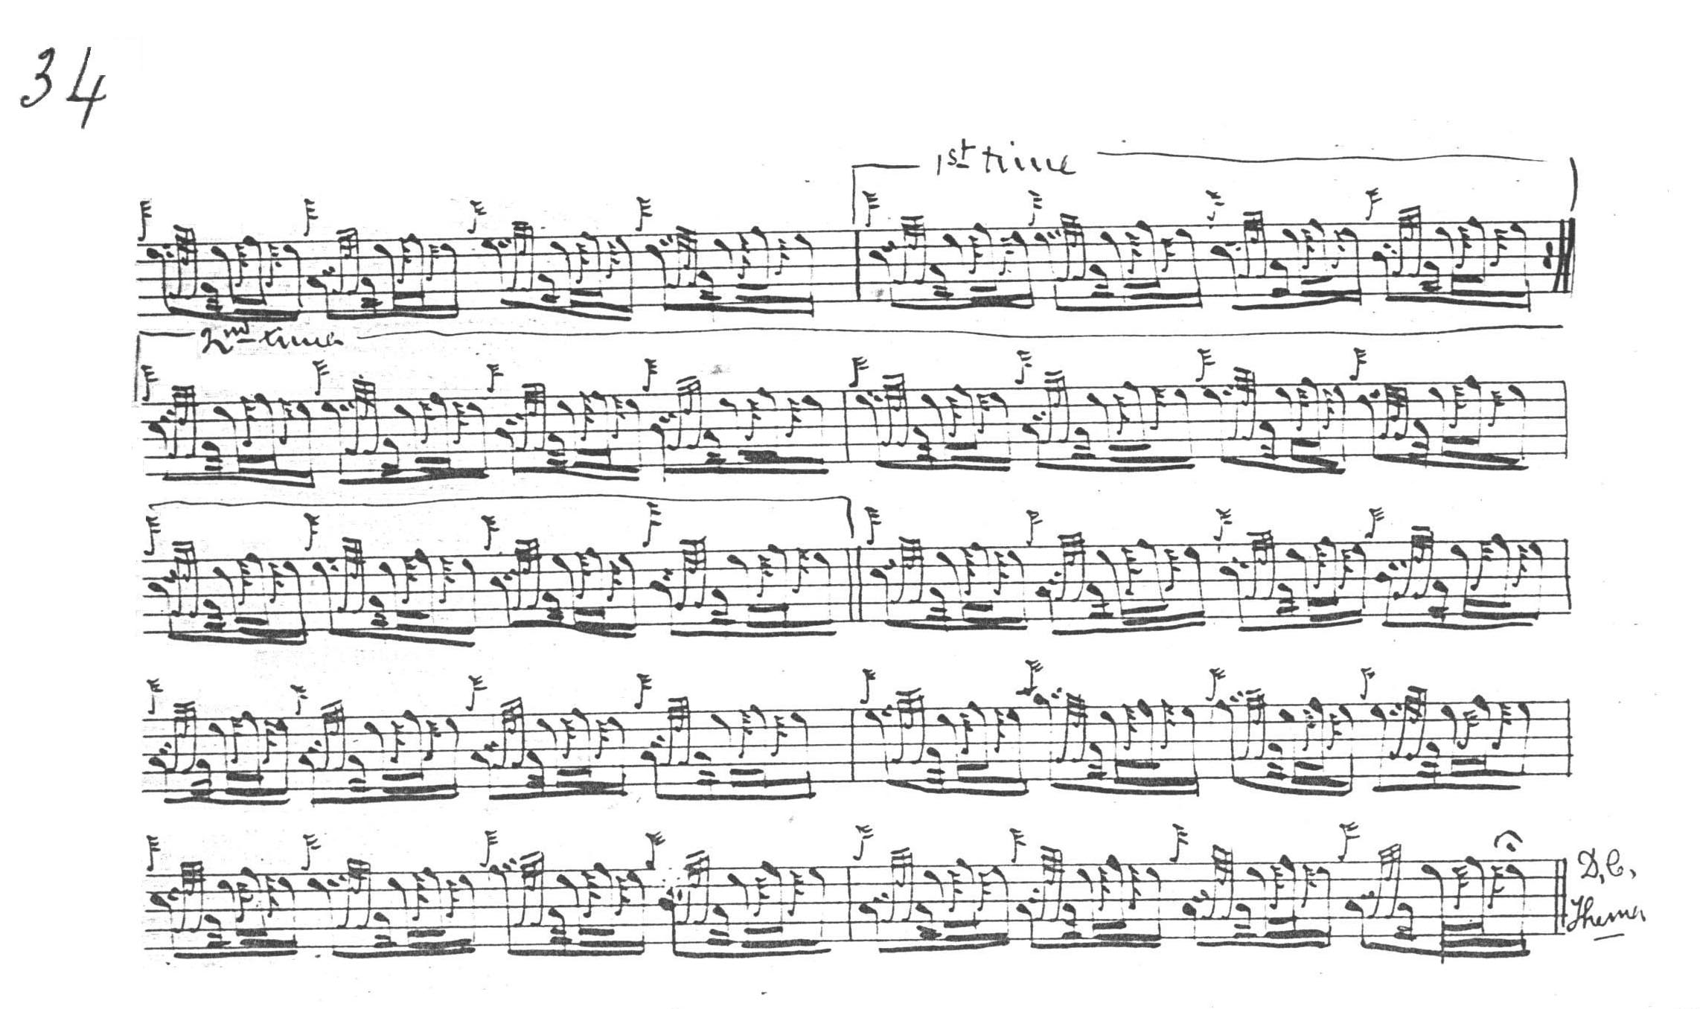

C. S. Thomason gives as his sources Angus MacKay’s manuscript and Donald MacKay (Angus’s nephew, a leading pupil of Donald Cameron and Thomason’s collaborator in the development of the Ceol Mor notation). Thomason’s score broadly follows Angus MacKay, but he interestingly substitutes an E dotted quaver for MacKay’s C dotted quaver in the A phrase of the ground. Thomason sets the tune as follows:

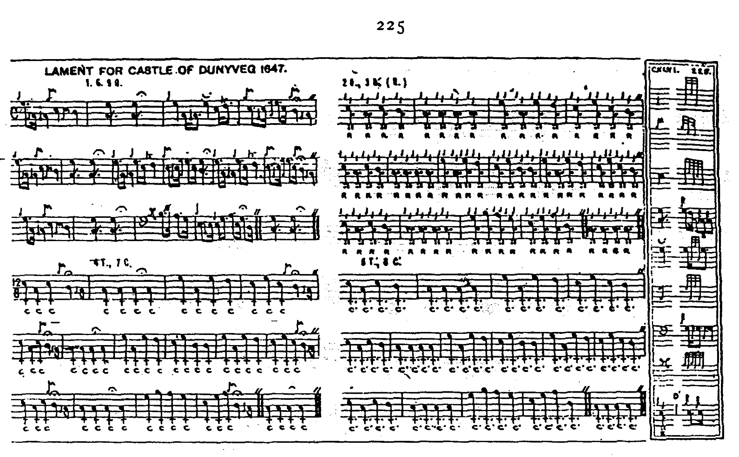

Commentary:

Dunyveg commands the entrance to Lagavulin bay on the south east coast of Islay, and played a prominent part in the power struggles of the Inner Hebrides and the south west Highlands in the foundered lordship of the isles. It was taken for the last time during the civil wars in 1647, when it was defended by the famous Colkitto (Colla Ciotach, who was hanged from the mast of his own galley, and it is to this that the tune may allude.

At the end of the 18th century the castle was still relatively intact and it was described in detail by the local minister

“On the E. side of this place there is a tower, or castle, known by the name of DUN-NAOMHAIG. The castle is built on a large rock, which is surrounded by the sea on all sides except the N. There are still, on the N., the remains of many old houses that had been built for barracks and storehouses. Some of the cellars, and a baker’s house, are still visible here. There is a very strong wall to the W. side, between the castle and the barracks; and the side walls of a large gate are still standing. This gate is called the Iron Gate: and it is reported here, that the fort was supplied with water from a small river, that runs past the end of the manse; and that it was conducted in pipes, under the sea, across this bay, to the distance of about half a mile. There is a large strong room on the top of the fort; and here the gun ports are entire. On the N. side of this room there is an earthen mound, which is very thick; and it appears to have been built up to the top of the fort, as a kind of defence to that part of the building; for the N. is the only place where an enemy could make an attack on this fort. There is a high hill on the W. side of the bay, opposite to this fort, where there was also a tower, for the defence of Dun-naomhaig; and as both places are nearly of the same height, and only about the distance of about a quarter of a mile from each other, it was an easy matter to prevent small vessels from coming to this place; for no vessels that draw above 6 or 7 feet water, can come here at any time. It is said, that the McDonalds of Islay lived here about the beginning of the last century. There are a great many forts and buildings also within a few miles of this place.” Statistical Account of Scotland (1791-99), xi, 286-297, entry for the parish of Kildalton, written by Rev. Archibald Robertson.

See also the notes on the taking of the castle of Dunyveg in “The Piper’s Warning to his Master, Cholla mo run” in the present series.

* * *

Electronic text © Dr. William Donaldson, Aberdeen, Scotland, December 2007

