The Laird of Contullich’s Lament

There are settings of this tune in the following manuscript sources:

--Colin Mór Campbell, “Nether Lorne Canntaireachd”, ii, 5-7;
--Angus MacKay’s MS, ii, 74-76; (and in the so-called “Kintarbert MS”, ff.33-5);
--Peter Reid’s MS, f.43 (with the title “MacDonald of Sanda’s Lament”);
--Colin Cameron’s MS, ff.139-140;
--Duncan Campbell of Foss’s MS, ff.61-65;
--Uilleam Ross’s MS, ff.172-175;
--D. S. MacDonald’s MS, i, 93-7;
--David Glen’s MS, ff.54-56;
--John MacDougall Gillies’s MS, f.113;

and in the following published source:

--C. S. Thomason, Ceol Mor, pp.324-5.

There are two main approaches to this tune, the first is Colin Campbell’s, the second, a narrow scribal tradition descending from Angus MacKay.

The Nether Lorn has two tunes entitled “Contalich’s Lament”: the first, (i, 74-5), is the piece now known as “MacLeod’s Controversy”.
Colin Campbell sets the tune like this:
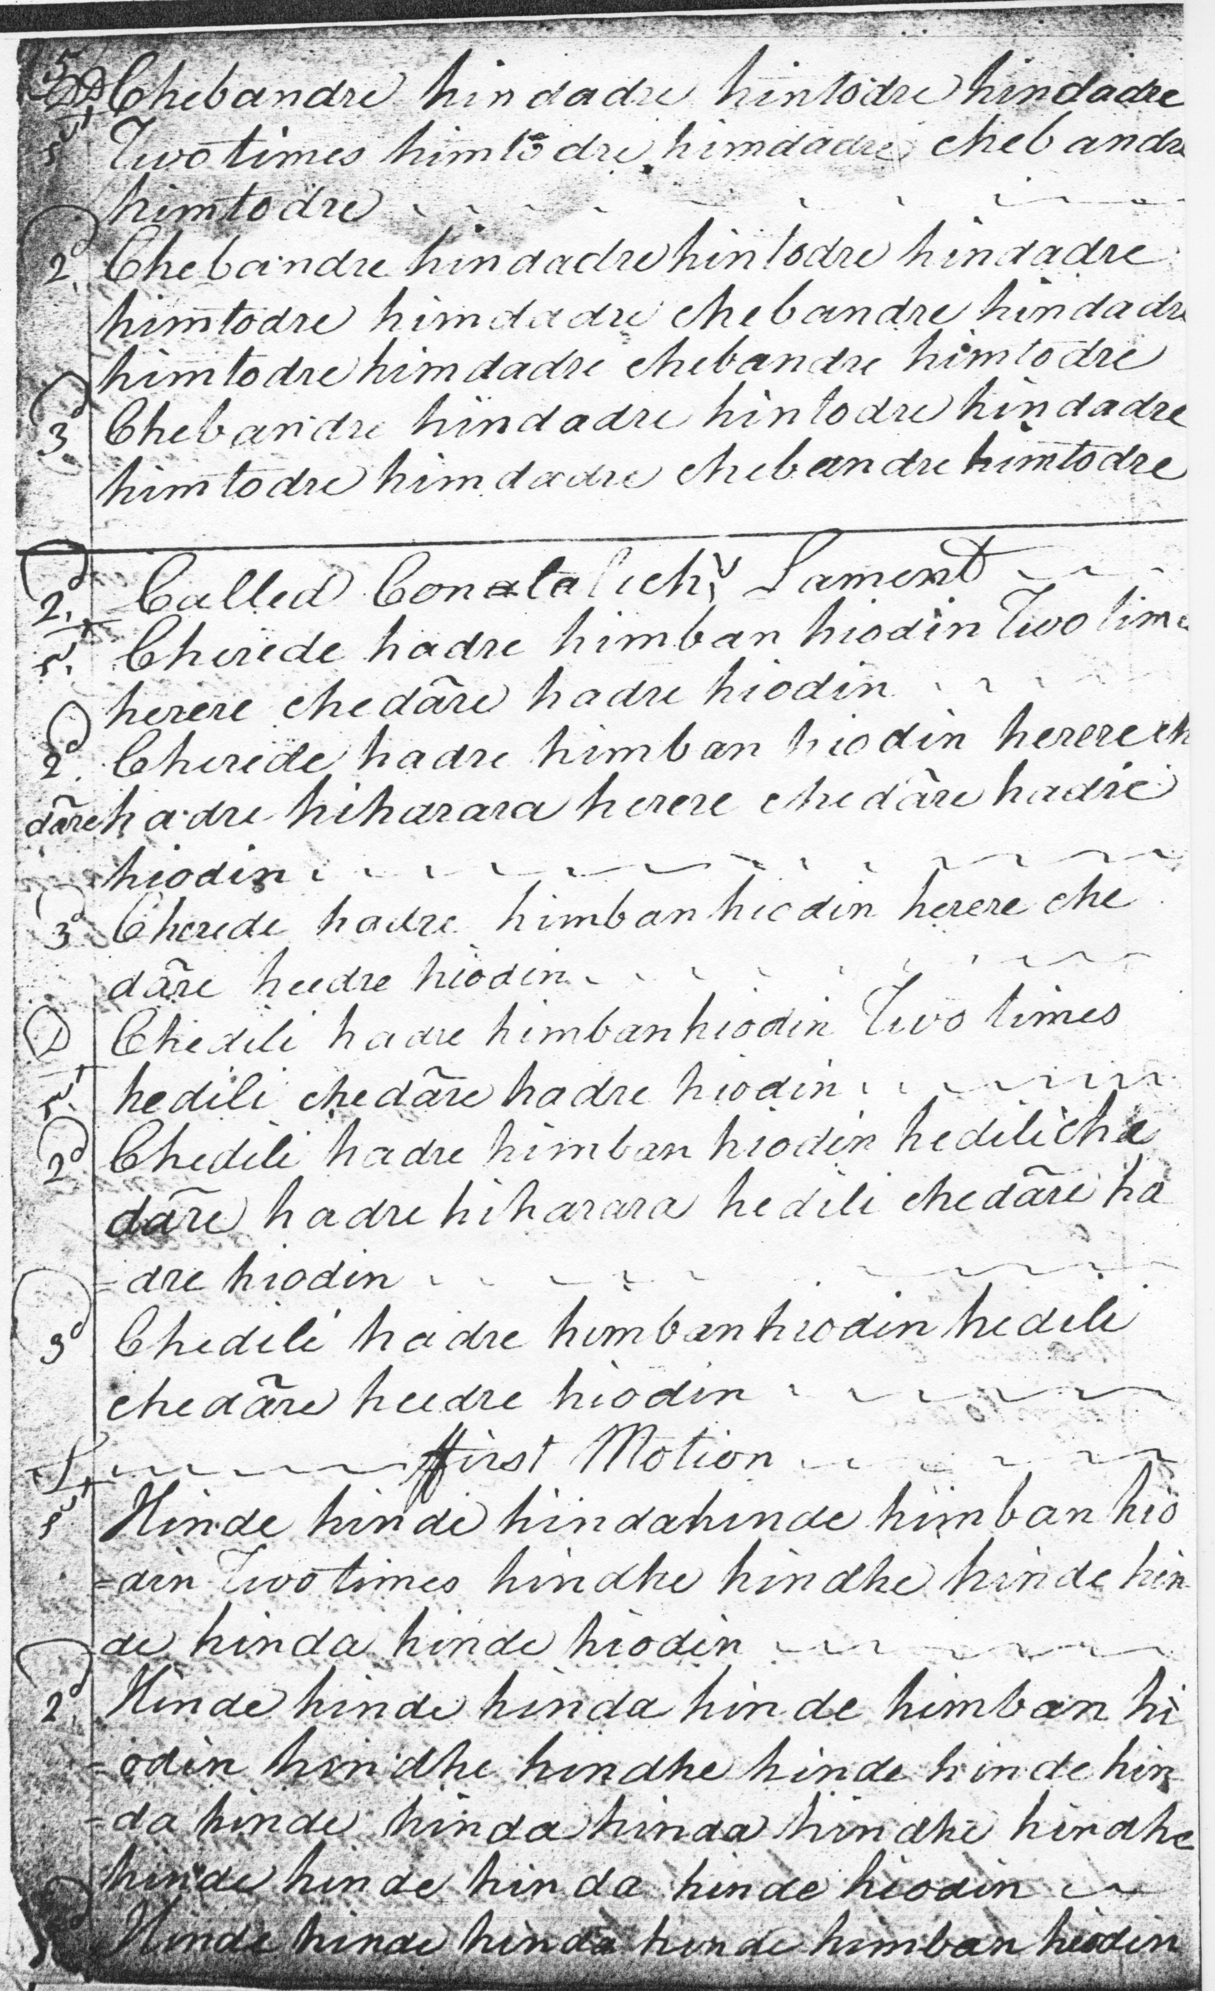
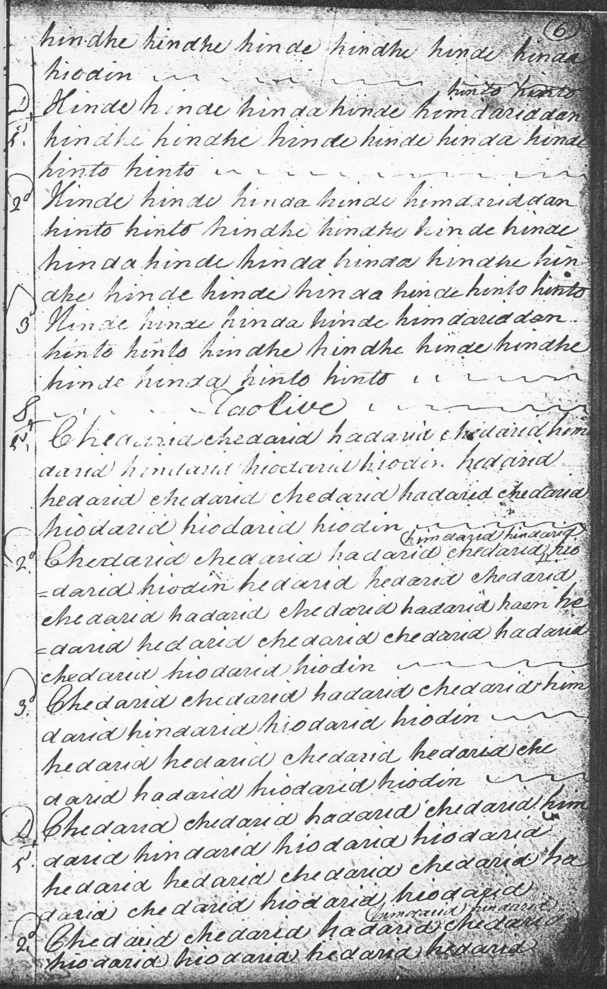
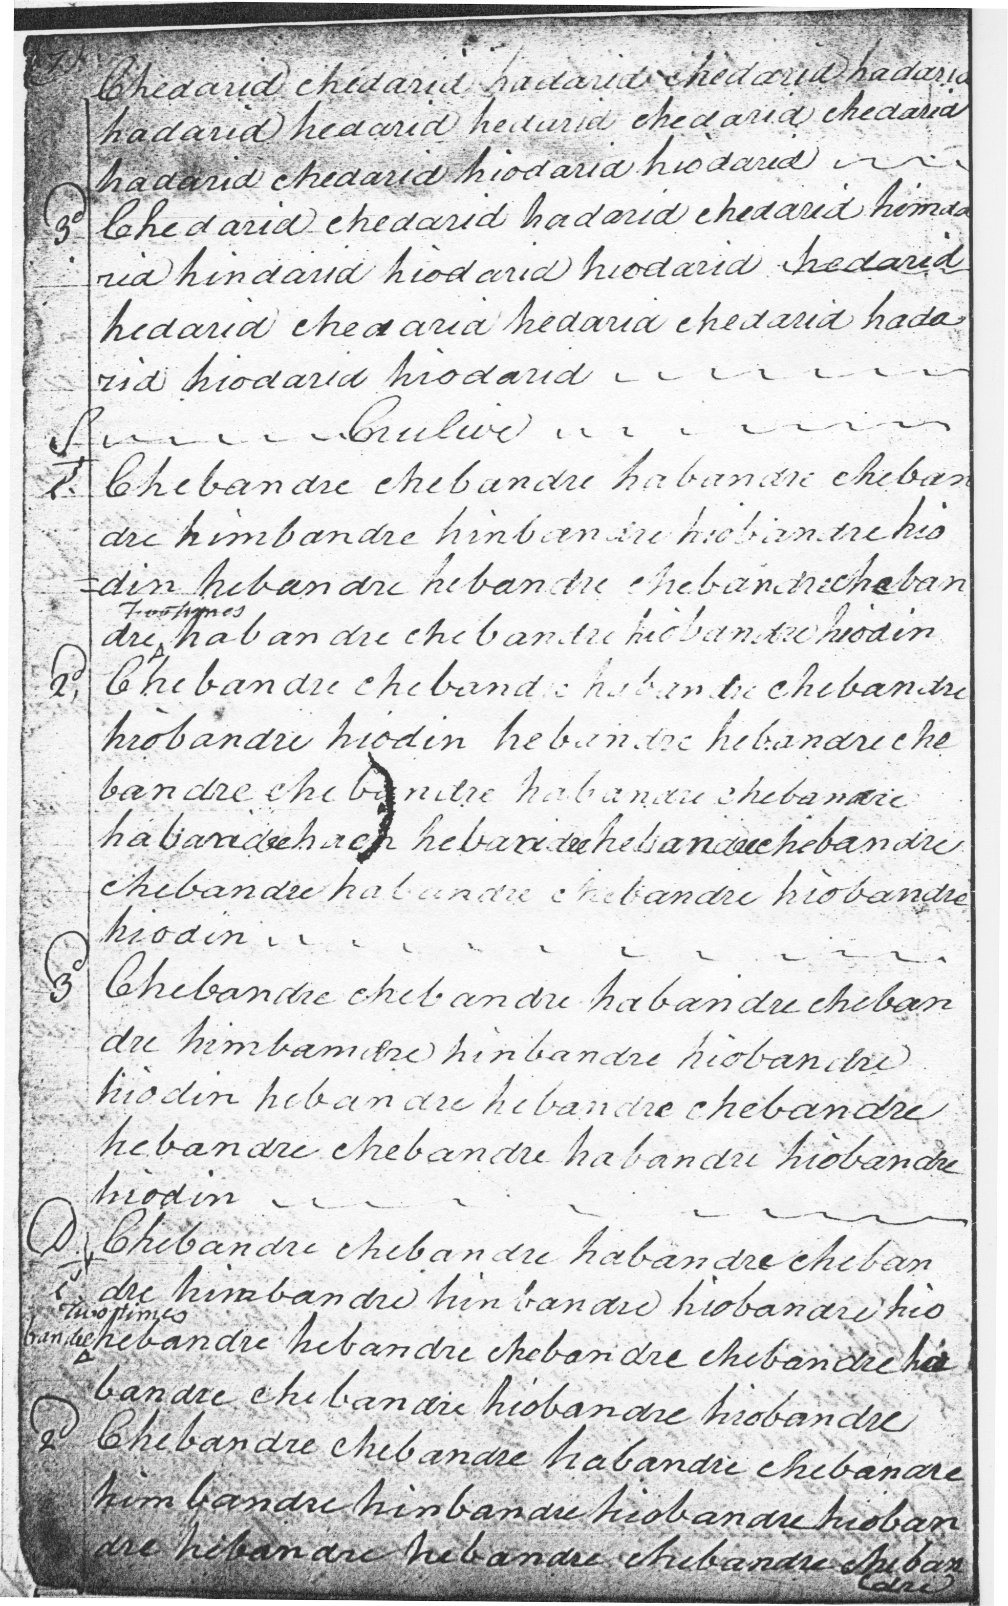

Colin Mór develops the tune thus: ground and thumb variation; siubhal singling and doubling; taorluath duinte singling and doubling, and crunluath duinte singling and doubling. There are a number of inaccuracies in the score: the
taorluath singling towards the end of the first line appears to have one syllable, “hiodarin”, too many. The superscript “four times” added to line one of the crunluath singling is clearly superfluous. There are further transcription errors in the crunluath singling second line, as well as some uncertainty about whether to repeat the opening sequence of each variation and, if so, how often. In addition the text appears to be incomplete, ending in the second line of the crunluath doubling at the bottom of folio seven.

Peter Reid’s setting bears the name “MacDonald of Sanda’s Lament”:

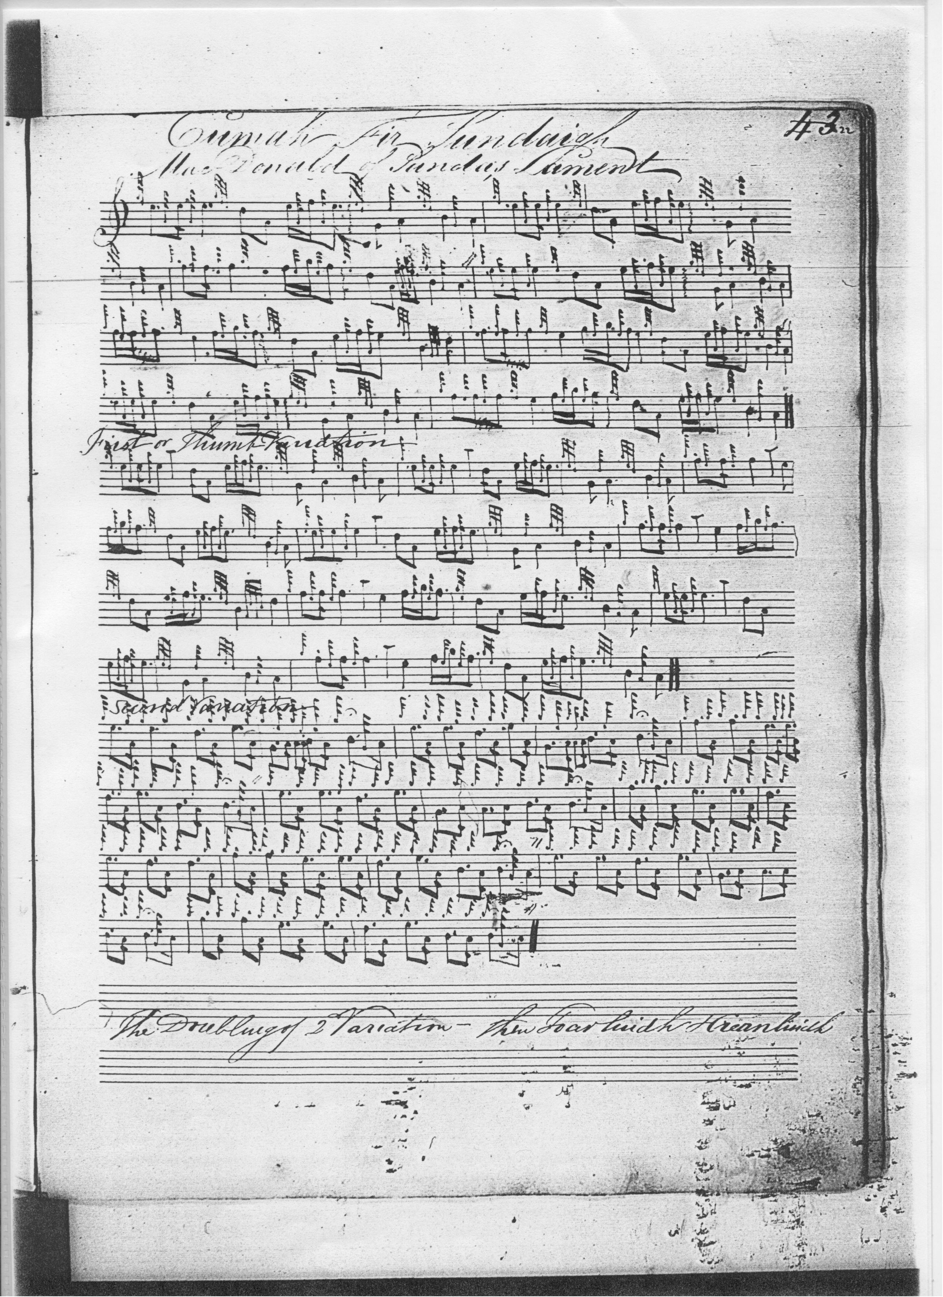

Reid’s beautifully decorated line is redolent of the school of Donald MacDonald in which he was apparently trained, and it is interesting that he retains the thumb variation we see in Colin Campbell’s score above. If expanded, as he directs, to double the siubhal, and proceed to a set of taorluath and crunluath variations based upon it, Reid’s score would form a very attractive version of this tune.

Angus MacKay sets the tune like this:

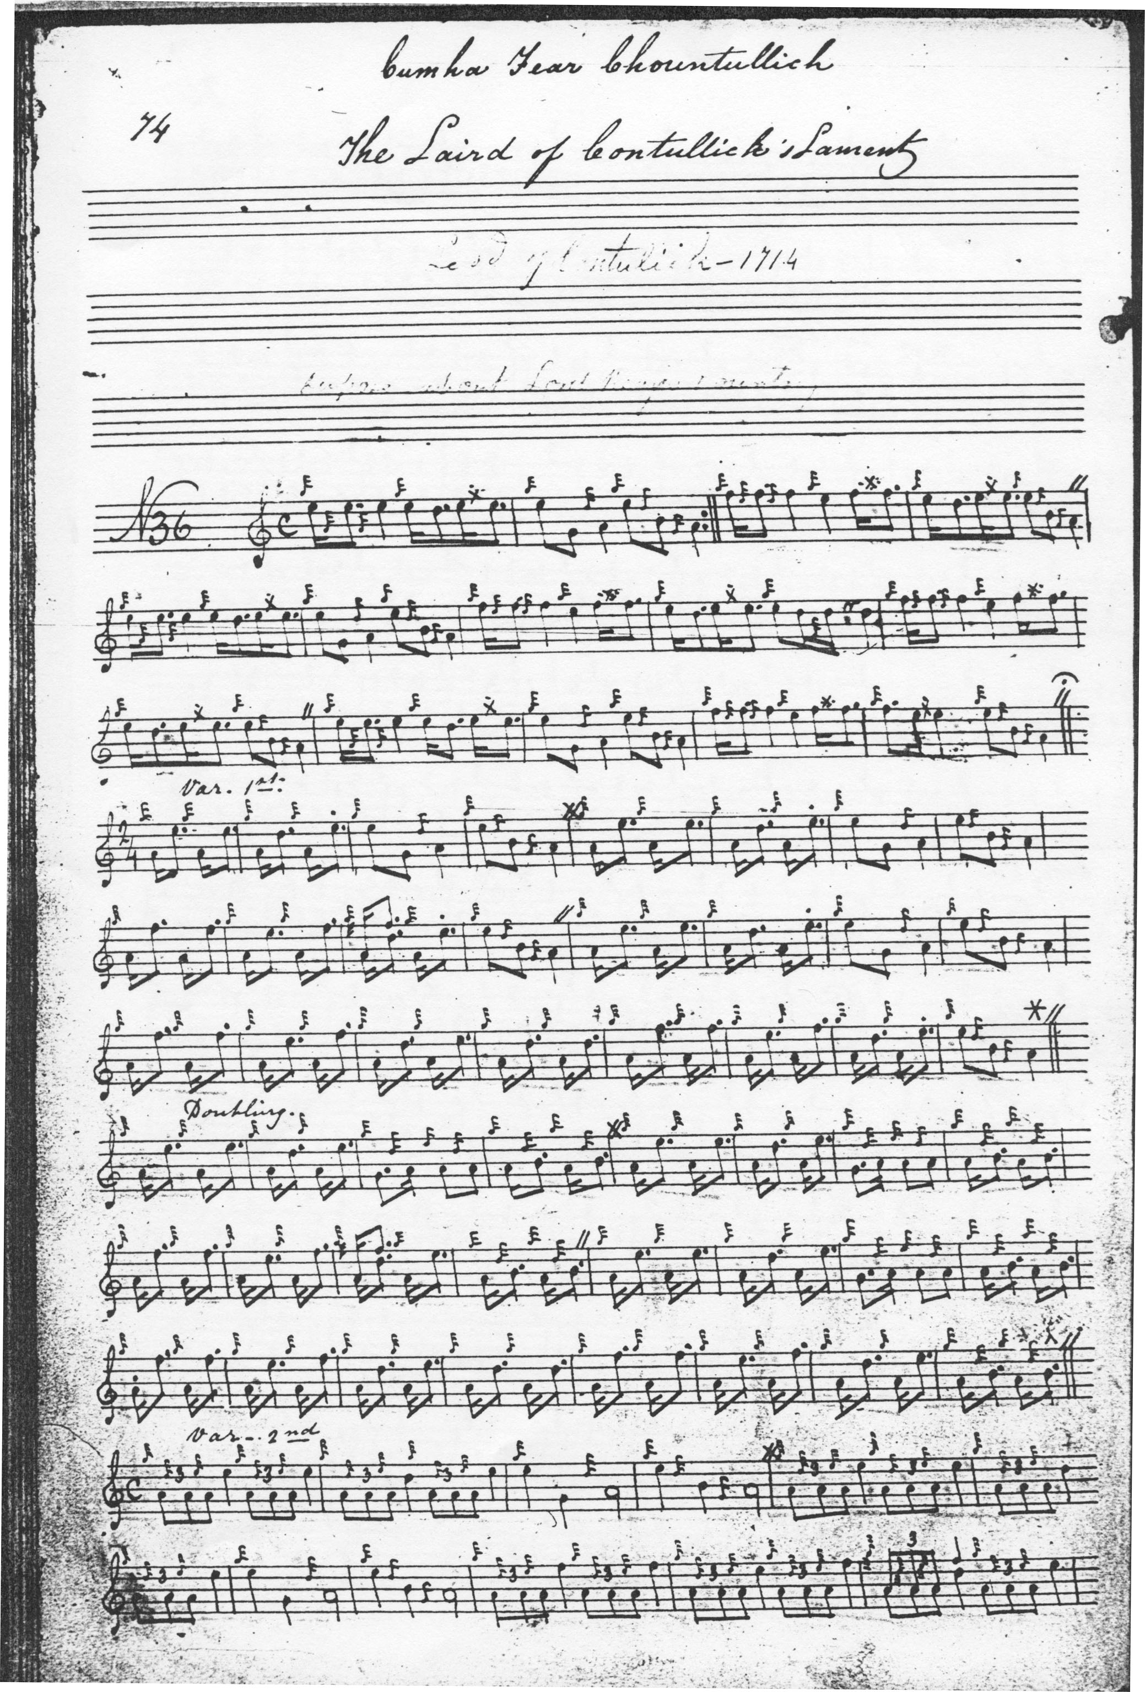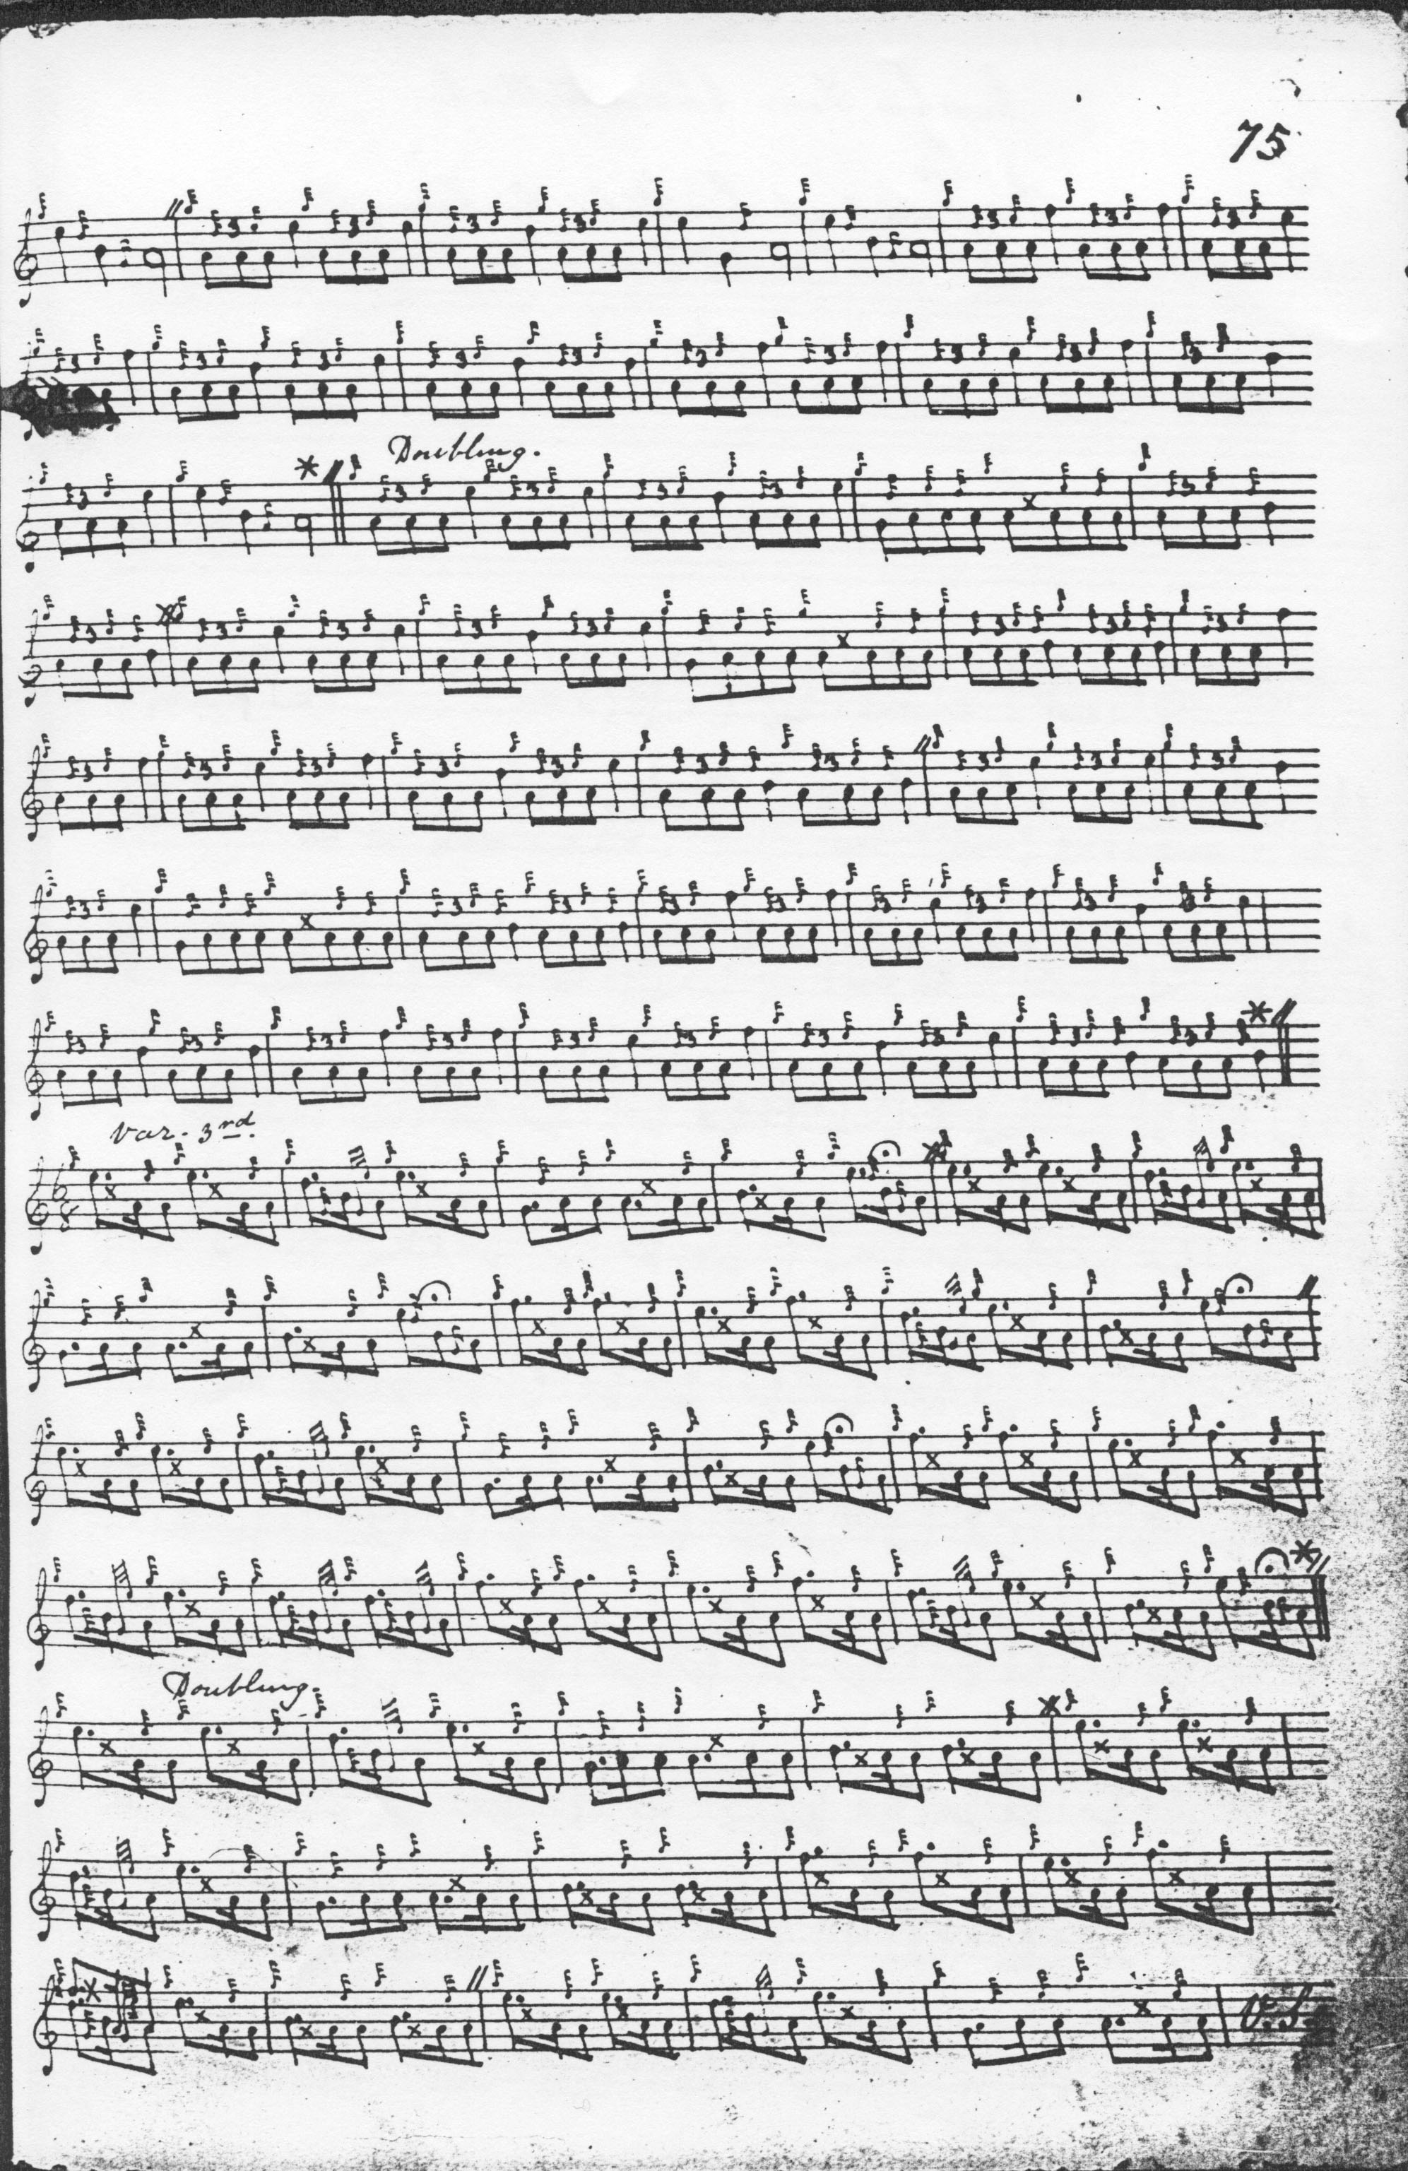
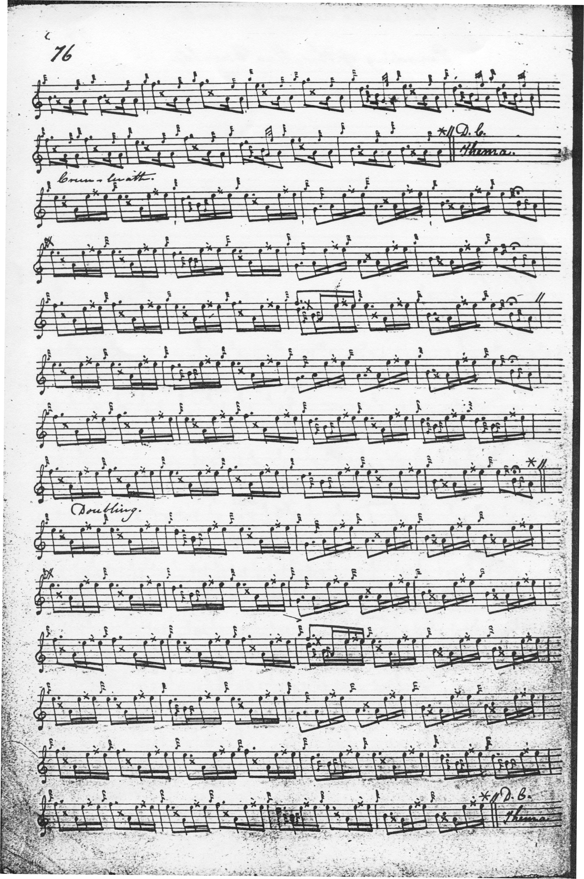There are some interesting differences between Angus MacKay’s setting and that in the Nether Lorn. MacKay has no thumb variation, but does include a taorluath fosgailte variation, singling and doubling, absent in Colin Campbell. The 4/4 timing seems perfectly deliberate, as the contrast it provides with surrounding movements would itself imply, unlike the “modern” duple timing of the taorluath fosgailte based on demi-semi-quaver runs. MacKay also indicates that the ground should be repeated after the taorluath duinte doubling and at the end of the tune.

The other surviving MacKay setting, in the so-called “Kintarbert MS”, exactly follows the melodic contour seen above in his main manuscript, although it is not fully grace-noted. It is not reproduced here.

The remaining manuscript settings mostly appear to be transcriptions of MacKay. Colin Cameron gives an outline score only, ending with the taorluath variations and simply indicating “Crunluadh” to follow. It adds nothing to the interpretational possibilities of the tune and is nor reproduced here. Duncan Campbell of Foss, and Uilleam Ross likewise add nothing to MacKay, and their scores are not reproduced here. John MacDougall Gillies’s score is a partial transcript from C. S. Thomason’s Ceol Mor, and is not reproduced here.

David Glen’s score shows his usual thoughtful editing, including giving alternative titles for the tune, and including a taorluath fosgailte timed more in accordance with later practice:

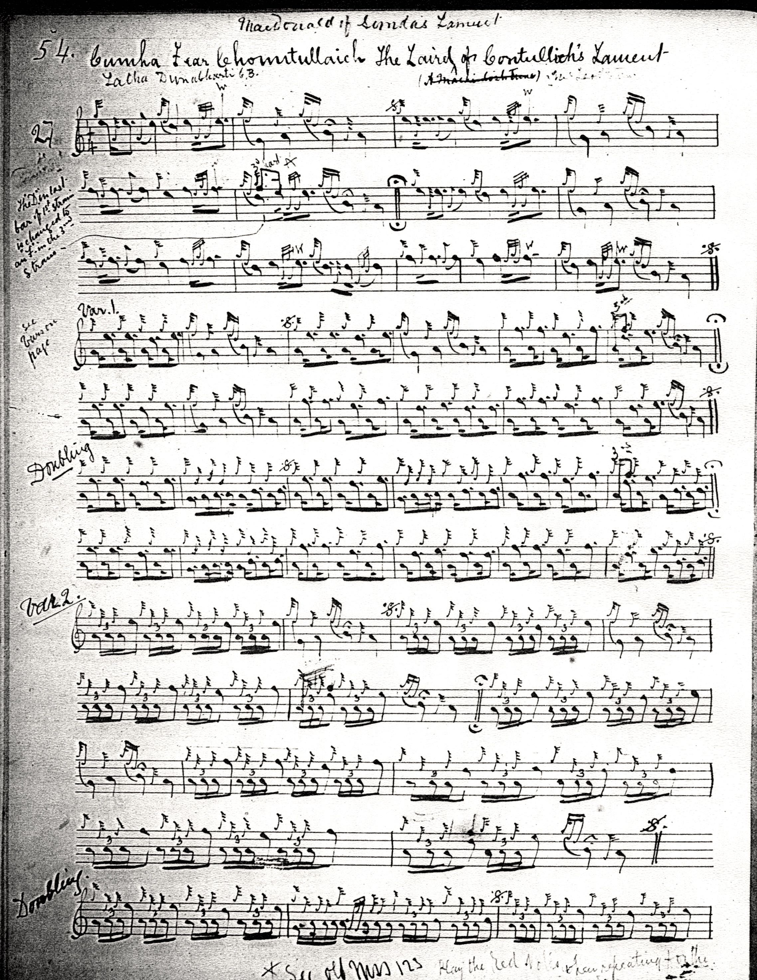
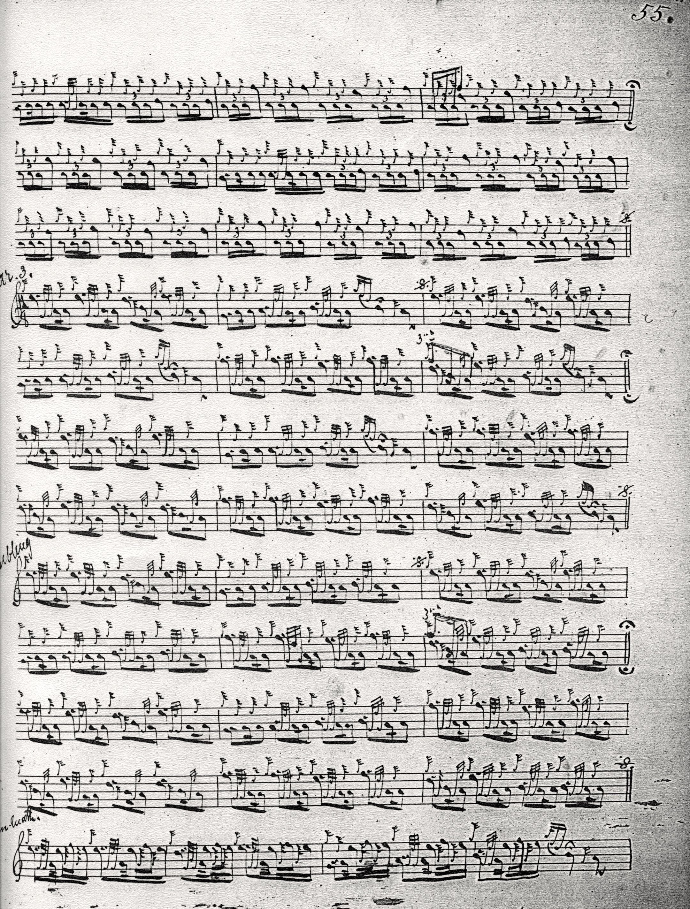

“The Laird of Contullich’s Lament” is an austerely beautiful tune, a classic three-lined primary piobaireachd, with its phrase pattern AAB, ABB, AB, strongly marked throughout; a grand and solemn piece proceeding by dignified and measured steps towards its pre-ordained conclusion.

Commentary:

Professor Colm O’Boyle, our leading authority on Gaelic terms of art in music, advises that one of the last extant songs from the famous poet Màiri nighean Alasdair Ruaidh (?c.1620-c.1707) was addressed to Iain (John) MacLeod of Contulaich (c.1646-1726) in return for his gift to her of a snuff mill, adding that Iain of Contulaich was also a poet, and composed a song entitled “Oran do MacLeoid” (“a song for the chief of the MacLeods”), published in Donald Macleod, ed., Orain Nuadh Ghaeleach (“New Gaelic Songs”), Inverness 1811. Iain of Contulaich seems a likely candidate as dedicatee of the present tune.

Amongst the alternative titles given by David Glen is “Latha Dunabherti”, or the Day of Dunaverty. Usually used of battles, the formula here refers to a siege, and it takes us to Argyllshire, and the weird, broken-backed headland on which stood the Castle of Dunaverty at the south-easternmost tip of the long peninsula of Kintyre, and one of the more unpleasant passages in Scottish history. Now a ruin, the castle changed hands several times during its long and bloody history. Although dramatically situated and approachable only one side, it does not seem to have been very defensible (a serious shortcoming in a castle), and so, when Sir Alexander MacDonald, young Colkitto, left it garrisoned during the Civil Wars of the seventeenth century (in themselves basically an episode in the long struggle for supremacy between the MacDonalds and Campbells in the south-west Highlands), it fell to the besieging Covenanting forces in 1647 once they had intercepted its water supply. The garrison, which included women and children, may have surrendered on terms, but these were immediately broken, and they were slaughtered out of hand. The garrison commander, Archibald Mór MacDonald of Sanda and his son, Archibald Og were killed. The place has an unsettling atmosphere to this day:

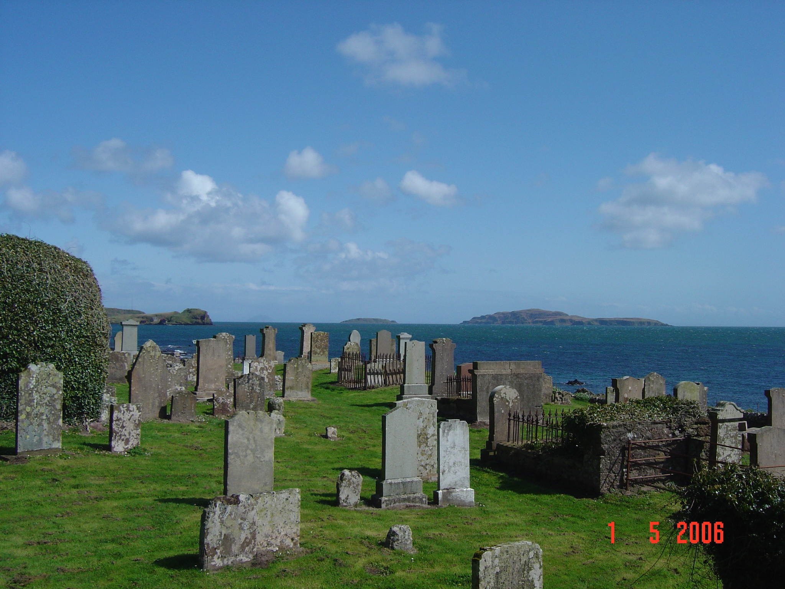

This is the view across the bay from Southend Old Kirk at Keil Point with Dunaverty rearing up like a whale back on the left, and Sanda and Ailsa Craig on the centre and right.

*

Electronic text © Dr. William Donaldson, Cambridge, Massachusetts, 10th September 2016

