Lady Margaret MacDonald’s Salute

There are settings of this tune in the following manuscript sources:
--MacArthur/MacGregor MS, ff.84-6;
--Angus MacKay’s MS, ii, 107-108;
--Donald MacKay’s “Ballindalloch Manuscript”, ff.7-8;
--D. S. MacDonald’s MS, i, 15-17;
--David Glen’s MS, ff.224-225 and again at ff.247-249;
--Robert Meldrum’s MS, ff.170-172.

The tune also appears in the following published sources:
--Frans Buisman and Andrew Wright, eds., The MacArthur MacGregor Manuscript of Piobaireachd (1820), p.155;
--C. S. Thomason’s Ceol Mor, pp. 305-6, 339;
--David Glen’s Ancient Piobaireachd, pp.238-9.

The MacArthur/MacGregor treats the tune as follows:

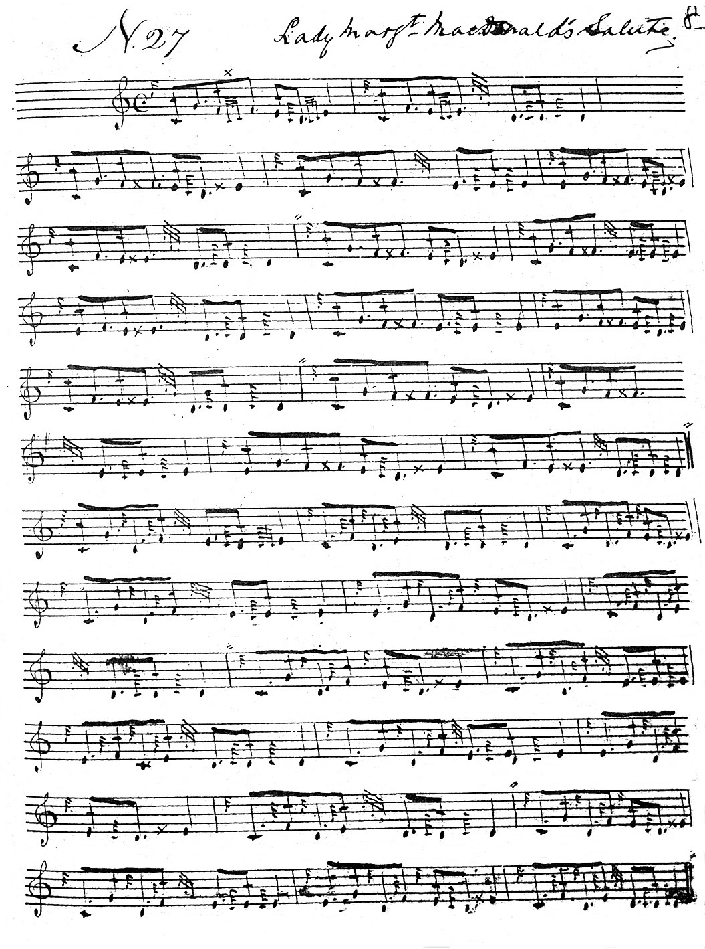

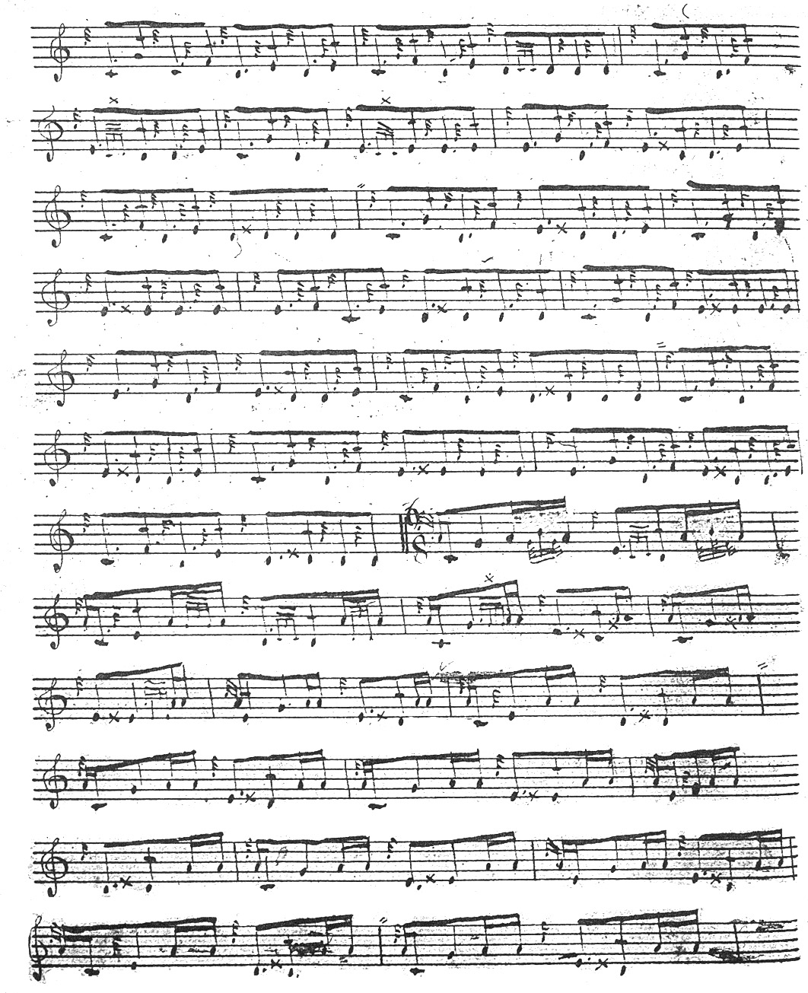
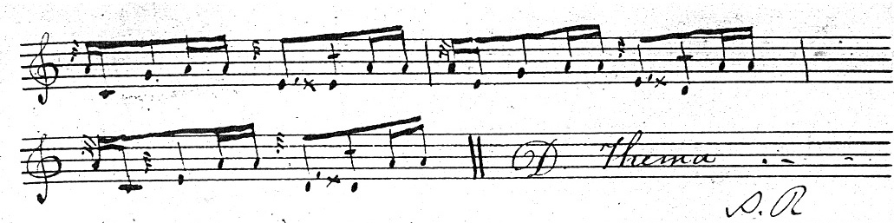

The MacArthur/MacGregor score shows a number of interesting stylistic features; the double echoes have an initial dotted quaver in the usual MacArthur style; the siubhal is pointed “down”, and the tune is developed in 6 6 4 pattern through a ground, siubhal singling and doubling, and a crunluath fosgailte singling played off an ostinato E cadence. In the published version Andrew Wright rearranges this final variation presumably to square it more closely with the tone row of the ground. But the original score offers no support for this.

Angus MacKay treats the tune as follows:

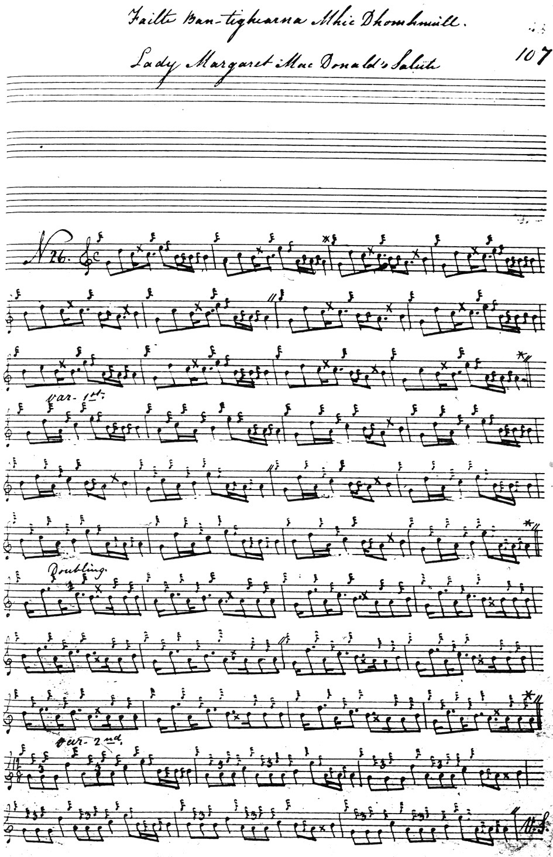
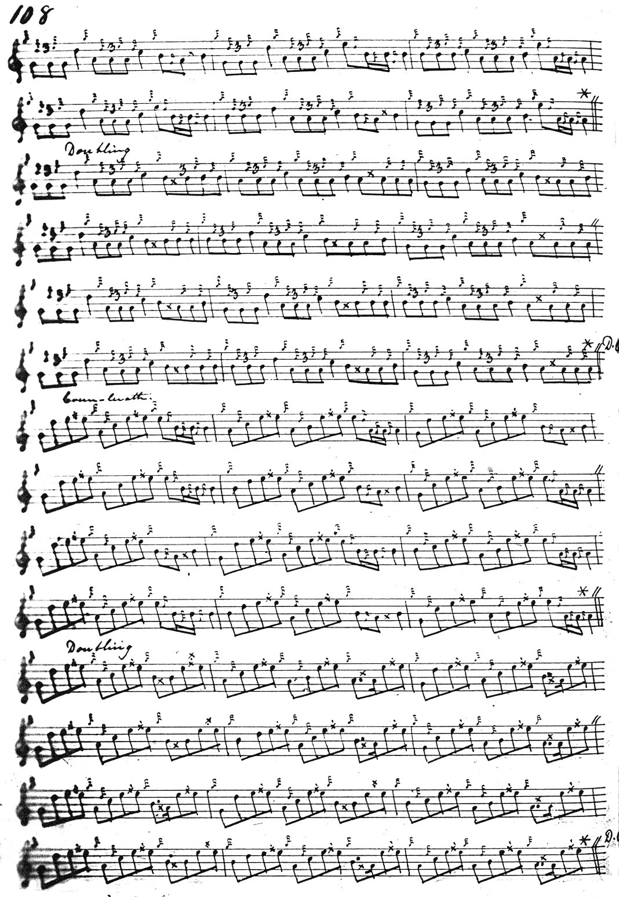

Some may feel that Angus MacKay’s double echoes in the ground do not sit so comfortably with the flow of the melody as the MacArthur/MacGregor, but MacKay’s variations are much fuller. MacKay develops the tune as follows:
ground;
siubhal singling and doubling;
taorluath fosgailte singling and doubling;
repeat of ground after taorluath doubling;
crunluath fosgailte singling and doubling;
repeat of ground after crunluath doubling.
The score is clean and although Angus occasionally misses his little repeat marks, the intention can easily be construed.

Donald MacKay’s score is close in style to his uncle Angus MacKay’s. It is incomplete: the ground is written out as even quavers and taken through only to the end of the taorluath fosgailte doubling, ending with a note “Crunluath Fosgailte to be taken from last Variation”. It is docketed “not correct” and is not reproduced here.

D. S. MacDonald differs in a number of interesting minor respects from MacKay, his ostensible source, in the tone contour of his ground as follows:

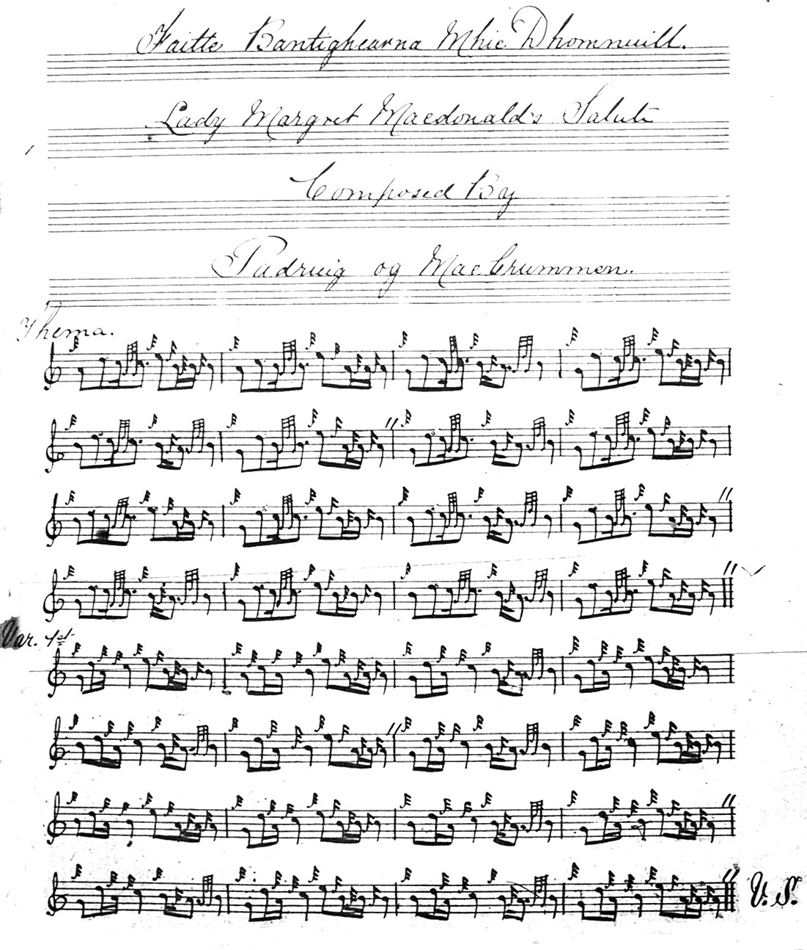

and so on.
David Glen’s first setting in his manuscript pleasingly combines aspects of both MacArthur and MacKay’s scores. Glen will have had access to both, thanks to his friendship with Dr. Charles Bannatyne who then had the originals in his possession. It is an interesting comment on the stylistic freedom of pìobaireachd at the beginning of the 20th century that while the MS version obviously provided the basis for Glen’s setting, he felt able to depart from it in his published score. In the MS he timed the ground and siubhal as follows:

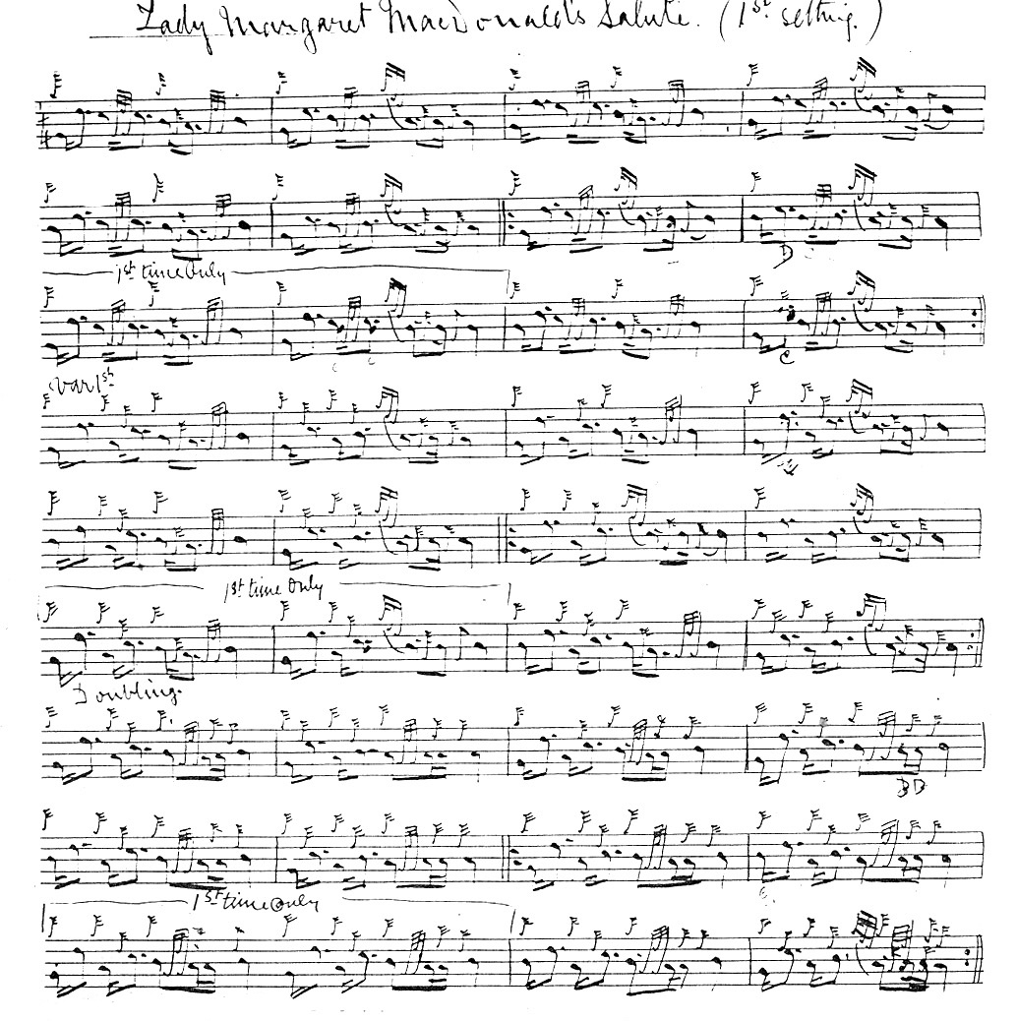

and so on.

The second setting of “Lady Margaret MacDonald’s Salute” in David Glen’s MS is identified in a marginal note as a transcript from Ceol Mor and is not reproduced here.

The setting in Robert Meldrum’s MS follows the treatment of the tune by Glen and Thomason and is not reproduced here.

C. S. Thomason gives MacKay and Colin Cameron as his sources and although there are some minor differences from the way MacKay times the tune, in playing these would be relatively trivial and Thomason’s score is not reproduced here.
In his published book, A Collection of Ancient Piobaireachd, David Glen gives the tune as a composition of Angus MacArthur. His score is a judicious combination of MacArthur and MacKay, and is probably the best of the playing scores. Glen times the tune as follows:

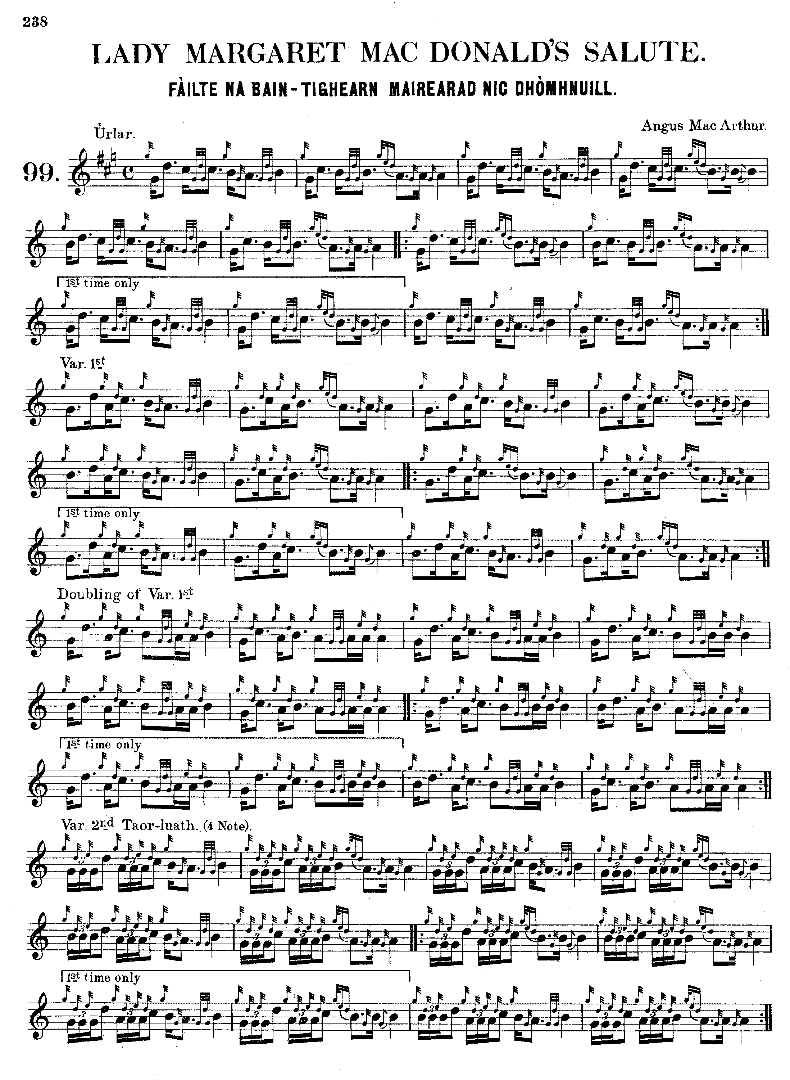
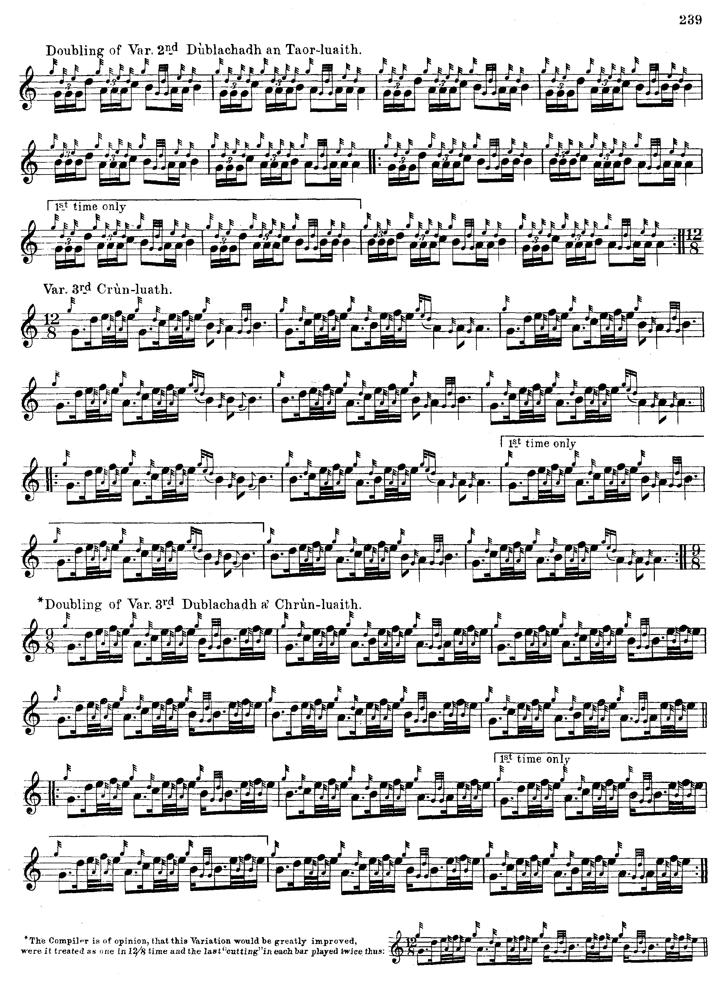

Commentary:

Its plaintive descending phrase contours make this tune sound, to a modern ear, more like a lament than a salute.

Lady Margaret MacDonald was the wife of one of the greatest of the Skye chieftains, Sir Alexander MacDonald of Sleat. Thanks to her Jacobite sympathies and relations with Flora MacDonald and the MacDonalds of Kingsburgh, Lady Margaret had an active role in the escape of Prince Charles Edward Stuart after the ’45. Robert Chambers in his History of the Rebellion of 1745-6 (7th edn., 1869, first published in 2 vols., Edinr., 1827) gives a vivid account of these affairs drawn from contemporary documents showing the consternation at Mugstad when the house was visited by government forces searching for the Prince who at the time was sitting on a trunk at the bottom of the garden:

Sir Alexander was at this time at Fort Augustus, in attendance on the Duke of Cumberland; but his spouse, Lady Margaret Macdonald – one of the beautiful daughters of Alexander and Susanna, Earl and Countess of Eglintoune, a lady in the bloom of life, of elegant manners, and one who was accustomed to figure in the fashionable scenes of the metropolis – now resided at Mugstat. Well affected from education to the house of Stuart, and possessed of humane feelings, she had pitied the condition of the Prince in the Long Island, of which she was made aware, and had sent him…the newspapers of the day, which he had regarded as a great obligation. Mr Macdonald of Balshair, who served as a medium for this intercourse, had recently transmitted a letter of thanks, written by the Prince to Lady Margaret, enclosed in the one to his brother Donald Roy Macdonald, one of the Prince’s captains, who was now residing, for the cure of a wound in his foot (got at Culloden), in the house of Mr John Maclean, surgeon in Trotternish. Donald Roy, a well-bred Highland gentleman, delivered the Prince’s letter to Lady Margaret with his own hand, and immediately after, as he had been ordered, desired her ladyship to burn it, for the sake of her own safety, as well as that of the Prince. But, kissing it, she said: “No, I will not burn it – I will preserve it for the sake of him who sent it to me. Although King George’s forces should come to the house I hope I shall find a way to secure the letter.” She hid it in a closet. The purport of Balshair’s letter to Donald Roy was, that the Prince (the escape with Flora MacDonald not being then projected) designed to leave the Long Island and take refuge in a small solitary isle named Fladdachuan, six miles from Trotternish, and inhabited by only one family, tenants under Sir Alexander MacDonald. Donald was desired to keep a look-out, and be ready to assist the Prince with necessaries in that island. At the interview which Donald had with Lady Margaret, she entered heartily into the scheme, and gave him six shirts, and twenty broad pieces of gold, for the Prince’s use. She offered blankets, which Donald refused, as he could not get them carried without the risk of exciting suspicion. During the interval between the receipt of these letters and the arrival of the Prince in Skye, Donald had gone to Fladdachuan to look out for the expected stranger, but of course in vain. Lady Margaret had also more recently received, by a Mrs Macdonald of Kirkibost in North Uist, a letter informing her of the altered scheme, and of the concern which Miss Flora was taking in the matter. She was therefore in some measure prepared for the arrival of the Prince in Skye, but not for his coming so near her residence.
When the boat containing the Wanderer had landed, Miss Macdonald, attended by Neil Mackechan, proceeded to the house, leaving Charles, in his female dress, sitting on her trunk upon the beach. On arriving at the house, she desired a servant to inform Lady Margaret that she had called on her way home from the Long Island. She was immediately introduced to the family apartment, where she found, besides Mrs Macdonald of Kirkibost, a Lieutenant Macleod, the commander of a band of militia stationed near by, three or four of whom were also in the house. There was also present Mr Alexander Macdonald of Kingsburgh, a gentleman of the neighbourhood, who acted as chamberlain or factor to Sir Alexander Macdonald, and who was, she knew, a sound Jacobite. Miss Macdonald entered easily into conversation with the officer, who asked her a number of questions – as, where she had come from, where she was going, and so forth – all of which she answered without manifesting the least trace of that confusion which might have been expected from a young lady under such circumstances. The same man had been in the custom of examining every boat which landed from the Long Island: that, for instance, in which Miss Macdonald of Kirkibost arrived had been so examined; and I can only account for his allowing that of Miss Flora to pass, by the circumstances of his meeting her under the imposing courtesies of the drawing-room of a lady of rank. Miss Macdonald, with the same self-possession, dined in Lieutenant Macleod’s company. Seizing a proper opportunity, she apprised Kingsburgh of the circumstances of the Prince, and he immediately proceeded to another room, and sent for Lady Margaret, that he might break the intelligence to her in private. She was greatly alarmed, insomuch as to scream, and exclaim aloud that she and her family were undone; but Kingsburgh, who was a cool, sensible man, soon calmed her fears in some degree, assuring here that, if necessary, he would take the Prince to his own house. He was now, he said, an old man, and it made little difference to him whether he should immediately die with a halter about his neck, or await a natural death which could not be far distant. It was then agreed to send an express to Donald Roy, requesting his immediate attendance on business of the utmost importance. It does not appear to have been thought that Donald was in any danger from Lieutenant Macleod; and indeed the reverse of this appears, for he tells us himself that he at this time used to meet the militiamen and jest with them on his late career as a rebel officer. For the protection, however, of Lady Margaret, the letter was directed by Mrs Macdonald of Kirkbost, and put into the messenger’s hands, as from her.
When Donald soon after approached the house, he saw Lady Margaret and Kingsburgh walking together in the garden, as in deep consultation. Her ladyship’s first address to him was: “Oh, Donald, we are ruined for ever!” The three now held an anxious council as to the best means of disposing of the Prince, whose resting-place for the meantime was at the bottom of the garden in which they were walking. It was suggested that he might proceed in the boat to the island of Raasay; but this was seen to be too dangerous, as he would require to pass a military party in sailing along the coast in that direction. It was at last determined that he should be sent overland to Portree, the principal port in Skye, and thence transported to Raasay. (pp.351-4)

There is a note in David Glen by “Fionn” on this tune as follows:

The MacArthurs were hereditary pipers to the MacDonalds. The most famous of them was undoubtedly Charles, whose musical education was perfected by Patrick Og MacCrimmon. Charles had two sons, Donald and Alexander, the former of whom was drowned; the latter went to America. His brother Neil had a son John, who was taught by his uncle Charles, who settled in Edinburgh, and was appointed piper to the Highland Society of Scotland, an appointment which he held until his death. He taught the art to many students, from which he was usually styled Professor MacArthur.
John Bàn MacArthur, another brother, had a son named Angus, who went with Lord MacDonald to London, where he remained till his death. He is believed to have been the last of the MacArthurs, hereditary pipers to the MacDonalds of the Isles.
Lady Margaret, to whom this Salute was composed, was the daughter of Alexander, Ninth Earl of Eglinton, and wife of Sir Alexander MacDonald of Slate, mother of Sir James, the “Scottish Marcellus,” and of Alexander, Lord MacDonald. She entertained the Prince in Skye, though Sir Alexander, her husband was on the other side. (“Historic, Biographic, and Legendary Notes to the Tunes”, p.21).

* * *

Electronic text © Dr. William Donaldson, Aberdeen, Scotland, September 2006

