Lady MacDonald’s Lament
There are settings of this tune in the following manuscript source:
--John MacGregor and Angus MacArthur, “Highland Society of London’s MS”, ff.73-8;
and in the following published sources:
--Frans Buisman and Andrew Wright, eds., The MacArthur-MacGregor Manuscript of Piobaireachd (1820), p.152;
--Angus MacKay, Ancient Piobaireachd, pp.137-140;
--C. S. Thomason, Ceol Mor, p.199;
--David Glen, Ancient Piobaireachd, pp.185-7;
--G. F. Ross, Some Piobaireachd Studies, p.35.

The MacArthur-MacGregor MS sets the tune like this:
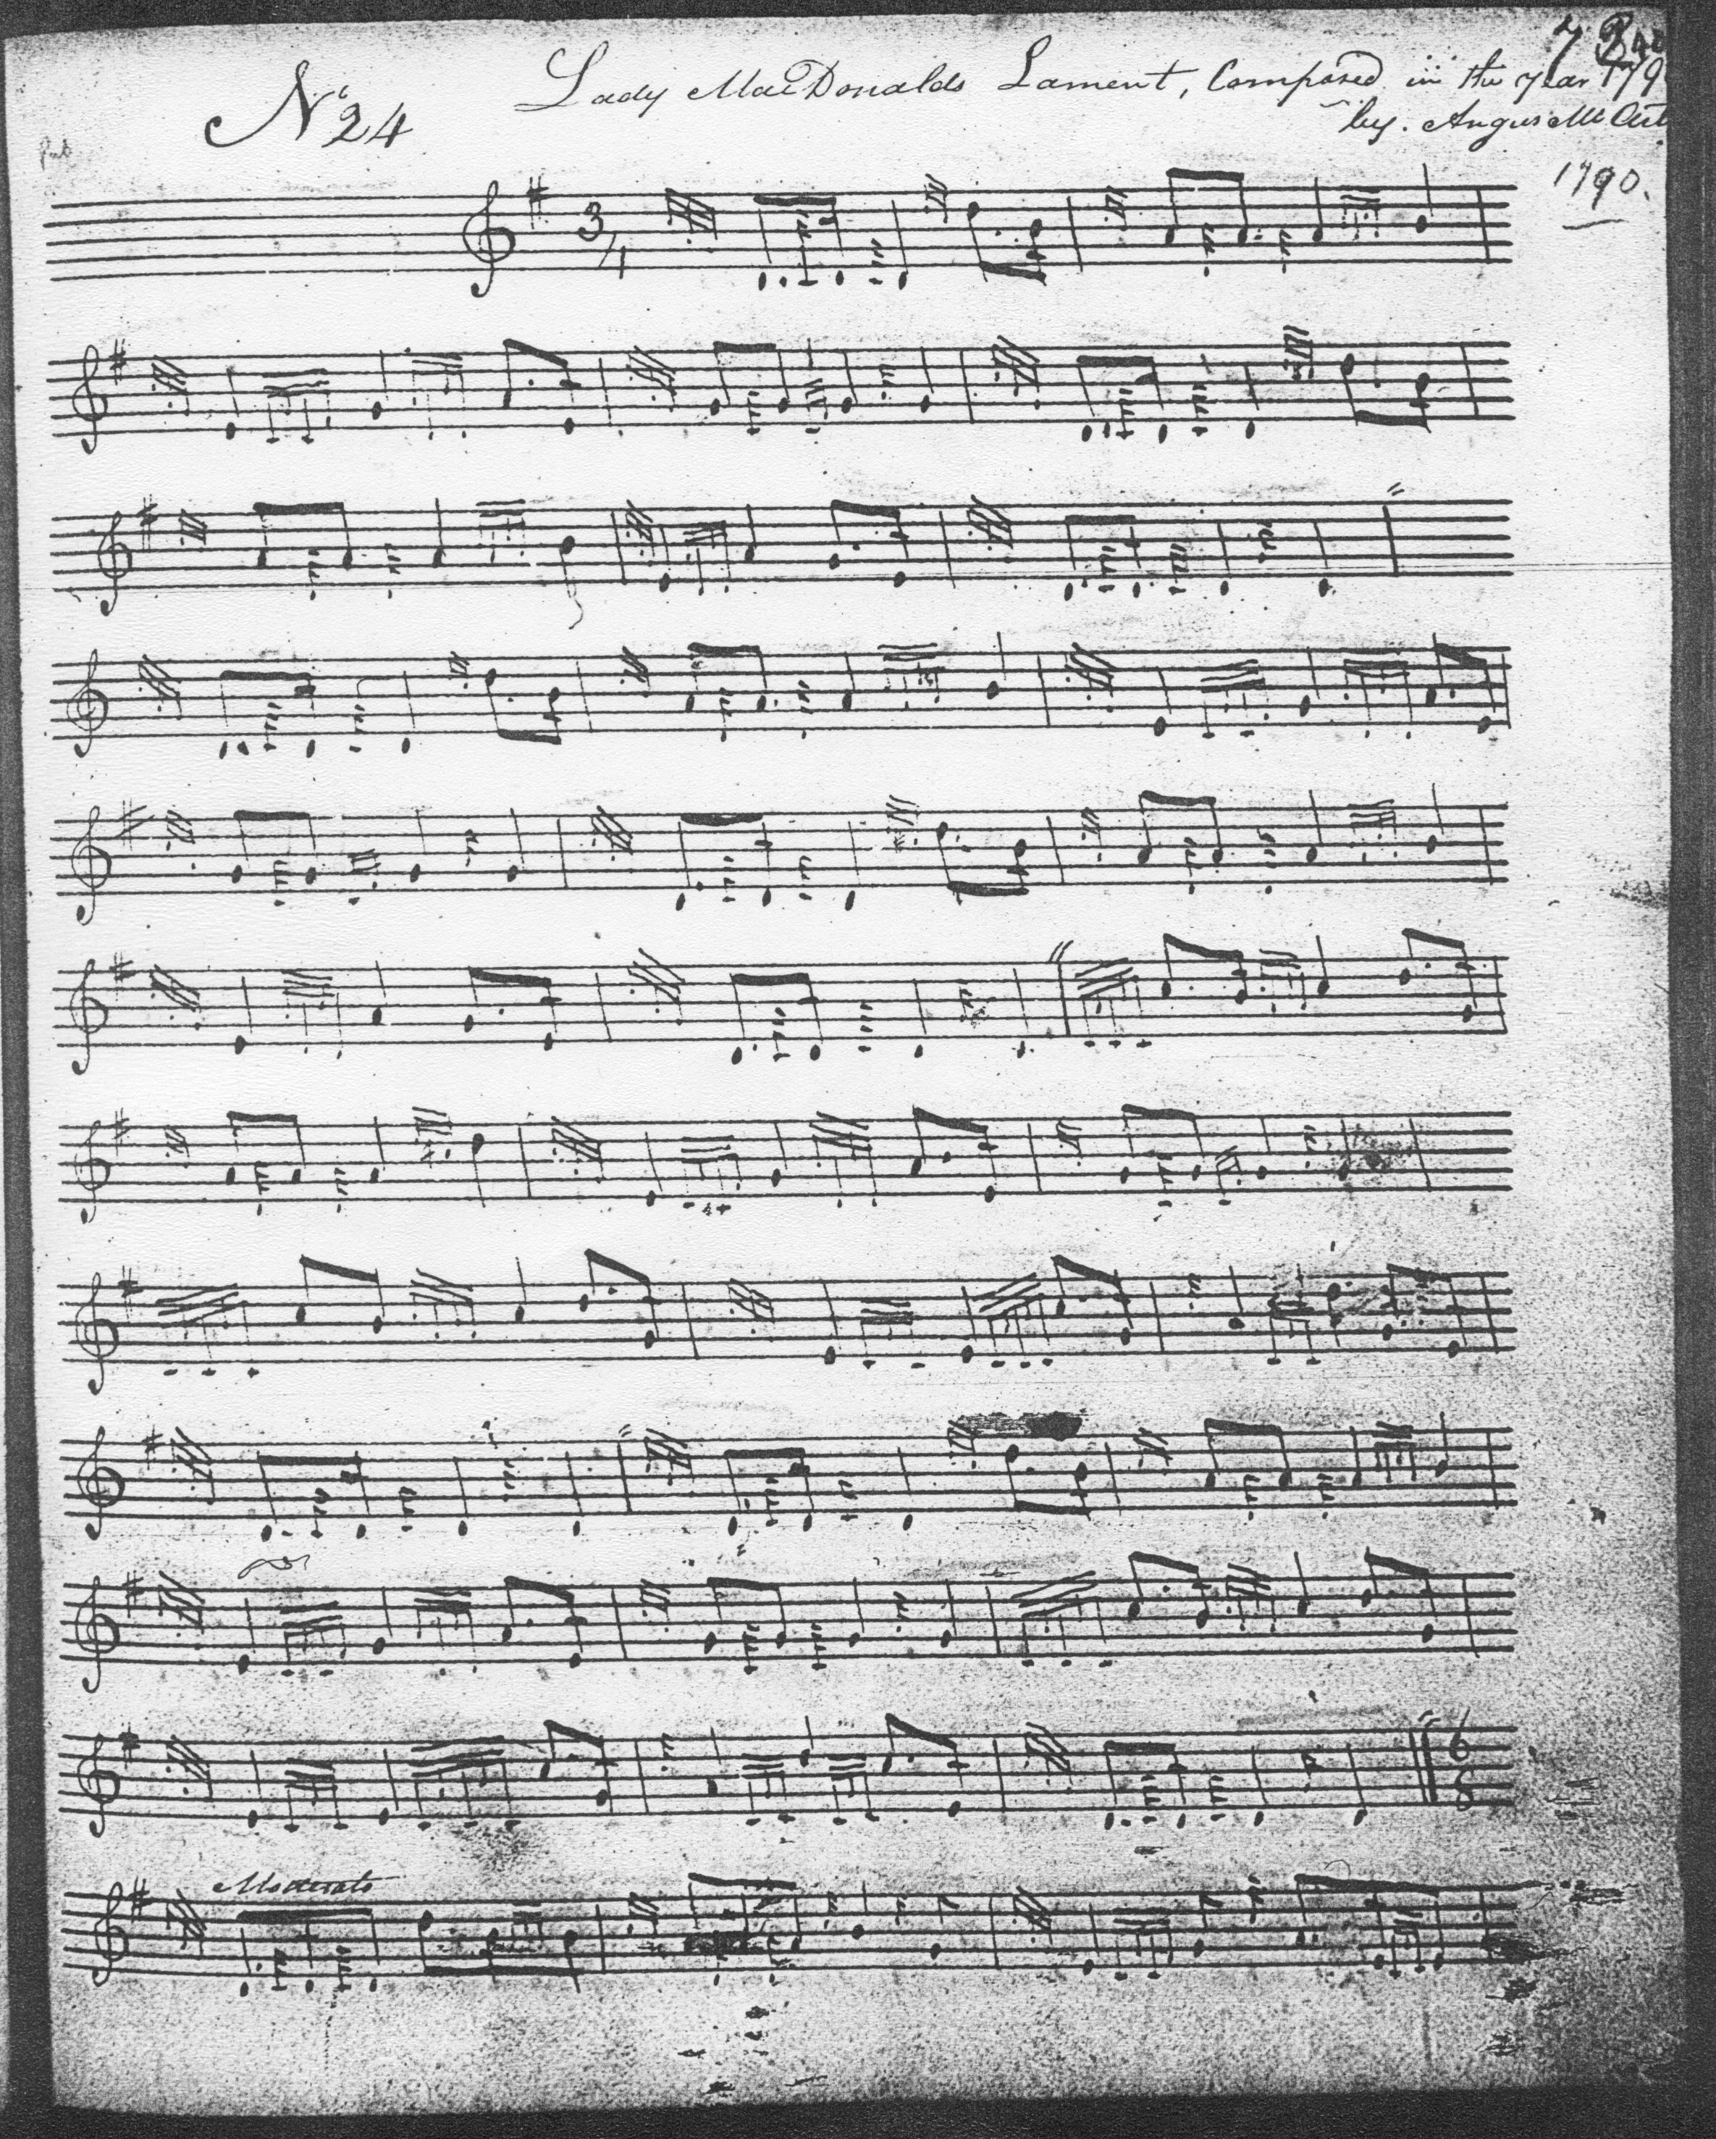
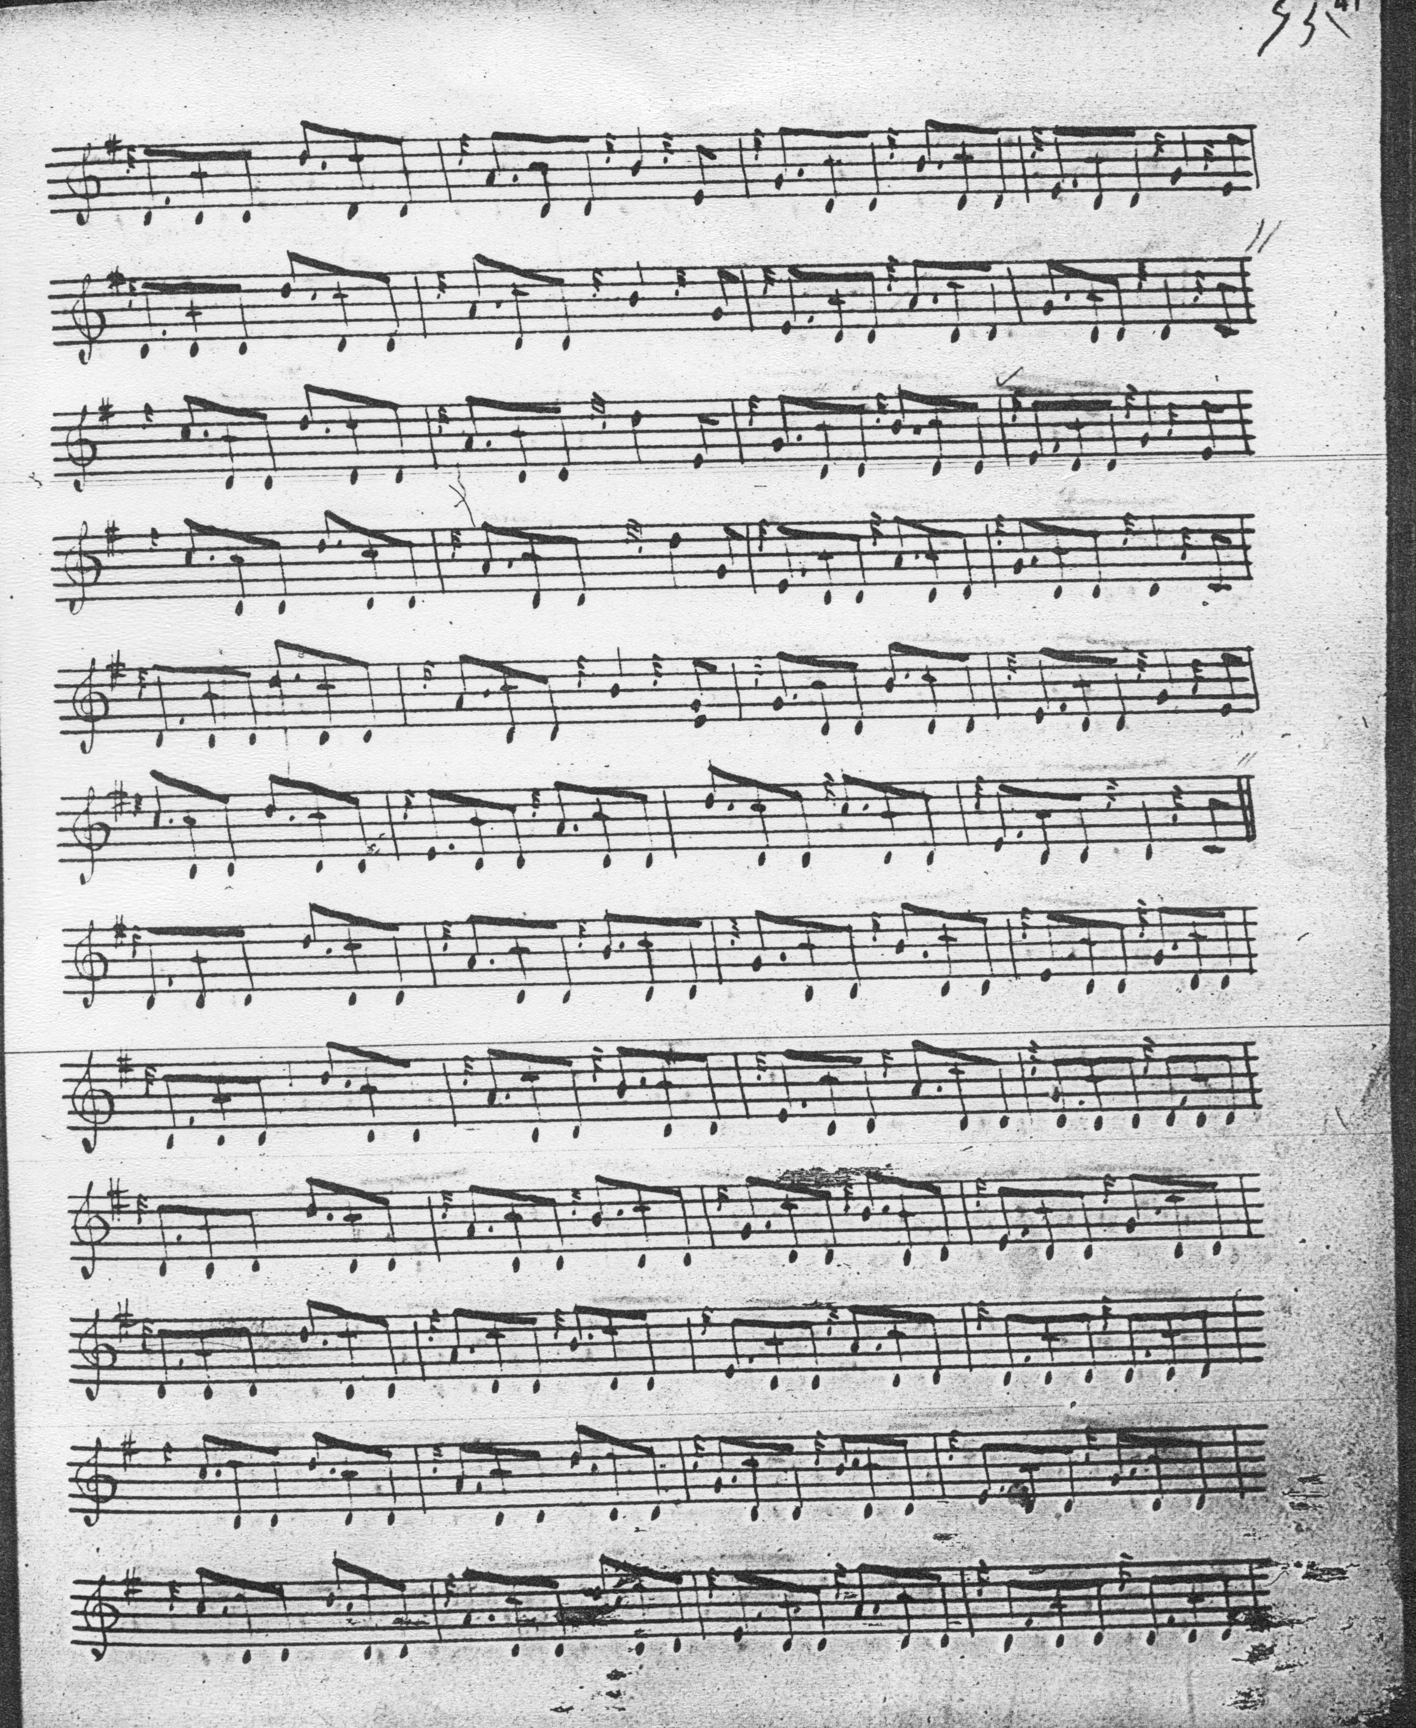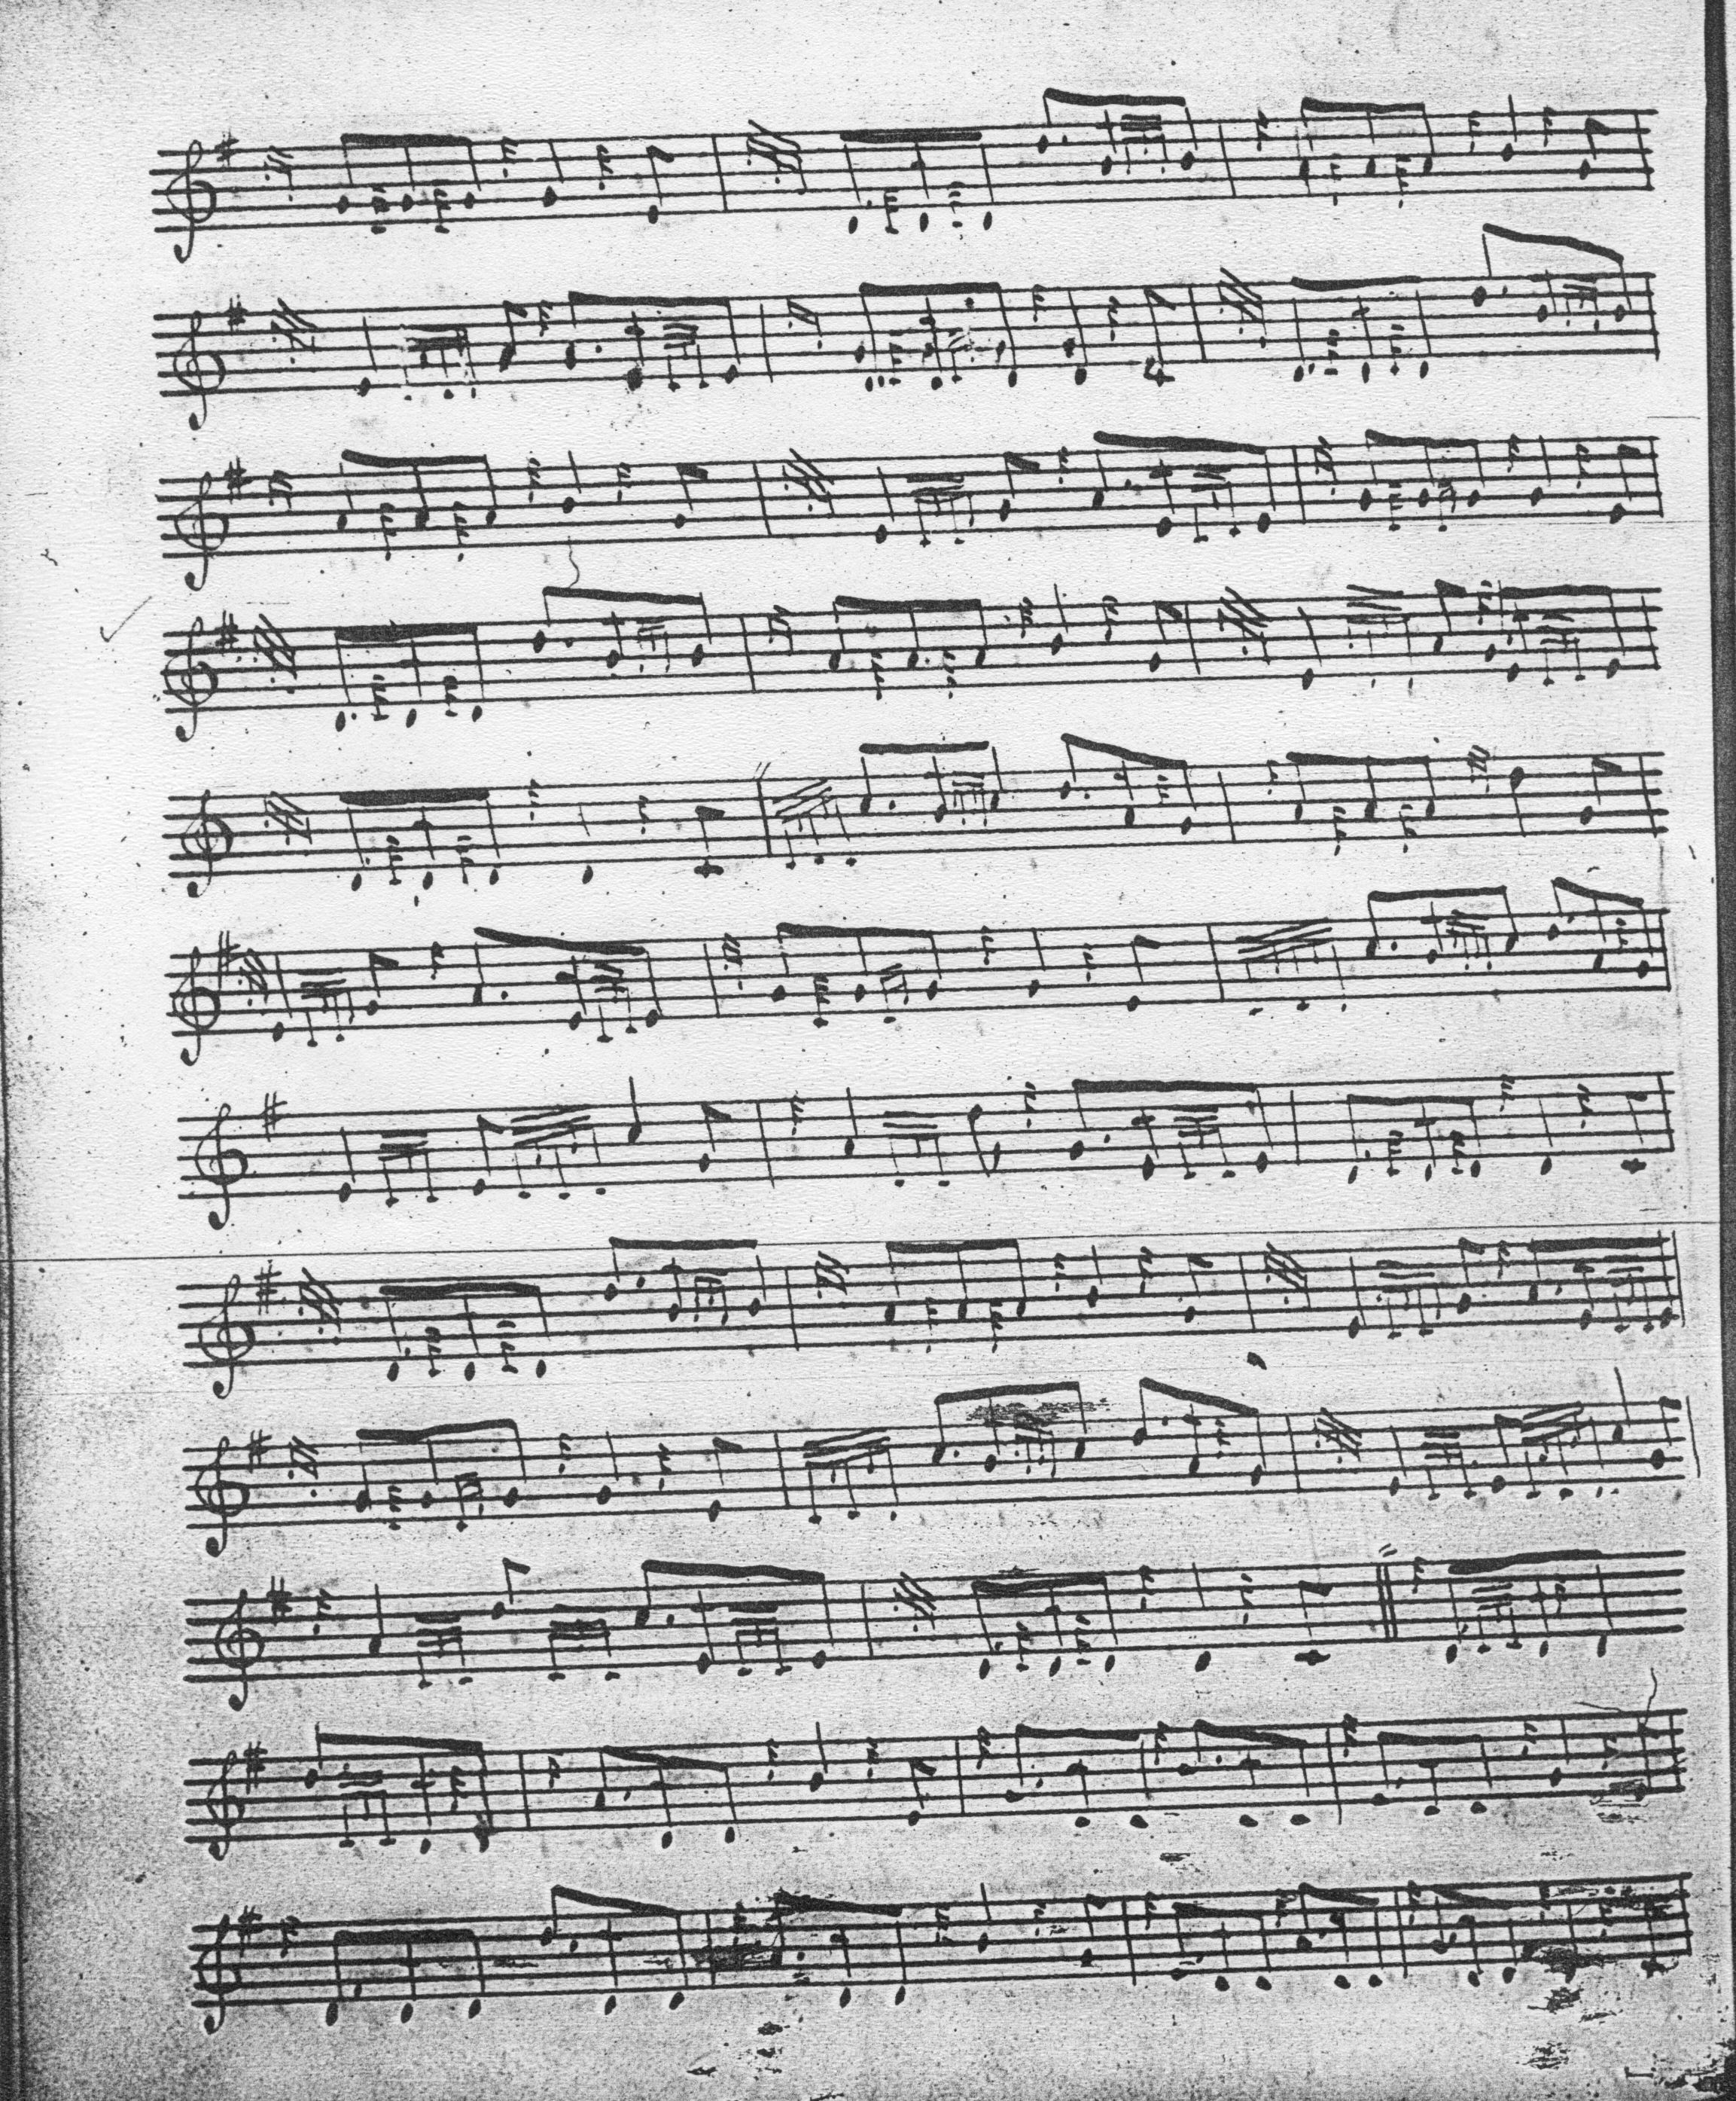

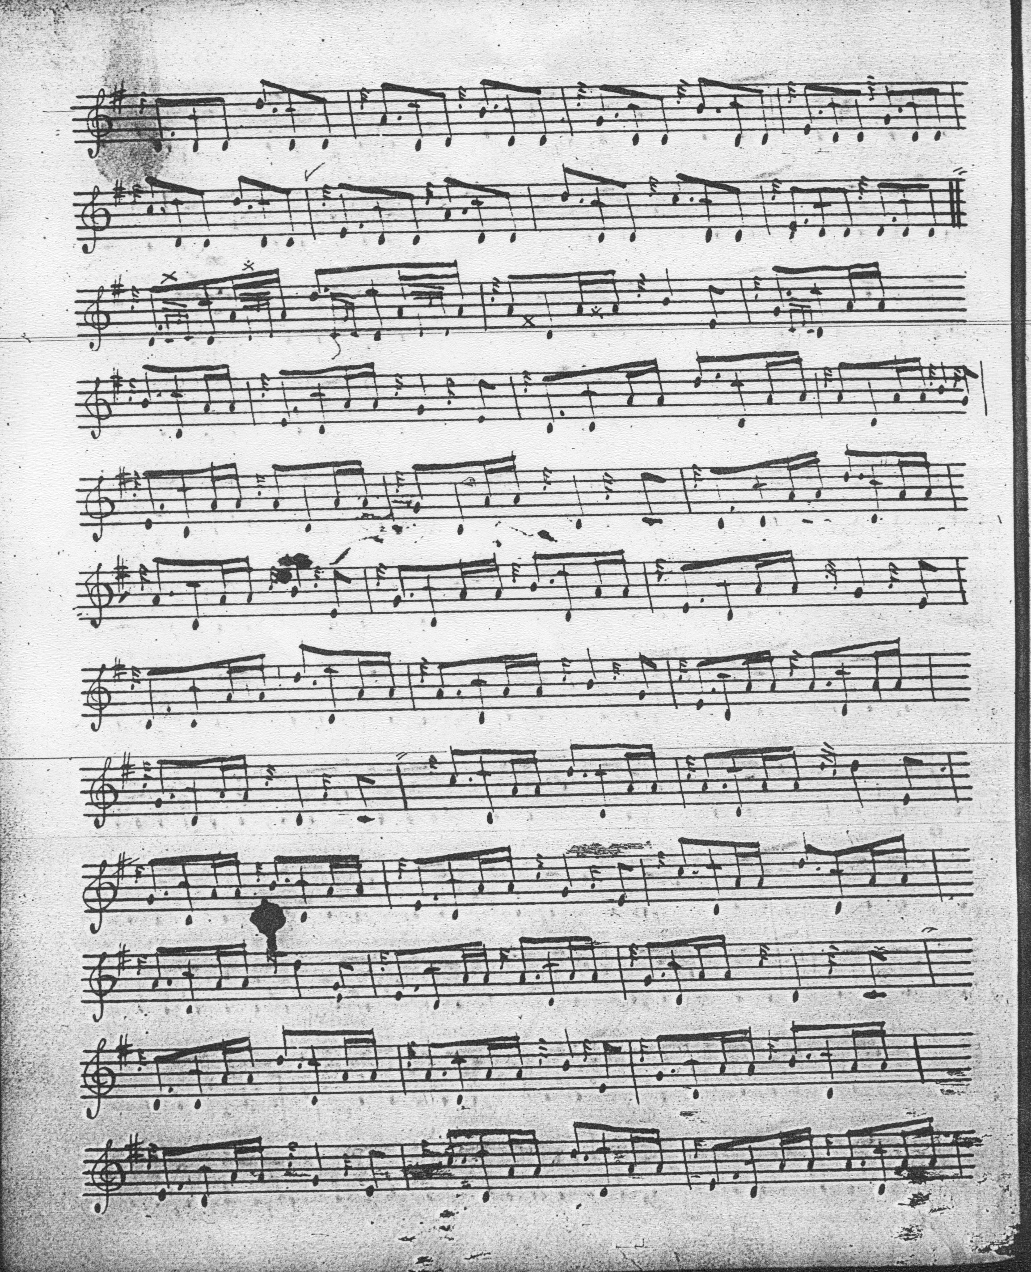

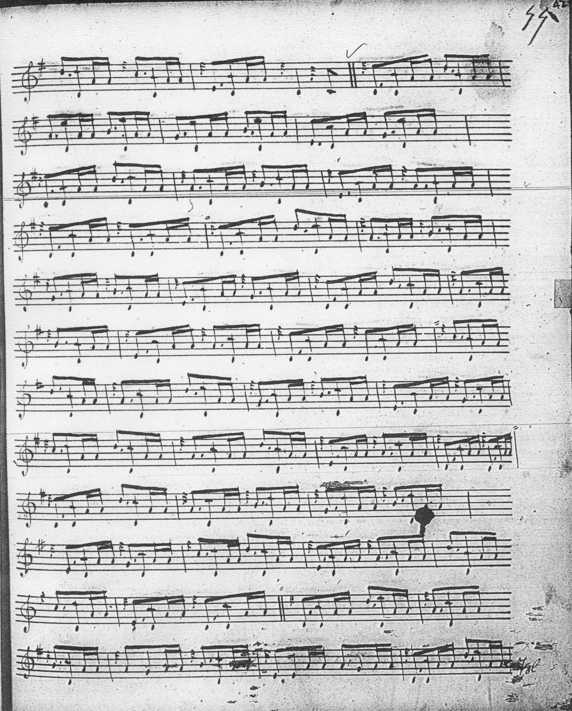

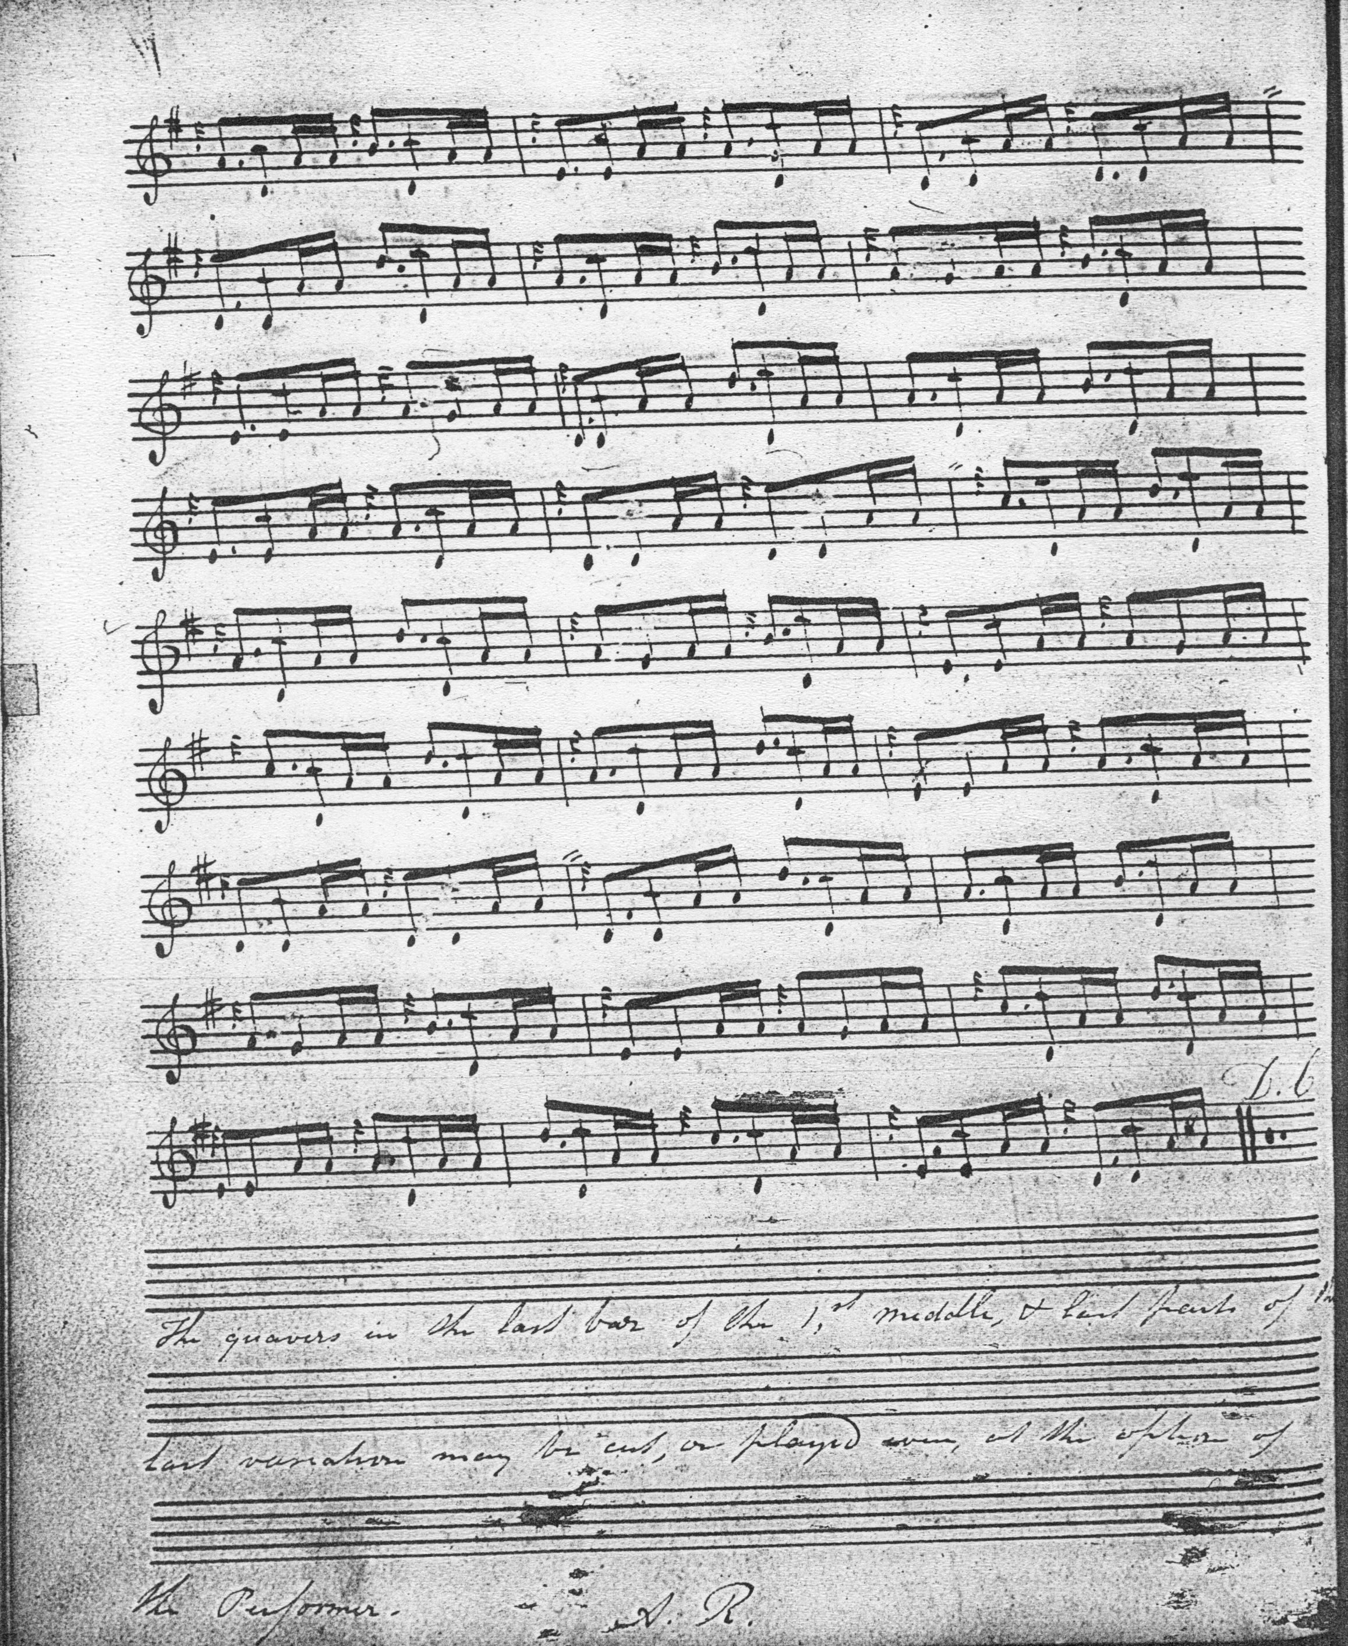

There are a number of interesting features in the MacArthur/MacGregor setting including the step-up in tempo in the first variation suggested by the moderato marking and the switch from 3/4 to 6/8 time; the little reflexive F gracenotes before the double echo beats on E, and the fact that there is no indication the ground should be repeated at the end of the taorluath doubling and the concluding a mach (whose inclusion is a rather surprising feature given the tonality of the tune) timed in the normal MacArthur manner with the initial B and C given at least a full quaver value and the movement on D played off an initial E. We also note the rather ambiguous comments about timing the ends of lines in the final variation by Andrew Robertson, the Highland Society of London’s agent, under whose auspices the collection was compiled, which probably refer to the timing of the cadences in the crunluath singling.

Angus MacKay sets the tune as follows:
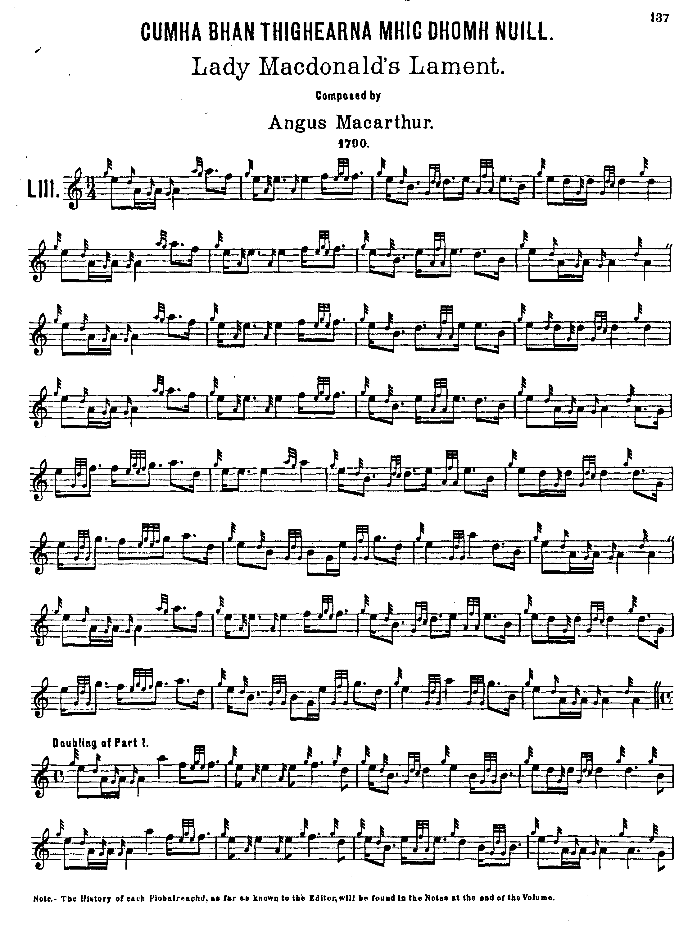

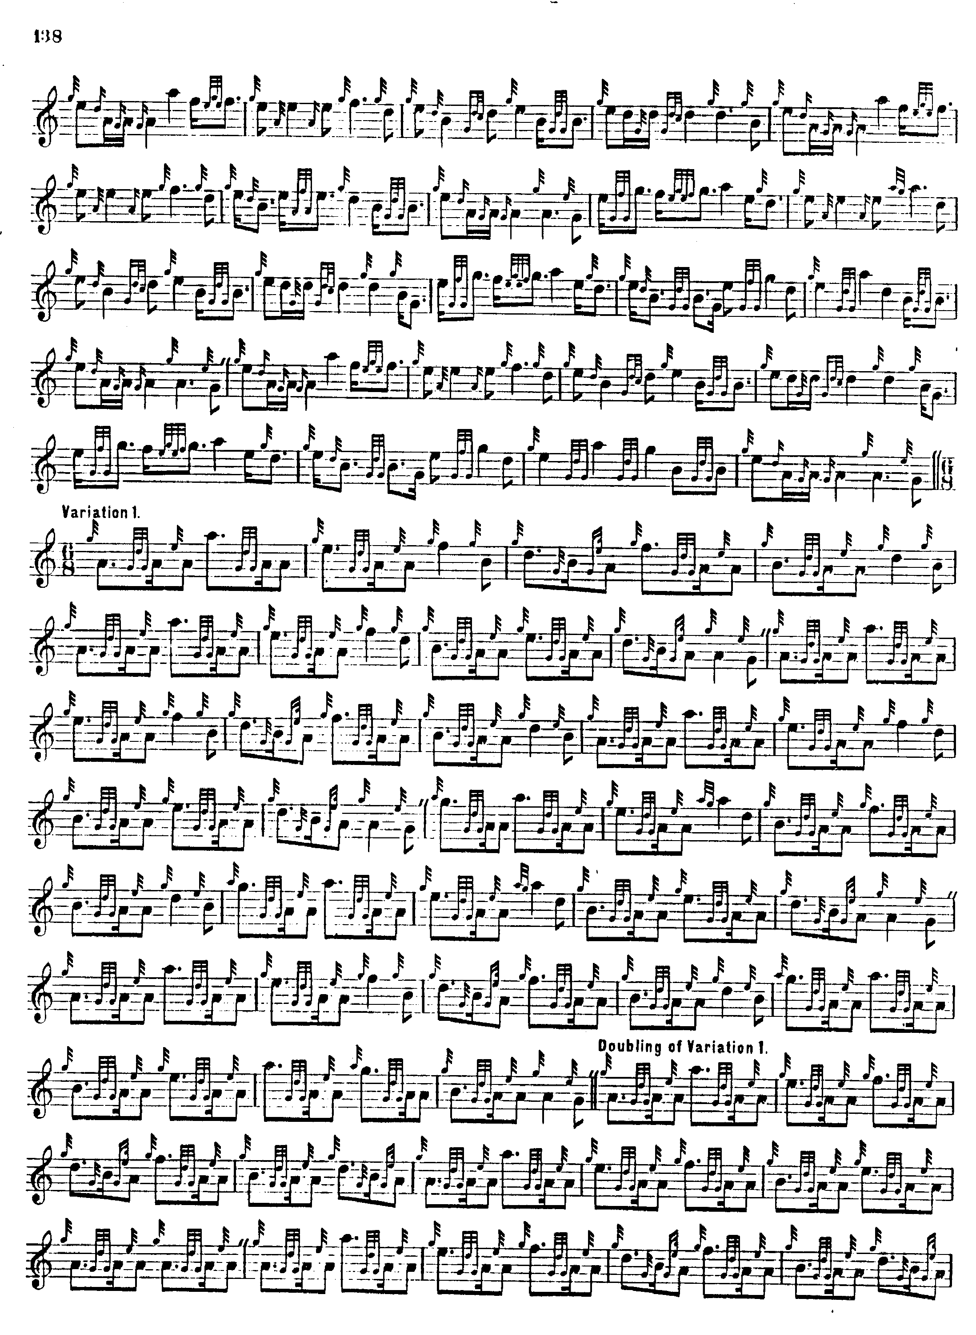
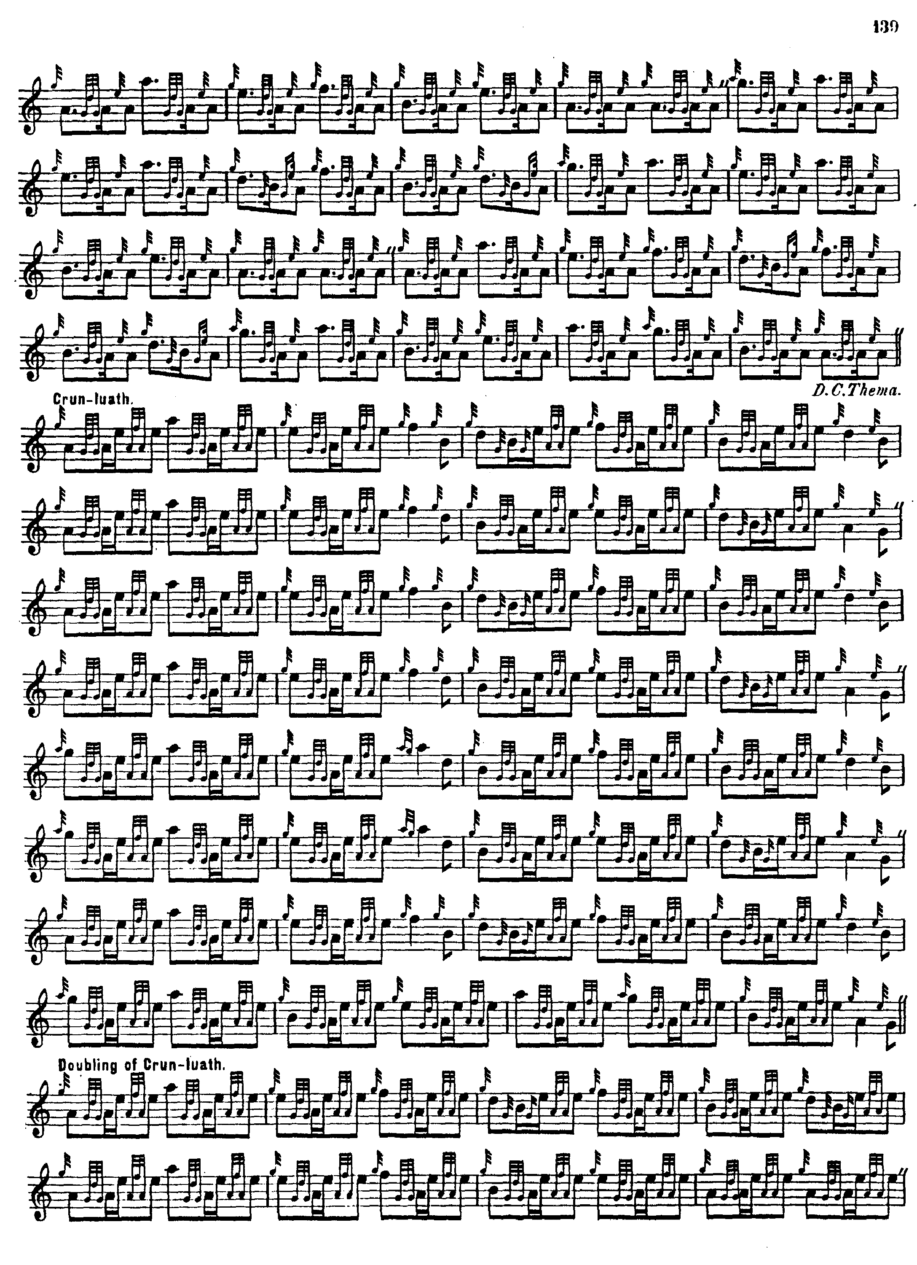

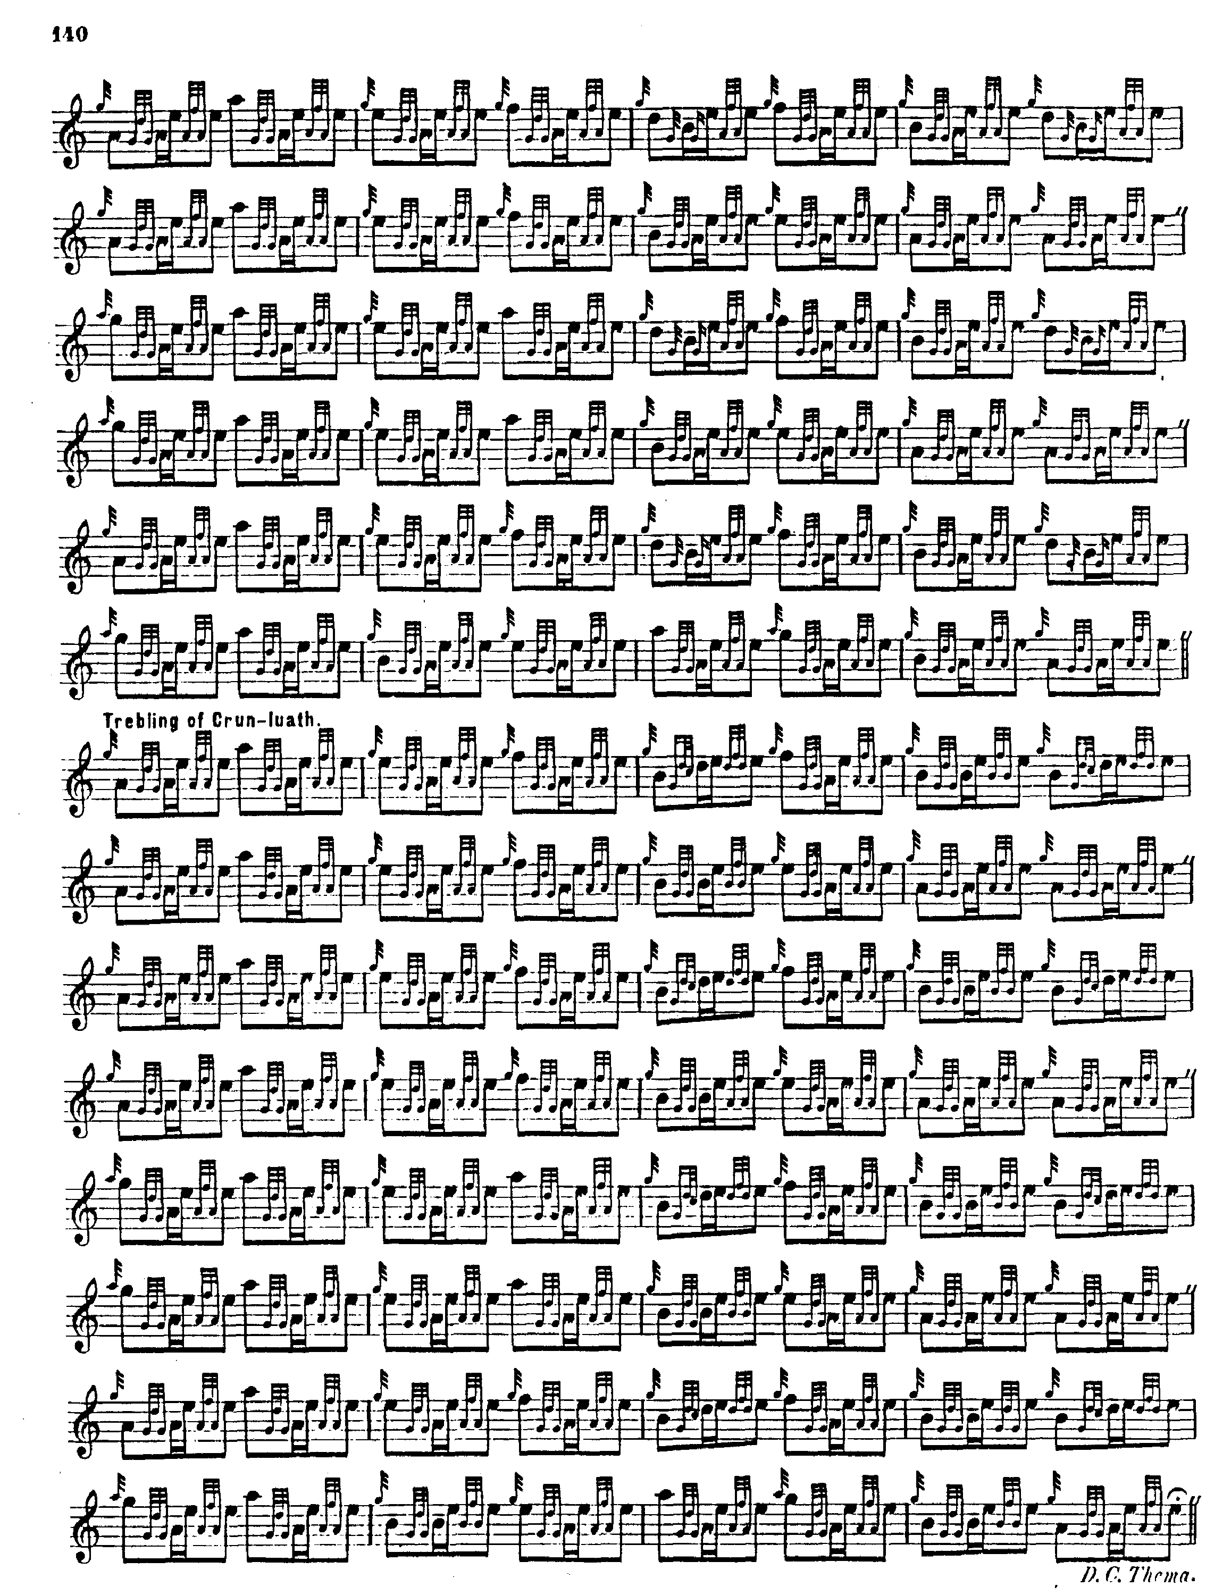

MacKay’s score has the usual sprinkling of typographical inconsistencies, for example the missing gracenotes in bar eighteen of the ground, and altogether his style is sparer than MacArthur/MacGregor, consistent with the move towards standardised settings then being promoted by the Highland Societies of London and Scotland.
His timing of the opening and concluding gestures on A is different from MacArthur’s and we note also his specification of precise durations for his cadence Es. MacKay also repeats the ground at the end of the taorluath and crunluath doublings. In his crunluath a mach he plays his movements on D off an expressed B quaver (as opposed to the E in MacArthur).

C. S. Thomason cites Angus MacKay’s published volume as his source and except that his melody notes are D/E rather than D/F, in bar three of his taorluath and crunluath variations (and at corresponding positions elsewhere) his score adds little to MacKay and is not reproduced here.

David Glen sets the tune like this:

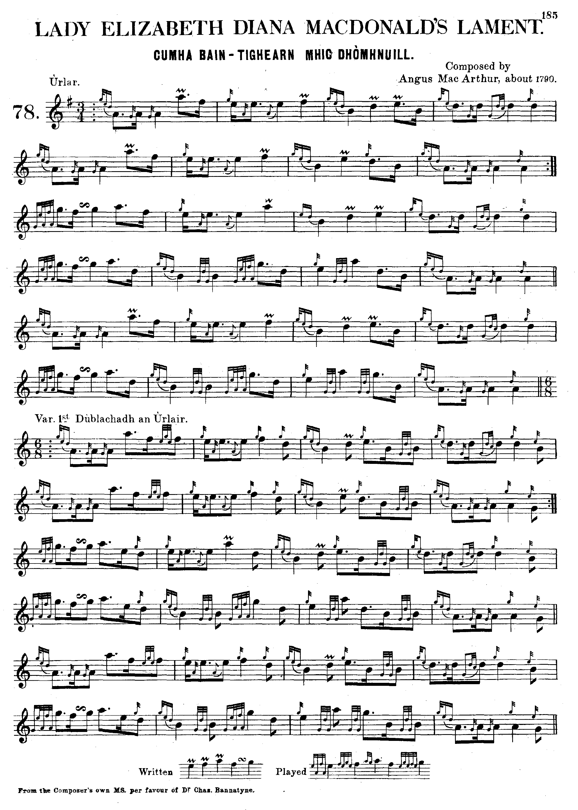

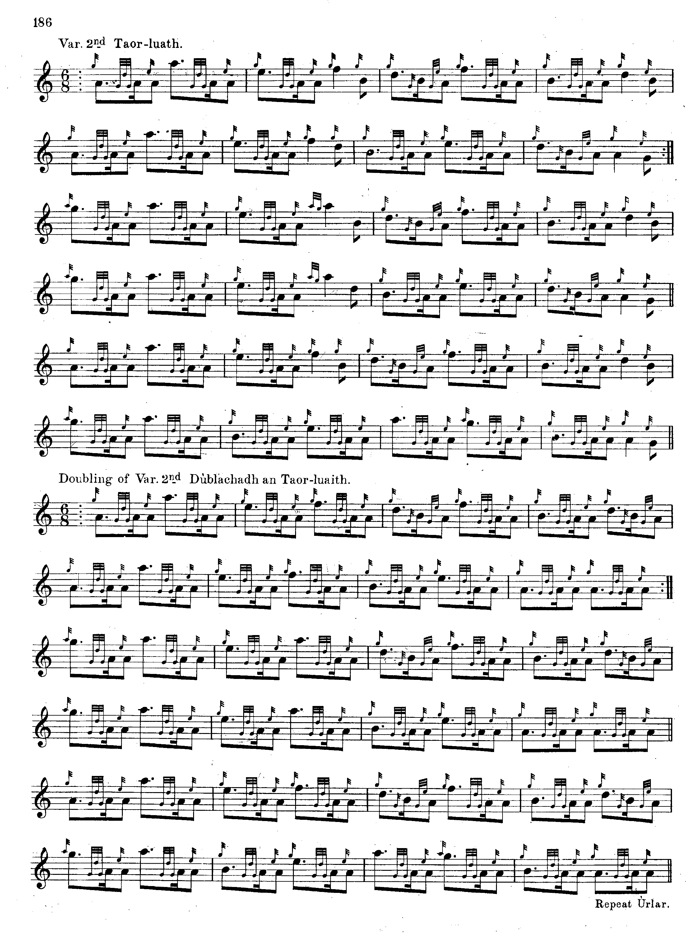
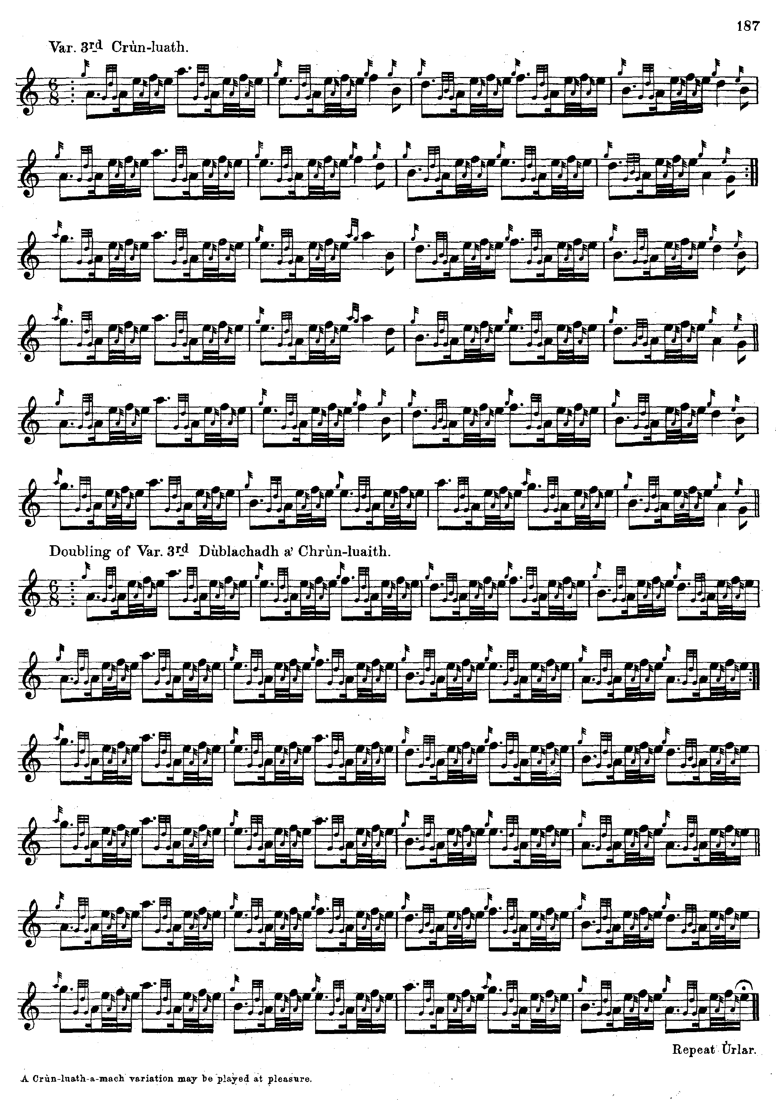

Glen chooses 6/8 for his doubling of the ground (MacKay uses 4/4) and indicates that “A Crùn-luath-a-mach variation may be played at pleasure”, but otherwise his setting is basically a typographically “cleaner” version of MacKay, and people preparing the tune from a MS or printed score might well prefer this version.

G. F. Ross’s preference of duple to triple timings is in evidence once again in his notes on “Lady MacDonald’s Lament” in Some Piobaireachd Studies (Glasg. 1926), although it is clear that he had not seen a copy of the Highland Society of London’s MS which was the ultimate source of the tune:

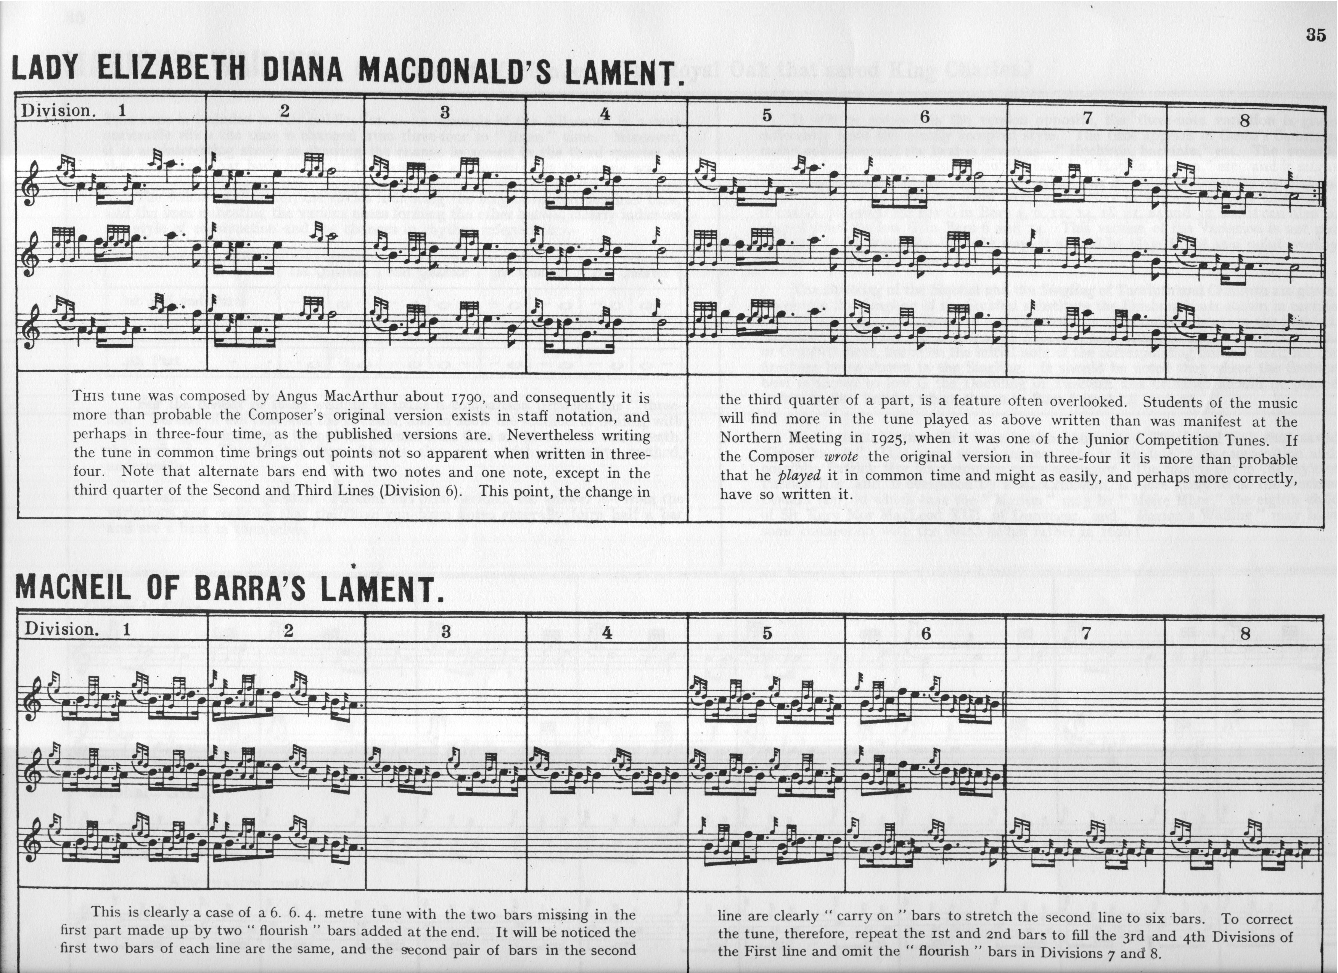

It is interesting that the Piobaireachd Society’s editor, Archibald Campbell, took a very similar route through this tune in volume eight of the Society’s Collection (second series) published in 1939, although he makes no mention of Ross, and, after Ross’s death, expressed a low opinion of his work, recommending that Ross’s papers, which had in the meantime come into the Piobaireachd Society’s possession, should be quietly destroyed (see The Highland Pipe and Scottish Society, p. 439). One notes G. F. Ross’s unusual timing of the echo beats on E and D here with the internal low As and Gs being given dotted quaver value with shortening of the subsequent note—a not unattractive effect.

Commentary:

James Logan’s notes to Angus MacKay’s Ancient Piobaireachd record that the tune was “Composed by Angus MacArthur 1790”, and Logan’s “Historical and Traditional Notes” add “This fine piobaireachd, was composed in 1790 by Angus MacArthur, the family Piper, on the death of Elizabeth Diana, Lady of Alexander, first Lord MacDonald, who died 18th October 1789. It is taken from the original MSS. In possession of the Highland Society of London.” (p.12).

The Lady MacDonald commemorated in this lament entertained James Boswell and Dr. Samuel Johnson at Armadale in 1773 during their celebrated tour of the Hebrides. Both writers published accounts of their travels, and the following reflections from Johnson on Sir Alexander MacDonald’s piper playing “Glengarry’s March” are of interest:

As we sat at Sir Alexander’s table, we were entertained, according to the ancient usage of the North, with the melody of the bagpipe. Every thing in those countries has its history. As the bagpiper was playing, an elderly Gentleman informed us, that in some remote time, the Macdonalds of Glengarry having been injured, or offended by the inhabitants of Culloden, and resolving to have justice or vengeance, came to Culloden on a Sunday, where finding their enemies at worship they shut them up in the church, which they set on fire; and this, said he, is the tune that the piper played while they were burning.
Narrations like this, however uncertain, deserve the notice of the traveller, because they are the only records of a nation that has no historians, and afford the most genuine representation of the life and character of the ancient Highlanders. (Dr. Samuel Johnson, A Journey to the Western Islands”, in R. W. Chapman, ed., Johnson’s Journey to the Western Islands of Scotland and Boswell’s Journal of a Tour to the Hebrides with Samuel Johnson, LL.D. Oxford, OUP, Oxford Standard Authors, 1930, first published 1924, p.44).

* * *

Electronic text © Dr William Donaldson, Cambridge, Massachusetts, 24th May 2013; revised January 2025.

