Lady Doyle’s Salute:

This attractive tune is a composition of John MacKay (1767-1848) and was first published by his son, Angus MacKay, in Ancient Piobaireachd, pp.43-4;
--it also appears in C. S. Thomason’s Ceol Mor, p. 150;
--and in William Stewart, et.al., eds., Piobaireachd Society Collection (first series), iv, 14;

There is a setting of this tune in David Glen’s manuscript, ff.330-331.
Angus MacKay sets the tune like this:

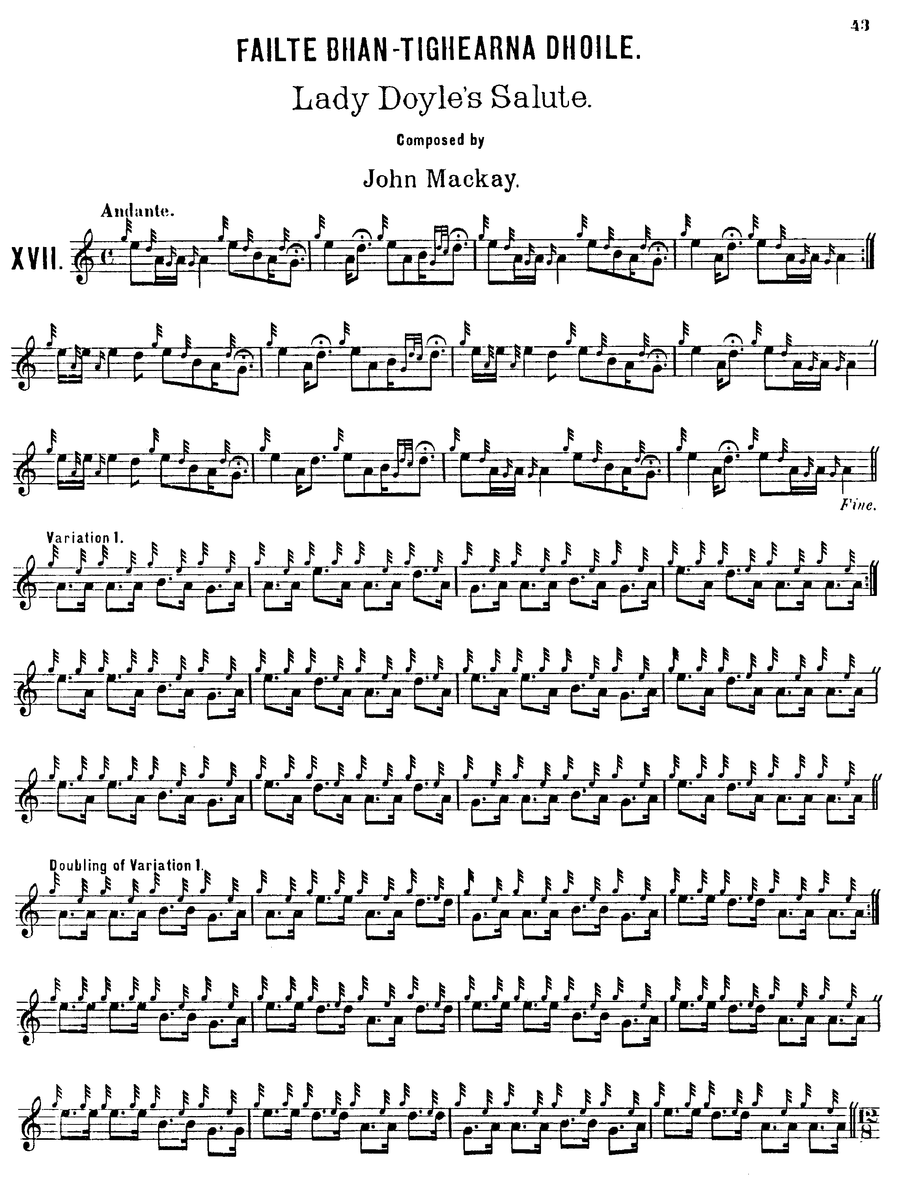
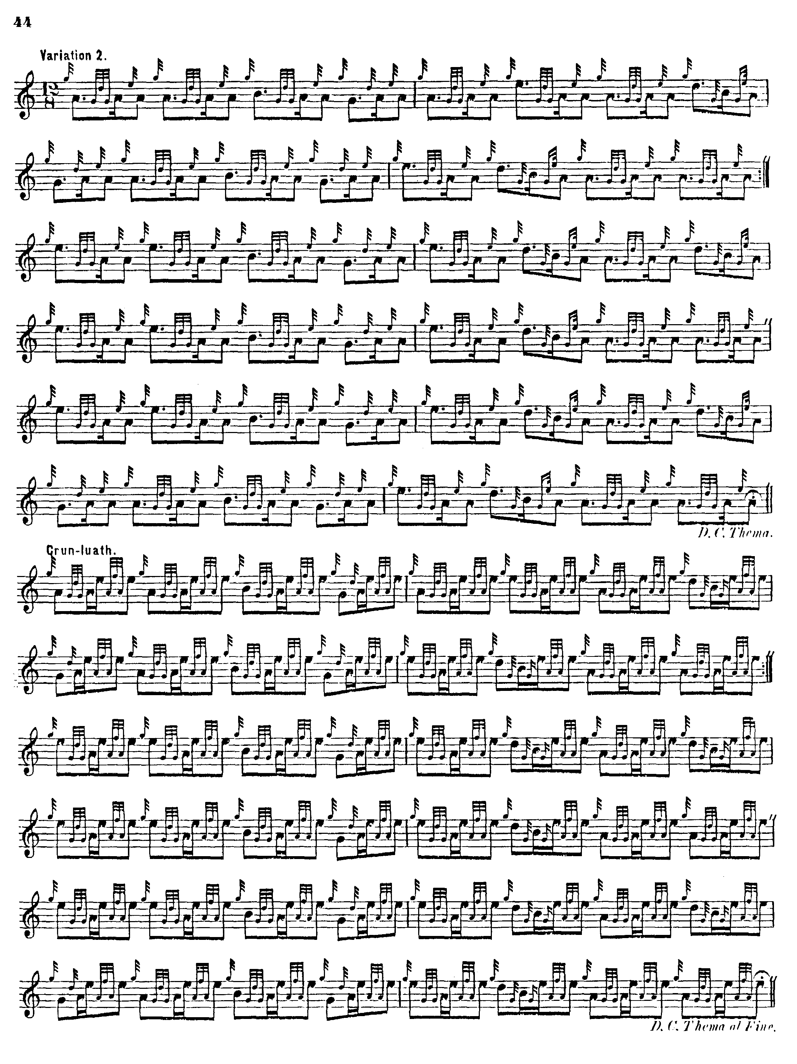

There are audible echoes here of another tune made for a woman, “Lady Anapool’s Lament”. In the doubling of variation one, the third line should probably be:

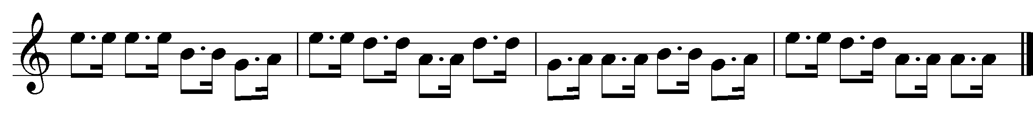

as we see in David Glen’s score below.

David Glen sets the tune like this:

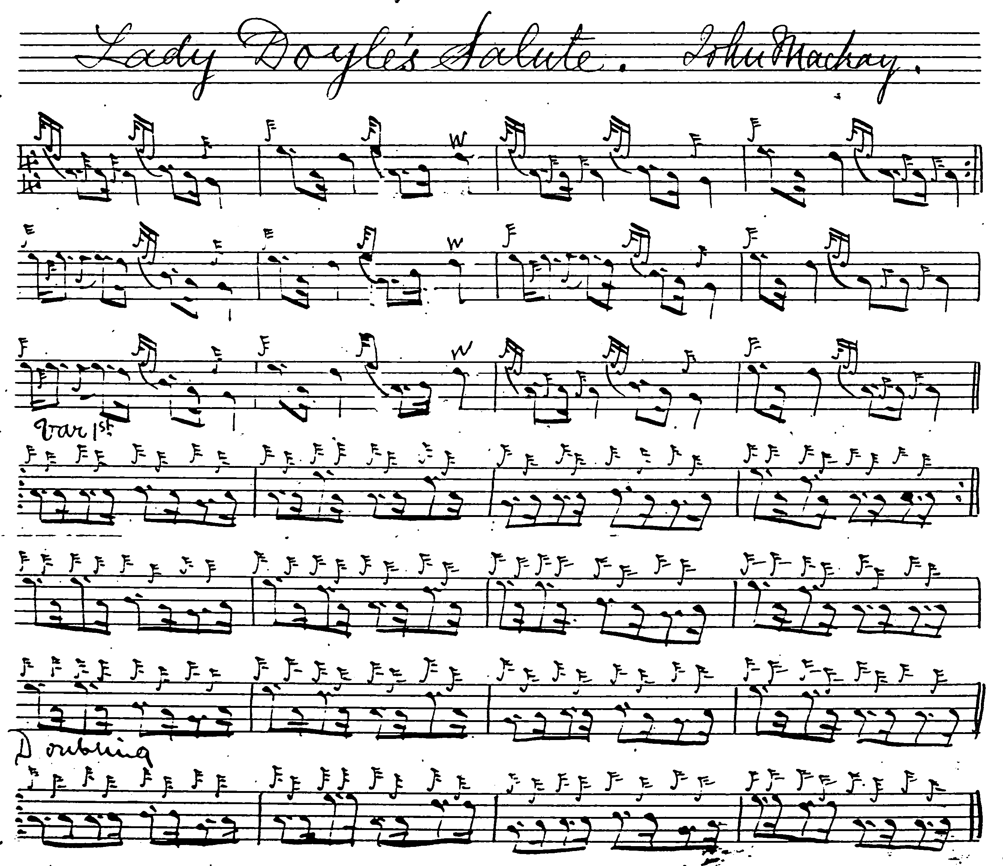
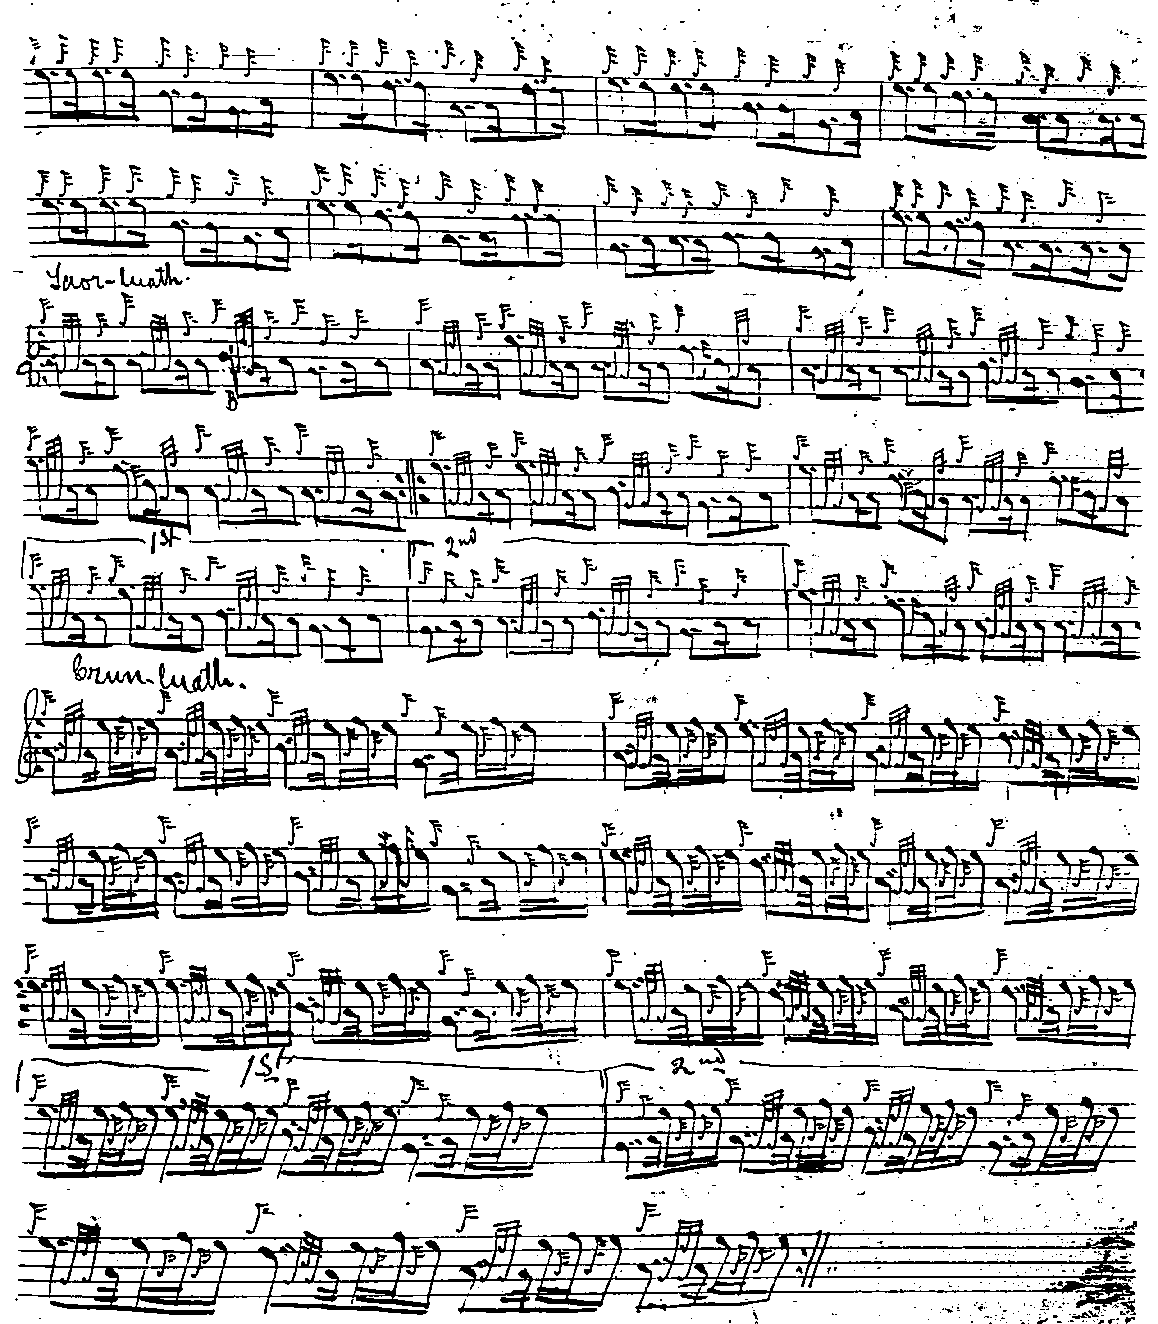

Glen’s score has the advantage of showing the pointing of the ground more clearly and stylishly than we see in Angus MacKay.

C. S. Thomason’s score shows subtle little differences in timing from Glen, playing the MacKay-style eallach with nice little runs down from E to low G, which Glen points the other way:

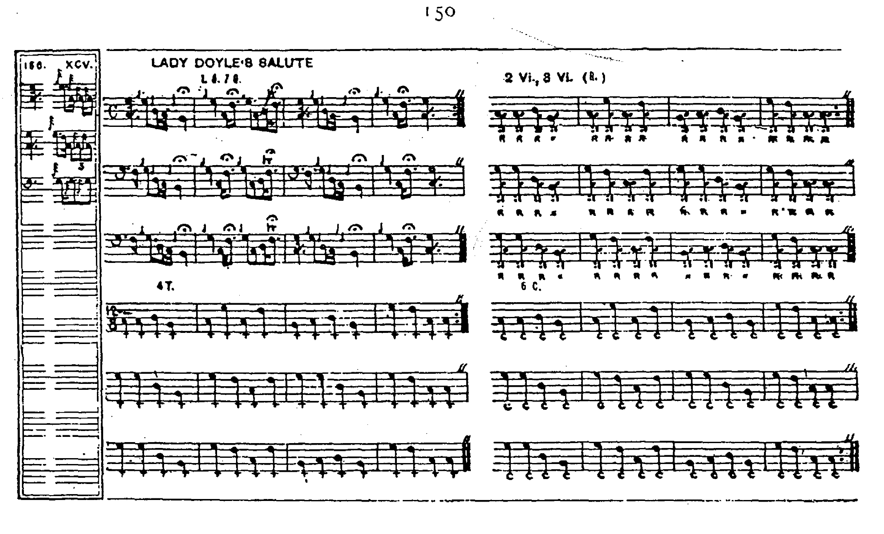

William Stewart’s score appears to be an attempt to combine Glen with Angus MacKay, producing an interesting hybrid:

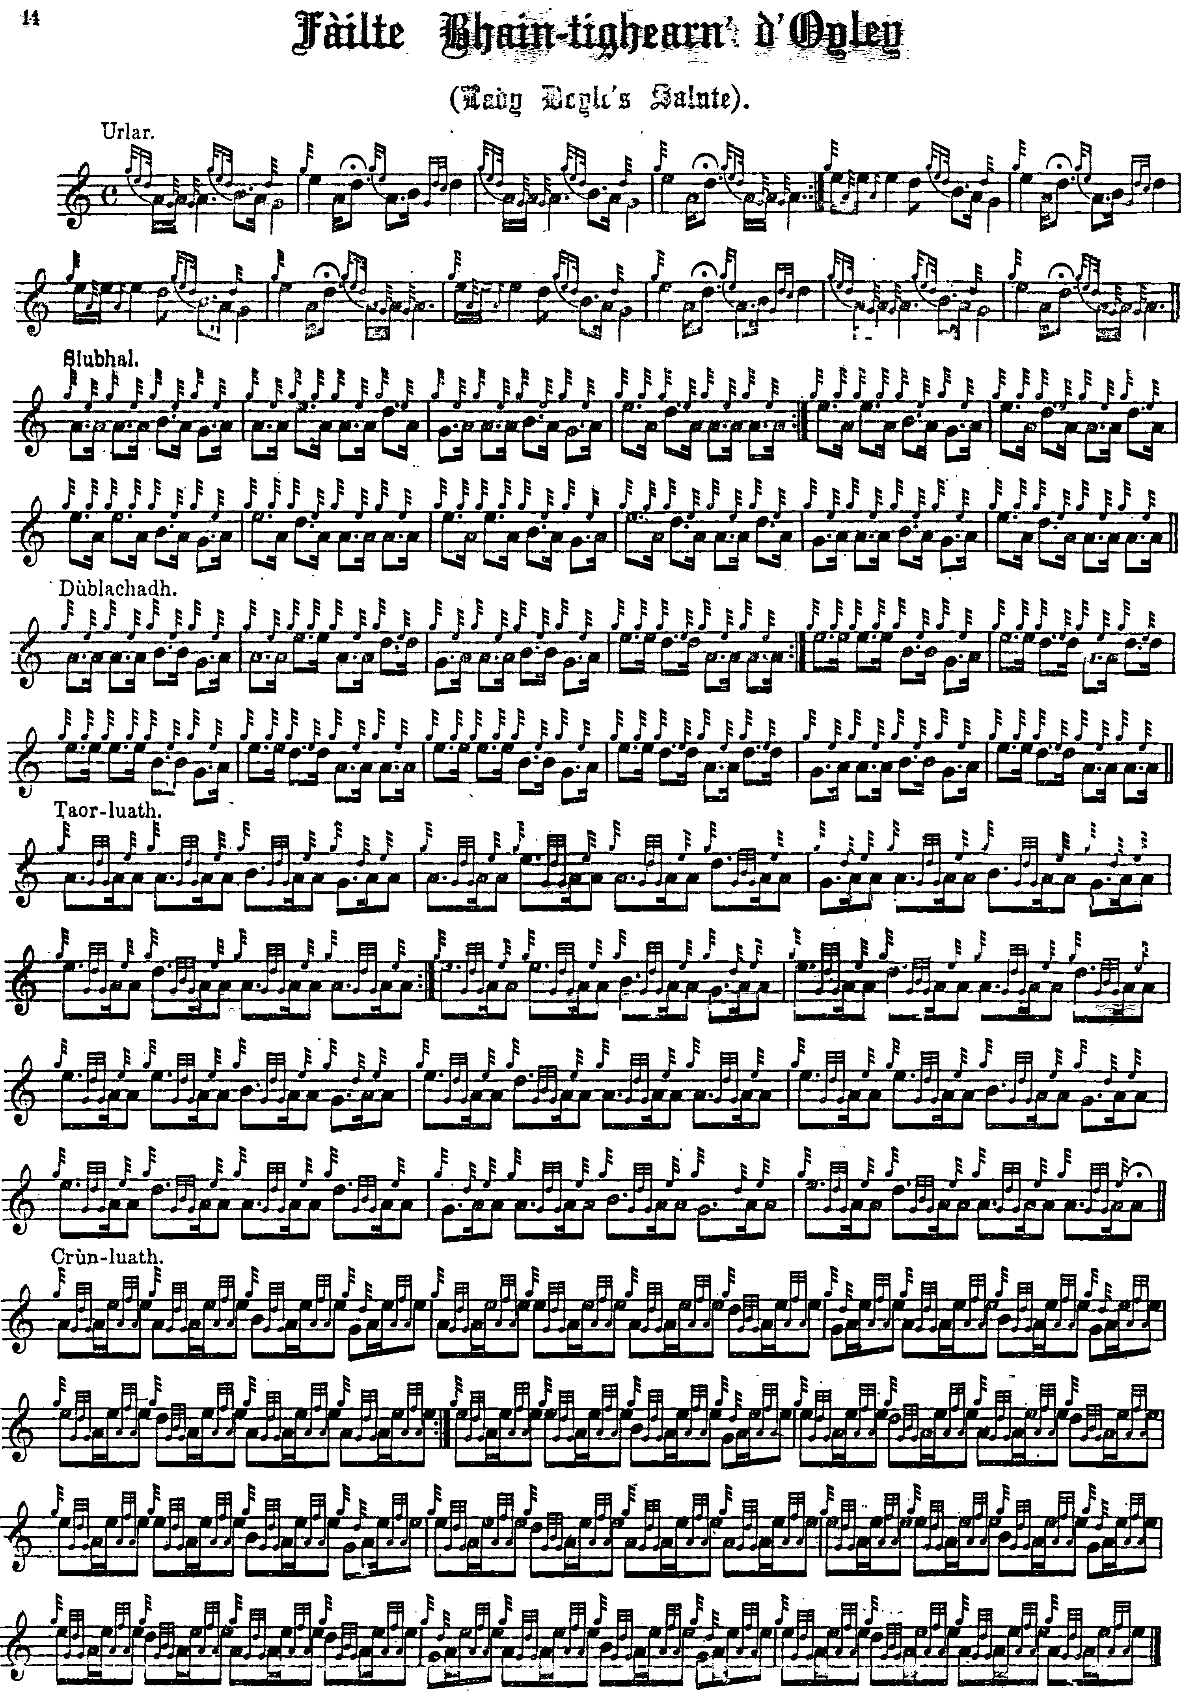

Commentary:

This tune formed part of an exchange of musical compliments between Elizabeth Ross, Lady D’Oyly, and John MacKay, father of Angus. Elizabeth Ross was a scion of the MacLeods of Raasay, a keyboard player and harper, and while in Raasay compiled a manuscript book of Highland vocal and instrumental music including a number of pieces of ceòl mór from the playing of John MacKay. This fascinating record of Highland music was later published as Original Highland Airs Collected at Raasay in 1812, edited for the Musica Scotica Editions of Early Scottish Music series, by Peter Cooke, Morag MacLeod and Colm Ó Baoill, published in 2016. Later she sent Mackay a handsome bagpipe made by local craftsmen as a keepsake from India where she had married into the Raj. In return, MacKay made for her this salute in his characteristically rather angular style with much interplay between tonic and sub-dominant.

In his note to the tune in MacKay’s Ancient Piobaireachd, James Logan says: “Lady Doyle was a daughter of Major Ross, who married Isabella, sister of the late James MacLeod, Esq. of Rasay. Her father and mother having died when she was in infancy, the former in the East Indies, and the latter on her passage to Scotland, she was left under the guardianship of her uncle, who brought her up in his own family of Rasay. She became a great favourite with all who knew her, being imbued with the finest feelings of the Highlander. Her musical taste was remarkably good, and she was so fond of Piobaireachd, that she acquired many of the longest pieces from the performance of the family Piper, and was accustomed to play them on the piano with much effect. She accompanied her cousin, the Marchioness of Hastings, to the East Indies, where she married the Hon. Sir Charles Doyle. Here she did not forget MacKay, the Piper of Rasay, but had an elegant stand of Pipes, of peculiar native workmanship, prepared, which she presented to him, and which will be handed down as an heir-loom in the family.
This Piobaireachd was composed in gratitude for her Ladyship’s liberality.” (“Historical and Traditional Notes on the Piobaireachd”, p.7)

* * *

Electronic text © Dr. William Donaldson, Aberdeen, Scotland, October 2004; revised Cambridge, Massachusetts, January 2025

