Lady Anapool’s Lament
There are settings of this tune in the following manuscript sources:
--Colin Mór Campbell’s “Nether Lorn Canntaireachd”, i, 46-8 (with the title “MacAlaster’s lively Lament”);
--Angus MacKay’s MS, i, 107-9 (and also in the so-called “Kintarbert MS” ff. 57-8);
--Colin Cameron’s MS, f.27;
--Duncan Campbell of Foss’s MS, ff.5-7;
--Uilleam Ross’s MS, ff.160-162;
--D. S. MacDonald’s MS, i, 121-3;
--David Glen’s MS, ff. 268-70;

and in the following published source:
--C. S. Thomason, Ceol Mor, p.180.

Colin Campbell sets the tune like this:

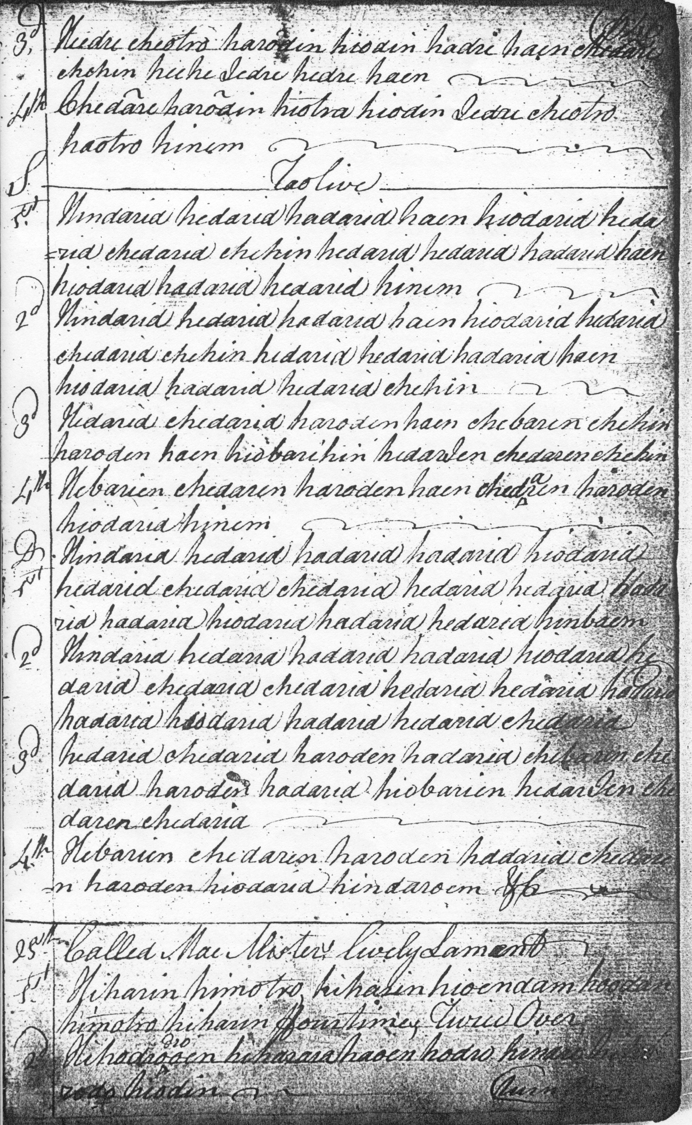
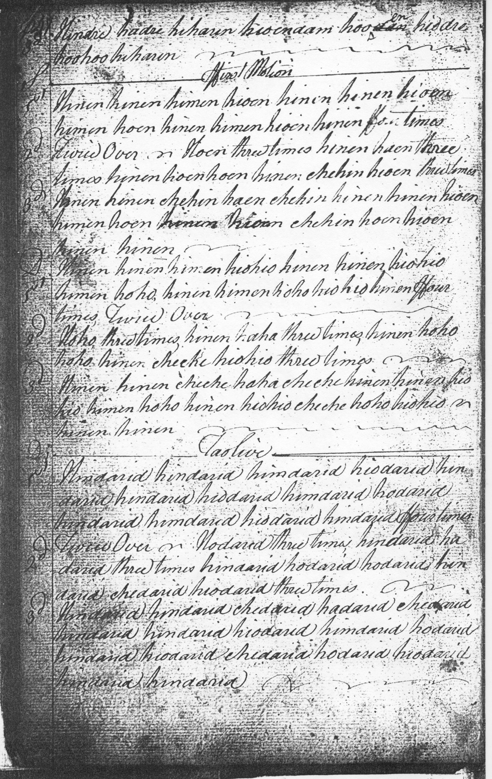
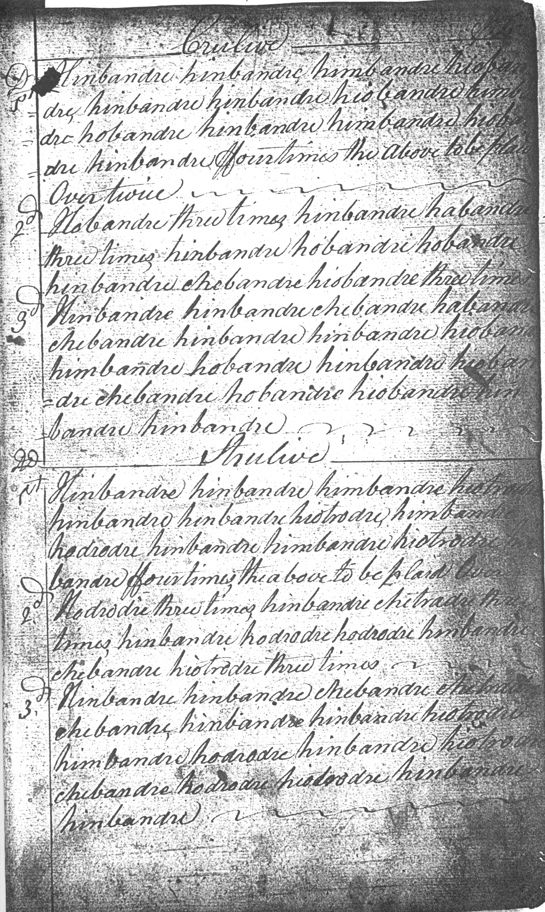
The tune is developed thus: ground, siubhal singling/doubling; taorluath, crunluath and crunluath a mach. The second occurrence of the “ho ho” syllable in line one of the siubhal doubling seems superfluous. This piece bears a family likeness to a number of other tunes—one thinks, for example, of “Hector MacLean’s Warning”, but it has a distinctive melodic motif is the thrice-repeated Cs and Ds that begin the second line of the ground.

Angus MacKay sets the tune like this:

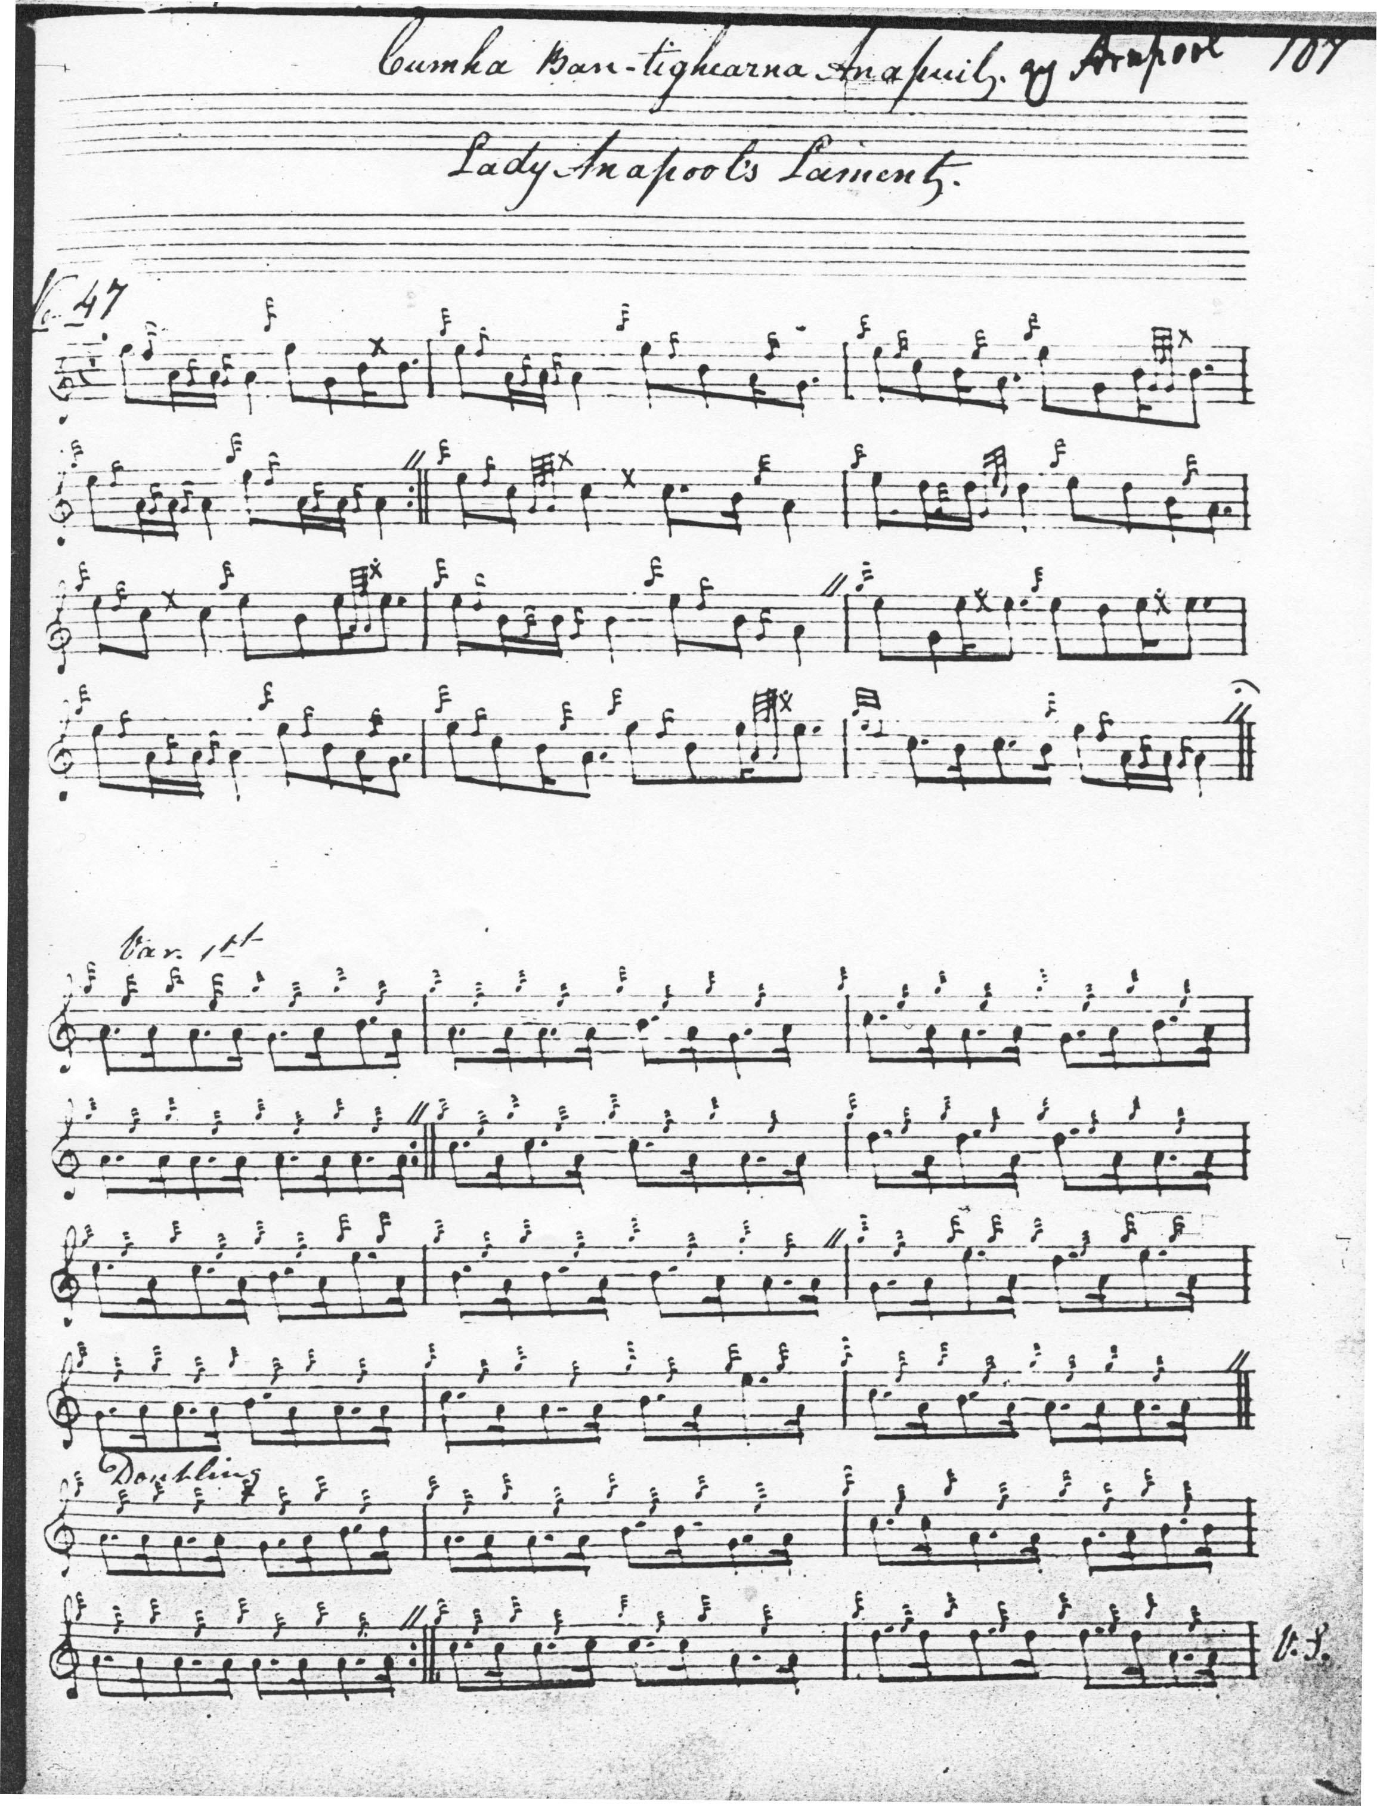
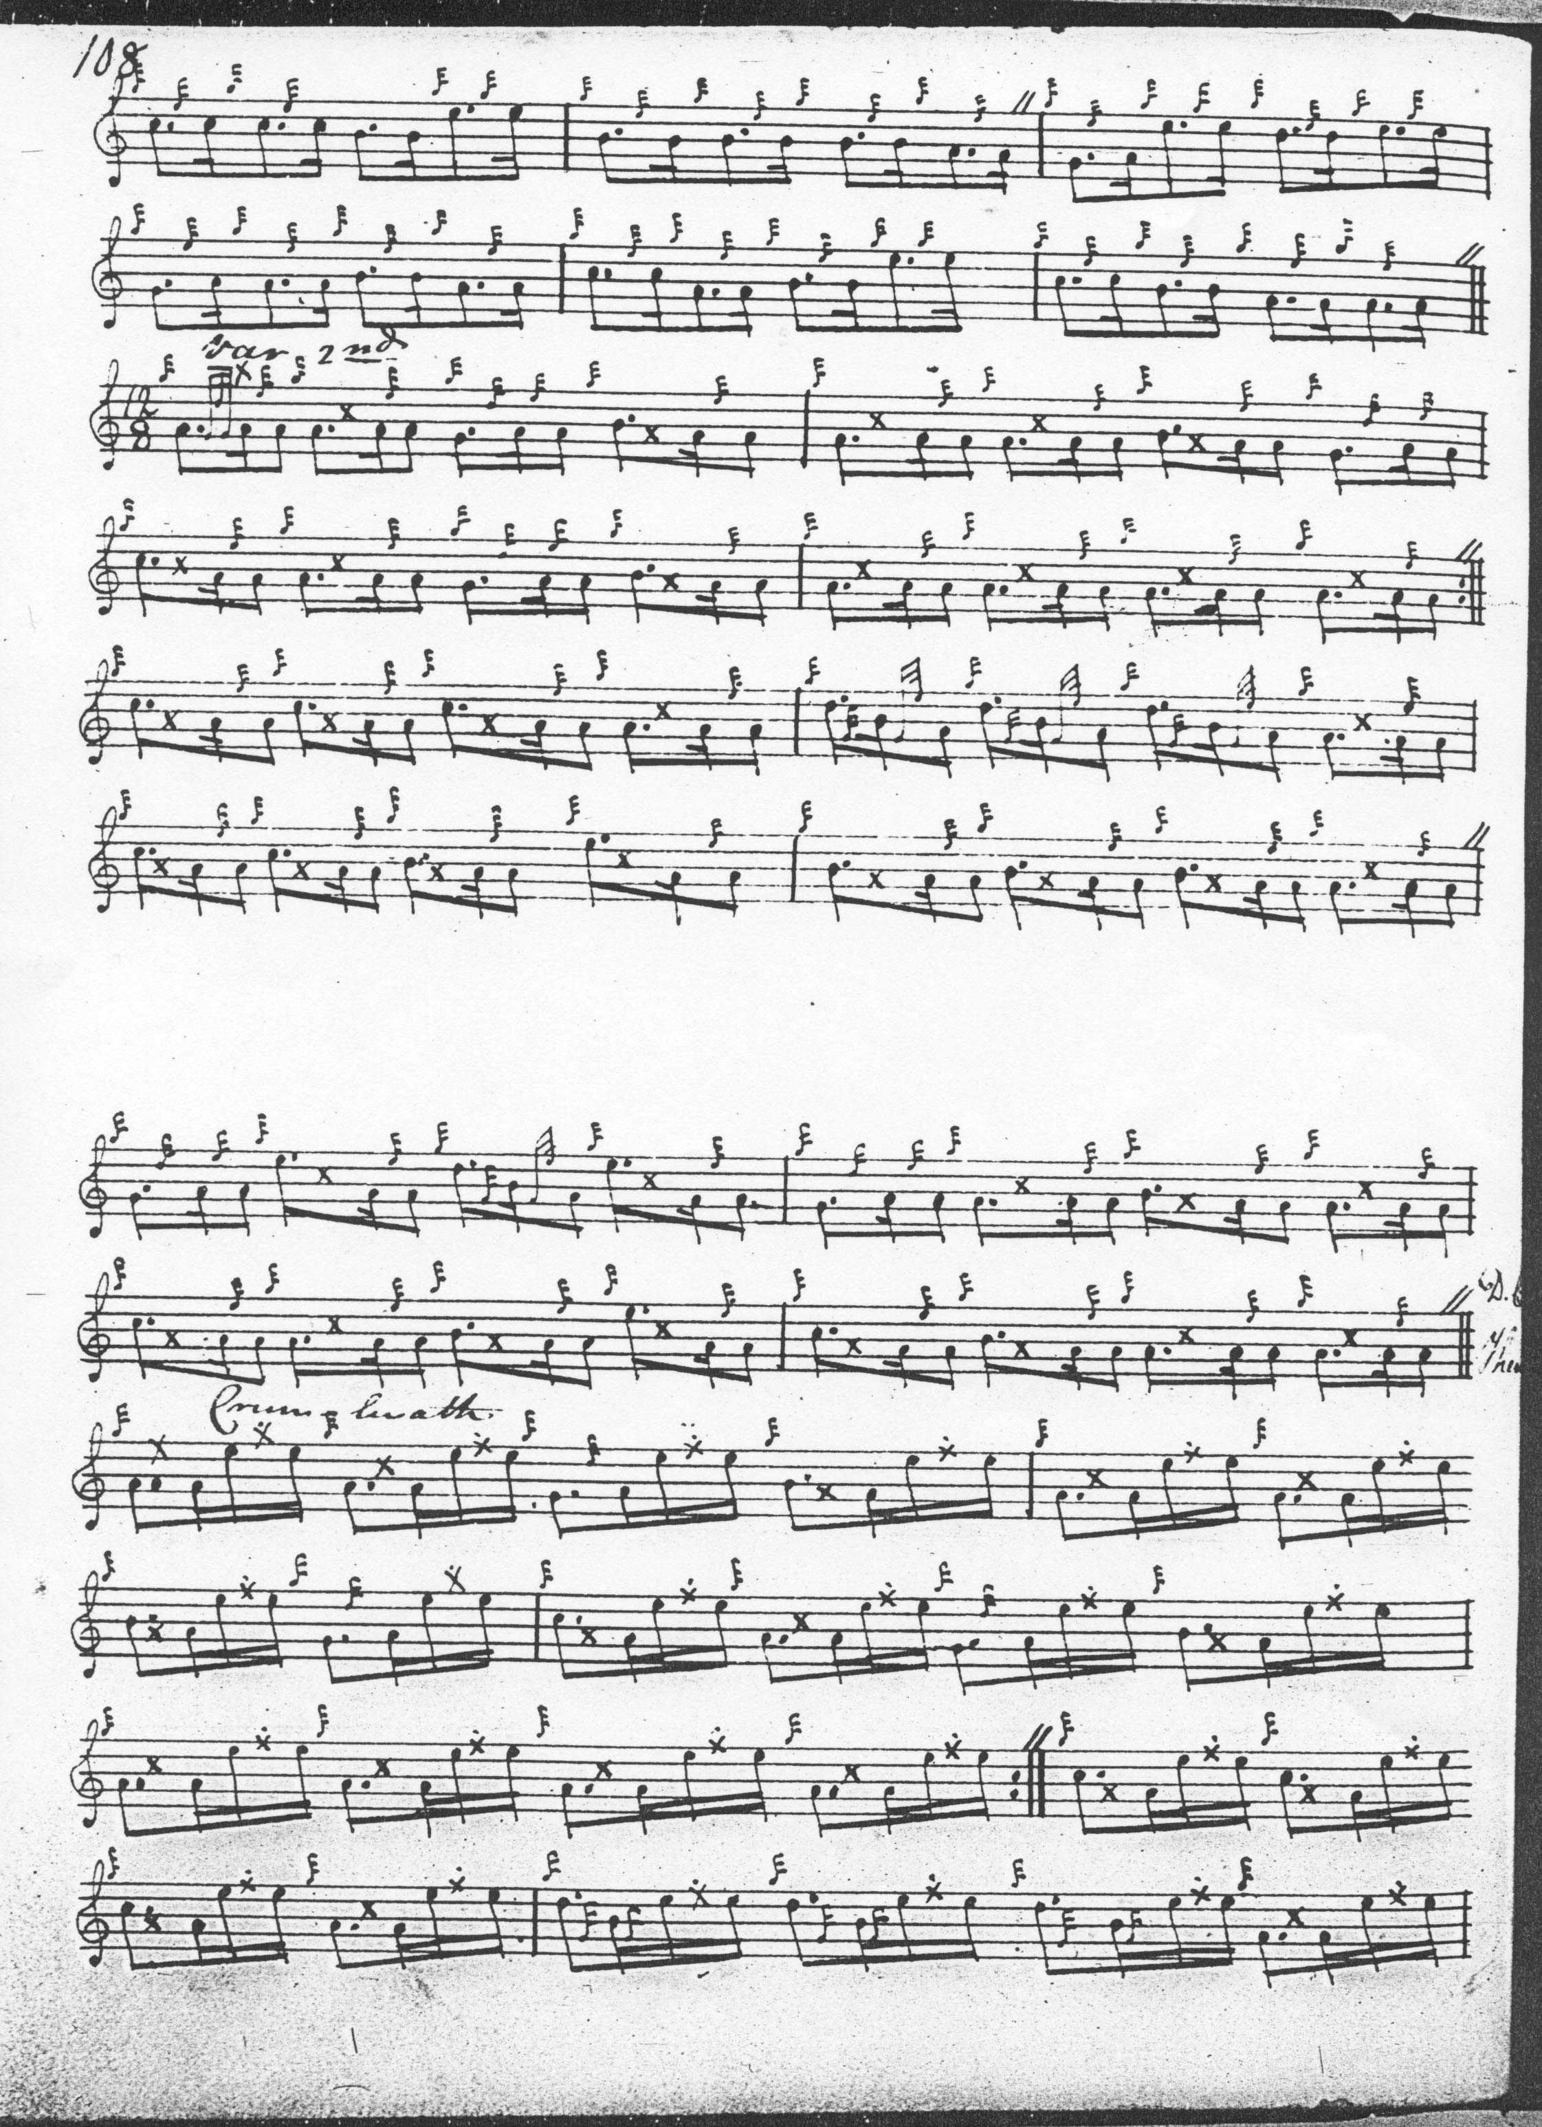
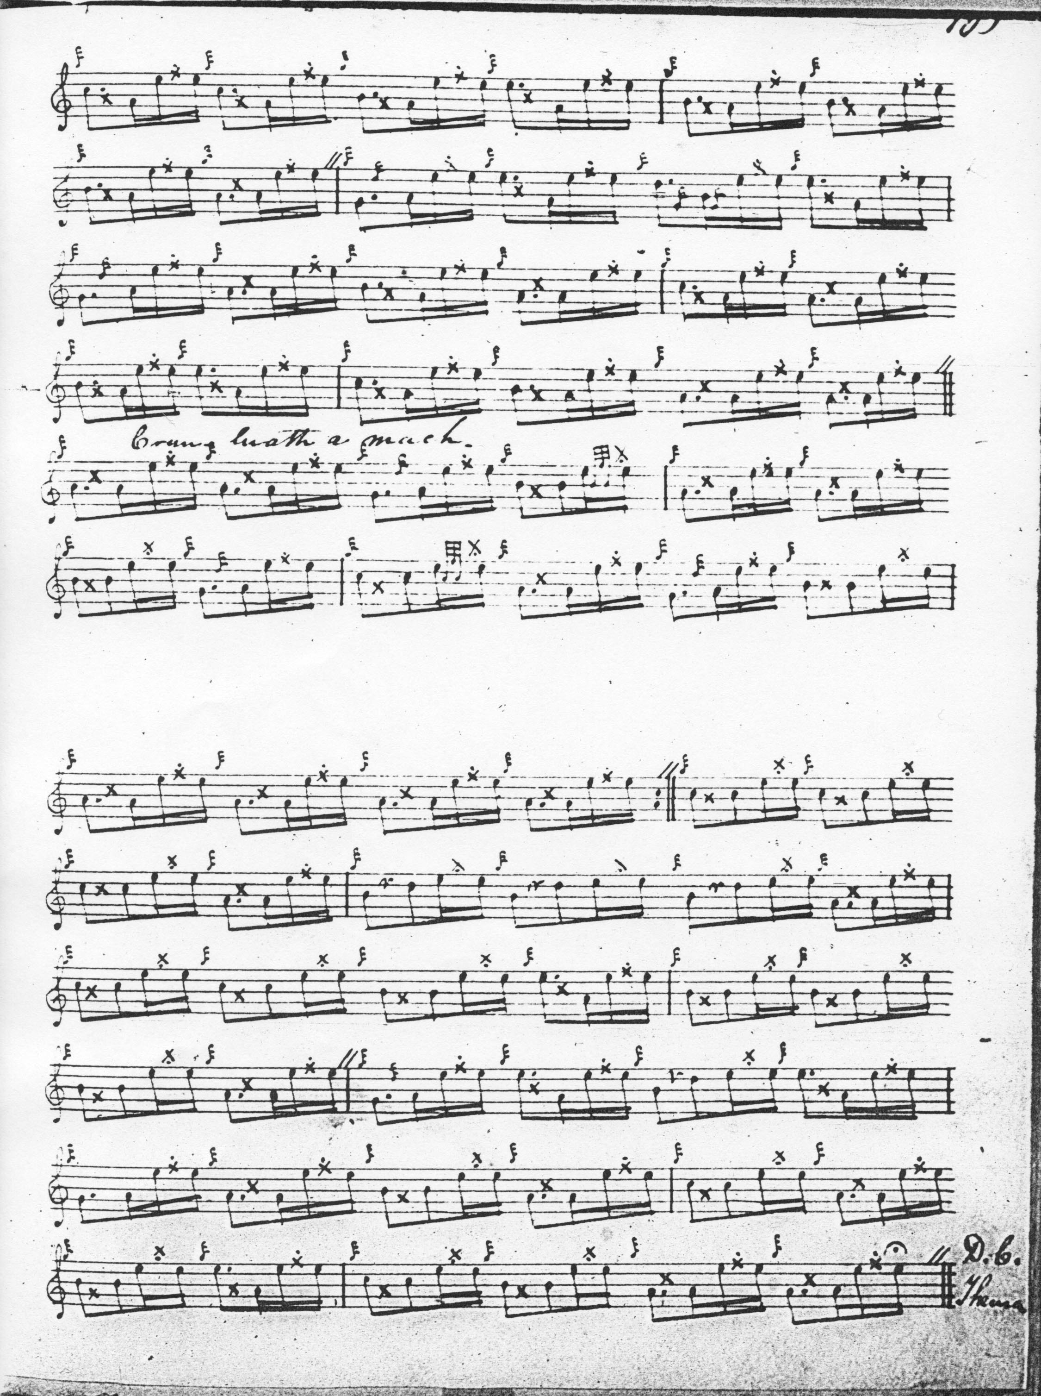

In the ground MacKay sounds the eallach twice only (as opposed to Colin Campbell’s four times), giving four lines of four bars each as opposed to Colin Campbell’s “long” first line (but later in Colin Campbell’s score, it balances out: in the siubhal he indicates the syllable “hinen” at the end of line one be repeated ‘ffour times’’, and this is just the same as MacKay’s. There are superficial differences in the siubhal variations (some may think Colin Campbell’s rather superior) but the development of the tune is thereafter exactly similar. The setting in the so-called “Kintarbert MS” is in outline only, and not graced beyond the beginning of the siubhal singling. It is not reproduced here.

Colin Cameron sets the tune like this:

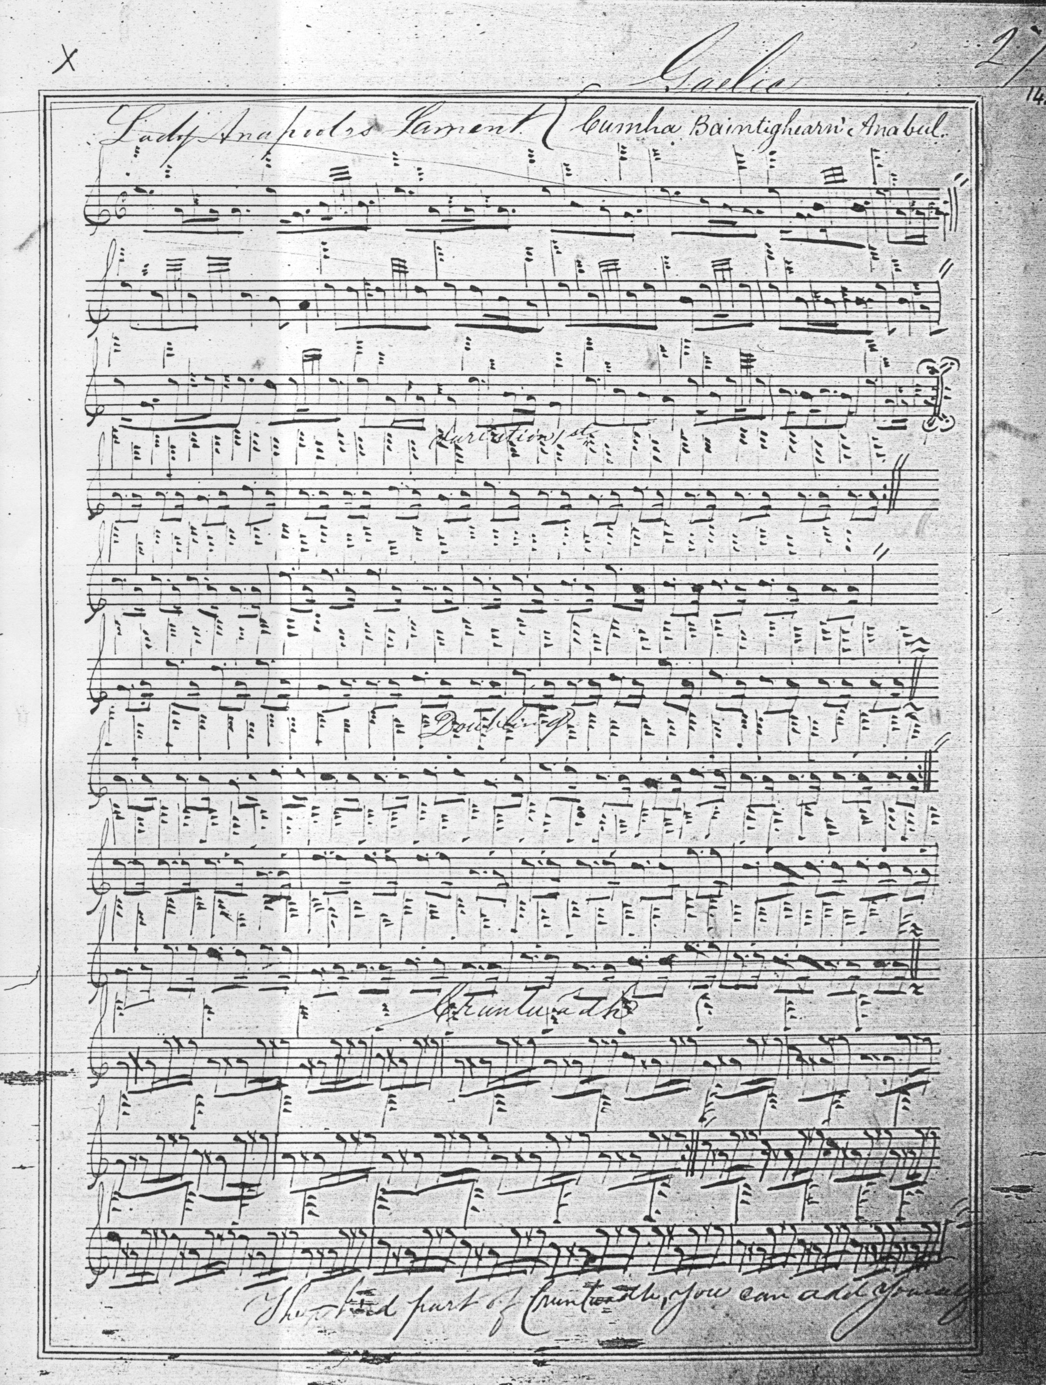

Cameron is more precise rhythmically than MacKay, as we see, for example, in the emphatic cut down from E to low G in the first bar and the “run down” at the beginning of bar three in the ground. We see this happen often when we compare the two manuscripts. Perhaps MacKay set things as even quavers to accommodate the different possibilities in timing which he knew to exist in tradition at such points; on the other hand, perhaps his style was genuinely rather square and even, and the Cameron one more cut and pointed.

Duncan Campbell of Foss gives a fully graced setting, but except for the fact that he does not indicate that the ground should be repeated at the end of the taorluath variation, and he does not have a crunluath a mach, his version is the same as Angus MacKay’s—it seems likely that one of his sources will have been MacKay’s so-called “Kintarbert MS” to which it is highly likely that Duncan Campbell will have had access. Uilleam Ross does not include the a mach either. Neither of these scores is reproduced here. D. S. MacDonald writes out the piece in full, expanding his source Angus MacKay’s contractions, but otherwise he follows MacKay closely—as he generally does since his manuscript was—ostensibly--a clean copy of MacKay’s intended for a publication that never came to press. It is noteworthy, though, that in the a mach he does not follow the “cut” style later assumed to be MacKay’s but dots the initial low A, B and C quavers in the style more commonly associated with Donald MacDonald. C. S. Thomason gives Angus MacKay’s manuscript as his source; his setting adds little to the expressive possibilities of the tune and is not reproduced here.

David Glen’s is the most rhythmically explicit of the Victorian scores, and hence the most precise guide for actual playing. Glen treats the tune like this:

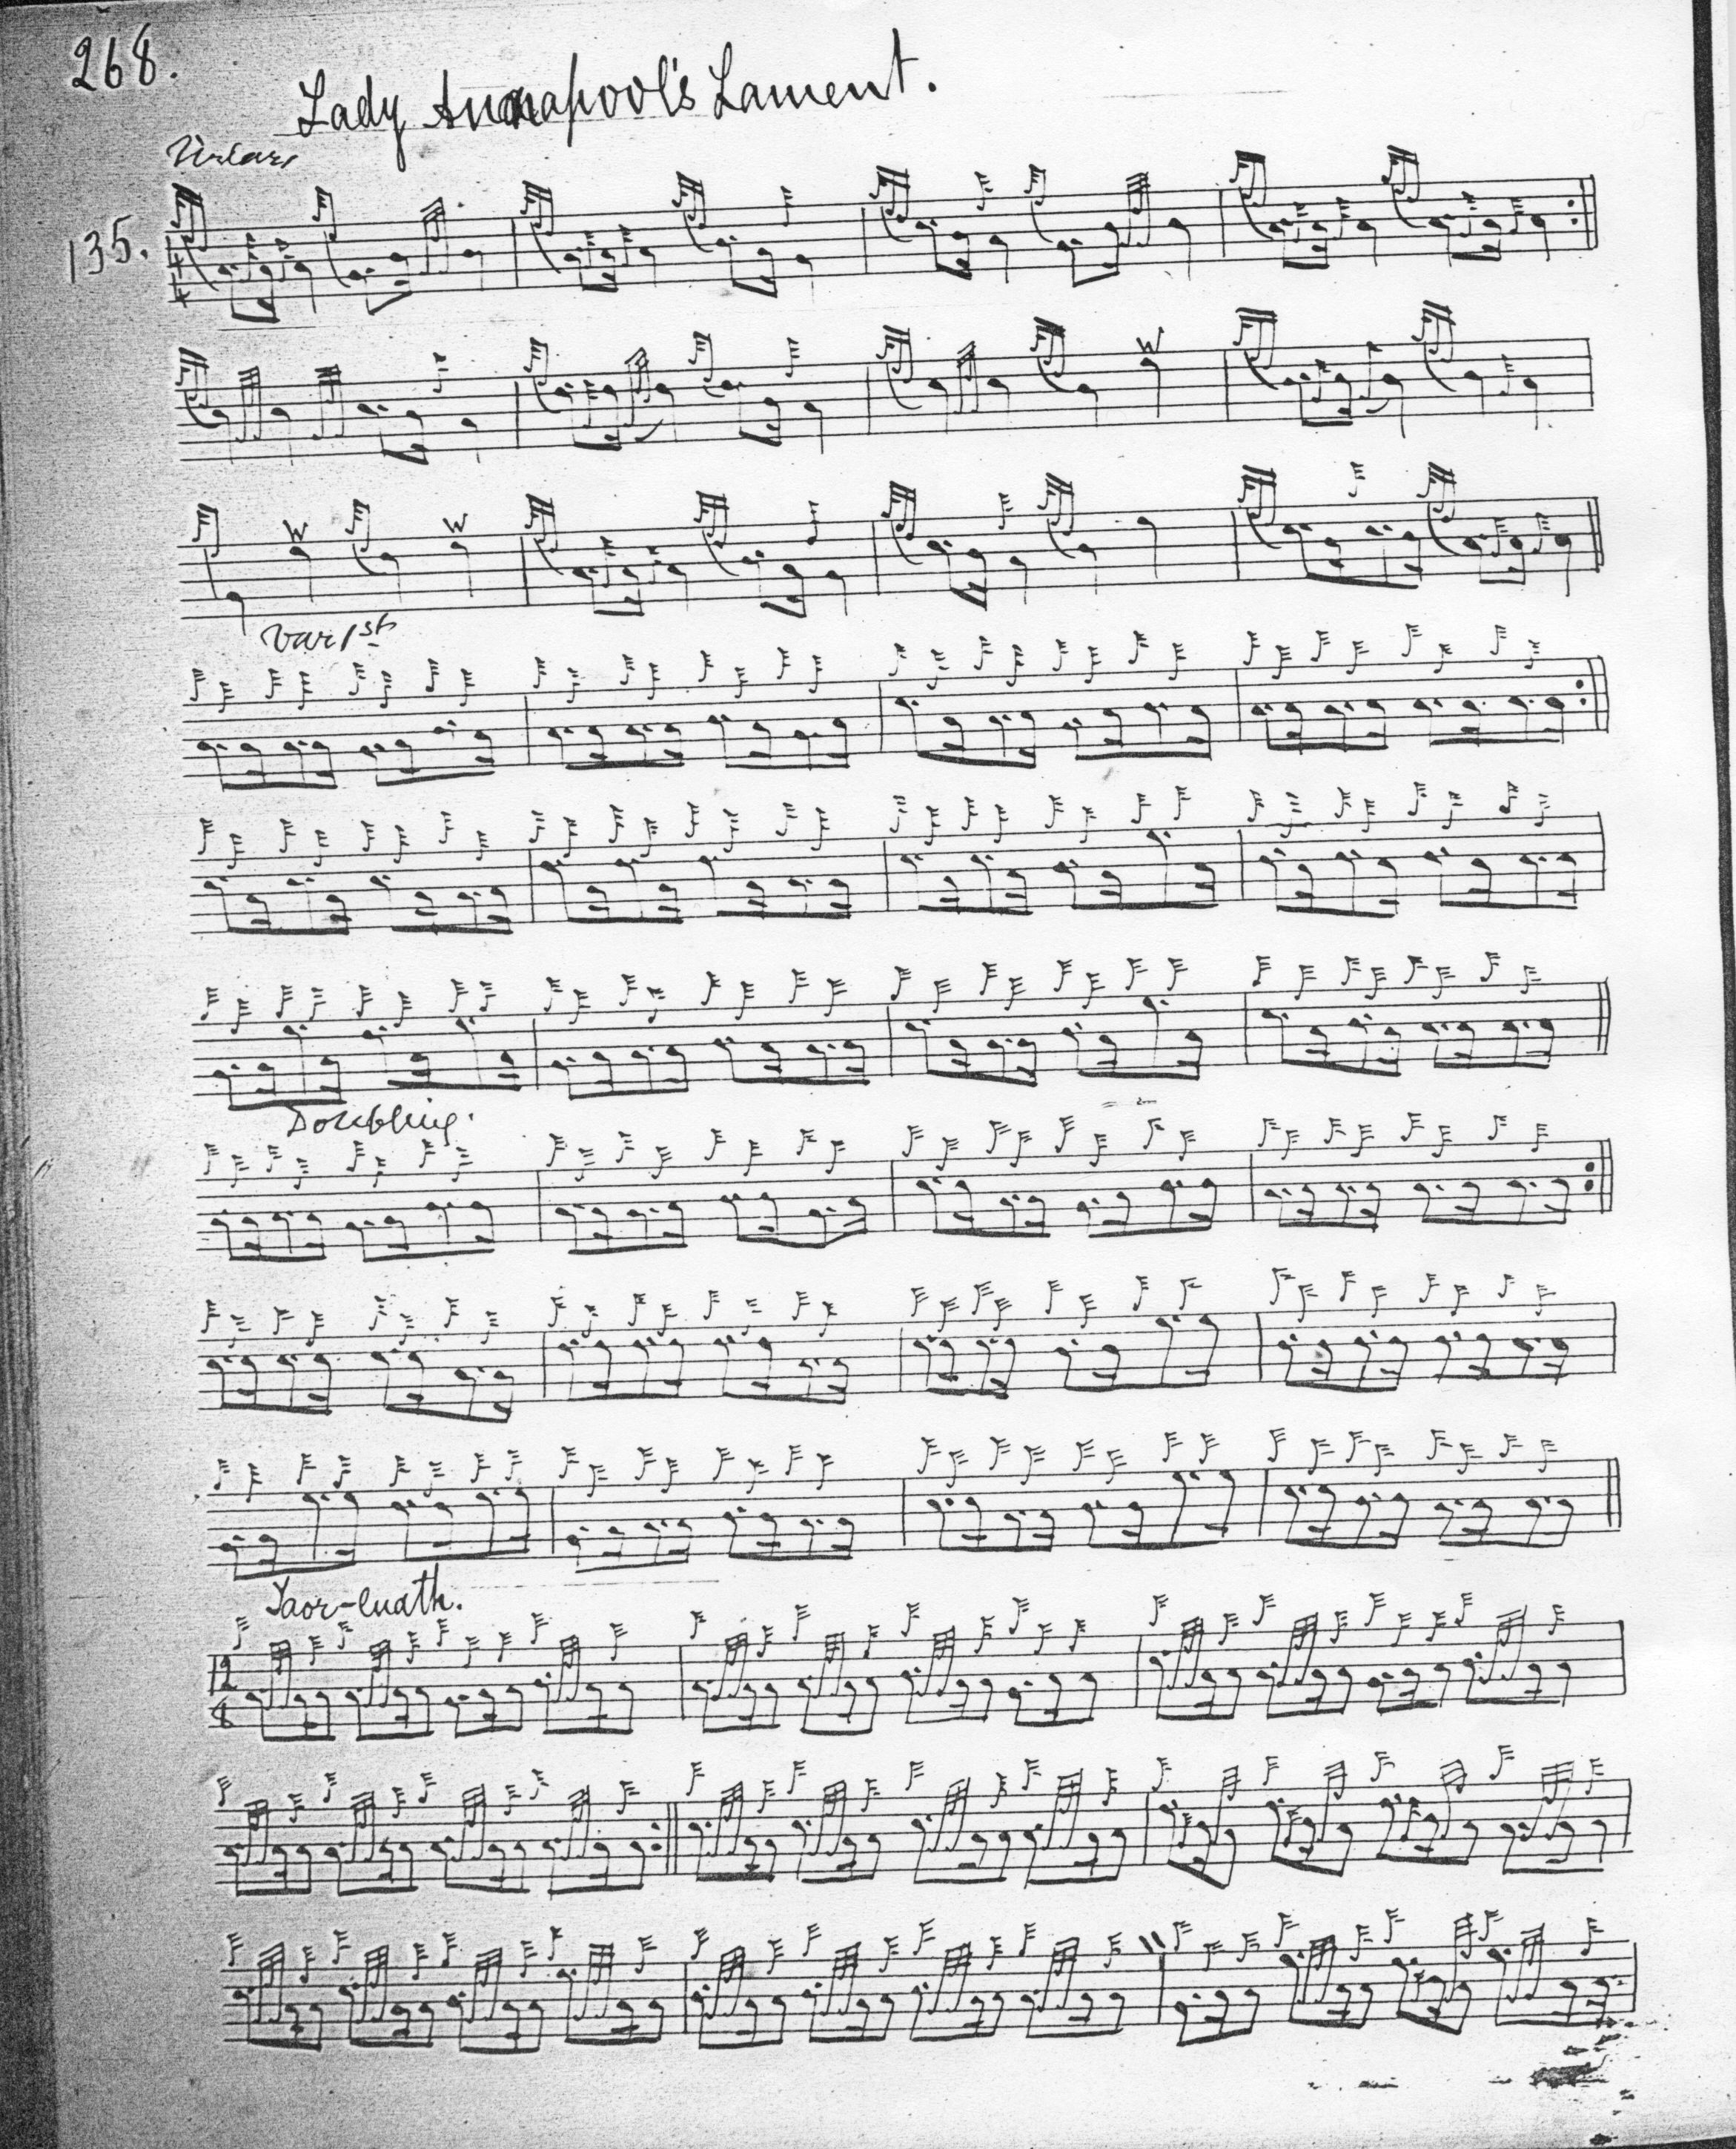

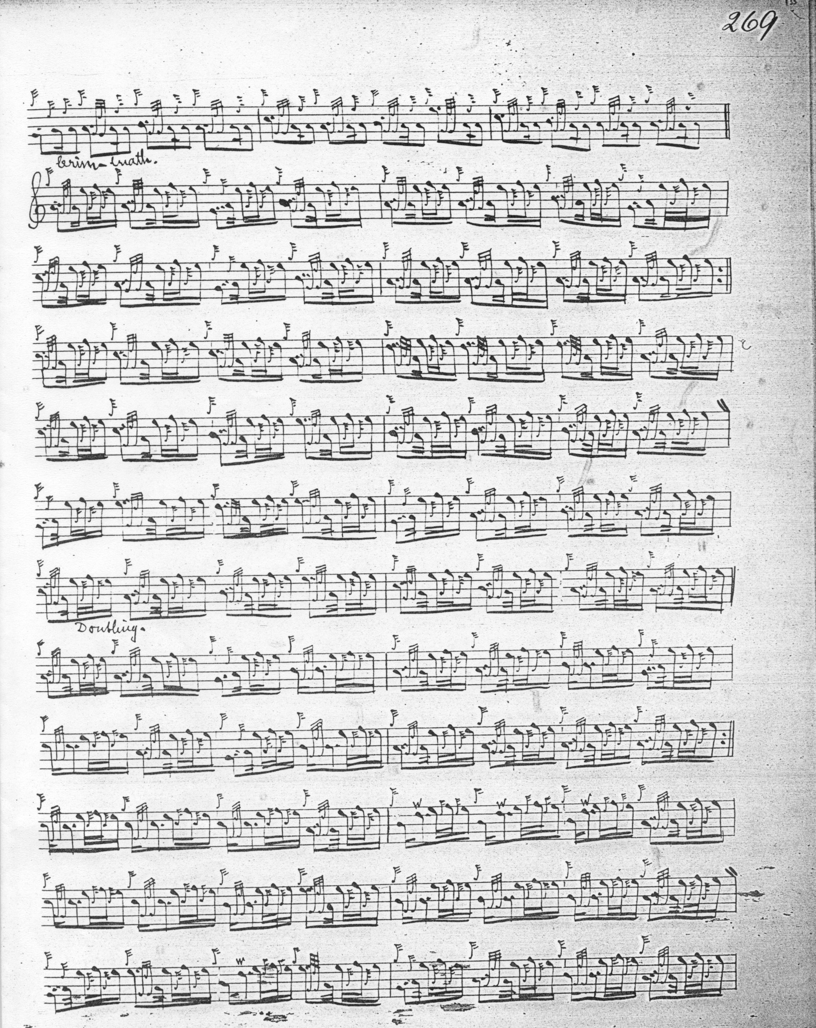

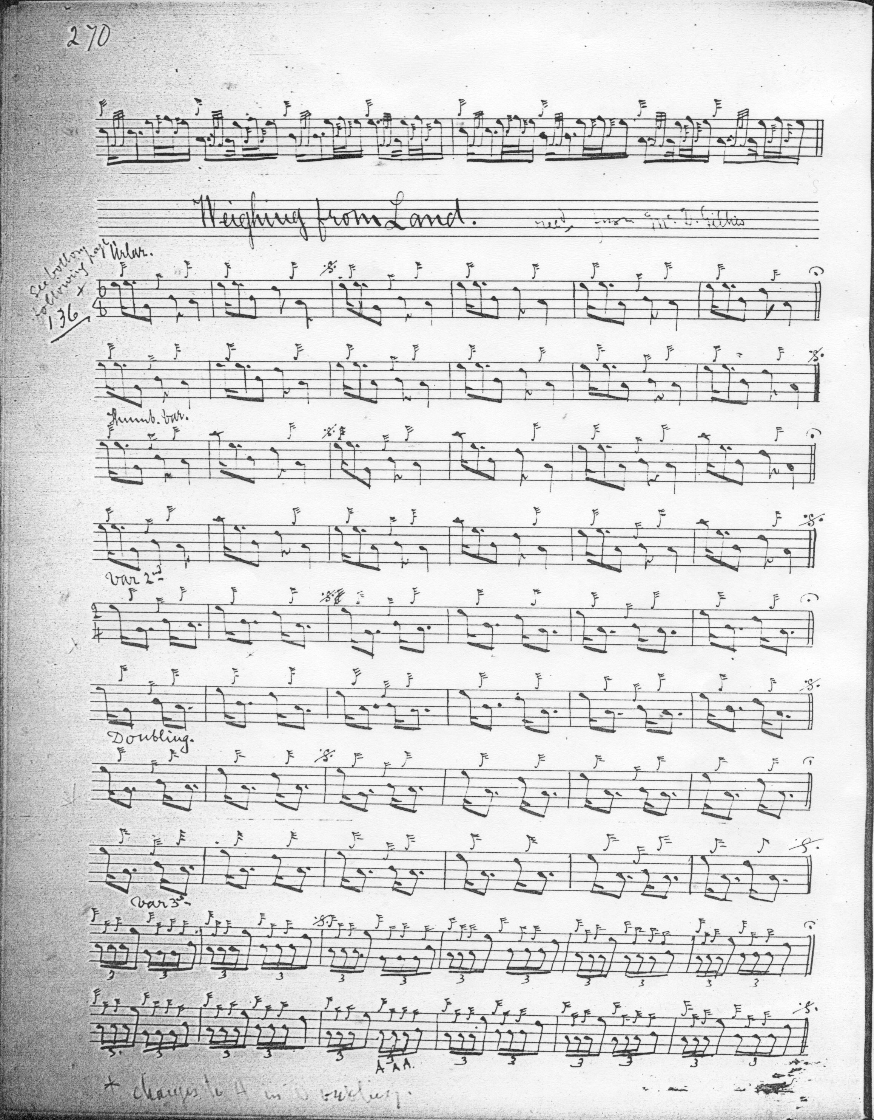

Glen gives no indication that the ground is to be repeated either within or at the end of the tune.

Commentary:

There has been speculation about the location of “Anapool” celebrated for its connection with this tune and the lament for the laird of Anapool, the latter commonly regarded as one of the grandest tunes in the tradition. This point is discussed in the notes to the “Lament for the Laird of Anapool” included in this site.

“Lady Anapool’s Lament” is a very bottom-handed tune; using a hexachordal scale low G to E, so there’s curiously little sense here of what Bob Brown used to call “high-pitched keening.”

* * *

Electronic text © Dr. William Donaldson, Cambridge, Massachusetts, 28 April 2013; revised Cambridge, Massachusetts, January 2025.

