Lachlan MacNeill Campbell’s Fancy

There are settings of this tune in the following manuscripts:
--Angus MacKay, i, 195-7;
--Duncan Campbell of Foss, ff.205-7;
--D. S. MacDonald, ii, 78-70.

The Piobaireachd Society Collection (second series) vol. 8 (1939) appears to be the earliest published source.

Angus MacKay treats the tune as follows:

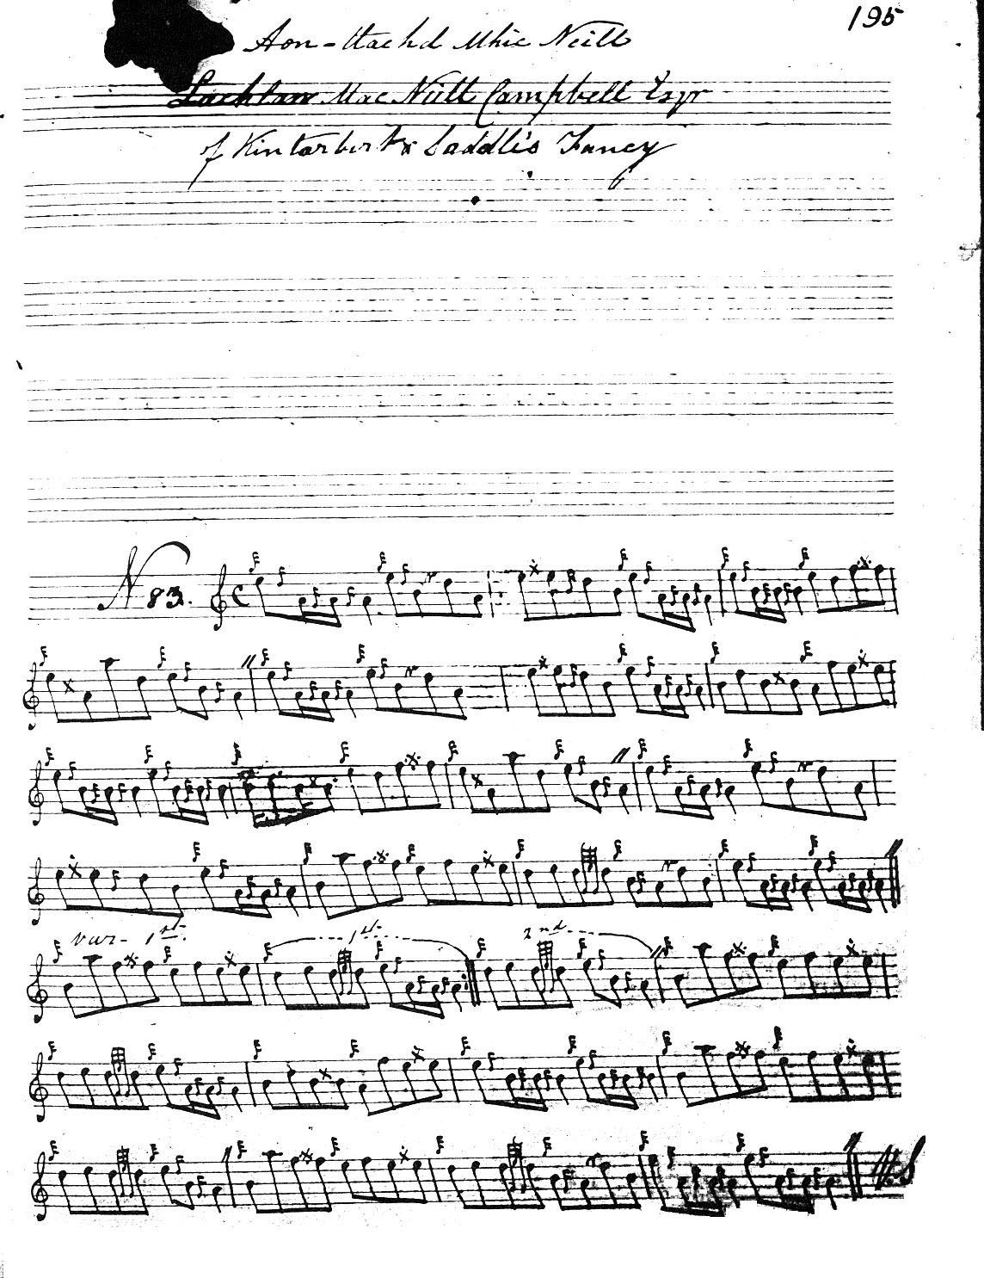
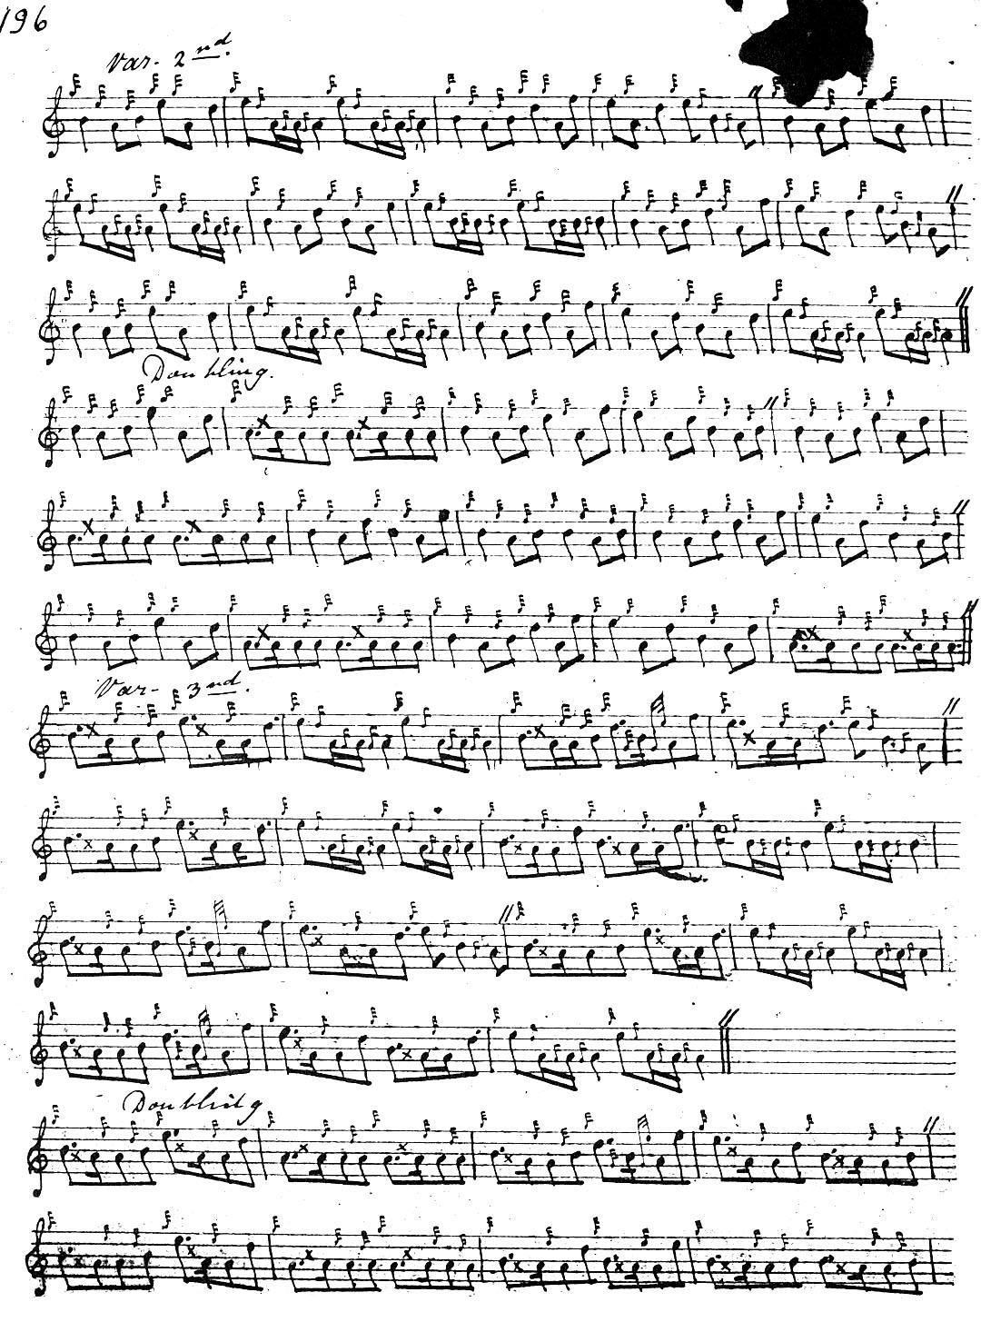
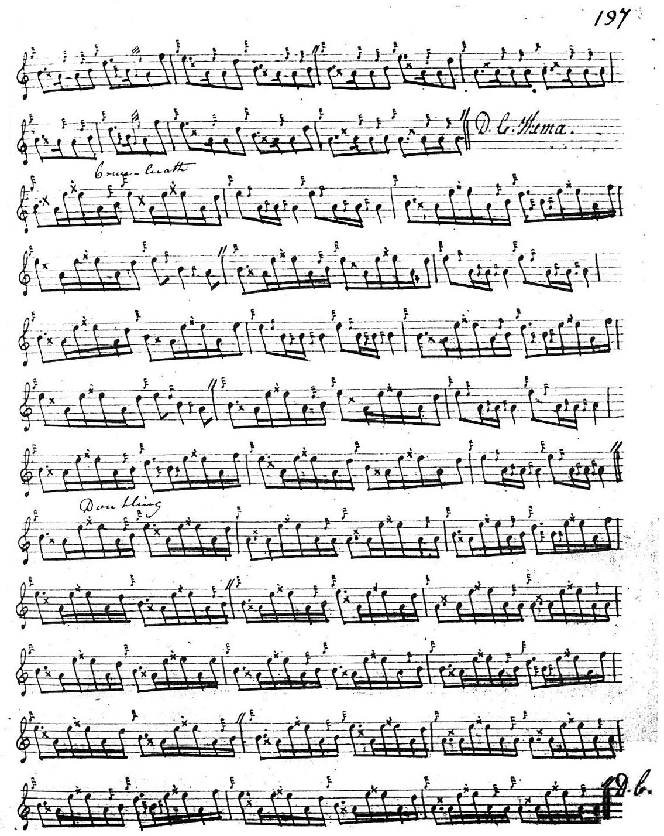

As an original composition, this tune falls somewhat short of Angus MacKay’s best; the melody line seems rather abrupt, and to be cobbled together casually out of bits of something else, including echoes of “The Battle of Glenshiel” and “The Sister’s Lament”.

Duncan Campbell times the ground slightly differently from MacKay giving a more varied expression.

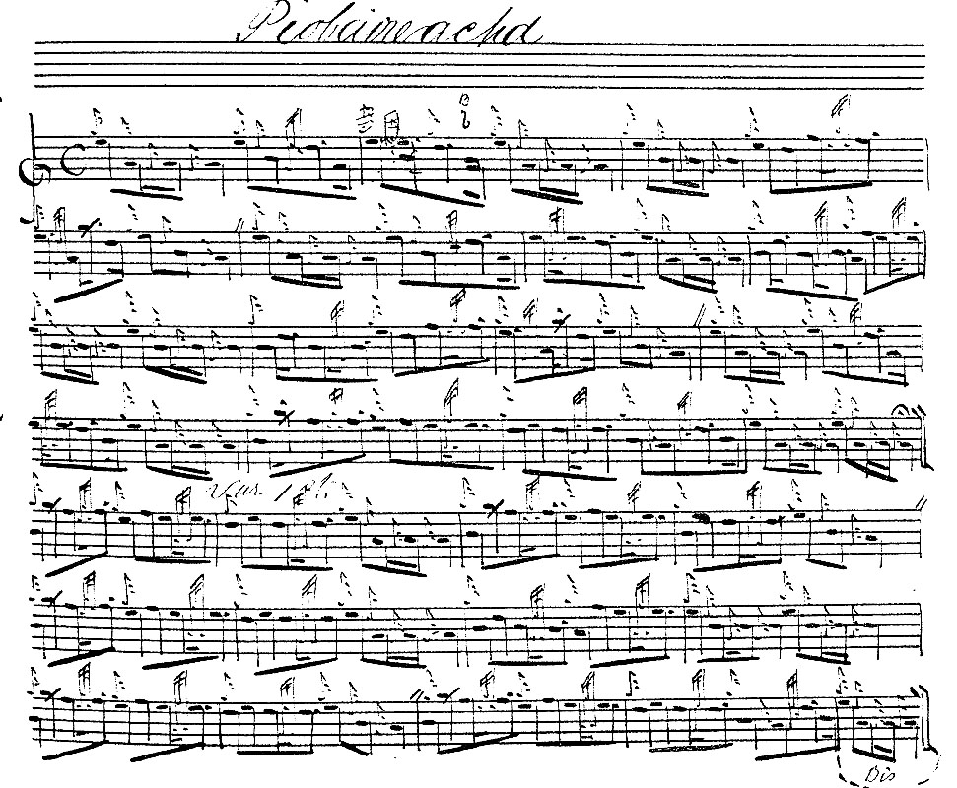

MacKay directs that the ground should be repeated after the taorluath and crunluath doublings; Duncan Campbell brings back the ground after the crunluath doubling only.

D. S. MacDonald follows Angus MacKay and adds nothing to the stylistic possibilities of the tune. This setting is not reproduced here.

Commentary:
The audio version in the MP3 file is based on Angus MacKay’s manuscript. In his “emendation” in the Piobaireachd Society Collection (second series) Book 8 Archibald Campbell adds a couple of bars to the beginning of line three of Variation 1, saying that their omission is an obvious clerical slip. He also refers obliquely to Angus Mackay’s manuscript having been “tampered with” and of time values being added later, but there seems no evidence of this in the original. Campbell himself silently added fermatas not present in the manuscript source.

A large manuscript by Angus Mackay came to light amongst the McLennan Papers recently acquired by the National Library of Scotland, and was dubbed the “Kintarbert MS” by the Piobaireachd Society’s Roderick Cannon. (“A ‘New’ Manuscript of Angus MacKay”, Piping Times, Vol.51, no.10, July 1999, pp.15-17). The McLennan Papers (NLS Acc.11516), form a large and miscellaneous collection from various sources assembled by various members of the McLennan family, one of piping’s greatest, and described by the National Library of Scotland as "A collection of manuscript music, mainly for bagpipe, presented by Mrs Jessie MacLennan, widow of George MacLennan [G. S. McLennan's son]. Eight volumes of bagpipe music 19th century including one possibly in the hand of Angus Mackay." The National Library was being too cautious. Examination of the document shows it to be unmistakeably in the hand of Angus MacKay, and it forms a large collection of pìobaireachd, numbering some eighty-eight tunes. Judging by its layout it could well be the intended second volume of his Collection of Ancient Piobaireachd that he did not live to publish. The rear cover bears a plate stating "It is particularly desired that this Music Book be kept quite clean" and it is signed "Chas. Forbes. Broom Wood." This is Sir Charles Forbes (1803-1877) of Castle Newe, Strathdon, in western Aberdeenshire, who employed Duncan Campbell of Foss as his piper,. His English seat was at Broomwood, in Surrey. On the endpapers front and rear is jotted casually in ink the single word "Kintarbert." These seem rather slender grounds for a claim that the manuscript was intended by Angus MacKay as a presentation volume for Lachlan MacNeill Campbell of Kintarbert, in view of the rather more substantial-seeming connection with Forbes of Newe. If the MS had indeed been intended for Kintarbert one would expect Angus’s father, John MacKay senior's, tune "Lachlan MacNeill Campbell Esq. of Kintarbert's Salute" to have been included amongst the contents; but it is not.

The grave of the dedicatee of this tune, Lachlan MacNeill Campbell of Kintarbert and Saddell is located near the Ardpatrick turn off from the B8024 in southern Knapdale in Argyllshire. The Mausoleum is much dilapidated. Some of the tablets in stone and marble have fallen from their places and shattered, amongst them that of Lachlan MacNeill Campbell himself. But the inscription can still be read on the fragment propped against the wall, as follows: “In memory of Lauchlan MacNeill Campbell of Kintarbert died 29th May 1852 aged 49 years.”

Electronic text © Dr. William Donaldson, Aberdeen, Scotland, August 2006; revised Cambridge, Massachusetts, January 2025.

* * *

