Isabel MacKay

There are settings of this tune in the following manuscript sources:
--Colin Mór Campbell, “Nether Lorn Canntaireachd”, i, 63 (with the title “Clann donail Raoich”);
--Donald MacDonald’s MS, ff.254-7 (with the title “The Battle of Maolroy”);
--John McLennan Papers, f.30 (with the title “The Battle of Mulroy”);
--Robert Meldrum’s MS, ff.219-220 (with the title “Isabel MacKay”);

and in the following published sources:
--Niel MacLeod of Gesto, Pibaireachd or Pipe Tunes, pp.35-37;
--Angus MacKay, Ancient Piobaireachd, pp.26-7;
--C. S. Thomason, Ceol Mor, p.134;
--David Glen, Ancient Piobaireachd, pp.40-41;
--William Stewart, et al., Piobaireachd Society Collection (first series), i, 10-11.

Colin Mór Campbell sets the tune like this:

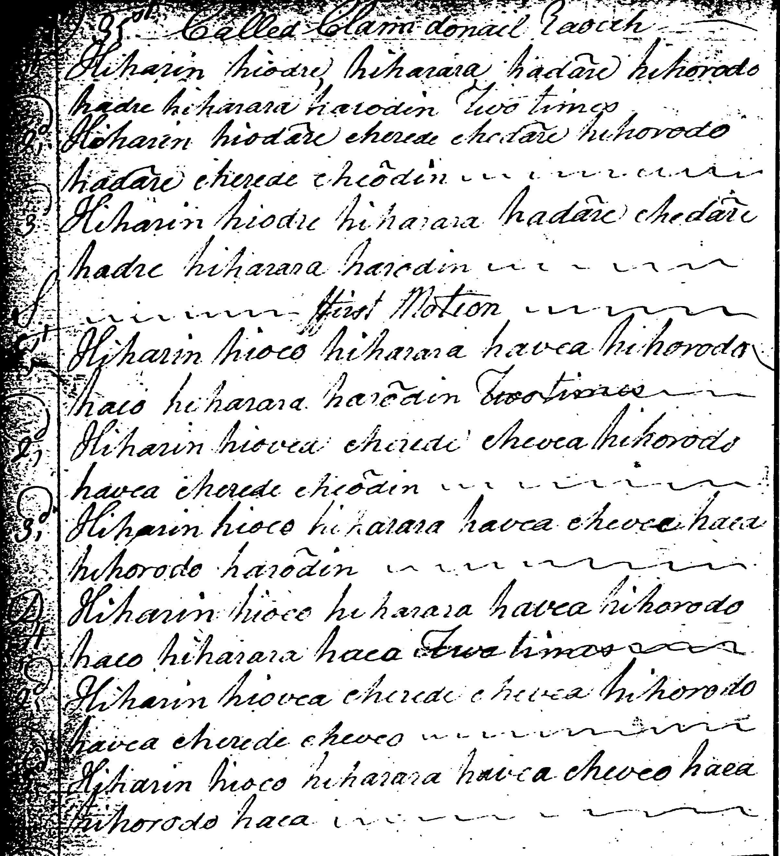

This might suggest a timing along the following lines:

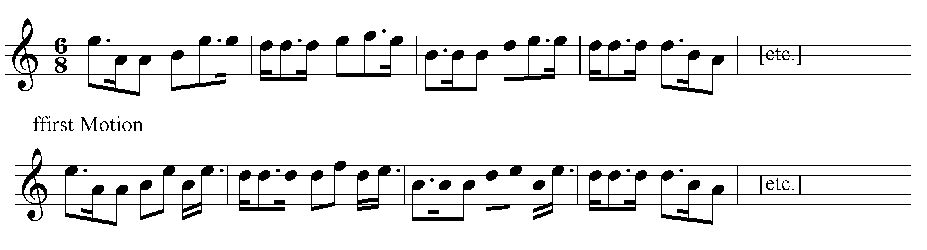

The tune ends with the “ffirst Motion” doubling; there are no taorluath or crunluath variations.

Donald MacDonald develops the tune in a very similar fashion, but includes a taorluath and crunluath singling and doubling as follows:

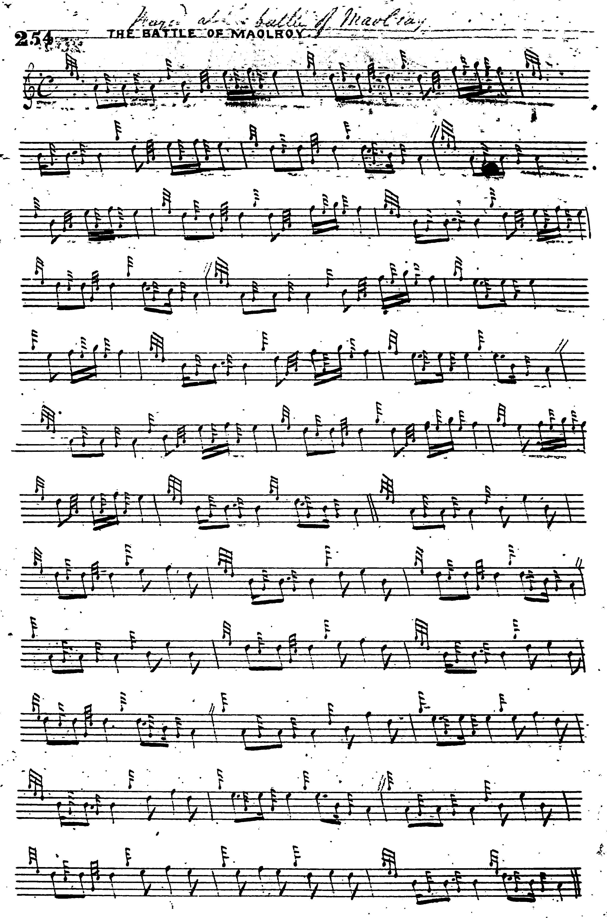
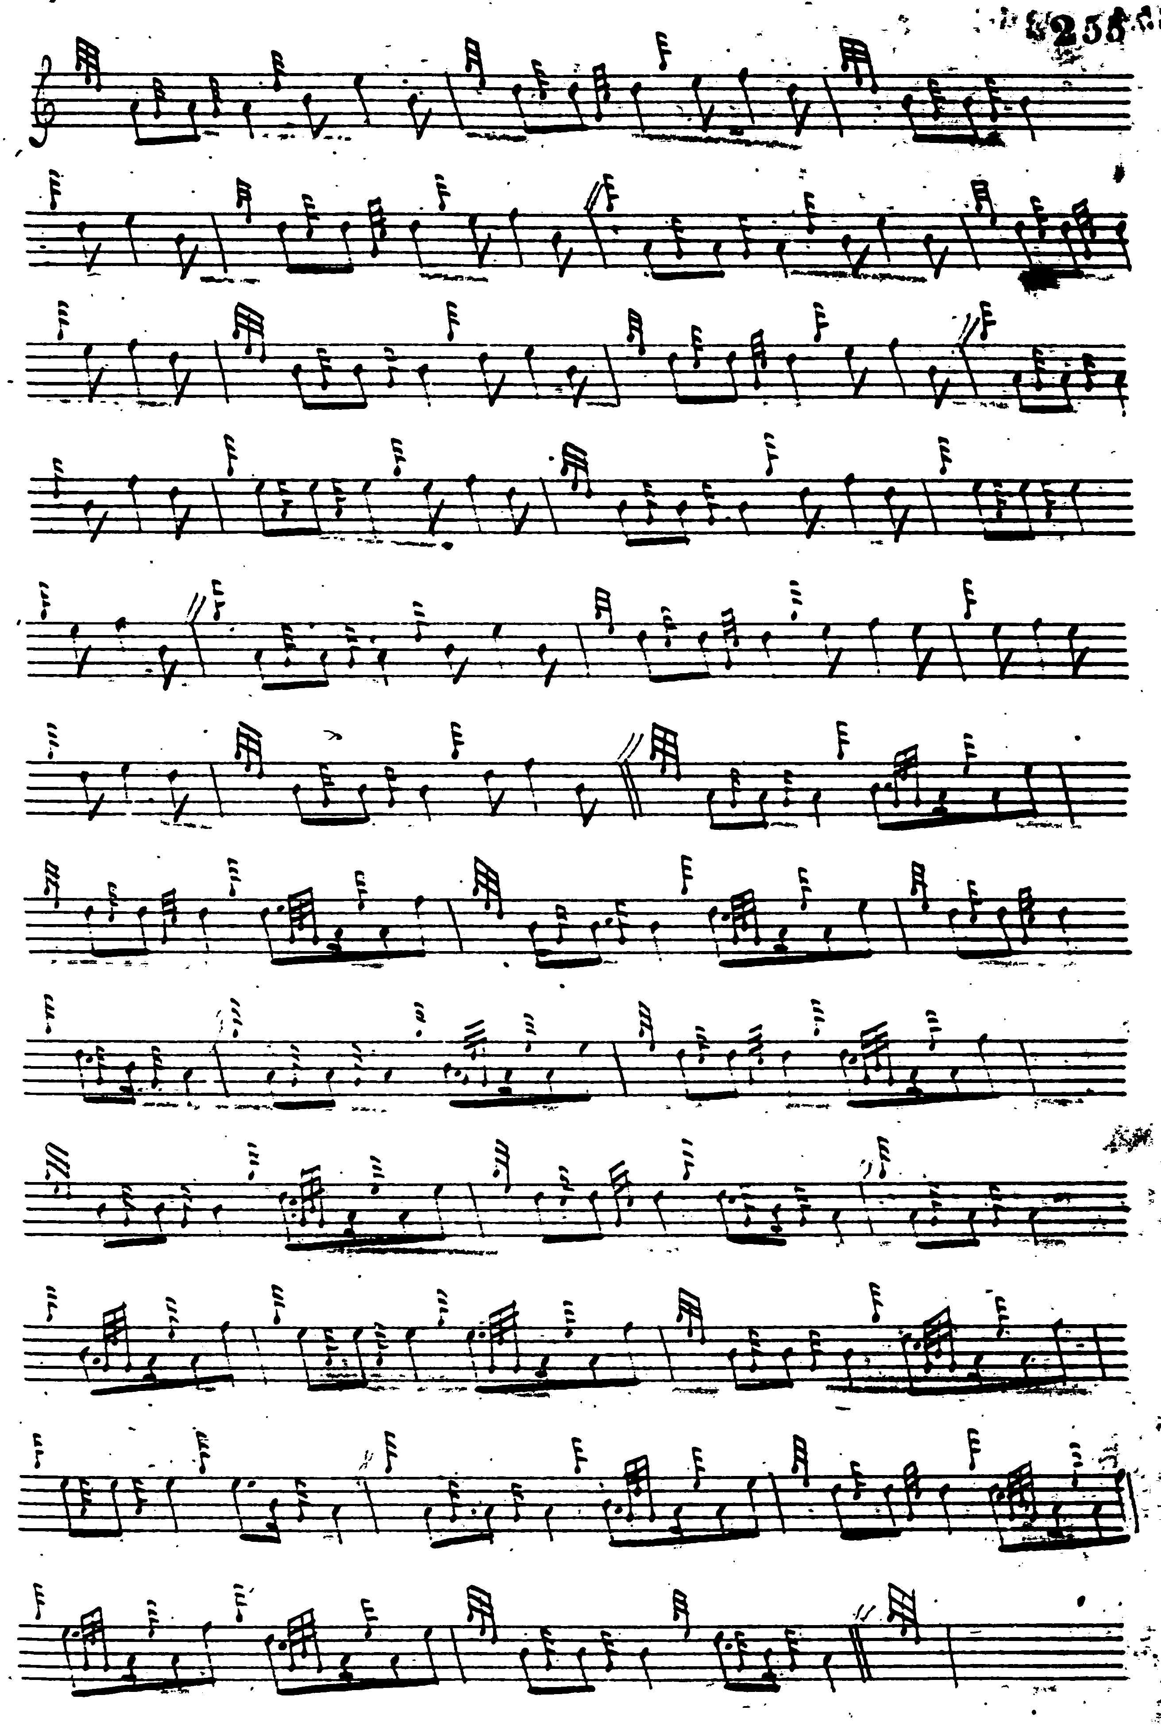
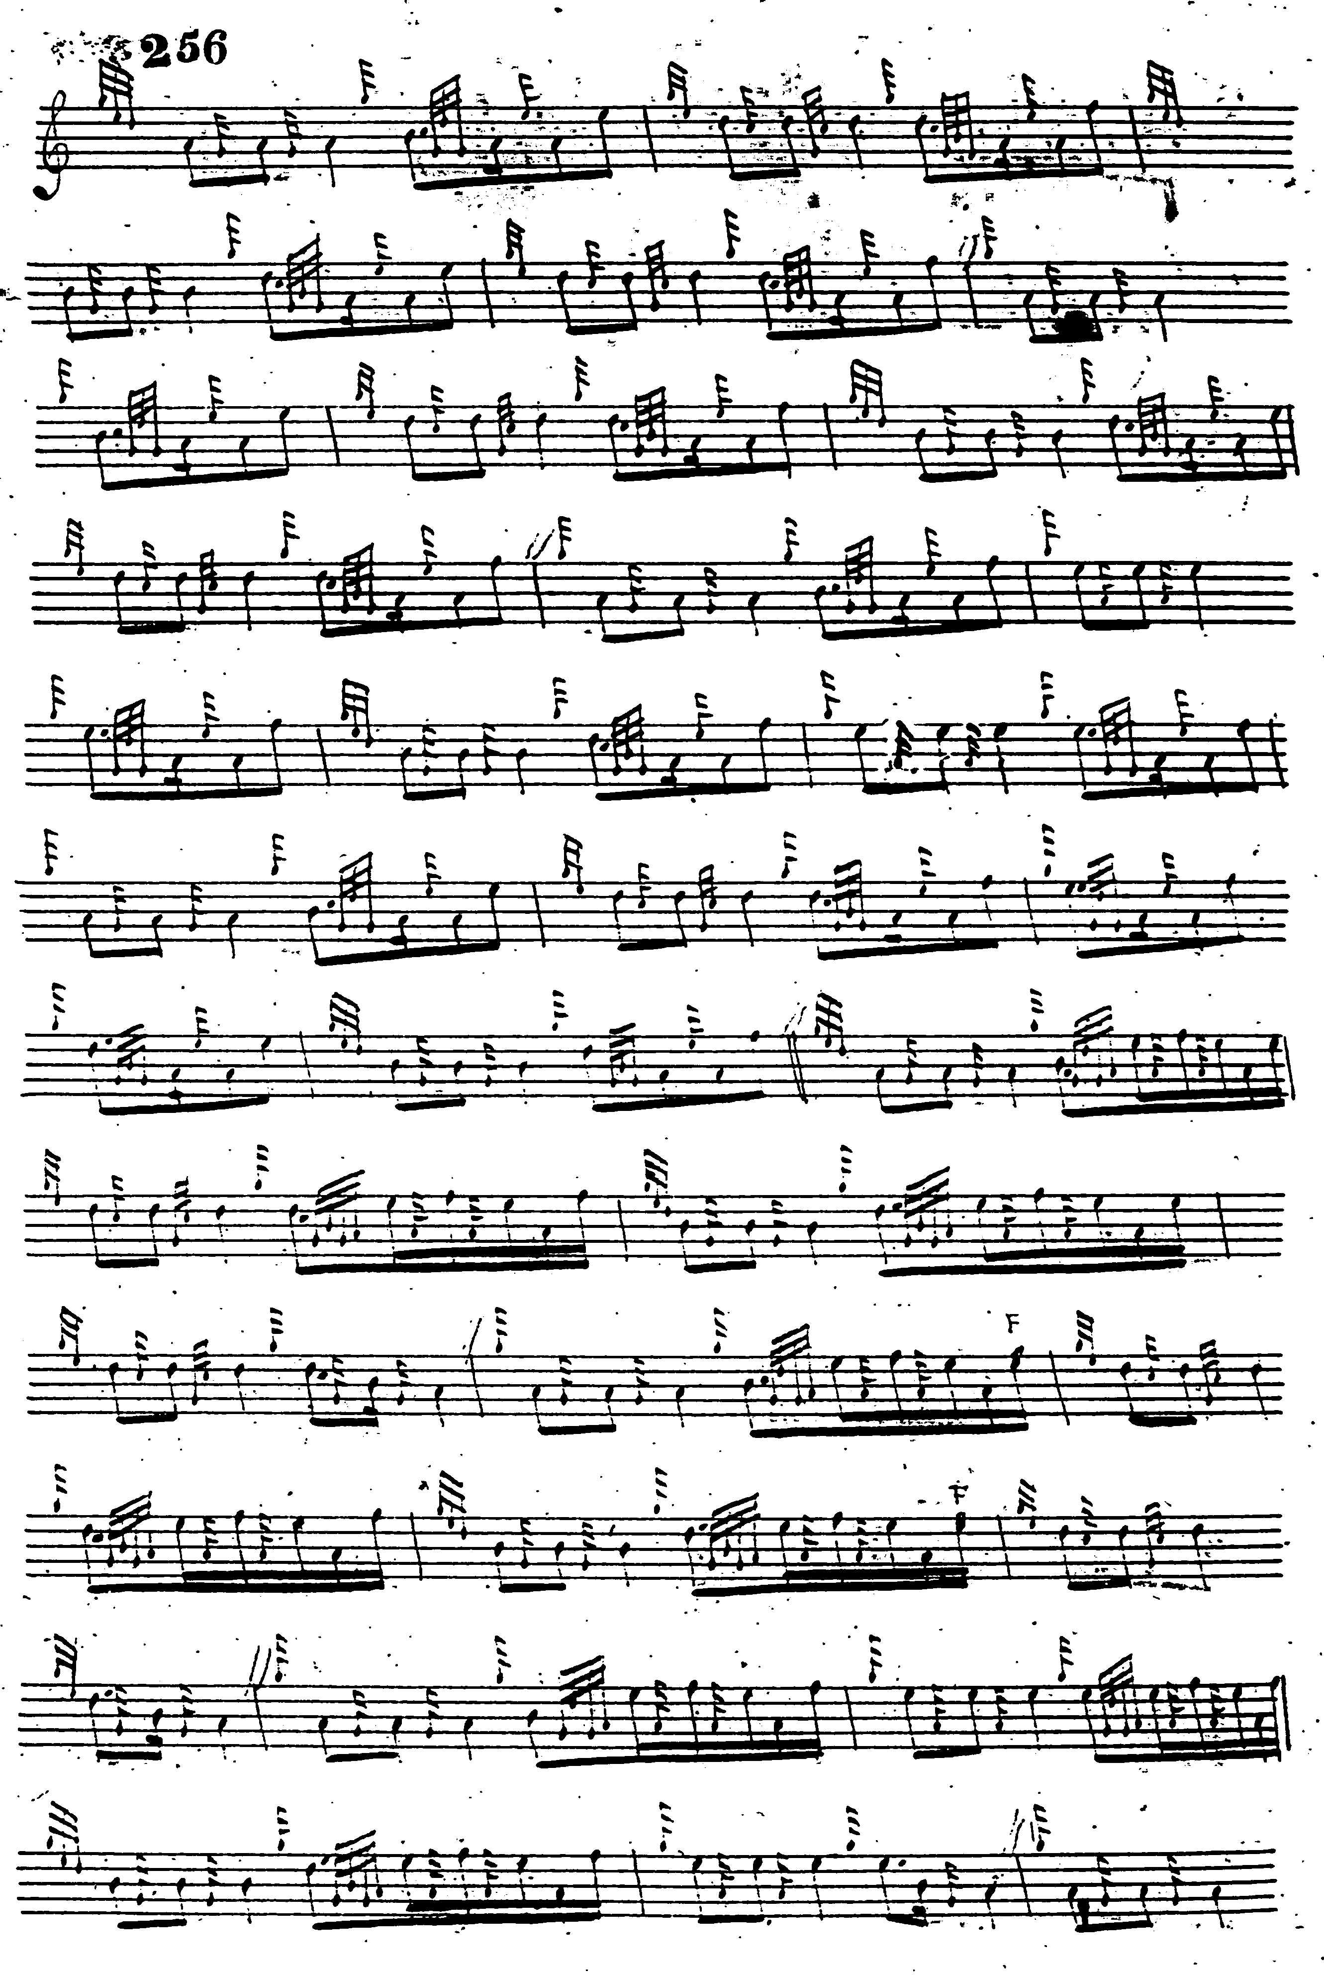
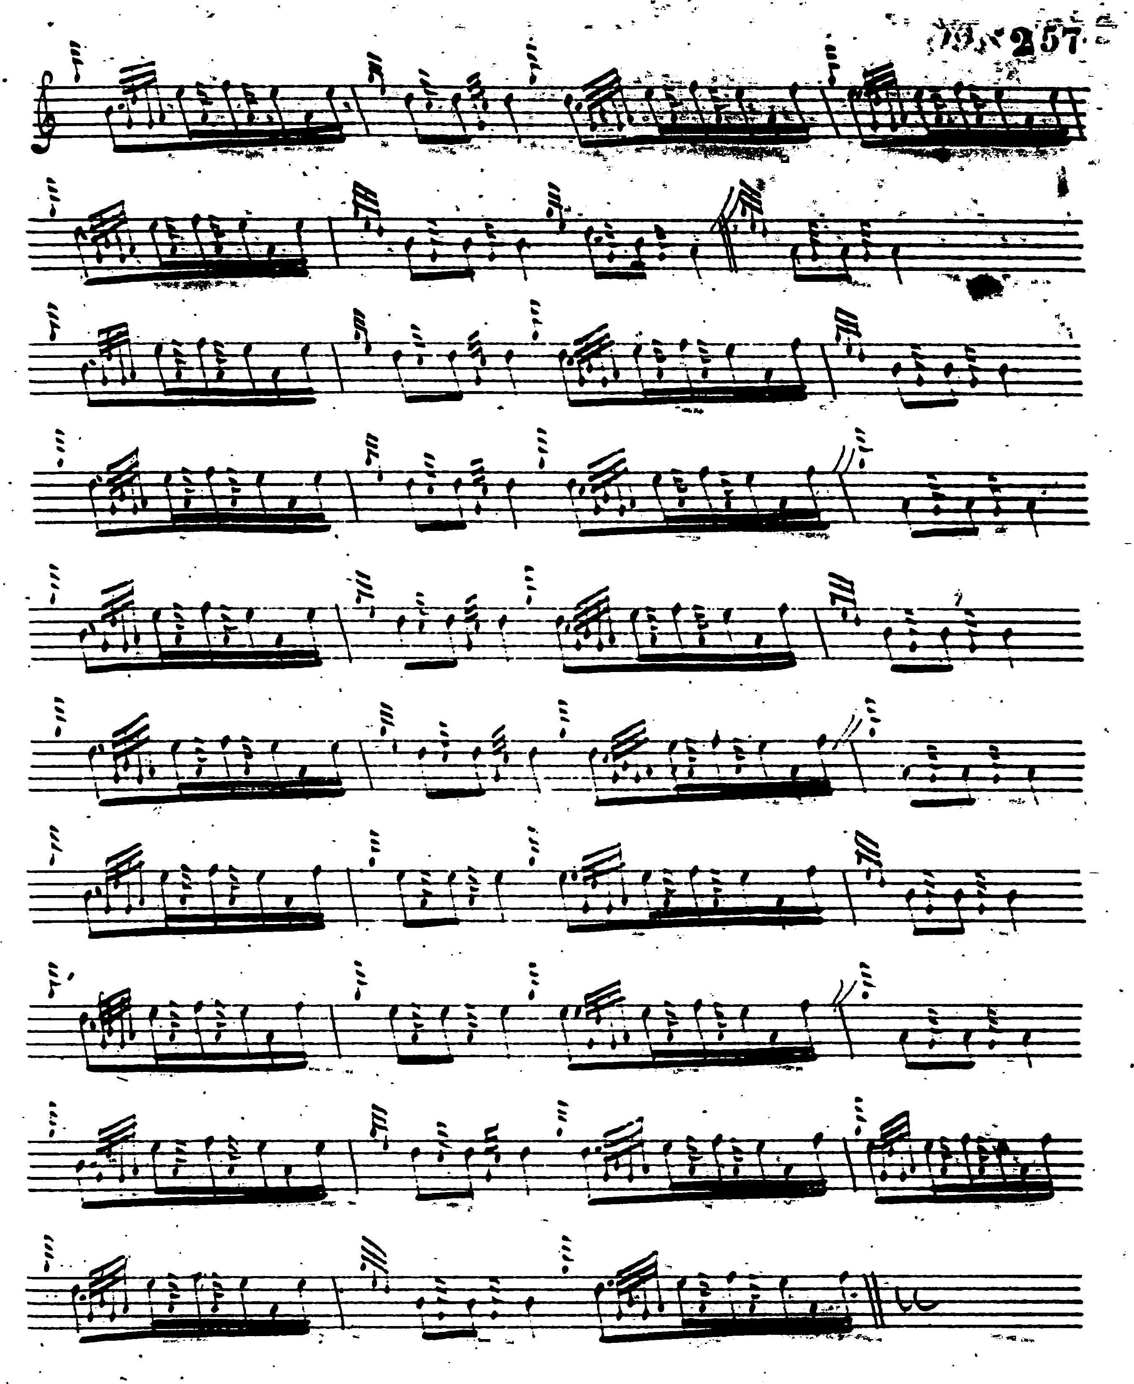

John McLennan’s setting is a mere sketch of the ground, and is not reproduced here.

Robert Meldrum’s setting adds nothing to the tune stylistically, and is not reproduced here.

Amongst the published settings, Niel MacLeod of Gesto sets the tune as follows:

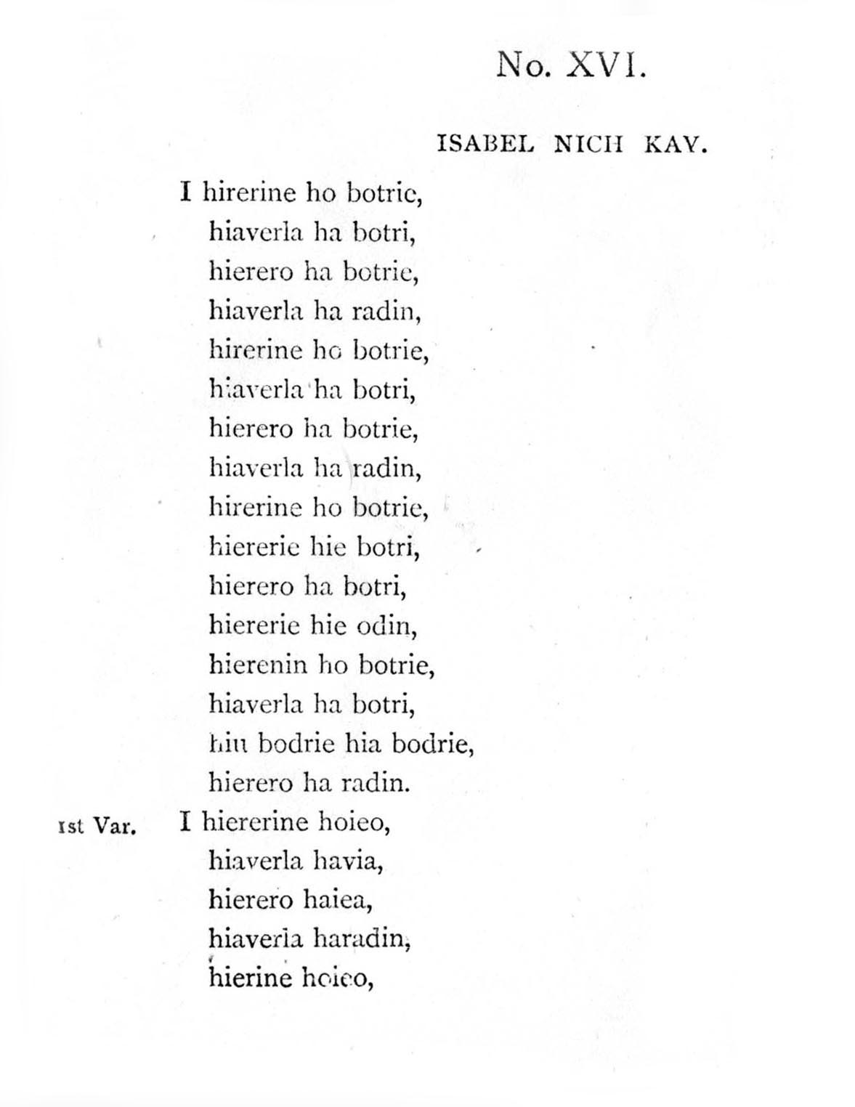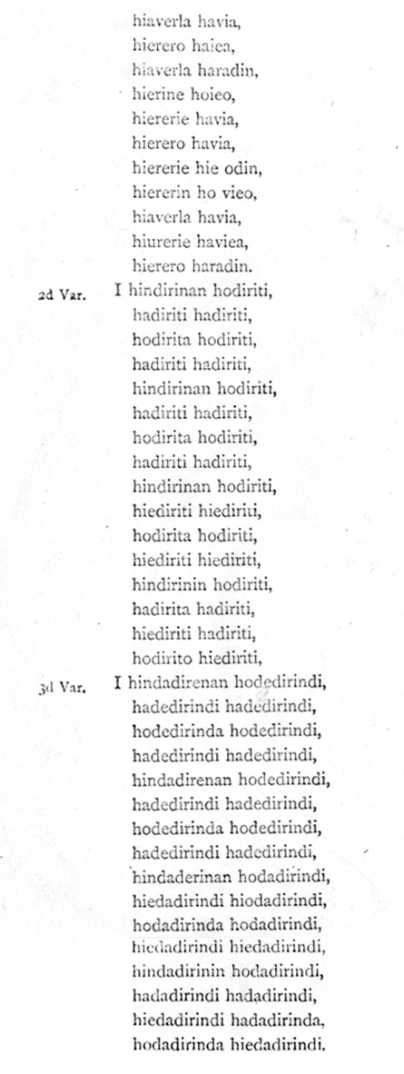

The general style is very similar to that of Colin Mór Campbell and Donald MacDonald although Niel MacLeod is less spacious than Donald MacDonald, having a single first variation followed by single taorluath and crunluath variations as opposed to the latter’s singlings and doublings.

Angus MacKay sets the tune in a very square and heavily cadenced style, and includes a thumb variation not included in Colin Campbell, Donald MacDonald, or Niel MacLeod, as follows:

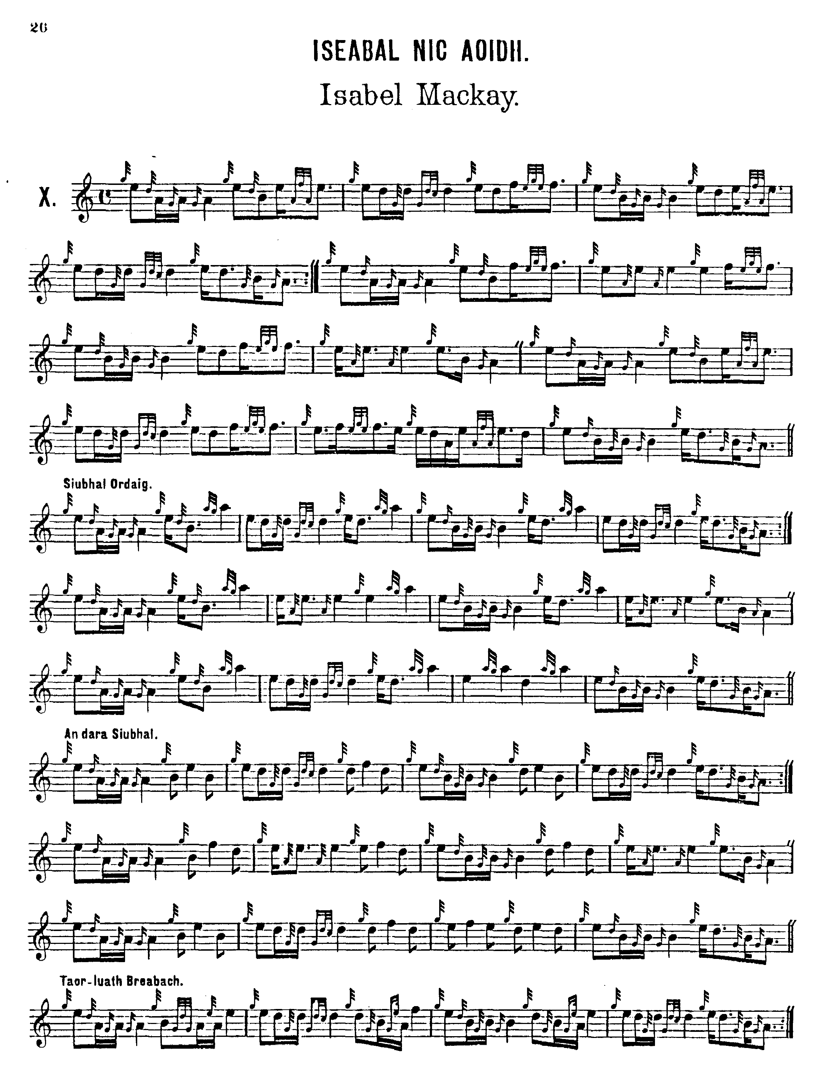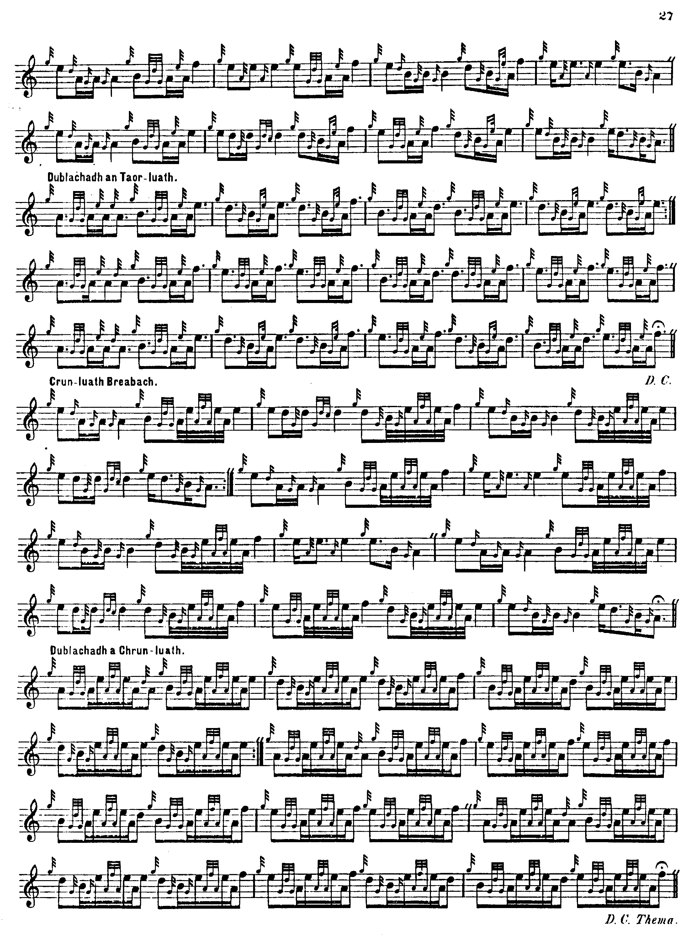

C. S. Thomason produces a composite text, giving as his sources Donald MacDonald’s manuscript, Angus MacKay’s published book, and Donald MacKay; Donald MacDonald is clearly the predominant influence, however. Thomason set the tune as follows:

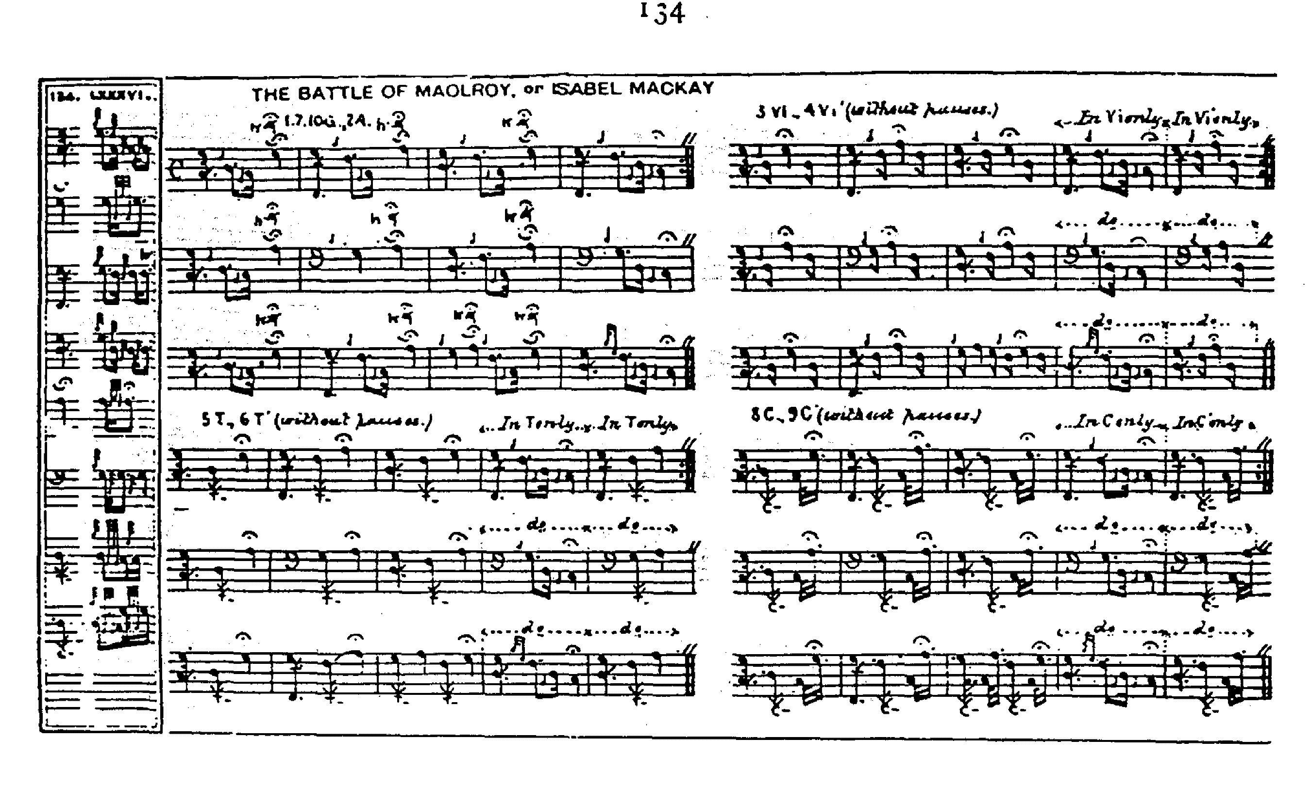

David Glen follows MacKay’s style of the tune, but shows his usual pointing of the double echo beats with the emphasis given to the opening note of each group. He also gives what he describes as a “second arrangement” of the ground and thumb variation. Glen sets the tune as follows:

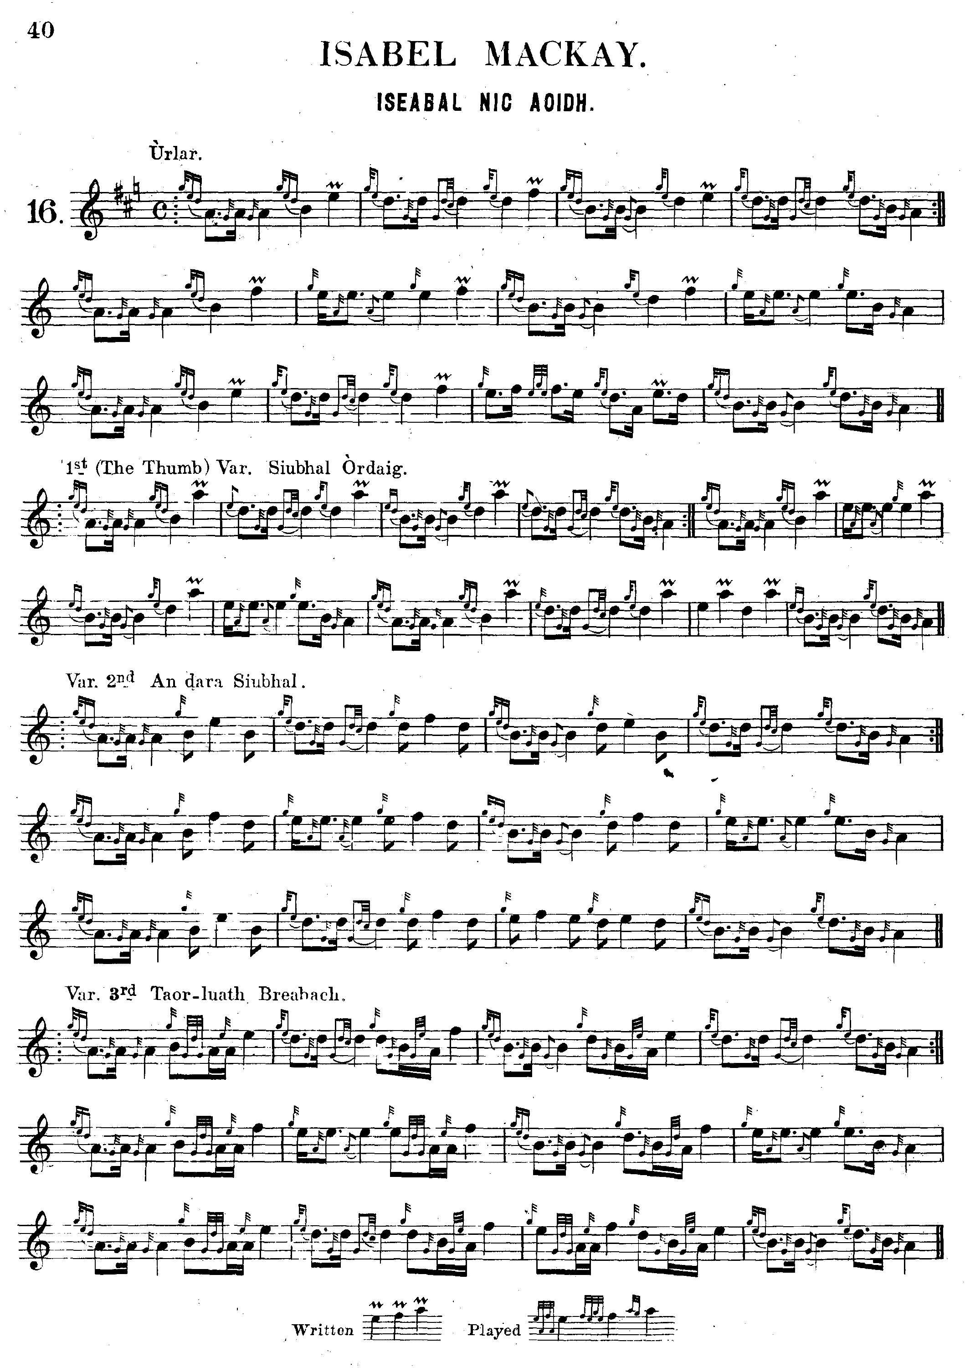
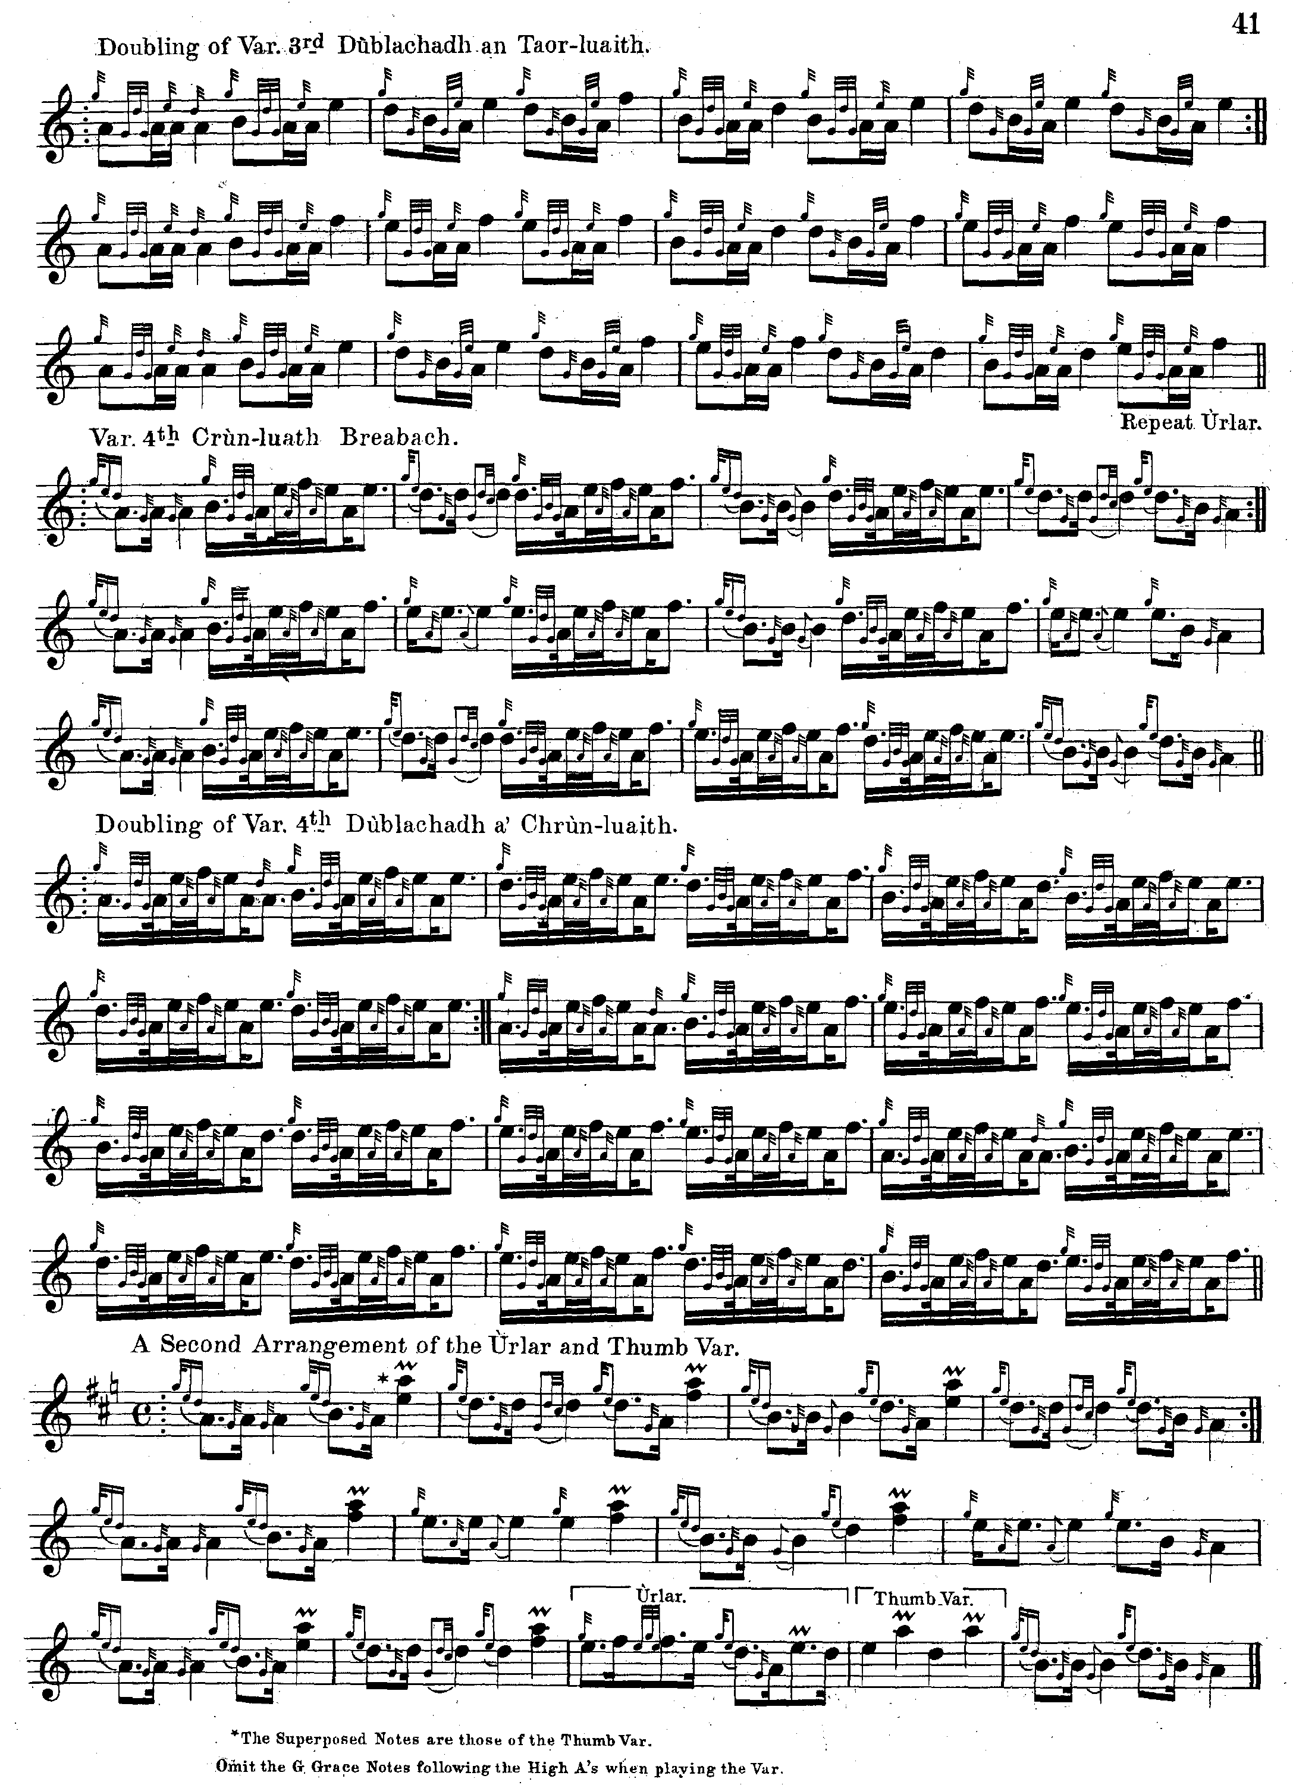

William Stewart of Ensay edited this tune for the Piobaireachd Society Collection (first series). In his notes he stated that “Mackay’s version of this Piobaireachd is considered the best we have, and is given here unchanged” (“Preface” p.10) and except that he removed MacKay’s instructions to repeat the ground at the end of the taorluath and crunluath doublings, this is exactly what he did. Since it follows MacKay very closely, William Stewart’s setting is not reproduced here.
His practice differs strikingly from that of his successor, Archibald Campbell, in the Piobaireachd Society Collection (second series), who although stating that “The setting printed is that of Angus MacKay” (vi, 183) silently departed in numerous respects from the way that MacKay had set the tune.

Commentary:

In his “Historic, Biographic and Legendary Notes to the Tunes” attached to David Glen’s Ancient Piobaireachd, Henry Whyte (“Fionn”) states

This beautiful Piobaireachd was composed by some unknown piper to Isabel Mackay, daughter of John, second son of Hector Mackay of Skerry. She was celebrated for her accomplishments and personal beauty. She is immortalised by Rob Donn, the bard, in a poem of considerable merit. She married [John, son of] Kenneth Sutherland of Keoldale. [Factor of the barony of Durness who was also notable as being the violin teacher of Joseph MacDonald of Compleat Theory fame, see The Highland Pipe and Scottish Society1750-1950, pp.20-21] Here are some lines of a translation of the bard’s verses:--

Isabel Mackay, list to her sigh;
Isabel Mackay, all so lonely;
Isabel Mackay, list to her sigh;
Isabel Mackay, all so lonely.

Sad laggard I trow, lone bachelor thou,
Come never or now, and all thy love vow
To Isabel divine, tending the kine;
O, why let her pine! O, why let her pine
While tending the kine all so lonely.

Isabel Mackay, list to her sigh, &c.

Was such a prize ever seen before
Upon the mountains green before,
A pining noon and e’en before?
A maid so divine, O, why let her pine;
O why let her pine while tending the kine
All so lonely. (p.8)

The song itself, “Iseabail Nic-Aoidh” beginning “Iseabail Nic-Aoidh aig a’ crodh laoigh, / Iseabail Nic-Aoidh ’s i ’n a h-aonar, &c.” is one of the class of “piobaireachd songs”, falling into four sections headed: ‘An ceud siubhal, An dara siubhal, An Taobhluath, and An Crunluath’

Robb Donn was born and lived for a time at the head of Loch Hope, a beautiful spot near the famous Dundornaigil Broch and the spectacular Alltnacaillich waterfall. His wife was also very musical, and neighbours used to listen to them singing to one another as they sat by the fire on winter evenings. It must have been marvellous to hear.

As for the alternative title, and the Rout of Mulroy, C. S. Thomason gives details in his “Ceol Mor Legends” as follows (ff.232-7):

There had been, for a great many years, much debate and some skirmishing betwixt MacIntosh of Moy, the chief of that ancient surname, and a sept of the MacDonalds called MacDonald of Keppoch. The MacIntoshes had claims of an ancient date upon the district of Glenroy (now famous for the phenomenon called the parallel roads) and the neighbouring valley of Glenspean. MacIntosh had the right to these lands expressed in written grants from the Crown, but Keppoch was in actual possession of the property. When asked upon what charters he founded his claim, MacDonald replied that he held his land not by a sheep’s skin, but by the sword and his clan, an uncommonly bold and hardy race, were ready to support his boast. Several proposals having been in vain made to accommodate this matter, MacIntosh resolved to proceed to open force, and possess himself of the disputed territory. He therefore displayed the yellow banner, which was the badge of his family, raised his clan and marched towards Keppoch, being assisted by an independent company of soldiers, raised for the service of government, and commanded by Capt. MacKenzie of Suddie […] On their arrival at Keppoch, MacIntosh found his rival’s house deserted, and imagining himself in possession of victory, even without a combat, he employed many workmen, whom he had brought with him for that purpose, to construct a castle, or fort, on a precipitous bank overhanging the River Roy, where the vestiges of his operations are still to be seen. The work was speedily interrupted, by tidings that the MacDonalds of Keppoch, assisted by their kindred tribes of Glengarry and Glencoe, had assembled and that they were lying on their arms, in great numbers in a narrow glen behind the ridge of hills, which rises to the north-east of Keppoch, the sloping declivity of which is called Mullroy. Their purpose was to attack MacIntosh at daybreak: but that chief determined to anticipate their design, and marched towards his enemy before the first peep of dawn. The MacDonalds with their Chief, Coll of Keppoch, were equally ready for the conflict and in the grey light of the morning, when the MacIntoshes had nearly surrounded the heights of Mullroy, the MacDonalds appeared in possession of the upper ridges and battle instantly commenced.
A lad who had lately run away from his master, a tobacco spinner [tobacconist] in Inverness and had enlisted in Suddies’ independent company, gives the following account of the action:--“The MacDonalds came down the hill upon us, without either shoe, stockings, or bonnet on their heads; they gave a shout, and then the fire began on both sides; and continued a hot dispute for an hour (which made me wish I had been spinning tobacco). Then they broke in upon us with sword and target, and
Lochaber axes, which obliged us to give way. Seeing my captain severely wounded, and a great many men lying with heads cloven on every side, and having never witnessed the like before, I was sadly affrighted. At length a Highlandman attacked me with sword and target, and cut my wooden handled bayonet out of the muzzle of my gun. I then clubbed my gun and gave him a stroke with it, which made the but end to fly off and seeing the Highlandman come fast down upon me, I took to my heels, and ran thirty miles before I looked behind me, taking every person who I saw or met for my enemy.” Many better used to such scenes fled as far and fast as Donald MacBane the tobacco spinner’s apprentice. The gentlemen who bore MacIntosh’s standard, being a special object of pursuit, saved himself and the sacred deposit by a wonderful exertion. At a place where the River Roy flows between two precipitous rocks, which approach each other over the torrent, he hazarded a desperate leap where no enemy dared follow him, and bore off his charge in safety.
It is said by tradition that the MacIntoshes fought with great bravery, and that the contest was decided by the desperation of a half crazed man, called “the red-haired Bo- man,” or cowherd, whom Keppoch had not summoned to the fight, but who came hither, nevertheless, with a club on his shoulder. This man being wounded by a shot was so much incensed with the pain, that he started forward into the thickest of the MacIntoshes, calling out “They fly, they fly! upon them, upon them!” The boldness he displayed, and the strokes he dealt with his unusual weapon, caused the first impression on the army of the enemies of his chief.
MacDonald was very unwilling to injure any of the government soldiers, yet Suddie, their commander, received his death-stroke. He was brave, and well armed with carabine, pistols, and a halberd or half pike. This officer came in front of a cadet of Keppoch, called MacDonald of Tullich, and by a shot aimed at him, killed one of his brothers, and then rushed on with his pike. Notwithstanding this desperate provocation, Tullich, sensible of the pretext which the death of a captain under government would give against his clan, called out more than once,
“Avoid me--avoid me.”--“The MacDonald was never born that I would shun,” replied the MacKenzie, pressing on with his pike. On which Tullich hurled at his head a pistol, which he had before discharged. The blow took effect, the skull was fractured, and MacKenzie died shortly after, as his soldiers were carrying him into Inverness.
MacIntosh himself was taken by his rival, who, in his esteem was only insurgent vassal. When the captive heard the MacDonalds greeting their chieftain with shouts of “Lord of Keppoch! Lord of Keppoch!” he addressed him boldly, saying, “You are as far from being Lord of the lands of Keppoch at this moment, as you had been all your life” – “Never mind” answered the victorious chieftain, with much good humour, “we’ll enjoy the good weather while it lasts.” Accordingly, the victory of his tribe is recorded still in the pipe tune, called “MacDonald took the brae on them”.

“Isabel MacKay” was one of the set tunes for 1938 season, it being the Piobaireachd Society’s practice to choose the set tunes for any year from its own most recently published volumes. The Oban Times report on the Open competition at the Argyllshire Gathering of 17th September 1938 suggests that the competitors had difficulty in getting the Archibald Campbell setting of this tune to sound like music. We learn that Bob Nicol’s playing was “rather slow and uninspired and he was placed second. John MacDonald of the Glasgow Police was third, also playing Isabella MacKay, but the judges did not like his style of rendering the tune. The same observation applies to most of those who played this composition. They seemed to find difficulty in giving a really musical rendering.” (p.2)

* * *

Electronic text © Dr. William Donaldson, Aberdeen, Scotland, July 2005; revised Cambridge, Massachusetts, January 2025

