I got a Kiss of the King’s Hand

This tune appears in the following manuscript sources:
--Peter Reid’s MS, f.41;
--Robert Meldrum’s MS, ff.102-5;

and in the following published sources:
--Angus MacKay, Collection of Ancient Piobaireachd (pp.14-16);
--C. S. Thomason, Ceol Mor pp. 156-7 (citing Donald MacKay, although Thomason assumed responsibility for the setting—see below);
--David Glen, Collection of Ancient Piobaireachd, pp.72-3;
--John McLennan, The Piobaireachd as MacCrimmon Played it, p.7;
--G. F. Ross, Collection of MacCrimmon and other Piobaireachd, pp.40-1.

There was a long-standing problem with “The King’s Hand”, namely that Angus MacKay’s version—the earliest published source, and widely distributed in the performer community, hence the relative scarcity of manuscript settings--had thirty two bars in the ground but only thirty one in the variations from the siubhal singling onwards. The missing bar (on analogy from the ground) was bar three in the first line in each case. A practice had arisen of playing MacKay’s score in competition as it stood, because this was what bookish benches of judges expected to hear. One correspondent of the Oban Times described the situation in the early years of the twentieth century:

let us take “I got a kiss of the king's hand”--Angus MacKay’s book. The first part of the ground or Urlar has twelve bars, and in the same part in the variations there are only eleven bars. One naturally concludes that there is something wrong in this.
On comparing the variations with the ground, it is at once apparent that the third bar of the ground is left out in the variations. This little error is known to every leading piper in Scotland, and he plays it wrongly simply because it is in MacKay’s book, and if he did play it correctly, most of those who at present act as judges of piobaireachd would say that he was wrong. (“The Piobaireachd Society of Scotland”, Oban Times, 19/09/1903, p.3).

In his epoch-making edition, Ceol Mor, C. S. Thomason wrote “The metre of ‘I got a kiss of the King’s hand’, given in bars is 12, 12, 8, and in sections ABC-BDC-BE. The music of the ‘Urlar’ given by A.[ngus] MacKay is, I believe, quite correct, but when we come to the first variation we find the metre to be 11,12, 8. There is evidently a bar missing in the first line, but what is the bar? Analysing the first section of the ‘Urlar’ we can distinctly trace two phrases in it, each phrase consisting of two bars, the first of which bars is identical in both phrases, and it should be the same in the variation, but the third bar is wanting. If, therefore, at this point we insert the first bar, we shall get the metre correct…” (Ceol Mor, “Rhythm in Sections”, pp.2-3). Thomason amended the tune as follows:

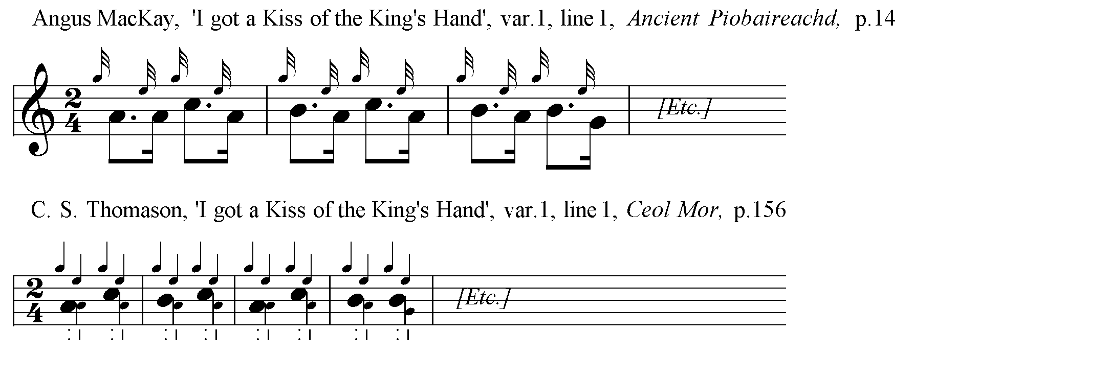

Thomason set the tune as follows:

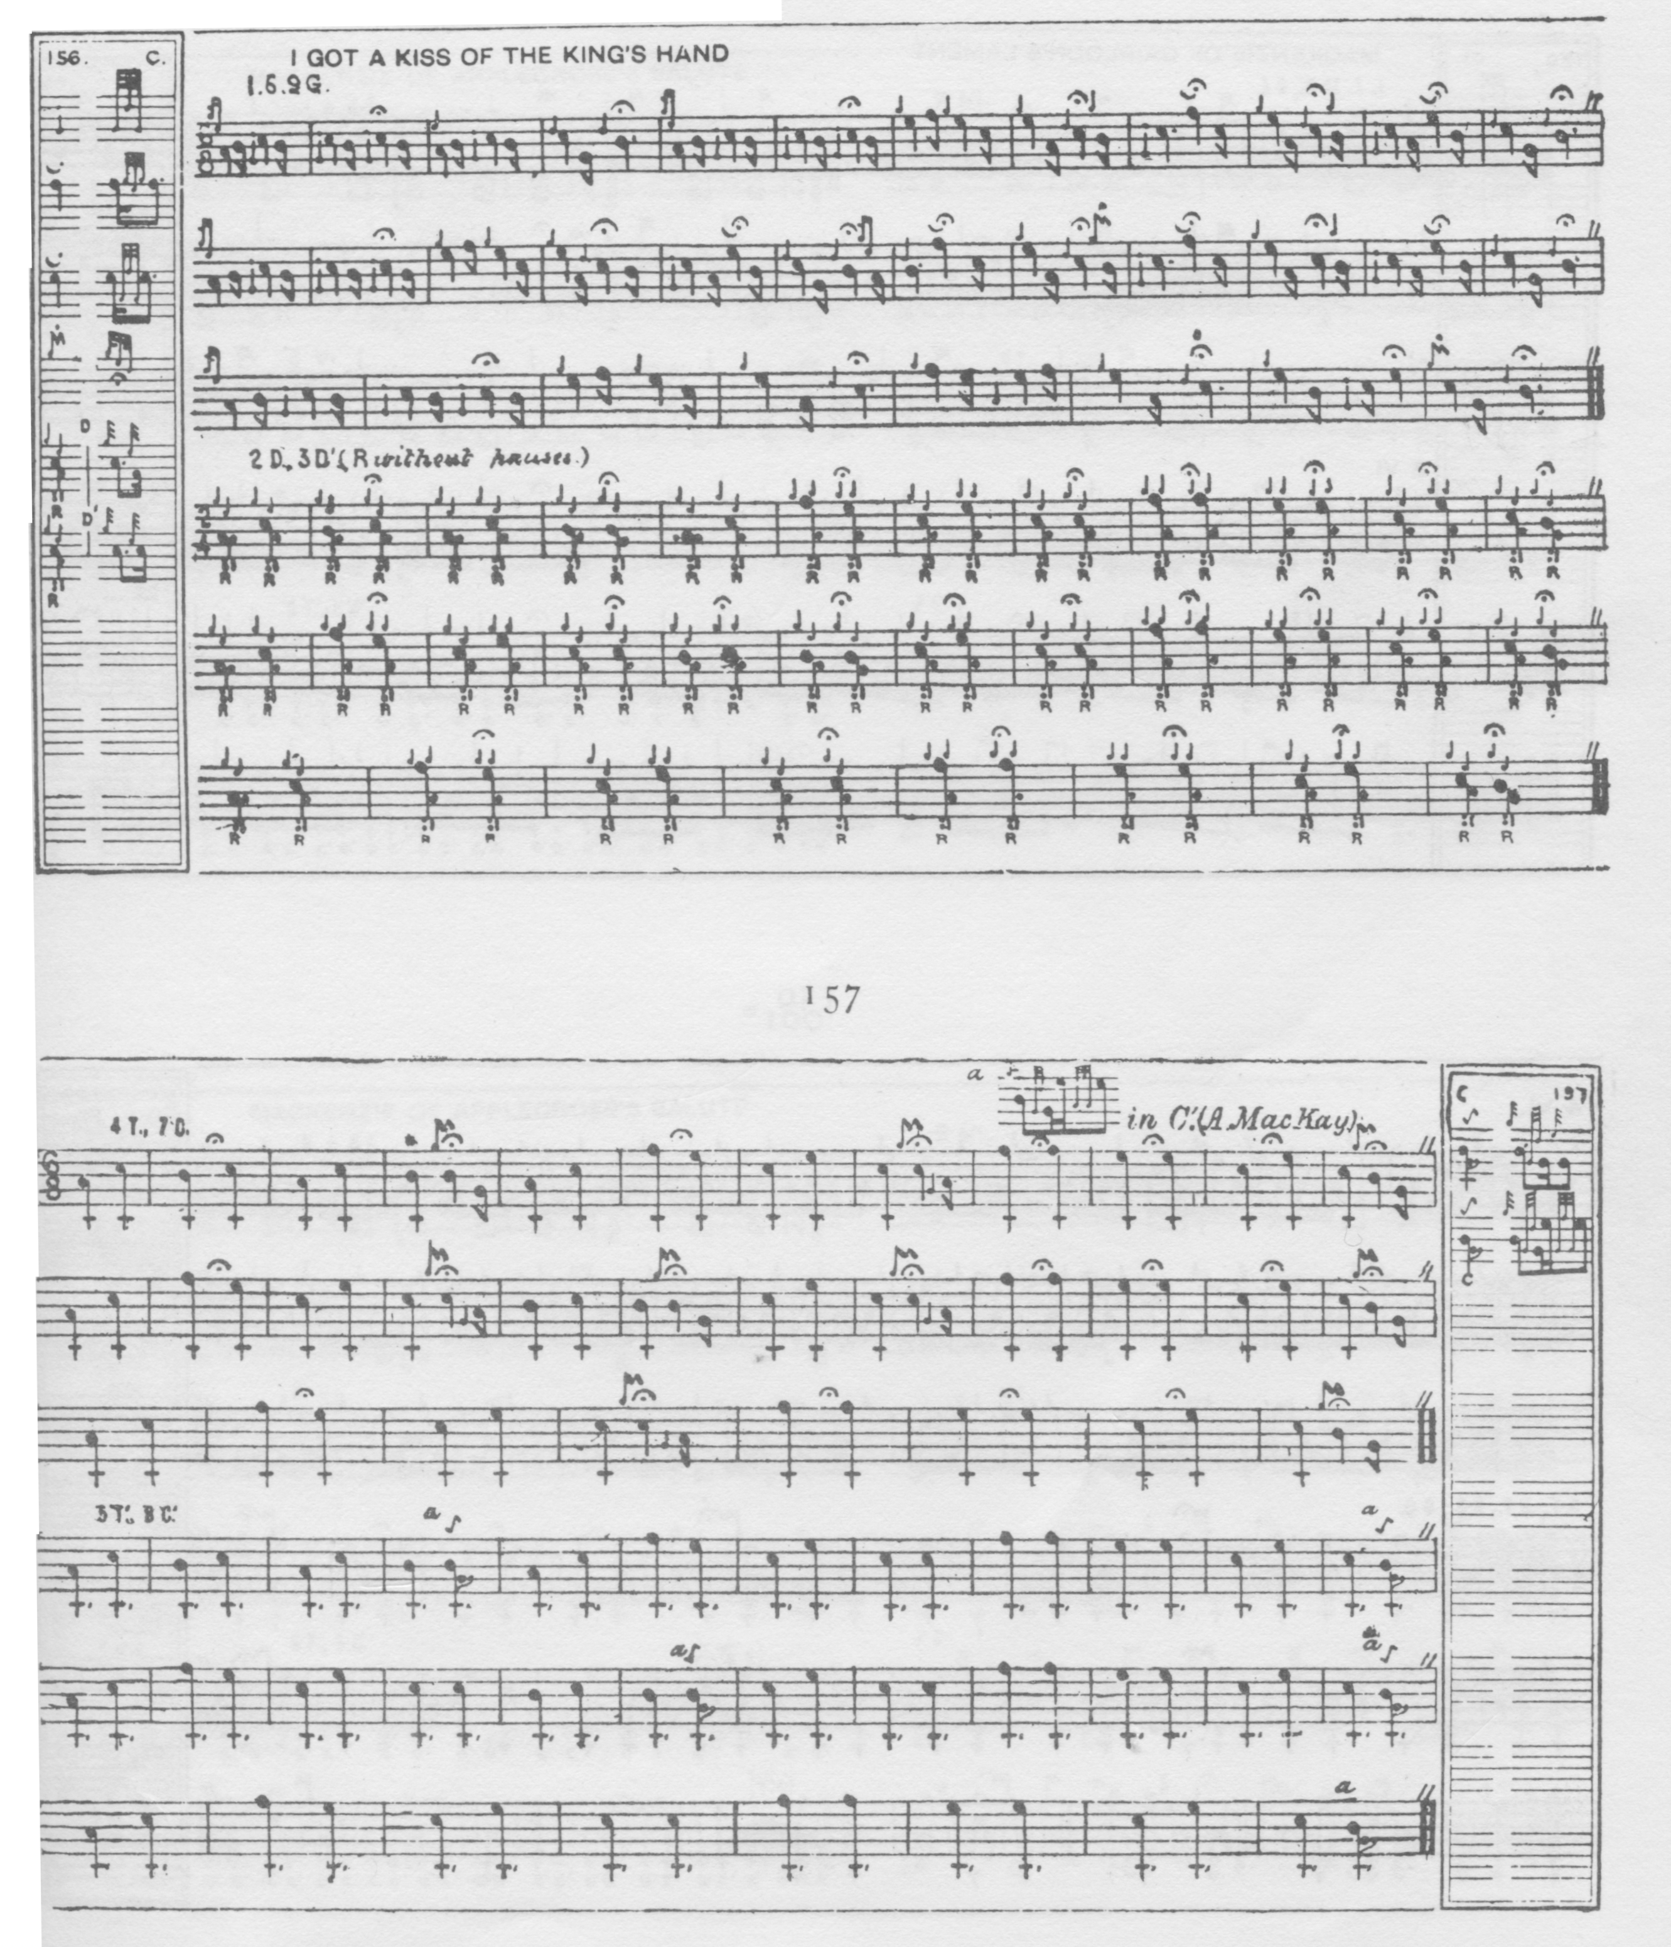

Thomason’s barring was a little eccentric, perhaps, but his emendation quickly won acceptance and was followed by all later editors and players.

In 1933 a copy of MacKay’s book with mistakes corrected in MacKay’s own hand was offered for sale to the Piobaireachd Society who, at Archibald Campbell’s instigation, refused to buy it. What happened to the volume subsequently is unclear, but it seems to have joined several other significant pìobaireachd sources which disappeared from view during the 20th century.

Amongst the older sources, many might think that David Glen’s idiomatic and well-timed setting would be the one to go for. It gives a good idea of the phrasing of the ground and avoids the prolongation of passing notes and cadences at phrase endings which mark the Piobaireachd Society’s scores:

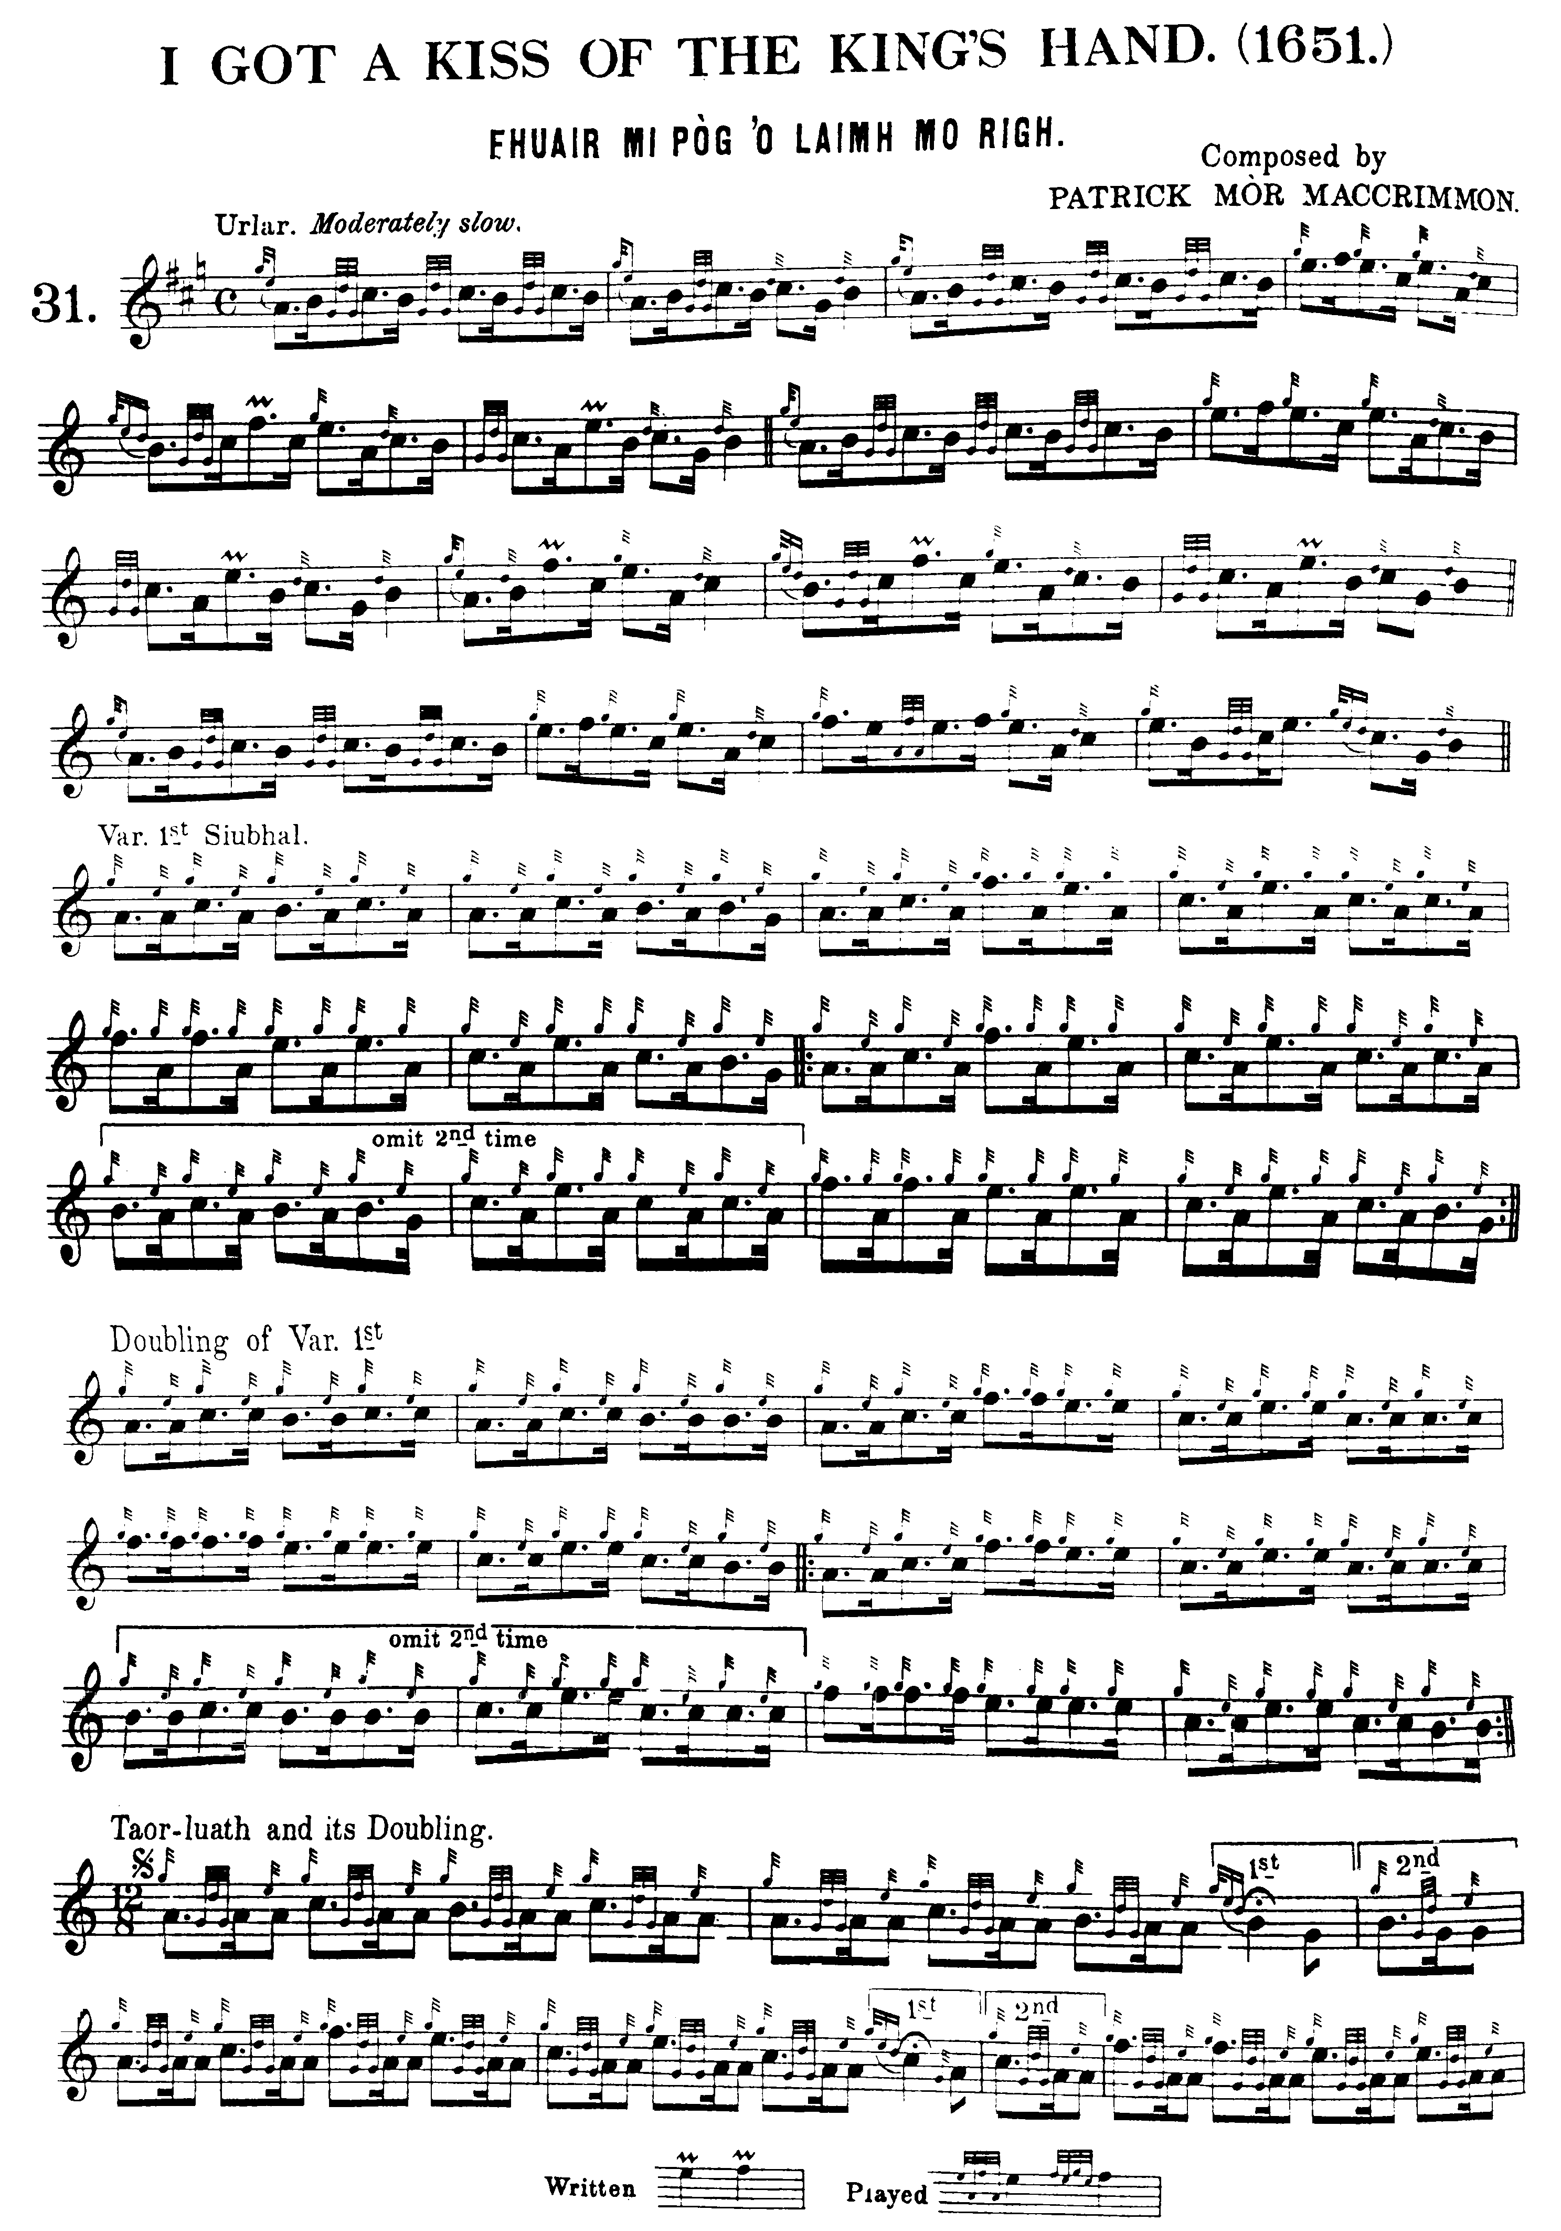
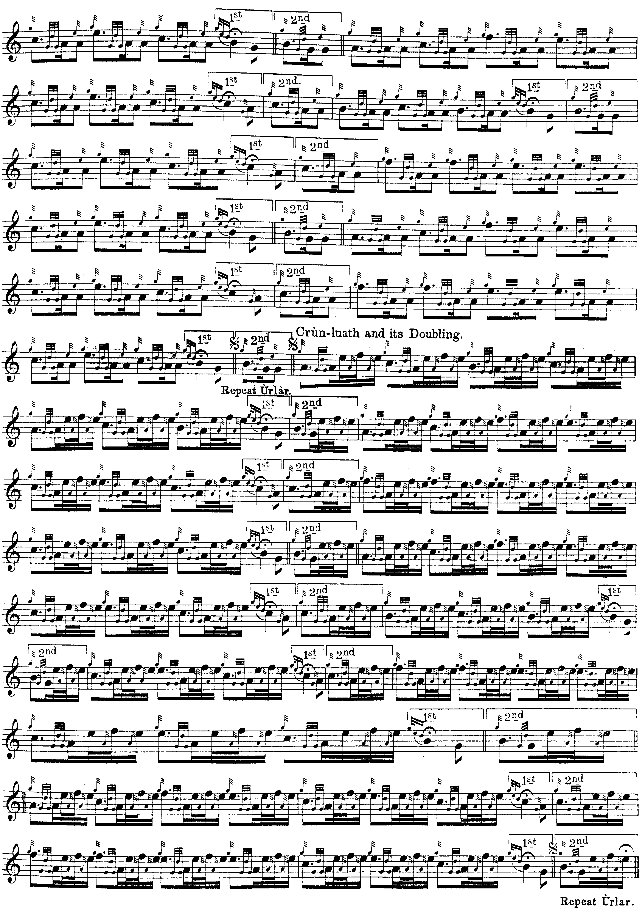

In the ground we see Glen’s normal usage of the slur to indicate smooth transition between the notes so joined. There was an attempt by James Campbell, then Hon. President of the Piobaireachd Society, to justify his father, Archibald Campbell’s, notational practice by suggesting that Glen meant this to indicate an appoggiatura, implying that the first note of the pair thus linked should borrow time from the second (James Campbell, “The Elusive Appoggiatura”, Piping Times, 40/9, June 1988, pp.22-5). But applying this principle to Glen’s normal practice throughout his extensive published and manuscript scores would result in rhythmical incoherence in most cases, as we can see above.

Lt. John McLennan (father and teacher of G. S. McLennan) takes an interestingly different route through the tune. Although excluded from the “official” accounts during the 20th century, the McLennans were an influential and extended piping family who traced their musical roots back to the early sixteenth century. Leading representatives during the 19th century included G. S. McLennan’s great-uncle Donald Mór MacLennan of Moy (born c.1783) who taught a whole generation of Victorian master players. Two of Donald of Moy’s sons, Sandy (1811—1896, prize pipe Inverness 1857, gold medal 1860) and John (1817-1906, prize pipe Inverness, 1848, gold medal 1854), were also important players and teachers, Sandy being taught by Donald Cameron, and John by his father and John Bàn Mackenzie. G. S.’s cousin, William MacLennan (1860-1892) was also a champion piper and dancer (Inverness prize pipe, 1878, Gold medal 1879) and a pioneer of the new more technically elaborate style of play in competition light music. Following the death of his parents, William was brought up by G. S.’s father, Lt. John McLennan, whose pupil he became. Lt. John was heir of a rich and complex family tradition. For a more extended account of the McLennan family, see The Highland Pipe and Scottish Society 1750-1950, pp.196-7, 301-5; and Pipers: a Guide to the Players and Music of the Highland Bagpipe, pp.141-4). Although Lt. John McLennan’s published books were later quite arbitrarily dismissed as “not authentic”, this judgment probably owed more to his public criticisms of the Piobaireachd Society during the early decades of the 20th century than to any serious flaw in his work as an editor or in the strand of tradition he represented. His interesting treatment of the tone row in line one of the variations from the siubhal onwards may be historically well rooted, and is certainly not unpleasing in playing:

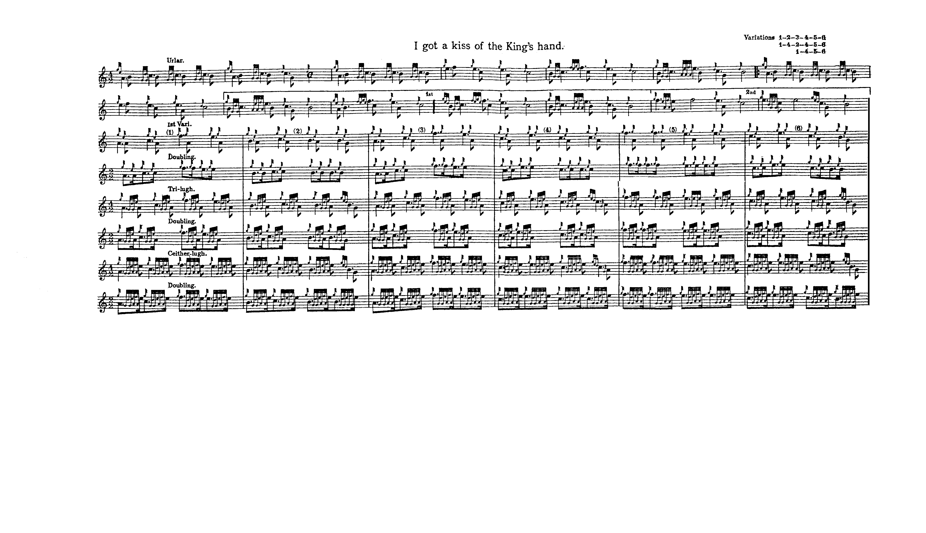

Commentary

Archibald Campbell, editing the tune in the Piobaireachd Society Collection (second series, vii, 216, 8), followed Glen in setting it in common time rather than the 6/8 preferred by MacKay and Thomason. Campbell also arbitrarily lengthened numerous passing notes by placing fermatas over them. In the Kilberry Book of Ceol Mor (p.100), this taste for inappropriately prolonged passing notes can be seen in his strings of fermatas (four in a row) attached to cadence notes from the taorluath singling onwards. It is also interesting to note that none of the earlier published or manuscript sources includes a crunluath a mach.

In MacKay’s Ancient Piobaireachd, James Logan states that the tune was “Composed by Patrick Mor MacCrummen. 1651” and gives words to the ground, as follows:

Thuair mi Pòg s’ Pòg s’ Pòg
ga’n d’thuair mi Pòg o’ Laimh an Righ…
cha’d chur seid a n Croicion Caorach
a thuair an turram a thuair mi.

He adds in a note:

Norman MacLeod of Macleod, and Roderick MacLeod of Talisker joined the army of king Charles II, and were knighted before the battle of Worcester, in 1651. Patrick Mòr MacCrummen having played his Pipes in presence of the king, his majesty was so much pleased with his performance and fine appearance, that he graciously condescended to allow him the honour of kissing hands. It was on this occasion that he composed the Piobaireachd, which to those acquainted with the Gaelic language, and enthusiastic in Pipe music, seems to speak forth the pride and gratitude of the performer; the words adapted to the opening measure inserted with the music, and thus translated:--

I have had a kiss, a kiss, a kiss,
I have had a kiss of the king’s hand:--
No one who blew in a sheep’s skin,
Has received such honour as I have.
(“Historical and Traditional Notes on the Piobaireachds”, p.4)

However, a seventeenth century account places this event at the royal camp near Stirling in 1651:

Never was Prince more taken up with an army as our King was, especially with the Scotch Highlanders, whom he tearmed the flour of his forces...There was great competition betuixt the trumpets in the army: one Axell, the Earl of Hoomes trumpeter, carried it by the King’s own decision! The next was anent the pipers; but the Earle of Sutherlands domestick carried it of all the camp, for non contended with him. All the pipers in the army gave John Macgurmen [MacCrimmon] the van, and acknowledged him for their patron in chiefe. It was pretty in a morning [the King] in parad viewing the regiments and bragads. He saw no less then 80 pipers in a crould bareheaded, and John M‘gyurmen in the middle, covered. He asked What society that was? It was told his Majesty: Sir, yow are our King, and yonder old man in the midle is the Prince of Pipers. He cald him by name, and comeing to the King, kneeling, his Majesty reacht him his hand to kiss; and instantly played an extemporanian port, Fuoris Pòòge i spoge i Rhì’, I got a kiss of the Kings hand; of which he and they all were vain. (James Fraser, Chronicles of the Frasers, ed., William MacKay, Edinr., 1905, pp.379-80).

A leading Highland antiquary, Dr. Alexander Stewart (1829-1901), who wrote under the pen name of “Nether Lochaber”, noted that the occasion of the tune occurred much later: ‘“Fuair mi pòg o lamh mo Rìgh,’ [was] composed at Holyrood in 1745 by ‘Ewen MacDhomhnuill Bhuidhe’, a Macmillan from Glendessary and piper to Lochiel, on seeing his chief kiss Charles Edward’s hand at a levee held in the palace of his ancestors by that Prince a day or two after the victory at Gladsmuir.” (quoted in “An Old Pipe Tune”, by “Fionn”, Oban Times, 23/05/1908, p.3).

John MacDonald of Inverness played “I got a Kiss of the King’s Hand” at the dedication of the MacCrimmon cairn at Boreraig in August 1933.

* * *

Electronic text © Dr. William Donaldson, Aberdeen, Scotland, November 2002; revised Cambridge, Massachusetts, January 2025.

