I am Proud to Play a Pipe

There are settings of this tune in the following manuscript sources:
--Colin Campbell’s “Nether Lorn Canntaireachd”, ii, 17-18;
--Angus MacKay’s MS, ii, 29-30;
--Colin Cameron’s MS, f.138;
--Duncan Campbell of Foss’s MS, ff.57-59;
--Uilleam Ross’s MS, ff.178-179;
--D. S. MacDonald’s MS, ii, 44-45;
--David Glen’s MS, ff.52-53;
--Robert Meldrum’s MS, ff.64-66;

and in the following published source:
--C. S. Thomason’s Ceol Mor, p.311 (with the title “Hey for the Old Pipes”).

In terms of the distribution of variations, Colin Campbell develops the tune in fairly conventional manner, ground, thumb variation, taorluath breabach singling and doubling and crunluath breabach singling and doubling. There seem to be problems, however, with the second line throughout, which consistently contains what to a modern ear sounds like redundant or perhaps insufficient syllables, the structure being a first line of four bars followed by two of five, the third line repeating the first with the addition of a flourish bar at the end. Colin Campbell sets the tune as follows:

1st Cherede hadre hotra chehodro hadre hotra himban hodarodo
2^{d} Cherede hadre hotra chehodro hioenem hiharin himotra hodre himban hioenem
3^{d} Cherede hadre hotra chehodro hadre hotra himban hodarodo hiharin hiharin

D
1st Chedili hadre hotra chehodro hadili hotra himban hodarodo
2^{d} Chedili hadre hotra chehodro hioenem hiharin himotra hodili himban hioenem
3^{d} Chedili hadre hotra chehodro hadili hotra himban hodarodo hiharin hiharin

S Taolive
1st Chedaridde hadaridde hodaridda chehodro hadarride hodaridda himdariddo hioendam
2^{d} Chedaridde hadaridde hodaridda chehodro hioenem hiharin hiobabemba hodaridde himdariddo hioendam
3^{d} Chedaridde hadaridde hodaridda chehodro hadaridde hodaridda himdariddo hioendam hiharin hiharin

D
1st Chedaridde hadaridde hodaridda chedariddo hadarride hodaridda himdariddo hiobabemto
2^{d} Chedaridde hadaridde hodaridda chedariddo hiobabemto hiobabemto hiobabemba horaridde himdariddo hiobabemto
3^{d} Chedaridde hadaridde hodaridda chedariddo hadaridde hodaridda himdariddo hiobabemto hindariddan hindaridan

S Crulive Gear
1st Chebandreende habandreende hobandreenda chehodro habandreende hobandreenda himbandreendo hioendam
2^{d} Chebandreende habandreende hobandreenda chehodro hioenem hiharin hiobamdreemda hobandreende himbandreendo hioendam
3^{d} Chebandreende habandreende hobandreenda chehodro habandreende hobandreenda himbandreendo hioendam hiharin hiharin

D
1st Chebandreende habandreende hobandreenda chebandreendo hadabandreende hobandreenda himbandreendo hiobamdreemto
2^{d} Chebandreende habandreende hobandreenda chebandreendo hiobamdreemto hiobamdreemto hiobamdreemda hobandreende himbandreendo hiobamdreemto
3^{d} Chebandreende habandreende hobandreenda chebandreendo habandreende hobandreenda himbandreendo hiobamdreemto hinbandreendan hinbandreendan

Angus MacKay misses a repeat mark at the end of the first line of the ground, and his indications of repeats and second endings do not exhibit his usual clarity. Notwithstanding this, most of the later settings of the tune seem to derive in one way or another from MacKay’s, and their lack of variety would perhaps suggest that this was not a widely-played piece. MacKay has the same basic development as Colin Campbell, but indicates that the ground should be repeated after the taorluath and crunluath doublings. He sets the tune as follows:

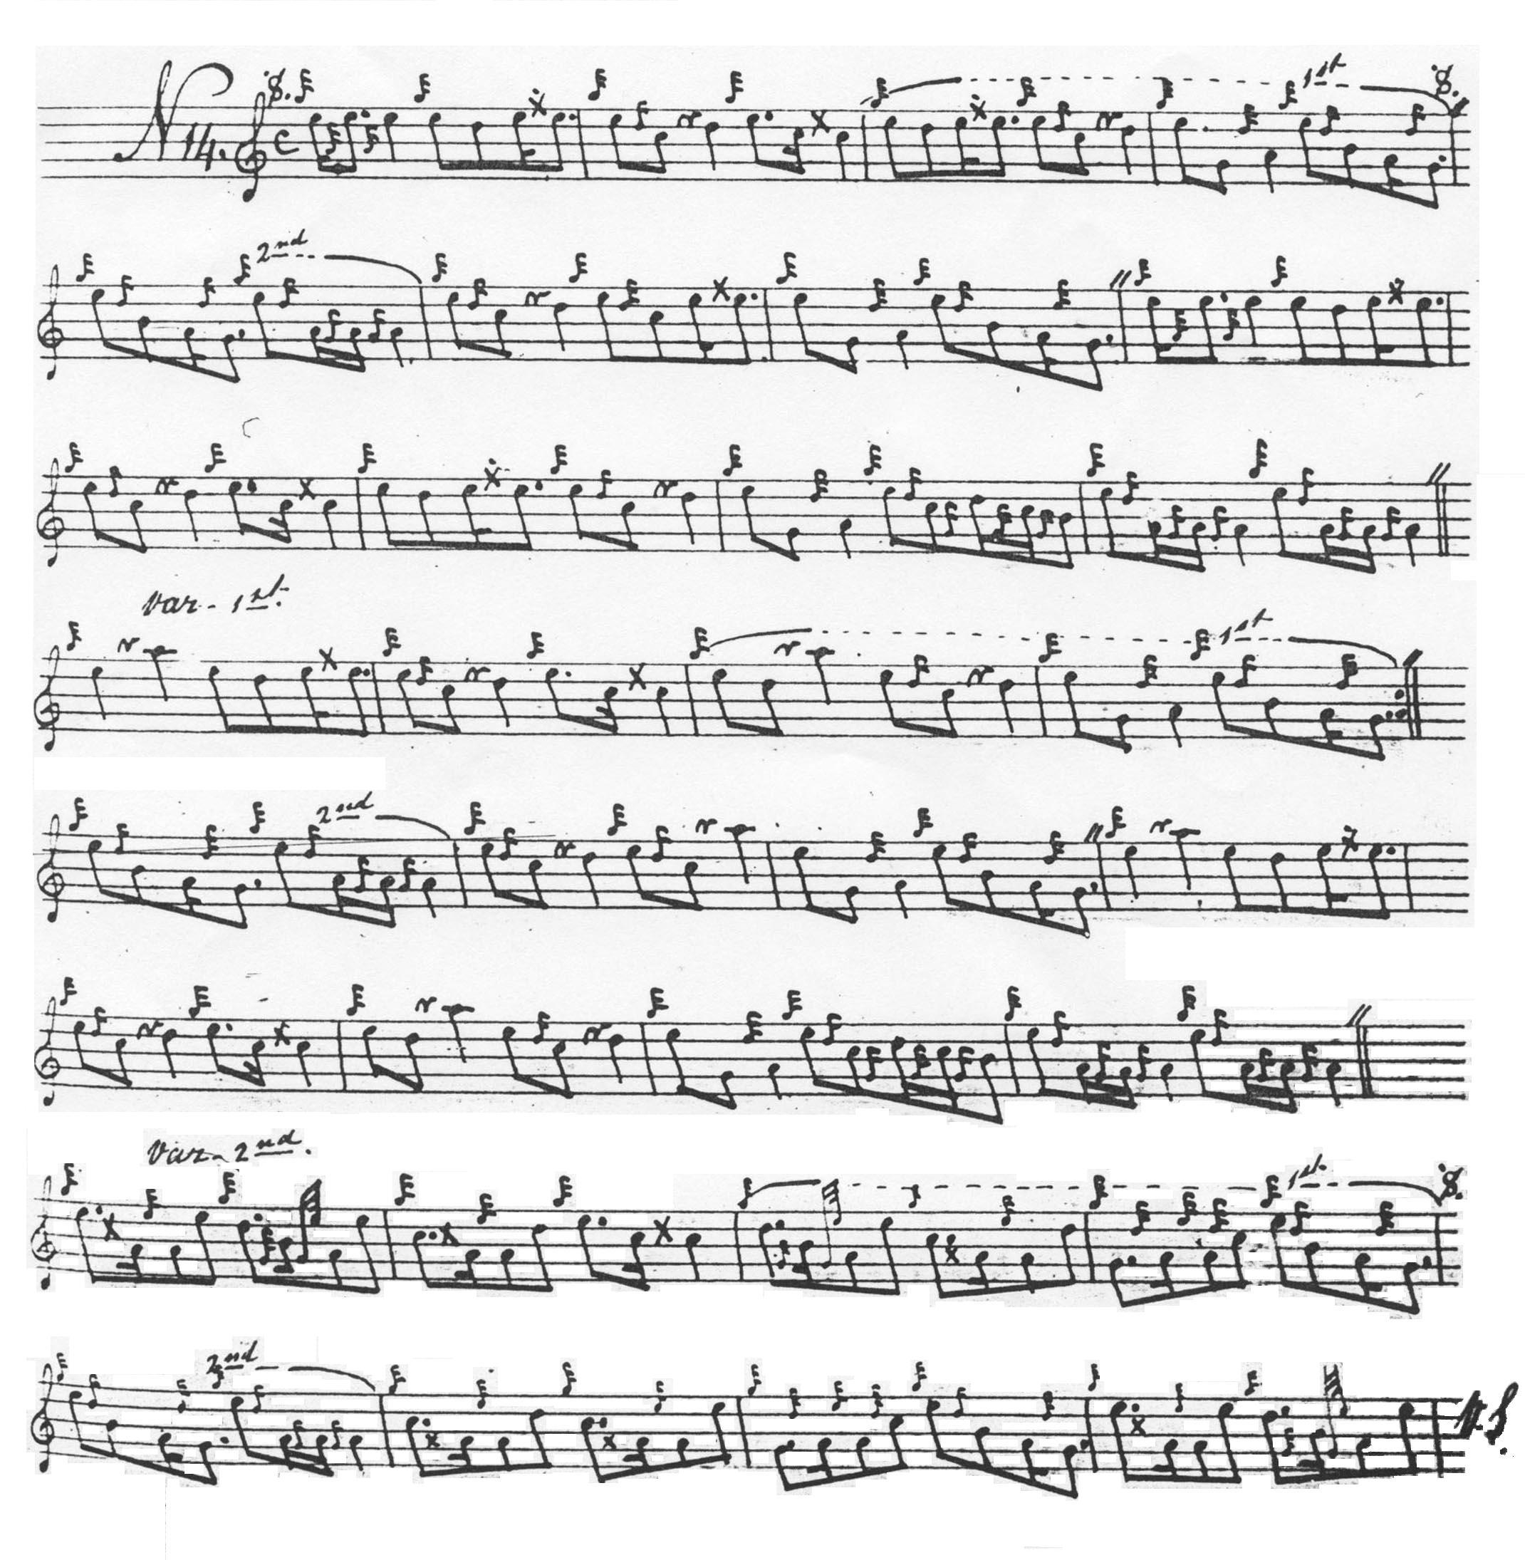

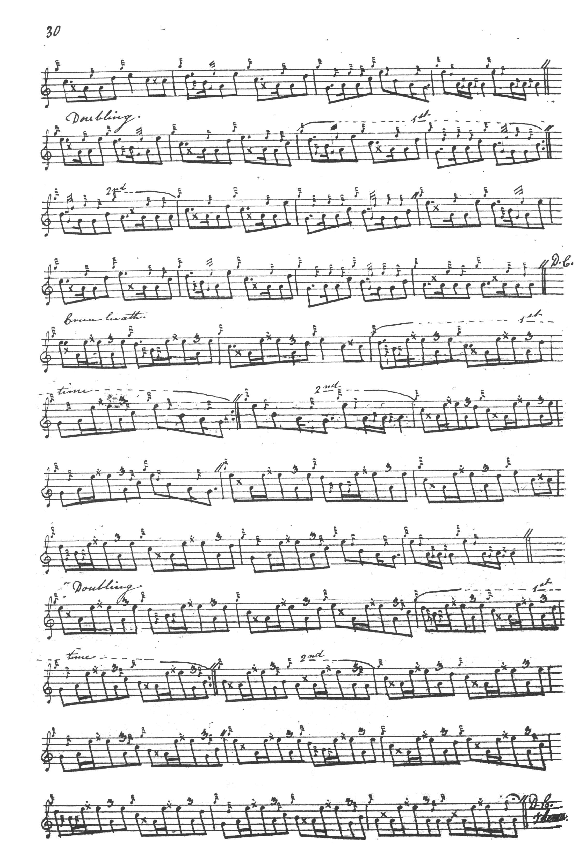

Duncan Campbell of Foss plays his taorluath breabach “round” and points his crunluath “up”, but otherwise he follows Angus MacKay. Duncan Campbell set the tune as follows:

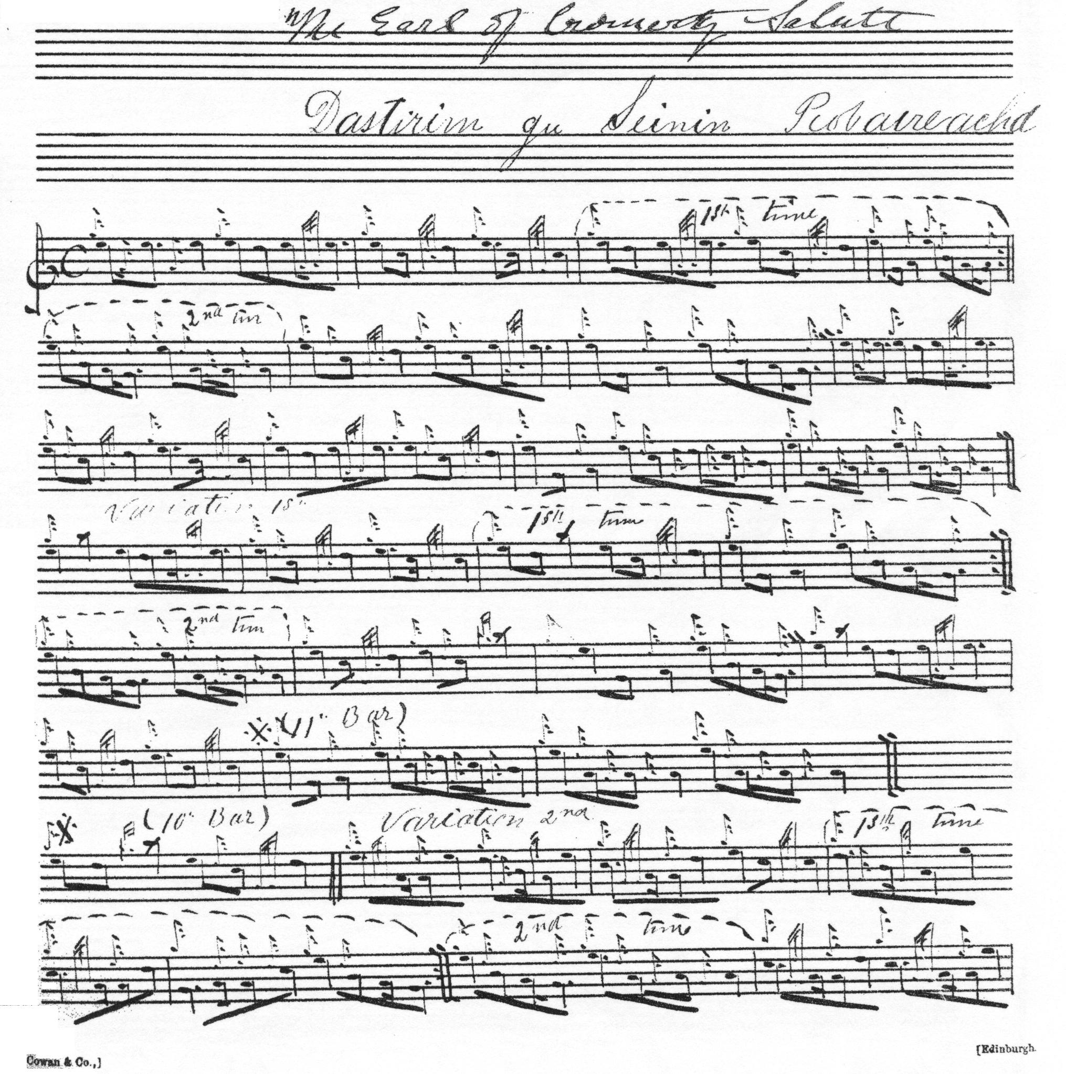

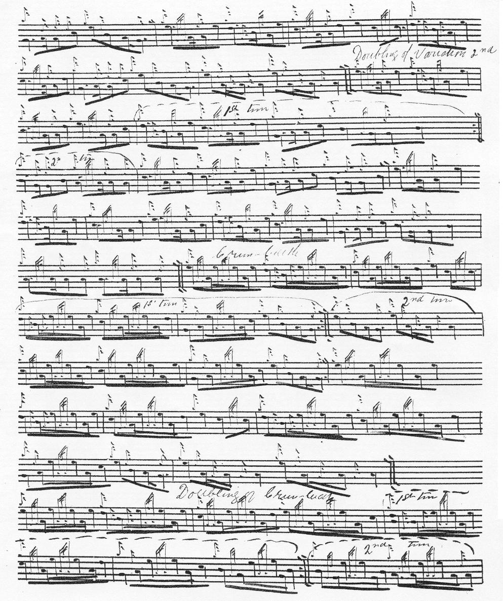
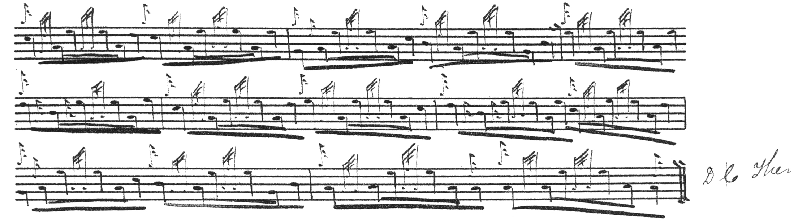

Colin Cameron gives the alternative title “Earl of Cromartie’s Salute” but his score follows Angus MacKay’s (including the eccentric line divisions) and his score is not reproduced here.

Uilleam Ross also follows Angus MacKay’s manuscript and his score is not reproduced here.

D. S. MacDonald amends MacKay’s first and second ending marks but otherwise does not intervene in the tune. His score is not reproduced here.

David Glen’ manuscript at this point shows an interesting example of his general editorial style, in particular his carefully noting a range of alternative titles, including “The Earl of Cromartie’s Salute”, “Hey for the Old Pipes”, “Dancing to the Music of the Pipes” and so on. The numbering of the bars (a fairly unusual occurrence in this source) may indicate uneasiness about the structure of the tune. Glen sets the tune as follows:

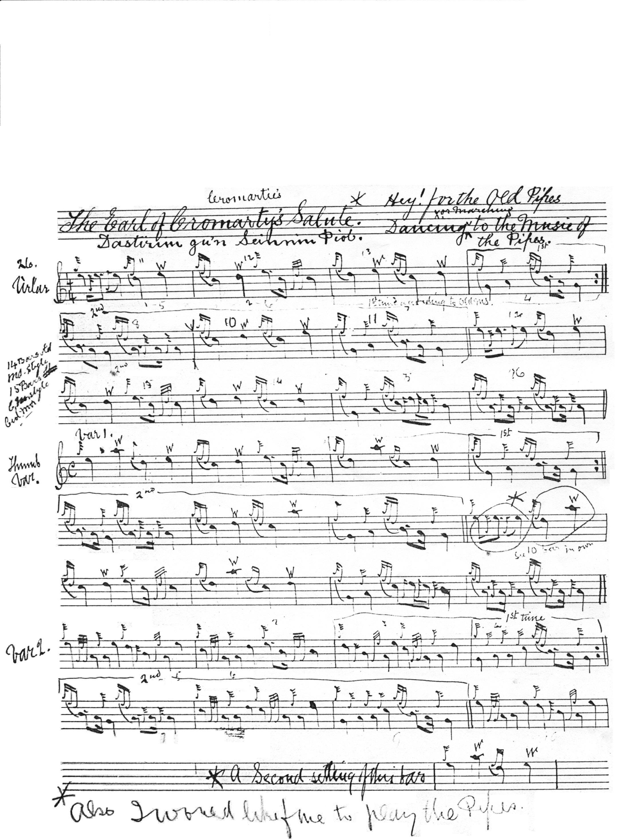
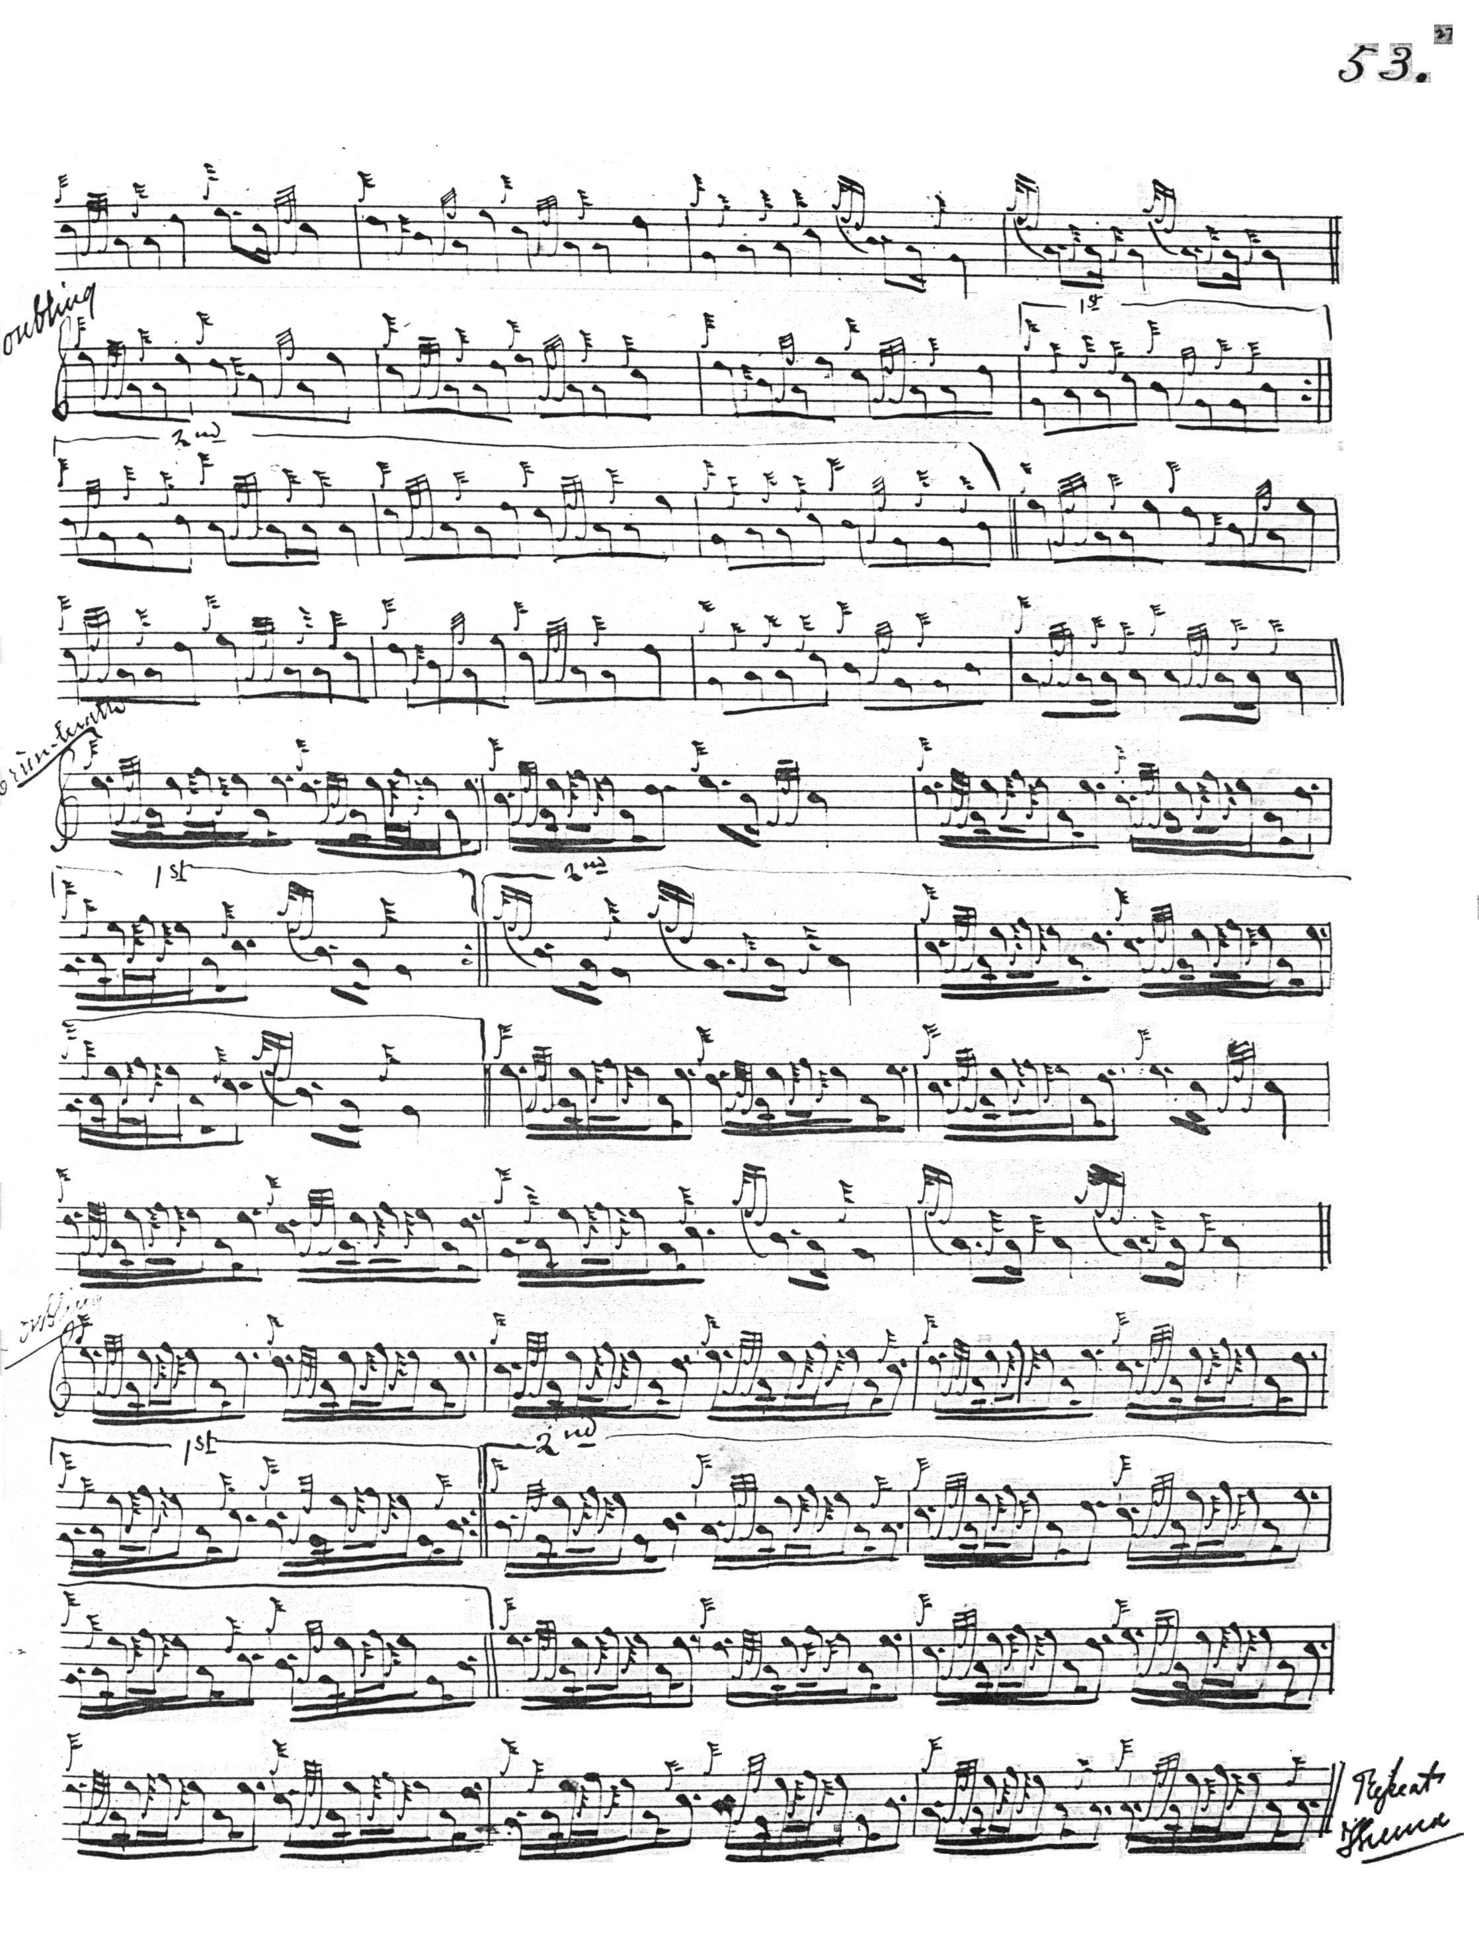

Robert Meldrum’s score adds nothing to the stylistic possibilities of the tune and is not reproduced here.

General Thomason gives Angus MacKay’s manuscript as his source and indicates that he has intervened editorially, but he adds little of significance to the tune and his score is not reproduced here.

Commentary:

Although Angus MacKay had noted the tune in his manuscript probably during the later 1830s or early 1840s, it remained unpublished until its appearance in Thomason’s Ceol Mor, and it would appear that it was little known, even amongst master pipers, during the second half of the 19th century. We know, for example, that John MacDougall Gillies was a pivotal figure amongst collectors and editors during the later Victorian and Edwardian periods, and we learn that when Robert Meldrum found this tune in an old roll of piping manuscript which came through John Bàn MacKenzie at Taymouth Castle, he transcribed it and sent a copy to Gillies, the suggestion being that Meldrum considered it a rarity.

This tune is one of the dozen or so which led Archibald Campbell to posit a group based on the structure 4 6 4 (1/2) in PS vi, 167, but Colin Campbell’s structure consistently follows a different pattern. The claims made for the scores of MacKay and Duncan Campbell in PS vi, can be assessed against the examples reproduced above.

* * *

Electronic text © Dr. William Donaldson, Aberdeen, Scotland, December 2007

